Central Chilled Water Systems (CCWS)
Design/Control Manual
Of
HOUSTON LARGE OFFICE

ASHRAE DESIGN
&
(min kW) DESIGN

Kirby Nelson PE
1/11/2015

Contents: Houston Design Manual
Preface
Introduction
CHAPTER (1) ASHRAE Design & (min kW Design)
-Peak Design Day Performance
-Average Summer Day Performance
-Average Spring/Fall Day Performance
-Average Winter Day Performance
-(bEQ) estimate for year.
NOMENCLATURE

PREFACE
DOE building energy models do not work, this Design Manual presents a modeling approach that does. Following is a brief summary of the characteristics of system energy equilibrium (SEE) models and the (SEE) model experience of the author.
(SEE) Model
System energy equilibrium (SEE) models and schematics can be developed for any condition of weather and operational conditions that may occur in a real system. The requirement for the (SEE) model/schematic is always the same; it must duplicate the performance of the equipment that make up the system and it must obey the laws of thermodynamics and physics and include the nonlinear characteristics of the components of the system. The (SEE) model/schematics defined here assume all chillers are of the same size and model and the air handlers are the same size and model and equally loaded.
Math models that duplicate the real time performance of systems are standard practice in the space program and in the development of military products such as missiles, cannons, and other complex systems.
The System Energy Equilibrium (SEE) Model presented here duplicates the thermodynamic and nonlinear performance of real systems and therefore can define the best possible performance of a system consistent with the design and control concepts incorporated in the design i.e. the theoretical performance of the system as designed.
The author has found that the design and control concepts advocated by ASHRAE and Pacific Northwest National Laboratory (PNNL) yields a design that requires more demand kW and therefore energy than does a more conventional design and control strategy. These differences in design and control are detailed below.

Kirby Nelson experience
The following is a brief history of Kirby’s experience in System Energy Equilibrium (SEE) Modeling and analysis.
System Energy Equilibrium (SEE) modeling is not a new concept. The author was involved in this approach to modeling in the 1970’s designing military products and then as corporate energy manager for Texas Instruments Inc. modeling building systems.
The concept is to simply write the basic physics and thermodynamic equations of the system and simultaneously solve the set of equations with a computer. The results will duplicate the performance of the real system if the equations are correct; nonlinear characteristics input and equipment efficiencies input. The equations can be, and should be, corrected by iterating between the real performance data verses the model and updating the model equations.
The first HVAC paper published using this approach was in the ASHRAE Journal of December 2006. "7 Upgrades to Reduce Building Electrical Demand"
In March 2010 he had an article in Engineered Systems "Central Chilled Water System Modeling" & July 2010 an HPAC article on chiller selection "Central-Chiller Plant Modeling"
In 2011 a 5 article series in HPAC dealing with Primary/Secondary vs. Primary-Only pumping. The second article dealt with the efficient control of a P/S plant and the third article with efficient control of a P-only plant. The fourth article was "Anatomy of Load delta-T" and the fifth added the building and air side equipment to the analysis.
In 2012 Kirby presented two advance technical papers at ASHRAE Chicago 2012. (CH-12-002) title “Simulation Modeling of a Central Chiller Plant” and (CH-12-003) "Simulation Modeling of Central Chilled Water Systems".
Since Chicago he has continued to develop the concept of (SEE) modeling and has entered into discussions on ASHRAExCHANGE on the ASHRAE web site. Kirby’s analysis of these issues and others to follow can be viewed at http://kirbynelsonpe.com/

INTRODUCTION
Several events give cause for concern regarding the capabilities of DOE models and the misunderstanding that has developed and become part of the ASHRAE culture.
DOE Energy Models:
40 years after the oil embargo of 4th quarter 1973 an air side model is not part of the DOE, PNNL, ASHRAE tool bag as evidenced by the ASHRAE Journal of July 2014 page 70 & September 2014 page 10.
Limit heating air temperature:
Table 5.2 of the (PNNL) study calls for “Limit reheat temperature to 20 degrees F above room temperature for better air distribution effectiveness”. The (PNNL) study also states “EnergyPlus limitations make it impractical to capture savings. May revisit after upgrade to EnergyPlus”. The (SEE) model finds this control strategy significantly increases the energy consumption of the system. The fact that (PNNL) believes this control strategy will reduce energy consumption is troubling.
ASHRAE Journal Plant Design:
The ASHRAE Journal approach to plant design as given by a series of article beginning July 2011 by Taylor results in significantly greater plant kW than a “(min KW) Design” as presented here.
Pacific Northwest National Laboratory study of ASHRAE Standard 90.1-2010.
The study by Pacific Northwest National Laboratory (PNNL) of ASHRAE Standard 90.1-2010 defines a large office building that is used as the base building for this study. The (PNNL) study defines the building characteristics, schedules, control, and HVAC equipment of the large office building defined here as the “ASHRAE Design”. Further the ASHRAE Journal of July 2011 defines “Optimizing Design & Control of Chilled Water Plants”, which is used to define the plant of the “ASHRAE Design”. This (SEE) model analysis has found that the “ASHRAE Design” calls for design and control concepts that significantly increase the energy consumption of the system compared to a “(min kW) Design”. The “(min kW) Design” is, I believe, less first cost. The (PNNL) study can be viewed at;
http://www.energycodes.gov/sites/default/files/documents/BECP_Energy_Cost_Savings_STD2010_May2011_v00.pdf or
http://www.energycodes.gov/achieving-30-goal-energy-and-cost-savings-analysis-ashrae-standard-901-2010
BUILDING DEFINED
The (PNNL) study defines the building as given by the Figure, a 13 story office with 498,600 square feet of air conditioned space.
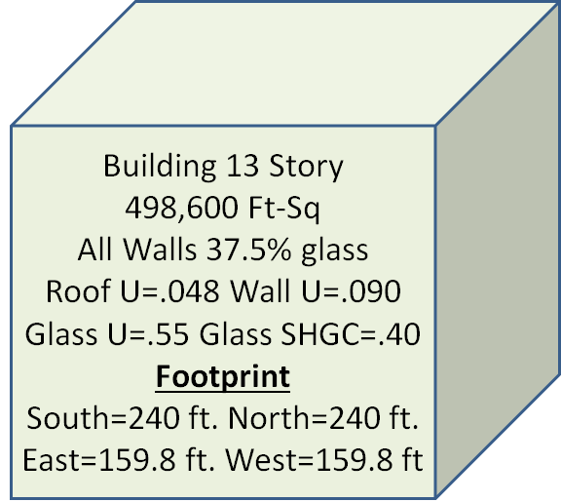
Building description
The peak design temperatures are taken from the 2013 ASHRAE Fundamentals Handbook weather data for Chicago/Midway, IL, U.S.A. The peak dry bulb is 91.7F and the peak design wet bulb is 81.8F as given by monthly design wet bulb and mean coincident dry bulb at .4% in the Handbook.
Two Design/Control Approaches
Two design/control approaches will be studied; the first is based on the plant design as presented by the ASHRAE Journal of July 2011 thru June 2012 by Taylor, coupled with the control and design procedures defined by the (PNNL) study of Standard 90.1-2010. This approach will be named here as the ASHRAE Design.
The second design/control approach is based on more conventional design/control practice and will be defined as the (min kW) Design.
Plant design procedures as given by the ASHRAE Journal of July 2011 thru June 2012
The ASHRAE Journal articles define a procedure for designing a central chilled water plant based on life cycle cost. This (min kW) Design model study will show that the ASHRAE designed plant requires significantly more kW demand than does a plant based on an (min kW) Design.

# | ASHRAE Journal & Standard 90.1-2010  Design & Control. | (Min kW) Design & Control.
(1) | Infiltration of 6,811 CFM is called for by  Std. 90.1-2010. | Pressurize the building to exfiltration of 3,378 CFM, no return fans.
(2) | 70F perimeter stat set pt. will be aborted resulting in loss of stat control. | Control thermostats to minimize heating & cooling energy.
(3) | Building return air path not controlled. | Control returns air to minimize heating & cooling energy.
(4) | Installed fan powered supply air terminals. | Design the air supply system without fan powered terminals.
(5) | Control air supply (55F) temperature to 60F when not at full cooling load, page 97 of Oct. 2013 ASHRAE Journal. | Control supply air to 55F design but may decrease to 50F to decrease fan kW.
(6) | Table 5.2 of (PNNL) 90.1-2010 study limits heating air temperature to 20F above room temperature, (94F). | Perimeter heating air temperature of 110F.
(7) | Table 5.11 of the (PNNL) study call for a TSP of 5.58 w.c. | Use same duct size as ASHRAE design, therefore less TSP for (min kW) Design.
(8) | Design the plant based on ASHRAE Journal articles, “Optimizing Design & Control of Chilled Water Plants”, July 2011-June 2012, by Taylor. | Design the plant with the objective of minimizing plant kW consistent with first cost control.
Table: Two designs compared

The Table briefly summarizes the major differences in the two designs.

REQUIRMENTS OF (SEE) MODELS
The requirements of a (SEE) Model include the follow:
(1) The performance of the components of the system agrees with manufactures verified performance data, specifically the chiller, tower & air side equipment.
(2) Energy into the system can be shown to equal the energy out of the system.
(3) The model can produce a System Energy Equilibrium (SEE) Schematic.
(4) The model can perform real time analysis of a building and input inefficiency to arrive at a duplication of the buildings real time performance.
Chapter (1) will demonstrate these requirements for the (SEE) model of this Design Manual.

Peak Design Weather
The 2013 ASHRAE Handbook-Fundamentals gives design weather data for Houston/Ellington, Texas as 99.2F dry blub & 77.9F mean coincident wet bulb for .4%. Design wet bulb is 82.1F & 91.2F MCDB; the question is which is the greater load or results in the greater system kW demand? The following two total system schematics answer the question.
A review of Schematics A & B below illustrates that the design wet bulb conditions, Schematic B, give a slightly greater system kW and will therefore be used as the peak design weather.

SCHEMATIC A: System schematic at
99.2F DB & 77.9F WB

SCHEMATIC B: System schematic at
91.2F DB & 82.1F WB

CHAPTER (1); ASHRAE Design & (min kW Design) at PEAK Design Day Conditions
Figure 1-1 gives the assumed design day weather.
The peak design temperatures are taken from the 2013 ASHRAE Fundamentals Handbook weather data. The peak dry bulb is 91.2F and the peak design wet bulb is 82.1F as given by monthly design wet bulb and mean coincident dry bulb at .4% in the Handbook.

FIGURE 1-1: Assumed design day weather
Figure 1-2 illustrates the slight difference in the building load of the two designs. This chart can also be thought of as the energy into the building due to weather plus the light, plug, and people loads. The infiltration of the ASHRAE Design accounts for the slight increase over the min kW Design.
FIGURE 1-2: Building design loads
The point of Figure 1-2 is that the difference in the energy consumption of the two designs is due to design and control of the two systems; not a difference in the design of the basic building.
Requirements of (SEE) Model
Four requirements of a (SEE) model are given above and will be illustrated here for the ASHRAE Design at peak summer design conditions.
Figure 1-3 illustrates the energy into the ASHRAE Design; requirement (2). Note that at 4PM the energy into the system is about 2.7 times the energy into the building, Figure 1-1; illustrating the amount of energy required & consumed by the CCWS to condition the building.
Figure 1-4 illustrates the energy out of the ASHRAE Design system.

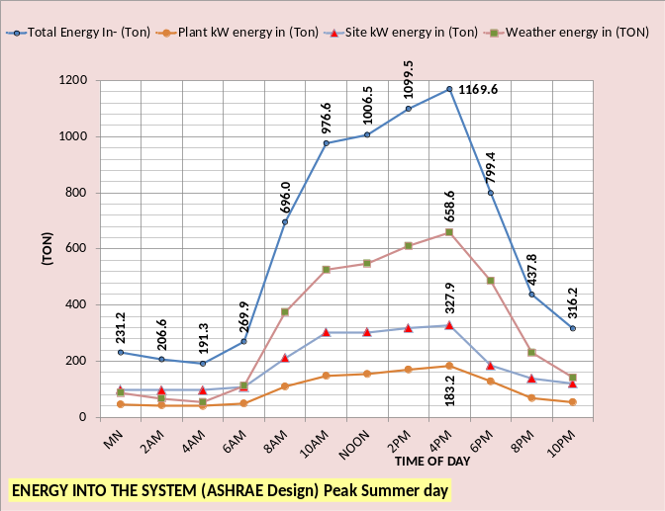
FIGURE 1-3: Energy in ASHRAE Design

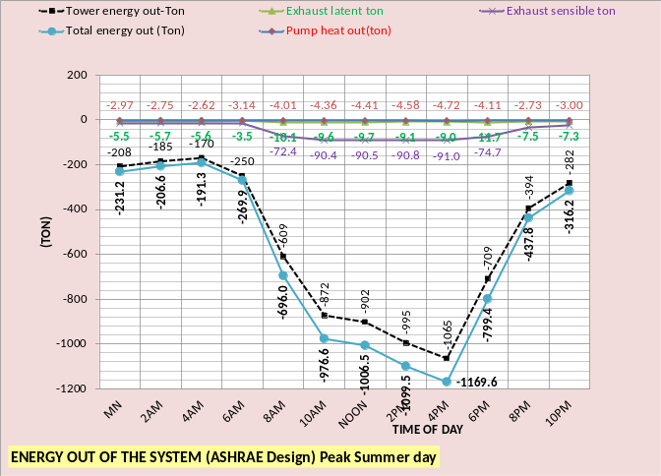
FIGURE 1-4: Energy out ASHRAE Design
Figure 1-5 & 1-6 illustrate the chiller & tower performance,(SEE Model requirement 1) as the evaporator load changes. At peak conditions the chiller kW/evaporator ton is (544kW/886ton=.61) and the tower range + approach is (21.1).
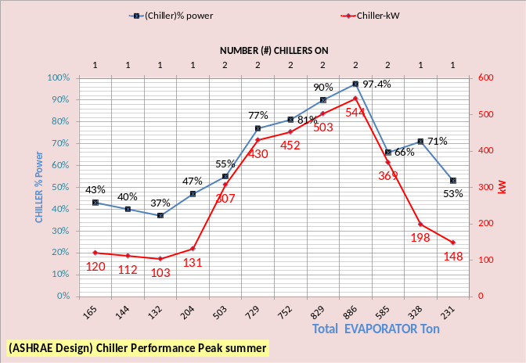
FIGURE 1-5: Chiller performance
FIGURE 1-6: Tower performance

(SEE) Model requirement (3) (SEE) Schematic is illustrated by Schematics A & B above & requirement (4) real time analysis will be demonstrated later in this manual; note a (SEE) Schematic is also given in the Nomenclature.

FIGURE 1-7: Systems total kW demand
Figure 1-7 illustrates the difference in total system kW for the two designs at design day conditions.
The charts below compare the two designs side by side.

Figure 1-8: ASHRAE design kW demand components
Figures 1-8 & 1-9 illustrate the building kW is the same for both designs; the plant and air side system account for the greater values of the ASHRAE design.

Table 1-1: ASHRAE design 24 hours at design day weather
Tables 1-1 & 1-2 illustrate the difference in 24 hour energy consumption of the two designs at assumed design day weather conditions. The ASHRAE design consumes about 24% more energy at peak design day conditions; a significant increase due to what may appear as minor differences in the designs. Later chapters will explore in detail the differences in the two designs and control.

Figure 1-9: (Min kW design) kW components at design day

Table 1-2: (min kW design) 24 hours at design day weather

The following pages will consider performance at average summer, spring/fall and winter conditions with annual (bEQ) estimated.

Average summer performance

Figure 1-10: Assumed average summer weather day
Figure 1-10 illustrates the assumed weather conditions for an average summer day, based on ASHRAE Handbook data. Note the % clear sky is assumed as 90%.
Figure 1-11: Systems total kW demand
Figure 1-11 illustrates the same pattern as Figure 1-7 but reduced values as expected. The following charts and tables compare the two designs.

Figure 1-12: (ASHRAE design) component kW
Figures 1-12 & 1-13 again illustrate the building kW is the same for both designs; the difference is in the response of the air side system and the plant to the building loads.
Table 1-3: (ASHRAE design) 24 hours average summer weather
Tables 1-3 & 1-5 illustrate the difference in 24 hour consumption and Tables 1-4 & 1-5 illustrate (bEQ) values based on 24 hour consumption.
Table 1-4: (ASHRAE design)(bEQ) estimate
The min kW Design and control concepts provide significantly better (bEQ) performance at average summer conditions and better performance as weather conditions cool.
Figure 1-13: (min kW design) kW components

Table 1-5: (min kW design) 24 hours average summer weather

Table 1-6: (min kW Design)(bEQ) estimate

Average Spring/Fall Weather
Houston

Figure 1-14: Average spring/fall weather day
Figure 1-14 illustrates the assumed average spring/fall weather and Figure 1-15 gives the difference in kW performance of the two designs.

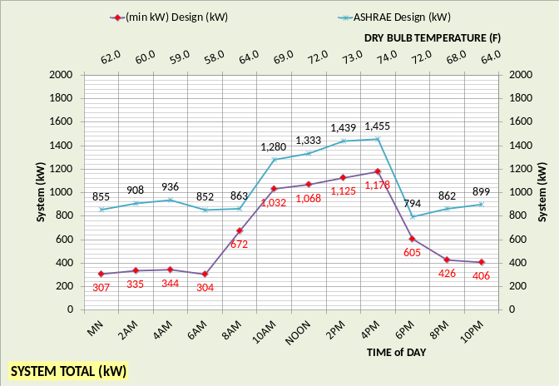
Figure 1-15: Systems total kW demand

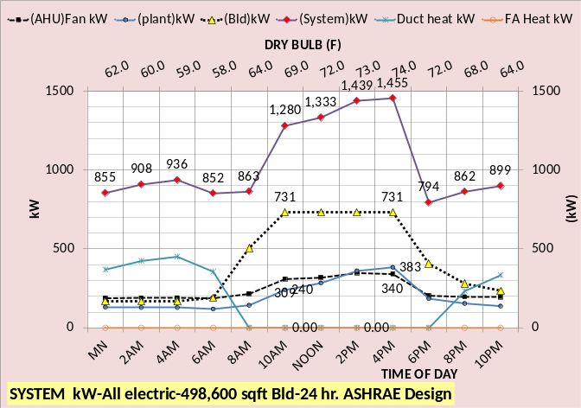
Figure 1-16: (ASHRAE design) component kW
Figures 1-16 & 1-17 illustrate the building kW is the same for both designs; the difference is in the response of the air side system and the plant.
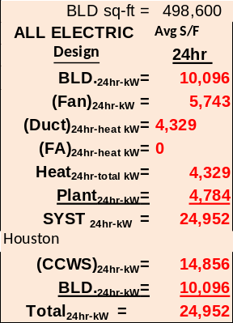
Table 1-7: (ASHRAE design) 24 hours average spring/fall weather
Tables 1-7 & 1-8 illustrate the difference in 24 hour consumption and Tables 1-9 & 1-10 illustrate (bEQ) based on 24 hour consumption.
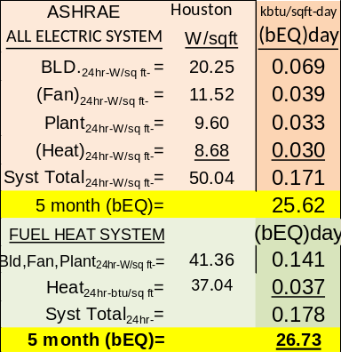
Table 1-9: (bEQ) estimate

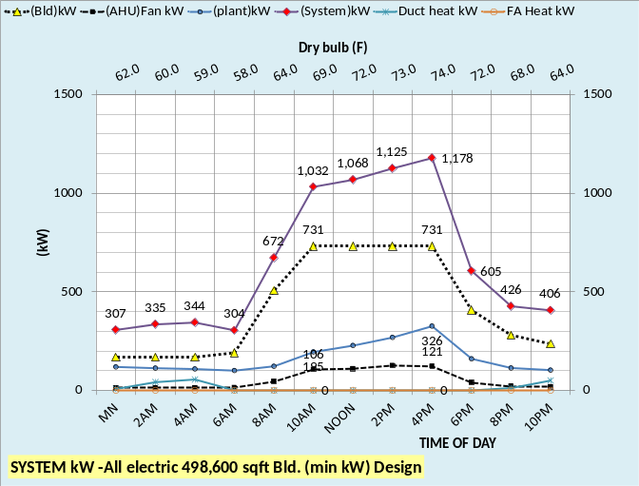
Figure 1-17: (min kW design) kW components

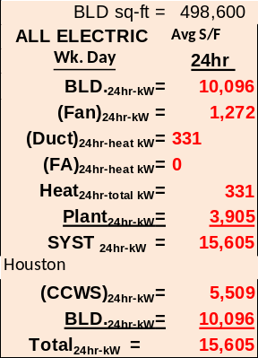
Table 1-8: (min kW design) 24 hours average spring/fall weather

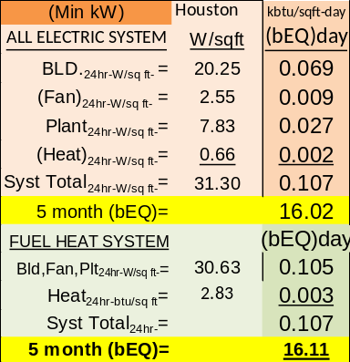
Table 1-10: (bEQ) estimate

Average winter weather
Houston

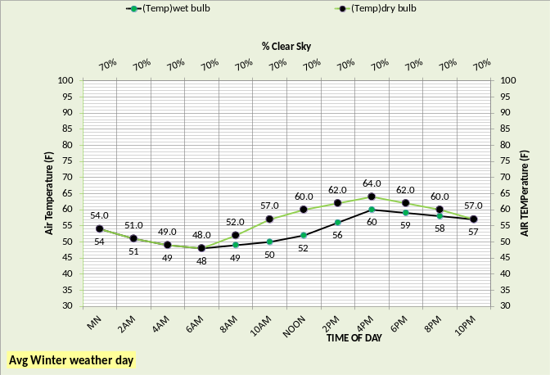
Figure 1-18: Assumed average winter weather day
Figure 1-18 illustrates the assumed average winter weather and Figure 1-19 gives the difference in kW performance of the two designs.

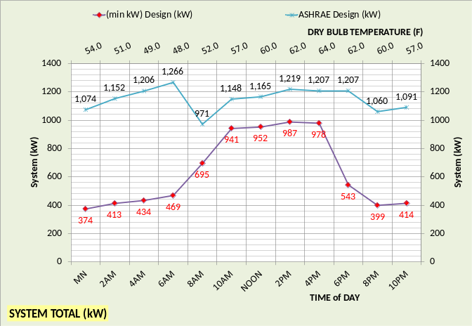
Figure 1-19: Systems total kW demand

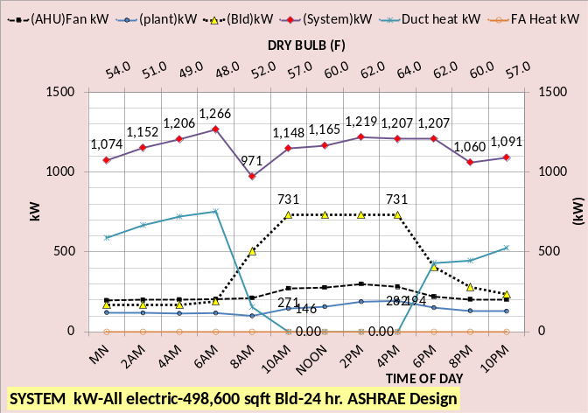
Figure 1-20: (ASHRAE design) component kW
Figures 1-20 & 1-21 illustrate the building kW is the same for both designs; the difference is in the response of the air side system and the plant.
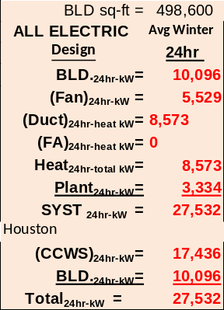
Table 1-11: (ASHRAE design) 24 hours average winter weather
Tables 1-11 & 1-13 illustrate the difference in 24 hour consumption and Tables 1-12 & 1-14 illustrate (bEQ) based on 24 hour consumption.
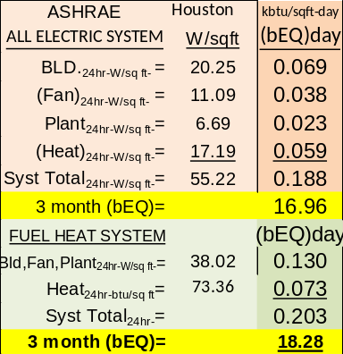
Table 1-12: (bEQ) estimate

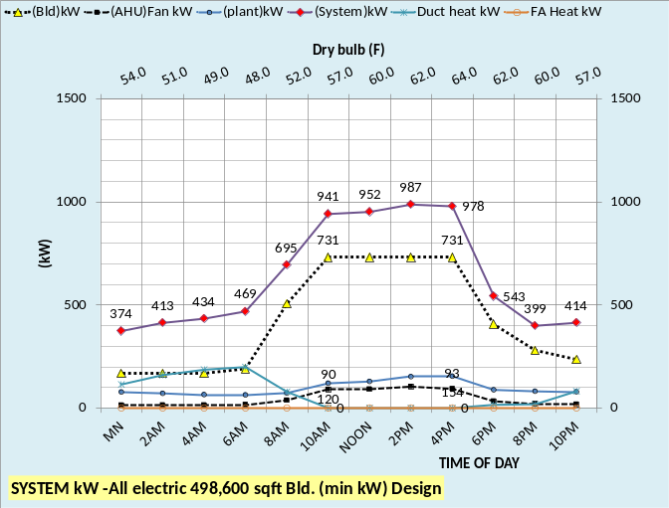
Figure 1-21: (min kW design) kW components

Table 1-13: (min kW design) 24 hours average winter weather

Table 1-14: (bEQ) estimate

CONCLUSIONS of CHAPTER 1
The purpose of this chapter (1) is to give an indication of the magnitude of the difference in energy consumption that can occur with seemingly slight differences in system design and control.
Table 1-15 illustrates estimated (bEQ) value based on 5 months of average summer weather, 4 months of average spring/fall weather, and 3 months of average winter weather.

All Elect. Building | ASHRAE design (bEQ) | Min kW design (bEQ)
Summer -5m | 24.37 | 18.29
spring/fall-4m | 25.62 | 16.02
Winter -3m | 16.96 | 9.36
Est. annual (bEQ) | 66.95 | 43.67
TABLE 1-15: Houston (bEQ) Estimate

Table 1-15 illustrates that the ASHRAE Design becomes less efficient, as compared to the min kW Design, as the weather becomes colder. The winter ASHRAE Design (bEQ) is twice the value of the (min kW Design). The difference is primarily due to the air side design & control of the perimeter heating; to be discussed in detail in coming chapters.

The detail differences in the design and control of the two designs form the basis of the remainder of this Design/Control Manual.

Table 1-16 presents the Chicago (bEQ) estimates for comparison. Chicago (bEQ) is based on 3 months of average summer weather, 6 months of average spring/fall weather, and 3 months of average winter weather.
All Elect. Building | ASHRAE design (bEQ) | Min kW design (bEQ)
Summer -3m | 15.34 | 9.93
spring/fall-6m | 35.98 | 20.15
Winter -3m | 33.39 | 16.83
Est. annual (bEQ) | 84.71 | 46.91
Table 1-16: Chicago (bEQ) Estimate

System Nomenclature
Each of the more than 100 components of the system will be defined.
The (PNNL) study defines the large office building as given by Figure N-1, a 13 story office with 498,600 square feet of air conditioned space.
FIGURE N-1: Building description
The (PNNL) study can be viewed at;
http://www.energycodes.gov/sites/default/files/documents/BECP_Energy_Cost_Savings_STD2010_May2011_v00.pdf or
http://www.energycodes.gov/achieving-30-goal-energy-and-cost-savings-analysis-ashrae-standard-901-2010

BUILDING NOMENCLATURE:
Building structure;
BLD ft² = air conditioned space
# Floors = number of building floors
Roof ft² = roof square feet
N/S wall ft² =north/south wall square feet
E/W wall ft² =east/west wall square feet
Wall % glass = percent of each wall that is glass
Glass U = glass heat transfer coefficient
Wall U = wall heat transfer coefficient
Glass SHGC = glass solar heat gain coefficient
Wall emit = wall solar index
Building interior space;
Roof_{trans-ton} =transmission through roof (ton)
Roof_{sky-lite-ton} =sky lite load (ton)
People_{ton} = cooling load due to people (ton)
Plug_{ton} = cooling load due to plug kW
Plug_{tkW} = kW demand due to plug loads
Light_{ton} = cooling load due to lights (ton)
Light_{kW} = kW demand due to lights
(int-cfm)_{to-per-return} = CFM of interior supply air that returns to perimeter of building
Total Bld_{int-ton} = total building interior load (ton)
T_{stat-int} = interior stat set temperature (F)
Bld_{int-air-ton} = supply air ton to offset interior load
Building perimeter space;
%_{clear sky} = percent solar that hits building
T_{dry bulb} = outside dry bulb temperature (F)
T_{wet bulb} = outside wet bulb temperature (F)
Infil_{lat-ton} = latent load due to air infiltration (ton)
Infil_{CFM} = air infiltration CFM
Infil_{sen-ton} = sensible load due to air infiltration (ton)
Wall_{n trans ton} = north wall transmission (ton)
Wall_{s trans ton} = south wall transmission (ton)
Wall_{E trans ton} = east wall transmission (ton)
Wall_{w trans ton} = west wall transmission (ton)
Wall_{tot-trans-ton} = total wall transmission (ton)
Glass_{N-trans-ton} = north wall glass transmission (ton)
Glass_{S-trans-ton} = south wall glass transmission (ton)
Glass_{E-trans-ton} = east wall glass transmission (ton)
Glass_{W trans-ton} = west wall glass transmission (ton)
Glass_{tot-trans-ton} = total transmission thru glass (ton)
Glass_{N-solar-ton} = north glass solar load (ton)
Glass_{S-solar-ton} = south glass solar load (ton)
Glass_{E-solar-ton} = east glass solar load (ton)
Glass_{W-solar-ton} = west glass solar load (ton)
Glass_{tot-solar-ton} = total glass solar load (ton)
(int cfm)_{per-ton} = effect of interior CFM to wall (ton)
Total Bld_{per-sen-ton} total perimeter sensible load (ton)
T_{stat-per} = perimeter stat set temperature (F)
Bld_{per-air-ton} = supply air ton to offset perimeter load
FIGURE 2A
Air handler system

AIR HANDLER DUCT SYSTEM NOMENCLATURE

Duct system nomenclature
T_{air supply int} = temperature air supply to interior (F)
(fan)_{int-ter-kW} = kW demand of interior terminal fans
(fan)_{int-ter-ton} = load due to interior terminal fans kW
(D)_{int-air-ton} = cooling (ton) to interior duct
T_{air coils} = supply air temperature off coils to duct
(D)_{int-CFM} = supply air CFM to interior duct
(ABS Bld Ton) = absolute building load on (CCWS)
T_{air supply per} = temperature air supply perimeter (F)
(fan)_{per-ter-kW} = kW demand perimeter terminal fans
(fan)_{per-ter-ton} = load due to perimeter terminal fans
T_{heat-air} = temp supply air before terminal fan heat
(D)_{heat-kW} = kW heat to perimeter supply air
(D)_{heat-ton} = (ton) heat to perimeter supply air
T_{reheat air} = temp(F) perimeter supply air after reheat
(D)_{reheat-kW} = kW reheat to perimeter supply air
(D)_{reheat-ton} = (ton) reheat to perimeter supply air
(D)_{per-air-ton} = cooling (ton) to perimeter duct
T_{air coils} = supply air temperature off coils to duct
(D)_{per-CFM} = supply air CFM to perimeter duct
COIL NOMENCLATURE
(coil)_{sen-ton} = sensible load on all coils (ton)
(coil)_{cap-ton} = LMTD * UA = capacity (ton) one coil
(coil)_{H2O-ft/sec} = water velocity thru coil (ft/sec)
(coil)_{design-ft/sec} = coil design water velocity (ft/sec)
LMTD = coil log mean temperature difference (F)
(coil)_{L+s-ton} = latent + sensible load on all coils (ton)
(coil)_{gpm} = water flow (gpm) thru one coil
UA_{design} = coil UA design value
UA = coil heat transfer coefficient * coil area. UA varies as a function water velocity (coil)_{gpm} thru the coil, therefore as the (coil)_{gpm} decreases the coil capacity decreases.
Coils
(one coil)_{ton} = load (ton) on one coil
(H)_{coil} = air pressure drop thru coil (ft)
(H)_{coil-design} = design air pressure drop (ft)
VAV FAN SYSTEM NOMENCLATURE
Fresh air nomenclature:
stat_{FA} = fresh air freeze stat set temperature (F)
T_{FA to VAV} = temperature of fresh air to VAV fan
(FA)_{sen-ton} = fresh air sensible load (ton)
(FA)_{CFM} = CFM fresh air to VAV fan inlet
(FA)_{Lat-ton} = fresh air latent load (ton)
(FA)_{kW} = heat kW to stat_{FA} set temperature
Air return nomenclature:
T_{BLD-AR} = return air temp (F) before return fan
(Air)_{ret-CFM} = CFM air return from building
(FAN)_{ret-kW} = return fans total kW
(FAN)_{ret-ton} = cooling load (ton) due to (FAN)_{ret-kW}
(Air)_{ret-ton} = return air (ton) before return fans
T_{AR to VAV} = T_{BLD-AR} + delta T due to return fans kW
VAV_{ret-ton} = return (ton) to VAV fans inlet
Infil_{VAV-Lat-ton} = infiltration latent (ton) to VAV fans
VAV_{ret-CFM} = return CFM to VAV fans inlet
Infil_{CFM-ton} = load (ton) due to infiltration CFM
Exhaust air nomenclature
Ex_{Lat-ton} = latent load (ton) exhausted
Ex_{CFM} = CFM of exhaust air
T_{Ex} = temperature of exhaust air
Ex_{sen-ton} = sensible load (ton) exhausted
VAV Fans nomenclature
T_{air-VAV} = temp. air to coils after VAV fan heat
(FAN)_{VAV-CFM} = CFM air thru coils
(FAN)_{ton-VAV} = load (ton) due to VAV fan kW
(FAN)_{kW-VAV} = total VAV fan kW demand
T_{ret+FA} = return and fresh air mix temperature (F)
(dh) = VAV air static pressure (ft)
E_{fan-VSD} = VAV fans efficiency

AIR SIDE SYSTEM PLUS BUILDING

CENTRAL PLANT
Nomenclature will be defined by addressing each component of the plant.
Primary/secondary pumping nomenclature
gpm_{evap} = total gpm flow thru evaporators
(H)_{pri-total} = total primary pump head (ft) = (H)_{pri-pipe} + (H)_{pri-fittings} + (H)_{pri-bp} + (H)_{evap}
(H)_{pri-pipe} = primary pump head due to piping (ft)
(H)_{pri-fittings} = primary head due to pump & fitting (ft)
(Ef)_{c-pump} = efficiency of chiller pump
P_{c-heat-ton} = chiller pump heat to atmosphere (ton)
P_{c-kW} = one chiller pump kW demand (kW)
P_{chiller-#} = number chiller pumps operating
(lwt)_{evap} = temperature water leaving evaporator (F)
T_{bp} = temperature of water in bypass (F)
gpm_{bp} = gpm water flow in bypass
(H)_{pri-bp} = head if chiller pump flow in bypass (ft)
(ewt)_{evap} = temp water entering evaporator (F)
P_{sec-heat-ton} = secondary pump energy not into system (ton), goes to atmosphere
P_{sec-kW} = kW demand of secondary pumps
Ef_{des-sec-p} = design efficiency of secondary pumping
Ef_{sec-pump} = efficiency of secondary pumping
(H)_{sec} = secondary pump head (ft) = (H)_{sec-pipe} + (H)_{sec-bp} + (H)_{coil} + (H)_{valve}
(H)_{sec-pipe} = secondary pump head due to pipe (ft)
(H)_{sec-bp} = head in bypass if gpm_{sec} > gpm_{evap}
gpm_{sec} = water gpm flow in secondary loop
(ewt)_{coil} = water temperature entering coil (F)
Plant_{ton} = load (ton) from air side to plant
Pipe_{size-in} = secondary pipe size (inches)
(lwt)_{coil} = temperature of water leaving coil (F)
Condenser nomenclature:
(cond)_{ton} = load (ton) on one condenser
T_{CR} = temperature of condenser refrigerant (F)
T_{CR-app} = refrigerant approach temperature (F)
(COND)_{ton} = total load (ton) on all condensers
(H)_{cond} = tower pump head thru condenser (ft)
(cond)_{ft/sec} = tower water flow thru condenser
Compressor:
(chiller)_{kW} = each chiller kW demand
(chiller)_{lift} = (T_{CR} – T_{ER}) = chiller lift (F)
(chiller)% = percent chiller motor is loaded
(chiller)# = number chillers operating
(CHILLER)_{kW} = total plant chiller kW
(chiller)_{kW/ton} = chiller kW per evaporator ton
Evaporator
(evap)_{ton} = load (ton) on one evaporator
T_{ER} = evaporator refrigerant temp (F)
T_{ER-app} = evaporator refrigerant approach (F)
EVAP_{ton} = total evaporator loads (ton)
(H)_{evap} = pump head thru evaporator (ft)
(evap)_{ft/sec} = velocity water flow thru evaporator
(evap)_{des-ft/sec} = evaporator design flow velocity
Tower piping nomenclature
Pipe_{size-in} = tower pipe size (inches)
gpm_{T} = each tower water flow (gpm)
(H)_{T-total} = total tower pump head (ft)
P_{T-heat} = pump heat to atmosphere (ton)
P_{T-kW} = each tower pump kW demand
Ef_{T-pump} = tower pump efficiency
P_{tower #} = number of tower pumps
(H)_{T-pipe} = total tower pump head (ft)

Tower piping nomenclature cont.
(ewt)_{T} = tower entering water temperature (F)
(H)_{T-static} = tower height static head (ft)
T_{range} = tower range (F)= (ewt)_{T} – (lwt)_{T}
(lwt)_{T} = tower leaving water temperature (F)
T_{approach} = (lwt)_{T} – (T_{wet-bulb})
Tower nomenclature
t_{fan-kW} = kW demand of one tower fan
Tfan-kW = tower fan kW of fans on
t_{fan-%} = percent tower fan speed
t_{ton-ex} = ton exhaust by one tower
T# = number of towers on
T_{ton-ex} = ton exhaust by all towers on
T_{rg+app} = tower range + approach (F)
SYSTEM PERFORMANCE
The performance indices of the following Tables are self-explanatory. A complete schematic will be shown below.
Performance table at given hour

24 Hour performance, all-electric

24 Hour performance, heat with fuel

24 Hour Energy in = Energy out

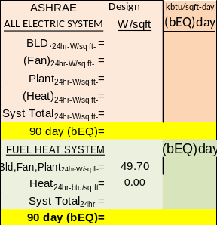
(bEQ) estimate

Next the full system energy equilibrium (SEE) schematic.

System Energy Equilibrium (SEE) Schematic

