EXHAUST AIR ENERGY RECOVERY
ANALYSIS by SYSTEM ENERGY EQUILIBRIUM (SEE) MODEL
The objective of a System Energy Equilibrium (SEE) building energy model is to duplicate the hourly performance of a real building energy system at all operating conditions of weather and load; giving flows, temperatures, cooling loads, kW demand of equipment, and total site kW as weather and operational conditions change. The (SEE) model, as presented here, consists of a set of simultaneous equations that obey the laws of thermodynamics, models the hour by hour loads of the building and the response of the central chilled water system (CCWS) to the building loads and air side system, and includes the nonlinear performance characteristics of the plant equipment and air side equipment. A (SEE) model iterates to steady state energy equilibrium after a perturbation to the system just as a real system responds; a defining characteristic of a (SEE) model.
The primary objective of this paper is to investigate the energy savings potential of an exhaust air energy recovery system applied to a large office building located in weather zone 4.
(SEE) MODEL CHARACTERISTICS
Understanding the performance of a complex system, in this case a building and (CCWS) that serves the building, requires a model that includes detail model equations of all components of the system. These equations of each system component are solved simultaneous, by computer, giving the effect of each component on the operation of the total system and the effect of the system on the performance of the component. Real building energy systems operate according to the laws of thermodynamics and the performance characteristics of the equipment installed; therefore the model must incorporate equations that duplicate the laws of thermodynamics and input the characteristics of the system components consistent with the manufactures verified data. To accomplish this objective the model must incorporate every design and control feature of the real system; resulting in a model, as presented here, consisting of more than 150 performances and design variables, each variable defined by an equation and/or is a design constant that changes if the design is changed. The set of equations is solved simultaneously by computer and will duplicate the performance of a real system if sufficient detail has been incorporated into the model and the detail is consistent with the actual equipment and controls of the real system. The model is always at System Energy Equilibrium (SEE).
The challenge developing a (SEE) model might be summarized as; a real system is very complex where minor changes in weather, design, and control, can have a major effect on the performance of the system; therefore the system (SEE) model must be equally complex incorporating all characteristics of the real system within a set of simultaneous equations solved by a computer.

THE BUILDING & ASSUMED WEATHER
Figure 1 illustrates the building and Figure 2 the assumed weather for this analysis of exhaust air energy recovery.
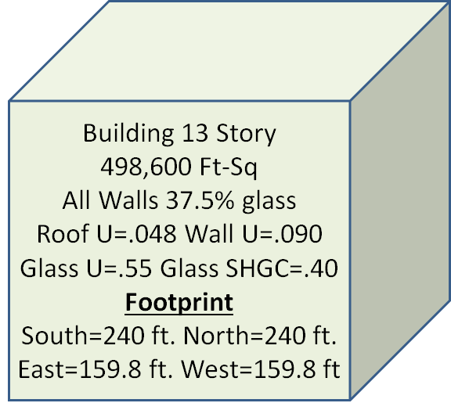
Figure 1 Building

The building of this study is defined by the Pacific Northwest National Laboratory (PNNL) study of ASHRAE Standard 90.1-2010, a large 13 story office building, Figure 1, with 498,600 square feet of air conditioned space. The (PNNL) study is given by Liu, B. May 2011. “Achieving the 30% Goal: Energy and Cost Savings Analysis of ASHRAE Standard 90.1-2010” Pacific Northwest National Laboratory.
http://www.energycodes.gov/achieving-30-goal-energy-and-cost-savings-analysis-ashrae-standard-901-2010. The building schedules and other details of the building, as defined by the (PNNL) study, are in this model design but the plant of this study is designed to a series of articles in the ASHRAE Journal, (Taylor 2011).

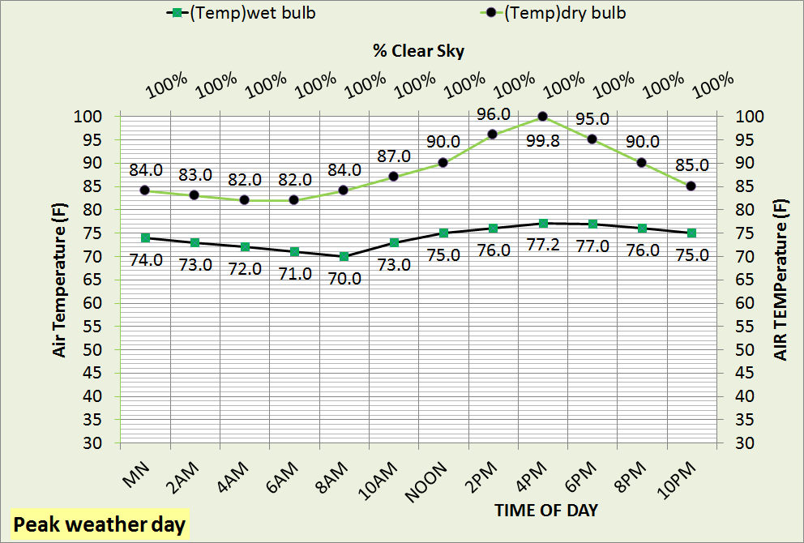
Figure 2 Assumed peak summer design weather
BUILDING SCHEMATIC

Figure 3 defines the components of the building schematic and nomenclature is given at the end of this paper.

Figure 3 Building schematic defined

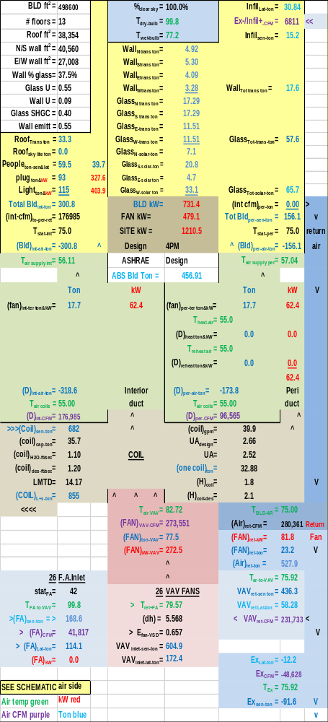Figure 4 Air side system-no exhaust energy recovery at peak design weather
Figure 4 illustrates the air side system without exhaust energy recovery and Figure 5 gives the effect of recovery. Note that all system values are the same for the building, duct system, and VAV kW fan performance. With recovery, Figure 5, the exhaust air temperature increases from 75.92F to 92.27F and the fresh air into the VAV fans
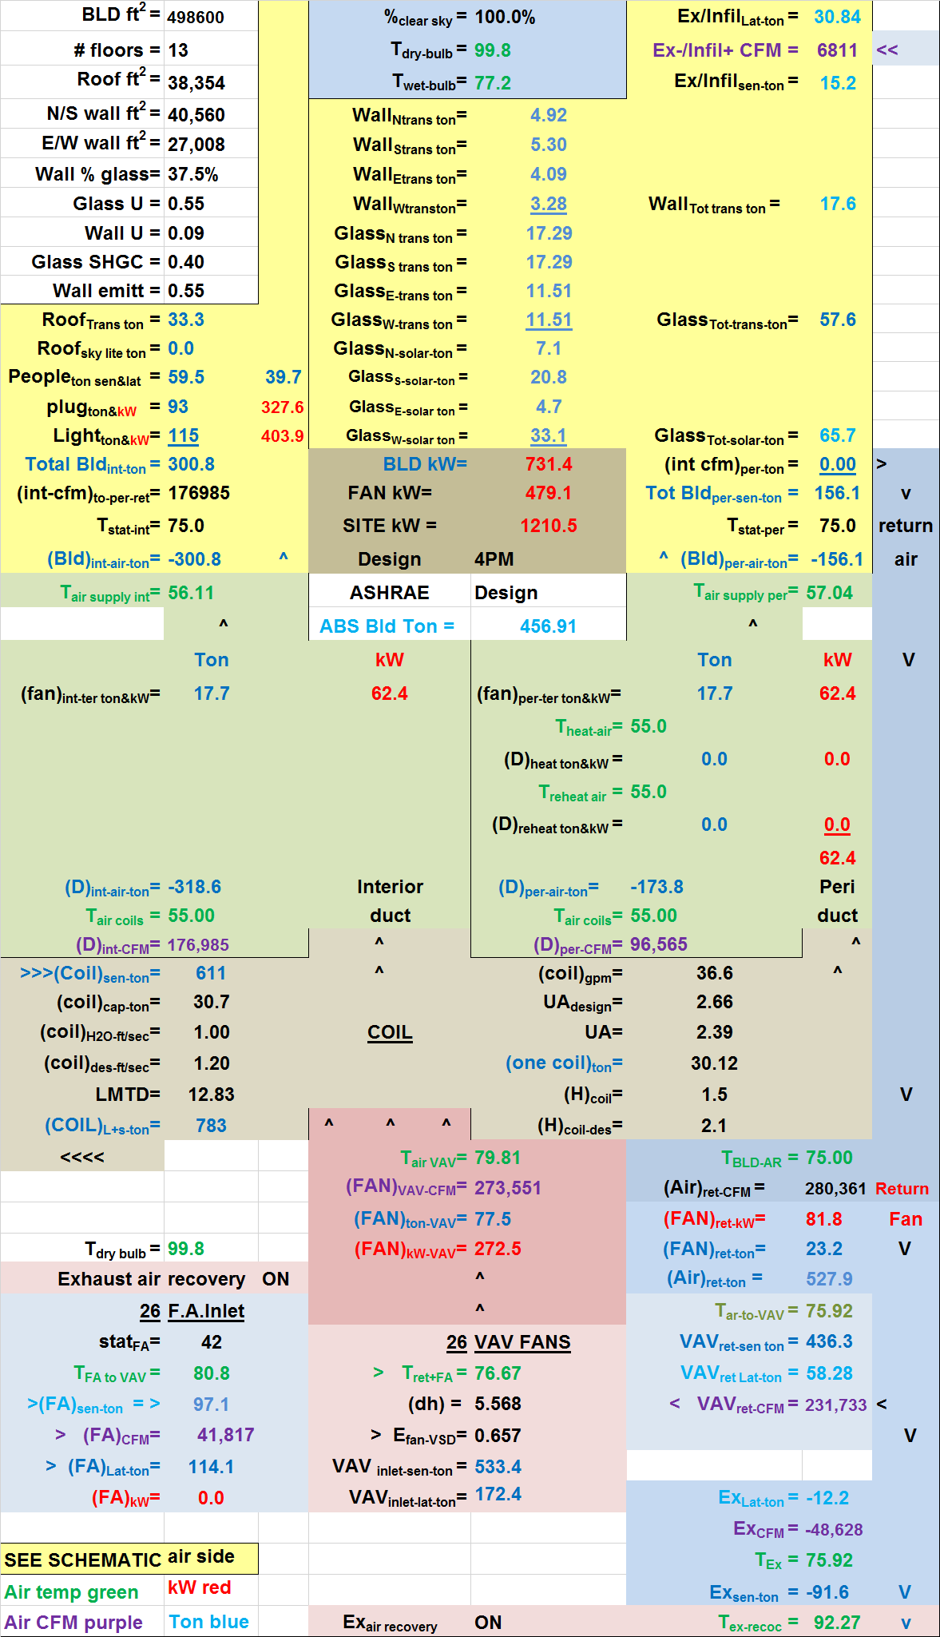Figure 5 Air side system with exhaust energy recovery at peak design weather
decreases from 99.8F, the outside dry bulb temperature, to 80.8F; resulting in a drop of load to the plant of (855 - 783 = 72 ton). Exhaust air energy recovery only reduces the load on the plant.

Figures 6 & 7 are of the VAV fan systems of Figures 4 & 5.

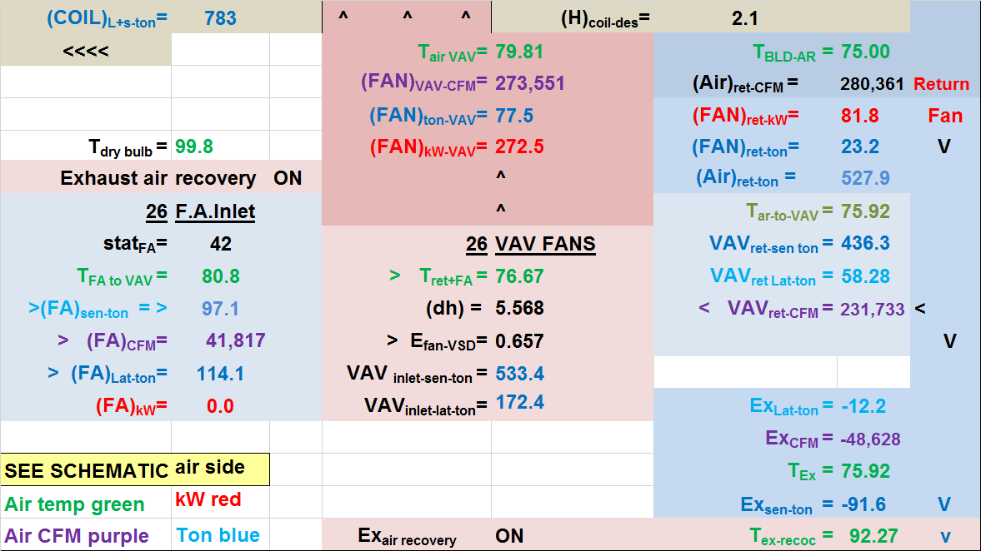
Figure 6 VAV fan system of Figure 5-exhaust air recovery on

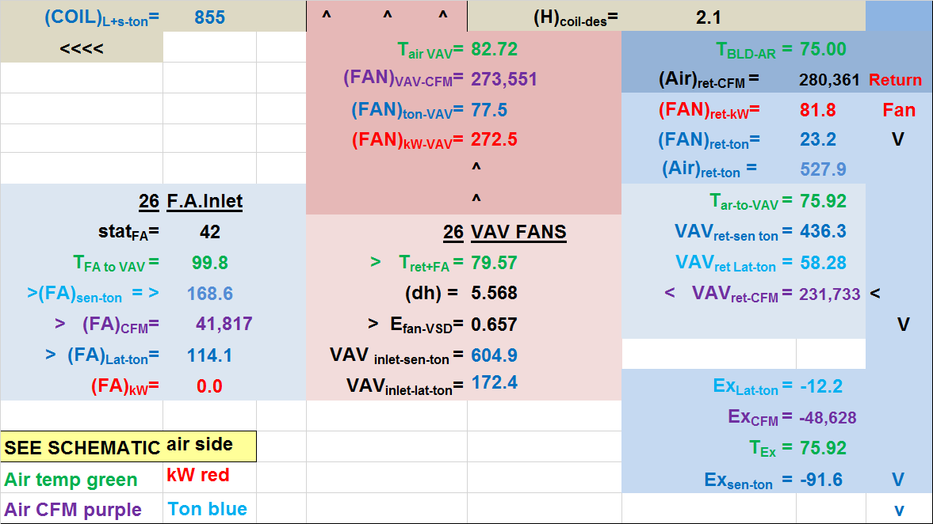
Figure 7 VAV fan system of Figure 4-no exhaust air recovery

Comparing Figures 6 & 7 illustrates the effect of exhaust air energy recovery at peak summer design conditions. Transferring energy from the exhaust air to the fresh air decreases the air into the VAV fans from 79.57F to 76.67F; resulting in a return air load to the VAV fans of 533.4 ton sensible load verses 604.9 ton without recovery. Note that the VAV kW and CFM are not changed by the exhaust air recovery systems.
The load presented to the plant is reduced from 855 ton to 783 ton; let’s look at the response of the plants.

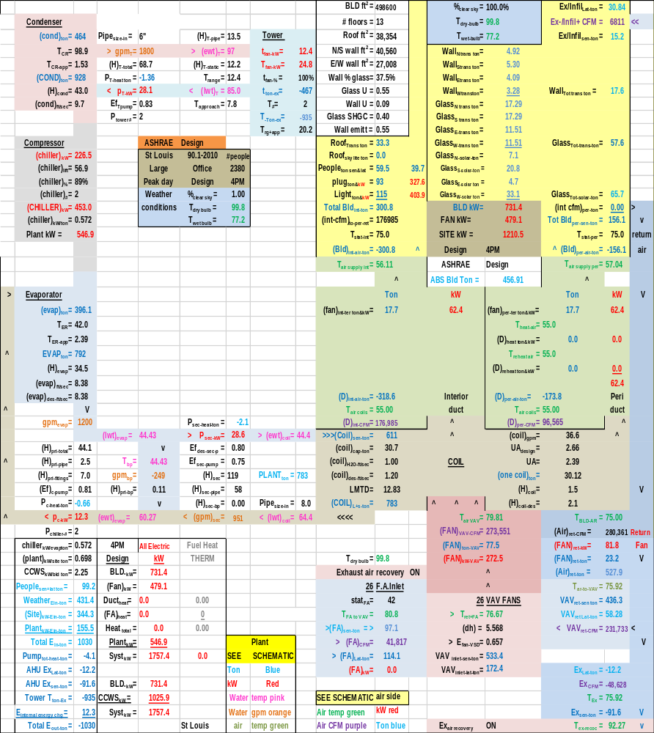
Figure 8 Total system with exhaust air energy recovery.
Comparing 8 & 9 illustrates the plant kW reduces from 597.4 kW to 546.9 kW and the total system kW reduces from 1807.9 kW to 1757.4 kW at peak summer design conditions. Each chiller kW reduces from 249.4 kW to 226.5 kW. A 9% smaller chiller with exhaust air energy recovery; the only significant effect of exhaust air energy recovery as we will show with an analysis of 24 hour energy consumption.

Figure 9 Total system without exhaust air energy recovery

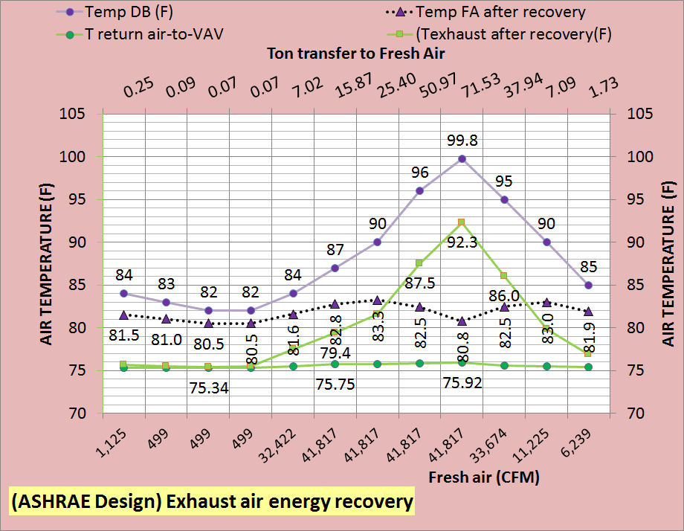

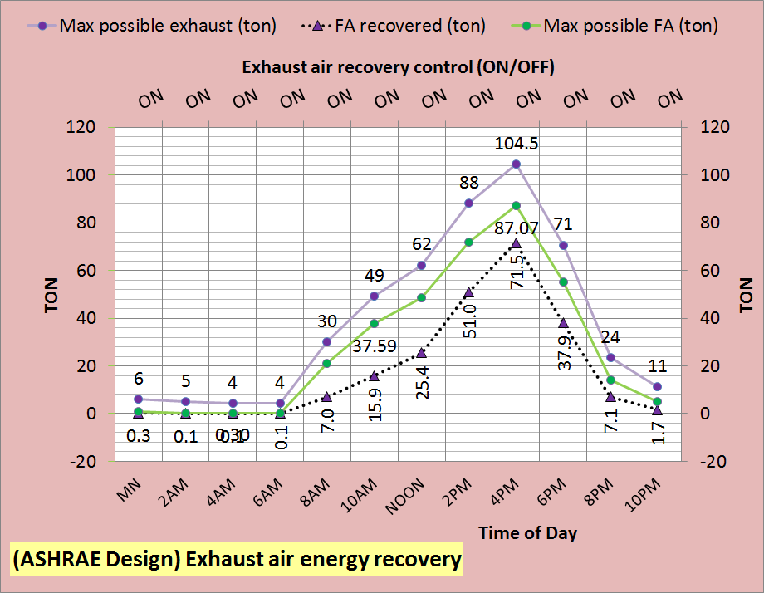
Figure 10: 24 hour performance with recovery
Figure 10 illustrates the 24 hour performance of the system with exhaust air energy recovery. The bottom chart illustrates the maximum possible energy transfer to the fresh air as a function of air CFM and delta temperature. For the conditions of this design and the fact that it is a one shift office building; the exhaust air has more max possible energy than the fresh air. The bottom chart also gives the energy transferred to the fresh air.
The top chart of Figure 10 shows the fresh air CFM drops off and therefore the tons transferred to the fresh air drops off. The top chart also shows the air temperatures illustrating the difference in the dry bulb temperature of outside air and the approximate 75.8F exhaust air drives the amount of energy available for transfer to the fresh air.
A building that operates more than one shift would have greater 24 hour transfer of energy to the fresh air.

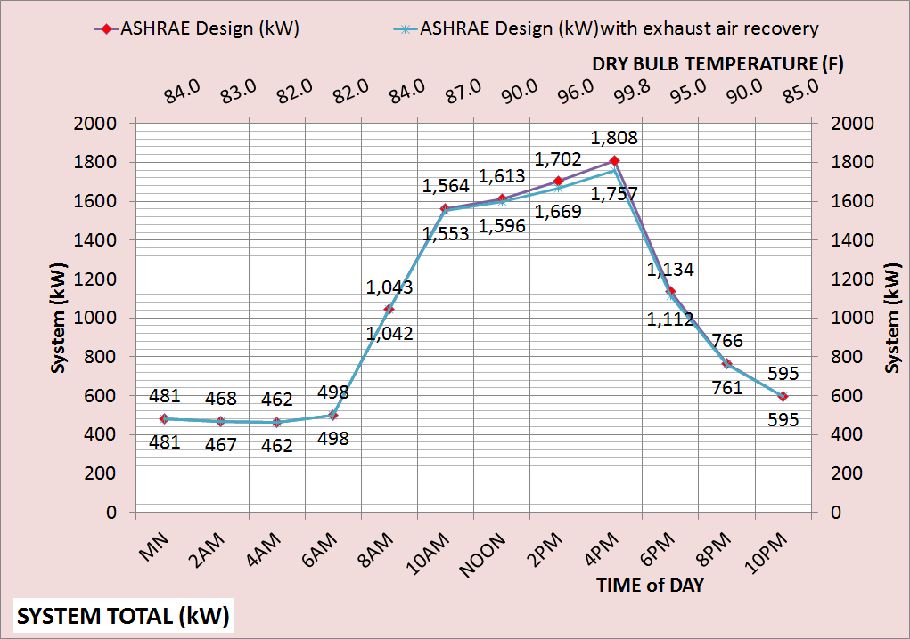
Figure 11: 24 hour performance

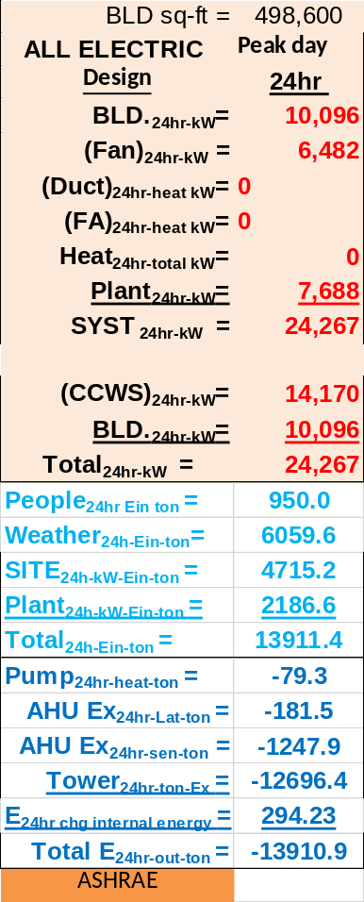
Figure 12: 24 hour performance without exhaust air energy recovery

Figure 11, 12, & 13 illustrates the exhaust air energy recovery has moderate effect on 24 hour energy consumption at peak design summer weather conditions.

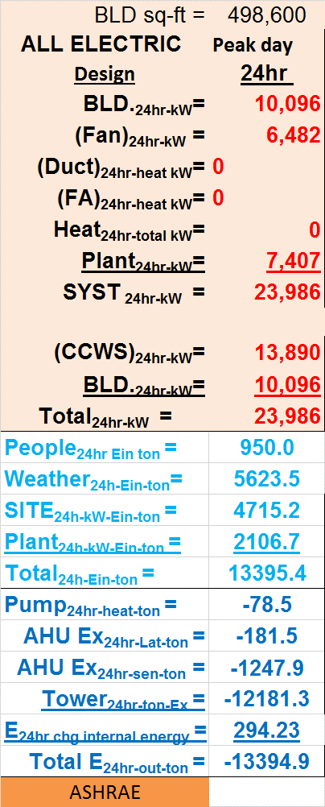
Figure 13: 24 hour performance with exhaust air energy recovery

CONCLUSION FOR PEAK DESIGN DAY WEATHER CONDITIONS
Exhaust air energy recovery reduces the chiller kW about 9% for the conditions studied here.
Next we will consider average summer conditions.
TYPICAL SUMMER WEATHER
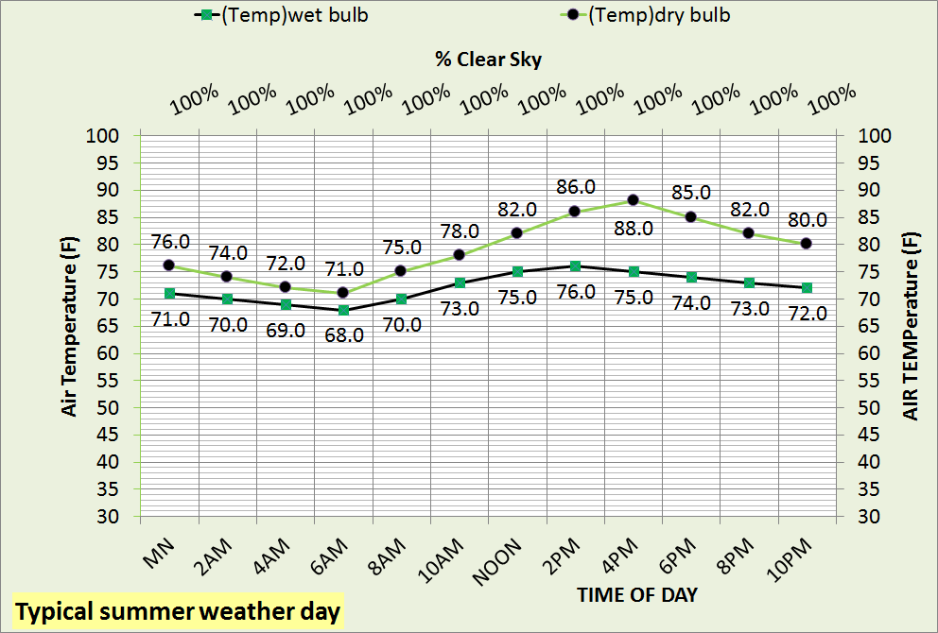Figure 14: Summer weather
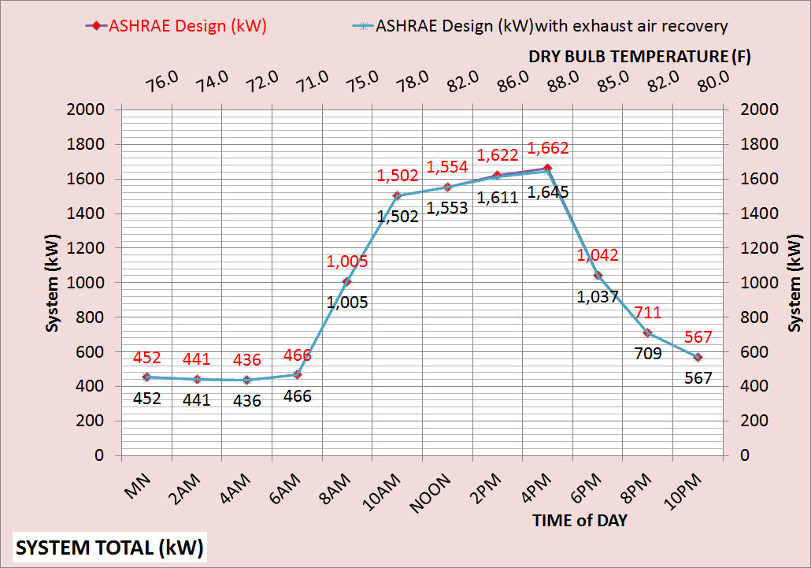Figure 15 24 hour system kW demand
Figure 14 gives the assumed typical summer weather and Figure 15 gives the 24 hour system kW for the system with and without exhaust air energy recovery illustrating very little effect with exhaust air energy recovery.

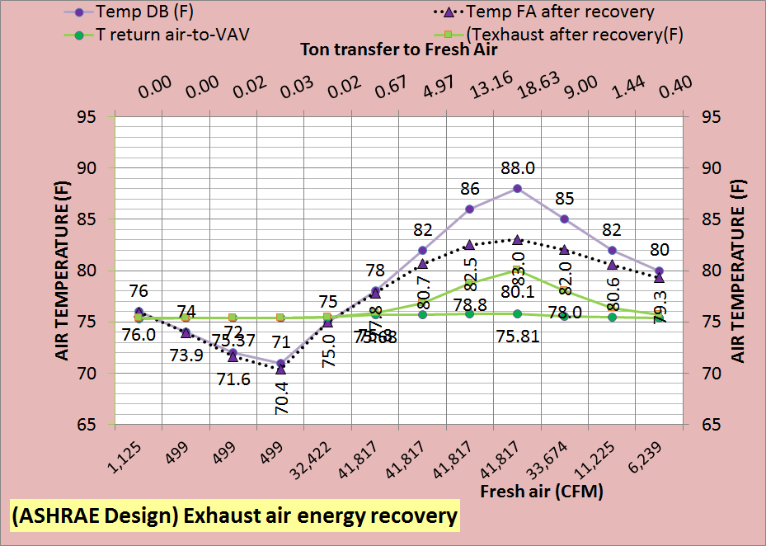 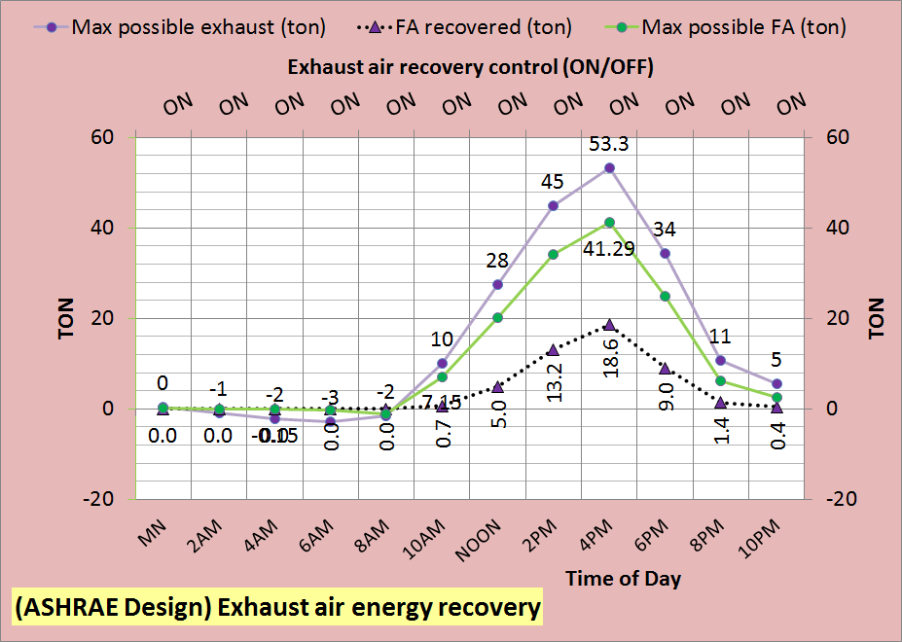Figure 16 System 24 hour performance with exhaust air recovery
CONCLUSION
For the conditions studied here exhaust air energy recovery has be shown to have very little effect on the total energy consumption of the system. This study showed that the kW size of the chiller is reduced about 9% if exhaust air energy recovery is installed in all 26 VAV fan systems.
ASHRAE Standard 90.1-2013 requirement for exhaust air energy recovery is at best questionable.

NOMENCLATURE (NOTE see other papers at this site for additional understanding of the system and nomenclature)
Air Side System Nomenclature
Each of the more than 100 variables of the air side system will be defined.
Building structure;
BLD ft² = air conditioned space
# Floors = number of building floors
Roof ft² = roof square feet
N/S wall ft² =north/south wall square feet
E/W wall ft² =east/west wall square feet
Wall % glass = percent of each wall that is glass
Glass U = glass heat transfer coefficient
Wall U = wall heat transfer coefficient
Glass SHGC = glass solar heat gain coefficient
Wall emit = wall solar index
Building interior space;
Roof_{trans-ton} =transmission through roof (ton)
Roof_{sky-lite-ton} =sky lite load (ton)
People_{ton sen&lat} = sensible & latent cooling load due to people (ton)
Plug_{ton&kW} = cooling load & kW due to plug loads
Light_{ton&kW} = cooling load & kW due to lights
Total Bld_{int-ton} = total building interior load (ton)
(int-cfm) _{to-per-return} = CFM of interior supply air that returns to perimeter of building
T_{stat-int} = interior stat set temperature (F)
Bld_{int-air-ton} = supply air ton to offset interior load
BLD kW = total building kW demand
Building perimeter space;
%_{clear sky} = percent clear sky
T_{dry bulb} = outside dry bulb temperature (F)
T_{wet bulb} = outside wet bulb temperature (F)
Ex/Infil_{lat-ton} = latent load due to air infiltration or exfiltration (ton)
Ex/Infil_{CFM} = air infiltration or exfiltration CFM
Exfil_{sen-ton} =sensible load due to air exfiltration or infiltration (ton)
Wall_{n trans ton} = north wall transmission (ton)
Wall_{s trans ton} = south wall transmission (ton)
Wall_{E trans ton} = east wall transmission (ton)
Wall_{w trans ton} = west wall transmission (ton)
Wall_{tot-trans-ton} = total wall transmission (ton)
Glass_{N-trans-ton} = north wall glass transmission (ton)
Glass_{S-trans-ton} = south wall glass transmission (ton)
Glass_{E-trans-ton} = east wall glass transmission (ton)
Glass_{W trans-ton} = west wall glass transmission (ton)
Glass_{tot-trans-ton} = total transmission thru glass (ton)
Glass_{N-solar-ton} = north glass solar load (ton)
Glass_{S-solar-ton} = south glass solar load (ton)
Glass_{E-solar-ton} = east glass solar load (ton)
Glass_{W-solar-ton} = west glass solar load (ton)
Glass_{tot-solar-ton} = total glass solar load (ton)
(int cfm)_{per-ton} = effect of interior CFM to wall (ton)
Total Bld_{per-sen-ton} total perimeter sensible load (ton)
T_{stat-per} = perimeter stat set temperature (F)
Bld_{per-air-ton} = supply air ton to offset perimeter load
Air handler duct system
Interior duct
T_{air supply int} = temp air supply to building interior (F)
(fan)_{int ter ton&kW} = interior ton & kW due to terminal fans
(D)_{int-air-ton} = cooling (ton) to building interior duct
T_{air coils} = supply air temperature off coils to duct (F)
(D)_{int-CFM} = supply air CFM to building interior duct
Perimeter duct
T_{air supply per} =temp (F) air supply to building perimeter
(fan)_{per ter ton&kW} = perimeter ton & kW of terminal fans
T_{heat-air} = temp supply air before terminal fan heat (F)
(D)_{heat-ton&kW} = heat to perimeter supply air ton & kW
T_{reheat air} = temp perimeter supply air after reheat (F)
(D)_{reheat ton&kW} = reheat of perimeter supply air ton & kW
(D)_{per-air-ton} = cooling (ton) to perimeter duct
T_{air coils} = supply air temperature off coils to duct (F)
(D)_{per-CFM} = supply air CFM to perimeter duct
(ABS Bld Ton) = absolute building load on (CCWS)
Coil
(coil)_{sen-ton} = sensible load on all coils (ton)
(coil)_{cap-ton} = LMTD * UA = capacity (ton) one coil
(coil)_{H2O-ft/sec} = water velocity thru coil (ft/sec)
(coil)_{design-ft/sec} = coil design water velocity (ft/sec)
LMTD = coil log mean temperature difference (F)
(coil)_{L+s-ton} = latent + sensible load on all coils (ton) transferred to Plant
(coil)_{gpm} = water flow (gpm) thru one coil
UA_{design} = coil UA design value
UA = coil heat transfer coefficient * coil area. UA varies as a function water velocity (coil)_{gpm} thru the coil, as the (coil)_{gpm} decreases the coil capacity decreases.
(one coil)_{ton} = load (ton) on one coil
(H)_{coil} = air pressure drop thru coil (inches)
(H)_{coil-design} = design air pressure drop (inches)
VAV Fan system
Fresh air
stat_{FA} = fresh air freeze stat set temperature (F)
T_{FA to VAV} = temperature of fresh air to VAV fan
(FA)_{sen-ton} = fresh air sensible load (ton)
(FA)_{CFM} = CFM fresh air to VAV fan inlet
(FA)_{Lat-ton} = fresh air latent load (ton)
(FA)_{kW} = heat kW to stat_{FA} set temperature
Air return
T_{BLD-AR} = return air temp (F) before return fans
(Air)_{ret-CFM} = CFM air return from building
(FAN)_{ret-kW} = return fans total kW
(FAN)_{ret-ton} = cooling load (ton) due to (FAN)_{ret-kW}
(Air)_{ret-ton} = return air (ton) before return fans
T_{AR to VAV} = T_{BLD-AR} + delta T due to return fans kW
VAV_{ret-sen ton} = return sensible (ton) to VAV fans inlet
VAV_{ret-lat ton} = return latent (ton) to VAV fans inlet

VAV_{ret-CFM} = return CFM to VAV fans inlet
Exhaust air
Ex_{Lat-ton} = latent load (ton) exhausted
Ex_{CFM} = CFM of exhaust air
T_{Ex} = temperature of exhaust air
Ex_{sen-ton} = sensible load (ton) exhausted
VAV Fans
T_{ret+FA} = return and fresh air mix temperature (F)
(dh) = VAV air static pressure (in)
E_{fan-VSD} = VAV fans efficiency
VAV_{inlet-sen-ton} = sensible load (ton) inlet to VAV fans
VAV_{inlet-lat-ton} = latent load (ton) inlet to VAV fans
T_{air-VAV} = temp air to coils after VAV fan heat
(FAN)_{VAV-CFM} = CFM air thru coils
(FAN)_{ton-VAV} = load (ton) due to VAV fan kW
(FAN)_{kW-VAV} = total VAV fan kW demand
AIR SIDE SYSTEM PLUS BUILDING
FAN kW = total air handlers kW
SITE kW = total site or air side kW
Plant_{ton} = (COIL)_{L+s ton} load (ton) to plant

CENTRAL PLANT
Nomenclature will be defined by addressing each component of the plant.
Primary/secondary pumping nomenclature
gpm_{evap} = total gpm flow thru evaporators
(H)_{pri-total} = total primary pump head (ft) = (H)_{pri-pipe} + (H)_{pri-fittings} + (H)_{pri-bp} + (H)_{evap}
(H)_{pri-pipe} = primary pump head due to piping (ft)
(H)_{pri-fittings} = primary head due to pump & fitting (ft)
(Ef)_{c-pump} = efficiency of chiller pump
P_{c-heat-ton} = chiller pump heat to atmosphere (ton)
P_{c-kW} = one chiller pump kW demand (kW)
P_{chiller-#} = number chiller pumps operating
(lwt)_{evap} = temperature water leaving evaporator (F)
T_{bp} = temperature of water in bypass (F)
gpm_{bp} = gpm water flow in bypass
(H)_{pri-bp} = head if chiller pump flow in bypass (ft)
(ewt)_{evap} = temp water entering evaporator (F)
P_{sec-heat-ton} = secondary pump heat to atmosphere (ton)
P_{sec-kW} = kW demand of secondary pumps
Ef_{des-sec-p} = design efficiency of secondary pumping
Ef_{sec-pump} = efficiency of secondary pumping
(H)_{sec} = secondary pump head (ft) = (H)_{sec-pipe} + (H)_{sec-bp} + (H)_{coil} + (H)_{valve}
(H)_{sec-pipe} = secondary pump head due to pipe (ft)
(H)_{sec-bp} = head in bypass if gpm_{sec} > gpm_{evap}
gpm_{sec} = water gpm flow in secondary loop
(ewt)_{coil} = water temperature entering coil (F)
Plant_{ton} = load (ton) from air side to plant
Pipe_{size-in} = secondary pipe size (inches)
(lwt)_{coil} = temperature of water leaving coil (F)
Evaporator
(evap)_{ton} = load (ton) on one evaporator
T_{ER} = evaporator refrigerant temp (F)
T_{ER-app} = evaporator refrigerant approach (F)
EVAP_{ton} = total evaporator loads (ton)
(H)_{evap} = pump head thru evaporator (ft)
(evap)_{ft/sec} = velocity water flow thru evaporator
(evap)_{des-ft/sec} = evaporator design flow velocity
Compressor:
(chiller)_{kW} = each chiller kW demand
(chiller)_{lift} = (T_{CR} – T_{ER}) = chiller lift (F)
(chiller)% = percent chiller motor is loaded
(chiller)# = number chillers operating
(CHILLER)_{kW} = total plant chiller kW
Plant kW = total kW demand of plant
Condenser nomenclature:
(cond)_{ton} = load (ton) on one condenser
T_{CR} = temperature of condenser refrigerant (F)
T_{CR-app} = refrigerant approach temperature (F)
(COND)_{ton} = total load (ton) on all condensers
(H)_{cond} = tower pump head thru condenser (ft)
(cond)_{ft/sec} = tower water flow thru condenser
Tower piping nomenclature
Pipe_{size-in} = tower pipe size (inches)
gpm_{T} = each tower water flow (gpm)
(H)_{T-total} = total tower pump head (ft)
P_{T-heat} = pump heat to atmosphere (ton)
P_{T-kW} = each tower pump kW demand
Ef_{T-pump} = tower pump efficiency
P_{tower #} = number of tower pumps
(H)_{T-pipe} = total tower pump head (ft)
(ewt)_{T} = tower entering water temperature (F)
(H)_{T-static} = tower height static head (ft)
T_{range} = tower range (F)= (ewt)_{T} – (lwt)_{T}
(lwt)_{T} = tower leaving water temperature (F)
T_{approach} = (lwt)_{T} – (T_{wet-bulb})
Tower nomenclature
t_{fan-kW} = kW demand of one tower fan
T_{fan-kW} = tower fan kW of fans on
t_{fan-%} = percent tower fan speed
t_{ton-ex} = ton exhaust by one tower
T# = number of towers on
T_{ton-ex} = ton exhaust by all towers on
T_{rg+app} = tower range + approach (F)
One hour performance indices
BLD_{kW} = kW demand of building lights & plug loads
Fan_{kW} = air side fans kW, VAV, return terminals
Duct_{heat} = perimeter heat to air supply
FA_{heat} = heat added to fresh air
Heat_{total} = total heat added to air
Plant_{kW} = total plant kW
Syst_{kW} = total system kW
CCWS_{kW} = air side + plant kW
Chiller_{kW/evap ton} = chiller kW/evaporator ton performance
Plant_{kW/site ton} = plant kW per site or air side ton
CCWS_{kW/site ton} = CCWS kW per load to plant
Weather_{Ein-ton} = weather energy into the system
Site_{kW-Ein-ton} = load (ton) due to site kW
Plant_{kW-Ein-ton} = load (ton) due to plant kW
Total_{Ein-ton} = total energy in to system (ton
Pump_{tot-heat-ton} = total pump heat out (ton)
AHU Ex_{lat ton} = air exhausted latent ton
AHU Ex_{sen ton} = air exhausted sensible ton
Tower T_{ton Ex} = energy exhausted by tower (ton)
Total E_{out ton} = total energy out of system (ton)
24 hour performance indices
BLD_{24hr-kW} = building 24 hour kW usage
Fan_{24hr-kW} = fan system 24 hour kW usage
Duct_{24hr-heat kW or therm} = duct heat
FA_{24hr heat kW or therm} = fresh air heat
Heat_{24hr total kW or therm} = total heat into system air
Plant_{24hr kW} = plant 24 hour kW usage
Syst_{24hr kW & therm} = total system 24 hour energy usage
(CCWS)_{24hr-kW} = Central chilled water system (air side + plant) 24 hour kW usage
Weather_{24hr-Ein-ton} = 24 hour weather energy into system
SITE_{24hr-kW-Ein-ton} = 24 hour energy into site, building & air side system
Plant_{24hr-kW-Ein-ton} = 24 hour kW energy into plant
Total_{24hr-Ein-ton} = total 24 hour energy into system
Pump_{24hr Heat out-ton} = pump heat to atmosphere (ton)
AHU Ex_{24hr Lat ton} = exhausted latent load from building
AHU Ex_{24hr-sen-ton} = exhausted sensible load from building

Tower_{24hr out-ton} = tower exhaust from system (ton)
Total E_{24hr-out-ton} = total 24 hour energy out of system

