SYSTEM ENERGY EQUILIBRIUM (SEE) MODELING
The objective of a System Energy Equilibrium (SEE) building energy model is to duplicate the hourly performance of a real building at all operating conditions of weather and load; giving flows, temperatures, cooling loads, kW demand of equipment, and total site kW as weather and operational conditions change. The (SEE) model, as presented here, consists of a set of simultaneous equations that obey the laws of thermodynamics, models the hour by hour loads of the building and the response of the central chilled water system (CCWS) to the building loads, and includes the nonlinear performance characteristics of the plant equipment and air side equipment. A (SEE) model iterates to steady state energy equilibrium after a perturbation to the system just as a real system responds; a defining characteristic of a (SEE) model.
The primary objective of this article is to demonstrate the approach to (SEE) modeling, and of secondary importance are the values determined by the model. Where disagreement with the (SEE) model answers exists a discussion sidebar may be provided with input by reviewers and response by the author.
(SEE) MODEL CHARACTERISTICS
Understanding the performance of a complex system, in this case a building and (CCWS) that serves the building, requires a model that includes detail model equations of all components of the system. These equations of each system component are solved simultaneous, by computer, giving the effect of each component on the operation of the total system and the effect of the system on the performance of the component. Real building energy systems operate according to the laws of thermodynamics and the performance characteristics of the equipment installed; therefore the model must incorporate equations that duplicate the laws of thermodynamics and input the characteristics of the system components consistent with the manufactures verified data. To accomplish this objective the model must incorporate every design and control feature of the real system; resulting in a model, as presented here, consisting of more than 150 performances and design variables, each variable defined by an equation and/or is a design constant that changes if the design is changed. The set of equations is solved simultaneously by computer and will duplicate the performance of a real system if sufficient detail has been incorporated into the model and the detail is consistent with the actual equipment and controls of the real system. The model is always at System Energy Equilibrium.
The challenge developing a (SEE) model might be summarized as; a real system is very complex where minor changes in weather, design, and control, can have a major effect on the performance of the system; therefore the system model must be equally complex incorporating all characteristics of the real system within a set of simultaneous equations solved by a computer.
The requirements of a (SEE) Model as presented here include the following:
(1) For a given design the model gives 24 hour performance of the building system at any conditions of weather and system control settings.
(2) For a change in weather the model acts in essentially the same way as a real system; the equations respond to the weather change by adjusting the air side system and plant to the new load at energy equilibrium. No change is made to the equations of the model.
(3) Energy into the system always equals the energy out of the system, energy equilibrium.
(4) The performance of the components of the system agrees with manufactures verified performance data, specifically the chiller, tower & air side equipment.
(5) The model can produce a System Energy Equilibrium (SEE) Schematic for any hour.
(6) The model can perform real time analysis of a building by inputting loads, inefficiency, and control settings to arrive at or near a duplication of the buildings real time performance.
MODEL CHARACTERISTICS/LIMITATIONS
The model presented here has the following known limitations. All air handlers of the system are assumed to be of the same size and model and to be equally loaded. The chiller/towers are assumed to be of the same size and model and equally loaded. The model is of the total building and not a model of individual spaces within the building. Therefore the fresh air, infiltration, and exhaust, is for the building total. Thermostat set points are assumed to be the same for all interior and/or perimeter spaces. To eliminate any of these limitations requires more computer power than the author presently has available.
THE BUILDING & ASSUMED WEATHER
Since an ASHRAE Journal article of 2006¹⁰ and the presentation of two advanced technical paper at the ASHRAE Chicago 2012 Conference^{8,9} a building model has been added to the (SEE) model as presented here. The building selected for this study is defined by the Pacific Northwest National Laboratory (PNNL) study of standard 90.1-2010¹, a large 13 story Chicago office building, Figure 1, with 498,600 square feet of air conditioned space. A link to the (PNNL) study is given by the reference¹. The building schedules and other details of the building, as defined by the (PNNL) study, are in this model design but the plant of this study is designed to a series of articles in the ASHRAE Journal, Taylor 2011². Figure 1 also shows the assume weather conditions for the 24 hours to be modeled. The peak building load occurs at 4PM with 100% solar, 91.7F dry bulb and 82F wet bulb.
The building is modeled with an internal zone that has all electrical and people loads plus the roof load and a perimeter zone that models all wall/glass solar and transmission loads plus air infiltration or exfiltration.

BUILDING PERIMETER LOADS
Figure 2 top chart gives the glass solar load, as determined by the model, for the 24 hour period assuming no cloud cover. The secondary horizontal axis of the top chart gives the total glass solar load with the peak of 72.1 ton occurring at 10:00AM and 6:00PM. Figure 2 middle chart provides the other loads on the perimeter of the building for the 24 hour period. The secondary horizontal axis of the middle chart gives the total sensible perimeter load, peaking at 128.7 ton and a minimum of 7.1 ton at 2:00AM. The glass solar load is the largest perimeter load followed by the latent load due to air infiltration. Glass transmission is the third largest load with wall transmission and sensible infiltration about the same. The peak perimeter load of 128.7 ton occurs at 4PM.
The perimeter infiltration latent load is based on a constant CFM of infiltration as defined by the (PNNL) study.
The bottom chart of Figure 2 gives the building interior loads with a 299.3 ton peak at 4PM given by the secondary horizontal axis, dropping to 48.1 ton at 2:00AM. Lights give the largest load with plug loads and people load following and roof transmission occurring in the late afternoon due to building mass effect. The building interior load is significantly greater than the perimeter load for peak design summer conditions; however winter conditions provide a very different perimeter load as may be addressed in a future article.
AIR HANDLER RESPONSE TO BUILDING LOADS
The top chart of Figure 3 summarizes the building kW demand and cooling load to the air handler system due to the building. The building kW demand is due to the lights kW and plug kW, 731 kW max. The cooling loads include the lights and plug load effect but do not include the fresh air loads to be covered below in the detail analysis of air flow rates and air temperatures of the VAV air handler system. Infiltration latent load of almost 49 ton at peak is a significant load to the perimeter of the building. This latent load is modeled as carried by the return air to the coil resulting in a load on the plant.
The bottom chart of FIGURE 3 defines the air supply temperature and CFM of air to the interior and perimeter of the building to meet the building loads. At 4:00 PM the peak interior CFM is 176,135 and a supply temperature of 56.1F to meet the interior peak loads of 299 ton. Six hours later at 10:00PM the interior load is 92 ton, 30% of the 299 ton peak and the supply temperature is 58.2F and the supply CFM is 61,187. The perimeter peak CFM is 81,382 at a supply temperature of 57.4F to meet the peak perimeter sensible load of 129 ton at 4:00PM. Six hours later the perimeter load is 27 ton and the CFM is 24,884 and the supply temperature is 62.9F. Note that the perimeter supply air temperature is 69.3F when the perimeter sensible load is 7 ton and the interior supply air is 60.4F when the interior load is 48 ton. The fan powered terminals of the air side system affect the supply air temperature as will be shown below in the air side system discussion. The supply air temperatures and CFM of air adjusts as required for the system to be at energy equilibrium. The fan powered terminals add heat to the supply air to the space; illustrating the ability of the model to iterate to energy equilibrium.
These building loads, interior, perimeter, and infiltration are transferred to the suction side of the VAV air handler system via return air and in the process pass through a return air fan system and an air exhaust system, a very complex system difficult to show just with charts; therefore schematics will be used in the next two figures to explain the performance of the air side system.
AIR SIDE SCHEMATICS AT 4:00PM & 10:00PM
A central chilled water system (CCWS) is a complex system and to understand its operation a complex model is required as demonstrated here. Several charts have been presented above and each has several parameters changing as a function of other parameters. Putting together all the charts above, and others not given here, in an attempt to understand the system is, at least for the author a near impossible task, the need is for schematics at any of the 24 hours so the interrelation of the varies parameters can be better visualized.
Figures 4 & 5 present the air side schematics for conditions at 4:00PM, peak load, and at 10:00PM when the solar load is zero and the building load is about 28% of 4:00PM peak. All numbers given by the charts are given in the schematics for the given time of day.
An important point to make about the model is the models ability to iterate to a steady state value. At 4:00PM the return load to the VAV fan system is 406.0 sensible ton and the fresh air is 138.1 sensible ton for a total of 544.1 ton to the suction side of the VAV fan system; delivered by 215,700 + 41,817 = 257,517 CFM of return plus fresh air. The VAV fan system must consume power, kW, to move this 257,517 CFM of air through the coils and in this case 255 kW of VAV power is required. The 255 kW of VAV fan power adds heat to the 257,517 CFM of air for a total sensible load transferred to the coil of 544.1 + 72.6 = 616.7 ton. Air temperature into the suction side of the VAV fans is 78.48F and the 255 kW raises the air temperature to 81.61F. The model iterated to this 255 kW VAV fan power and resultant heat in the same way a feedback control system iterates to steady state. This “feedback control” characteristic is present in real systems and must therefore also be present in a (SEE) model if the model is to have the capability to define a system of minimum kW demand and the ability to define best control practice and the ability to duplicate the real time energy consumption of a real building.
Figure 4 illustrates a total site kW demand of 1188.3 kW made up by the building 731.4 kW and the fan system 456.8 kW that includes the VAV fans, return fans, and terminal fans. The figure shows a total sensible plus latent load of 881 ton to be picked up by the primary/secondary pumping and delivered to the plant chillers. Figure 5 at 10:00PM shows a site kW of 426.7 and a load of 244 ton to be delivered to the plant. The only change made to the model from Figure 4 to Figure 5 was the change in dry bulb and wet bulb temperatures. The set of equations iterated to a new condition of steady state as shown by Figure 4 at 91.7F dry bulb and 81.8F wet bulb and Figure 5 at 82F dry bulb and 78F wet bulb. A comparison of numbers in the two figures gives an understanding of how the system responds to changing weather.
AIR HANDLER 24 HOUR RESPONSES
Figure 6 top chart gives seven variables of the air side system over the 24 hour period. The primary horizontal axis gives the latent plus sensible load to the plant and the secondary horizontal axis gives the sensible load to the plant. CFM air flows and temperatures to the VAV fans illustrates the complexity of a real system; making the point that simplification of a building energy model cannot occur if the objective is to model the effect of design, controls, and the real time performance of a building system.
The bottom chart of Figure 6 gives the components that make up the kW demand of the air side system. Three of the terms, duct heat, duct reheat, and fresh air heat, will not occur until winter conditions. The primary horizontal axis of the bottom chart gives the building kW; add that to the air handler total kW within the chart and you get the total site kW given by the secondary horizontal axis.
TOTAL SYSTEM kW DEMAND
Figure 7 illustrates the total system kW demand and the components that make up the kW demand. Thus far we have discussed the building kW, made up by the lights and plug loads, and the air handler kW as shown by the bottom chart of Figure 6. Figure 7 introduces the plant kW and therefore gives the total system kW on the secondary horizontal axis showing a peak of 1829.6 kW. The building is the largest value followed by the plant and then the air handlers. As stated above the winter weather conditions will give very different results for Figure 7 and all figures above. Having introduced the plant kW over the 24 hour period, Figure 7, the following figures will show a total system schematic for two hours of the day.
TOTAL SYSTEM (SEE) SCHEMATIC
Figure 8 gives the plant added to the air side system of Figure 4, for a total system schematic at peak conditions at 4:00PM. The peak kW demand is shown as 1829.6 kW; the same as shown on Figure 7 at 4:00PM.
Figure 8 shows the total system at energy equilibrium. The energy equilibrium of the chiller/tower is a model challenge, (feedback control), similar to the VAV fan system as discussed above. The model has the capability to iterate until energy balance is achieved between the chiller and tower. The chiller kW demand is in part determined by the lift on the chiller and the lift is in part determined by the condenser load and therefore entering water temperature to the tower. The model can perform this iteration in milliseconds where a manual approach could take hours and impractical when we consider 24 hours.
The plant is designed based on the procedures given in the ASHRAE Journal². Figure 8 gives about 175 system values at 4PM peak conditions and Figure 9 gives similar data at 10:00PM when the solar load through glass is zero and the other building loads are considerable reduced. Input to the model to go from Figure 8 to Figure 9 consisted of changing the dry bulb and wet bulb temperatures and adjusting the chiller power to achieve approximately 44F supply water to the coils. All other values were determined by the system of equations and iteration to the new energy equilibrium conditions as shown by Figures 8 & 9; the model acts in a manner similar to a real system as building load conditions change and the chiller controls and number of chillers on adjust to the new building loads.
The lower left of Figures 8 & 9 gives performance data for the given hour; illustrating the major change that can occur in a system in six hours.
Next we will look at the 24 hour performance of the components of the plant beginning with the P/S water distribution pumping.
PRIMARY/SECONDARY PUMPING
Figure 10 gives the flows, kW demand, and water temperatures of the P/S pumping chilled water distribution system. The top chart gives the pumping kW demand showing a chiller pump kW that is a function of how many chillers is operating; 17.1 kW when two chillers are on. The secondary pump kW is a function of secondary flow as shown; peaking at 35.4 kW. The evaporator gpm is modeled as constant 600 gpm per evaporator: so the bypass flow gpm is shown as it varies as a function of secondary flow and number of chillers in operation. Figure 10 top chart illustrates the bypass flow is always from supply to return; therefore bypass flow does not decrease the temperature of supply water to the coils. Bypass flow from return to supply is a classic problem defined as low load delta temperature. The (SEE) model provides a good method to understand the effects of low load delta T.
The primary horizontal axis of the top chart gives the plant load or load picked up by the P/S pumping and the secondary axis gives the evaporator load that is a little more due to the heat added to the water by the P/S pumps. The heat added by the pumps is modeled as a function of the efficiency of the pumps with the inefficiency heat going to the atmosphere; this feature of the model will be further discussed when system energy out is discussed below.
The bottom chart of Figure 10 gives the water temperatures of the P/S pumping system. The evaporator leaving water temperature, bypass water temperature, and the coil entering temperature are all the same, about 44.5F, given the bypass flow is always from supply to return. The bypass flow and temperature affects the temperature of water entering the evaporator as shown by the bottom chart; a low value of 49.73F occurs when the bypass flow is about -430 gpm when the evaporator load (ton) is at the low value of 137 ton. The coil leaving water temperature is approximately 64.5F and the supply water to the coils is about 44.5F for a delta T of 20F, as called for by Taylor March 2012².
CHILLER RESPONSE
Figure 11 gives the chiller response to the loads on the evaporator from the air side system plus the heat added to the return water by the P/S pumping. The top chart gives condenser and evaporator refrigerant temperatures which determine the lift on the chiller. The top chart also gives the refrigerant approach temperature for the condenser and evaporator; relatively low values suggesting rather high cost of the condenser and evaporator.
The evaporator refrigerant temperature is a function of evaporator refrigerant approach temperature and supply water temperature from the evaporator. The condenser refrigerant temperature is a function of condenser refrigerant approach and water from the condenser to the tower. Modeling the refrigerant temperatures is necessary to determine the chiller lift and therefore kW demand. This model analysis of refrigerant temperatures is another example of iterations the model must accomplish to arrive at system energy equilibrium.
The bottom chart of Figure 11 gives the chiller kW, chiller % power, and number of chillers operating as a function of evaporator load over the 24 hours.
CHILLER & PLANT PERFORMANCE
Figure 12 gives the performance of the chiller and plant. The top chart gives the chiller and plant kW for the 24 hour period and the bottom chart gives the performance in kW per load. The rather large chiller kW per evaporator ton is strongly influenced by the plant design procedures of Taylor 2012 that calls for a tower approach plus range of about 22F²; (page 63 of the March 2012 ASHRAE Journal), resulting in an increased lift on the chiller even though a condenser approach of about 1.2F was selected resulting in increased cost of the chiller. The issues raised here and a more efficient chiller/plant design may be addressed by a future article.
TOWER PERFORMANCE
Figure 13 gives tower performance over the 24 hours. The top chart gives the kW demand of the tower pump and tower fans and also gives the water temperature entering and leaving the tower. The primary horizontal axis of the top chart gives the total condenser load (ton) and the secondary axis gives the energy exhausted by the tower.
The bottom chart provides the tower range and approach and the secondary horizontal axis gives the sum of the range and approach.
ENERGY IN = ENERGY OUT
Figure 14 gives the energy in and out of the system for the 24 hour period. The top chart gives the energy in consisting of the site, plant, and weather with total energy in also shown. The bottom chart provides the energy out consisting of tower energy out, exhaust latent and sensible energy out, and pump heat to the atmosphere; the total energy out is also given and is equal to the energy in of the top chart. Figure 14 also gives, by the table, the 24 hour sum of the energy in and energy out of the system. The big energy in value is the weather and the big energy out value is the tower exhaust.
SYSTEM kW DEMAND FOR 24 HOURS
Figure 15 provides the kW usage of the system over the 24 hours. The chart provides kW demand of the major components of the system, building, air handlers, and plant, plus the total system kW. The duct heat kW and fresh air heat kW is zero for these peak summer day conditions. The table of Figure 15 gives 24 hour sums showing that the building is the biggest energy user with the plant and fan system about 80% and 60% of the building kW sum.
The CCWS exists to condition the building and the table shows the CCWS consumes about 50% more energy than does the building.
BUILDING INFILTRATION & EXFILTRATION
An ASHRAE Journal article of July 2014 includes a discussion in the letters section, page10, regarding the inability of DOE models to consistently model energy consumption of buildings³. The same issue on page 70 illustrates the DOE approach to modeling building energy. The article (Improving Infiltration In Energy Modeling⁴) makes the obvious but not stated point that 40 years after the oil embargo the DOE models do not have an air side model that can model infiltration/exfiltration and the article illustrates why as stated in my letter in the ASHRAE Journal of September 2014⁵. The DOE models are based on curve fitting rather than thermodynamic equations and cannot provide a system schematic or data so a schematic can be constructed.
Figure 16 illustrates a (SEE) model analysis of building air infiltration verses exfiltration. The top chart is also presented above as Figure 2 and shows the building perimeter loads with infiltration of 6811 CFM. The bottom chart of Figure 16 illustrates the building loads with 3378 CFM of exfiltration; the building is pressurized. The latent load is eliminated with exfiltration and the sensible load is decreased about 15 ton at 4PM as shown by the secondary horizontal axis. This reduction in sensible building load and elimination of the infiltration latent load significantly reduces the air side and plant load and therefore system kW demand⁷.
BUILDING ENERGY TRANSFER
An ASHRAE Journal article of January 2015⁶ (Have We Run Out Of Savings Potential In Standard 90.1?) states that the data presented by the article “do not include the impact of improved controls or interactive effects”, again illustrating the inadequacy of the DOE models to analyze the air side system. Figure 17 illustrates the significant effect of building energy transfer. The (SEE) model of this article assumes all internal supply air is returned to the perimeter of the building and then to the suction side of the VAV fans system. If the internal and perimeter stats are set at the same value no energy is transferred. Figure 17 input the perimeter stat set point as 73F; the result is a transfer of 75F internal air to the perimeter with stat set at 73F and therefore the perimeter system cools, or tries to cool, the 75F air to 73F resulting in additional load on the perimeter of about 32 ton at 4PM. Comparing the top chart of Figure 16 with stats set at 75F and the top chart of Figure 17 with the perimeter stat lowered to 73F; the transmission loads and infiltration sensible load are a little greater in Figure 17 and the latent infiltration very slightly decreases as a function of the modeled enthalpy of the infiltrating air. The bottom chart of Figure 17 gives the system kW values for the 24 hours and can be compared with Figure 7 above to see the increase due to the transfer of 75F air from the interior of the building to the perimeter of the building. The building kW is the same but the air handler and plant kW increase about a total of 135 kW at 4PM. Clearly the inability to model energy transfer, as Hart 2015⁶ states is a major inadequacy of DOE building energy models.
Figure 18 gives the system schematic at 4PM with the perimeter stat set at 73F. The building increased load results in an increase in VAV CFM and resulting kW demand to move greater CFM of air. The increased load on the plant (927 ton – 881 ton of Figure 8 is 46 ton) results in the plant unable to deliver 44F water to the coils, 45.3F water is the result. Note that the one coil load is 35.66 ton and the coil capacity is 32.3 ton therefore the system is not in energy balance, the coil is over loaded.
The system will go to a balance condition and Figure 19 illustrates. With the perimeter temperature stat raised from 73F to 73.6F the system is in energy equilibrium and the plant load reduces to 912 ton, a 15 ton reduction. The coil capacity of 35 ton is equal to the load on the coil and the supply water is 44.31F to the coils. Note that the system demand is 1923.1 kW up from 1829.6 kW of Figure 8 when the perimeter stat is set at 75F.
This difference in system kW demand as a result of return air path and stat set points illustrates that a minor detail can have a significant effect on the performance and energy consumption of a system. Several other examples can be given especially during winter operation.
MINIMUM kW DESIGN
Table 1 lists rather minor changes in the ASHRAE design that results in a minimum kW design. Figure 20 gives the change in system kW as a result of these minor changes illustrating significant reduction in hourly system kW and defining a major purpose of a (SEE) model; define design and control techniques that minimize building energy consumption. The reduction in system kW for the minimum kW design is even greater during spring/fall and winter operation due in large part to the decreased perimeter reheat required by the minimum kW design. Annually the minimum kW design will reduce energy consumption to about 60% of the ASHRAE design consumption⁷.
CONCLUSIONS
The energy consumption of buildings has significantly reduced since the oil embargo of 1973 in large part due to the understanding provided by the DOE type energy models. The value of these type models is significant but limitations exist. Hart 2015⁶ illustrates the information provided by this modeling approach and defines its inability to model improved controls or interactive effects. (SEE) model analysis addresses the detail hourly effect of controls and design; providing greater opportunity to understand HVAC systems and how to further reduce energy consumption of buildings. Table 1 and Figure 20 illustrate the significant reduction in building energy consumption that can be identified with a detail hour by hour model of a building system. The authors experience with system modeling has found that a detail model always identifies additional opportunities to improve the performance of a system and that has again been the case in this (SEE) model study of a Chicago office building. (SEE) model analysis of various type buildings in various cities, coupled with R&D, will identify opportunities to reduce building energy consumption not yet understood or imagined.
References
1. Liu, B. May 2011. “Achieving the 30% Goal:
Energy and Cost Savings Analysis of ASHRAE Standard 90.1-2010” Pacific Northwest National Laboratory.
http://www.energycodes.gov/achieving-30-goal-energy-and-cost-savings-analysis-ashrae-standard-901-2010
2.Taylor, S. 2011. “Optimizing Design & Control of Chilled Water Plants.” ASHRAE Journal (12)
3. Menconi, Pete. Letters page 10. ASHRAE Journal July 2014
4. Ng, Lisa C., Persily, Andrew K., Emmerich, Steven J. 2014. “Improving Infiltration In Energy Modeling.” ASHRAE Journal July 2014
5. Nelson, Kirby 2014. Letters page 10. ASHRAE Journal September 2014
6. Hart, Reid 2015. “Have We Run Out Of Savings Potential In Standard 90.1?” ASHRAE Journal January 2015
7. Nelson, Kirby 2015. “High Performance Building Model” http://kirbynelsonpe.com
8. Nelson, Kirby 2012. “Simulation Modeling of a Central Chiller Plant” (CH-12-002) Chicago 2012 Conference.
9. Nelson, Kirby 2012.”Simulation Modeling of Central Chilled Water Systems” (CH-12-003) Chicago 2012 Conference.
10. Nelson, Kirby 2006. “7 Upgrades to Reduce Building Electrical Demand” ASHRAE Journal December 2006.
System Nomenclature
Each of the more than 100 variables of the system will be defined.
Building structure;
BLD ft² = air conditioned space
# Floors = number of building floors
Roof ft² = roof square feet
N/S wall ft² =north/south wall square feet
E/W wall ft² =east/west wall square feet
Wall % glass = percent of each wall that is glass
Glass U = glass heat transfer coefficient
Wall U = wall heat transfer coefficient
Glass SHGC = glass solar heat gain coefficient
Wall emit = wall solar index
Building interior space;
Roof_{trans-ton} =transmission through roof (ton)
Roof_{sky-lite-ton} =sky lite load (ton)
People_{ton} = cooling load due to people (ton)
Plug_{ton&kW} = cooling load & kW due to plug loads
Light_{ton&kW} = cooling load & kW due to lights
Total Bld_{int-ton} = total building interior load (ton)
(int-cfm) _{to-per-return} = CFM of interior supply air that returns to perimeter of building
T_{stat-int} = interior stat set temperature (F)
Bld_{int-air-ton} = supply air ton to offset interior load
BLD kW = total building kW demand
Building perimeter space;
%_{clear sky} = percent clear sky
T_{dry bulb} = outside dry bulb temperature (F)
T_{wet bulb} = outside wet bulb temperature (F)
Infil_{lat-ton} = latent load due to air infiltration (ton)
Infil_{CFM} = air infiltration CFM
Exfil_{CFM} = air exfiltration CFM
Infil_{sen-ton} = sensible load due to air infiltration (ton)
Enfil_{sen-ton} =sensible load due to air exfiltration (ton)
Wall_{n trans ton} = north wall transmission (ton)
Wall_{s trans ton} = south wall transmission (ton)
Wall_{E trans ton} = east wall transmission (ton)
Wall_{w trans ton} = west wall transmission (ton)
Wall_{tot-trans-ton} = total wall transmission (ton)
Glass_{N-trans-ton} = north wall glass transmission (ton)
Glass_{S-trans-ton} = south wall glass transmission (ton)
Glass_{E-trans-ton} = east wall glass transmission (ton)
Glass_{W trans-ton} = west wall glass transmission (ton)
Glass_{tot-trans-ton} = total transmission thru glass (ton)
Glass_{N-solar-ton} = north glass solar load (ton)
Glass_{S-solar-ton} = south glass solar load (ton)
Glass_{E-solar-ton} = east glass solar load (ton)
Glass_{W-solar-ton} = west glass solar load (ton)
Glass_{tot-solar-ton} = total glass solar load (ton)
(int cfm)_{per-ton} = effect of interior CFM to wall (ton)
Total Bld_{per-sen-ton} total perimeter sensible load (ton)
T_{stat-per} = perimeter stat set temperature (F)
Bld_{per-air-ton} = supply air ton to offset perimeter load
Air handler duct system
Interior duct
T_{air supply int} = temp air supply to building interior (F)
(fan)_{int ter ton&kW} = interior ton & kW due to terminal fans
(D)_{int-air-ton} = cooling (ton) to building interior duct
T_{air coils} = supply air temperature off coils to duct (F)
(D)_{int-CFM} = supply air CFM to building interior duct
Perimeter duct
T_{air supply per} =temp (F) air supply to building perimeter
(fan)_{per ter ton&kW} = perimeter ton & kW of terminal fans
T_{heat-air} = temp supply air before terminal fan heat (F)
(D)_{heat-ton&kW} = heat to perimeter supply air ton & kW
T_{reheat air} = temp perimeter supply air after reheat (F)
(D)_{reheat ton&kW} = reheat of perimeter supply air ton & kW
(D)_{per-air-ton} = cooling (ton) to perimeter duct
T_{air coils} = supply air temperature off coils to duct (F)
(D)_{per-CFM} = supply air CFM to perimeter duct
(ABS Bld Ton) = absolute building load on (CCWS)
Coil
(coil)_{sen-ton} = sensible load on all coils (ton)
(coil)_{cap-ton} = LMTD * UA = capacity (ton) on one coil
(coil)_{H2O-ft/sec} = water velocity thru coil (ft/sec)
(coil)_{design-ft/sec} = coil design water velocity (ft/sec)
LMTD = coil log mean temperature difference (F)
(coil)_{L+s-ton} = latent + sensible load on all coils (ton)
(coil)_{gpm} = water flow (gpm) thru one coil
UA_{design} = coil UA design value
UA = coil heat transfer coefficient * coil area. UA varies as a function water velocity (coil)_{gpm} thru the coil, as the (coil)_{gpm} decreases the coil capacity decreases.
(one coil)_{ton} = load (ton) on one coil
(H)_{coil} = air pressure drop thru coil (inches)
(H)_{coil-design} = design air pressure drop (inches)
VAV Fan system
Fresh air
stat_{FA} = fresh air freeze stat set temperature (F)
T_{FA to VAV} = temperature of fresh air to VAV fan
(FA)_{sen-ton} = fresh air sensible load (ton)
(FA)_{CFM} = CFM fresh air to VAV fan inlet
(FA)_{Lat-ton} = fresh air latent load (ton)
(FA)_{kW} = heat kW to stat_{FA} set temperature
Air return
T_{BLD-AR} = return air temp (F) before return fans
(Air)_{ret-CFM} = CFM air return from building
(FAN)_{ret-kW} = return fans total kW
(FAN)_{ret-ton} = cooling load (ton) due to (FAN)_{ret-kW}
(Air)_{ret-ton} = return air (ton) before return fans
T_{AR to VAV} = T_{BLD-AR} + delta T due to return fans kW
VAV_{ret-ton} = return (ton) to VAV fans inlet
Infil_{VAV-Lat-ton} = infiltration latent (ton) to VAV fans
VAV_{ret-CFM} = return CFM to VAV fans inlet
Exhaust air
Ex_{Lat-ton} = latent load (ton) exhausted
Ex_{CFM} = CFM of exhaust air
T_{Ex} = temperature of exhaust air
Ex_{sen-ton} = sensible load (ton) exhausted
VAV Fans
T_{ret+FA} = return and fresh air mix temperature (F)
(dh) = VAV air static pressure (ft)
E_{fan-VSD} = VAV fans efficiency
VAV_{inlet-sen-ton} = sensible load (ton) inlet to VAV fans
VAV_{inlet-lat-ton} = latent load (ton) inlet to VAV fans
T_{air-VAV} = temp air to coils after VAV fan heat
(FAN)_{VAV-CFM} = CFM air thru coils
(FAN)_{ton-VAV} = load (ton) due to VAV fan kW
(FAN)_{kW-VAV} = total VAV fan kW demand
AIR SIDE SYSTEM PLUS BUILDING
FAN kW = total air handlers kW
SITE kW = total site or air side kW
Plant_{ton} = load (ton) to plant
CENTRAL PLANT
Nomenclature will be defined by addressing each component of the plant.
Primary/secondary pumping nomenclature
gpm_{evap} = total gpm flow thru evaporators
(H)_{pri-total} = total primary pump head (ft) = (H)_{pri-pipe} + (H)_{pri-fittings} + (H)_{pri-bp} + (H)_{evap}
(H)_{pri-pipe} = primary pump head due to piping (ft)
(H)_{pri-fittings} = primary head due to pump & fitting (ft)
(Ef)_{c-pump} = efficiency of chiller pump
P_{c-heat-ton} = chiller pump heat to atmosphere (ton)
P_{c-kW} = one chiller pump kW demand (kW)
P_{chiller-#} = number chiller pumps operating
(lwt)_{evap} = temperature water leaving evaporator (F)
T_{bp} = temperature of water in bypass (F)
gpm_{bp} = gpm water flow in bypass
(H)_{pri-bp} = head if chiller pump flow in bypass (ft)
(ewt)_{evap} = temp water entering evaporator (F)
P_{sec-heat-ton} = secondary pump heat to atmosphere (ton)
P_{sec-kW} = kW demand of secondary pumps
Ef_{des-sec-p} = design efficiency of secondary pumping
Ef_{sec-pump} = efficiency of secondary pumping
(H)_{sec} = secondary pump head (ft) = (H)_{sec-pipe} + (H)_{sec-bp} + (H)_{coil} + (H)_{valve}
(H)_{sec-pipe} = secondary pump head due to pipe (ft)
(H)_{sec-bp} = head in bypass if gpm_{sec} > gpm_{evap}
gpm_{sec} = water gpm flow in secondary loop
(ewt)_{coil} = water temperature entering coil (F)
Plant_{ton} = load (ton) from air side to plant
Pipe_{size-in} = secondary pipe size (inches)
(lwt)_{coil} = temperature of water leaving coil (F)
Evaporator
(evap)_{ton} = load (ton) on one evaporator
T_{ER} = evaporator refrigerant temp (F)
T_{ER-app} = evaporator refrigerant approach (F)
EVAP_{ton} = total evaporator loads (ton)
(H)_{evap} = pump head thru evaporator (ft)
(evap)_{ft/sec} = velocity water flow thru evaporator
(evap)_{des-ft/sec} = evaporator design flow velocity
Compressor:
(chiller)_{kW} = each chiller kW demand
(chiller)_{lift} = (T_{CR} – T_{ER}) = chiller lift (F)
(chiller)% = percent chiller motor is loaded
(chiller)# = number chillers operating
(CHILLER)_{kW} = total plant chiller kW
(chiller)_{kW/ton} = chiller kW per evaporator ton
Plant kW = total kW demand of plant
Condenser nomenclature:
(cond)_{ton} = load (ton) on one condenser
T_{CR} = temperature of condenser refrigerant (F)
T_{CR-app} = refrigerant approach temperature (F)
(COND)_{ton} = total load (ton) on all condensers
(H)_{cond} = tower pump head thru condenser (ft)
(cond)_{ft/sec} = tower water flow thru condenser
Tower piping nomenclature
Pipe_{size-in} = tower pipe size (inches)
gpm_{T} = each tower water flow (gpm)
(H)_{T-total} = total tower pump head (ft)
P_{T-heat} = pump heat to atmosphere (ton)
P_{T-kW} = each tower pump kW demand
Ef_{T-pump} = tower pump efficiency
P_{tower #} = number of tower pumps
(H)_{T-pipe} = total tower pump head (ft)
(ewt)_{T} = tower entering water temperature (F)
(H)_{T-static} = tower height static head (ft)
T_{range} = tower range (F)= (ewt)_{T} – (lwt)_{T}
(lwt)_{T} = tower leaving water temperature (F)
T_{approach} = (lwt)_{T} – (T_{wet-bulb})
Tower nomenclature
t_{fan-kW} = kW demand of one tower fan
T_{fan-kW} = tower fan kW of fans on
t_{fan-%} = percent tower fan speed
t_{ton-ex} = ton exhaust by one tower
T# = number of towers on
T_{ton-ex} = ton exhaust by all towers on
T_{rg+app} = tower range + approach (F)
One hour performance indices
BLD_{kW} = kW demand of building lights & plug loads
Fan_{kW} = air side fans kW, VAV, return terminals
Duct_{heat} = perimeter heat to air supply
FA_{heat} = heat added to fresh air
Heat_{total} = total heat added to air
Plant_{kW} = total plant kW
Syst_{kW} = total system kW
CCWS_{kW} = air side + plant kW
Chiller_{kW/evap ton} = chiller kW/evaporator ton performance
Plant_{kW/site ton} = plant kW per site or air side ton
CCWS_{kW/site ton} = CCWS kW per load to plant
Weather_{Ein-ton} = weather energy into the system
Site_{kW-Ein-ton} = load (ton) due to site kW
Plant_{kW-Ein-ton} = load (ton) due to plant kW
Total_{Ein-ton} = total energy in to system (ton
Pump_{tot-heat-ton} = total pump heat out (ton)
AHU Ex_{lat ton} = air exhausted latent ton
AHU Ex_{sen ton} = air exhausted sensible ton
Tower T_{ton Ex} = energy exhausted by tower (ton)
Total E_{out ton} = total energy out of system (ton)
24 hour performance indices
BLD_{24hr-kW} = building 24 hour kW usage
Fan_{24hr-kW} = fan system 24 hour kW usage
Duct_{24hr-heat kW or therm} = duct heat
FA_{24hr heat kW or therm} = fresh air heat
Heat_{24hr total kW or therm} = total heat into system air
Plant_{24hr kW} = plant 24 hour kW usage
Syst_{24hr kW & therm} = total system 24 hour energy usage
(CCWS)_{24hr-kW} = Central chilled water system (air side + plant) 24 hour kW usage
Weather_{24hr-Ein-ton} = 24 hour weather energy into system
SITE_{24hr-kW-Ein-ton} = 24 hour energy into site, building & air side system
Plant_{24hr-kW-Ein-ton} = 24 hour kW energy into plant
Total_{24hr-Ein-ton} = total 24 hour energy into system
Pump_{24hr Heat out-ton} = pump heat to atmosphere (ton)
AHU Ex_{24hr Lat ton} = exhausted latent load from building
AHU Ex_{24hr-sen-ton} = exhausted sensible load from building
Tower_{24hr out-ton} = tower exhaust from system (ton)
Total E_{24hr-out-ton} = total 24 hour energy out of system

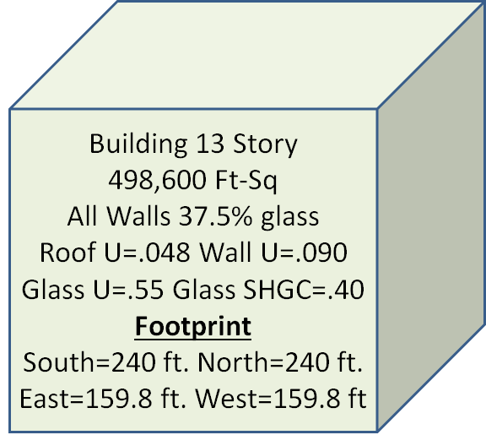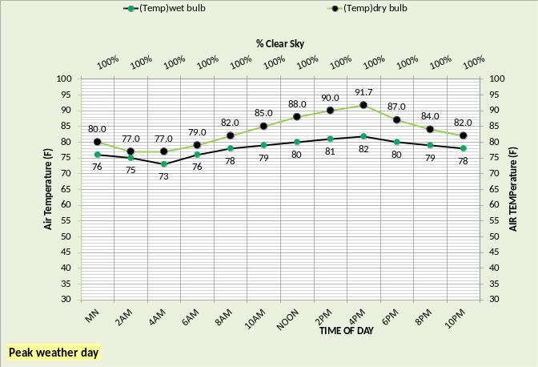FIGURE 1: Building configuration & 24 hour weather

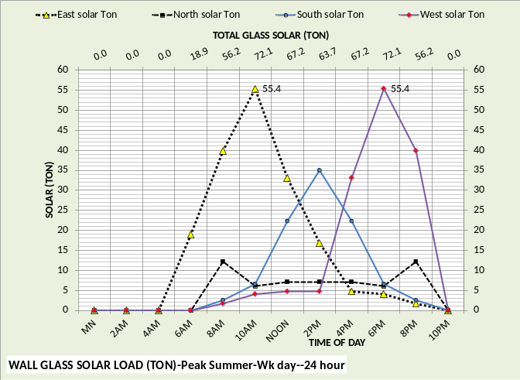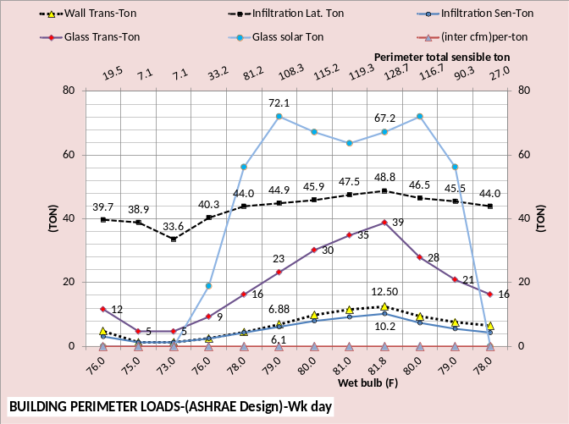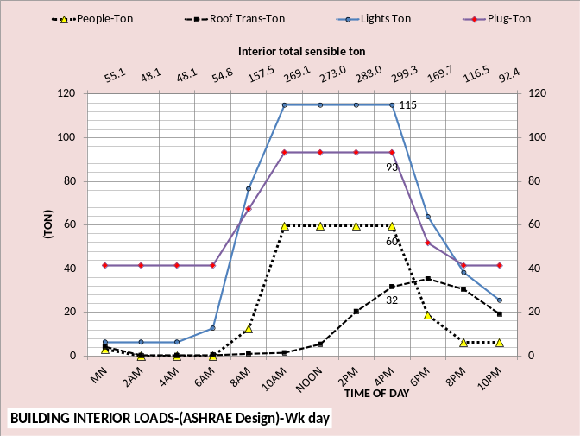FIGURE 2: Building interior & perimeter loads

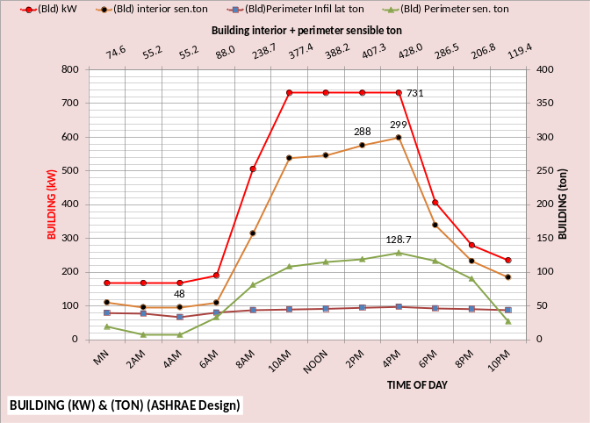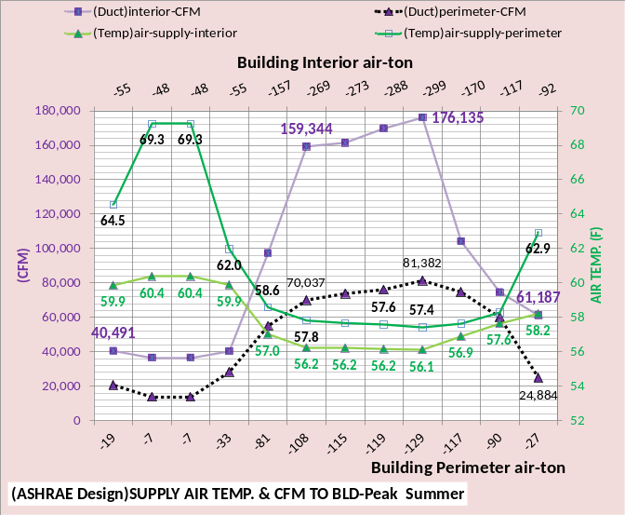FIGURE 3: Building loads & air handler response

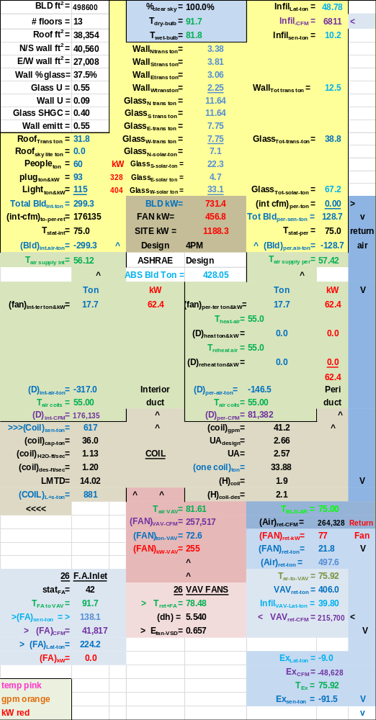FIGURE 4: Air side system at 4:00PM

FIGURE 5: Air side system at 10:00PM

FIGURE 6: Air handler response to building loads

FIGURE 7: Total system kW demand

FIGURE 8: System (SEE) schematic at 4:00PM

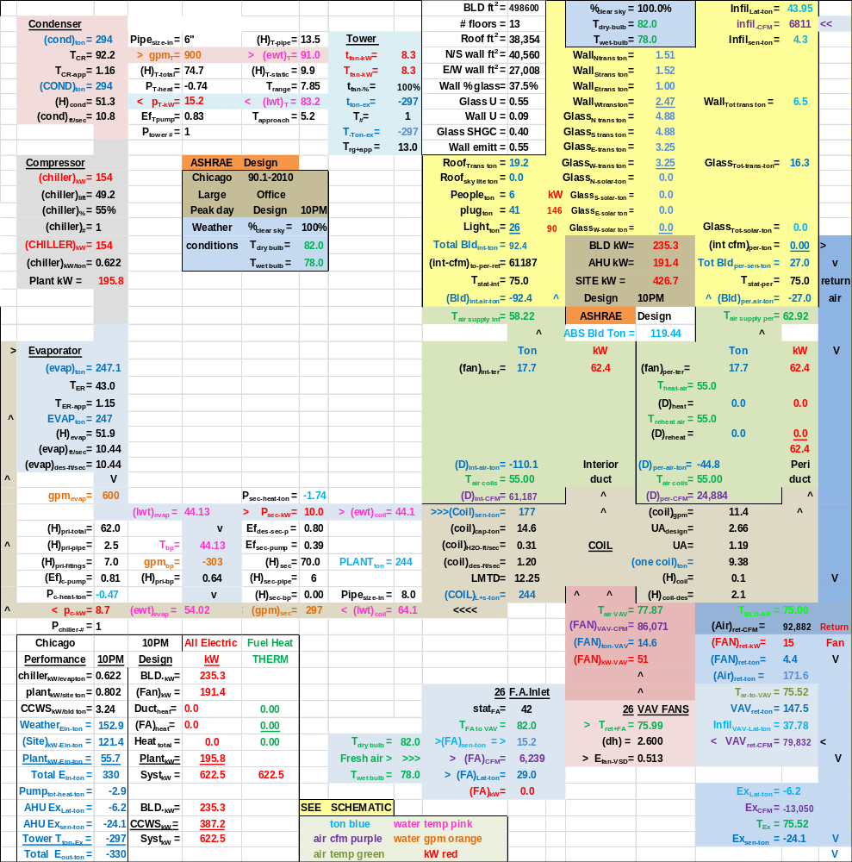FIGURE 9: System (SEE) schematic at 10:00PM

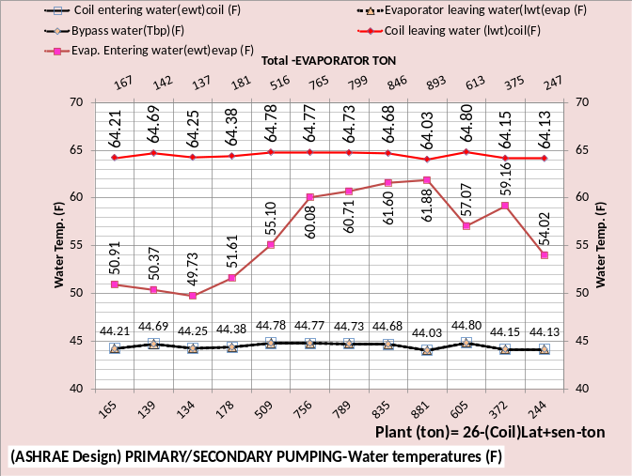FIGURE 10: Primary/Secondary pumping

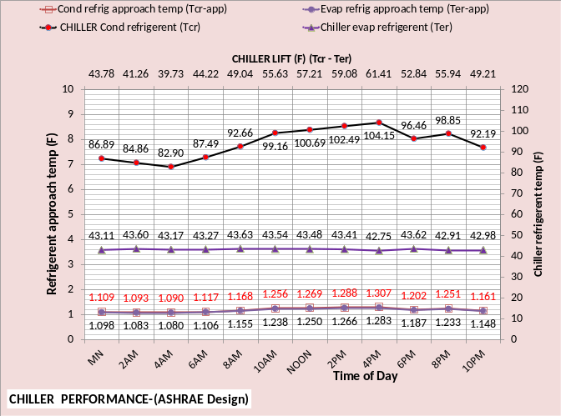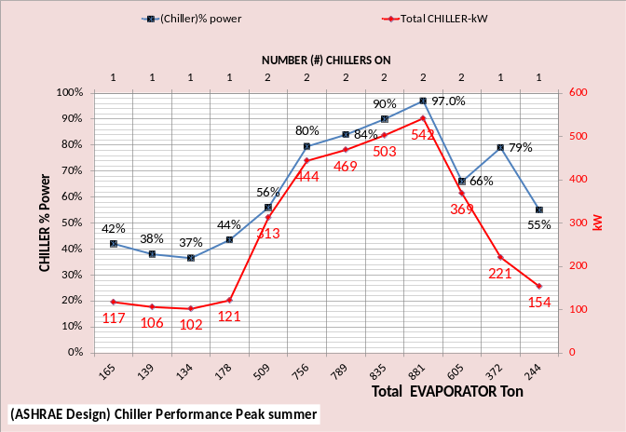FIGURE 11: Chiller response to loads

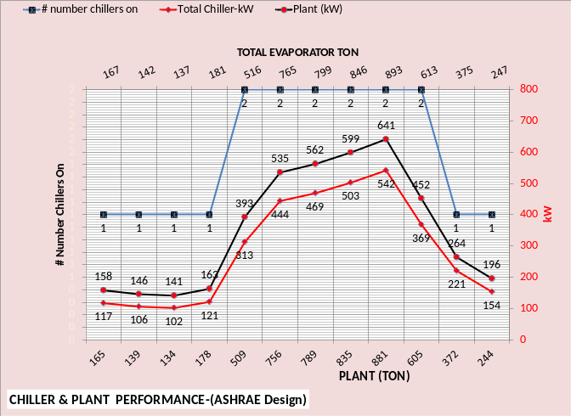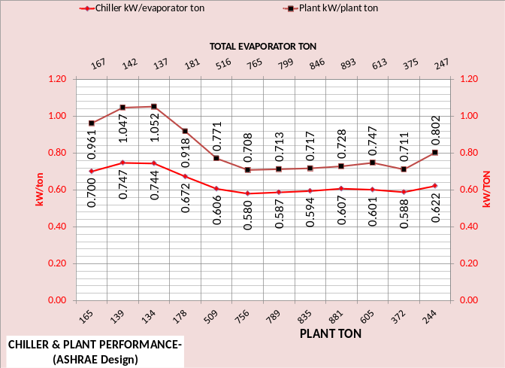FIGURE 12: Chiller & plant performance

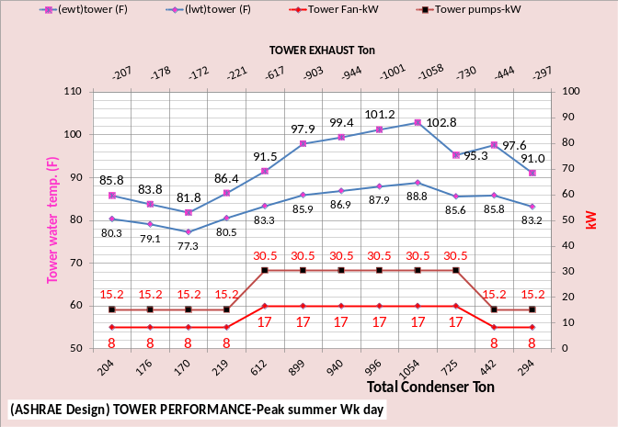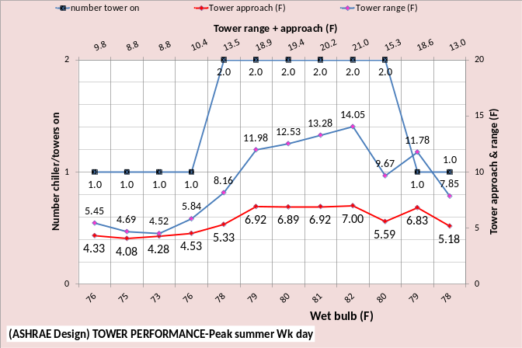FIGURE 13: Tower performance

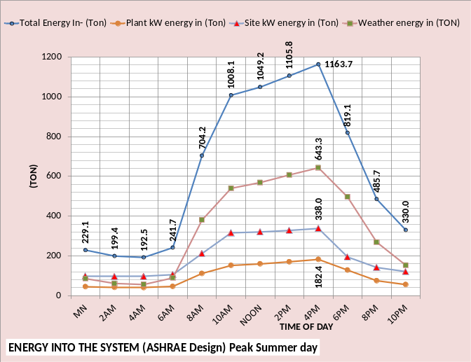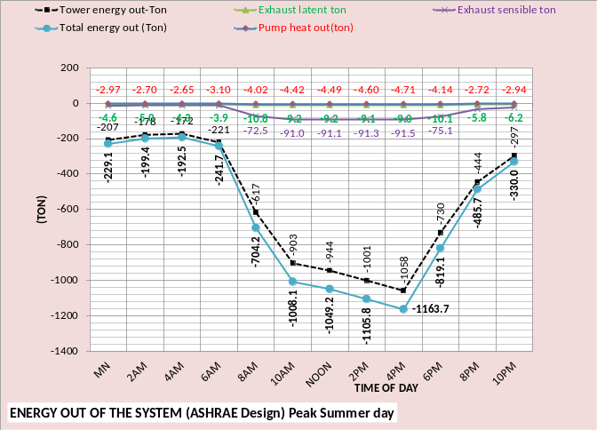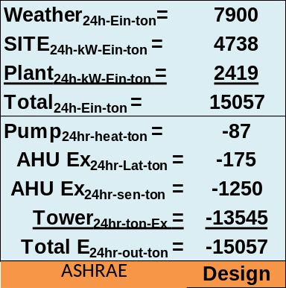 FIGURE 14: Energy in = Energy out

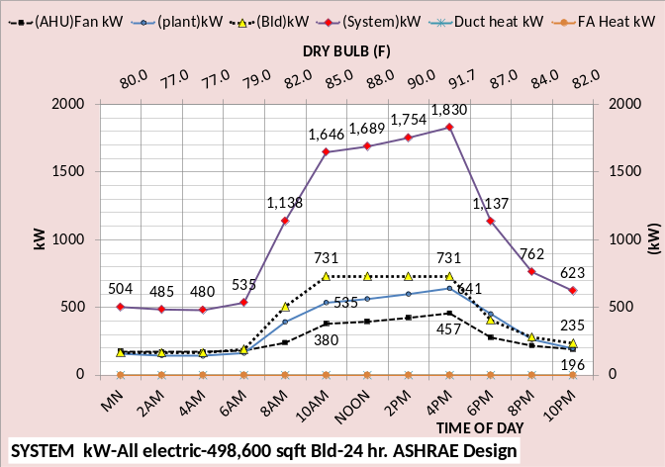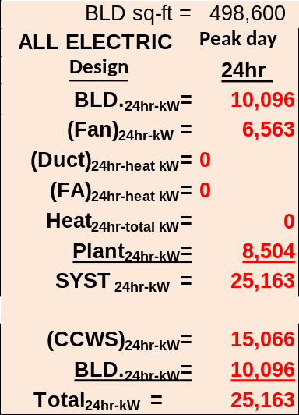 FIGURE 15: System 24 hour kW usage

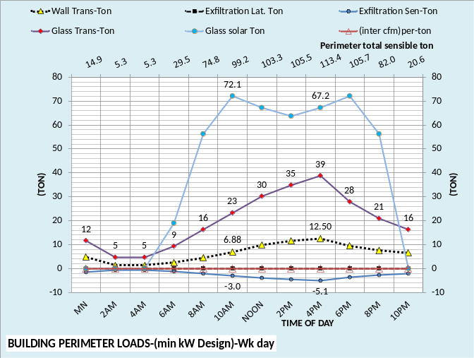
FIGURE 16: Building Infiltration vs. Exfiltration

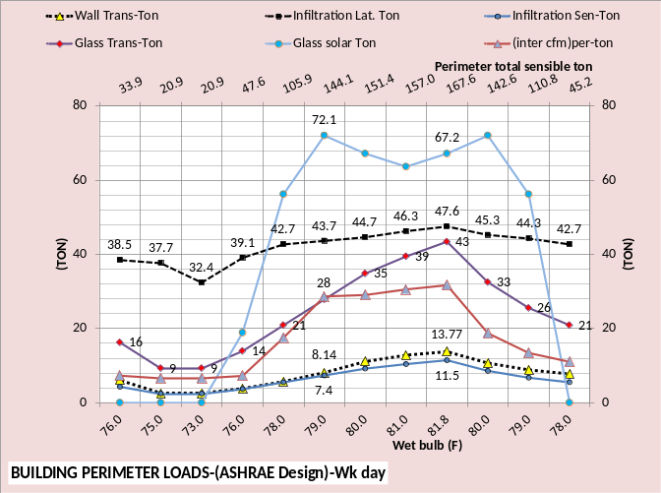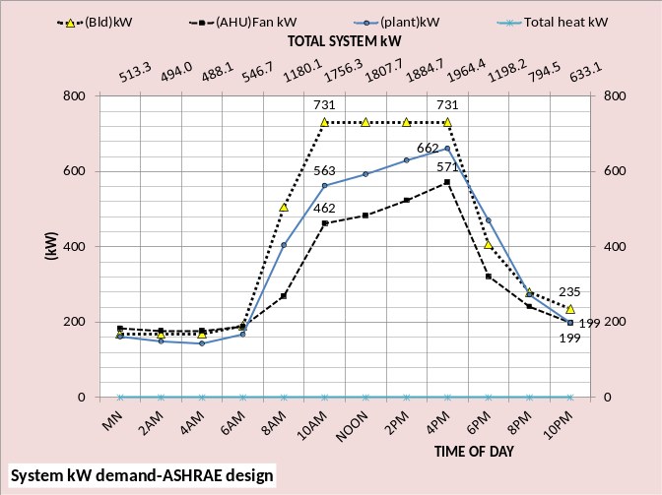
FIGURE 17: Building energy transfer

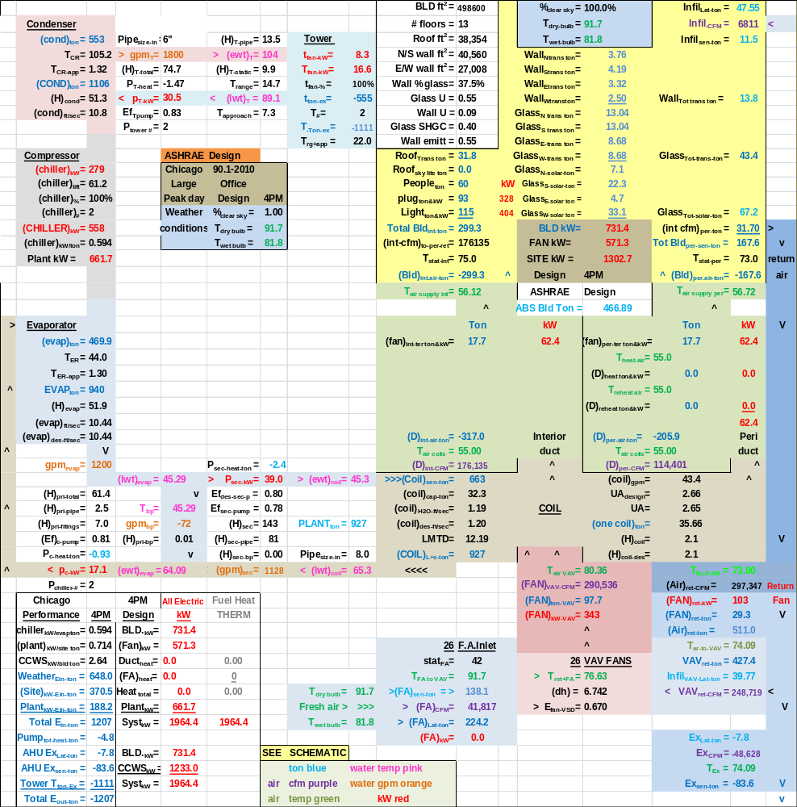
FIGURE 18: Interior stat at 75F perimeter at 73F

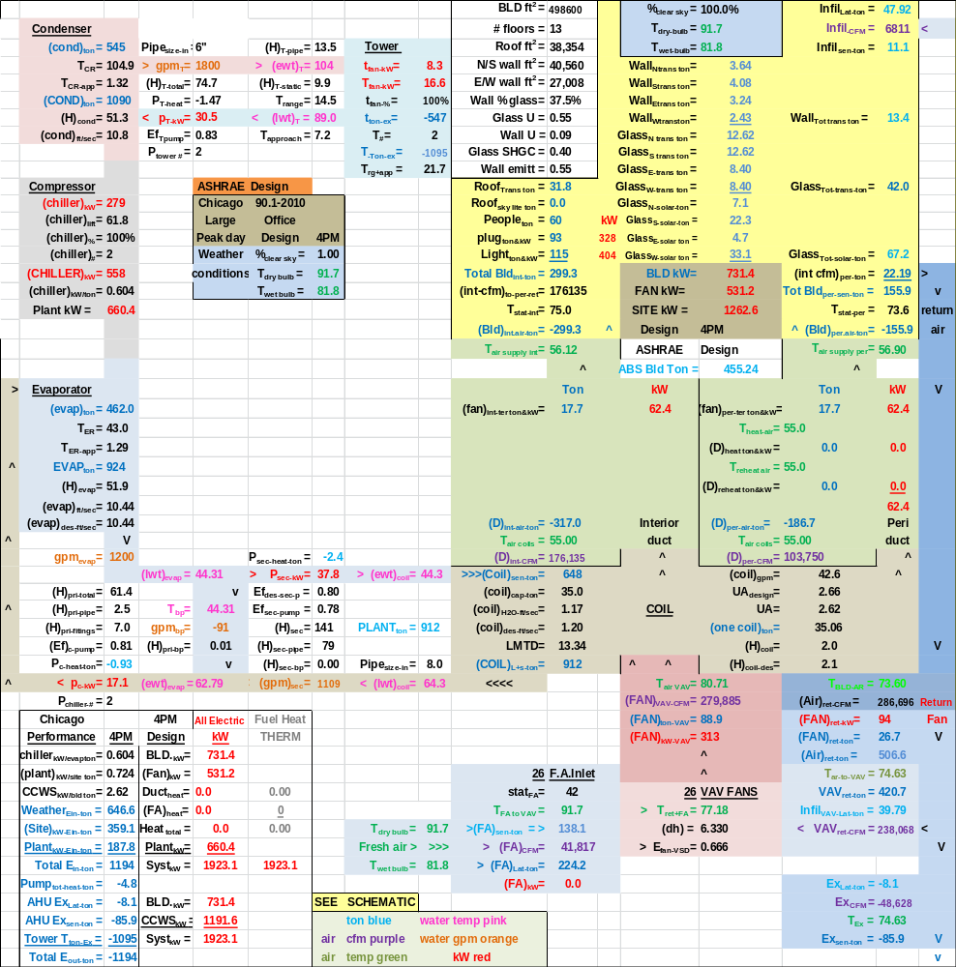
FIGURE 19: Energy equilibrium at perimeter temperature 73.6F

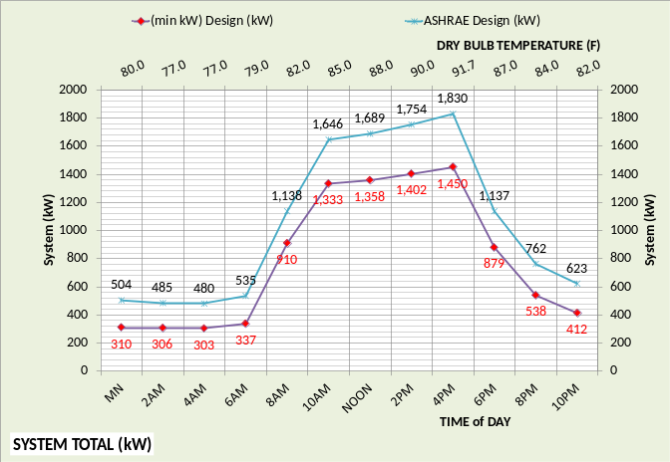
FIGURE 20: Minimum kW design verses ASHRAE design kW at peak design day conditions

# | ASHRAE Journal & Standard 90.1-2010  Design & Control. | (Min kW) Design & Control.
(1) | Infiltration of 6,811 CFM is called for by  Std. 90.1-2010. | Pressurize the building to exfiltration of 3,378 CFM, no return fans.
(2) | 70F perimeter stat set pt. will be aborted resulting in loss of stat control. | Control thermostats to minimize heating & cooling energy.
(3) | Building return air path not controlled. | Design return air path to minimize heating & cooling energy.
(4) | Installed fan powered supply air terminals. | Design the air supply system without fan powered terminals.
(5) | Control air supply (55F) temperature to 60F when not at full cooling load, page 97 of Oct. 2013 ASHRAE Journal. | Control supply air to 55F design but may decrease to less than 55F to decrease fan kW.
(6) | Table 5.2 of (PNNL) 90.1-2010 study limits heating air temperature to 20F above room temperature, (94F). | Perimeter heating air temperatures of greater than 94F say 110F.
(7) | Table 5.11 of the (PNNL) study call for a TSP of 5.58 w.c. | Use same duct size as ASHRAE design, therefore less TSP for (min kW) Design.
(8) | Design the plant based on ASHRAE Journal articles, “Optimizing Design & Control of Chilled Water Plants”, July 2011-June 2012, by Taylor. | Design the plant with the objective of minimizing plant kW consistent with first cost control.
TABLE 1: Changes to ASHRAE design to define minimum kW design

