ST. LOUIS
LARGE OFFICE

Cold Supply Air
&
Air Economizer
Analysis

System Energy Equilibrium (SEE) Model Analysis

Kirby Nelson PE
2/12/2017
CONTENTS
Purpose
Executive Summary:
CHAPTER 1: The 55F SAT Design & 48F SAT at peak summer design conditions.
CHAPTER 2: Summer operation.
CHAPTER 3: Spring/Fall operation.
CHAPTER 4: Winter operation.
Chapter 5: Set heat air temp to greater than 90.1 Standard.
Chapter 6: Stat control.
Chapter 7: Air economizer.
Final conclusions:
References & nomenclature at end of paper

Purpose:
The purpose of this paper is to evaluate supply air temperature primarily in response to an ASHRAE Journal article of December 2016 by Mr. Stephen W. Duda, P.E. titled “A Critical Look at Cold Supply Air Systems”. Mr. Duda’s final statement in the conclusions is “-and use energy modeling as accurately as possible to understand the overall energy differences on an annual basis.” This paper will follow that recommendation by analyzing a large office with a System Energy Equilibrium (SEE) model. The large office building is defined by the DOE/PNNL study of ASHRAE Standard 90.1-2010, see references for a link to that DOE/PNNL study.
Executive summaries
Chapter 1: The 48F SAT design consumes less energy at peak summer design day conditions than the 55F SAT design. The 48F design requires an increase in coil size of about 50% and a slight increase in chiller size. The downsizing of the air duct system, and the resulting first cost reduction, with the 48F design, would be a very building specific decision and therefore no firm recommendation can be made here.
Chapter 2: The 48F design results in about a 1.5% reduction in energy use during summer operation; not a big reason to pick a 48F design over a 55F design for the large office building as defined here.
Chapter 3: For spring/fall weather the 48F design results in about a 4.5% increase in annual energy use.
Chapter 4: Primarily due to winter operation the annual increase in energy consumption is about 5% for the 48F SAT design verses the 55F SAT design.
Chapter 5: ASHRAE Standard 90.1-2010 requires the temperature of heating air be about 94F. Increasing to 110F significantly reduces the system kW.
Chapter 6: Controlling stat set points & return air paths can significantly reduce system kW.
Chapter 7: An air economizer has several pitfalls, see chapter 7 conclusions.
Final conclusions: This (SEE) model analysis of cold air supply (48F) verses (55F) has shown little difference in energy consumption. However Chapter 7 has shown the coil must be designed for air economizer. This analysis has shown that bringing in fresh air for cooling can increase system kW demand.

CHAPTER 1:
The 55F SAT Design & 48F SAT Design are defined at peak summer conditions.
The building selected for this study is defined by the Pacific Northwest National Laboratory (PNNL) study of standard 90.1-2010¹, a large 13 story St Louis office building, Figure 1-1, with 498,600 square feet of air conditioned space. A link to the (PNNL) study is given by the reference¹. The building schedules and other details of the building, as defined by the (PNNL) study, are in this model design but the plant of this study is designed to a series of articles in the ASHRAE Journal, Taylor 2011². Figure 1-2 shows the assumed St Louis peak weather day conditions for the 24 hours to be modeled. The peak building load occurs at 4PM with 100% solar, 99.8F dry bulb and 77.2F wet bulb.
The building is modeled with an internal zone that has all electrical and people loads and a perimeter zone that models all wall/glass solar and transmission loads plus air infiltration or exfiltration.

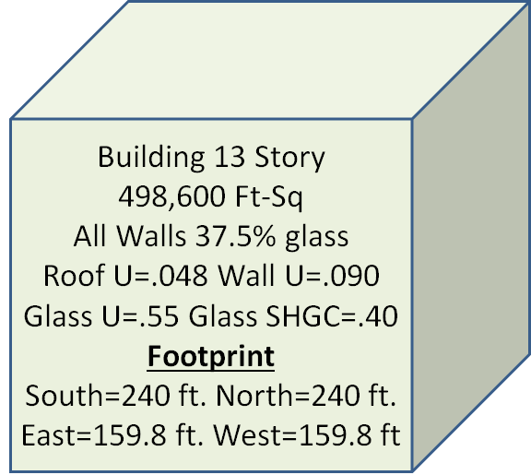FIG. 1-1 Large Office Building from ASHRAE Standard 90.1-2010 study by DOE/PNNL
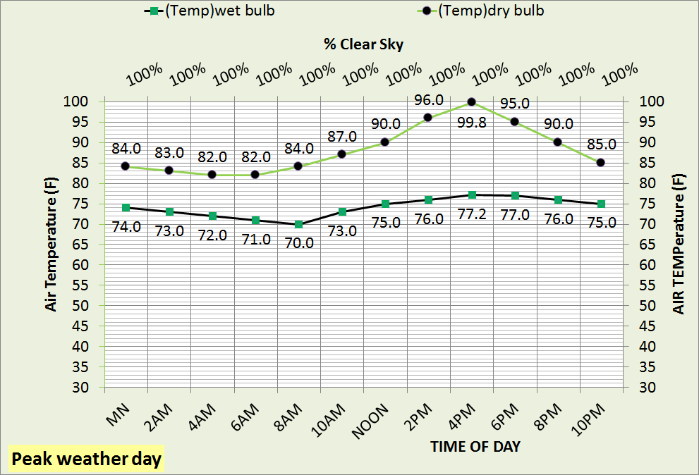Fig. 1-2 Assumed peak weather day

Figure 1-3 defines the components of the building schematic and nomenclature is given at the end of this paper.

FIGURE 1-3 System Schematic defined
Figure 1-3 gives an understanding of how the components of the building system interface.
The next Figure 1-4 is a total system schematic of the system at peak load with 55F SAT-design conditions.

FIGURE 1-4 System schematic at peak load SAT=55F, (dh=5.568)
Figure 1-4 illustrates the SAT=55F design system at peak design conditions and at energy equilibrium, obeying the first law and modeling component nonlinear characteristics. The building sensible interior load is 300.8 ton and the perimeter sensible load is 156.1 ton and a latent load of 30.84 ton, fresh air adds 114.1 ton latent load and 168.6 ton sensible load. Supply air off the coil is 55F with 176,985 CFM to the interior and 96,565 CFM to the perimeter for a total of 273,551 CFM provided by the VAV fan system requiring 272.5 fan kW. The terminal fans add heat to the supply air resulting in 56.11F air to the interior and 57.04F supply air to the perimeter. Note the coil design UA is 2.66 and each coil capacity is 35.7 ton and each coil load is 32.88 ton and (LMTD=14.17). Now change SAT to 48F, Figure 1-5.
FIGURE 1-5 System schematic at peak load SAT=48F, (dh) =3.708
Figure 1-5 iterates to a new steady state with only two changes input to the set of model equations; SAT is changed from 55F to 48F and the chiller kW is increased to meet a bigger load. Total fan kW drops from 479.1 to 309.7 reducing the coil sensible load from 682 ton to 635 ton, but the latent load increased due to the 48F supply air from 172.4 ton to 235.4 ton resulting in a greater load on the plant. The latent load increased due to fresh air and outside air infiltration. Total system kW dropped from 1807.9 of Figure 1-4 (SAT=55F) to 1649.9 kW (SAT=48F) of Figure 1-5; however the air duct size of Figure 1-4 is the same as Figure 5 as evidenced by the drop in VAV air static pressure from (dh=5.568) to (dh=3.708). Note that the LMTD has reduced in Figure 1-5, as expected with a reduction in SAT to 48F, to a value of LMTD=9.12 verses 14.17 of Figure 1-4 with SAT = 55F. The coil UA design is the same, i.e. same coil so the capacity of each of the 26 coils is 23.2 ton and the coil load is 33.49 ton i.e. must increase size and cost of coil to meet the load and conditions of a 48F SAT deign.
Designing a system with cold SAT usually is to reduce the size of the air duct system due to space or some other reason, perhaps first cost reduction? The next Figure 1-6 reduces the duct size to (dh=5.568) at peak summer design conditions.


FIGURE 1-6 System schematic at peak load SAT=48F

The result of increasing (dh) or reducing air duct size is shown by Figure 1-6. The total system kW is 1739.2 kW which is less than the 1807.9 kW of Figure 1-4 by about 3.8%. The 48F SAT design consumes less energy at peak summer design conditions than the 55F SAT design primarily due to total fan kW reducing from 479.1 kW to 387.2 kW, however the 48F SAT design requires an increase in coil size of about 50% with resulting increase in first cost of the CCWS system. Also note the chiller size is increased from about 255 kW of Figure 1-4 to about 260 kW of Figure 1-6. So the cost tradeoffs are two slightly bigger chillers and 26 bigger coils for a reduction in air duct size and therefore cost. Keep in mind that a 55F SAT air duct design could mean the need for bigger building space and therefore increased building cost.
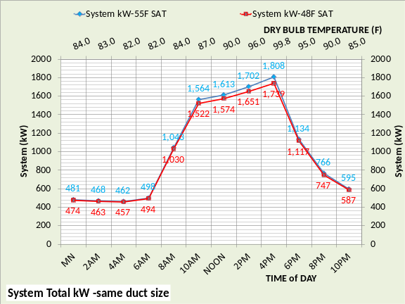
Figure 1-7: 24 Hour kW demand of 55F SAT design of Figure 4 & 48F SAT design of Figure 6
Figure 1-7 illustrates that the 48F design has less system kW for all hours of the design day. Figure 1-8 gives the 24 hour kW demand of the two designs at peak summer day conditions illustrating that the fan system kW is significantly less with the 48F design but the plant kW is a little more. The total system kW is shown on the secondary horizontal axis for both designs illustrating that the 48F SAT design has less kW demand for all hours.
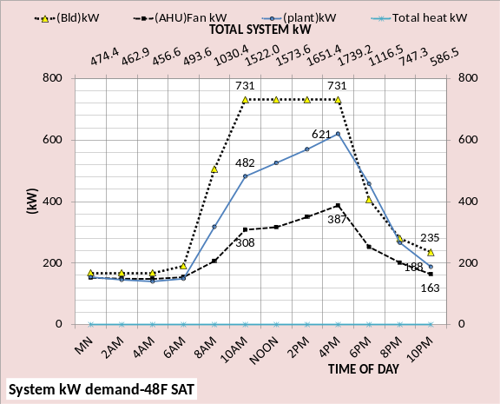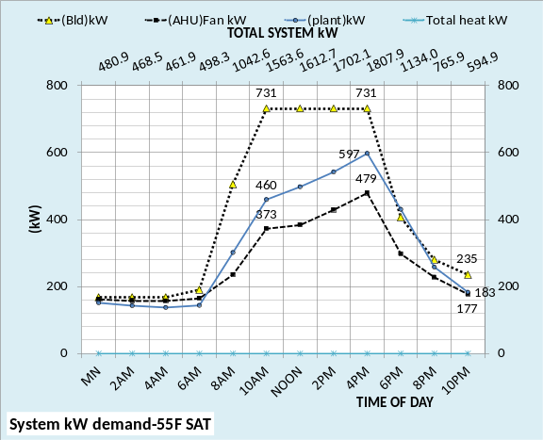
Figure 1-8: 24 hour system kW demand for both designs at peak design day conditions

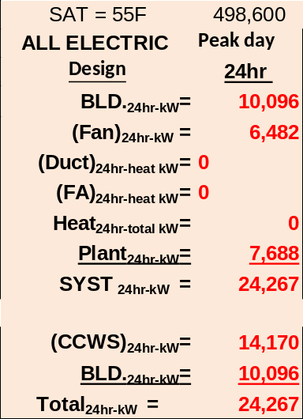
Figure 1-9: 55F SAT design
Figures 1-9 & 1-10 give the 24 hour sum of kW for the two designs, at peak design day conditions, illustrating the 24 hour drop in fan kW and the increase in plant kW for the 48F SAT design.
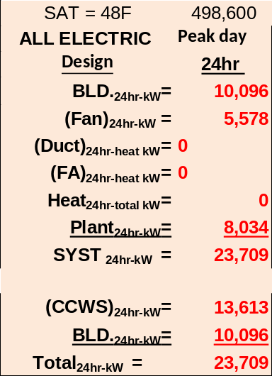
Figure 1-10: 48F SAT design
CONCLUSIONS FOR PEAK SUMMER DAY OPERATION
The 48F SAT design consumes less energy at peak summer design day conditions than the 55F SAT design. The 48F design requires an increase in coil size of about 50% and a slight increase in chiller size.
The first cost reduction of downsizing of the air duct system verses the increased coil cost and slight increased chiller cost would be a very building specific decision and therefore no firm recommendation can be made here. Also note that the cost of the building might decrease with smaller air duct.
Mr. Duda asks in his article why an engineer would select a cold SAT design. The answer may be because it’s the better design or required by available building space.
Next we will consider typical summer operation, Chapter 2.

CHAPTER 2:
Summer operation of the two designs.
Figure 2-1 gives the 24 hour weather conditions to be modeled including dry bulb and wet bulb temperature and % clear sky. As we will see the 24 hour operation is very different for each season and therefore requires, in my opinion, a detail 24 hour model to understand and therefore make good decisions. Blind dependence on a building energy model that cannot produce checkable equations, data, and schematics, is at best questionable.
The next two figures look at 24 hour operation of the 55F design and 48F design at peak weather conditions of Figure 1-2 and typical summer weather conditions of Figure 2-1. Note that the system kW=1808 of Figure 1-4 is the same as the top chart of Figure 2-2 at 4PM & also Figure 1-6 system kW=1739 is the same as top chart of Figure 2-3 at 4PM.
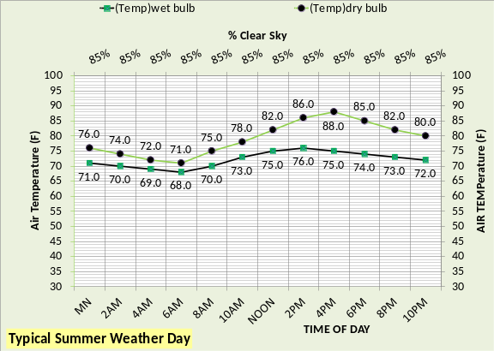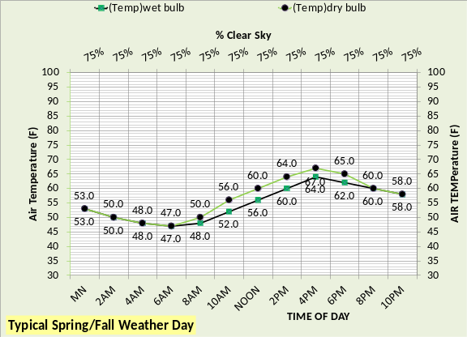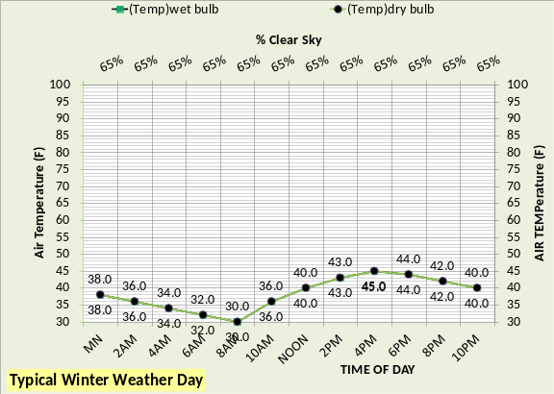Figure 2-1: Assumed typical weather days
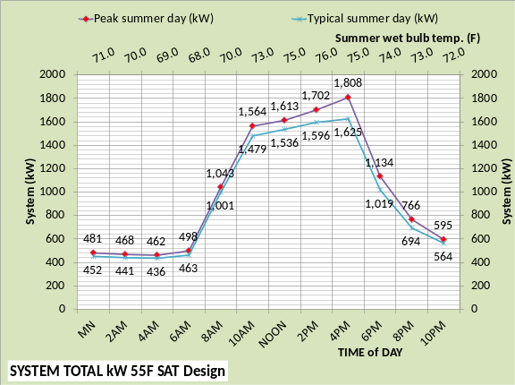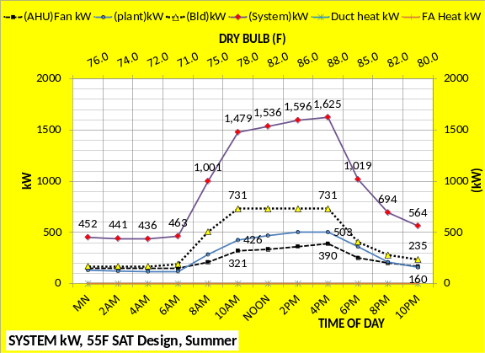
Figure 2-2: 55F SAT Design
As expected the system kW decreases with typical summer weather verses peak weather conditions as shown by Figures 2-2 & 2-3 top charts. The bottom charts of both figures illustrate that heat is zero for these summer conditions. The building kW is the same for both designs, as required because no change is made to the building. The plant kW, at 4PM, is about 28 kW more for the 48F design and the
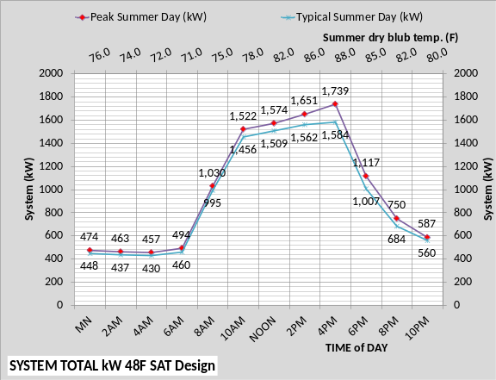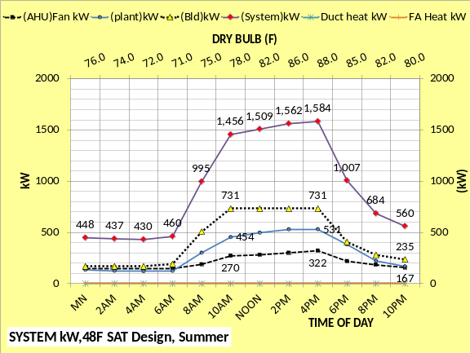Figure 2-3: 48F SAT Design fan kW is about 68 kW less for a net less of 41 kW for the 48F SAT design.
There is absolutely no reason to believe that a 48F SAT design will always give less system kW than a 55F SAT design at peak and typical summer weather conditions. The problem is much too complex to make that assumption. Next we will look at the air side schematics of both designs, first at 4PM.
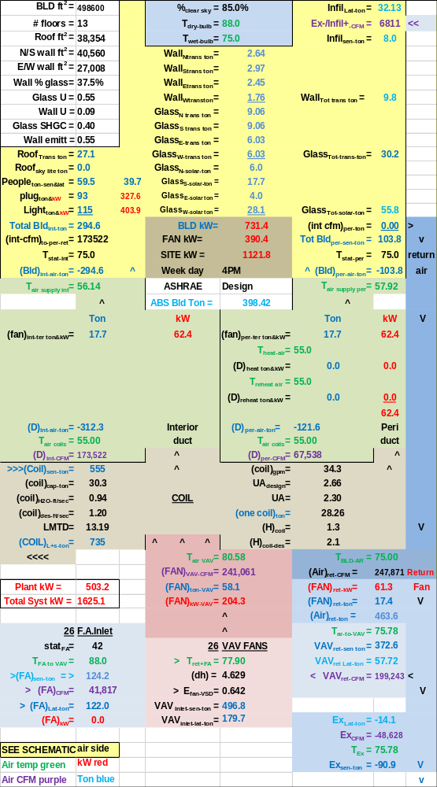Figure 2-4: 55F Design at 4PM, typical summer weather.
These two schematics give details of the systems at 4PM. The sensible load reduces with the 48F design because the fan kW decreased but the latent load increased for a net increase in plant load and therefore a plant kW increase of 28 kW.
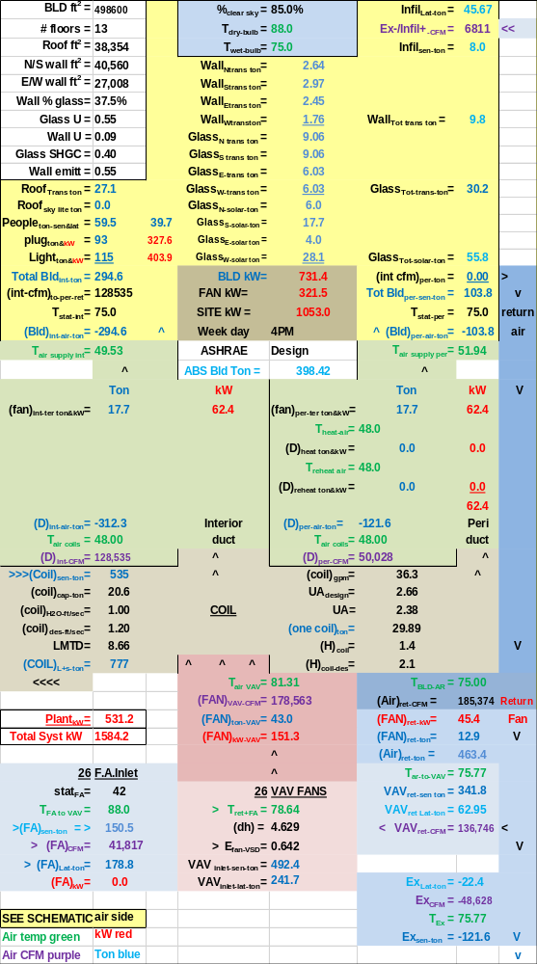Figure 2-5: 48F Design at 4PM, typical summer weather
The 55F SAT design latent load of (735-555=180 ton) increased to (777-535=242 ton) with the 48F SAT design. However the system kW reduced about 41 kW with the 48F SAT design. Next we look 10PM when the solar load is zero and the plant load is decreased over 500 ton.
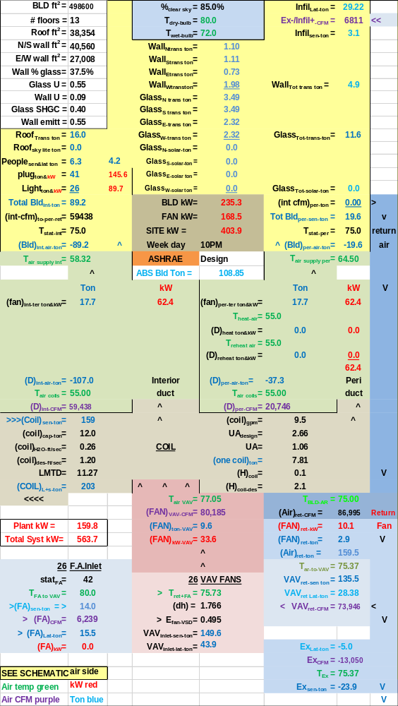Figure 2-6: 55F Design at 10PM, typical summer weather
This low load condition at 10PM results in little difference in the response of the two designs. The VAV fan CFM is about 59,000 for the 48F design and 80,000 CFM for the 55F design resulting in about a 9 kW reduction in VAV kW; not much.
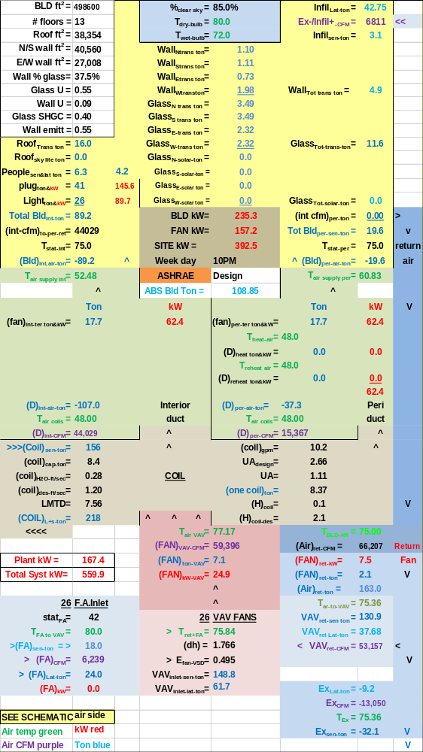Figure 2-7: 48F Design at 10PM, typical summer weather
System kW is about the same for both designs. The next two figures look at 10AM operation where the plant load significantly increases as the day begins.

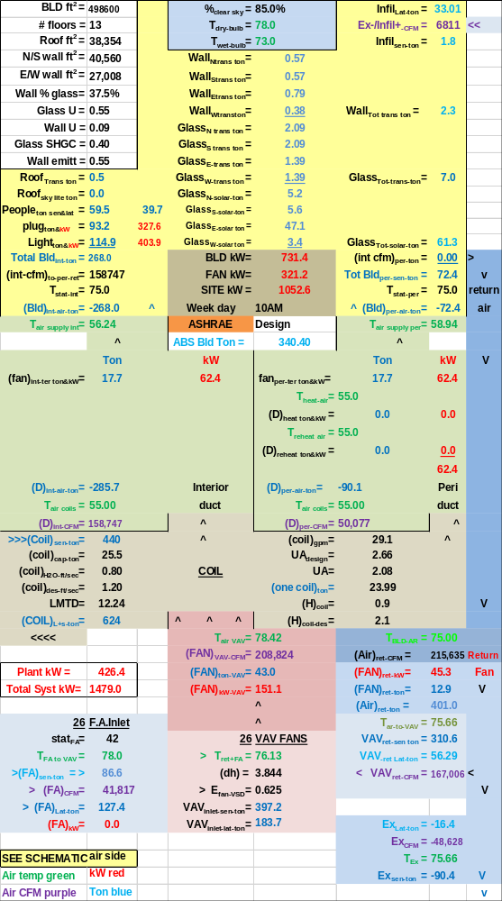Figure 2-8: 55F Design at 10AM, typical summer weather
Again we have a 48F SAT design that requires less total kW demand than the 55F design; the reduction in fan CFM and therefore fan kW is greater than the increase in plant kW.

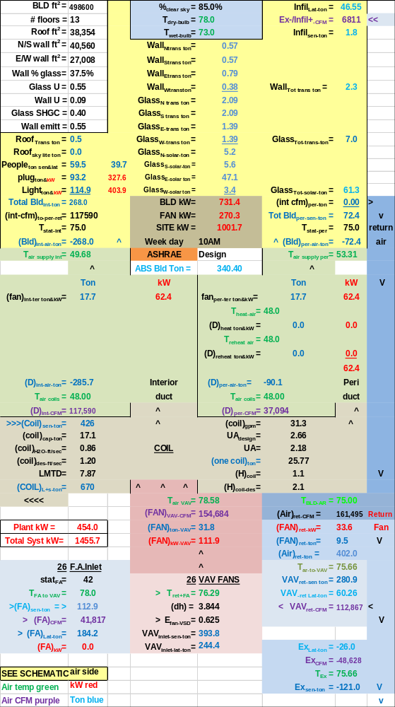Figure 2-9: 48F Design at 10AM, typical summer weather
System kW decreased about 23 kW with the 48F SAT design. Next we look at an estimate of annual (bEQ) for summer operation.

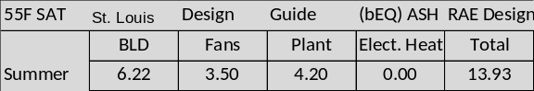Figure 2-10: (bEQ) for 55F SAT design
Figures 2-10 & 2-11 illustrate an estimate of the annual effect of the two designs for typical summer weather. The 48F design results in about a 1.5% reduction in energy use, not a big reason to pick a 48F design over a 55F design for the large office building as defined here.
Note that Table 1 of the Duda article does not break the energy use by season nor does it give the building energy use. More detail always gives better understanding. The inability to check model answers is not consistent with my training as a systems simulator. Blind acceptance of a models answers is not how I was trained.
System schematics give very detail understanding and in fact are needed to fully understand a system as we will demonstrate within this paper.
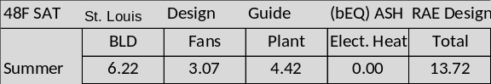Figure 2-11: (bEQ) for 48F SAT design
We will now look at operation at spring/fall weather conditions, chapter 3, and see a big change in results.

CHAPTER 3:
Spring/Fall operation of the two designs; 55F & 48F supply air
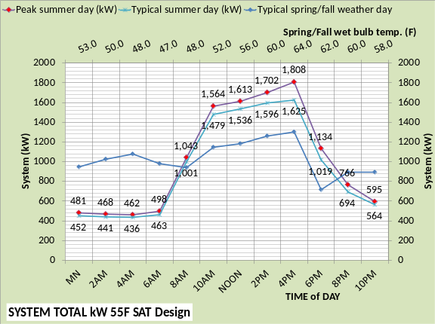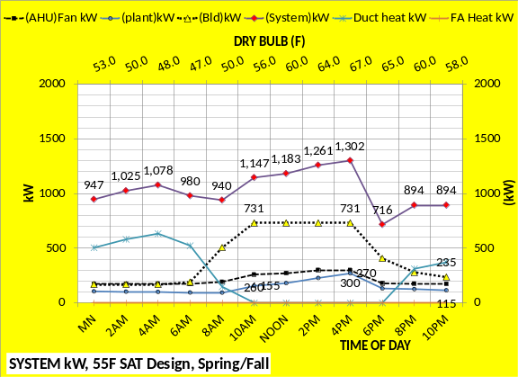Figure 3-1: 55F SAT Design
The top charts of both Figures 3-1 & 3-2 show the total system kW demand for peak summer, typical summer, and typical spring/fall weather conditions as defined by Figure 1-2 & 2-1 above. The top charts illustrate significant changes that occur as weather changes; the bottom charts in part explain why.
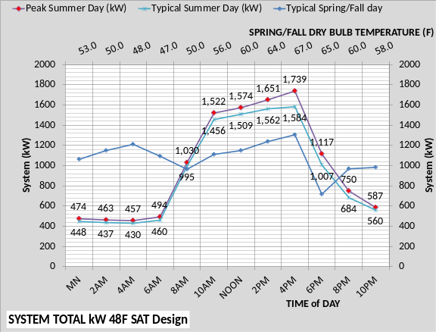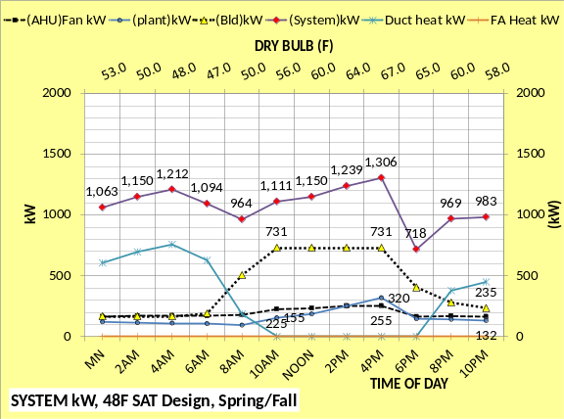Figure 3-2: 48F SAT Design
The bottom charts show that the total kW demand is a little more for the 48F design for all hours except 10AM, noon, and 2PM. We will look at 10AM below. Perimeter heat is now a major factor in the total system kW with the plant and fans playing a lesser role. Plant kW was 597 at 4PM in Figure 1-8, dropping to 503 kW in Figure 2-2 & now 270 kW in Figure 3-1, less than half the peak plant kW demand. Next we will look at schematics for 4PM.
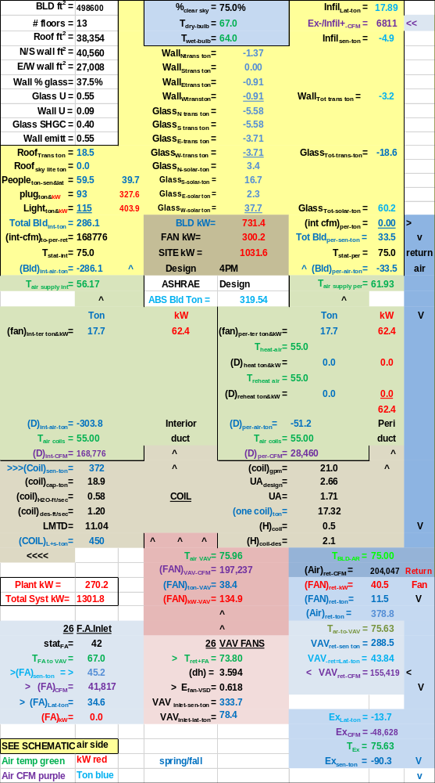Figure 3-3: 55F SAT Design at 4PM, typical spring/fall weather The total system kW is essentially the same for both designs. The decrease in fan kW for the 48F design is negated by the increase in plant kW due to the latent load increase of the 48F design.
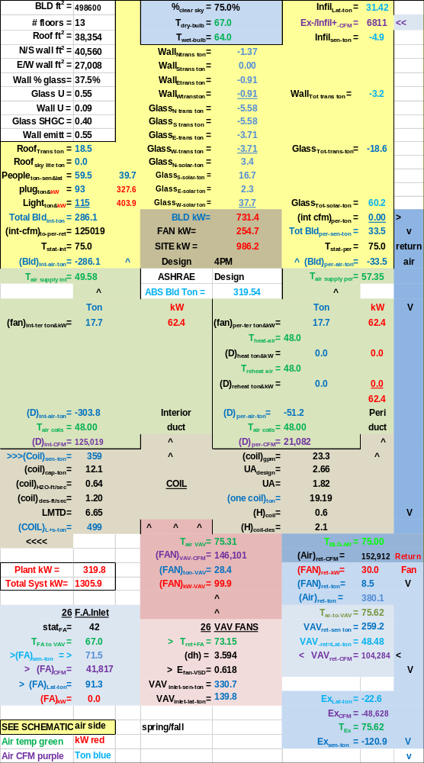Figure 3-4: 48F SAT Design at 4PM, typical spring/fall weather
Next we will look at 10PM when the sun is down, temperatures drop and people leave the building.

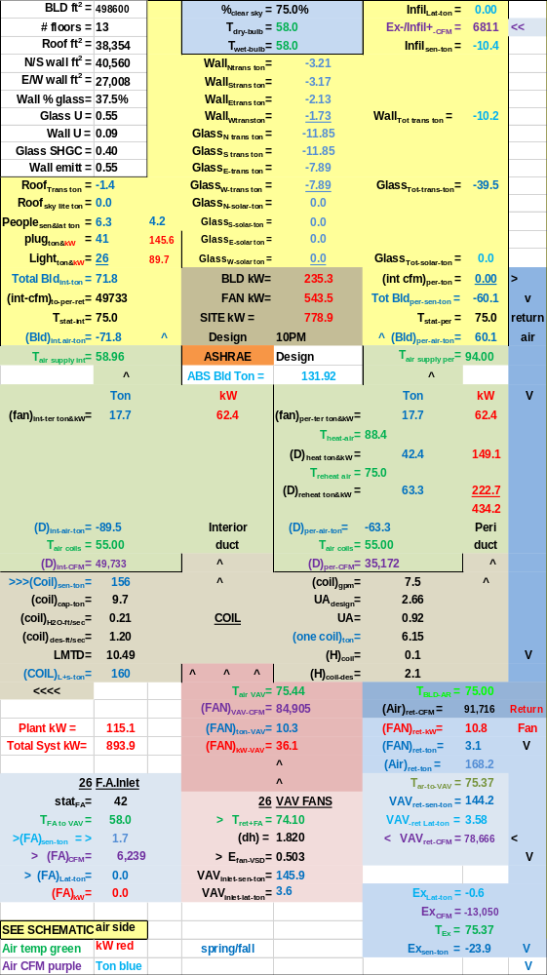Figure 3-5: 55F Design at 10PM, typical spring/fall weather
The load to the plant drops about 300 ton resulting in major changes in system response as illustrated by Figures 3-5 & 3-6. The total system kW demand is about 90 kW more for the 48F design with the big reason being the required perimeter heat.
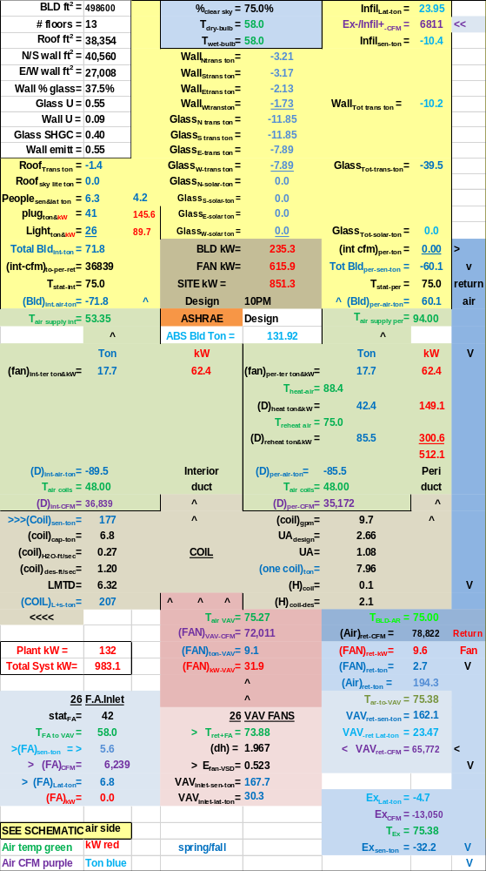Figure 3-6: 48F Design at 10PM, typical spring/fall weather Mr. Duda correctly states this is one of the disadvantages of the 48F SAT design. Note that the CFM of the air to the perimeter is the same for both designs (35,172 CFM), the difference is reheat (300.6-222.7=77.9kW). Next we will look at 10AM.
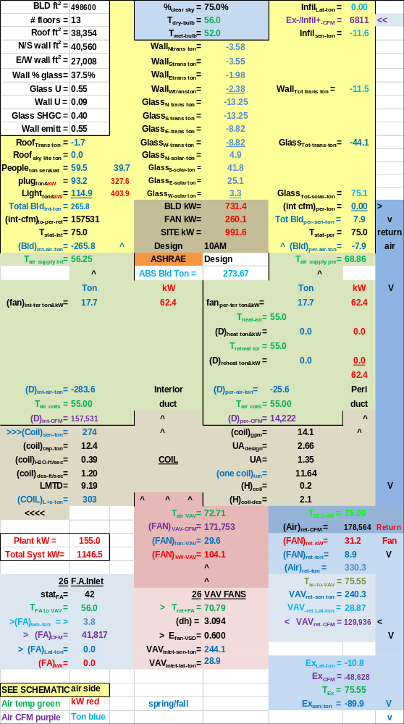Figure 3-7: 55F Design at 10AM, typical spring/fall weather
The system kW for the 48F design is less for these conditions; the decrease in fan kW is about 35 kW and the plant kW is about the same for both designs.

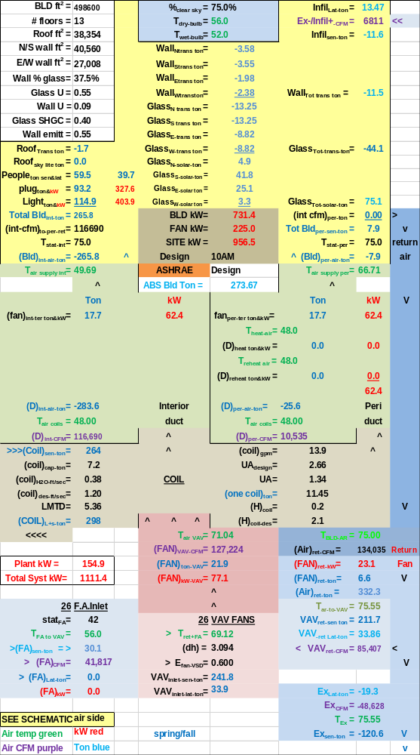Figure 3-8: 48F Design at 10AM, typical spring/fall weather
Next a look at estimated (bEQ).

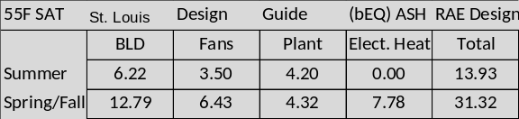Figure 3-9: (bEQ) for 55F SAT design
Figures 3-9 & 3-10 illustrate an estimate of the annual (bEQ) for the two designs for typical summer weather and typical spring/fall weather. The 48F design results in about a 1.5% reduction in energy use for summer conditions and about a 4.5% increase for spring/fall for the large office building as defined here.
Mr. Duda makes the statement in his article that colder SAT reduces the effect of economy cycle. Figures 3-7 & 3-8 illustrate this is not the case. The temperature of the mixed return air and fresh air is 70.79F for the 55F design & 69.12F for the 48F design for the same CFM of fresh air. The air temperature off the VAV fan is also a little less for the 48F design, 71.04F vs. 72.71F.

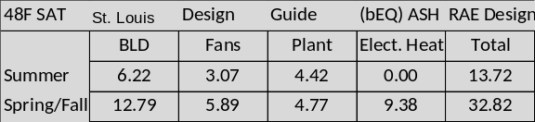Figure 3-10: (bEQ) for 48F SAT design
The result is a little less sensible load on the coil for the 48F design, 264 ton vs. 274 ton.
The point is the system is much too complex for this generalized conclusion. The winter analysis makes this point more clearly.
We will now look at operation at winter weather conditions, Chapter 4, and see a continuing increase in the energy use of the 48F design verses the 55F design.

CHAPTER 4:
Winter operation of the two designs; 55F & 48F supply air temperature.
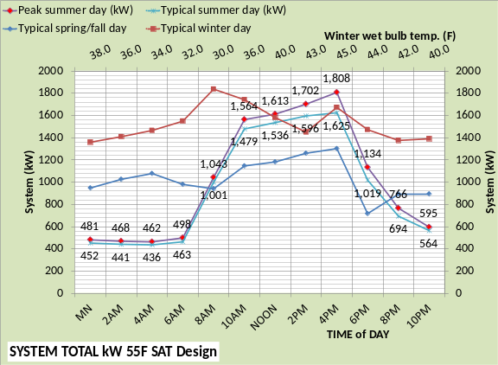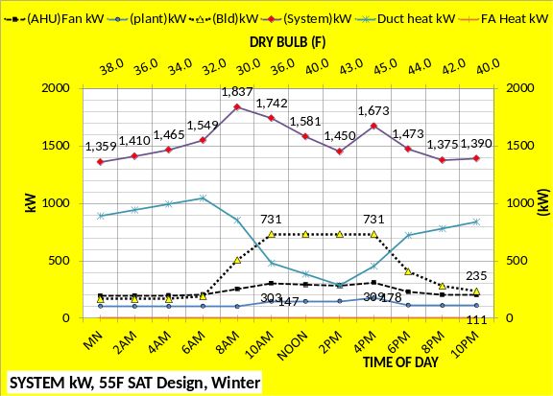Figure 4-1: 55F SAT Design
The top charts of both Figures 4-1 & 4-2 show the total system kW demand for peak summer, typical summer, typical spring/fall, and winter weather conditions as defined by Figure 1-2 & 2-1 above. A significant increase in 24 hour kW demand occurs for the 48F design during the winter due to reheat.
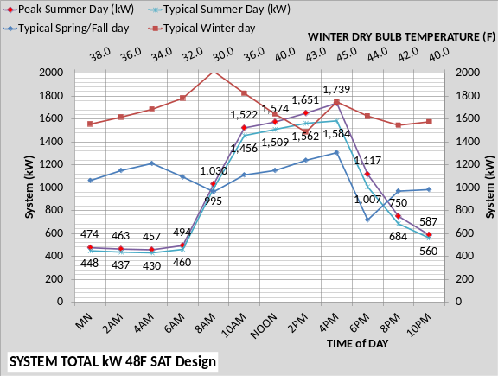 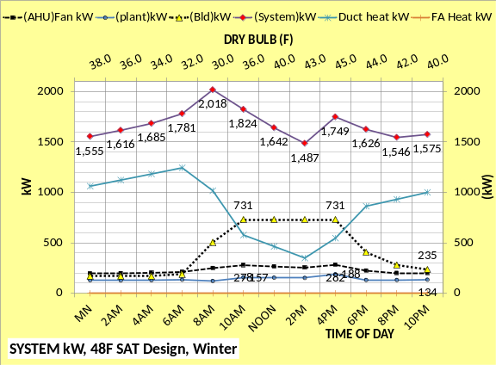Figure 4-2: 48F SAT Design The bottom charts show that the total kW demand is more for the 48F design for all hours as expected because the 48F supply air requires more reheat. During winter operation perimeter heat is a major factor in the total system kW with the plant and fans playing a lesser role. Plant kW is lowest on the charts; below 200kW & less than the air handler system kW. ASHRAE’s focus on plant kW is misplaced.
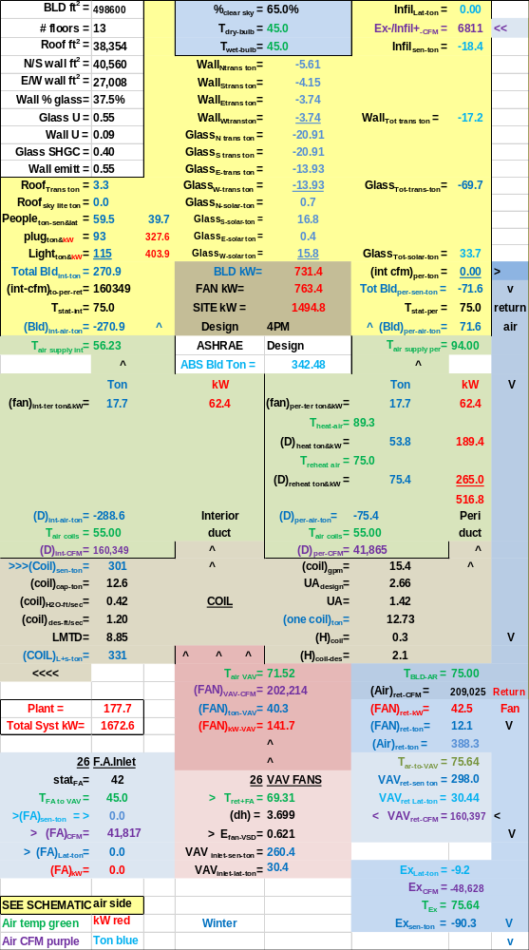 Figure 4-3: 55F SAT Design Winter Operation The two schematics illustrate the details of why the 48F SAT design requires more kW due to reheat and also illustrates a system characteristic. Note the CFM of air to the interior of the building is less, (118,777 CFM) for the 48F design and (160,349) for the 55F design.
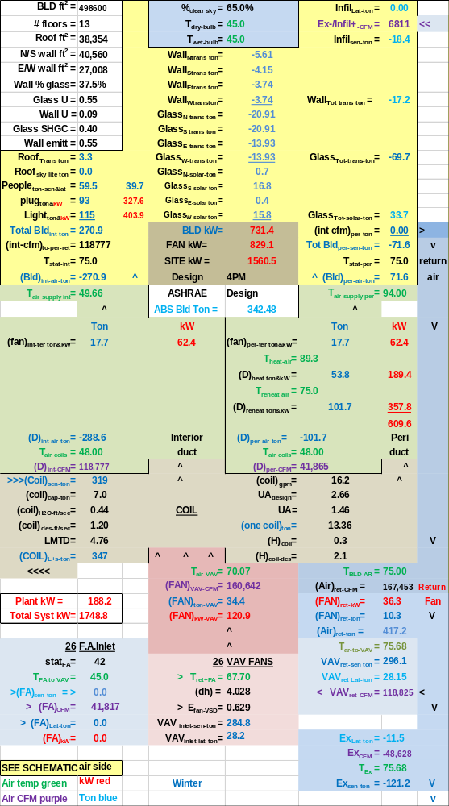Figure 4-4: 48F SAT Design Winter Operation
However the perimeter CFM is the same for both designs. Both designs need 41,865 CFM of 94F air to heat the perimeter of the building. The 48F design needs more kW to reheat the air from 48F up to 75F and that is the difference in kW required.
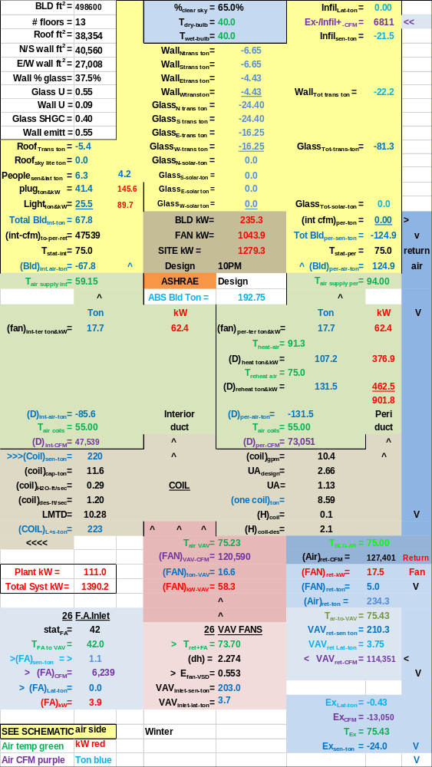Figure 4-5: 55F SAT Design, 10PM Winter
The sun is down and the outside temperature is 40F resulting in the 48F design requiring about 12% more energy. Again we see that the CFM of heating air to the perimeter is the same for both designs and reheat is the difference.
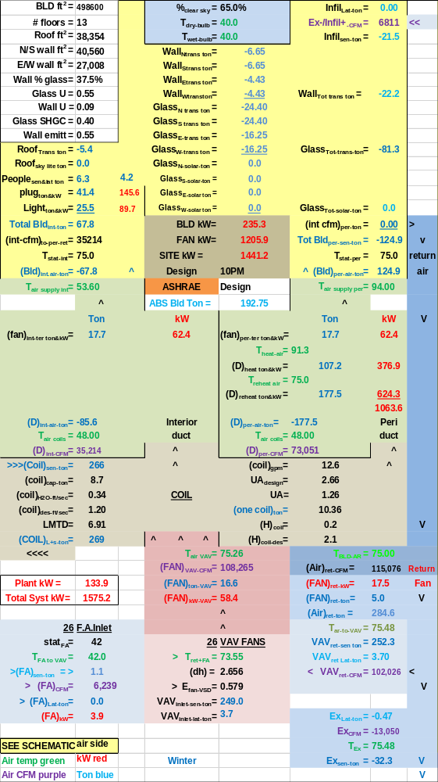Figure 4-6: 48F SAT Design at 10PM Winter
Changing the 94F air (94F is required by ASHRAE Std 90.1-2010) to a higher temperature would change things. We will look into that in an upcoming chapter.

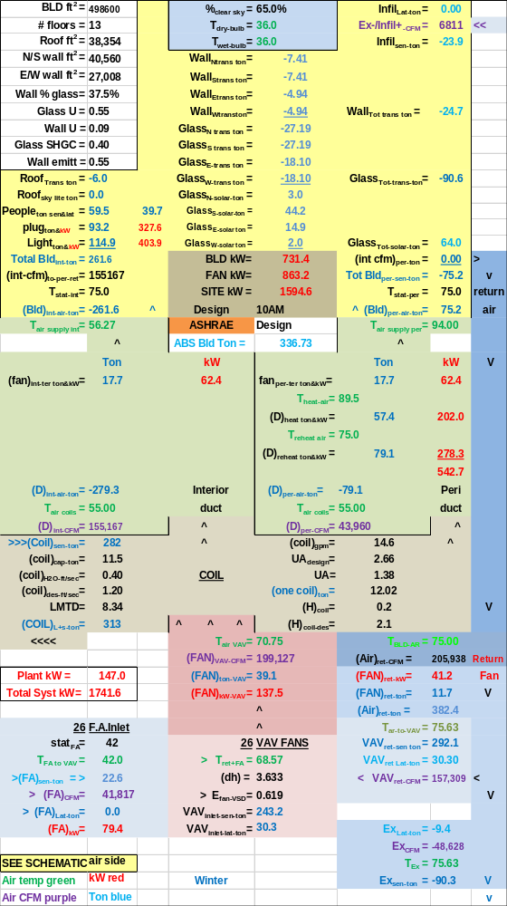Figure 4-7: 55F SAT Design, 10AM Winter This analysis brings several questions regarding how the kW demand could be reduced with temperature control. As stated above the temperature of the heated air (94F) to the perimeter could be changed. Also the supply air could be greater than 55F.
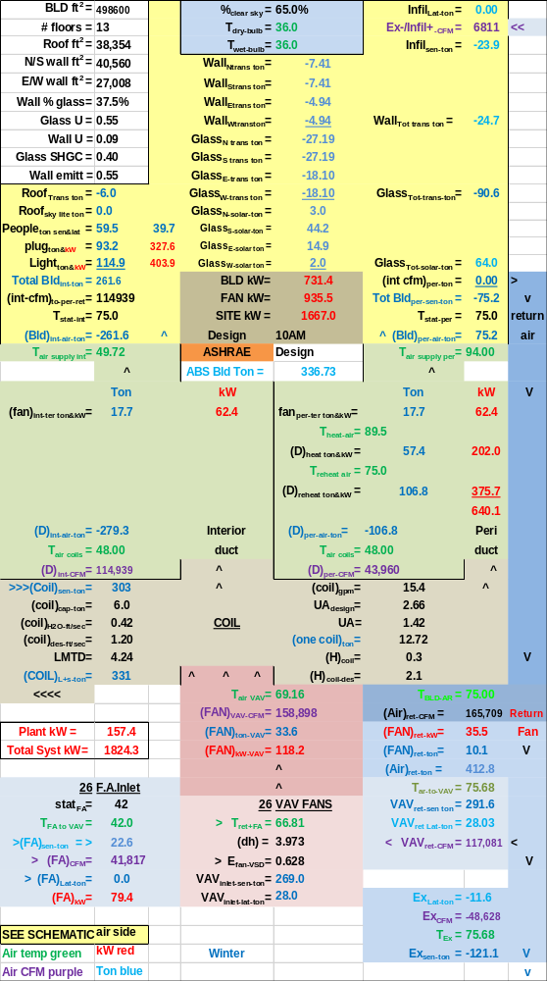Figure 4-8: 48F SAT Design, 10AM Winter
Another possibility is changing the thermostat settings to facilitate energy transfer in the building based on return air path. Another possibility is to pressurize the building and therefore eliminate outside air infiltration.
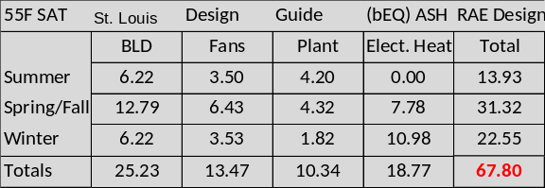Figure 4-9: (bEQ) for 55F SAT design
Figures 4-9 & 4-10 illustrate an estimate of the annual effect of the two designs for typical summer weather, typical spring/fall & winter weather. The 48F design results in about a 1.5% reduction in energy use for summer conditions and about a 4.5% increase for spring/fall and an increase of about 9% for winter for the large office building as defined here. The annual increase is about 5% for the 48F SAT design.
The 48F design uses less energy at peak summer design and during summer operation but little more energy during the spring/fall months and considerable more during the winter.

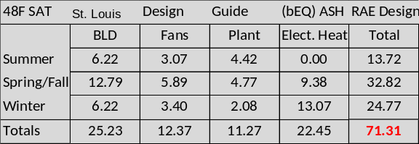Figure 4-10: (bEQ) for 48F SAT design
Figures 4-9 & 4-10 illustrate that the building annual energy use is the same for both designs. The fans use less energy with the 48F design and the plant offsets this with more energy required. The 48F design uses about 16% more heating energy and is therefore the big reason the 48F design uses more energy than the 55F design by about 5% for the year.
Conclusions to Chapters 1 thru 4
This analysis agrees with Duda’s article that a 55F SAT design uses less annual energy than a 48F SAT design; however the difference found here is much less than suggested by Duda’s ASHRAE article. Also we find that the peak design system requires a little less total kW demand with SAT=48F.
Mr. Duda makes a statement in the ASHRAE article, just prior to the conclusions, which may illustrate a misunderstanding of how systems work, or at least how the system of this study works, he states “-cfm at reheat is actually greater for the colder air than for conventional air”.
If I understand this statement, Figures 4-3 & 4-4 and the discussion below the figures show this statement to be incorrect. The figures obey the first law.
Chapter 5: Increase heated air to perimeter from 94F to 110F.
Figure 4-9 from above gives an annual (bEQ) of 67.80 for the 55F design and Figure 4-10 gives 71.31 for the 48F SAT design as shown below.

Both of these designs deliver 94F heated air to the perimeter as required by ASHRAE Standard 90.1-2010. Changing to a perimeter heating air temperature of 110F significantly reduces the (bEQ) of the 48F SAT design as shown by Figure 5-1.
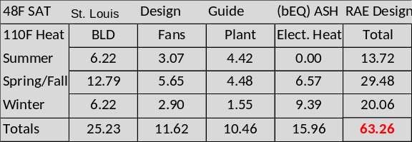
Figure 5-1: Heat air = 110F
The (bEQ) value has dropped from 71.31 to 63.26, an 11% decrease by just increasing the temperature of the heated air to the perimeter from 94F to 110F. We will examine why this drop in energy occurs with side by side schematics of the air side system during spring/fall & winter operation.
The 55F SAT design would also have a significant drop in energy consumption with the 110F heating supply air.

Figure 5-2: 48F SAT Design with 94F heating air-Spring/Fall
Comparing the two Figures 5-2 & 5-3 we see that the 110F heating air gives less total system kW when perimeter heat is required during night hours. Why less perimeter heat is required for the 110F air will be addressed with side by side schematics for 10PM.

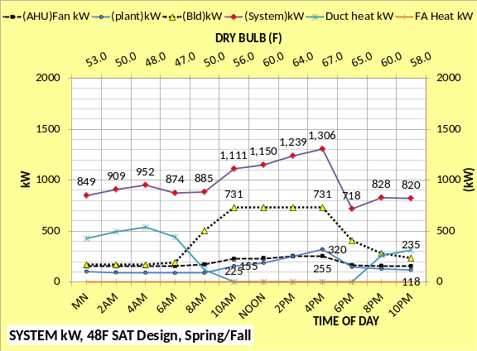
Figure 5-3: 48F SAT Design with 110F heating air-Spring/Fall

Figure 5-4: 48F SAT Design with 94F heating air
The fundamental effect of the 110F heating air is the reduction of CFM required by the perimeter, 35,172 CFM verses 19,093 CFM. This in turn reduces the reheat from 300.6 kW to 163.2 kW to get the supply air up to 75F for both designs. Both designs use the same amount of energy, 149.1 kW, to get the air up to the required
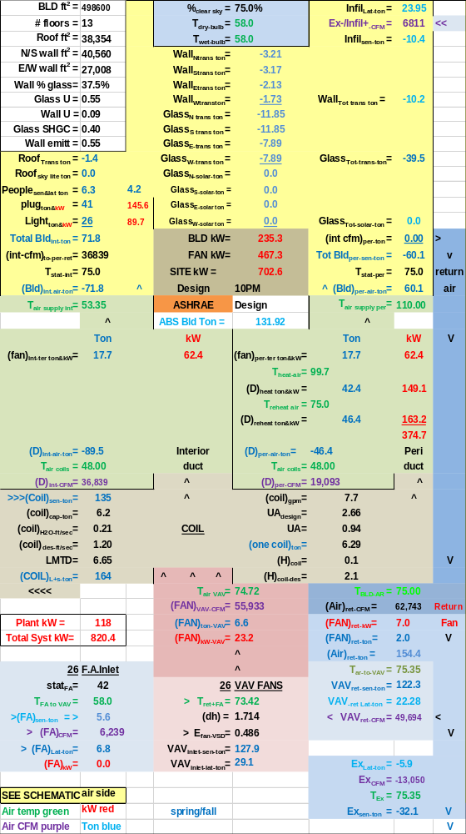
Figure 5-5: 48F SAT Design with 110F heating air
temperature at the inlet to the fan powered terminals. The terminal fans add heat to the air resulting in 94F air in Figure 5-4 & 110F air in Figure 5-5. The net result is a drop in system kW for the 110F supply air system as shown by Figure 5-5.

Figure 5-6: 48F SAT Design with 94F heating air-winter

Comparing the two Figures 5-6 & 5-7 we see that the 110F heating air gives less total system kW for all hours because perimeter heat is required for all hours. Why less perimeter heat is required for the 110F air will be addressed with side by side schematics.

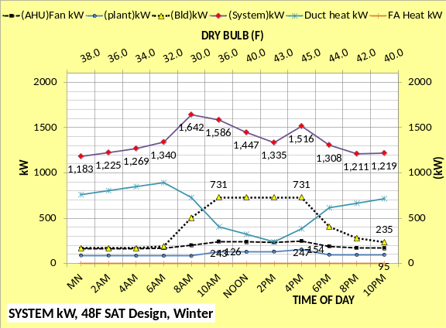
Figure 5-7: 48F SAT Design with 110F heating air-winter

Figure 5-8: 48F SAT Design with 94F heating air, winter 4PM
The 110F heating air to the perimeter reduces air reheat kW that reduces VAV fan kW that reduces plant load and therefore plant kW.
Table 5.2 of the PNNL analysis, referenced at right, states that restricting the heating air temperature to about 94F will save energy illustrating a lack of understanding by PNNL.
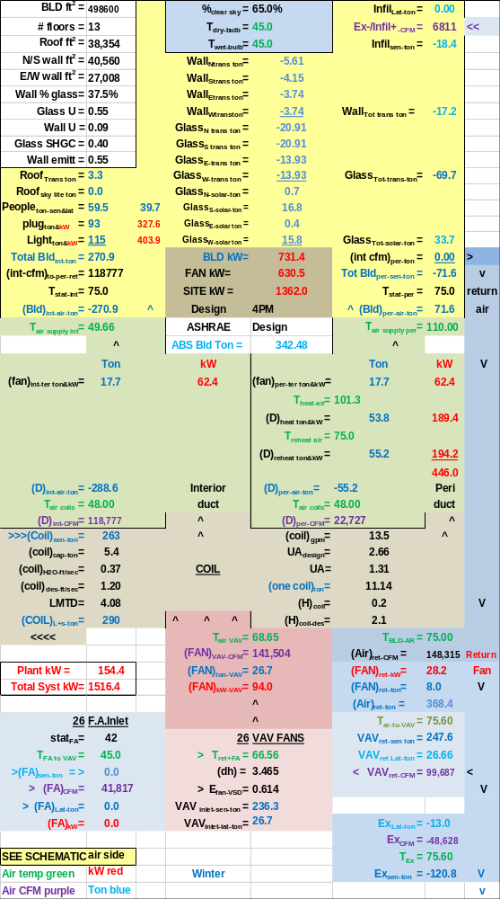
Figure 5-9: 48F SAT Design with 110F heating air, winter 4PM
- Liu, B. May 2011. “Achieving the 30% Goal: Energy and Cost Savings Analysis of ASHRAE Standard 90.1-
2010” Pacific Northwest National Laboratory. http://www.energycodes.gov/achieving-30-goal-energy-and-cost-savings-analysis-ashrae-standard-901-2010

Figure 5-10: 48F SAT Design with 94F heating air, winter 10PM
The 110F heating air gives a significant reduction in system kW for the same reasons given above.

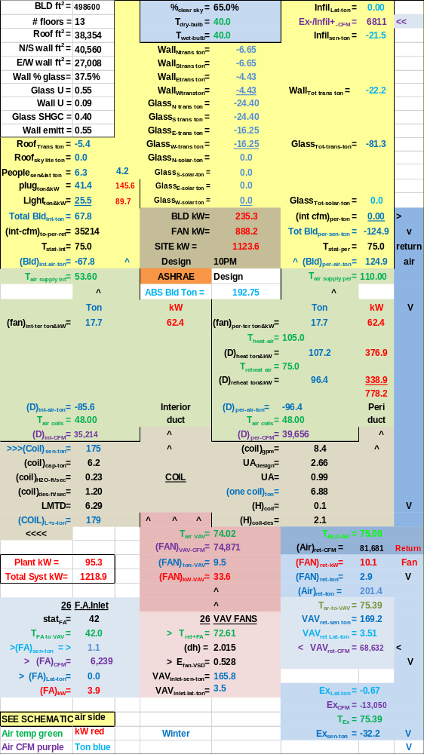
Figure 5-11: 48F SAT Design with 110F heating air, winter 10PM

Figure 5-12: 48F SAT Design with 94F heating air, winter 10AM
The changes in the system as a result of 110F heating air is rather complex and not easy, if not impossible, to understand without a detail first law analysis as given here. PNNL’s misunderstanding is understandable given the fact that they do not have an air side model that meets the first law.
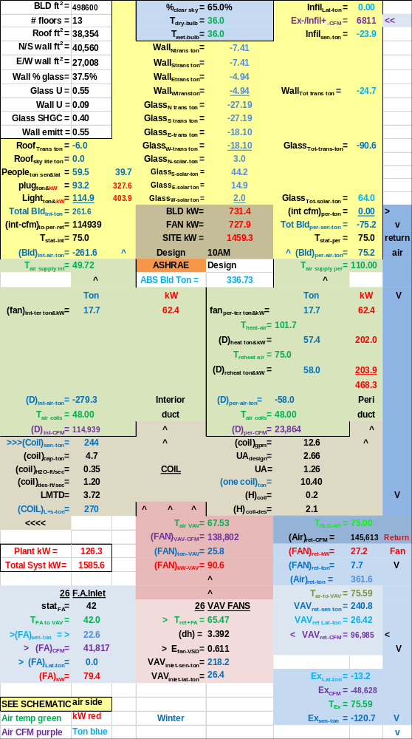
Figure 5-13: 48F SAT Design with 110F heating air, winter 10AM

Chapter 6 Building Energy Transfer via stat set points
Figure 4-9 from above gives an annual (bEQ) of 67.80 for the 55F design and Figure 4-10 gives 71.31 for the 48F SAT design as shown below.
Copy Fig 4-9 & 4-10
Both of these designs deliver 94F heated air to the perimeter as required by ASHRAE Standard 90.1-2010. Changing to a perimeter heating air temperature of 110F significantly reduces the (bEQ) of the 48F SAT design as shown by Figure 5-1 from above.
Copy-Figure 5-1: Heat air = 110F
The (bEQ) value has dropped from 71.31 to 63.26, an 11% decrease by just increasing the temperature of the heated air to the perimeter from 94F to 110F. The reason for this drop in energy demand was examined in Chapter 5 above.
This Chapter 6 will look at controlling thermostat set points to transfer energy within the building for the purpose of reducing kW demand. Figure 6-1 gives the annual (bEQ) for this control strategy, a drop from 63.26 to 60.13 a 5% reduction for the 48F SAT design. The side by side air side schematics below will provide understanding of this energy saving control concept.
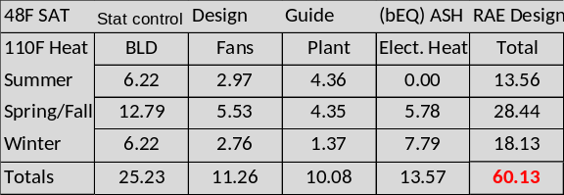
Figure 6-1: Includes stat control

Figure 6-2: No stat set control

Figures 6-2 & 6-3 illustrate that controlling stat set points can result in significant reductions in system kW demand. Side by side schematics at 4PM below will provide understanding.

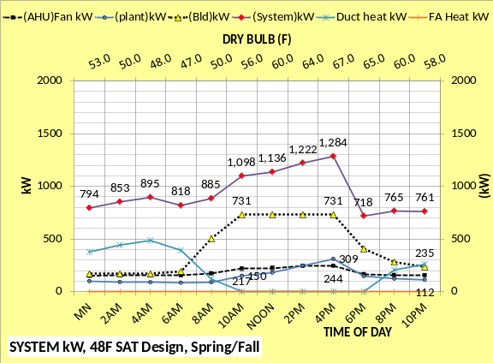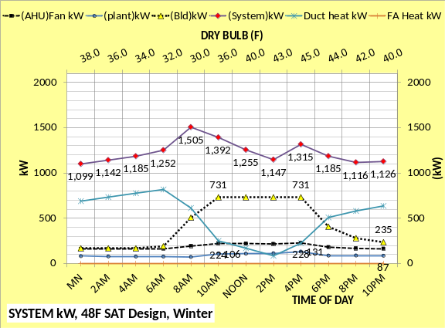
Figure 6-3: With stat set control

Figure 6-4: No stat set control 4PM winter
The concept is to transfer energy within the building for the purpose of reducing system kW demand. The path of return air will determine how stats should be set to accomplish the purpose. For this design all return air goes to the perimeter of the building; therefore the interior air goes to the perimeter.
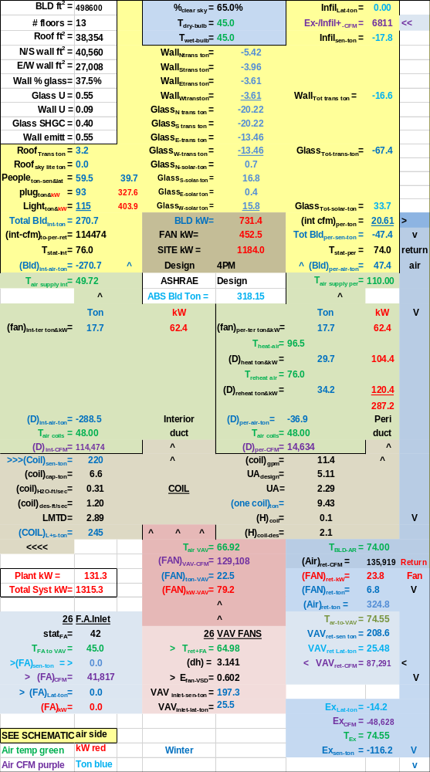
Figure 6-5: With stat set control 4PM winter
Figure 6-5 has the interior stats set at 76F and the perimeter stats set at 74F. the result is the interior 76F air moves to the perimeter and provides 20.61 ton of heat therefore reducing reheat VAV CFM & therefore air handler kW plus reduce plant load & plant kW.

Chapter 7 Air Economizer
Duda¹ item 2 under disadvantages of cold air gives a discussion that is for the most part not supported by this analysis. The issue is much more complicated than given by Duda¹ that suggests fresh air cooling is a function of SAT; this system analysis shows that return air temperature is one of the controlling variables and SAT is not relevant. The coil is a controlling component in the concept of fresh air cooling as will be shown below.
See conclusions to Chapter 7 below for more detail.

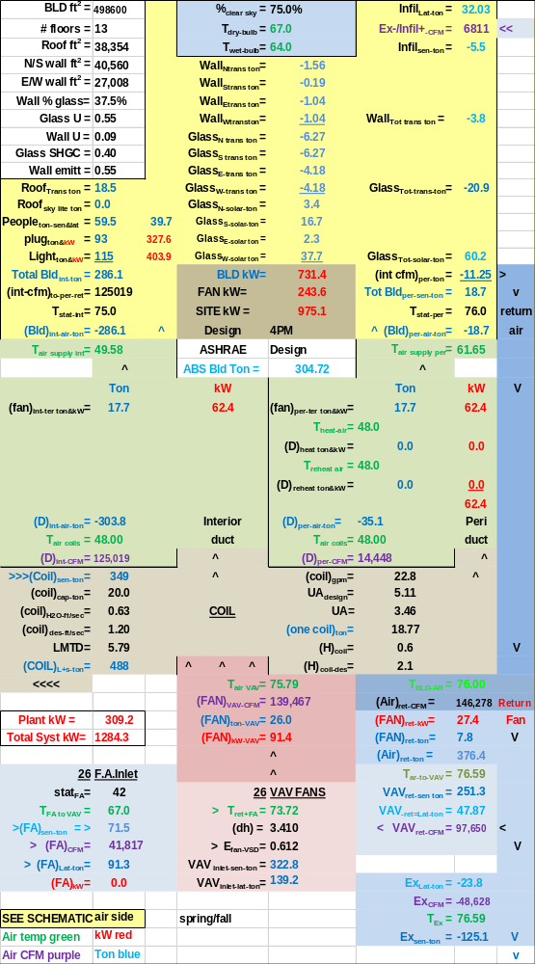
Figure 7-1: With stat set control 4PM Spring/Fall-Design FA
Figure 7-1 is a system in energy equilibrium as designed and controlled as discussed above. Figure 7-2 increases the fresh air from design 41,817 CFM to 136,551 CFM. Several changes occur. The fresh air latent load on the coil increases from 488 ton to 567 ton but the coil sensible load decreases from 349 ton to 267 ton. However
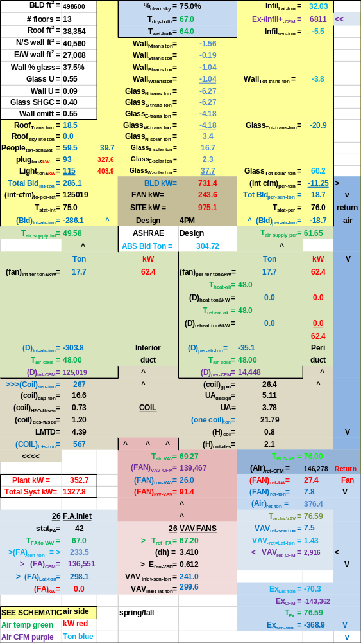
Figure 7-2: With stat set control 4PM Spring/Fall-Increased FA
none of that matters because the coil is over loaded with a load of 21.79 ton & a capacity of 16.6 ton; something must change and that something is an increase in SAT until the system is in energy equilibrium. This will occur without any control changes. The next Figure 7-3 illustrates.

Figure 7-1: With stat set control 4PM Spring/Fall-Design FA
Figure 7-1 is copied to give a side by side comparison. Figure 7-3 illustrates a system in energy equilibrium with the coil capacity equal to the coil load and the fresh air is increased from 41,817 CFM to 145,775 CFM. The coil was unable to supply 48F SAT so SAT increased to an energy equilibrium condition. Figure 7-3 illustrates more fresh
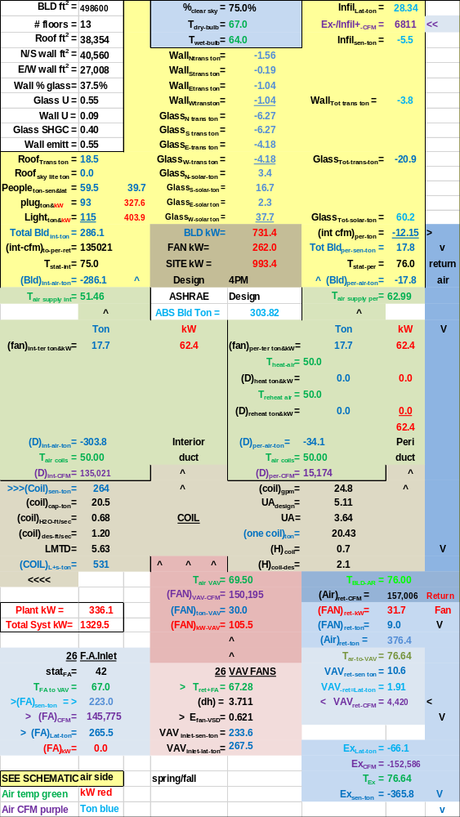
Figure 7-3: With stat set control 4PM Spring/Fall-Increased FA-Coil OK due to 50F SAT
air into the system that reduced the air inlet temp to the VAV fans from 73.72F down to 67.28F but the net effect is the system kW increased from 1284.3 kW to 1329.5 kW because the fan kW had to increase because CFM increased and therefore the plant load increased; economizer increased system kW.
Figure 7-4: 4PM winter conditions Design FA-coil over loaded.
Figure 7-4 illustrates the system with design fresh air CFM at winter conditions and the selected coil is over loaded. Something must change and it will most likely be an increase in SAT as shown by Figure 7-5 which illustrates very little changed as SAT increased to 50F.

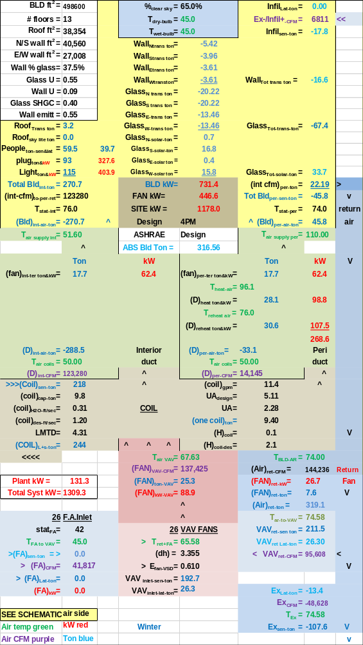
Figure 7-5: 4PM winter conditions Design FA-coil ok
Figure 7-5 shows 95,608 CFM of 74F return air to the suction side of the VAV fans so a lot more fresh air cooling with 45F outside air can occur. The next Figure 7-6 will increase fresh air CFM.

Copy-Figure 7-5: 4PM winter conditions Design FA-coil ok
SAT =50F to balance.
Figure 7-6 illustrates that as the system balances at FA CFM = 86,691, SAT increases to 59F & the VAV fan CFM necessarily must increase so we now have 112,373 CFM of 74F return air verses 95,608 CFM before the fresh air CFM was increased from 41,817 to 86,691 CFM.

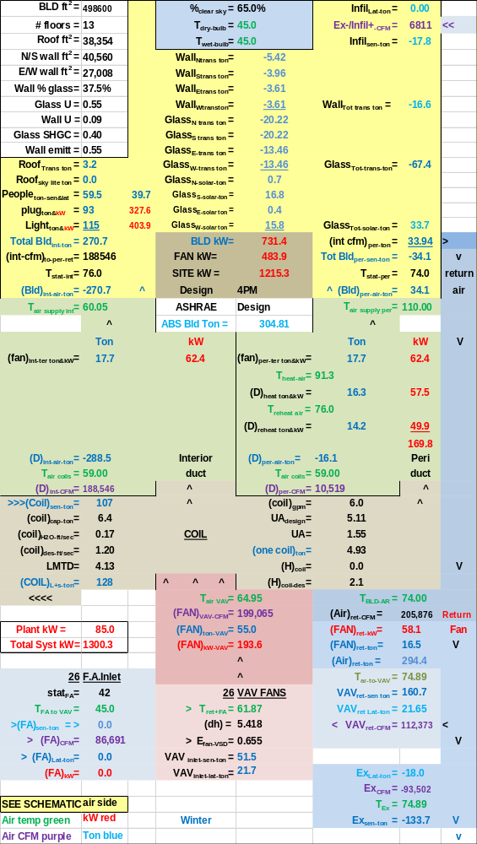
Figure 7-6: 4PM winter-increased FA-coil ok
SAT=59F to balance
As the fresh air CFM is increased SAT must increase because of the coil capacity and an SAT increase increases the VAV CFM, apparently the system is in a dive. Let’s try one more time to increase fresh air CFM.

Copy Figure 7-6: 4PM winter-increased FA-coil ok
SAT=59F to balance
Figure 7-7 illustrates the dive continues as SAT increased to 62F to balance an increase in fresh air CFM from 86,691 to 111,621. Figure 7-7 also shows we have more return to the VAV fans increasing from 112,373 CFM to 125,602 CFM.

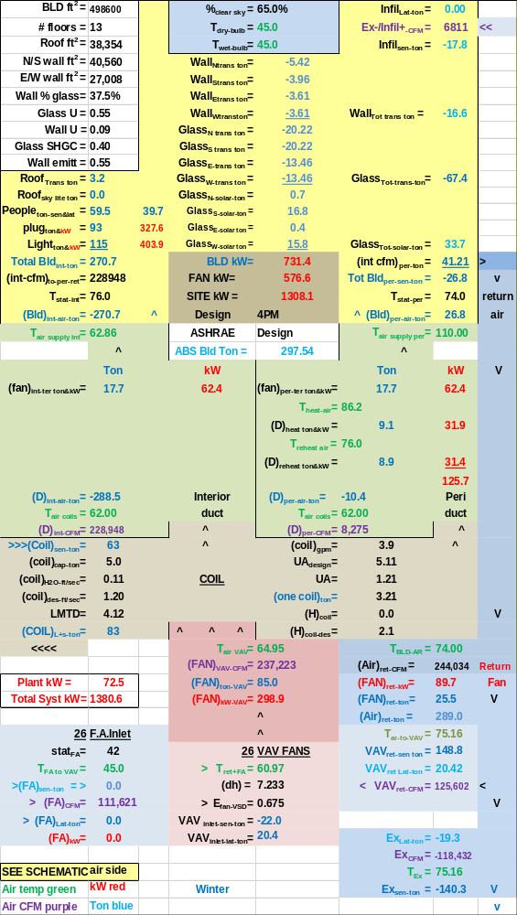
Figure 7-7: 4PM winter-increased FA-coil ok
SAT=62F to balance
Clearly as the fresh air CFM is gradually increased the system goes into a dive where SAT must increase for the system to balance. Let’s see what happens if the plant is turned off, with exception of pumps, and the building is flushed with outside air as shown by Figure 7-8.

Copy Figure 7-5: 4PM winter conditions Design FA-coil ok
SAT = 50F
Figure 7-5 is where we started with SAT increasing from 48F to 50F to balance with design fresh air of 41,817 CFM into the system. Figure 7-8 brings in sufficient fresh air to provide 48F SAT with the plant chillers off. The system kW drops from 1309.3 kW to 1211.0 kW, about 8% with the plant off.
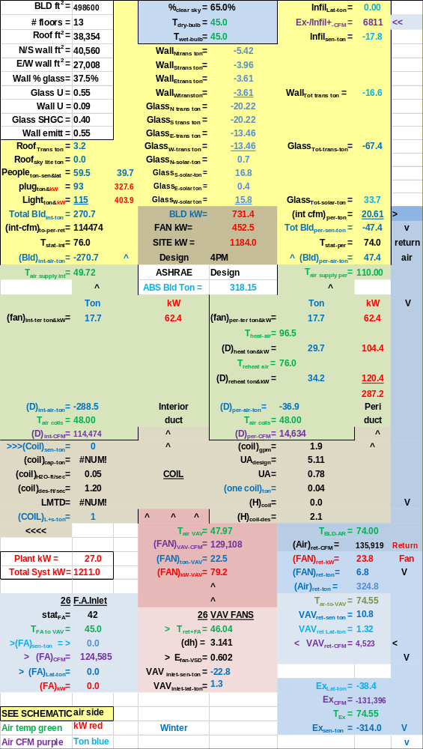
Figure 7-8: 4PM winter-Plant off flush with FA-coil not needed-
SAT=48F due FA=45F
Note that if the freeze stat was set higher than 42F this analysis could significantly change.
Conclusions regarding air economizer:
This analysis has shown that fresh air cooling is a complex issue that requires designing the coil to not only meet peak summer day conditions but also winter conditions. If the coil is under sized for required fresh air at winter weather then the system will go into an inefficient dive as the fresh air is increased. A way out of this inefficient dive is to flood the system with fresh air if fresh air alone can meet the load and therefore turn the plant off. Asking auto controls to make this decision might be risky.
The fact that as more fresh air is brought into the system the coil capacity decreases is a major impairment to an air economizer. Also keep in mind that the air economizer only effects the plant kW and the plant kW is relatively small during winter operation. Also if the coil is not selected/sized to take increased outside air then the fan CFM will increase and drive system kW up. The bottom line to this complexity may be to only use air economizer when the outside air will permit turning the plant off, and that as stated above has some risk.
Final Conclusions: This analysis has shown that fresh air cooling can result in an increase in system kW demand. Designing a coil for fresh air cooling is necessary.

References
- ASHRAE Journal December 2016, “A Critical Look at Cold Supply Air Systems” by Stephen W. Duda, P.E.
- Liu, B. May 2011. “Achieving the 30% Goal: Energy and Cost Savings Analysis of ASHRAE Standard 90.1-
2010” Pacific Northwest National Laboratory. http://www.energycodes.gov/achieving-30-goal-energy-and-cost-savings-analysis-ashrae-standard-901-2010
- Marley 2014 SPX Cooling Technologies Update
- Taylor, S. 2011. “Optimizing Design & Control of Chilled Water Plants.” ASHRAE Journal

NOMENCLATURE
Air Side System Nomenclature
Each of the more than 100 variables of the air side system will be defined.
Building structure;
BLD ft² = air conditioned space
# Floors = number of building floors
Roof ft² = roof square feet
N/S wall ft² =north/south wall square feet
E/W wall ft² =east/west wall square feet
Wall % glass = percent of each wall that is glass
Glass U = glass heat transfer coefficient
Wall U = wall heat transfer coefficient
Glass SHGC = glass solar heat gain coefficient
Wall emit = wall solar index
Building interior space;
Roof_{trans-ton} =transmission through roof (ton)
Roof_{sky-lite-ton} =sky lite load (ton)
People_{ton} = cooling load due to people (ton)
Plug_{ton&kW} = cooling load & kW due to plug loads
Light_{ton&kW} = cooling load & kW due to lights
Total Bld_{int-ton} = total building interior load (ton)
(int-cfm) _{to-per-return} = CFM of interior supply air that returns to perimeter of building
T_{stat-int} = interior stat set temperature (F)
Bld_{int-air-ton} = supply air ton to offset interior load
BLD kW = total building kW demand
Building perimeter space;
%_{clear sky} = percent clear sky
T_{dry bulb} = outside dry bulb temperature (F)
T_{wet bulb} = outside wet bulb temperature (F)
Infil_{lat-ton} = latent load due to air infiltration (ton)
Infil_{CFM} = air infiltration CFM
Exfil_{CFM} = air exfiltration CFM
Infil_{sen-ton} = sensible load due to air infiltration (ton)
Exfil_{sen-ton} =sensible load due to air exfiltration (ton)
Wall_{n trans ton} = north wall transmission (ton)
Wall_{s trans ton} = south wall transmission (ton)
Wall_{E trans ton} = east wall transmission (ton)
Wall_{w trans ton} = west wall transmission (ton)
Wall_{tot-trans-ton} = total wall transmission (ton)
Glass_{N-trans-ton} = north wall glass transmission (ton)
Glass_{S-trans-ton} = south wall glass transmission (ton)
Glass_{E-trans-ton} = east wall glass transmission (ton)
Glass_{W trans-ton} = west wall glass transmission (ton)
Glass_{tot-trans-ton} = total transmission thru glass (ton)
Glass_{N-solar-ton} = north glass solar load (ton)
Glass_{S-solar-ton} = south glass solar load (ton)
Glass_{E-solar-ton} = east glass solar load (ton)
Glass_{W-solar-ton} = west glass solar load (ton)
Glass_{tot-solar-ton} = total glass solar load (ton)
(int cfm)_{per-ton} = effect of interior CFM to wall (ton)
Total Bld_{per-sen-ton} total perimeter sensible load (ton)
T_{stat-per} = perimeter stat set temperature (F)
Bld_{per-air-ton} = supply air ton to offset perimeter load
Air handler duct system
Interior duct
T_{air supply int} = temp air supply to building interior (F)
(fan)_{int ter ton&kW} = interior ton & kW due to terminal fans
(D)_{int-air-ton} = cooling (ton) to building interior duct
T_{air coils} = supply air temperature off coils to duct (F)
(D)_{int-CFM} = supply air CFM to building interior duct
Perimeter duct
T_{air supply per} =temp (F) air supply to building perimeter
(fan)_{per ter ton&kW} = perimeter ton & kW of terminal fans
T_{heat-air} = temp supply air before terminal fan heat (F)
(D)_{heat-ton&kW} = heat to perimeter supply air ton & kW
T_{reheat air} = temp perimeter supply air after reheat (F)
(D)_{reheat ton&kW} = reheat of perimeter supply air ton & kW
(D)_{per-air-ton} = cooling (ton) to perimeter duct
T_{air coils} = supply air temperature off coils to duct (F)
(D)_{per-CFM} = supply air CFM to perimeter duct
(ABS Bld Ton) = absolute building load on (CCWS)
Coil
(coil)_{sen-ton} = sensible load on all coils (ton)
(coil)_{cap-ton} = LMTD * UA = capacity (ton) one coil
(coil)_{H2O-ft/sec} = water velocity thru coil (ft/sec)
(coil)_{design-ft/sec} = coil design water velocity (ft/sec)
LMTD = coil log mean temperature difference (F)
(coil)_{L+s-ton} = latent + sensible load on all coils (ton)
(coil)_{gpm} = water flow (gpm) thru one coil
UA_{design} = coil UA design value
UA = coil heat transfer coefficient * coil area. UA varies as a function water velocity (coil)_{gpm} thru the coil, as the (coil)_{gpm} decreases the coil capacity decreases.
(one coil)_{ton} = load (ton) on one coil
(H)_{coil} = air pressure drop thru coil (inches)
(H)_{coil-design} = design air pressure drop (inches)
VAV Fan system
Fresh air
stat_{FA} = fresh air freeze stat set temperature (F)
T_{FA to VAV} = temperature of fresh air to VAV fan
(FA)_{sen-ton} = fresh air sensible load (ton)
(FA)_{CFM} = CFM fresh air to VAV fan inlet
(FA)_{Lat-ton} = fresh air latent load (ton)
(FA)_{kW} = heat kW to stat_{FA} set temperature
Air return
T_{BLD-AR} = return air temp (F) before return fans
(Air)_{ret-CFM} = CFM air return from building
(FAN)_{ret-kW} = return fans total kW
(FAN)_{ret-ton} = cooling load (ton) due to (FAN)_{ret-kW}
(Air)_{ret-ton} = return air (ton) before return fans
T_{AR to VAV} = T_{BLD-AR} + delta T due to return fans kW
VAV_{ret-ton} = return (ton) to VAV fans inlet
Infil_{VAV-Lat-ton} = infiltration latent (ton) to VAV fans
VAV_{ret-CFM} = return CFM to VAV fans inlet
Exhaust air
Ex_{Lat-ton} = latent load (ton) exhausted
Ex_{CFM} = CFM of exhaust air
T_{Ex} = temperature of exhaust air
Ex_{sen-ton} = sensible load (ton) exhausted
VAV Fans
T_{ret+FA} = return and fresh air mix temperature (F)
(dh) = VAV air static pressure (in)
E_{fan-VSD} = VAV fans efficiency
VAV_{inlet-sen-ton} = sensible load (ton) inlet to VAV fans
VAV_{inlet-lat-ton} = latent load (ton) inlet to VAV fans
T_{air-VAV} = temp air to coils after VAV fan heat
(FAN)_{VAV-CFM} = CFM air thru coils
(FAN)_{ton-VAV} = load (ton) due to VAV fan kW
(FAN)_{kW-VAV} = total VAV fan kW demand
AIR SIDE SYSTEM PLUS BUILDING
FAN kW = total air handlers kW
SITE kW = total site or air side kW
Plant_{ton} = load (ton) to plant
CENTRAL PLANT
Nomenclature will be defined by addressing each component of the plant.
Primary/secondary pumping nomenclature
gpm_{evap} = total gpm flow thru evaporators
(H)_{pri-total} = total primary pump head (ft) = (H)_{pri-pipe} + (H)_{pri-fittings} + (H)_{pri-bp} + (H)_{evap}
(H)_{pri-pipe} = primary pump head due to piping (ft)
(H)_{pri-fittings} = primary head due to pump & fitting (ft)
(Ef)_{c-pump} = efficiency of chiller pump
P_{c-heat-ton} = chiller pump heat to atmosphere (ton)
P_{c-kW} = one chiller pump kW demand (kW)
P_{chiller-#} = number chiller pumps operating
(lwt)_{evap} = temperature water leaving evaporator (F)
T_{bp} = temperature of water in bypass (F)
gpm_{bp} = gpm water flow in bypass
(H)_{pri-bp} = head if chiller pump flow in bypass (ft)
(ewt)_{evap} = temp water entering evaporator (F)
P_{sec-heat-ton} = secondary pump heat to atmosphere (ton)
P_{sec-kW} = kW demand of secondary pumps
Ef_{des-sec-p} = design efficiency of secondary pumping
Ef_{sec-pump} = efficiency of secondary pumping
(H)_{sec} = secondary pump head (ft) = (H)_{sec-pipe} + (H)_{sec-bp} + (H)_{coil} + (H)_{valve}
(H)_{sec-pipe} = secondary pump head due to pipe (ft)
(H)_{sec-bp} = head in bypass if gpm_{sec} > gpm_{evap}
gpm_{sec} = water gpm flow in secondary loop
(ewt)_{coil} = water temperature entering coil (F)
Plant_{ton} = load (ton) from air side to plant
Pipe_{size-in} = secondary pipe size (inches)
(lwt)_{coil} = temperature of water leaving coil (F)
Evaporator
(evap)_{ton} = load (ton) on one evaporator
T_{ER} = evaporator refrigerant temp (F)
T_{ER-app} = evaporator refrigerant approach (F)
EVAP_{ton} = total evaporator loads (ton)
(H)_{evap} = pump head thru evaporator (ft)
(evap)_{ft/sec} = velocity water flow thru evaporator
(evap)_{des-ft/sec} = evaporator design flow velocity
Compressor:
(chiller)_{kW} = each chiller kW demand
(chiller)_{lift} = (T_{CR} – T_{ER}) = chiller lift (F)
(chiller)% = percent chiller motor is loaded
(chiller)# = number chillers operating
(CHILLER)_{kW} = total plant chiller kW
(chiller)_{kW/ton} = chiller kW per evaporator ton
Plant kW = total kW demand of plant
Condenser nomenclature:
(cond)_{ton} = load (ton) on one condenser
T_{CR} = temperature of condenser refrigerant (F)
T_{CR-app} = refrigerant approach temperature (F)
(COND)_{ton} = total load (ton) on all condensers
(H)_{cond} = tower pump head thru condenser (ft)
(cond)_{ft/sec} = tower water flow thru condenser
Tower piping nomenclature
Pipe_{size-in} = tower pipe size (inches)
gpm_{T} = each tower water flow (gpm)
(H)_{T-total} = total tower pump head (ft)
P_{T-heat} = pump heat to atmosphere (ton)
P_{T-kW} = each tower pump kW demand
Ef_{T-pump} = tower pump efficiency
P_{tower #} = number of tower pumps
(H)_{T-pipe} = total tower pump head (ft)
(ewt)_{T} = tower entering water temperature (F)
(H)_{T-static} = tower height static head (ft)
T_{range} = tower range (F)= (ewt)_{T} – (lwt)_{T}
(lwt)_{T} = tower leaving water temperature (F)
T_{approach} = (lwt)_{T} – (T_{wet-bulb})
Tower nomenclature
t_{fan-kW} = kW demand of one tower fan
T_{fan-kW} = tower fan kW of fans on
t_{fan-%} = percent tower fan speed
t_{ton-ex} = ton exhaust by one tower
T# = number of towers on
T_{ton-ex} = ton exhaust by all towers on
T_{rg+app} = tower range + approach (F)
One hour performance indices
BLD_{kW} = kW demand of building lights & plug loads
Fan_{kW} = air side fans kW, VAV, return terminals
Duct_{heat} = perimeter heat to air supply
FA_{heat} = heat added to fresh air
Heat_{total} = total heat added to air
Plant_{kW} = total plant kW
Syst_{kW} = total system kW
CCWS_{kW} = air side + plant kW
Chiller_{kW/evap ton} = chiller kW/evaporator ton performance
Plant_{kW/site ton} = plant kW per site or air side ton
CCWS_{kW/site ton} = CCWS kW per load to plant
Weather_{Ein-ton} = weather energy into the system
Site_{kW-Ein-ton} = load (ton) due to site kW
Plant_{kW-Ein-ton} = load (ton) due to plant kW
Total_{Ein-ton} = total energy in to system (ton
Pump_{tot-heat-ton} = total pump heat out (ton)
AHU Ex_{lat ton} = air exhausted latent ton
AHU Ex_{sen ton} = air exhausted sensible ton
Tower T_{ton Ex} = energy exhausted by tower (ton)
Total E_{out ton} = total energy out of system (ton)
24 hour performance indices
BLD_{24hr-kW} = building 24 hour kW usage
Fan_{24hr-kW} = fan system 24 hour kW usage
Duct_{24hr-heat kW or therm} = duct heat
FA_{24hr heat kW or therm} = fresh air heat
Heat_{24hr total kW or therm} = total heat into system air
Plant_{24hr kW} = plant 24 hour kW usage
Syst_{24hr kW & therm} = total system 24 hour energy usage
(CCWS)_{24hr-kW} = Central chilled water system (air side + plant) 24 hour kW usage
Weather_{24hr-Ein-ton} = 24 hour weather energy into system
SITE_{24hr-kW-Ein-ton} = 24 hour energy into site, building & air side system
Plant_{24hr-kW-Ein-ton} = 24 hour kW energy into plant
Total_{24hr-Ein-ton} = total 24 hour energy into system
Pump_{24hr Heat out-ton} = pump heat to atmosphere (ton)
AHU Ex_{24hr Lat ton} = exhausted latent load from building
AHU Ex_{24hr-sen-ton} = exhausted sensible load from building
Tower_{24hr out-ton} = tower exhaust from system (ton)
Total E_{24hr-out-ton} = total 24 hour energy out of system

