“Prescription for Chiller Plants” Modeled
The purpose of this paper is to add to the understanding of the design and performance of chiller plants by modeling the chiller plant as defined by Baker¹ in a 2006 ASHRAE Journal supplement. The plant model is a System Energy Equilibrium (SEE) model as defined by Nelson². This paper will provide answers to several questions posed by the Baker¹ article. Go to the end of this paper for content and conclusions/summary.
Chiller Plant Defined
Baker¹ defines the chiller capacity as 750 ton with the following flow and supply water temperatures.
1125 gpm x (58F -42F)/24 = 750 ton design capacity, (Table 1 of Baker¹)
The two new chiller’s performance is defined as .571 kW/ton at design conditions. Therefore 750 ton times .571 kW/ton = 428.25 kW required by each of the two new chillers to provide 750 ton of 42F supply water.
Tower load
The chiller motor adds heat to the refrigerant system; 428.25 kW/3.517 kW/ton = 121.8 ton, transferred to the chiller condenser via the refrigerant and therefore load on the cooling tower.
The load on the tower = 750 ton + 121.8 ton = 871.8 ton. The tower pump also adds load to the cooling tower.
Baker¹ defines the design tower load as; 2250 gpm x (93.4F – 84F)/24 = 881.25 ton.
Therefore the tower load due to the condenser pump = 881.25 ton – 871.8 ton = 9.45 ton.
Condenser Pump
The condenser pump efficiency is given¹ as 85%. The (SEE) model models 85% of the energy to the condenser pump goes into the plant thermodynamic system and is therefore a load on the tower and 15% of the condenser pump energy is lost to the atmosphere as heat. Therefore the total condenser pump energy = 9.45 ton/.85 = 11.12 ton total energy to the condenser pump; and 11.12 ton x 3.517 kW/ton = 39.1 kW required by the condenser pump. The design value of the condenser pump, as given by Baker¹, is (60 HP/.85) x .746 kW/HP = 52.66 kW. Therefore 39.1 kW/52.66 kW = 74 % of the condenser pump capacity is required to move 2250 gpm thru the condenser/tower piping system.
Small Tower Defined
As defined above the design load on each of the new towers is 881.25 ton, however Baker¹ chose to install a larger tower capable of greater load as given by¹;
2250 gpm x (95F – 84F)/24 = 1031.3 ton capacity.
This bigger tower of 1031.3 ton design capacity will be selected and installed into the (SEE) plant model but first the smaller tower must be selected and installed into the (SEE) plant model in order to determine the new chiller performance characteristics not given by Baker¹.
Towers Selected
The (SEE) Plant Model input must include the design refrigerant approach temperatures for both the condenser and evaporator, values that are readily available from chiller manufactures but not given by Baker¹. The values will be determined here by analysis but first the towers must be selected. Baker¹ defines both towers with a design wet bulb of 76F, therefore the tower approach is (84F – 76F = 8F) and the range is (95F – 84F = 11F). The tower fan horsepower is given as 40hp for both the small tower and the bigger tower. Inputting these condition and requirement for a 40 hp tower into a tower manufactures selection program³ gave the two towers to be input to the (SEE) model.
Tower | Small Tower | Big Tower
Design Wet bulb | 76.0F | 76.0F
Design Load | 881.25 ton | 1031.3 ton
Tower water flow | 2250 gpm | 2250 gpm
Approach temp. | 8.0F | 8.0 F
Range | 9.43F | 11.05F
Range + approach | 17.43F | 19.05F
Fan HP | 40 | 40
Selected Tower³ | NC8409TAN1 | NC8410TAN1
Tower Cold water | 84F | 84F
Return water to tower | 93.43F | 95.05F
Capacity | 104.2% | 102.5%
ASHRAE 90.1 gpm/Hp | 65.8 | 70.5
Static lift feet | 12 | 16
Table 1: Selected Towers
The big tower is selected with a larger load than actually exists and therefore will provide water colder than 84F when matched to the 750 ton chillers. The colder water with the big tower reduces chiller lift and therefore chiller kW. Details of this (SEE) Model result with the big tower will be demonstrated later in this series of papers.
Chiller coefficient of performance (COP)
A defining characteristic of a chiller/tower and a required input to the (SEE) plant model is the design ratio of actual COP divided by maximum COP. The maximum COP, Carnot cycle, of the (SEE) modeled chiller/tower is defined by the condenser and evaporator refrigerant temperatures and that is the reason the (SEE) Plant Model must have the condenser and evaporator refrigerant approach temperatures.
The actual COP of the chiller matched to the small tower is defined by cooling provided divided by power required.
Actual COP = (750 ton * 12000 btu/ton) / (428.25kW * 3413 btu/kW) = 6.158.
The COP ratio is 6.158/max COP.
To calculate this max COP value the condenser and evaporator refrigerant approach temperatures are needed but as stated above not given by Baker¹.
Reference 2, System Energy Equilibrium (SEE) Model Development and Verification², chapter 5 figure 5-17 gives COP ratio value for a series of chiller/towers that vary from about .712 up to .728 and based on this data a COP ratio value of .72 will be assumed for the new chillers of Baker¹.
Therefore;
COP ratio = .72 = actual COP/Max COP =
6.158/Max COP
And
Max COP = 6.158/.72 = 8.56
And
Max COP⁴ = T2/ (T1 – T2) = 8.56
Where;
T2 = absolute evaporator refrigerant temperature. T1 = absolute condenser refrigerant temperature.
Trial and error analysis could be used to determine the refrigerant approach temperatures that match the .72 COP ratio but using the (SEE) Plant Model is a much more efficient method. Figure 1 illustrates the (SEE) Model result. Table 1 shows the small selected tower as having a capacity of 104.2%, therefore the (SEE) Model calculates the condenser leaving water as 93.09F as shown by Figure 1 versus the Table 1 design value of 93.43F. The calculated values for refrigerant approach temperatures of 3.6F for both the condenser and evaporator are;

Max COP⁴ = T2/ (T1-T2) where
T2 = absolute evaporator refrigerant temperature. For an evaporator refrigerant approach of 3.6F; T2 = (42.06F-3.6F) + 460F = 38.46F + 460F = 498.46F
T1 = absolute condenser refrigerant temperature. For a condenser refrigerant approach of 3.6F; T1 = (93.09F + 3.6F) + 460F = 96.69F + 460F = 556.69F
Max COP⁴ = T2/(T1-T2) =(498.46)/(556.69-498.46) = 8.56
As stated above the actual COP of the chiller/tower is defined by cooling provided/power required.
Actual COP = 6.158.
The calculated COP ratio is 6.158/8.56 = .72 as assumed and input to the (SEE) Model.
The chiller manufacture can provide the refrigerant approach temperatures for the condenser and evaporator and the COP ratio can be calculated as shown above. All three values are necessary inputs to the (SEE) Plant Model.
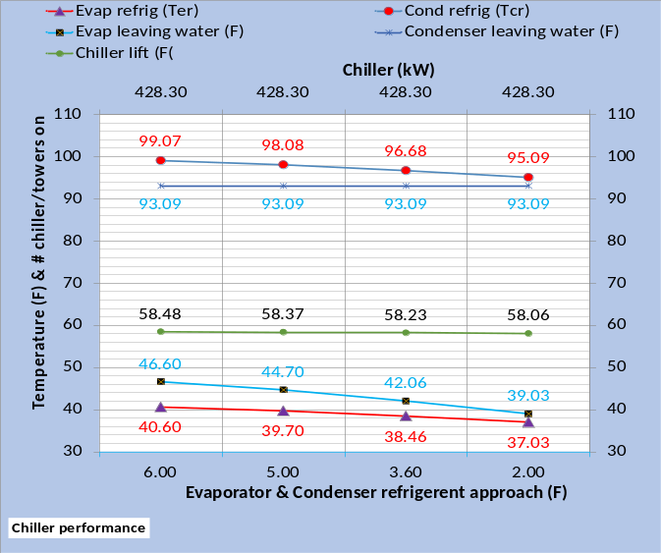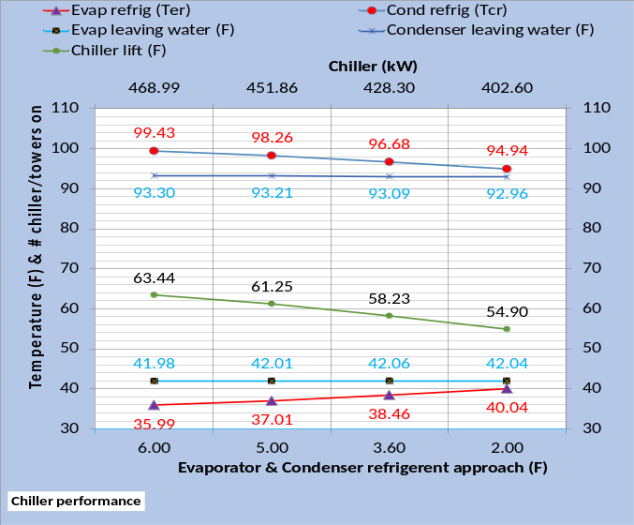
Figure 1: For COP ratio = .72 Small Tower Installed in (SEE) Plant Model-Chiller performance with changing refrigerant approach temperatures. Top chart constant chiller kW and bottom chart with chiller kW that gives 42F supply water.

Figure 1 illustrates how the chiller kW must increase to provide 42F supply water with the refrigerant approach temperature greater than 3.6F and chiller kW can decrease for a condenser and evaporator refrigerant approach of less than 3.6F. A COP ratio different than .72 would give different Figure 1 results.
Chiller lift is the driving issue, as the lift increases the chiller kW must increase to provide the desired supply water temperature. Figure 1 top chart illustrates an essentially constant chiller lift because the supply water temperature and condenser refrigerant temperature increases as the refrigerant approach temperatures increase. Figure 1 bottom chart illustrates that as the chiller kW increases to provide 42F supply water the condenser refrigerant temperature decreases and therefore chiller lift increases for refrigerant approach greater than 3.6F and decreases for less than 3.6F refrigerant approach.
Figure 1 is for a COP ratio of .72 as discussed above. A chiller/tower design with a slightly different COP ratio would result in slightly different condenser and evaporator refrigerant approach temperatures required to provide 42F supply water. The manufacture can provide refrigerant approach temperatures at design conditions. Go to kirbynelsonpe.com² and click on System Energy Equilibrium (SEE) Model Development and Verification² for a detail analysis of the issues discussed here.

Plant with small tower-Schematics

The (SEE) Model can provide schematics that the author has found to be very valuable in understanding a plant’s performance. Schematic 1 is at design conditions with the small towers installed in a two chiller (SEE) Plant Model, providing 42.06F supply water as also shown by Figure 1 with 3.6F refrigerant approach temperatures.
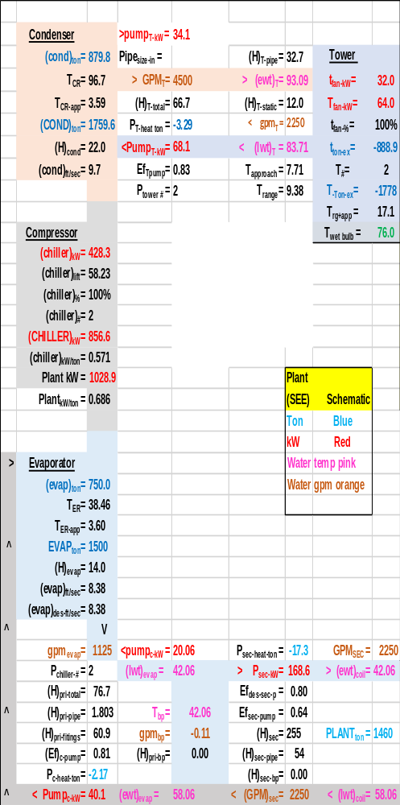
Schematic 1: Plant with small tower at design conditions of refrigerant approach 3.6F for both condenser & evaporator.

Schematic 1 and Table 2 are at design conditions providing the same plant performance data. The schematic provides more data and more clearly illustrates the plant performance at design conditions.
R  O  w | Two chiller plant  At design conditions | Small Tower, chiller refrig. app. = 3.6F
1 | Wet bulb | 76F
2 | Plant load | 1460 ton
3 | Evap. load | 1500 ton
4 | Ea. Evap. load | 750 ton
5 | Ea. Evap. flow | 1125gpm
6 | Evap. Refrig. App. | 3.6F
7 | Evap. Refrig temp. | 38.46F
8 | Chiller Lift | 58.23F
9 | Supply water | 42.06F
10 | Return water | 58.06F
11 | Ea. Cond. load | 879.8 ton
12 | Ea. Tower flow | 2250gpm
13 | Cond. Refrig. app. | 3.59F
14 | Cond Refrig temp. | 96.7F
15 | Tower cold water | 83.71F
16 | Tower return | 93.09F
17 | Tower app. | 7.71F
18 | Tower range | 9.38F
19 | Tower rg + app. | 17.1F
20 | primary pumps | 40.1 kW
21 | Chillers | 856.6 kW
22 | Condenser pumps | 68.1 kW
23 | Tower fans | 64.0 kW
24 | Total Plant | 1028.9 kW
25 | Plant kW/ton | .686
26 | E in = E out
27 | Plant load | 1460 ton
28 | sec pump(.64*kW) | 30.7 ton
29 | pri pump(.81*kW) | 9.2 ton
30 | Chiller kW | 243.6 ton
31 | cond pump.85*kW | 16.4 ton
32 | Cond load | 1759.6 ton
33 | Tower fan kW | 18.2 ton
34 | Energy in = | 1778 ton
35 | Tower exh.=E out = | 1778 ton
Table 2: Plant performance with small tower

The next schematic and table will be for a refrigerant approach of 6F illustrating the differences as also shown by Figure 1.

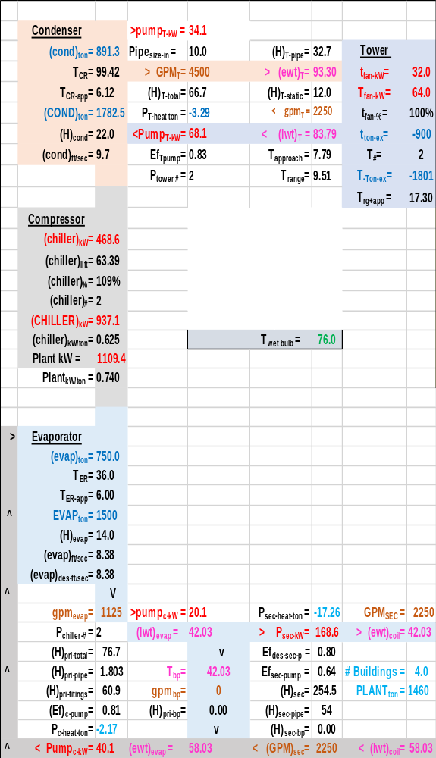
Schematic 2: Plant with small tower at design conditions & refrigerant approach of 6.0F for both condenser & evaporator.

R  O  w | Two chiller plant  At design conditions | Small Tower, chiller refrig. app. = 6.0F | Small Tower, chiller refrig. app. = 3.6F
1 | Wet bulb | 76F | 76F
2 | Plant load | 1460 ton | 1460 ton
3 | Evap. load | 1500 ton | 1500 ton
4 | Ea. Evap. load | 750 ton | 750 ton
5 | Ea. Evap. flow | 1125gpm | 1125gpm
6 | Evap. Refrig. App. | 6.00F | 3.6F
7 | Evap. Refrig temp. | 36.0F | 38.46F
8 | Chiller Lift | 63.39F | 58.23F
9 | Supply water | 42.03F | 42.06F
10 | Return water | 58.03F | 58.06F
11 | Ea. Cond. load | 891.3 ton | 879.8 ton
12 | Ea. Tower flow | 2250gpm | 2250gpm
13 | Cond. Refrig. app. | 6.12F | 3.59F
14 | Cond Refrig temp. | 99.42F | 96.7F
15 | Tower cold water | 83.79F | 83.71F
16 | Tower return | 93.30F | 93.09F
17 | Tower app. | 7.79F | 7.71F
18 | Tower range | 9.51F | 9.38F
19 | Tower rg + app. | 17.30F | 17.1F
20 | primary pumps | 40.1 kW | 40.1 kW
21 | Chillers | 937.1 kW | 856.6 kW
22 | Condenser pumps | 68.1 kW | 68.1 kW
23 | Tower fans | 64.0 kW | 64.0 kW
24 | Total Plant | 1109.4 kW | 1028.9 kW
25 | Plant kW/ton | .740 | .686
26 | E in = E out
27 | Plant load | 1460 ton | 1460 ton
28 | sec pump(.64*kW) | 30.7 ton | 30.7 ton
29 | pri pump(.81*kW) | 9.2 ton | 9.2 ton
30 | Chiller kW | 266.5 ton | 243.6 ton
31 | cond pump.85*kW | 16.4 ton | 16.4 ton
32 | Cond load | 1782.5 ton | 1759.6 ton
33 | Tower fan kW | 18.2 ton | 18.2 ton
34 | Energy in = | 1801 ton | 1778 ton
35 | Tower exh.=E out = | 1801 ton | 1778 ton
Table 3: Plant performance-small tower with changing refrigerant approach

Schematic 2 & Table 3 illustrate the performance difference with an increased, 6.0F refrigerant approach.

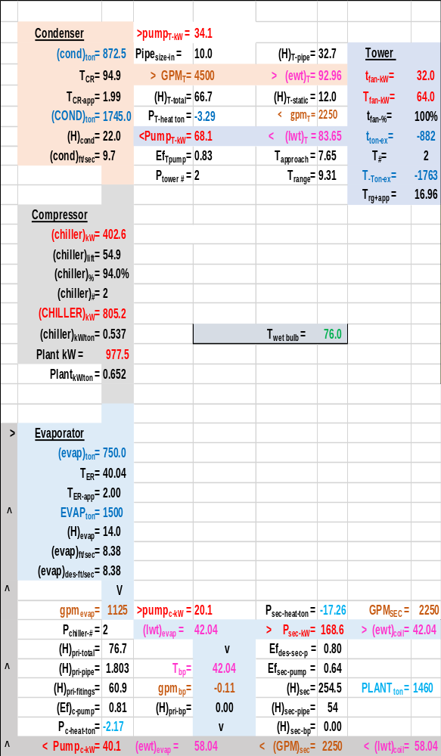
Schematic 3: Plant with small tower at design conditions & refrigerant approach of 2.0F for both condenser & evaporator.

R  O  w | Two chiller plant  At design conditions | Small Tower, chiller refrig. app. = 6.0F | Small Tower, chiller refrig. app. = 3.6F | Small Tower, chiller refrig. app. = 2.0F
1 | Wet bulb | 76F | 76F | 76F
2 | Plant load | 1460 ton | 1460 ton | 1460 ton
3 | Evap. load | 1500 ton | 1500 ton | 1500 ton
4 | Ea. Evap. load | 750 ton | 750 ton | 750 ton
5 | Ea. Evap. flow | 1125gpm | 1125gpm | 1125gpm
6 | Evap. Refrig. App. | 6.00F | 3.6F | 2.0F
7 | Evap. Refrig temp. | 36.0F | 38.46F | 40.04F
8 | Chiller Lift | 63.39F | 58.23F | 54.9F
9 | Supply water | 42.03F | 42.06F | 42.04F
10 | Return water | 58.03F | 58.06F | 58.04F
11 | Ea. Cond. load | 891.3 ton | 879.8 ton | 872.5 ton
12 | Ea. Tower flow | 2250gpm | 2250gpm | 2250gpm
13 | Cond. Refrig. app. | 6.12F | 3.59F | 1.99F
14 | Cond Refrig temp. | 99.42F | 96.7F | 94.9F
15 | Tower cold water | 83.79F | 83.71F | 83.65F
16 | Tower return | 93.30F | 93.09F | 92.96F
17 | Tower app. | 7.79F | 7.71F | 7.65F
18 | Tower range | 9.51F | 9.38F | 9.31F
19 | Tower rg + app. | 17.30F | 17.1F | 16.96F
20 | primary pumps | 40.1 kW | 40.1 kW | 40.1 kW
21 | Chillers | 937.1 kW | 856.6 kW | 805.2 kW
22 | Condenser pumps | 68.1 kW | 68.1 kW | 68.1 kW
23 | Tower fans | 64.0 kW | 64.0 kW | 64.0 kW
24 | Total Plant | 1109.4 kW | 1028.9 kW | 977.5 kW
25 | Plant kW/ton | .740 | .686 | .652
26 | E in = E out
27 | Plant load | 1460 ton | 1460 ton | 1460 ton
28 | sec pump(.64*kW) | 30.7 ton | 30.7 ton | 30.7 ton
29 | pri pump(.81*kW) | 9.2 ton | 9.2 ton | 9.2 ton
30 | Chiller kW | 266.5 ton | 243.6 ton | 229.0 ton
31 | cond pump.85*kW | 16.4 ton | 16.4 ton | 16.4 ton
32 | Cond load | 1782.5 ton | 1759.6 ton | 1745.0 ton
33 | Tower fan kW | 18.2 ton | 18.2 ton | 18.2 ton
34 | Energy in = | 1801 ton | 1778 ton | 1763 ton
35 | Tower exh.=E out = | 1801 ton | 1778 ton | 1763 ton
Table 4: Plant performance-small tower with changing refrigerant approach.

Row 8 of Table 4 illustrates how chiller lift decreases as the refrigerant approach temperature decreases. Row 21 gives the chiller kW and row 25 gives the plant kW/ton as the refrigerant approach temperatures is decreased from 6.0F down to 2.0F.
The reader is reminded go to kirbynelsonpe.com² and click on System Energy Equilibrium (SEE) Model Development and Verification² for a detail analysis of the effect of chiller refrigerant approach temperatures.
Next the big tower will be installed into the (SEE) Model Plant.

Install the Big Tower into (SEE) Plant Model

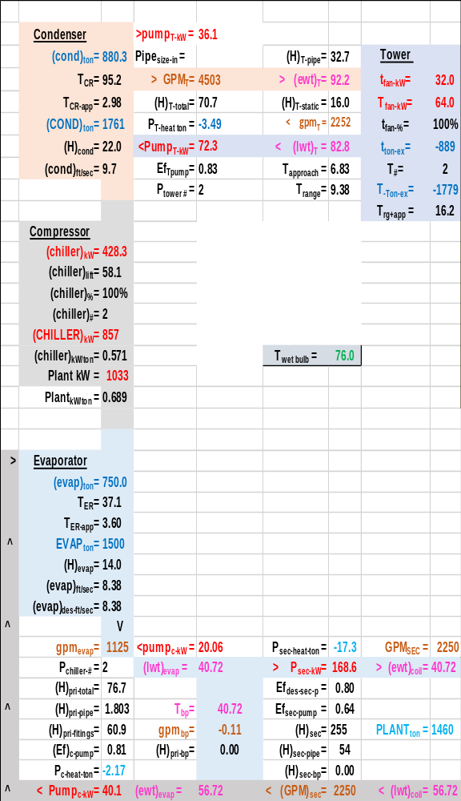
Schematic 4: Big Tower Installed, Chiller kW = 428.3 giving 40.72F supply water-refrigerant approach = 3.6F

Schematic 4 & Table 5 illustrate the positive effect of installing the big tower into the plant. The supply water drops to 40.72F, therefore the chiller kW can be reduced and still provide the design chiller water supply of 42F.

R  O  w | Two chiller plant  At design conditions | Small Tower, each chiller kW=428.3 app. = 3.6F | Big Tower, each chiller kW=428.3 app. = 3.6F
1 | Wet bulb | 76F | 76F
2 | Plant load | 1460 ton | 1460 ton
3 | Evap. load | 1500 ton | 1500 ton
4 | Ea. Evap. load | 750 ton | 750 ton
5 | Ea. Evap. flow | 1125gpm | 1125gpm
6 | Evap. Refrig. App. | 3.6F | 3.6F
7 | Evap. Refrig temp. | 38.46F | 37.1F
8 | Chiller Lift | 58.23F | 58.1F
9 | Supply water | 42.06F | 40.72F
10 | Return water | 58.06F | 56.72F
11 | Ea. Cond. load | 879.8 ton | 880.3 ton
12 | Ea. Tower flow | 2250gpm | 2252gpm
13 | Cond. Refrig. app. | 3.59F | 2.98F
14 | Cond Refrig temp. | 96.7F | 95.2F
15 | Tower cold water | 83.71F | 82.8F
16 | Tower return | 93.09F | 92.2F
17 | Tower app. | 7.71F | 6.83F
18 | Tower range | 9.38F | 9.38F
19 | Tower rg + app. | 17.1F | 16.2F
20 | primary pumps | 40.1 kW | 40.1 kW
21 | Chillers | 856.6 kW | 856.6 kW
22 | Condenser pumps | 68.1 kW | 72.3 kW
23 | Tower fans | 64.0 kW | 64.0 kW
24 | Total Plant | 1028.9 kW | 1033 kW
25 | Plant kW/ton | .686 | .689
26 | E in = E out
27 | Plant load | 1460 ton | 1460 ton
28 | sec pump(.64*kW) | 30.7 ton | 30.7 ton
29 | pri pump(.81*kW) | 9.2 ton | 9.2 ton
30 | Chiller kW | 243.6 ton | 243.6 ton
31 | cond pump.85*kW | 16.4 ton | 17.5 ton
32 | Cond load | 1759.6 ton | 1761 ton
33 | Tower fan kW | 18.2 ton | 18.2 ton
34 | Energy in = | 1778 ton | 1779 ton
35 | Tower exh.=E out = | 1778 ton | 1779 ton
Table 5: Plant performance with small & large tower-Design conditions

Row 8 of Table 5 illustrates the chiller lift is about the same for both chiller/towers and rows 7 & 14 give the refrigerant temperatures that define chiller lift. Row 21 illustrates the chiller kW is the same resulting in less chilled water supply temperature for the big tower as given by row 9.
Next the chiller kW of the big tower plant will be reduced to provide 42F supply water.

Reduce Chiller kW of big tower plant to provide 42F supply water

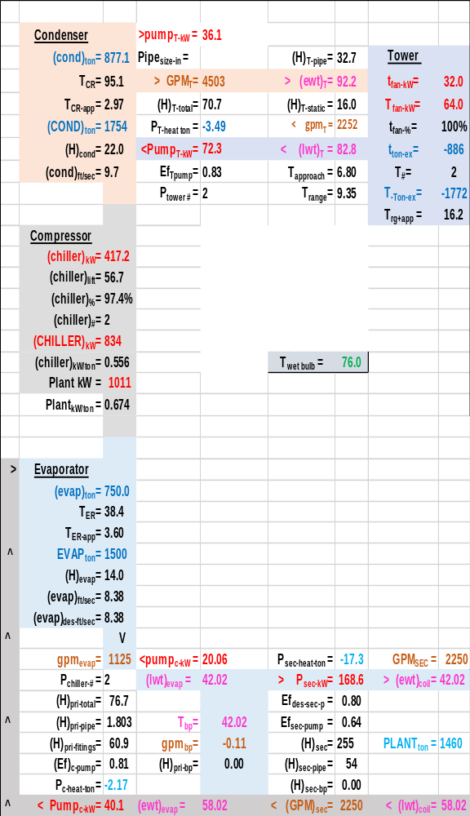
Schematic 5: Big Tower with Chiller kW = 417.2 giving 42.02F supply water-refrigerants approach = 3.6F
Energy in = Energy out
Table 6 illustrates a fundamental requirement of a (SEE) Plant Model; energy in = energy out. Row 34 is a sum of rows 27 thru 33.giving energy into the system. Row 35 is the energy out of the system or energy exhausted by the cooling tower.

R  O  w | Two chiller plant  At design conditions | Small Tower, each chiller kW=428.3 app. = 3.6F | Big Tower, each chiller kW=428.3 app. = 3.6F | Big Tower, each chiller kW=417.2  app. = 3.6F
1 | Wet bulb | 76F | 76F | 76F
2 | Plant load | 1460 ton | 1460 ton | 1460 ton
3 | Evap. load | 1500 ton | 1500 ton | 1500 ton
4 | Ea. Evap. load | 750 ton | 750 ton | 750 ton
5 | Ea. Evap. flow | 1125gpm | 1125gpm | 1125gpm
6 | Evap. Refrig. App. | 3.6F | 3.6F | 3.6F
7 | Evap. Refrig temp. | 38.46F | 37.1F | 38.4F
8 | Chiller Lift | 58.23F | 58.1F | 56.7F
9 | Supply water | 42.06F | 40.72F | 42.02F
10 | Return water | 58.06F | 56.72F | 58.02F
11 | Ea. Cond. load | 879.8 ton | 880.3 ton | 877.1 ton
12 | Ea. Tower flow | 2250gpm | 2252gpm | 2252gpm
13 | Cond. Refrig. app. | 3.59F | 2.98F | 2.97F
14 | Cond Refrig temp. | 96.7F | 95.2F | 95.1F
15 | Tower cold water | 83.71F | 82.8F | 82.8F
16 | Tower return | 93.09F | 92.2F | 92.2F
17 | Tower app. | 7.71F | 6.83F | 6.8F
18 | Tower range | 9.38F | 9.38F | 9.35F
19 | Tower rg + app. | 17.1F | 16.2F | 16.2F
20 | primary pumps | 40.1 kW | 40.1 kW | 40.1 kW
21 | Chillers | 856.6 kW | 856.6 kW | 834 kW
22 | Condenser pumps | 68.1 kW | 72.3 kW | 72.3 kW
23 | Tower fans | 64.0 kW | 64.0 kW | 64.0 kW
24 | Total Plant | 1028.9 kW | 1033 kW | 1011 kW
25 | Plant kW/ton | .686 | .689 | .674
26 | E in = E out
27 | Plant load | 1460 ton | 1460 ton | 1460 ton
28 | sec pump(.64*kW) | 30.7 ton | 30.7 ton | 30.7 ton
29 | pri pump(.81*kW) | 9.2 ton | 9.2 ton | 9.2 ton
30 | Chiller kW | 243.6 ton | 243.6 ton | 237.2 ton
31 | cond pump.85*kW | 16.4 ton | 17.5 ton | 17.5 ton
32 | Cond load | 1759.6 ton | 1761 ton | 1754 ton
33 | Tower fan kW | 18.2 ton | 18.2 ton | 18.2 ton
34 | Energy in = | 1778 ton | 1779 ton | 1772 ton
35 | Tower exh.=E out = | 1778 ton | 1779 ton | 1772 ton
Table 6: Plant performance with small & large tower-Design conditions

Schematic 5 & Table 6 illustrate the reason for the big tower; reduce chiller kW demand and therefore plant kW. Row 21 shows a chiller kW decrease of about 23 kW. Row 25 shows a plant kW/ton of .674 verses .686 for the small tower plant. Installing the big tower increases the capacity of the chiller to greater than 750 ton. Let’s take a look.

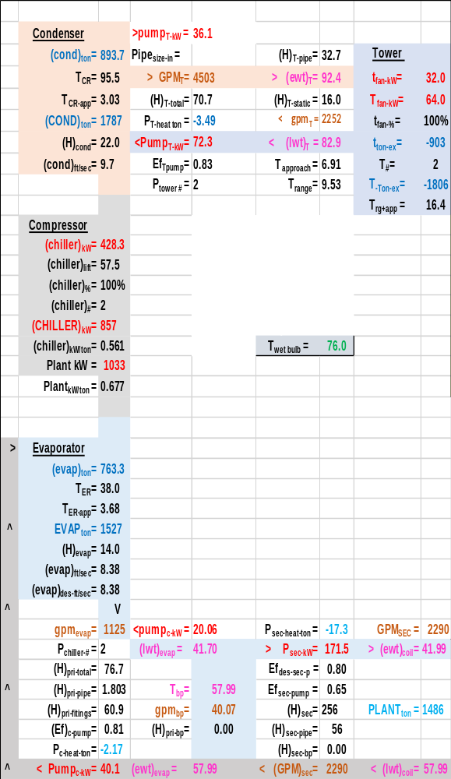
Schematic 5A: Big Tower with Chiller kW = 428.3 giving 41.99F coil supply water- design refrigerants approach = 3.6F

Schematic 5A shows the design chiller with the big tower has a capacity of 763.3 ton verses the design capacity of 750 ton. Note the capacity is slightly reduced due to the wrong way flow in the bypass.

R  O  w | Two chiller plant  At design conditions | Small Tower, each chiller kW=428.3 app. = 3.6F | Big Tower, each chiller kW=428.3 app. = 3.6F | Big Tower, each chiller kW=417.2  app. = 3.6F
1 | Wet bulb | 76F | 76F | 76F
2 | Plant load | 1460 ton | 1486 ton | 1460 ton
3 | Evap. load | 1500 ton | 1527 ton | 1500 ton
4 | Ea. Evap. load | 750 ton | 763.3 ton | 750 ton
5 | Ea. Evap. flow | 1125gpm | 1125gpm | 1125gpm
6 | Evap. Refrig. App. | 3.6F | 3.68F | 3.6F
7 | Evap. Refrig temp. | 38.46F | 38.0F | 38.4F
8 | Chiller Lift | 58.23F | 57.5F | 56.7F
9 | Coil supply water | 42.06F | 41.99F | 42.02F
10 | Return water | 58.06F | 57.99F | 58.02F
11 | Ea. Cond. load | 879.8 ton | 893.7 ton | 877.1 ton
12 | Ea. Tower flow | 2250gpm | 2252gpm | 2252gpm
13 | Cond. Refrig. app. | 3.59F | 3.06F | 2.97F
14 | Cond Refrig temp. | 96.7F | 95.5F | 95.1F
15 | Tower cold water | 83.71F | 82.9F | 82.8F
16 | Tower return | 93.09F | 92.4F | 92.2F
17 | Tower app. | 7.71F | 6.91F | 6.8F
18 | Tower range | 9.38F | 9.53F | 9.35F
19 | Tower rg + app. | 17.1F | 16.4F | 16.2F
20 | primary pumps | 40.1 kW | 40.1 kW | 40.1 kW
21 | Chillers | 856.6 kW | 856.6 kW | 834 kW
22 | Condenser pumps | 68.1 kW | 72.3 kW | 72.3 kW
23 | Tower fans | 64.0 kW | 64.0 kW | 64.0 kW
24 | Total Plant | 1028.9 kW | 1033 kW | 1011 kW
25 | Plant kW/ton | .686 | .677 | .674
26 | E in = E out
27 | Plant load | 1460 ton | 1486 ton | 1460 ton
28 | sec pump(.64*kW) | 30.7 ton | 30.7 ton | 30.7 ton
29 | pri pump(.81*kW) | 9.2 ton | 9.2 ton | 9.2 ton
30 | Chiller kW | 243.6 ton | 243.6 ton | 237.2 ton
31 | cond pump.85*kW | 16.4 ton | 17.5 ton | 17.5 ton
32 | Cond load | 1759.6 ton | 1787 ton | 1754 ton
33 | Tower fan kW | 18.2 ton | 18.2 ton | 18.2 ton
34 | Energy in = | 1778 ton | 1806 ton | 1772 ton
35 | Tower exh.=E out = | 1778 ton | 1806 ton | 1772 ton
Table 6A: Plant performance with small & large tower-Design conditions

Table 6A middle column shows the chiller with big tower plant design values. The capacity of the plant at design conditions is 763.3 ton per chiller/tower operating.
Baker¹ provides plant performance data for August 7-8, 2003. Weather data⁵ was obtained for this date and input to the (SEE) Plant Model as given next.

August 7-8, 2003-Plant performance with big tower and pumps operating at 100%

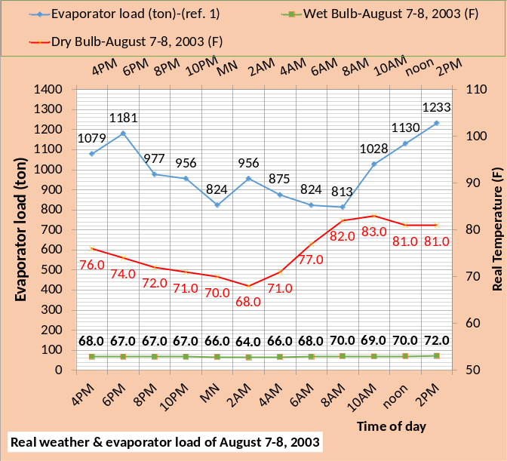
Figure 2: Evaporator load (ton)¹ and weather data⁵ of August 7-8, 2003.
Figure 2 gives the weather data⁵ and the evaporator load and time of day as determined from figure 5 of Baker¹. Note the evaporator load hits a low at midnight and a max value at 2PM. The chiller has a maximum capacity of 750 ton at design wet bulb of 76F. The capacity of a chiller/tower increases with decreasing wet bulb; an interesting performance characteristic to be addressed later in this paper.

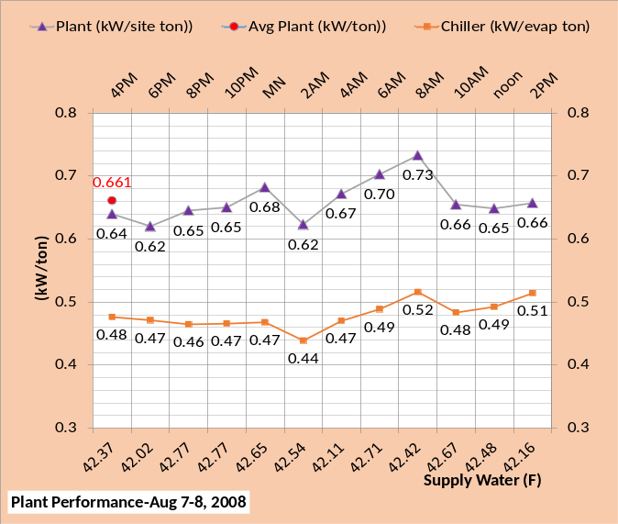
Figure 3: (SEE) Plant Model Chiller kW/ton & Plant kW/evaporator ton & average plant kW/ton-tower and pumps operating at 100%
The author normally defines plant kW per site ton and therefore the evaporator load includes the energy into the system due to the primary/secondary pumping. Baker appears to define plant load as equal to the evaporator load and the evaporator load includes the load due to the primary pumps but not the secondary pumps.
Figure 3 gives the (SEE) Plant Model chiller and plant kW/ton and also gives the average 24 hour plant kW/ton as .661 kW/ton. The author determines the Baker¹ figure 5 values to vary from a high of about .68 kW/ton and a low value of about .54 kW/ton and the mean value appears to be about .62 kW/ton. This .62 kW/ton value from Baker is a fine tuned value utilizing the variable speed of the tower and pumps.
The (SEE) Plant Model values of Figure 3 are at 100% capacity of the tower and pumps giving an average plant kW/ton of .661 about 7% greater than the .62 kW/ton value of Baker¹. This paper will evaluate the effect of variable speed control of the tower and pumps in sections below.

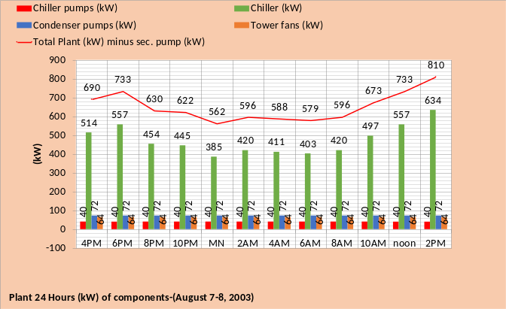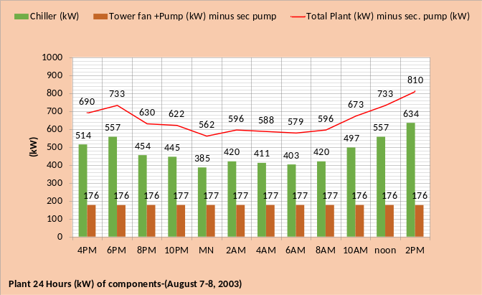
Figure 4: Hourly kW demand of plant components as given by (SEE) Plant Model-tower & pumps at 100%

Figure 4 gives the plant kW over the 24 hours as defined by Figure 2. The top chart shows that the (SEE) plant model shows no difference in kW demand for the tower and pumps over the 24 hours of August 7-8, 2003; the tower and pumps are operating at full kW. The bottom chart gives the same data but sums the tower and pumps kW showing a constant 177 kW over the 24 hours. The total plant kW is also given by Figure 4.

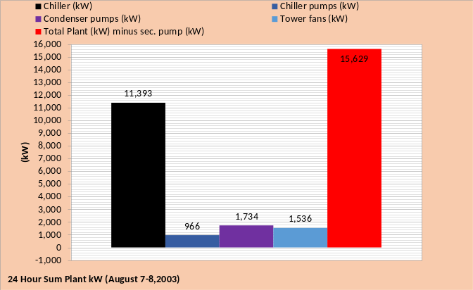
Figure 5: 24 hour sum of Plant components

Figure 5 gives the 24 hour kW sum of the plant components illustrating once again the overriding value of the chiller kW.

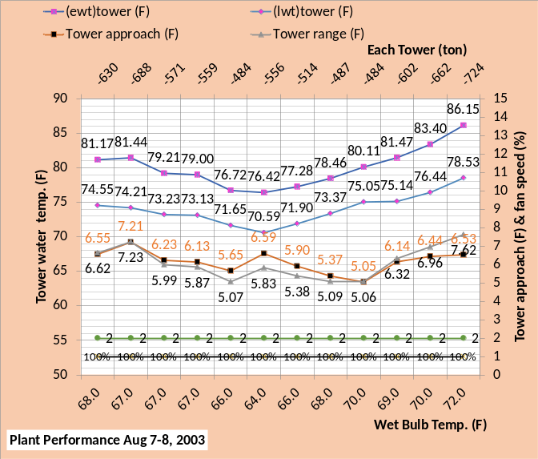
Figure 6: Tower Performance-100% tower fan speed

Figure 6 gives the tower performance over the 24 hours of August 7-8, 2003 with the tower fans and pumps operating at 100%. The figure gives entering and leaving tower water temperature, tower approach, & tower range. Also given is tower fan speed of 100% and the number of chiller/towers on as two for all 24 hours.
Schematic 5 illustrates that the range at design is 9.35F, a value that is obviously greater than the 7.23F high value of Figure 6 and the low range value of 5.06F due to the tower load being less. Schematic 5 also shows the tower approach is 6.8F at design load of 886 ton tower load. At this design load of 866 ton and 67F wet bulb the tower manufactures data³ shows the approach would increase to about 10.3F and provide tower cold water of 77.3F temperature. Figure 6 gives cold water of 74.21F at 67F wet bulb, an approach of 7.21F at a tower load of 688 ton. The (SEE) Model of tower performance checks close to manufactures data³ as developed by reference 2.

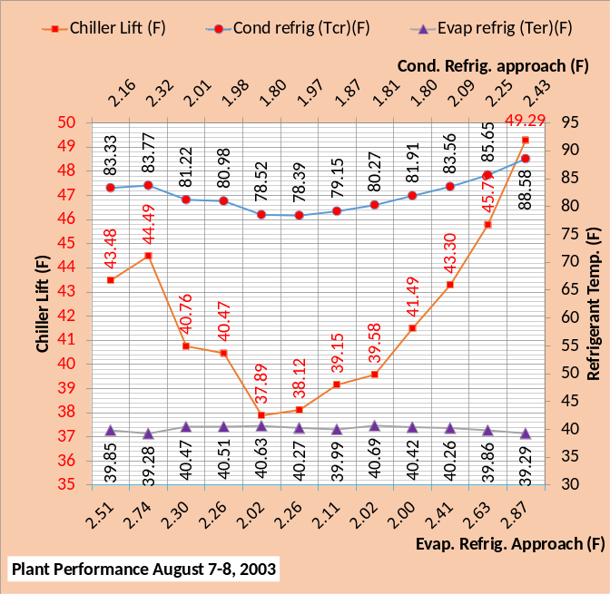
Figure 7: Chiller Performance

Figure 7 gives the parameters that most determine the performance of a chiller; refrigerant temperatures and therefore chiller lift that drives chiller kW demand. The (SEE) Plant Model² must solve for the refrigerant temperatures to determine chiller kW. Note that the chiller lift values of Figure 7 track the chiller kW values of Figure 4.

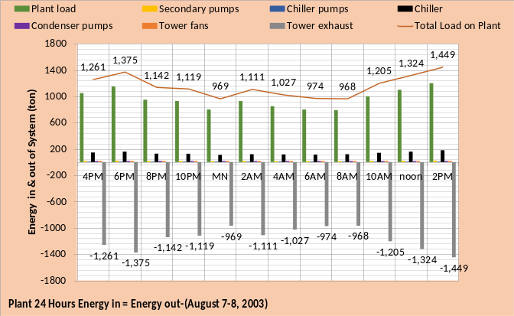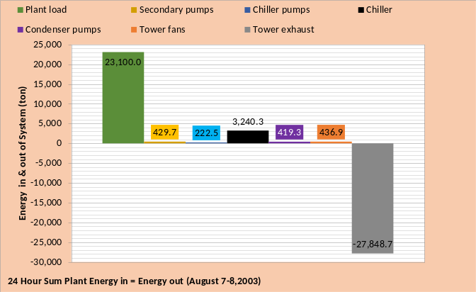
Figure 8: 24 hour Energy in = Energy out with tower and pumps at 100% kW

Figure 8 illustrate the necessary condition of a (SEE) Plant Model, energy in equal energy out.
Next the effect of tower fan speed will be considered.

Plant performance at design conditions as the big tower fan speed is reduced
Figure 9 illustrates that the plant kW increases as the tower fan speed is reduced at design evaporator load of 750 ton. The top chart shows the tower range is an approximate constant 9.47F due to the slightly increasing tower load as given by the secondary horizontal axis of the top chart. The top chart shows the tower approach increases from 6.80F up to 16.03F as the tower fan speed is reduced from 100% to 40% speed. The middle chart illustrates the chiller kW per 750 ton evaporator load gradually increases as the tower fan speed is reduced and the plant kW per 750 ton also increases.

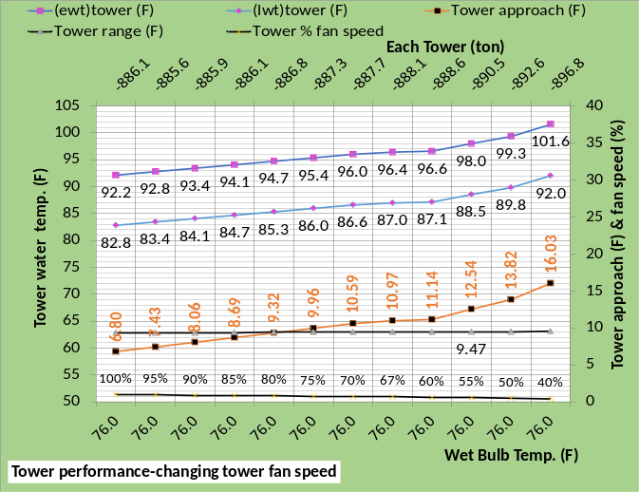
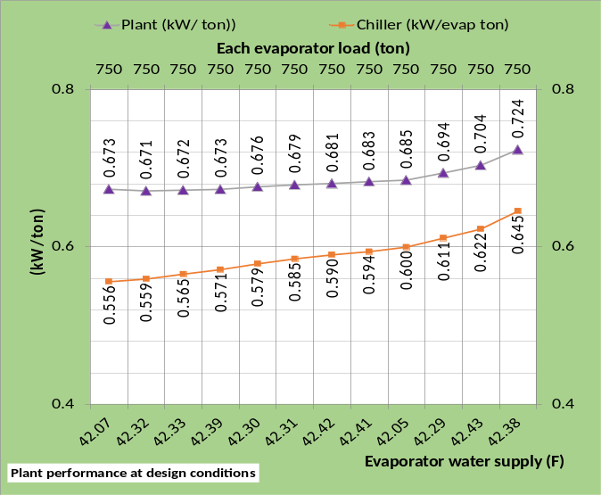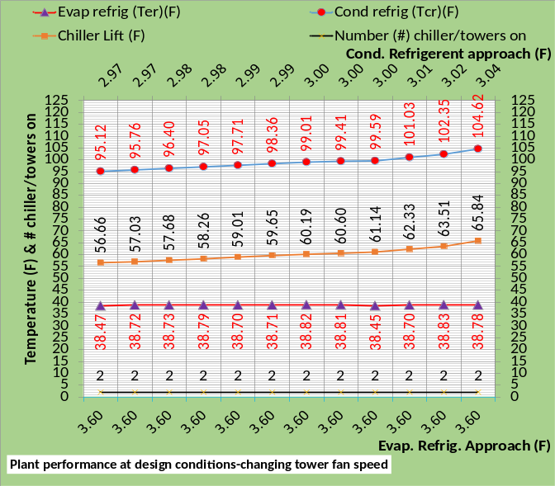
Figure 9: Tower & Plant performance as tower fan speed is reduced at constant 76F wet bulb & 750 ton evaporator load.
The primary horizontal axis of the middle chart gives the temperature of water supply from the evaporator; a parameter that strongly effects the chiller kW, colder water requires more chiller kW. Note that with the exception of the 42.07F water supply at 100% tower fan speed and the 42.05F at 60% fan speed the other values are about 42.3F to 42.4F. If at 100% tower fan speed the water supply had been about 42.3F then the plant kW/ton would have been less than the value at 90% fan speed; the point is the (SEE) Plant Model finds that decreasing the tower fan speed at design conditions of 750 ton evaporator load is a bad control idea. Part load conditions will be addressed next.
The bottom chart of Figure 9 gives the refrigerant temperatures as the tower fan speed is reduced and therefore the chiller lift resulting in greater chiller kW required to provide 42.3F supply water.

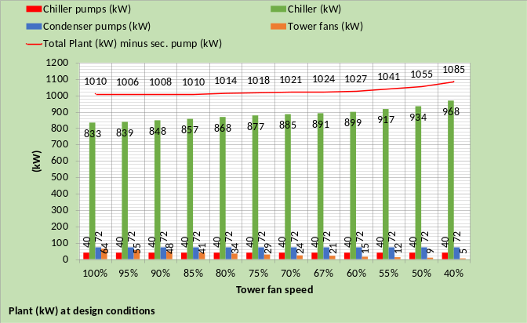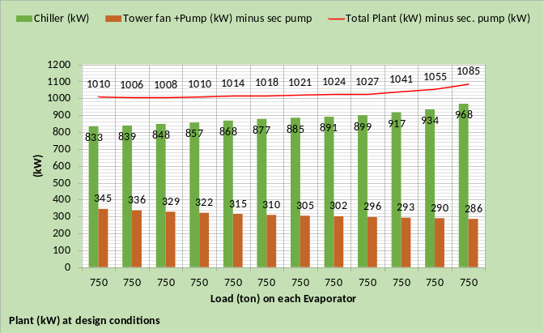
Figure 10: Plant kW performance as the tower fan speed is reduced at 750 ton on each evaporator
The top and bottom charts of Figure 10 give essentially the same data. The top chart shows the pumps kW is constant as the tower fan kW drops from 64 kW down to 5 kW. The bottom chart shows the sum of pumps kW and fan kW drops from 345 kW at 100% fan speed down to 286 kW at 40% fan speed. Both charts of Figure 10 show how the chiller kW increases as the tower fan speed is reduced and the plant kW also increases with the slight difference at 100% fan speed due to the 42.07F supply water as explained above.

August 8, 2003-Plant performance with tower fans operating at 67% and pumps operating at 100%

The effect of tower fan speed at the conditions of August 7-8, 2003 will be addressed by reducing the tower fan speed to 67% and comparing the plant performance at 100% tower fan speed.
The top chart of Figure 11 is copied from above showing the evaporator load and weather temperatures of August 7-8, 2003. The middle and bottom charts of Figure 11 illustrate little if any effect on plant kW per ton due to reducing tower fan speed to 67%. Figures 9 & 10 above show that the plant kW at peak conditions increased for a tower fan speed of 67%, so why does Figure 11 not show an increase for 67% tower fan speed? The answer is illustrated by Figure 12 taken from (kirbynelsonpe.com and click on System Energy Equilibrium (SEE) Model Development and Verification²). Figure 12 illustrates that as the evaporator load and wet bulb temperature decrease the chiller efficiency improves for these particular conditions of load and wet bulb. Figure 12 illustrates that at peak conditions of Figures 9 & 10 the chiller kW/ton is greater than at a lesser load and wet bulb which is the case for Figure 11 demonstrating why little if any change in plant kW/ton for 100% tower fan speed verses 67% tower fan speed. The average plant kW/ton of the middle chart at 100% fan speed is .661 and the bottom chart for 67% fan speed is .651 illustrating essentially no difference considering the effect of evaporator water supply temperature show on the primary horizontal axis of the middle and bottom charts of Figure 11.
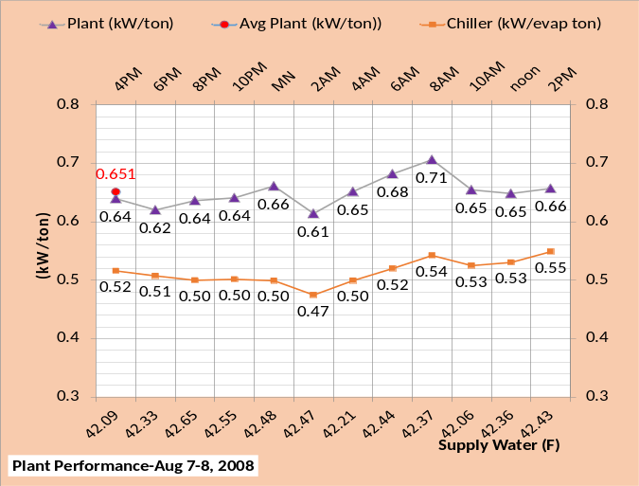
Figure 11: Top chart weather temperatures and evaporator load, middle chart 100% tower fan speed, bottom chart 67% tower fan speed.
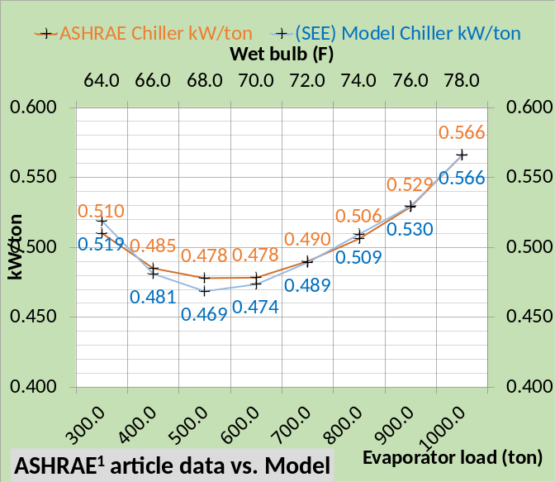
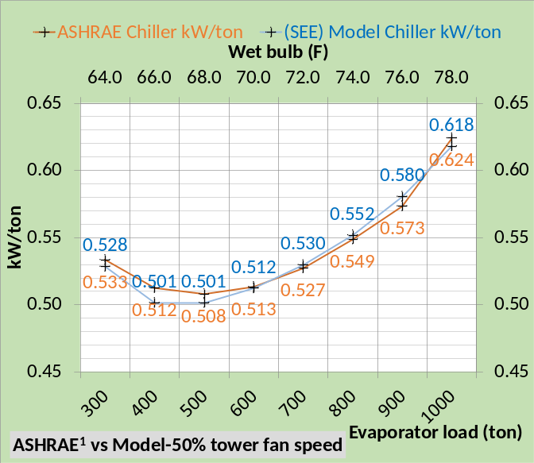Figure 12: Top chart 100% tower fan speed, bottom chart 50% tower fan speed. Taken from reference 2.
Figure 12 also illustrates the ability of the (SEE) Plant Model to accurately model manufactures data for both 100% and 50% tower fan speed which is a requirement for any plant model. Those readers wanting more understanding should go to kirbynelsonpe.com for several papers.

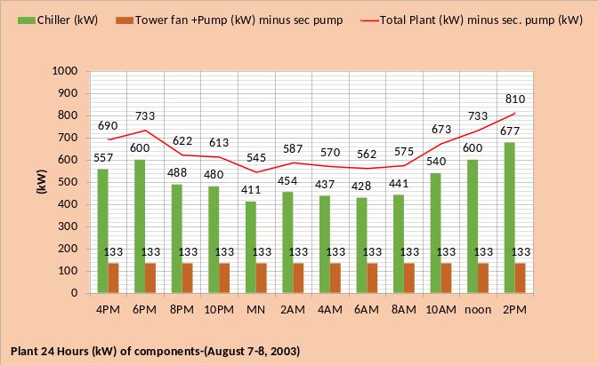
Figure 13: Plant components kW-Top chart 100% tower fan speed, bottom chart 67% tower fan speed.

Figure 13 illustrates the increase in chiller kW for the 67% tower fan speed and the corresponding drop in the tower fan plus pumping kW total.

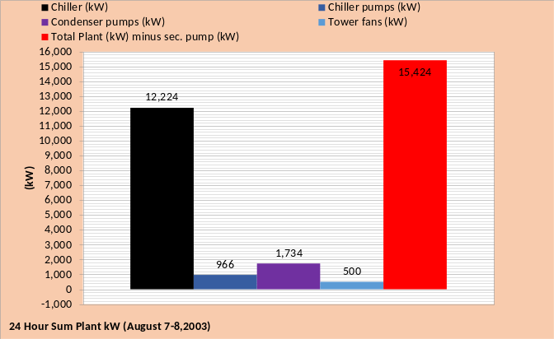Figure 14: 24 hour sums-Top chart 100% tower fan speed, bottom chart 67% tower fan speed.
Figure 14 shows about a 1.3% difference in total plant kW over the 24 hours of August 7-8, 2003. As discussed above the difference is primarily a function of chilled water supply temperature and not a fundamental advantage by operating at reduced tower fan speed.
The author concludes that for this particular plant as defined by Baker¹, the plant kW is not significantly affected by reducing the tower fan speed.

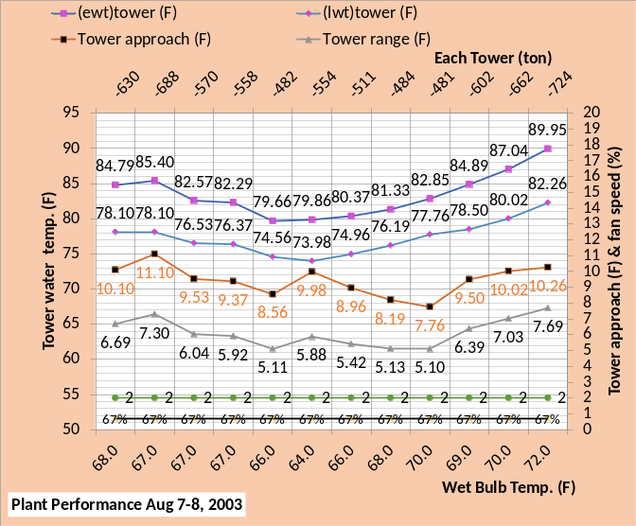Figure 15: Plant 7 Tower performance-Top chart 100% tower fan speed, bottom chart 67% tower fan speed.
Figure 15 illustrates a significant difference in tower performance for 100% versus 67% tower fan speed resulting in a significant increase in chiller lift and therefore chiller kW for the 67% tower fan speed operation.

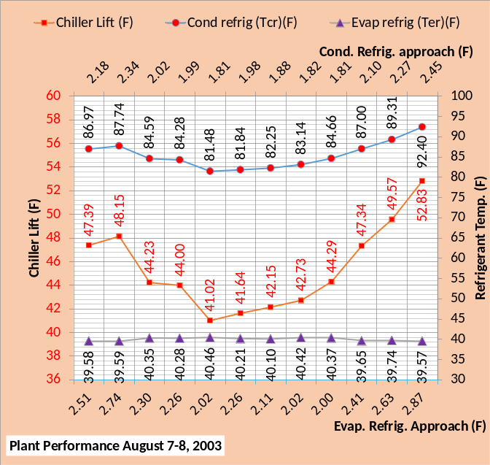Figure 16: Refrigerant temperatures & chiller lift-Top chart 100% tower fan speed, bottom chart 67% tower fan speed.
The condenser refrigerant temperature minus the evaporator refrigerant temperature defines the chiller lift and chiller lift in large part defines chiller kW. Figure 16 illustrates that the chiller lift is typically increased a little more than 3F with the 67% tower fan speed primarily due to the increase in condenser refrigerant temperature. Figure 16 also shows how the evaporator refrigerant temperature is a function of the evaporator supply water temperature.
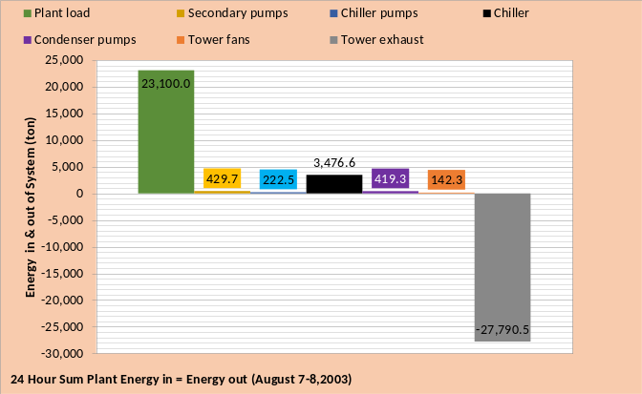Figure 17: 24 hour sum Energy in = Energy out-Top chart 100% tower fan speed, bottom chart 67% tower fan speed.
Figure 17 shows the plant load energy in is the same for both 100% and 67% tower fan speed as is also the secondary pumps, chiller pumps, and condenser pumps. The difference is in the tower fan energy and chiller energy into the system.
Next will be Schematics that show in detail how the plant system responds to the 67% tower fan speed.

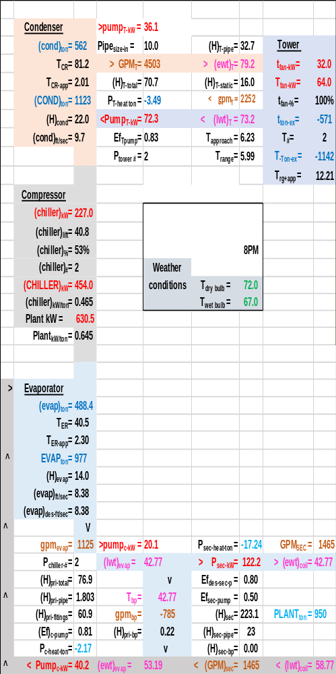Schematic 6: August 7-8, 2003 8PM with 100% tower fan speed.

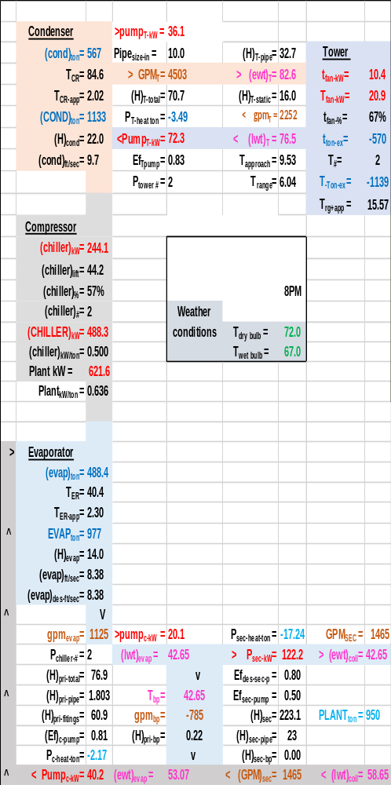Schematic 7: August 7-8, 2003 8PM with 67% tower fan speed.

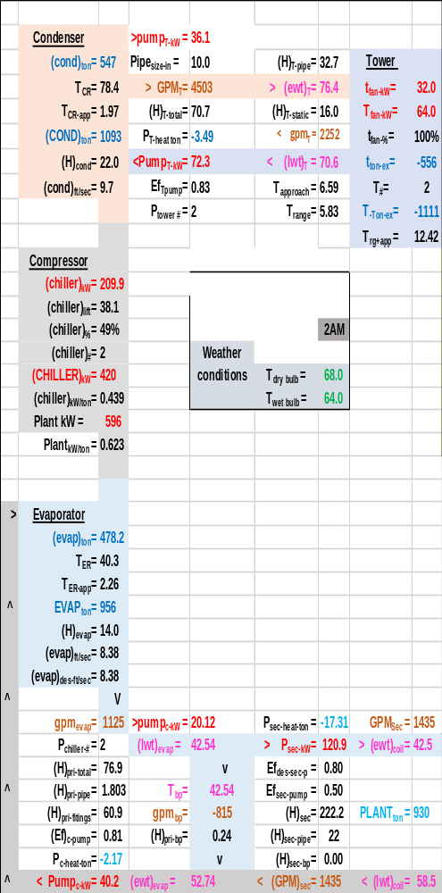Schematic 8: August 7-8, 2003 8PM with 100% tower fan speed.

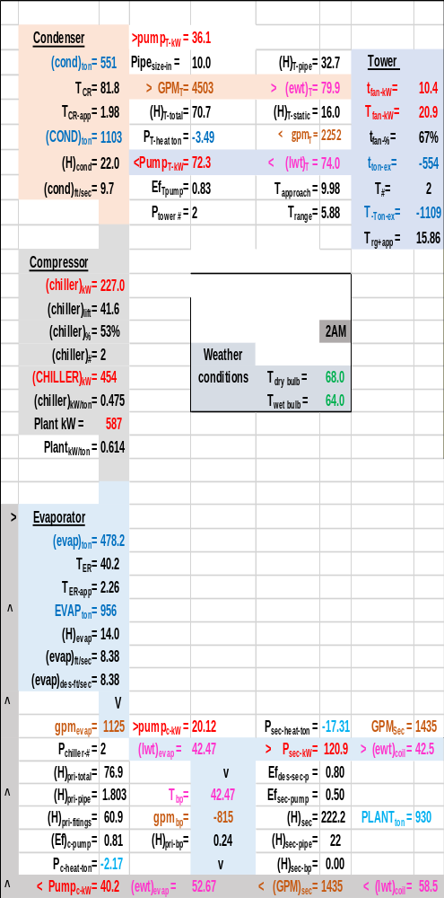Schematic 9: August 7-8, 2003 8PM with 67% tower fan speed.

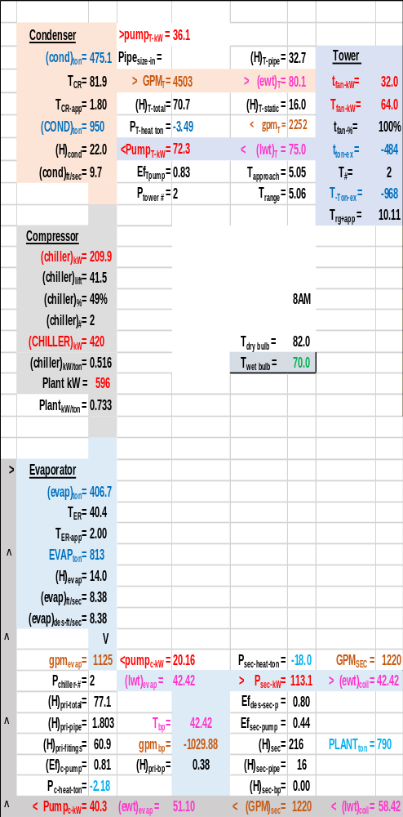Schematic 10: August 7-8, 2003 8PM with 100% tower fan speed.

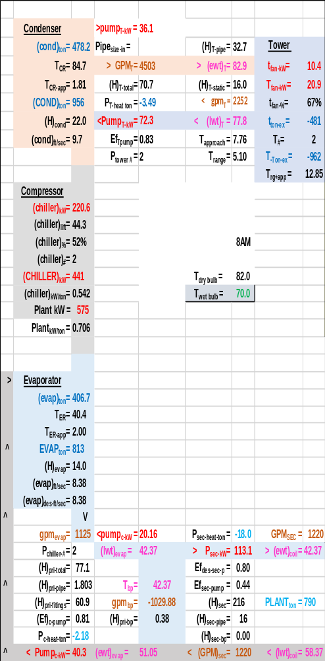Schematic 11: August 7-8, 2003 8PM with 67% tower fan speed.

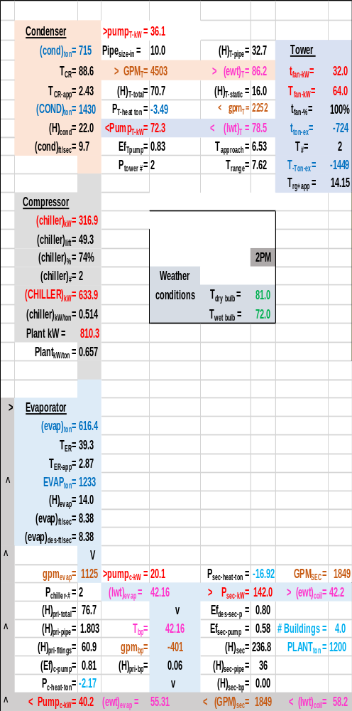Schematic 12: August 7-8, 2003 8PM with 100% tower fan speed.

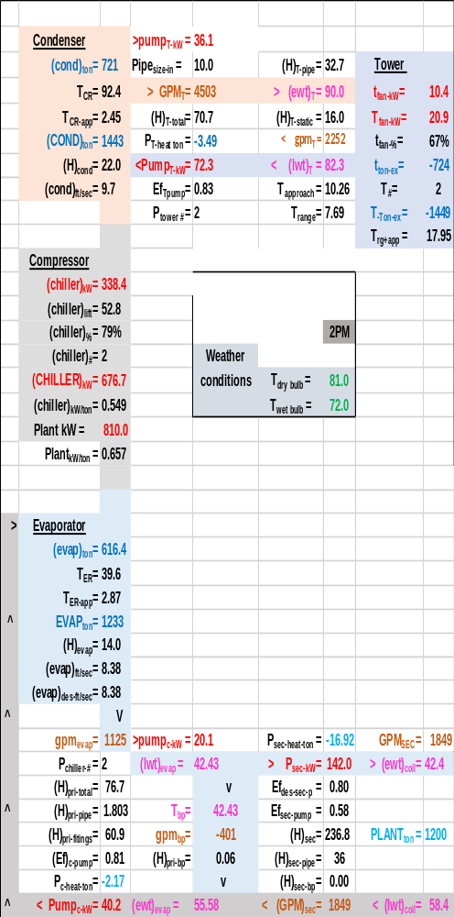Schematic 13: August 7-8, 2003 8PM with 67% tower fan speed.

Plant performance at design conditions as condenser pump kW is reduced and tower fan speed is 100%
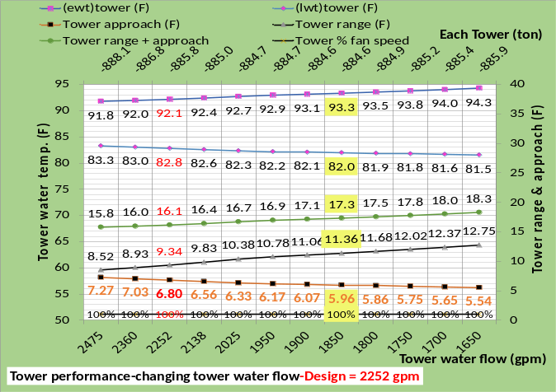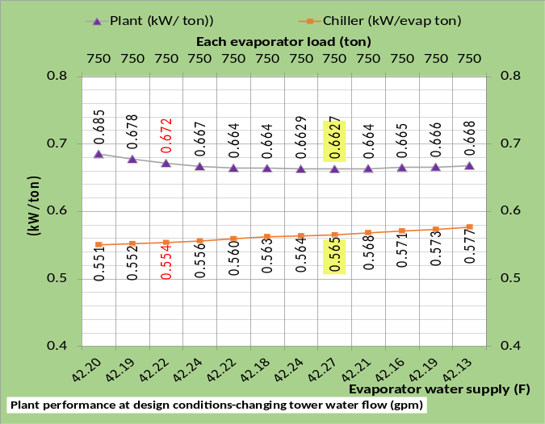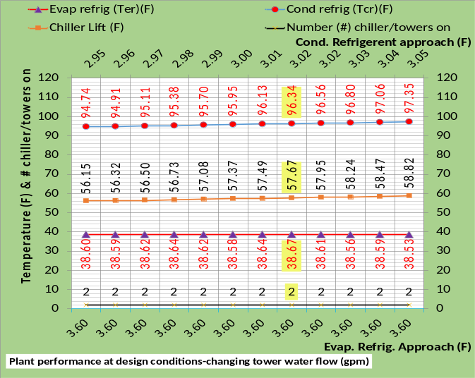
Figure 18: Plant performance as condenser water flow varies at constant 750 ton evaporator load & 100% tower fan speed

Figure 18 provides plant performance data as the condenser water flow varies from 2475 gpm down to 1650 gpm. Design flow is 2252 gpm, shown in red on the figure, and 1850 gpm is highlighted because this value of condenser flow will be used in the August 7-8, 2003 analysis to follow.
The top chart of Figure 18 shows the tower water temperature in and out of the tower increases as the tower water flow decreases from 2475 gpm down to 1650 gpm. The tower range increases and the tower approach decreases for a net increase in tower range plus approach from 15.8F up to 18.3F as the tower flow decreases.
The middle chart of Figure 18 shows the chiller kW per evaporator ton at design is .544 for a tower flow of 2,252 gpm and decreases for an increase in tower water flow showing a value of .551 kW/ton at 2,475 gpm. The chiller kW/ton increases as the tower/condenser water flow is decreased going to a value of .577 kW/ton for a water flow of 1,650 gpm. The plant kW/ton decreases to a minimum value of .6627 at 1,850 gpm tower/condenser water flow and then slightly increases for water flow less than 1,850 gpm.
The bottom chart of Figure 18 shows how the chiller lift increases as the tower/condenser water flow decreases resulting in greater chiller kW/ton as show by the middle chart. The bottom chart also shows that two chiller/towers are on for all conditions shown. A later discussion will consider one chiller/tower on for some hours of August 7-8, 2003.

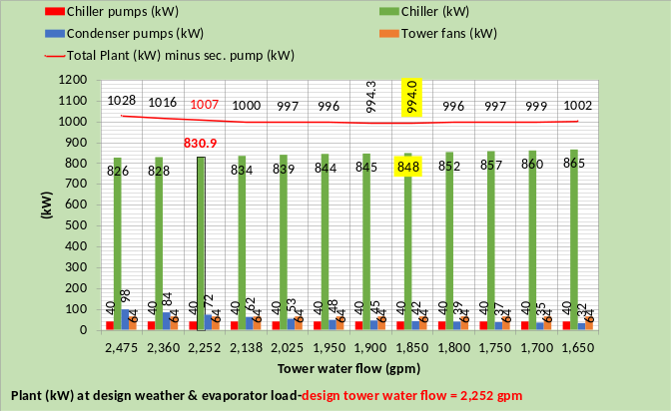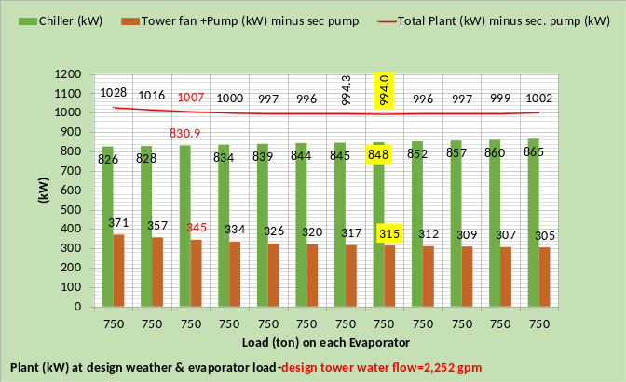
Figure 19: Plant performance as condenser/tower water flow reduces

Figure 19 illustrates how the chiller kW increased with decreasing tower water flow and the sum of tower fan plus pumps kW decreased. The plant kW reached a minimum point at 1,850 gpm at peak design conditions. This value of tower flow will be used in the model of August 7-8, 2003, however there may be a different minimum plant kW point at these part load conditions. The point is; the plant system is a very complex system which can only be fully understood with a good (SEE) Plant Model.

August 7-8, 2003-Plant performance with tower fans operating at 100% & condenser pumps operating at 82% = 1850 gpm & supply water is controlled to about 42F.
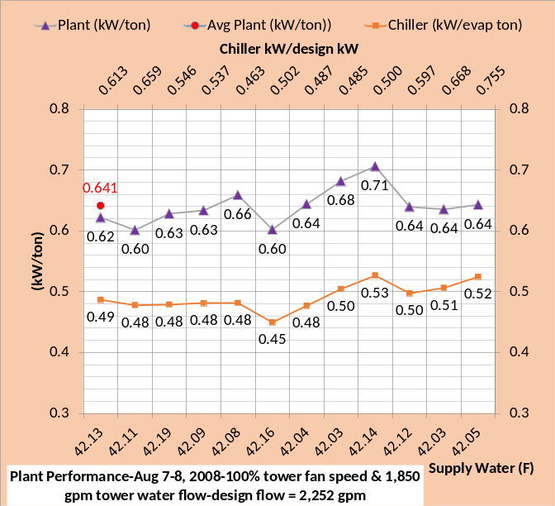
Figure 20: Plant performance-top chart, copied figure 11, 2,252 gpm tower water flow & 100% tower fan-bottom chart 1,850 gpm tower water flow & 100% tower fan
Figure 20 illustrates that operating the tower water pumps at reduced flow of 1,850 gpm results in improved kW/ton of the plant, the average is reduced from .661 kW/ton of Figure 3 down to .641 kW/ton. The primary horizontal axis of Figure 20 gives the controlled water supply temperature and shows a value closer to 42F for the bottom chart. If the top chart had be controlled at the same water supply temperature the average of .641 kW/ton would be higher, demonstrating a more positive effect by operating the condenser pumps at 1,850 gpm. The point; evaporator supply water temperature has a major effect on the kW demand of the chiller and therefore a major effect on the plant kW/ton.

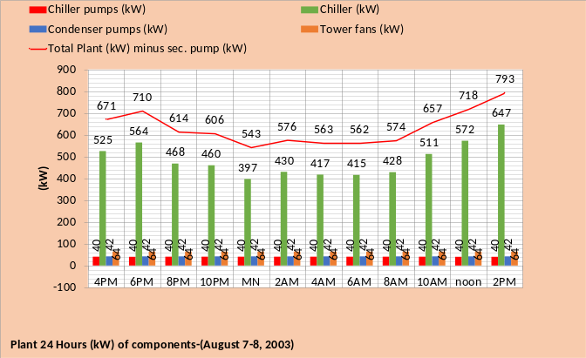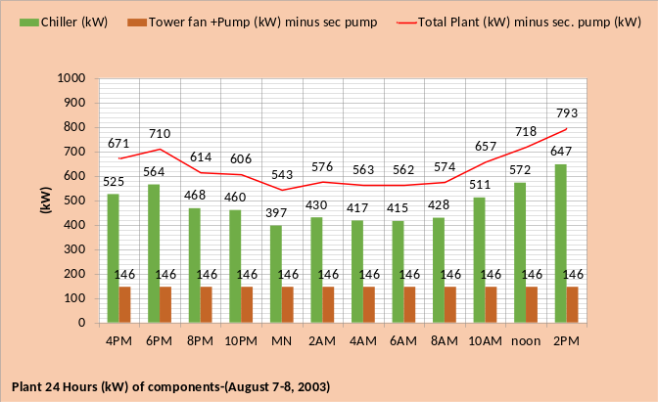
Figure 21: Plant performance for 1,850 gpm condenser/tower water flow
Figure 21 gives the 24 hour performance of the plant. The top chart shows the tower fan kW is a constant 64 kW, the chiller pumps 40 kW and the condenser pumps 42 kW.

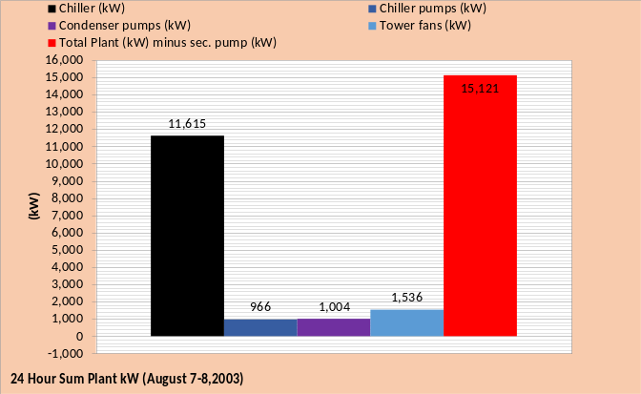
Figure 22: Plant 24 hour performance-top chart, copied figure 14, 2,252 gpm tower water flow & 100% tower fan-bottom chart 1,850 gpm tower water flow & 100% tower fan
Figure 22 gives 24 hour performance for the two control conditions of the plant. The total plant kW is shown to be about 3.2% less by operating the condenser pumps at reduced 1,850 gpm flow. The 24 hour kW of the condenser pumps is reduced from 1,734 to 1,004, a 42% reduction. The total 24 hour chiller kW increased from 11,393 to 11,615, a 1.9% increase. The net result is a reduction in 24 hour plant kW demand of (15,629 – 15,121 = 508 kW).

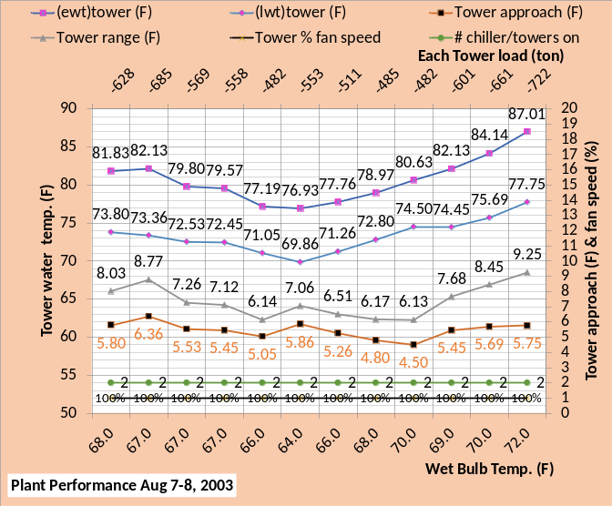
Figure 23: Plant performance-top chart, copied figure 15, 100% tower fan speed & 2,252 gpm condenser water flow-bottom chart 100% tower fan speed & 1,850 gpm condenser water flow

Figure 23 & 24 illustrate the complexity of the chiller/tower performance by changing the condenser water flow. The tower water temperatures increased and therefore the range increased but the tower approach to the wet bulb decreased as shown by Figure 23. The sum of the tower range plus approach in large part determines the condenser refrigerant temperature and therefore the chiller lift and therefore the chiller kW demand required to produce a given water supply temperature. Figure 23 illustrates the sum of range plus approach increased and Figure 24 illustrates a resulting increase in chiller lift.
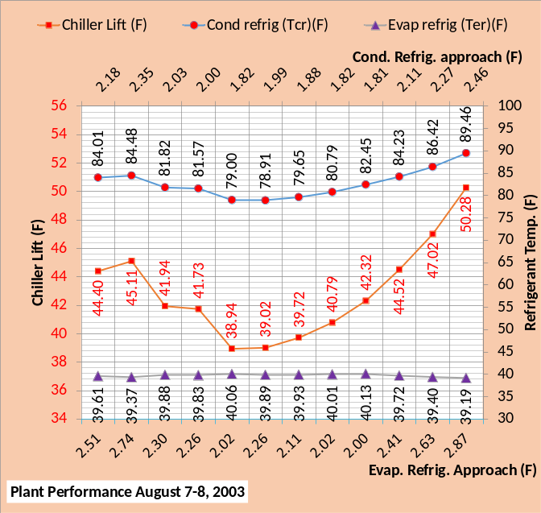
Figure 24: Plant performance-top chart, copied figure 16, 2,252 gpm tower water flow & 100% tower fan-bottom chart 1,850 gpm tower water flow & 100% tower fan

Figures 21 & 22 show that the chiller kW increased with the reduced 1,850 gpm condenser water flow and Figures 23 & 24 illustrate why.
Baker¹ suggests that operating the plant to provide 44F supply water is acceptable, and given the effect of supply water temperature on plant kW, as has been develop above. The next section will consider 44F supply water.
August 7-8, 2003-Plant performance with tower fans operating at 100%, condenser pumps operating at 82% = 1850 gpm & evaporator water supply = 44F

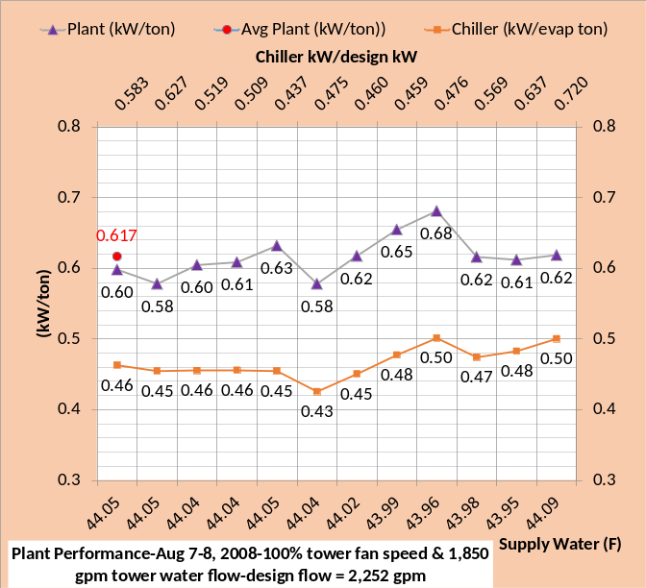
Figure 25: Plant performance-Top chart 42F supply water & bottom chart 44F supply water

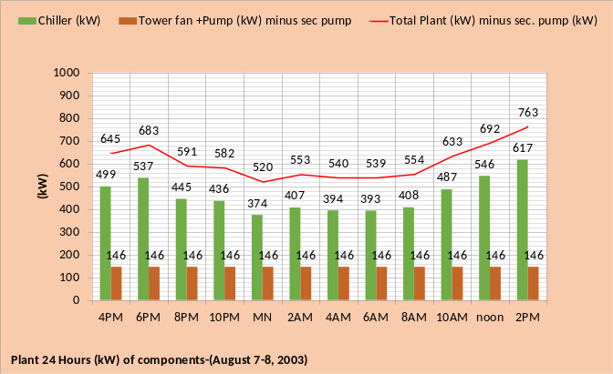
Figure 26: Top chart 42F supply water & bottom chart 44F supply water

Figure 25 bottom chart gives an average value of plant kW/ton=.617 with 44F supply water, a drop from .641 kW/ton, top chart and 42F supply water. This 4% improvement in the 24 hour plant performance suggests the chilled water supply should be increased as much as possible while meeting the needs of the facilities.
Figure 26 gives the plant component values of kW. The total plant kW is about 4% greater with 42F supply water.

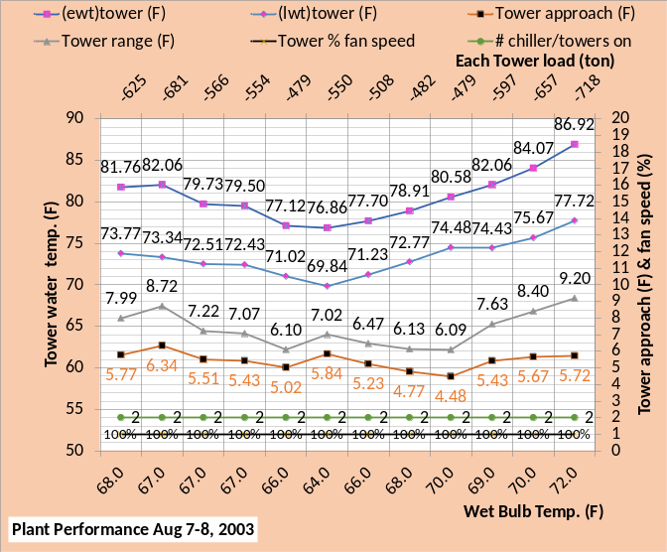
Figure 27: Tower performance-top chart 42F supply water & bottom chart 44F supply water

Figure 27 illustrates very little difference in the tower/condenser performance with an increase in chilled water supply; the difference is in the evaporator performance as shown by Figure 28.

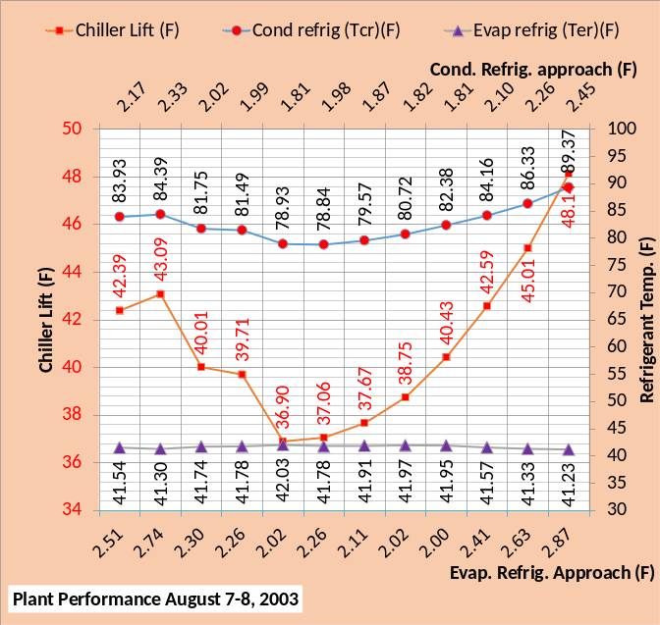
Figure 28: Plant performance-top chart 42F supply water & bottom chart 44F supply water
Figure 28 shows the chiller lift is reduced, and therefore chiller kW, because the evaporator refrigerant temperature increased about 2F due to the increase in chilled water supply of the bottom chart.

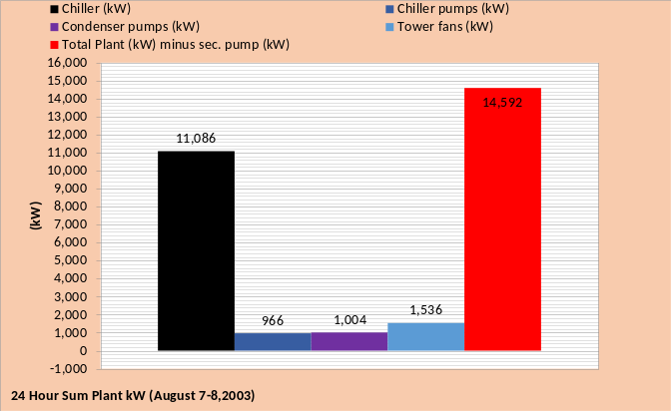
Figure 29: Plant 24 hour summed kW values-top chart 42F supply water & bottom chart 44F supply water

Figure 29 illustrates that the only change in 24 hour consumption is the 24 hour chiller kW due to the chilled water supply being increased from 42F to 44F.

Can one chiller/tower meet the load from midnight to 8AM providing 44F water to the coils?
Figure 27 and other figures above are for two chiller/towers operating. We will now consider the possibility of operating with one chiller/tower for the conditions of August 7-8, 2003 providing 44F supply water to the coils.
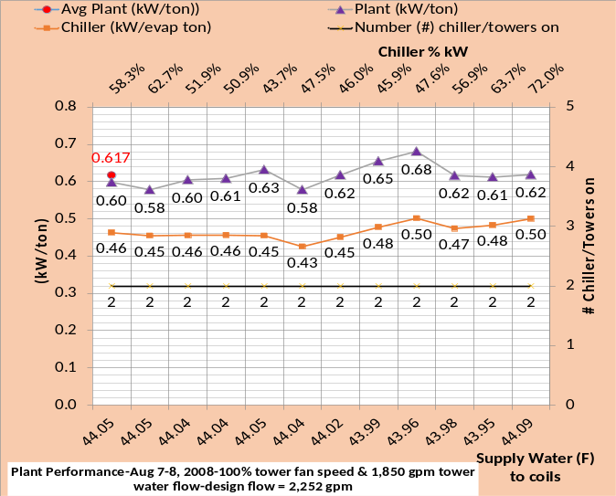
Figure 30: Evaporator load and weather top chart-Plant performance bottom chart

Figure 30 top chart is the evaporator load and weather on August 7-8, 2003 and the bottom chart is the same as Figure 25 bottom chart above but additional data is provided. The secondary horizontal axis of the bottom chart shows the percent of chiller power required to produce the chilled water supply to the building coils shown on the primary horizontal axis. Chiller power of less than 50% is required from midnight through 8AM; suggesting one chiller/tower can meet the load?
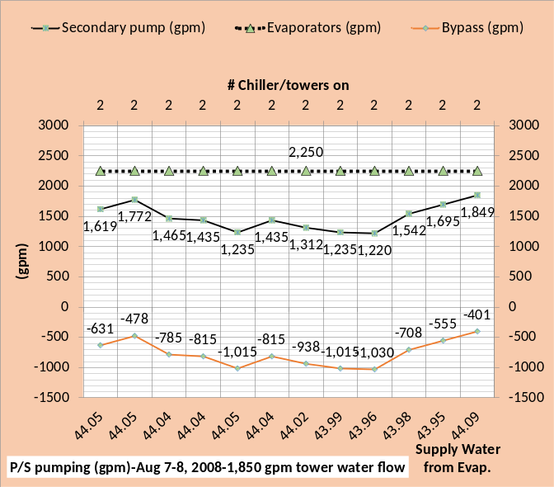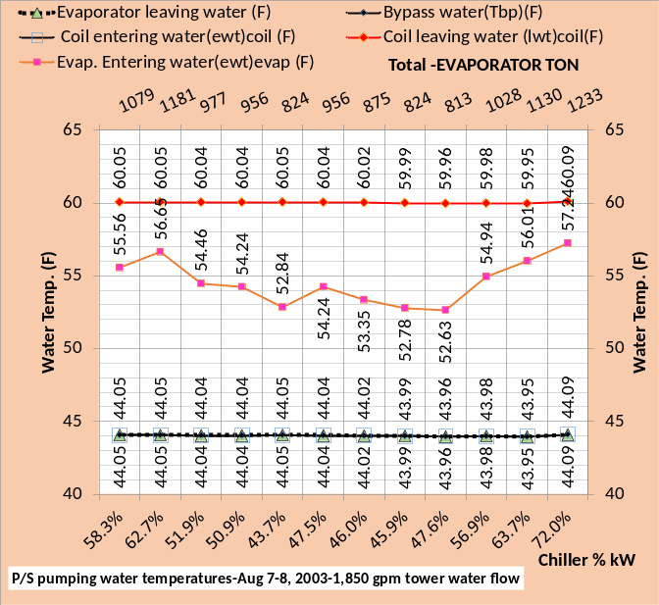
Figure 31: Primary/Secondary pumping-2 chiller/tower plant

The P/S pumping must be addressed to determine if one chiller/tower can meet the load; Figure 31 gives the details. The top chart gives the water flow (gpm) and the bottom chart gives the water temperatures. The evaporator flow is 1,125 gpm per evaporator or 2,250 gpm for two chiller/towers as shown on the top chart. The evaporator flow minus the secondary flow equals the bypass flow as show by the top chart. If the secondary flow becomes greater than the evaporator flow then the supply water to the coils is reduced because return water from the coils is added to the supply water flow, a condition to be avoided because it reduces the effective capacity of the chiller/tower.
The bottom chart of Figure 31 gives the water temperatures of the P/S pumping. The evaporator leaving water, bypass water, and coil entering water are all the same temperature of about 44F. The coil leaving water is 16F warmer than the coil entering, therefore about 60F as shown. The evaporator entering water is a mix of the 60F coil leaving water and the 44F bypass water and therefore varies with the load (ton); the evaporator load as shown by the top chart of Figure 30.
Next we will investigate operation with one chiller/tower.

One chiller/tower operation providing 44F supply water to the coils

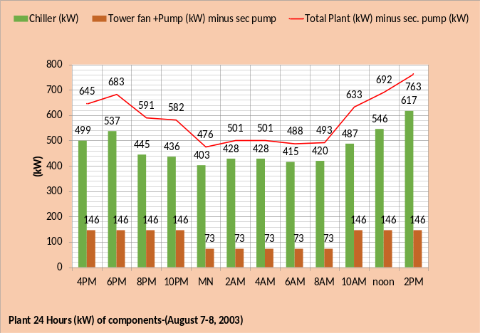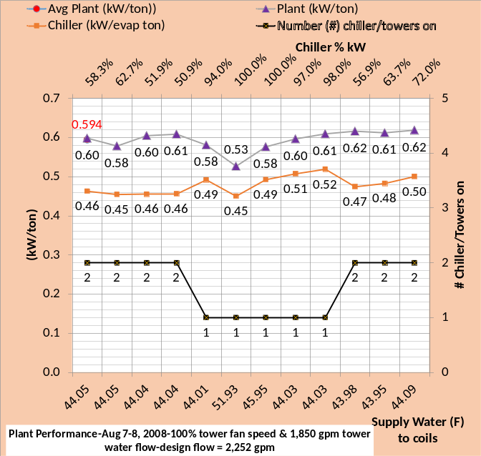
Figure 32: Two chiller/tower operation top chart-One chiller/tower operation, midnight to 8AM, middle & bottom charts
Figure 32 illustrates the results of attempting to operate with one chiller/tower where the chiller % power is less than 50% as shown by Figure 30. The top chart of Figure 32 is copied from the bottom chart of Figure 26. Comparing the top chart and middle chart shows the tower fan and pumps kW was cut in half, as expected, from midnight to 8AM and the chiller kW significantly increased also as expected with a net reduction in plant kW as shown. However the bottom chart of Figure 32 illustrates the water temperature to the coils is greater than 44F for 2AM and 4AM. Figure 33 P/S pumping gives additional understanding.

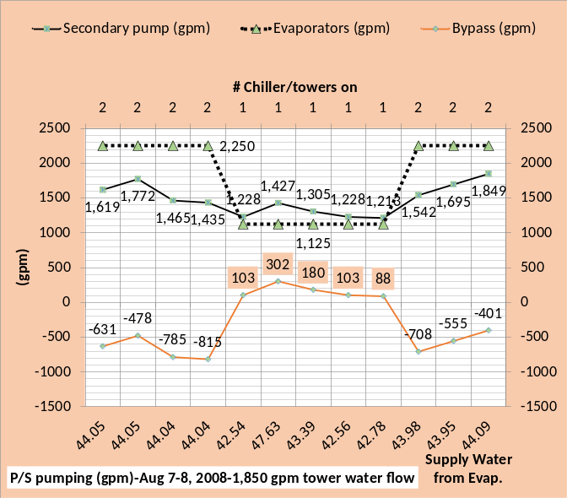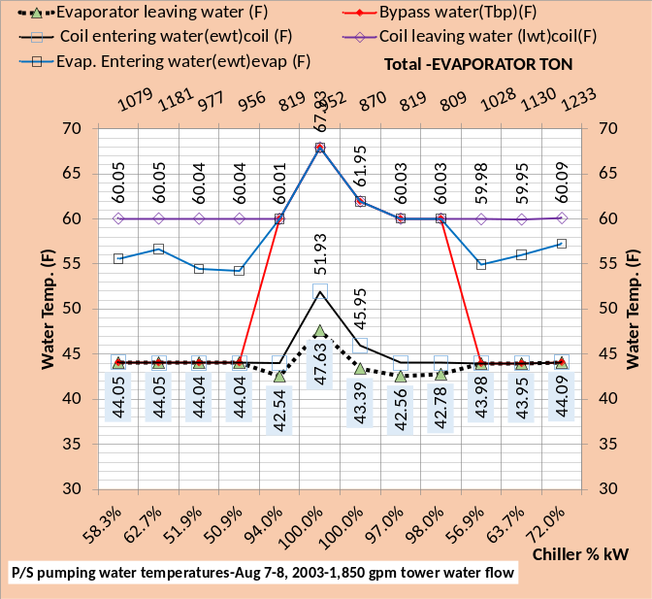
Figure 33: Primary/Secondary pumping
Figure 33 top chart shows the flow in the bypass is in the wrong direction for all five one chiller/tower operating hours of midnight to 8AM; the secondary flow is greater than the evaporator flow. As shown by the primary horizontal axis of the top chart of Figure 33 the chiller must produce colder than 44F water to get 44F water to the coils as a result of the wrong way flow in the bypass. The bottom chart shows the water temperatures for these conditions. at 2AM & 4AM one chiller/tower cannot provide 44F water to the coils.

Schematics for analysis of two chiller/tower operation verses one chiller/tower operation when providing 44F supply water to coils

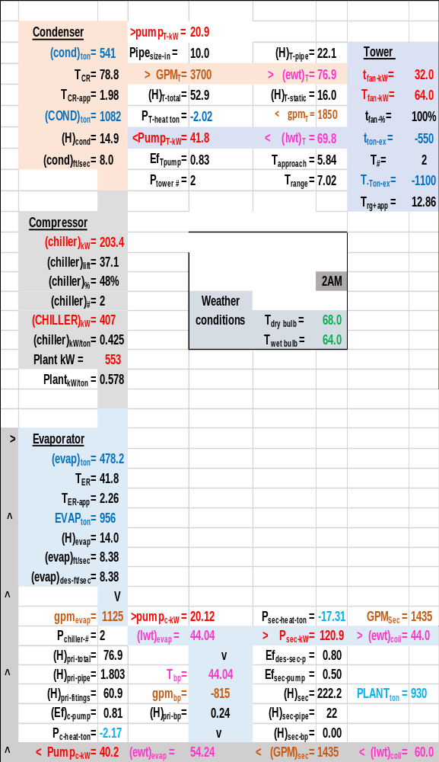
Schematic 14: Two chiller operation at 2AM

Schematic 14 shows the two chiller power is at 48% for each chiller suggesting one chiller could meet the load. Schematic 15 illustrates that one chiller cannot meet the load for two reasons, the bypass flow is in the wrong direction and the evaporator design load is 750 ton and the load as shown by Schematic 15 is 952 ton. The analysis below will show that the chiller/tower can meet a load significantly greater than 750 ton at wet bulb 64F but not as great as 952 ton. Note the top chart of Figure 33 shows a wrong way bypass flow of 302 gpm.

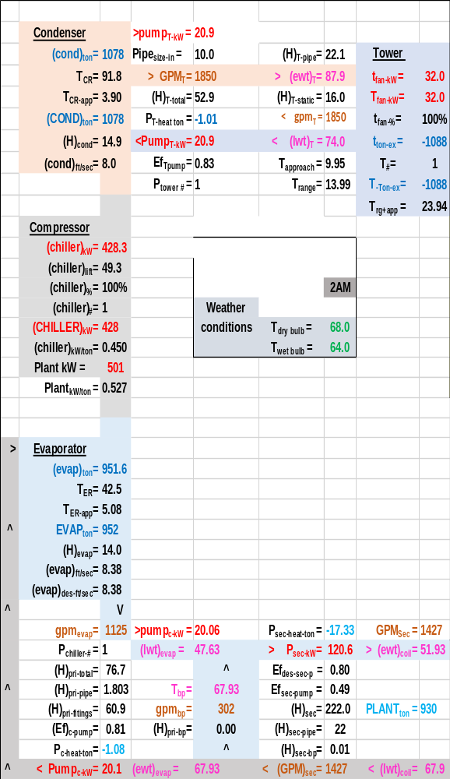
Schematic 15: One chiller operation at 2AM

At wet bulb temperatures less than design (76F) the chiller can meet a load greater than 750 ton as illustrated by the next schematics.
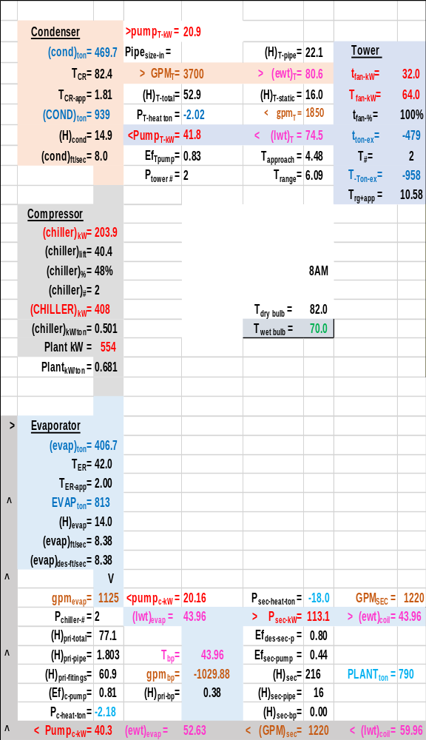
Schematic 16: Two chiller operation at 8AM

Schematic 16 shows an evaporator load of 813 ton and Schematic 17 shows 809 ton slightly reduced because the chiller pump load on the evaporator is less. As stated the chiller design load at 76F wet bulb is 750 ton and Schematic 17 shows the plant can meet a load of 809 ton at a wet bulb of 70F even though the bypass flow is 88 gpm in the wrong direction and therefore the chiller must provide 42.78F water off the evaporator to get 44.03F to the coils, also shown by Figure 33 top chart.

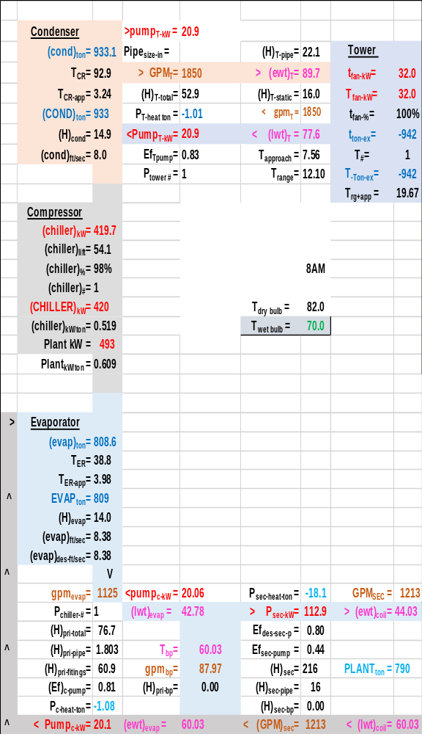
Schematic 17: One chiller operation at 8AM

A fundamental questions operators need to know is the capacity of the chiller/tower as the wet bulb drops. A (SEE) plant model can provide that understanding.
One obvious question raised by the above analysis; would increasing the condenser flow back to design of 2,252 gpm improve plant performance? Let’s take a look.

August 7-8, 2003-Plant performance with tower fans operating at 100% & condenser pumps operating at 100% = 2,252 gpm & coil water supply increased to 44F

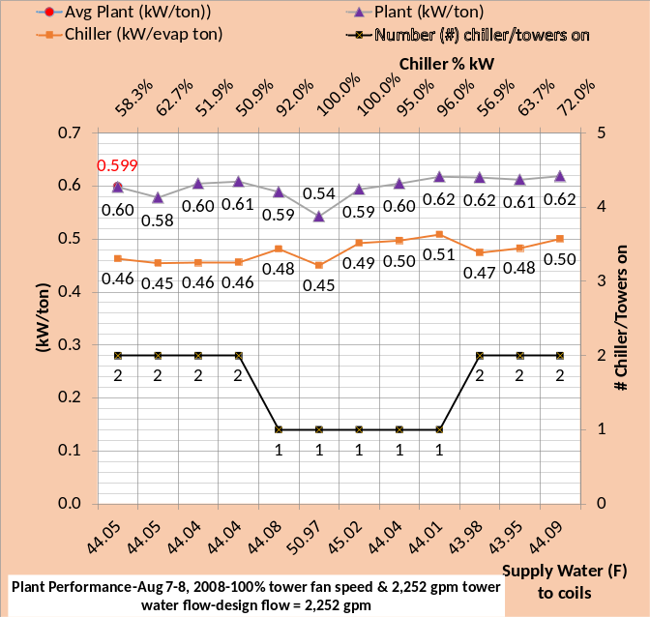
Figure 34: One chiller/tower operation, midnight to 8AM,-top chart 1,850 gpm tower flow-bottom chart 2,252 gpm tower flow

Comparing the top and bottom charts of Figure 34 illustrates that increasing the tower water flow from 1,850 gpm to design 2,252 gpm brought the supply water to the coils down a little at 2AM & 4AM but not to 44F as required. The average plant kW slightly increased from .594 to .599 however this is not relevant because the supply water is not at 44F for these two hours.

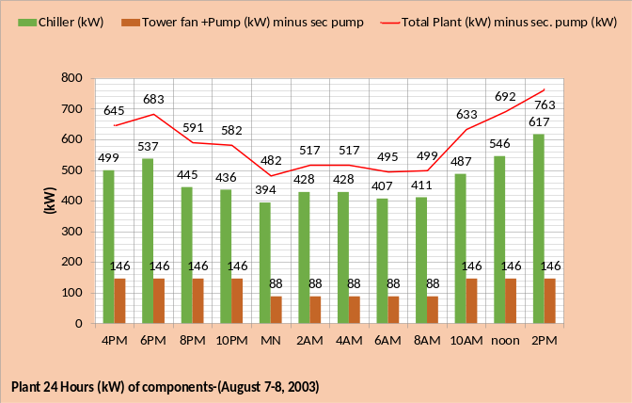
Figure 35: Plant 24 hour performance- top chart 1850gpm tower flow-bottom chart 2252 gpm.

Figure 35 illustrates the increase in tower fan plus pump kW, with 2252 gpm tower flow, from 73 kW to 88 kW from midnight to 8am when one chiller/tower is on. At midnight the chiller kW decreased from 403 to 394 due to increased tower flow. The chiller kW is at 100% at 2AM & 4AM and therefore does not change. At 6AM & 8AM the chiller kW decreased with 2,252 tower flow, bottom chart, however the plant kW increased with 2,252 tower flow about 7 kW at midnight, 6AM, & 8AM.

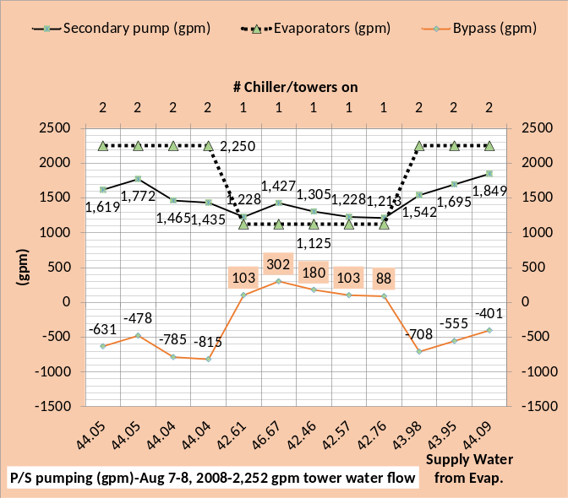
Figure 36: P/S pumping 24 hour performance- top chart 1850gpm tower flow-bottom chart 2252 gpm tower flow

Figure 36 is provided to illustrate nothing changes with P/S pumping due to the change in tower water flow.

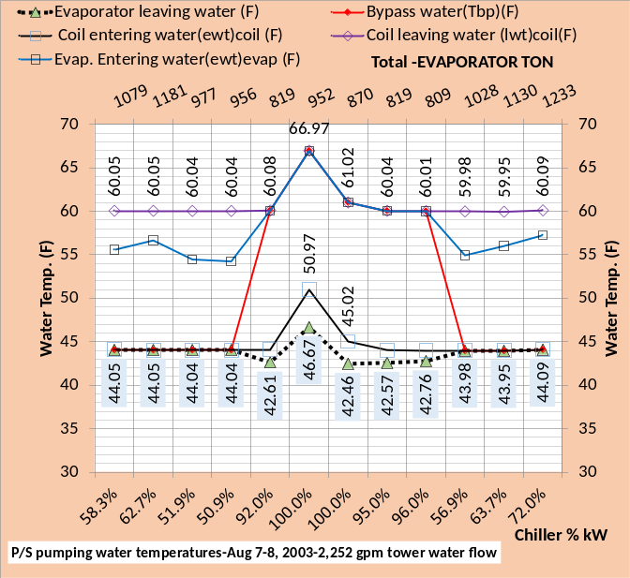
Figure 37: Plant 24 hour performance- top chart 1850gpm tower flow-bottom chart 2252 gpm.

Figure 37 illustrates the slight change in evaporator leaving water temperature and coil entering water temperature, at 2AM & 4AM, with 100% chiller kW and increased tower flow to 2,252 gpm. Bypass flow in the wrong direction requires the water temperature from the evaporator be less than 44F as shown.

Schematic 18: One chiller operation at 2AM-1,850 (gpm) tower water flow

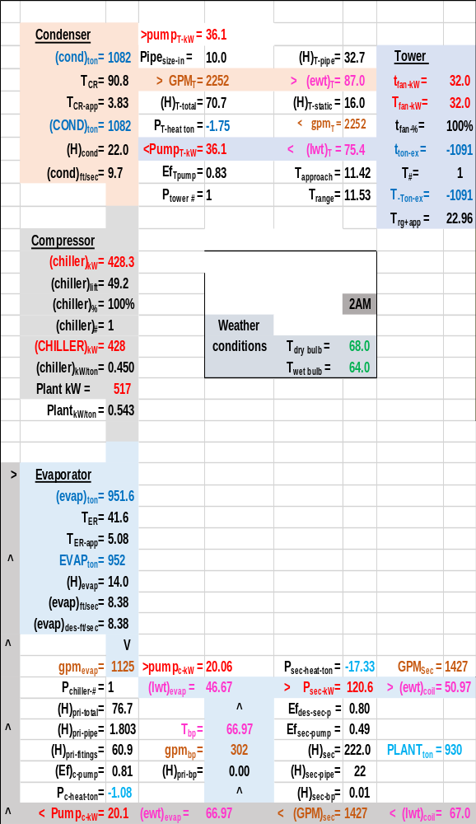
Schematic 19: One chiller operation at 2AM-2,252 (gpm) tower water flow

Comparing Schematics 18 & 19 illustrates the complexity of the plant system. The tower range plus approach decreased with 2,252 gpm tower water flow therefore the condenser refrigerant temperature decreased about one degree. However the evaporator refrigerant temperature increased as the evaporator supply water decreased, arriving at a system energy equilibrium point of chiller lift of about the same.
The wrong way flow in the bypass suggests the possibility of increasing evaporator flow so the chiller need not provide water colder than 44F. This control strategy will be looked at next.

August 7-8, 2003-Plant performance with tower fans operating at 100% & condenser pumps operating at 100% = 2,252 gpm & evaporator water supply = 44F.
Control strategy-Increase evaporator flow to eliminate wrong way bypass flow.
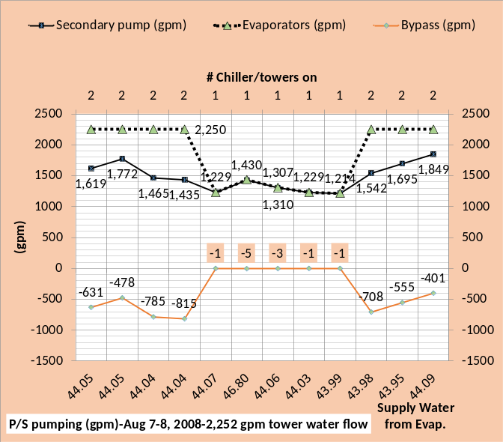
Figure 38: P/S pumping-top chart design evap. water flow-bottom chart increased evaporator flow to eliminate wrong way flow in bypass

Figure 38 top chart is copied from Figure 36 and gives the wrong way flow in the bypass from midnight to 8am. The bottom chart increases the evaporator flow to give correct flow in the bypass. The horizontal axis of the bottom chart illustrates the temperature of water from the evaporator is about 44F except at 2AM where the evaporator can only provide 46.80F water with 100% chiller kW.

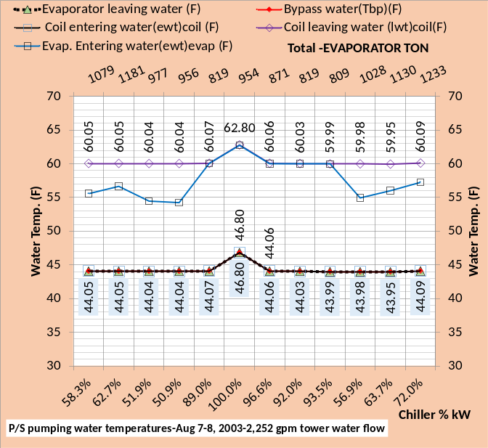
Figure 39: P/S pumping-top chart design evaporator flow-bottom chart variable evap. flow

Figure 39 top chart is from figure 37 illustrating the effect of wrong way flow in the bypass and the bottom chart shows how the water temperatures are stabilize by increasing evaporator flow to accomplish correct bypass flow direction. However as shown by the bottom chart at 2AM the evaporator supply water temperature is above 44F, a water supply of 46.80F with 100% chiller power.

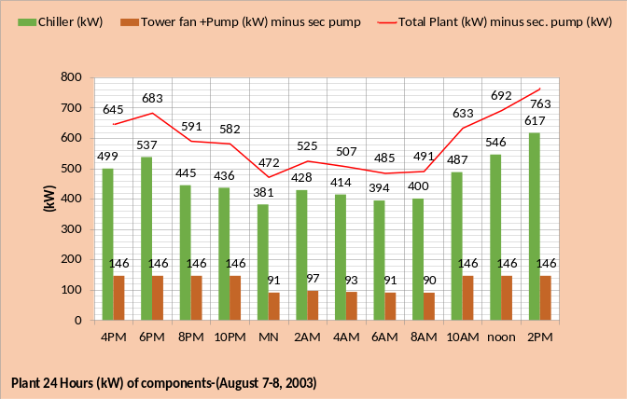
Figure 40: Plant kW-top chart at design evaporator flow-bottom chart variable evaporator water flow
Figure 40 shows that the plant kW decreased by controlling the evaporator flow for midnight, 4AM, 6AM & 8AM. The 2AM value is not relevant because the supply water is 46.80F as discussed above.
Figure 41 is top chart is copied from figure 34 showing the one chiller plant cannot supply 44F water at 2AM & 4AM. The bottom chart shows one chiller with correct flow in the bypass can provide 44F supply water except at 2AM where supply water is 46.80F and therefore two chillers are required to provide 44F supply water.

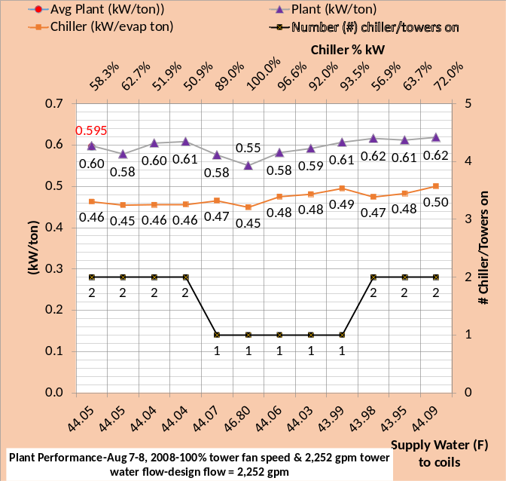
Figure 41: One chiller/tower operation at midnight to 8AM,-top chart design evaporator flow-bottom chart variable evaporator flow

Schematic 20: 2AM performance with design evaporator flow
Schematic 21 shows the evaporator water flow has been increased to 1,430 gpm to accomplish correct flow direction in the bypass. The temperature of water entering the coils is dropped from 50.97F of Schematic 20 to 46.80F of Schematic 21, 44F supply water required therefore this control strategy falls short. Controlling evaporator flow appears to be a viable control strategy for this plant, however better understanding is needed to decide when one chiller/tower can meet the load.

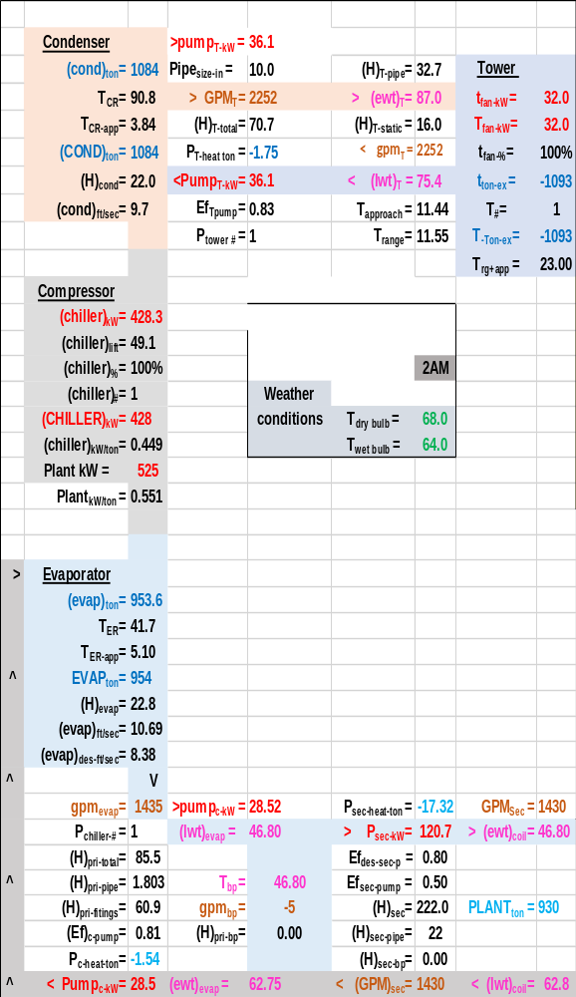
Schematic 21: 2AM performance with increased evaporator flow.

Schematic 5A above showed the chiller with the big tower has a capacity of 763 ton or 13 ton more than the design load of 750 ton.
Figure 42 gives the load and wet bulb temperature of August 7-8, 2003 showing the chiller capacity had to be significantly greater than 763 ton from midnight to 8AM to operate with one chiller.
Figure 42: Evaporator load (ton) and weather conditions verses time of day.

One chiller/tower was operated from midnight to 8AM and the load was met with the 763 ton chiller at design 76F wet bulb except for 2AM when the load was 956 ton and a wet bulb of 64F. At midnight the load is 824 ton and wet bulb 66F, 4AM is 875 ton & 66F wet bulb, and 6AM is 824 ton & 68 wet bulb, and 8AM load is 813 ton at a wet bulb of 70F. Clearly the capacity of the chiller/tower significantly increased with decreasing wet bulb illustrating the need for plant operators to know the capacity of the plant as a function of wet bulb.
Therefore next we will look at the capacity of the chiller/tower as the wet bulb decreases and increases from the design 76F wet bulb temperature. A necessary understanding for the plant to be operated efficiently.

Chiller/Tower Capacity when providing 42F coil supply water as Wet Bulb Temperature both increases and decreases.
The following analysis will define the decrease in plant load (ton) capacity as the wet bulb is greater than 76F and also the increase in capacity as the wet bulb drops below 76F.
Figure 43 illustrates how the tower and chiller change performance as the wet bulb temperature varies from 60F up to 82F, shown by the secondary horizontal axis of the top chart. The top chart illustrates the tower performance as the wet bulb changes from the design temperature of 76F and an evaporator load of 763 ton as shown on the primary horizontal axis. The chiller kW is held at constant 428.3 kW for both chillers and the evaporator load for two chillers can increase up to 882 ton as shown by the primary horizontal axis, the plant can still provide 42F supply water to the coils. As the wet bulb drops the tower water temperature in and out drops as shown resulting in a drop in chiller lift as shown by the top chart. With increasing evaporator load both the range and tower approach increase as shown by the top chart.
The middle chart illustrates the refrigerant temperatures drop with decreasing wet bulb and therefore the chiller lift drops allowing greater evaporator load as shown by the top chart.
The bottom chart gives the chiller and plant kW per evaporator load (ton) values, showing an increase in chiller and plant kW per ton as the wet bulb increases above 76F and improves or drops as the wet bulb drops below 76F down to 60F wet bulb. The primary horizontal axis of the bottom chart illustrates that the evaporator water supply is less than 42F to provide 42F coil supply water for all wet bulb temperatures of 76F and less. The reason is the bypass flow is in the wrong direction to be further explained below.

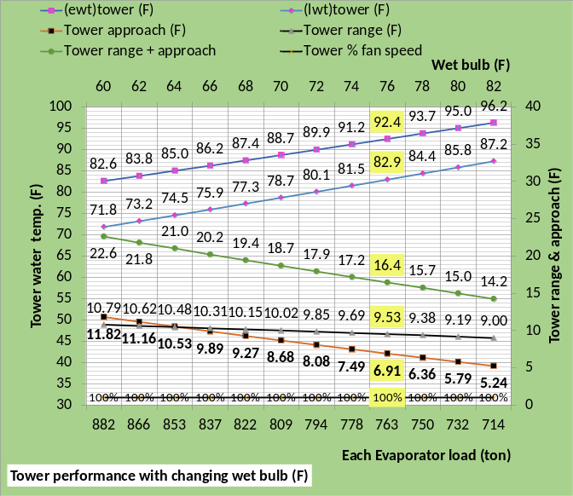
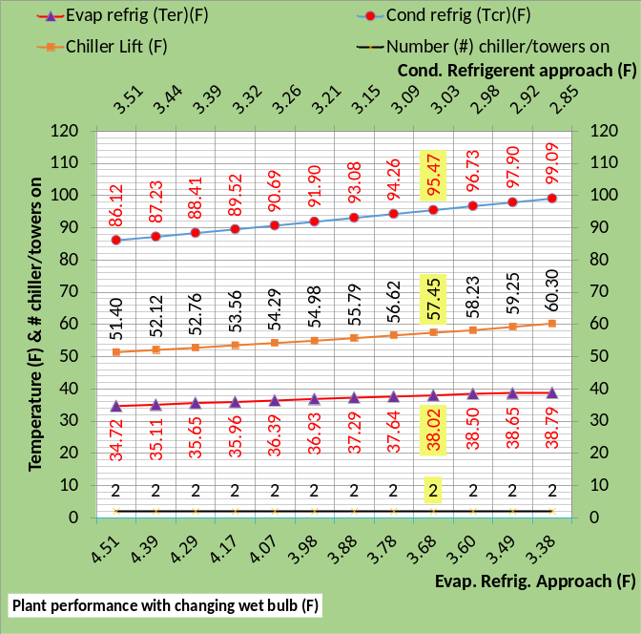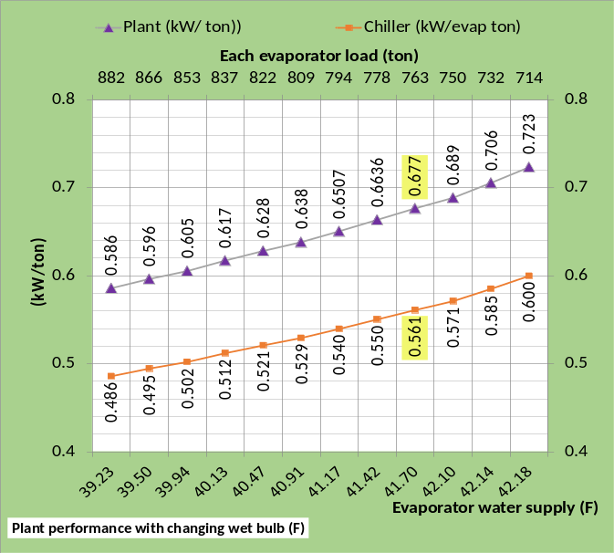
Figure 43: Plant performance as wet bulb changes from design 76F.
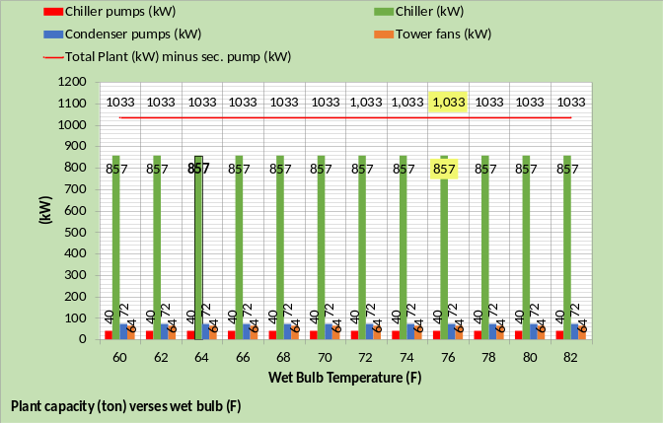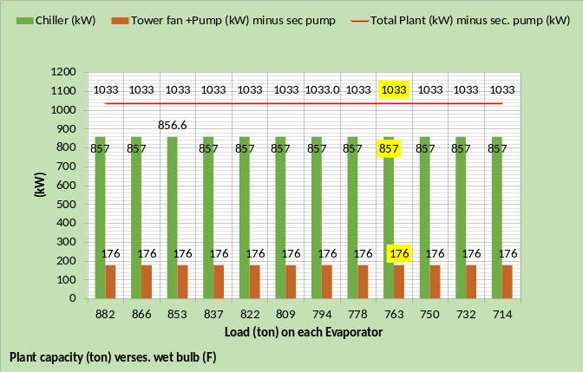
Figure 45: Plant capacity (ton) as wet bulb changes from design 76F
Figure 45 illustrates the chiller kW, tower fan kW, and pumps kW is constant as the wet bulb temperature drops and the evaporator load is increased while suppling 42F water to the coils. However as stated above the water supply off the evaporator must be less than 42F; Figure 46 illustrates why.
The top chart of Figure 46 illustrates the bypass flow is in the wrong direction for all values of wet bulb less than 78F. The bypass flow is slightly (40gpm) in the wrong direction at design 76F wet bulb because the chiller was designed with a small tower and a bigger tower was installed resulting in a sight bypass water flow in the wrong direction.
The bottom chart of Figure 46 illustrates the bypass water temperature changes to the same as the coil leaving water temperature at 76F wet bulb and the evaporator leaving water temperature is required to be less than the 42F water to the coils due to the wrong way flow in the bypass.

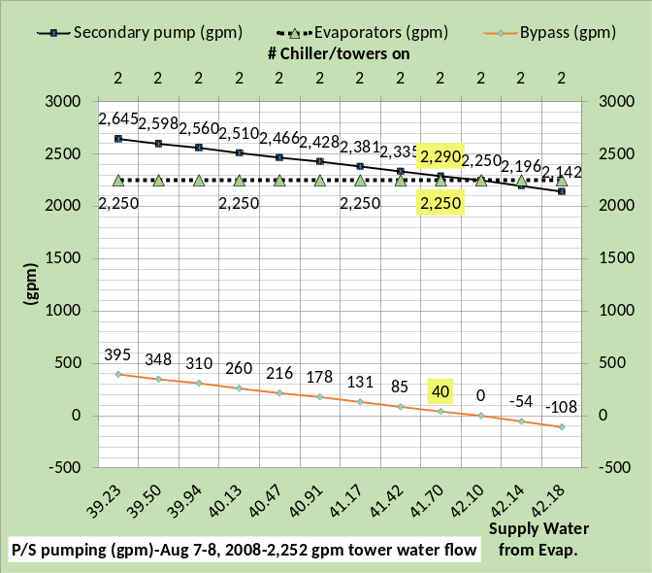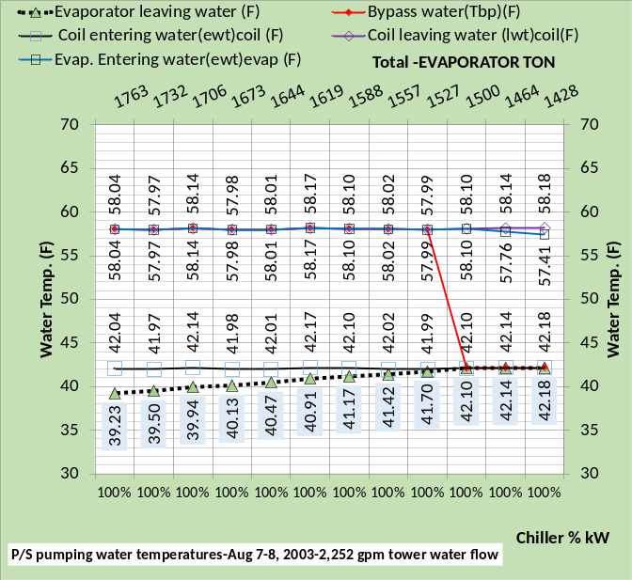
Figure 46: P/S pumping as wet bulb changes from design 76F-No evaporator flow control

Figure 46 brings an obvious question; would increasing the evaporator pump kW and therefore evaporator water flow to assure correct flow in the bypass result in a decrease in plant kW per ton? Next we will answer that question.

Chiller/Tower Capacity when providing 42F coil supply water as Wet Bulb Temperature changes with controlled evaporator water flow.

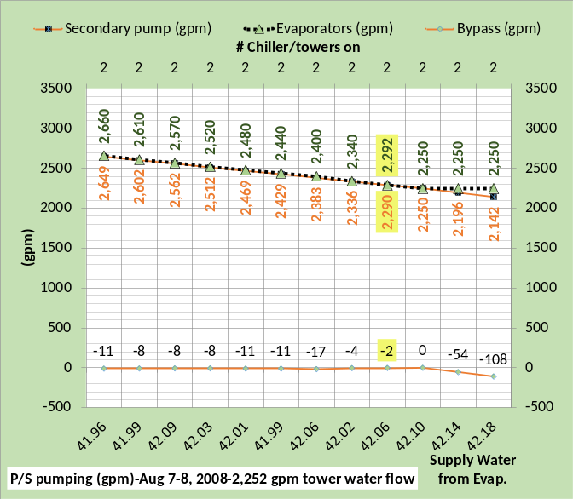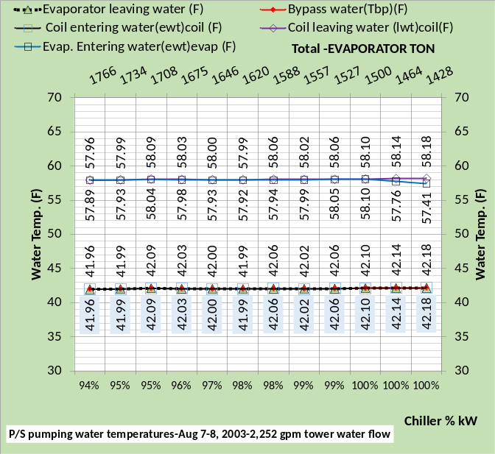
Figure 47: Primary/Secondary pumping with evaporator flow control-42F supply water

Figure 47 illustrates the water flow and water temperatures with evaporator water flow control to assure correct flow in the bypass. The top chart illustrates negative or correct flow in the bypass resulting in the water temperatures in the bypass, evaporator leaving water, and coil entering water, all being about 42F as shown by the bottom chart.
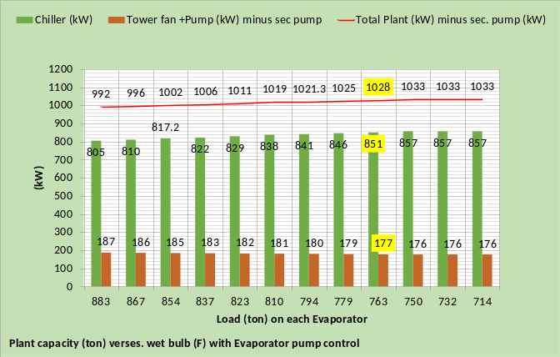
Figure 48: Plant capacity (ton), top chart constant evaporator flow-bottom chart with evaporator flow control

The top chart of Figure 48 is copied from Figure 45 showing constant plant kW as the wet bulb drops and the evaporator load can be increased as discussed above. The bottom chart of Figure 48 shows an increasing tower fan plus pump kW due to the increased evaporator pump kW as the wet bulb drops but the chiller kW can decrease with evaporator water flow control and still provide 42F supply water as shown by the bottom chart of Figure 47 primary horizontal axis.
The net result, with evaporator water flow control, is a decrease in plant kW as wet bulb drops as shown by the bottom chart of Figure 48, however the most important result of evaporator flow control is the increase in chiller/tower capacity as show by Figure 48 bottom chart. As the evaporator load increases with decreasing wet bulb, the chiller kW drops from 857 kW for two chillers down to 805 kW and still provides 42F supply water to the coils.

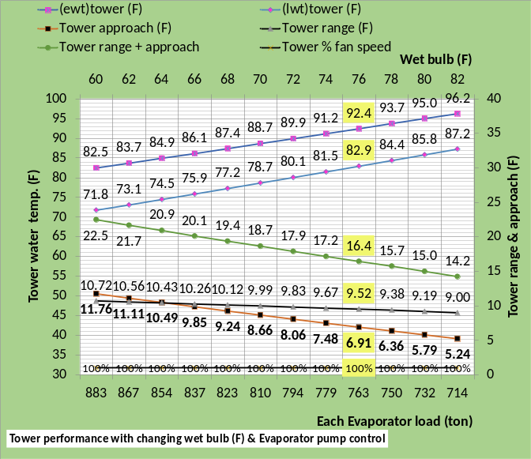
Figure 49: Tower performance with and without evaporator flow control

Figure 49 shows the tower performance is essentially unchanged with evaporator water flow control. The primary horizontal axis of the top and bottom charts show a slight increase in evaporator load with evaporator flow control because of the increase in evaporator pump kW also shown by Figure 48.

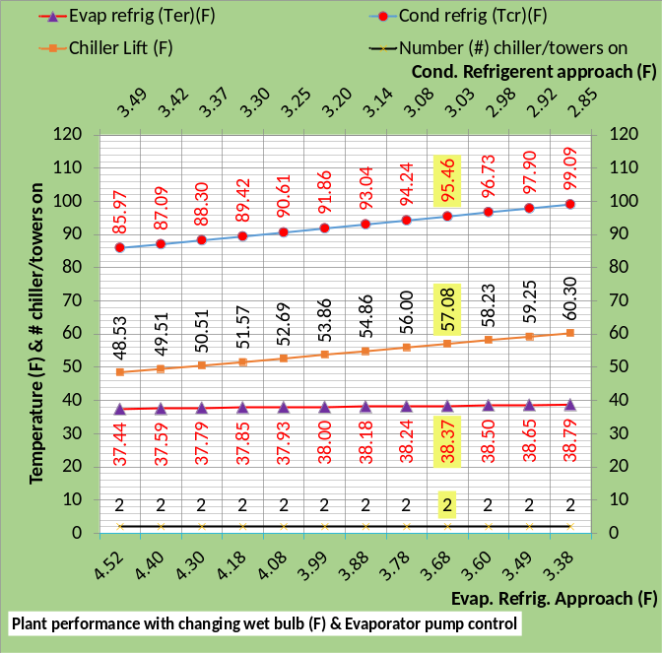
Figure 50: Plant performance with and without evaporator flow control

Figure 50 shows the chiller lift decrease with evaporator pump control primarily due to the increase in evaporator refrigerant temperature with evaporator pump control.

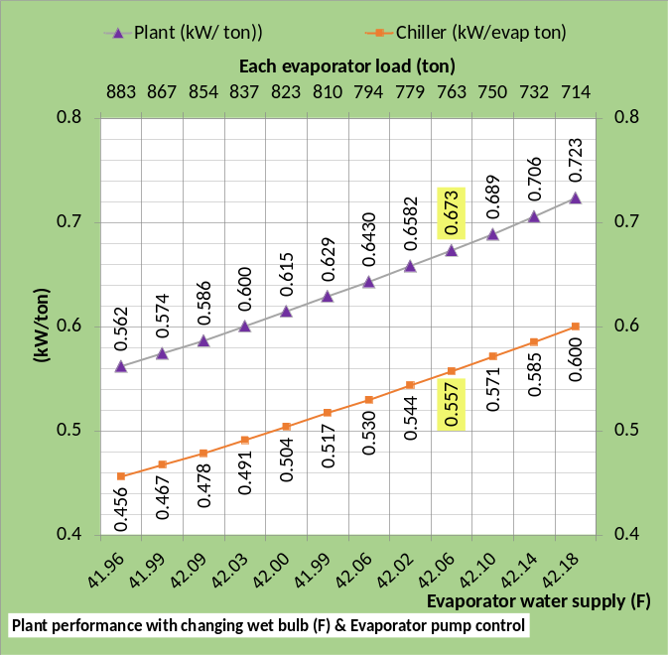
Figure 51: Plant kW/ton performance with and without evaporator flow control

Figure 51 illustrates the improvement in plant and chiller kW per ton is about 1% to 4% with evaporator pump control, not a big improvement in efficiency, however Figure 48 illustrates a significant increase in chiller capacity with evaporator pump control.

Schematics that illustrate the effect of evaporator flow control
The next eight schematics illustrate the effect of evaporator pump control.
Schematics 22 at 82F wet bulb verses 76F design & correct flow in the bypass can only meet an evaporator load of 713.9 ton verses 763.4 ton at design and still provide required 42.06F supply water to the coils.
Schematics 23 & 24 at 76F design wet bulb illustrate the improvement evaporator pump control provides. With a slight increase in evaporator pump power the bypass flow is changed to the correct direction and the chiller kW is reduced to 99% to produce 42.06F supply water to the coils at evaporator load of 763.5 ton.
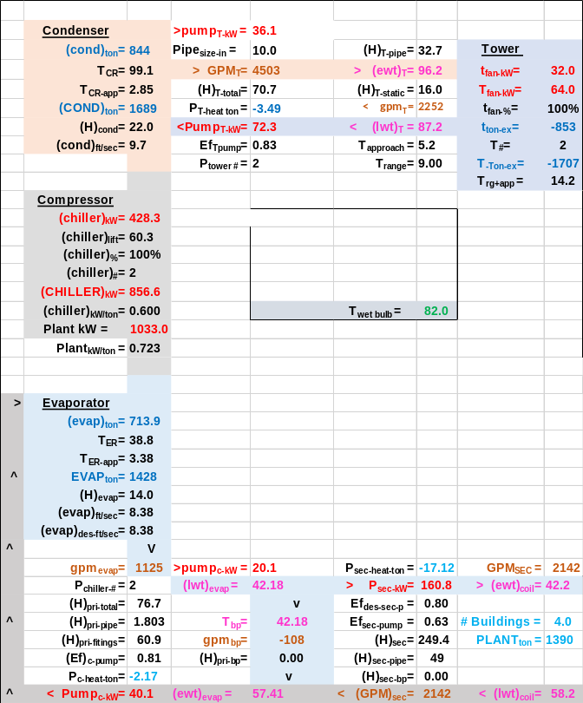
Schematic 22: Evaporator Load=713.9 ton-wet bulb 82F-bypass flow correct direction-100% chiller power-1125 gpm constant evaporator flow

Schematics 25 & 26 at 70F wet bulb further illustrates the improvement evaporator pump control provides. With an increase in evaporator pump power the bypass flow is changed to the correct direction and the chiller kW is reduced to 98% to produce 41.99F supply water to the coils at an evaporator load of 809.8 ton verses 763 ton at design.

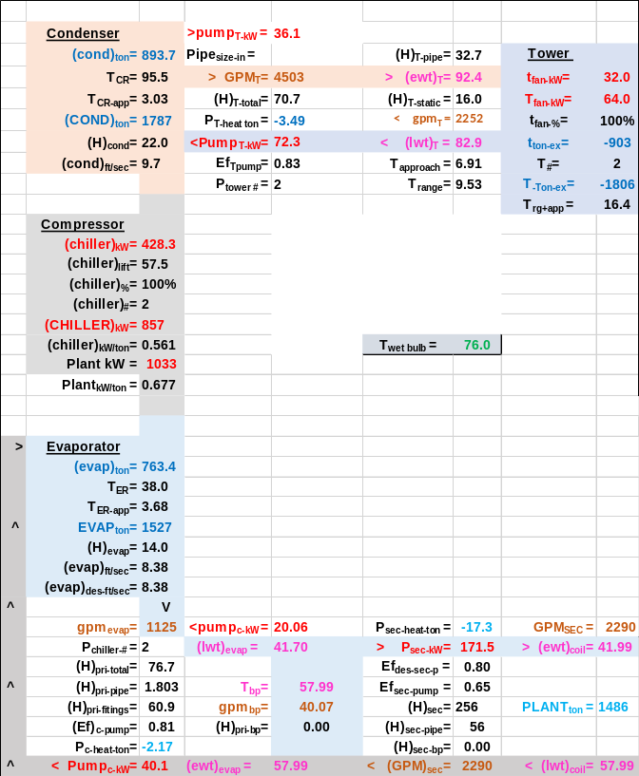
Schematic 23: Evaporator Load=763.4 ton-wet bulb 76F-bypass flow wrong direction-100% chiller power-1125 gpm constant evaporator flow

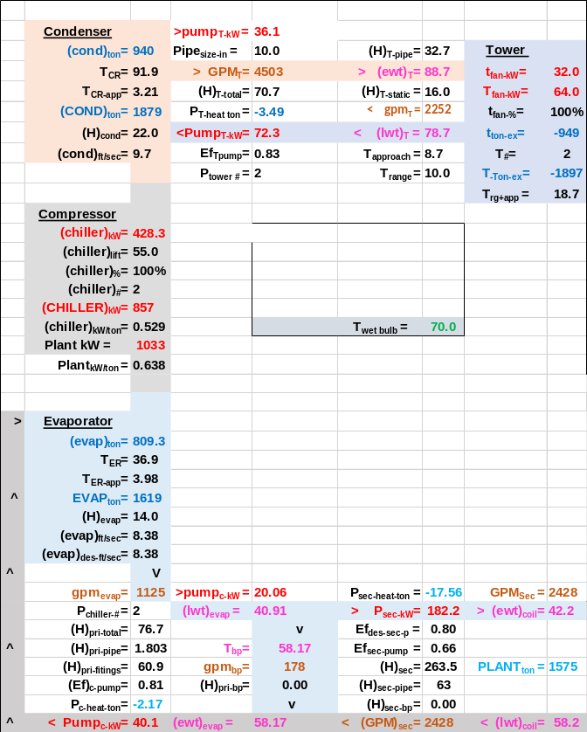
Schematic 25: Evaporator Load=809.3 ton-wet bulb 70F-bypass flow wrong direction-100% chiller power-1125 gpm constant evaporator flow
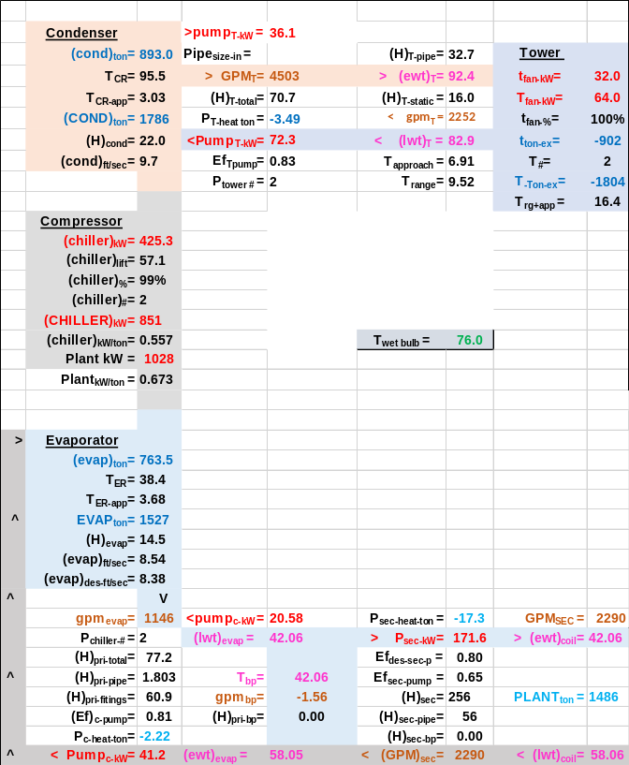
Schematic 24: Evaporator Load=763.5 ton-wet bulb 76F-bypass flow correct direction-99% chiller power-1146 gpm variable evaporator flow

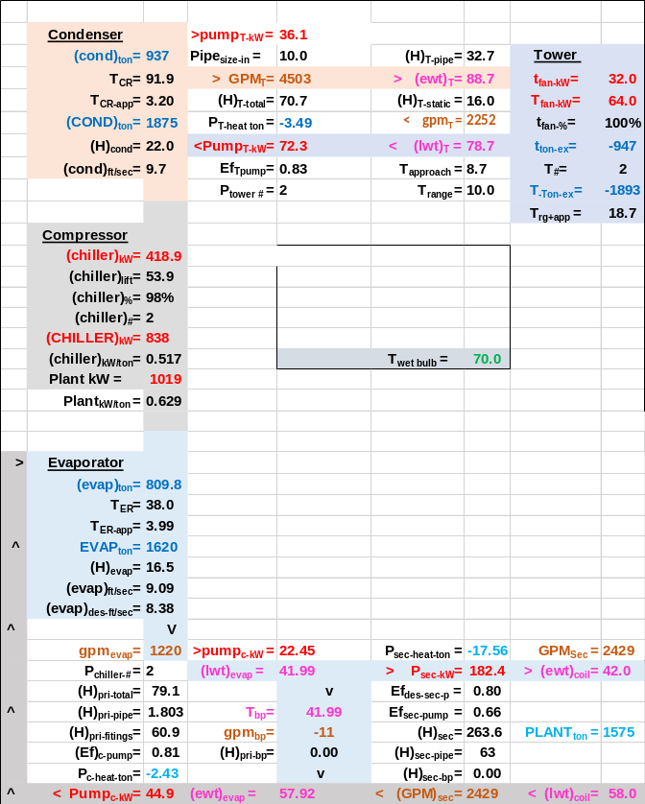
Schematic 26: Evaporator Load=809.8 ton-wet bulb 70F-bypass flow correct direction-98% chiller power-1220 gpm constant evaporator flow
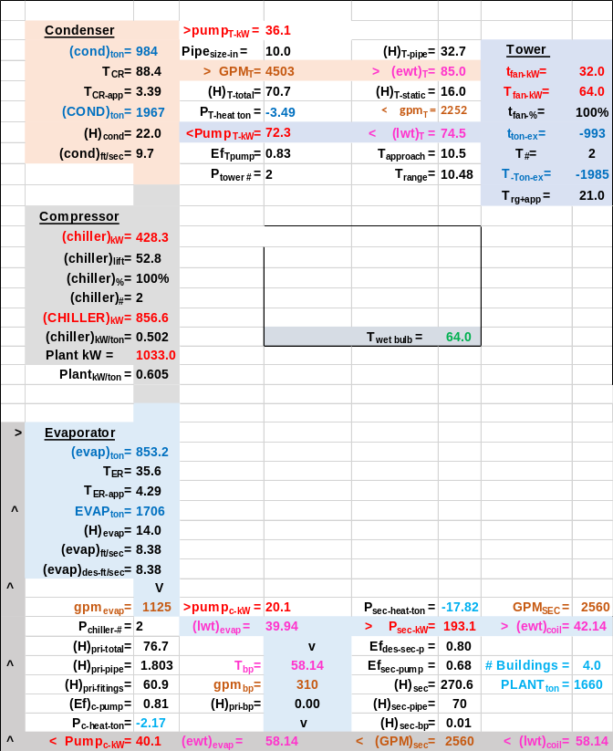
Schematic 27: Evaporator Load=853.2 ton-wet bulb 64F-bypass flow wrong direction-100% chiller power-1125 gpm constant evaporator flow

Schematics 27 & 28 at 64F wet bulb illustrates a significant improvement with evaporator pump control. With an increase in evaporator pump power of about 8kW the bypass flow is changed to the correct direction and the chiller kW is reduced to 95% to produce 42.09F supply water to the coils at an evaporator load of 854.2 ton. Clearly the capacity of the plant is significantly increased with decreasing wet bulb.

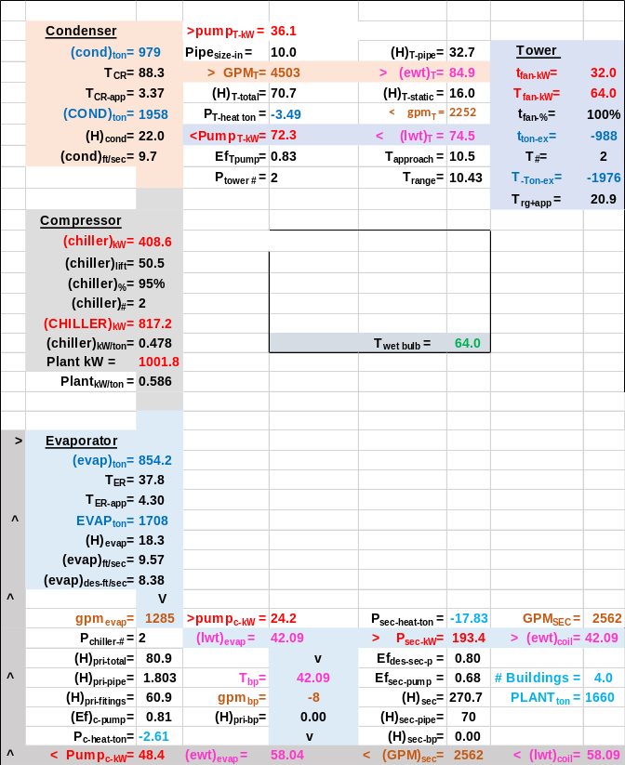
Schematic 28: Evaporator Load=854.2 ton-wet bulb 64F-bypass flow correct direction-95% chiller power-1285 gpm variably evaporator flow

Summary of Plant capacity as function of wet bulb
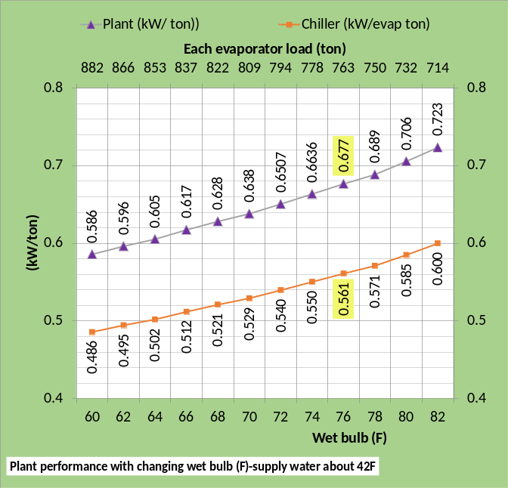
Figure 52: Top chart evaporator load of August 7-8, 2003-bottom chart plant capacity verses wet bulb (F)

Figure 52 bottom chart summarizes how the capacity of this plant varies as the wet bulb changes. At design wet bulb of 76F the capacity of the plant is 763 ton with the big tower installed. As the wet bulb increases the capacity of the plant drops down to 714 ton at 82F wet bulb. For wet bulb values of less than 76F the capacity of the plant increases up to 882 ton at a wet bulb of 60F, a significant increase. The top chart gives the evaporator load and wet bulb for August 7-8, 2003 as taken from Baker¹. As discussed above the (SEE) Model attempted to operate the plant with one chiller/tower from midnight to 8AM and was unsuccessful at 2AM; the bottom chart of Figure 52 illustrates why. At 2AM the top chart shows a wet bulb temperature of 64F and a load of 956 ton and the bottom chart shows a chiller/tower capacity of 853 ton at a wet bulb of 64F. Clearly one chiller/tower cannot provide 42F supply water at these 2AM conditions of 853 ton capacity and load of 956 ton. Figure 53 illustrates that with evaporator flow control the chiller kW is reduced as the evaporator pump kW is increased to eliminate wrong flow direction in the bypass. Eliminating wrong flow direction in the bypass increased the capacity of the chiller as shown by the bottom chart of Figure 53.

Figure 53 Copied from figures 47 & 48 42F supply water with evaporator flow control
Wet Bulb | One Chiller Capacity (ton) | Chiller kW w/o evap.  flow cont. | Chiller kW with evap. flow cont. | Aug.7-8, 2003 load (ton)
82F | 714 ton | 428 kW | 428 kW
80F | 732 ton | 428 kW | 428 kW
78F | 750 ton | 428 kW | 428 kW
76F | 763 ton | 428 kW | 426 kW
74F | 778 ton | 428 kW | 423 kW
72F | 794 ton | 428 kW | 421 kW
70F | 809 ton | 428 kW | 419 kW | 8AM=813
68F | 822 ton | 428 kW | 415 kW | 6AM=824
66F | 837 ton | 428 kW | 411 kW | MN=824  4AM=875
64F | 853 ton | 428 kW | 409 kW | 2AM=956
62F | 866 ton | 428 kW | 405 kW
60F | 882 ton | 428 kW | 403 kW
One | Two | Three | Four | Five
Table 7: Chiller capacity & kW demand as wet bulb decreases with & without evaporator flow control while providing 42F supply water to coils

Table 7 column one gives the wet bulb temperature and column two the evaporator load the chiller can meet without evaporator flow control and a chiller kW of 428 as given by column three. Column four illustrates the decrease in chiller kW that can occur with evaporator flow control and still meet the evaporator load of column two. Column five, see top chart Figure 52, gives the time and loads of August 7-8, 2003 where one chiller has the potential of meeting the load. At midnight the August 7-8 load is 824 ton and the capacity of the chiller is 837 ton therefore one chiller can meet the load. All other times of column five show the load is greater than column two; however column four shows the chiller is at reduced kW with evaporator flow control and can still meet the load of column two. Column four raises the obvious question; if the chiller was operated at full kW what load could it meet? The following answers that question.
Figure 54 illustrates the increase in plant capacity as a result of evaporator flow control to assure near zero flow in the bypass. The top chart shows the flow in the bypass is set close to zero but not always in the correct direction to illustrate a point. The middle chart illustrates the temperature of bypass water jumps to return water temperature of about 58F when bypass flow is positive and 42F when flowing in the correct direction. The bottom chart illustrates the resulting increase in evaporator load also shown by Table 8.

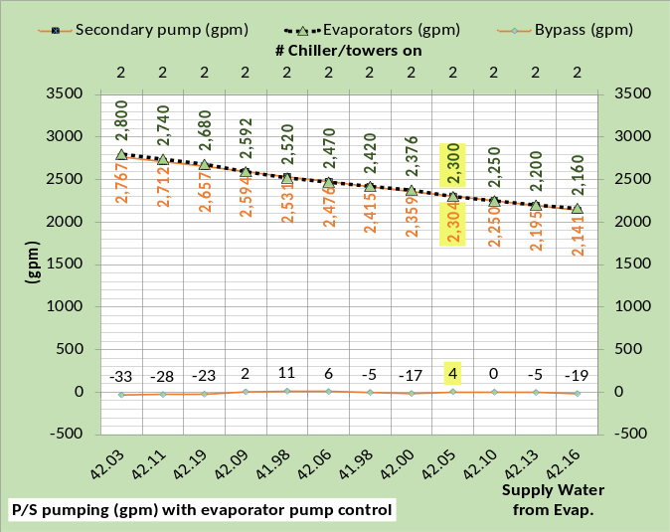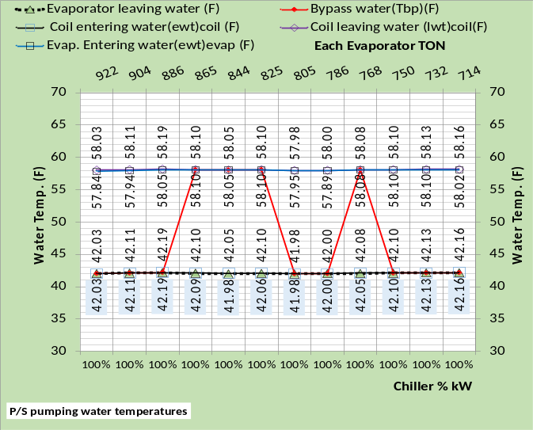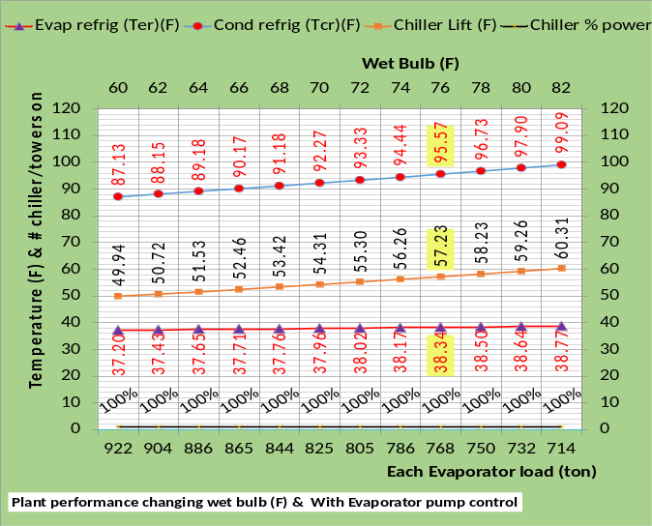
Figure 54: Plant performance with evaporator flow control
Wet Bulb | Chiller Cap. w/o evap. Flow cont. | Chiller kW w/o evap.  flow cont. | Chiller kW w/evap. flow cont. | Aug.7-8, 2003 load (ton) | Chiller cap. with evap. Flow control
82F | 714 ton | 428 kW | 428 kW |  | 714 ton
80F | 732 ton | 428 kW | 428 kW |  | 732 ton
78F | 750 ton | 428 kW | 428 kW |  | 750 ton
76F | 763 ton | 428 kW | 426 kW |  | 768 ton
74F | 778 ton | 428 kW | 423 kW |  | 786 ton
72F | 794 ton | 428 kW | 421 kW |  | 805 ton
70F | 809 ton | 428 kW | 419 kW | 8AM=813 | 825 ton
68F | 822 ton | 428 kW | 415 kW | 6AM=824 | 844 ton
66F | 837 ton | 428 kW | 411 kW | MN=824  4AM=875 | 865 ton
64F | 853 ton | 428 kW | 409 kW | 2AM=956 | 886 ton
62F | 866 ton | 428 kW | 405 kW |  | 904 ton
60F | 882 ton | 428 kW | 403 kW |  | 922 ton
One | Two | Three | Four | Five | Six
Table 8: Two Chiller Plant capacity & kW demand as wet bulb decreases with & without evaporator flow control while providing 42F supply water to coils

Table 8 illustrates that one chiller can meet the load of August 7-8, 2003 and provide 42F supply water to the coils at 8AM, 6AM, and midnight. One chiller/tower cannot meet the load and provide 42F supply water at 2AM & 4AM. The 4AM 875 ton load cannot be met by the 865 ton chiller capacity when providing 42F supply water. However if 44F supply water was acceptable then one chiller can meet the load as will be shown below. The 4AM load of 875 ton is however “a bridge to far”.
Schematics 29 & 30 are for wet bulb of 70F, illustrating the plants characteristics at these two conditions of evaporator flow. Schematic 29 shows 178 gpm of 58.17F water flow in the bypass that requires 40.91F water off the evaporator and therefore the chiller can only meet a load of 809 ton as shown by the schematic and Table 8. Schematic 30 shows 6 gpm of 58.17F water flow in the bypass that requires 42.06F water off the evaporator to provide 42.10F water to the coils and the chiller can meet a load of 825 ton as shown by the schematic and Table 8.
For this plant as configured, evaporator flow control can have a very positive effect.
We will now return to the August 7-8, 2008 conditions and develop plant control strategies that minimize plant kW.

Schematic 29: No evaporator flow control

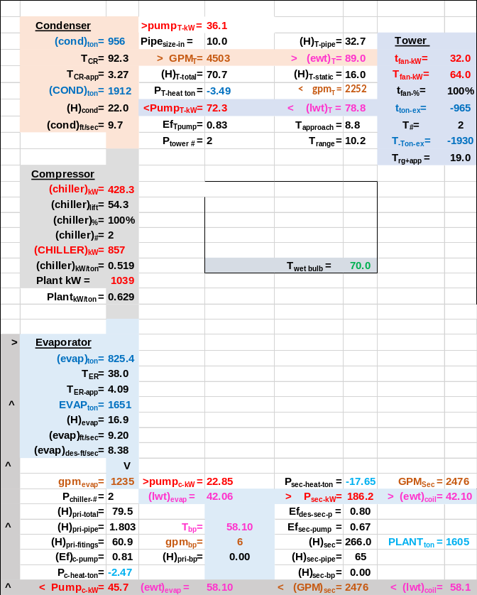
Schematic 30: With evaporator flow control

August 7-8, 2003. Two chiller plant performance with tower fans and pumps operating at 100%.

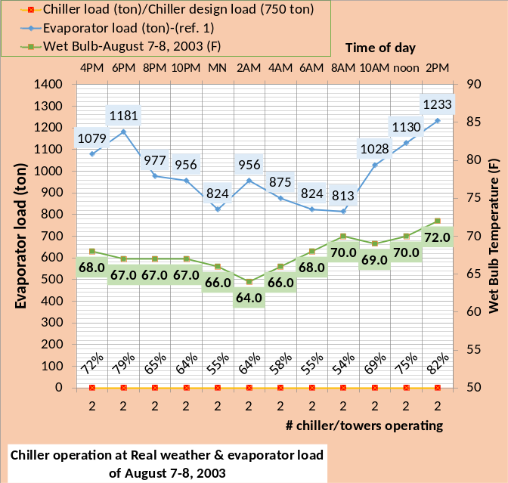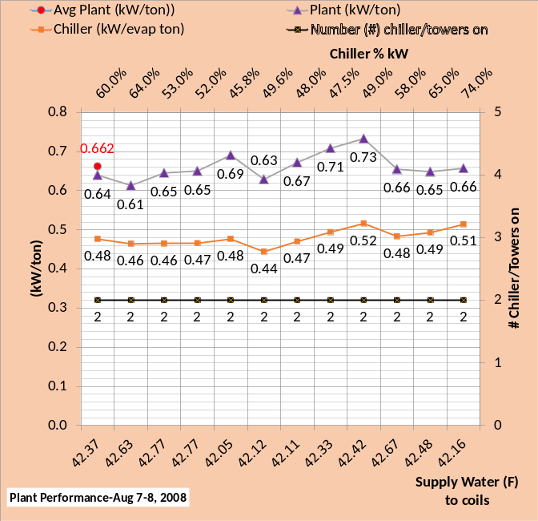
Figure 55: Two Chiller/Tower Plant performance with tower fans & pumps operated at 100%

Figure 55 gives an average of .662 kW/ton for the 24 hours of two chiller plant operation with tower fans and pumps operating at 100% capacity. Comparing the top chart % load to the secondary horizontal axis of the bottom chart illustrates that the chiller % kW demand is always less than the % load due to the increased capacity of the chiller/tower as the wet bulb drops below design 76F.
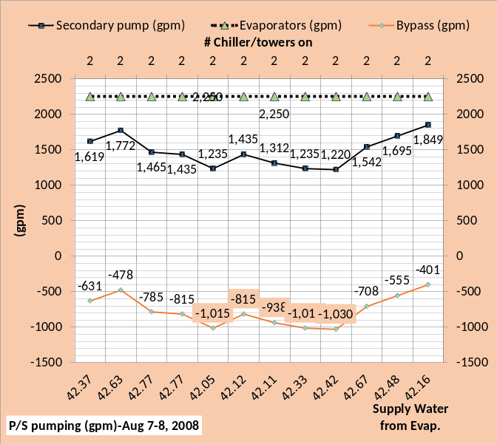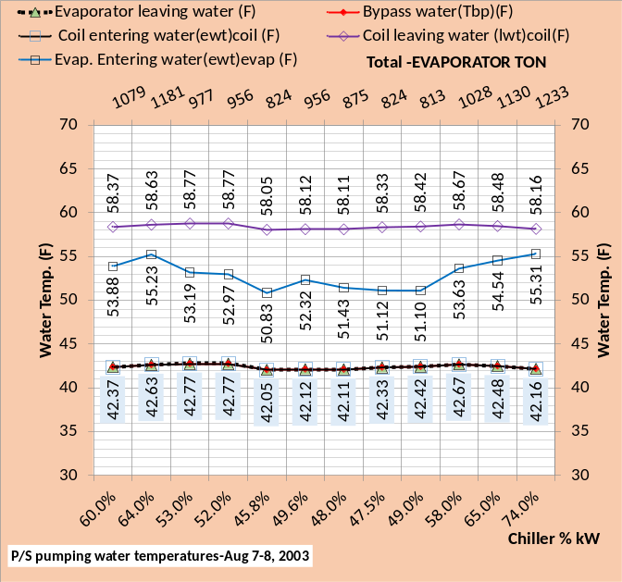
Figure 56: Primary/Secondary pumping

The top chart of Figure 56 illustrates that the bypass flow is always in the correct direction and therefore the water temperatures as show by the bottom chart are as desired for smooth operation of the plant. The temperature of water off the evaporator is about 42F as is the bypass water and water entering the coils. The temperature of water leaving the coils is about 58F and when mixed with the bypass water enters the evaporator at a temperature significantly less than 58F.

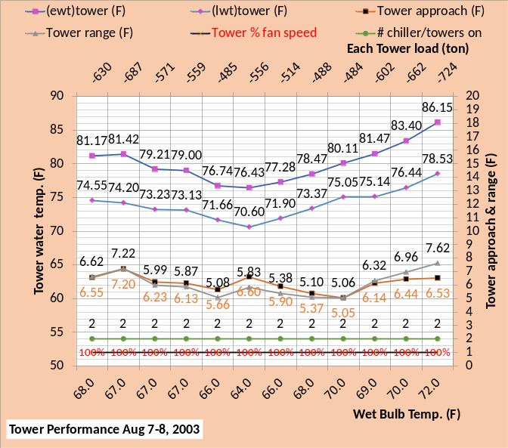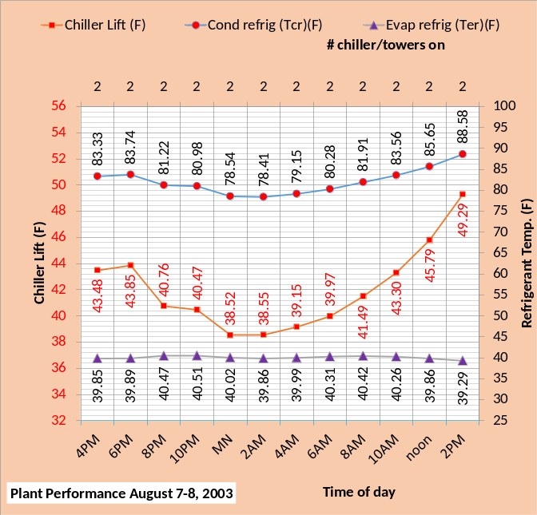
Figure 57: Tower & plant performance

Figure 57 top chart shows the tower operating at 100% fan speed and a tower approach to wet bulb and tower range of about the same value. The bottom chart shows the refrigerant temperatures and the resulting chiller lift. Chiller lift in large part determines chiller kW demand.

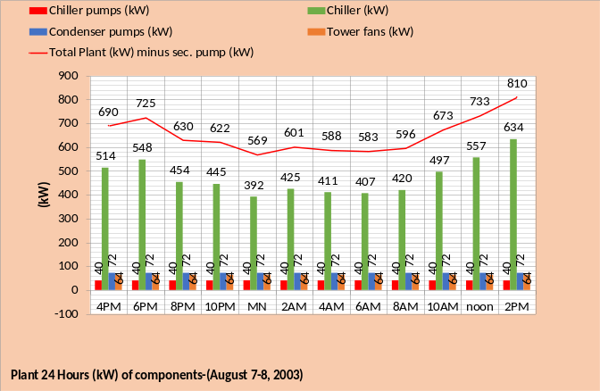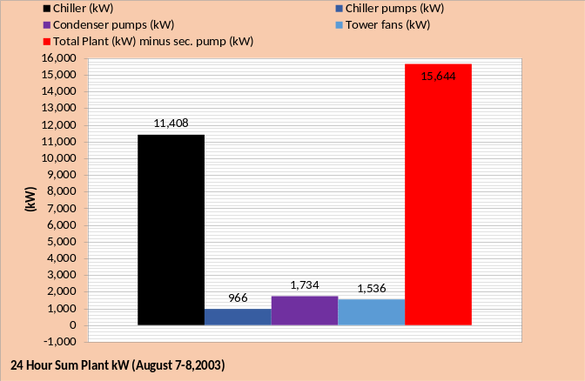
Figure 58: Plant kW performance over 24 hours

Figure 58 top chart shows the tower fan and pump kW is constant over the 24 hours. The chiller kW demand changes as required to provide 42F supply water to the coils. Total plant kW is also given with secondary pump kW not in the total. The bottom chart gives the 24 hour totals showing the chiller as predominate kW demand followed by the condenser pumps, then tower fans and chiller pumps.

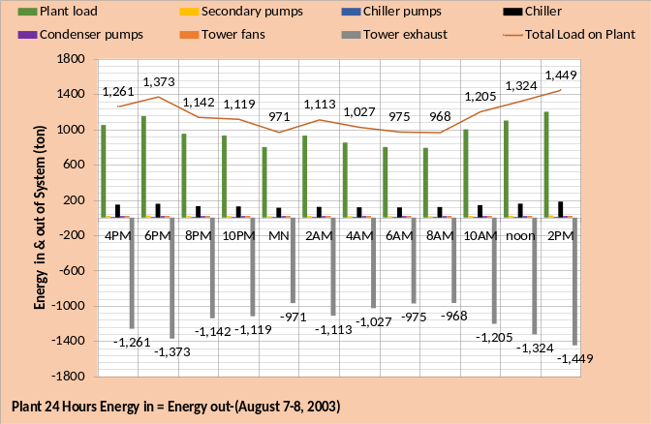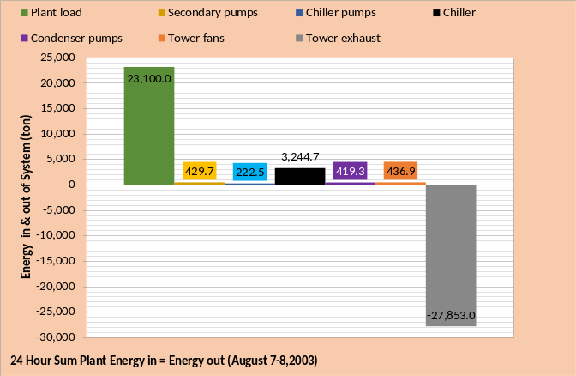
Figure 59: Plant Energy in = Energy out

The energy into and out of a real system must equal and therefore a System Energy Equilibrium (SEE) Model must also demonstrate this fundamental thermodynamic property. Figure 59 top chart illustrates that for each hour energy in = energy out and the bottom chart gives the 24 hour summed values for each plant component. The plant load is the big energy in value and the tower exhaust is the only energy out value. The energy in due to the components is a function of its kW demand, therefore the chiller provides the largest energy in value followed by the secondary pumps. The secondary pumps must be in the (SEE) Model to accomplish energy equilibrium.
Schematic 31 is provided for reader study.

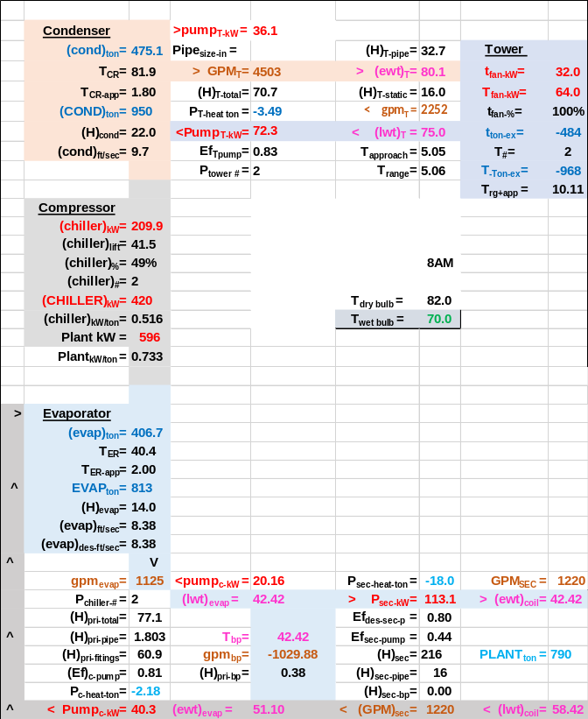
Schematic 31: Two chiller plant at 813 ton evaporator load & 70F wet bulb operating at 100% fan & pump kW

August 7-8, 2003-Plant performance with tower fans and condenser pumps at 100% with one chiller operation during 4 hours & control of evaporator water flow to correct bypass flow.

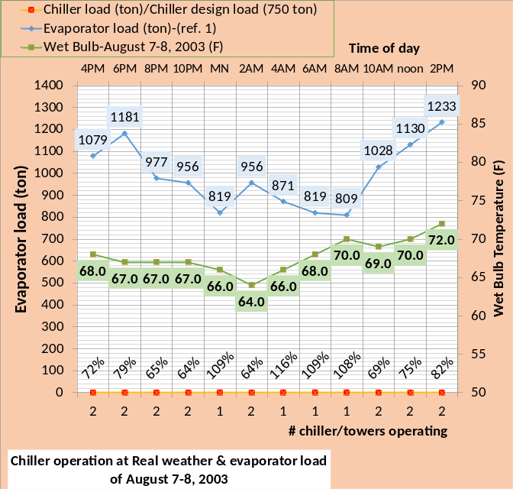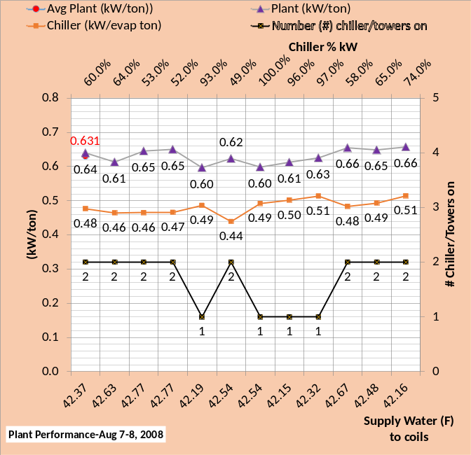
Figure 60: Plant performance with tower fans and condenser pumps at 100%. With evaporator water flow (gpm) control.
Figure 60 gives an average of .631 kW/ton for the 24 hours of plant operation. Operating with one chiller/tower reduced the average from .662 kW/ton as given by Figure 55 above. The top chart of Figure 60 shows the % load exceeded 100% for one chiller/tower operation due to the increased chiller capacity at wet bulb below 76F. The secondary horizontal axis of the bottom chart of Figure 60 illustrates that the chiller % kW demand is 100% at 4AM and the water supply is 42.54F at a load of 871 ton verses a design load of 750 ton.

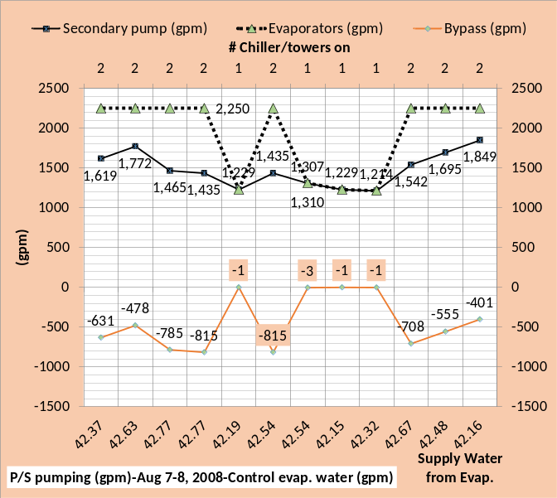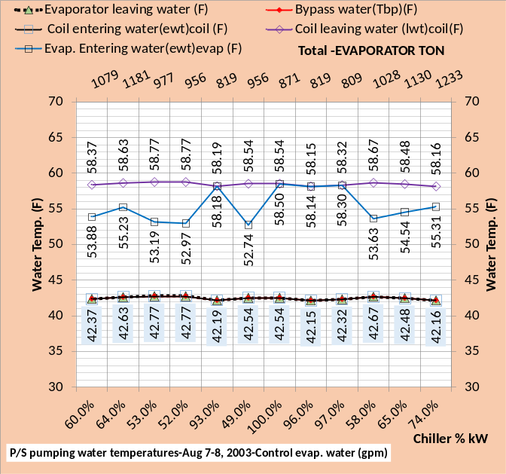
Figure 61: Primary/Secondary pumping
At one chiller/tower operation the top chart of Figure 61 shows the bypass flow is controlled to be slightly in the correct direction. The bottom chart shows P/S water temperatures.

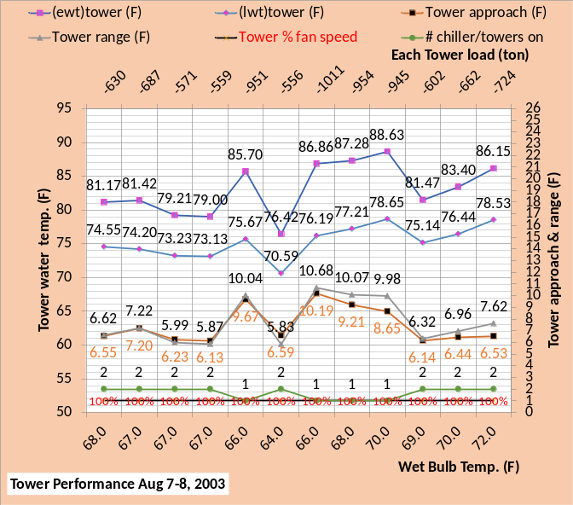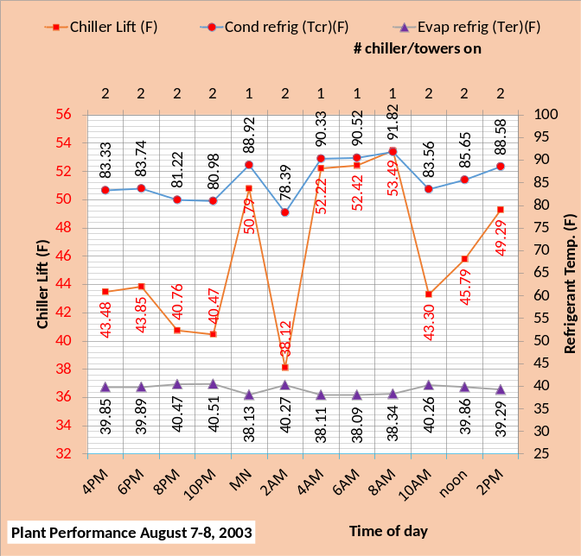
Figure 62: Plant & tower performance

Figure 62 top chart shows the tower operating at 100% fan speed and a tower approach to wet bulb and tower range of about the same value. The bottom chart shows the refrigerant temperatures and the resulting chiller lift. Chiller lift significantly increases at one chiller/tower operation. Figure 62 illustrates the complexity of a chiller plant operation and therefore the need for a (SEE) Plant Model to help control a plant to peak efficiency.

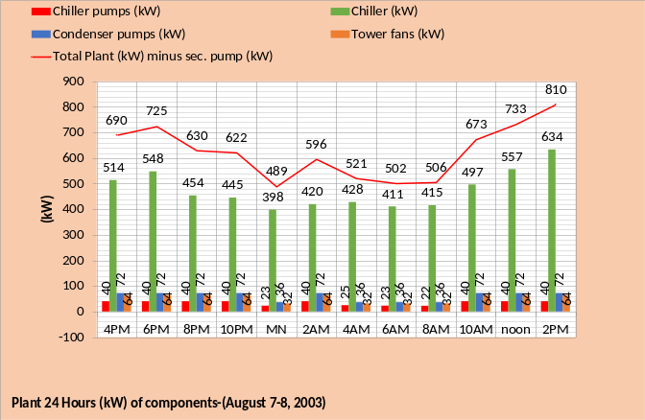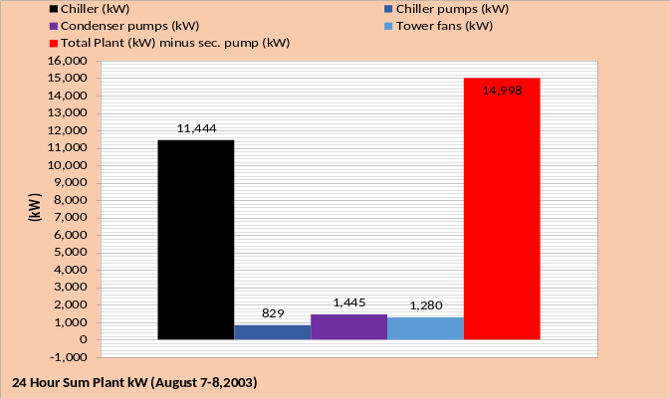
Figure 63: Plant 24 Hour kW

Figure 63 top chart shows the drop in tower fan and pump kW at the 4 hours of one chiller/tower operation. The chiller kW demand changes as required to provide 42F supply water to the coils. Total plant kW is also given with secondary pump kW not in the total. The bottom chart gives the 24 hour totals showing the chiller as predominate kW demand followed by the condenser pumps, then tower fans and chiller pumps. Comparing to Figure 58 above that has a 24 hour total of 15,644 kW verses 14,998 kW of Figure 63 illustrates the 24 hour advantage of operating when possible with one chiller/tower. However the plant is being operated at 100% tower and pump power and we will see below that operating according to the strategy of Baker¹ will provide an improvement in 24 hour plant performance.

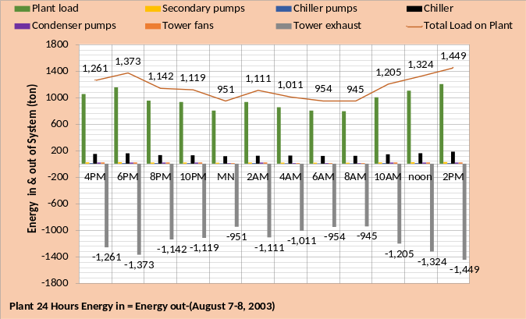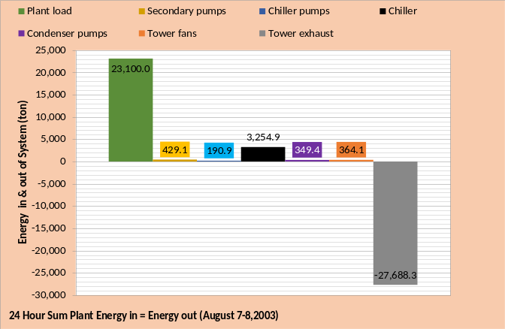
Figure 64: Plant Energy in = Energy out

Figure 64 top chart illustrates that for each hour energy in = energy out and the bottom chart gives the 24 hour summed values for each plant component. The plant load is the big energy in value and the tower exhaust is the only energy out value. The energy in due to the components is a function of its kW demand, therefore the chiller provides the largest energy in value followed by the secondary pumps. The secondary pumps must be in the (SEE) Model to accomplish energy equilibrium.
Schematic 32 thru 35 are provided for reader study. Note that Schematic 34 at one chiller/tower operation can be compared to Schematic 31 at two chiller/tower operation.

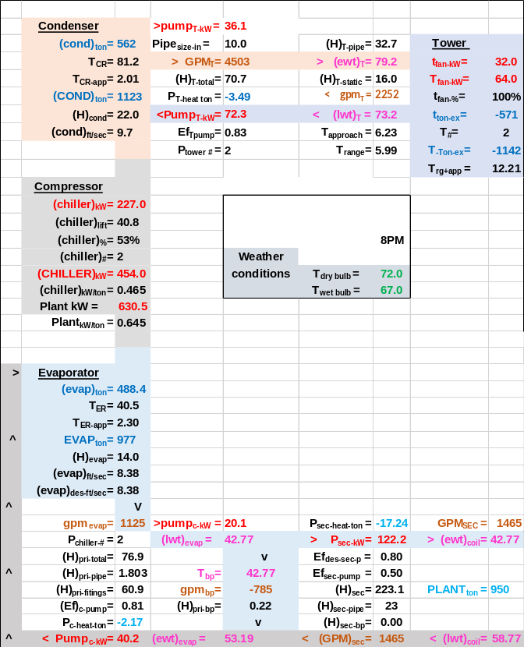
Schematic 32: Evaporator water control
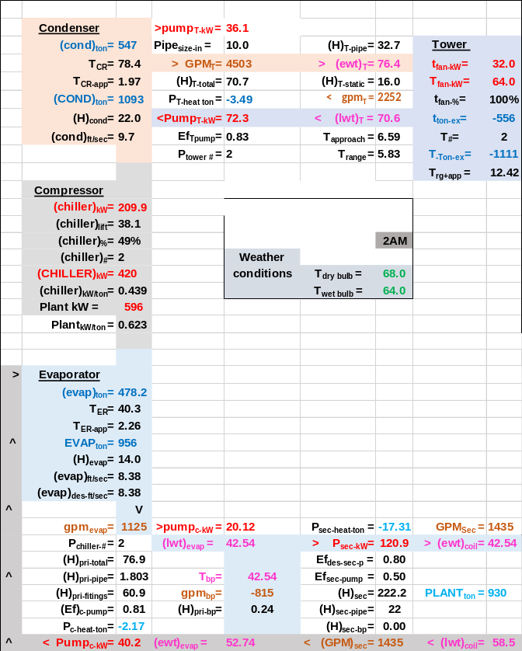
Schematic 33: Evaporator water control

Schematic 31: Two Chiller/Tower operating at 790 ton plant load & 813 ton evaporator load at 70F wet bulb & 100% fan & pump kW

Schematic 31 is copied so that a side by side comparison can be made of two chiller/tower operation verses one chiller/tower operation at the same conditions. Note that the plant ton of 790 is the same for both plants but the evaporator load is 813 ton for the two chiller/tower and 809 ton for the one chiller/tower. The difference is the load due to the P/S pumping which is less for the one chiller/tower. The tow chiller/tower plant chiller kW is two times 210 kW or 420 kW as shown by Schematic 31. Schematic 34 shows the one chiller requires 415.5 kW, about 4 kW less. Operating with one chiller/tower reduces the tower fan and pump kW to about half so the plant kW is reduced from 596 kW of Schematic 31 to 506 kW of Schematic 34.

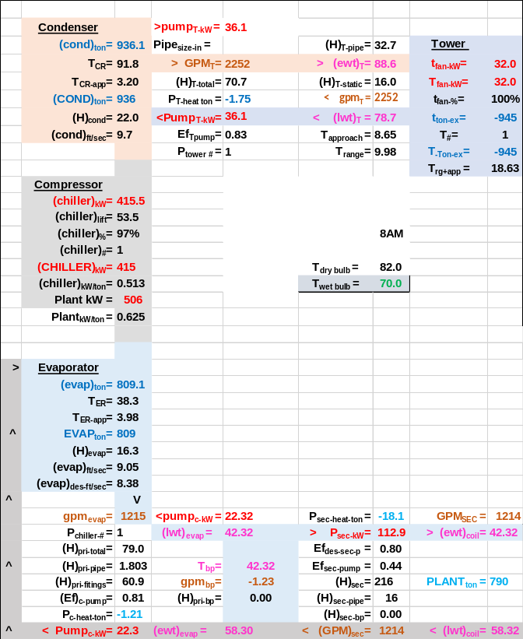
Schematic 34: One Chiller/Tower operating at 790 ton plant load & 809 ton evaporator load at 70F wet bulb & 100% fan kW with evaporator water control.

Note that the evaporator flow is 1125 gpm for each chiller of Schematic 31 and 1215 gpm for the one chiller of Schematic 34. The evaporator flow control increased the flow (1215-1125=90 gpm) to achieve correct flow in the bypass of Schematic 34 with a resulting increase in chiller pump kW from 20.16 to 22.32 kW.
The next Schematic 35 will show the plant at equilibrium with 1125 gpm evaporator flow, i.e. no evaporator water flow control.

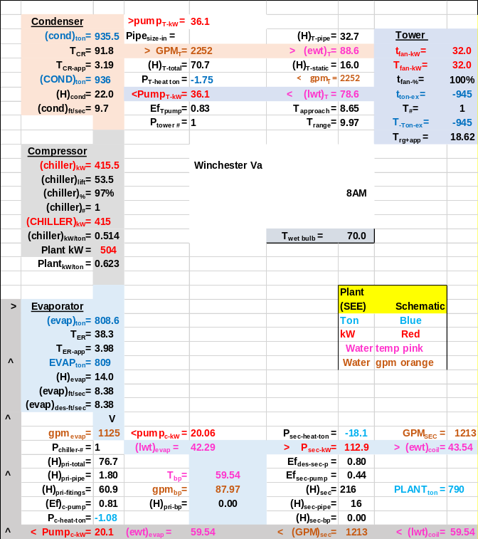
Schematic 35: One Chiller/Tower operating at 790 ton plant load & 809 ton evaporator load at 70F wet bulb & 100% fan kW without evaporator water control.

Schematic 35 shows that with design evaporator flow of 1125 gpm there is wrong way flow in the bypass therefore giving 43.54F supply water to the coils verse the 42.29F provided by the evaporator. The 87.97 gpm of flow at 59.54F in the bypass mixes with the 42.29F water from the evaporator resulting in 43.54F water to the coils. To achieve 42F water to the coils will require increased chiller kW and therefore increased plant kW, i.e. evaporator flow control reduced plant kW.
Next we will operate the plant according to Baker¹ figure 4.

August 7-8, 2003 plant performance with tower fans and condenser pumps operated to Figure 4 of Baker¹

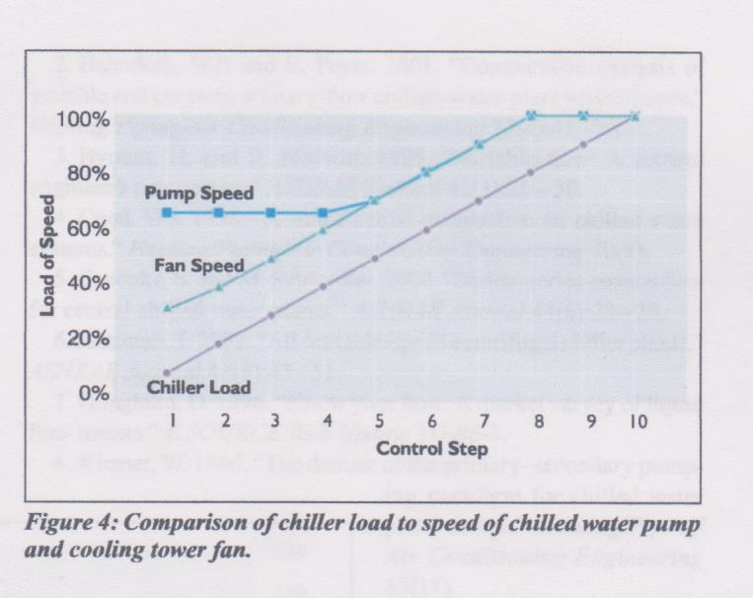From Baker¹ “Prescription for Chiller Plants”

This figure 4 plant operation strategy from Baker¹ will be input to the (SEE) Plant Model.

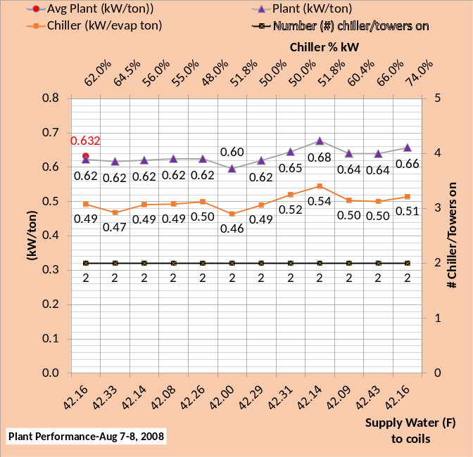
Figure 65: Two Chiller/Tower Plant performance operating to figure 4 of Baker¹
Figure 65 gives 24 hour average of .632 kW/ton which is better than the .662 kW/ton average of Figure 55, also two chiller/tower operation. Clearly the 24 hours of two chiller plant operation with tower fans and pumps operating at 100% capacity is less efficient than operating the two chiller plant according to figure 4 of Baker¹. Figure 65 average plant kW/ton of .632 is about the same as Figure 60 average of .631 kW/ton where Figure 60 operates with one chiller/tower four hours of the day and with evaporator flow control.

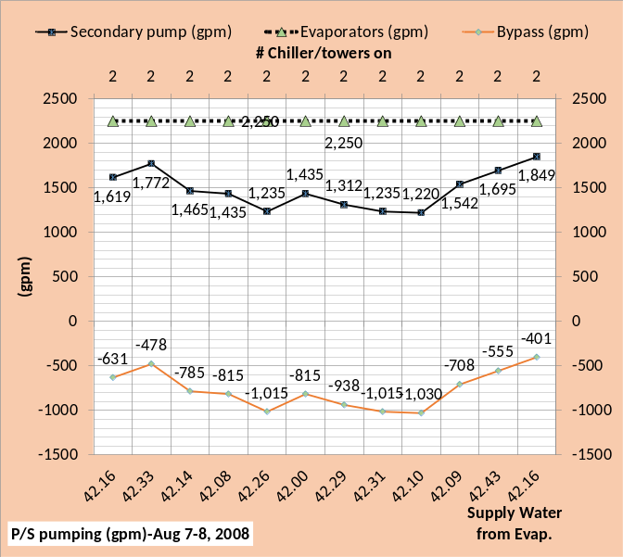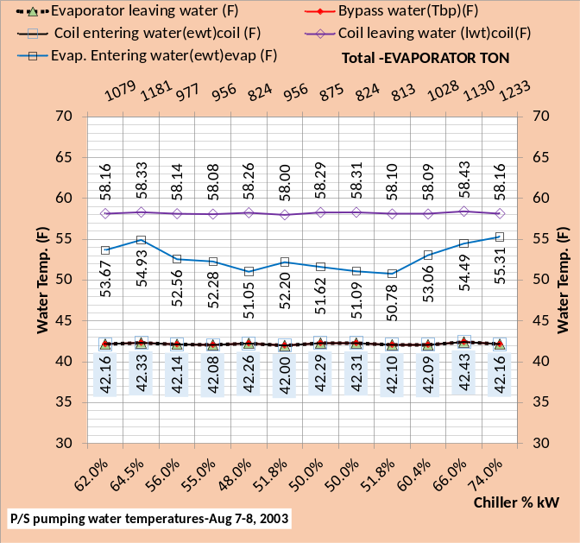
Figure 66: Primary/Secondary pumping with Baker¹ control of tower fan & condenser pumps
The top chart of Figure 66 illustrates that the bypass flow is always in the correct direction, because of two chiller/tower operation, and therefore the water temperatures as show by the bottom chart are as desired for smooth operation of the plant. The temperature of water off the evaporator is about 42F as is the bypass water and water entering the coils. The temperature of water leaving the coils is about 58F and when mixed with the bypass water enters the evaporator at a temperature significantly less than 58F.

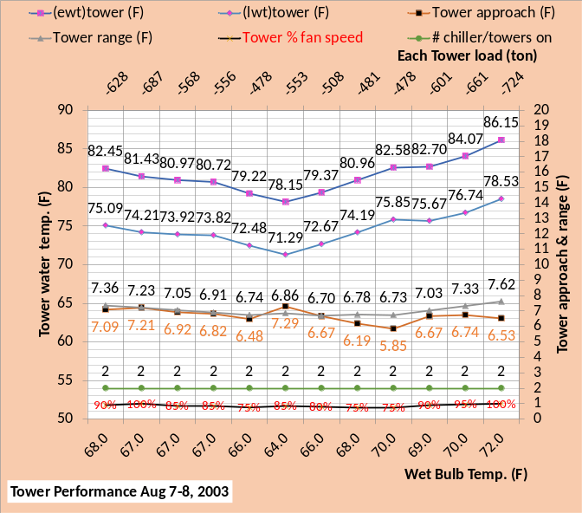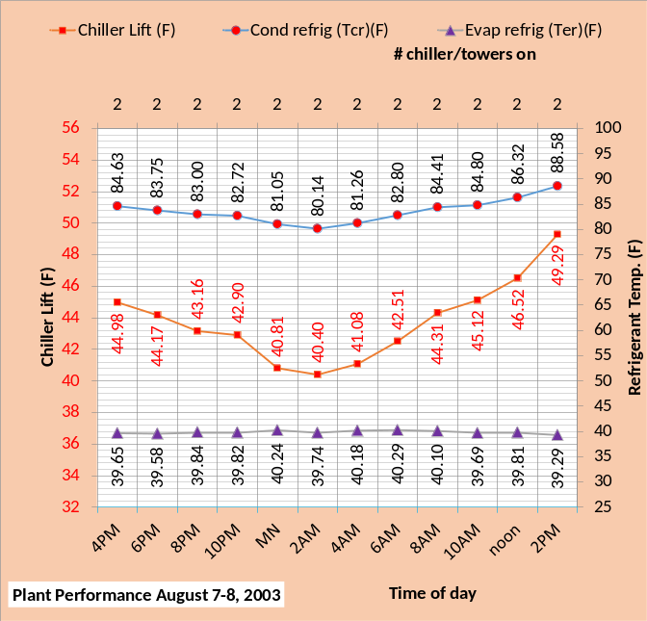
Figure 67: Plant & Tower Performance operated per figure 4 of Baker¹

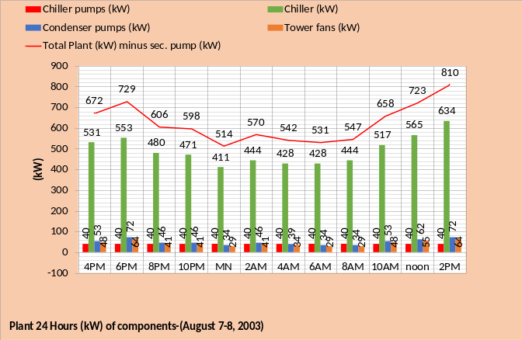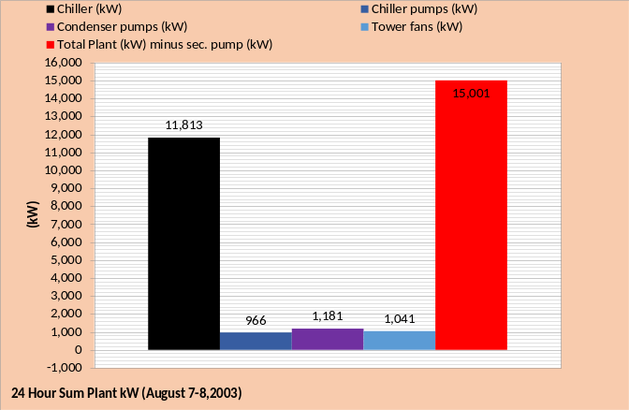
Figure 68: Plant kW performance over 24 hours

Figure 67 top chart gives the tower fan % and the top chart of Figure 68 gives the kW demand of the condenser pumps showing a reduction according to figure 4 of Baker¹. Figure 58 gives a total plant kW of 15,644 and Figure 68 gives 15,001, an approximate 4% improvement by operating the tower and condenser pumps according to Baker¹ verses operating at 100% tower fan and pumps.

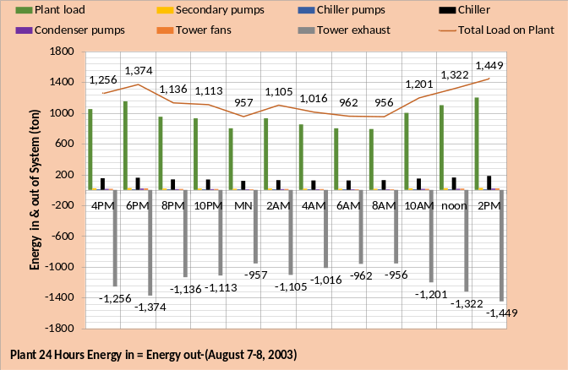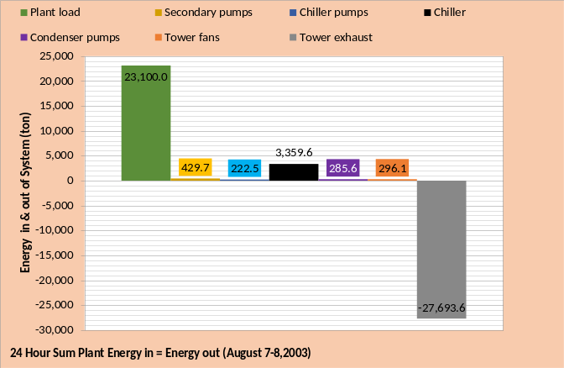
Figure 69: Plant Energy in = Energy out, Baker¹ control of tower fan and condenser pumps

The energy into and out of a real system must equal and therefore a System Energy Equilibrium (SEE) Model must also demonstrate this fundamental thermodynamic property. Figure 69 top chart illustrates that for each hour energy in = energy out and the bottom chart gives the 24 hour summed values for each plant component. The plant load is the big energy in value and the tower exhaust is the big energy out value. The energy in due to the components is a function of the components kW demand, therefore the chiller provides the largest energy in value followed by the secondary pumps. Figure 59 copied, shows a tower exhaust energy out of 27,853 ton verses 27,693.6 ton for Figure 64, a (0.57%) reduction with the Baker¹ control strategy.

Figure 59: copied from above. Plant Energy in = Energy out with 100% tower fan and pumps kW.

Figure 59 compared to Figure 69 shows the decrease in energy in is with the Baker¹ control of the tower fans and condenser pumps. A decrease of (419.3-285.6=133.7 + 436.9-296.1=140.8=274.5 ton) and a chiller increase of (3,359.6 - 3,244.7=114.9 ton) for a net reduction of Energy in with the Baker control of (274.5-114.9=159.6 ton), also given by the difference in tower exhaust energy out.
The following Schematics 31 & 36 at 70F wet bulb illustrate the positive effect of the Baker¹ control.

Schematic 31: 8AM two chiller plant at 813 ton evaporator load & 70F wet bulb operating at 100% fan & pump kW
Comparing Schematic 31, copied from above, and Schematic 37 gives the details of why the Baker¹ control strategy decreased plant kW; decreasing tower and condenser pump kW is more than the increase in chiller kW.

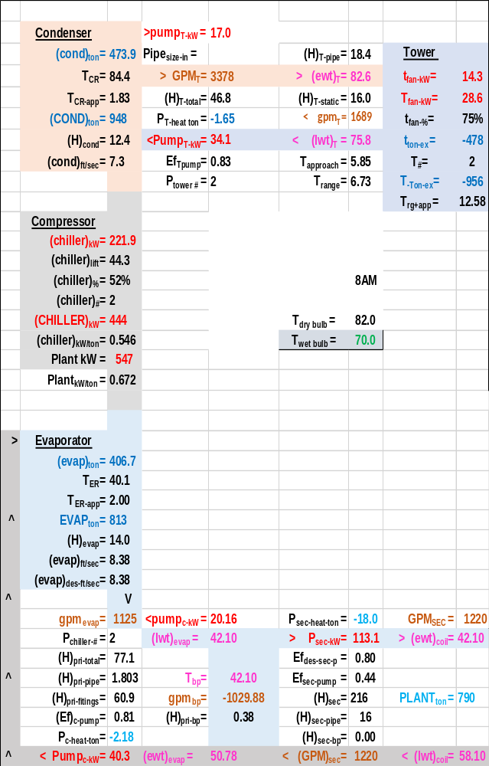
Schematic 36: 8AM two chiller plant at 813 ton evaporator load & 70F wet bulb operating at 75% fan speed & 75% condenser pump gpm per Baker¹ figure 4 shown above.

The following schematics are for information.

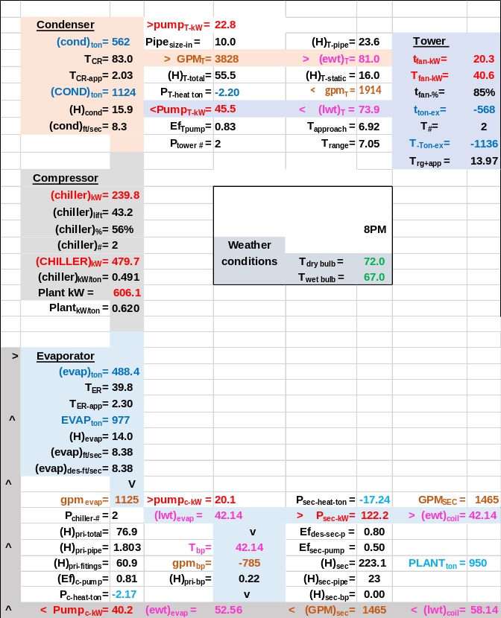
Schematic 37: 8PM two chiller plant at 977 ton evaporator load & 72F wet bulb operating at 85% fan speed & 85% condenser pump gpm per Baker¹ figure 4.

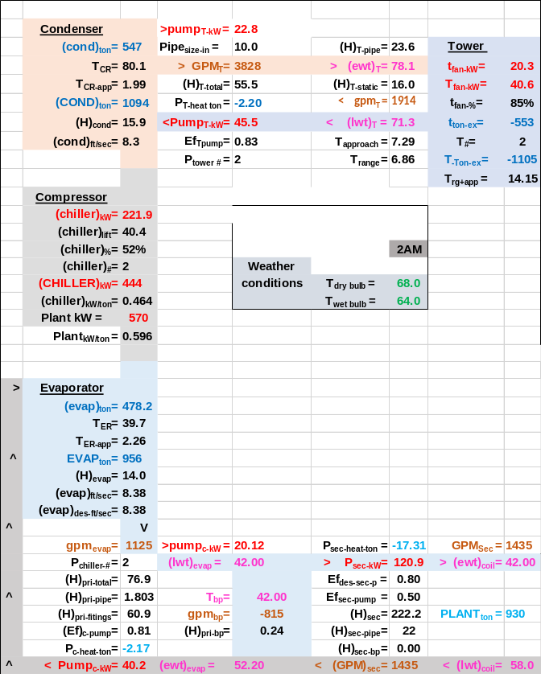
Schematic 38: 2AM two chiller plant at 956 ton evaporator load & 64F wet bulb operating at 85% fan speed & 85% condenser pump gpm per Baker¹ figure 4.

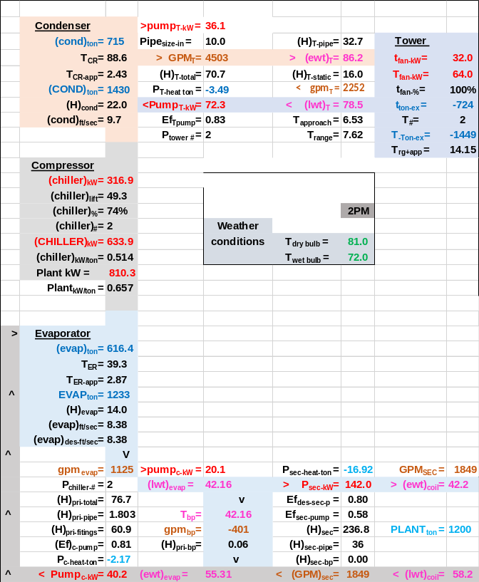
Schematic 39: 2PM two chiller plant at 1233 ton evaporator load & 72F wet bulb operating at 100% fan speed & 100% condenser pump gpm per Baker¹ figure 4.

August 7-8, 2003 plant performance with tower fans and condenser pumps operated to Figure 4 of Baker¹ –adjusted to operate with one chiller/tower at midnight, 4AM, 6AM, & 8AM.

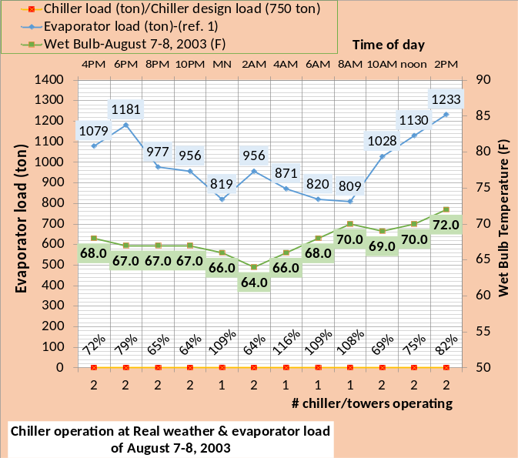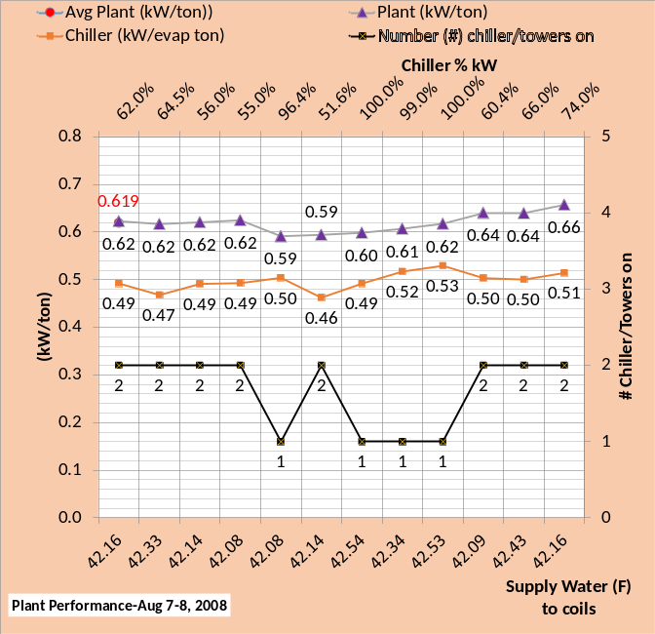
Figure 70: Plant performance operating to figure 4 of Baker¹ except at one chiller operation where tower fan is 100% and evaporator pumps control bypass flow.

Comparing Figures 70 & 65 illustrates that operating per Baker¹ figure 4 with one chiller/tower is more efficient than operating with two chiller/towers. The net result is that the average plant kW/ton is reduced from .632 of Figure 65 to .619 of Figure 70. The tower fan speed of Figure 70 had to be set at 100% with one chiller/tower operation to increase the capacity of the chiller/tower. The condenser water flow was also reset if required to increase the capacity of the chiller/tower.

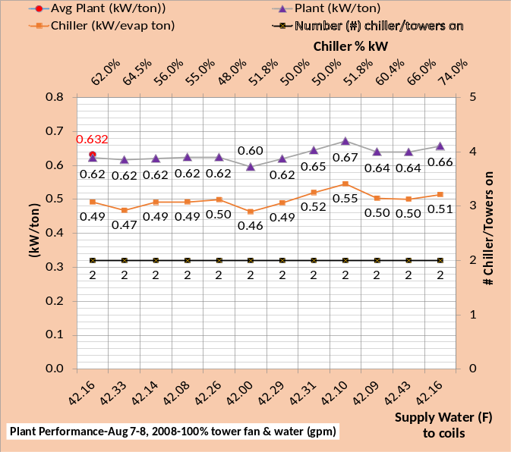
Figure 65 copied: Plant performance operating to figure 4 of Baker¹

Note that the chiller % load is greater than 100% for all one chiller/tower operation as shown by the top chart of Figure 70. This is possible because of the increased capacity of the chiller/tower with wet bulb at values below design wet bulb. The top charts also show that the evaporator load is about 5 ton less when one chiller/tower is in operation because only one evaporator pump is on and adding load.

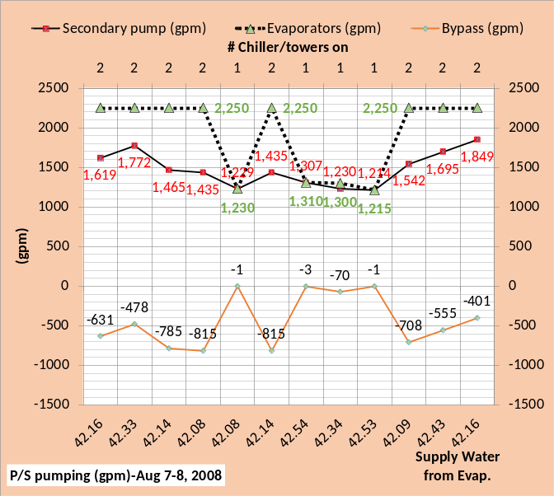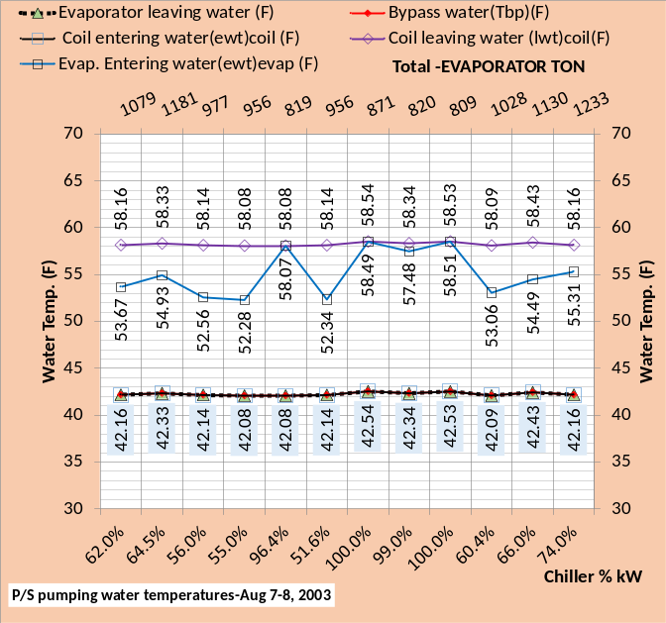
Figure 71: Primary/Secondary pumping with Baker¹ control of tower fan & condenser pumps except as adjusted plus evaporator pump control for one chiller/tower operation
The top charts of Figures 71 & 66 illustrate the action of the evaporator pump when operating with one chiller/tower. With two chiller/tower operation the bypass flow is in the order of 400 gpm to 1000 gpm and with one chiller/tower operation the bypass flow is around 1 to 70 gpm with evaporator pump control to assure the correct direction of bypass flow. The top charts also show the evaporator flow is a constant 2,250 gpm for the two chiller/tower operation and greater than 1,125 gpm for one chiller/tower operation to accomplish correct bypass flow as shown.
Figure 66 copied: Primary/Secondary pumping with Baker¹ control of tower fan & condenser pumps
The bottom chart of Figure 71 shows the chiller must operate at 100% kW to achieve 42.54F and 42.53F supply water to the coils. The load at midnight is 819 ton at wet bulb 66F and the load at 809 ton at wet bulb 70F as shown by the top chart of Figure 71. Table 8 above shows the chiller capacity with evaporator flow control is 865 ton at 66F wet bulb & 825 ton at 70F wet bulb, significantly more chiller capacity than the load. However the tower &condenser pump is operated at Baker¹ figure 4 control strategy and therefore reduces the capacity of the chiller/tower.
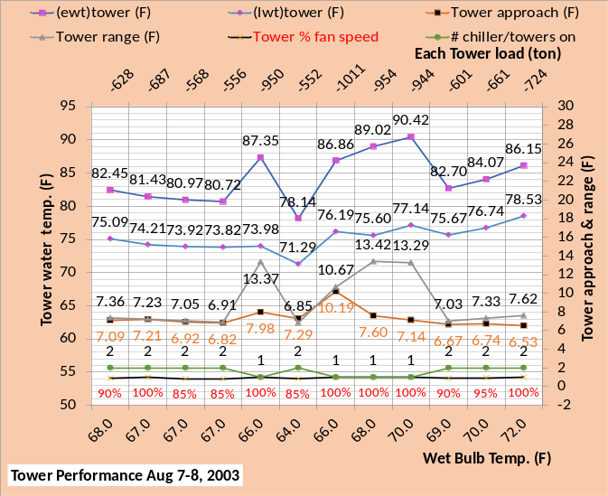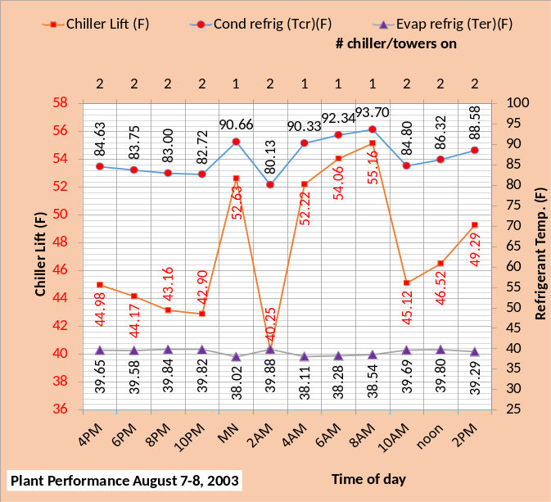
Figure 72: Plant & Tower Performance with Baker¹ control of tower & condenser pumps except for one chiller/tower operation where tower fan is 100% & evaporator pump control assures correct bypass flow.
Figure 72 top chart illustrates that the tower fan speed is controlled to 100% when one chiller/tower is on. Tower water temperatures jump around due to this control as does tower approach and range. The bottom chart illustrates that the condenser refrigerant temperature increases with one chiller/tower operation resulting in increased chiller lift.
Figure 67 copied: Two chiller/tower Plant & Tower Performance operated per figure 4 of Baker¹

Figure 67 illustrates a less efficient plant operation but a less complicated control strategy.

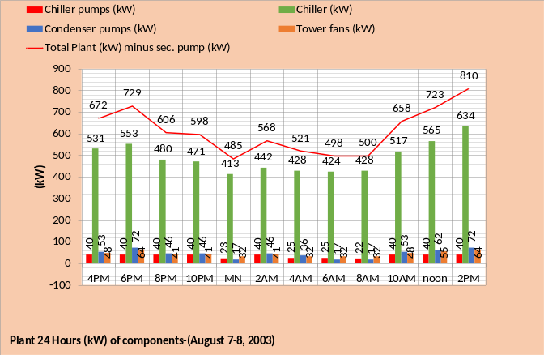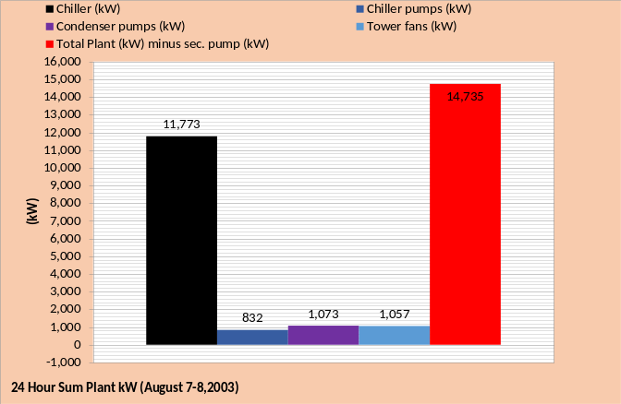
Figure 73: Plant kW performance over 24 hours

Figure 73 gives the 24 hour kW as 14,735 versus 15,001, from Figure 68, an approximate 2% reduction with one chiller operation during 4 hours of operation. Both plants are operated to the conditions of figure 4 of Baker¹.

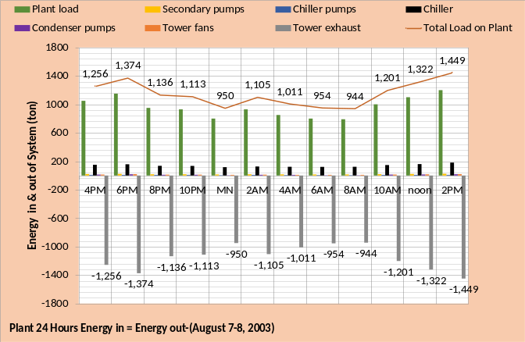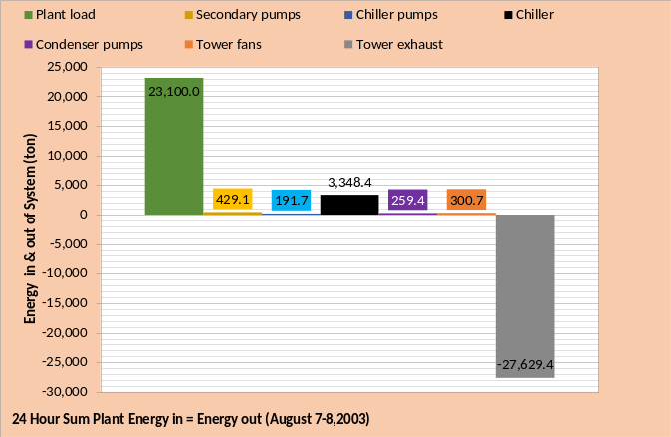
Figure 74: Plant Energy in = Energy out

Figure 74 shows energy in equals’ energy out. The values are less than the previous analyzed plants.

The two schematics illustrate the difference in plant performance with two chiller/tower operation versus one chiller/tower operation at 8AM conditions of August 7-8, 2008.

Schematic 36 copied: 8AM two chiller plant at 790 ton plant load & 70F wet bulb operating at 75% fan speed & 75% condenser pump gpm per Baker¹ figure 4 shown above at page 61.

The evaporator load is 4 ton more with two chiller/tower operation because the P/S pumping kW is greater. The one chiller/tower plant has a greater chiller pump kW, 22.32 kW vs. 20.16 kW, because additional power is applied to achieve right way flow in the bypass.

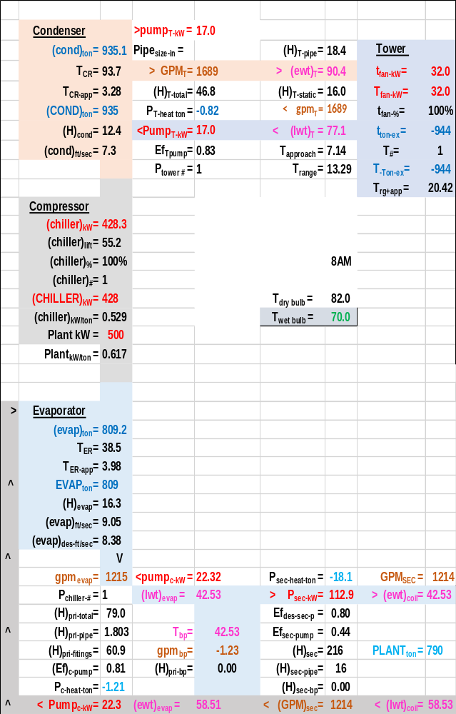
Schematic 40: 8AM one chiller plant at 790 ton plant load & 70F wet bulb operating at 100% fan speed & 75% condenser pump gpm.

The tower must operate at 100% fan speed with one chiller/tower operation; the condenser pump is operated at 75% for both plants. The net result is a plant kW of 500 for the one chiller/tower plant and 547 kW for the two chiller/tower plant. However at 100% chiller capacity the one chiller plant provides 42.53F water to the coils vs. 42.10F by the two chiller plant.

Summary/Conclusions
Figure 55 copied: Two Chiller/Tower Plant performance with tower fans & pumps operated at 100%
Figure 60 copied: Plant performance with tower fans and condenser pumps at 100%. With evaporator water flow controlled to correct bypass flow.

The operation of the plant is summarized in two categories; one is expressed by Figures 55 & 60 where tower fans and pumps are operated at 100% power. The second is plant operation by the control strategy defined by figure 4 in Baker’s¹ article “Prescription for Chiller Plants”. Figures 65 & 70 below discuss that control.
Figure 55 is operation with two chiller/towers and Figure 60 is operating only one chiller/tower if one can meet the load. The values on the two charts are the same except when one chiller/tower can meet the load that occurs four times as given by Figure 60. When one chiller/tower can meet the load the plant kW/ton is less. The net result is an average of .662 plant kW/ton for Figure 55 with two chiller/tower operation and .631 average plant kW/ton when operating with one chiller/tower when possible.
Next we will consider plant operation according to the control strategy given by Baker¹ figure 4 as shown above on page 57.

Figure 65 copied: Two Chiller/Tower Plant performance operating to figure 4 of Baker¹
Figure 70 copied: Plant performance operating to figure 4 of Baker¹ except at one chiller operation where tower fan is 100% and evaporator pumps control bypass flow.

Plant operation to Baker¹ figure 4
Figures 65 & 70 are both plant performance operating according to the control strategy presented by figure 4 of Baker¹. The top chart is as defined by Baker and the bottom chart adds the control strategy of operating with one chiller/tower when possible. Figure 65, compared to Figure 55, clearly illustrates that the Baker control strategy reduces plant kW over the 24 hours of operation on August 7-8 2008.
Figure 70 illustrates that the average plant kW/ton is reduced to .619, versus .632 of Figure 65, by operating the plant with one chiller/tower when one will meet the load. All values on the figures are the same except when one chiller/tower is operated and the value of plant kW/ton is reduced.

This paper will be expanded and adjusted based on questions from readers and additions the author makes.
Best Regards to all
Kirby Nelson P.E.
Life Member ASHRAE

Contents
Page 1-Chiller Plant defined.
Page 2-Chiller coefficient of performance.
Page 4-Plant performance with small tower.
Page 7-Plant performance with big tower.
Page 10- August 7-8, 2003-Plant performance with big tower and pumps operating at 100%.
Page 13- Plant performance at design conditions as the big tower fan speed is reduced.
Page 17- The author concludes that for this particular plant as defined by Baker¹, the plant kW is not significantly affected by reducing the tower fan speed.
Page 19-Schematics showing 67% tower fan speed.
Page 23- Plant performance at design conditions as condenser pump kW is reduced and tower fan speed is 100%.
Page 27- August 7-8, 2003-Plant performance with tower fans operating at 100%, condenser pumps operating at 82% = 1850 gpm & evaporator water supply = 44F.
Page 29- Can one chiller/tower meet the load from midnight to 8AM providing 44F water to the coils?
Page 32- Schematics for analysis of two chiller/tower operation verses one chiller/tower operation when providing 44F supply water to coils.
Page 34- August 7-8, 2003-Plant performance with tower fans operating at 100% & condenser pumps operating at 100% = 2,252 gpm & coil water supply increased to 44F.
Page 37- August 7-8, 2003-Plant performance with tower fans operating at 100% & condenser pumps operating at 100% = 2,252 gpm & evaporator water supply = 44F.
Control strategy-Increase evaporator flow to eliminate wrong way bypass flow.
Page 42- Chiller/Tower Capacity when providing 42F coil supply water as Wet Bulb Temperature both increases and decreases.
Page 46- Schematics that illustrate the effect of evaporator flow control.
Page 50- Summary of Plant capacity as function of wet bulb.
Page 53- August 7-8, 2003. Two chiller plant performance with tower fans and pumps operating at 100%.
Page 56- August 7-8, 2003-Plant performance with tower fans and condenser pumps at 100% with one chiller operation during 4 hours & control of evaporator water flow to correct bypass flow.
Page 60-One chiller/tower schematic vs. two chiller/tower schematic.
Page 61- August 7-8, 2003 plant performance with tower fans and condenser pumps operated to Figure 4 of Baker¹
Page 68- August 7-8, 2003 plant performance with tower fans and condenser pumps operated to Figure 4 of Baker¹ –adjusted to operate with one chiller/tower at midnight, 4AM, 6AM, & 8AM.
Page 71- The two schematics illustrate the difference in plant performance with two chiller/tower operation versus one chiller/tower operation at 8AM conditions of August 7-8, 2008.
Page 73- Summary & Conclusions
Page 75- References
Page 76- Nomenclature

References for this paper
- Mark Baker, Dan Roe, Mick Schwedler. ASHRAE Journal June 2006. “Prescription for Chiller Plants”. (SEE) Plant Model analysis at http://kirbynelsonpe.wordpress.com
- Nelson, K. System Energy Equilibrium (SEE) Building Energy Model Verification. http://kirbynelsonpe.com/
- SPX Cooling Technologies (Marley). UPDATE Version
- Introduction to Thermodynamics and Heat Transfer. 1956 Prentice-Hall, Inc. by David A. Mooney, page 325.
- Real weather data www.wunderground.com/
References for (SEE) Model of Building & Plant
- Schwedler, Mick. July 1998 “Take It to The Limit…Or Just Halfway?” ASHRAE Journal.
- SPX Cooling Technologies (Marley). UPDATE Version 5.4.2
- Introduction to Thermodynamics and Heat Transfer. 1956 Prentice-Hall, Inc. by David A. Mooney, page 325.
- Thermal Environmental Engineering third edition. 1998 Prentice-Hall Inc. by Thomas H. Kuehn, chapter 3.
- 2012 ASHRAE HANDBOOK, HVAC Systems and Equipment, page 43.10 Figure 11 Temperature Relations in a Typical Centrifugal Liquid Chiller.
- ASHRAE. 2010. ASHRAE GreenGuide: The Design, Construction, and Operation of Sustainable Buildings, 3rd ed. Atlanta: ASHRAE.
- Taylor, S. 2011. “Optimizing design & control of chiller plants.” ASHRAE Journal (12).
- Liu, B. May 2011. “Achieving the 30% Goal: Energy and Cost Savings Analysis of ASHRAE Standard 90.1-
2010” Pacific Northwest National Laboratory. http://www.energycodes.gov/achieving-30-goal-energy-and-cost-savings-analysis-ashrae-standard-90.1-2010
- Schwedler, M. 2017. “Using Low-Load Chillers to Improve System Efficiency.” ASHRAE Journal.
- July 2014 ASHRAE Journal, page 70. The article (Improving Infiltration in Energy Modeling) makes the obvious but not stated point; 40 years after the oil embargo and an air side model is still not in the ASHRAE models.
- ASHRAE Journal September 2014. Letters, “Energy Modeling”, by Kirby Nelson
- ASHRAE Journal May 2016. “Modeled Performance Isn’t Actual Performance”
- Nelson, K. “Simulation Modeling of a Central Chiller Plant” CH-12-002. ASHRAE 2012 Chicago Winter Transactions.
- Nelson, K. System Energy Equilibrium (SEE) Building Energy Model Verification. http://kirbynelsonpe.com/
- Tredinnick, Steve. 2015. “District Energy Enters The 21st Century”. ASHRAE Journal.
- Morrison, Frank. 2014. “Saving energy with cooling towers.” ASHRAE Journal
- Kavanaugh, Steve. June 2000 “Fan Demand and Energy” ASHRAE Journal
- Nelson, Kirby. July 2010 “Central-Chiller-Plant Modeling” HPAC Engineering
- Trane chiller selection data received by Kirby Nelson from Springfield Missouri Trane office 1/30/01.
- Real weather data www.wunderground.com/
NOMENCLATURE for (SEE) Model Building & Plant
Each of the more than 200 variables will be defined.
Building structure;
BLD ft² = air conditioned space
# Floors = number of building floors
Roof ft² = roof square feet
N/S wall ft² =north/south wall square feet
E/W wall ft² =east/west wall square feet
Wall % glass = percent of each wall that is glass
Glass U = glass heat transfer coefficient
Wall U = wall heat transfer coefficient
Glass SHGC = glass solar heat gain coefficient
Wall emit = wall solar index
Building interior space;
Roof_{trans-ton} =transmission through roof (ton)
Roof_{sky-lite-ton} =sky lite load (ton)
People_{ton sen&lat} = sensible & latent cooling load due to people (ton)
Plug_{ton&kW} = cooling load & kW due to plug loads
Light_{ton&kW} = cooling load & kW due to lights
Total Bld_{int-ton} = total building interior load (ton)
(int-cfm) _{to-per-return} = CFM of interior supply air that returns to perimeter of building
T_{stat-int} = interior stat set temperature (F)
Bld_{int-air-ton} = supply air ton to offset interior load
BLD kW = total building kW demand
FAN kW = total fan kW
HEAT kW = total kW due to heat
SITE kW = total site kW=Bld+ Fan+Heat
Building perimeter space;
%_{clear sky} = percent clear sky
T_{dry bulb} = outside dry bulb temperature (F)
T_{wet bulb} = outside wet bulb temperature (F)
Ex/Infil_{lat-ton} = latent air infiltration or exfiltration (ton)
Ex/Infil_{CFM} = air infiltration or exfiltration CFM
Exfil_{sen-ton} =sensible air exfiltration or infiltration (ton)
Wall_{n trans ton} = north wall transmission (ton)
Wall_{s trans ton} = south wall transmission (ton)
Wall_{E trans ton} = east wall transmission (ton)
Wall_{w trans ton} = west wall transmission (ton)
Wall_{tot-trans-ton} = total wall transmission (ton)
Glass_{N-trans-ton} = north wall glass transmission (ton)
Glass_{S-trans-ton} = south wall glass transmission (ton)
Glass_{E-trans-ton} = east wall glass transmission (ton)
Glass_{W trans-ton} = west wall glass transmission (ton)
Glass_{tot-trans-ton} = total transmission thru glass (ton)
Glass_{N-solar-ton} = north glass solar load (ton)
Glass_{S-solar-ton} = south glass solar load (ton)
Glass_{E-solar-ton} = east glass solar load (ton)
Glass_{W-solar-ton} = west glass solar load (ton)
Glass_{tot-solar-ton} = total glass solar load (ton)
(int cfm)_{per-ton} = effect of interior CFM to wall (ton)
Total Bld_{per-sen-ton} total perimeter sensible load (ton)
T_{stat-per} = perimeter stat set temperature (F)
Bld_{per-air-ton} = supply air ton to offset perimeter load
Air handler duct system-Interior duct
T_{air supply int} = temp air supply to building interior (F)
(fan)_{int ter ton&kW} = interior ton & kW due to terminal fans
(D)_{int-air-ton} = cooling (ton) to building interior duct
T_{air coils} = supply air temperature off coils to duct (F)
(D)_{int-CFM} = supply air CFM to building interior duct
Perimeter duct
T_{air supply per} =temp (F) air supply to building perimeter
(fan)_{per ter ton&kW} = perimeter ton & kW of terminal fans
T_{heat-air} = temp supply air before terminal fan heat (F)
(D)_{heat-ton&kW} = heat to perimeter supply air ton & kW
T_{reheat air} = temp perimeter supply air after reheat (F)
(D)_{reheat ton&kW} = reheat of perimeter supply air ton & kW
(D)_{per-air-ton} = cooling (ton) to perimeter duct
T_{air coils} = supply air temperature off coils to duct (F)
(D)_{per-CFM} = supply air CFM to perimeter duct
Coil
(Coil)_{sen-ton} = sensible load on all coils (ton)
(Coil)_{cap-ton} = LMTD * UA = capacity (ton) one coil
LMTD = Coil log mean temperature difference (F)
(Coil)_{L+s-ton} = latent + sensible load on all coils (ton) transferred to Plant
UA = coil heat transfer coefficient * coil area. UA varies as a function water velocity (coil)_{gpm} thru the coil, as the (coil)_{gpm} decreases the coil capacity decreases.
(one Coil)_{ton} = load (ton) on one coil
VAV Fan system
Fresh air
stat_{FA} = fresh air freeze stat set temperature (F)
T_{FA to VAV} = temperature of fresh air to VAV fan
(FA)_{sen-ton} = fresh air sensible load (ton)
(FA)_{CFM} = CFM fresh air to VAV fan inlet
(FA)_{Lat-ton} = fresh air latent load (ton)
(FA)_{kW} = heat kW to stat_{FA} set temperature
Air return
T_{BLD-AR} = return air temp (F) before return fans
(Air)_{ret-CFM} = CFM air return from building
(FAN)_{ret-kW} = return fans total kW
(FAN)_{ret-ton} = cooling load (ton) due to (FAN)_{ret-kW}
(Air)_{ret-ton} = return air (ton) before return fans
T_{AR to VAV} = T_{BLD-AR} + delta T due to return fans kW
VAV_{ret-sen ton} = return sensible (ton) to VAV fans inlet
VAV_{ret-lat ton} = return latent (ton) to VAV fans inlet
VAV_{ret-CFM} = return CFM to VAV fans inlet
Exhaust air
Ex_{Lat-ton} = latent load (ton) exhausted
Ex_{CFM} = CFM of exhaust air
T_{Ex} = temperature of exhaust air
Ex_{sen-ton} = sensible load (ton) exhausted
VAV Fans
T_{ret+FA} = return and fresh air mix temperature (F)
(dh) = VAV air static pressure (in)
E_{fan-VSD} = VAV fans efficiency
VAV_{inlet-sen-ton} = sensible load (ton) inlet to VAV fans
VAV_{inlet-lat-ton} = latent load (ton) inlet to VAV fans
T_{air-VAV} = temp air to coils after VAV fan heat
(FAN)_{VAV-CFM} = CFM air thru coils
(FAN)_{ton-VAV} = load (ton) due to VAV fan kW
(FAN)_{kW-VAV} = total VAV fan kW demand
AIR SIDE SYSTEM PLUS BUILDING
FAN kW = total air handlers kW
SITE kW = total site or air side kW
Plant_{ton} = (COIL)_{L+s ton} load (ton) to plant
CENTRAL PLANT
# Buildings = number of buildings served by plant
Plant ton = total load (ton) to plant
Primary/secondary pumping nomenclature
gpm_{evap} = total gpm flow thru one evaporators
(H)_{pri-total} = total primary pump head (ft) = (H)_{pri-pipe} + (H)_{pri-fittings} + (H)_{pri-bp} + (H)_{evap}
(H)_{pri-pipe} = primary pump head due to piping (ft)
(H)_{pri-fittings} = primary head due to pump & fitting (ft)
(Ef)_{c-pump} = efficiency of chiller pump
P_{c-heat-ton} = chiller pump heat to atmosphere (ton)
P_{c-kW} = one chiller pump kW demand (kW)
P_{chiller-#} = number chiller pumps operating
(lwt)_{evap} = temperature water leaving evaporator (F)
T_{bp} = temperature of water in bypass (F)
gpm_{bp} = gpm water flow in bypass
(H)_{pri-bp} = head if chiller pump flow in bypass (ft)
(ewt)_{evap} = temp water entering evaporator (F)
P_{sec-heat-ton} = secondary pump heat to atmosphere (ton)
P_{sec-kW} = kW demand of secondary pumps
Ef_{des-sec-p} = design efficiency of secondary pumping
Ef_{sec-pump} = efficiency of secondary pumping
(H)_{sec} = secondary pump head (ft) = (H)_{sec-pipe} + (H)_{sec-bp} + (H)_{coil} + (H)_{valve}
(H)_{sec-pipe} = secondary pump head due to pipe (ft)
(H)_{sec-bp} = head in bypass if gpm_{sec} > gpm_{evap}
GPM_{sec} = water gpm flow in secondary loop
(ewt)_{coil} = water temperature entering coil (F)
Pipe_{size-in} = secondary pipe size (inches)
(lwt)_{coil} = temperature of water leaving coil (F)
Evaporator
(evap)_{ton} = load (ton) on one evaporator
T_{ER} = evaporator refrigerant temp (F)
T_{ER-app} = evaporator refrigerant approach (F)
EVAP_{ton} = total evaporator loads (ton)
(H)_{evap} = pump head thru evaporator (ft)
(evap)_{ft/sec} = velocity water flow thru evaporator
(evap)_{des-ft/sec} = evaporator design flow velocity
Compressor:
(chiller)_{kW} = each chiller kW demand
(chiller)_{lift} = (T_{CR} – T_{ER}) = chiller lift (F)
(chiller)% = percent chiller motor is loaded
(chiller)# = number chillers operating
(CHILLER)_{kW} = total plant chiller kW
(chiller)_{kW/ton} = chiller kW per evaporator ton
Plant kW = total kW demand of plant
(Plant)_{kW/site ton} = Plant kW per site ton
Condenser nomenclature:
(cond)_{ton} = load (ton) on one condenser
T_{CR} = temperature of condenser refrigerant (F)
T_{CR-app} = refrigerant approach temperature (F)
(COND)_{ton} = total load (ton) on all condensers
(H)_{cond} = tower pump head thru condenser (ft)
(cond)_{ft/sec} = tower water flow thru condenser
Tower piping nomenclature
Pipe_{size-in} = tower pipe size (inches)
gpm_{T} = each tower water flow (gpm)
GPM_{T} = total tower water flow (gpm)
(H)_{T-total} = total tower pump head (ft)
P_{T-heat} = pump heat to atmosphere (ton)
P_{T-kW} = each tower pump kW demand
Ef_{T-pump} = tower pump efficiency
P_{tower #} = number of tower pumps
(H)_{T-pipe} = total tower pump head (ft)
(ewt)_{T} = tower entering water temperature (F)
(H)_{T-static} = tower height static head (ft)
T_{range} = tower range (F)= (ewt)_{T} – (lwt)_{T}
(lwt)_{T} = tower leaving water temperature (F)
T_{approach} = (lwt)_{T} – (T_{wet-bulb})
Tower nomenclature
t_{fan-kW} = kW demand of one tower fan
T_{fan-kW} = tower fan kW of fans on
t_{fan-%} = percent tower fan speed
t_{ton-ex} = ton exhaust by one tower
T# = number of towers on
T_{ton-ex} = ton exhaust by all towers on
T_{rg+app} = tower range + approach (F)
One hour performance indices
BLD_{kW} = kW demand of building lights & plug loads
Fan_{kW} = air side fans kW, VAV, return terminals
Duct_{heat} = perimeter heat to air supply
FA_{heat} = heat added to fresh air
Heat_{total} = total heat added to air
Plant_{kW} = total plant kW
Syst_{kW} = total system kW
CCWS_{kW} = air side system + plant kW
Chiller_{kW/evap ton} = chiller kW/evaporator ton performance
Plant_{kW/site ton} = plant kW per site or air side ton
CCWS_{kW/site ton} = CCWS kW per load to plant
Weather_{Ein-ton} = weather energy into the system
Site_{kW-Ein-ton} = load (ton) due to site kW
Plant_{kW-Ein-ton} = load (ton) due to plant kW
Total_{Ein-ton} = total energy in to system (ton
Pump_{tot-heat-ton} = total pump heat out (ton)
AHU Ex_{lat ton} = air exhausted latent ton
AHU Ex_{sen ton} = air exhausted sensible ton
Tower T_{ton Ex} = energy exhausted by tower (ton)
Total E_{out ton} = total energy out of system (ton)
24 hour performance indices
BLD_{24hr-kW} = building 24 hour kW usage
Fan_{24hr-kW} = fan system 24 hour kW usage
Duct_{24hr-heat kW or therm} = duct heat
FA_{24hr heat kW or therm} = fresh air heat
Heat_{24hr total kW or therm} = total heat into system
Plant_{24hr kW} = plant 24 hour kW usage
Syst_{24hr kW & therm} = total system 24 hour energy usage
People_{sen+lat ton} =total load (ton) due to people
Enfil_{24hr cfm energy} = change in internal energy
Weather_{24hr-Ein-ton} = 24 hour weather energy into system
SITE_{24hr-kW-Ein-ton} = 24 hour energy into site
Plant_{24hr-kW-Ein-ton} = 24 hour kW energy into plant
Total_{24hr-Ein-ton} = total 24 hour energy into system
Pump_{24hr Heat out-ton} = pump heat to atmosphere (ton)
AHU Ex_{24hr Lat ton} = exhausted latent load from building
AHU Ex_{24hr-sen-ton} = exhausted sensible load from building

