System Energy Equilibrium (SEE)
Model Development and Verification.

Content (page 1)
Introduction & The Challenge (Page 2)
References & Nomenclature (Page 8)
Chapter 1. Kansas City Model verification at 100% & 50% tower fan speed. ------------- (Page11)
Chapter 2. Long Beach Model verification at 100% & 50% tower fan speed. ------------- (Page 35)
Chapter 3. Salt Lake City Model verification at 100% & 50% tower fan speed. ---------- (Page 55)
Chapter 4. ARI chiller Model verification & Summary of first 4 chapters. ----------------- (Page 76)
Chapter 5. Manufacture’s chiller selection data for Kansas City. ---------------------------- (Page 83)
Chapter 6. (SEE) Plant Model of Kansas City Manufacture’s chiller selection data. ----- (Page 88)
Plant Design
Chapter 7. Kansas City High lift vs low lift Design-Chiller/Tower selection. ---------------- (Page 94)
Chapter 8. (SEE) Plant Model of Long Beach Manufacture’s chiller selection data. ------ (Page 99)
Chapter 9. Long Beach High lift vs low lift Design-Chiller/Tower selection. ---------------- (Page 110)
Building Model Defined & Plant Performance
Chapter 10 Long Beach Model of Standard 90.1-2010 Large Office Building. -------------- (Page 116)
Chapter 11. Long Beach one chiller plant design/performance. ------------------------------- (Page 128)
Chapter 12. Long Beach 3 chiller plant design/performance-high lift vs. low lift design – (Page 134)
Building & Plant Aging & Design Issues
Chapter 13. Plant performance with design and/or aging issues. ----------------------------- (Page 148)
Chapter 14. Poor control of standard kW design building. -------------------------------------- (Page 155)
Chapter 15. Poor design of air distribution system. ----------------------------------------------- (Page 163)
Chapter 16. Increased light & plug loads of standard kW design building. ------------------ (Page 168)
Real Weather Performance of Standard & Min kW Designed One Building & Plant
Chapter 17: Standard 90.1 Long Beach Large Office Modified to Min. kW. (Page 173)
Chapter 18. Summary of Peak Design Analysis. ---------------------------------------------------- (Page 193)
Chapter 19. Long Beach real weather analysis for December 10, 2018. --------------------- (Page 196)
Chapter 20. Summary of real weather performance of one building campus. ------------ (Page 212)
Real Weather Performance of Six Building Plant
Chapter 21. Six building campus performance on December 10, 2018 weather. --------- (Page 216)
Chapter 22. Campus plant performance issues. ---------------------------------------------------- (Page 220)
Chapter 23. Benchmark, Judge & Analyze Office Buildings at Real Weather Conditions. (Page 223)
Chapter 23 Summary. -------------------------------------------------------------------------------------- (Page 256)
Final word. ---------------------------------------------------------------------------------------------------- (Page 262)
References & Nomenclature. ---------------------------------------------------------------------------- (Page 262)

INTRODUCTION & the CHALLENGE

A Personal Note
My career in building energy management and energy modeling began the fourth quarter of 1973 when the “Oil Embargo” occurred. I was a military systems design engineer with Texas Instruments Inc. (TI) and a member of a small group that simulated or modeled systems on computers for the purpose of design and evaluating the performance of the systems. The systems we modeled included missile flight & control, the gas dynamics of pneumatic actuators, cannon internal explosion & projectile speed, and the dynamics of impact of electronics with soil and the dynamics of metal failure. This experience led me to the task of modeling the energy consumption of TI buildings for the purpose of defining what could be done to reduce energy consumption. I used building energy computer programs available at the time that were based on simulating the yearly energy use of a building based on about twelve energy bills. I became convinced that the need was for a building energy model that could model the last 24 hours of energy use and could also model the real time energy use of a building. To accomplish this a building energy model would require the same level of detail and sophistication as was required to model the military systems I had experience with. I spent my career looking for this 24 hour model but it never showed. So when I retired I decided to develop my own and here it is for your review. At present this document is almost 300 pages and growing. I think it will be about 400 plus pages when complete and made available in full. In the mean time I suggest you review “Prescription for Chiller Plants Modeled” that is on this blog¹⁴ and the Building Benchmark analysis for several cities also on this blog. Also, I plan to summit technical papers to HVAC technical magazines.
Best regards to all & stay tuned.
Kirby Nelson P.E.
Life Member ASHRAE

(SEE) Model Objectives
The objective of a System Energy Equilibrium (SEE) Model is to duplicate the hourly performance of real systems at all operational conditions. To accomplish this the (SEE) model must obey the laws of thermodynamics and input the nonlinear characteristics of the real system components and model all details of the system that contribute to the performance of the real system, thereby developing a math model of the real system.
Real time models for control
System models are used in the real time control of systems as evidenced by the real time model and control NASA employs on space shots. Modeling the flight of a space vehicle after it has returned to earth is too late. Similarly modeling the energy consumption of a building over the past year is too late and impossible to perform with reasonable accuracy¹². The need is for real-time 24-hour building and plant energy models and a (SEE) Model offers that capability.
Data Used to Verify (SEE) Model
The development of the (SEE) Chiller Plant Model used three basic data sources to show the Plant Model duplicates manufactures data. First Schwedler¹ provides chiller/tower performance data for three plants as the load drops from 1000-ton design load down to 300-ton load and the wet bulb drops 10F to 14F degrees below design wet bulb which is different for each city. Second the tower performance was verified against a manufacture’s computer program for tower selection and performance data². Third Trane¹⁹ provided chiller data that included the evaporator and condenser refrigerant approach temperatures showing how it affects chiller kW. This Trane data was invaluable to the development of the (SEE) Plant Model.
Why (SEE) Chiller Plant Model?
The first task of a chiller plant model is the design of the plant. The second task, after the plant is operational, is to answer the question, “is the plant operating as designed?” A difficult question to answer because the plant may never operate at peak design conditions and if it did would data be taken? A (SEE) Model of the plant offers the opportunity to visit the plant under any conditions of weather and load and the model will define “as designed performance” of the plant as it operates at part load conditions. Third if the plant is not operating as designed then the (SEE) Model provides a means to evaluate and define why plant performance is substandard. Fourth the (SEE) Model provides a means of defining control strategies or become part of the control software. Fifth the (SEE) Model offers the ability to visit the plant in future years and define plant degradation due to aging, bad control practice or other issues. Sixth the (SEE) Model offers a design tool for defining upgrading or expansion of the plant. And seventh a (SEE) model provides the opportunity to evaluate issues raised by the ASHRAE Journal and other HVAC publications. In summary a (SEE) plant model provides;
- Plant design tool.
- Answers “Is the plant operating as designed”?
- Define why plant performance is substandard.
- Define plant control strategies.
- Define causes of plant degradation.
- Define upgrading or expansion of plant.
- Model issues raised by technical publications.
This paper will show that the (SEE) Plant Model duplicates manufacturing data of Schwedler¹, Trane¹⁹ and Marley² and then apply those same principles of modeling to the model of a large office building defined by Pacific Northwest National laboratory, Liu⁸. The building (SEE) Model will illustrate the ability to evaluate total building performance at real weather conditions.
The Challenge for Chiller Plant Model
The challenge for the (SEE) Plant Model is to duplicate the data of Schwedler¹, Trane¹⁹ and Marley² and do so with no changes to the basic set of plant equations. For a given city and design weather conditions, the tower is selected from manufactures data² and input to the (SEE) Model and the chiller is selected from manufactures data¹⁹ and also input to the (SEE) Model. As load and wet bulb conditions change the only input to the (SEE) Plant Model is a change in chiller kW required to provide the desired chilled water supply, 44F in many cases.
Figure 1, data from Schwedler¹, illustrates the challenge for the (SEE) Plant Model with regard to wet bulb temperature and response of the tower to provide entering condenser water temperature (ECWT). The top chart of Figure 1 illustrates the wide variation in design wet bulb for the three cities and the middle chart gives the tower response at 100% tower fan speed and the bottom chart is at 50% tower fan speed. The tower approach for Kansas City is 4F, Long Beach is 9F, and Salt Lake City is 10F. The middle chart shows the ECWT for KC & LB is close with 100% tower fan speed and the bottom chart shows the LB ECWT is greater than the KC ECWT when the tower operates at 50% fan speed. Clearly curve fitting or other forms of math gymnastics will not model these chiller/tower performance conditions; basic thermodynamic equations can and will be shown to do so within about 2%.

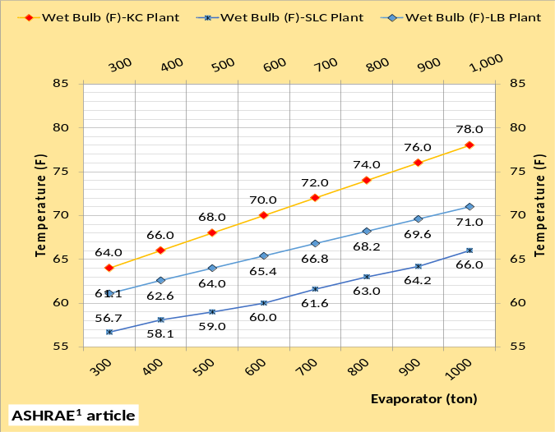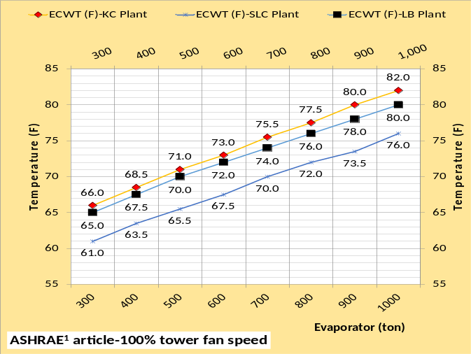
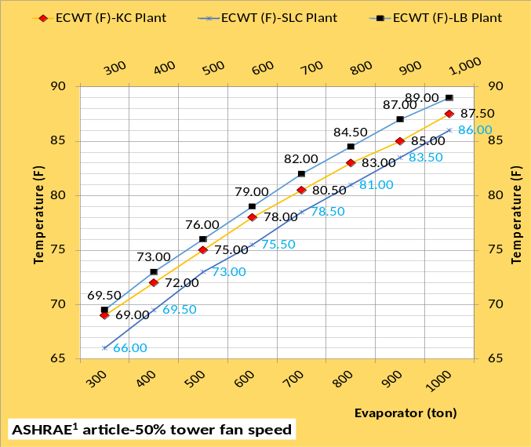Figure 1: Schwedler¹ Data-wet bulb & tower ECWT (F)

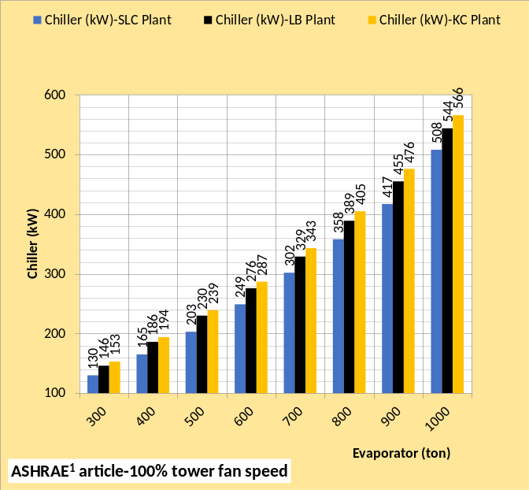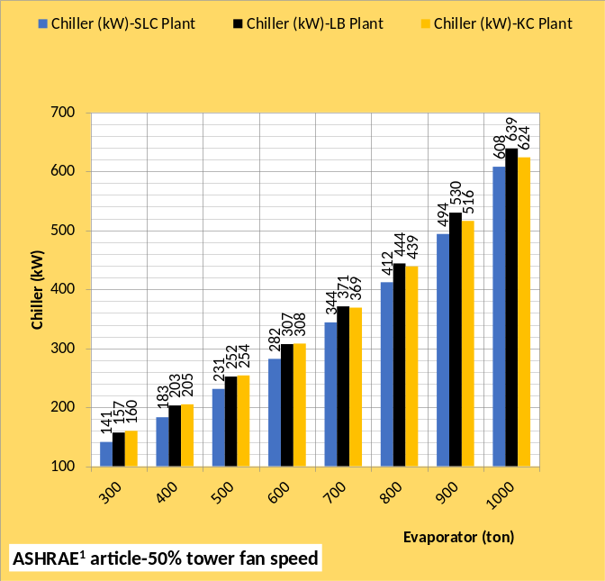Figure 2: Schwedler¹ data-Chiller kW
Figure 2 gives the chiller kW for 100% tower fan speed, top chart, and 50% tower fan speed by the bottom chart. Comparing the two charts illustrates the increase in chiller kW with 50% tower fan speed but also shows the chiller kW for LB is greater than KC at 50% tower fan speed. Clearly a complex chiller/tower system requiring considerable detail of the system equations to duplicate this chiller/tower performance as illustrated by Figures 1 & 2.

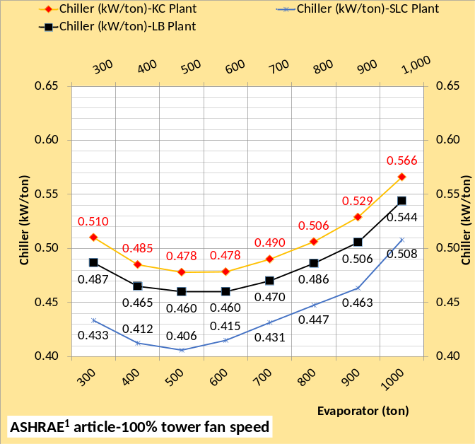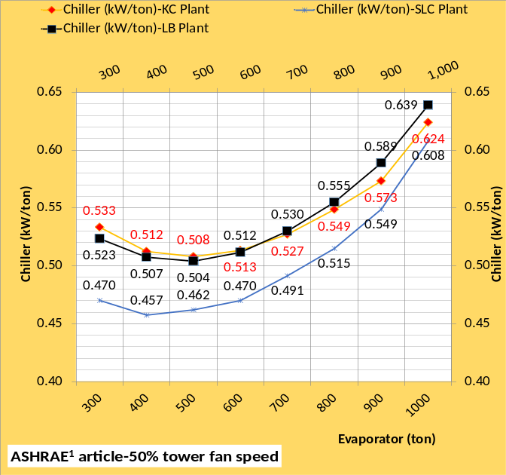Figure 3: Schwedler data-Chiller kW/ton
Figure 3 top chart gives the chiller kW/ton with 100% tower fan speed and the bottom chart 50% tower fan speed. The charts illustrate that Kansas City & Long Beach change places with 50% tower fan speed. This shift in efficiency is due to chiller lift⁵ and chiller lift is a function of chiller/tower performance that must be and is modeled by the (SEE) Plant Model. Chapters below address chiller lift. Trane¹⁹ provided invaluable data regarding chiller lift.
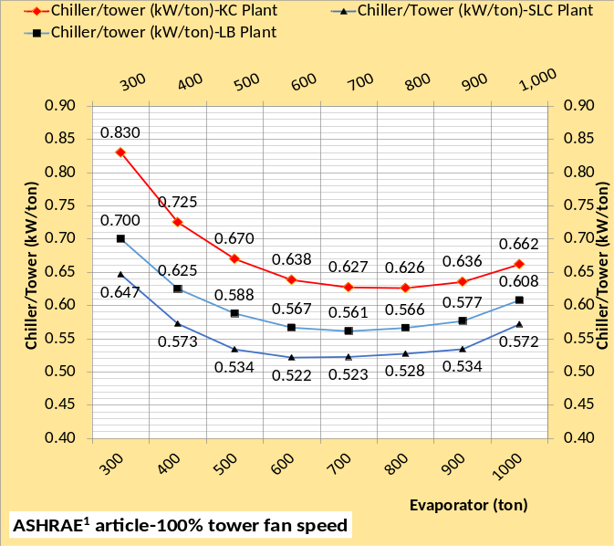 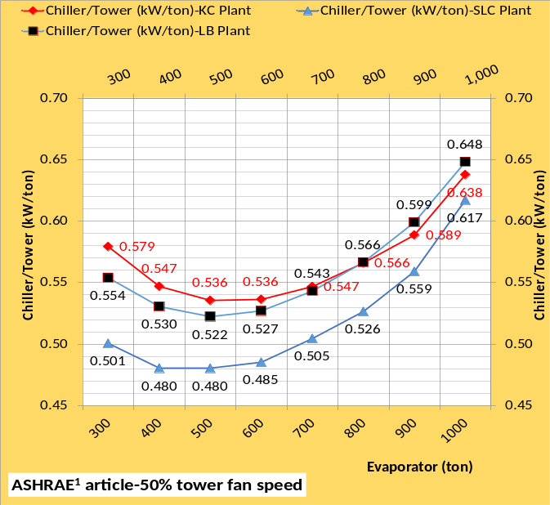Figure 4: Schwedler¹ data-Chiller/Tower kW/ton
Figure 4 is the chiller plus tower kW per evaporator ton provided by Schwedler. The (SEE) Plant Model must include all components of a plant and does so consistent with the data of Figure 4 within 3%.

Trane Data

Chiller  # | Evap.  Ton | WB  F | Tower  kW | ECWT  F | Refrig.  app. | Chiller  kW | Water  F
1 | 1000 | 78 | 96 | 82 | 10.1 | 566 | 44
4 | 1000 | 78 | 96 | 82 | 9.3 | 554 | 44
7 | 1000 | 78 | 96 | 82 | 8.5 | 546 | 44
10 | 1000 | 78 | 96 | 82 | 8.3 | 540 | 44
13 | 1000 | 78 | 96 | 82 | 8.0 | 534 | 44
16 | 1000 | 78 | 96 | 82 | 7.4 | 529 | 44
19 | 1000 | 78 | 96 | 82 | 6.8 | 523 | 44
22 | 1000 | 78 | 96 | 82 | 6.1 | 518 | 44
25 | 1000 | 78 | 96 | 82 | 5.1 | 510 | 44
28 | 1000 | 78 | 96 | 82 | 4.8 | 505 | 44
31 | 1000 | 78 | 96 | 82 | 4.2 | 502 | 44
32 | 1000 | 78 | 96 | 82 | 4.2 | 501 | 44

Table 1: Trane¹⁹ Chiller selection data
Table 1 is data provided by Trane¹⁹ showing the decrease in the evaporator plus condenser refrigerant approach temperatures results is less chiller kW required to produce 44F supply water. The reason is the drop in chiller lift as the refrigerant approach temperatures decreases. Chiller lift is defined⁵ as the difference in the condenser refrigerant temperature minus the evaporator refrigerant temperature. Chiller lift is address by chapters below. Chapter 5 will show that the (SEE) Plant Model duplicates this Table 1 data within less than 1%.
The first eight chapters of this document show that the (SEE) Plant Model duplicates the Schwedler¹ chiller and tower data, duplicates the Marley² data and duplicates the Trane¹⁹ data all within 3% and most data within 2% to 1%, clearly establishing the validity of the (SEE) Plant Model.
Building Benchmarking
The ability to define the 24-hour energy consumption of a well-designed building and the chiller plant that serves the building offers the opportunity to benchmark a building system on any day the 24-hour energy consumption data of the real building is taken. The ability to define the well-designed building energy consumption during a winter day or a hot summer day offers the opportunity to benchmark a real building under any conditions of weather and control. The building of this study is defined by the Pacific Northwest National Laboratory (PNNL) study of ASHRAE Standard 90.1-2010, (Liu 2011)⁸, a large 13 story office building with 498,600 square feet of air-conditioned space. A link to the (PNNL) study is given under references⁸. The building schedules and other details of the building, as defined by the (PNNL) study, are in the building model. The (SEE) Building Model is developed to the same standards as the (SEE) Plant Model. Nelson¹⁴ provides building energy benchmarking data in kW/sq ft and btu/sq ft for several cities on particular days of weather.
This introduction has given a brief discussion of the data the (SEE) Building and Plant model used to verify the validity of the Model. The following pages of this paper show and discuss the many control and design parameters that determine the energy use characteristics of a building system. A building & chiller plant is a very complex system and that is the primary objective of this (SEE) Model study; bring understanding of a very complex system. One very important tool used to accomplish this understanding is the development of Schematics of the building and the plant that serves the building. Schematic 1 below illustrates and the nomenclature defines most of the parameters in the (SEE) Model.

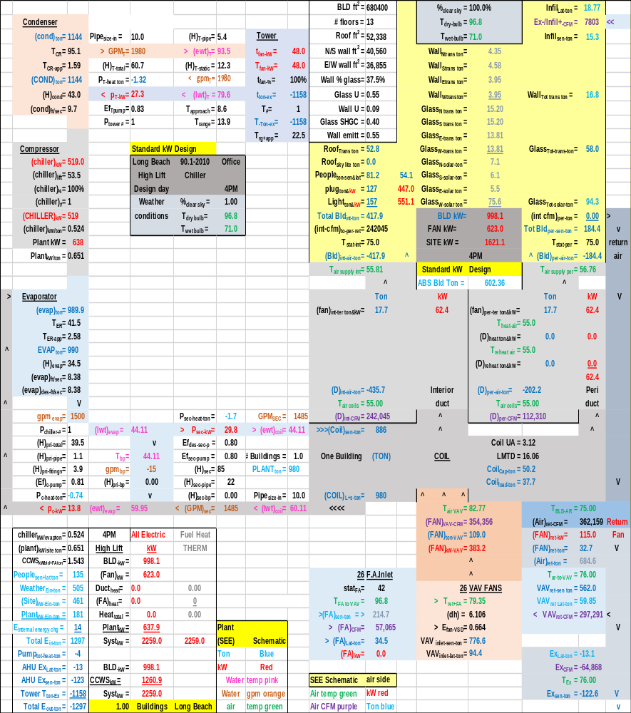

SCHEMATIC 1: Full System Schematic
References:
- Schwedler, Mick. July 1998 “Take It to The Limit…Or Just Halfway?” ASHRAE Journal.
- SPX Cooling Technologies (Marley). UPDATE Version 5.4.2
- Introduction to Thermodynamics and Heat Transfer. 1956 Prentice-Hall, Inc. by David A. Mooney, page 325.
- Thermal Environmental Engineering third edition. 1998 Prentice-Hall Inc. by Thomas H. Kuehn, chapter 3.
- 2012 ASHRAE HANDBOOK, HVAC Systems and Equipment, page 43.10 Figure 11 Temperature Relations in a Typical Centrifugal Liquid Chiller.
- ASHRAE. 2010. ASHRAE GreenGuide: The Design, Construction, and Operation of Sustainable Buildings, 3rd ed. Atlanta: ASHRAE.
- Taylor, S. 2011. “Optimizing design & control of chiller plants.” ASHRAE Journal (12).
- Liu, B. May 2011. “Achieving the 30% Goal: Energy and Cost Savings Analysis of ASHRAE Standard 90.1-2010” Pacific Northwest National Laboratory. http://www.energycodes.gov/achieving-30-goal-energy-and-cost-savings-analysis-ashrae-standard-90.1-2010
- Schwedler, M. 2017. “Using Low-Load Chillers to Improve System Efficiency.” ASHRAE Journal.
- July 2014 ASHRAE Journal, page 70. The article (Improving Infiltration in Energy Modeling) makes the obvious but not stated point; 40 years after the oil embargo and an air side model is still not in the ASHRAE models.
- ASHRAE Journal September 2014. Letters, “Energy Modeling”, by Kirby Nelson
- ASHRAE Journal May 2016. “Modeled Performance Isn’t Actual Performance”
- Nelson, K. “Simulation Modeling of a Central Chiller Plant” CH-12-002. ASHRAE 2012 Chicago Winter Transactions.
- Nelson, K. System Energy Equilibrium (SEE) Building Energy Model. http://kirbynelsonpe.com/
- Tredinnick, Steve. 2015. “District Energy Enters The 21st Century”. ASHRAE Journal.
- Morrison, Frank. 2014. “Saving energy with cooling towers.” ASHRAE Journal
- Kavanaugh, Steve. June 2000 “Fan Demand and Energy” ASHRAE Journal
- Nelson, Kirby. July 2010 “Central-Chiller-Plant Modeling” HPAC Engineering
- Trane chiller selection data received by Kirby Nelson from Springfield Missouri Trane office 1/30/01.
- Real weather data www.wunderground.com/
NOMENCLATURE
Each of the more than 200 variables will be defined.
Building structure;
BLD ft² = air conditioned space
# Floors = number of building floors
Roof ft² = roof square feet
N/S wall ft² =north/south wall square feet
E/W wall ft² =east/west wall square feet
Wall % glass = percent of each wall that is glass
Glass U = glass heat transfer coefficient
Wall U = wall heat transfer coefficient
Glass SHGC = glass solar heat gain coefficient
Wall emit = wall solar index
Building interior space;
Roof_{trans-ton} =transmission through roof (ton)
Roof_{sky-lite-ton} =sky lite load (ton)
People_{ton sen&lat} = sensible & latent cooling load due to people (ton)
Plug_{ton&kW} = cooling load & kW due to plug loads
Light_{ton&kW} = cooling load & kW due to lights
Total Bld_{int-ton} = total building interior load (ton)
(int-cfm) _{to-per-return} = CFM of interior supply air that returns to perimeter of building
T_{stat-int} = interior stat set temperature (F)
Bld_{int-air-ton} = supply air ton to offset interior load
BLD kW = total building kW demand
FAN kW = total fan kW
HEAT kW = total kW due to heat
SITE kW = total site kW=Bld+ Fan+Heat
Building perimeter space;
%_{clear sky} = percent clear sky
T_{dry bulb} = outside dry bulb temperature (F)
T_{wet bulb} = outside wet bulb temperature (F)
Ex/Infil_{lat-ton} = latent air infiltration or exfiltration (ton)
Ex/Infil_{CFM} = air infiltration or exfiltration CFM
Exfil_{sen-ton} =sensible air exfiltration or infiltration (ton)
Wall_{n trans ton} = north wall transmission (ton)
Wall_{s trans ton} = south wall transmission (ton)
Wall_{E trans ton} = east wall transmission (ton)
Wall_{w trans ton} = west wall transmission (ton)
Wall_{tot-trans-ton} = total wall transmission (ton)
Glass_{N-trans-ton} = north wall glass transmission (ton)
Glass_{S-trans-ton} = south wall glass transmission (ton)
Glass_{E-trans-ton} = east wall glass transmission (ton)
Glass_{W trans-ton} = west wall glass transmission (ton)
Glass_{tot-trans-ton} = total transmission thru glass (ton)
Glass_{N-solar-ton} = north glass solar load (ton)
Glass_{S-solar-ton} = south glass solar load (ton)
Glass_{E-solar-ton} = east glass solar load (ton)
Glass_{W-solar-ton} = west glass solar load (ton)
Glass_{tot-solar-ton} = total glass solar load (ton)
(int cfm)_{per-ton} = effect of interior CFM to wall (ton)
Total Bld_{per-sen-ton} total perimeter sensible load (ton)
T_{stat-per} = perimeter stat set temperature (F)
Bld_{per-air-ton} = supply air ton to offset perimeter load
Air handler duct system-Interior duct
T_{air supply int} = temp air supply to building interior (F)
(fan)_{int ter ton&kW} = interior ton & kW due to terminal fans
(D)_{int-air-ton} = cooling (ton) to building interior duct
T_{air coils} = supply air temperature off coils to duct (F)
(D)_{int-CFM} = supply air CFM to building interior duct
Perimeter duct
T_{air supply per} =temp (F) air supply to building perimeter
(fan)_{per ter ton&kW} = perimeter ton & kW of terminal fans
T_{heat-air} = temp supply air before terminal fan heat (F)
(D)_{heat-ton&kW} = heat to perimeter supply air ton & kW
T_{reheat air} = temp perimeter supply air after reheat (F)
(D)_{reheat ton&kW} = reheat of perimeter supply air ton & kW
(D)_{per-air-ton} = cooling (ton) to perimeter duct
T_{air coils} = supply air temperature off coils to duct (F)
(D)_{per-CFM} = supply air CFM to perimeter duct
Coil
(Coil)_{sen-ton} = sensible load on all coils (ton)
(Coil)_{cap-ton} = LMTD * UA = capacity (ton) one coil
LMTD = Coil log mean temperature difference (F)
(Coil)_{L+s-ton} = latent + sensible load on all coils (ton) transferred to Plant
UA = coil heat transfer coefficient * coil area. UA varies as a function water velocity (coil)_{gpm} thru the coil, as the (coil)_{gpm} decreases the coil capacity decreases.
(one Coil)_{ton} = load (ton) on one coil
VAV Fan system
Fresh air
stat_{FA} = fresh air freeze stat set temperature (F)
T_{FA to VAV} = temperature of fresh air to VAV fan
(FA)_{sen-ton} = fresh air sensible load (ton)
(FA)_{CFM} = CFM fresh air to VAV fan inlet
(FA)_{Lat-ton} = fresh air latent load (ton)
(FA)_{kW} = heat kW to stat_{FA} set temperature
Air return
T_{BLD-AR} = return air temp (F) before return fans
(Air)_{ret-CFM} = CFM air return from building
(FAN)_{ret-kW} = return fans total kW
(FAN)_{ret-ton} = cooling load (ton) due to (FAN)_{ret-kW}
(Air)_{ret-ton} = return air (ton) before return fans
T_{AR to VAV} = T_{BLD-AR} + delta T due to return fans kW
VAV_{ret-sen ton} = return sensible (ton) to VAV fans inlet
VAV_{ret-lat ton} = return latent (ton) to VAV fans inlet
VAV_{ret-CFM} = return CFM to VAV fans inlet
Exhaust air
Ex_{Lat-ton} = latent load (ton) exhausted
Ex_{CFM} = CFM of exhaust air
T_{Ex} = temperature of exhaust air
Ex_{sen-ton} = sensible load (ton) exhausted
VAV Fans
T_{ret+FA} = return and fresh air mix temperature (F)
(dh) = VAV air static pressure (in)
E_{fan-VSD} = VAV fans efficiency
VAV_{inlet-sen-ton} = sensible load (ton) inlet to VAV fans
VAV_{inlet-lat-ton} = latent load (ton) inlet to VAV fans
T_{air-VAV} = temp air to coils after VAV fan heat
(FAN)_{VAV-CFM} = CFM air thru coils
(FAN)_{ton-VAV} = load (ton) due to VAV fan kW
(FAN)_{kW-VAV} = total VAV fan kW demand
AIR SIDE SYSTEM PLUS BUILDING
FAN kW = total air handlers kW
SITE kW = total site or air side kW
Plant_{ton} = (COIL)_{L+s ton} load (ton) to plant
CENTRAL PLANT
# Buildings = number of buildings served by plant
Plant ton = total load (ton) to plant
Primary/secondary pumping nomenclature
gpm_{evap} = total gpm flow thru one evaporators
(H)_{pri-total} = total primary pump head (ft) = (H)_{pri-pipe} + (H)_{pri-fittings} + (H)_{pri-bp} + (H)_{evap}
(H)_{pri-pipe} = primary pump head due to piping (ft)
(H)_{pri-fittings} = primary head due to pump & fitting (ft)
(Ef)_{c-pump} = efficiency of chiller pump
P_{c-heat-ton} = chiller pump heat to atmosphere (ton)
P_{c-kW} = one chiller pump kW demand (kW)
P_{chiller-#} = number chiller pumps operating
(lwt)_{evap} = temperature water leaving evaporator (F)
T_{bp} = temperature of water in bypass (F)
gpm_{bp} = gpm water flow in bypass
(H)_{pri-bp} = head if chiller pump flow in bypass (ft)
(ewt)_{evap} = temp water entering evaporator (F)
P_{sec-heat-ton} = secondary pump heat to atmosphere (ton)
P_{sec-kW} = kW demand of secondary pumps
Ef_{des-sec-p} = design efficiency of secondary pumping
Ef_{sec-pump} = efficiency of secondary pumping
(H)_{sec} = secondary pump head (ft) = (H)_{sec-pipe} + (H)_{sec-bp} + (H)_{coil} + (H)_{valve}
(H)_{sec-pipe} = secondary pump head due to pipe (ft)
(H)_{sec-bp} = head in bypass if gpm_{sec} > gpm_{evap}
GPM_{sec} = water gpm flow in secondary loop
(ewt)_{coil} = water temperature entering coil (F)
Pipe_{size-in} = secondary pipe size (inches)
(lwt)_{coil} = temperature of water leaving coil (F)
Evaporator
(evap)_{ton} = load (ton) on one evaporator
T_{ER} = evaporator refrigerant temp (F)
T_{ER-app} = evaporator refrigerant approach (F)
EVAP_{ton} = total evaporator loads (ton)
(H)_{evap} = pump head thru evaporator (ft)
(evap)_{ft/sec} = velocity water flow thru evaporator
(evap)_{des-ft/sec} = evaporator design flow velocity
Compressor:
(chiller)_{kW} = each chiller kW demand
(chiller)_{lift} = (T_{CR} – T_{ER}) = chiller lift (F)
(chiller)% = percent chiller motor is loaded
(chiller)# = number chillers operating
(CHILLER)_{kW} = total plant chiller kW
(chiller)_{kW/ton} = chiller kW per evaporator ton
Plant kW = total kW demand of plant
(Plant)_{kW/site ton} = Plant kW per site ton
Condenser nomenclature:
(cond)_{ton} = load (ton) on one condenser
T_{CR} = temperature of condenser refrigerant (F)
T_{CR-app} = refrigerant approach temperature (F)
(COND)_{ton} = total load (ton) on all condensers
(H)_{cond} = tower pump head thru condenser (ft)
(cond)_{ft/sec} = tower water flow thru condenser
Tower piping nomenclature
Pipe_{size-in} = tower pipe size (inches)
gpm_{T} = each tower water flow (gpm)
GPM_{T} = total tower water flow (gpm)
(H)_{T-total} = total tower pump head (ft)
P_{T-heat} = pump heat to atmosphere (ton)
P_{T-kW} = each tower pump kW demand
Ef_{T-pump} = tower pump efficiency
P_{tower #} = number of tower pumps
(H)_{T-pipe} = total tower pump head (ft)
(ewt)_{T} = tower entering water temperature (F)
(H)_{T-static} = tower height static head (ft)
T_{range} = tower range (F)= (ewt)_{T} – (lwt)_{T}
(lwt)_{T} = tower leaving water temperature (F)
T_{approach} = (lwt)_{T} – (T_{wet-bulb})
Tower nomenclature
t_{fan-kW} = kW demand of one tower fan
T_{fan-kW} = tower fan kW of fans on
t_{fan-%} = percent tower fan speed
t_{ton-ex} = ton exhaust by one tower
T# = number of towers on
T_{ton-ex} = ton exhaust by all towers on
T_{rg+app} = tower range + approach (F)
One hour performance indices
BLD_{kW} = kW demand of building lights & plug loads
Fan_{kW} = air side fans kW, VAV, return terminals
Duct_{heat} = perimeter heat to air supply
FA_{heat} = heat added to fresh air
Heat_{total} = total heat added to air
Plant_{kW} = total plant kW
Syst_{kW} = total system kW
CCWS_{kW} = air side system + plant kW
Chiller_{kW/evap ton} = chiller kW/evaporator ton performance
Plant_{kW/site ton} = plant kW per site or air side ton
CCWS_{kW/site ton} = CCWS kW per load to plant
Weather_{Ein-ton} = weather energy into the system
Site_{kW-Ein-ton} = load (ton) due to site kW
Plant_{kW-Ein-ton} = load (ton) due to plant kW
Total_{Ein-ton} = total energy in to system (ton
Pump_{tot-heat-ton} = total pump heat out (ton)
AHU Ex_{lat ton} = air exhausted latent ton
AHU Ex_{sen ton} = air exhausted sensible ton
Tower T_{ton Ex} = energy exhausted by tower (ton)
Total E_{out ton} = total energy out of system (ton)
24 hour performance indices
BLD_{24hr-kW} = building 24 hour kW usage
Fan_{24hr-kW} = fan system 24 hour kW usage
Duct_{24hr-heat kW or therm} = duct heat
FA_{24hr heat kW or therm} = fresh air heat
Heat_{24hr total kW or therm} = total heat into system
Plant_{24hr kW} = plant 24 hour kW usage
Syst_{24hr kW & therm} = total system 24 hour energy usage
People_{sen+lat ton} =total load (ton) due to people
Enfil_{24hr cfm energy} = change in internal energy
Weather_{24hr-Ein-ton} = 24 hour weather energy into system
SITE_{24hr-kW-Ein-ton} = 24 hour energy into site
Plant_{24hr-kW-Ein-ton} = 24 hour kW energy into plant
Total_{24hr-Ein-ton} = total 24 hour energy into system
Pump_{24hr Heat out-ton} = pump heat to atmosphere (ton)
AHU Ex_{24hr Lat ton} = exhausted latent load from building
AHU Ex_{24hr-sen-ton} = exhausted sensible load from bld.

CHAPTER 1: Kansas City Model verification against Schwedler¹ at 100% & 50% tower fan speed.
Model verification
As a designer of military products, the author was trained that a system model must duplicate the performance of the real system within reasonable accuracy, 2% to 5%, if the model is to be used in the design and evaluation of the system’s performance. Verification of system models was accomplished in corporate laboratories and field tests at the Naval Ordnance Test Station (NOTS) in China Lake CA. A verified model gave the ability to evaluate the systems performance at any conditions and therefore define redesigns to improve the system’s performance.
The verification approach here will be to show that this (SEE) plant model duplicates and/or closely follows a published 1998 ASHRAE Journal article by Schwedler¹. Table 1-1 illustrates the data given by Schwedler¹ for a Kansas City Missouri plant at 100% tower fan speed. The table illustrates that the evaporator load is decreased from 1,000 ton down to 300 ton as the wet bulb decreases from 78F down to 64F. Table 1-1 shows that the cold water from the tower decreases from 82F down to 66F as the wet bulb and evaporator load decreased. The chiller kW demand drops from 566 kW down to 153 kW. Table 1-1 illustrates the challenge for a chiller/tower plant model; however if one incorporates the basics of thermodynamics an accurate model can be defined as will be shown here not only for 100% tower fan speed but also for 50% tower fan speed as given by Schwedler¹.
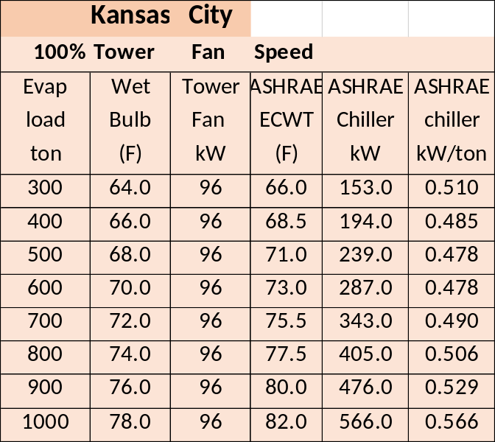Table 1-1: Data from Schwedler¹
This Chapter 1 will demonstrate the (SEE) Models ability to duplicate the Schwedler¹data with tower fan speeds of 100% and 50%. Only two changes are made to the model going from 100% tower fan speed to 50% fan speed; the tower fan speed is reduced to 50% and the chiller kW power is increased to provide 44F supply water to the building; probably the same procedure as would occur in a real system and that is the point of a (SEE) Model, duplication of the real system’s performance.
Chiller manufacture’s selection data
Table 1-2 gives the manufacture’s chiller selection data for the chiller as defined by Schwedler¹. The chiller manufacture also provided invaluable data¹⁹ for the development of the (SEE) Model giving chiller data down to an evaporator refrigerant approach of 2.60F and a condenser refrigerant approach of 1.60F. Decreasing the condenser and evaporator refrigerant approach temperatures decreases chiller kW and necessarily increases the cost of the chiller. Chapter 5 will discuss the chiller manufacture’s provided data¹⁹ in detail. The author is indebted to the chiller manufacture for providing the data of Chapter 5.

Design Tons | 1000.0
Chiller kW | 566.0
Chiller kW/ton | .566
Evap water flow rate (gpm) | 2400.0
Evap entering water temp (F) | 54.0
Evap leaving water temp (F) | 44.0
Evap refrigerant temp (F) | 38.8
Evap refrigerant approach (F) | 5.2
Evap pressure drop (ft. water) | 27.6
Evap water velocity (ft. /sec.) | 10.06
Cond heat rejection (ton) | 1172
Cond water flow rate (gpm) | 3000.0
Cond entering water temp (F) | 82.0
Cond leaving water temp (F) | 91.4
Cond refrigerant temp (F) | 96.3
Cond refrigerant approach (F) | 4.9
Cond pressure drop (ft. water) | 31.2
Cond water velocity (ft. /sec) | 10.28
Table 1-2: Manufacture’s chiller selection data¹⁹ as defined by Schwedler¹ for Kansas City
Tower for (SEE) model | Low cost tower¹
Design Wet bulb | 78.0F
Design Load | 1155 ton
Tower water flow | 3000 gpm
Approach temperature | 4.0 F
Calculated range | 9.27F
Range + approach | 13.27F
Three cells with 40HP fans¹ | 96 kW¹
Selected Tower² | NC8403TLS3
Cold water | 82F
Return water to tower | 91.27F
Capacity | 102.9%
ASHRAE 90.1 performance | 43.5 gpm/HP
Static lift | 12.234 ft.
Table 1-3: Tower selected
Table 1-3 gives the performance data of the tower selected based on Schwedler¹. The data of Tables 1-2 & 1-3 will be input to the (SEE) Plant Model.
(SEE) Model Plant at Peak Conditions
Schematic 1-1 illustrates the primary/secondary (P/S) pumping system not defined by Schwedler¹ but necessary for the plant (SEE) Model. The load from the building to the plant is 985 ton increasing to 1000 ton, as given by Schwedler¹, at the evaporator as a result of heat added to the system by the P/S pumping. The kW of the pumps is (46.3+18.2=64.5 kW) that adds (64.5/3.513=18.4 ton) load. Pump heat not going into the system but to the atmosphere is modeled as (2.64+.98=3.62 ton) for a total of (18.4-3.62=14.8 ton added to the plant load of 985 ton giving (985+14.8=1000 ton) to the evaporator as shown by Schematic 1-1.
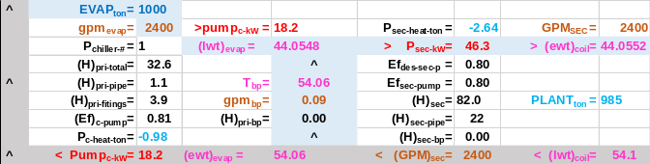Schematic 1-1: Primary/Secondary Pumping
Schematic 1-1 also illustrates that the flow in the bypass is .09 (gpm) resulting in a temperature of water in the bypass of 54.06F with little effect on the supply water temperature, 44.0548F off the evaporator and 44.0552F to the building. A slight decrease in plant load will reverse the direction of flow in the bypass.
Schematic 1-2 illustrates the condenser, compressor, and evaporator at 1,000-ton evaporator load. Schwedler¹ did not define the condenser and evaporator designs however the author requested selection data as detailed in Chapter 5¹⁹ that provides the necessary data.
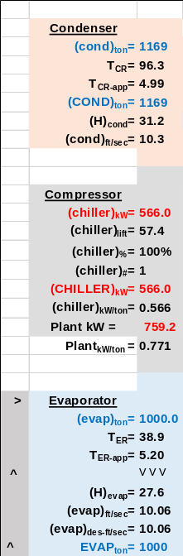 Schematic 1-2: Condenser, Compressor, and Evaporator.
The compressor motor demand is 566 kW to move the refrigerant from the evaporator to the condenser. The condenser load is (1000 ton + 566kW/3.513 =1,161 ton). Schematic 1-2 shows the condenser load as 1,169 ton due to the addition of the 8 ton tower pump heat to the system.
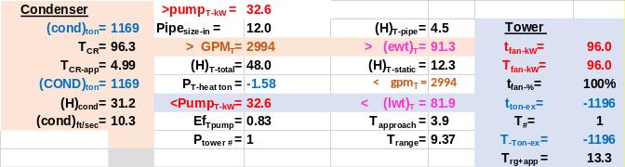Schematic 1-3: Condenser & Tower.
Schematic 1-3 illustrates the condenser and tower plus pumping, not defined by Schwedler¹, at peak load of 1000 ton on the evaporator. Pumping heat added to the condenser is (32.6kW/3.512=9.28ton-1.58ton=7.70 ton rounded to 8 ton) as stated above. The tower exhausts the condenser load plus the tower fan heat for a total of -1196 ton exhausted from the system. The load from the building was 985 ton as shown by Schematic 1-1 and the plant added (1196-985=211 ton) to the system to be exhausted by the tower. Clearly the more the plant adds to the building load the greater the size of the required tower, condenser, and evaporator, also increasing the cost of the plant and probably decreasing plant efficiency. A later chapter will address plant design and make this point more clear.
Plant Schematic
Schematic 1-4 illustrates the full plant combining Schematics 1-1, 1-2, & 1-3. The energy into the system is 985ton + 758kW/3.513=1200.8 ton minus the pump heat to atmosphere of (-2.64-.98-1.57=-5.19 ton) for a total of (1200.8-5.19=1196 ton in and out as exhausted by the tower. The laws of thermodynamics state that the energy into a system is equal to the energy out of the system. Therefore, the same must be true for a system model if the system model is to be judged as a true model of the system.

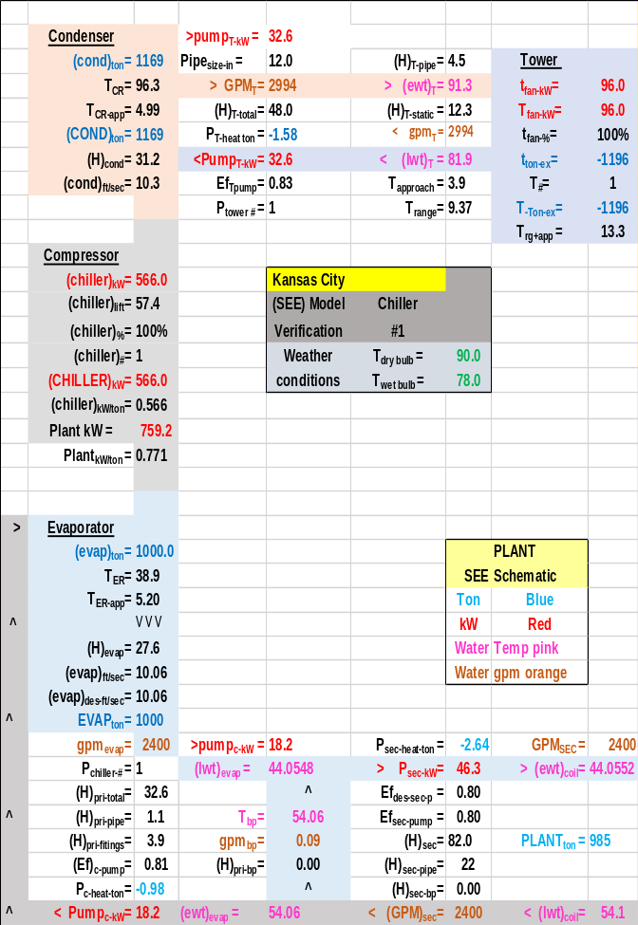Schematic 1-4: Plant at 1000-ton evaporator load & 100% tower fan speed & 566 kW chiller demand-matching Schwedler¹ data.
Schematic 1-4 is consistent with the data provided by Schwedler¹, 566 kW chiller demand and 81.9F entering condenser water (ECWT) temperature. Schwedler¹ did not define the condenser and evaporator refrigerant approach temperatures which must be defined for the (SEE) Model. The chiller manufacture data provided condenser & evaporator approach temperatures plus other data that is addressed in Chapter 5. The (SEE) plant model required an evaporator value of 5.20F refrigerant approach and 4.99F for the condenser resulting in 44.05F supply water as required. Installing different condenser & evaporator refrigerant approach temperatures into the (SEE) model results in a different chiller kW and/or different supply water temperature as will be demonstrated below. Based on data given by Schwedler¹ and Chapter 5 the sum of the refrigerant approach temperatures must be about 10.2F to arrive at the data as given by Schwedler for Kansas City. Schematics 1-5 & 1-6 illustrate.

See Chapter 10, Schematic 10-1, for a description of the schematics and also see nomenclature above.

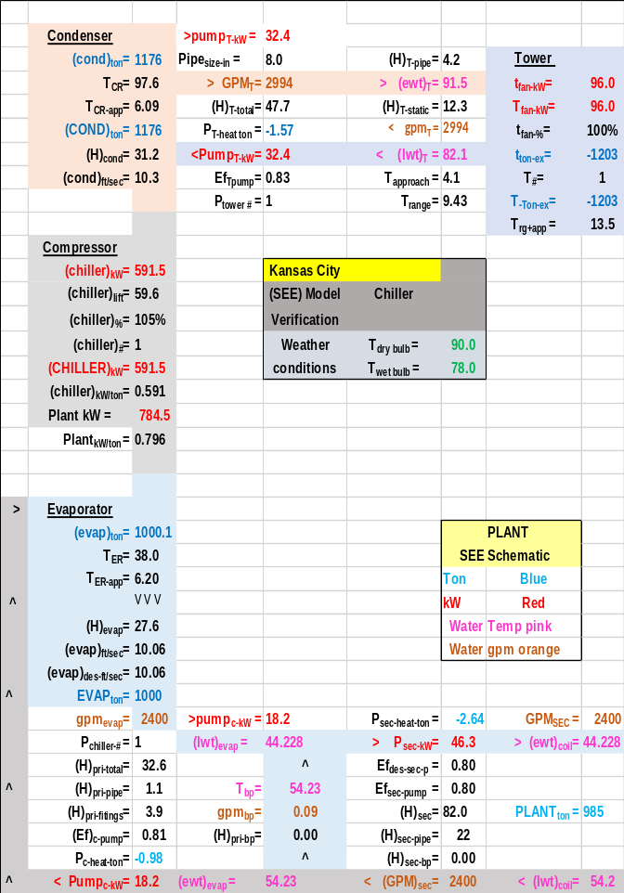Schematic 1-5: Evaporator & condenser refrigerant approach temperatures increased one degree (F)
Schematic 1-5 & 1-6 illustrate the difference in plant performance with different refrigerant approach temperatures. Schematic 1-5 increased the approach temperatures one-degree F and the chiller kW had to be increased from 566 kW, as given by Schwedler¹, to 591.5 kW to achieve 44.2F supply water.
Schematic 1-6 is with refrigerant approach temperatures reduced one degree F to 4.2F for the evaporator and 3.94 for the condenser as shown on schematics 1-6. For this condenser and evaporator design the chiller kW is reduced from 566 to 546.2 kW to achieve 44.25F supply water.

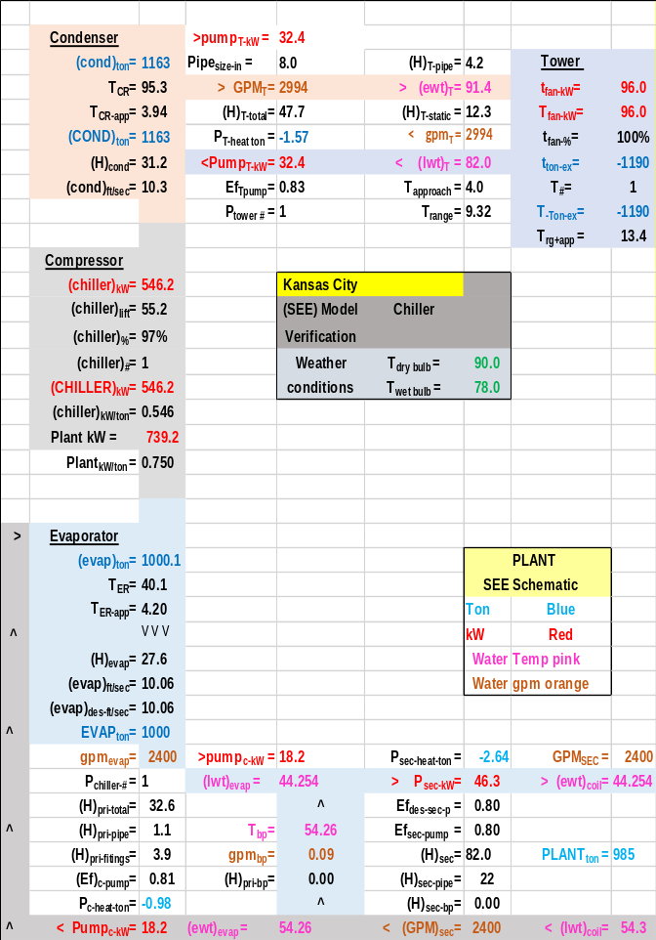Schematic 1-6: Evaporator & condenser refrigerant approach temperatures decreased one degree (F)
The point is that for the conditions given by Schwedler¹ and the assumptions made regarding the P/S pumping, and tower pumping, the condenser and evaporator refrigerant approach temperatures must total about 10.2F for the Plant (SEE) model to provide 44F supply water when the chiller demand is 566 kW.
Another defining characteristic of a chiller/tower is the design ratio of actual COP divided by maximum COP as discussed next.

Chiller coefficient of performance (COP)
Figure 1-1 illustrates a thermodynamic characteristic of chiller/tower systems. The maximum COP, Carnot cycle, of the (SEE) model chiller/tower is defined by the refrigerant temperatures.
Max COP = T2/ (T1-T2) where
T2 = absolute evaporator refrigerant temperature.
T1 = absolute condenser refrigerant temperature.
From Schematic 1-4 for 100% tower fan speed at design conditions.
Max COP^{3,4} = T2/(T1-T2) =
= (38.9+460)/(96.3+460-38.9-460) = 8.69
Max COP = 8.69 (shown on Figure 1-1)
The actual COP of the chiller/tower is defined by cooling provided/power required.
Actual COP = (1000 ton * 12000 btu/ton) / (566kW * 3413 btu/kW) = 6.21, (Schematic 1-4)&(Figure 1-1)
Therefore the COP ratio at design is 6.21/8.69 = .715 for the conditions of (Schematic 1-4).
This COP ratio is a necessary input to the (SEE) model & will vary due to type chiller, weather conditions, and probably by chiller manufacture.
Figure 1-1 illustrates how these values change as given by the (SEE) model. For 100% fan speed the max COP increases to 20.55, at 100-ton evaporator load, from 8.69 at 1000-ton evaporator load while the actual COP increases from 6.21 to a value of 7.50 at 500 ton evaporator load and then decreases to a value of 1.44 at 100 ton evaporator load.
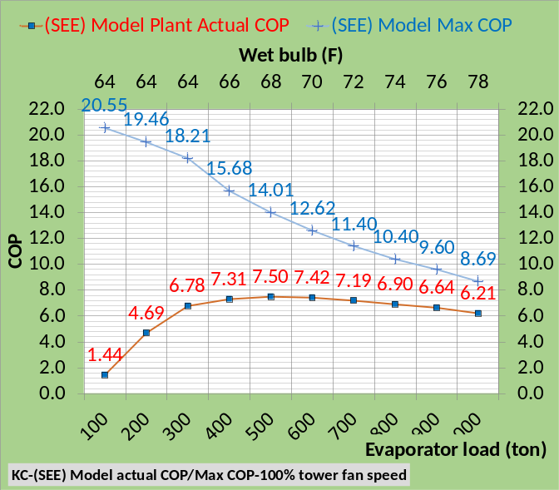 Figure 1-1. Chiller Max COP & actual COP-100% tower fan speed
The next two schematics illustrate the effect of the design COP ratio.
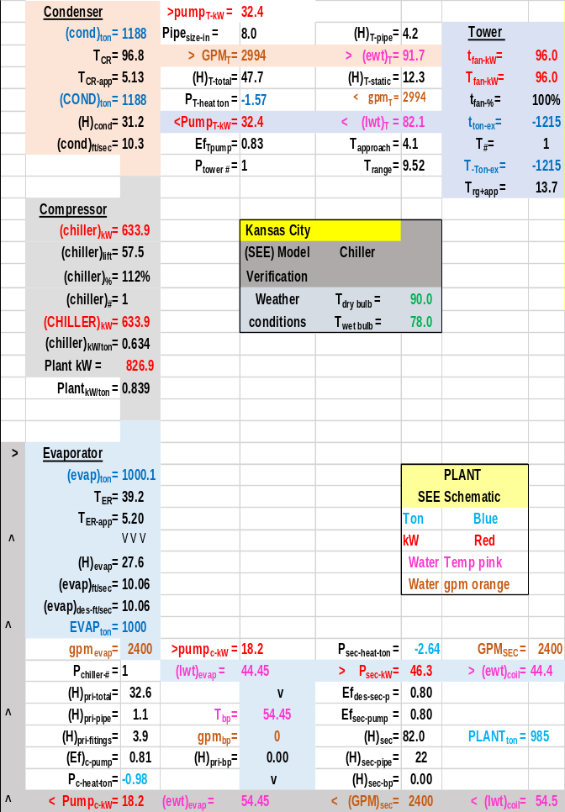Schematic 1-7: Chiller COP/COP max decreased 10% with chiller kW increased to achieve 44.45F supply water
Schematic 1-7 is the (SEE) model schematic at 1000 ton evaporator load and the COP ratio decreased 10%. The result is an increase in chiller kW to 633.9 kW from 566 kW to achieve 44.45F supply water.
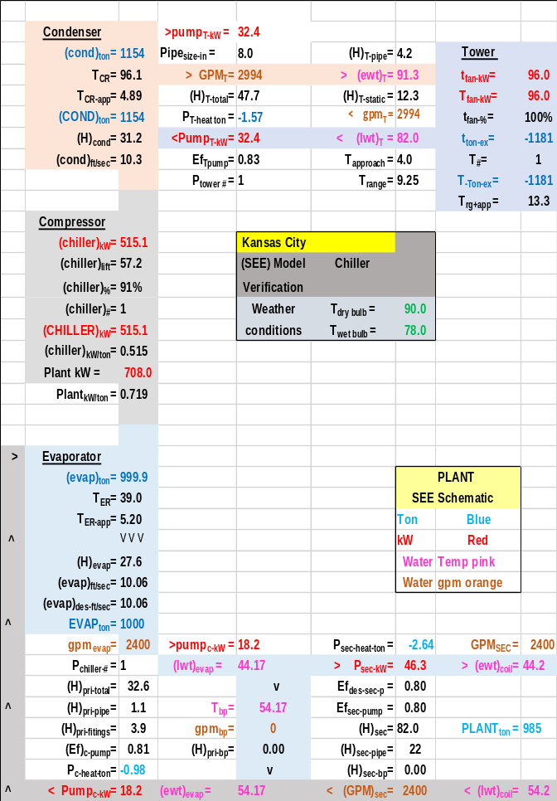Schematic 1-8: Chiller COP/COP max increased 10% with chiller kW decreased to achieve 44.17F supply water
Schematic 1-8 is the (SEE) model schematic at 1000 ton evaporator load and the COP ratio increased 10%. The result is a decrease in chiller kW to 515.1 kW from 566 kW to achieve 44.17F supply water. Clearly the design COP ratio has a significant effect on the performance of the chiller/tower and must be defined for (SEE) Model analysis.
Verification of (SEE) model at part load
Schematic 1-4 defines the (SEE) Model plant at peak design conditions; the question is can the (SEE) model duplicate the off peak values of Schwedler¹? Figure 1-2 illustrates the data given by Schwedler¹ for the performance of the chiller and cooling tower as the evaporator load and wet bulb decrease with 100% tower fan speed.
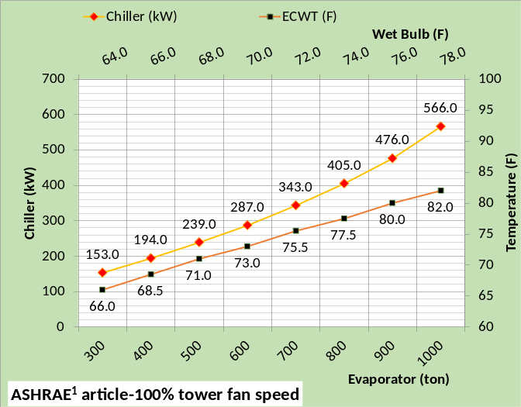Figure 1-2: Kansas City data from Schwedler¹
Figure 1-2 at 100% tower fan speed demonstrates the challenge for the (SEE) plant model and even more demanding is the requirement that the model must duplicate the plant performance when the tower fan speed is reduced to 50%. The good news is that the real plant follows the laws of thermodynamics and if the (SEE) Model does the same then a model that duplicates the performance of the real system is possible as will be demonstrated here.
Tower selection
Schwedler¹ defines the cooling tower as a low cost tower with 96 kW fan demand. The tower for this (SEE) model was defined with a manufactures selection program². Table 1-3 above gives the details of the selected tower that closely matches the Schwedler¹ data.

Tower simulation model results
The tower data of Table 1-3 is input to the model and is shown to closely duplicate the data given by Schwedler¹ as shown by Figure 1-3.
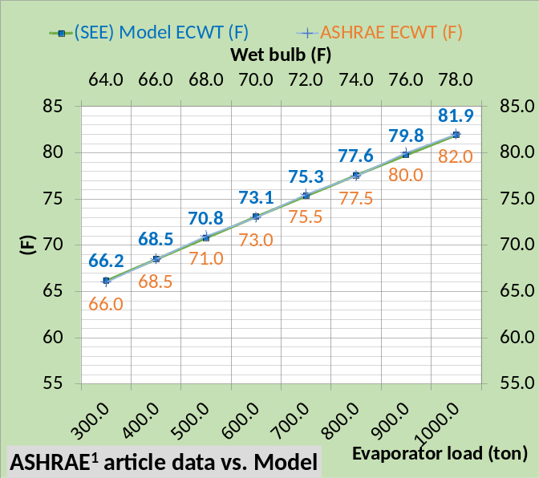Figure 1-3: (SEE) model vs Schwedler¹ tower ECWT-100% tower fan speed
At 100% tower fan speed Figure 1-3 illustrates that the (SEE) Model of the tower, from 1000 ton evaporator load down to 300 ton as the wet bulb drops from 78F down to 64F, closely follows the data provided by Schwedler¹.
Chiller performance
As the wet bulb and evaporator load decrease the chiller kW required to maintain 44F supply water decreases from 566 kW down to 153 kW as show by Figure 1-2¹. The (SEE) Model closely duplicates this Schwedler¹ data as shown by Figure 1-4.
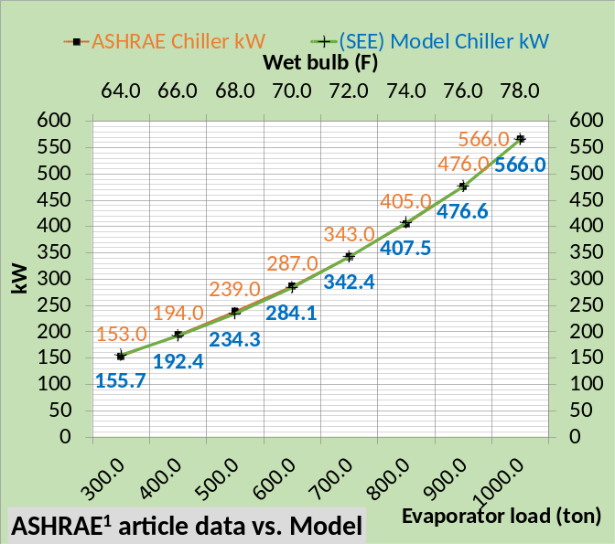Figure 1-4: (SEE) model vs. Schwedler¹ Chiller kW
Figure 1-4 illustrates the (SEE) model duplicates the manufactures data¹ to within 2% for all values of evaporator load and wet bulb.
Figure 1-5 provides a comparison of the (SEE) Model chiller kW per evaporator ton verses the manufactures data¹.

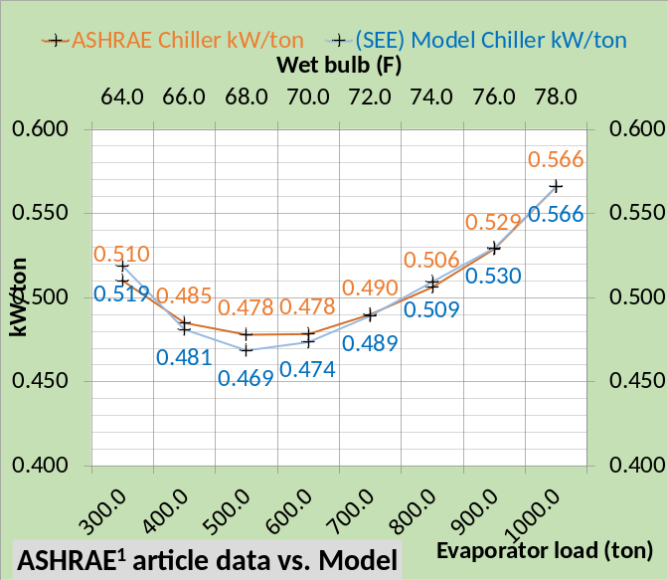Figure 1-5: (SEE) model vs. Schwedler¹ Chiller kW/ton
Figure 1-5, 100% tower fan speed illustrates close agreement to the manufactures data¹ with all values being less than 2% off the Schwedler¹ manufactures data. The manufactures data is given for the chiller and tower and does not include the chiller plant in total; pumping is not given and that has a significant effect on the plant performance as will be shown below.
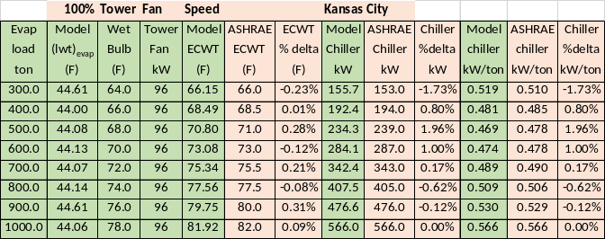Table 1-4: Model Results & Schwedler¹ data.
Table 1-4 provides tabular comparison of the Schwedler¹data and the (SEE) Model results illustrating close agreement for the tower model and chiller kW. The authors modeling experience judges this less than 2% deviation from manufactures data as acceptable i.e. a good model.
Table 1-5 illustrates the peak design data given by Schwedler¹ and the design conditions of the (SEE) Model as given by Schematic 1-4. Note that Schematic 1-4 provides 44.05F supply water resulting in a .05F increase in evaporator refrigerant temperature verses Schwedler¹44F supply water.
 | Schwedler data¹ | (SEE) MODEL
Design Tons | 1000.0 | 1000.0
Chiller kW | 566.0 | 566.0
Chiller kW/ton | .566 | .566
Evap water flow rate (gpm) | 2400.0 | 2400.0
Evap entering water temp (F) | 54.0 | 54.06
Evap leaving water temp (F) | 44.0 | 44.05
Evap refrigerant temp (F) | 38.8 | 38.9
Evap refrigerant approach (F) | 5.2 | 5.2
Evap pressure drop (ft. water) | 27.6 | 27.6
Evap water velocity (ft. /sec.) | 10.06 | 10.06
Cond heat rejection (ton) | 1172 | 1169
Cond water flow rate (gpm) | 3000.0 | 2994
Cond entering water temp (F) | 82.0 | 81.9
Cond leaving water temp (F) | 91.4 | 91.3
Cond refrigerant temp (F) | 96.3 | 96.3
Cond refrigerant approach (F) | 4.9 | 4.99
Cond press. drop (ft. water) | 31.2 | 31.2
Cond water velocity (ft. /sec) | 10.28 | 10.3
Table 1-5: Schwedler chiller design data¹⁹ vs. (SEE) Model chiller
Tower | Schwedler¹ | (SEE) Model
Design Wet bulb | 78.0F | 78.0F
Design Load |  | 1155 ton
Tower water flow | 3000 gpm | 3000 gpm
Approach temp. | 4.0F | 4.0 F
Calculated range | 10F | 9.27F
Range + approach | 14F | 13.27F
3 cells 40HP fans¹ | 96 kW | 96 kW¹
Selected Tower² |  | NC8403TLS3
Cold water | 82F | 82F
Return water to tower | 92F | 91.27F
Capacity |  | 102.9%
ASHRAE 90.1 |  | 43.5 gpm/HP
Static lift |  | 12.234 ft.
Table 1-6: (SEE) Model tower vs Schwedler¹
Schwedler¹ does not define the pumping system nor the details of the condenser and evaporator. Tables 1-5 & 1-6 illustrates the necessary assumed details for the (SEE) model, however the condenser and evaporator refrigerant approach temperatures as given by Table 1-5 where determined by the (SEE) Model as the necessary values for the model to balance to the conditions of Schwedler¹. Details of this analysis was shown by Schematics 1-5 & 1-6 above and Schematics 1-7 & 1-8 illustrated the effect of the design COP ratio.
Model Verification at 50% Tower Fan Speed
Tower Fan Speed Reduced to 50%
Reducing the tower fan speed from 100% to 50% results in significant changes in the performance of the plant and therefore a significant challenge for the (SEE) Model.
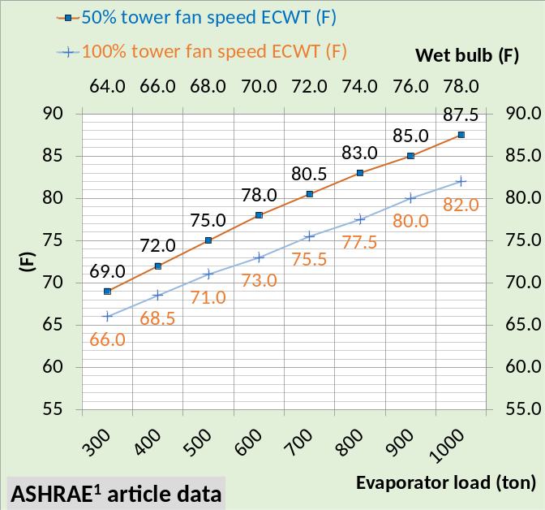Figure 1-6: ECWT-100% & 50% tower fan speed¹
Figure 1-6 illustrates the change in entering condenser water temperature (ECWT) as given by Schwedler¹ for 50% & 100% tower fan speed. ECWT increased 5.5F at design conditions and 3.0F at 300 ton evaporator load and 64F wet bulb. The increase in tower water temperature and therefore entering condenser water temperature results in an increase in required chiller kW to produce 44F supply water as discussed below.
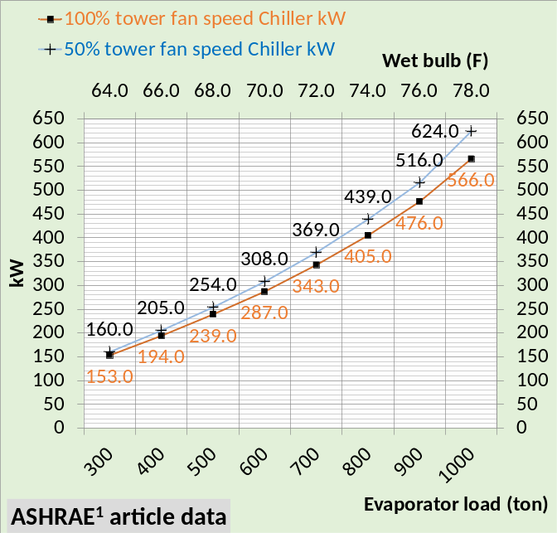Figure 1-7: Chiller kW-100% & 50% fan speed¹
Figure 1-7 gives the chiller kW at 100% and 50% tower fan speed as given by Schwedler¹ and Figure 1-8 gives chiller kW/ton as given by Schwedler¹ for 100% and 50% tower fan speed. Clearly reducing the tower fan speed to 50% has a significant effect on chiller kW and therefore chiller kW/ton.
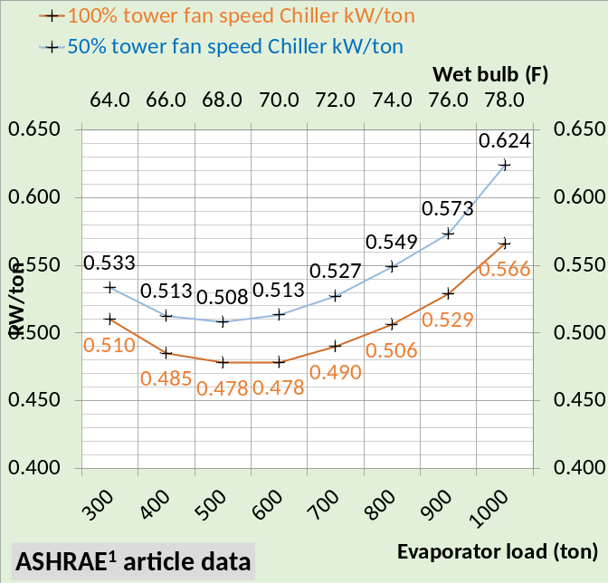Figure 1-8: Chiller kW/ton-100% & 50% tower fan speed¹
Figures 1-6, 1-7 & 1-8 illustrate the challenge for the (SEE) Model. A real system would probably reduce the tower fan speed in steps from 100% to 50% and also increase chiller kW in steps to meet the load and provide 44F supply water. The (SEE) Model will also perform this change in steps. Schematics will first show the changes in the plant when the tower fan speed is reduced to 50%. Then schematics will show the change when the chiller kW is increased to provide 44F supply water.

Schematic 1-4 copied: Plant at 1000 ton evaporator load, 100% tower fan speed, supply water 44.05F, and chiller kW=566.
The above Schematic 1-4 is copied from above and shows the plant at peak design conditions. Schematic 1-9 illustrates the plant when the only change is the fan speed has been change from 100% to 50%. No changes occur in the P/S pumping. Supply water increased from 44.05F to 48.45F and the evaporator refrigerant temperature increased from T_{ER} = 38.9F to 43.3F a 4.4F increase. The water leaving the tower and entering the condenser increased from 81.9F to 86.8F a 4.9F increase. This raised the condenser refrigerant temperature, (T_{CR} ), from 96.3F to 101.2F a 4.9F increase all shown by comparing Schematics 1-4 & 1-9.
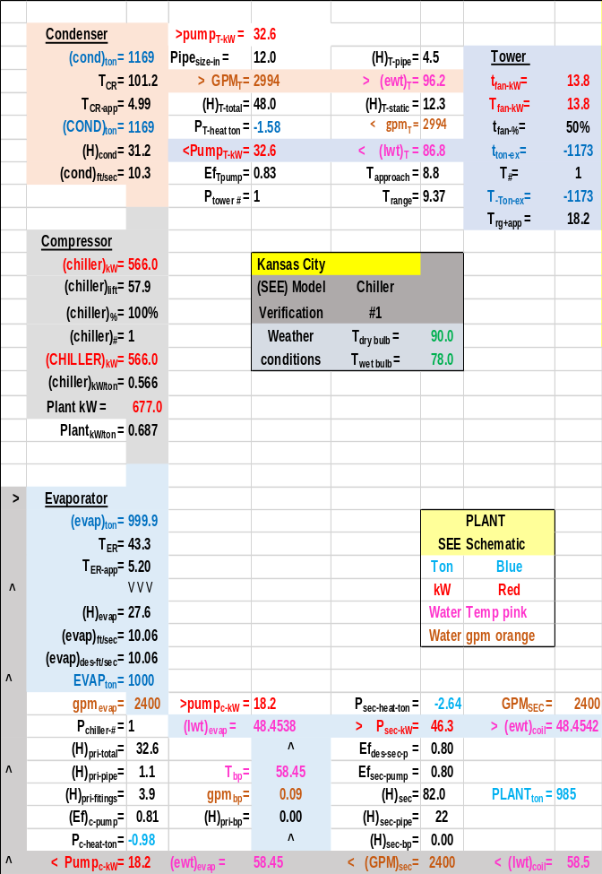Schematic 1-9: Plant at 1000 ton evaporator load, 50% tower fan speed, supply water 48.45F, and chiller kW=566.
The tower kW decreased from 96 to 13.8 kW and therefore the plant kW decreased from 759.2 kW to 677.0 kW but the supply water temperature is 48.45F.
The next step is to increase the chiller kW until the supply water is about 44F with 50% tower fan speed.

Schematic 1-9 copied: Plant at 1000 ton evaporator load, 50% tower fan speed and chiller kW=566 resulting in 48.45F supply water.
The above Schematic 1-9 is copied from above so that a side by side comparison can be made. The only input to the (SEE) Model of Schematic 1-10 is the increase in chiller kW from 566 kW to 618.1 kW, all other changes as shown by Schematic 1-10 occur due to the solution of the equations of the simulation model. Increasing the chiller kW to 618.1 reduced the supply water to 44.00F which was the objective. No changes occurred in the P/S pumping kW. The load on the condenser increased from 1169 ton to 1183 ton due to the increase in chiller kW.
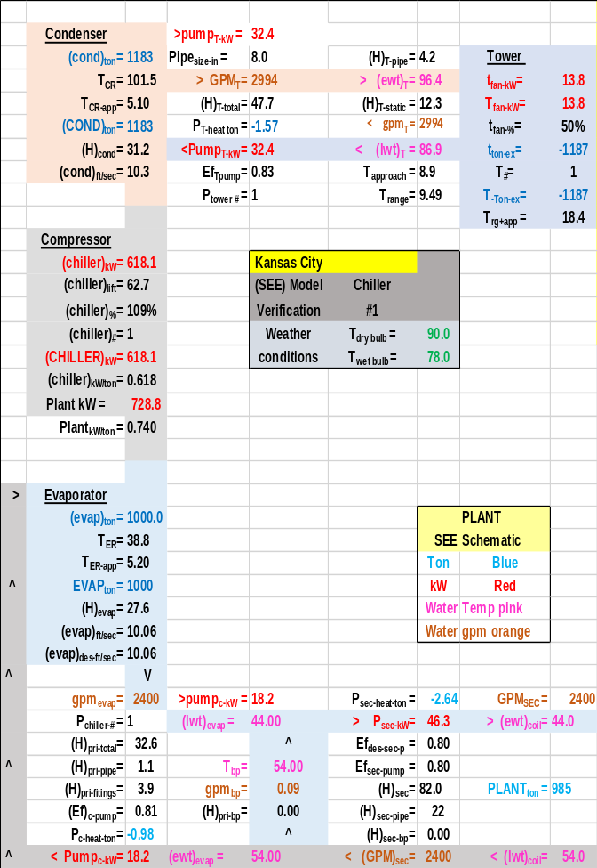Schematic 1-10: Plant at 1000 ton evaporator load, 50% tower fan speed and chiller kW=618.1 resulting in 44.00F supply water.
Greater chiller kW resulted in a slight increase in condenser refrigerant temperature due to the increased condenser load. Plant kW increased from Schematic 1-9 about 51 kW all due to the chiller kW increase.
A primary objective of Schematics 1-4, 1-9, & 1-10 is to show total plant changes but to also make the point that the only (SEE) Model changes made are first to decrease the tower fan speed to 50% and then increase the chiller kW to provide about 44F supply water. All other changes in the plant, as shown by the schematics, is a result of the (SEE) Model equations reaching a new steady state condition where energy in equals energy out.

50% Tower Fan Speed Comparison of (SEE) Model and Schwedler¹data
Figure 1-9 shows the (SEE) Model cooling tower performance, at 50% fan speed, closely duplicates the data provided by Schwedler¹. Dropping both the condenser load and wet bulb provides a rather extreme test for the (SEE) Model of the tower; Figure 1-9 illustrating the ability of the (SEE) Model to model the tower performance at these extreme conditions.
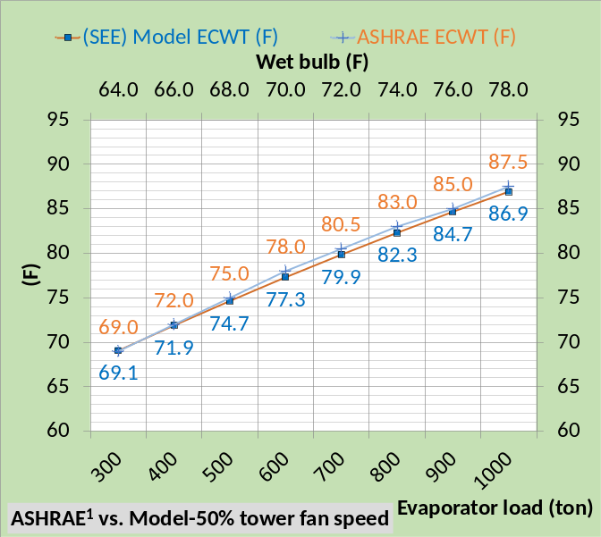Figure 1-9: (SEE) Model & Schwedler¹ ECWT data
Figure 1-10 illustrates close compliance with the Schwedler¹ chiller kW data as the ECWT drops as given by Figure 1-9.
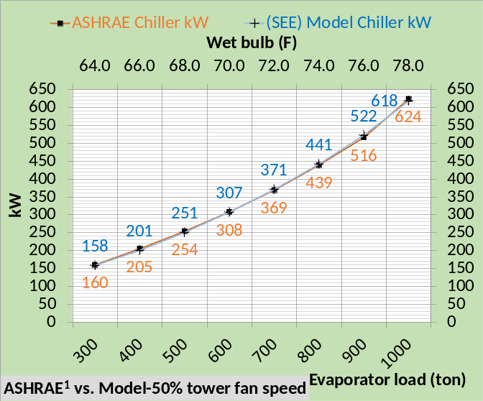Figure 1-10: (SEE) Model & Schwedler¹ kW data
The (SEE) Model chiller kW is within 2% of the manufactures data¹ for all conditions of evaporator load except at 400 ton where the Schwedler¹ value is 205 kW and the model value is 200.6 kW, see Table 1-7 below.
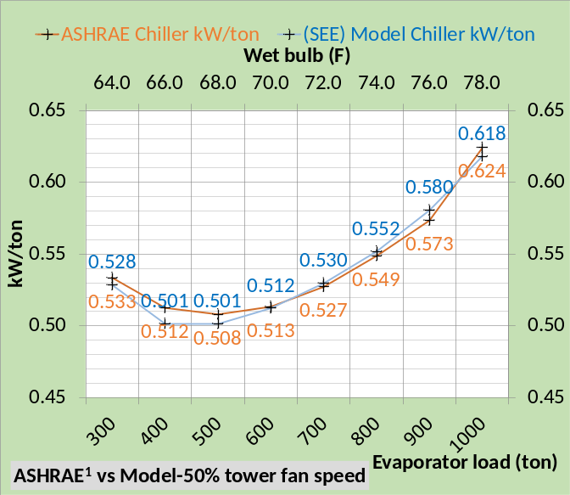Figure 1-11: (SEE) Model & Schwedler¹ chiller kW/ton data
Figure 1-11 shows chiller kW/ton of the (SEE) Model is shown to be within 2% of the manufactures¹ data for all but the condition of 400 ton evaporator load and 66.0F wet bulb where the difference is 2.15%.
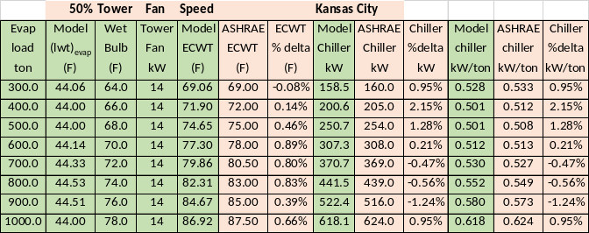Table 1-7: (SEE) Model & Schwedler¹ data at 50% tower fan speed
Table 1-7 presents the data listed and discussed above in tabular form comparing Schwedler¹data with the (SEE) Model result.
Plant performance at 200 ton & 100 ton evaporator load
Plant operation below 30% chiller load is not given by Schwedler¹. The (SEE) Model can show performance down to 10% or 100 ton evaporator load. The (SEE) model became unstable at about 50 ton evaporator load and will not be shown. A real chiller will also surge or become unstable at low loads.
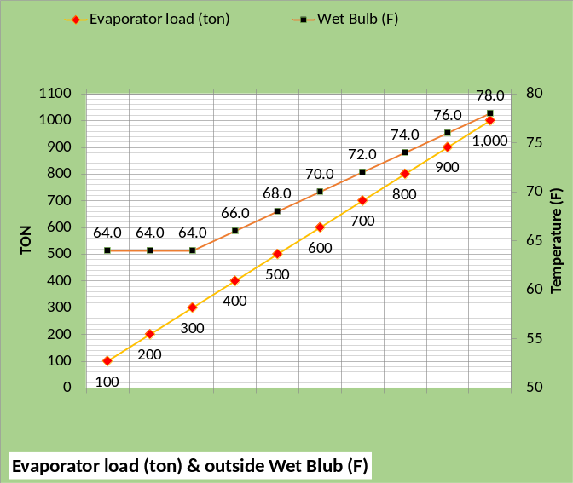Figure 1-12: Evaporator load and wet bulb
Figure 1-12 gives the evaporator load and wet bulb to be modeled. The values down to 300 ton are the same as Schwedler¹.
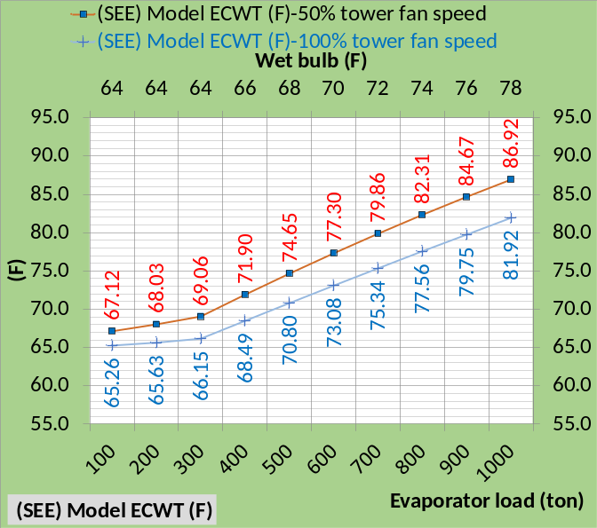Figure 1-13: ECWT (F) at 100% & 50% tower fan speed
Figure 1-13 illustrates the ECWT drops about one degree (F) from 300 ton to 200 ton and 200 ton to 100 ton evaporator load for a constant 64F wet bulb.
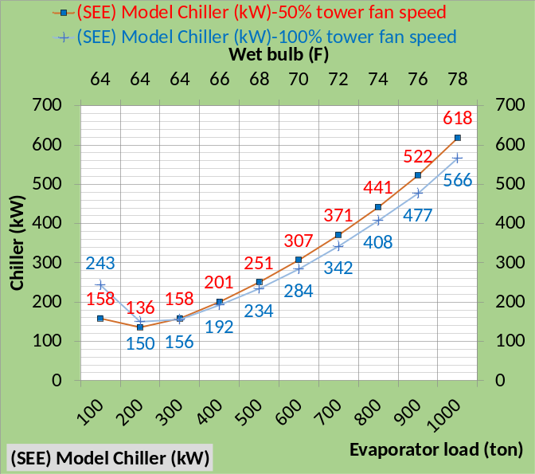Figure 1-14: Chiller kW
Figure 1-14 illustrates that chiller kW is greater with 50% tower fan speed down to 300 ton evaporator load, same as Schwedler¹, but reverses at 200 ton and 100 ton evaporator load where 50% tower fan speed gives less chiller kW demand.
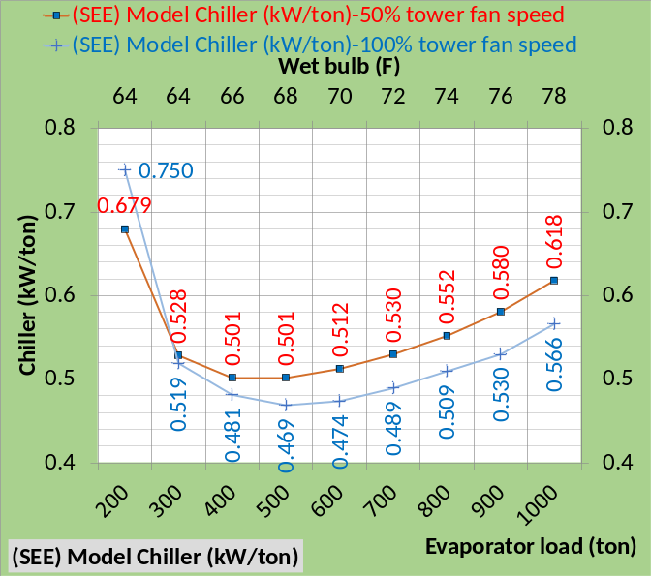Figure 1-15: (SEE) Model Chiller kW/ton
Figure 1-15 gives (SEE) Model chiller kW/evaporator ton illustrating less kW/ton with 100% tower fan speed down to 300-ton evaporator load. At 300 ton load the kW/ton values are turning up and at 200-ton load kW/ton is greater than at design and increasing at a rapid rate.
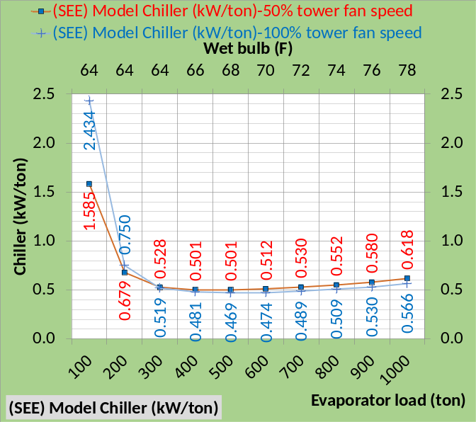Figure 1-16: (SEE) Model (kW/ton)
Figure 1-16 illustrates the (SEE) Model kW/ton values at 100 ton are 3 to 4 times the 1000 ton design values. These (SEE) model values at 200 ton and 100 ton are presented but not verified against manufactures data as have the values from 1000 ton down to 300 ton.
Reference 5, 2012 ASHRAE HANDBOOK, HVAC Systems and Equipment, page 43.10 Figure 11 Temperature Relations in a Typical Centrifugal Liquid Chiller, illustrates data down to about 10% load suggesting that less than 10% load is unstable as is the case with the (SEE) Model.
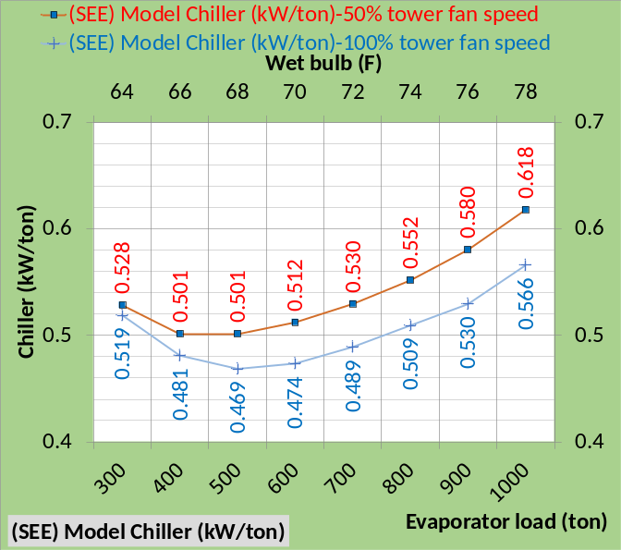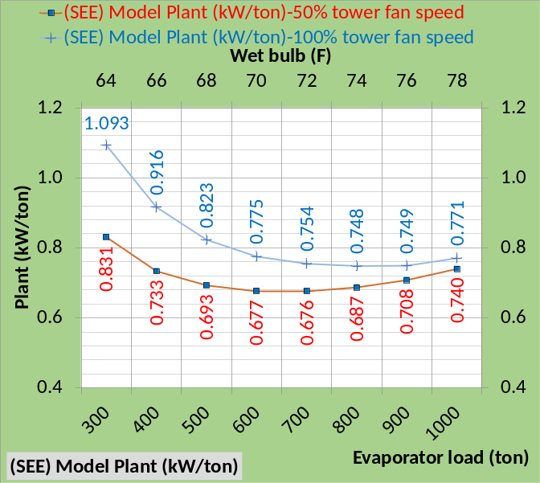Figure 1-17: (SEE) Model kW/ton for chiller & plant
Figure 1-17 makes the point Schwedler¹ is making in the article and given by table 1 of the article. The kW of the chiller plus tower is less when the tower is operated at 50% tower fan speed. Figure 1-17 shows this is also true for the (SEE) model simulation. However the 96 kW tower with 4F approach is not a good design selection to be discussed in a later chapter.
The next eight schematics will present side by side 100% & 50% tower fan speeds comparisons for 1000 ton, 700 ton, 400 ton, and 100 ton evaporator loads.
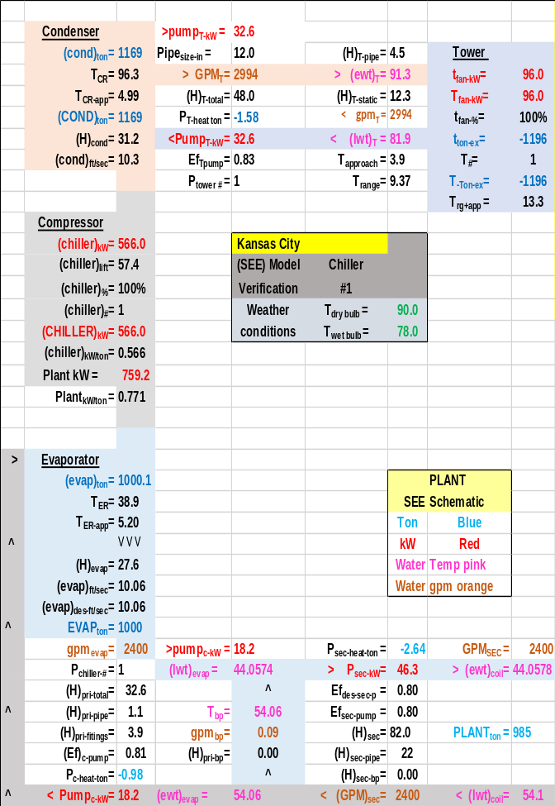Schematic 1-11: Plant at 1000 ton evaporator load, 100% tower fan speed and chiller kW=566.0 resulting in 44.05F supply water.
Schematics 1-11 & 1-12 illustrate the necessary increase in chiller kW required when the tower fan speed is reduced to 50% and also illustrates the reduction in plant kW from 759.2 to 728 kW.

Schematic 1-12: Plant at 1000 ton evaporator load, 50% tower fan speed and chiller kW=618.1 resulting in 44.00F supply water.
The reason the plant kW decreases with 50% tower fan speed is the 96-kW tower that reduces to 13.8 kW at 50% speed for an 82-kW reduction and the chiller kW increases only 30.4 kW. A later chapter dealing with plant design will select a more efficient chiller/tower.
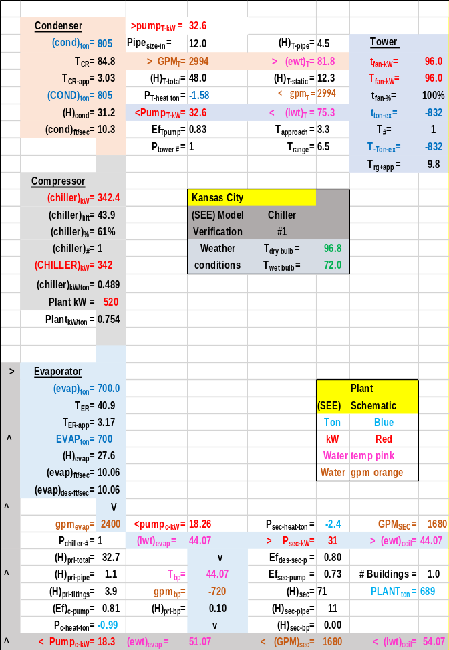 Schematic 1-13: Plant at 700 ton evaporator load, 100% tower fan speed and chiller kW=342.4 resulting in 44.07F supply water.
At 700-ton evaporator load the plant kW is less for the 50% tower fan speed for the same reason as discussed above.

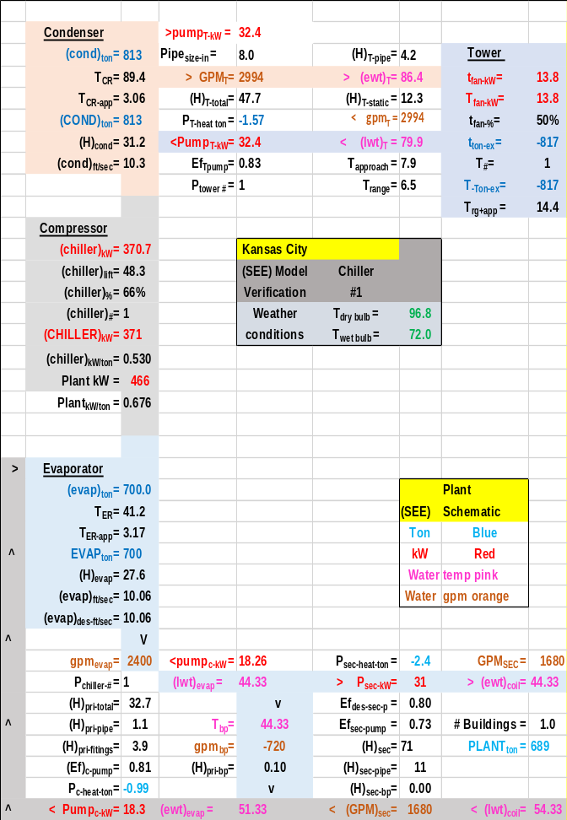Schematic 1-14: Plant at 700 ton evaporator load, 50% tower fan speed and chiller kW=370.7 resulting in 44.33F supply water.

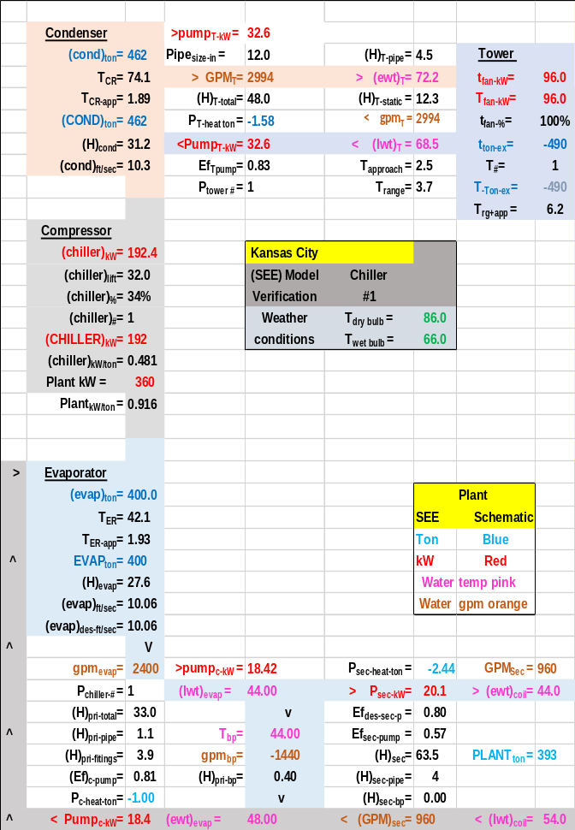Schematic 1-15: Plant at 400-ton evaporator load, 100% tower fan speed and chiller kW=192.4 resulting in 44.00F supply water.
Schwedler¹ table 1 shows a 11-kW increase in chiller kW for 400-ton evaporator load and 50% tower fan speed verses 100% tower fan speed. Schematics 1-15 & 1-16 show a (200.6-192.4=8.2kW) increase in chiller kW also show by above Tables 1-4 & 1-7. At these conditions chiller kW increases little while tower kW significantly decreases at 50% tower fan speed, resulting in a (360-287=73kW) decrease in plant kW.

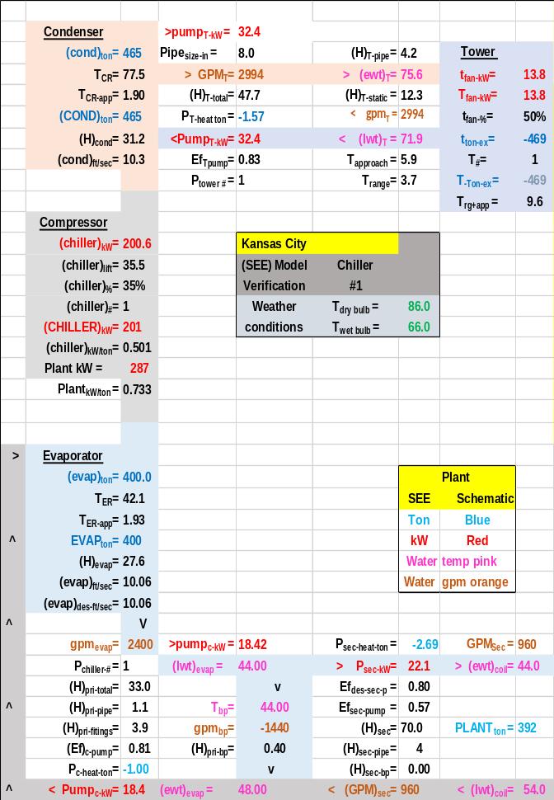Schematic 1-16: Plant at 400-ton evaporator load, 50% tower fan speed and chiller kW=200.6 resulting in 44.00F supply water.

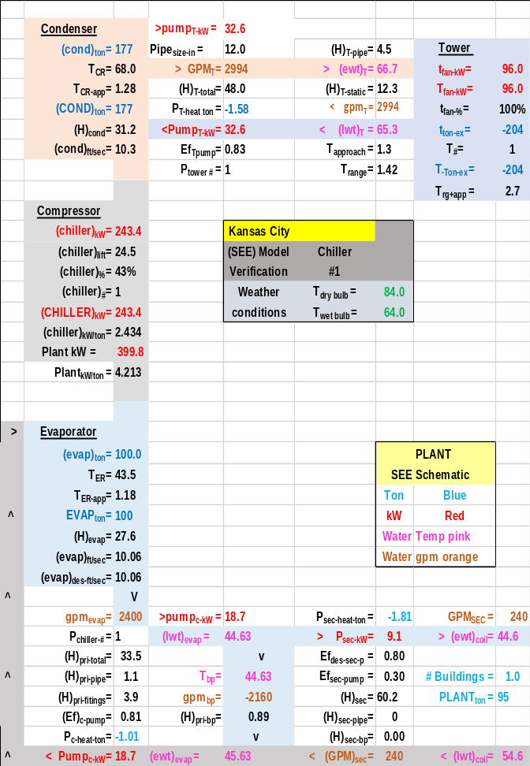Schematic 1-17: Plant at 100 ton evaporator load, 100% tower fan speed and chiller kW=243.4 resulting in 44.63F supply water.
The author is not aware of any data dealing with plant conditions similar to Schematics 1-17 & 1-18. The author welcomes discussion and input from all including chiller & tower manufactures.

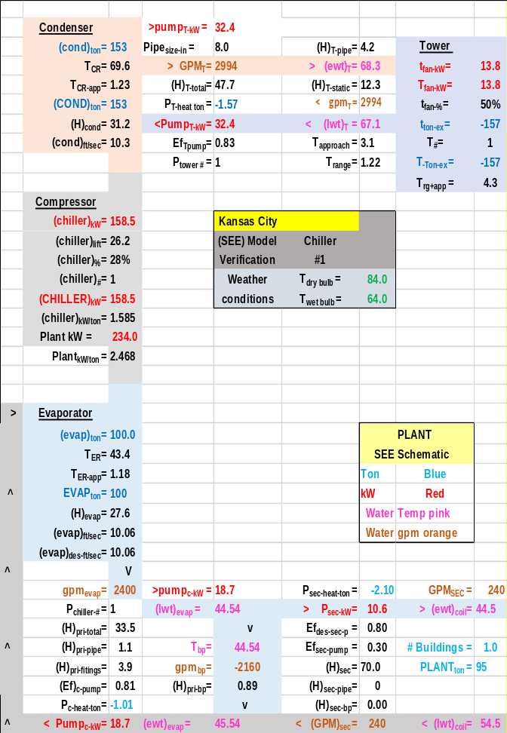Schematic 1-18: Plant at 100 ton evaporator load, 50% tower fan speed and chiller kW=158.5 resulting in 44.54F supply water.
This completes the analysis of the Kansas City data presented by Schwedler¹ verses the (SEE) Plant Model. The following will look at some details of the (SEE) Plant Model that duplicates the Schwedler¹ chiller/tower data for Kansas City.

(SEE) Model Plant Performance at 100% & 50% Tower fan speed
The above has shown that the (SEE) Plant Model duplicates the Schwedler chiller/tower data. The following will give additional plant performance data which Schwedler¹ did not provide.
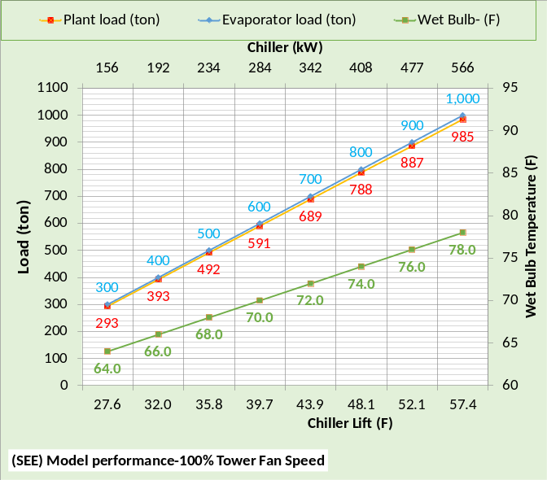 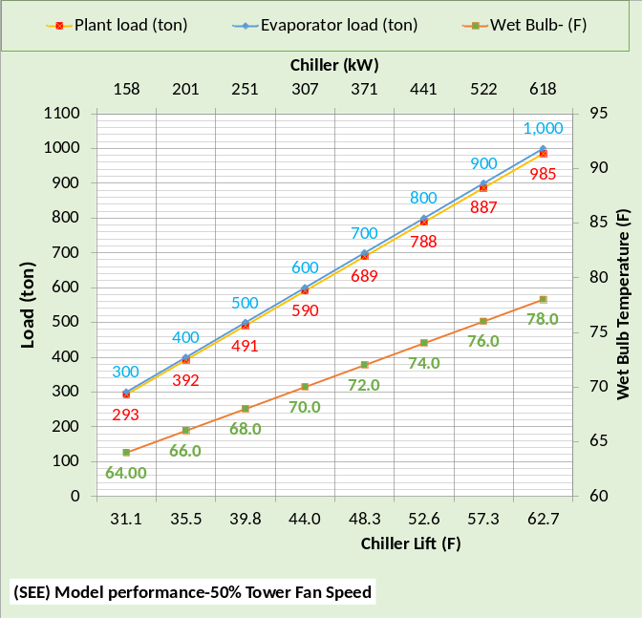Figure 1-18: Kansas City (SEE) Plant performance
Figure 1-18 gives the increase in chiller lift and chiller kW demand for 50% tower fan speed verses 100%. Also shown is the plant load that is less than the evaporator load because the P/S pumping adds load to the evaporator.
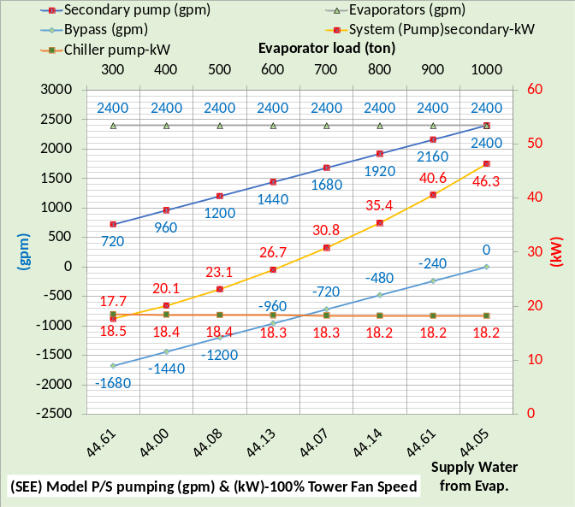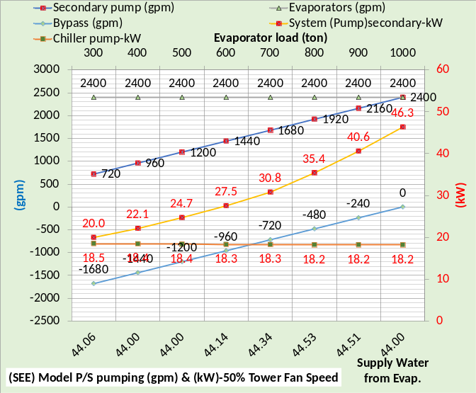Figure 1-19: Primary/Secondary pumping
Figure 1-19 illustrates that the tower fan speed does not affect the P/S pumping.
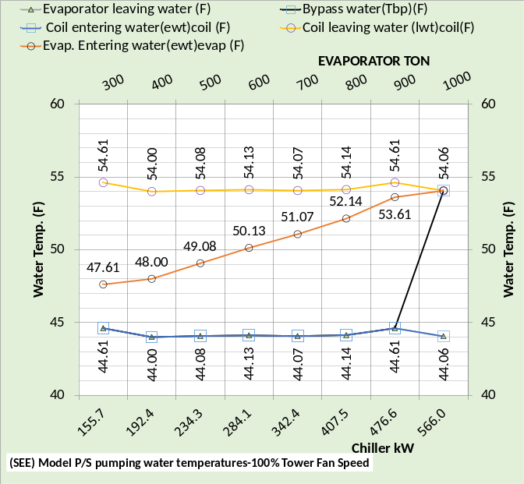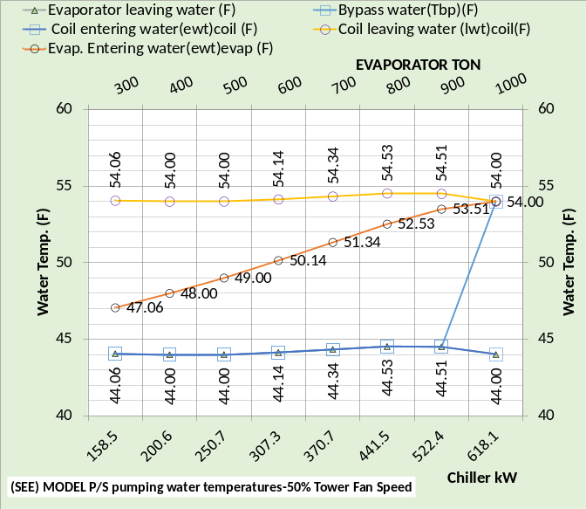Figure 1-20: P/S water temperatures
Figure 1-20 illustrates that the tower fan speed does not affect the P/S water temperatures. The slight difference in temperatures is due to the slight difference in water leaving the evaporator which is a function of chiller kW that is not exactly the same for both tower fan speeds.
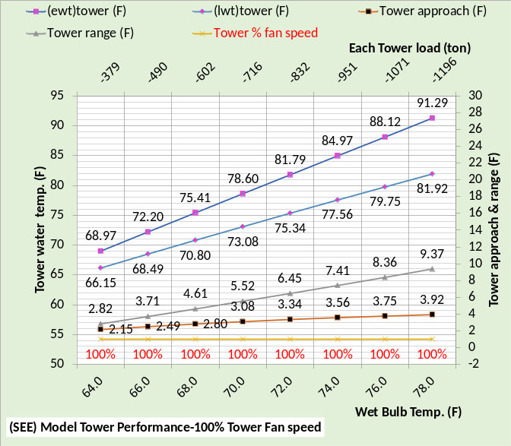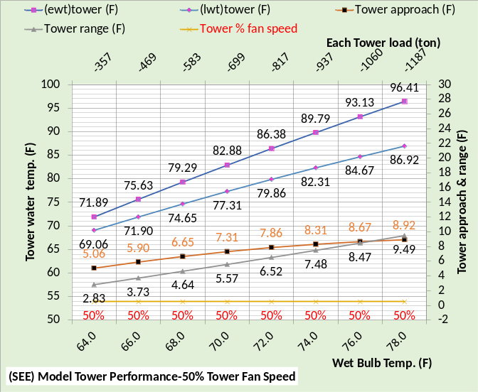Figure 1-21: Tower performance
Figure 1-21 illustrates a significant drop in tower performance with 50% tower fan speed. Tower range changes little but tower approach significantly increases with 50% tower fan speed, resulting in an increase in chiller lift as shown by Figure 1-18 and therefore an increase in chiller kW to provide 44F supply water as show by Figure 1-22.
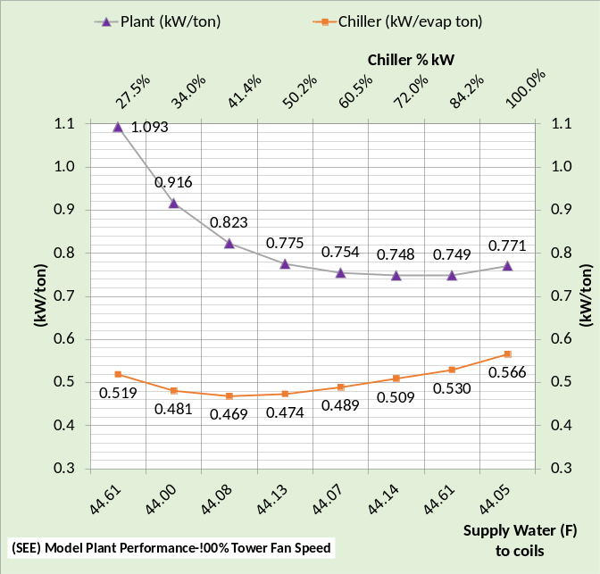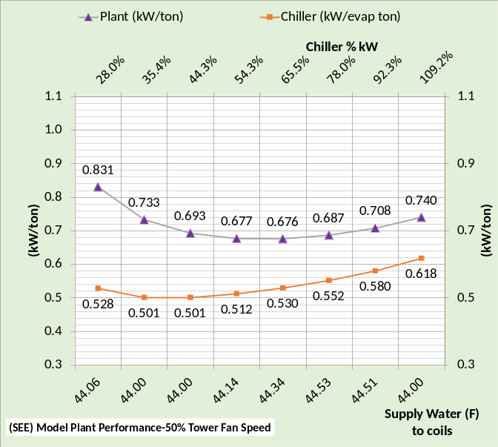Figure 1-22: (SEE) Model plant performance
Figure 1-22 gives the increase in chiller kW/ton with 50% tower fan speed and also shows the plant kW/ton decrease with 50% tower fan speed. As previously discussed the plant kW/ton decreases with 50% tower fan speed because the chiller kW increase is less than the tower fan decrease.
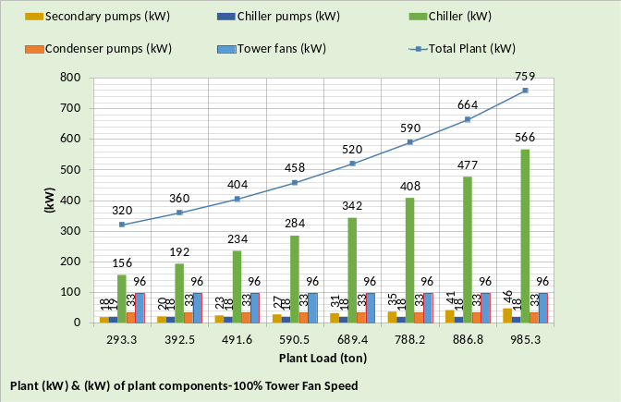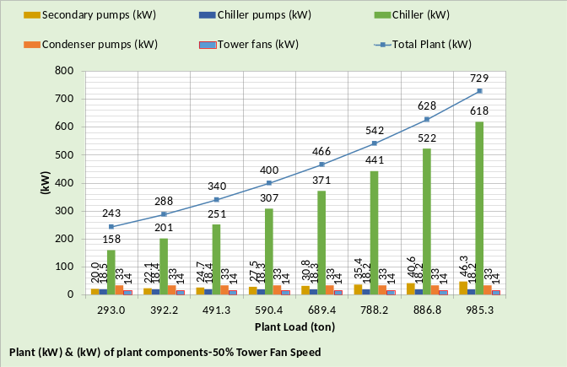Figure 1-23: Plant kW
Figure 1-23 gives the kW demand of the plant components illustrating the dominance of the chiller kW. The plant kW is less at 50% tower fan speed for all conditions.
ENERGY IN = ENERGY OUT
Energy in = energy out is a fundamental requirement of a System Energy Equilibrium (SEE) Model. The following figures illustrate compliance with this basic thermodynamic requirement.
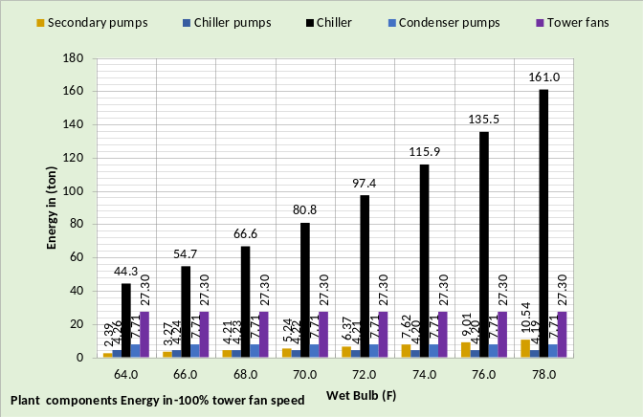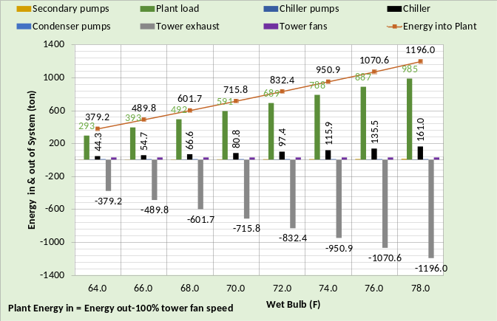Figure 1-24: Energy in = Energy out-100% tower fan speed
The top chart of Figure 1-24 gives the pumps and tower fan energy in (ton) which is also on the bottom chart but difficult to read. The plant load is the big energy in component and the tower exhaust is the total energy out.
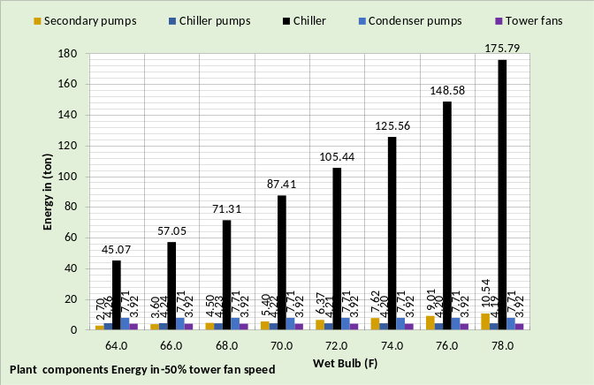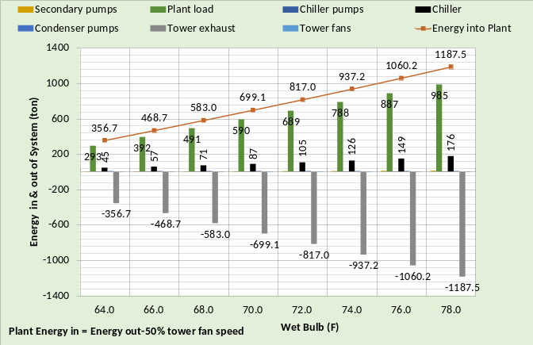Figure 1-25: Energy in = Energy out-50% tower fan speed
Figure 1-25 gives energy in = energy out for 50% tower fan speed illustrating the smaller values for 50% fan speed.
Chiller Lift (F)
Chiller lift is the difference in the refrigerant temperatures of the condenser minus the evaporator refrigerant temperature⁷. The evaporator refrigerant temperature is largely set by the evaporator water supply temperature and therefore varies little compared to the condenser refrigerant temperature. Figure 1-21, Tower Performance, illustrates how the tower entering water temperature varies with load and wet bulb temperature. Tower entering water temperature is also the condenser leaving water temperature which in large part sets the condenser refrigerant temperature.
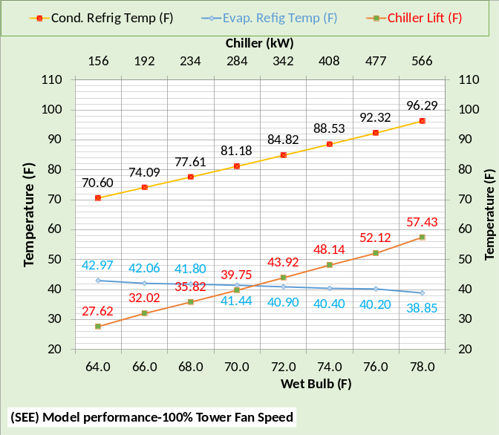 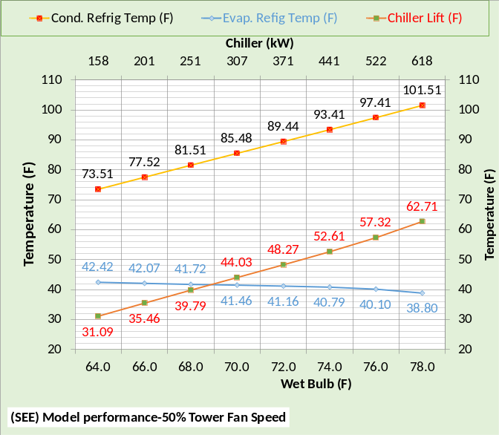Figure 1-26: Chiller Lift (F)
Figure 1-26 gives the refrigerant temperatures and chiller lift for both 100% & 50% tower fan speed. Tower fan speed of 50% versus 100% increases the tower entering water temperature and therefore the condenser refrigerant temperature resulting in increased chiller kW as shown by Figure 1-23.

Chapter 1 is an attempt by the author to give the reader confidence in the Kansas City (SEE) Plant Model. The author is open to questions and additional data and clarifications as may be requested by readers. Similar analysis and verification for Schwedler’s Long Beach & Salt Lake City data is given by chapters 2 & 3.
The next Chapter 2 will show that the (SEE) plant model duplicates the table 3¹ data presented by Schwedler¹ for Long Beach, with design wet bulb of 71F and a 9F approach tower. The only changes to the (SEE) model will be to input the wet bulb conditions, select a new tower² and adjust the chiller kW to provide 44F supply water. No change is necessary or will be made to the set of simultaneous equations that simulate the chiller/tower performance.
CHAPTER 2: Long Beach Model verification against Schwedler¹ Data at 100% & 50% tower fan speed.
Model verification
Table 2-1 illustrates the data given by Schwedler¹ for a Long Beach plant at 100% tower fan speed. The table illustrates that the evaporator load is decreased from 1,000 ton down to 300 ton as the wet bulb decreases from 71F down to 61.1F. Table 2-1 shows that the cold water from the tower decreases from 80F down to 65F as the wet bulb and evaporator load decrease. The chiller kW demand drops from 544 kW down to 146 kW. Comparing Table 1-1 & Table 2-1 illustrates the challenge for a chiller/tower plant model; the same (SEE) Model must duplicate both cities with no change in the basic equations.
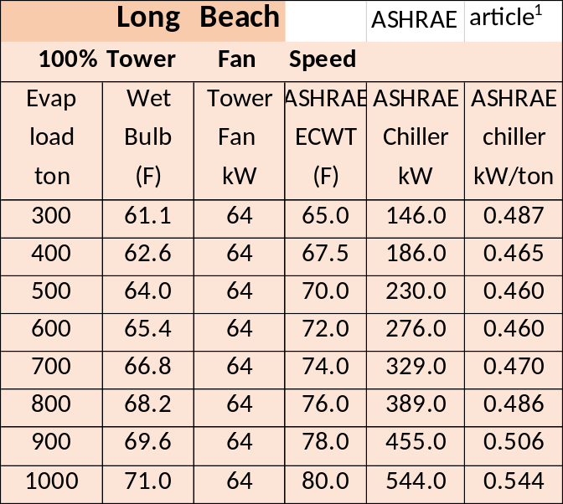Table 2-1: Data from Schwedler¹
This Chapter 2 will demonstrate the (SEE) Models ability to duplicate the Schwedler¹data with tower fan speeds of 100% and 50%. Only two changes are made to the model going from 100% tower fan speed to 50% fan speed; the tower fan speed is reduced to 50% and the chiller kW power is increased to provide 44F supply water; the same procedure as would occur in a real system and that is the point of a (SEE) Model, duplication of the real system performance.
Chiller & Tower data
Table 2-2 gives the chiller data and Table 2-3 gives the tower data for Long Beach.
Design Tons | 1000.0
Chiller kW | 544.0
Chiller kW/ton | .544
Evap water flow rate (gpm) | 2400.0
Evap entering water temp (F) | 54.0
Evap leaving water temp (F) | 44.0
Evap refrigerant temp (F) | 38.8
Evap refrigerant approach (F) | 5.2
Evap pressure drop (ft. water) | 27.6
Evap water velocity (ft. /sec.) | 10.06
Cond heat rejection (ton) | 1172
Cond water flow rate (gpm) | 3000.0
Cond entering water temp (F) | 80.0
Cond leaving water temp (F) | 89.26
Cond refrigerant temp (F) | 94.1
Cond refrigerant approach (F) | 4.9
Cond pressure drop (ft. water) | 31.2
Cond water velocity (ft. /sec) | 10.28
Table 2-2: Long Beach Chiller data¹⁹
Tower for (SEE) model | Low cost tower¹
Design Wet bulb | 71.0F
Design Load | 1155 ton
Tower water flow | 3000 gpm
Approach temperature | 9.0 F
Calculated range | 9.26F
Range + approach | 18.26F
Three cells with 40HP fans¹ | 64 kW¹
Selected Tower² | NC8403TAS2
Cold water | 80F
Return water to tower | 89.26F
Capacity | 105.9%
ASHRAE 90.1 performance | 44.8 gpm/HP
Static lift | 12.234 ft.
Table 2-3: Tower selected
Table 2-3 gives the performance data of the tower selected² based on Schwedler¹. The data of Tables 2-2 & 2-3 will be input to the (SEE) Model.
(SEE) Model Plant at Peak Conditions
Schematic 2-1 illustrates the primary/secondary (P/S) pumping system not defined by Schwedler¹ but necessary for the plant (SEE) Model. The load from the building to the plant is 985 ton increasing to 1000 ton, as given by Schwedler¹, at the evaporator as a result of heat added to the system by the P/S pumping. The kW of the pumps is (46.3+18.2=64.5 kW) that adds (64.5/3.513=18.4 ton) load. Pump heat not going into the system but to the atmosphere is modeled as (2.64+.98=3.62 ton) for a total of (18.4-3.62=14.8 ton added to the plant load of 985 ton giving (985+14.8=1000 ton) to the evaporator as shown by Schematic 2-1.
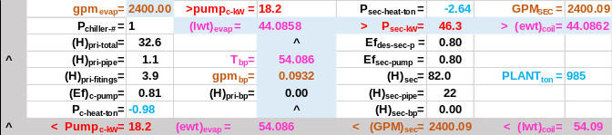Schematic 2-1: Primary/Secondary Pumping
Schematic 2-1 also illustrates that the flow in the bypass is .0932 (gpm) resulting in a temperature of water in the bypass of 54.086F with little effect on the supply water temperature, 44.0858F off the evaporator and 44.0862F to the building. Also note that the gpm off the evaporator is 2400.00 and the gpm to the coils is 2400.09 due to the wrong flow direction in the bypass pipe. A slight decrease in evaporator load will reverse the direction of flow in the bypass.
Schematic 2-2 illustrates the condenser, compressor, and evaporator at 1,000 ton evaporator load.
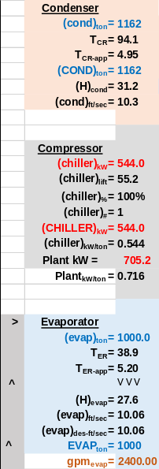 Schematic 2-2: Condenser, Compressor, and Evaporator at design conditions.
The compressor motor demand is 544 kW to move the refrigerant from the evaporator to the condenser. The condenser load is (1000 ton + 544kW/3.513 =1,155 ton). Schematic 2-2 shows the condenser load as 1,162 ton due to the addition of the 8 ton tower pump heat to the system.
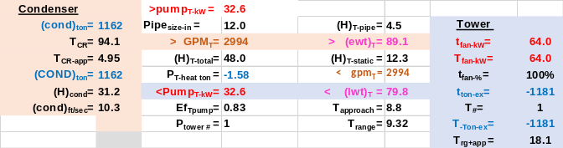Schematic 2-3: Condenser & Tower.
Schematic 2-3 illustrates the condenser and tower plus pumping, not defined by Schwedler¹, at peak load of 1000 ton on the evaporator. Pumping heat added to the condenser is (32.6kW/3.512=9.28ton-1.58ton=7.70 ton rounded to 8 ton) as stated above. The tower exhausts the condenser load plus the tower fan heat for a total of -1181 ton exhausted from the system. The load from the building was 985 ton as shown by Schematic 2-1 and the plant added (1181-985=196 ton) to the system to be exhausted by the tower. Clearly the more the plant adds to the building load the greater the size of the required tower, condenser, and evaporator, also increasing the cost of the plant and probably decreasing plant efficiency. A later chapter will address plant design and make this point more clear.
Plant Schematic
Schematic 2-4 illustrates the full plant combining Schematics 2-1, 2-2, & 2-3. The energy into the system is 985ton + 705.2kW/3.513=1185.7 ton minus the pump heat to atmosphere of (-2.64-.98-1.58=-5.2 ton) for a total of (1185.7-5.2=1180.5 ton rounded to 1181 ton) in and out as exhausted by the tower. The laws of thermodynamics state that the energy into a system is equal to the energy out of the system. Therefore the same must be true for a system model if the system model is to be judged as a true model of the system.
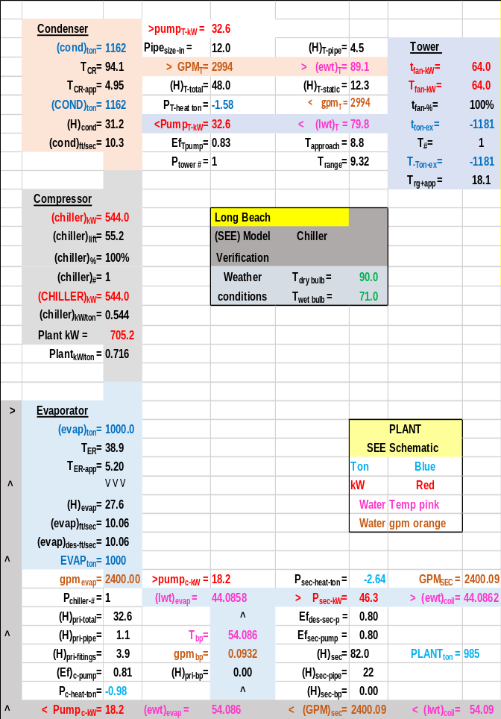Schematic 2-4: Plant at 1000 ton evaporator load & 100% tower fan speed & 544 kW chiller demand-matching Schwedler¹ data table 3.
Schematic 2-4 is consistent with the data provided by Schwedler¹, 544 kW chiller demand and 79.8F entering condenser water (ECWT) temperature. Schwedler¹ defined the base chiller as ARI 550 (.600 kW/ton) and Schematic 1 above determined the condenser and evaporator refrigerant approach temperatures required by the (SEE) Model to provide 44F supply water. The chiller manufacture data provided condenser & evaporator approach temperatures plus other data that is addressed in Chapter 5. An evaporator design value of 5.20F refrigerant approach and 4.95F for the condenser results in 44.08F supply water as given on Schematic 2-4. Installing different condenser & evaporator refrigerant approach temperatures into the (SEE) model results in a different chiller kW and/or different supply water temperature as will be demonstrated here. Based on data given by Schwedler¹ and Chapter 5 the sum of the refrigerant approach temperatures must be about 10.2F. Schematics 1-5 & 1-6 above in Chapter 1 illustrated this effect of condenser and evaporator refrigerant approach temperatures and Chapter 5 will provide details.

Verification of (SEE) model at part load
Schematic 2-4 defines the (SEE) Model Long Beach plant at peak design conditions; the question is can the (SEE) model duplicate the off peak values of Schwedler¹? Figure 2-1 illustrates the data given by Schwedler¹ for the performance of the chiller and cooling tower as the evaporator load and wet bulb decrease with 100% tower fan speed.
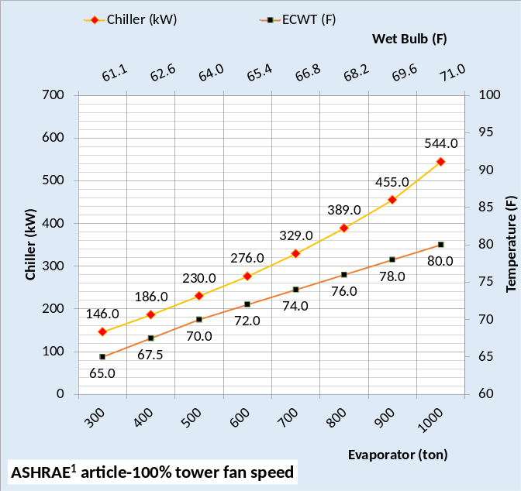Figure 2-1: Long Beach data from Schwedler¹
Figure 2-1 at 100% tower fan speed demonstrates the challenge for the (SEE) plant model and even more demanding is the requirement that the model must duplicate the plant performance when the tower fan speed is reduced to 50%, discussed below. The good news is that the real plant follows the laws of thermodynamics and if the (SEE) Model does the same then a model that duplicates the performance of the real system is possible as will be demonstrated here.
Tower selection
Schwedler¹ defines the cooling tower as a low cost tower with 64 kW fan demand. The tower for this (SEE) model was defined with a manufacture’s selection program². Table 2-3 above gives the details of the selected tower that closely matches the Schwedler¹ data.
Tower simulation model results
The tower data of Table 2-3 is input to the model and is shown to closely duplicate the data given by Schwedler¹ as shown by Figure 2-2.
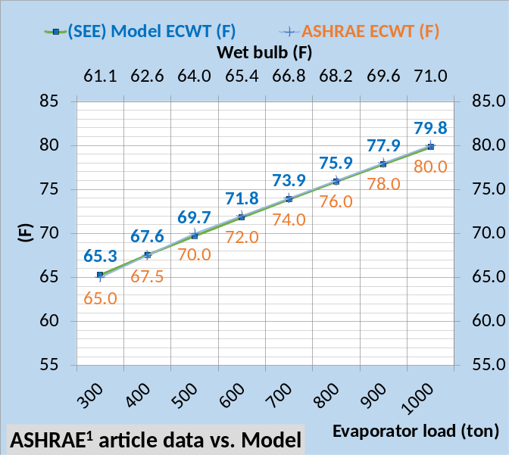Figure 2-2: (SEE) model vs Schwedler¹ tower ECWT-100% tower fan speed-Long Beach
At 100% tower fan speed Figure 2-2 illustrates that the (SEE) Model of the tower, from 1000 ton evaporator load down to 300 ton as the wet bulb drops from 71F down to 61.1F, closely follows the data provided by Schwedler¹.
Chiller performance
As the wet bulb and evaporator load decrease the chiller kW required to maintain 44F supply water decreases from 544 kW down to 146 kW as show by Figure 2-1¹. The (SEE) Model closely duplicates this Schwedler¹ data as shown by Figure 2-3.
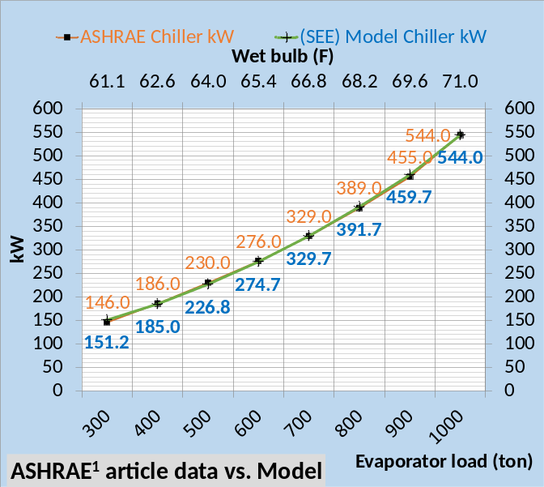Figure 2-3: (SEE) model vs. Schwedler¹ Chiller kW
Figure 2-3 illustrates the (SEE) model duplicates the manufactures data to within 2% for all values of evaporator load and wet bulb except at 300 ton load and 61.1F wet bulb. The (SEE) model value is 151.2 kW and the Schwedler¹ data is 146 kW giving a 3.5% deviation as shown by Table 2-4.
Figure 2-4 provides a comparison of the (SEE) Model chiller kW per evaporator ton verses the manufactures data¹.
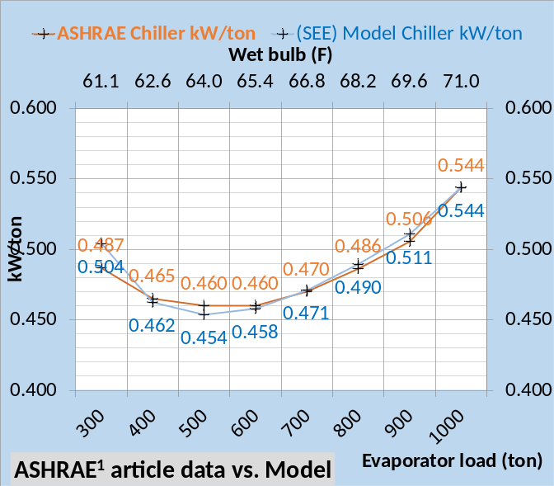Figure 2-4: (SEE) model vs. Schwedler¹ Chiller kW/ton
Figure 2-4, 100% tower fan speed illustrates close agreement to the manufactures data¹. The manufactures data is given for the chiller and tower and does not include the chiller plant in total; pumping is not given and that has an effect on the plant performance as will be shown below.
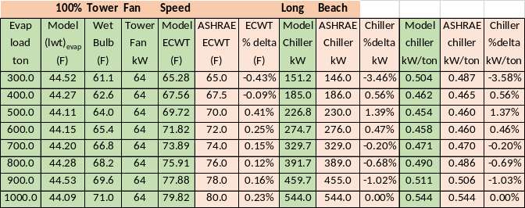Table 2-4: Model Results & Schwedler¹ data.
Table 2-4 provides tabular comparison of the Schwedler¹data and the (SEE) Model results illustrating close agreement for the tower model and chiller kW. The authors modeling experience judges this less than 2% deviation from manufactures data except at 300 ton load as acceptable i.e. a good model.

Model Verification at 50% Tower Fan Speed- Long Beach
Tower Fan Speed Reduced to 50%
Reducing the tower fan speed from 100% to 50% results in significant changes in the performance of the plant and therefore a significant challenge for the (SEE) Model.
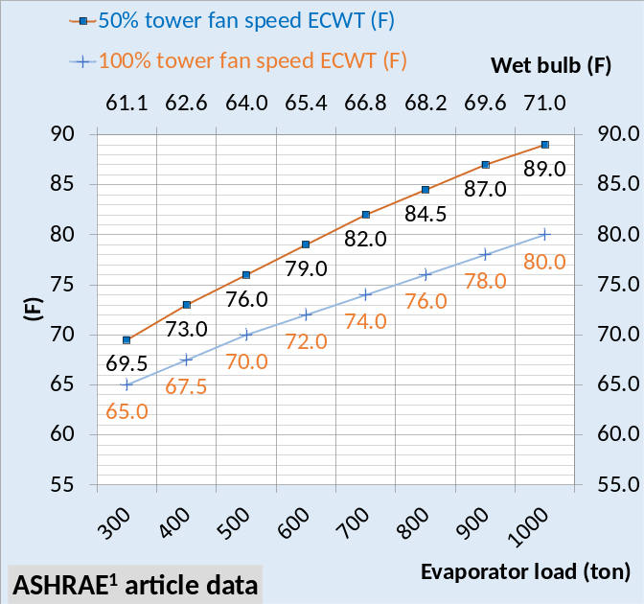Figure 2-5: ECWT-100% & 50% tower fan speed
Figure 2-5 illustrates the change in entering condenser water temperature (ECWT) as given by Schwedler¹ for 50% & 100% tower fan speed. ECWT increased 9F at design conditions and 4.5F at 300 ton evaporator load and 61.1F wet bulb. The increase in tower water temperature and therefore entering condenser water temperature results in an increase in required chiller kW to produce 44F supply water.
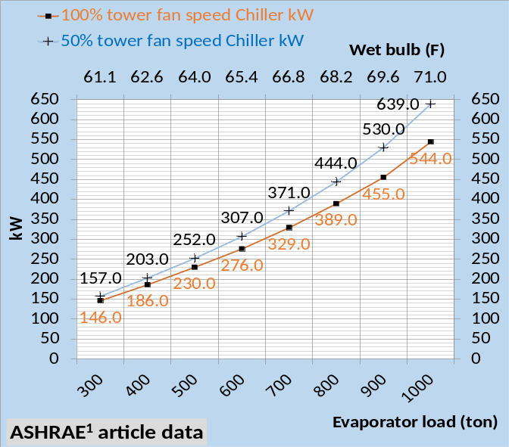Figure 2-6: Chiller kW-100% & 50% fan speed
Figure 2-6 gives the chiller kW at 100% and 50% tower fan speed as given by Schwedler¹ and Figure 2-7 gives chiller kW/ton as given by Schwedler¹ for 100% and 50% tower fan speed. Clearly reducing the tower fan speed to 50% has a significant effect on chiller kW and therefore kW/ton.
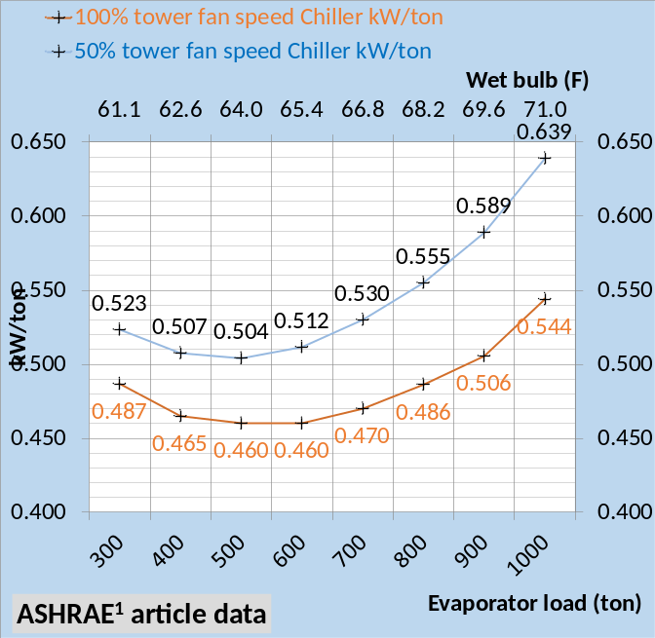Figure 2-7: Chiller kW/ton-100% & 50% tower fan speed
Figures 2-5, 2-6 & 2-7 illustrate the challenge for the (SEE) Model going from 100% tower fan speed to 50% tower fan speed. Only two changes will be made to the (SEE) Model, first change the tower speed to 50% then increase the chiller kW until 44F supply water is obtained. To illustrate the following Schematics will first show the changes in the plant when the tower fan speed is reduced to 50%, then schematics will show the change when the chiller kW is increased to provide 44F supply water.
Schematic 2-4 copied: Plant at 1000-ton evaporator load, 100% tower fan speed, supply water 44.08F, and chiller kW=544.
The above Schematic 2-4 is copied from above and shows the plant at peak design conditions. Schematic 2-9 illustrates the plant when the only change is the fan speed that has been change from 100% to 50%. No changes occur in the P/S pumping. Supply water increased from 44.08F to 51.67F and the evaporator refrigerant temperature increased from T_{ER} = 38.9F to 46.5F a 7.6F increase. The water leaving the tower and entering the condenser increased from 79.8F to 88.3F an 8.5F increase. This raised the condenser refrigerant temperature (T_{CR} ) from 94.1F to 102.5F an 8.4F increase all shown by comparing Schematics 2-4 & 2-9.

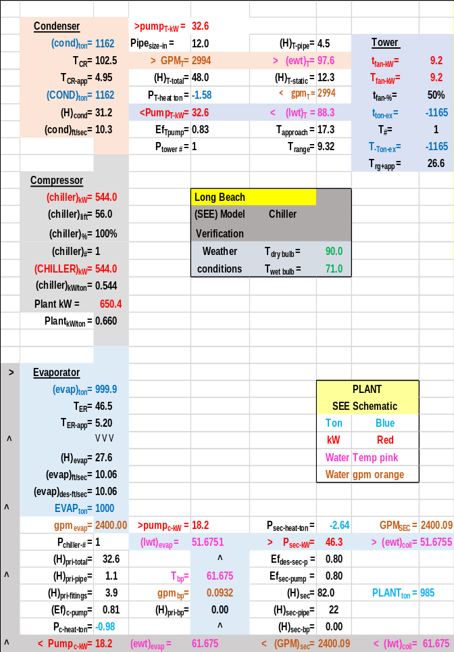Schematic 2-9: Plant at 1000 ton evaporator load, 50% tower fan speed, supply water 51.67F, and chiller kW=544.
The tower kW decreased from 64 to 9.2 kW and therefore the plant kW decreased from 705.2 kW to 650.4 kW.
The next step is to increase the chiller kW until the supply water is about 44F with 50% tower fan speed.
Schematic 2-9 copied: Plant at 1000 ton evaporator load, 50% tower fan speed and chiller kW=544 resulting in 51.67F supply water.
The above Schematic 2-9 is copied from above so that a side by side comparison can be made. The only input to the (SEE) Model of Schematic 2-10 is the increase in chiller kW from 544 kW to 633.8 kW, all other changes as shown by Schematic 2-10 occur due to the solution of the equations of the simulation model. Increasing the chiller kW to 633.8 reduced the supply water to 44.12F which was the objective. No changes occurred in the P/S pumping kW. The load on the condenser increased from 1162 ton to 1188 ton due to the increase in chiller kW.
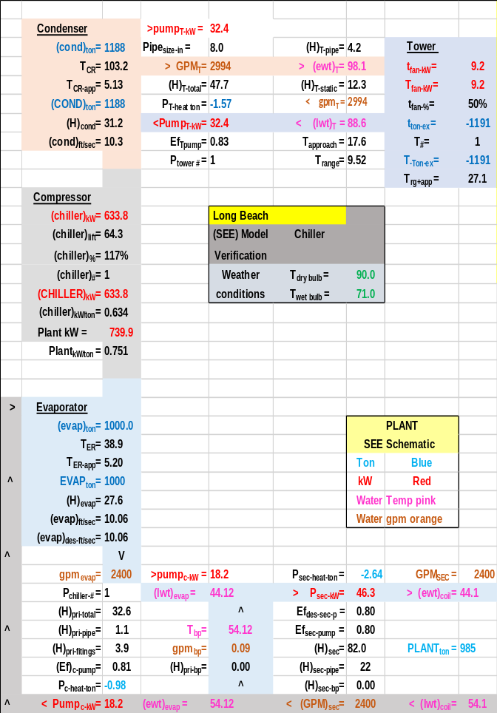Schematic 2-10: Plant at 1000 ton evaporator load, 50% tower fan speed and chiller kW=633.8 resulting in 44.12F supply water.
Greater chiller kW resulted in a slight increase in condenser refrigerant temperature due to the increased condenser load. Plant kW increased from Schematic 2-9 to Schematic 2-10 about 89.5 kW all due to the chiller kW increase except (32.6 kW- 32.4 kW = .2 kW) difference in the tower pump kW. Note that Schematic 2-9 shows a 12 inch tower pipe and Schematic 2-10 shows an 8 inch tower pipe that accounts for the difference in pump kW. An error in design input that is not significant to the answer but very significant in pointing out the detail of the (SEE) Model.
A primary objective of Schematics 2-4, 2-9, & 2-10 is to show total plant changes but to also make the point that the only changes made in the (SEE) Model are first to decrease the tower fan speed to 50% and then increase the chiller kW to provide about 44F supply water. All other changes in the plant, as shown by the schematics, is a result of the (SEE) Model equations reaching a new steady state condition where energy in equals energy out.
50% Tower Fan Speed Comparison of (SEE) Model and Schwedler¹data for Long Beach
Figure 2-8 shows the (SEE) Model cooling tower performance, at 50% fan speed, closely duplicates the data provided by Schwedler¹, table 3 for Long Beach. Dropping both the condenser load and wet bulb provides a rather extreme test for the (SEE) Model of the tower; Figure 2-8 illustrating the ability of the (SEE) Model to model the tower performance at these extreme conditions.
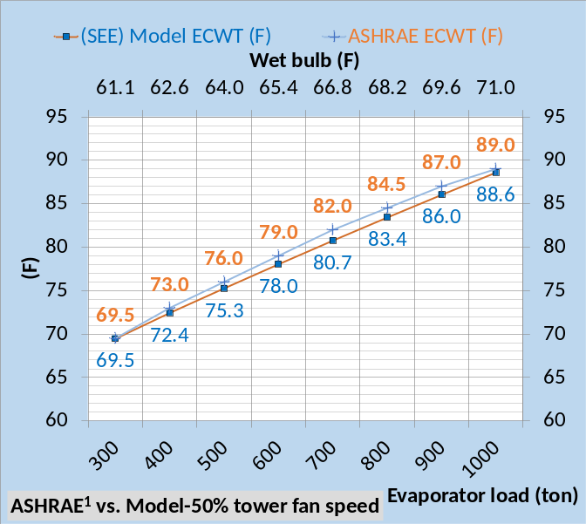Figure 2-8: (SEE) Model & Schwedler¹ ECWT data
Figure 2-9 illustrates close compliance with the Long Beach Schwedler¹ chiller kW data as the ECWT drops as given by Figure 2-8.
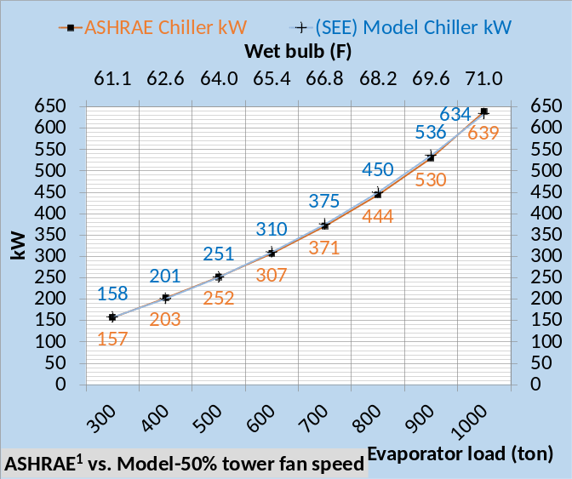Figure 2-9: (SEE) Model & Schwedler¹ kW data
The (SEE) Model chiller kW is within 2% of the manufactures data¹ for all conditions of evaporator load, see Table 2-5 below.
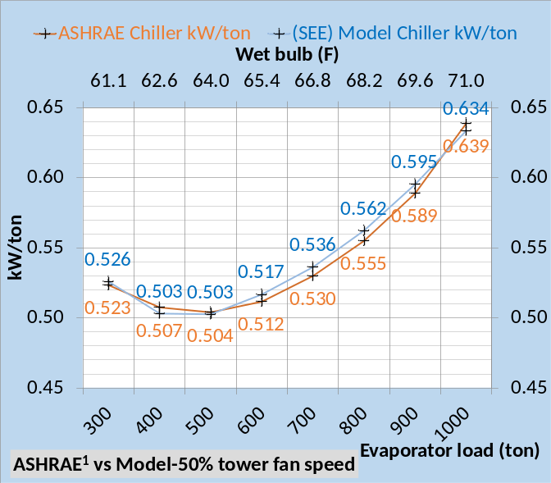Figure 2-10: (SEE) Model & Schwedler¹ chiller kW/ton data
Figure 2-10 shows chiller kW/ton of the (SEE) Model is within 2% of the manufactures¹ data for all conditions as shown by Table 2-5.
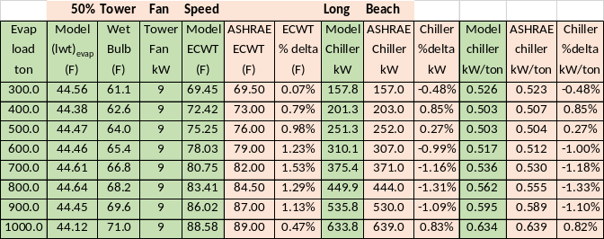Table 2-5: (SEE) Model & Schwedler¹ data at 50% tower fan speed-Long Beach
Table 2-5 presents the data listed and discussed above in tabular form comparing Schwedler¹data with the (SEE) Model result demonstrating the ability of the (SEE) Model to go from 100% tower fan speed to 50% tower fan speed and maintain compliance with Schwedler¹ data.
Plant performance at 200 ton & 100 ton evaporator load
Plant operation below 30% chiller load is not given by Schwedler¹. The (SEE) Model can show performance down to 10%- or 100-ton evaporator load. The (SEE) model became unstable at about 50 ton evaporator load and will not be shown. A real chiller will also surge or become unstable at low loads.
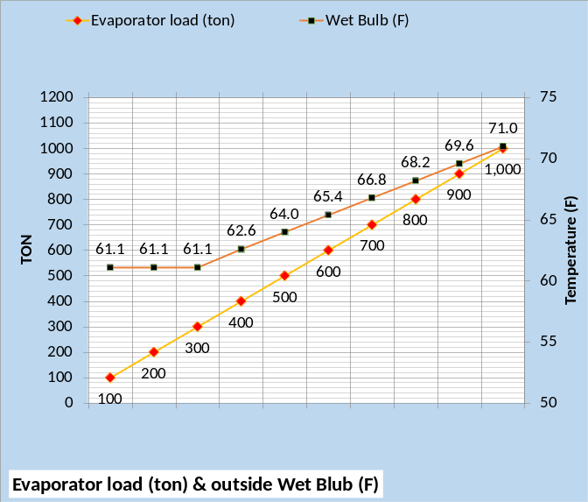Figure 2-11: Evaporator load and wet bulb
Figure 2-11 gives the evaporator load and wet bulb to be modeled. The values down to 300 ton are the same as Schwedler¹ with 200 ton and 100 ton added by the author.
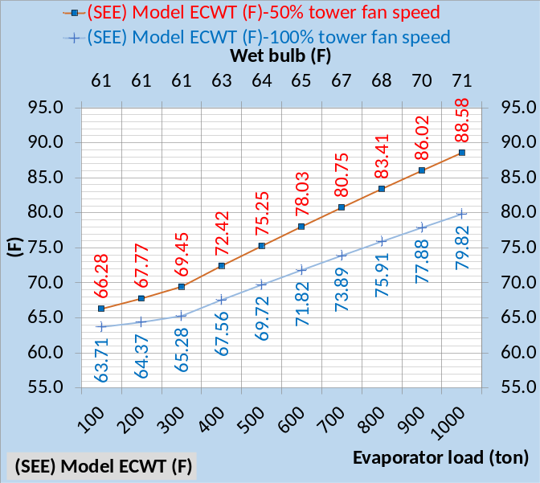Figure 2-12: ECWT (F) at 100% & 50% tower fan speed
Figure 2-12 illustrates how the ECWT drops at constant 61F wet bulb and evaporator loads of 200 ton and 100 ton.
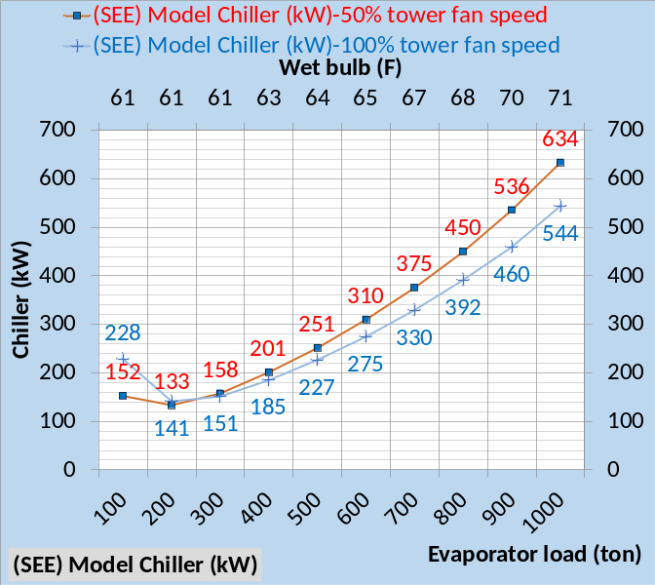Figure 2-13: Chiller kW down to 100 ton load
Figure 2-13 illustrates that chiller kW is greater with 50% tower fan speed down to 300 ton evaporator load, same as Schwedler¹, but reverses at 200 ton and 100 ton evaporator load where 50% tower fan speed gives less chiller kW demand.
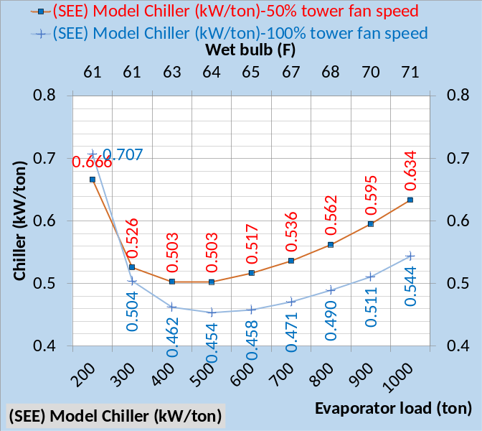Figure 2-14: (SEE) Model Chiller kW/ton
Figure 2-14 gives (SEE) Model chiller kW/evaporator ton illustrating less kW/ton with 100% tower fan speed down to 300 ton evaporator load. At 300 ton load the kW/ton values are turning up and at 200 ton load kW/ton is greater than at design and increasing at a rapid rate.
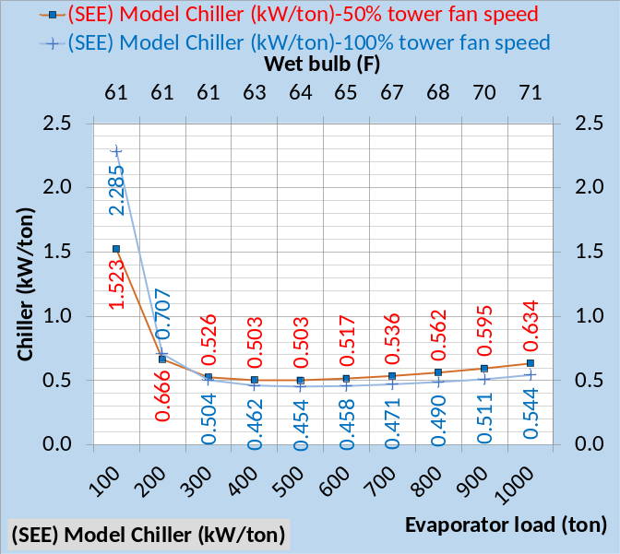Figure 2-15: (SEE) Model (kW/ton)
Figure 2-15 illustrates the (SEE) Model kW/ton values at 100 ton are 3 to 4 times the 1000 ton design values. These (SEE) model values at 200 ton and 100 ton are presented but not verified against manufactures data as has the values from 1000 ton down to 300 ton.
Reference 5, 2012 ASHRAE HANDBOOK, HVAC Systems and Equipment, page 43.10 Figure 11 Temperature Relations in a Typical Centrifugal Liquid Chiller, illustrates data down to about 10% load suggesting that less than 10% load is unstable as is the case with the (SEE) Model.
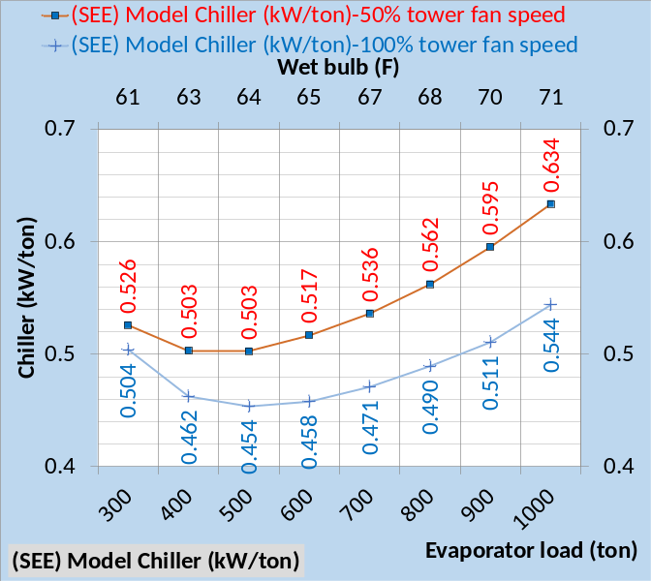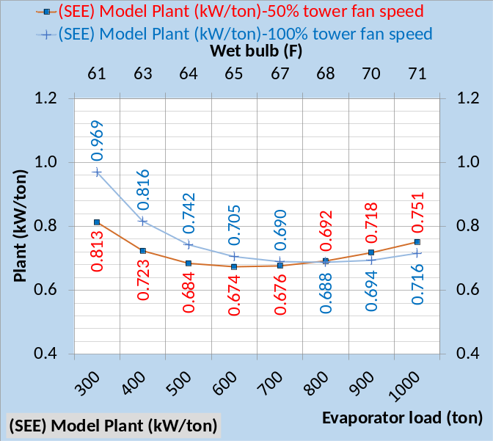Figure 2-16: (SEE) Model kW/ton for chiller & plant
Figure 2-16 shows that the kW of the plant is less, when the tower is operated at 50% tower fan speed, for plant loads less than 800 ton. . Figure 2-16 top chart shows that the chiller kW/ton is greater for 50% tower fan speed but not always true for the kW/ton of the plant. A tower selected with less fan kW would significantly change Figure 2-16 as presented by Chapters 7, 8, & 9.
The next eight schematics will present side by side 100% & 50% tower fan speeds comparisons for 1000 ton, 700 ton, 400 ton, and 100 ton evaporator loads.
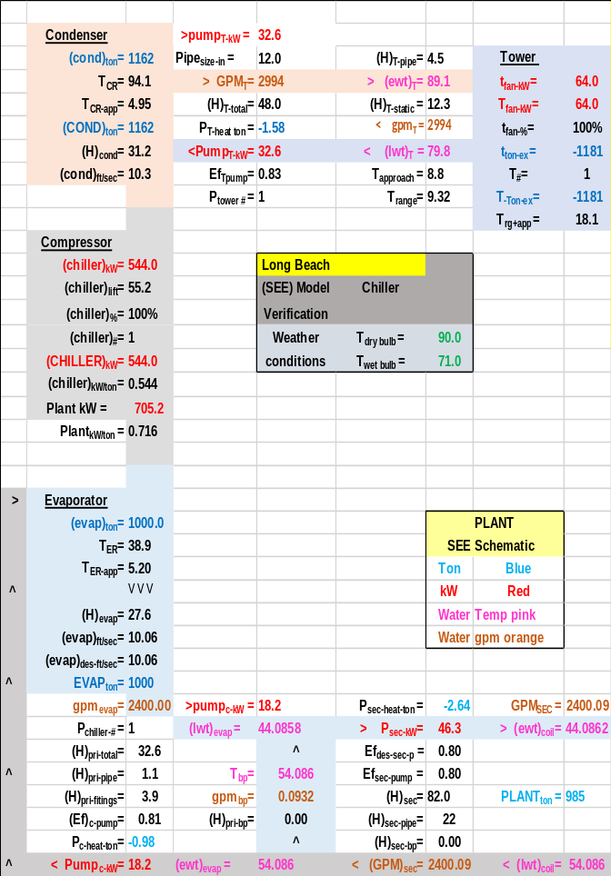Schematic 2-11: Plant at 1000 ton evaporator load, 100% tower fan speed and chiller kW=544.0 resulting in 44.08F supply water.
Schematics 2-11 & 2-12 illustrate the necessary increase in chiller kW required when the tower fan speed is reduced to 50% and also illustrates the increase in plant kW from 705.2 to 740.1 kW.
The reason the plant kW increased with 50% tower fan speed is the big increase in chiller kW as a result of 50% fan speed that off sets the reduction in tower fan kW. Schematics 1-11 & 1-12 of Chapter 1 has a 4F approach tower requiring 96 kW and the result was reversed, the 50% tower fan speed had less plant kW demand.

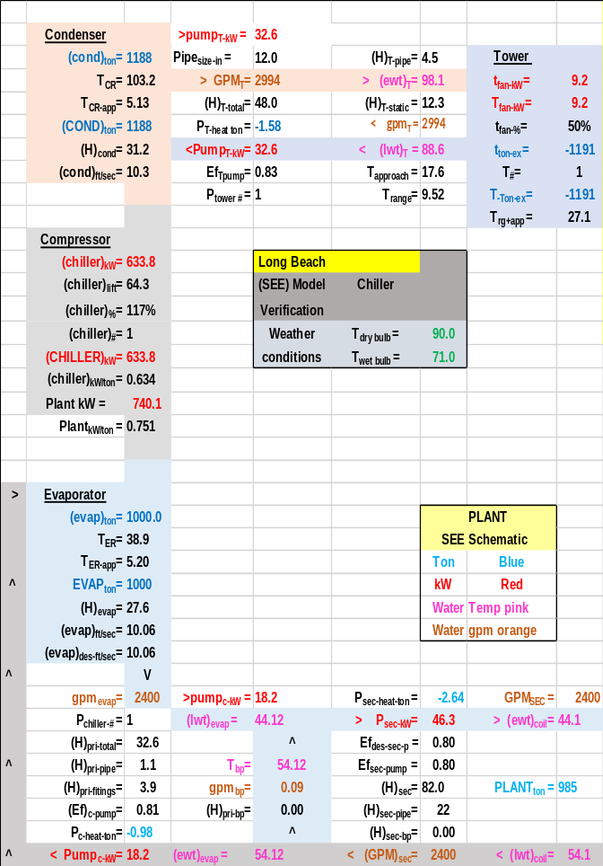Schematic 2-12: Plant at 1000 ton evaporator load, 50% tower fan speed and chiller kW=633.8 resulting in 44.12F supply water.

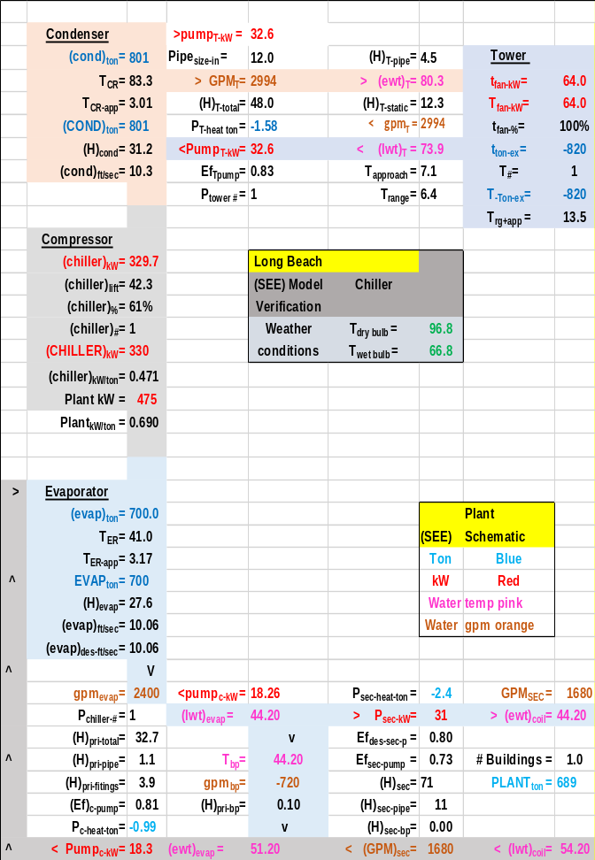 Schematic 2-13: Plant at 700 ton evaporator load, 100% tower fan speed and chiller kW=329.7 resulting in 44.20F supply water.
At 700 ton evaporator load the plant kW is slightly less for the 50% tower fan speed, 475 kW for 100% fan speed and 466 kW for 50% tower fan speed. The chiller kW is greater for the 50% tower fan speed condition but the big drop in tower fan kW, (64-9.2=54.8 kW) verses a (375.4-329.7=45.7 kW) increase in chiller kW with 50% fan speed.

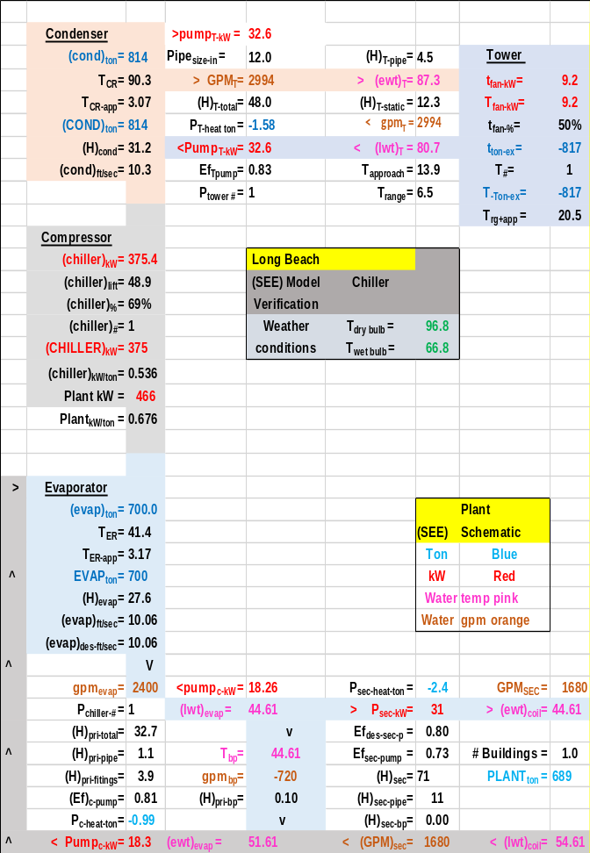Schematic 2-14: Plant at 700-ton evaporator load, 50% tower fan speed and chiller kW=375.4 resulting in 44.61F supply water.

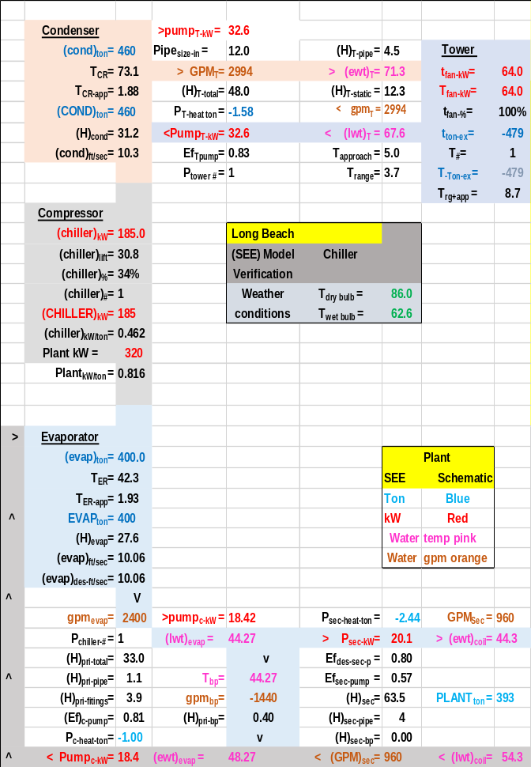Schematic 2-15: Plant at 400 ton evaporator load, 100% tower fan speed and chiller kW=185.0 resulting in 44.27F supply water.
The article by Schwedler¹ table 3 shows a 17-kW increase in chiller kW for 400-ton evaporator load and 50% tower fan speed verses 100% tower fan speed. (SEE) Model Schematics 2-15 & 2-16 show a (201.3-185.0=16.3kW) increase in chiller kW also show by above Tables 2-4 & 2-5. At these conditions chiller kW increases little while tower kW significantly decreases at 50% tower fan speed, resulting in a (320-284=36kW) decrease in plant kW.

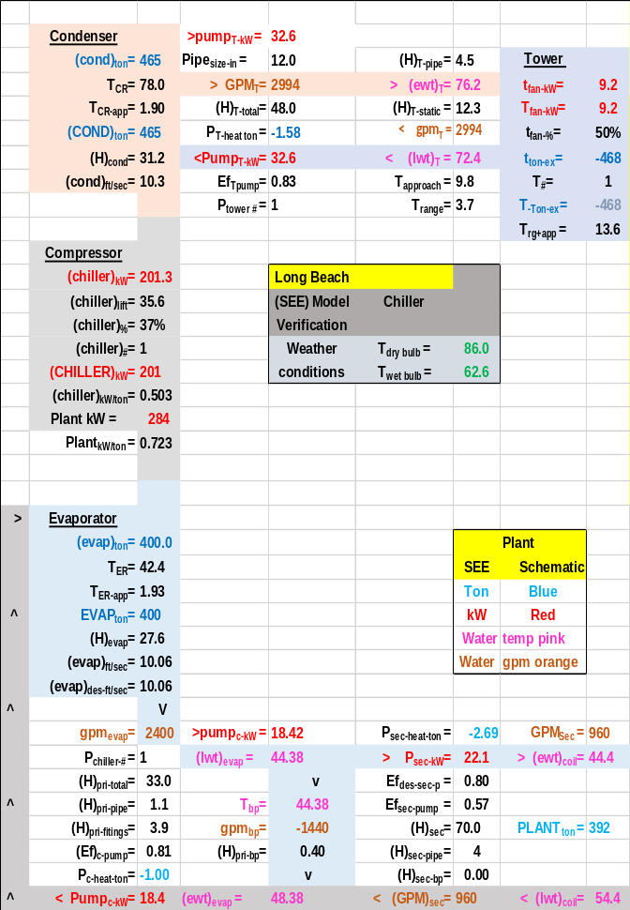Schematic 2-16: Plant at 400-ton evaporator load, 50% tower fan speed and chiller kW=201.3 resulting in 44.38F supply water.

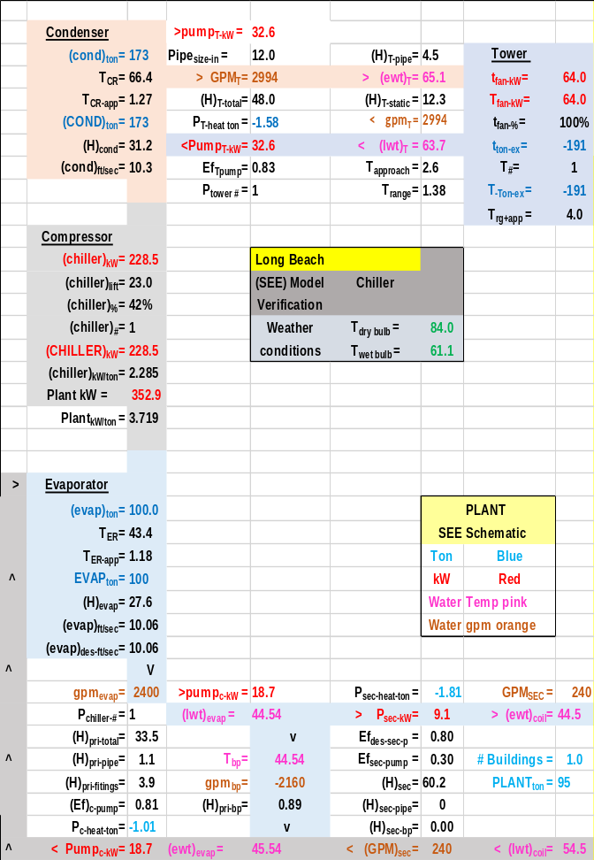Schematic 2-17: Plant at 100 ton evaporator load, 100% tower fan speed and chiller kW=228.5 resulting in 44.54F supply water.
The author is not aware of any data, evaporator load of 10%, dealing with plant conditions similar to Schematics 2-17 & 2-18. The author welcomes discussion and input from all including chiller & tower manufactures.

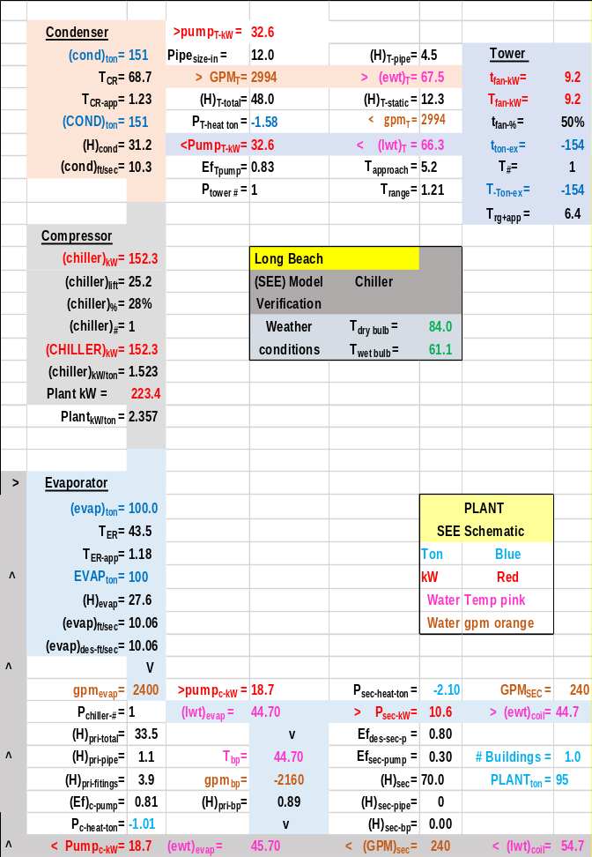Schematic 2-18: Plant at 100 ton evaporator load, 50% tower fan speed and chiller kW=152.3 resulting in 44.70F supply water.
This completes the analysis of the Long Beach data presented by Schwedler¹. The next Chapter 3 will show that the (SEE) plant model duplicates the table 4 data presented by Schwedler¹ for Salt Lake City, with design wet bulb of 66F and a 10F approach tower. The only changes to the (SEE) model will be to input the wet bulb conditions, select a new tower² and adjust the chiller kW to provide 44F supply water. No change is necessary or will be made to the set of simultaneous equations that simulate the chiller/tower performance at these or any other weather conditions.

(SEE) Model Plant Performance at 100% & 50% Tower fan speed
The above has shown that the (SEE) Plant Model duplicates the Schwedler chiller/tower data for Long Beach. The following will give additional (SEE) plant performance data which Schwedler¹ did not provide.
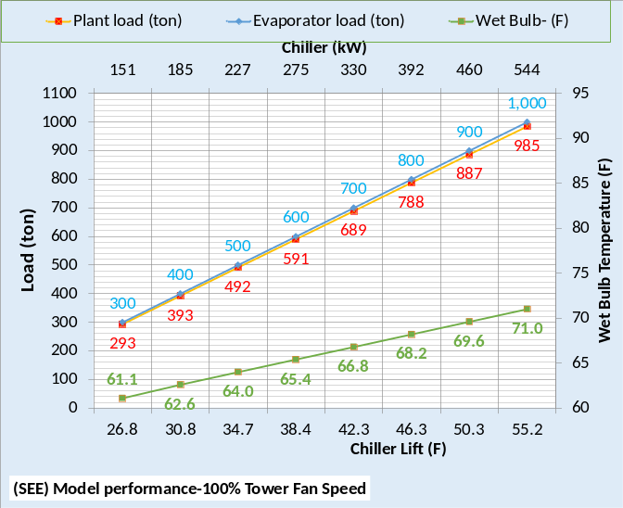 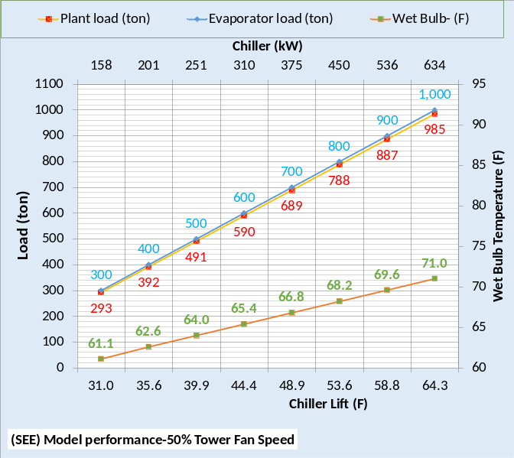Figure 2-17: Long Beach (SEE) Plant performance
Figure 2-17 gives the increase in chiller lift and chiller kW demand for 50% tower fan speed verses 100%. Also shown is the plant load that is less than the evaporator load because the P/S pumping adds load to the evaporator.
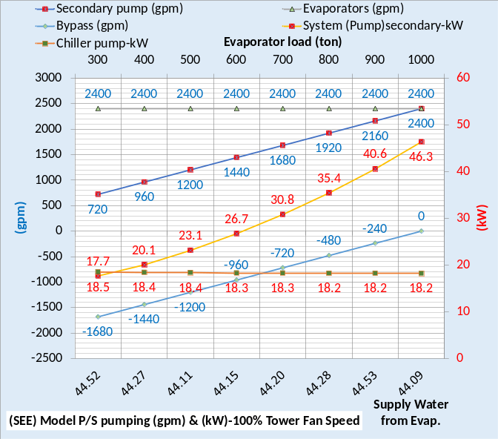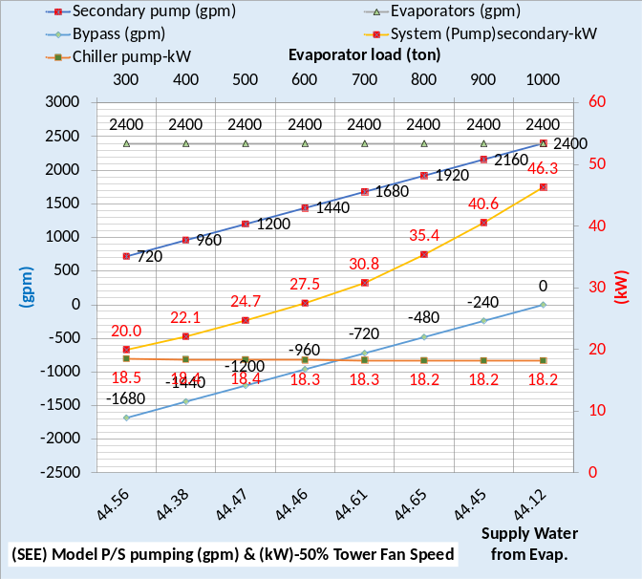Figure 2-18: Primary/Secondary pumping
Figure 2-18 illustrates that the tower fan speed does not affect the P/S pumping.
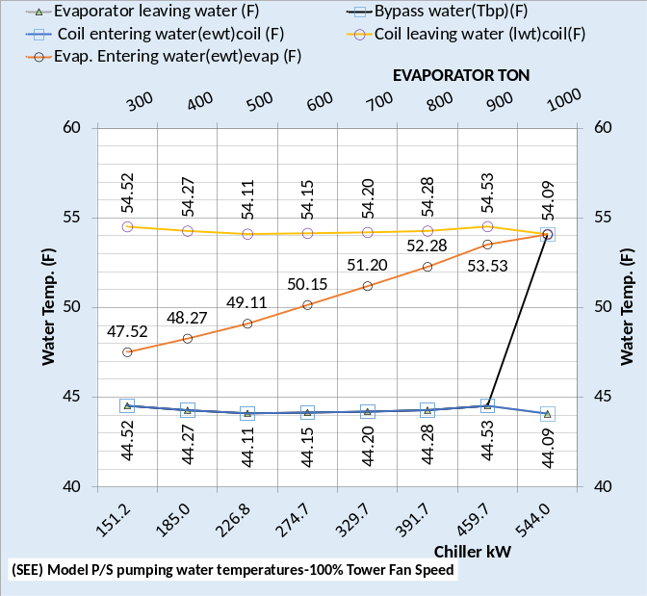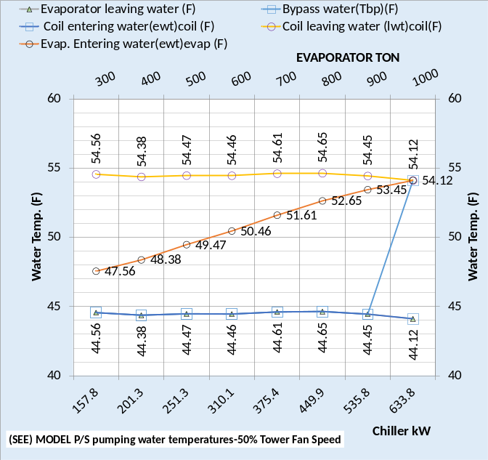Figure 2-19: P/S water temperatures
Figure 2-19 illustrates that the tower fan speed does not affect the P/S water temperatures. The slight difference in temperatures is due to the slight difference in water leaving the evaporator which is a function of chiller kW that is not exactly the same for both tower fan speeds.
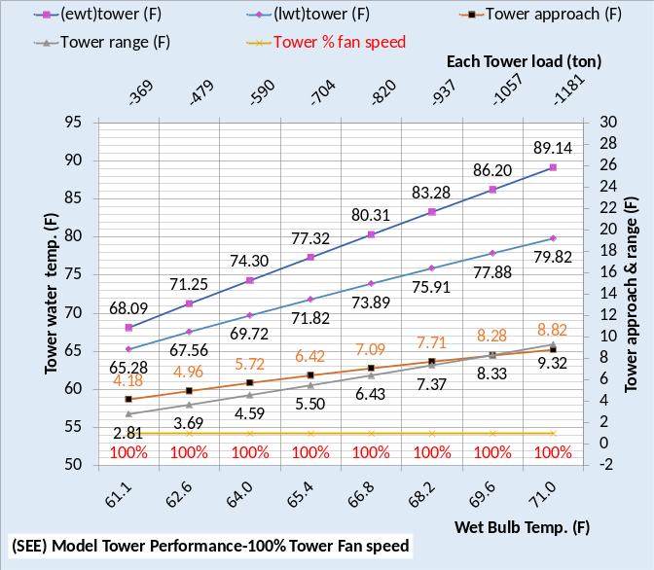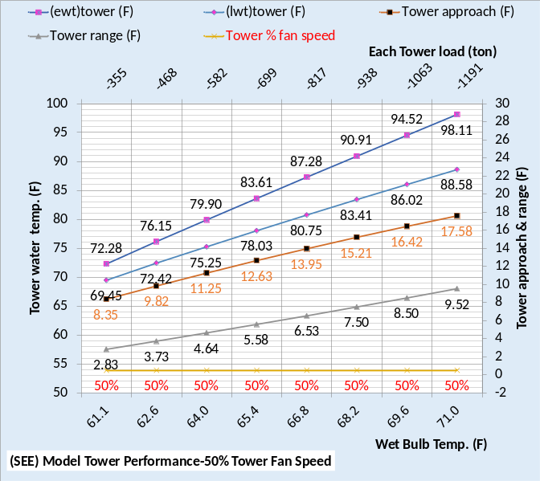Figure 2-20: Tower performance
Figure 2-20 illustrates a significant drop in tower performance with 50% tower fan speed. Tower range changes little but tower approach significantly increases with 50% tower fan speed, resulting in an increase in chiller lift as shown by each of the above schematics and therefore an increase in chiller kW to provide 44F supply water.
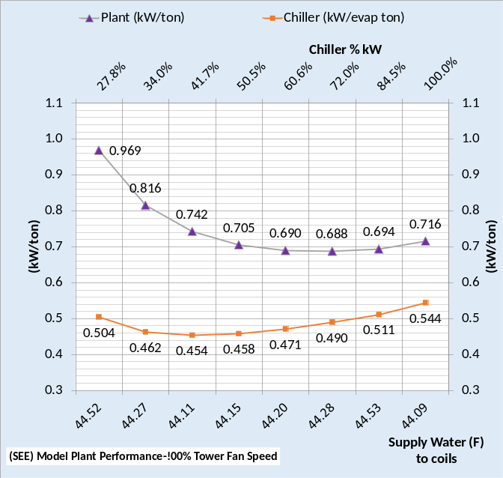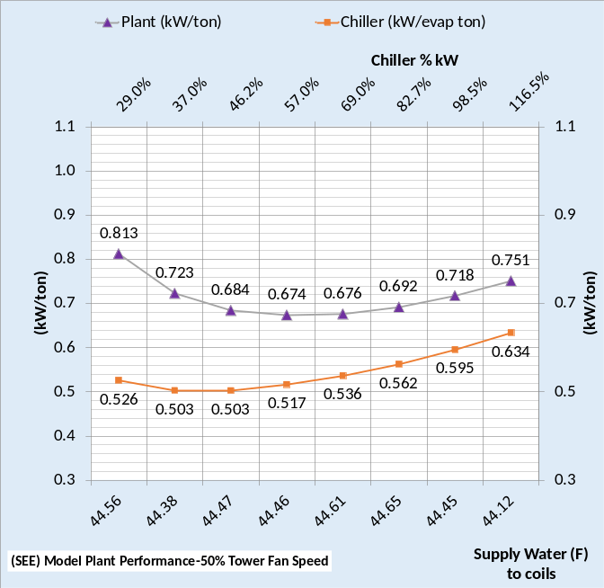Figure 2-21: (SEE) Model plant performance
Figure 2-21 gives the increase in chiller kW/ton with 50% tower fan speed and also shows the plant kW/ton decrease with 50% tower fan speed. As previously discussed the plant kW/ton decreases with 50% tower fan speed because the chiller kW increase is less than the tower fan decrease.
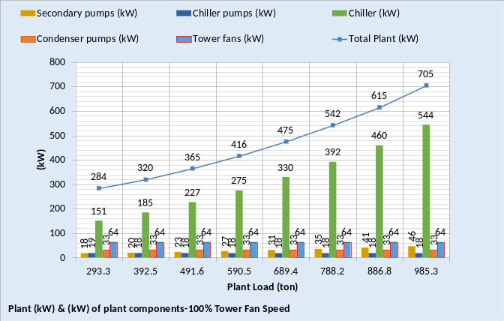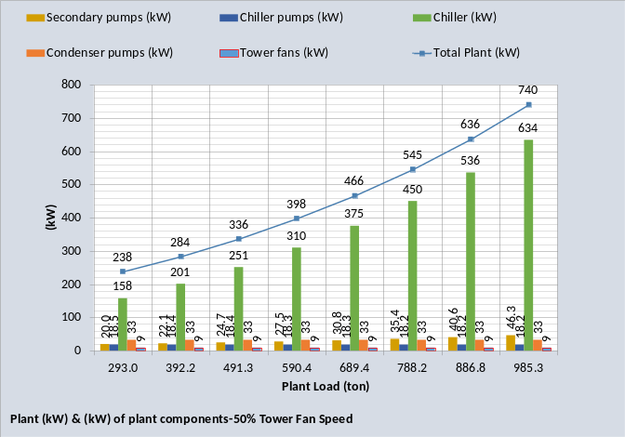Figure 2-22: Plant kW
Figure 2-22 gives the kW demand of the plant components illustrating the dominance of the chiller kW. The plant kW is less at 50% tower fan speed for all conditions.
ENERGY IN = ENERGY OUT
Energy in = energy out is a fundamental thermodynamic requirement of a System Energy Equilibrium (SEE) Model. The following figures illustrate compliance with this basic thermodynamic requirement.
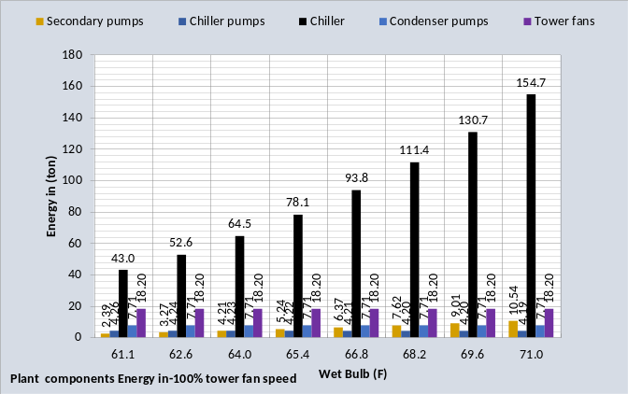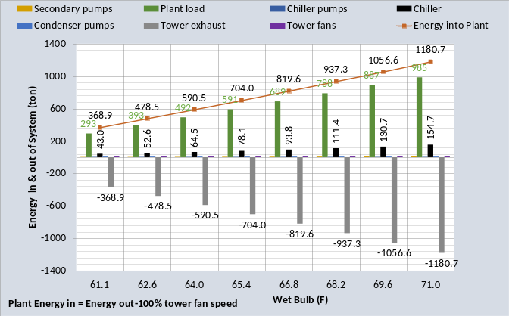Figure 2-23: Energy in = Energy out-100% tower fan speed
The top chart of Figure 2-23 gives the pumps and tower fan energy in (ton) which is also on the bottom chart but difficult to read. The plant load is the big energy in component and the tower exhaust is the total energy out.
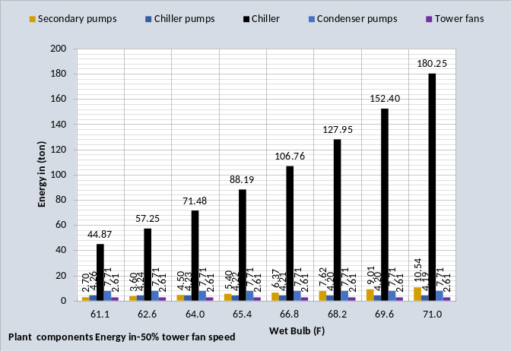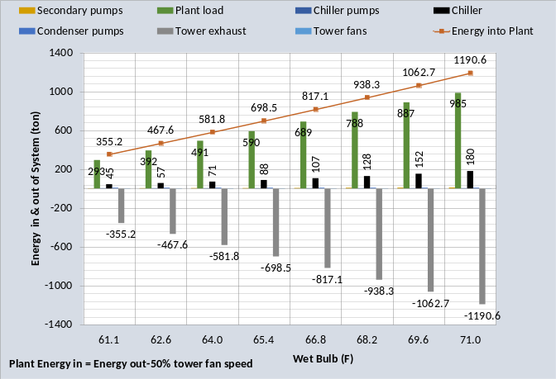Figure 2-24: Energy in = Energy out-50% tower fan speed
Figure 2-24 gives energy in = energy out for 50% tower fan speed illustrating the smaller values for 50% fan speed at wet bulb 66.8F and below.
Chiller Lift (F)
Chiller lift is the difference in the refrigerant temperatures of the condenser minus the evaporator refrigerant temperature⁵. The evaporator refrigerant temperature is largely set by the evaporator water supply temperature and therefore varies little compared to the condenser refrigerant temperature. Figure 2-20, Tower Performance, illustrates how the tower entering water temperature varies with load and wet bulb temperature. Tower entering water temperature is also the condenser leaving water temperature which in large part sets the condenser refrigerant temperature.
Figure 2-25: Chiller Lift (F)
Figure 2-25 gives the refrigerant temperatures and chiller lift for both 100% & 50% tower fan speed. Tower fan speed of 50% versus 100% increases the tower entering water temperature and therefore the condenser refrigerant temperature resulting in increased chiller kW as shown by Figure 2-22.

Chapter 2 is an attempt by the author to give the reader confidence in the Long Beach (SEE) Plant Model. The author is open to questions and additional data and clarifications as may be requested by readers. Similar analysis and verification for Schwedler’s Salt Lake City data is given by chapters 3.
CHAPTER 3: Salt Lake City Model verification against Schwedler¹ at 100% & 50% tower fan speed.
Model verification
The verification approach here will be to show that this (SEE) plant model duplicates and/or closely follows a published 1998 ASHRAE Journal article by Schwedler¹. Table 3-1 illustrates the data given by Schwedler¹ for a Salt Lake City plant at 100% tower fan speed. The table illustrates that the evaporator load is decreased from 1,000 ton down to 300 ton as the wet bulb decreases from 66F down to 56.7F. Table 3-1 shows that the cold water from the tower decreases from 76F down to 61F as the wet bulb and evaporator load decreased. The chiller kW demand drops from 508 kW down to 130 kW. Table 3-1 illustrates the challenge for the (SEE) chiller/tower plant model. 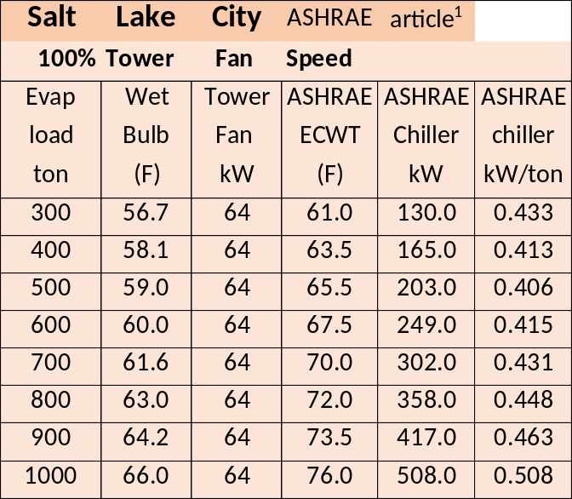Table 3-1: Data from Schwedler¹
This Chapter 3 will demonstrate the (SEE) Models ability to duplicate the Schwedler¹data with tower fan speeds of 100% and 50%. Only two changes are made to the model going from 100% tower fan speed to 50% fan speed; the tower fan speed is reduced to 50% and the chiller kW power is increased to provide 44F supply water; the same procedure as would occur in a real system and that is the point of a (SEE) Model, duplication of the real system performance.
Chiller data
Table 3-2 gives the chiller data and Table 3-3 gives the tower data for Salt Lake City.
Design Tons | 1000.0
Chiller kW | 508.0
Chiller kW/ton | .508
Evap water flow rate (gpm) | 2400.0
Evap entering water temp (F) | 54.0
Evap leaving water temp (F) | 44.0
Evap refrigerant temp (F) | 38.8
Evap refrigerant approach (F) | 5.2
Evap pressure drop (ft. water) | 27.6
Evap water velocity (ft. /sec.) | 10.06
Cond heat rejection (ton) | 1145
Cond water flow rate (gpm) | 3000.0
Cond entering water temp (F) | 75.9
Cond leaving water temp (F) | 85.3
Cond refrigerant temp (F) | 90.1
Cond refrigerant approach (F) | 4.88
Cond pressure drop (ft. water) | 31.2
Cond water velocity (ft. /sec) | 10.28
Table 3-2: Salt Lake City Chiller data¹⁹
Tower for (SEE) model | Low cost tower¹
Design Wet bulb | 66.0F
Design Load | 1155 ton
Tower water flow | 3000 gpm
Approach temperature | 10.0 F
Calculated range | 9.26F
Range + approach | 19.26F
Three cells with 40HP fans¹ | 64 kW¹
Selected Tower² | NC8403TLS2
Cold water | 76F
Return water to tower | 85.26F
Capacity | 100.5%
ASHRAE 90.1 performance | 43.5 gpm/HP
Static lift | 12.234 ft.
Table 3-3: Tower selected
Table 3-3 gives the performance data of the tower selected based on Schwedler¹. The data of Tables 3-2 & 3-3 will be input to the Salt Lake City chiller/tower (SEE) Model.

(SEE) Model Plant at Peak Conditions
Schematic 3-1 illustrates the primary/secondary (P/S) pumping system not defined by Schwedler¹ but necessary for the plant (SEE) Model. The load from the building to the plant is 985 ton increasing to 1000 ton, as given by Schwedler¹, at the evaporator as a result of heat added to the system by the P/S pumping. The kW of the pumps is (46.3+18.2=64.5 kW) that adds (64.5/3.513=18.4 ton) load. Pump heat not going into the system but to the atmosphere is modeled as (2.64+.98=3.62 ton) for a total of (18.4-3.62=14.8 ton added to the plant load of 985 ton giving (985+14.8=1000 ton) to the evaporator as shown by Schematic 3-1.
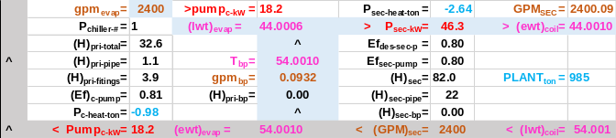Schematic 3-1: Primary/Secondary Pumping
Schematic 3-1 also illustrates that the flow in the bypass is .0932 (gpm) in the wrong direction resulting in a temperature of water in the bypass of 54.001F with little effect on the supply water temperature, 44.0006F off the evaporator and 44.0010F to the building. Also note that the gpm off the evaporator is 2400.0 and the gpm to the coils is 2400.09 due to the wrong flow direction in the bypass pipe. A slight decrease in evaporator load will reverse the direction of flow in the bypass.
Schematic 3-2 illustrates the condenser, compressor, and evaporator at 1,000 ton evaporator load.
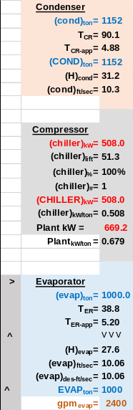 Schematic 3-2: Condenser, Compressor, and Evaporator at design conditions.
The compressor motor demand is 508 kW to move the refrigerant from the evaporator to the condenser. The condenser load is (1000 ton + 508kW/3.513 =1,145 ton). Schematic 3-2 shows the condenser load as 1,152 ton due to the addition of the 8 ton tower pump heat to the system.
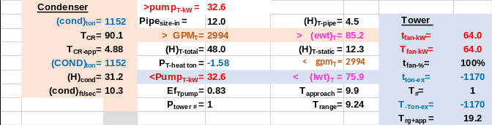Schematic 3-3: Condenser & Tower.
Schematic 3-3 illustrates the condenser and tower plus pumping, not defined by Schwedler¹, at peak load of 1000 ton on the evaporator. Pumping heat added to the condenser is (32.6kW/3.512=9.28ton-1.58ton=7.70 ton rounded to 8 ton) as stated above. The tower exhausts the condenser load plus the tower fan heat for a total of (-1152-64/3.512= -1170 ton) exhausted from the system. The load from the building was 985 ton as shown by Schematic 3-1 and the plant added (1170-985=185 ton) to the system to be exhausted by the tower. Clearly the more the plant adds to the building load the greater the size of the required tower, condenser, and evaporator, also increasing the cost of the plant and probably decreasing plant efficiency. Later Chapters 7, 8, & 9 will address plant design and make this point more clear.
Plant Schematic
Schematic 3-4 illustrates the full plant combining Schematics 3-1, 3-2, & 3-3. The energy into the system is 985ton + 669.2kW/3.513=1175.5 ton minus the pump heat to atmosphere of (-2.64-.98-1.58=-5.20 ton) for a total of (1175.5-5.2=1170.3 ton in and out as exhausted by the tower. The laws of thermodynamics state that the energy into a system is equal to the energy out of the system. Therefore the same must be true for a system model if the system model is to be judged as a true model of the system.
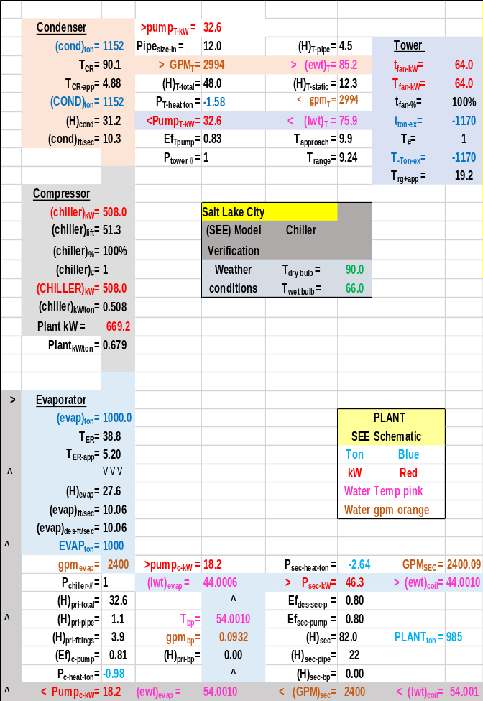Schematic 3-4: Plant at 1000 ton evaporator load & 100% tower fan speed & 508 kW chiller demand-matching Schwedler¹ data table 4.
Schematic 3-4 is consistent with the data provided by Schwedler¹, 508 kW chiller demand and 75.9F entering condenser water (ECWT) temperature. Schwedler¹ defined the base chiller as ARI 550 (.600 kW/ton) and Schematic 1 above in the Introduction & Summary determined the condenser and evaporator refrigerant approach temperatures required by the (SEE) Model to provide 44F supply water. The chiller manufacture’s data provided condenser & evaporator approach temperatures plus other data that is addressed in Chapter 5. An evaporator design value of 5.20F refrigerant approach and 4.88F for the condenser results in 44.00F supply water. Installing different condenser & evaporator refrigerant approach temperatures into the (SEE) model results in a different chiller kW and/or different supply water temperature as will be demonstrated. Based on data given by Schwedler¹ and Chapter 5 the sum of the refrigerant approach temperatures must be about 10.2F. Schematics 1-5 & 1-6 above in Chapter 1 illustrated this effect of condenser and evaporator refrigerant approach temperatures and Chapter 5 will provide additional details.
Verification of (SEE) model at part load
Schematic 3-4 defines the (SEE) Model Salt Lake City plant at peak design conditions; the question is can the (SEE) model duplicate the off peak values of Schwedler¹? Figure 3-1 illustrates the data given by Schwedler¹ for the performance of the chiller and cooling tower as the evaporator load and wet bulb decrease with 100% tower fan speed.
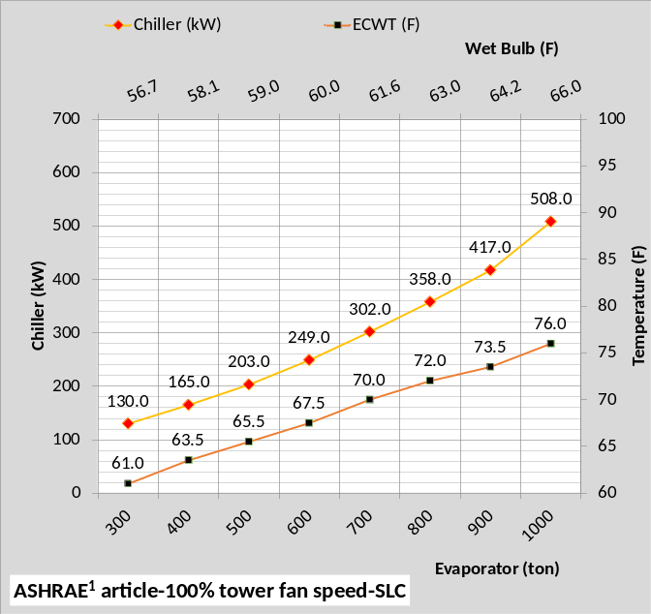Figure 3-1: Salt Lake City data from Schwedler¹
Figure 3-1 at 100% tower fan speed demonstrates the challenge for the (SEE) plant model and even more demanding is the requirement that the model must duplicate the plant performance when the tower fan speed is reduced to 50%, discussed below. The good news is that the real plant follows the laws of thermodynamics and if the (SEE) Model does the same then a model that duplicates the performance of the real system is possible as will be demonstrated here.
Tower selection
Schwedler¹ defines the cooling tower as a low cost tower with 64 kW fan demand. The tower for this (SEE) model was defined with a manufactures selection program². Table 3-3 above gives the details of the selected tower that closely matches the Schwedler¹ data.
Tower simulation model results
The tower data of Table 3-3 is input to the model and is shown to closely duplicate the data given by Schwedler¹ as illustrated by Figure 3-2.
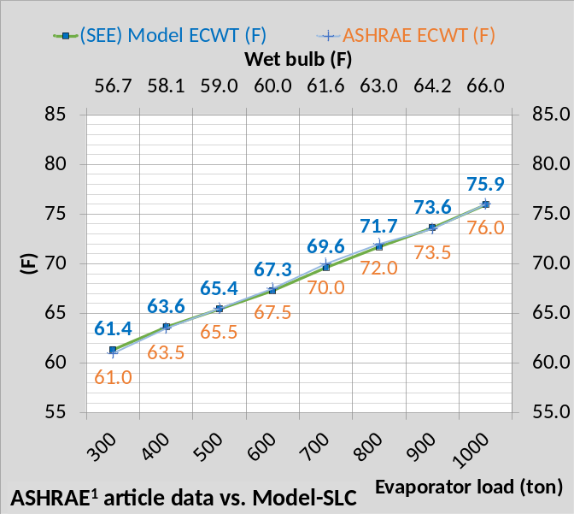Figure 3-2: (SEE) model vs Schwedler¹ tower ECWT-100% tower fan speed
At 100% tower fan speed Figure 3-2 illustrates that the (SEE) Model of the tower, from 1000 ton evaporator load down to 300 ton as the wet bulb drops from 66F down to 56.7F, closely follows the data provided by Schwedler¹.
Chiller performance
As the wet bulb and evaporator load decrease the chiller kW required to maintain 44F supply water decreases from 508 kW down to 130 kW as show by Figure 3-1¹. The (SEE) Model closely duplicates this Schwedler¹ chiller kW data as shown by Figure 3-3.
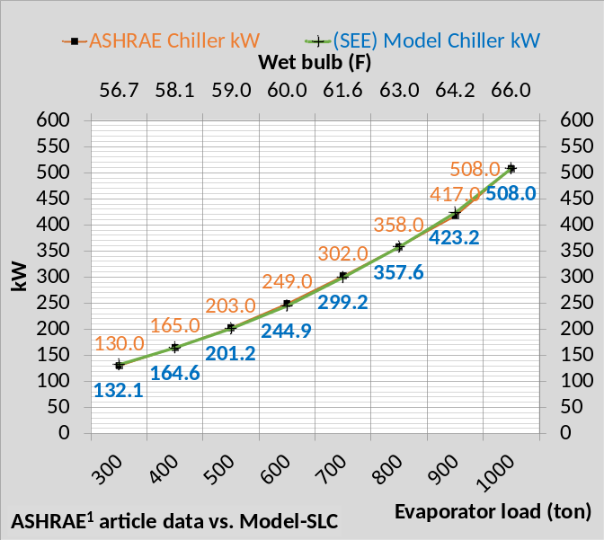Figure 3-3: (SEE) model vs. Schwedler¹ -Chiller kW
Figure 3-3 illustrates the (SEE) model duplicates the manufactures data to within 2% for all values of evaporator load and wet bulb as shown by Table 3-4.
Figure 3-4 provides a comparison of the (SEE) Model chiller kW per evaporator ton verses the manufactures data¹.
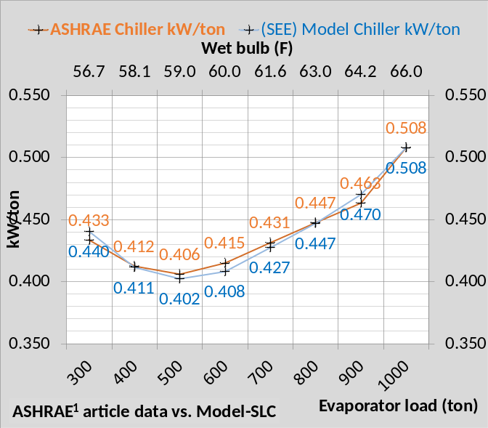Figure 3-4: (SEE) model vs. Schwedler¹ -Chiller kW/ton
Figure 3-4, 100% tower fan speed illustrates close agreement to the manufactures data¹. The manufactures data is given for the chiller and tower and does not include the chiller plant in total; pumping is not given and that has an effect on the plant performance as will be shown below.
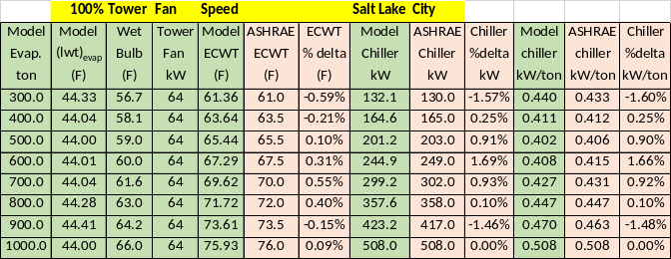Table 3-4: Model Results & Schwedler¹ data.
Table 3-4 provides tabular comparison of the Schwedler¹data and the (SEE) Model results illustrating close agreement for the tower model and chiller kW. The authors modeling experience judges this less than 2% deviation from manufactures data as a very good model.
Model Verification at 50% Tower Fan Speed
Tower Fan Speed Reduced to 50%
Reducing the tower fan speed from 100% to 50% results in significant changes in the performance of the plant and therefore a significant challenge for the (SEE) Model.
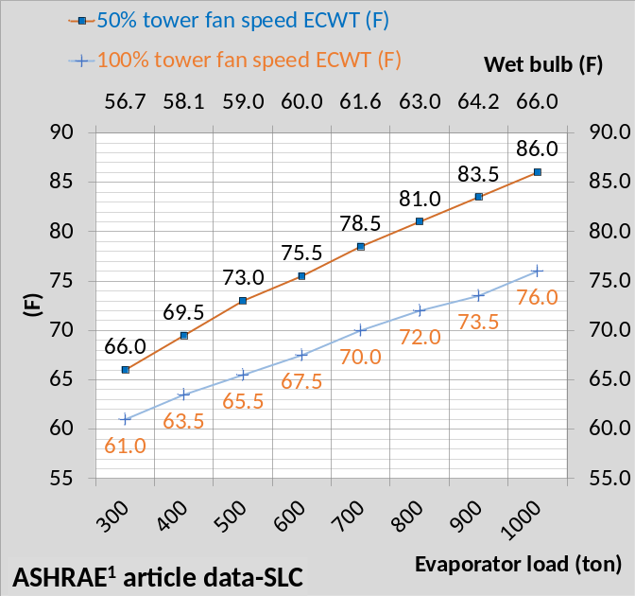Figure 3-5: ECWT-100% & 50% tower fan speed
Figure 3-5 illustrates the change in entering condenser water temperature (ECWT) as given by Schwedler¹ for 50% & 100% tower fan speed. ECWT increased 10F at design conditions due to the tower approach temperature of 10F and 5F at 300 ton evaporator load and 56.7F wet bulb. The increase in tower water temperature, due to 50% tower fan speed, and therefore entering condenser water temperature results in an increase in required chiller kW to produce 44F supply water.
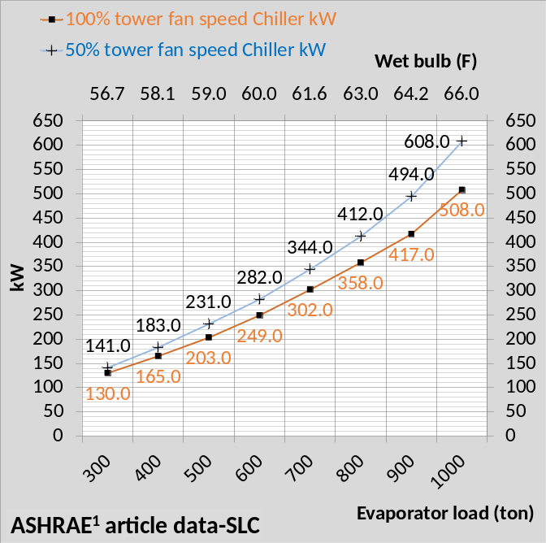Figure 3-6: Chiller kW-100% & 50% fan speed
Figure 3-6 gives the chiller kW at 100% and 50% tower fan speed as given by Schwedler¹ and Figure 3-7 gives chiller kW/ton as given by Schwedler¹ for 100% and 50% tower fan speed. Clearly reducing the tower fan speed to 50% has a significant effect on chiller kW and therefore chiller kW/ton.
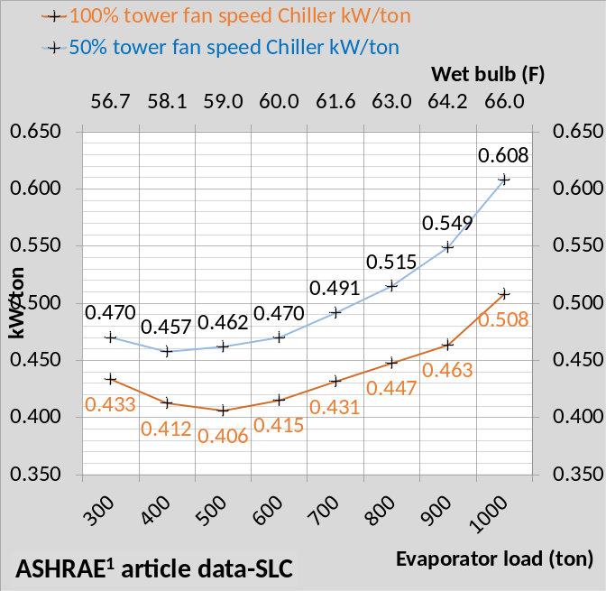Figure 3-7: Chiller kW/ton-100% & 50% tower fan speed
Figures 3-5, 3-6 & 3-7 illustrate the challenge for the (SEE) Model going from 100% tower fan speed to 50% tower fan speed. Only two changes will be made to the (SEE) Model, first change the tower speed to 50% then increase the chiller kW until 44F supply water is obtained. To illustrate the following Schematics will first show the changes in the plant when the tower fan speed is reduced to 50%, then schematics will show the change when the chiller kW is increased to provide 44F supply water.

Schematic 3-4 copied: Plant at 1000 ton evaporator load, 100% tower fan speed, supply water 44.00F, and chiller kW=508.
The above Schematic 3-4 is copied from above and shows the plant at peak design conditions. Schematic 3-9 illustrates the plant when the only change is the fan speed that has been change from 100% to 50%. No changes occur in the P/S pumping. Supply water increased from 44.00F to 52.19F and the evaporator refrigerant temperature increased from T_{ER} = 38.8F to 47.0F an 8.2F increase. The water leaving the tower and entering the condenser increased from 75.9F to 85.0F a 9.1F increase. This raised the condenser refrigerant temperature (T_{CR} ) from 90.1F to 99.1F an 9.0F increase all shown by comparing Schematics 3-4 & 3-9.
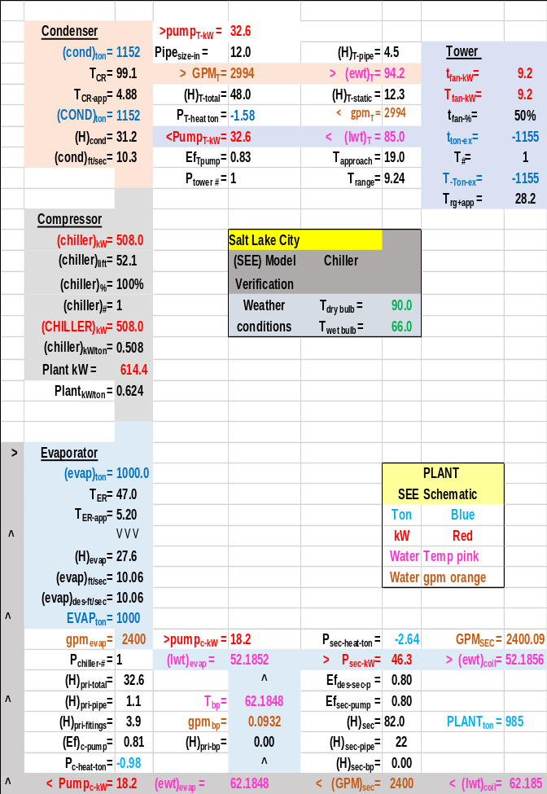Schematic 2-9: Plant at 1000 ton evaporator load, 50% tower fan speed, supply water 52.19F, and chiller kW=508.
The tower kW decreased from 64 to 9.2 kW and therefore the plant kW decreased from 669.2 kW to 614.4 kW, a 54.8 kW decrease by operating at 50% tower fan speed but supply water is 52.18 and must be dropped to about 44F by increasing chiller kW.
The next step is to increase the chiller kW until the supply water is about 44F with 50% tower fan speed. The only input to the model will be an increase in chiller kW until approximately 44F supply water is obtained.

Schematic 3-9 copied: Plant at 1000 ton evaporator load, 50% tower fan speed and chiller kW=508 resulting in 52.18F supply water.
The above Schematic 3-9 is copied from above so that a side by side comparison can be made. The only input to the (SEE) Model of Schematic 3-10 is the increase in chiller kW from 508 kW to 605.5 kW, all other changes as shown by Schematic 3-10 occur due to the solution of the equations of the simulation model. Increasing the chiller kW to 605.5 reduced the supply water to 44.00F which was the objective. No changes occurred in the P/S pumping kW. The load on the condenser increased from 1152 ton to 1180 ton due to the increase in chiller kW.
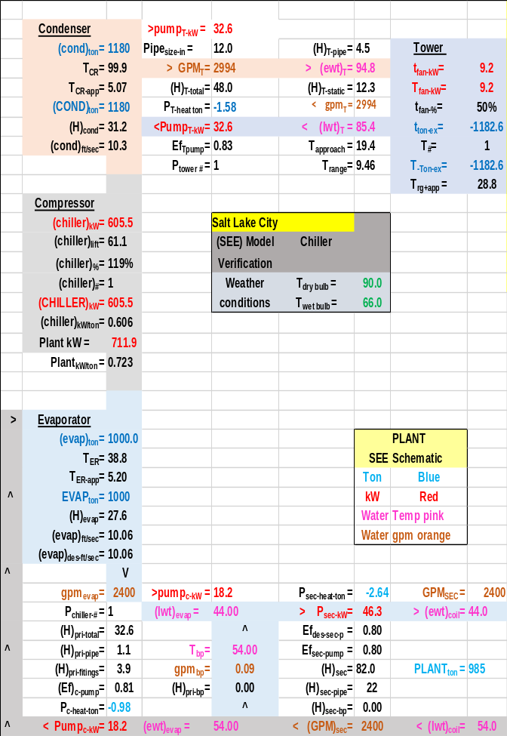Schematic 3-10: Plant at 1000 ton evaporator load, 50% tower fan speed and chiller kW=605.5 resulting in 44.00F supply water.
Greater chiller kW resulted in a slight increase, (99.9F-99.1F=.8F), in condenser refrigerant temperature due to the increased condenser load. Plant kW increased from Schematic 3-9 to Schematic 3-10 about 97.5 kW all due to the chiller kW increase.
A primary objective of Schematics 3-4, 3-9, & 3-10 is to show total plant changes but to also make the point that the only two changes were made to the (SEE) plant model, first to decrease the tower fan speed to 50% and then increase the chiller kW to provide about 44F supply water. All other changes in the plant, as shown by the schematics, is a result of the (SEE) Model equations reaching a new steady state condition where energy into the plant equals energy out of the plant.
Energy into the plant with 100% tower fan speed is;
(985 ton + 614.4/3.513 ton -2.64-.98-1.58 = 1154.7 ton)
Energy out at the tower is 1155 ton = Energy in
At 50% tower fan speed energy in equals;
(985 ton + 711.9/3.513 ton -2.64-.98-1.58 = 1182.4
Energy out at the tower is 1182.6 ton = Energy in
50% Tower Fan Speed Comparison of (SEE) Model and Schwedler¹data for Salt Lake City.
Figure 3-8 shows the (SEE) Model cooling tower performance, at 50% fan speed, closely duplicates the data provided by Schwedler¹, table 3 for Salt Lake City. Dropping both the condenser load and wet bulb provides a rather extreme test for the (SEE) Model of the tower; Figure 3-8 illustrating the ability of the (SEE) Model to model the tower performance at these extreme conditions.
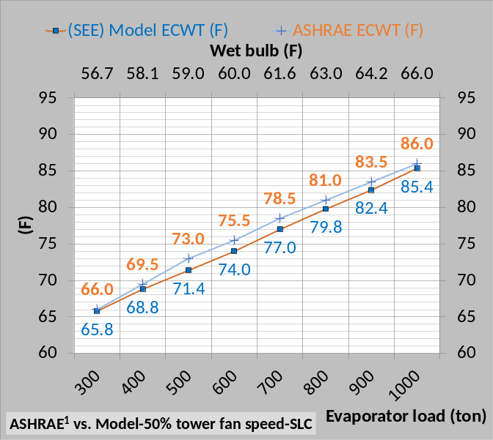Figure 3-8: (SEE) Model & Schwedler¹ ECWT data
Figure 3-9 illustrates close compliance with the Salt Lake City Schwedler¹ chiller kW data as the ECWT drops as given by Figure 3-8.
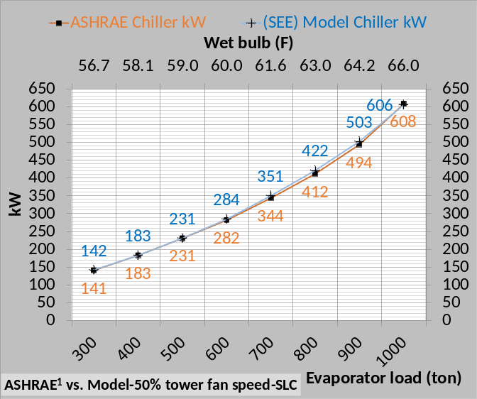Figure 3-9: (SEE) Model & Schwedler¹ kW data
The (SEE) Model chiller kW is within 2% of the manufactures data¹ for all conditions of evaporator load except at 800 ton evaporator load, see Table 3-5 below.
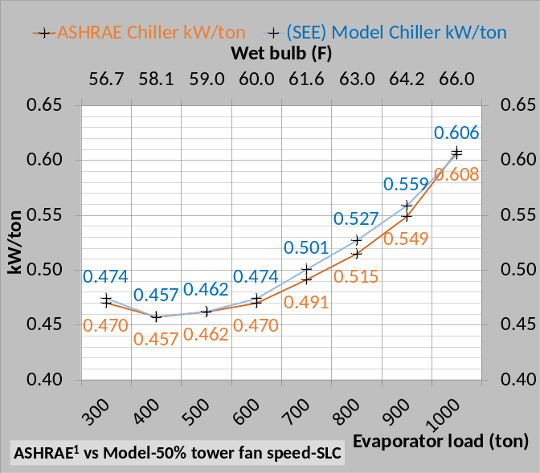Figure 2-10: (SEE) Model & Schwedler¹ chiller kW/ton data
Figure 2-10 shows chiller kW/ton of the (SEE) Model is within 2% of the manufactures¹ data for all conditions except at 800 ton load as shown by Table 3-5.
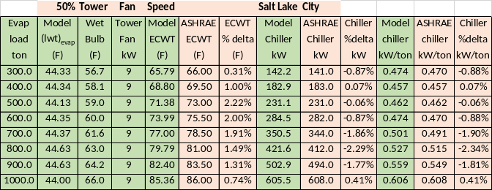Table 3-5: (SEE) Model & Schwedler¹ data at 50% tower fan speed-Salt Lake City
Table 3-5 presents the data listed and discussed above in tabular form comparing Schwedler¹data with the (SEE) Model result demonstrating the ability of the (SEE) Model to go from 100% tower fan speed to 50% tower fan speed and maintain compliance with Schwedler¹ data within 2.3%.
Plant performance at 200 ton & 100 ton evaporator load-Salt Lake City
Plant operation below 30% chiller load is not given by Schwedler¹. The (SEE) Model can show performance down to 10% or 100 ton evaporator load. The (SEE) model became unstable at about 50 ton evaporator load and will not be shown. A real chiller will also surge or become unstable at low loads.
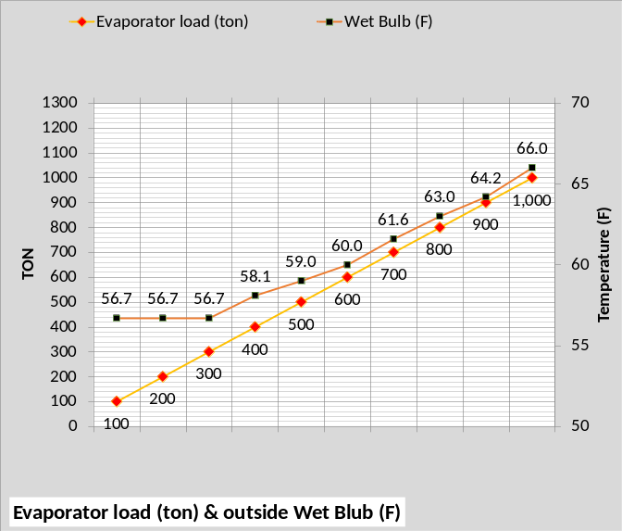Figure 3-11: Evaporator load and wet bulb
Figure 3-11 gives the evaporator load and wet bulb to be modeled. The values down to 300 ton are the same as Schwedler¹ with 200 ton and 100 ton added by the author.
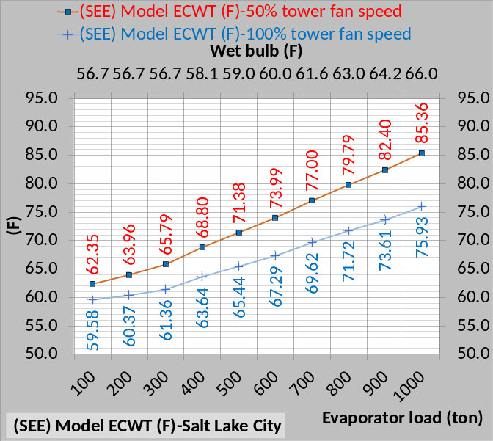Figure 3-12: ECWT (F) at 100% & 50% tower fan speed
Figure 3-12 illustrates how the ECWT drops at constant 56.7F wet bulb and evaporator loads of 200 ton and 100 ton.
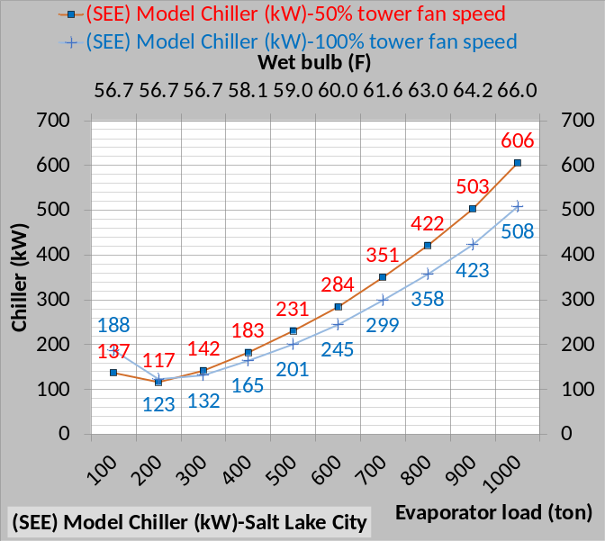Figure 3-13: Chiller kW down to 100 ton load
Figure 3-13 illustrates that chiller kW is greater with 50% tower fan speed down to 300 ton evaporator load, same as Schwedler¹, but reverses at 200 ton and 100 ton evaporator load where 50% tower fan speed gives less chiller kW demand.
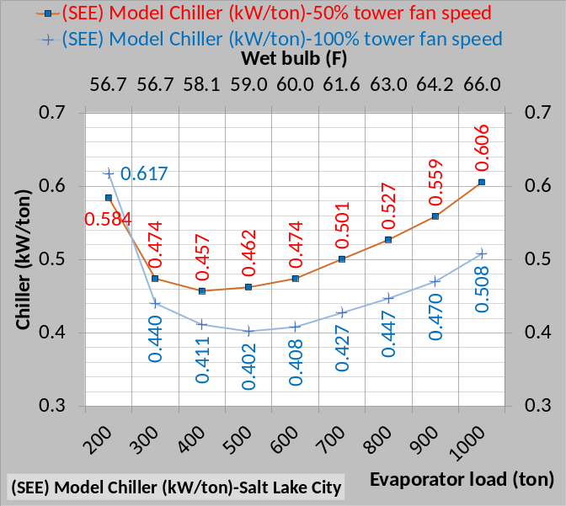Figure 3-14: (SEE) Model Chiller kW/ton
Figure 3-14 gives (SEE) Model chiller kW/evaporator ton illustrating less kW/ton with 100% tower fan speed down to 300 ton evaporator load. At 300 ton load the kW/ton values are turning up and at 200 ton load kW/ton is greater at 100% tower fan speed than at design and increasing at a rapid rate.
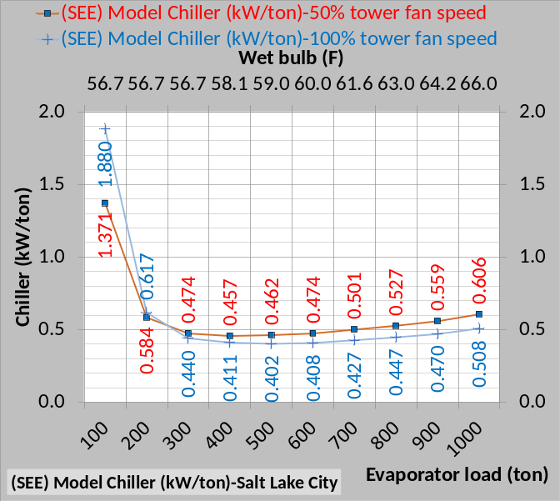Figure 3-15: (SEE) Model (kW/ton)
Figure 3-15 illustrates the (SEE) Model kW/ton values at 100 ton are 2 to 3 times the 1000 ton design values. These (SEE) model values at 200 ton and 100 ton are presented but not verified against manufactures data as were the values from 1000 ton down to 300 ton.
Reference 5, 2012 ASHRAE HANDBOOK, HVAC Systems and Equipment, page 43.10 Figure 11 Temperature Relations in a Typical Centrifugal Liquid Chiller, illustrates data down to about 10% load suggesting that less than 10% load is unstable as is the case with the (SEE) Model.
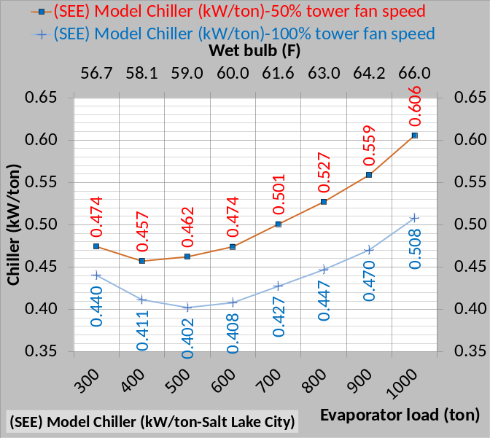 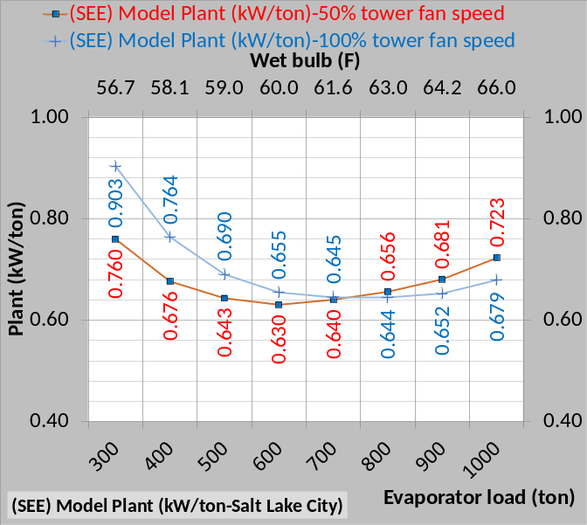Figure 3-16: (SEE) Model kW/ton for chiller & plant
Figure 3-16 shows that the kW of the plant is less, when the tower is operated at 50% tower fan speed, for plant loads less than 700 ton. Figure 3-16 top chart shows that the chiller kW/ton is greater for 50% tower fan speed but not always true for the kW/ton of the plant. A tower selected with less fan kW would significantly change Figure 3-16.
The next eight schematics will present side by side 100% & 50% tower fan speeds comparisons for 1000 ton, 700 ton, 400 ton, and 100 ton evaporator loads.

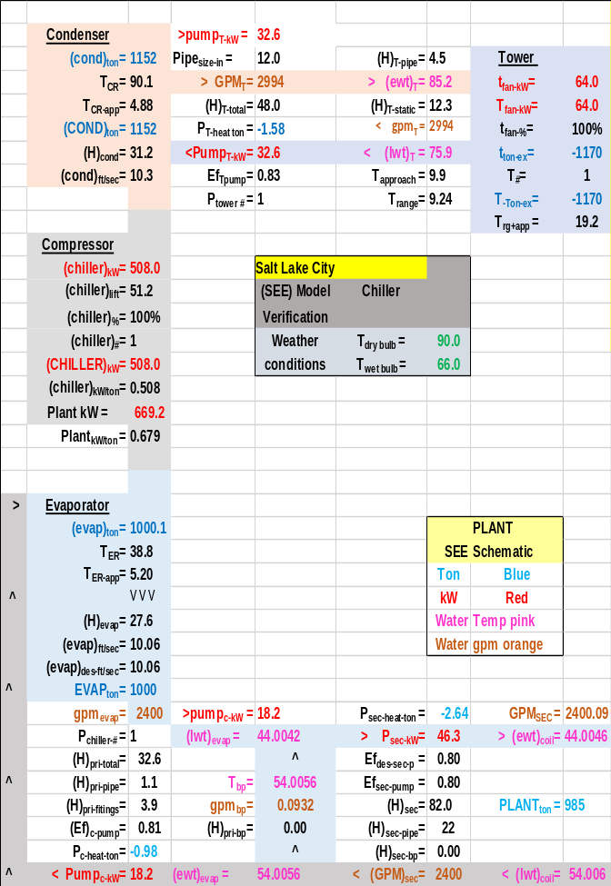Schematic 3-11: Plant at 1000 ton evaporator load, 100% tower fan speed and chiller kW=508.0 resulting in 44.04F supply water.
Schematics 3-11 & 3-12 illustrate the necessary increase in chiller kW required when the tower fan speed is reduced to 50% and also illustrates the increase in plant kW from 669.2 to 711.9 kW.

Schematic 3-12: Plant at 1000 ton evaporator load, 50% tower fan speed and chiller kW=605.5 resulting in 44.00F supply water.

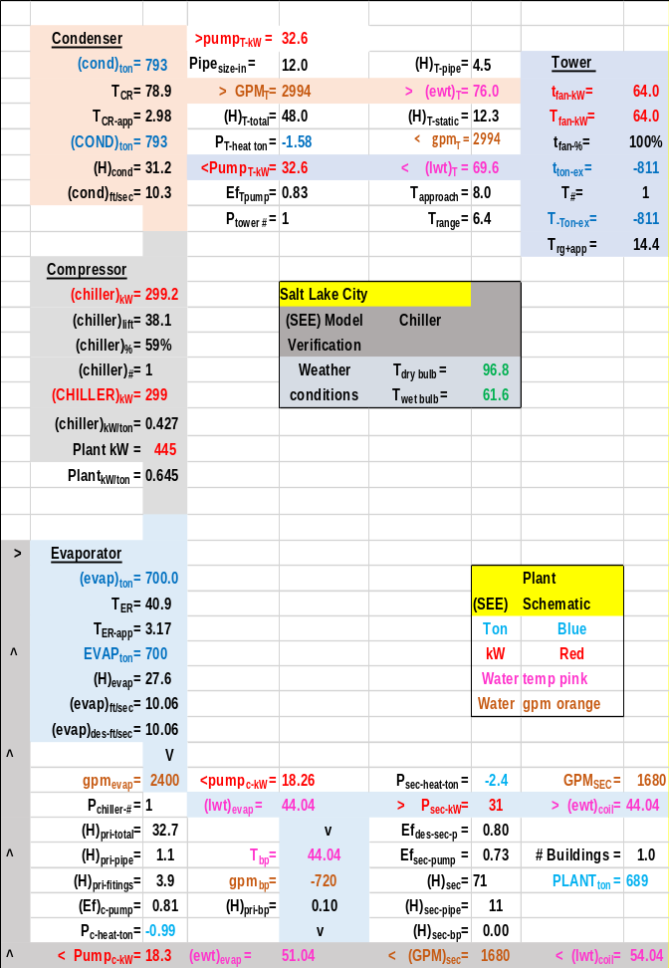 Schematic 3-13: Plant at 700 ton evaporator load, 100% tower fan speed and chiller kW=299.2 resulting in 44.04F supply water & plant kW = 445.
At 700 ton evaporator load the plant kW is slightly greater for the 100% tower fan speed, 445 kW for 100% fan speed and 441 kW for 50% tower fan speed. The chiller kW is greater for the 50% tower fan speed condition, 299.2 kW verses 350.5 kW or a 51.3 kW increase for 50% tower operation, but the big drop in tower fan kW, (64-9.2=54.8 kW) drives the plant kW to a value slightly less than the 100% tower fan system operation.

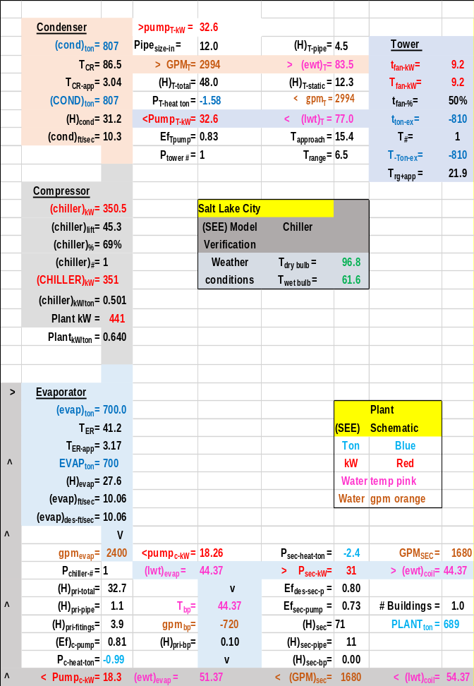Schematic 3-14: Plant at 700 ton evaporator load, 50% tower fan speed and chiller kW=350.5 resulting in 44.37F supply water & plant kW = 441.

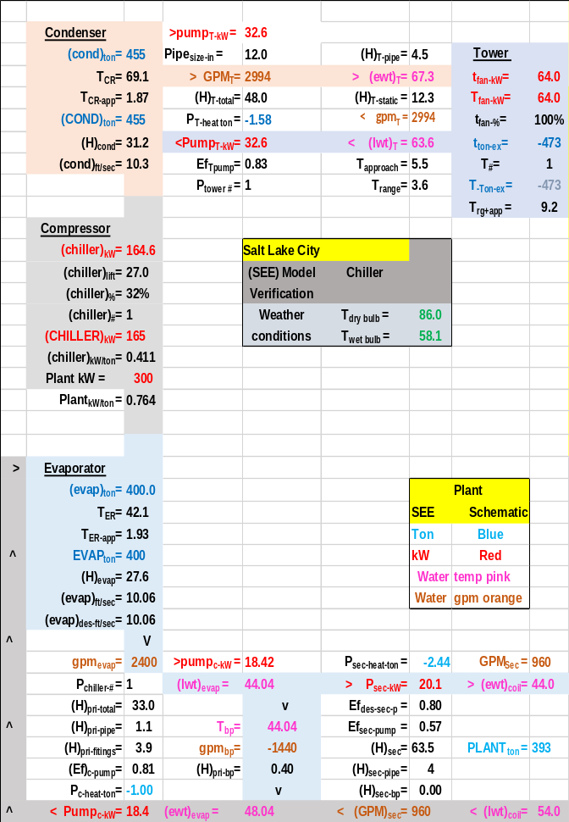Schematic 3-15: Plant at 400 ton evaporator load, 100% tower fan speed and chiller kW=164.6 resulting in 44.04F supply water & plant kW = 300.
Schwedler¹ table 3 shows a (183-165=18 kW) increase in chiller kW for 400 ton evaporator load and 50% tower fan speed verses 100% tower fan speed. (SEE) Model Schematics 3-15 & 3-16 show a (182.9-165.0=17.9kW) increase in chiller kW also show by above Tables 3-4 & 3-5. At these conditions chiller kW increases little while tower kW significantly decreases at 50% tower fan speed, resulting in a (300-265=35kW) decrease in plant kW for 50% tower fan operation.

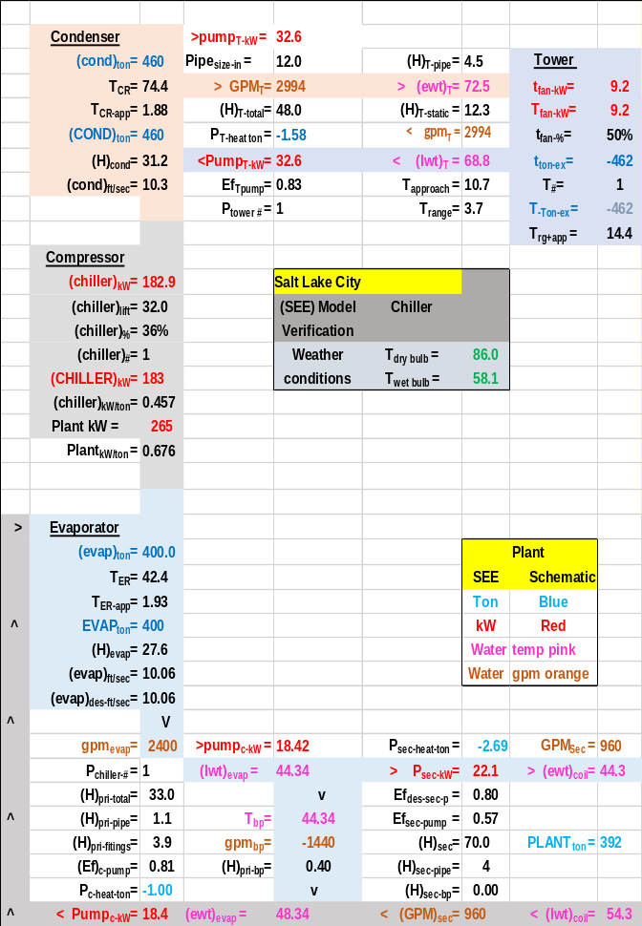Schematic 3-16: Plant at 400 ton evaporator load, 50% tower fan speed and chiller kW=182.9 resulting in 44.34F supply water & plant kW = 265.

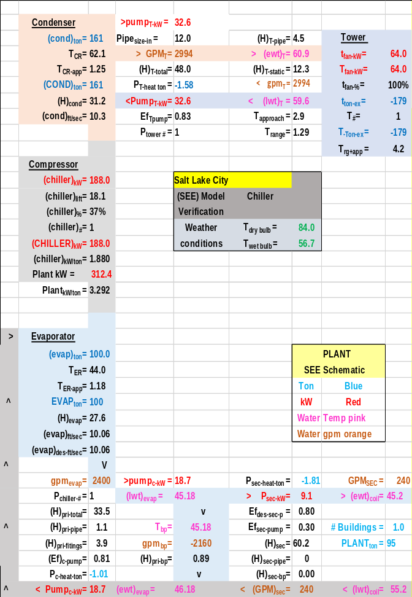Schematic 3-17: Plant at 100 ton evaporator load, 100% tower fan speed and chiller kW=228.5 resulting in 44.54F supply water.
The author is not aware of any data dealing with plant conditions similar to Schematics 3-17 & 3-18 at 10% evaporator load. The author welcomes discussion and input from all including chiller & tower manufactures.

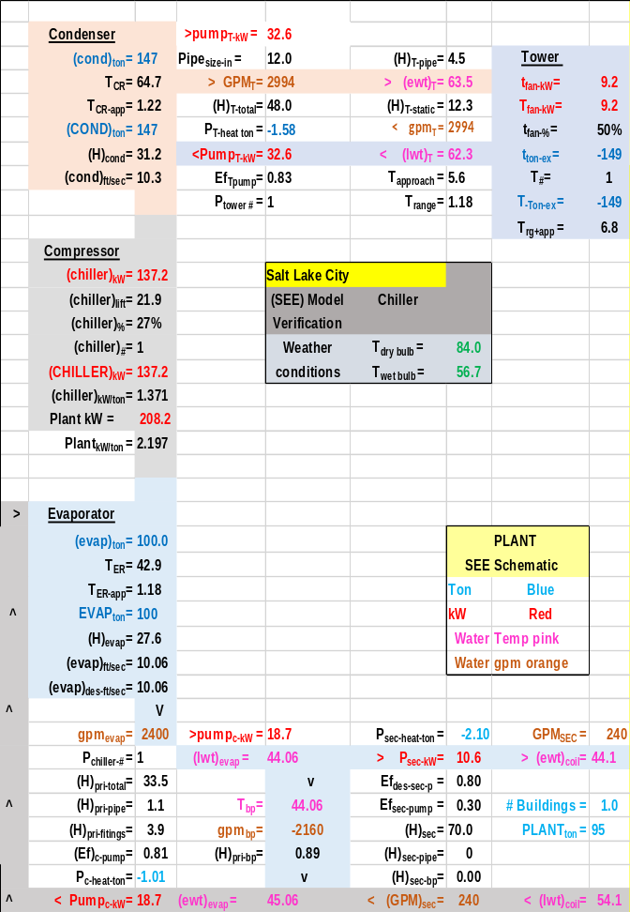Schematic 3-18: Plant at 100 ton evaporator load, 50% tower fan speed and chiller kW=152.3 resulting in 44.70F supply water.

(SEE) Model Plant Performance at 100% & 50% Tower fan speed
The above has shown that the (SEE) Plant Model duplicates the Schwedler chiller/tower data for Salt Lake City. The following will give additional (SEE) plant performance data which Schwedler¹ did not provide.
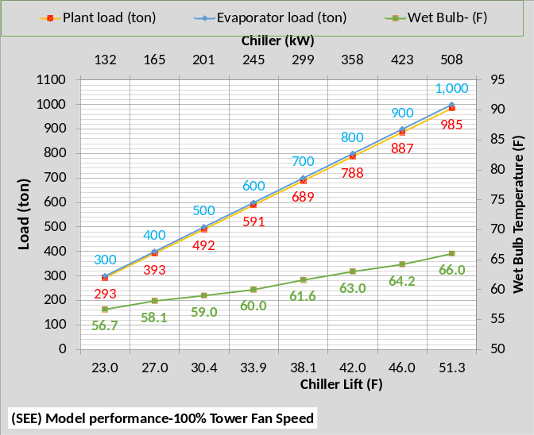 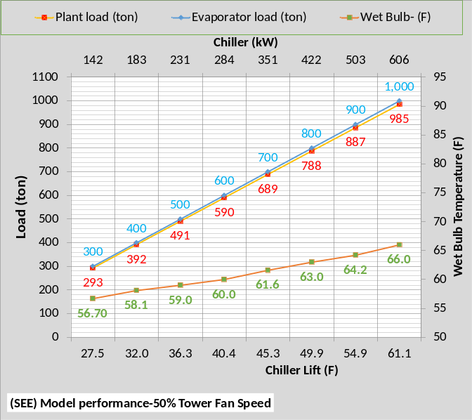Figure 3-17: Salt Lake City (SEE) Plant performance
Figure 3-17 gives the increase in chiller lift and chiller kW demand for 50% tower fan speed verses 100%. Also shown is the plant load that is less than the evaporator load because the P/S pumping adds load to the evaporator.
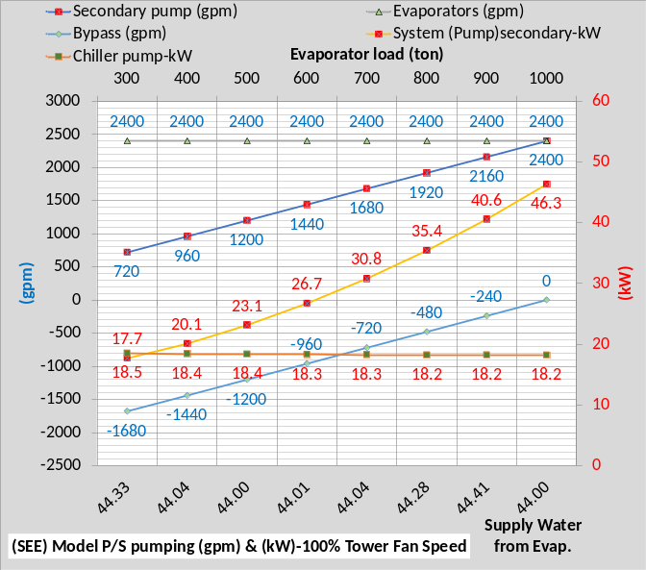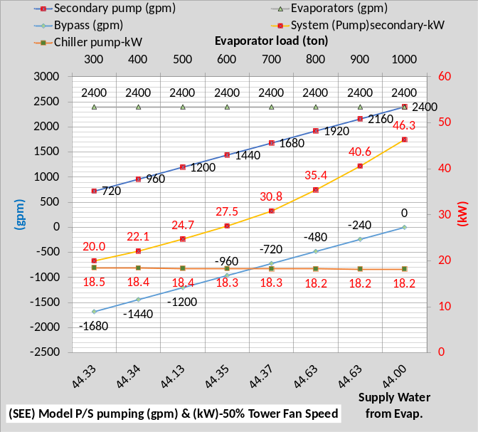Figure 3-18: Primary/Secondary pumping
Figure 3-18 illustrates that the tower fan speed does not affect the P/S pumping.
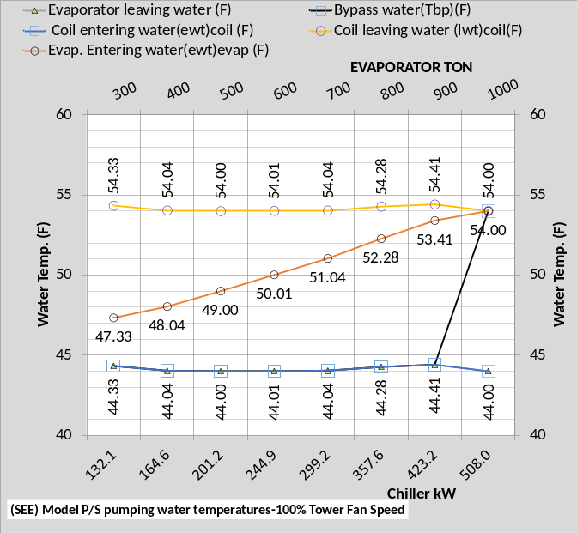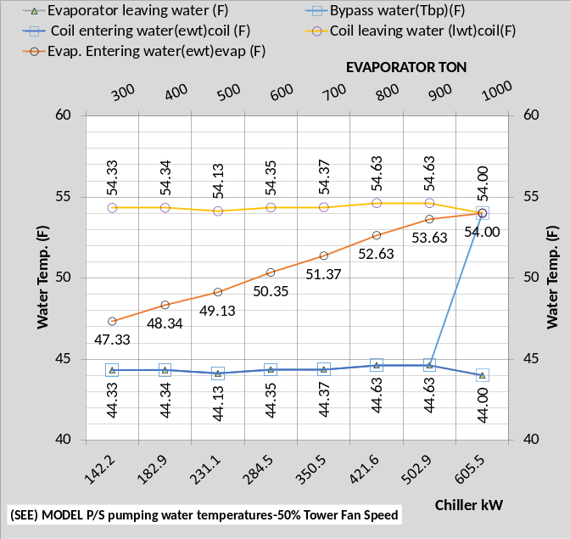Figure 3-19: P/S water temperatures
Figure 3-19 illustrates that the tower fan speed does not affect the P/S water temperatures. The slight difference in temperatures is due to the slight difference in water leaving the evaporator which is a function of chiller kW that is not exactly the same for both tower fan speeds due to the sensitivity of the (SEE) Model.
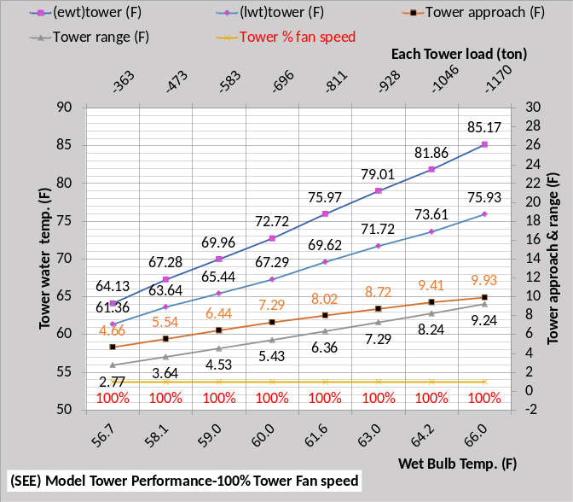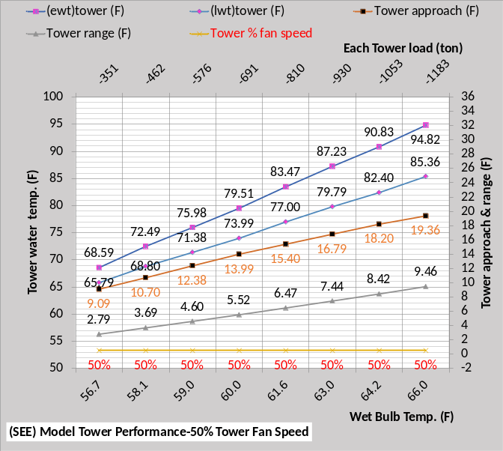Figure 3-20: Tower performance
Figure 3-20 illustrates a significant drop in tower performance with 50% tower fan speed. Tower range changes little but tower approach significantly increases with 50% tower fan speed, resulting in an increase in chiller lift as shown by each of the above schematics and therefore an increase in chiller kW to provide 44F supply water.
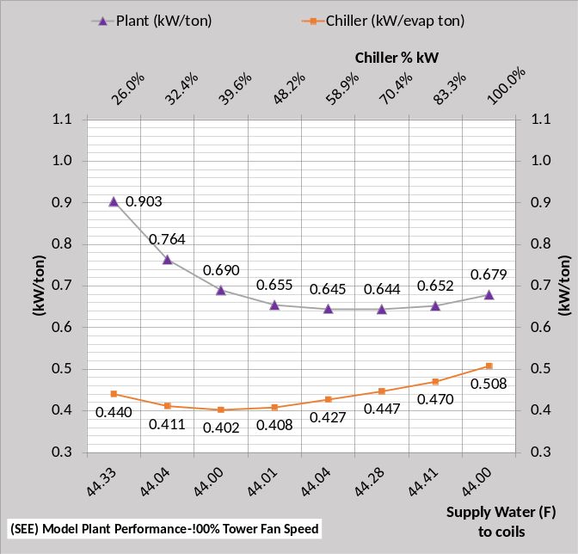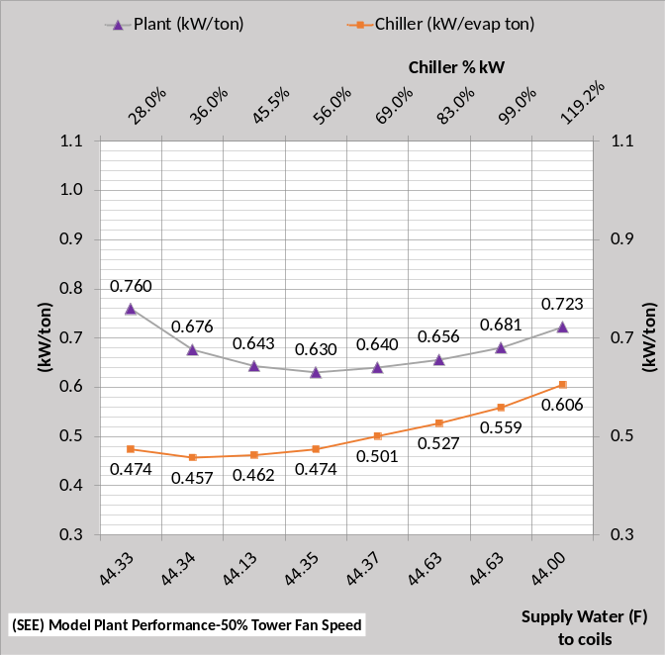Figure 3-21: (SEE) Model plant performance
Figure 3-21 gives the increase in chiller kW/ton with 50% tower fan speed and also shows the plant kW/ton is greater with 50% tower fan speed down to wet bulb 61.6F & 810 ton tower load then becomes less as load and wet bulb decrease. As previously discussed the plant kW/ton decreases with 50% tower fan speed because the chiller kW increase is less than the tower fan decrease.
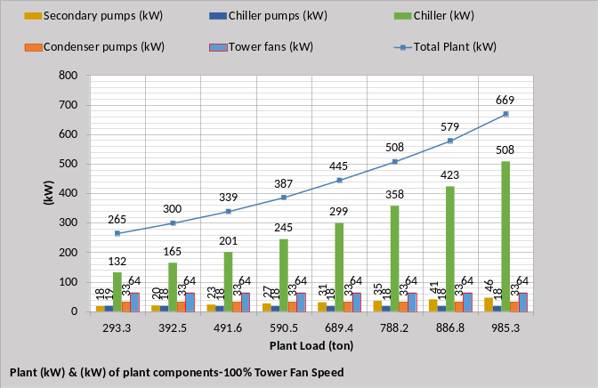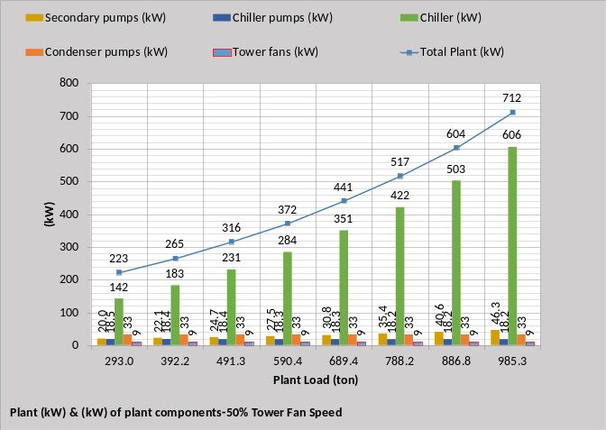Figure 3-22: Plant kW
Figure 3-22 gives the kW demand of the plant components illustrating the dominance of the chiller kW. The plant kW is less at 50% tower fan speed is less at 689.4 ton Plant load and below.

ENERGY IN = ENERGY OUT
Energy in = energy out is a fundamental thermodynamic requirement of a System Energy Equilibrium (SEE) Model. The following figures illustrate compliance with this basic thermodynamic requirement.
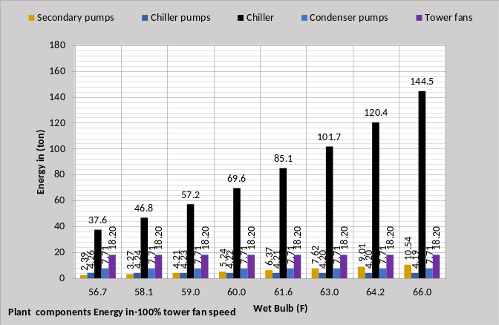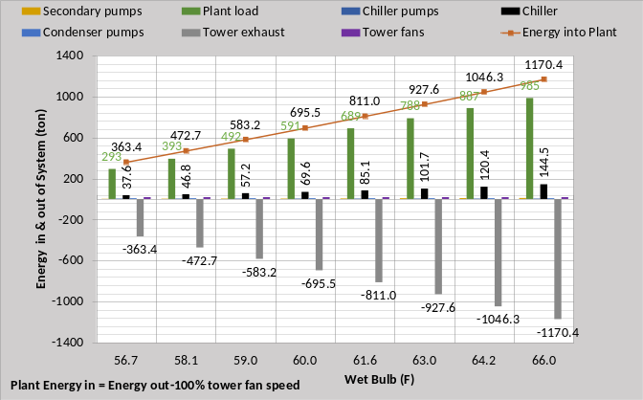Figure 3-23: Energy in = Energy out-100% tower fan speed
The top chart of Figure 3-23 gives the pumps and tower fan energy in (ton) which is also on the bottom chart but difficult to read. The plant load is the big energy in component and the tower exhaust is the total energy out.
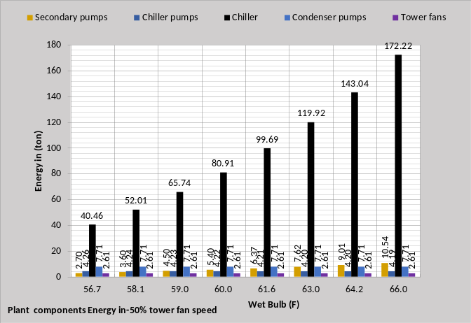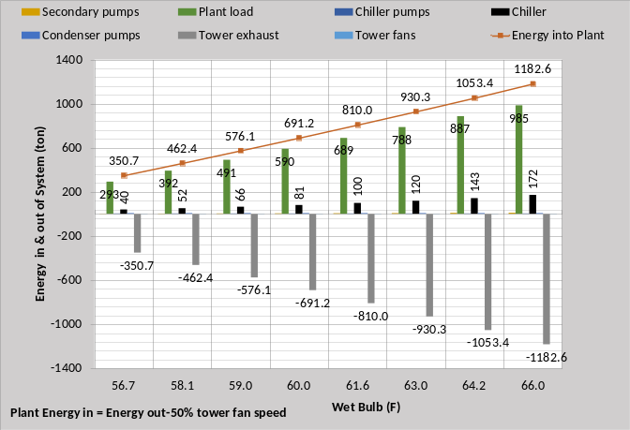Figure 3-24: Energy in = Energy out-50% tower fan speed
Figure 3-24 gives energy in = energy out for 50% tower fan speed illustrating the smaller values for 50% fan speed at wet bulb 61.6F and below.
Chiller Lift (F)
Chiller lift is the difference in the refrigerant temperatures of the condenser minus the evaporator refrigerant temperature⁵. The evaporator refrigerant temperature is largely set by the evaporator water supply temperature and therefore varies little compared to the condenser refrigerant temperature. Figure 3-20, Tower Performance, illustrates how the tower entering water temperature varies with load and wet bulb temperature. Tower entering water temperature is also the condenser leaving water temperature which in large part sets the condenser refrigerant temperature.
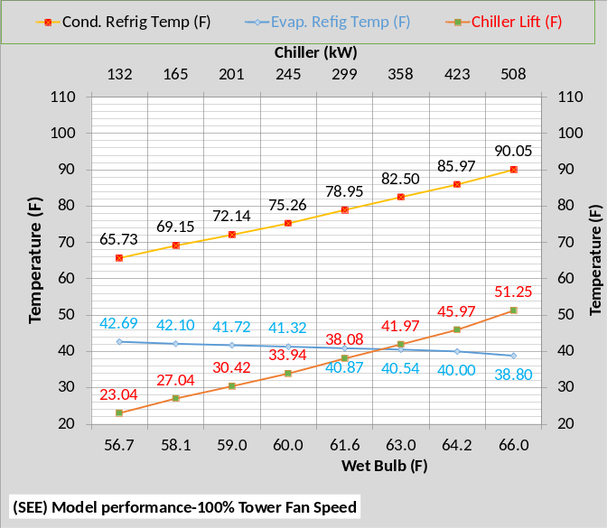 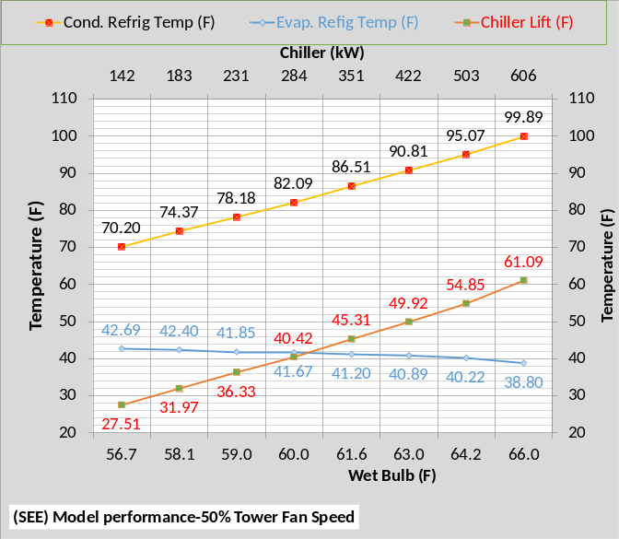Figure 3-25: Chiller Lift (F)
Figure 3-25 gives the refrigerant temperatures and chiller lift for both 100% & 50% tower fan speed. Tower fan speed of 50% versus 100% increases the tower entering water temperature and therefore the condenser refrigerant temperature resulting in increased chiller kW as shown by Figure 3-22.

Chapter 3 is an attempt by the author to give the reader confidence in the Salt Lake City (SEE) Plant Model. The author is open to questions and additional data and clarifications as may be requested by readers. Similar analysis and verification for Schwedler’s Salt Lake City data is given by chapters 3.
This completes the analysis of the three data tables presented by Schwedler¹.
The next Chapter 4 will show that installing the ARI conditions into the (SEE) Model gives the correct ARI chiller kW demand.

Chapter 4: ARI Chiller modeled
Page 33 of Schwedler¹ states “Since the present “industry-average” chiller is based on 0.60-kW/ton performance at ARI Standard 550 rating conditions, the “base” chiller was selected at those parameter”. This chapter will show that the (SEE) Model of the Kansas City chiller of Chapter 1 duplicates the ARI 0.60 kW/ton when a 7F approach tower is installed in the (SEE) model.
(SEE) model Tower | KC Tower | ARI Tower
Design Wet bulb | 78.0F | 78.0F
Design Load | 1155 ton | 1179 ton
Tower water flow | 3000 gpm | 3000 gpm
App. temperature | 4.0 F | 7F
Range | 9.27F | 9.46F
Range + app. | 13.27F | 16.46F
Tower fan kW | 96 kW¹ | 60 kW
Selected Tower | NC8403TLS3 | NC8411WAN1
Cold water | 82F | 85F
Return water | 91.27F | 94.46F
Capacity | 102.9% | 100.5
ASHRAE 90.1 | 43.5 gpm/HP | 46.9 gpm/HP
Static lift | 12.234 ft. | 19.19 ft.
Table 4-1

Table 4-1 gives the difference in the two tower selections. The ARI tower is a 7F approach tower giving 85F cold water verses the 82F cold water for the 4F approach tower as developed in Chapter 1 where the Kansas City data of Schwedler¹ was duplicated with the (SEE) Model. This increase in approach reduces the selected tower fan kW from 96 to 60 kW for the ARI tower.
Figure 4-1 illustrates the difference in cold water from the tower or entering condenser water temperature (ECWT-F). Table 4-1 illustrates why. The Kansas City tower is selected to provide 82F cold water and the ARI tower is selected to provide 85F cold water.
Figure 4-2 gives the increase in chiller lift for the ARI chiller as a result of the 85F tower design cold water verses the 82F cold water of the KC tower. An increase in lift results in an increase in chiller kW as shown by Figure 4-3 below.
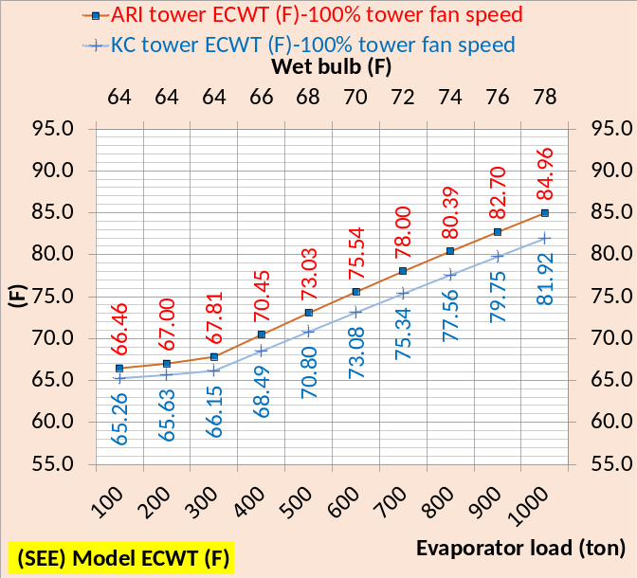Figure 4-1: Tower cold water (F)-ARI Tower vs Kansas City Tower
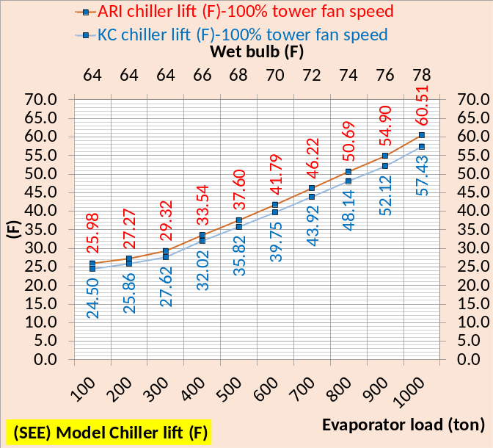Figure 4-2: ARI Chiller lift & KC Chiller lift
Schematic 1-4 & 4-1 below illustrate the two plants at peak conditions.

Schematic 1-4 copied: Plant at 1000 ton evaporator load, 100% tower fan speed, supply water 44.05F, and chiller kW=566.
The only change made to the ARI plant of Schematic 4-1 was to install the tower as defined by Table 4-1 and then increase the chiller kW to provide 43.8F supply water.
The P/S pumping and evaporator conditions are essentially the same as illustrated by the schematics. The condenser/tower loop is where the changes occurred that required an increase in chiller kW for the ARI plant. The tower pump kW increased from 32.6 to 38.1 kW due to the slight increase in gpm and the static lift of 19.2 ft. verses 12.3 ft. for the KC plant.
The plant kW of the ARI plant increased (762.7-759.2=3.5 kW) due to the chiller increase but the tower kW reduced with the ARI plant from 96 kW to 60 kW.
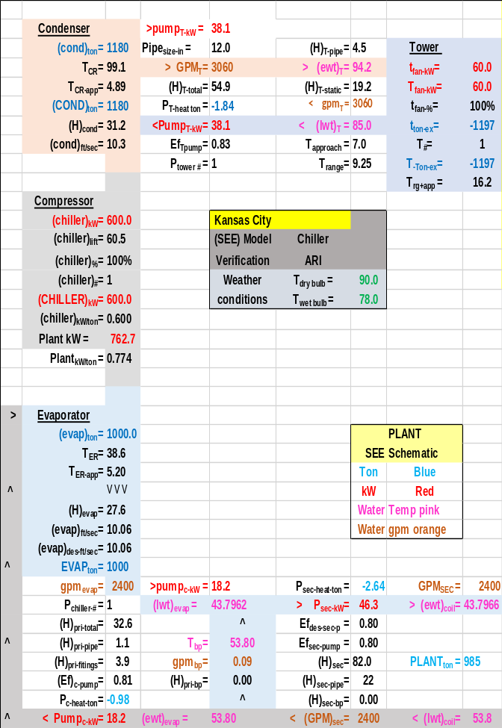Schematic 4-1: ARI chiller plant at 1000 ton evaporator load, 100% tower fan speed, supply water 43.8F, and chiller kW=600.
Schwedler¹ states “Since the present “industry-average” chiller is based on 0.60-kW/ton performance at ARI Standard 550 rating conditions, the “base” chiller was selected at those parameter”. The (SEE) plant model finds the “base chiller” to be as defined by Schematic 4-1.
The following figures will compare the ARI plant of this chapter and Kansas City (KC) plant as developed in Chapter 1.

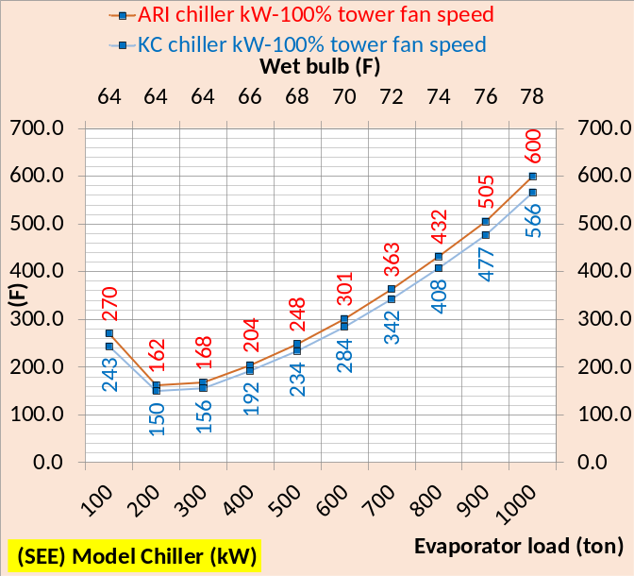Figure 4-3: (SEE) Model chiller kW
Figure 4-3 illustrates that the ARI chiller kW is greater than the KC chiller kW for all evaporator loads given.
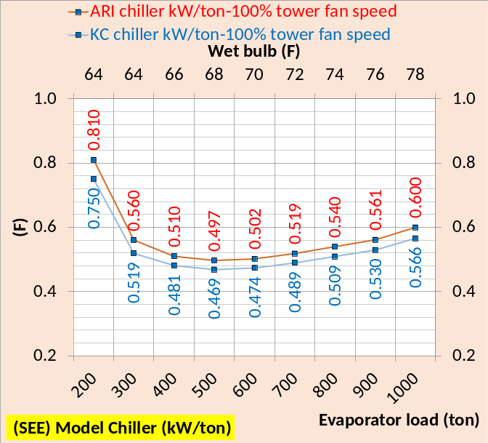Figure 4-4: (SEE) Model chiller kW/ton
As a result the chiller kW per evaporator load is greater for the ARI chiller as shown by Figure 4-4.

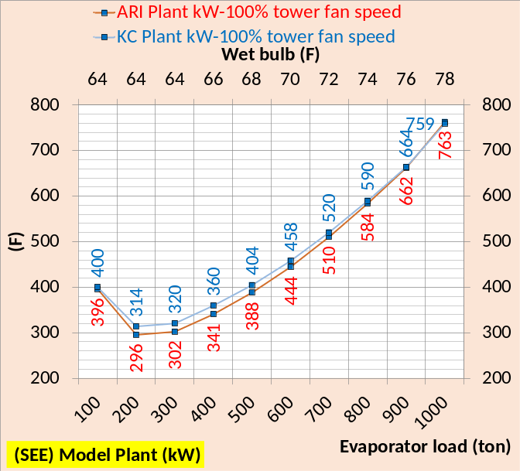Figure 4-5: (SEE) Model Plant kW
Figure 4-5 shows the ARI plant kW is less than the KC plant except at peak design conditions also as shown by Schematics 1-4 & 4-1 above.
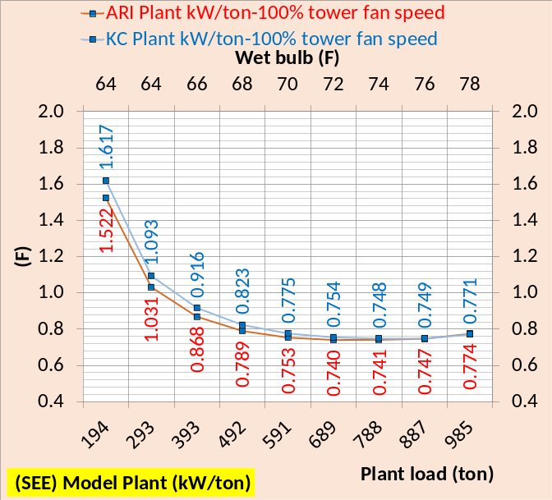Figure 4-6: (SEE) Model Plant kW/ton
Figure 4-6 shows the plant kW per plant load is consistent with Figure 4-5.
The next three sets of schematics will show the two plants at 700 ton, 400 ton & 100 ton evaporator loads so the reader can study the full plant differences.

Schematic 4-2: KC chiller plant at 700 ton evaporator load, 100% tower fan speed, supply water 44.07F, and chiller kW=342.4 & plant kW=520

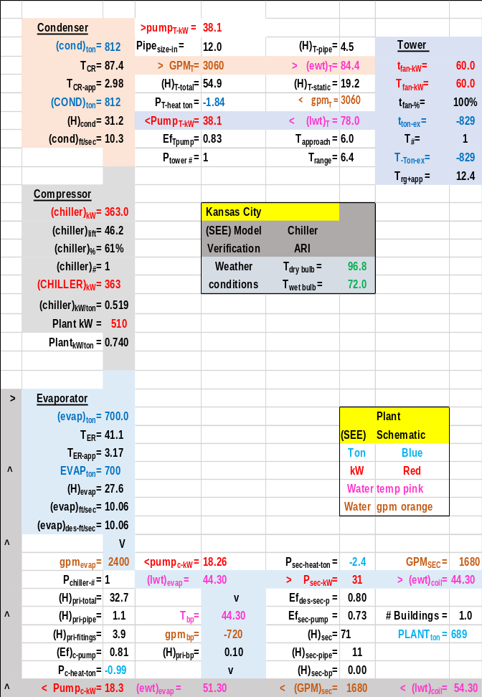Schematic 4-3: ARI chiller plant at 700 ton evaporator load, 100% tower fan speed, supply water 44.3F, and chiller kW=363.0 & plant kW=510

Schematic 4-4: KC chiller plant at 400 ton evaporator load, 100% tower fan speed, supply water 44.0F, chiller kW=192.4 & plant kW=360

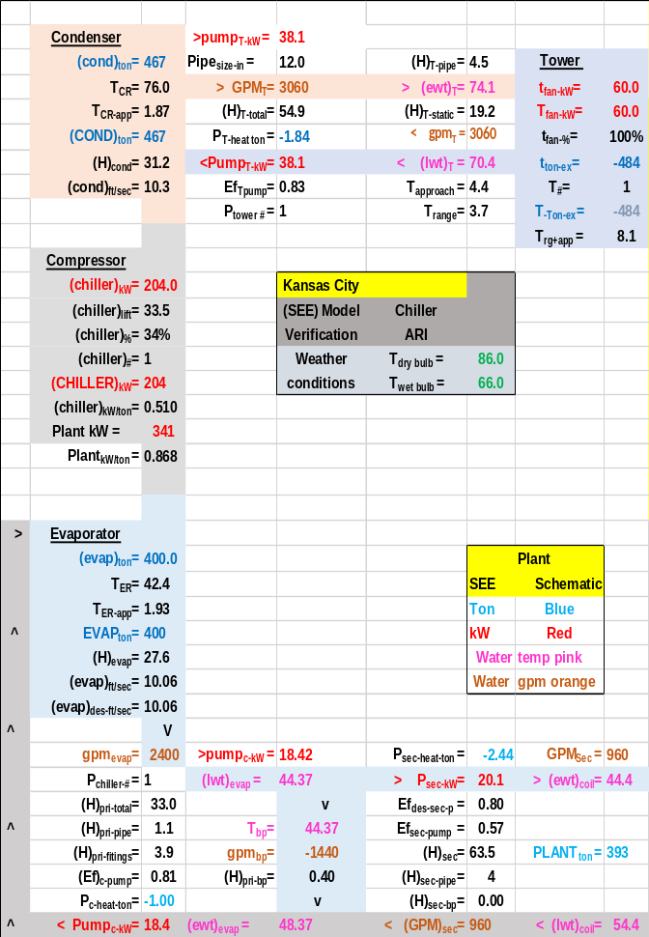Schematic 4-5: ARI chiller plant at 400 ton evaporator load, 100% tower fan speed, supply water 44.4F, chiller kW=204.0 & plant kW=341

Schematic 4-6: KC chiller plant at 100 ton evaporator load, 100% tower fan speed, supply water 44.63F, chiller kW=243.4 & plant kW=399.8

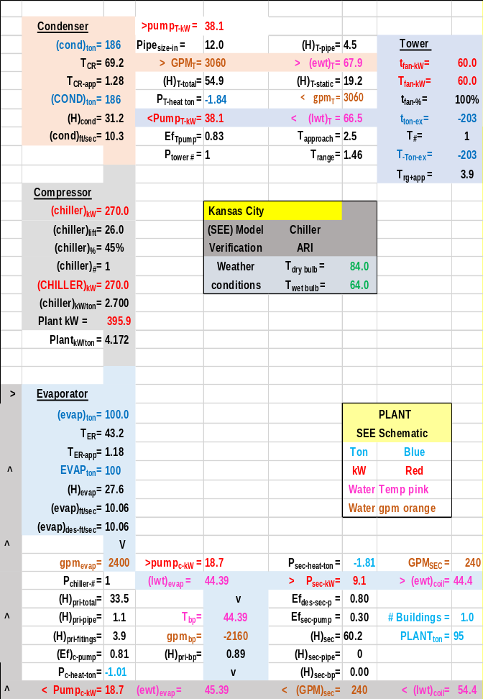Schematic 4-7: ARI chiller plant at 100 ton evaporator load, 100% tower fan speed, supply water 44.4F, chiller kW=270.0 & plant kW=395.9

Summary Regarding (SEE) Model Verification of Schwedler¹ data.
The objective of a System Energy Equilibrium (SEE) Model is to duplicate the hourly performance of the real system at all operational conditions. To accomplish this the (SEE) model must obey the laws of thermodynamics and input the nonlinear characteristics of the real system components and model all details of the system that contribute to the performance of the system.
These first four chapters have demonstrated a chiller/tower plant (SEE) Model that duplicates the performance of a Kansas City chiller/tower, Long Beach chiller/tower, Salt Lake City chiller/tower, and ARI chiller as defined by Schwedler¹. The following three tables, from above chapters, illustrate the performance of the (SEE) model to duplicate manufacture’s data as presented by Schwedler¹.
Table 4-2: Kansas City Model vs. Manufactures data¹.
The only changes made in the model to duplicate the Long Beach and Salt Lake City data is to install a new tower and change the ambient temperatures.
Table 4-3: Long Beach Model vs Manufactures data¹
Table 4-4: Salt Lake City Model vs Manufactures data¹
As stated in the introduction a chiller/tower (SEE) Model provides the following capabilities.
- Plant design tool.
- Answers “Is the plant operating as designed”?
- Define why plant performance is substandard.
- Define plant control strategies.
- Define causes of plant degradation.
- Define upgrading or expansion of plant.
- Model issues raised by technical publications.

The Schwedler¹ chillers of the first three chapters were low cost chillers with evaporator and condenser refrigerant approach temperatures of about 5.0F each. The next Chapter 5 will present chiller manufactures selection data¹⁹ for 32 chillers, illustrating some very important characteristics of chiller/tower systems.
CHAPTER 5: Chiller selection data for Kansas City Chiller plant
The following data analysis is of a chiller manufacture’s selection data for 32 combinations of evaporators, condensers, and motors to provide 44F supply water for a load of 1000 ton and 82F entering condenser water temperature (ECWT). The author greatly appreciates the manufacture providing this data¹⁹.
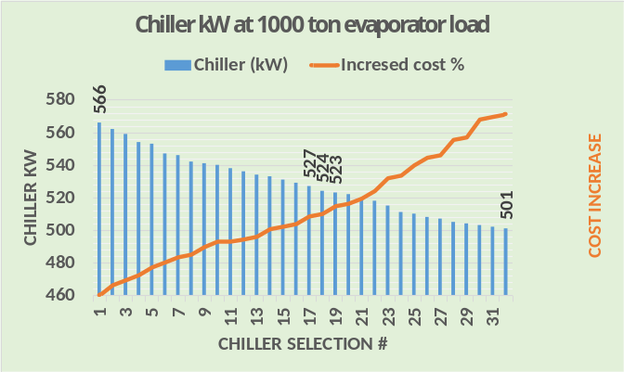Figure 5-1: Chiller kW vs. chiller cost
Figure 5-1 illustrate a fundamental, as the chiller kW decreases for a given load, 1000 ton for this discussion, the cost of the chiller increases. Note that the chiller kW decreased from 566 kW down to 501 kW. Why chiller kW decreased is in general because chiller lift (F) decreased and why chiller lift decreased is in general because a more expensive evaporator and/or condenser was selected that had smaller refrigerant approach temperatures.
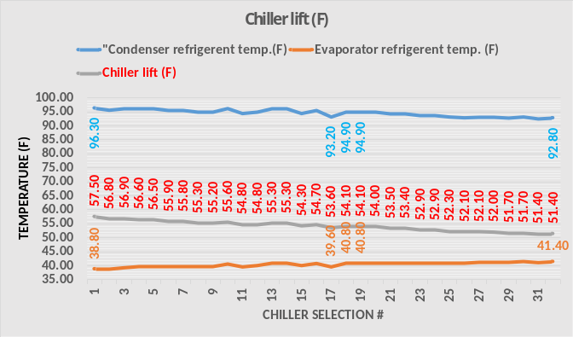Figure 5-2: Chiller lift & refrigerant temperatures
Figure 5-2 illustrates the drop in the condenser refrigerant temperature and the increase in the evaporator refrigerant temperature resulting in a general decrease in chiller lift for the 32 chiller selections. However, a careful review of Figure 5-2 illustrates that lift does not always decrease with a decrease in chiller kW. From Figure 5-1, chiller #17 kW is 527, #18 = 524 kW, and #19 = 523 kW. However Figure 5-2 shows that lift increased from #17 to #18 and #19 was the same as #18, however chiller kW decreased from #17 to #19. The manufactures data indicates that for chillers #17 & #18 the following changed. The condenser & evaporator refrigerant approach temperature, the evaporator bundle size, the evaporator tube type, orifice size, inlet guide vane, and evaporator and condenser water pressure drop. The point is, I believe, reducing chiller lift by reducing refrigerant approach is the primary reason chiller kW decreases but there are several other components changes the manufacture makes to reduce chiller kW and not significantly increase the chiller cost. A very complex problem that each manufacture will likely approach differently. It is incumbent on the plant designer to request, question, and evaluate each manufacture’s proposed chiller selection list.
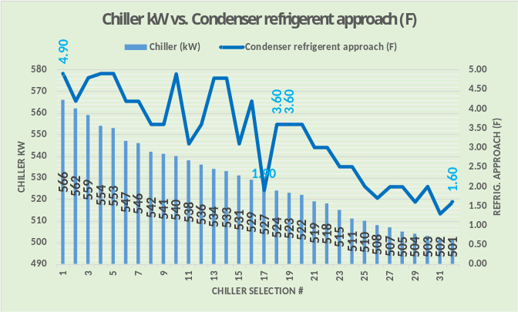Figure 5-3: Chiller kW & condenser refrigerant approach temperature (F)
Figure 5-3 gives the condenser refrigerant approach temperature for the 32 selections and Figure 5-4 gives the evaporator refrigerant approach temperatures. There is a general decrease in approach temperature for both the condenser and evaporator but with ups and downs along the way.
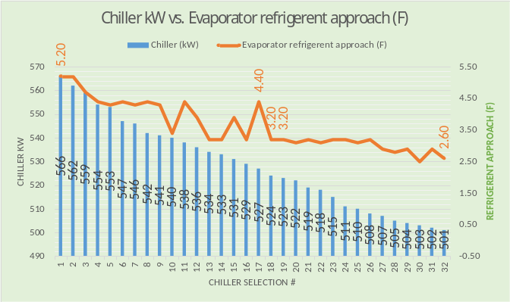
Figure 5-4: Chiller kW & evaporator refrigerant approach temperature (F)

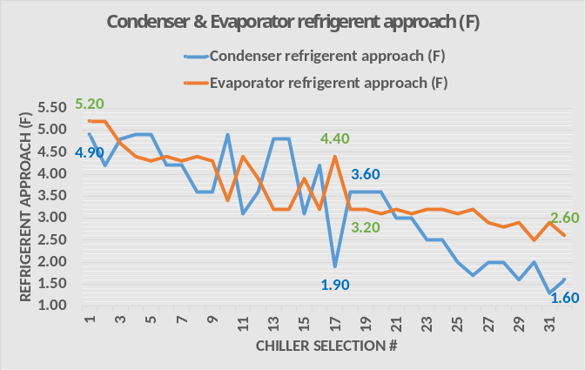Figure 5-5: Condenser and evaporator refrigerant approach temperatures (F)
Figure 5-5 illustrates both the condenser & evaporator refrigerant approach temperatures for each of the 32 chiller selections. Clearly the manufactures combination of condenser and evaporator plus the other details defined above is a very complex problem to always achieve a decrease in chiller kW with minimum increase in cost.
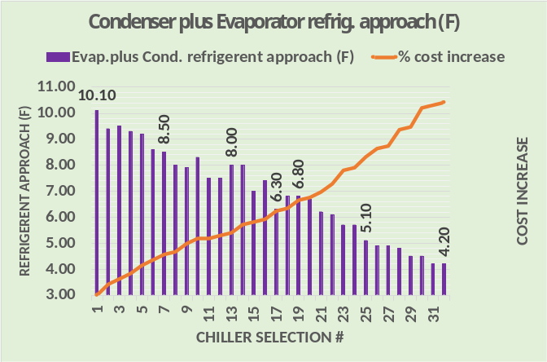Figure 5-6: Condenser + evaporator refrigerant approach (F) vs cost
Figure 5-6 illustrates that the sum of the approach temperatures is the primary reason the chiller kW demand decreases, for a given load, but is not the only reason given that for some selections the approach sum increased as the chiller kW decreased.
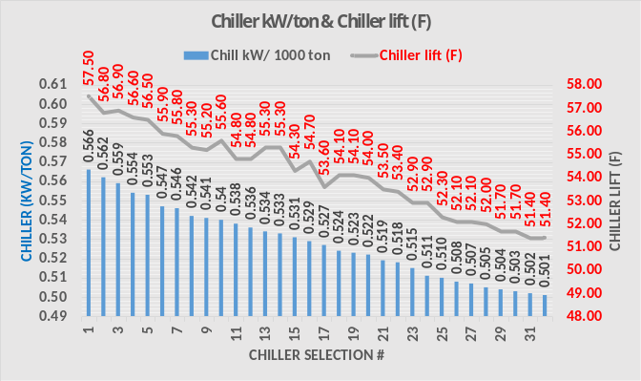Figure 5-7: Chiller lift (F) & chiller kW/ton
Figure 5-7 shows that the chiller kW/ton always decreases but the chiller lift does not always decrease. Again making the point that the manufacture must in general select a condenser and evaporator that in sum reduces refrigerant approach temperature but there are other component changes that fine tune the chiller performance.
Condenser & evaporator pressure drop
At this point one might conclude that if one is willing to pay the cost chiller #32 gives the best performance. However plant performance not chiller performance is the bottom line and pressure drop thru the condenser and evaporator becomes a necessary and significant issue.
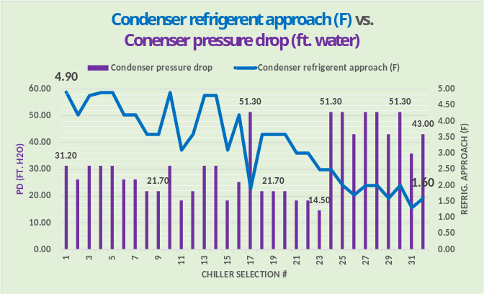Figure 5-8: Condenser approach and pressure drop
Figure 5-8 illustrates that in general the condenser water pressure increases as the refrigerant approach temperature decreases, but not always. Chiller #17 pressure drop is 51.3 for an approach of 1.9F (Figure 5-5). Chillers #24 thru #32 have similar approach temperatures and high pressure drops.
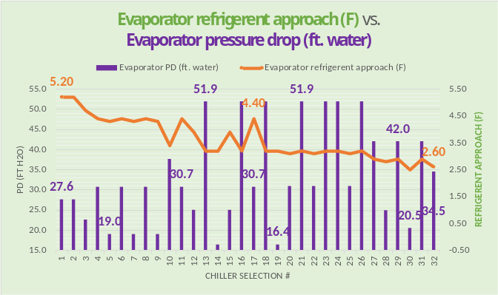Figure 5-9: Evaporator approach and pressure drop
Figure 5-9 gives the evaporator refrigerant approach and pressure drop illustrating a wide variation of values.
Figure 5-10 gives both condenser and evaporator pressure drop illustrating that in general if the condenser pressure drop is low then the evaporator pressure drop is relatively high for this particular set of 32 chiller selections.
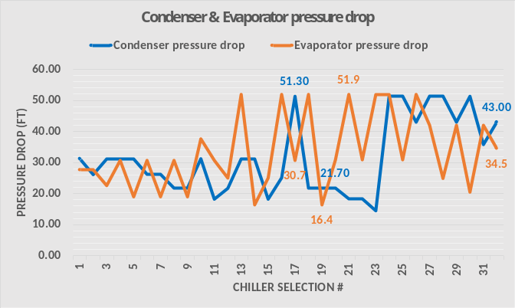Figure 5-10: Condenser and evaporator pressure drop
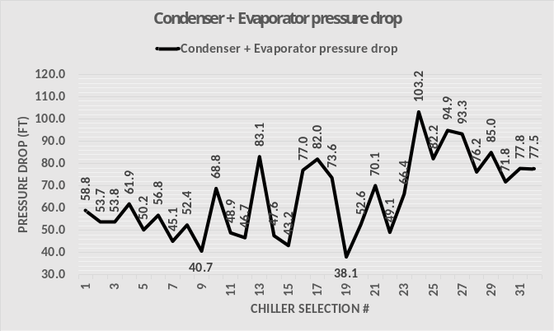Figure 5-11: Condenser + evaporator pressure drop
Figure 5-11 sums the pressure drops illustrating chiller #9 has a low value of 40.7 feet of water but #19 at 38.1 is the lowest. Chiller #24 has the highest sum and the best kW/ton chiller #32 has a summed pressure drop of 77.5 feet of water.
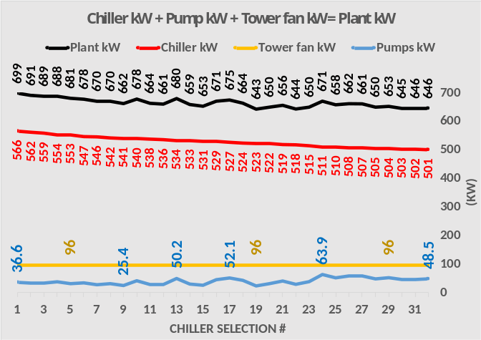Figure 5-12: System kW
Pressure drop directly relates to the pumping kW thru the condenser and evaporator as given by Figure 5-12. The tower fan kW is a constant 96 and the chiller kW is a function of the condenser and evaporator refrigerant approach temperatures and decreases from chiller #1 to #32. The pumping kW is the variable that results in a plant kW that does not follow the chiller kW. Figure 5-12 shows that chiller #19 has the lowest plant kW at 643 kW and chiller #32 with the lowest chiller kW at 501 kW and a plant kW of slightly more at 646 kW.
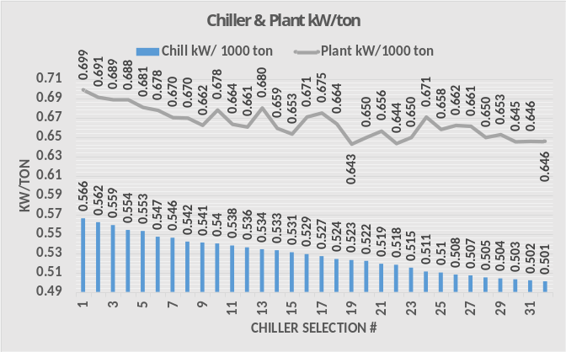Figure 5-13: Chiller and plant kW/ton
Figure 5-13 gives the chiller kW and plant kW for the 1000 ton evaporator load. However it should be recognized that the plant load of a real system is the load from the building or coil loads picked up by the secondary pumping and delivered to the evaporators. Therefore the plant load is less than the evaporator load because the primary/secondary pumping adds load to the system. This detail will be covered more clearly in a chapter below.
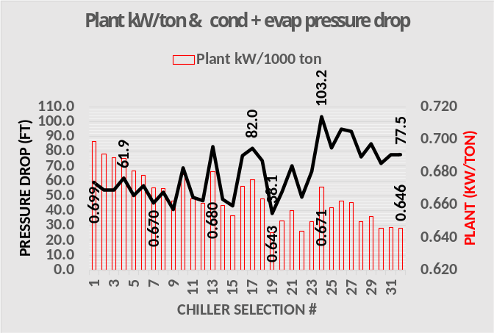Figure 5-14: plant kW per 1000 ton and condenser + evaporator pressure drop
Figure 5-14 further illustrates the effect of pressure drop and pumping kW on plant kW. The point is; selecting the most efficient chiller #32 gives a plant kW that is slightly more than the plant kW of a less cost chiller #19.
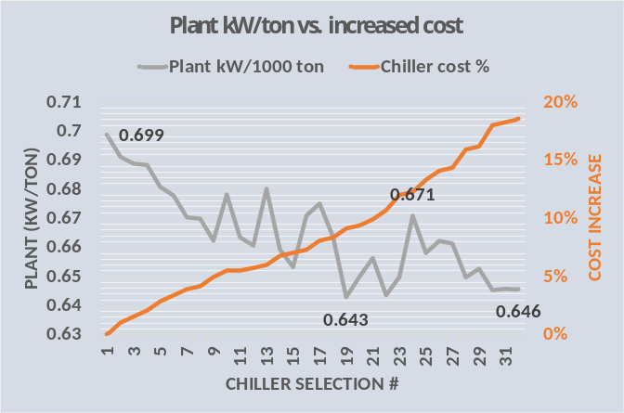Figure 5-15: Plant kW/ton vs. chiller % cost increase.
Figure 5-15 illustrates that the best chiller buy for these particular conditions is chiller #19 with a chiller kW/ton of .523 giving a plant kW/ton of .643 with chiller #32 at .501 kW/ton has a plant kW/ton of .646 slightly more than #19.
Figure 5-15 shows that, for the day and conditions these estimates were received, chiller #19 cost about 9% more than chiller #1 and chiller #32 costs about 19% more than #1 chiller. However these cost numbers should be viewed as trends and not absolute and recognize that the data was received in 2001.
Figure 1 of Chapter 1 discussed the necessary input to the (SEE) plant model, COP ratio.
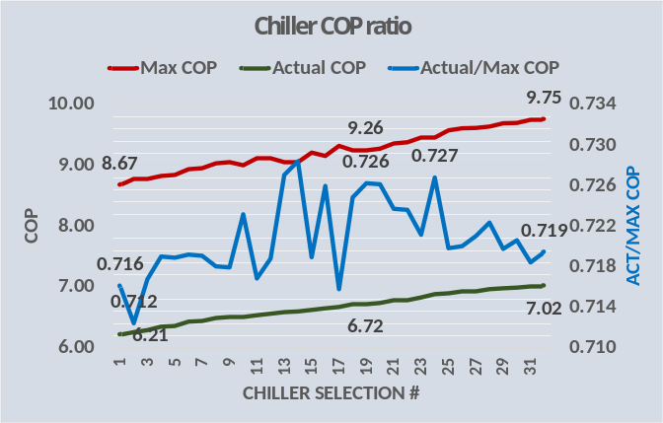Figure 5-16: Chiller COP
Figure 5-16 gives the design COP values for the 32 chiller selections. The max COP increases from 8.67 to 9.75 and the actual COP increases from 6.21 to 7.02. The ratio of actual COP to max COP has a low value of .712 for chiller #2 and a high value of .727 for #24 chiller.
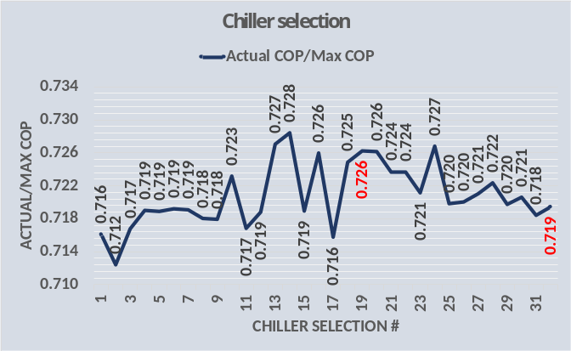Figure 5-17: COP ratio for 32 chiller selections
Figure 5-17 gives the design COP ratios for the 32 chillers. The mean value is .72 with the minimum and max values being only plus or minus .008 or plus or minus 1% from the mean value.
Chiller selection Data summary
The manufactures data¹⁹ obtained by the author showed the tube type of each condenser and evaporator and chiller #19 was the last selection using a tube type we will call (A). All chiller selections #20 thru #32 used a condenser & evaporator tube type (B). Apparently the manufactures tube type (A) was limited, for this application, to a minimum refrigerant approach of about 3.5F and further reductions in refrigerant approach required a more expensive tube type (B).
In summary, chiller selection is not the issue. Plant design/selection is. Each manufacture will have a set of motors, condensers and evaporators to meet a given set of peak design conditions. Evaluating each manufactures chillers as they define the plant performance is the challenge.

CHAPTER 6: (SEE) Plant Model of Manufacture’s chiller selection data

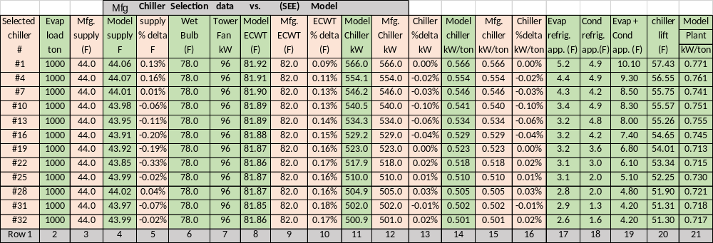Table 6-1: Manufactures chiller selection data & (SEE) Model of Kansas City chiller plant

Table 6-1 gives the results of the (SEE) model simulation of the chiller selection data for 12 chillers of the 32 chiller selections given by Chapter 5. The 12 selections of row 1 were made at 1000 ton evaporator load and an entering condenser water temperature (ECWT) of 82F as given by rows 2 & 9 with row 8 giving the modeled ECWT. Rows 3 & 4 give the supply water temperatures of the selection data that can be a constant 44F, versus the modeled supply water of row 4 that varies a little from 44F due to the sensitivity of the model. Rows 11 & 12 give the selection chiller kW & the modeled chiller kW, showing very close agreement.
Rows 17 thru 20 illustrate an important point. Row 17 gives the evaporator refrigerant approach temperature and row 18 the condenser value with row 19 giving the sum of the two values. Row 20 gives the modeled chiller lift and clearly the drop in lift follows the drop in chiller kW of row 11. That’s the point; for a given set of design conditions chiller manufactures improve chiller kW/ton by installing condensers and evaporators with smaller refrigerant approach temperatures and typically more cost as discussed in Chapter 5.
Figure 6-1 gives the chiller kW and sum of the condenser plus evaporator refrigerant approach temperatures of Table 6-1, illustrating how the chiller kW drops for this set of chillers as the refrigerant approach temperature decreases.
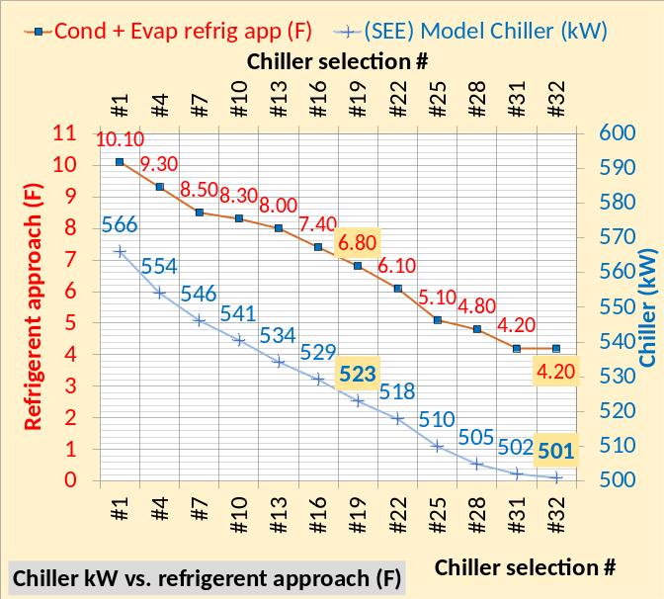Figure 6-1: Chiller kW verses sum of refrigerant approach temperatures
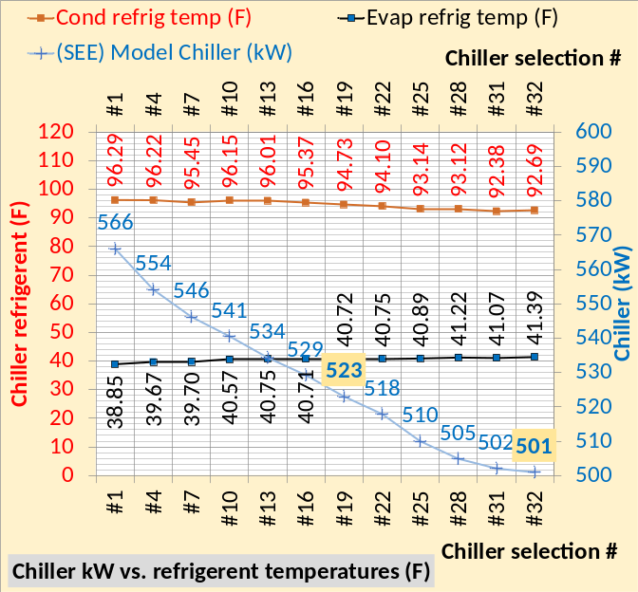Figure 6-2: Chiller kW vs. condenser & evaporator refrigerant temperatures
Figure 6-2 illustrates how the condenser and evaporator refrigerant temperatures change, not always less for both, but the difference (Cond (F)-Evap (F)) = chiller lift decreases as shown by Figure 6-3.
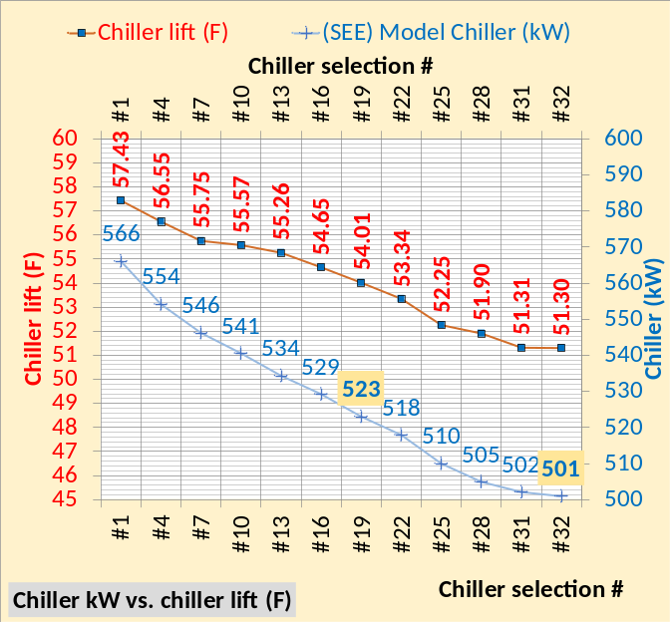Figure 6-3: Chiller kW vs chiller lift (F)
Figure 6-3 illustrates that for this set of chillers the chiller kW drops about 10.6 kW per degree F drop in lift.
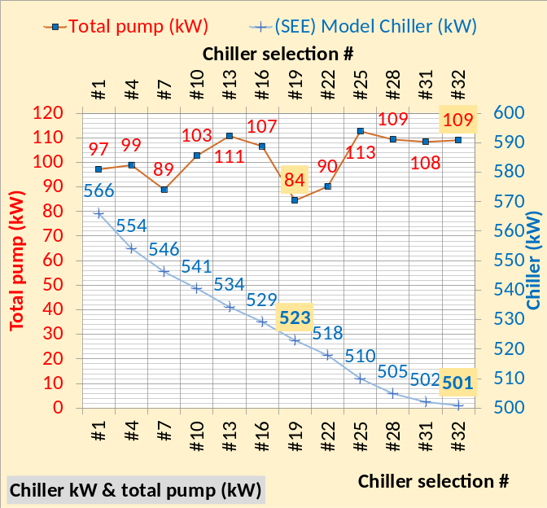 Figure 6-4: Chiller kW and total pump kW
Figure 6-4 illustrates a point made in Chapter 5; in general as the refrigerant temperature drops the pressure drop thru the condenser and evaporator increases.
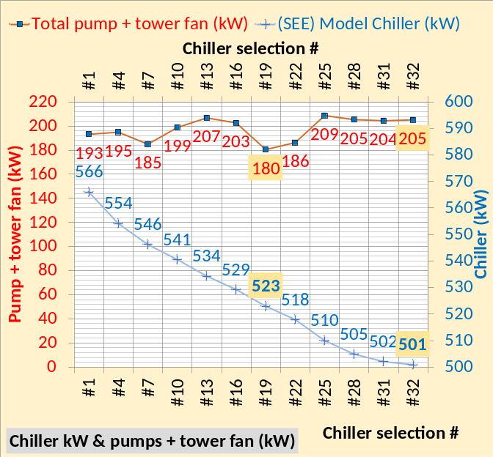Figure 6-5: Chiller kW vs pumps + tower fan kW
Figure 6-5 illustrates the plant kW by summing the two curves. At design, chiller #1, plant kW = 566 kW + 193 kW = 759 kW. Chiller #32 = 501 kW + 205 kW = 706 kW a value 53 kW less; therefore the more expensive #32 chiller must be considered.
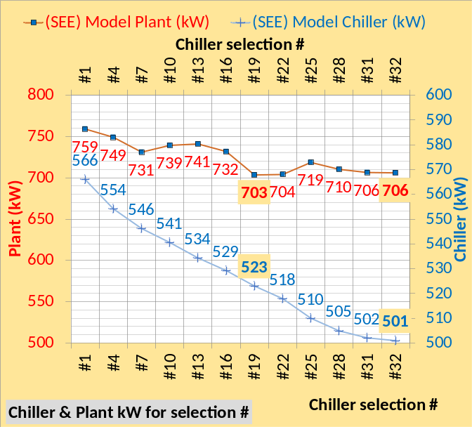Figure 6-6: (SEE) Model Chiller & Plant kW for 12 chiller selections of Chapter 5, Kansas City
Figure 6-6, for this set of chillers, gives the data necessary to make a good chiller selection decision. Chiller #19 gives the lowest plant kW of 703 with chillers #31 & #32 at 706 plant kW.
The next Chapter 7 will install a chiller/tower as called for by GreenGuide⁶ and Taylor⁷. These two documents call for a tower range plus approach of about 23F, resulting in a high lift chiller and therefore increased chiller kW/ton. Therefore the plant design engineer would likely select the lowest chiller kW/ton, in this case chiller #32 which will be the chiller studied in the remainder of this paper defined as the high lift chiller/tower plant.
The high lift chiller/tower plant, as called for by GreenGuide⁶ & Taylor⁷, will be compared to the authors¹⁴ suggested low lift chiller/tower plant that utilizes chiller #19 that has a chiller kW/ton significantly greater than #32 at these conditions but an approximately equivalent plant kW/ton as illustrated by Table 6-1.
GreenGuide⁶ & Taylor⁷, as stated above, call for a tower range plus approach of about 23F which significantly increases the kW/ton of the high lift chiller design to be more clearly discussed below in Chapter 7, 8, & 9.
To further illustrate the capabilities of the (SEE) model to provide understanding, six schematics follow. The reader can study the side by side schematics and develop a better understanding of how the plant performance changes with different condensers and evaporators.

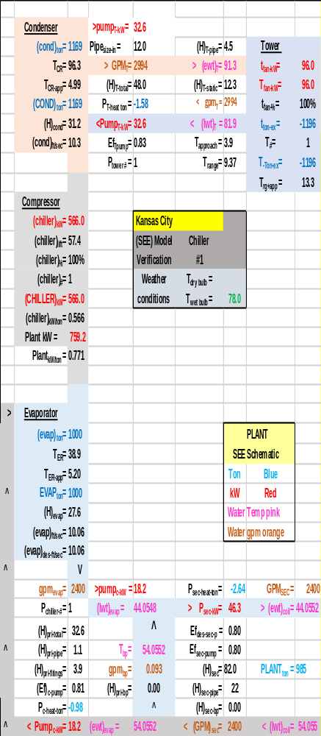Schematic 6-1: Model of manufactures selection #1

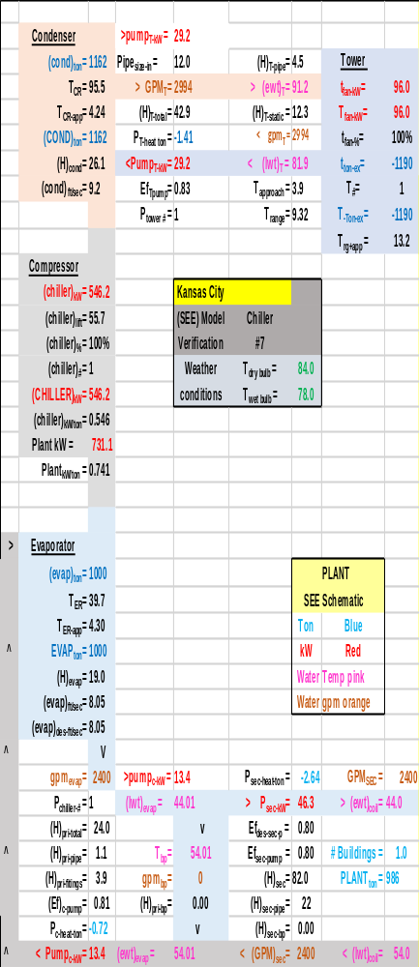Schematic 6-2: Model of manufactures selection #7

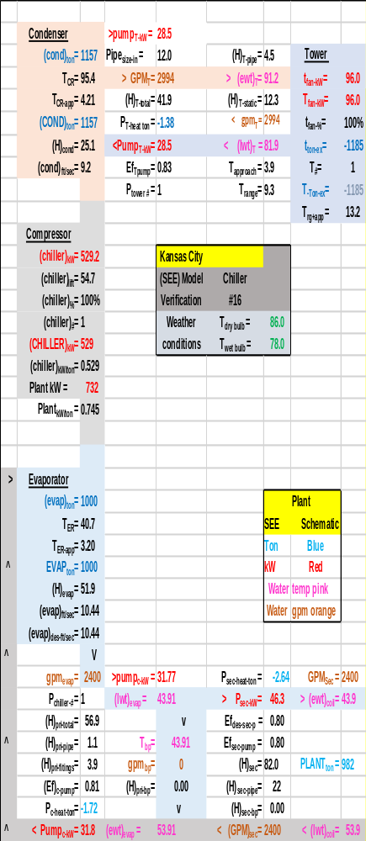Schematic 6-3: Model of manufactures selection #16

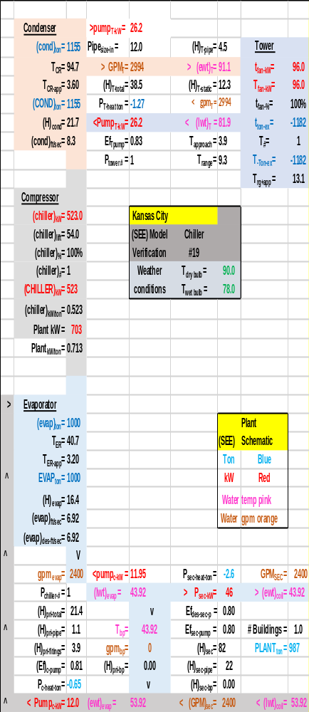Schematic 6-4: Model of manufactures selection #19

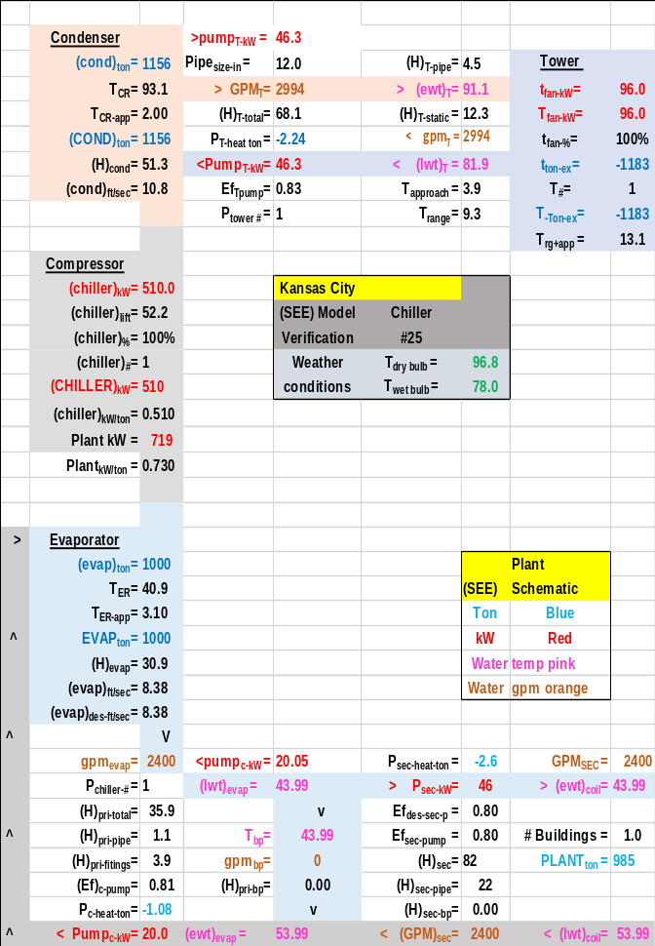Schematic 6-5: Model of manufactures selection #25

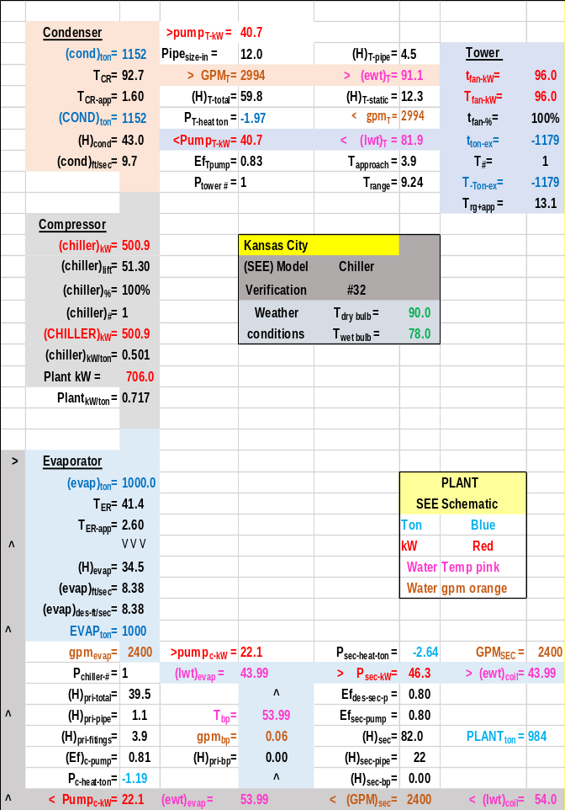Schematic 6-5: Model of manufactures selection #32

CHAPTER 7: High lift chiller design vs Low lift chiller design for Kansas City Chiller Plant
This Chapter 7 will consider a GreenGuide’s⁶ chiller design and plant performance verses a min kW chiller and plant performance defined by the author¹⁴.
Schwedler⁹ makes the argument that the off-peak kW demand of an office building central chiller plant, designed to the requirements of ASHRAE GreenGuide⁶, can be significantly reduced with the addition of a small chiller for low load conditions. This article does not question the addition of a small chiller for off peak operation but makes the argument that the requirements of ASHRAE GreenGuide⁶ and Taylor⁷ results in high chiller lift and therefore greater plant kW demand than can be achieved with a low lift chiller plant or min kW design as defined here. Chiller lift is defined as the condenser refrigerant temperature minus the evaporator refrigerant temperature⁵. Chiller lift in large part determines the kW demand of a chiller and therefore the plant. This (SEE) plant model analysis will show that the chiller kW demand of a low lift designed chiller will be significantly less than a GreenGuide¹ Taylor² designed chiller plant.

Tower selection
The tower for GreenGuides⁶ requires that the tower water flow delta T equal 14F⁹ and tower range plus tower approach total about 23F⁷. A minimum kW design as defined here will have a total range plus tower approach of about 15F. GreenGuides⁶ basically calls for a small tower and a large chiller where the min kW design calls for a large tower and small chiller. Table 7-1 gives the design details of the selected tower for GreenGuides⁶ verses Min kW¹⁴ installed in the chiller #’s as shown from Chapter 6. The GreenGuide tower increases tower range from 9.27F to 13.26F and therefore increases condenser refrigerant temperature and therefore chiller lift that therefore increases chiller kW demand. The net result is that the GreenGuide⁶ tower increases chiller kW demand and therefore chiller kW/ton.

Tower selection data | Min kW  Chiller #19 | GreenGuide  Chiller #32
Design Wet bulb | 78.0F | 78.0F
Design Load | 1155 ton | 1155 ton
Tower water flow | 3000 gpm | 2100 gpm
Approach temp. | 5.0 F | 10.0F
Calculated range | 9.27F | 13.26F
Range + approach | 14.27F | 23.26F
Cells | 2 | 1
Tower fan kW | 40 kW | 40 kW
Selected Tower² | NC8409RAN2 | NC8407UAN1
Cold water at design | 83F | 88F
Tower return water | 92.3F | 101.26F
Capacity | 102.1% | 105.7%
ASHRAE 90.1 | 90.9gpm/hp | 49.2gpm/hp
Static lift | 12.34 ft. | 12.34 ft.
Table 7-1. Design tower comparison-Kansas City chiller plant.
Figure 7-1 gives the effect on the chiller selection data with installing the GreenGuide and min kW towers of Table 7-1.
An important point for the reader. The Table 6-1 data and charts of Chapter 6 are actual chiller manufactures data illustrating how the manufacture reduces chiller kW/ton by selecting condensers and evaporators with less refrigerant approach temperatures. For the conditions of Table 6-1 each manufacture would likely have a different set of condensers and evaporators to reduce chiller kW/ton and obviously different condition for different cities, for example Long Beach and Salt Lake City conditions of Chapters 2 & 3, would result in different combinations of condensers and evaporators to meet chiller kW/ton requirements. However the basic chiller selection data of Table 6-1 will, the author believes, generally hold true. Therefore the condenser and evaporator refrigerant approach temperatures of Table 6-1 will be assumed for all plant models of this paper including Figure 7-1. The alternative would be to request Table 6-1 data for all cities to be studied here and that was not practical. However the (SEE) chiller plant model can evaluate specific data for any city and any manufactures data.
The top chart of Figure 7-1 is a copy of Figure 6-6. The middle chart shows the effect of installing the GreenGuide⁶, and/or Taylor⁷ tower. The chiller kW for chiller #32 is increased from 501 kW to 605 kW and the plant kW is increased only 10 kW, (716 kW – 706 kW = 10 kW) because the fan kW and tower pump kW are decreased with the GreenGuide design or as defined here the high lift chiller design.
The bottom chart illustrates the effect of installing the min kW tower into chiller #19. Compared to the top chart the chiller kW slightly increases because the min kW tower approach is 5F verses 4F for the manufacturing data shown by the top chart.
The following schematics will further define and discuss chiller lift for the Kansas City chiller plant.

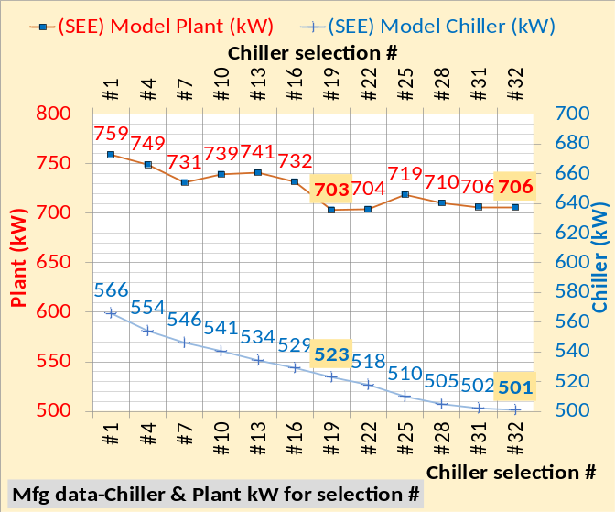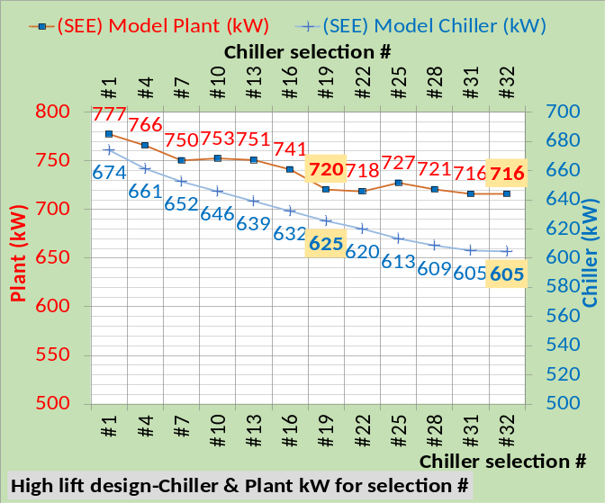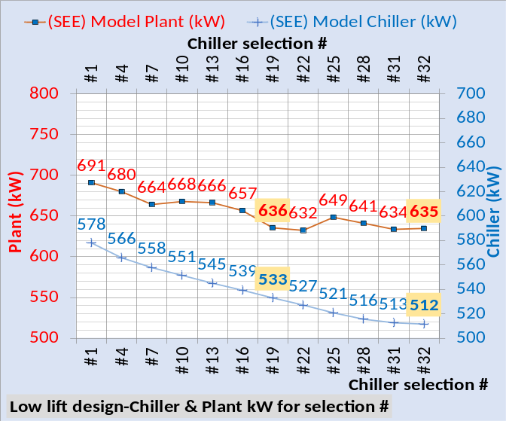
Figure 7-1: Chiller selection data
Chiller Lift, Kansas City chiller plant

Schematic 1-11: copied Plant at 1000 ton evaporator load, 100% tower fan speed and chiller kW=566.0 resulting in 44.05F supply water-K.C. chiller #1.
Schematic 1-11 is copied from Chapter 1 and is chiller #1 at peak conditions also defined by Schwedler¹. Schematic 7-1 installs chiller #32 into Schematic 1-11 resulting in significant reduction in chiller kW and plant kW. The tower is the same for both Schematic 1-11 & 7-1, the difference is the condenser & evaporator associated with chiller #32 which has a refrigerant approach of (2.6 +1.6 = 4.2F) verses (5.2 + 4.99 = 10.19F) for chiller #1 of Schematic 1-11. This difference in refrigerant approach accounts for the difference in chiller kW. Chiller #32 of Schematic 7-1 requires 500.9 kW to produce 44F supply water and chiller #1 of Schematic 1-11 requires 566 kW.
Now let’s look designing the plant to GreenGuide⁶/Taylor⁷ requirements.

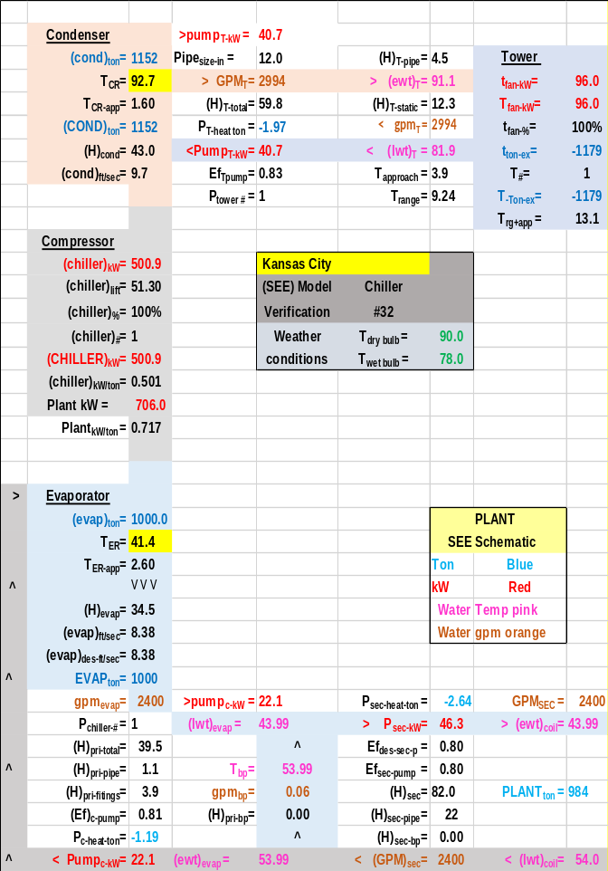
Schematic 7-1: Manufactures data-K.C. chiller #32

Schematic 7-1 gives the chiller lift as (92.7F – 41.4F = 51.3F) for chiller #32 as defined by the manufactures data of Chapter 6 and also shown by Schematic 6-5.
Schematic 7-2 illustrates the changes in the plant, at peak design conditions, as a result of installing the tower as required by GreenGuide⁶ & Taylor⁷ and defined by Table 7-1 where the condenser delta T is 14F and the supply water/evaporator delta T is 16F. The lift is increased (103.3F – 41.4F = 61.9F) which increases the chiller kW from 500.9 to 604.6 kW, a 103.7 kW increase. The plant kW increased only (716 kW – 706 kW = 10 kW) because the pumping and tower kW significantly decreased with the Schematic 7-2 design.

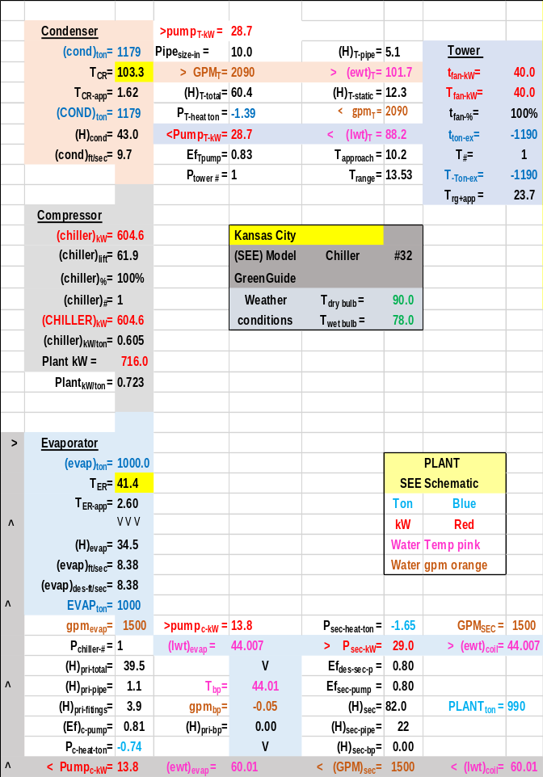
Schematic 7-2: GreenGuide design-chiller #32

Schematics 1-11, & 7-1, illustrate that replacing chiller #1 with chiller #32 drops the plant kW from 759.2 kW to706 kW and the GreenGuide/Taylor design requirements drove plant kW up to 716 kW as shown by Schematic 7-2.

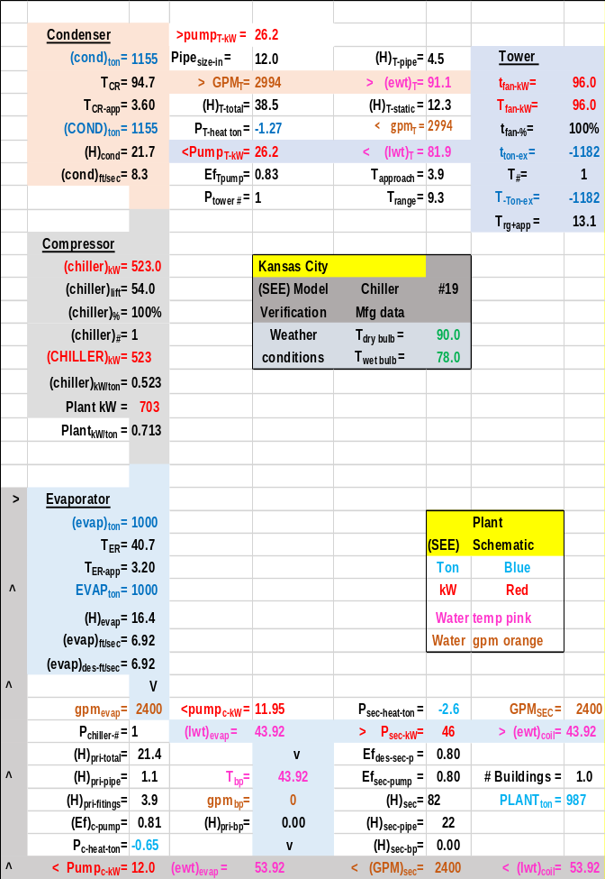
Schematic 7-3: Manufactures data-chiller #19 with tower approach = 4F & supply water delta T = 10F

Schematic 7-3 gives the chiller lift as (94.7F – 40.7F = 54.0F) for chiller #19 as defined by the manufactures data of Chapter 6 and also shown by Schematic 6-4.
Schematic 7-4 illustrates the changes in the plant, at peak design conditions, as a result of installing the tower as defined by the min kW design of Table 7-1. The condenser delta T is (92.3-83=9.3F) and the supply water/evaporator delta T is 16F and the tower approach is selected at 5F verses 4F of the manufactures data. The chiller lift is slightly increased with the min kW design due to the 5F tower approach, 55.1F verses 54.0F of Schematic 7-3 resulting in an increased chiller kW of about 10 kW. The plant kW significantly decreased with the min kW design, 636 kW verses 703 kW.

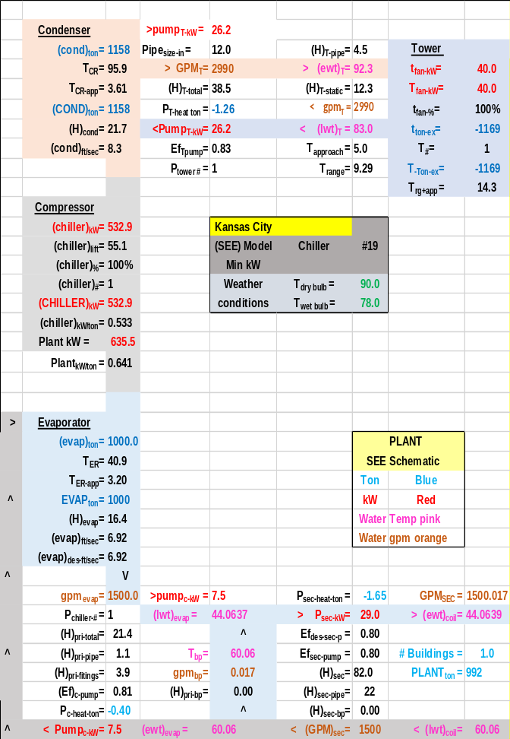
Schematic 7-4: Min kW design-chiller #19 with tower approach = 5F & supply water delta T = 16F

Schematic 7-3 illustrates that operating the supply water at 10F delta T increased the P/S pumping kW as compared to Schematic 7-4. Also selecting a tower at 4F approach, Schematic 7-3, resulted in a 96 kW tower fan verses 40 kW for the plant of Schematic 7-4.
This chapter has made the argument that the requirements of ASHRAE GreenGuide⁶ and Taylor⁷ results in high chiller lift and therefore greater plant kW demand than can be achieved with a low lift chiller plant or min kW design as defined here. Chiller lift is defined as the condenser refrigerant temperature minus the evaporator refrigerant temperature⁵. The design of low lift verses high lift chiller design will be further developed in Chapters 8 & 9 below.

CHAPTER 8: (SEE) Plant Model of Long Beach Manufacture’s chiller selection data.

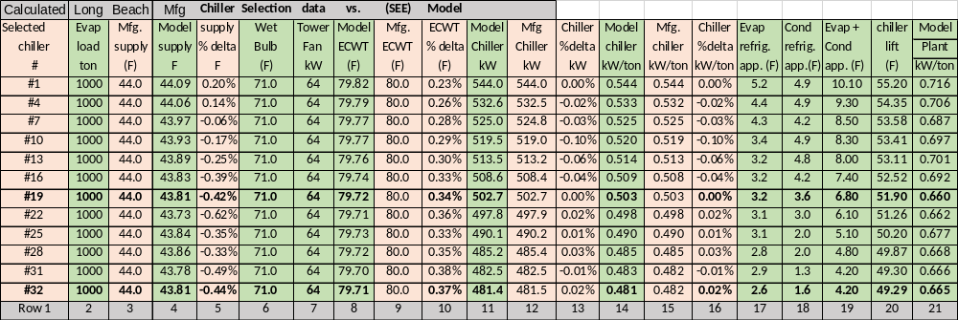Table 8-1: Manufactures chiller selection data & (SEE) Model of Long Beach chiller plant
Table 8-1 gives the results of the (SEE) model simulation of the chiller selection data for 12 chillers of the 32 chiller selections given by Chapter 5 as calculated for Long Beach. The 12 selections of row 1 were made at 1000 ton evaporator load and an entering condenser water temperature (ECWT) of 80F as given by rows 2 & 9 with row 8 giving the modeled ECWT. Rows 3 & 4 give the supply water temperatures of the selection data that can be a constant 44F, versus the modeled supply water of row 4 that varies a little from 44F due to the sensitivity of the model. Rows 11 & 12 give the selection chiller kW & the modeled chiller kW, showing very close agreement as given by row 13.
Rows 17 thru 20 illustrate an important point. Row 17 gives the evaporator refrigerant approach temperature and row 18 the condenser value with row 19 giving the sum of the two values. Row 20 gives the modeled chiller lift and clearly the drop in lift follows the drop in chiller kW of row 11. That’s the point; for a given set of design conditions chiller manufactures improve chiller kW/ton by installing condensers and evaporators with smaller refrigerant approach temperatures and typically more cost as discussed in Chapter 5.

Figure 6-1 copied: Kansas City Chiller kW verses sum of refrigerant approach temperatures
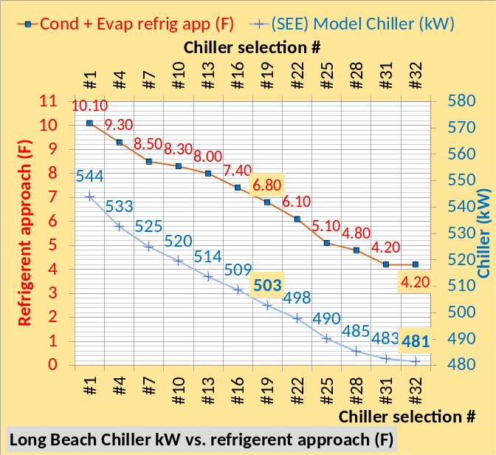Figure 8-1: Long Beach Chiller kW verses sum of refrigerant approach temperatures
Figure 6-1 copied for Kansas City, and Figure 8-1 for Long Beach give the chiller kW and sum of the condenser plus evaporator refrigerant approach temperatures illustrating how the chiller kW drops for this set of chillers as the refrigerant approach temperatures decreases, also illustrating the difference for the two City’s weather conditions.
Figure 6-2 copied: Kansas City Chiller kW vs. condenser & evaporator refrigerant temperatures
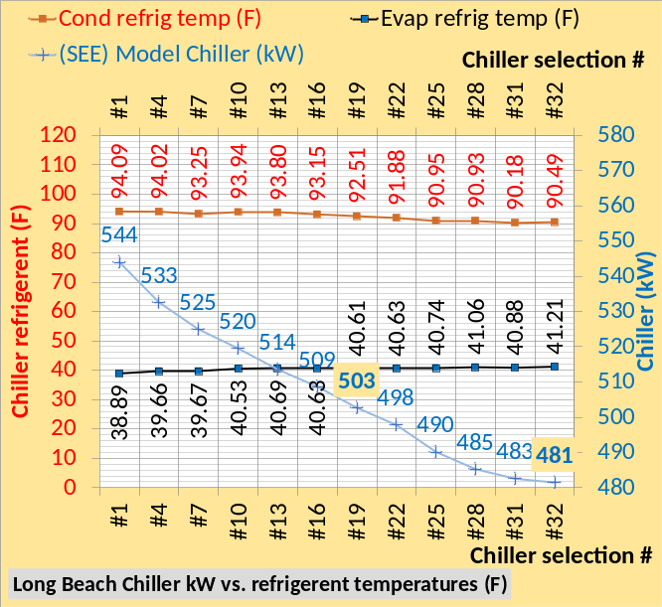 Figure 8-2: Long Beach Chiller kW vs. condenser & evaporator refrigerant temperatures
Figures 6-2 & 8-2 illustrates how the condenser and evaporator refrigerant temperatures change, not always less for both, but the difference (Cond (F)-Evap (F)) = chiller lift decreases as shown by the next set of figures Figure 6-3 & 8-3.
Figure 6-3 copied: Kansas City Chiller kW vs chiller lift
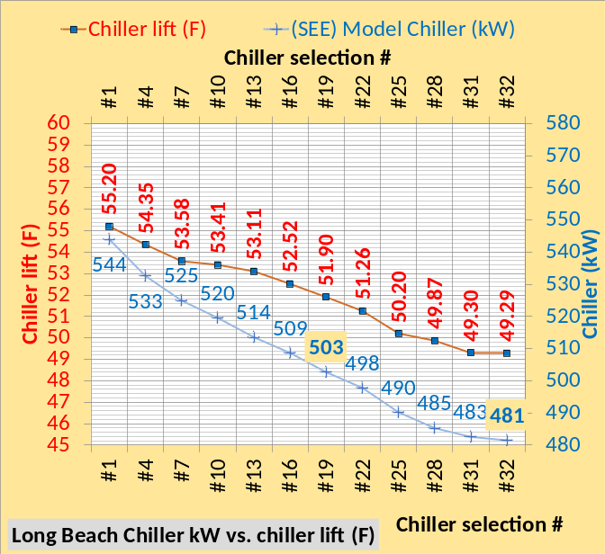Figure 8-3: Long Beach Chiller kW vs chiller lift (F)
Figure 6-3 Kansas City & 8-3 Long Beach illustrates that for this set of chillers the chiller kW drops about 10.6 kW per degree F drop in lift. Chiller lift drives chiller kW and that is a key point of this study of low lift chiller plant verses a high lift chiller plant as advocated by Taylor⁷ and GreenGuide⁶.
Figure 6-4 copied: Kansas City Chiller kW & pump kW
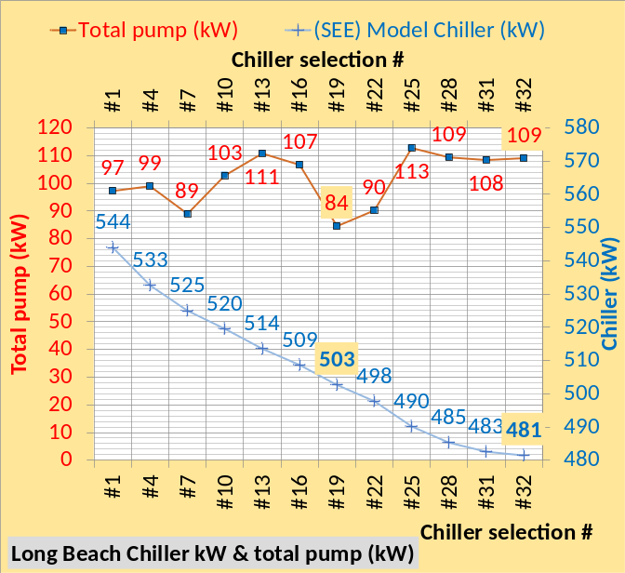Figure 8-4: Long Beach Chiller kW & pump kW
Figure 6-4 Kansas City & 8-4 Long Beach illustrates the pumping kW did not change and also a point made in Chapter 5; in general, as the refrigerant approach temperature drops the pressure drop thru the condenser and evaporator increases requiring greater pump kW.
Figure 6-5 copied: Kansas City Chiller kW vs pumps + tower fan kW
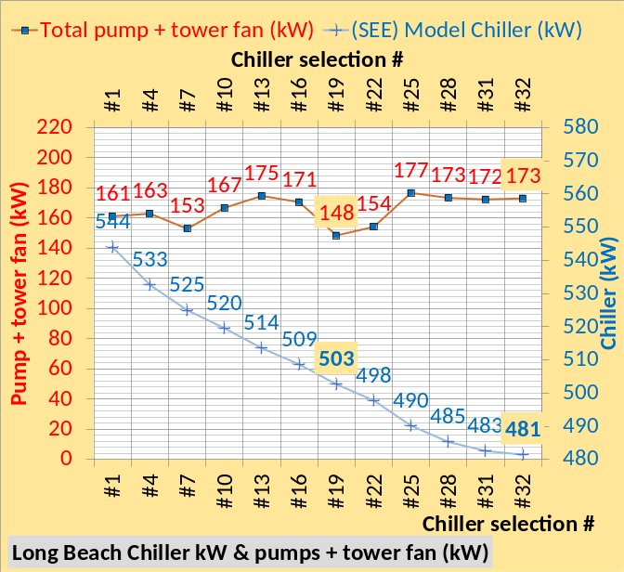Figure 8-5: Long Beach Chiller kW vs pumps + tower fan kW
Figure 6-5 Kansas City & Figure 8-5 Long Beach illustrates the plant kW is reduced by the tower fan kW of 64 for the Long Beach plant verses 96 kW for the Kansas City plant.
Figure 6-6 copied: (SEE) Model Chiller & Plant kW for 12 chiller selections of Chapter 5, Kansas City
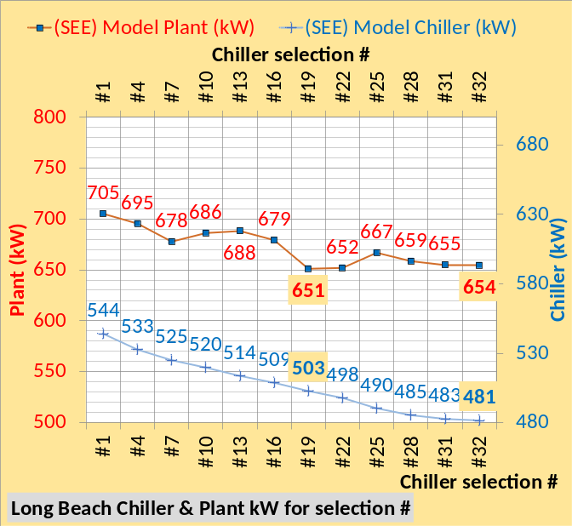Figure 8-6: (SEE) Model Chiller & Plant kW for 12 chiller selections adjusted to Long Beach conditions
Figure 6-6 Kansas City & Figure 8-6, for this set of chillers, gives the data necessary to make a good chiller selection decision. For both cities chiller #19 gives the lowest plant kW with chillers #31 & #32 giving lowest chiller kW/ton and slightly greater plant kW.
The next Chapter 9 will install a chiller/tower as called for by GreenGuide⁶ and Taylor⁷. These two documents call for a tower range plus approach of about 23F, resulting in high lift chillers and therefore increased chiller kW/ton. Therefore the plant design engineer would likely select the lowest chiller kW/ton, in this case chiller #32 which will be the chiller studied in the remainder of this paper defined as the high lift chiller/tower plant.
The high lift chiller/tower plant, as called for by GreenGuide⁶ & Taylor⁷, will be compared to the authors¹⁴ suggested low lift chiller/tower plant that utilizes chiller #19 that has a kW/ton significantly greater than #32 at these conditions but an approximately equivalent plant kW/ton as illustrated by Tables 6-1 & 8-1 and Figures 6-6 & 8-6.
Installing chiller #32 into the min kW design would give the min kW design additional reduced plant kW and that is a design that may be addressed in future papers. However this paper will install chiller #19 into the min kW design.
GreenGuide⁶ & Taylor⁷, as stated above, call for a tower range plus approach of about 23F which significantly increases the kW/ton of the high lift chiller design to be more clearly discussed below in Chapter 9.
To further illustrate the capabilities of the (SEE) model to provide understanding, six sets of schematics follow. The reader can study the side by side schematics of the Kansas City plant and Long Beach plant and develop a better understanding of how the plant performance changes with different condensers and evaporators.

Schematic 6-1: Kansas City Model of manufactures selection #1

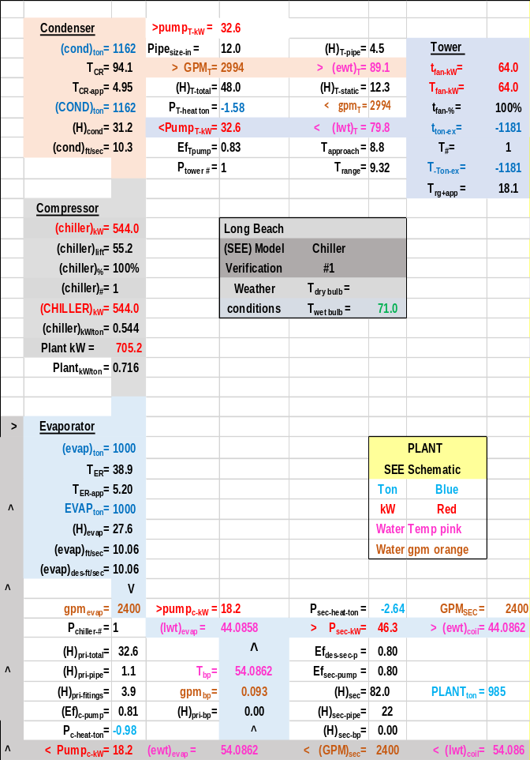Schematic 8-1: Long Beach Model of manufactures selection #1

Schematic 6-2: Kansas City Model of manufactures selection #7

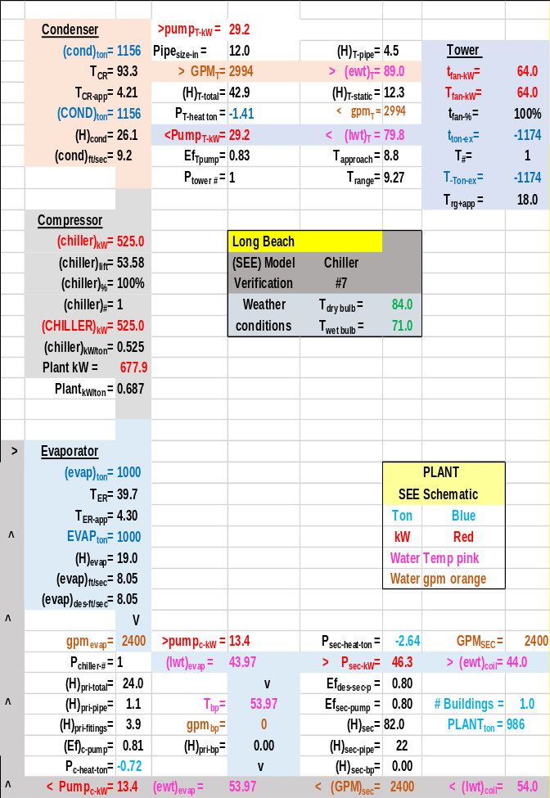Schematic 8-2: Long Beach Model of manufactures selection #7

Schematic 6-3: Kansas City Model of manufactures selection #16

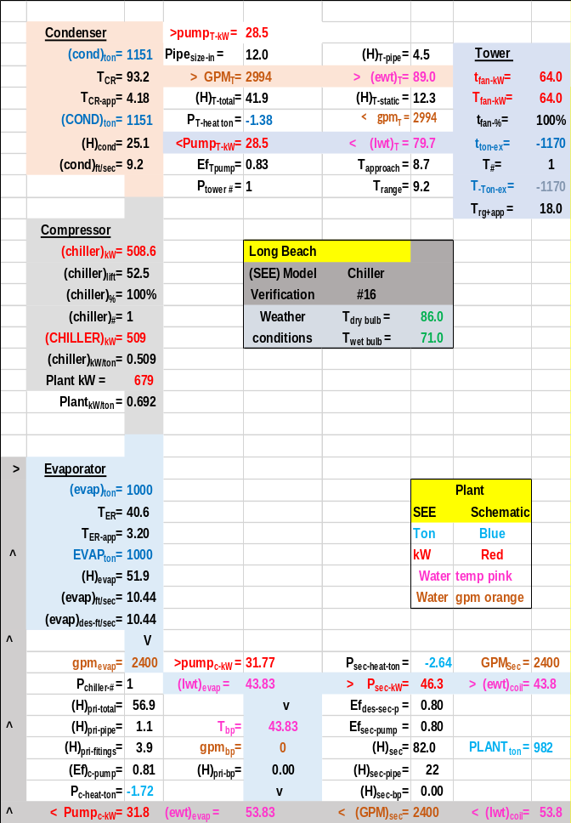Schematic 8-3: Long Beach Model of manufactures selection #16

Schematic 6-4: Kansas City Model of manufactures selection #19

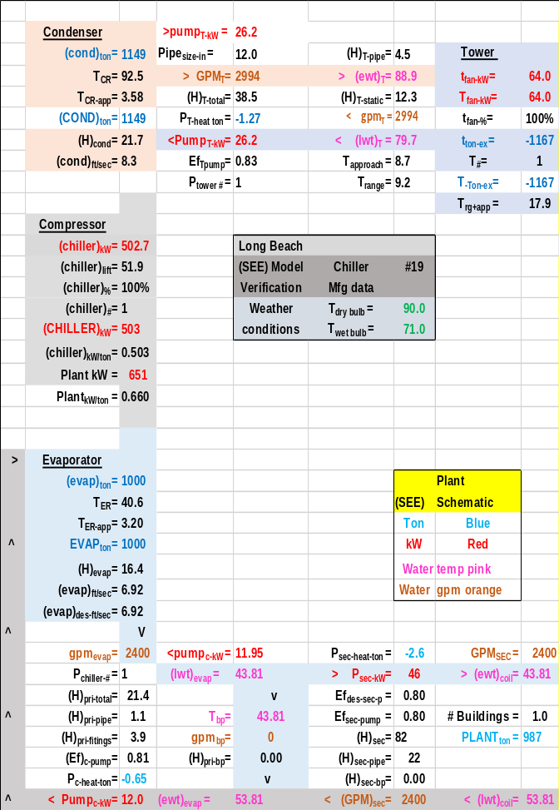Schematic 8-4: Long Beach Model of manufactures selection #19

Schematic 6-5: Kansas City Model of manufactures selection #25

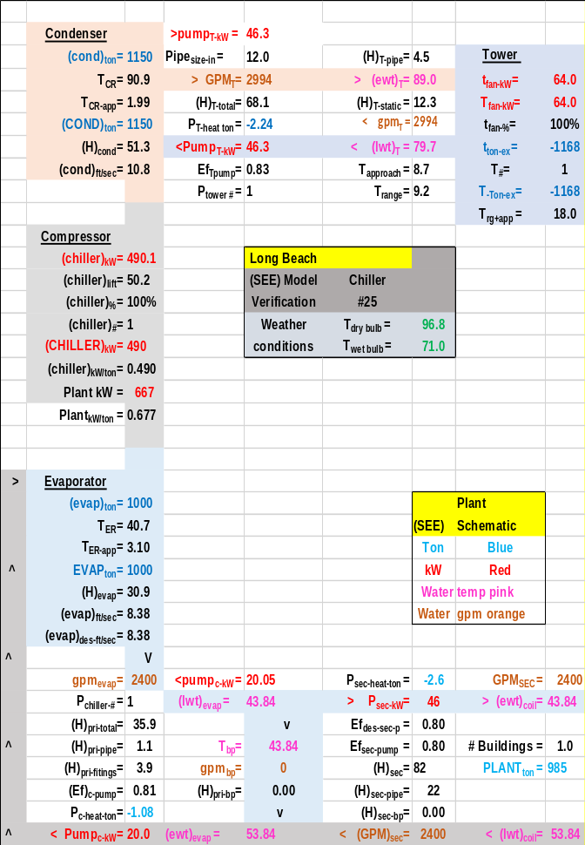Schematic 8-5: Long Beach Model of manufactures selection #25

Schematic 6-5: Kansas City Model of manufactures selection #32
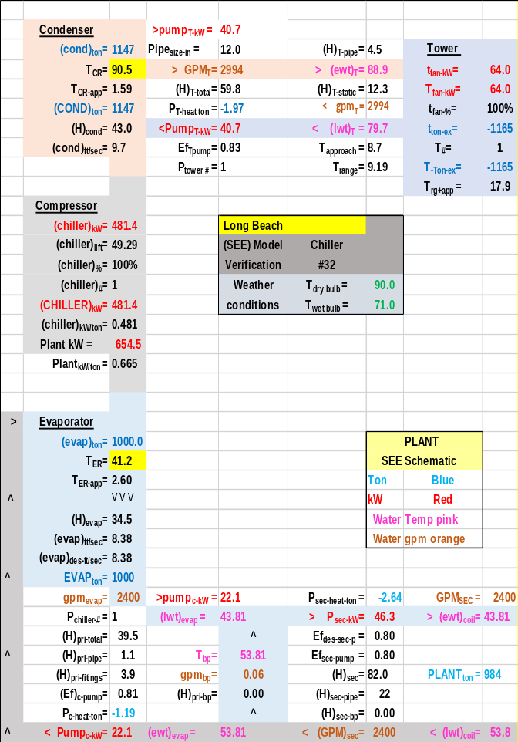 Schematic 8-5: Long Beach Model of manufactures selection #32

CHAPTER 9: Long Beach Chiller Plant-High lift chiller design vs Low lift chiller design
This Chapter 9 will consider a GreenGuide’s⁶ Taylor⁷ chiller design plant verses a min kW chiller and plant defined by the author¹⁴, for Long Beach.
As stated above Schwedler⁹ makes the argument that the off peak kW demand of an office building central chiller plant, designed to the requirements of ASHRAE GreenGuide⁶, can be significantly reduced with the addition of a small chiller for low load conditions. This paper does not question the addition of a small chiller for off peak operation but makes the argument that the requirements of ASHRAE GreenGuide⁶ and Taylor⁷ results in high chiller lift and therefore greater plant kW demand than can be achieved with a low lift chiller plant or min kW design as referred to here. Chiller lift is defined as the condenser refrigerant temperature minus the evaporator refrigerant temperature⁵. Chiller lift in large part determines the kW demand of a chiller and therefore the plant. This (SEE) plant model analysis will show that the chiller kW demand of a low lift designed chiller will be significantly less than a GreenGuide¹ Taylor² designed chiller plant.
Tower selection
The tower for GreenGuides⁶ requires that the tower water flow delta T equal 14F⁹ and tower range plus tower approach total about 23F⁷. A minimum kW design as defined here will have a total range plus tower approach of about 14F to 15F. GreenGuides⁶ basically calls for a small tower and a large chiller where this min kW design calls for a large tower and small chiller. Table 9-1 gives the design details of the selected tower for GreenGuides⁶ verses Min kW¹⁴. The GreenGuide tower increases tower range from 9.28F to 14.04F and therefore increases condenser refrigerant temperature and therefore chiller lift that therefore increases chiller kW demand. The net result is that the GreenGuide⁶ tower increases chiller kW demand and therefore chiller kW/ton.

Tower selection data | Min kW  Chiller #19 | GreenGuide  Chiller #32
Design Wet bulb | 71.0F | 71.0F
Design Load | 1155 ton | 1155 ton
Tower water flow | 2994 gpm | 1980 gpm
Approach temp. | 5.0 F | 9.0F
Calculated range | 9.28F | 14.04F
Range + approach | 14.28F | 23.04F
Cells | 2 | 1
Tower fan kW | 40 kW | 40 kW
Selected Tower² | NC8409TAN2 | NC8409VAN1
Cold water | 76F | 80F
Tower return water | 85.28F | 94.04F
Capacity | 101.4% | 103.9%
ASHRAE 90.1 | 65.8gpm/hp | 49.3gpm/hp
Static lift | 12.34 ft. | 12.34 ft.
Table 9-1. Design tower-Long Beach chiller plants.
Figure 9-1 illustrates the effect on a Long Brach plant designed to the high lift chiller design procedures as called for by GreenGuide & Taylor verses a minimum kW design as defined here. The top chart, high lift design, compared to the bottom chart, low lift design, illustrates a significant reduction in chiller kW and plant kW for the low lift design.
A plant designed to GreenGuide & Taylor, top chart, will probably lead the designer to select the most efficient chiller, #32, at .522 kW/ton rather than the .542 kW/ton #19. Chiller #32 will be installed into the high lift designs of all chapters below.
A plant designed to “min kW design”, bottom chart of Figure 9-1, would probably justify selecting the less expensive chiller #19 at .462 kW/ton verses #32 at .441 kW/ton because the (SEE) Model analysis shows the plant kW is the same for both chillers.

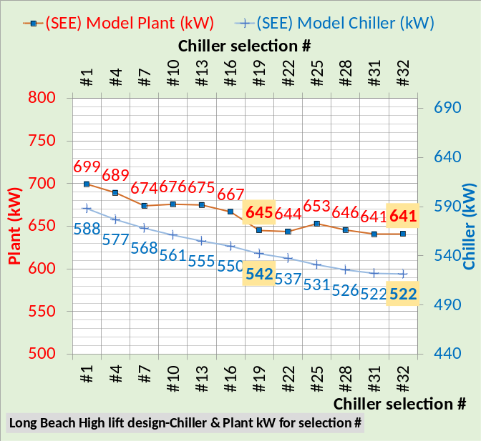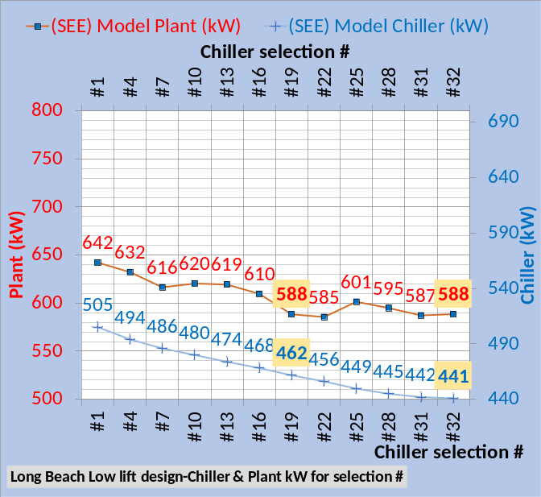
Figure 9-1: Long Beach chiller selection data for high lift design & low lift designs

Figure 9-2 illustrates the difference in the two designs. The high lift design of GreenGuide and Taylor result in an increase in chiller lift and therefore chiller kW. The plant pumping kW is the same for both designs but the tower kW is greater for the low lift design, also called the min kW design here. The chiller kW is significantly less for the low lift design resulting in a significantly less plant kW for the low lift design. Each plant design would have to consider pumping kW, tower fan kW, and chiller kW to arrive at the best design, however the rational for a low lift design seems inescapable to the author.

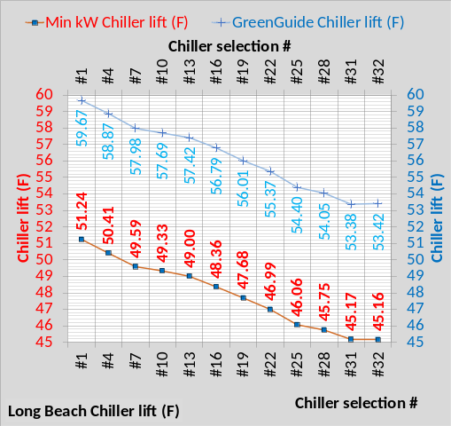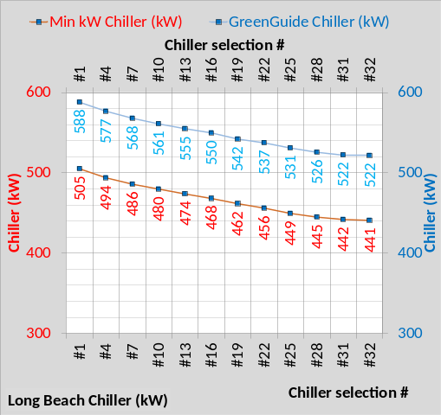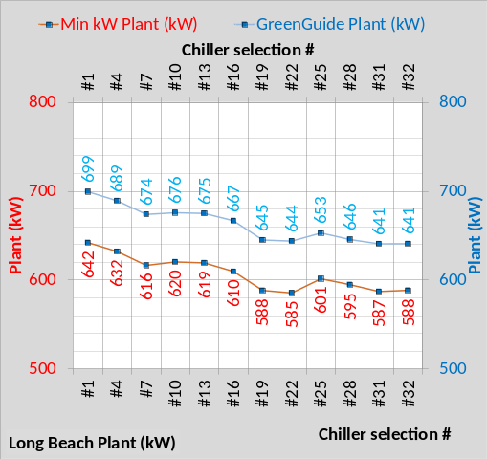
Figure 9-2: High lift design vs. low lift design

The following schematics are provided to assist in better understanding the concepts presented.
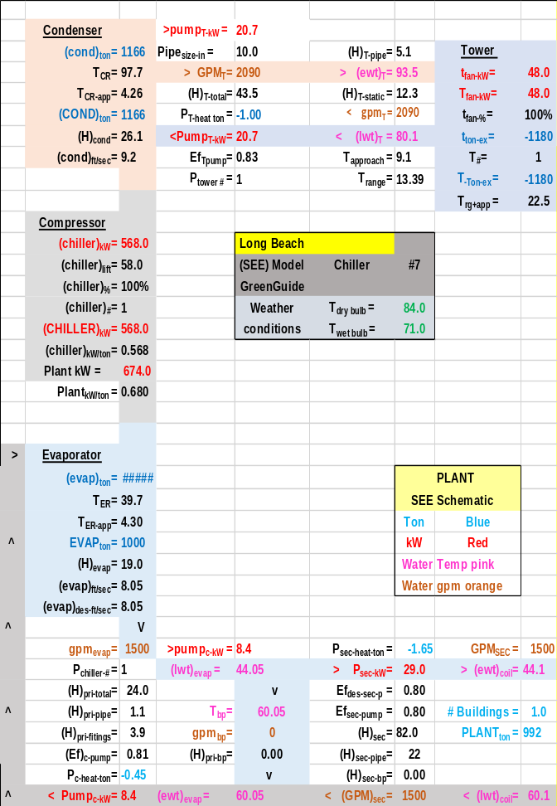
Schematic 9-1: High lift design-Chiller #7

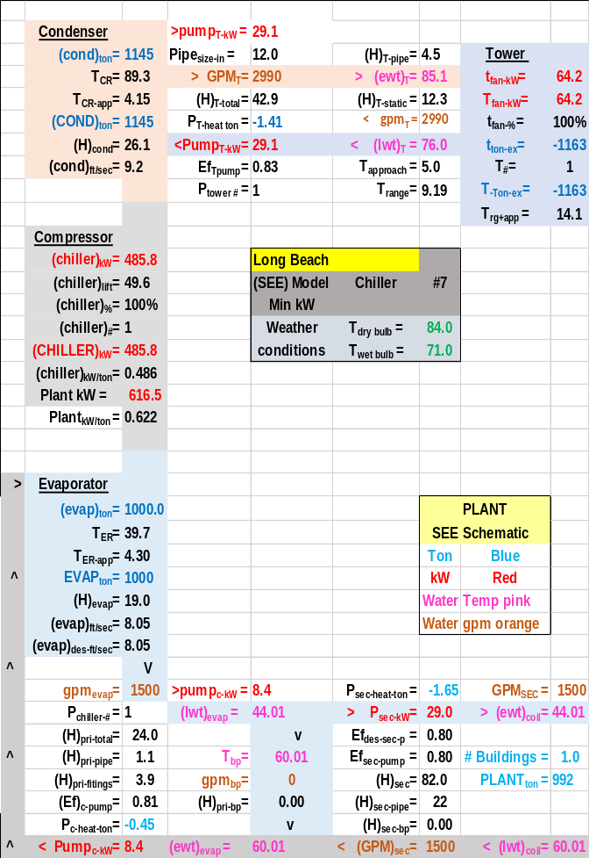
Schematic 9-2: Low lift design-Chiller #7

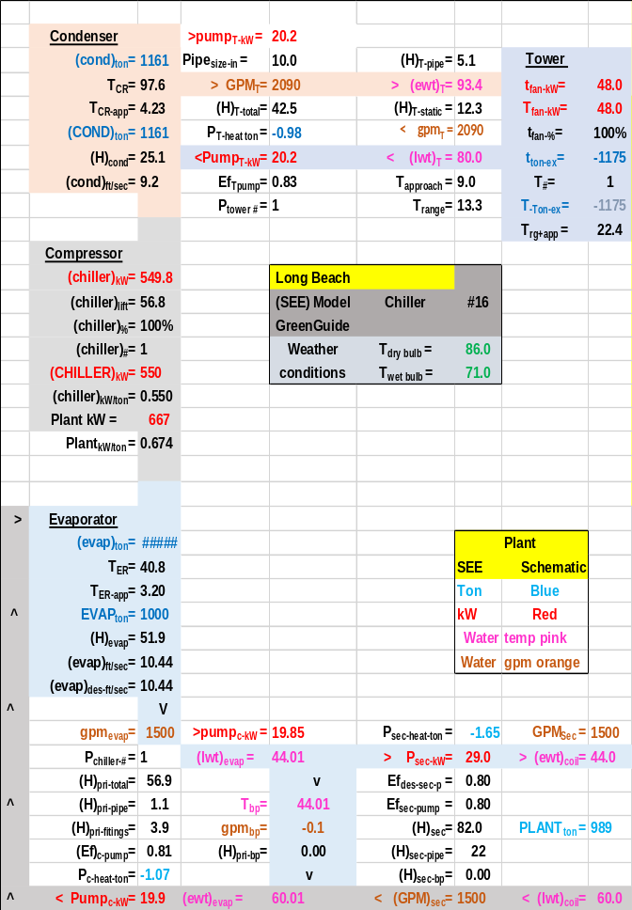
Schematic 9-3: High lift design-chiller #16

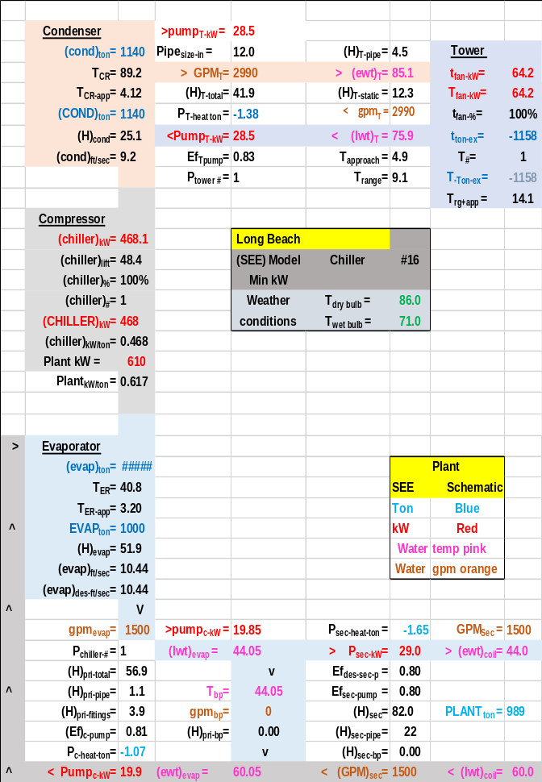
Schematic 9-4: Low lift design-chiller #16

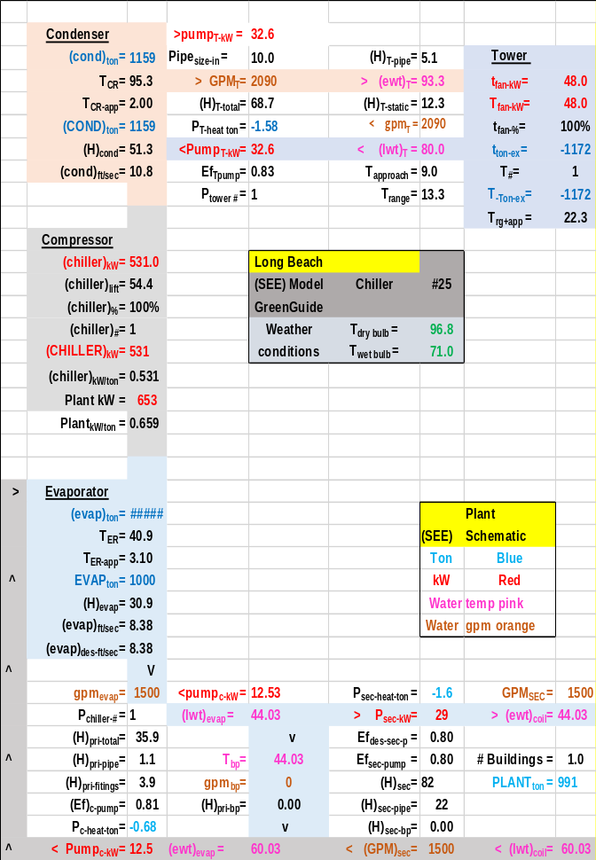
Schematic 9-5: High lift design-chiller #25

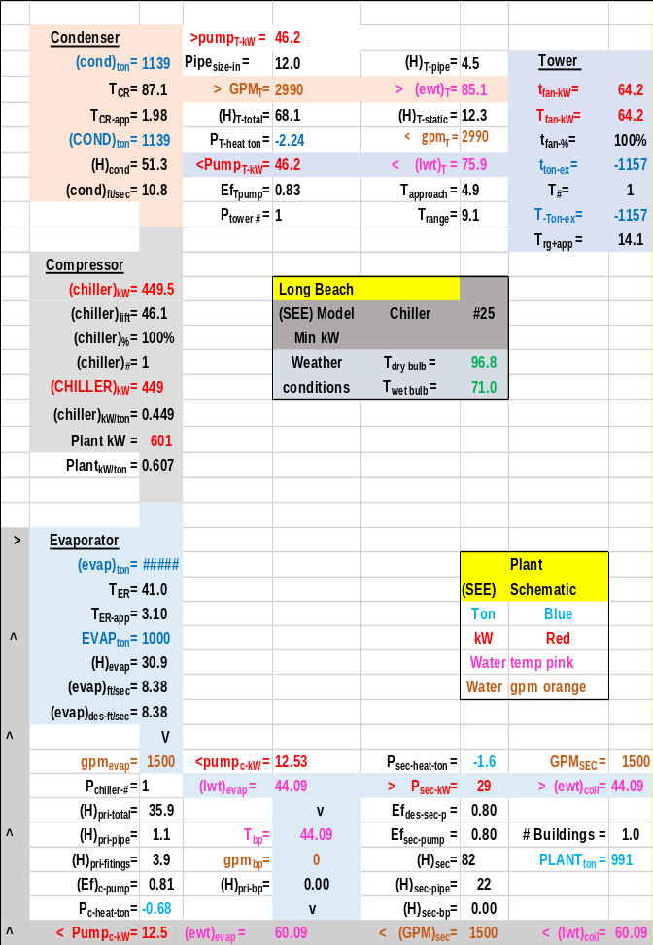
Schematic 9-6: Low lift design-chiller #25

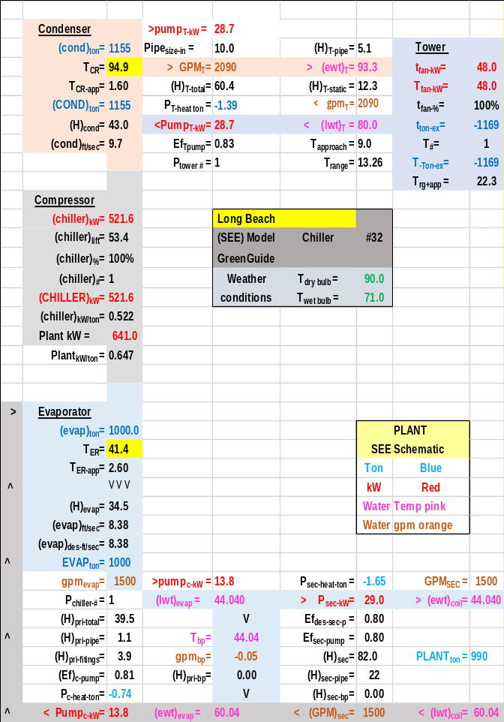
Schematic 9-7: High lift design-chiller #32

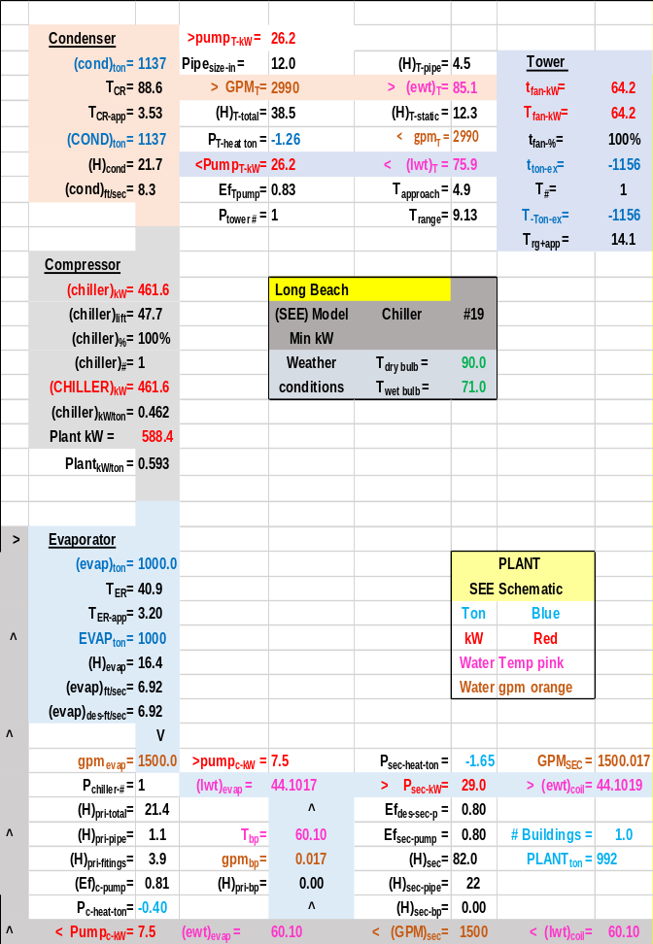
Schematic 9-8: Low lift design-chiller #19

The next Chapter 10 will install chiller #19 into a model of a min kW design, or low lift design, and chiller #32 into a standard design or high lift design. Both plant designs will operate against 24-hour operation of a large office building as defined by Standard 90.1-2010 study by Pacific Northwest National Laboratory⁸.
First the office building will be defined.

Chapter 10: ASHRAE Standard 90.1 Large Office Building-Long Beach Ca.
The July 2014 ASHRAE Journal, page 70¹⁰, makes the obvious but not stated point that 40 years after the oil embargo an airside model is not in the ASHRAE and (PNNL) accepted DOE building energy models. The ASHRAE Journal of September 2014¹¹ published a letter that concluded, “Is it not time for all to admit we have been on the wrong modeling path for more than 40 years?” The ASHRAE Journal of May 2016¹² published a paper titled, Modeled Performance Isn’t Actual Performance, which states “All (energy) models are wrong, but are useful.” The paper points to the lack of real 8,760 hours of data; a model based on 12 utility bills for the year cannot be a duplication of the building performance over 8,760 hours.
The purpose of this paper is to present an alternative to the present methods of modeling building energy consumption, a method based on the laws of thermodynamics and model equations solved on a desk top computer. A fundamental difference in the model presented here is that it is configured to model one 24-hour day verses 365 days, 8,760 hours of energy consumption history.
MODEL VERIFICATION
Several years ago, there were comparisons of 8,760-hour building energy models to see which gave the closest result to the annual energy consumption of a facility; a fool’s errand. An analogy would be NASA modeling a trip to the moon after the space craft returned to earth; too late. NASA must model real time performance for obvious reasons. Similarly, ASHRAE must have building energy models that can model real time performance of buildings if the objective of energy efficient buildings is to be achieved. The building energy model presented here is set up to model real time energy performance over any real or assumed 24 hour period giving flows, temperatures, cooling loads, kW demand of equipment, and total site kW as weather and operational conditions change. The model presented here consists of a set of simultaneous equations solved by lap top computer. The model iterates to steady state energy equilibrium after a perturbation to the system just as a real system responds, a defining characteristic of a System Energy Equilibrium (SEE) model. A fundamental concept of the (SEE) Model is incorporation of “feedback control equations”.
(SEE) MODEL CHARACTERISTICS
Understanding the performance of a complex system, in this case a Central Chilled Water System (CCWS) that serves an office building requires a model that includes detail model equations of all components of the system. These equations of each system component are solved simultaneously giving the effect of each component on the operation of the total system and the effect of the system on the performance of the component. Real building energy systems operate according to the laws of thermodynamics and the performance characteristics of the equipment installed; therefore, the model must incorporate equations that are consistent with the laws of thermodynamics and input the characteristics of the system components consistent with the manufactures verified data. To accomplish this detail the model must incorporate every design and control feature of the real system; resulting in a model as presented here consisting of more than 150 performance and design variables (see nomenclature). Each variable is defined by an equation and/or is a design constant that changes if the design is changed. The set of equations is solved simultaneously by computer and will duplicate the performance of a real system if sufficient detail has been incorporated into the model and the detail is consistent with the actual equipment and controls of the real system. The model is always at System Energy Equilibrium (SEE), energy in = energy out as is true for a real system.
The primary challenge in developing a (SEE) model might be summarized as; a real system is very complex where minor changes in weather, design, and control, can have a major effect on the performance of the system, therefore the system model must be equally complex incorporating all characteristics of the real system within a set of equations solved simultaneously by a computer.
The basic approach to this building (SEE) Model is the same as presented above for the (SEE) Plant Model.

THE BUILDING DEFINED AND ASSUMED WEATHER
Figure 10-1: Building description
Building 13 Story
680,400 Ft-Sq
Building height=169 Ft
Roof = 52,339 Ft-Sq
All walls 37.5% glass
Roof U=.048 Wall U=.090
Glass U=.55 Glass SHGC=.40
Footprint
South=240 Ft North=240 Ft
Each wall=40,560 Ft-Sq
East=218.08 Ft West=218.08 Ft
Each Wall=36,855 Ft-Sq

The building of this study is defined by the Pacific Northwest National Laboratory (PNNL) study of ASHRAE Standard 90.1-2010, (Liu 2011)⁸, a large 13 story office building, Figure 10-1, with 680,400 square feet of air conditioned space. The (Liu 2011) study is based on an office building of 498, 600 square feet. The square feet here is increased to 680,400 for this (SEE) Model analysis so that the evaporator load is about 1000 ton as is the case of Chapter 1 Model Verification. A link to the (PNNL) study is given under references⁸. The building schedules and other details of the building, as defined by the (PNNL) study, are in this model design but the plant of this study is designed to a series of articles in the ASHRAE Journal, (Taylor 2011)⁷.

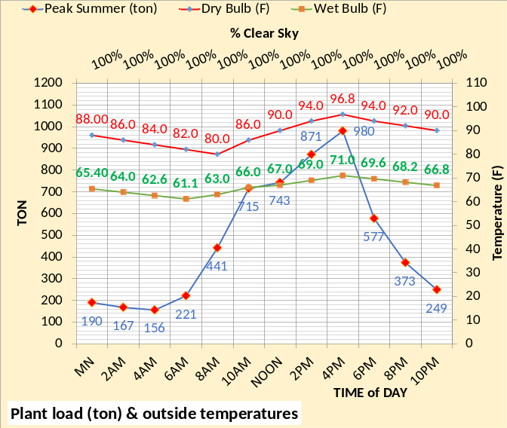Figure 10-2: Long Beach assumed 24-hour design weather conditions & (SEE) Model calculated building load (ton)
Figure 10-2 gives the assumed 24 hour peak weather conditions and building load for the 24 hours to be modeled. The peak building load (980 ton) occurs at 4PM with 100% solar, 96.8F dry bulb and 71.0F wet bulb.
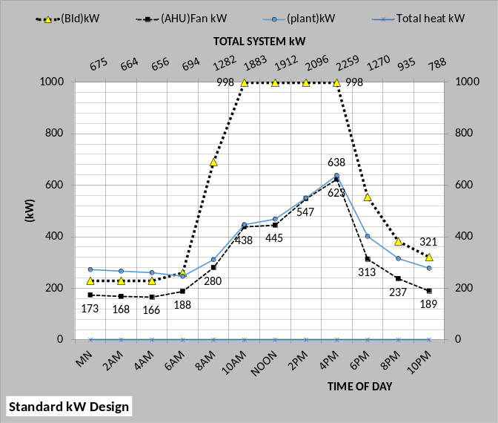 Figure 10-3: Total system kW demand.
SYSTEM kW DEMAND
Figure 10-3 gives the total system kW demand of the building and one high lift chiller plant as modeled. The Standard building kW Design includes infiltration as defined by the (PNNL) study of ASHRAE Standard 90.1-2010, and also includes return air fans and fan powered terminals as part of the air handler system. The following will give a detail description of the building and air handler performance, air side, which produces a load (ton) to the plant.
SCHEMATIC STRUCTURE
Schematic 10-1 defines the basic structure of the air side system and plant schematics to be presented.
Schematic 10-1: System schematic structure.
Understanding the system with only charts is a difficult task so a system performance schematic was developed so that the system can be viewed and studied at any hour. Schematic 10-1 illustrates the basic system components that make up the system schematic, the building, duct system, coil, exhaust & fresh air, VAV fans, water distribution, chiller evaporator-compressor-condenser, and the tower. Schematic 10-1 illustrates the location of the components of a building served by a (CCWS). The building is in the upper right of Schematic 10-1 with the duct system that serves the interior and perimeter of the building shown below. The fan system including exhaust and fresh air is shown in the lower right of the schematic with the coil on top of the VAV fan outlet. The right half of Schematic 10-1 represents the air side of the system or site and the left side is the plant. Water enters and leaves the coils therefore transferring the air side or site load to the plant evaporators. The chiller motor pumps refrigerant from the evaporator transferring the load to the condenser and the cooling tower picks up the load from the condenser and exhausts the load to the atmosphere. The lower left of the Schematic 10-1 gives system performance data for the hour. The most relevant values of the model are placed in the schematic to give a much better understanding of the system at a steady state condition hour. Schematic 10-2 illustrates the system values at a 4PM steady state condition.
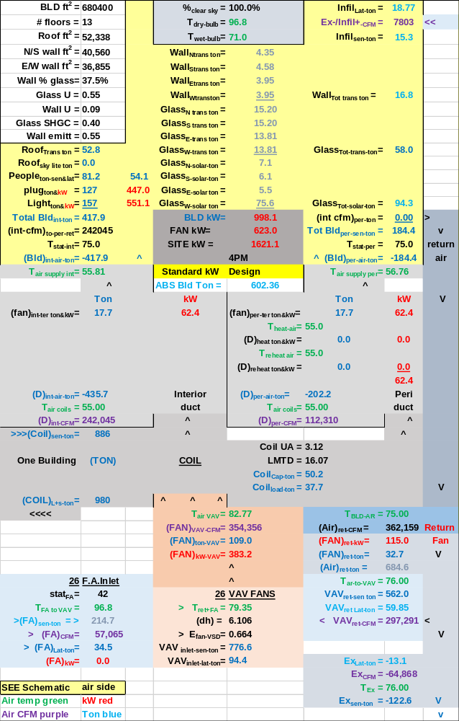Schematic 10-2: Peak Design Conditions of Standard kW design building at 4PM
All charts to follow will show the same values as Schematic 10-2 at 4PM peak condition.
Building interior sensible loads
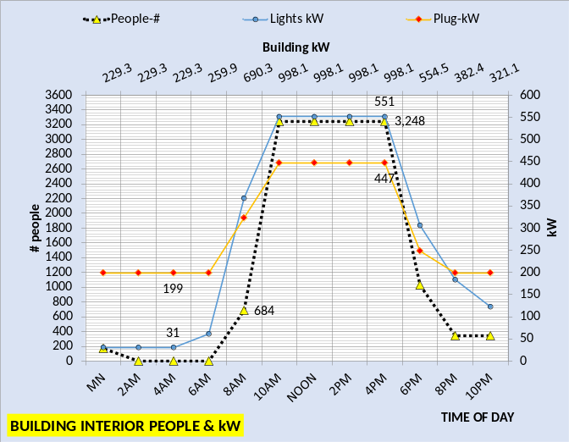 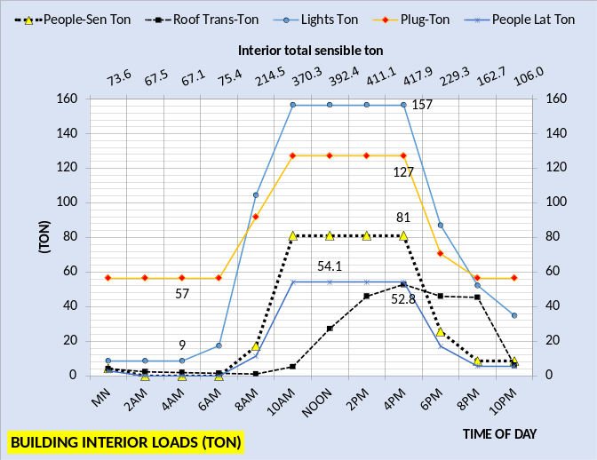Figure 10-4: Building interior loads
Figure 10-4 gives the building interior loads. The top charts gives the number of people in the building and the kW demand of lights and plug loads. The bottom chart gives the interior sensible load with 157 ton light load, 127 ton plug load, 81 ton people sensible, 54.1 ton latent people load, and 52.8 ton roof load all at 4PM peak conditions. All of these values can be seen on Schematic 10-2. The secondary horizontal axis sums the interior sensible load as 417.9 ton at 4PM. At midnight the total sensible load is 73.6 ton increasing to 214.5 ton at 8AM and peaks at 417.9 ton at 4PM. At 10PM the sun is down and most people have left the building and the total sensible load has dropped to 106 ton.
Figure 10-5 gives the total building interior sensible load and the air supply to the interior to meet the load. The primary horizontal axis gives the CFM of air supply and the secondary horizontal axis gives the temperature of air supply that is increased from 55F by the fan powered terminals.
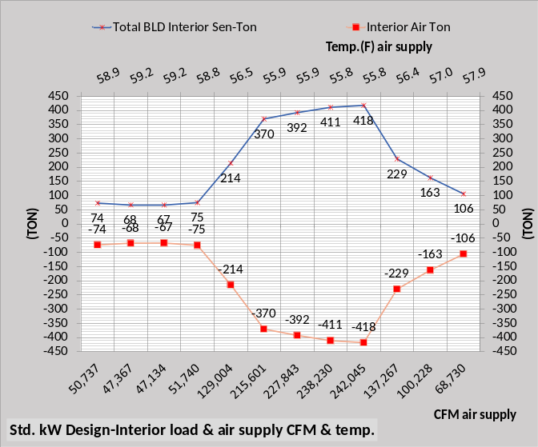Figure 10-5: Interior sensible load & air supply ton
Air ton=CFM*1.08*(dT)/12,000
From Figure 3-5 & Schematic 3-2 at 4PM we have;
Air ton = (242,045 * 1.08 * (75.0-55.81)/12,000
Air ton = 417.9 ton
Schematic 3-2 gives the air supply temperature as 55.81F where Figure 3-5 gives the value to one place.
The above equation holds for all other values given on Figure 10-5.

Building perimeter loads
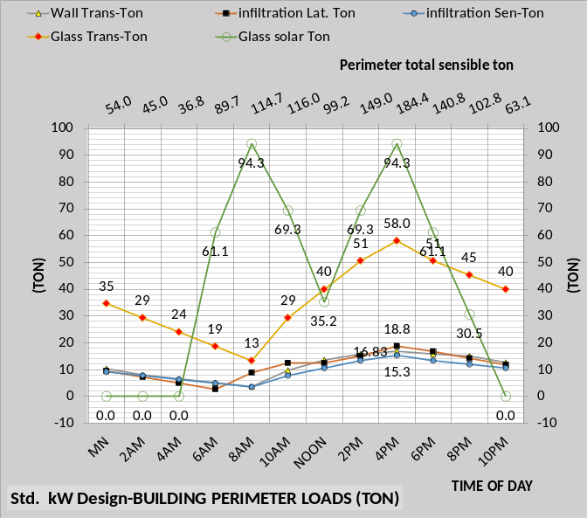Figure 10-6: Building perimeter loads
Figure 10-6 gives the building perimeter loads. At 4PM the glass solar load is 94.3 ton, glass transmission 58.0 ton, infiltration latent 18.8 ton, wall transmission 16.83 ton, and infiltration sensible 15.3 ton. The total perimeter sensible load is 184.4 ton at 4Pm as shown on the secondary horizontal axis not including the 18.8 ton latent infiltration load.
Figure 10-7 gives the total building perimeter sensible load and the air supply to meet the load. The primary horizontal axis gives the CFM of air supply and the secondary horizontal axis gives the temperature of air supply.
Air ton=CFM*1.08*(dT)/12,000
From Figure 10-7 & Schematic 10-2 at 4PM we have;
Air ton = (112,310 * 1.08 * (75.0-56.76)/12,000
Air ton = 184.4 ton

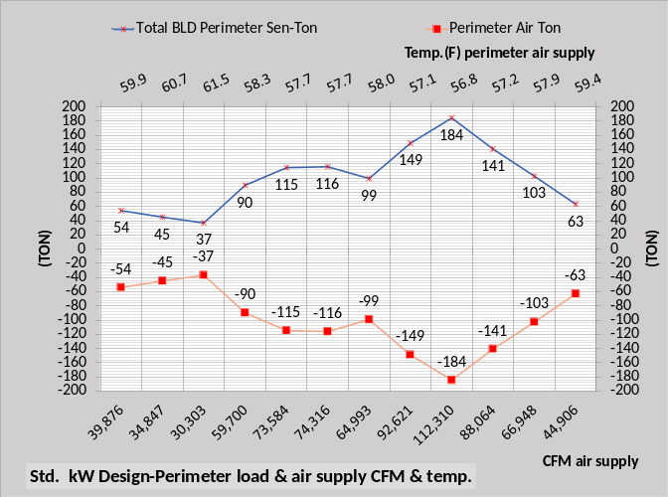Figure 10-7: Perimeter sensible load & air supply

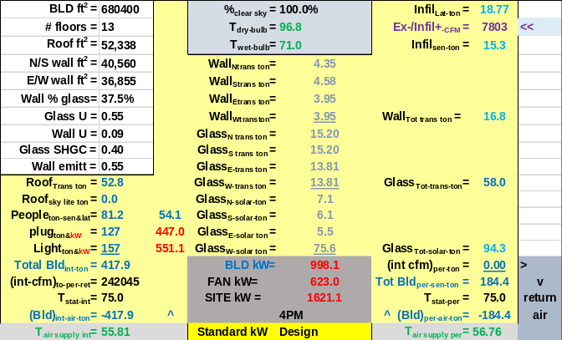Schematic 10-3: Building interior & perimeter loads
Schematic 10-3 is copied from Schematic 10-2 showing the building conditions at 4PM.

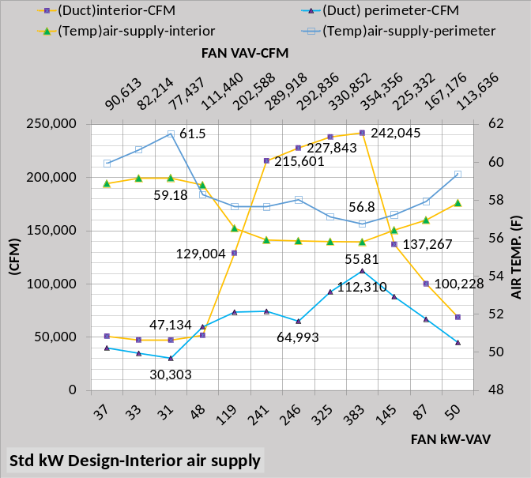Figure 10-8: Perimeter & interior air supply
Figure 10-8 illustrates the complexity of air supply to the interior and perimeter of the building over 24 hours. The figure shows the VAV fan kW on the primary horizontal axis and the VAV fans CFM on the secondary horizontal axis. Schematic 10-4 illustrates at peak conditions.
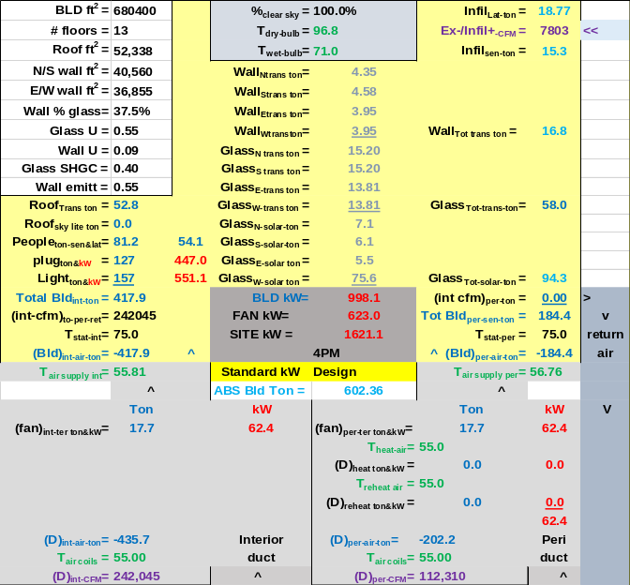Schematic 10-4: Building & coils

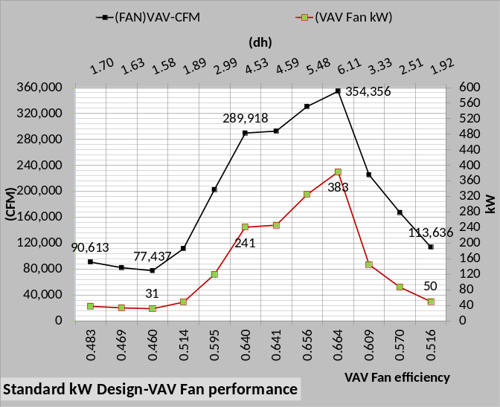Figure 10-9: VAV fans
Figure 10-9 gives the VAV fans kW demand, air static pressure and efficiency.
The VAV fan kW is given by the equation;
VAV Fan kW = .746 * CFM * (dh)/(E_{fan-VSD} * 6356)
(dh) = VAV air static pressure (in)
E_{fan-VSD} = VAV fans efficiency
At peak conditions;
VAV fan kW= .746*354,356*6.11/ (.664*6356)
VAV fan kW = 383 kW
Also shown on Schematic 10-2. The equation holds for all other values of Figure 10-9.
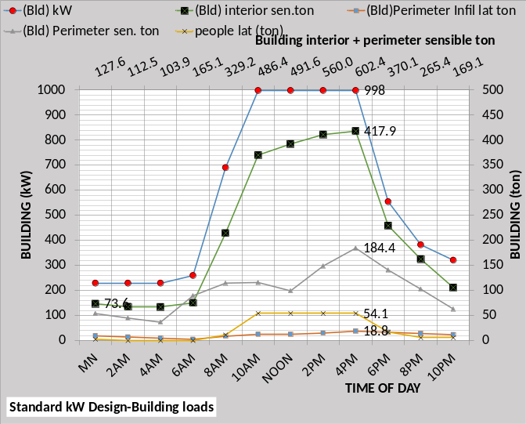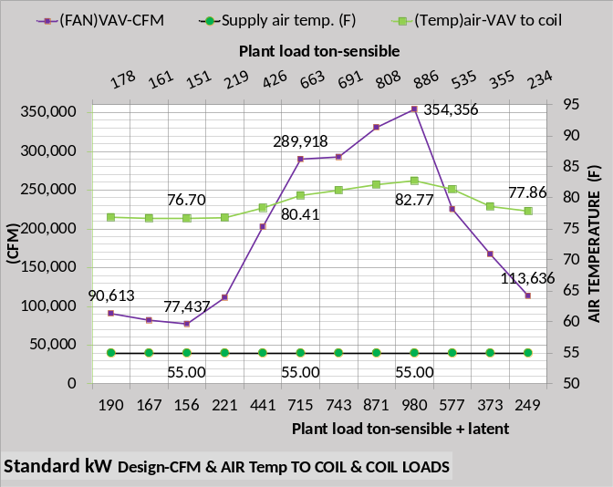Figure 10-10: Perimeter & interior loads & VAV fans response to loads
Figure 10-10 top chart gives the building loads and building kW including the latent loads that are passed to the coils by the VAV fans. The bottom chart shows the air temperature entering the VAV fans and the supply air temperature of 55F. The primary horizontal axis of the bottom chart gives the sensible + latent plant load and the secondary horizontal axis gives the plant sensible load.
Air ton=CFM*1.08*(dT)/12,000
At peak conditions the sensible load is;
Air ton = 354,356*1.08*(82.77F-55F)/12,000
Air ton = 886 ton
Also shown as the sensible coil load on Schematic 10-2.
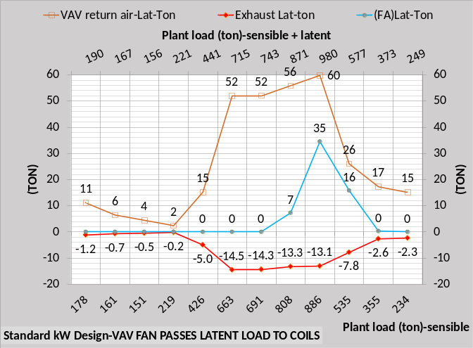 Figure 10-11: Latent load
Figure 10-11 illustrates the latent load transferred to the coils. As shown by Schematic 10-5 some of the infiltration and people latent is exhausted (-13.1 ton) with 59.85 ton sent to the VAV suction side. Fresh air brings in 34.5 ton latent load therefore 94.4 ton of latent is delivered to the coils by the VAV fans and therefore load on the plant.
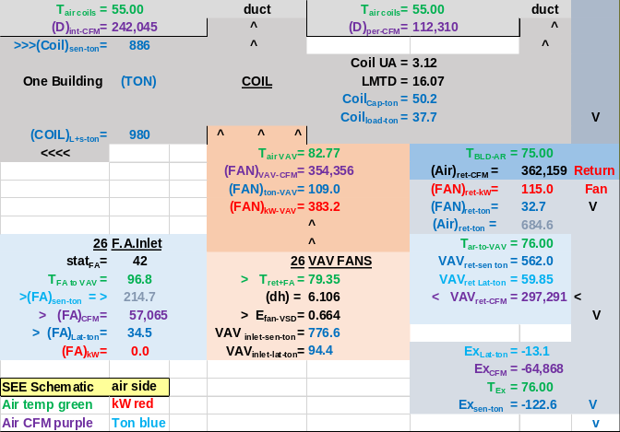 Schematic 10-5: VAV fan conditions
Schematic 10-5 illustrates the complexity of the VAV fans air inlet, with fresh air in and exhaust out of the system to mix with the building return air i.e. a (SEE) model is necessary to understand this complex system.
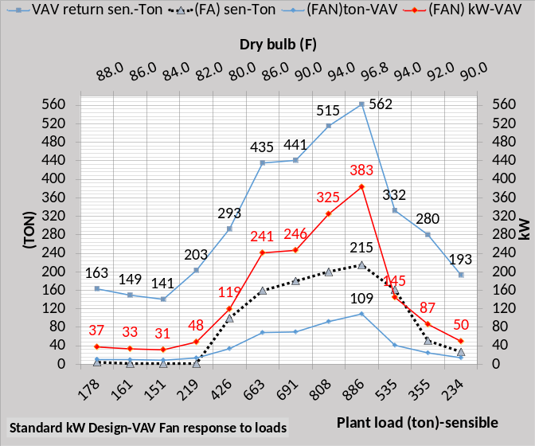Figure 10-12: VAV fans load and response
Figure 10-12 illustrates the load to the VAV fans and the load the VAV fan kW demand puts on the VAV fans. Schematic 10-5 also illustrates at peak conditions. The VAV sensible return is 562.0 ton and the fresh air adds 214.7 ton and the VAV fan kW adds 109 ton for a total sensible load on the coils of (562+215+109=886ton) as shown on the primary horizontal axis.
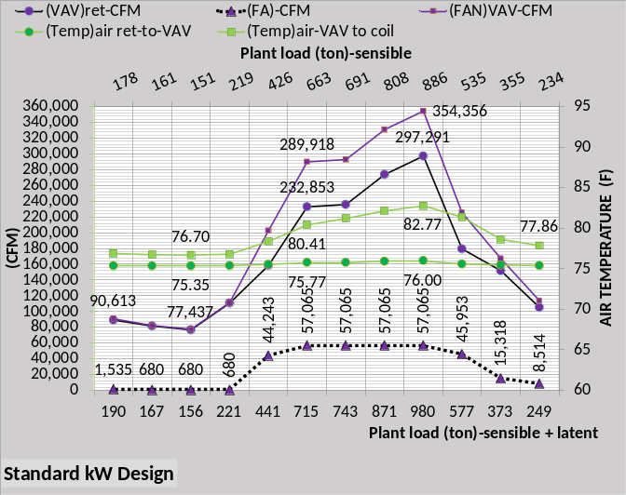Figure 10-13: VAV fans conditions
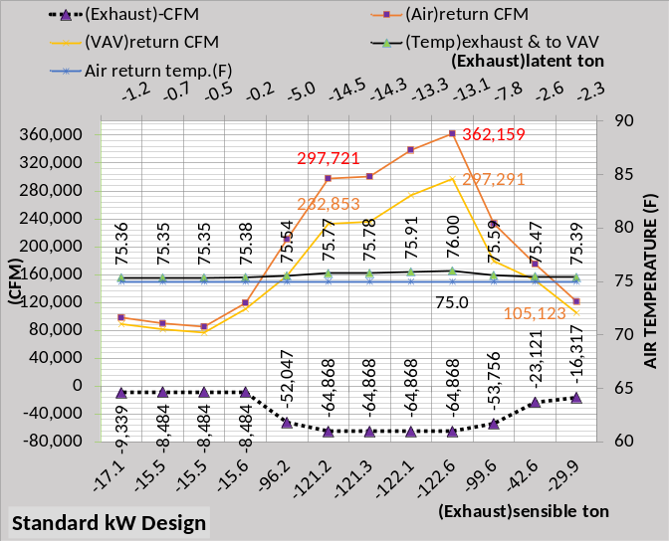Figure 10-14: VAV fans conditions
Figures 10-13 thru 10-16 illustrate the 24 hour conditions at the VAV fans, illustrating the complexity of the air system and the need for (SEE) Model analysis. These charts and schematics brought understanding to the author of how the system “works”; hope it works for you.
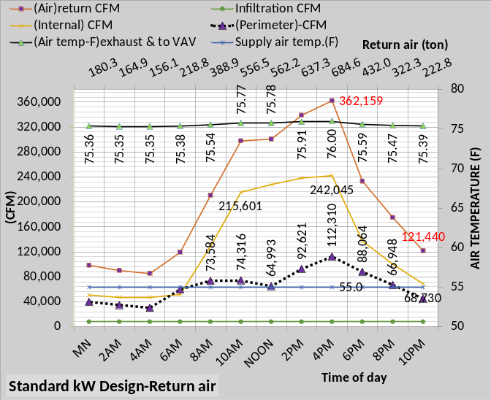Figure 10-15: VAV fans conditions

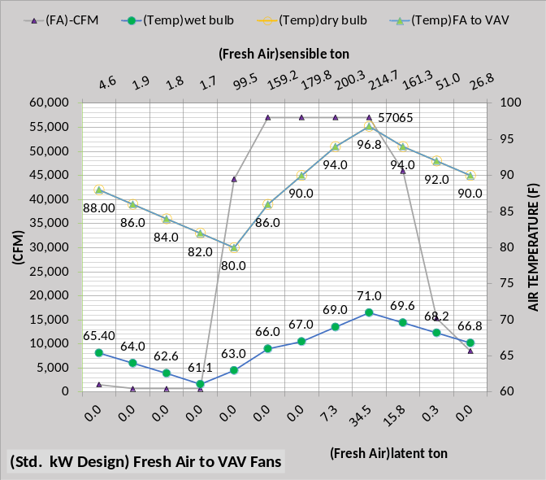Figure 10-16: Fresh air conditions
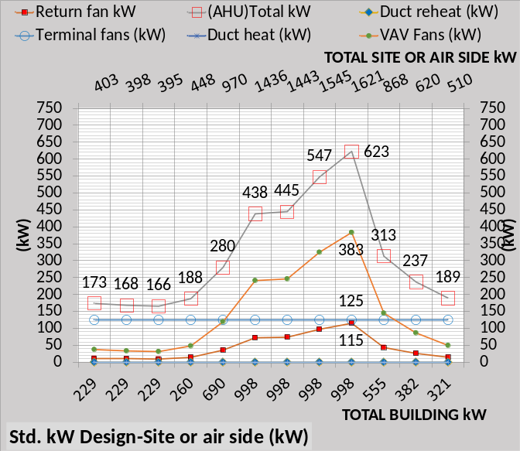Figure 10-17: Air handler kW demand
Figure 10-17 gives the air handler system kW for the 24 hours. At peak conditions for this design day the duct heat and reheat is zero. As the model considers fall and winter conditions these values will become significant. At peak conditions the VAV fans kW is 383, the terminal fans are 125 kW and the return fans are 115 kW for a total of 623 kW as shown on Figure 10-17. Add this air handler kW to the building kW of 998 at peak gives 1621 kW as shown on the secondary horizontal axis of Figure 10-17.
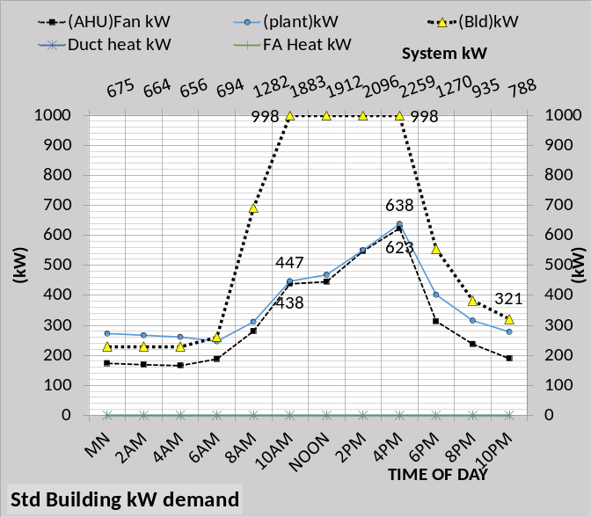 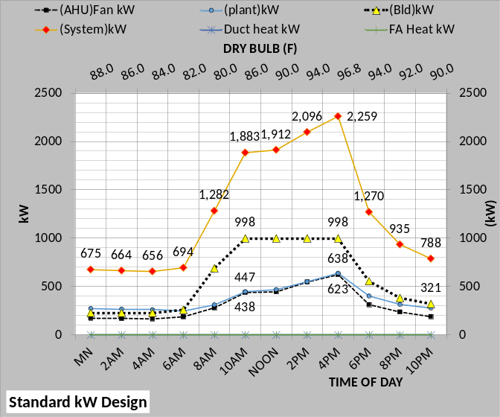Figure 10-18: System kW demand
The top chart of Figure 10-18 gives the system kW demand with the total on the secondary horizontal axis. The bottom chart gives the same data. At peak conditions the building 998 kW is largest followed by the plant at 638 kW then the fan system at 623 kW. The plant will be addressed in chapters to follow.

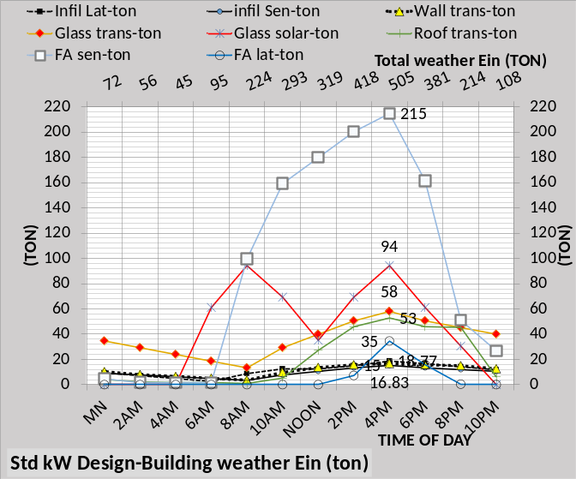 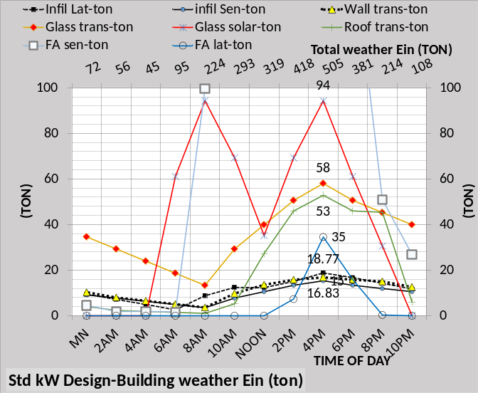Figure 10-19: Weather Energy in
Figure 10-19 top chart gives the eight components that make up the weather energy into the system and the bottom chart is the same chart with the scale reduced so that the smaller loads can be better determined. The top chart shows that the fresh air sensible is the largest load, (215 ton at peak), followed by glass solar 94 ton, glass transmission 53 ton, fresh air latent 35 ton, with the other loads about 16 to 18 ton.

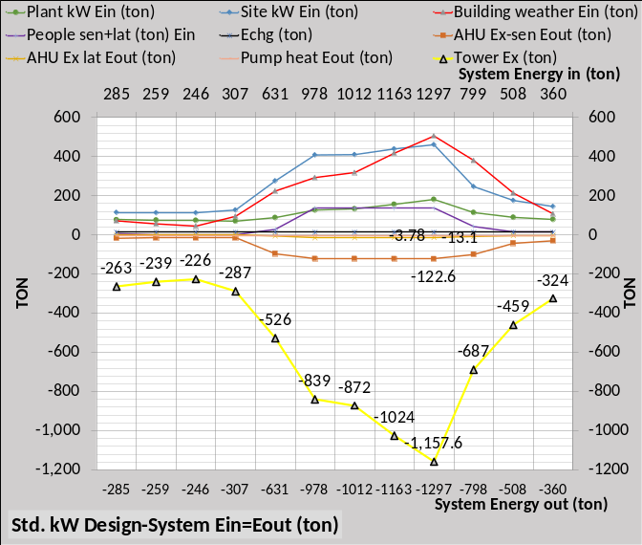 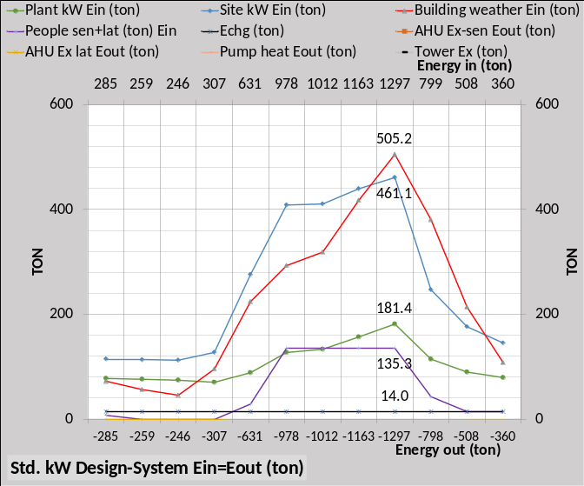Figure 10-20: System Energy in = Energy out
The top chart of Figure 10-20 illustrates that energy into the system equals energy out of the system. The bottom chart is the same with the axis scales reduced so that energy in values can be better determined. The top chart shows that the tower is the big energy out value, -1159.5 ton at peak, followed by sensible exhaust of -122.6 ton and exhaust latent is -13.1 and pump motor heat out of -2.95 ton for a total energy out of -1298 ton as shown on Figure 10-20.
The bottom chart of Figure 10-20 expands the energy in values. At peak the weather energy in is 505.2 ton, also shown by Figure 10-19, and the load due to site kW is 461.1 ton. Plant kW gives a load of 182.4 ton, people 135.3 ton, and infiltration of 7637 CFM gives a change in energy of 13.7 ton for a total energy in at peak of 1297 ton.
The next page gives a full Schematic 10-6 at peak design conditions. A schematic of this type can be given for any hour.
The next Chapter 11 will address the response of the low lift and high lift one chiller plants to the Long Beach building loads defined by this Chapter 10.

Schematic 10-6: Full schematic at peak 4PM conditions-Long Beach Ca.
Chapter 11: Long Beach one chiller plant-high lift & low lift plant performance meeting Standard 90.1 office building loads as defined by Chapter 10
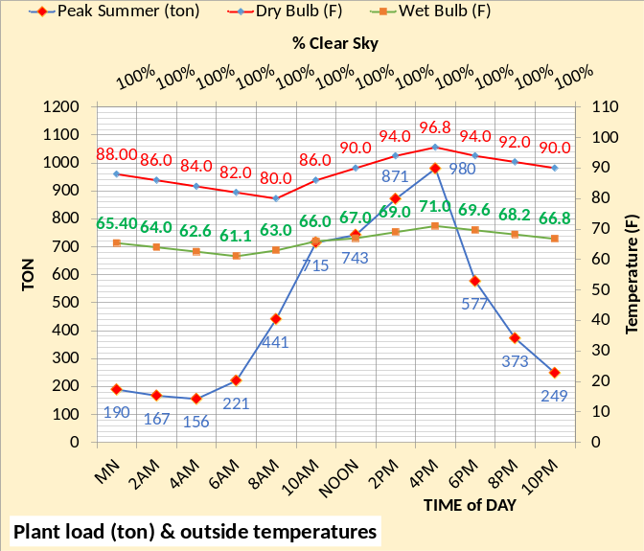Figure 11-1: Weather & plant load (ton)
Figure 11-1 gives the weather and plant load for the following evaluation of the two plant designs consisting of one chiller with 1000 ton capacity. The next Chapter 12 will consider multiply chillers and plant control to minimize plant kW demand.
 | Plant performance, at design peak hour | High Lift | Low Lift
1 | DB (F) | NA | NA
2 | WB (F) | 71.0 | 71.0
3 | Plant load (ton) | 980 | 980
4 | Pump sec-kW at peak | 29.8 | 29.8
5 | # chiller/towers on | 1 | 1
6 | chiller pump kW | 13.8 | 7.5
7 | Temp evap. refrig. (F) | 41.5 | 40.9
8 | Evap refrig. app. (F) | 2.58 | 3.16
9 | Temp. supply water (F) | 44.11 | 44.08
10 | Temp return water (F) | 60.11 | 60.08
11 | Each evaporator gpm | 1500 | 1500
12 | Evap. pressure drop (ft) | 34.5 | 16.4
13 | Evaporators load (ton) | 989.5 | 988.5
14 | Chiller motor kW | 519 | 455
15 | Chiller kW/ evap. ton | .524 | .460
16 | Condensers load (ton) | 1144 | 1124
17 | Temp cond. refrig. (F) | 95.1 | 88.3
18 | Chiller lift (F)=row17-7 | 53.5 | 47.4
19 | Cond refrig. app. (F) | 1.59 | 3.48
20 | Cond. leaving water (F) | 93.5 | 84.8
21 | Tower leaving water (F) | 79.6 | 75.8
22 | Cond. pump kW | 27.3 | 25.9
23 | Condensers gpm | 1980 | 2987
24 | Cond. press drop (ft) | 43.0 | 21.7
25 | Tower exhaust (ton) | 1158 | 1142
26 | Tower range (F) | 13.9 | 9.03
27 | Tower approach (F) | 8.6 | 4.81
28 | Tower range + app (F) | 22.5 | 13.84
29 | Tower fan kW | 48.0 | 64.2
30 | Total plant kW | 638 | 582.4
31 | Plant kW/plant ton | .651 | .594
 | Table 11-1: High lift & Low lift One Chiller Plants | High Lift | Low Lift

Table 11-1 illustrates the difference in the two designs. The evaporators are essentially the same for both designs; the difference is in the design of the condenser and tower. Line 14 shows the chiller kW for the high lift chiller is 84 kW more than the low lift chiller. Line 18 illustrates why; the chiller lift is greater for the high lift chiller. The condenser pump kW and fan kW are greater for the low lift chiller but the net result, line 30, is about 59 kW less plant kW for the low lift chiller plant. Analysis below will show that operating the larger tower of the low lift design at 67% fan speed will provide additional savings in plant kW at off peak conditions.
Schematics 11-1 & 11-2 below give all data given by Table 11-1 plus additional data and understanding of the systems at peak load System Energy Equilibrium (SEE) conditions.
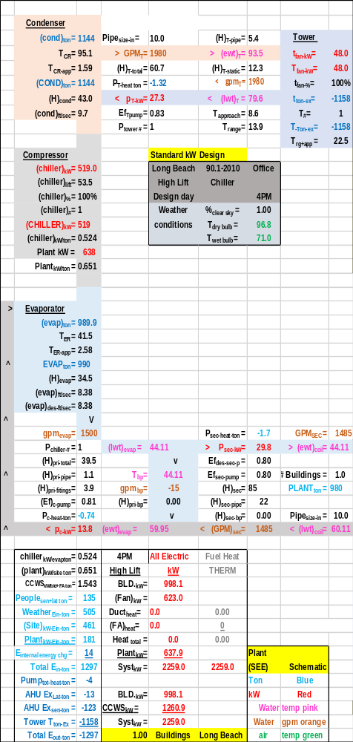Schematic 11-1: Peak Design-High lift chiller plant
Schematics 11-1 & 11-2 are the two plants at peak load and at system energy equilibrium.

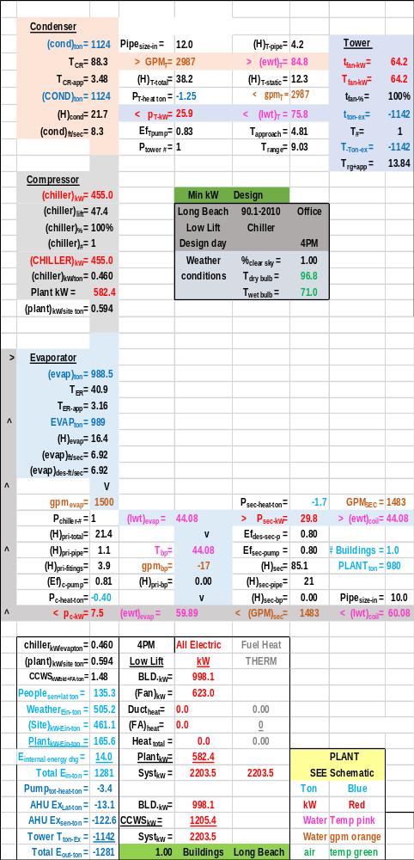Schematic 11-2: Peak Design-Low lift chiller plant

Primary/Secondary Pumping
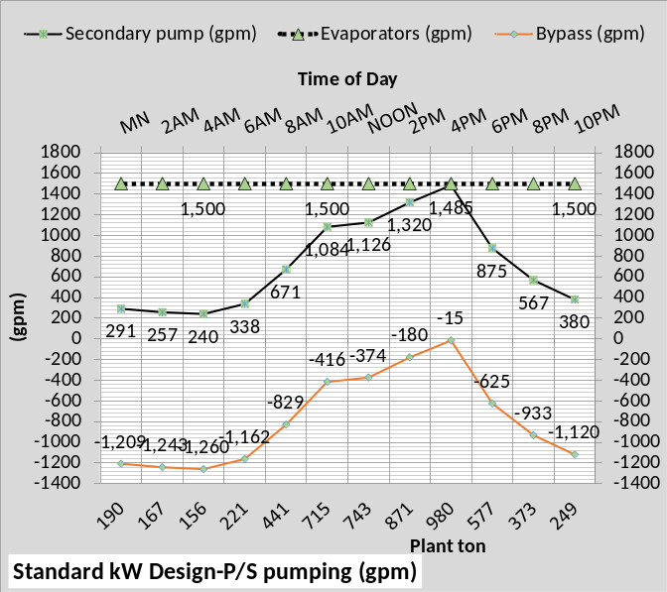Figure 11-2: P/S (gpm)
Figure 11-2 gives the flows (gpm) for the P/S pumping. The data is essentially the same for the low lift chiller plant. The evaporator primary flow is constant 1500 gpm and the secondary flow varies from 1485 gpm at design conditions down to 240 gpm at 4AM & 156 ton plant load. The bypass negative flow increases to balance the decreasing secondary flow.
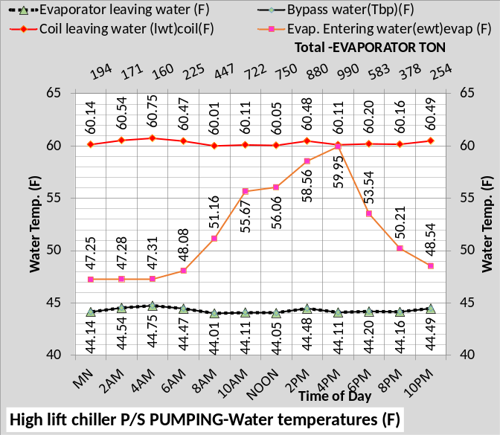Figure 11-3: P/S temperatures (F)
Figure 11-3 gives the temperatures of the P/S water. The supply water and bypass water temperature is about 44F, a function of chiller power or chiller kW as applied by an input to the model. The design dT for the secondary is 16F, therefore the return water temperature is about 60F. The bypass water, Figure 11-2, of about 44F mixes with the return 60F water resulting in a water temperature to the evaporator of 59.95F at design down to 47.25F at midnight.
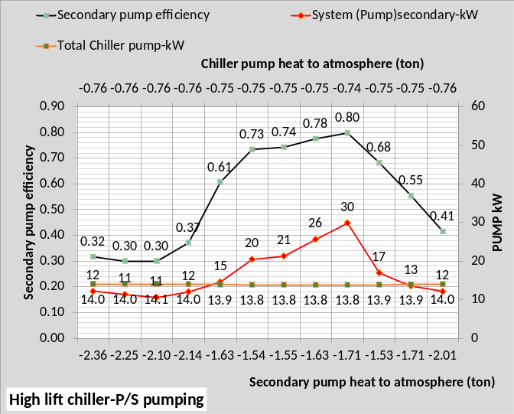Figure 11-4: P/S Demand kW & characteristics
Figure 11-4 gives the primary & secondary pumps kW demand and also gives the (SEE) Model efficiency of the secondary pump showing a decreasing efficiency as the supply water flow decreases. Also shown is the (SEE) Model pump heat to atmosphere.
Chiller Performance
Figure 11-5 shows the performance of both chiller designs against the plant load as determined by the (SEE) Model of the building as given by Chapter 10. Chiller kW is greater for the high lift chiller for all evaporator loads. The number of chillers on is shown as one, a condition that will change with Chapter 12, resulting in a significant difference in plant performance.

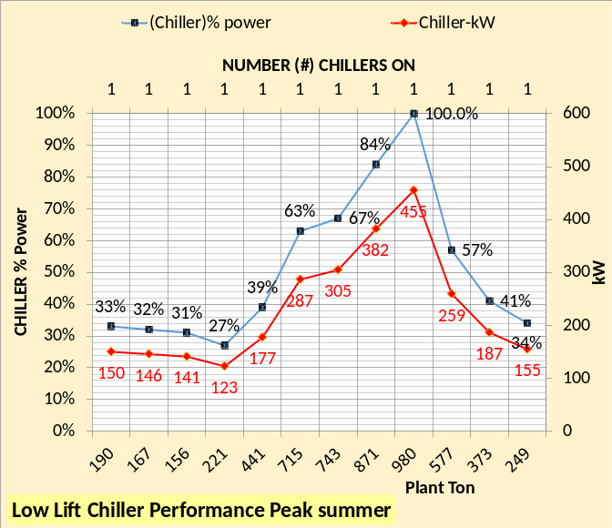 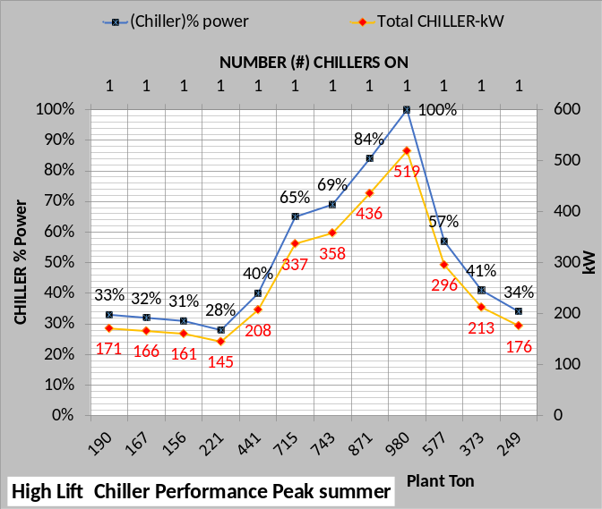Figure 11-5: Chiller performance of both chiller designs

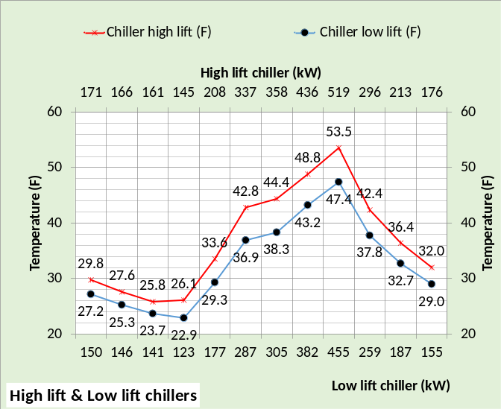Figure 11-6: Chillers lift and kW
Figure 11-6 gives the chiller lift for both designs illustrating why the chiller kW is less for the min kW design. Table 11-1 also made this point.

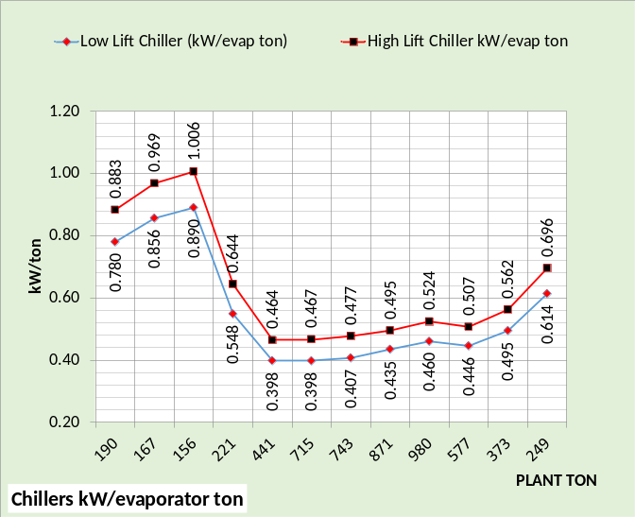 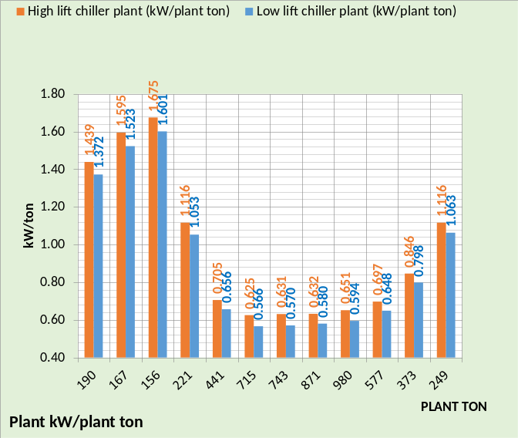Figure 11-7: Chillers & Plants kW/ton
Figure 11-7 top chart shows the chiller kW per evaporator ton is significantly less for the low lift chiller for all hours. The bottom chart shows that the plant kW per ton is also less for all hours. Analysis below will show that operating the bigger tower of the low lift design at 67% tower fan speed results in additional chiller kW but less plant kW.

Pumps & Tower Fan kW
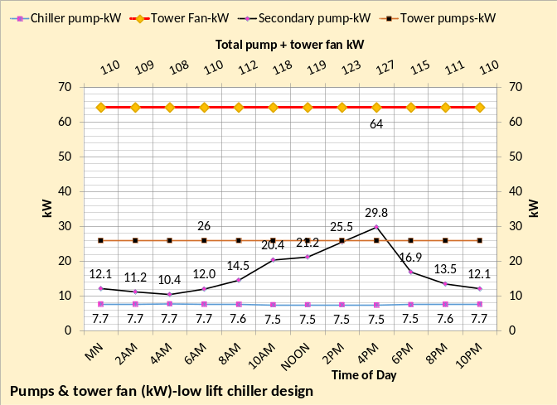 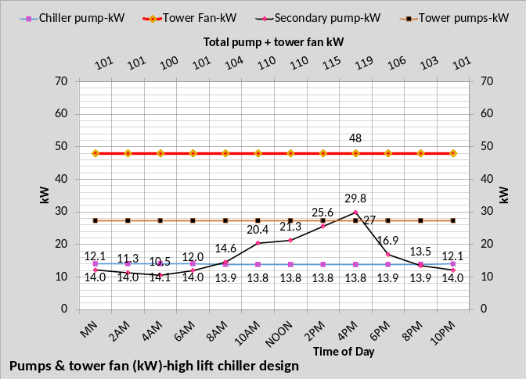Figure 11-8: Pumps & tower fan kW
Figure 11-8 shows the kW due to the tower fan and pumps. The tower fan is (64-48=16 kW) greater for the low lift design. The tower pump is about one kW greater for the high lift design as is the chiller pump of 13.8 kW verses 7.7 kW for the low lift design. However, the net result shown on the secondary axis of each chart is about 9 kW less for the high lift designs tower and pumps kW.

Tower Performance
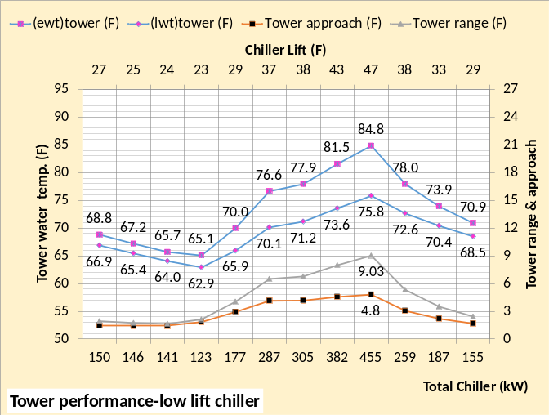 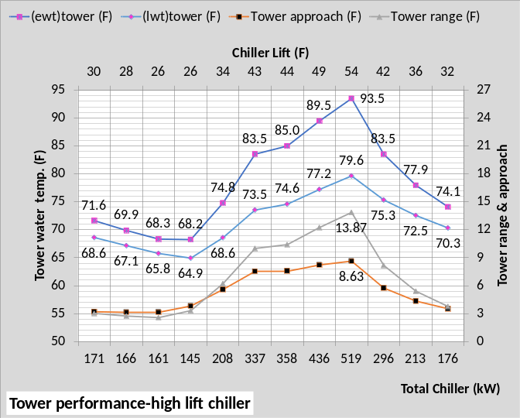Figure 11-9: Tower performance
Figure 11-9 illustrates the difference in performance in the two selected² towers that in large part provides the difference in chiller lift and therefore chiller kW. Tower water delta temperature or range thru the smaller high lift tower is 13.89F at design and the larger low lift tower range is 9.03F. The tower approach to wet bulb for the low lift tower is 4.8F and the high lift tower is 8.64F. These differences in tower size and therefore performance results in a chiller lift, Figure 11-6 that is significantly less for the low lift chiller and therefore the chiller kW demand is less as given by Figure 11-5 above.

Plant kW demand
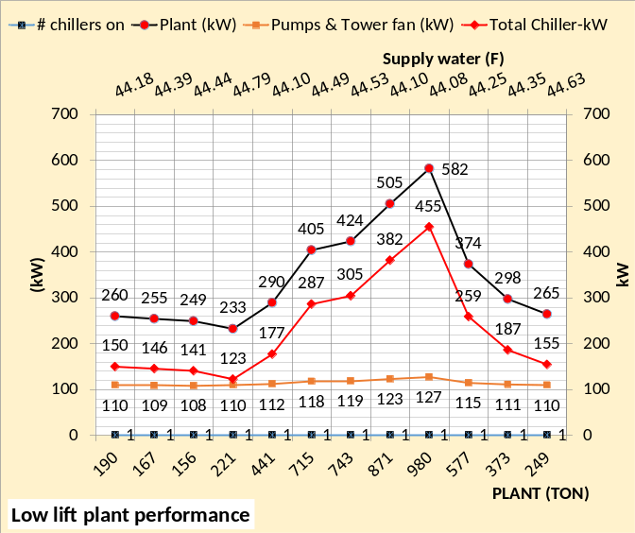 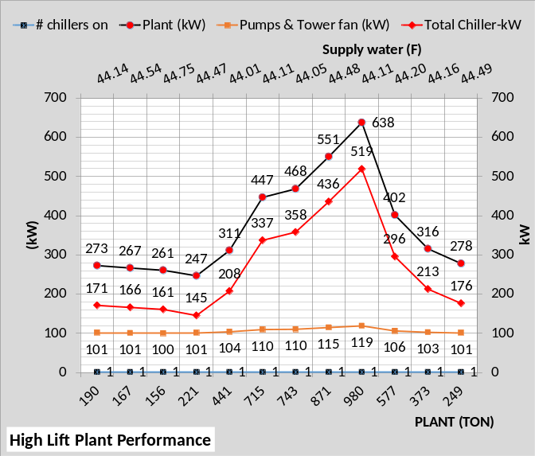Figure 11-10: Plant kW
Figure 11-10 illustrates the kW of each design for the 24 hours modeled. The chiller kW of the low lift design, top chart, provides less plant kW for all hours by comparing with the bottom chart of Figure 11-10. The temperature of supply water is shown on the secondary horizontal axis of each chart illustrating about 44F supply water for both designs.
Figure 11-11 further illustrates the low lift chiller plant advantage over the high lift plant.
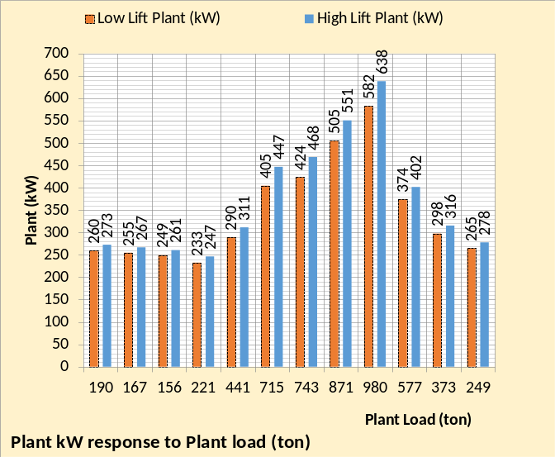 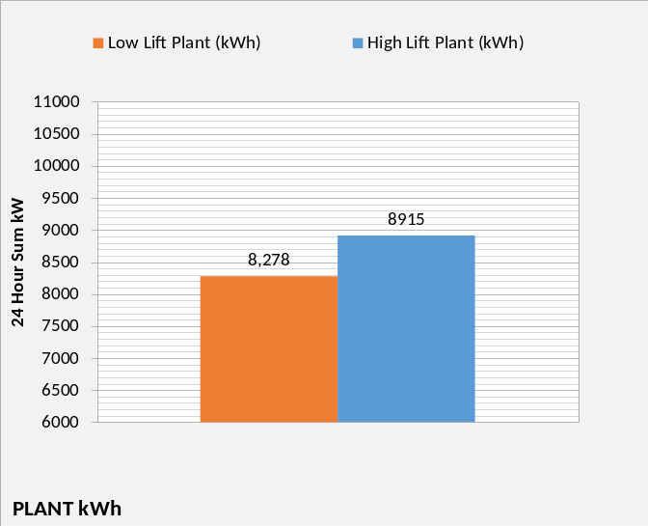Figure 11-11: Plant kW of high lift & low lift designs with tower fan speeds 100%-one chiller plant
Figure 11-11 top chart illustrates the plant kW of the low lift design is less for all hours. The bottom chart gives the 24 hour plant demand showing the low lift plant provides about a 7% reduction in kWh for the design day conditions.
The next Chapter 12 will analyze three chiller plants operating against the 980 ton plant load as defined by this Chapter 11.

Chapter 12: High Lift Plant & Low Lift Plant Performances-3 Chiller Plant-Standard 90.1⁸ Long Beach office building

Figure 12-1: Weather & plant load (ton)
Figure 12-1 gives the weather and plant load (same as Chapter 4) for the following evaluation of the two plant designs consisting of three chillers with each having 334 ton capacity.
 | Plant performance, at design peak hour | High Lift | Low Lift
1 | DB (F) | NA | NA
2 | WB (F) | 71.0 | 71.0
3 | Plant load (ton) | 980 | 980
4 | Pump sec-kW at peak | 29.8 | 29.8
5 | # chiller/towers on | 3 | 3
6 | chiller pump kW | 4.6 | 2.6
7 | Temp evap. refrig. (F) | 41.7 | 41.2
8 | Evap refrig. app. (F) | 2.57 | 3.15
9 | Temp. supply water (F) | 44.26 | 44.37
10 | Temp return water (F) | 60.06 | 60.15
11 | Each evaporator gpm | 501 | 501
12 | Evap. pressure drop (ft) | 34.5 | 16.4
13 | Evap load (ton) each | 330.0 | 329.5
14 | Chiller motor kW-each | 173.0 | 150.2
15 | Chiller kW/ evap ton | .524 | .456
16 | Cond load (ton)-each | 381 | 374
17 | Temp cond. refrig. (F) | 95.2 | 88.1
18 | Chiller lift (F)=row17-7 | 53.5 | 46.9
19 | Cond refrig. app. (F) | 1.59 | 3.46
20 | Cond. leaving water (F) | 93.6 | 84.7
21 | Tower leaving water (F) | 79.8 | 75.7
22 | Cond. pump kW-each | 9.5 | 8.7
23 | Condenser gpm-each | 661 | 998
24 | Cond. press drop (ft) | 43.0 | 21.7
25 | Tower exh. (ton)-each | 385 | 381
26 | Tower range (F) | 13.8 | 9.00
27 | Tower approach (F) | 8.8 | 4.67
28 | Tower range + app (F) | 22.6 | 13.67
29 | Tower fan kW-each | 12 | 24
30 | Total plant kW | 627 | 586
31 | Plant kW/plant ton | .640 | .598
 | Table 12-1: High lift & Low lift Chiller | High Lift | Low Lift

Table 12-1 illustrates the difference in the two designs. The evaporators are essentially the same for both designs; the difference is in the design of the condenser and tower. Line 14 shows the chiller kW for the high lift chiller is 23 kW more than the low lift chiller. Line 18 illustrates why; the chiller lift is greater for the high lift chiller. The condenser pump kW and fan kW are greater for the low lift chiller but the net result, line 30, is about 41 kW less plant kW for the low lift chiller plant at peak summer conditions. Analysis below will show that operating the larger tower of the low lift design at 67% fan speed will provide additional savings in plant kW at off peak conditions.
Schematics 12-1 & 12-2 below give all data given by Table 12-1 plus additional data and understanding of the systems at peak load System Energy Equilibrium (SEE) steady state condition.
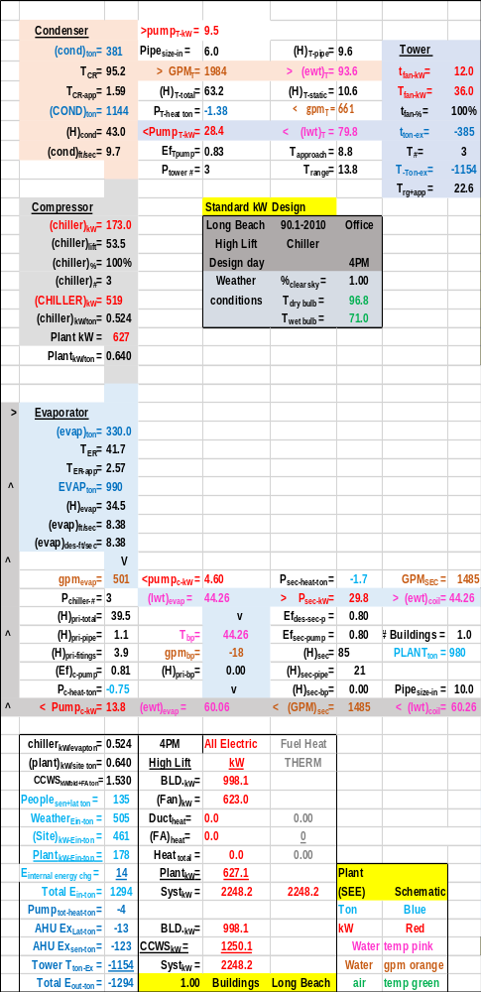Schematic 12-1: Peak design-High lift chiller plant
Schematics 12-1 & 12-2 are the three chiller/tower plants at peak load and at system energy equilibrium.

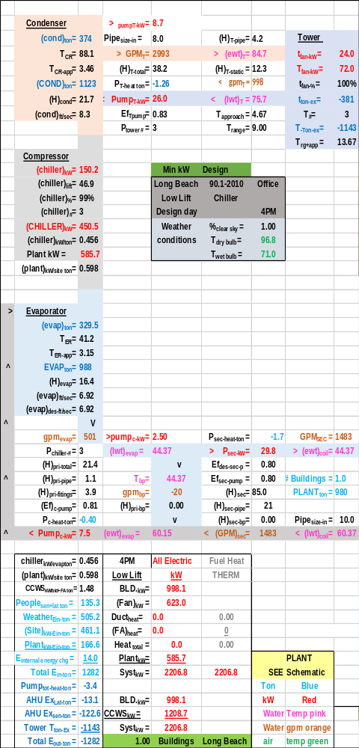Schematic 12-2: Peak Design-Low lift chiller plant

Primary/Secondary Pumping
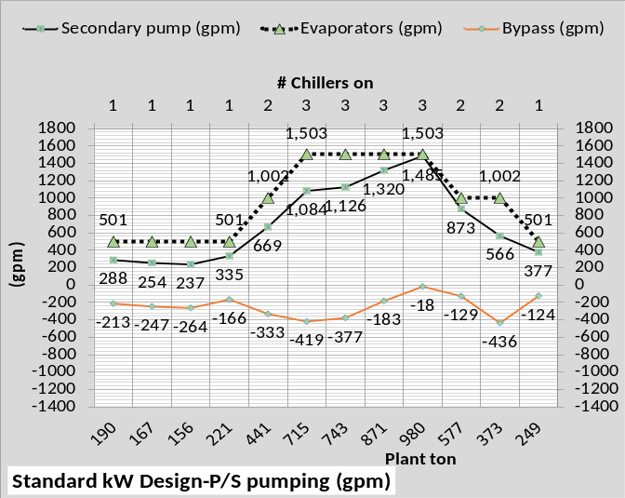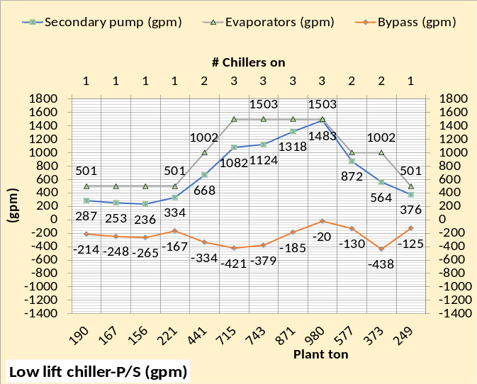Figure 12-2: P/S (gpm)-1 chiller & 3 chiller plants
Figure 12-2 gives the flows (gpm) for the P/S pumping systems. The top chart is the one chiller chart from Chapter 11. The middle and bottom chart show the significant difference the three chiller plant has on the flow in the bypass. The number of chillers on is shown on the secondary horizontal axis of the middle and bottom charts.

Figure 12-3: P/S temperatures (F)
Figure 12-3 gives the temperatures of the P/S water. The top chart is one chiller/tower and the other two charts are three chiller/tower plants. The supply water and bypass water temperature is about 44F for all three charts/plants. The design dT for the secondary is 16F, therefore the return water temperature is about 60F for all three plants. The bypass water of about 44F mixes with the return 60F water resulting in a water temperature to the evaporator of 59.95F at design down to 47.25F at midnight for one chiller/tower plant as shown by the top chart. The three chiller/tower plants as shown by the middle and bottom charts results in a warmer water return to the evaporator due to less flow in the bypass as also shown by Figure 12-2.
Chiller Performance
Figure 2-4 from Chapter 2-100% tower fan speed
The above Figure 2-4 from Chapter 2 illustrates one reason why a multi chiller/tower plant will operate more efficiently than a one chiller/tower plant. Figure 2-10 of Chapter 2 illustrates the same for 50% tower fan speed. Note that at less than 50% load on the chiller (500 ton) the kW/ton begins to increase and at less than 30% load the kW/ton significantly increases. This characteristic of centrifugal chillers is in the set of (SEE) model simultaneous equations.
Figure 12-4: 1 chiller/tower & 3 chiller/tower plants
Figures 12-4 & 12-5 give the performance of the 1000 ton chiller/tower plant, top charts from Chapter 11, and the performance of the three 334 ton chiller/tower plant, bottom chart of this Chapter 12. Consider the midnight plant load of 190 ton which is about 19% load for the 1000 ton chiller, top chart, and about 57% load on the 334 ton chiller of the three chiller/tower plant. The kW/ton for the 1000 ton chiller, top chart, is 150kW/190 ton = .79 kW/ton and the 334 ton chiller is 76 kW/190 ton = .40 kW/ton. Clearly the number of chillers in a plant effects the performance of the plant.
Figure 12-5: 1 chiller/tower & 3 chiller/tower plants
The motor kW capacity of the low lift design is 455 kW for the 1000 ton chiller, see Table 11-1, and 152 kW for the three chiller plant of this Chapter 12. Therefore the 1000 ton chiller, top chart of Figure 12-4, used at 190 ton load (.33*455kW=150kW) as shown. The three chiller low lift plant used (.50*152kW=76kW) as shown on bottom chart of Figure 12-4. The high lift design motor capacity is 519 kW for 1000 ton chiller, see Table 11-1, and 173 kW for the 334 ton chiller.

Figure 12-6: Chillers lift and kW
Figure 12-6 gives the chiller lift for both designs. The top chart is Figure 11-6 from Chapter 11 showing the performance of the 1000 ton chiller. The bottom chart of Figure 12-6 shows the chiller lift and chiller kW of the three chiller plant. Comparing the top and bottom charts illustrates the complexity in the performance of a chiller plant; chiller lift alone does not define the chiller kW for a given load. Figure 2-4 of Chapter 2, copied above, illustrates the point and also makes the point that the (SEE) Model equations must stay with the basics of thermodynamics to achieve a good model of a chiller plant. Chapter 2 illustrates this to be the case.

Figure 12-7: Chiller performance
Figure 12-7 gives the chiller kW/ton for the one chiller plant, top chart, and the three chiller plant, bottom chart, clearly illustrating the advantage of the three chiller plant to improve chiller kW/ton.
Figure 12-8: Chillers & Plants kW/ton
Figure 12-8 top chart shows the plant kW/ton for the one chiller plant and the bottom chart shows the three chiller plant kW/ton. The low lift design had better performance at all hours but note that at a plant load of 156 ton the plant kW/ton is very close. Operating the tower fans at 67% will be consider below. The values of kW/ton are best at higher plant loads illustrating the effect of the pumps and tower fan kW values.

Pumps & Tower Fan kW
Figure 12-9: Pumps & tower fan kW
Figure 12-9 top chart gives the one chiller pumps and tower fan kW and the bottom chart gives the three chiller performance. The secondary horizontal axis illustrates the three chiller value is more until two chillers are required to meet the plant load. An obvious question; can the big tower of the low lift chiller design be operated at 67% tower fan speed and reduce plant kW?
Figure 12-10: Pumps & tower fan kW
Figure 12-10 top chart gives the one chiller plant pumps and tower fan kW and the bottom chart gives the three chiller plant performance for the high lift chiller design. The secondary horizontal axis illustrates the three chiller value is less for all hours illustrating the advantage of the small tower of the big chiller design. However if the objective is to minimize plant kW demand then the low lift chiller design has a clear advantage as will be further shown.

Tower Performance
Figure 12-11: Tower performance
Figure 12-11 top chart is the one chiller tower and the bottom chart is the three chiller tower. The number of towers on is given by Figure 12-7. The horizontal axis gives the chiller kW for each design.
Figure 12-12: Tower performance
Figure 12-12 top chart is the one chiller plant and the bottom chart is the three chiller plant of the high lift design.

Plant kW demand
Figure 12-13: Plant kW
Figure 12-13 top chart gives the one chiller plant kW values and the bottom chart gives the three chiller plant values. The three chillers on values of plant kW are greater for the three chiller plant but for two or one chillers on the plant kW is less for the three chiller plant.
Figure 12-14: Plant kW
Figure 12-14 top chart gives the one chiller plant kW values and the bottom chart gives the three chiller plant values for the high lift plant. All values of plant kW are less for the three-chiller plant verses the one chiller plant.

Figure 12-15: Plant kW of high lift & low lift designs with tower fan speeds 100%
Figure 12-15 top chart is the one chiller plant and the bottom chart is the three-chiller plant. The low lift chiller plant kW is less for all hours but only slightly less for low loads.
Figure 12-16: Plant kW of high lift & low lift designs with tower fan speeds 100%
Figure 12-16 top chart gives the 24 hour summed kW of the one chiller plant and the bottom chart gives the three chiller plant values, illustrating the 24 hour advantage of the three chiller plant.
Next the tower fans will be operated at 67%.
Figure 12-17: Plant kW of high lift & low lift designs with tower fan speeds 67%
Comparing Figures 12-16 & 12-17 bottom charts illustrates the 24-hour kWh decreased for the low lift plant but increased for the high lift plant. A simple explanation is that the chiller kW of the high lift plant increased more than the tower fan kW decreased and the reverse is true for the low lift plant. Comparing the top chart of Figure 12-17 with the bottom chart of Figure 12-15 generally illustrates an increase in plant kW with 67% tower fan speed for the high lift design.
Figure 12-18: Top chart 100% tower fan speed & bottom chart 67% tower fan speed.
Figure 12-18 illustrates how the chiller kW increased as the tower fan kW decreased giving a net result of increased plant kW with 67% tower fan speed for the high lift chiller plant.
Figure 12-19: Top chart 100% tower fan speed & bottom chart 67% tower fan speed.
Figure 12-19 illustrates that the plant kW decreased for all hours except the peak kW where tower fan speed must remain at 100% to meet the peak load.
Clearly the low lift chiller plant with the large towers and small chillers has a significant kW demand advantage over the high lift three chiller plant design especially if tower fan speed is controlled to minimize plant kW. The charts below further define the two systems.

System watts per square foot
Figure 12-20: watts/sq ft over 24 hours
Figure 12-20 gives the major system components energy use in w/sq. ft. with total system w/sq. ft. given and plant w/sq. ft. given at peak 4PM hour. Chapter 10 gives the building sq. ft. as 680,400 sq. ft. and Figure 12-19 above gives the peak plant kW for the Standard design as 627 kW. Therefore 627,000 watts/680,400 sq. ft. = .922 w/sq. ft. as given by the top chart of Figure 12-20 illustrating how all values of this paper tie together.
Figure 12-21: Building watts/sq. ft.
Figure 12-22: Plant & System watts/sq. ft.
Figure 12-21 illustrates no change in the building electrical demand for the two systems and Figure 12-22 illustrates that the only change is the plants that is reflected in the system watts per square foot.
Chapter 13: Plant Design &/or Aging Deficiencies-Standard 90.1 Building & High Lift plant Design
The high lift plant, meeting the loads of the Standard 90.1 building of Chapter 10, will be referred to as the Standard design.
Schematic 13-1 is the Standard kW plant at design conditions at 10AM when the plant load is 715 ton and Schematic 13-2 is the plant with the following design deficiencies. In Chapter 1 COP ratio was discussed as a necessary input to the SEE plant model, (“This COP ratio is a necessary input to the (SEE) model & will vary due to type chiller, conditions, and probably by manufacture”). The COP ratio of the plant as designed is .719 and the ratio is .680 for the plant of Schematic 13-2, about a 5% assumed degradation. Also the condenser and evaporator refrigerant design approach is increased one degree F and the tower cold water supply is increased one degree F.

Comparing Schematics 13-1 & 13-2 shows an increase in chiller kW from 337 kW to 384 kW, a 14% increase. Plant kW increased from 436 to 483 an 11% increase.
Schematic 13-1: High Lift or Standard plant design

Schematic 13-2: Standard plant with deficiencies
The evaporator refrigerant approach temperature increased about one half degree in Schematic 13-2 which results in chiller lift increasing one half degree. However the big increase in chiller lift is due to the condenser and tower. The chiller lift is increased (45.2-42.8 = 2.4F) therefore 1.9F of this increase is due to the tower and condenser of Schematic 13-2. Tower water leaving the condenser is increased (84.9-83.6=1.3F) and the refrigerant approach increased (2.00-1.40=.6F) for a total increase in lift of 1.9F at the condenser/tower. Add the increase of .5F at the evaporator gives a total increase in lift of 2.4F that accounts for the increase in chiller kW from 337 kW to 384 kW.
Now we will look at peak conditions at 4PM.

Schematic 13-3: Standard plant design
Schematic 13-3 gives the plant condition at peak load as designed and Schematic 13-4 is the plant with deficiencies as defined above. The chiller and plant kW are the same for both but the supply water of Schematic 13-4 has increased to 49.70F; the redundant chiller 4 must be turned on to achieve 44F supply water. Chiller lift has decreased with Schematic 13-4 (53.5-51.0=2.5) primarily because the chilled water supply temperature has increased. The next Schematic 13-5 will add the 4th chiller and reduce the supply water to about 44F.

Schematic 13-4: Standard plant with deficiencies-no increase in chiller kW

Schematic 13-4: copied Standard plant with deficiencies
Schematic 13-4 is copied so that a side by side comparison can be made. Total chiller kW increased from 519 kW to 574 kW, an 11% increase. Plant kW also increased from 627 kW to 709 kW due to the additional chiller, tower fan and pumping. A comparison of Schematics 13-4 & 13-5 illustrates significant changes in the performance of the plant.
Schematic 13-5: Standard plant with deficiencies-4th chiller on

Schematic 13-6: Standard kW design plant
Schematic 13-6 is the standard kW plant at design conditions at 10PM when the plant load is 249 ton and Schematic 13-7 is the plant with the design deficiencies. Comparing Schematics 13-6 & 13-7 shows an increase in chiller kW from 119 kW to 135 kW, a 13% increase primarily due to chiller lift increasing from 44.2F to 46.5F.

Schematic 13-7: Standard kW plant with deficiencies

Figure 13-1: High lift plant performance as designed and with deficiencies
Figure 13-1 illustrates the difference in kW demand of the plant with design deficiencies as defined above.
Figure 13-2: High lift tower performance as designed and with deficiencies
Figure 13-2 illustrates the tower performances showing an increase in tower water temperature for the deficient tower with the exception at peak load where 4 chiller/towers are on for the deficient plant.

Figure 13-3: Systems watts/sq. ft.
Figure 13-3 illustrates the changes in the electrical demand of the system major components for min kW design, top chart, Standard design, middle chart, and Standard design with plant deficiencies, bottom chart.
Figure 13-4: Building 24 hour watt-hr/sq. ft.
Figure 13-4 illustrates no change in the site kW demand for the three systems thus far addressed.

Figure 13-5: Plant & System watts/sq. ft.
Figures 13-4 & 13-5 illustrate the electrical demand per building square foot for the three systems addressed thus far.
Figure 13-5 illustrates that the standard plant with deficiencies has about an 11% increase in energy use over the standard as designed for the 24 hour weather and building conditions defined by Chapter 10.

Chapter 14: Poor control of standard kW design building
This chapter will assume the following poor control issues for the standard kW design building of Chapter 10. The plant deficiencies of Chapter 13 will not be carried over to this Chapter 14 or other chapters.
- The lights are manually controlled i.e. depending on people to turn lights off. This procedure sometimes works well for a few months but usually degenerates. This analysis will assume that 67% of lights are on after hours (LV) verses 6% for the standard design⁸.
- Fresh air will be assumed as on all hours. (NF)
- Thermostats not controlled can have a significant effect on the energy consumption of a building. Thermostat set points and return air paths must be considered in minimizing building energy consumption. In general, this analysis models all return air to the perimeter of the building. Therefore, if the internal and perimeter thermostats are set different then energy can be transferred from the interior of the building to the perimeter.
- Design load delta temperature is 16F. The “poor control” model will input a secondary pump kW close to max 700kW resulting in a load delta T of less than 16F. (IG)
Figure 14-1 illustrates the difference in light control of the two buildings. The top chart gives the standard kW design lights, plug, and people and the bottom chart illustrates the increased lights kW at after hours for the building with no light control. The secondary horizontal axis gives the total building kW for both conditions of lights control showing the increase in kW for after hours.
Figure 14-1: Building lights & plug loads
Figure 14-2: Fresh air into system
Figure 14-2 gives the fresh air details for both the standard design and the conditions defined as poor control of this chapter 14. Comparing Figures 14-1 & 14-2 illustrates the fresh air CFM is controlled to the people in the building as shown by the top chart of Figure 14-2.
The bottom chart of Figure 14-2 illustrates the condition where fresh air is not controlled resulting in significant increase in fresh air CFM and load on the coils as shown by the horizontal axis.
Figure 14-3: Building loads
Figure 14-3 illustrates the first three control issues listed above, lights left on at night, fresh air is not minimized, and stats are not controlled to minimize load. The bottom chart illustrates the increase in building kW due to lights and plug loads and the building interior load is increased. The building perimeter sensible load is increased due to the perimeter stat being set at 74F and the interior stat is set at 75F. All return air goes to the perimeter of the building so the interior adds heat load to the perimeter. The following side by side schematics illustrate.
Schematic 14-1: Standard building design-4PM
Comparing Schematics 14-1 & 14-2 illustrates the effect of an internal stat set at 75F and perimeter stat set at 74F. The wall transmission load is increased from 16.8 ton to 17.6 ton and glass transmission increased from 58 to 60.7 ton. Infiltration load is about 34 ton, slightly increasing sensible .7 ton and decreasing latent .7 ton with the change of perimeter stat from 75F t0 74F. The biggest addition to load as shown by Schematic 14-2 is the effect of the 75F internal air returning to the perimeter and is therefore cooled to 74F. All 242,045 CFM of internal supply air is returned to the perimeter therefore adding a load of 21.78 ton to the perimeter.

Schematic 14-2: Standard building design-4PM with stats not controlled to minimize load.
Schematic 14-2 shows 383,201 CFM of 74F return air verses 362,159 CFM of 75F return air of Schematic 14-1. The result is greater load and therefore greater VAV fan kW, (442.7 vs. 383.2) for the VAV fans of Schematic 14-2. The net result is an increase in site kW from 1621.1 kW to 1698.4 kW and an increased plant load of 1011 ton presented to the plant of Schematic 14-2 and 980 ton of Schematic 14-1.
The next two schematics will be at 10PM when the loads have reduced.

Schematic 14-3: Standard building design-10PM
At 10PM the loads have significantly reduced and the effect of the 74F perimeter stat is still significant. The load to the plant is 380 ton verses 249 ton with control as defined by Schematic 14-3.
Schematic 14-4: Standard building design with stats & fresh air not controlled to minimize load. The forth “poor control” listed above is a load delta T of 10F verses a design of 16F.
Figure 14-4: Chiller performance
The top chart of Figure 14-4 gives a peak chiller kW of 519 for a plant load of 980 ton, see Schematic 14-1. The bottom chart shows a chiller kW of 561 at a load of 1011 ton, see Schematic 14-2. The bottom chart shows that the 4th chiller had to be turned on to meet the load.
Figure 14-5: Plant performance
Figure 14-5 gives the plant performance for the standard design plant, top chart, and with poor control, bottom chart.
Plant Schematics at 4PM are next.
Schematic 14-5: Standard design plant
Schematic 14-5 shows a plant kW of 627 and Schematic 14-6 plant kW increases to 734 kW also as shown by Figures 14-4 & 5 above.

Schematic 14-6: Standard design plant with “poor control”

24 hour watts per building square foot
Figure 14-6: Systems watts/sq. ft.

Figure 14-7: Site 24 hour performance-watts/square foot

Figure 14-8: Plant & systems watts/sq. ft.
Figures 14-6, 14-7 & 14-8 illustrate that the poor control issues listed above have a major effect on the system performance.

CHAPTER 15: Building with poor air distribution design and/or construction
This chapter will assume the following for the standard kW design building of Chapter 10.
- The terminal fan kW is about 36% greater.
- The duct static pressure is increased about 36% due to design and/or construction.
Figure 15-1: Plant kW demand of poor control system & poor fan design/construction system
Figure 15-1 provides the plant kW demand for the Standard system with poor control as defined by Chapter 14 and poor fan system design and/or construction as defined by this Chapter 15.
Fan demand kW can have a significant effect on total system kW as shown by Figure 15-2. The peak total system watts/sq. ft. has gone from 3.30 for the Standard design of Chapter 12 to 3.575 for the Standard design with control problems of Chapter 14 to 4.137 for the Standard design of this Chapter 15.
The top chart of Figure 15-2 shows a peak fan watt/sq. ft. of about .92 increasing to about 1.08 in the middle chart and 1.481 watts/sq. ft. as shown by the bottom chart, a 60% increase in fan electrical demand.

Figure 15-2: Systems watts/sq. ft.

Figure 15-3: Systems watts/sq. ft.

Figure 15-3 illustrates that the building kW demand, top chart, did not increase from the poor control system to the poor air distribution system. The middle chart shows the increase in fan watts/sq. ft. to be about 36% more than the poor control system. The bottom chart gives the site values which is the sum of the building value and the fan value.
Figure 15-4: Plant & System watt/sq. ft.

Figure 15-4 shows the plant and systems demand per building square foot. The top chart shows that the ton load on the plant is the same for three of the systems. The middle chart shows the plant required demand to meet the load increases for all systems from the min kW low lift chiller plant and Standard building to the Standard building with poor air distribution design. The first increased because the plant is a high lift design plant as discussed in Chapter 12. The next increased because of plant deficiencies and the next two increased because of increased plant load.
The bottom chart of Figure 15-4 gives the total system electrical demand per building square foot showing a 40% increase from the minimum kW plant and Standard building to the Standard building with poor air distribution.

Schematic 15-1: Total system-Standard design with Poor control

Schematic 15-2: Total system with poor control & Poor fan design and/or construction
Schematics 15-1 & 15-2 give full system schematics at peak load for the two systems of Chapters 14 & 15.

CHAPTER 16: Building with increased light & plug watts/sq. ft.
This chapter will assume the following for the standard kW design building of Chapter 10.
- Lights are increased from .9 watts/sq ft⁸ to 1.4 watts/sq ft.(LW)
- Plug loads are increased from .73 watts/sq ft⁸ to 1.1 watts/sq ft.(LT)
- All poor control issues of Chapter 14 & poor fan system design of Chapter 15 will be incorporated into this Chapter 16 analysis.
Figure 16-1 gives the building kW & air distribution fans kW plus the kW due to fresh air heat and perimeter heat. The heat values are zero for these summer conditions but will become significant during heat season conditions. The secondary horizontal axis gives the total site kW of the systems. The top chart is the Standard design building as defined by Chapter 10 and the charts below progress to the bottom chart that shows the increase in site kW, fans kW, and building kW as a result of increases as defined above for this Chapter 16. The second chart is defined by Chapter 14 and the third chart down is defined by Chapter 15.
At peak conditions the site kW increased from 1621 kW for the Standard design, to 1698 kW for poor building control, to 2006 kW for poor building control plus poor fan system design and/or construction, to 3294 kW for the increases in light and plug kW as defined above. Air side fan kW is a major contributor to the increase in site kW going from 623 kW for the Standard design, to 1763 kW for the bottom chart system, 283% increase. The building kW increased from 998 kW to 1531 kW, a 153% increase. Clearly as designed here the air distribution system is a major concern in minimizing the kW demand of a building.

Figure 16-1: Building kW, fans kW, heat kW, and site kW of four systems.
Figure 16-2: Building loads

Figure 16-2 top chart is from Chapter 10 that defines the Standard building and the middle chart is from Chapter 15 that defines the poor control plus poor air distribution system. The bottom chart of Figure 16-2 adds the additional lighting & plug kW demand. The secondary horizontal axis of each chart gives the sensible load (ton) due to the building illustrating a significant increase from the standard design⁸ of the top chart to the conditions of the bottom chart.

Figure 16-3: Chiller performance

Figure 16-3 gives the chiller response to the loads of the primary horizontal axis illustrating a significant increase in plant load as the conditions change. The middle chart showing that 4 chillers are required and the bottom chart showing that 5 chillers are required to meet the load.

Figure 16-4: Plant performance

Figure 16-4 gives the plant performance for the standard design plant, top chart, and with poor control plus poor fan system design given by the middle chart and increased light and plug kW given by the bottom chart. At peak conditions the plant kW increased from 627 kW up to 1143 kW a 183% increase.
24 hour watts per building square foot
The following charts will show the building energy use per building square foot.

Figure 16-5: Site 24 hour performance-watts/square foot
Figure 16-5 illustrates the building watts/sq ft of the six systems thus far studied. The top chart gives the building load and the middle chart gives the fan watts per building square foot and the bottom chart gives the site which is the sum of the building and fan system.
Figure 16-6: Plant 24 hour ton-hours & watts per building square foot
Figure 16-6 top chart illustrates the 24 hour plant load (ton hour) for each plant and the bottom chart gives the plant electrical consumption in watt hr/sq ft.

Figure 16-7: Systems 24 hour watts per building square foot
Figure 16-7 gives the total system energy use per square foot illustrating a wide variation in system performance as a result of the different control and/or design conditions.

Chapter 17: ASHRAE Standard 90.1 Long Beach Large Office Building-Modified to Minimize kW.

(SEE) MODEL CHARACTERISTICS
Understanding the performance of a complex system, in this case a Central Chilled Water System (CCWS) that serves an office building, requires a model that includes detail model equations of all components of the system. These equations of each system component are solved simultaneously giving the effect of each component on the operation of the total system and the effect of the system on the performance of the component. Real building energy systems operate according to the laws of thermodynamics and the performance characteristics of the equipment installed; therefore the model must incorporate equations that are consistent with the laws of thermodynamics and input the characteristics of the system components consistent with the manufactures verified data. To accomplish this detail the model must incorporate every design and control feature of the real system; resulting in a model as presented here consisting of more than 150 performances and design variables (see nomenclature). Each variable is defined by an equation and/or is a design constant that changes if the design is changed. The set of equations is solved simultaneously by computer and will duplicate the performance of a real system if sufficient detail has been incorporated into the model and the detail is consistent with the actual equipment and controls of the real system. The model is always at System Energy Equilibrium (SEE) energy in = energy out as is true for a real system.
The primary challenge in developing a (SEE) model might be summarized as; a real system is very complex where minor changes in weather, design, and control, can have a major effect on the performance of the system, therefore the system model must be equally complex incorporating all characteristics of the real system within a set of equations solved simultaneously by a computer.

THE BUILDING DEFINED AND ASSUMED WEATHER
Figure 17-1: Building description
Building 13 Story
680,400 Ft-Sq
Building height=169 Ft
Roof = 52,339 Ft-Sq
All walls 37.5% glass
Roof U=.048 Wall U=.090
Glass U=.55 Glass SHGC=.40
Footprint
South=240 Ft North=240 Ft
Each wall=40,560 Ft-Sq
East=218.08 Ft West=218.08 Ft
Each Wall=36,855 Ft-Sq

The building of this study is defined by the Pacific Northwest National Laboratory (PNNL) study of ASHRAE Standard 90.1-2010, (Liu 2011)⁸, a large 13 story office building, Figure 17-1, with 680,400 square feet of air-conditioned space. The (Liu 2011) study is based on an office building of 498, 600 square feet. The square feet here is increased to 680,400 for this (SEE) Model analysis so that the evaporator load is about 1000 ton for the Standard Design Building as is the case of Chapter 1 Model Verification. A link to the (PNNL) study is given under references⁸. The building schedules and other details of the building, as defined by the (PNNL) study, are in this model design. The building as defined by Figure 17-1 does not change for the Min kW Building design, however as illustrated by Figure 17-2 the load presented to the plant is reduced. The following will explain why this plant load can be reduced.

Figure 17-2: Long Beach assumed 24 hour design weather conditions & (SEE) Model calculated building load (ton) for Standard Building & Min kW Building
Figure 17-2 gives the assumed Long Beach peak weather conditions and building loads, determined by (SEE) Model of the min kW building, for the 24 hours as modeled. The peak Standard Building load (980 ton) occurs at 4PM with 100% solar, 96.8F dry bulb and 71.0F wet bulb and the peak Min kW Building load occurs at the same conditions but a reduced load of 847 ton, 133 ton less than the Standard design building. The following (SEE) model analysis will show why the plant load can be reduced.
Figure 17-3: Total system kW demand.
SYSTEM kW DEMAND
Figure 17-3 gives the total system kW demand of the two building systems. The Standard building kW Design includes infiltration as defined by the (PNNL) study of ASHRAE Standard 90.1-2010, and also includes return air fans and fan powered terminals as part of the air handler system. The min kW demand building pressurizes the building resulting in exfiltration providing for the elimination of return air fans. Fan powered terminals of the air supply system are also eliminated. The heating system of the min kW design also has changes that minimize perimeter heat that will be demonstrated under real weather modeling of a chapter below. The result of these air side system modifications is a significant reduction in total system kW as shown by the secondary horizontal axis of both charts of Figure 17-3.
SCHEMATIC STRUCTURE DEFINED
Understanding the system with only charts is a difficult task so a system performance schematic was developed so that the system can be viewed and studied at any hour. Schematic 17-1 defines the basic structure of the air side system and plant schematics to be presented.
Schematic 17-1: System schematic structure.
Schematic 17-1 illustrates the basic system components that make up the system schematic, the building, duct system, coil, exhaust & fresh air, VAV fans, water distribution, chiller evaporator-compressor-condenser, and the tower. Schematic 17-1 illustrates the location of the components of a building served by a (CCWS). The building is in the upper right of Schematic 17-1 with the duct system that serves the interior and perimeter of the building shown below. The fan system including exhaust and fresh air is shown in the lower right of the schematic with the coil on top of the VAV fan outlet. The right half of Schematic 17-1 represents the air side of the system and the left side is the plant. Water enters and leaves the coils therefore transferring the air side or site load to the plant evaporators. The chiller motor pumps refrigerant from the evaporator transferring the load to the condenser and the cooling tower picks up the load from the condenser and exhausts the load to the atmosphere. The lower left of the Schematic 17-1 gives system performance data for the hour. The most relevant values of the model are placed in the schematic to give a much better understanding of the system at a steady state condition hour. Schematic 17-2 & 17-2a illustrates the system values at a 4PM steady state condition.
Schematic 17-2: Peak Design Conditions of Standard kW design building at 4PM

Comparing these two schematics provides understanding how rather simple changes in a design can have significate results in the kW demand of the system.

Schematic 17-2a: Peak Design Conditions of min kW Design Building at 4PM.

Building interior sensible loads
Figure 17-4: Standard Building interior loads
Figure 17-4 gives the Standard Building interior loads. The top charts gives the number of people in the building and the kW demand of lights and plug loads. The bottom chart gives the interior sensible load with 157 ton light load, 127 ton plug load, 81 ton people sensible, 54.1 ton latent people, and 52.8 ton roof load all at 4PM peak conditions. All of these values can be seen on Schematic 17-2. The secondary horizontal axis sums the interior sensible load as 417.9 ton at 4PM. At midnight the total sensible load is 73.6 ton increasing to 214.5 ton at 8AM and peaks at 417.9 ton at 4PM. At 10PM the sun is down and most people have left the building and the total sensible load has dropped to 106 ton. Figure 17-4a illustrates that the Min kW Design Building interior kW demand and load is the same as the Standard Design building.
Figure 17-4a: Min kW Building interior loads
Figure 17-5 gives, for both the Standard Design & Min kW Design, the total building interior sensible load and the air supply properties to the interior to meet the load. The primary horizontal axis gives the CFM of air supply and the secondary horizontal axis gives the temperature of air supply.
Figure 17-5: Interior sensible load & air supply ton, CFM & air supply temperature
Figure 17-5 top chart illustrates that the supply air is heated by the fan powered terminals of the Standard Building Design therefore requiring more supply air CFM to meet the same interior load as the min kW Design. The primary axis illustrates the increased CFM required by the Standard Design therefore requiring greater fan kW to deliver the greater CFM.
The basic air side equations of the (SEE) model can be in part illustrated by the following.
Interior air supply;
Air ton=CFM*1.08*(dT)/12,000
From Figure 17-5 top chart & Schematic 17-2 at 4PM we have;
Air ton = (242,045 * 1.08 * (75.0-55.81)/12,000
Air ton = 417.9 ton
From Figure 17-5 bottom chart & Schematic 17-2a at 4PM we have;
Air ton = (232,188 * 1.08 * (75.0-55.0)/12,000
Air ton = 417.9 ton
The above air ton equation holds for all other values given on Figure 17-5.

Building perimeter loads
Figure 17-6: Building perimeter loads
Figure 17-6 gives the building perimeter loads for both building systems. At 4PM, top chart for the Standard Design, the glass solar load is 94.3 ton, glass transmission 58.0 ton, infiltration latent 18.8 ton, wall transmission 16.83 ton, and infiltration sensible 15.3 ton. The total perimeter sensible load is 184.4 ton at 4PM as shown on the top chart secondary horizontal axis not including the 18.8 ton latent infiltration load.
The bottom chart of Figure 17-6 gives the min kW Design values with total perimeter sensible load of 153.8 ton at 4PM or about 31 ton less perimeter load for the min kW Design.
Figure 17-6a: Building perimeter loads
Figure 17-6a is the same as Figure 17-6 except the scale has been reduced so that the effects of infiltration, top chart, verses exfiltration, bottom chart, can be seen. The basic difference is that infiltration brings energy into the building and exfiltration pushes energy out of the building.
Figure 17-7 gives the total building perimeter sensible load and the air supply to meet the load for both building designs. The primary horizontal axis gives the CFM of air supply and the secondary horizontal axis gives the temperature of air supply. Comparing the top chart, Standard Design, with the bottom chart, min kW Design, illustrates a significant reduction in perimeter load if the building is pressurized. The air supply temperature of the Standard Building Design, top chart, is greater than 55F due to the heat added by the fan powered terminals which in turn increases VAV fan CFM which in turn increases fan kW and therefore building total kW as will be illustrated by charts below.
Perimeter air supply
Air ton=CFM*1.08*(dT)/12,000
From Figure 17-7 top chart & Schematic 17-2 at 4PM we have;
Air ton = (112,310 * 1.08 * (75.0-56.76)/12,000
Air ton = 184.4 ton
From Figure 17-7 bottom chart & Schematic 17-2a at 4PM we have;
Air ton = (85,442 * 1.08 * (75.0-55.00)/12,000
Air ton = 153.8 ton

Figure 17-7: Perimeter sensible load & air supply

Schematics 17-3: Building interior & perimeter loads
Schematics 17-3 is copied from Schematics 17-2 & 17-2a above showing the building conditions at 4PM for both designs. The interior people, plug, and light load is the same for both designs. The difference is the air supply temperature is greater, 55.81F for the Standard Design due to heat added by the fan powered terminals and 55F for the min kW Design because the fan powered terminals are designed out.
The perimeter wall and glass loads are the same for both designs, the difference is the infiltration of the top chart adds load to the perimeter and the exfiltration of the bottom chart exhausts load.
Figure 17-8 illustrates the complexity of air supply to the interior and perimeter of the two building designs over 24 hours. The figure shows the VAV fan kW on the primary horizontal axis and the VAV fans CFM on the secondary horizontal axis. Schematic 17-4 illustrates at 4PM peak conditions. The air supply temperature is 55F for the min kW Design, bottom chart, and varies for the Standard Design, top chart, from 61.5F down to 56.8F for the perimeter and 59.18F down to 55.81F for the interior. Clearly the air side system is very complex, requiring a (SEE) Model for the author to understand. DOE models do not offer this understanding^{10,11,12}.
Figure 17-8: Perimeter & interior air supply
Schematic 17-4: Building & Air Supply
Schematic 17-4 is copied from Schematics 17-2 & 17-2a from above, illustrating the difference in air supply CFM and temperature for the two designs.
Figure 17-9: VAV fans performance
Figure 17-9 gives the VAV fans kW demand, air static pressure and efficiency for both designs.The VAV fan kW is given by the equation;
VAV Fan kW = .746 * CFM * (dh)/(E_{fan-VSD} * 6356) (dh) = VAV air static pressure (in) E_{fan-VSD} = VAV fans efficiency
At peak Standard Design conditions;
VAV fan kW= .746*354,356*6.11/ (.664*6356)
VAV fan kW = 383 kW
Also shown on Schematic 17-2. The equation holds for all other values of Figure 17-9.
Figure 17-10: Perimeter & interior loads & VAV fans response to loads-Standard Building Design
Figure 17-10 top chart gives the building loads and building kW including the latent loads that are passed to the coils by the VAV fans. The bottom chart shows the air temperature entering the VAV fans and off the coils supply air temperature of 55F. The primary horizontal axis of the bottom chart gives the sensible + latent plant load and the secondary horizontal axis gives the plant sensible load.
Air ton=CFM*1.08*(dT)/12,000
At peak conditions the sensible load is;
Air ton = 354,356*1.08*(82.77F-55F)/12,000
Air ton = 886 ton
Also shown as the sensible coil load on Schematic 17-2.
Figure 17-10a gives similar data for the min kW Design building showing the same interior loads but the perimeter loads are less due to exfiltration verses infiltration. Schematic 17-2a shows the exfiltration values at peak load.
Figure 17-10a: Perimeter & interior loads & VAV fans response to loads-Min kW Building Design Figure 17-11: Latent load
Figure 17-11 illustrates the latent load, for both designs, transferred to the coils. As shown by Schematic 17-5 for the Standard design some of the infiltration and people latent is exhausted (-13.1 ton) with 59.85 ton sent to the VAV suction side. Fresh air brings in 34.5 ton latent load therefore 94.4 ton of latent is delivered to the coils by the VAV fans. For the Min kW Design as shown by Schematic 17-5 some of the infiltration and people latent is exhausted (-8.4 ton) with 44.38 ton sent to the VAV suction side. Fresh air brings in 34.5 ton latent load therefore 78.9 ton of latent is delivered to the coils by the VAV fans.
Schematic 17-5: VAV fan conditions
Schematic 17-5 illustrates the complexity of the VAV fans air inlet, with fresh air in and exhaust out of the system to mix with the building return. Clearly a (SEE) Model is necessary to understand this small portion of the system and without question necessary to understand the total system^{10, 11}.
Figure 17-12: VAV fans load and response
Figure 17-12 illustrates, for both designs, the load to the VAV fans and the load the VAV fan kW demand puts on the VAV fans. Schematic 17-5 also illustrates at peak conditions. For the Standard Design at peak load the VAV sensible return is 562.0 ton and the fresh air adds 214.7 ton and the VAV fan kW adds 109 ton for a total sensible load on the coils of (562+215+109=886ton) as shown on the primary horizontal axis of the top chart. For the Min kW Design, bottom chart, at peak load the VAV sensible return is 469.0 ton and the fresh air adds the same 214.7 ton and the VAV fan kW adds 84.1 ton for a total sensible load on the coils of (469+215+84=768ton) as shown on the primary horizontal axis of the bottom chart.
Exfiltration reduces the load returning to the VAV fan system that reduces the VAV fan kW that reduces the load due to VAV fan kW.
Figure 17-13: VAV fans conditions
Figure 17-14: VAV fans conditions
Figures 17-13 thru 17-16 illustrate the 24 hour conditions at the VAV fans, illustrating the complexity of the air system and the need for (SEE) Model analysis. These charts and schematics brought understanding to the author of how the system “works”.
Figure 17-15: VAV fans conditions

Figure 17-16: Fresh air conditions
Figure 17-16 illustrates no difference in the two designs with respect to fresh air into the system.

Figure 17-17: Air handler kW demand
Figure 17-17 gives the air handler system kW for the 24 hours. At peak conditions for this design day the duct heat and reheat is zero. As the model considers fall and winter conditions these values will become significant. For the Standard Design, top chart, at peak conditions the VAV fans kW is 383, the terminal fans are 125 kW and the return fans are 115 kW for a total of 623 kW as shown on Figure 17-17. Add this air handler kW to the building kW of 998 at peak gives 1621 kW as shown on the secondary horizontal axis of Figure 17-17. For the min kW Design all kW values are zero except VAV fans kW therefore also the total air handler system kW.
Figure 17-18: Standard System kW demand
The top chart of Figure 17-18 gives the system kW demand with the total on the secondary horizontal axis. The bottom chart gives the same data. At peak conditions the building 998 kW is largest followed by the plant at 638 kW then the fan system at 623 kW.
Figure 17-18a gives similar data for the Min kW Design.

Figure 17-18a: Min kW System kW demand

Figure 17-19: Standard-Weather Energy in
Figure 17-19 top chart gives the eight components that make up the weather energy into the system and the bottom chart is the same chart with the scale reduced so that the smaller loads can be better determined. The top chart shows that the fresh air sensible is the largest load, (215 ton at peak), followed by glass solar 94 ton, glass transmission 53 ton, fresh air latent 35 ton, with the other loads about 16 to 18 ton.

Figure 17-19a: Min kW-Weather Energy in
Figure 17-19a gives similar data for the Min kW design again showing the positive effect of pressurizing the building.

Figure 17-20: Standard System E in = E out
Energy in = Energy out-Standard Design
A requirement of a (SEE) Model is that energy into the system equal energy out of the system, nine components for this (SEE) Model. The top chart of Figure 17-20 illustrates that energy into the standard system equals energy out of the system. The middle chart changes the axis so that the five energies into the system can be better seen. The bottom chart is the same with the axis scales reduced so that the four energy out values can be better determined. The top chart shows that the tower is the big energy out value, -1154.5 ton at peak, followed by sensible exhaust of -122.6 ton and exhaust latent is -13.1 and pump motor heat out of -3.84 ton for a total energy out of -1294 ton as shown by Figure 17-20.
The next page gives a full Schematic 17-6 at peak design conditions. A schematic of this type can be given for any hour. Note that the energy in and out values of Schematic 17-6 are the same as given by Figure 17-20.

Schematic 17-6: Full Standard System schematic at peak 4PM conditions

Energy in = Energy out-Min kW Design
Figure 17-21 gives the Energy in = Energy out for the Min kW System. The top chart of Figure 17-21 illustrates that energy into the Min kW system equals energy out of the system. The second chart changes the axis so that the five energies into the system can be better seen. The third chart is the same with the axis scales reduced so that the four energy out values can be better determined and the bottom chart gives better detail of small energy out values. The next page gives a full Schematic 17-7 at peak design conditions. A schematic of this type can be given for any hour.
Figure 17-21: Min kW System Ein=Eout
Note that the energy in and out values on the lower left of the Schematic 17-7 are the same as given by Figure 17-21.

Schematic 17-7: Full Min kW System schematic at peak 4PM conditions

Chapter 18: Summary
One objective of this paper is to arrive at a method of evaluating the energy performance of buildings located anywhere in the world. To that end this summary chapter will present the peak design 24 hour energy consumption in watts per building square foot and then Chapter 19 will evaluate the seven building system designs presented here against actual weather conditions; giving the opportunity for buildings of Long Beach to be judge and evaluated on a particular day. The author plans to perform this analysis for several cities of the world. If the building owner records energy use data for the day this (SEE) Model analysis is done, then the building owner can evaluate the buildings performance.
Building watts/sq. ft. Data
Figure 18-1: Building data.
Figure 18-1 presents the results of the previous chapters. The figure is color coded as follows; Chapter 16, Chapter 15, Chapter 14, Chapter 13, Chapter 12, Chapter 12, Chapter 17.
Figure 18-1 illustrates that the building 24 hour kW demand is at minimum 20.249 watt-hr./sq. ft. for four of the systems modeled, increasing to 25.559 due to poor control as defined by Chapter 14. Poor air distribution system control and/or design, Chapter 15, did not increase building kW demand but increased light and plug kW significantly increased watt-hr./sq. ft. values of Chapter 16.
Figure 18-2: Fans kW demand
Figure 18-2 illustrates significant variation in fan kW demand.
Figure 18-3: Site kW demand
Figure 18-3 gives the site kW demand which is the sum of Figures 18-1 & 18-2.
Figure 18-4: Plant performance
Figure 18-4 top chart gives the plant load for the seven systems studied and the bottom chart gives the plant 24 hour response. The min kW plant has the lowest value with each of the other six systems having an increase in 24 hour kW demand.
Figure 18-5: System performance.
Figure 18-5 gives “the bottom line” system kW demand over 24 hours at the peak weather conditions defined here in. These values will significantly change for different Long Beach weather conditions, especially when perimeter heat is required.
The next Chapter 19 will evaluate the seven system against real Long Beach weather of December 10, 2018.

Chapter 19: Long Beach Real Weather of December 10, 2018
Figure 19-1: Real weather & (SEE) Model plant (ton)
Figure 19-1 gives the real weather of Long Beach on December 10 2018, a cold rainy day. Figure 19-1 also gives the plant load (ton) for the standard design building as defined by Chapter 10. The following charts will give data for the seven systems studied.
Standard designed building & plant of Chapter 10 & Chapter 12
Figure 19-2 gives the performance of the standard design building⁸, Chapter 10, and high lift chiller plant of Chapter 12. The top chart shows that two chiller/towers are required to meet the load. The middle chart illustrates that the perimeter heat is a significant value, greater than fan kW for all but one hour at 4PM. The bottom chart gives the plant kW of the high lift design plant.
The next Figure 19-3 illustrates an objective of the author; present real weather building energy use per square foot data for many cities of the world so that relative performance of real buildings in that city can be judged.

Figure 19-2: Standard design performance charts

Figure 19-3: Standard design with electric heat
Figure 19-3 top chart gives performance in watts/sqft and the bottom chart gives 24 hour performance for the all-electric system and Figure 19-4 gives performance for the system with fuel heat. Fuel heat is assumed as 80% efficient delivery to the perimeter of the building and or heating of the fresh air. Figure 19-3 bottom chart shows the building kW due to lights and plug loads is the largest 24 hour value followed closely by the perimeter electric heat.
Figure 19-4: Standard design with fuel heat
The secondary horizontal axis, top chart, of both figures illustrates the drop in kW demand of the system with fuel heat and the bottom charts, system watt-hr/sqft, gives the 24 hour reduction in kW that is met by fuel heat at 80% efficiency.
Next we will consider performance of the low lift chiller/tower plant design operating against the standard building of Chapter 10 with temperature control installed.

Standard designed building with perimeter temperature control & low lift plant of Chapter 10, Chapter 12, & Chapter 17
Figure 19-5 gives the performance of the standard design building⁸, Chapter 10, except perimeter temperature control is installed. The plant is the low lift chiller/tower plant as defined in Chapter 12. The top chart shows that two chiller/towers at 40% capacity are required to meet the 394 ton plant load at 4PM when tower fan speed is 67%. The middle chart illustrates that the perimeter heat is a significant value greater than fan kW for after hour operation. The bottom chart gives the plant kW of the low lift design plant illustrating values less than Figure 19-2.
The next Figures 19-5 thru 19-22 are self-explanatory and presented with little comment. However one message is clear; the plant has the smallest energy use for all systems studied.

Figure 19-5: Low lift plant & Standard Building with temperature control

Schematic 19-1: 2 chiller/tower at 67% tower fan
Comparing Schematics 19-1 & 19-2 we see that one chiller/tower cannot provide 44F supply water to the coil with 67% tower fan speed. Evaporator water is
Schematic 19-2: 1 chiller/tower at 67% tower fan
45.4F and wrong flow in the bypass ups it to 48.29F & plant kW is greater with one chiller/tower. Now we will look at 100% tower fan speed.
Schematic 19-3: 1 chiller/tower at 100% tower fan. One chiller/tower can provide 44.27F water to the coils but plant kW has increased to 197 verses 173 kW for Schematic 19-1.
Schematic 19-4: 2 chiller/tower at 100% tower fan. Two chiller/tower at 100% tower fan speed can meet the load but plant kW is greater than Schematic 19-1, two chiller/towers at 67% tower fan speed is best.
Figure 19-6: Low lift chiller plant & Standard building with perimeter temperature control-electric heat
Figure 19-6 top chart gives performance in watts/sqft and the bottom chart gives 24 hour performance for the all-electric system and Figure 19-7 gives performance for the system with fuel heat. Fuel heat is assumed as 80% efficient delivery to the perimeter of the building and or heating of the fresh air. Figure 19-6 bottom chart shows the building kW due to lights and plug loads is the largest 24 hour value followed by the perimeter electric heat & and air handler system.
The secondary horizontal axis, top chart, of both figures illustrates the drop in kW demand of the system with fuel heat.
Figure 19-7: Low lift chiller plant & Standard building with perimeter temperature control-fuel heat
Comparing the standard design performance of Figures 19-2, 3, & 4 above illustrates a significant reduction in energy use.
Next we will consider performance of the minimum kW building and plant of Chapter 18.

Minimum kW design building & plant of Chapter 17 & 18.
Figure 19-8 gives the performance of the all-electric minimum kW building & plant as defined by Chapters 17 & 18. The plant load has dropped as shown by the top chart and the plant operates with one chiller for all 24 hours.
The bottom chart illustrates that the plant kW has significantly reduced from the Standard design of Figures 19-2, 3 & 4 above. Chapters 17 & 18 illustrate that this is an achievable design.

Figure 19-8: Min kW building & plant performance

Figure 19-9: Min kW design-all electric
Figures 19-9 & 10 illustrate that the building kW has not changed from the above two designs of Figures 2, 3 & 4 (Standard design) & Figures 5, 6 & 7 (low lift chiller & standard building with temperature control). However the other components of the system have significantly reduced giving a system 24 hour energy use that is less than the Standard design of Figures 19-2, 3, & 4 by about 36%.

Figure 19-10: Min kW design-fuel heat

Standard building design and high lift design plant with plant design deficiencies
Figure 19-11 gives the performance of the high lift chiller design plant operating against the standard design building of Chapter 13.

Figure 19-11: Standard building & high lift plant with design deficiencies
Figure 19-12: Standard building with plant deficiencies-all electric

Figure 19-13: Standard building with plant deficiencies-fuel heat

Figure 19-14: Standard design plant performance with poor building control-Chapter 14

Figure 19-15: System performance –all electric

Figure 19-16: System performance-fuel heat

Figure 19-17: Standard design plant with poor building control & poor fan system design/control

Figure 19-18: Standard design plant with poor building control & poor fan system design/control-All Electric system

Figure 19-19: Standard design plant with poor building control & poor fan system design/control-Fuel Heat system

Figure 19-20: Standard design plant with poor building control & poor fan system design/control plus increase in light & plug kW-All Electric system

Figure 19-21: Standard design plant with poor building control & poor fan system design/control plus increase in light & plug kW-All Electric system

Figure 19-22: Standard design plant with poor building control & poor fan system design/control plus increase in light & plug kW-Fuel Heat system
The above Figures 19-5 thru 19-22 are self-explanatory and presented with little comment.
Next we will summarize the performance of the seven systems studied.

Chapter 20: Summary & Conclusions of December 10, 2018 real weather performance of the seven Long Beach one building three chiller systems
Figure 20-1: Real weather data
Figure 20-1 gives the modeled real weather data for Long Beach on December 10, 2018.
Figure 20-2: Buildings watt hr/sqft
Figure 20-2 gives the building kW for the seven systems studied. Building kW consists of the lights and plug loads. The first four buildings, from the left of Figure 20-2, are all the same 24 hour value of 20.249 watt-hour/square foot. The standard building with poor control, see Chapter 14, increases to 25.559 watt-hr/sqft for the following reasons as stated in Chapter 14.
This chapter will assume the following poor control issues for the standard kW design building of Chapter 10. The plant deficiencies of Chapter 13 will not be carried over to this Chapter 14 or other Chapters.
- The lights are manually controlled i.e. depending on people to turn lights off. This procedure sometimes works well for a few months but usually degenerates. This analysis will assume that 67% of lights are on after hour verses 36% for the standard design⁸.
- Fresh air will be assumed as on all hours.
- Thermostats not controlled can have a significant effect on the energy consumption of a building. Thermostat set points and return air paths must be considered in minimizing building energy consumption. In general this analysis models all return air to the perimeter of the building. Therefore if the internal and perimeter thermostats are set different then energy can be transferred from the interior of the building to the perimeter.
- Design load delta temperature is 16F. The “poor control” model will input a secondary pump kW close to max 700kW resulting in a load delta T of less than 16F.
The building kW for the poor air distribution design and control does not change but the standard building with increased lights and plug loads of Chapter 16 increases to a value of 39.25 watt-hr/sqft for the following reasons as stated in Chapter 16.
This chapter will assume the following increases for the standard kW design building of Chapter 10.
- Lights are increased from .9 watts/sq ft⁸ to 1.4 watts/sq ft.(LW)
- Plug loads are increased from .73 watts/sq ft⁸ to 1.1 watts/sq ft.(LT)
- All poor control issues of Chapter 14 & poor fan system design of Chapter 15 will be incorporated into this Chapter 16 analysis.
Next we will consider perimeter heat.
Figure 20-3: Perimeter heat-all electric & fuel heat
Figure 20-3 gives the perimeter heat in terms of 24 hour watt-hour per square foot, top chart, & 24 hour btu per square foot, bottom chart.
Figure 20-4: Perimeter fuel heat.
Figure 20-4 illustrates very little fresh air heat for the weather conditions of Figure 20-1. The fresh air stat is set at 60F for the poor control & poor control pus poor air distribution system but set at 42F for the increased light & plug kW system.
Figure 20-5: Fan system
Figure 20-5 gives the fan systems 24 hour energy use illustrating a continued increase from the min kW plant & building value due to the increased fan conditions of Chapter 15.
“This Chapter 15 will assume the following for the standard kW design building of Chapter 10.
- The terminal fan kW is about 36% greater.
- The duct static pressure is increased about 36% due to design and/or construction.”
Figure 20-6 illustrates site watt-hr/sqft with electric heat and with fuel heat.
Figure 20-7 gives the plant ton-hours for the seven designs and Figure 20-8 gives the plants response to the loads.
Figure 20-6: Site watt-hour with electric & fuel heat.
Figure 20-7: Plant ton-hours
Figure 20-8: plant response to load
Figure 20-8 top chart shows the 24 hour plant energy consumption increases due to the increasing building load and the bottom chart shows the 24 hour plant kW per site load (ton) is relatively constant.
Figure 20-9 illustrates that the all-electric 24 hour energy use of the minimum kW plant and building is about one third the energy use of the standard building design with poor control, poor fan system design/control and increased light and plug loads.
Figure 20-9: System 24 hour watt-hours/sq ft with electric heat

Figure 20-10: System 24 hour watt-hours/sq ft with fuel heat
Figure 20-10 illustrates that the fuel heat and electric use of the 24 hour energy use of the minimum kW plant and building is about one third the energy use of the standard building design with poor control, poor fan system design/control and increased light and plug loads.
This Chapter 20 illustrates the type of real weather data the author plans to provide for several cities of the World so that a given building in a given city can be judged for a given day weather conditions. Stay tuned. If you want me to run your City, let me know.

Chapter 21: Six Building Campus performance on December 10, 2018 real weather, seven Long Beach systems
This chapter will illustrate the performance of a six building campus, each building as defined by Chapter 10, and the Standard design plant consisting of six 1000 ton chiller/towers.
Figure 21-1: Real weather data
Figure 21-1 gives the modeled real weather data for Long Beach on December 10, 2018, same as Chapter 20.
Figure 21-2: Buildings watt hr/sqft
Figure 21-2 illustrates that the building watts per square foot is the same for the campus, however the plant load is increased by six, i.e. six buildings. Building kW consists of the lights and plug loads. The first four buildings, from the left of the Figure 21-2, are all the same 24 hour value of 20.249 watt-hour/square foot. The standard building with poor control, see Chapter 14, increases to 25.559 watt-hr/sqft for the following reasons as stated in Chapter 14.
This chapter will assume the following poor control issues for the standard kW design building of Chapter 10. The plant deficiencies of Chapter 13 will not be carried over to this Chapter 14 or other Chapters.
- The lights are manually controlled i.e. depending on people to turn lights off. This procedure sometimes works well for a few months but usually degenerates. This analysis will assume that 67% of lights are on after hour verses 36% for the standard design⁸.
- Fresh air will be assumed as on all hours.
- Thermostats not controlled can have a significant effect on the energy consumption of a building. Thermostat set points and return air paths must be considered in minimizing building energy consumption. In general this analysis models all return air to the perimeter of the building. Therefore if the internal and perimeter thermostats are set different then energy can be transferred from the interior of the building to the perimeter.
- Design load delta temperature is 16F. The “poor control” model will input a secondary pump kW close to max 700kW resulting in a load delta T of less than 16F.
The building kW for the poor air distribution design and control does not change but the standard building with increased lights and plug loads of Chapter 16 increases to a value of 39.25 watt-hr/sqft for the following reasons as stated in Chapter 16.
This chapter will assume the following increases for the standard kW design building of Chapter 10.
- Lights are increased from .9 watts/sq ft⁸ to 1.4 watts/sq ft.(LW)
- Plug loads are increased from .73 watts/sq ft⁸ to 1.1 watts/sq ft.(LT)
- All poor control issues of Chapter 14 & poor fan system design of Chapter 15 will be incorporated into this Chapter 16 analysis.
Next we will consider the plant load and the response of the plant.

Figure 21-3: Plant ton-hours
Figure 21-3 top chart is from Chapter 20 and the bottom chart gives the plant load due to the six buildings, an increase of about six times.
Figure 21-4: Plant 24 hour watt-hr per building sqft
Figure 21-4 illustrates the plant electrical demand is about the same for both the one building three 334 ton chiller/tower plant, top chart, and the six building campus with six 1000 ton chiller/towers, bottom chart.

Figure 21-5: plant response to load
Figure 21-5 illustrates the 24 hour plant kW per site load (ton) is relatively constant for the six building campus, bottom chart, and the three chiller one building, top chart.
Figure 21-6: System 24 hour watt-hours/sq ft with electric heat
Figure 21-6 illustrates the point to be made here; the energy use per building square foot is about the same for the one building system and the six building system.

Chapter 22: Campus Plant Performance Issues
This chapter will install some plant inefficient issues and show the effect on the buildings of Chapter 21. This analysis is also at the real weather conditions as given by Figure 21-1.
Figure 22-1: Buildings watt hr/sqft
Figure 22-1 illustrates that the building watts per square foot is the same for the six building campus with and without the plant issues of this Chapter 22.
Next we will consider the plant load and the response of the plant.
Figure 22-2: Plant ton-hours
Figure 22-2 top chart is from Chapter 21 and the bottom chart is the plant load with plant issues illustrating no change. That is the point; the load to the plant is the same for both systems.
Figure 22-3: Plant 24 hour watt-hr. per building sq. ft.
Figure 22-3 illustrates the plant electrical demand per building square foot did not change for the first four systems from the left of the figure and an increase for the next three systems. The first three systems, min kW Bld & plant, min kW plant & Standard Bld, & Std kW design Bld & plant, do not have plant inefficiencies installed in the plant model. However Std Bld with Plant deficiencies, has as defined above in Chapter 13 and repeated here. The COP ratio of the plant as designed is .719 and the ratio is .680 for the plant of Schematic 13-2, about a 5% assumed degradation. Also the condenser and evaporator refrigerant design approach is increased one degree F and the tower cold water supply is increased one degree F.
The standard kW design-poor control includes the plant inefficiencies of the previous system plus additional tower deficiency. The selected design tower can provide 69F water at full design load and a wet bulb temperature of 55F. The tower will be modeled as providing 72F water at 55F wet bulb rather than 69F. This tower aging or design/installation problem resulted in an increase in plant watt hours per building square foot from 7.314 to 8.552, a 17% increase.
The plant for the standard building with poor air distribution will have the deficiencies defined thus far plus run all four chillers 24 hours rather than controlling chillers on/off. This results in about a 21% increase.
The plant for the standard building with increased light & plug kW will operate the plant at 40.5F supply water but control number of chillers on. The cumulative result of these plant inefficiencies is a 14.655 verses 11.830, a 24% increase in plant kW.
These numbers are provided to give the reader some sense of the effect an inefficient plant can have on the energy use and therefore cost of operating a plant.
The author plans to model district plants for several cities.

Figure 22-4: Plant response to load
Figure 22-4 top chart shows the 24-hour plant energy consumption without the plant inefficiencies defined by this Chapter and the bottom chart shows the increases. Plant kW is in part driven by the number of chiller/towers on so the plant kW increases as the plant load increases as shown by Figure 22-2, however as shown by the bottom chart the plant inefficiencies have a significant effect.
Figure 22-5 top chart illustrates that the plant inefficiencies is not a major factor in the total system energy use. However the efficient operation of a large chiller plant can have a major effect on energy costs. Figure 22-5: System 24 hour watt-hours/sq ft with electric heat
The next Chapter 23 will present methods to judge the energy performance of existing buildings against the large office building as defined by the (PNNL)⁸ study of Standard 90.1-2010.

Chapter 23: Benchmark, Judge, and/or analyze Office Building Performance
The purpose of this Chapter is to give an understanding of how to benchmark, judge, and/or analyze the energy performance of office buildings for a given City. The plan is to give notice ahead of a given date for a given City so that building owners of that City can set up to measure their buildings energy consumption, over 24 hours, and compare it against the data given by this (SEE) Model.

Introduction
As stated in the Introduction a (SEE) plant model provides;
- Plant design tool.
- Answers “Is the plant operating as designed”?
- Define why plant performance is substandard.
- Define plant control strategies.
- Define causes of plant degradation.
- Define upgrading or expansion of the plant.
- Model issues raised by technical publications.
This paper has shown that the plant model duplicates manufacturing data of Schwedler¹, Trane¹⁹ and Marley² and then applied those same principles of modeling to the model of a large office building defined by Pacific Northwest National laboratory, Liu⁸. The building (SEE) Model will, in this Chapter 23, illustrate the ability to evaluate the following building performance issues.
- Design conditions & performance.
- Real weather performance
- Plant kW per plant load (ton).
- Chiller kW per evaporator load (ton).
- Energy balance analysis
This chapter will present data per square foot so that readers can compare their buildings to the (SEE) Model analysis.
First we must define the system as designed and performance at design conditions before we can evaluate the systems performance at real weather conditions.
Two Systems Defined
Chapter 10 defines the standard design building as follows.

THE STANDARD DESIGNED SYSTEM DEFINED
Figure 10-1: Building description
Building 13 Story
680,400 Ft-Sq
Building height=169 Ft
Roof = 52,339 Ft-Sq
All walls 37.5% glass
Roof U=.048 Wall U=.090
Glass U=.55 Glass SHGC=.40
Footprint
South=240 Ft North=240 Ft
Each wall=40,560 Ft-Sq
East=218.08 Ft West=218.08 Ft
Each Wall=36,855 Ft-Sq

The building of this study is defined by the Pacific Northwest National Laboratory (PNNL) study of ASHRAE Standard 90.1-2010, (Liu 2011)⁸, a large 13 story office building, Figure 10-1, with 680,400 square feet of air conditioned space. The (Liu 2011) study is based on an office building of 498, 600 square feet. The square feet here is increased to 680,400 for this (SEE) Model analysis so that the evaporator load is about 1000 ton as is the case of Chapter 1 Model Verification. A link to the (PNNL) study is given under references⁸. The building schedules and other details of the building, as defined by the (PNNL) study, are in this model design but the plant of this study is designed to a series of articles in the ASHRAE Journal, (Taylor 2011)⁷ and to GreenGuide⁶.
The (SEE) Model can include any number of the buildings and design the central plant to meet the load. The plant model of this Chapter 23 assumes six buildings are served by the central plant.

Min kW Design System Defined
The building lights and plug loads as defined by Figure 10-1 of Chapter 10 does not change for the Min kW Building design. The Standard building kW Design includes infiltration as defined by the (PNNL) study of ASHRAE Standard 90.1-2010, and also includes return air fans and fan powered terminals as part of the air handler system. The min kW design building pressurizes the building resulting in exfiltration providing for the elimination of return air fans and also modifies the fan system to eliminate the fan powered terminals from the air supply system. The heating system of the min kW design also has changes that minimize perimeter heat that will be demonstrated. The result of these air side system modifications provides a significant reduction in total system kW as will be shown by this Chapter 23.
Most of the data provided by this chapter is in watts per square foot and btu per square foot so that the reader can judge existing building systems against the designs given here.

Figure 23-1: Design weather Day & system performance

Figure 23-1 gives the assumed summer design day conditions and the system energy use per square foot of building. The min kW design has a significantly less energy use to be further defined below.

Figure 23-2: 24 hour performance-Design day

Figures 23-2 & 23-3 gives the 24 hour performance of the two systems. The building watts per square foot is due to the lights and plug loads and is the same for both designs. The difference in fan system performance is due to the pressurization of the min kW design building and the resultant removal of the return fans and fan powered terminals. This results in less load to the plant and therefore the plant watts per square foot is less with the min kW design. Figure 23-3 illustrates that the site watt/sq ft plus the plant watt/sq ft equals the system watt/sq ft.
Figure 23-3: 24 hour performance-Design day

Figure 23-2 shows the perimeter and fresh air heat as zero for these design conditions, however this value will become significant during winter real weather conditions. The system watt/sq ft is shown on the secondary horizontal axis of Figure 23-2 which is the sum of the building, plant, and fan system values plus the electric heat illustrating a significant reduction with the min kW design.
Figure 23-4: Summed 24 hour watt/sq ft-Design day

Figure 23-4 sums the values given by Figures 23-2 & 23-3. The building watt/sq ft is the same for both designs as defined by Liu⁸. The big difference is in the reduction of air handler system kW demand for the min kW design (see Chapter 17) followed by the reduction in plant electrical demand due to less load but also due to the low lift design of the min kW plant.
The above provides the reader the ability to compare an as designed system to the ASHRAE Standard 90.1-2010 Large Office as modeled by Pacific Northwest National Laboratory⁸. Next we will provide system performance & indices data of the two systems.

Chiller/Tower Performance Figure 23-5 gives (SEE) Model data that can be compared to real chiller data to arrive at conclusions regarding the design performance of the real chiller.
Figure 23-5: Chiller performance-Design day
The condenser refrigerant temperature of the Standard Design, top chart, is generally greater than the min kW design, bottom chart, and therefore chiller lift is greater for the Standard Design. Chiller lift is the condenser refrigerant temperature (Tcr) minus the evaporator refrigerant temperature (Ter).

Tower Performance
Figure 23-6 provides (SEE) Model data of the tower performance giving tower water temperatures, tower approach to wet bulb, and % tower fan speed.
Figure 23-6: Tower performance-Design day

The Standard Design generally has a higher tower entering water temperature (ewt) as discussed in Chapter 9, resulting in increased chiller lift and therefore increased chiller kW. Tower water temperature approach to wet bulb temperature is given by both charts and illustrates at design conditions, where the min kW tower speed is 100%, the approach is about half that of the Standard Design, top chart. Operating the min kW tower at 67% speed minimizes plant kW as discussed in Chapter 9.
Plant & Chiller Performance Indices

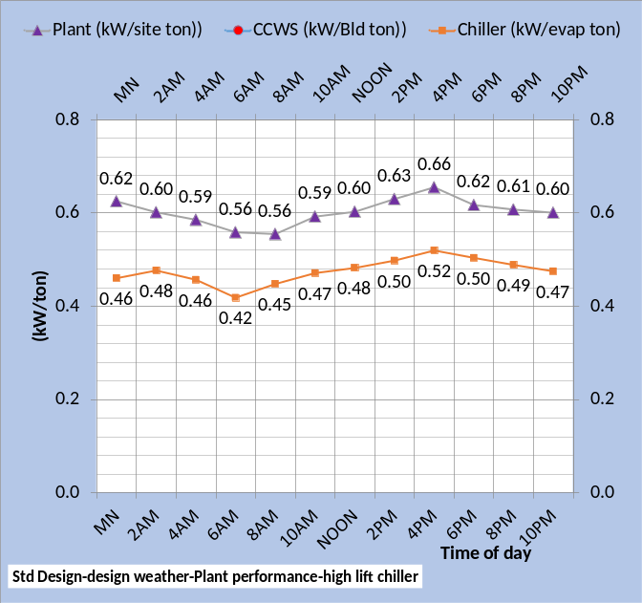
Figure 23-7: Plant & Chiller Performance-Design day

Figure 23-7 gives the kW per ton performance of the chiller & plant for both designs at design day weather conditions, illustrating a significant advantage for the min kW design.
Figure 23-8: Chiller & Plant kW/ton

Figure 23-8 compares the two designs plant & chiller performance at design day conditions of Figure 23-1 illustrating the improved performance of the low lift chiller design plant operating at 67% tower fan speed verses the high lift chiller plant as called for by GreenGuide⁶ & Taylor⁷.

Plant Energy Balance-Design Day

Figure 23-9: Plant load energy balance-design conditions.

Figure 23-9 gives the plant load energy balance for both designs at design weather conditions. The top chart, Standard Design, shows a plant load of 200.45 btu/sqft. The other five loads add up to this plant load value i.e. energy in, the five loads, equals energy out, the plant load. Similarly, for the bottom chart.
The weather energy into the top chart is more than the bottom chart because of infiltration for the Standard Design and exfiltration for the min kW Design.
The six values of Figure 23-9 can be measured or estimated to give an understanding of the building energy effectiveness at real weather conditions. The weather load is a measure of the building design with regard to weather. Therefore measuring or estimating the other five components of Figure 23-9 provides an estimate of the buildings effectiveness against weather.
Figure 23-10: 24 Hour Energy Balance-Design day

Figure 23-10 illustrates the hourly plant energy balance for both systems. The Standard design, top chart, has one component of energy out, air handler exhaust. The min kW design, bottom chart, has air handler exhaust plus exfiltration as energy out components. The plant load is greater for the Standard design for all hours.

System energy in = Energy out

Figure 23-11: System Ein = Eout-design conditions

Figure 23-11 illustrates the (SEE) Model requirement of system Energy in = Energy out. Eight energy components make up the energy balance as shown by Figure 23-11. Energy into the system primarily consists of the building plus fan system electrical demand, or site btu/ft2, plus the weather energy into the system. The cooling tower removes most of the energy from the system followed by air handler exhaust. Pump heat not going into the thermodynamic system is a relatively small value.

Figure 23-12: 24 Energy Balance-Design Day

Figure 23-12 gives the system hourly energy balance.
Next we will consider Long Beach at real weather of December 10, 2018.

Long Beach Real Weather Performance- December 10, 2018

This real weather analysis will be for the Standard design and min kW design as defined above plus a third system that is defined as the Standard system design with bad control. The bad control issues will be installed into the model one at a time so that the effect of each can be illustrated. Each bad control issue will be added to the previous installed bad control issues building to a bad controlled system. The first bad control will be manually control of lights.

Figure 23-13: Design & Real weather of Dec. 10, 2018

Figure 23-13 gives the Long Beach assumed design day weather and the real winter weather of December 10, 2018²⁰, a cold rainy cloudy day that requires building perimeter heat and therefore represents a major change in the system performance, energy consumption, and energy balance of the systems. The first bad control will be;
- LIGHTS-The lights are manually controlled i.e. depending on people to turn lights off. This procedure sometimes works well for a few months but usually degenerates. This analysis will assume that 67% of lights are on after hour’s verses 6% for the standard design⁸ with good control.

Figure 23-14: 24 Hour watt hours per building square foot-min kW design-Standard design-& Standard design with bad control (1. LIGHTS)

Figure 23-14 gives the 24 hour watts hours per building square foot illustrating the min kW design is about 30% less than the Standard Design building & plant & the Standard design with bad light control (1. LIGHTS) is about 16% greater than the Standard design.
Figure 23-15 gives the 24 hour sum of the main four components of energy consumption, building, air handler system, electric heat, and plant. The sum of the four components is also given. The building use per building square foot is due to lights and plug loads and is the same for the min kW design & Standard design but increases with bad manual control of lights as shown by the bottom chart. The min kW design air handler energy use, plant energy use, and electrical heat energy use are all significantly less than the Standard design and the bad light controls further increases these three components over the Standard design. The electrical energy for heat is less for the min kW design primarily because the heat supply air is 110F verses 94F for the Standard design. Heat energy is the same for the Standard design and the Standard design with bad light control.
Figure 23-15: 24 hour energy use summed-all electric system at real weather conditions-Bad light control

Figure 23-16: 24 hour energy use watts/sq ft-Bottom chart bad (1.LIGHT) control
Figures 23-16 & 17 provide the hourly detail of energy use illustrating the effect of bad (1. LIGHTS) control.
Figure 23-17: 24 hour energy use watts/sq ft-Bottom chart bad (1. LIGHT) control

The middle & bottom charts of Figure 23-17 illustrate no change with bad lights control during building occupied hours but significant change after hours.

- THERMOSTATES not controlled can have a significant effect on the energy consumption of a building. Thermostat set points and return air paths must be considered in minimizing building energy consumption. In general this analysis models all return air to the perimeter of the building. Therefore if the internal and perimeter thermostats are set different then energy can be transferred from the interior of the building to the perimeter. Bad thermostat control will be modeled as, during heating, 76F perimeter stat set and 75F interior stat set point. A perimeter stat set at 75F would be neutral and less than 75F would be good control because of transferring interior energy to the perimeter during heating.

Figure 23-18: 24 Hour watt hours per building square foot-min kW design-Standard design-& Standard design with bad control of (1. LIGHTS) &
(2. THERMOSTATS)
Setting the perimeter stats at 76F and the internal stats at 75F and all return air goes to the perimeter results in a significant increase in system energy use as shown by Figure 23-18 & 23-19. This arrangement results in all supply air being heated to 76F.
Figure 23-19 shows that the building watt/sq ft did not change with the bad control of thermostat setting but the air handler and plant increased but the big increase was in heat required to maintain the perimeter at 76F thermostat set point with the condition that all internal supply air returns to the perimeter.

Figure 23-19: 24 hour energy use summed-all electric system at real weather conditions-top chart bad LIGHTS control, bottom chart plus bad THERMOSTAT control.
The heat enegy into the system, bottom chart, is 22.242 watts-hr/sq ft. this can be converted to btu by;
22.242 watt-hr/sq ft x 3.412 btu/watt-hr=
=75.89 btu/sq ft.
This is the heat energy going into the system whether electric or from fuel burning. The efficiency of a boiler and the system to get the heat to the people space will determine how much fuel is consumed at the boiler. For example assume 80% efficiency.
Therefore the boiler will consume over 24 hours;
75.89 btu/sq ft/.80 = 94.86 btu/sq ft.

Figure 23-20: Top chart Bad (1. LIGHT) control, bottom chart plus bad (THERMOSTAT) control.

The bottom chart of Figure 23-20 with bad light control plus bad stat control compared to the top chart with bad light control illustrates the heat energy due to the bad stat control significantly increases.

Figure 23-21: Top chart Bad (1. LIGHT) control, bottom chart plus bad (THERMOSTAT) control.

Figures 23-20 & 23-21 illustrate that bad stat control, as defined here with all return air to the building perimeter, increases the plant and site energy for all hours.

Figure 23-22: Real weather of December 10, 2018, watts per square foot of min kW design, Standard design, & Standard design with bad (1.LIGHT) control & bad (2. THERMOSTATE) control.

Figure 23-22 shows the hourly watts/sq ft for the systems as thus far discussed showing the Standard design watts/sq ft has been increased about (3.45w/ft2 – 3.03w/ft2 = .42 w/ft2) at noon conditions with bad (1. LIGHT) & (2. THERMOSTAT) control. The big reason for the increase is the increase in perimeter heat.

3. INFILTRATION doubled from 7,803 CFM to 15,607 CFM.
Figure 23-23 shows the effect of adding the bad control (3. INFILTRATION) by doubling from 7,803 CFM to 15,607 CFM. The Standard design has 7,803 CFM of infiltration as the author interoperates Liu⁸. Comparing Figures 23-22 & 23-23 illustrates an hourly increase in system watts per building square foot with the addition of more outside air infiltration into the building.

Figure 23-23: Real weather of December 10, 2018, watts per square foot of min kW design, Standard design, & Standard design with bad (1.LIGHT) control, bad (2. THERMOSTATE) control & doubled outside air
(3. INFILTRATION).

Comparing Figures 23-22 & 23-23 illustrates about a 6% to 8% increase in total system energy use due to the increased outside air infiltration into the building.

Figure 23-24: Real weather of December 10, 2018, watts per square foot of min kW design, Standard design, & Standard design with bad (1.LIGHT) control, bad (2. THERMOSTATE) control & doubled outside air
(3. INFILTRATION) into the building.

Comparing Figure 23-24 with Figures 23-20 & 23-21 illustrates that most of the increase in energy use is due to the increase in heat energy.

Figure 23-25: : Real weather of December 10, 2018, 24 hour watt-hour per square foot for min kW design, Standard design, & Standard design with bad (1.LIGHT) control, bad (2. THERMOSTATE) control top chart & plus doubled outside air (3. INFILTRATION) into the building, bottom chart.

Figure 23-25 illustrates that increased infiltration increased the system energy use (70.748 – 65.995 = 4.753 W/sq ft). Most of the increase was due to heat energy for the building perimeter.

Figure 23-26: : Real weather of December 10, 2018, 24 hour watt-hour per square foot for min kW design, Standard design, & Standard design with bad (1.LIGHT) control, bad (2. THERMOSTATE) control & doubled outside air (3. INFILTRATION) into the building.

Figure 23-26 give the 24-hour totals of the three systems as defined.

The (SEE) Model schematics are not in energy per square foot form and Figure 23-27 is from the schematics data. The left table of Figure 23-27 gives the data for the Standard design and the right table gives the effect of the three bad control inputs, light control, stat control, and doubled infiltration.
For the Standard design Figure 23-27 gives;
206,643 kW * 1000w/kW/4,082,400 sqft =
50.618 w/sqft , same as Figure 23-26.
The energy balance illustrates that only the energy in due to people is the same for both tables of Figure 23-27. All other values increase as shown.

Figure 23-27: 24 hour electrical use and energy balance

The author has found the need for system schematics to evaluate and understand these complex systems. The next eight pages will give full page schematics for the reader to study. A great deal of data and information is given by the schematics and the author will give limited discussion at this point. However the author will attempt to answer questions by readers.

Schematic 23-1: Standard design at 4AM real weather conditions.

Schematic 23-2: Standard design with bad control-lights-stats-infiltration-4AM real weather conditions

Schematic 23-3: Standard design at 10AM real weather conditions.

Schematic 23-4: Standard design with bad control-lights-stats-infiltration-10AM real weather conditions

Schematic 23-5: Standard design at 4PM real weather conditions.

Schematic 23-6: Standard design with bad control-lights-stats-infiltration-4PM real weather conditions

Schematic 23-7: Standard design at 10PM real weather conditions.

Schematic 23-8: Standard design with bad control-lights-stats-infiltration-10PM real weather conditions

HEATING AIR TEMPERATURE. Decreasing the heat air temperature from 94F to 90F.
Figure 23-28 bottom chart shows the effect of adding the bad control (HEATING AIR TEMPERATURE). The temperature of the heated air is decreased from 94F to 90F resulting in greater heat kW and greater plant load.
Figure 23-28: Real weather of December 10, 2018, watts per square foot of min kW design, Standard design, & Standard design with bad (1.LIGHT) control, bad (2. THERMOSTATE) control & doubled outside air
(INFILTRATION)-TOP CHART. Decreasing heating air temperature from 94F to 90F-BOTTOM CHART

Figure 23-28 shows an increase in system watts/sq ft for all hours by simply lowering the perimeter heating air temperature from 94F t0 90F.

Comparing Figures 23-22 & 23-23 illustrates about a 6% to 8% increase in total system energy use due to the increased outside air infiltration into the building.

Figure 23-29: TOP CHART-Standard design with bad (1.LIGHT) (2. THERMOSTATE) (3. INFILTRATION) control. BOTTOM CHART-Add reduced heating air temperature.
Figure 23-29 illustrates the increase in energy per square foot by lowering the perimeter heating air temperature showing that most of the increase was due to perimeter heat.

Figure 23-30: TOP CHART-Standard design with bad (1.LIGHT) (2. THERMOSTATE) (3. INFILTRATION) control. BOTTOM CHART-Add reduced heating air temperature.
Figure 23-30 illustrates that the plant energy use increased little due to decreased heating air temperature.

Figure 23-31: TOP CHART-Standard design with bad (1.LIGHT) (2. THERMOSTATE) (3. INFILTRATION) control. BOTTOM CHART-Add reduced heating air temperature.

Figure 23-31 illustrates that lowering the perimeter heating air temperature added system energy;
(76.45-70.48=5.97 watts per sq ft) or about 8%.

Figure 23-32: : Real weather of December 10, 2018, 24 hour watt-hour per square foot for min kW design, Standard design, & Standard design with bad (1.LIGHT) control, bad (2. THERMOSTATE) control, doubled outside air (3. INFILTRATION), & heating air temperature is reduced from 94F to 90F.

Figure 23-32 gives the 24 hour totals of the three systems thus far defined showing that the four bad controls modeled have increased the energy use of the Standard Design about 50%.

5-INCREASE SUPPLY AIR FROM 55F to 60F
Increasing the supply air temperature during the winter is accepted by some as a good control strategy. Let’s take a look.
Figure 23-33 compared to Figure 23-32 illustrates that the 24 hour energy use of the Standard system with the four bad control concepts plus 60F supply air increased a little over operating at 55F supply air at these conditions of December 10, 2018.

Figure 23-33: Real weather of December 10, 2018, 24 hour watt-hour per square foot for min kW design, Standard design, & Standard design with bad (1.LIGHT) control, bad (2. THERMOSTATE) control, doubled outside air (3. INFILTRATION), heating air temperature reduced from 94F to 90F & supply air increased from 55F to 60F.
Figure 23-34: TOP CHART-Standard design with bad (1.LIGHT) (2. THERMOSTATE) (3. INFILTRATION) (90F heating AIR) control. BOTTOM CHART-Add 60F supply air.

Figure 23-34 illustrates that for the 24 hours the building energy use did not change by increasing supply air to 60F i.e. the light and plug kW did not change. The electric heat decreased with 60F supply air but the air handler energy significantly increased and the plant slightly increased for a net slight system increase of (77.213-76.450=.763watt hr/sqft).

Figure 23-35: TOP CHART-Standard design with bad (1.LIGHT) (2. THERMOSTATE) (3. INFILTRATION) (90F Heating Air). BOTTOM CHART-Add 60F supply air.
Figure 23-35 illustrates the hourly decrease in heating with 60F supply air, bottom chart, and the increase in air handler energy.
The next eight schematics will compare the building with 55F & 60F supply air at 4AM, 10AM, 4PM, & 10PM. The schematics will show that in general the 60F supply air reduces air reheat but the VAV fan kW increases is greater. The net result is that 60F supply air can increase system kW and/or can decrease system kW depending on the conditions. The following schematics help understand when 60F supply air reduces energy use and when it increases energy use.
Schematic 23-9: 4AM Building system with four bad control ideas installed.
Increasing supply air to 60F at 4AM reduced the building plus air handler system, or site, kW demand from 1778.3 to 1716.3 and the plant load from 399 ton to 381 ton.

Schematic 23-10: 4AM Building system with four bad control ideas installed plus 60F supply air
The big reason is simply that the decrease in heat kW, (966.8-852.2=114.6 kW) is greater than the increases in fan kW (317.6-265.0=52.6 kW) for a net kW decrease of (114.6-52.6=62 kW) by supplying 60F air.

Schematic 23-11: 10AM Building system with four bad control ideas installed.
At 10AM conditions the situation reverses with 60F supply air resulting in a significant increase in site kW. For each of the six buildings 26 VAV fans were installed into the model at a design 13,200 CFM and the conditions of Schematic 23-12 exceeds design, (367,695CFM/26=14,142CFM) resulting an increased air static (dh) above design and therefore VAV fan kW.
Schematic 23-12: 10AM Building system with four bad control ideas installed plus 60F supply air

Schematic 23-13: 4PM Building system with four bad control ideas installed.
These conditions at 4PM are similar to 10AM discussed above.

Schematic 23-14: 4PM Building system with four bad control ideas installed plus 60F supply air

Schematic 23-15: 10PM Building system with four bad control ideas installed.
At 10PM the numbers reverse and 60F supply air results in less site kW. This is a complex problem that probably requires a (SEE) Model to make a good decision on supply air temperature control.

Schematic 23-16: 10PM Building system with four bad control ideas installed plus 60F supply air
Heat to the perimeter is complex involving building design, temperature of heating air and VAV fan design/performance. A complex control problem requiring a (SEE) model or equivalent.

VAV STATIC PRESSURE SETPOINT
All above models have included VAV reset of static pressure to minimize fan kW. This bad control issue will set the VAV static pressure at a minimum of 5.5 inches of water resulting in significant increase in air handler energy use.

Figure 23-36: Real weather of December 10, 2018, 24 hour watt-hour per square foot for min kW design, Standard design, & Top Chart-Standard design with bad (1.LIGHT), (2. THERMOSTATE), (3. INFILTRATION), heating air temperature reduced from 94F to 90F, supply air increased from 55F to 60F & Bottom Chart-VAV static pressure min set at 5.5 inches of water.

Figure 23-37: TOP CHART-Standard design with bad (1.LIGHT) (2. THERMOSTATE) (3. INFILTRATION) (90F Heating Air) (60F supply air)-BOTTOM CHART change VAV control to constant VAV static pressure of 5.5 inches water.

Figure 23-37 illustrates that the increase in energy use in the air handler system occurs after hours when the building load is low. The plant also increases a little due to the increased plant load as a result of the increased air handler kW.

Figure 23-38: TOP CHART-Standard design with bad (1.LIGHT) (2. THERMOSTATE) (3. INFILTRATION) (90F Heating AIR) (60F supply air). BOTTOM CHART- adds VAV static pressure set to min 5.5 inches water.

The Standard design is modeled as having duct static pressure reset control therefore minimizing VAV fan kW. The bad control sets the duct static pressure at a minimum of 5.5 inches of water which results in significant increase in VAV fan energy use as shown by the bottom chart of Figure 23-38. The building and heat 24 hour values do not change. The fan value increases which in turn increases the plant value as shown by Figure 23-38.

Summary of Chapter 23
Figures copied from above.

Figure 23-13: Design & Real weather of Dec. 10, 2018

Figure 23-13 gives the design day weather of the model and the real weather of December 10, 2018.
Figure 23-4 gives the 24 hour summed performance of the two designs studied, min kW design top chart and Standard design bottom chart.
We will now look at how these two designs performed at real weather winter conditions.
Figure 23-4: Summed 24 hour watt/sq-ft
Design day weather conditions-min kW design top chart-Standard design bottom chart

Figure 23-15: Real weather of December 10, 2018-System as designed-24 hour energy use of all electric system-min kW design top chart-Standard design bottom chart
Comparing Figure 23-4 with 23-15 illustrates that the Standard design increased energy consumption at real weather conditions going from (41.534 watt-hr/sq ft to 50.6 watt-hr/sq ft). The min kW design also increased but very little going from (31.973 watt-hr/sq ft to 34.739 watt-hr/sq ft).

The following figures give performance of only the Standard design with bad control.

Figure 23-15: 24 hour energy use-all electric system at real weather conditions-Bad light control
- LIGHTS-The lights are manually controlled i.e. depending on people to turn lights off. This procedure sometimes works well for a few months but usually degenerates. This analysis will assume that 67% of lights are on after hour’s verses 6% for the standard design⁸ with good control.
With bad light control, as defined, the Standard design system increased about 8 watt-hr/sq ft for the 24 hours of real weather conditions.
Figure 23-19: 24 hour energy use-all electric system at real weather conditions-bad LIGHT control plus bad THERMOSTAT control.
THERMOSTATES not controlled can have a significant effect on the energy consumption of a building. Thermostat set points and return air paths must be considered in minimizing building energy consumption. In general, this analysis models all return air to the perimeter of the building. Therefore, if the internal and perimeter thermostats are set different then energy can be transferred from the interior of the building to the perimeter. Bad control will assume input, during heating, 78F perimeter stat set point and 75F interior stat set point. A perimeter stat set at 77F or 76F would be less bad and 75F would be neutral and less than 75F would be good control because of transferring interior energy to the perimeter during heating.
Bad light control plus bad thermostat control, as defined, resulted in about 7.4 watt-hr/sq ft increase in energy consumption.

Figure 23-25: Standard design with bad (1.LIGHT) control, bad (2. THERMOSTATE) control & doubled outside air (3. INFILTRATION)

INFILTRATION Double infiltration from 7,803 CFM to 15,606 CFM into the building. A condition that adds energy into the building and therefore results in greater load on the air handler system and therefore greater air handler kW demand and therefore increased load on the plant.
Figure 23-25 illustrates the Standard design with bad light and thermostat control plus double infiltration resulted in about 4.7 watt-hr/sq ft increased in system energy consumption.

Figure 23-31: Standard design with bad (1.LIGHT), (2. THERMOSTATE) (3. INFILTRATION) & heating air reduced from 94F to 90F.

HEATING AIR TEMPERATURE. The heating supply air temperature is 94F for the good control Standard design and will be 90F for bad control to illustrate the effect on system kW demand. The min kW Design sets the heat air temperature at 110F which reduces heat energy and therefore less system energy consumption.
Comparing Figure 23-25 to 23-31 illustrates the system energy use increased about 5.7 watt-hr/sq ft due to simply reducing the heating air temperature from 94F to 90F.

Figure 23-34: Standard design with bad (1.LIGHT) (2. THERMOSTATE) (3. INFILTRATION) (90F heating AIR) & increase supply air from 55F to 60F.

REDUCE SUPPLY AIR FROM 55F to 60F.
The supply air off the coil is 55F for the Standard Design and will be input at 60F during heating season. In general the 60F supply air reduces air reheat but the VAV fan kW increases. The net result is that 60F supply air can increase system kW and/or can decrease system kW depending on the conditions.
Comparing Figures 23-31 & 23-34 illustrates little change, less than one watt-hr/sq ft, for the conditions modeled.
Figure 23-38: Standard design with bad (1.LIGHT) (2. THERMOSTATE) (3. INFILTRATION) (90F Heating AIR) (60F supply air) & VAV static pressure set to min 5.5 inches water.

The Standard design is model as having duct static pressure reset control therefore minimizing VAV fan kW. The bad control sets the duct static pressure at a minimum of 5.5 inches of water which results in a significant increase in VAV fan energy, an increase of about 3.0 watt-hr/sq ft of building.

Figure 23-15 bottom chart gives the (SEE) Model watt-hr/sq ft values for the Standard design as defined by the Pacific Northwest National Laboratory modeling of the ASHRAE Standard 90.1-2010 large office building when the building system operates as designed. Figure 23-15 top chart gives the (SEE) Model values of the Standard design modified to the min kW features defined by Chapter 17 for the building and Chapter 7 for the min kW plant.

Figure 23-15: Real weather of December 10, 2018-System as designed-24 hour energy use of all electric system-min kW design top chart-Standard design bottom chart

Figure 23-38 gives the Standard design with bad control as defined.
These three systems given by Figures 23-15 & 23-38, at real weather conditions, will be the charts provided so that buildings of other cities can be evaluated against a Standard 90.1-2010 building design.
Figure 23-39: Three designs at real weather conditions- electric heat.

Figures 23-29 with electric heat & Figure 23-30 with fuel heat are the bottom line of this discussion.
If the reader has a building that operates, over 24 hours at the real weather conditions given²⁰, close to the min kW building and plant, then you have an excellent design. If you have a building and plant system that operates close to the Standard building & plant design then you have a system that meets Standard 90.1-2010. If the reader has a building system that approaches the poor control values then you have a building and plant that needs attention. A careful study of this paper should help decide how to evaluate the building/plant and what action to take to reduce energy consumption.

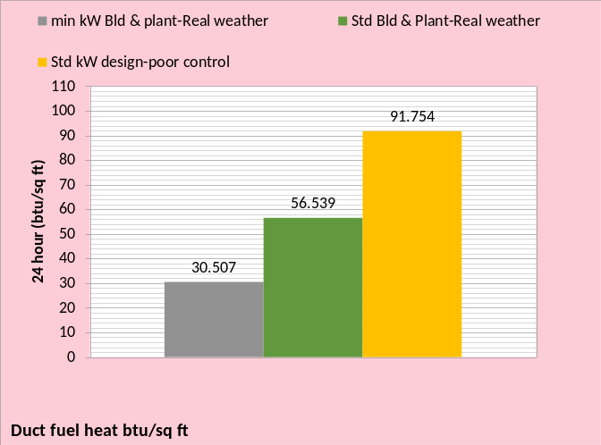
Figure 23-30: Three designs at real weather conditions- fuel heat.

Final Word
In the July 2014¹⁰ ASHRAE Journal under letters; Pete Menconi P.E. makes the point; “I used my first building simulation in 1973, and have used a variety of methods and on-site comparisons. In general, I’ve found typical +/- 50% variance between simulation and actual energy.”
Peter Rumsey P.E. responds; “In my experience I have found the same thing.” “My experience after having modeled and measured dozens of buildings is that models do not accurately capture system performance.”
My response.
The author of this paper was modeling buildings of Texas Instruments Inc. in 1974 using DOE and ECUBE. These two programs could rack up the total electrical use for a year if you input the schedule, and could also do a fair job at simulating the loads due to weather. However, the models could not accurately simulate the air side system or the plant performance. Sure, the models had inputs for the air side and plant but system models they were not.
In the late 1970’s some of us made the argument for ASHRAE models based on the equations of thermodynamics, but the decision was made to stick with the DOE approach and that is where we are today. DOE is the basis of eQUEST and Energy Pro as stated by Rumsey.
The reason these DOE based models have not, cannot, and will not in the future model building energy is given on page 70 of the July 2014 ASHRAE Journal. The article (Improving Infiltration in Energy Modeling) makes the obvious but not stated point; 40 years after the oil embargo that an air side model is still not in the ASHRAE and Pacific Northwest National Laboratory (PNNL) accepted energy models. The article also clearly illustrates why; empirical equations with several coefficients that have no relation to the laws of thermodynamics can never accurately model a real system. A real system operates according to the laws of thermodynamics and therefore so must our models.
The hypothesis of energy conservation (first law) was established by J.P. Joule in the 1840’s. For the past 170 years the first law has provided easy to understand relations that define the performance of thermodynamic systems. Is it not time for all to admit we have been on the wrong modeling path for more than 40 years?
Kirby Nelson¹¹ P.E.
ASHRAE Life Member

References:
- Schwedler, Mick. July 1998 “Take It to The Limit…Or Just Halfway?” ASHRAE Journal.
- SPX Cooling Technologies (Marley). UPDATE Version 5.4.2
- Introduction to Thermodynamics and Heat Transfer. 1956 Prentice-Hall, Inc. by David A. Mooney, page 325.
- Thermal Environmental Engineering third edition. 1998 Prentice-Hall Inc. by Thomas H. Kuehn, chapter 3.
- 2012 ASHRAE HANDBOOK, HVAC Systems and Equipment, page 43.10 Figure 11 Temperature Relations in a Typical Centrifugal Liquid Chiller.
- ASHRAE. 2010. ASHRAE GreenGuide: The Design, Construction, and Operation of Sustainable Buildings, 3rd ed. Atlanta: ASHRAE.
- Taylor, S. 2011. “Optimizing design & control of chiller plants.” ASHRAE Journal (12).
- Liu, B. May 2011. “Achieving the 30% Goal: Energy and Cost Savings Analysis of ASHRAE Standard 90.1-2010” Pacific Northwest National Laboratory. http://www.energycodes.gov/achieving-30-goal-energy-and-cost-savings-analysis-ashrae-standard-90.1-2010
- Schwedler, M. 2017. “Using Low-Load Chillers to Improve System Efficiency.” ASHRAE Journal.
- July 2014 ASHRAE Journal, page 70. The article (Improving Infiltration in Energy Modeling) makes the obvious but not stated point; 40 years after the oil embargo and an air side model is still not in the ASHRAE models.
- ASHRAE Journal September 2014. Letters, “Energy Modeling”, by Kirby Nelson
- ASHRAE Journal May 2016. “Modeled Performance Isn’t Actual Performance”
- Nelson, K. “Simulation Modeling of a Central Chiller Plant” CH-12-002. ASHRAE 2012 Chicago Winter Transactions.
- Nelson, K. System Energy Equilibrium (SEE) Building Energy Model. http://kirbynelsonpe.com/
- Tredinnick, Steve. 2015. “District Energy Enters The 21st Century”. ASHRAE Journal.
- Morrison, Frank. 2014. “Saving energy with cooling towers.” ASHRAE Journal
- Kavanaugh, Steve. June 2000 “Fan Demand and Energy” ASHRAE Journal
- Nelson, Kirby. July 2010 “Central-Chiller-Plant Modeling” HPAC Engineering
- Trane chiller selection data received by Kirby Nelson from Springfield Missouri Trane office 1/30/01.
- Real weather data www.wunderground.com/
NOMENCLATURE
Each of the more than 200 variables will be defined.
Building structure;
BLD ft² = air conditioned space
# Floors = number of building floors
Roof ft² = roof square feet
N/S wall ft² =north/south wall square feet
E/W wall ft² =east/west wall square feet
Wall % glass = percent of each wall that is glass
Glass U = glass heat transfer coefficient
Wall U = wall heat transfer coefficient
Glass SHGC = glass solar heat gain coefficient
Wall emit = wall solar index
Building interior space;
Roof_{trans-ton} =transmission through roof (ton)
Roof_{sky-lite-ton} =sky lite load (ton)
People_{ton sen&lat} = sensible & latent cooling load due to people (ton)
Plug_{ton&kW} = cooling load & kW due to plug loads
Light_{ton&kW} = cooling load & kW due to lights
Total Bld_{int-ton} = total building interior load (ton)
(int-cfm) _{to-per-return} = CFM of interior supply air that returns to perimeter of building
T_{stat-int} = interior stat set temperature (F)
Bld_{int-air-ton} = supply air ton to offset interior load
BLD kW = total building kW demand
FAN kW = total fan kW
HEAT kW = total kW due to heat
SITE kW = total site kW=Bld+ Fan+Heat
Building perimeter space;
%_{clear sky} = percent clear sky
T_{dry bulb} = outside dry bulb temperature (F)
T_{wet bulb} = outside wet bulb temperature (F)
Ex/Infil_{lat-ton} = latent air infiltration or exfiltration (ton)
Ex/Infil_{CFM} = air infiltration or exfiltration CFM
Exfil_{sen-ton} =sensible air exfiltration or infiltration (ton)
Wall_{n trans ton} = north wall transmission (ton)
Wall_{s trans ton} = south wall transmission (ton)
Wall_{E trans ton} = east wall transmission (ton)
Wall_{w trans ton} = west wall transmission (ton)
Wall_{tot-trans-ton} = total wall transmission (ton)
Glass_{N-trans-ton} = north wall glass transmission (ton)
Glass_{S-trans-ton} = south wall glass transmission (ton)
Glass_{E-trans-ton} = east wall glass transmission (ton)
Glass_{W trans-ton} = west wall glass transmission (ton)
Glass_{tot-trans-ton} = total transmission thru glass (ton)
Glass_{N-solar-ton} = north glass solar load (ton)
Glass_{S-solar-ton} = south glass solar load (ton)
Glass_{E-solar-ton} = east glass solar load (ton)
Glass_{W-solar-ton} = west glass solar load (ton)
Glass_{tot-solar-ton} = total glass solar load (ton)
(int cfm)_{per-ton} = effect of interior CFM to wall (ton)
Total Bld_{per-sen-ton} total perimeter sensible load (ton)
T_{stat-per} = perimeter stat set temperature (F)
Bld_{per-air-ton} = supply air ton to offset perimeter load
Air handler duct system-Interior duct
T_{air supply int} = temp air supply to building interior (F)
(fan)_{int ter ton&kW} = interior ton & kW due to terminal fans
(D)_{int-air-ton} = cooling (ton) to building interior duct
T_{air coils} = supply air temperature off coils to duct (F)
(D)_{int-CFM} = supply air CFM to building interior duct
Perimeter duct
T_{air supply per} =temp (F) air supply to building perimeter
(fan)_{per ter ton&kW} = perimeter ton & kW of terminal fans
T_{heat-air} = temp supply air before terminal fan heat (F)
(D)_{heat-ton&kW} = heat to perimeter supply air ton & kW
T_{reheat air} = temp perimeter supply air after reheat (F)
(D)_{reheat ton&kW} = reheat of perimeter supply air ton & kW
(D)_{per-air-ton} = cooling (ton) to perimeter duct
T_{air coils} = supply air temperature off coils to duct (F)
(D)_{per-CFM} = supply air CFM to perimeter duct
Coil
(Coil)_{sen-ton} = sensible load on all coils (ton)
(Coil)_{cap-ton} = LMTD * UA = capacity (ton) one coil
LMTD = Coil log mean temperature difference (F)
(Coil)_{L+s-ton} = latent + sensible load on all coils (ton) transferred to Plant
UA = coil heat transfer coefficient * coil area. UA varies as a function water velocity (coil)_{gpm} thru the coil, as the (coil)_{gpm} decreases the coil capacity decreases.
(one Coil)_{ton} = load (ton) on one coil
VAV Fan system
Fresh air
stat_{FA} = fresh air freeze stat set temperature (F)
T_{FA to VAV} = temperature of fresh air to VAV fan
(FA)_{sen-ton} = fresh air sensible load (ton)
(FA)_{CFM} = CFM fresh air to VAV fan inlet
(FA)_{Lat-ton} = fresh air latent load (ton)
(FA)_{kW} = heat kW to stat_{FA} set temperature
Air return
T_{BLD-AR} = return air temp (F) before return fans
(Air)_{ret-CFM} = CFM air return from building
(FAN)_{ret-kW} = return fans total kW
(FAN)_{ret-ton} = cooling load (ton) due to (FAN)_{ret-kW}
(Air)_{ret-ton} = return air (ton) before return fans
T_{AR to VAV} = T_{BLD-AR} + delta T due to return fans kW
VAV_{ret-sen ton} = return sensible (ton) to VAV fans inlet
VAV_{ret-lat ton} = return latent (ton) to VAV fans inlet
VAV_{ret-CFM} = return CFM to VAV fans inlet
Exhaust air
Ex_{Lat-ton} = latent load (ton) exhausted
Ex_{CFM} = CFM of exhaust air
T_{Ex} = temperature of exhaust air
Ex_{sen-ton} = sensible load (ton) exhausted
VAV Fans
T_{ret+FA} = return and fresh air mix temperature (F)
(dh) = VAV air static pressure (in)
E_{fan-VSD} = VAV fans efficiency
VAV_{inlet-sen-ton} = sensible load (ton) inlet to VAV fans
VAV_{inlet-lat-ton} = latent load (ton) inlet to VAV fans
T_{air-VAV} = temp air to coils after VAV fan heat
(FAN)_{VAV-CFM} = CFM air thru coils
(FAN)_{ton-VAV} = load (ton) due to VAV fan kW
(FAN)_{kW-VAV} = total VAV fan kW demand
AIR SIDE SYSTEM PLUS BUILDING
FAN kW = total air handlers kW
SITE kW = total site or air side kW
Plant_{ton} = (COIL)_{L+s ton} load (ton) to plant
CENTRAL PLANT
# Buildings = number of buildings served by plant
Plant ton = total load (ton) to plant
Primary/secondary pumping nomenclature
gpm_{evap} = total gpm flow thru one evaporators
(H)_{pri-total} = total primary pump head (ft) = (H)_{pri-pipe} + (H)_{pri-fittings} + (H)_{pri-bp} + (H)_{evap}
(H)_{pri-pipe} = primary pump head due to piping (ft)
(H)_{pri-fittings} = primary head due to pump & fitting (ft)
(Ef)_{c-pump} = efficiency of chiller pump
P_{c-heat-ton} = chiller pump heat to atmosphere (ton)
P_{c-kW} = one chiller pump kW demand (kW)
P_{chiller-#} = number chiller pumps operating
(lwt)_{evap} = temperature water leaving evaporator (F)
T_{bp} = temperature of water in bypass (F)
gpm_{bp} = gpm water flow in bypass
(H)_{pri-bp} = head if chiller pump flow in bypass (ft)
(ewt)_{evap} = temp water entering evaporator (F)
P_{sec-heat-ton} = secondary pump heat to atmosphere (ton)
P_{sec-kW} = kW demand of secondary pumps
Ef_{des-sec-p} = design efficiency of secondary pumping
Ef_{sec-pump} = efficiency of secondary pumping
(H)_{sec} = secondary pump head (ft) = (H)_{sec-pipe} + (H)_{sec-bp} + (H)_{coil} + (H)_{valve}
(H)_{sec-pipe} = secondary pump head due to pipe (ft)
(H)_{sec-bp} = head in bypass if gpm_{sec} > gpm_{evap}
GPM_{sec} = water gpm flow in secondary loop
(ewt)_{coil} = water temperature entering coil (F)
Pipe_{size-in} = secondary pipe size (inches)
(lwt)_{coil} = temperature of water leaving coil (F)
Evaporator
(evap)_{ton} = load (ton) on one evaporator
T_{ER} = evaporator refrigerant temp (F)
T_{ER-app} = evaporator refrigerant approach (F)
EVAP_{ton} = total evaporator loads (ton)
(H)_{evap} = pump head thru evaporator (ft)
(evap)_{ft/sec} = velocity water flow thru evaporator
(evap)_{des-ft/sec} = evaporator design flow velocity
Compressor:
(chiller)_{kW} = each chiller kW demand
(chiller)_{lift} = (T_{CR} – T_{ER}) = chiller lift (F)
(chiller)% = percent chiller motor is loaded
(chiller)# = number chillers operating
(CHILLER)_{kW} = total plant chiller kW
(chiller)_{kW/ton} = chiller kW per evaporator ton
Plant kW = total kW demand of plant
(Plant)_{kW/site ton} = Plant kW per site ton
Condenser nomenclature:
(cond)_{ton} = load (ton) on one condenser
T_{CR} = temperature of condenser refrigerant (F)
T_{CR-app} = refrigerant approach temperature (F)
(COND)_{ton} = total load (ton) on all condensers
(H)_{cond} = tower pump head thru condenser (ft)
(cond)_{ft/sec} = tower water flow thru condenser
Tower piping nomenclature
Pipe_{size-in} = tower pipe size (inches)
gpm_{T} = each tower water flow (gpm)
GPM_{T} = total tower water flow (gpm)
(H)_{T-total} = total tower pump head (ft)
P_{T-heat} = pump heat to atmosphere (ton)
P_{T-kW} = each tower pump kW demand
Ef_{T-pump} = tower pump efficiency
P_{tower #} = number of tower pumps
(H)_{T-pipe} = total tower pump head (ft)
(ewt)_{T} = tower entering water temperature (F)
(H)_{T-static} = tower height static head (ft)
T_{range} = tower range (F)= (ewt)_{T} – (lwt)_{T}
(lwt)_{T} = tower leaving water temperature (F)
T_{approach} = (lwt)_{T} – (T_{wet-bulb})
Tower nomenclature
t_{fan-kW} = kW demand of one tower fan
T_{fan-kW} = tower fan kW of fans on
t_{fan-%} = percent tower fan speed
t_{ton-ex} = ton exhaust by one tower
T# = number of towers on
T_{ton-ex} = ton exhaust by all towers on
T_{rg+app} = tower range + approach (F)
One hour performance indices
BLD_{kW} = kW demand of building lights & plug loads
Fan_{kW} = air side fans kW, VAV, return terminals
Duct_{heat} = perimeter heat to air supply
FA_{heat} = heat added to fresh air
Heat_{total} = total heat added to air
Plant_{kW} = total plant kW
Syst_{kW} = total system kW
CCWS_{kW} = air side system + plant kW
Chiller_{kW/evap ton} = chiller kW/evaporator ton performance
Plant_{kW/site ton} = plant kW per site or air side ton
CCWS_{kW/site ton} = CCWS kW per load to plant
Weather_{Ein-ton} = weather energy into the system
Site_{kW-Ein-ton} = load (ton) due to site kW
Plant_{kW-Ein-ton} = load (ton) due to plant kW
Total_{Ein-ton} = total energy in to system (ton
Pump_{tot-heat-ton} = total pump heat out (ton)
AHU Ex_{lat ton} = air exhausted latent ton
AHU Ex_{sen ton} = air exhausted sensible ton
Tower T_{ton Ex} = energy exhausted by tower (ton)
Total E_{out ton} = total energy out of system (ton)
24 hour performance indices
BLD_{24hr-kW} = building 24 hour kW usage
Fan_{24hr-kW} = fan system 24 hour kW usage
Duct_{24hr-heat kW or therm} = duct heat
FA_{24hr heat kW or therm} = fresh air heat
Heat_{24hr total kW or therm} = total heat into system
Plant_{24hr kW} = plant 24 hour kW usage
Syst_{24hr kW & therm} = total system 24 hour energy usage
People_{sen+lat ton} =total load (ton) due to people
Enfil_{24hr cfm energy} = change in internal energy
Weather_{24hr-Ein-ton} = 24 hour weather energy into system
SITE_{24hr-kW-Ein-ton} = 24 hour energy into site
Plant_{24hr-kW-Ein-ton} = 24 hour kW energy into plant
Total_{24hr-Ein-ton} = total 24 hour energy into system
Pump_{24hr Heat out-ton} = pump heat to atmosphere (ton)
AHU Ex_{24hr Lat ton} = exhausted latent load from building
AHU Ex_{24hr-sen-ton} = exhausted sensible load from bld.

