Anatomy of a Real Time Building Energy model
Part 1-Background, Model Description and Characteristics, Description of Building Modeled, Energy Balance Analysis
Abstract
This series of four articles presents a system energy equilibrium (SEE) model that simulates the real time performance of a building and plant on any given day. A (SEE) model of an “as designed building and plant” would be a tool for commissioning or evaluating the real time performance of a facility, on any day, against what the performance should be if constructed and controlled as designed. (SEE) models of ASHRAE Standard designs, for a given City, could be put on the internet so that building owners could evaluate their building’s energy performance on days of different weather and operation. Energy balance analysis is a powerful energy analysis tool and a fundamental requirement of a (SEE) model.
Background
When the “Oil Embargo” of 1973 occurred, I was a member of a small group of computer simulation engineers at Texas Instruments Inc. (T.I.) designing and evaluating military systems via hybrid (analog/digital) computer simulations. The modeled systems included the Shrike missile, laser guided systems, and anti-tank missiles. The oil embargo occurred the fourth quarter of 1973 and early 1974 (T.I.) gave me the task of modeling the energy consumption of (T.I.) buildings and processes for the purpose of defining what could be done to reduce energy consumption. I used building energy computer programs available at the time to simulate the annual energy use of a building and plant and the hybrid computer to simulate processes and attempted to simulate a building and plant on any given day. In 1982 I left T.I. and the enormous power of the hybrid computer. That experience convinced me that a real time model of one 24-hour day was needed³ so that a new building or plant could be commissioned on any day and the performance of old buildings and plants could be evaluated on any day. On retiring I decided to see if I could develop such a model. This effort has resulted in the System Energy Equilibrium (SEE) Model summarized by this series of four articles and presented in greater detail at Nelson⁴.
The (SEE) Model
The objective of the (SEE) model is to provide the ability to visit a building or plant on any day, with the (SEE) model on a lap top computer, and evaluate the building and plant performance, against expected performance, on that day’s weather conditions.
This (SEE) model has been developed over a period of several years and the authors modeling experience goes back to 1968. The following lists an estimated 501 equations and calculations, per hour, performed by the (SEE) model.
- Building Model 28
- Solar Model 94
- Tower Model 62
- Pumping Model 53
- Chiller Model 73
- Coil Model 23
- Fans-Supply Air Model 44
- Infiltration Model 21
- Fresh Air Model 27
- Perimeter Heat Model 43
- Performance Calculations 33
Total 501
Essentially nothing is constant in the model, no look up tables or constants, every value is a function of other values in the model. At design weather conditions the 501 equations would be at steady state for design dry bulb, wet bulb, and solar conditions. A change in any one of these three conditions of weather causes the set of equations to reach a new energy equilibrium or load to the plant. Input to the plant consists of adjusting the number of chiller/towers on and the power to the chiller motor to achieve 44F supply water. The accuracy of the (SEE) model is a function of how well the performance of the system components is understood and how well the understanding can be described by equations. Calculating a new steady state condition every 2 hours over 24 hours gives (12 x 501 = 6,012) calculations per modeled day and each variable’s equation must be reasonable correct over changing conditions of weather and load.
The following summarizes the basic characteristics of the (SEE) Model;
- The model is of the total building and plant as illustrated by Figure 1.
- The model is the simultaneous solution of basic HVAC equations.
- The model is of any 24-hour day.
- The building is modeled as five zones, four walls and the building interior.
- The building is modeled with all loads of Figure 2 in the interior of the building plus the roof load. The perimeter load is defined by the weather conditions of Figure 2 plus infiltration if it exists.
- The author expects some values will be questioned. That’s good; the objective is to present an approach to real time building energy modeling and not present the (SEE) Model given here as the final model. Modifications to the model based on better data/equations is a part of this (SEE) Model concept.
- The (SEE) Model requires that the energy into the building and plant equals the energy out^{1,2} just as occurs with a real building and plant.
- The (SEE) Model provides the ability to benchmark a building’s energy performance, on any day, against any ASHRAE Standard design, in this case ASHRAE Standard 90.1-2010 as interpreted from Liu⁵. This concept offers the opportunity for a city to provide benchmark data each day so that building owners can on any day benchmark their building against an ASHRAE Standard design.

Introduction
The System Energy Equilibrium (SEE) Model incorporates the basic equations, data, and analysis procedures used by engineers to design a building and plant, solved simultaneously by computer. The (SEE) Model requires, just as a real system operates, that the energy into the system equals the energy out of the system. This is a major check on the accuracy of the model; any model that does not balance energy in equals energy out has potential problems that should be resolved.
The procedure for evaluating the energy use of a building system is to first establish a (SEE) Model of the as designed building and plant. If on a given day the actual energy consumption of the system is greater than the as designed (SEE) Model, with real weather input, then the real system may not be operating as designed. A comparison of actual to modeled performance, on a given day of weather conditions, may also show that the as designed model needs to be updated. For example, if the lights (watts/ft²) are different than designed and cannot be changed in the real building, then the real value, as constructed, should be input to the (SEE) model.
The goal of the (SEE) Model is to duplicate each hour of the 24-hour performance of a real system within about 6%, and do so on any day of weather and operational conditions. To accomplish this the (SEE) Model must obey the laws of thermodynamics and model the nonlinear characteristics of the real system components and all details of the system that contribute to the performance of the real system.
These four articles demonstrate the (SEE) model characteristics and procedure for evaluating a real system on a given day, in this case a Kansas City Missouri six building office campus designed to ASHRAE Standard 90.1-2010⁵.
Article 1 defines the building to be modeled and presents the concept of energy balance analysis.
Article 2 presents the building (SEE) model.
Article 3 presents the plant (SEE) model.
Article 4 demonstrates the (SEE) model energy balance analysis on real weather days.

The Building and Weather Conditions

Building 13 Story
Each Building=565,000 Ft-Sq
Building height=169 Ft
13 story building
Roof = 43,462 Ft-Sq
All walls 37.5% glass
Roof U=.048 Wall U=.090
Glass U=.55 Glass SHGC=.40
Footprint
South=240 Ft North=240 Ft
Each wall=40,560 Ft-Sq
East=181.09 Ft West=181.09 Ft
Each Wall=30,604 Ft-Sq

Figure 1: Building Description-Kansas City Missouri Large Office Building Designed to Std. 90.1-2010⁵

Figure 1 presents the modeled building of this study, a 565,000 square foot large office building based on the data provided by Liu⁵. The office campus is assumed to consist of six Figure 1 buildings. The plant load for one building is 859.5-ton, Figure 3 top chart, therefore the design load on the plant is (6 * 859.5 = 5,157 ton). The plant is modeled as six chiller/towers each with a design capacity of 1,000 ton; therefore, the plant design capacity is 6,000 ton.
Figure 2 top chart gives the assumed design day weather conditions with a peak dry bulb of 101F and wet bulb of 78F occurring at 4PM. Figure 2 also gives assumed winter weather that will also be (SEE) modeled to illustrate the (SEE) Model capability to go from summer design conditions to winter conditions. The secondary horizontal axis of Figure 2 gives the percent clear sky as 100% for both summer and winter conditions. Real weather⁶ conditions addressed by article 4 input percent clear sky based on cloud conditions. Article 2 addresses the solar model in some detail.
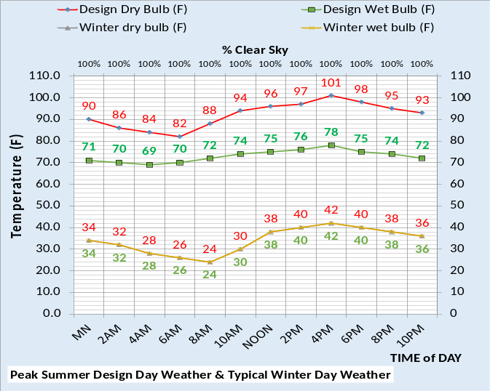
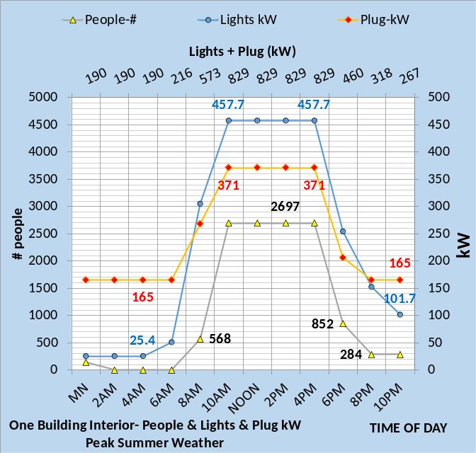
Figure 2: Top Chart-Design & Winter Weather-Bottom Chart⁵-Light kW, Plug kW, & # people

Figure 2 bottom chart gives the lights and plug kW demand per time of day and also the number of people in the building as interpreted from Liu⁵. The lights and plug loads track well to the number of people in the building illustrating a good shut down system is defined by Liu⁵. Figures 1 & 2 and Table 1 give the basic data required to define the building as designed.
Table 1 gives building design and control characteristics of the system to be established here as the benchmark best designed and controlled Standard 90.1-2010 building⁵ and plant¹³.
Building Location and Design
- Location=Kansas City Missouri.
- Building 565,000 ft²
- No external solar shading.
- Ambient temperatures Figure 2
- Percent clear sky 100%.
- Building design per Liu⁵
- Percent wall glass 37%
- Peak lights kW .81 watts/ft²
- Peak plugs kW .66 watts/ft²
- Return air is to building perimeter.
- Duct design static 5.5 inches water.
- Fan powered terminals not installed
- Return air fans not installed
Building Control
- Lights on/off control- 6% on after hours.
- Plugs on/off control-44% on after hours
- Building pressure control, yes
- Supply air = 55F
- Supply water 44F-44.6F
- Stats controlled, Yes
- Perimeter heat air temp, 105F.
- VAV fan duct pressure control, yes
- Fresh air CFM control, yes
- Fresh air heat stat set point, 42F
Plant Design & Control
- Chiller/Tower selection¹³.
Table 1: System

Energy Balance
System energy balance is a fundamental (SEE) model requirement and therefore a tool of a (SEE) Model. Figure 3 top chart gives the energy balance of the building design defining the plant load as 859.5 ton for one of the six buildings served by the central chilled water plant. The design energy balance of Figure 3 would have been determined during the design of the building and plant and is the basis for the 501 equations of the model. The basic equations and manufactures data required to determine the design energy balance are the basic equations of this (SEE) Model. Figure 3 also gives the (SEE) Model energy balance of the building at 4PM winter temperatures of 42F dry bulb and wet bulb; input to the 501 equations resulting in the winter energy balance. The building shell load and fresh air load are negative values and 42.1 ton of perimeter heat is required to maintain space comfort at winter weather.
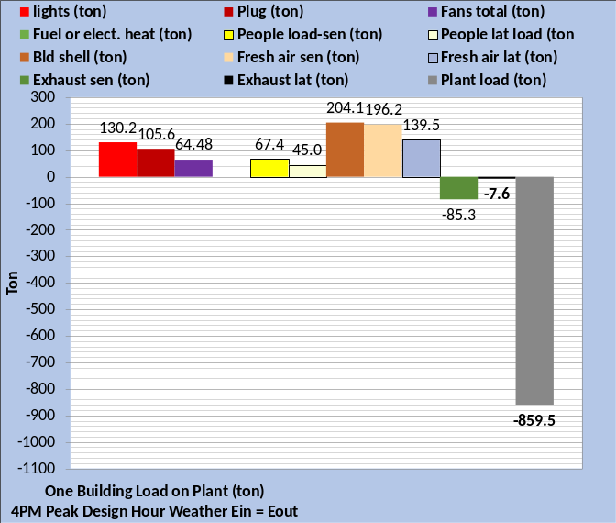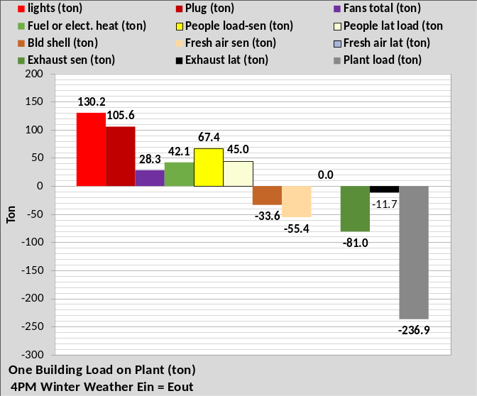
Figure 3: Table 1 System- Top chart energy balance at 4PM design weather of Figure 2-Bottom chart energy balance at 4PM winter weather conditions of Figure 2.
Comparing the charts of Figures 3 illustrates that the lights and plug loads are the same for design day and the winter day. Total building kW slightly increased at winter weather conditions. Summing the lights, plugs, and fans of the top chart gives 300.28 ton. The bottom chart includes heat and sums to 306.2 ton. Building perimeter heat of 42.1 ton is required for winter operation and the fans kW decreased due to less load. One building gives a plant load, at 101F outside temperature, of 859.5 ton, reducing to 236.9 ton at winter conditions of 42F outside temperature.
As stated above the top chart of Figure 3 would have been determined during the design of the building and plant. The bottom chart could also have been determined by desk top calculations, however the (SEE) Model accomplished the task by inputting the winter weather temperatures and adjusting the number of chiller/towers on and chiller power to provide 44F supply water.
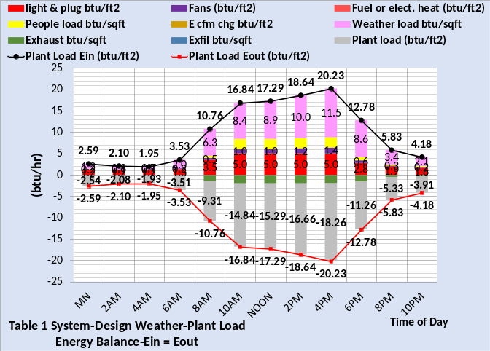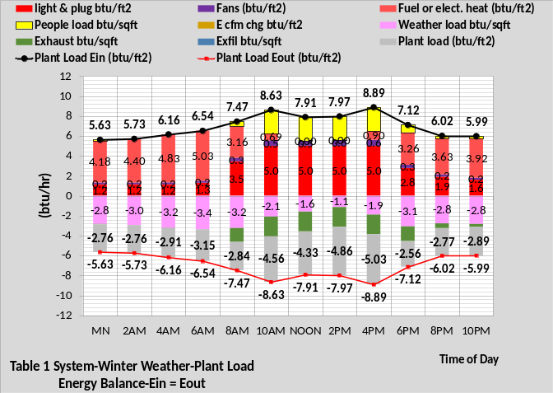
Figure 4: Table 1 System- Top chart 24 Hour Energy Balance at Design Weather-Bottom chart 24 Hour Energy Balance at Winter Weather
Figure 4 gives the energy balance data in (btu/ft²) so that data for any building can be judged against this (SEE) model Standard 90.1-2010 building⁵. From the top chart at 4PM; 18.26 btu/ft² x 565,000 ft²/12,000 btu/ton = 859.5 ton as given by the top chart of Figure 3.
Building Plus Plant Watts/ft²
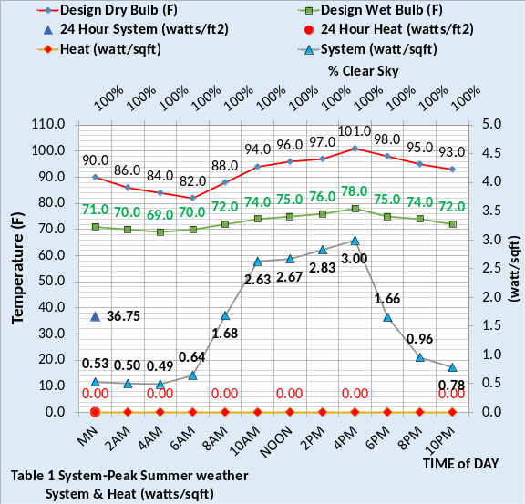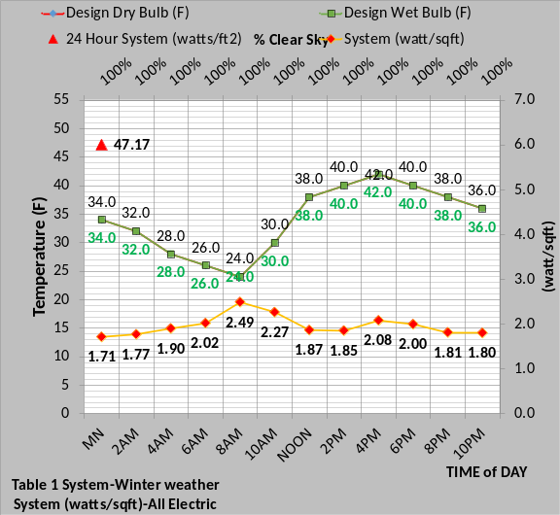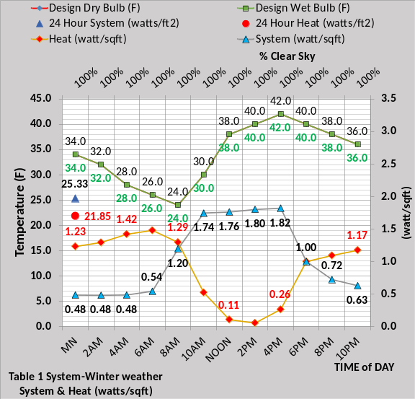
Figure 5: Building plus Plant (watts/ft²)
Figure 5 gives total system, building plus plant, watts/ft² for 24-hours of design and winter weather of Figure 2. Total kW demand meters are usually provided by utility companies so the figures give data to judge a building and plant operating at close to the weather conditions of Figure 2. The top chart is for design weather conditions and gives the total 24-hour sum as 36.75 watts/ft². The middle and bottom charts are for winter weather. The middle chart is for a system that uses electric heat and does not have separate heat energy metering. The total 24-hour sum is 47.17 watts/ft², a 28% increase over design day weather.
The bottom chart is for a system that uses fuel heat and the total 24-hour electric use is 25.33 watts/ft² and the fuel consumption is 21.85 watts/ft². Note the two values total the middle chart value. The fuel meter would be in terms of btu/ft² but watts/ft² is given so relative values can be seen.
Figure 5 bottom chart illustrates that the heat energy required by the ASHRAE Standard 90.1-2010 building and plant during winter operation is almost as much as the value for lights, plugs, fans, and the plant. Article 2 will address this characteristic in some detail.
The middle and bottom charts of Figure 5 illustrate the energy use visibility offered by separate metering on the heat required by the building. Article 4 suggests six energy meters required for a system energy balance;
- Plant load (ton)
- Tower exhaust (ton)
- Plant (watts/ft²)
- Site (watts/ft²)
- Heat (watts/ft²)
- System (watts/ft²)

System (EUI) Estimates (kbtu/ft²-yr) for the Table 1 System
Figure 6 is the (SEE) Model estimate of annual (EUI) value. The (SEE) model (EUI) estimates are based on average seasonal weather conditions of Kansas City Missouri. Programs that model 365 days, for example Energy-Plus, are much better for determining annual (EUI) values.

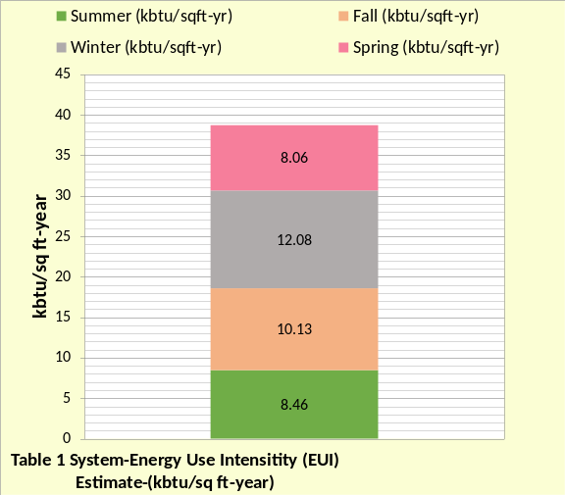
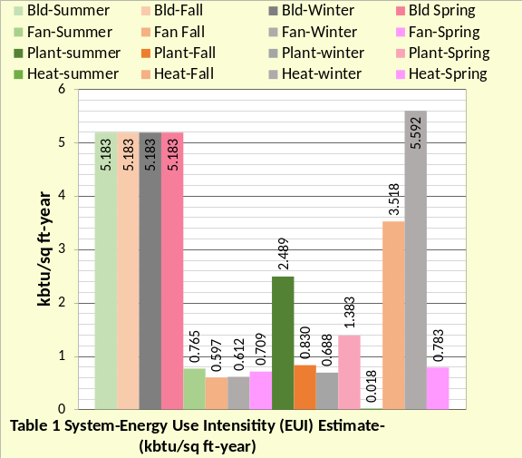
Figure 6: Table 1 System (EUI) estimate & System Components (EUI) per season
For Table 1 conditions Figure 6 top chart gives the (SEE) Model (EUI) estimated of 38.73 (kbtu/ft²-yr), a value that is within 11% of the DOE value of about 43 (kbtu/ft²-yr) for new constructed large office buildings. Kansas City reports values in the order of about 73 (kbtu/ft²-yr) for existing office buildings.
Table 1 gives 24 design and control decisions that were made for the building as defined by the figures and discussion thus far. Changing any one of the 24 items would change the building energy consumption and therefore the (EUI) value, perhaps explaining the Kansas City real building values being greater than the DOE value.
Figure 6 bottom chart breaks the (SEE) Model (EUI) estimate into four values for each of the four seasons. The largest value is the building load due to lights and plug loads and is the same for all seasons. The fan value is relatively constant and the plant load is high at summer conditions and significantly less for the other three seasons. The heat load is high during the winter and fall seasons and almost zero at summer conditions. Figure 6 illustrates that the building lights and plug loads are dominate for all seasons and building heat is the second largest energy consumer. Article 4 will demonstrate how poor control can drive these values to more than double the design values given by Figure 6.
As Constructed Building and Plant Table 2 System
For many projects it is a given that the constructed building and plant will not be exactly as designed; changes will occur as the system is constructed. The first challenge for the (SEE) Model, after the system is constructed, is to develop a (SEE) Model of the as constructed system that can be used to define how the system should operate at any day of weather, particularly during commissioning. Table 1 is the as designed system and Table 2 illustrates the as constructed system for this study. Table 2 assumes design changes were made to install fan powered terminals¹¹ and return fans¹². It is also assumed that the static pressure of the constructed air duct systems was determined to be 7.0 versus the 5.5 design value. Table 2 illustrates these design changes defined as the as constructed system.

Building Location and Design
- Location=Kansas City Mo.
- Building 565,000 ft².
- No external solar shading.
- Ambient temperatures-Figure 2
- Percent clear sky 100%.
- Building design per Liu⁵ changed.
- Percent wall glass 37%
- Peak lights kW .81 watts/ft²
- Peak plugs kW .66 watts/ft²
- Return air to perimeter-no change.
- Duct design 5.5 to 7.0 in. water
- Fan powered terminals installed
- Return air fans installed
Building Control
- Lights on/off control 6% on after hours.
- Plugs on/off control 44% on after hours.
- Building pressure control, no infiltration.
- Supply air = 55F
- Supply water = 44F to 44.5F
- Stats control-yes.
- Perimeter heat air temp-105F.
- VAV fan static control-yes.
- Fresh air CFM control-yes.
- Fresh air heat stat set 42F.
Plant Design & Control
- Chiller/Tower selection¹³.
Table 2: System

Energy Balance of Table 2 System
Comparing the energy balance charts of Figures 3 & Figure 7 illustrates that the lights and plug loads are the same for both designs. At design conditions the plant load increased from 859.5 ton of Figure 3 to 925.8 ton of Figure 7 and the winter plant load increased from 236.9 ton to 265 ton. Summing the lights, plugs, and fans of the top chart of Figure 3 gives 300.28 ton and Figure 7 gives 368.75 ton, a 23% increase at design conditions. At winter weather Figure 3 sums to 306.2 ton and Figure 7 is 335.5 ton. Figure 3 perimeter heat is 42.1 ton and total fans is 28.3 ton. The fans value of Figure 7 is more than double at 59.8 ton due to the fan powered terminals and return fans plus the increase in duct static pressure. Comparing the building heat shows a decrease in Figure 7, 39.9-ton verses 42.1 ton of Figure 3. The reason is that the fan powered terminals add heat to the space supply air and therefore decrease the required air heat. This characteristic will be further addressed by Article 2.

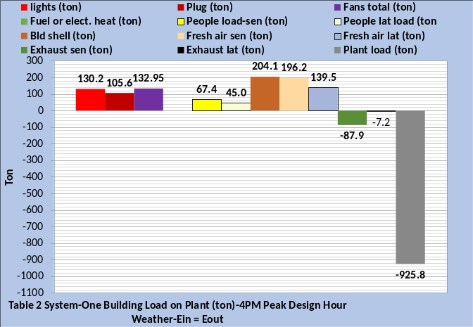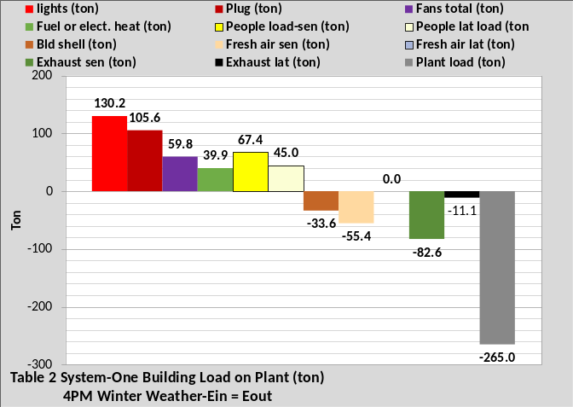
Figure 7: Table 2 System- Top chart energy balance at 4PM design conditions of Figure 2-Bottom chart energy balance at 4PM winter conditions of Figure 2.

Figure 8 gives the 24-hour energy balance data in (btu/ft²) so that data for any building can be judged against this (SEE) model Standard 90.1-2010 building⁵ as defined by Table 2. From the top chart at 4PM; 19.66 btu/ft² x 565,000 ft²/12,000 btu/ton = 925.8 ton as given by the top chart of Figure 7.
Comparing the charts of Figure 8 illustrates that the total energy into and out of the building at day time design conditions is about twice the winter values. However, the night time winter values are significantly greater than at design conditions.

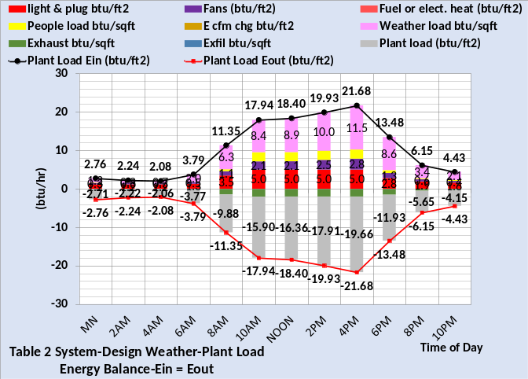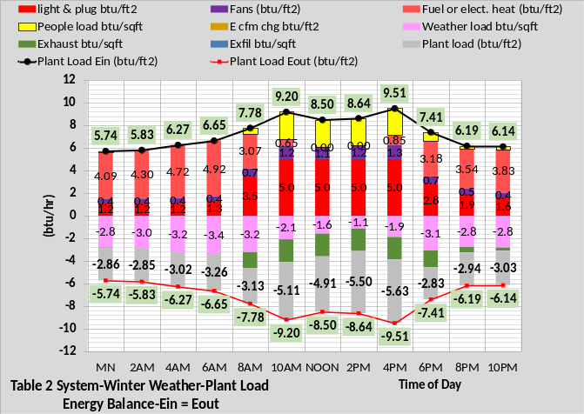
Figure 8: Table 2 System- Top chart energy balance at design weather-Bottom chart energy balance at winter weather

Figure 9 gives Table 2 system, building plus plant, watts/ft² similar to Figure 5 above. The top chart is for design weather conditions and gives the total 24-hour sum as 41.99 verses 36.75 watts/ft² for the Table 1 system of Figure 5. The middle and bottom charts are for winter weather. The middle chart is for a system that uses electric heat and does not have separate metering. The total 24-hour sum is 49.66 verses 47.17 watts/ft² for the Table 1 system, a 5% increase.
The bottom chart is for a system that uses fuel heat and the total 24-hour electric use is 28.29 verses 25.33 watts/ft² for the Table 1 system and the fuel consumption is 21.36 verses 21.85 watts/ft² for the Table 1 system, a slight decrease due to the air supply heat provided by the fan powered terminals.
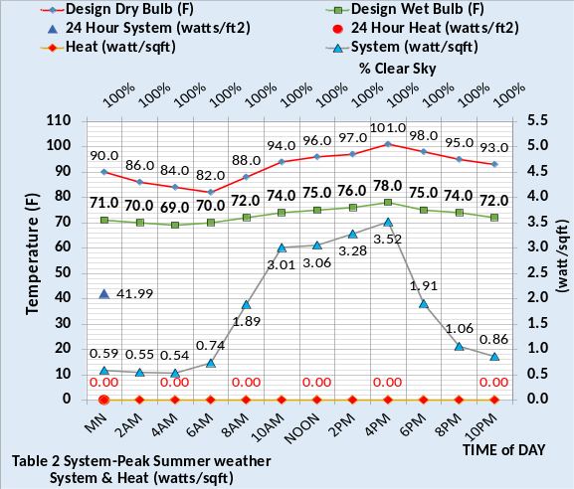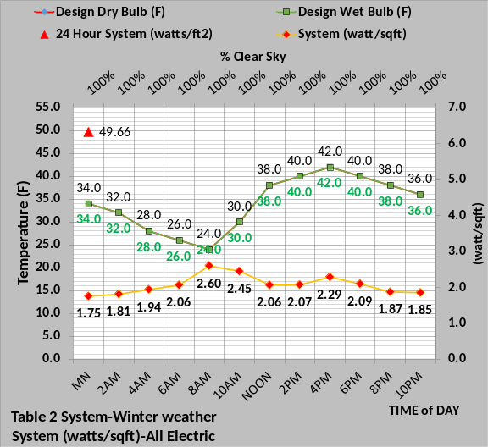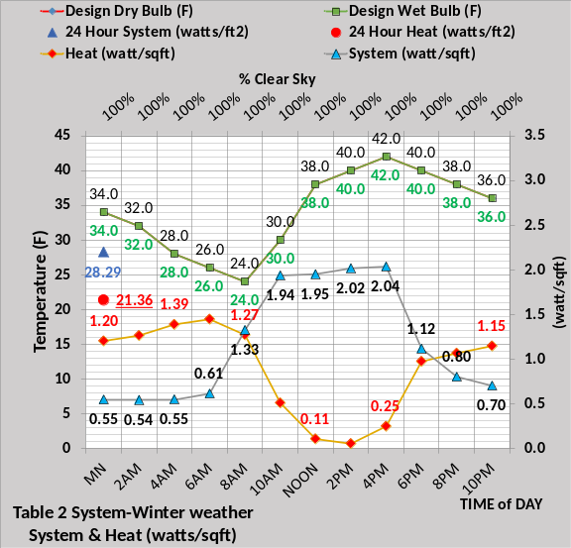
Figure 9: Table 2 Building plus Plant watts/ft²

(EUI) Estimates (kbtu/ft²-yr) for the
Table 2 System
Table 2 conditions increased the estimated annual (EUI) from 38.73 (btu/ft²-yr) of Figure 6 to 41.88 (btu/ft²-yr) of Figure 10 top chart, an 8% increase. Comparing Figure 6 top chart to Figure 10 the summer (kbtu/ft²-yr) value increased from 8.46 to 9.43, and the fall value increased from 10.13 to 10.80, a slight increase. The winter value increased from 12.08 to 12.71 and the spring value increased from 8.06 to 8.94, all summing to the Table 2 system increase over the Table 1 system of 3.15 (kbtu/ft²-yr). As stated above the (SEE) model (EUI) estimate is based on average four-season weather and 365-day models provide more accurate values.
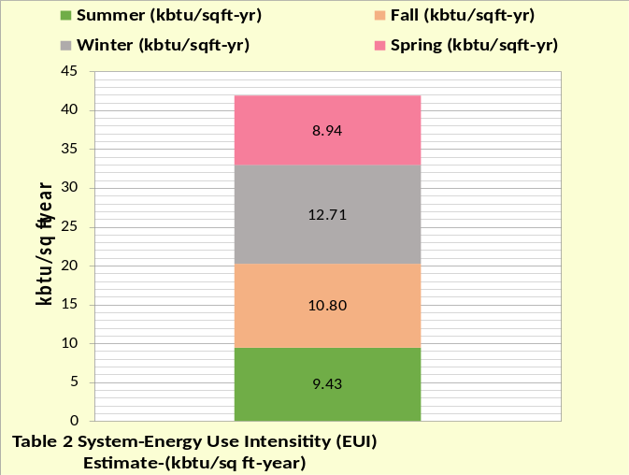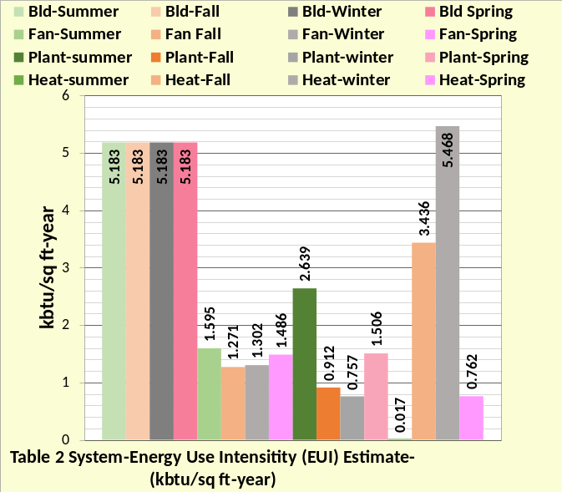
Figure 10: Table 2 System (EUI) estimate & System Components (EUI) per season
The bottom charts of Figures 6 & 10 give the (EUI) values of the system components at the four seasons. The building value, lights plus plugs, of 5.183 is the same for the Table 1 & 2 systems. The fan values more than doubled for the Table 2 system due to the installation of the fan powered terminals and return fans and the increase in duct static pressure. The plant (kbtu/ft²-yr) values increased a little with the Table 2 system. The heat required for the Table 2 system decreased as a result of the heat added to the air by the fan powered terminals. Article 2 will provide additional understanding of this air supply characteristic.

Table 3 System-Poor Control
The Table 3 system is the Table 2 system with poor control. The Table 3 system will be addressed in article 4 but is presented here to illustrate how much the estimated (EUI) value can be increased by poor control.
Each of the building controls listed are changed with Table 3 except the 55F supply air temperature and the plant control. The (SEE) model can evaluate each of these poor control issues, and others, as standalone or as additive effect on the performance of the system. Article 4 will address the effect of Table 3 poor control over the week of March 22 to March 26, 2021 real weather of Kansas City. Corrections to the poor control will be evaluated as the weather changes each day, arriving at good control on March 26.
System aging can also have a significant effect on the performance of a system but will not be addressed in this series of four articles.

Building Location and Design
- Location=Kansas City Mo.
- Building 565,000 ft².
- No external solar shading.
- Ambient temperatures-Figure 2
- Percent clear sky 100%.
- Building design per Liu⁵ changed.
- Percent wall glass 37%
- Peak lights kW .81 watts/ft²
- Peak plugs kW .66 watts/ft²
- Return air to perimeter-no change.
- Duct design 5.5 to 7.0 in. water
- Fan powered terminals installed
- Return air fans installed
Building Control
- Lights on/off control from 6% on after hours to 67% on.
- Plugs on/off control 44% on after hours to 67% on.
- Building pressure control; infiltration of .2 cfm/ft² walls max-varies as AHU cfm.
- Supply air = 55F
- Supply water = 44F to 44.5F
- Stats control-NO.
- Perimeter heat air temp-90F.
- VAV fan static control-NO.
- Fresh air CFM control-NO.
- Fresh air heat stat set from 42F to 60F.
Plant Design & Control
- Chiller/Tower selection¹³.
Table 3: System-Poor Control

Figure 11 top chart gives an estimated (EUI) for the Table 3 system of 89.85 (kbtu/sq ft-year), a value more than twice the 41.88 estimate for the Table 2 system. Comparing the bottom charts of Figure 10 & 11 shows all values increased with the Table 3 system. The building value, consisting of lights and plug demand, increased from 5.183 to 7.028, a 36% increase. The fans (EUI) increased in the order of three times and the plant (EUI) increased about 44% during the summer to 2 to 3 times for the other seasons.
Article 4 will address Table 3 system performance in detail.
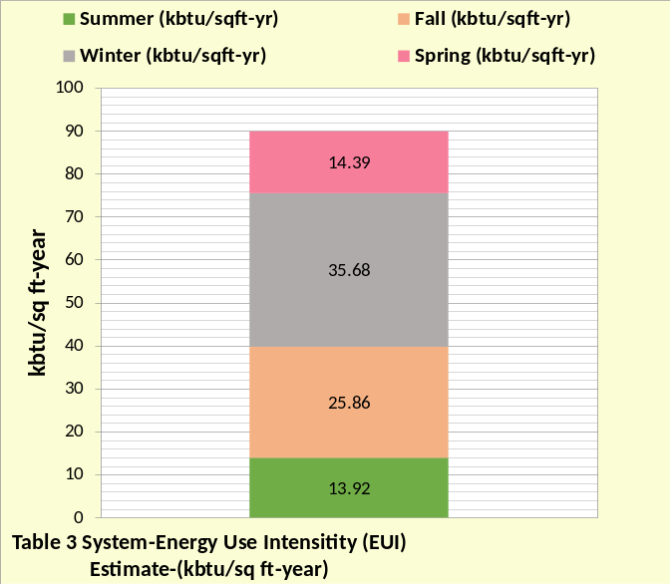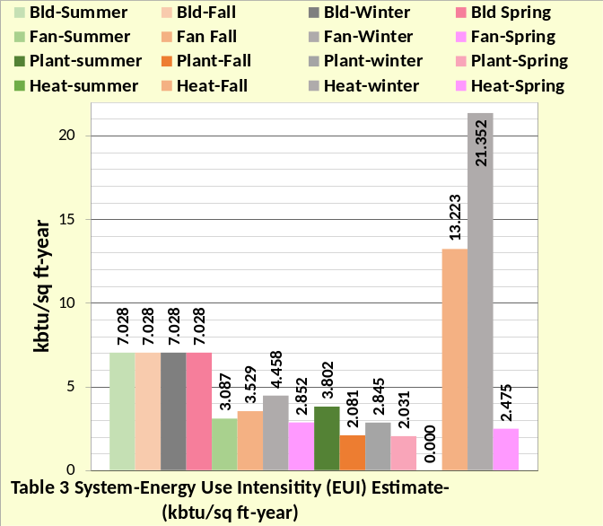
Figure 11: Table 3 System (EUI) estimate & System Components (EUI) per season

Article 1 Summary
Article 1 is to set the stage for the next articles by defining the buildings to be modeled, characteristics of the model, estimates of annual (EUI) values, and present the concept of system energy balance analysis. Simulating the performance of a building system on any given day is a rather complex problem; the next three articles give additional insight. The author approached this problem believing, based on experience modeling military products, that the task was doable. At this point the author believes this (SEE) Model as presently configured is capable of estimating, within reasonable accuracy, the benchmark performance of 90.1-2010 office building systems⁵ with the following caveat;
- Each floor of the building is large enough such that the interior space of the floor always requires cooling and only the walls require heat during cold weather.
The next article 2 will address details of the building model including the solar model. Article 3 will address the plant model. Article 4 will address real weather performance and define the significant effect poor control can have on the kW demand of the system.

References
- Introduction to Thermodynamics and Heat Transfer. 1956 Prentice-Hall, Inc. by David A. Mooney.
- Thermal Environmental Engineering third edition. 1998 Prentice-Hall Inc. by Thomas H. Kuehn, chapter 3.
- ASHRAE Journal May 2016. “Modeled Performance Isn’t Actual Performance”
- Nelson, Kirby. “System Energy Equilibrium (SEE) Building Energy Model Development & Verification”. http://kirbynelsonpe.com/
- Liu, B. May 2011. “Achieving the 30% Goal: (copy and paste) https://www.energycodes.gov/sites/default/files/documents/BECP_Energy_Cost_Savings_STD2010_May2011_v00.pdf
- Real weather data www.wunderground.com/
- Nelson, K. “7 Upgrades to, Reduce Building Electrical Demand” ASHRAE Journal, December, 2006,
- Nelson, K. “Simulation Modeling of a Central Chiller Plant” CH-12-002. ASHRAE 2012 Chicago Winter Transactions.
- Nelson, K. “Simulation Modeling of Central Chilled Water System” CH-12-003. ASHRAE 2012 Chicago Winter Transactions.
- Kavanaugh, S. “Fan Demand and Energy” ASHRAE Journal, 2000.
- Faris, Gus “Fan-Powered VAV Terminal Units” ASHRAE Journal November 2017
- Kettler, John “Return Fans or Relief Fans” ASHRAE Journal April 2004.
- Taylor, S. 2011. “Optimizing design & control of chiller plants.” ASHRAE Journal (12).
- Nelson, Kirby “The System Energy Equilibrium Model for Chiller Plants, Part 1” Engineered Systems, July 2020.
- Marley Tower SPX Cooling Technologies UPDATE Version
- Steven Taylor. ASHRAE Journal June 2007. “VAV System Static Pressure Setpoint Reset”

Anatomy of a Real Time Building Energy model
Part 2-(SEE) Model of Building
Table 2 System
The purpose of this article 2 is to provide details of the building (SEE) model. Additional detail, with schematics, can be found at Nelson⁴. Article 3 will address the plant model.
Building Interior-Peak Summer Weather

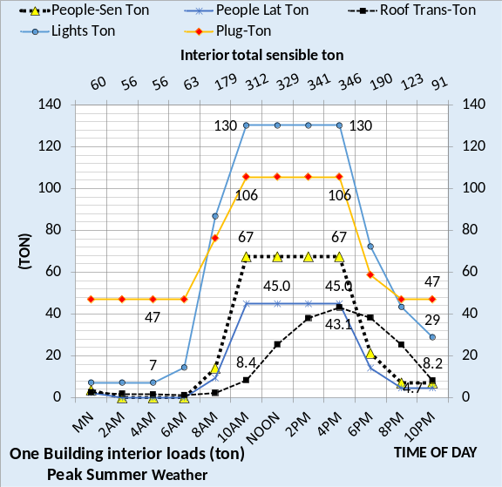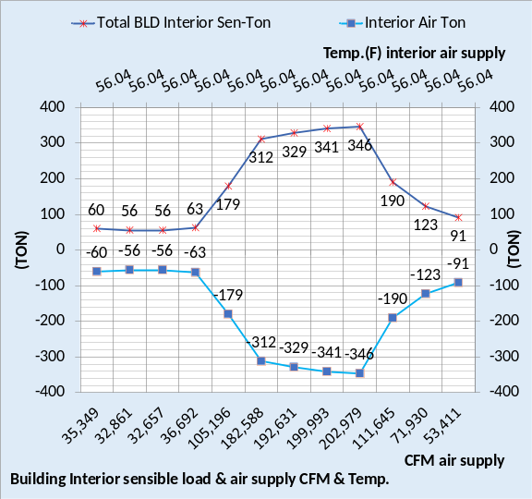
Figure 1: Interior Load & Air Supply to Meet Load

The top chart of Figure 1 gives the interior loads as defined by Figure 2 of Article 1. The secondary horizontal axis of the top chart sums the sensible loads. At 4PM the loads are; lights =130-ton, plugs = 106-ton, people sensible = 67-ton and roof = 43-ton for a total sensible load of 346 ton.
The bottom chart gives the air supply CFM and air temperature to meet the interior sensible loads.
For example, at 4PM;
Air Ton = (CFM)*1.08*(delta T)/12,000
Air Ton = (202,979) *1.08*(75F-56.04F)/12,000
Air Ton = 346.36-ton cooling
The air temperature off the coil is 55F but the fan powered terminals increase the supply air to the space to 56.04F. Additional detail of this and other characteristics of the air supply temperature and CFM is given below.

Building Perimeter-Peak Summer Weather
Figure 2 gives the (SEE) model perimeter loads and Figure 3, top chart, gives the summation of Figure 2 and the bottom chart gives the perimeter air supply to meet the perimeter loads.
Figure 2 top chart gives the solar load through the wall glass as the sun moves across the sky. The figure illustrating that east and west wall glass solar loads are significantly greater than the north-south wall loads. This condition significantly changes during winter conditions as shown below by Figure 9. The glass solar load is modeled as solar heat gain thru ordinary vertical glass¹⁷ including direct and diffuse radiation and that portion of the heat absorbed in the glass which gets into the conditioned space, reduced by the SHGC value of Figure 1 of Article 1. No internal blinds are assumed so the solar load thru glass is modeled as instantaneous load. No external shading is model here but the (SEE) model can input shading separately on each wall due to adjacent buildings or installed external shades. The (SEE) model also inputs sky or cloud conditions which defines the total solar energy to the building, demonstrated in Article 4 where real weather conditions are input to the model.
The middle chart of Figure 2 gives the perimeter glass transmission which is a function of glass U value given by Figure 1 of Article 1. Comparing the secondary horizontal axes of the top chart to the middle chart illustrates that solar loads are greater during day time hours with transmission providing a greater 24 hour summed value.
The bottom chart of Figure 2 gives the wall transmission with the solar effect on the wall delayed four hours. The solar effect on the roof is also delayed four hours.
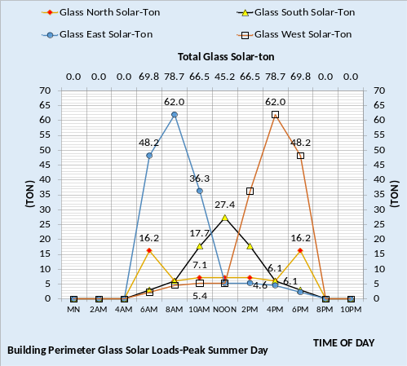
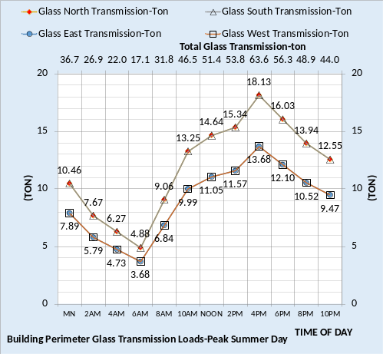
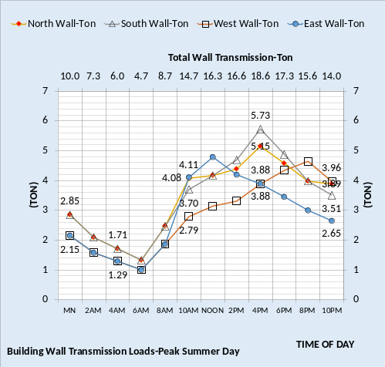
Figure 2: Building Perimeter Loads
The effect of solar on the walls is illustrated by the 4PM values for the north and south walls, bottom chart Figure 2. The total transmission is 5.15 ton on the north wall and 5.73 ton on the south wall; solar on the south wall increased the load by (5.73 – 5.15 = .58 ton) at 4PM.

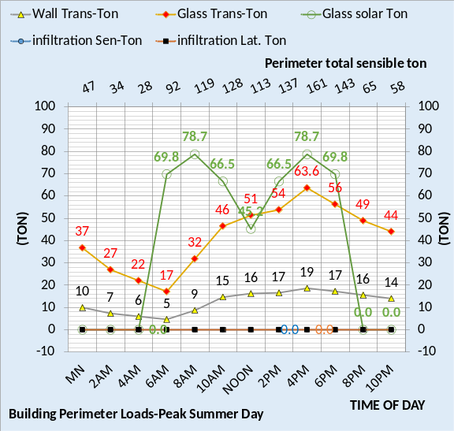
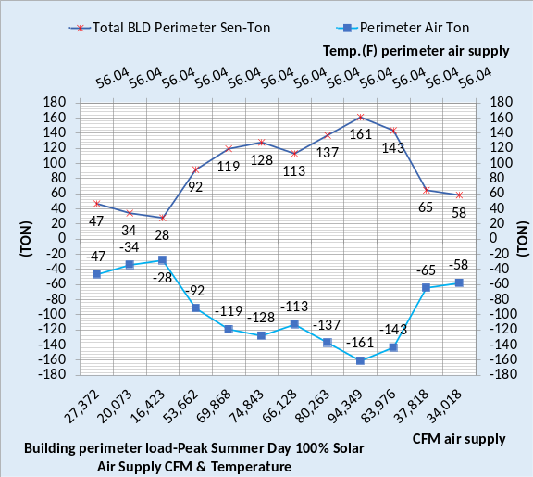
Figure 3: Building perimeter Loads and Air Supply to Meet Load
Figure 3 top chart gives the total perimeter sensible load and the bottom chart gives the perimeter air supply to meet the load.
For example, at 4PM;
Air Ton = (CFM)*1.08*(delta T)/12,000
Air Ton = (94,349) *1.08*(75F-56.04F)/12,000
Air Ton = 161-ton cooling
The air handler system must supply the total CFM given by Figures 1 and 3 addressed below; but first let’s consider the total effect of weather on the energy performance of the building.

Weather Effect and Energy Storage

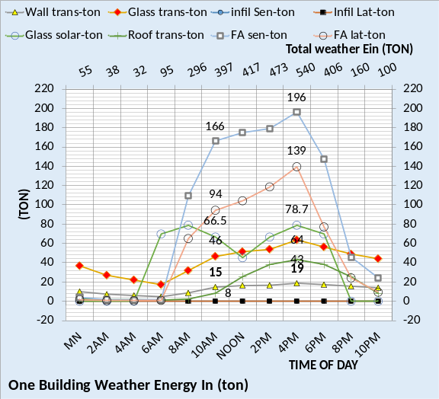
Figure 4: Weather into Building-Peak Design day

Figure 4 top chart gives the total weather energy (ton) into the building and the bottom chart is the energy balance copied from Figure 7 of Article 1. All values on the top chart of Figure 4 at 4PM are given by the bottom chart and by Figure 3. At 4PM the top chart of Figure 4, secondary horizontal axis, shows the total weather energy into the building is 540 ton which is 58% of the total plant load shown by the bottom chart of Figure 4. Figure 4 bottom chart shows weather energy in (ton) is; FA sensible 196.2 + FA latent 139.5 + Bld. Shell 204.1, for a total of 539.8 ton, same as the top chart at 4PM.
The top chart of Figure 4 shows the same values for fresh air and breaks the shell load into the same values as shown by the top chart of Figure 3;
glass solar 78.7 + glass trans. 63.6 + wall trans 19 for a total of 161.3 ton. Add to this 161.3 ton the roof load of 43.1 ton from Figure 1 top chart and you have the shell load of 204.1 given by Figure 4 bottom chart. At least two conclusions can be drawn from this discussion;
- The wall transmission value of 19 ton is a small number when compared to the total weather energy in value of 540 ton and the plant load of 925.8 ton. A day with assumed zero solar would reduce this value about 5 ton and the 78.7-ton glass solar load would be zero for a total reduction of about 84 ton which is 16% of the total weather in ton and 9% of the plant load. The purpose here is to put solar load into perspective but keep in mind this is for 4PM peak design hour condition. The issue will be addressed below at winter weather conditions.
- Energy storage in the building walls is not in the (SEE) model. Carrier¹⁷ chapter 3 page 1 states; “Transmission load is considered to be 100% convective load. This load is normally a relatively small part of the total load, and for simplicity is considered to be the instantaneous load on the equipment.”

Figure 4 top chart and all charts of this Article 2 are for zero infiltration, assuming the building is balanced in terms of fresh air in and exhaust out. Infiltration will be introduced in Article 4, illustrating a significant effect on the system energy use.
Next will consider the air handler system required to provide the supply air defined by Figures 1 & 3 bottom charts.

Air Handler Performance-Peak Summer Weather-Table 2 System

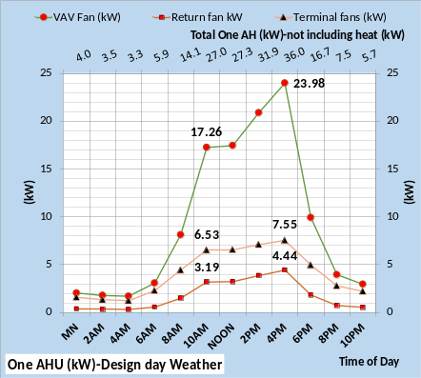
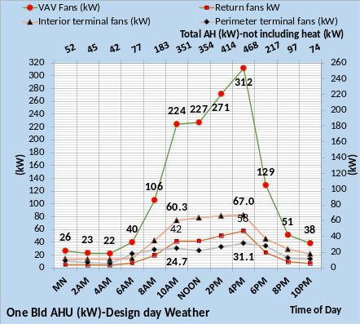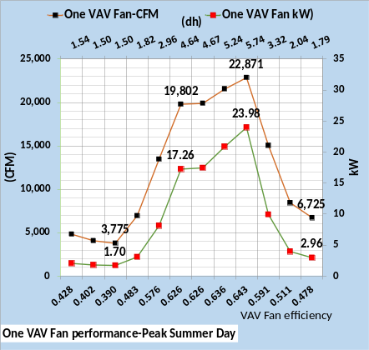
Figure 5: Table 2 System
Air handler Performance
Figure 5 gives air handler performance. There are 13 VAV air handlers in the building, one per floor, each with design CFM of 26,400. The top chart of Figure 5 gives the kW performance of one AHU and the middle chart gives the total for one building or values 13 times the top chart values. The secondary horizontal axis gives the total AHU kW not including heat kW. At 4PM one AHU has a total of 36 kW with the VAV fan at 23.98 kW, the terminal fans 7.55 kW and the return fans 4.44 kW. The middle chart gives the building total as 468 kW at 4PM with the VAV fans 312 kW and the return fans 58 kW. The fan powered terminals are 67 kW for the building interior and 31.1 kW for the building perimeter. The kW of the terminals and return fans is modeled as proportional to the CFM moved by the VAV fans.
The bottom chart gives the CFM and kW demand of one VAV fan. Figure 1 above gave the total interior CFM at 4PM as 202,979 and Figure 3 for the perimeter as 94,349 for a total of 297,328 CFM at 4PM for the building. Therefore, each of the 13 VAV units is 297,328/13 = 22,871 CFM as shown by the bottom chart at 4PM.
At 4PM for one VAV unit;
VAV kW = .746*(CFM)*(dh)/fan eff*6356
VAV kW = .746*(22,871 CFM) *5.74/ (.643*6,356)
VAV kW = 23.98 kW
The total CFM at 4PM is (13 * 22,871 = 297,329 CFM) and the total VAV kW is; (13 x 23.98 = 312 kW) as shown by the middle chart of Figure 5.
The bottom chart of Figure 5 shows that (dh) and fan efficiency change as the load changes. The VAV kW is a function of the constructed air duct static and the characteristics of the VAV fan in terms of how efficiency and static change¹⁰ as the CFM changes. Each manufacture will likely have a different set of characteristics? The values of (dh) and fan efficiency are valuing the author arrived at from varies articles¹⁰ and should not be considered good for all VAV fans.
The lights and plug loads are in the space and will be picked up by the supply air to the space but the air handler kW demand is input to the air as the air passes thru the VAV fans. The bottom chart of Figure 5 illustrates that much is changing as the air handler meets a changing load. The VAV fan increases CFM to meet an increased load but the increased CFM increases VAV kW and therefore the load on VAV fans that in turn changes (dh) and changes fan efficiency, all iterating to a new steady state condition just as occurs in a real system. As with all variables in the model; (dh) and fan efficiency are defined by equations that are a function of, among other variables the VAV CFM. The point is that the set of 501 (SEE) model equations are analogues to a set of feedback control equations¹⁸. Figure 6 further illustrates this point.

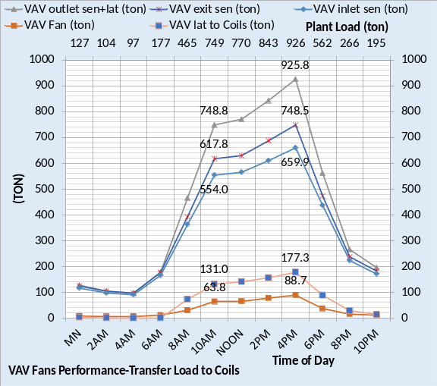
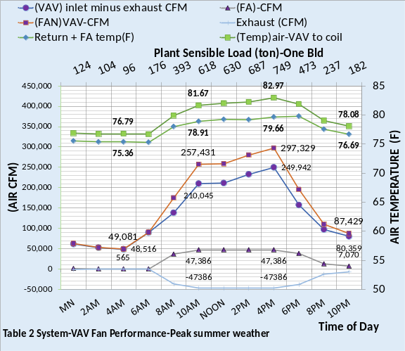
Figure 6: VAV Fan Performance
The top chart of Figure 6 gives the loads at the VAV fans. At 4PM the inlet sensible load to the VAV fans is 659.9 ton and the air exists the fans at 748.5 ton due to the addition of the VAV fan kW heat as the air moved thru the fan adding 88.7 ton. The VAV fans also transfer the latent load of 177.3 ton giving a total of 925.8 ton the VAV fans deliver to the coils in turn providing a plant load of 925.8 ton show on the secondary horizontal axis of the top chart.
The bottom chart at 4PM shows VAV air inlet of 249,942 CFM is mixed with the 47,368 CFM of fresh air resulting in 297,329 CFM of 79.66F air to the inlet of the VAV fans. As the VAV fans move the air toward the coils heat is added to the air as a result of the VAV fan kW, raising the air temperature to 82.97F. The supply air off the coils is 55F, therefore;
Air Ton = (CFM)*1.08*(delta T)/12,000
Air Ton = 297,329 * 1.08 * (82.97-55F)/12,000
Air Ton = 749 ton as shown by the secondary horizontal axis of the bottom chart.
Figure 7 top chart gives the air temperatures at the VAV fans. At 4PM the 75F return air from the occupied space, after passing thru the return fans is 75.61F. The 47,386 CFM of 101F fresh air mixes with 249,942 CFM of 75.61F return air resulting in 297,329 CFM of 79.66F air to the inlet of the VAV fans. As the air passes thru the VAV fan its temperature is increased and the air exits the fan at 82.97F. During the process of being heated the VAV fan increases CFM to accomplish 55F air off the coil and as the CFM is increased, as the air passes thru the fan, the static and fan efficiency change as indicated by Figure 5 bottom chart. Again, the point is the (SEE) models 501 equations are analogous to a set of feedback control equations¹⁸ all iterating to a steady state condition just as occurs in a real fan system.
This level of detail is required if the (SEE) model is to duplicate the performance of a real building.

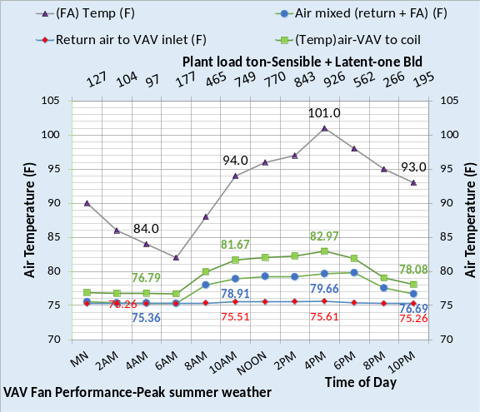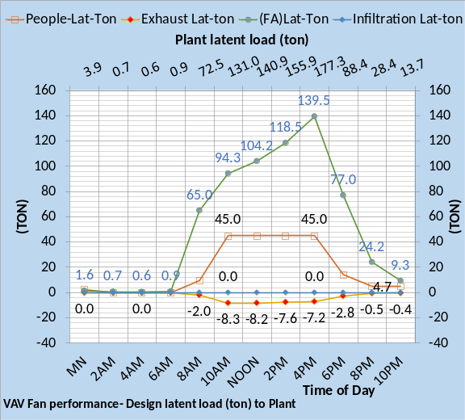
Figure 7: VAV Fan Performance

Figure 7 bottom chart gives the latent load into the building and the value transferred to the plant load. Figure 6 bottom chart secondary horizontal axis gives the plant sensible load and the top chart of Figure 7 secondary horizontal axis gives the sensible plus latent plant load. Infiltration is zero for the Table 2 system; the building is modeled as balanced with no infiltration. Infiltration can have a significantly effect on the building energy consumption to be addressed by Article 4.
The above discussion has been for design day weather conditions. The following will deal with winter weather operation illustrating a very different set of conditions and response by the 501 equations of the system.

Building Interior-Winter Weather
The only change made in the building (SEE) model going from design conditions, as discussed above, to winter conditions is to change the ambient dry bulb and wet bulb temperatures. The set of 313 building equations iterated to the new conditions providing a load to the plant. The only change to the 188 equations of the plant is the number of chiller/towers on and the chiller power is adjusted to meet the load and provide 44F supply water.
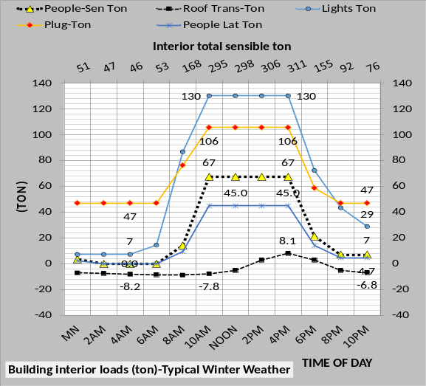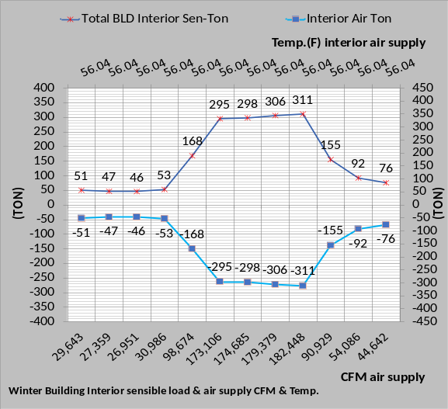
Figure 8: Winter Interior Load and Air Supply
The top chart of Figure 8 gives the interior loads as defined by Figure 2 of Article 1. The secondary horizontal axis sums the sensible loads. At 4PM the loads are; lights =130-ton, plugs = 106-ton, people sensible = 67-ton and roof = 8-ton for a total sensible load of 311 ton as also shown by the bottom chart. The bottom chart gives the air supply CFM and temperature to meet the interior sensible load over the 24-hour day.
For example, at 4PM;
Air Ton = (CFM)*1.08*(delta T)/12,000
Air Ton = (182,448) *1.08*(75F-56.04F)/12,000
Air Ton = 311 ton
The air temperature off the coil is 55F but the fan powered terminals increase the supply air temperature to 56.04F into the conditioned space.

Building Perimeter-Winter Weather
Figure 9 gives the (SEE) model solar and transmission loads and Figure 10, top chart, gives the summation of Figure 9 and the bottom chart gives the perimeter air supply to meet the loads.
Figure 9 top chart gives the solar load through the wall glass as the sun moves across the sky; illustrating that east, west, and north wall glass solar loads are significantly less than the south wall loads. This condition is significantly changed from the peak summer conditions of Figure 2 above where the east and west walls were dominate and the south wall peaked at 17.4-ton verses 83.7-ton of Figure 9. The glass solar load is solar heat gain thru ordinary vertical glass¹⁷ including direct and diffuse radiation and that portion of the heat absorbed in the glass which gets into the conditioned space, reduced by the SHGC of Figure 1 of Article 1. No internal blinds are assumed so the load is modeled as instantaneous load. No external shading is model here but the (SEE) model can input shading separately on each wall due to adjacent buildings or installed external shades. The (SEE) model also inputs sky or cloud conditions which defines the total solar energy to the building. Article 4 inputs real weather conditions to the model including wet bulb and dry bulb temperatures and percent cloud cover.
The middle chart of Figure 9 gives the perimeter glass transmission which is a function of glass U value given by Figure 1 of Article 1. Comparing the secondary horizontal axes of the top chart to the middle chart illustrates that solar loads are adding heat to the building and the walls are removing heat. The bottom chart of Figure 9 gives the wall transmission with the solar effect on the wall delayed four hours. The walls all transfer heat out of the building even with solar on the wall. The solar effect on the roof is delayed four hours as given by Figure 8.
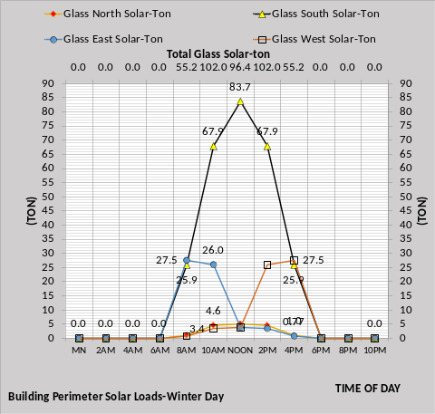
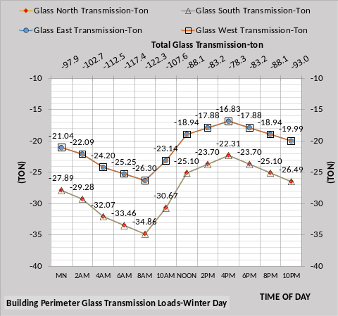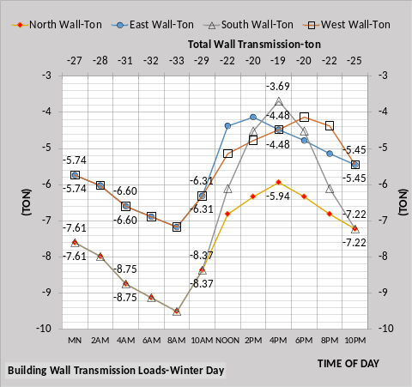
Figure 9: Building Perimeter Loads

The effect of solar on the walls is illustrated by Figure 9 bottom chart 4PM values. The east and west walls compared to the south wall show less heat is lost on the south wall due to solar on the wall.
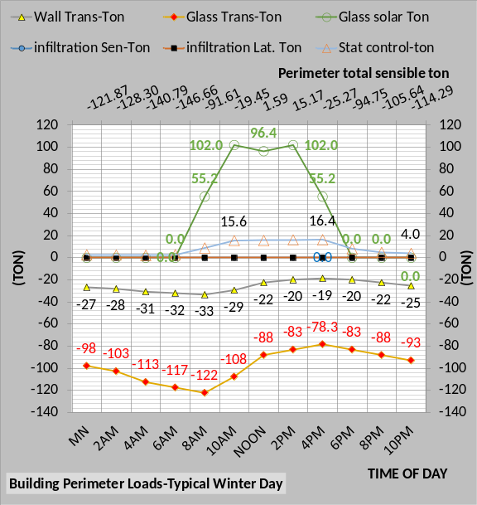
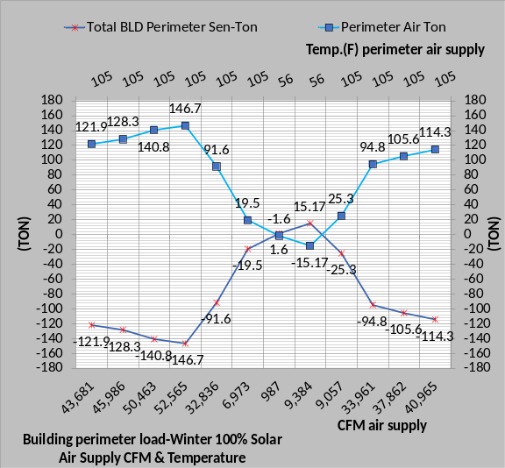
Figure 10: Building perimeter Loads and Air Supply to Meet Load
Figure 10 top chart gives the total perimeter load and the bottom chart gives the perimeter air supply to meet the load.
For example, at 4PM;
Air Ton = (CFM)*1.08*(delta T)/12,000
Air Ton = (9,057) *1.08*(74F-105)/12,000
Air Ton = -25.3-ton heat
The air handler system must supply the total CFM given by Figures 8 and 10 defined below; but first consider the total effect of weather on the energy performance of the building.
Winter Weather Effects on the Building

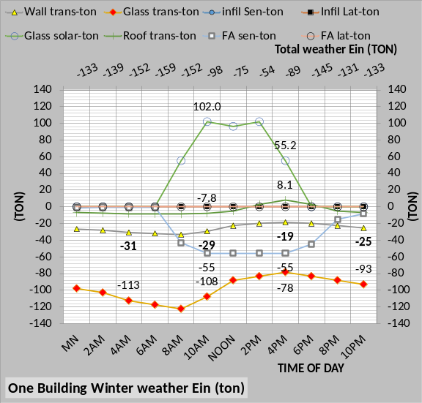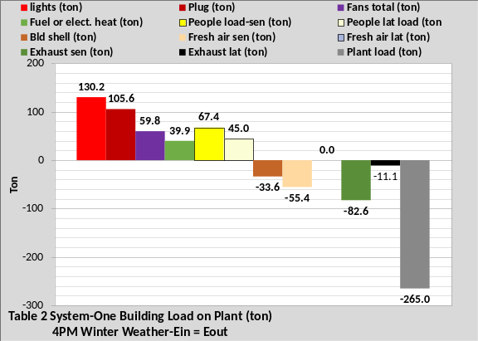
Figure 11: Weather into Building-Winter day

Figure 11 top chart gives the total weather energy (ton) into the building and the bottom chart is the energy balance at 4PM winter weather copied from Figure 7 of Article 1. All values on the top chart of Figure 11 are given by the bottom chart and by Figure 10. At 4PM the top chart of Figure 11, secondary horizontal axis, shows the total weather energy into the building is -89 ton. Figure 11 bottom chart shows weather energy in (ton) is;
FA sensible -55.4 + Bld. Shell -33.6, for a total of -89 ton.
The top chart of Figure 11 shows the same values for fresh air and breaks the shell load into the same values as shown by the top chart of Figure 10;
glass solar 55.2 + glass trans. -78.3 + wall trans -19 for a total of -42.1 ton. Add to -42.1 ton the roof load of 8.1 ton from Figure 8 top chart and you have the shell load of -34 ton given by Figure 11 bottom chart
Figure 11 top chart and all charts to this point have been for zero infiltration, assuming the building is balanced in terms of fresh air in and exhaust air out. Infiltration will be introduced in Article 4, illustrating a significant effect on the system energy use.
Air Handler System
The following will define the air handler system required to provide the supply air defined by Figures 8 & 10 bottom charts. There are 13 VAV air handlers in the building, one per floor, each with design CFM of 26,400. The top chart of Figure 12 gives the kW performance of one AHU and the middle chart gives the total for one building or values 13 times the top chart values. The secondary horizontal axis gives the total AHU kW not including heat kW. At 4PM one AHU has a total of 16.2 kW with the VAV fan at 9.54 kW, the terminal fans 4.86 kW and the return fans 1.77 kW. The middle chart gives the building total as 210 kW at 4PM with the VAV fans 124 kW and the return fans 23 kW. The fan powered terminals are 60.2 kW for the building interior and 3.0 kW for the building perimeter. The kW of the terminals and return fans is modeled as proportional to the CFM moved by the VAV fans. Figure 8 shows 182,448 CFM to the interior of the building at 4PM and Figure 10 shows 9,057 CFM to the perimeter. Figure 12 bottom chart shows the performance of one VAV fan in terms of static pressure and fan efficiency, values very different than the values of Figure 5. At 4PM;
VAV kW = .746*(CFM)*(dh)/fan eff*6356
VAV kW = .746*(14,731 CFM) *3.24/(.588*6,356)
VAV kW = 9.54 kW as shown by the top chart.

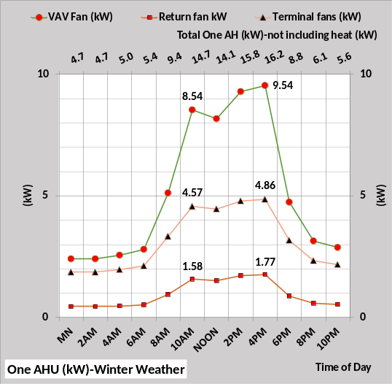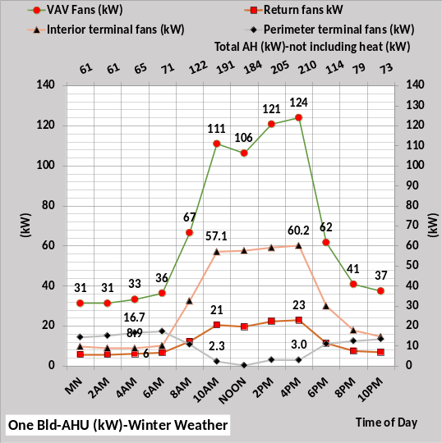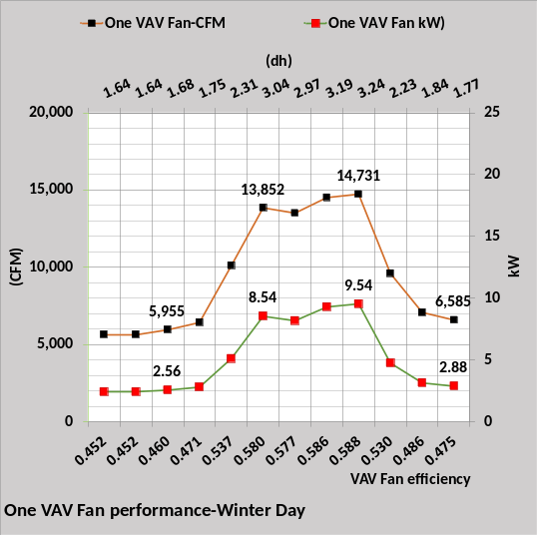
Figure 12: Table 2 System Air handler Performance-Winter

Total One Building kW

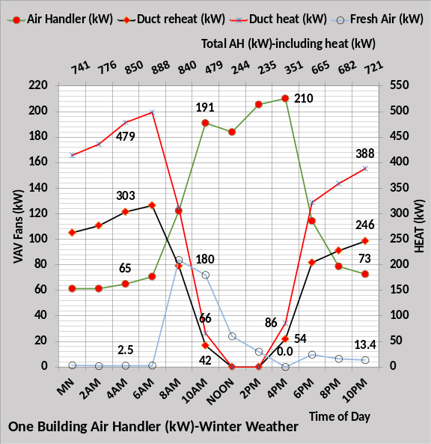
Figure 13: Building kW-Winter weather
Figure 13 puts the VAV fans plus terminals and return fans in perspective with regard to total air handler kW during winter weather. During the winter the heat required by the building perimeter is dominate as shown.

Feed Back Equations
The lights and plug loads are in the space and will be picked up by the supply air to the space but the air handler kW demand is input to the air as it occurs. As stated above the VAV fan increases CFM to meet an increased load but the increased CFM increases the load, changes (dh) and changes fan efficiency, all iterating to a new steady state condition just as occurs in a real system. The set of 501 (SEE) model equations are analogues to a set of feedback control equations¹⁸. Figure 14 illustrates the point. The top chart of Figure 14 gives the loads at the VAV fans. At 4PM the inlet to the VAV fans is 195.9 ton and the air exists the fans at 231.2 ton due to the addition of the VAV fan kW heat adding 35.3 ton; this heat was added as the air moved thru the fans.
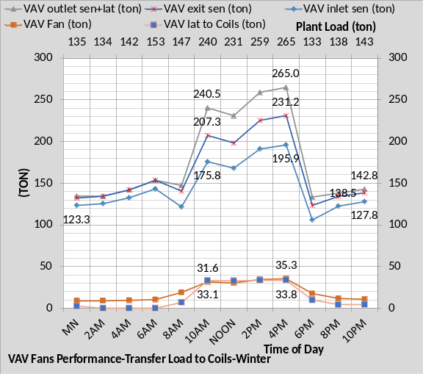
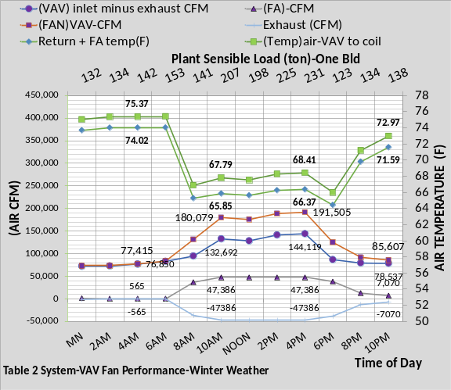
Figure 14: VAV Fan Performance
The VAV fans also transfer the latent load of 33.8 ton giving a total of 265 ton the VAV fans deliver to the coils in turn providing a plant load of 265 ton show on the secondary horizontal axis.
At 4PM the VAV air inlet of 144,119 CFM is mixed with the 47,368 CFM of fresh air resulting in 191,505 CFM of 66.37F air to the inlet of the VAV fans, shown by the bottom chart of Figure 14. As the VAV fans move the air toward the coils heat is added to the air as a result of the VAV fan kW, raising the air temperature to 68.41F. The supply air off the coils is 55F, therefore;
Air Ton = (CFM)*1.08*(delta T)/12,000
Air Ton = 191,505 * 1.08 * (68.41F-55F)/12,000
Air Ton = 231 ton as shown by the secondary horizontal axis of the bottom chart.
Add the 33.8 ton of latent load gives the total plant load of 265 ton shown by the top chart.

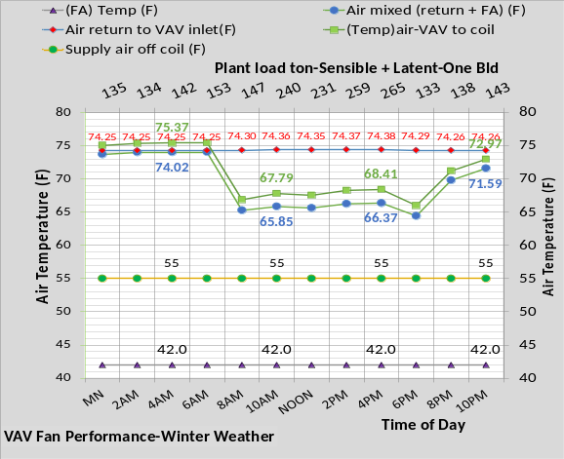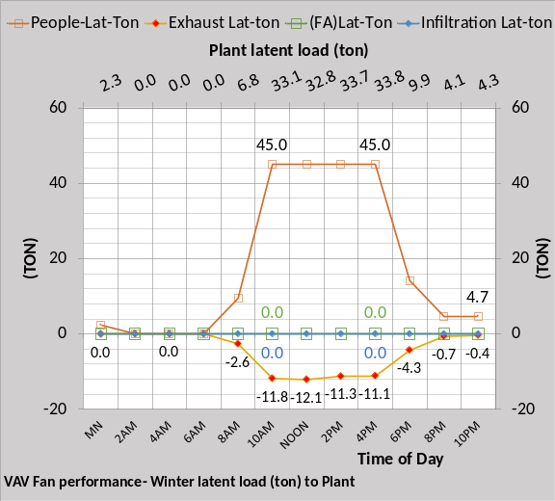
Figure 15: VAV Fan Performance

Figure 15 bottom chart gives the latent load into the building and the value transferred to the plant load. Latent due to people is the only value because the fresh air latent is zero at these winter conditions. The model can input other sources of latent load, for example infiltration. Figure 14 secondary horizontal axis gives the plant sensible load and the top chart of Figure 15 secondary horizontal axis gives the sensible plus latent plant load.
Summary/Conclusions
The model of the VAV fans must be accurate if the model is to duplicate the real time energy performance of a building. Therefore, the VAV fan model and all other components of the building, including the building solar model, must consist of sufficient detail and accuracy to accomplish the task of a real time building energy model.
This Article 2 has given some detail regarding the (SEE) model of the building defined by Figure 2 of article 1. The (SEE) model can provide charts for any and all variables of the model.
The difficulty of jumping from one chart to another to understand how the system was responding was solved by developing system schematics for any hour therefore providing a picture of the value of each relevant variable for a given hour. The building schematics are too large for this article but the next article 3 deals with the plant and the plant schematic is a bit smaller and is presented. Schematics are a part of the analysis and discussion given at Nelson⁴.

References
- Introduction to Thermodynamics and Heat Transfer. 1956 Prentice-Hall, Inc. by David A. Mooney.
- Thermal Environmental Engineering third edition. 1998 Prentice-Hall Inc. by Thomas H. Kuehn, chapter 3.
- ASHRAE Journal May 2016. “Modeled Performance Isn’t Actual Performance”
- Nelson, Kirby. “System Energy Equilibrium (SEE) Building Energy Model Development & Verification”. http://kirbynelsonpe.com/
- Liu, B. May 2011. “Achieving the 30% Goal: (copy and paste) https://www.energycodes.gov/sites/default/files/documents/BECP_Energy_Cost_Savings_STD2010_May2011_v00.pdf
- Real weather data www.wunderground.com/
- Nelson, K. “7 Upgrades to, Reduce Building Electrical Demand” ASHRAE Journal, December, 2006,
- Nelson, K. “Simulation Modeling of a Central Chiller Plant” CH-12-002. ASHRAE 2012 Chicago Winter Transactions.
- Nelson, K. “Simulation Modeling of Central Chilled Water System” CH-12-003. ASHRAE 2012 Chicago Winter Transactions.
- Kavanaugh, S. “Fan Demand and Energy” ASHRAE Journal, 2000.
- Faris, Gus “Fan-Powered VAV Terminal Units” ASHRAE Journal November 2017
- Kettler, John “Return Fans or Relief Fans” ASHRAE Journal April 2004.
- Taylor, S. 2011. “Optimizing design & control of chiller plants.” ASHRAE Journal (12).
- Nelson, Kirby “The System Energy Equilibrium Model for Chiller Plants, Part 1” Engineered Systems, July 2020.
- Marley Tower SPX Cooling Technologies UPDATE Version 5.4.2
- Steven Taylor. ASHRAE Journal June 2007. “VAV System Static Pressure Setpoint Reset”
- Carrier System Design Manual
- Miles Ryan. ASHRAE Journal February 2021. “Understanding Cascade Control and Its Applications For HVAC”

Anatomy of a Real Time Building Energy model
Part 3 The (SEE) Plant Model
This third article will demonstrate the plant (SEE) model that provides chilled water to the six-building campus defined by Article 1 and 2.
Why Model a Chiller Plant?
The first reason for a chiller plant model is to assist in the design of a plant. Second, provide plant operational data to assist operators and/or programing of the plant control system. Third, after the plant is operational, answer the question, “is the plant operating as designed?” An accurate model of the plant gives the opportunity to visit the plant under any conditions of weather and plant load and the plant model will define “as designed performance”. Forth, if the plant is not operating as designed then an accurate model provides a tool to evaluate why plant performance is substandard. The model offers the ability to visit the plant in future years and define plant degradation due to aging, bad control practice or other issues. The model also offers a design tool for helping define upgrades or expansion of the plant. In summary an accurate chiller plant model provides;
- Plant design tool.
- Define plant control strategies.
- Answer “Is the plant operating as designed?”
- Define causes of plant degradation/ageing.
- Define expansion and upgrades.
(SEE) Plant Model
A System Energy Equilibrium (SEE) Plant Model incorporates the basic equations and manufacturing data used by engineers to design a chiller plant. The equations are solved simultaneously by computer. The (SEE) Model requires, just as a real plant operates, that the energy into the plant equals the energy out of the plant. This is a major check on the accuracy of the model; a model that does not energy balance within about 6% cannot be relied on to make decisions regarding the real plant.
The objective of a (SEE) Plant Model is to duplicate the hourly performance of a real plant at all operational conditions. To accomplish this the (SEE) Model must obey the laws of thermodynamics, input the nonlinear characteristics of the real plant components and model all details of the plant that contribute to the performance of the real plant.
(SEE) Plant Model Limitations
Model verification, or agreement of the model with test data, was an absolute necessary step in my career as a designer of military products. This chiller/tower model has been verified against data presented by manufactures^{15,19} and ASHRAE articles^{7,8,9} have been presented regarding the model.
Chiller/Tower Design Data
Tables 1 gives (SEE) model input design data for the chiller and tower and Table 2 defines the chiller/tower lift. The chiller/tower has 1,000-ton capacity at design conditions of 101F dry bulb and 78F wet bulb as defined by Article 2. The chiller evaporator is selected with a 2.6F refrigerant approach and the condenser is 1.6F refrigerant approach.
The tower is selected¹⁵ at 1,173-ton load and 78F wet bulb with an approach to wet bulb of 8F and flow of 2,000 gpm with a calculated range of 14.13F. The tower is a one cell unit with a 50hp fan. Condenser design leaving water temperature is 100.13F and tower leaving water is 86F.

Chiller Design Load (Ton) | 1000.0
Chiller kW | 583.0
Chiller kW/ton | .583
Evap water flow rate (gpm) | 1500.0
Evap entering water temp (F) | 60.0
Evap leaving water temp (F) | 44.0
Evap refrigerant temp (F) | 41.4
Evap refrigerant approach (F) | 2.6
Evap pressure drop (ft. water) | 34.5
Evap water velocity (ft. /sec.) | 8.38
Cond heat rejection (ton) | 1173
Cond water flow rate (gpm) | 2000
Cond entering water temp (F) | 86
Cond leaving water temp (F) | 100.13
Cond refrigerant temp (F) | 101.73
Cond refrigerant approach (F) | 1.6
Cond pressure drop (ft. water) | 43
Cond water velocity (ft. /sec) | 9.71
Tower for (SEE) model | Tower¹⁵
Design Wet bulb | 78.0F
Design Load | 1173 ton
Tower water flow | 2000 gpm
Approach temperature | 8.0 F
Calculated range | 14.13F
Range + approach | 22.13F
One cells with 50HP fan | 40 kW
Selected Tower¹⁵ | NC8409UAN1
Cold water | 86F
Return water to tower | 100.13F
Capacity | 104.4%
Static lift | 12 ft.
Table 1: Chiller/Tower Design Data
Chiller/Tower Lift
Chiller lift²⁰ equals condenser refrigerant temperature minus evaporator refrigerant temperature as shown by Figure 2 and defined by Table 2 for this chiller/tower selection. Table 2 illustrates the design values that define the refrigerant temperatures and therefore chiller lift. All values are taken from Tables 1. The condenser refrigerant temperature is the sum of wet bulb + tower approach = entering condenser water + tower range = leaving condenser water + condenser refrigerant approach = 101.73F refrigerant temperature. The evaporator refrigerant temperature is determined by the design values of Table 1. Evaporator entering water minus evaporator delta T equals leaving chiller water temperature minus evaporator refrigerant approach temperature equals evaporator refrigerant temperature. The evaporator refrigerant temperature can also be determined by simply subtracting the evaporator refrigerant approach temperature from the evaporator supply water temperature, (44F – 2.6F = 41.4F). Therefore, chiller lift = 101.73F – 41.4F = 60.33F. Chilled water supply temperature has a significant effect on chiller lift and therefore chiller kW demand.

Design Chiller Lift (F)
Condenser refrigerant | 101.73F
Condenser refrigerant approach | 1.6F
Leaving condenser water | 100.13F
Tower range | 14.13F
Entering condenser water | 86F
Tower approach | 8.0F
Wet bulb temperature | 78.0F
Chiller lift = 101.73F – 41.4F = 60.33F
Evaporator entering water | 60F
Evaporator delta temperature | 16F
Leaving chilled water temperature | 44F
Evaporator refrigerant approach | 2.6F
Evaporator refrigerant temperature | 41.4F
Table 2: Chiller/Tower Lift

Temperature Relations in a Centrifugal Liquid Chiller
A plant model must simulate the refrigerant temperatures if the model is to accurately simulate the performance of a chiller/tower. Figure 2 is copied from an ASHRAE Handbook²⁰ page 43.10 illustrating typical temperatures within a centrifugal chiller. The ASHRAE Handbook data of Figure 2 is for a constant wet bulb temperature and a decreasing chiller load, therefore the (SEE) plant model, as defined by Table 1, was run with one chiller/tower, constant wet bulb, and decreasing evaporator load as given by Figure 3. The (SEE) plant temperatures of Figure 3 mimic the ASHRAE chart of Figure 2 for both chiller temperatures and tower temperatures. The top chart of Figure 3 gives chiller performance and the bottom chart tower performance.
Figure 2 shows chiller lift decreasing as the evaporator load decreases and Figure 3 demonstrates the same for the (SEE) plant model. The (SEE) model one chiller/tower temperatures exhibit all the same general characteristics as Figure 2. Figure 4 gives the same data for winter operation illustrating very different values but the same characteristics as Figure 2. The fact that the (SEE) model temperatures mimic the Figure 2 ASHRAE data does not prove the (SEE) model is a good model but not mimicking the data would have proved the (SEE) plant model is not good.

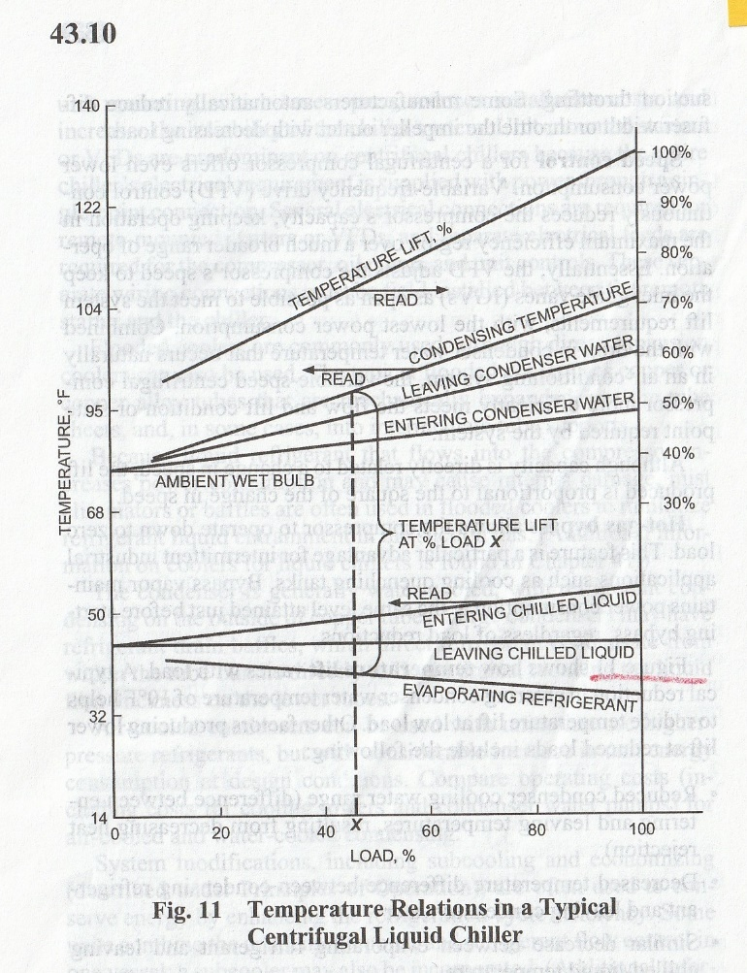Figure 2: ASHRAE Handbook Data²⁰
The bottom chart of Figure 3 agrees with manufactures data¹⁵. For example, at tower load of 499 ton the manufacture gives the same 81.8F tower cold water. Figure 4 bottom chart is at 42F wet bulb and 67% tower fan speed and the (SEE) model agrees with the manufactures data¹⁵ within 3%. Figures 2, 3, and 4 are for one chiller/tower and therefore present a clean picture of how chiller/tower temperatures vary as evaporator load decreases. A six chiller/tower plant is not so clean as illustrated by Figure 5.
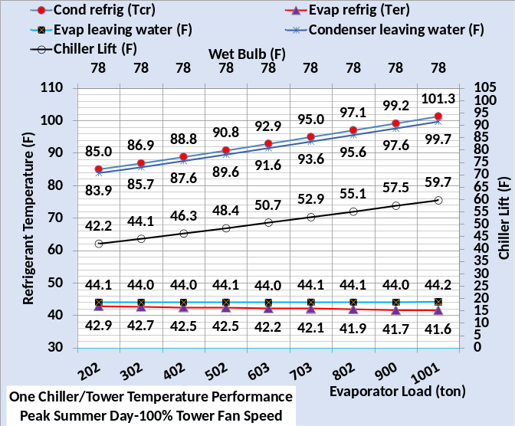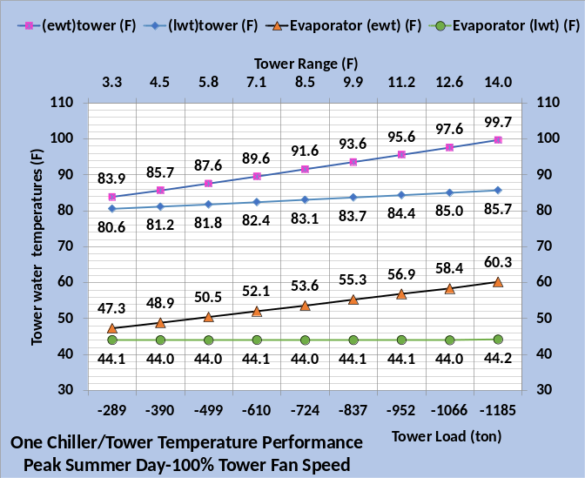
Figure 3: (SEE) Model Chiller/Tower¹⁵ Temperatures and Lift-Peak Summer Day

Refrigerant Temperatures of the Six Chiller/Tower Plant
The (SEE) model must model refrigerant temperatures for a single chiller/tower plant as illustrated by Figures 3&4 and must also model a multi chiller/tower plant as illustrated by Figure 5. The Figure 5 top chart gives (SEE) model condenser performance, the middle chart evaporator performance and the bottom chart gives chiller lift.
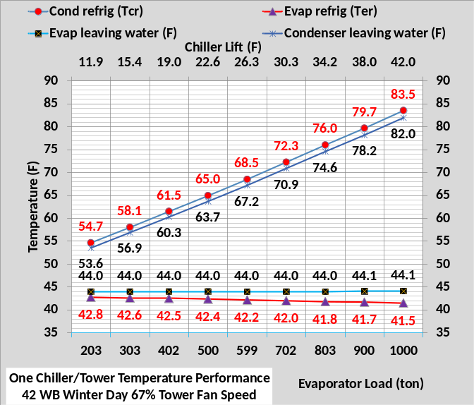 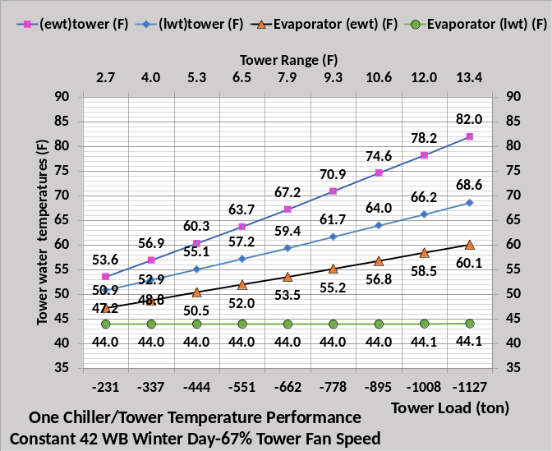Figure 4: (SEE) Model Chiller/Tower Temperatures & Lift-Winter Day
The design evaporator load is 1,000-ton, Table 1, and at 4PM each of the six evaporators is loaded to 943-ton, bottom chart, a little less than design. Therefore, the condenser refrigerant approach is 1.56F verses 1.6F at design and the evaporator approach is 2.46F verses 2.6F at design, consistent with the ASHRAE data of Figure 2. At 6AM the wet bulb is 70F and two chiller/towers meet the evaporator load of (2x538=1076) ton as shown on the secondary horizontal axis of the bottom chart. The design kW of the chiller is 583 kW and the middle chart shows each of the two chillers is at 283 kW or 48.5% of capacity.
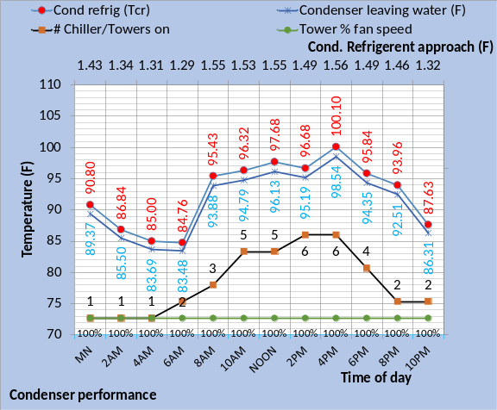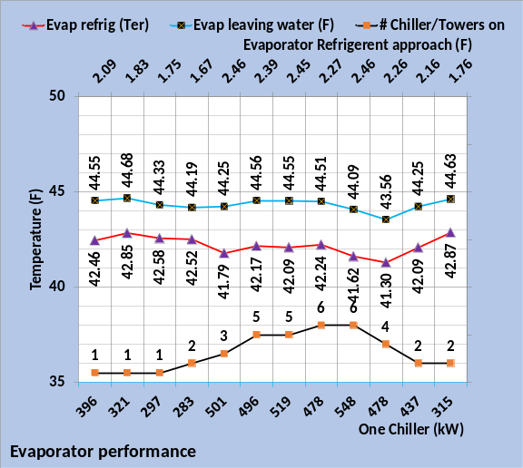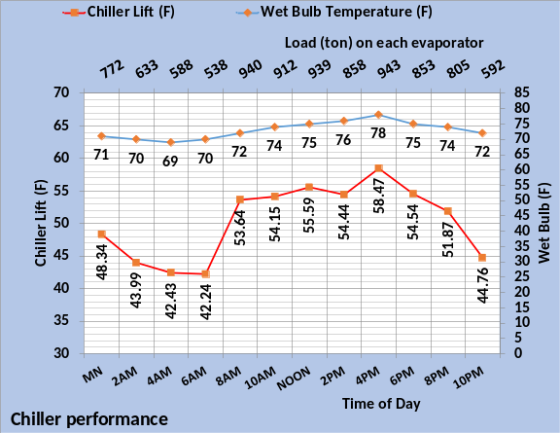 Figure 5: (SEE) Model of Table 2 Chiller/Tower Temperatures-Design Weather
The question is could one chiller/tower meet the 1076-ton evaporator load and if so, would plant kW decrease? The plant (SEE) model offers the ability to evaluate the two conditions of plant operation with plant schematics.

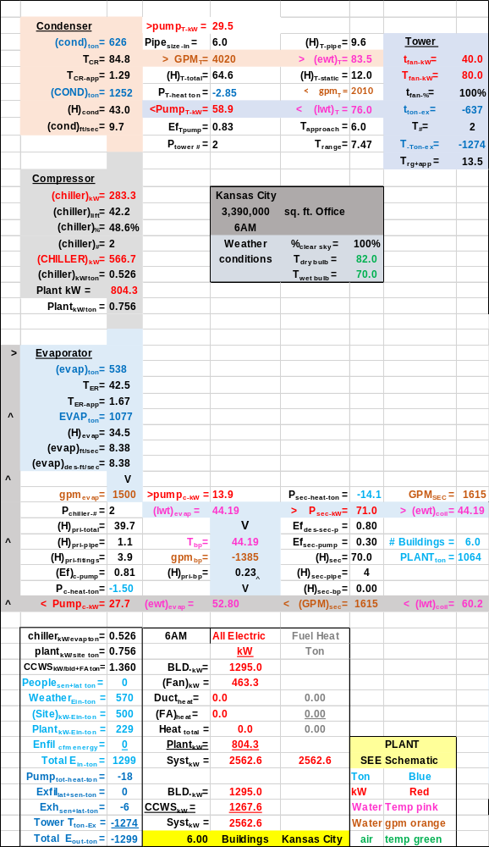Schematic 1: Two Chiller/Towers on at 6AM
The schematics contain a lot of data that can be reviewed at Nelson⁴ with full nomenclature given. The purpose here will focus on a few values on the schematics. The plant is at energy balance, as given by the lower left of the schematics. The plant kW decreased with one chiller/tower going from 804.3 kW of Schematic 1 to 737 kW of Schematic 2. All building kW values are the same. The plant load of 1,064 ton is the same for both conditions but the evaporator load slightly decreased with one chiller/tower because the pumping kW slightly decreased therefore decreasing the evaporator load. With one chiller/tower on, Schematic 2, the
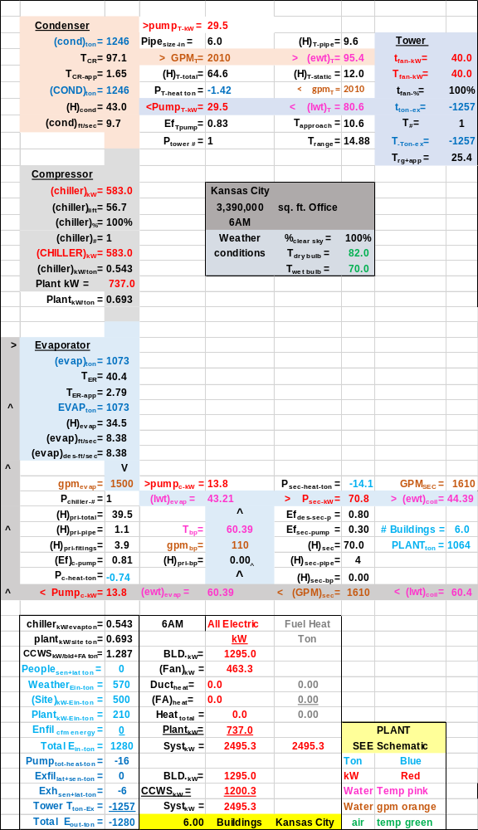Schematic 2: One Chiller/Tower on at 6AM
flow in the bypass is in the wrong direction causing the chiller to provide 43.21F water to get 44.39F water to the building. The tower performance is very different with tower approach to wet bulb increasing from 6.0F to 10.6F and range increasing from 7.47F to 14.88F with one chiller/tower on. Chiller lift increased from 42.2F with two chiller/towers on to 56.7F with one. At 6AM one chiller/tower was able to meet the load and provide 44.39F water to the building with 100% compressor motor capacity. All figures below will be for one chiller/tower on at 6AM design weather. Two hours later at 8AM three chiller/towers are required to meet the load as shown by Figure 5 middle chart.

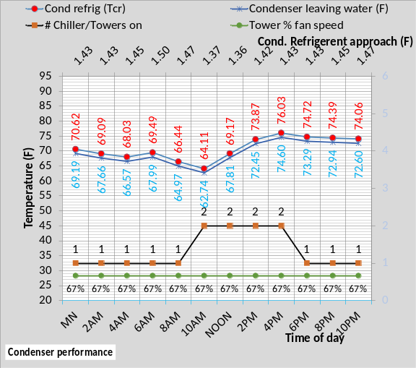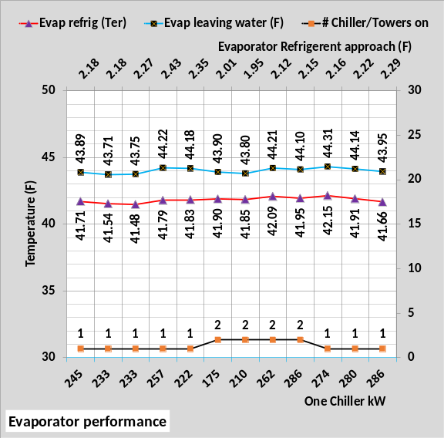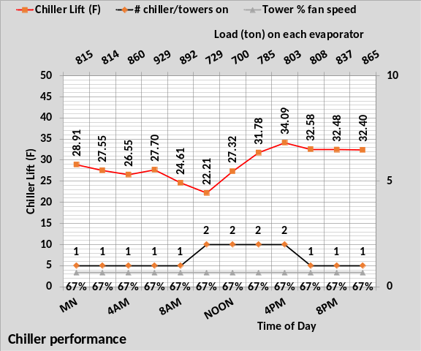
Figure 6: (SEE) Model of Table 2 Chiller/Tower Temperatures-Winter Weather
Figure 6 top chart gives (SEE) model condenser performance, the middle chart evaporator performance and the bottom chart gives chiller lift for winter weather. Comparing to Figure 5 illustrates significant changes in the temperatures of the chiller/tower. The middle chart shows that the chiller kW is less than 50% capacity for all hours when two chiller/towers are on and the tower is operated at 67% tower fan speed. Therefore, it seems likely that one chiller/tower could meet the load and probably at less plant kW. The point is the (SEE) model schematics offer the opportunity to look ahead and decide how to most efficiently operate a plant.
Tower Performance
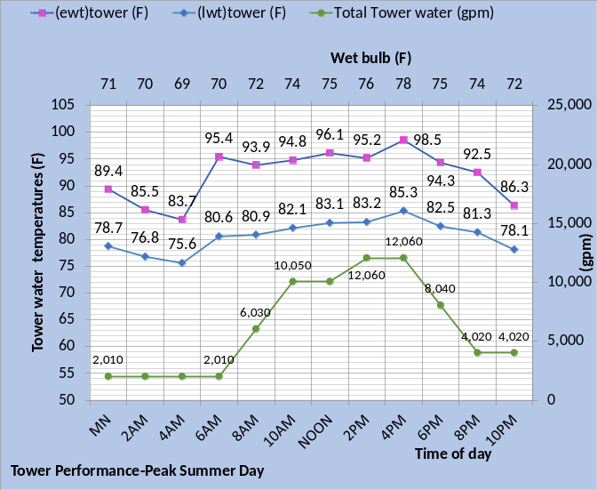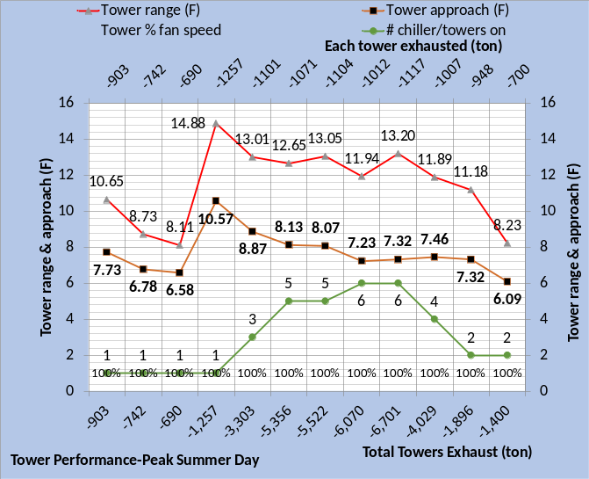
Figure 7: Tower Performance-Peak Summer
Figure 7 top chart gives the tower water flow and temperatures and the bottom chart gives the tower range and approach to wet bulb at design weather. These performance values are consistent with the data given by Marley¹⁵.
Figure 8 gives the tower performance at winter weather conditions where the tower is operated at 67% tower fan speed. Compared to design day operation and 100% tower fan speed of Figure 7, the range is generally a little less but the approach has more than doubled with winter operation and 67% tower fan speed.
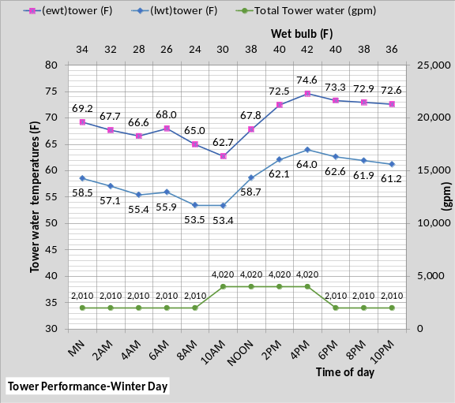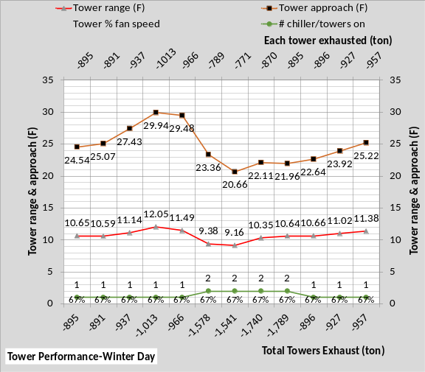 Figure 8: Tower Performance-Winter
A review of manufactures data¹⁵ illustrates the (SEE) model of the tower is close to the manufactures data. For example at 4PM the wet bulb is 42F and the (SEE) model tower cold water is 64.0F, verses 65.8F for the manufactures data¹⁵.
The performance of the tower is dependent on the performance of the chiller which puts load to the tower as given by the secondary horizontal axis of Figure 8. The point is that the real chiller performance cannot be seperated from the real tower and the performance of the real tower cannot be seperated from the real chiller. A chiller/tower operates as a unit and therefore must be modeled as a unit, each with its own set of equations dependent on the operation of the other.
Primary/Secondary Pumping
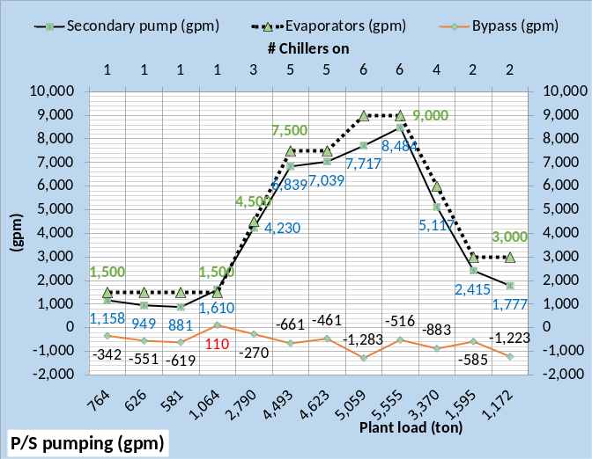 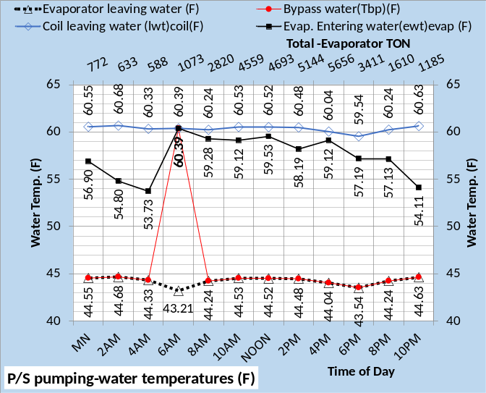Figure 9: Primary/Secondary Pumping-Peak Summer Day
Figure 9 top chart illustrates the bypass flow is in the wrong direction at 6AM as shown by Schematic 2, and the bottom chart shows the water temperature in the bypass is the same as the coil leaving water, 60.39F, or evaporator return water. As discussed above 6AM is when one chiller/tower can meet the 1073-ton evaporator load which is greater than the 1,000-ton design load. Turning on a second chiller/tower would put the bypass flow in the right direction but the plant kW would increase as shown by comparing Schematics 1&2.
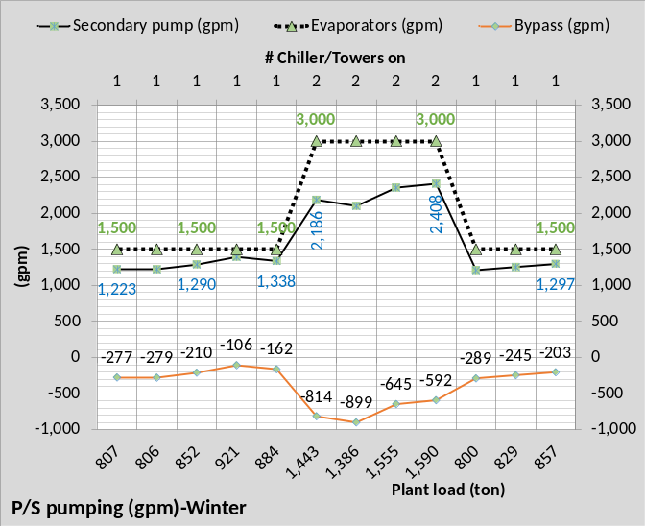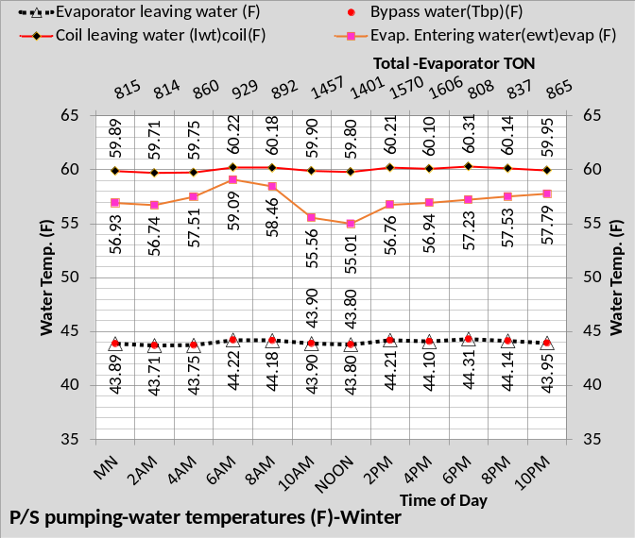Figure 10: Primary/Secondary Pumping-Winter Day
Figure 10 gives primary/secondary pumping at the winter conditions. The bypass flow is always in the right direction. The secondary horizontal axis shows the maximum number of chiller/towers on is two during winter operation compared to six for peak day operation of Figure 9. The total evaporator load is, as expected, significantly less for winter operation. As discussed above, Figure 8, the tower fan is operated at 67% for all winter hours.
Chiller and Plant kW/ton

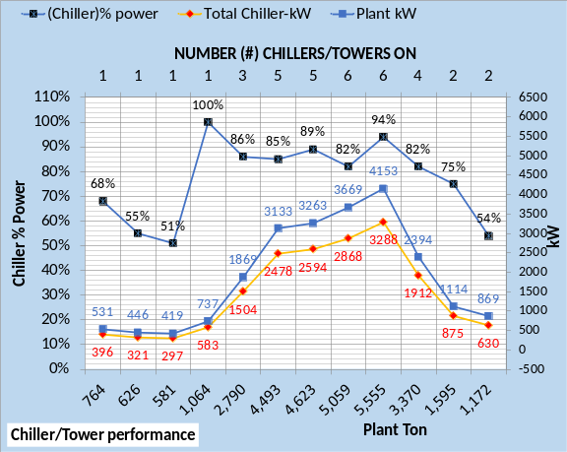 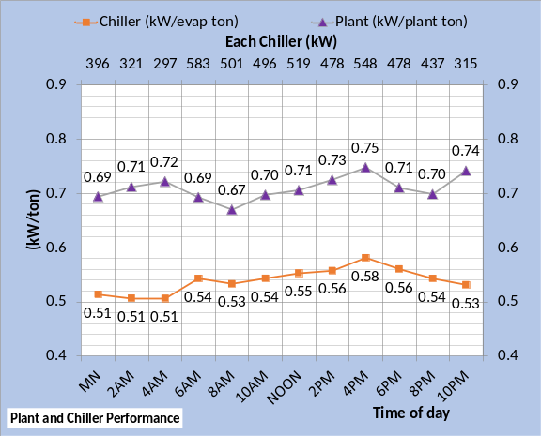 Figure 11: Plant and Chiller Performance-Peak Summer Day
Figure 11 bottom chart shows the chiller operates at a minimum of .51 kW per evaporator ton up to a maximum of .58 kW/ton at 4PM design conditions. At design the plant is at .75 kW/ton. The plant operates at a minimum of .67 kW per plant load at 8AM where three chiller/towers are on and the plant load is 2,790 ton. Figure 9 bottom chart shows the total evaporator load is 2,820 ton, therefore each of the three evaporators is loaded at 940 ton at 8AM.
Jumping to other charts to understand the operation of the plant was the reason the author developed plant schematics, illustrated above, so that plant performance and building performance could be better understood. Nelson⁴ gives analysis via schematics.
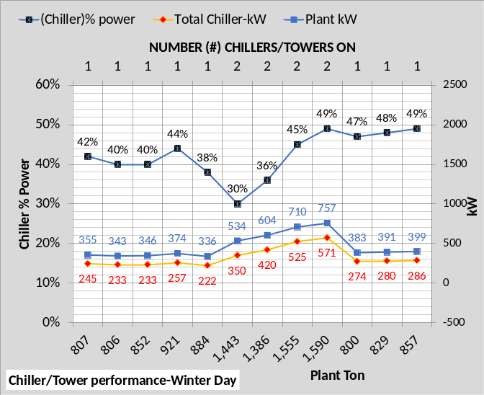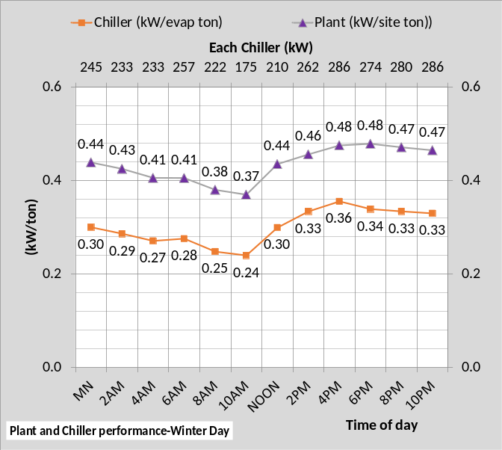
Figure 12: Plant and Chiller Performance-Winter Day
Figure 12 shows the chiller and plant operate at much better kW/ton values at winter weather conditions. The minimum chiller kW/ton occurs at 10AM with a value of .24 with two chiller/towers on and the plant load is 1,443 ton and the evaporator load is 1,457 ton given by the bottom chart of Figure 10. With two chiller/towers on the evaporator load on each is 728.5 ton and the chiller meets this load with 30% kW capacity as shown by the top chart of Figure 12. Table 1 gives the design chiller kW as 583. The chiller kW/ton would decrease with 100% tower fan speed; however, chiller surge could become a problem at these winter low lift conditions.
Plant Load & Plant kW
Figure 13 gives the plant load (ton) for the six office buildings and plant kW to meet the load of the six buildings. Figure 13 also gives the number of chiller/towers on, illustrating a maximum of six for peak day operation and two for winter operation.
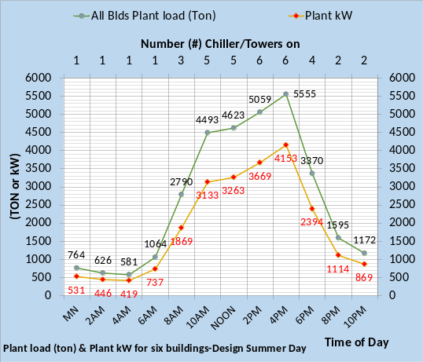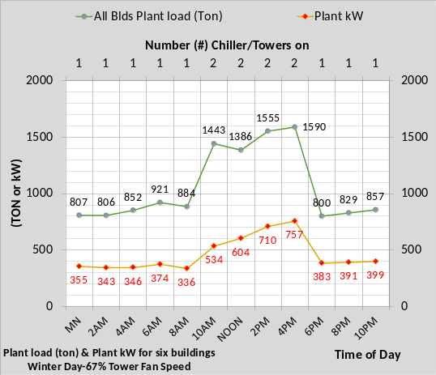 Figure 13: Plant Load and Plant kW

System kW Demand

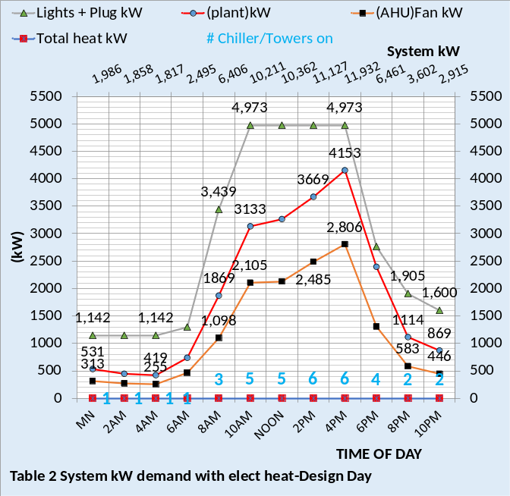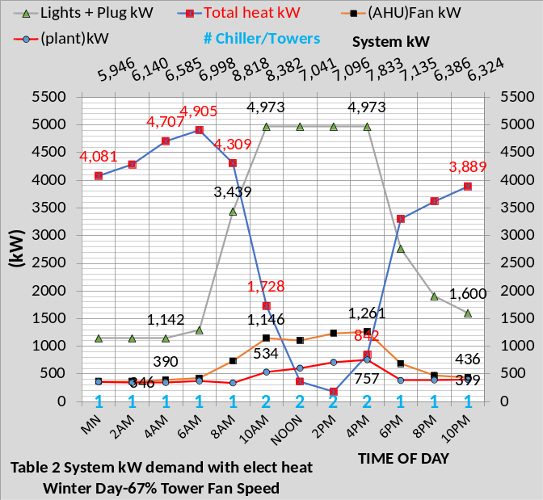
Figure 14: System kW Demand
Figure 14 includes the building kW demand covered by Article 2. Figure 14 gives system kW values showing that plant kW is large during design day conditions but rather small during winter operation of the bottom chart. However, required building heat at night pushes the total kW demand to greater than design day operation.

Plant Energy Balance
At least five performance metered data are suggested for day and hour benchmarking and for performing an energy balance analysis.
The suggested minimum data is;
- Plant load (ton)
- Tower exhaust (ton)
- Plant kW demand
- Site kW demand.
- Heat kW demand
- System kW demand
Article 4 will discuss day and hour benchmarking of a system in more detail. This article will deal with energy balance of the plant.

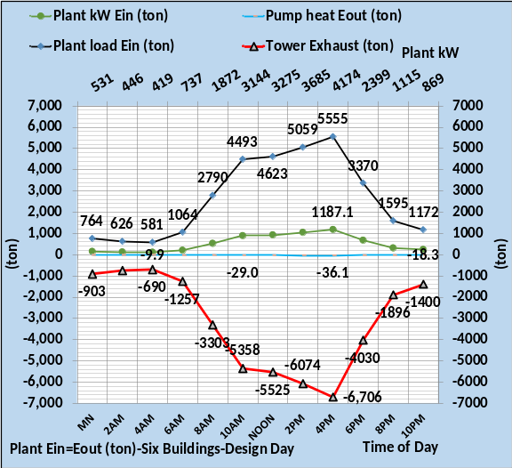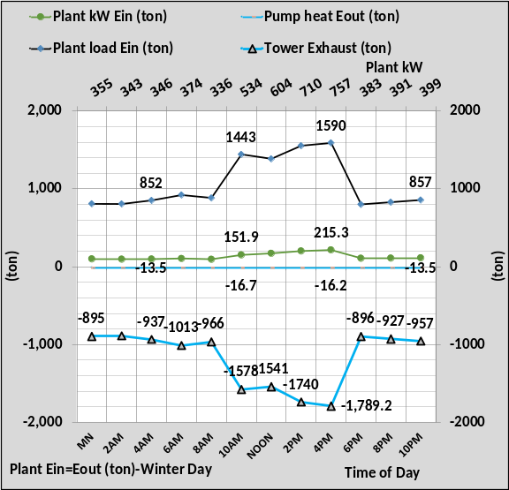
Figure 15: Plant Energy Balance Data
Any hour could be energy balanced if the data of Figure 15 was available. The pump heat out is given by the (SEE) model as the amount of energy to the pumps that does not go into the thermodynamic system. If the efficiency of the pumps is 80% then 20% goes to the atmosphere as heat. Article 4 states, one purpose of the plant energy balance is to establish the accuracy of the plant load value so that the energy balance of the building can be performed with confidence. Figure 16 gives the 24-hour plant energy balance based on the data of Figure 15.

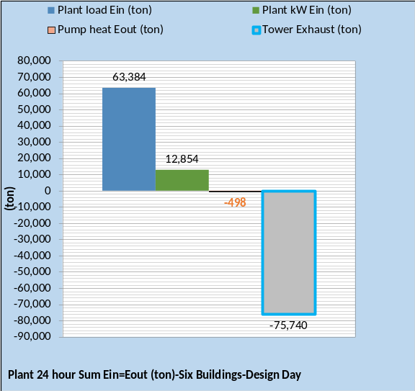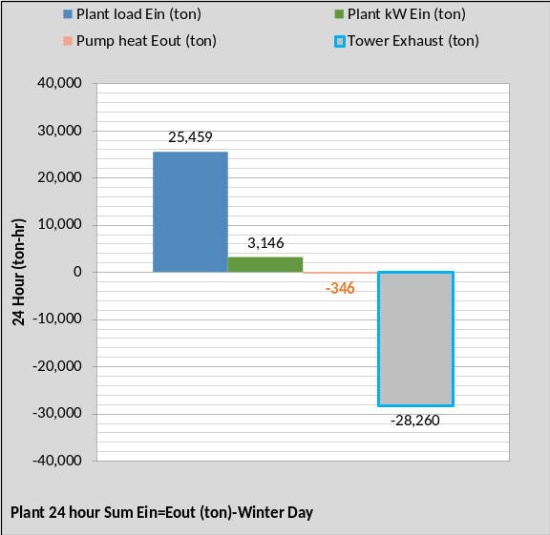
Figure 16: 24 Hour Plant Energy Balance

Summary
The purpose of this Article 3 is to give an understanding of the model detail necessary to simulate the performance of a chiller plant. The point has been made that an accurate model of the refrigerant temperatures is necessary and is given by the plant (SEE) model. Figures 3 & 4 gives modeled refrigerant temperatures that agree with ASHRAE Figure 2; a major test on the accuracy of the (SEE) model. Figures 5 & 6 further illustrate the (SEE) model performance by giving refrigerant temperatures for the six chiller/tower plant as the load and wet bulb change. Plant schematics were given to illustrate the value and understanding provided by schematics. The author developed the schematics as a necessary tool to understand the full plant or building performance verses skipping from one chart to the other to establish logic and understanding of what the system was doing. The system and therefore the schematics must energy balance to establish that the model agrees with the first law of thermodynamics.
The next article will deal with the performance and analysis of the building and plant at real weather conditions for the week of March 22, 2021 through March 26, 2021, Kansas City Missouri.

References
- Introduction to Thermodynamics and Heat Transfer. 1956 Prentice-Hall, Inc. by David A. Mooney.
- Thermal Environmental Engineering third edition. 1998 Prentice-Hall Inc. by Thomas H. Kuehn, chapter 3.
- ASHRAE Journal May 2016. “Modeled Performance Isn’t Actual Performance”
- Nelson, Kirby. “System Energy Equilibrium (SEE) Building Energy Model Development & Verification”. http://kirbynelsonpe.com/
- Liu, B. May 2011. “Achieving the 30% Goal: (copy and paste) https://www.energycodes.gov/sites/default/files/documents/BECP_Energy_Cost_Savings_STD2010_May2011_v00.pdf
- Real weather data www.wunderground.com/
- Nelson, K. “7 Upgrades to, Reduce Building Electrical Demand” ASHRAE Journal, December, 2006,
- Nelson, K. “Simulation Modeling of a Central Chiller Plant” CH-12-002. ASHRAE 2012 Chicago Winter Transactions.
- Nelson, K. “Simulation Modeling of Central Chilled Water System” CH-12-003. ASHRAE 2012 Chicago Winter Transactions.
- Kavanaugh, S. “Fan Demand and Energy” ASHRAE Journal, 2000.
- Faris, Gus “Fan-Powered VAV Terminal Units” ASHRAE Journal November 2017
- Kettler, John “Return Fans or Relief Fans” ASHRAE Journal April 2004.
- Taylor, S. 2011. “Optimizing design & control of chiller plants.” ASHRAE Journal (12).
- Nelson, Kirby “The System Energy Equilibrium Model for Chiller Plants, Part 1” Engineered Systems, July 2020.
- Marley Tower SPX Cooling Technologies UPDATE Version 5.4.2
- Steven Taylor. ASHRAE Journal June 2007. “VAV System Static Pressure Setpoint Reset”
- Carrier System Design Manual
- Miles Ryan. ASHRAE Journal February 2021. “Understanding Cascade Control and Its Applications For HVAC”
- Schwedler, Mick. July 1998 “Take It to The Limit…Or Just Halfway?” ASHRAE Journal.
- 2020 ASHRAE HANDBOOK, HVAC Systems and Equipment, page 43.10 Figure 11 Temperature Relations in a Typical Centrifugal Liquid Chiller.

Anatomy of a Real Time Building Energy model
Part 4- (SEE) Model Analysis Kansas City MO. March 22 thru March 26, 2021
Introduction
The purpose of this article 4 is to demonstrate how the (SEE) model would be of value in evaluating the energy performance of a real building and plant.
The (SEE) model can assist in commissioning and evaluating the performance of a building and plant on any day. A (SEE) model of the as designed building and plant would be compared to the actual performance of the facility. If the real facility was not performing as expected the (SEE) model, via energy balance analysis, would be used to define why and how the real system was not performing. This article 4 will demonstrate the concept.
Article 1 defined a Table 3 system with an (EIU) estimated of 89.85, a value significantly greater than the (EUI) of the system defined by Table 2 with an estimated 41.88 (EUI). The Table 3 system will be defined here as the real system with control problems and the Table 2 system is defined as the expected performance of the system if it was constructed and operated as designed. The analysis will be for the weather conditions⁶ in Kansas City Missouri during the week of March 22, 2021 through March 26, 2021.
The Table 3 System is the Table 2 System with Poor Control. Table 3 is copied from article 1 and defines poor control of the Table 2 system. The Table 3 system defined here as the real system will be evaluated against the as designed Table 2 system.

Building Location and Design
- Location=Kansas City Mo.
- Building 565,000 ft².
- No external solar shading.
- Ambient temperatures-Figure 2
- Percent clear sky 100%.
- Building design per Liu⁵ changed.
- Percent wall glass 37%
- Peak lights kW .81 watts/ft²
- Peak plugs kW .66 watts/ft²
- Return air to perimeter-no change.
- Duct design 5.5 to 7.0 in. water
- Fan powered terminals installed
- Return air fans installed
Building Control
- Lights on/off control from 6% on after hours to 67% on.
- Plugs on/off control 44% on after hours to 67% on.
- Building pressure control; infiltration of .2 cfm/ft² walls max-varies as AHU cfm.
- Supply air = 55F
- Supply water = 44F to 44.5F
- Stats control-NO.
- Perimeter heat air temp-90F.
- VAV fan static control-NO.
- Fresh air CFM control-NO.
- Fresh air heat stat set from 42F to 60F.
Plant Design & Control
- Chiller/Tower selection¹³.
Table 3: System-Poor Control

An energy analysist would not have the luxury of knowing the problems of the real system as given by Table 3; knowing only that its (EUI) was about twice what it was expected to be. Table 3 defines only control problems of the Table 2 system; in a real system the problems could be more and of greater value. The corrections to the Table 3 system controls will be accomplished during the week of March 22, 2021 and completed on Friday March 26. The corrections will be defined and the result given for each day. This analysis will show that the changing weather through the week had a significant effect on the energy consumption.
Energy Meters
System energy meters are necessary for performing a reasonable accurate (SEE) model energy balance analysis. The suggested minimum data required are;
- Plant load (ton)
- Tower exhaust (ton)
- Plant (watts/ft²)
- Site (watts/ft²)
- Heat (watts/ft²)
- Total System (watts/ft²)
The plant load and tower load require btu meters and the plant kW is converted to (ton) to facilitate a plant energy balance. The heat energy is assumed as a separate meter which would be the case if the building is heated with fuel. If the building heat is electrical then a separate heat meter might not be available which would add additional challenge to task of performing an energy balance.
The first step in an energy balance analysis is to verify the BTU meters are reading correct by performing a plant energy balance based on the btu meters. The plant energy balance has two primary purpose; calibrate the energy meters and establish the plant load for an energy balance of the site where the site is the buildings minus the plant, in this case a six-building office campus of 3,390,000 square feet.
A plant energy balance within 3% would be desired and anything over 6% should probably call for calibration of the BTU meters. The pump heat out value is a relatively small value calculated by the (SEE) Model, a value that can be estimated if a (SEE) model is not available. Pumping kW heat out is the inefficiency of the pumps. For example, if the pumps are 80% efficient 80% of the pump kW goes into the thermodynamic system model and 20% to the atmosphere.
System Performance and Analysis on March 22, 2021
The (SEE) model analysis concept is that the analyst would visit the real building with a (SEE) model of the as designed system on a lap top computer. The first task would be to input the weather data of March 22 into the as designed (SEE) model giving the Figure 1 data to be compared to the metered data of the real Table 3 system of Figure 2.
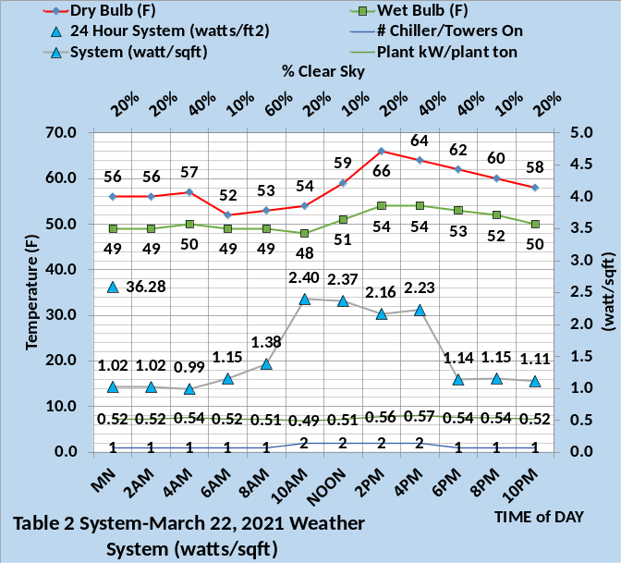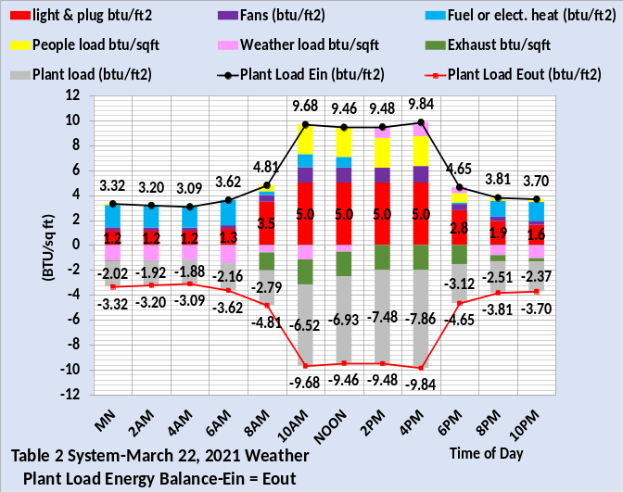
Figure 1: (SEE) Model of As Designed System
The top chart of Figure 1 gives the weather on March 22 and the 24-hour watts/ft² of the system that includes the six buildings and the plant. The top chart also gives the number of chiller/towers on and the plant kW per plant load. This is the expected performance of the Table 3 system. The bottom chart gives the 24-hour plant load energy balance illustrating that the energy into the system equals energy out with plant load being energy out. Figure 2 illustrates that the real system is operating far outside the expected performance of Figure 1. The top chart horizontal axis of Figure 2 gives the chiller/towers on, about twice the number of the Figure 1 top chart values. However, the plant kW/ton values of Figure 2 are about the same as Figure 1 demonstrating that no poor plant control concepts have been put into the Table 3 system.

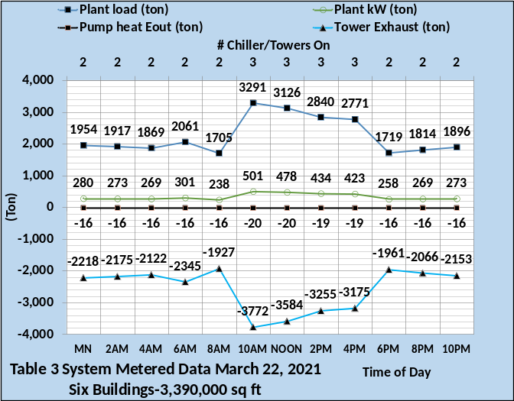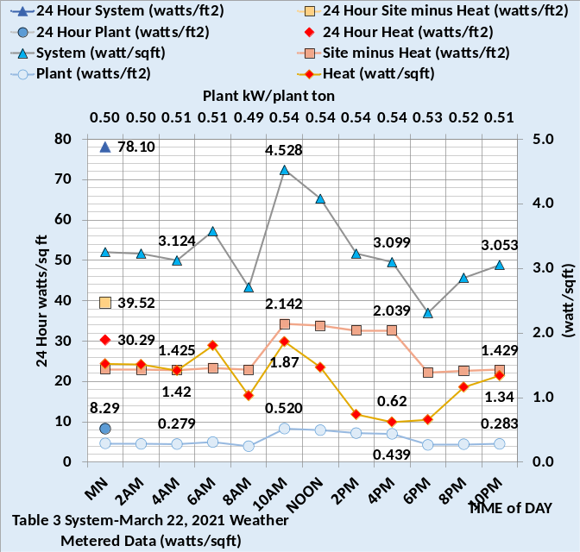
Figure 2: Metered Data-Table 3 System

Figure 2 is developed by inputting the Table 3 values into the (SEE) model. The top chart gives the btu meter readings that are the plant balance numbers. The plant load plus plant kW converted to ton equals the energy out consisting of the pump heat out and the tower exhaust.
As control problems of Table 3 are corrected the results will be shown and discussed.
The top chart of Figure 1 shows 36.28 watts/ft² as the 24-hour sum of the as designed Table 2 system. The bottom chart of Figure 2 shows a value of 78.1 watts/ft² for the Table 3 assumed real system. Clearly the control problems of Table 3 have a major effect on the energy consumption of the system.

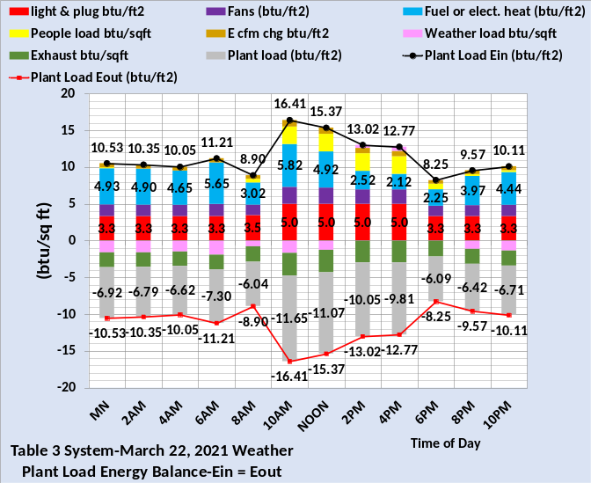
Figure 3: Plant Load Energy Balance of Table 3 System

Figure 3 gives the 24-hour plant energy balance of the Table 3 system. It is impossible to give a standard procedure for constructing an energy balance chart from the metered data of Figure 2, however the fundamental approach is to take the know metered values as goals to work to. The plant load is a measured btu meter value and the watts/ft² measured values of the bottom chart give much data to work with. The idea is that the analyst would develop two (SEE) models; one of the system as designed, Figure 1, and one of the real system utilizing metered data as defined by Figure 2. The task would be to calculate, estimate, and guess until the (SEE) model balanced to the measured and therefore know values of Figure 2, resulting in the plant load energy balance of Figure 3. The energy balance could show many different problems with the real system. For example, the load due to weather could be larger than expected; exposing problems in the construction and insulation of the buildings. Infiltration could be a large value that adds to the perimeter load of the building, in this case heating load due to the cold weather. The (E cfm) term on Figure 3 is the change in internal energy of the thermodynamic system as a result of infiltration. Infiltration will be addressed in some detail below for the March 25 analysis.
Comparing Figure 3 with Figure 1 shows the after hour btu/ft² is about three times the expected value. Therefore, the first correction will be to fix the lights and plug shut down control system and see how the system performs tomorrow March 23. The analyst would likely have observed early on that the after-hour energy use was high compared to expected performance and made the judgment that the lights and plug loads after hours control was not working.

System Performance and Analysis on March 23, 2021-Light & Plug kW Controlled

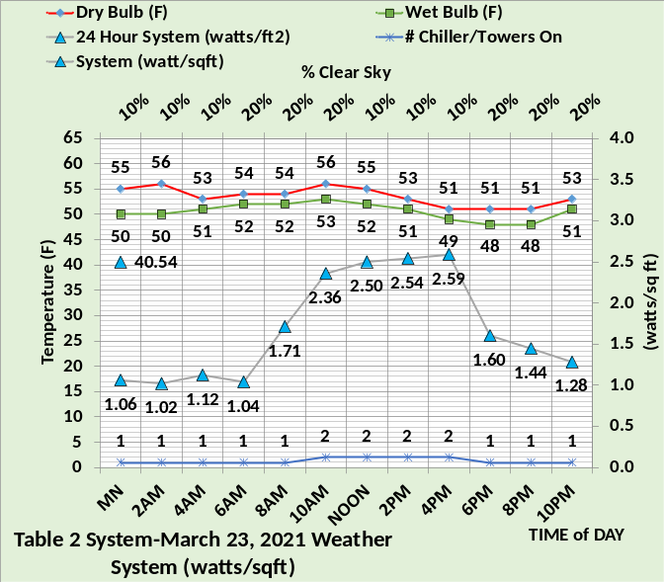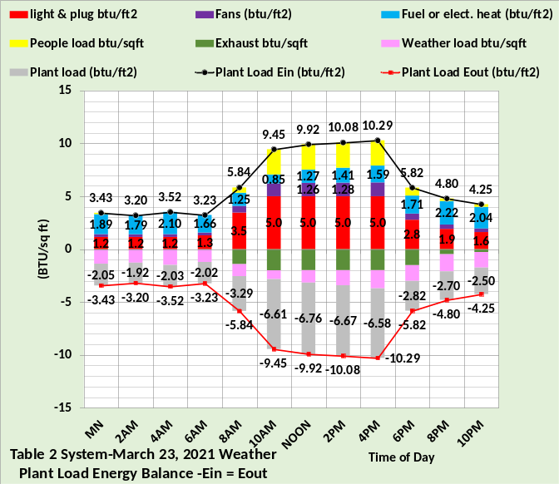
Figure 4: (SEE) Model of As Designed System
The first task of the analyst is to input the March 23 weather, top chart Figure 4, in both the Table 2 as designed (SEE) model and the (SEE) model of the Table 3 system with the after-hour control of the lights and plug loads installed.
- Lights on/off control 6% on after hours.
- Plugs on/off control 44% on after hours.
Figure 4 top chart shows the 24-hour watts/ft² of the Table 2 system has, due to colder weather, increased from 36.28 of Figure 1 to 40.54 watts/ft². Figure 5 shows that the 24 hour 80.12 watts/ft² of the Table 3 system with lights and plug control installed also increased over the 78.10 watts/ft² of Figure 2. The lights and plug control clearly worked as evidenced by the significant drop in afterhours metered data of Figure 5 verses Figure 2. However, the day time metered reading is significantly greater for Figure 5, primarily because the heat energy has increased. Comparing the 24-hour numbers of Figure 5 and 2 shows the site value, which includes the lights and plug sums, decreased about 8 watts/ft² with control but heat increased about 10 watts/ft². Leaving lights on to decrease perimeter heat is a question the (SEE) model can answer, perhaps at another time.
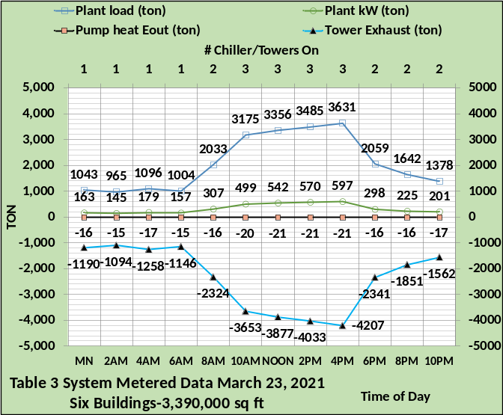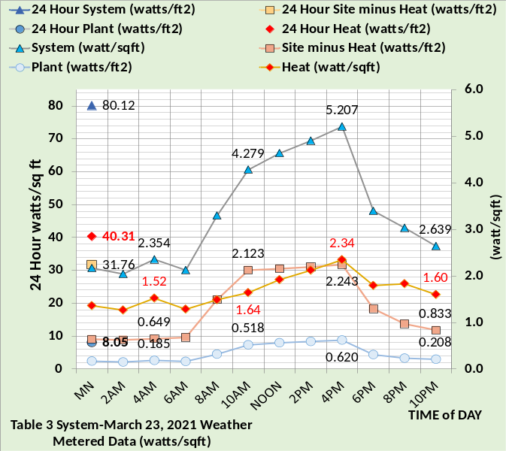
Figure 5: Metered Data Table 3 System with lights and plug control installed
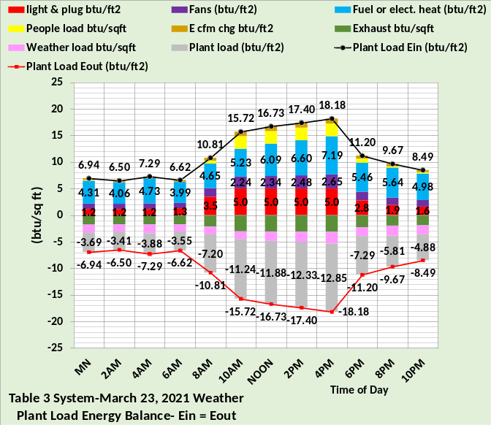
Figure 6: Plant Energy Balance of Table 3 System with lights and plug control installed

The energy balance would again require work on the part of the analyst to arrive at Figure 6 by working to the known measured values of Figure 5. Comparing Figure 4 bottom chart to Figure 6 shows about the same configuration but significantly greater values for the Figure 6 system. The lights and plug numbers are essentially the same demonstrating the lights and plug control system is now working.
Figure 6 shows significantly more heat required than the Figure 4 system and the fan energy is about twice the Figure 4 values. This difference would likely cause the analysist to check the VAV fans systems controls and the control of the fresh air.
Two changes will be made to the Table 3 system for March 24; the VAV static pressure control will be corrected and the fresh air cfm controls will be corrected. Tomorrow, March 24 will show the results of these control corrections. The fresh heat stat is at 60F and will not be changed until March 25.

System Performance and Analysis on March 24, 2021-VAV Fans Static Pressure Control and Fresh Air CFM Control Installed to Table 3 System

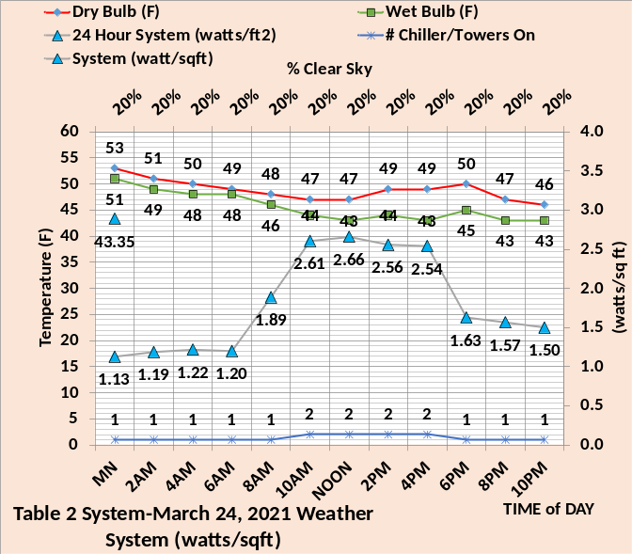
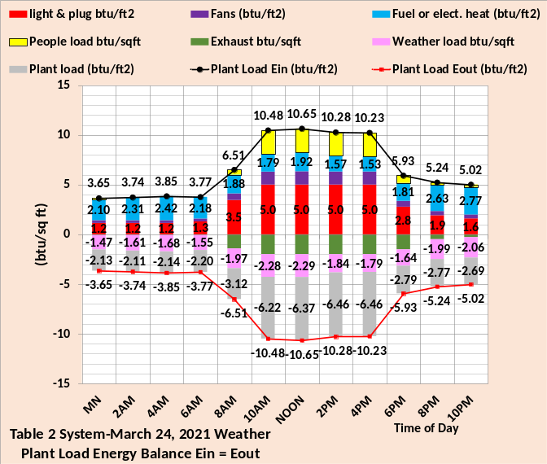
Figure 7: (SEE) Model of As Designed Table 2 System-March 24, 2021
The top chart of Figure 7 shows the March 24 weather is colder than March 23 resulting in an increase in the 24-hour watts/ft² of the Table 2 system from 40.54, Figure 4, to 43.35 watts/ft² of Figure 7. The metered Table 3 data of March 24 also shows an increase from 80.12, Figure 5, to 88.97 watts/ft², Figure 8. At this point the analyst might be questioning the results of the corrections being made. On March 22 the metered data gave a 24-hour sum of 78.10 watts/ft², Figure 2, and after two corrections to the system the March 24 value is 88.97 watts/ft², Figure 8.

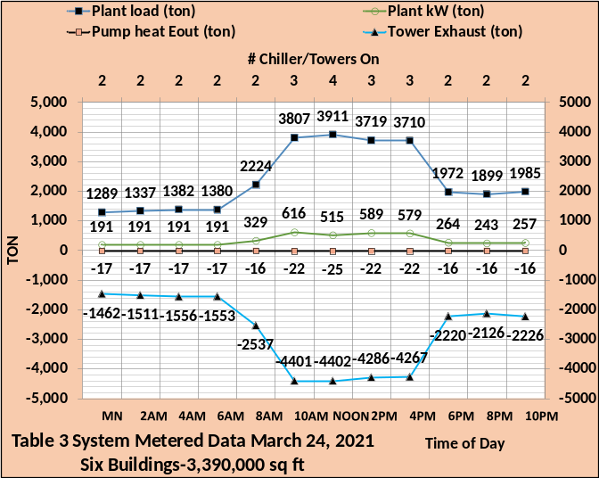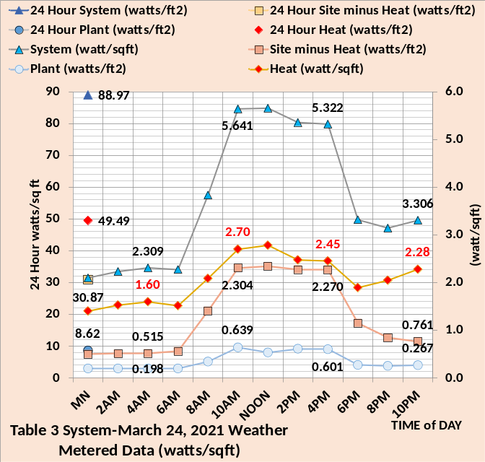
Figure 8: Metered Data Table 3 System with Lights and Plug Control plus Fresh Air and VAV Fan Duct Static Pressure Control
The reason for the continued increase is the cold weather requiring more building heat. Figure 2 shows a measured 24-hour heat of 30.29 watts/ft² for March 22, Figure 5 shows a measured value of 40.31 watts/ft² for March 23 and Figure 8 shows a measured value of 49.49 watts/ft² for March 24.

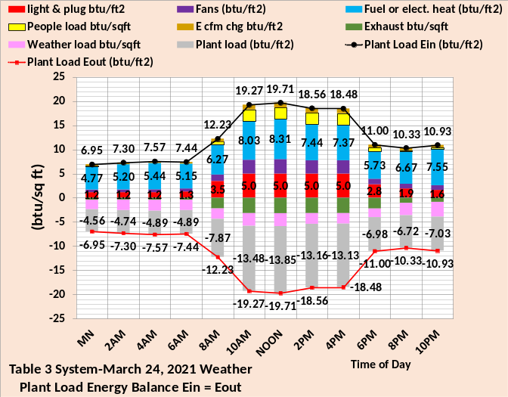
Figure 9: Plant Energy Balance of Table 3 System with lights and plug control plus Fresh Air CFM control and VAV Fan Duct Static Pressure Control

Figure 9 gives the plant energy balance of the Table 3 system after fresh air cfm control and VAV duct static pressure control is installed. Control of the fresh air was defined by Figure 6 of Article 2. During working hours, with fresh air cfm control, when people are in the building the fresh air into the building is 47,386 cfm dropping off to close to zero when people were not in the building. Poor cfm fresh air control was installed into the Table 3 system during March 23 with fresh air at night hours reduced but only to about 35,000 cfm.
VAV duct static pressure control was controlled to a minimum of 1.5 inches water in the Table 2 system and increased to a minimum of 5.0 inches water in the Table 3 system of March 23. The March 24 system of Figure 9 returns to the 1.5 in minimum static pressure control. Figure 5 of Article 2 gives some detail.
Comparing the energy balance charts of March 24, Figures 7&9 illustrates that the Table 3 system problems is primarily heat energy consumption. Figure 10 is the plant energy balance for the two systems at 4PM illustrating the heat required by the Table 3 system is all most 5 times the Table 2 system. The lights and plug (btu/ft²) values are the same but the fan value is greater for the Table 3 system due to the plant load being about two times the Table 2 value. The Table 3 system bottom chart has an (Ecfm chg) value that is due to infiltration and will be explained in detail below. The people load is the same for both systems but the building shell load is greater for the Table 3 system due to infiltration and the fresh air value is negative energy in for the Table 2 system and positive .45 btu/ft² for the Table 3 system due to the fresh air stat set at 60F.

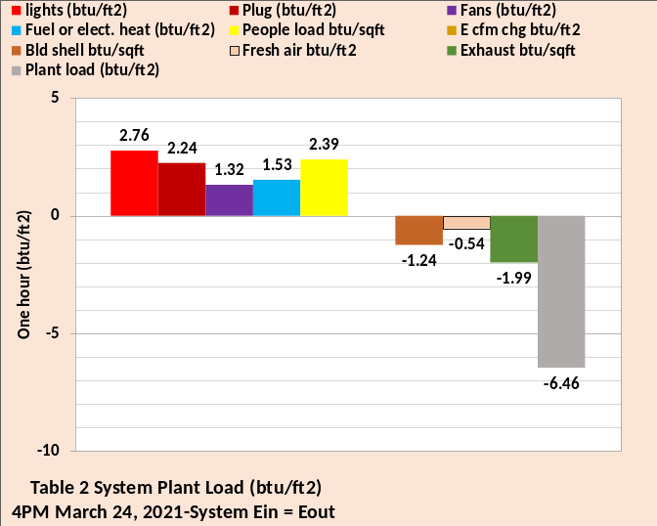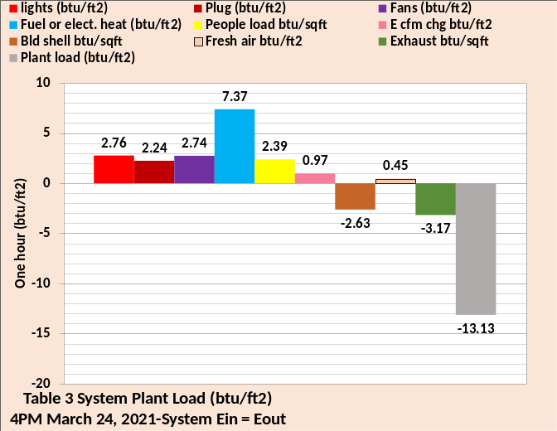
Figure 10: Plant Energy Balance at 4PM-Top Chart Table 2 System-Bottom Chart Table 3 System

Changes to the heat controls of the Table 3 system will be made for the March 25 analysis.

System Performance and Analysis on March 25, 2021-Space stats are controlled to transfer heat to the perimeter, heating supply air set 105F-Fresh air stat set 42F
The poor control problems corrected for the March 25 analysis are space stat control, changing the temperature of heating air to the building perimeter from 90F to 105F and setting the fresh air heat stat from 60F to 42F. Article two defined all building interior return air as going to the perimeter for return. Therefore, energy is transferred from the interior of the building to the perimeter and can have a positive or negative affect depending on how the stats are set. Figure 11 is from Table 3 building schematics⁴ showing the perimeter air supply for March 24 before the controls are changed, top schematic, and March 25, bottom schematic, with the temperature control changes made as stated above.
The perimeter heating load of the Table 3 system on March 24, top schematic, was 126.85 ton plus the 16.15-ton heating load due to interior return air to the perimeter for a total of 143-ton heating. The interior return air added to the heat load because the perimeter stat was set at 76F and the interior stat was at 75F, therefore the 75F interior air was heated to 76F resulting in a 16.15-ton additional heating load. On March 25, bottom schematic, the perimeter stat is set at 74F resulting in 15.92 ton of heat to the perimeter for a net heating load of 113.3 ton, a significant reduction in heat required that reduced VAV supply CFM. The following calculation and others of these articles will not agree exactly because the (SEE) model calculates to many places.
March 24, top schematic;
Supply CFM = 143-ton x 12,000/1.08 x (90F – 76F) = 113,531 CFM
March 25, bottom schematic;
Supply CFM = 113.3-ton x 12,000/1.08 x (105F – 74F) = 40,623 CFM
Stat control and increasing the heating air temperature from 90F to 105F has significantly reduced the perimeter supply air CFM which reduces fans kW and heat kW. Figure 11 breaks the heat into reheat and heat to the supply air.
March 24, top schematic;
113,531 CFM x 1.08 x (76F – 55F)/12,000 =
214.6 ton reheat = 754.7 kW.
113,531 CFM x 1.08 x (76F – 88.96F)/12,000 =
132.4-ton air heat = 465.6 kW
The terminals add 10.7-ton heat = 37.5 kW.
The total kW of heat added to the perimeter supply air on March 24 is 1257.8 kW.

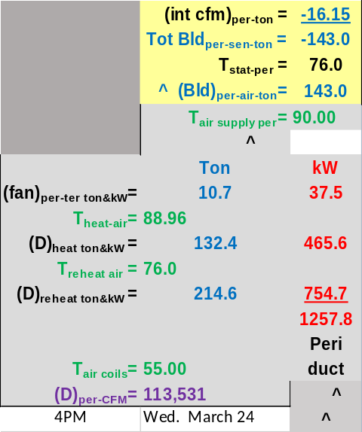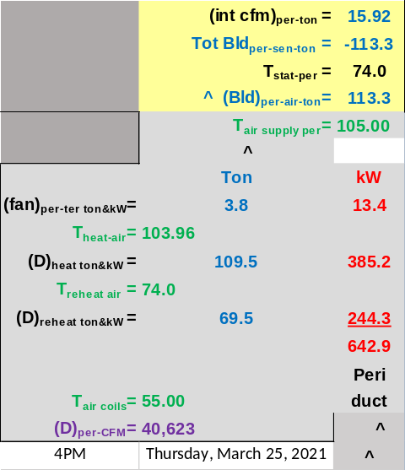
Figure 11: Perimeter Air Supply-Table 3 System Top chart March 24-Bottom Chart March 25, stats are controlled and heating air is increased to 105F

The changes made March 25 result in significant reductions.
March 25, bottom schematic;
40,623 CFM x 1.08 x (74F – 55F)/12,000 =
69.5 ton reheat = 244.3 kW.
40,623 CFM x 1.08 x (74F – 103.96F)/12,000 =
109.5-ton air heat = 385.2 kW
The terminals add 3.8-ton heat = 13.4 kW.
The total kW of heat added to the perimeter supply air on March 25 is 642.9 kW.
The heat kW at 4PM is reduced to almost half by the changes made to temperatures.
The only control correction not made to the March 25 Table 3 system is to eliminate infiltration. The following will evaluate the effects of infiltration.

Infiltration
The effect of infiltration can be evaluated by comparing the performance of the Table 2 system to the Table 3 system on March 25. The Table 2 system is model as balanced and the Table 3 system is modeled, on March 25, with .20 CFM infiltration per wall area proportional to the CFM moved by the fan system.
Figure 12 shows infiltration results in a Table 3 system watts/ft² of 55.57, bottom chart, verses 47.53 watts/ft² for the Table 2 system of the top chart, a 17% increase in power consumption illustrating the significant effect infiltration has on the energy consumption of a building. The difference is primarily additional heat required by the Table 3 system because cold air is introduced to the conditioned space. Figure 12 bottom chart shows 25.53 watts/ft² of heat required and the top chart shows 18.57 watts/ft².

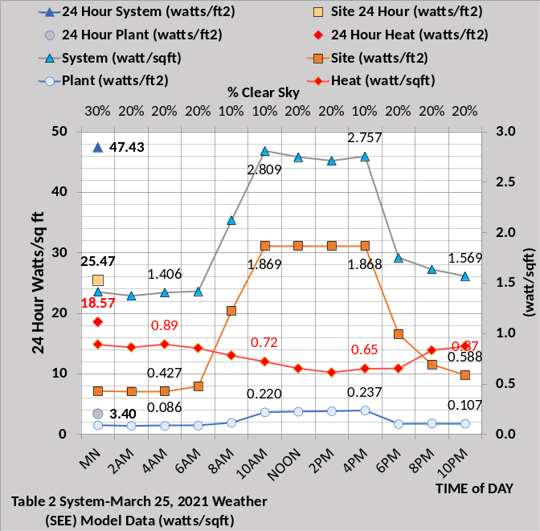
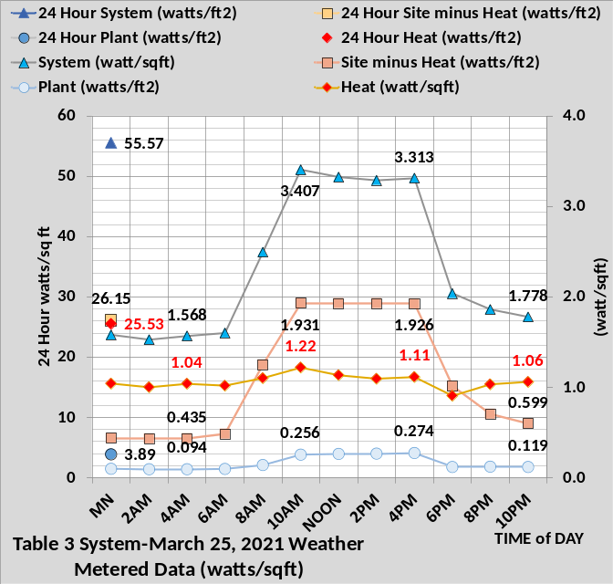
Figure 12: Table 2 & Table 3-Metered Data
March 25
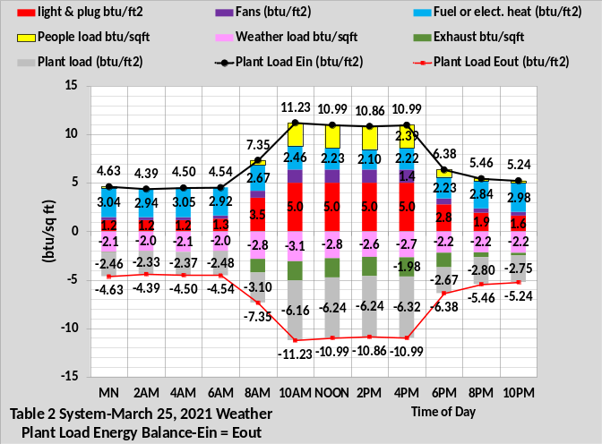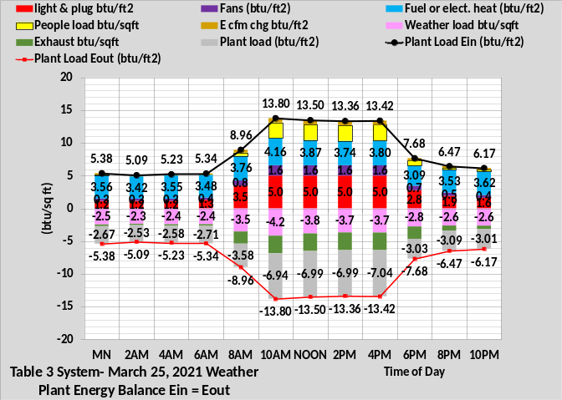
Figure 13: Table 2 & Table 3 System- 24 Hour Plant Energy Balance-March 25-All correction made to Table 3 System Except Infiltration.

Figure 13 gives the 24-hour energy balance for the two systems on March 25 showing the difference infiltrates makes in the energy consumption. At 4PM the top charts show 10.99 btu/ft² energy in and the bottom chart shows 13.42 btu/ft², a 22% increase primarily due to heat required to offset the cold air infiltrating the conditioned space. Note the fuel btu/ft² at 4PM is 2.22, top chart, and 3.80 bottom chart. At 4AM the btu/ft² increase dur to infiltration is about 16%.
The Table 3 system has increased heat energy required because the load due to weather is greater as illustrated by Figure 14.

Figure 14 is from the building schematics. The left schematic is the Table 2 system and the right chart is the Table 3 system on March 25. The 18,038 CFM of infiltration, right schematic, adds -47.1 ton to the perimeter heating load of the Table 3 system at 4PM.

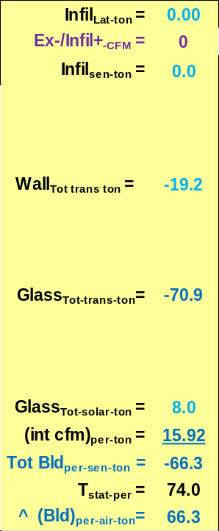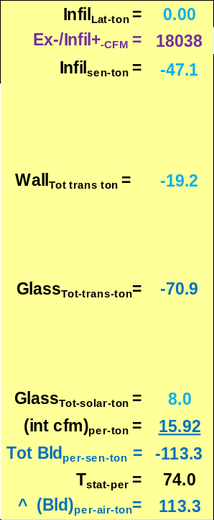
Figure 14: March 25 4PM Perimeter Load-Left chart Table 2 system with zero Infiltration-Right chart Table 3 system 18,038 CFM Infiltration.

Infiltration Ton = 18,038 CFM x 1.08 x (45F -74F) /12,000 = -47.1 ton
Where 45F is the dry bulb temperature and 74F is the perimeter stat set point as shown by Figure 11 bottom schematic.
Figure 11 bottom schematic and Figure 14 right schematic are from the same schematic of the Table 3 building at 4PM on March 25 when all control corrections have been made to the Table 3 system with the exception of eliminating infiltration. The left schematic of Figure 14 shows how the Table 3 schematic will respond when infiltration is eliminated.
Figure 15 illustrates the effect of infiltration at the VAV fan system, the top chart no infiltration, Table 2 system, and the bottom chart the Table 3 system with infiltration. At 4PM the plant sensible load increased from 263 ton to 299 ton as shown by the secondary horizontal axis. The fresh air in did not change but the exhaust increased from -47,386 CFM to -65,425 CFM. The CFM moved by the VAV fan system increased from 200,609 CFM to 217,483 CFM which increased the VAV kW from 135 kW to 158 kW.
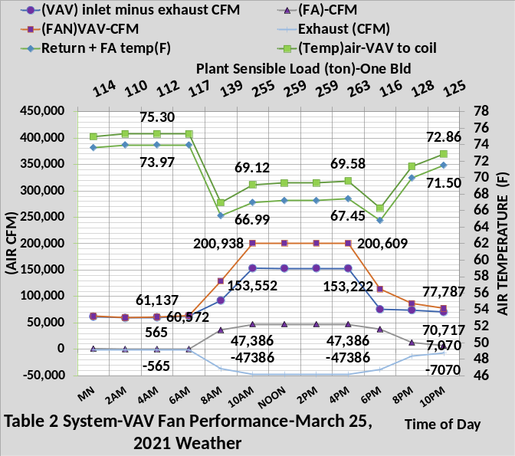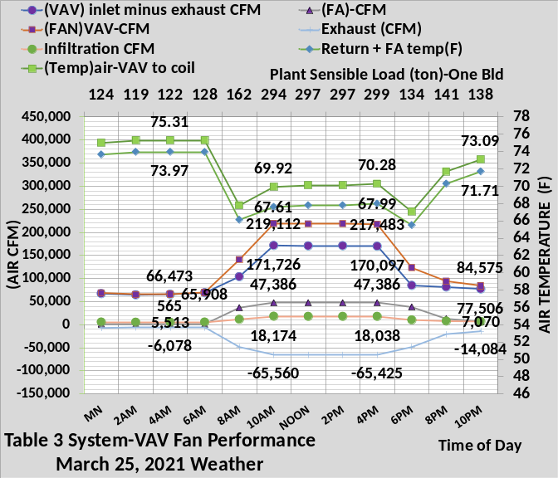
Figure 15: VAV Fan Performance with and without Infiltration
The bottom chart shows that at 4AM the fresh air had reduced to 565 CFM because people are not in the building. Infiltration reduced to 5,513 CFM because infiltration is modeled as a function of VAV CFM. The inlet CFM to the VAV fans is 65,908 and
fresh air adds 565 CFM for a 66,473 CFM to the building space. Exhaust is -6,078 CFM. Six hours later at 10AM the VAV fans CFM is more than three times at 219,112 CFM, infiltration has increased to 18,174 CFM, fresh air is 47,386 CFM and exhaust is -65,560 CFM.
The (SEE) model must model this level of detail to accomplish the objective of simulating the performance of a real system. The author recognizes that changes and modification to the air side equations will likely be necessary to model a particular air side system; the point is the model must be very detail to achieve the objective of real time modelling of a system.

Change in Internal Energy Due to Infiltration
As stated, infiltration results in a change in the internal energy of the thermodynamic system.
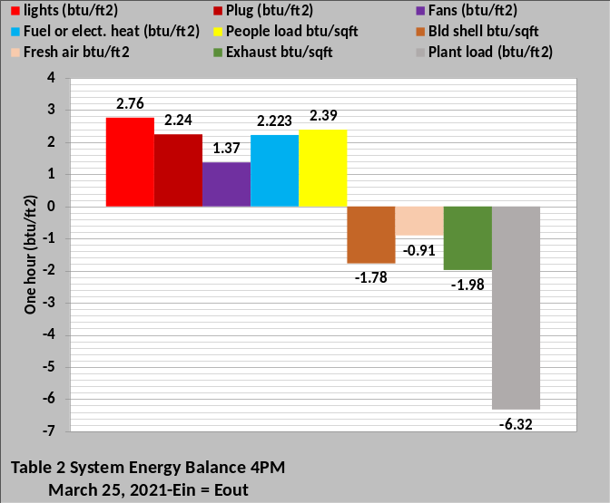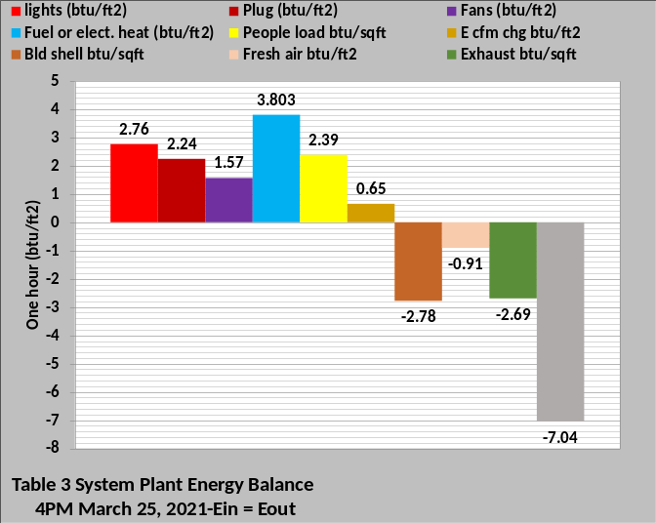
Figure 16: Plant Energy Balance
Figure 16 gives the 4PM energy balance for the two systems, also shown by Figure 13. The bottom chart shows infiltration increased heat required and added a system energy in term (E cfm). The system will not balance without this term. The shell negative load increased as shown by Figure 14 right schematic. Exhaust energy out increased because more return air had to be exhausted as a result of the 18,038 cfm of infiltration shown by Figure 15. Figure 12 shows that the watts/ft² increased due to infiltration by (55.57 – 47.43 = 8.14 watts/ft²), a 17% increase. Figure 16 bottom chart shows that energy change of the system, (Ecfm) is .65 btu/ft².

(Ecfm)= 1.08 x 18,038 CFM x (74F – 55F) = 370,139.76 btu/565,000 ft² = .65 btu/ft²
Where 74F is the return air temperature as shown by Figure 11 bottom schematic and 55F is the supply air temperature off the coils.

Summary of Article 4

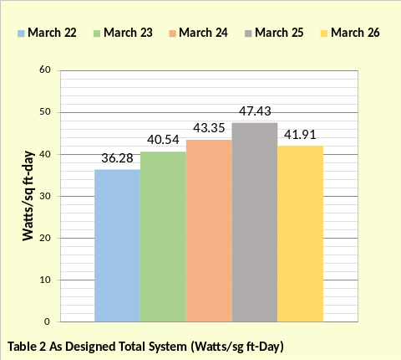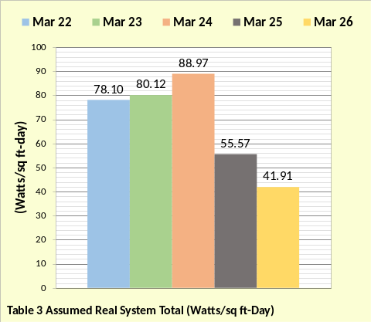
Figure 17: March 22 thru March 26
System (watts.ft²-day)

Figure 17 gives the watts/ft² of the two systems as conditions changed from March 22 to March 26. The top chart shows minimum energy consumption occurred on March 22 for the Table 2 system, increasing each day, due to cold weather, until March 26 when the Table 3 system controls was corrected to be the same as the Table 2 system. The Table 3 system watts/ft² increased each day until the change in heating controls was made on March 25, illustrating the effect the cold weather was having on the energy consumption of the two systems, illustrating the value of a (SEE) model in evaluation of a system. The difference in the values on March 25 show the effect of infiltration and fixing infiltration on March 26 brought the Table 3 system watts/ft² to the same value as the Table 2 system.

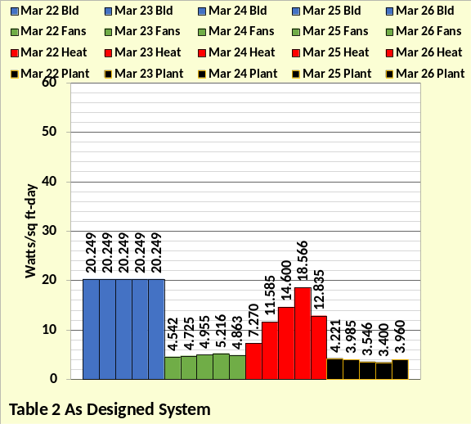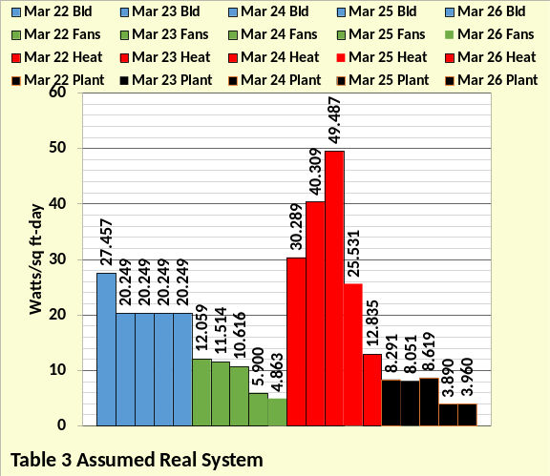
Figure 18: March 22 thru March 26
System watts/ft²-day
Figure 18 is the same data as Figure 17 but broken down into the four major components of the system, the building, the fan system, the heat required by the building, and the plant. The top chart is the Table 2 system that represents the system as designed and properly controlled. The bottom chart is the Table 3 system that represents the real system and the control changes made to bring the real system to the performance of the as designed system. The bottom chart shows the 24-hour building energy use consisting of the lights and plug loads was brought to as designed usage on March 23 by installing the lights and plug load shut down system. The other three components of the system were far outside of compliance on March 23.
March 24 fixed the VAV static pressure control and reduced the fresh air cfm to design. The fans energy use decreased a little but the cold weather was driving the energy consumption of the building.
March 25 fixed the stat control system assuring interior heat of the building was transferred to the perimeter, resulting in a significant reduction in perimeter heat load. The temperature of the heating air to the perimeter was increased from 90F to 105F further reducing the heat requirements of the perimeter. On March 25 the Table 3 system was operating close to the Table 2 system performance with infiltration being the only control left to be corrected.
On March 26 the real system, Table 3, is brought to the performance of the as designed system, Table 2. The path illustrated here to bring a poorly controlled system to the as designed system is a rather simple example. The author would expect the real world would, in many cases, be more complex.
Energy Balance Analysis
Evaluating the energy use and characteristics of a building and plant via energy balance analysis is a powerful tool given that room for error is minimized by the requirement that energy into the system equals energy out of the system. Figures 19 through 22 illustrate energy balance charts of the Table 3 system on March 25 when all control corrections have been made except infiltration; therefore the (Ecfm) term is in the energy balance charts.

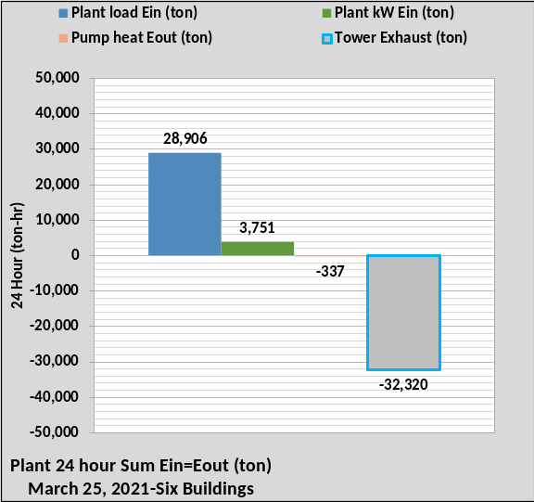
Figure 19: Plant Energy Balance-24 Hour
Figure 19 is the energy balance of the plant; requiring BTU meters on the load the buildings put to the plant and the energy out at the towers. The plant kW is also a required metered number but the pump heat out could be an estimated value.
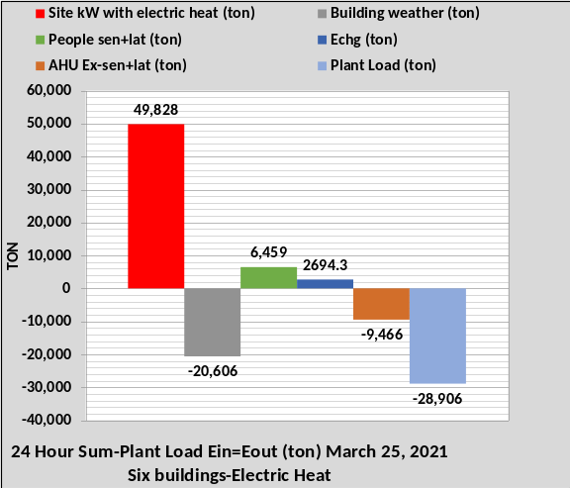
Figure 20: Site Energy Balance-Electric Heat
Figure 20 illustrates the minimum number of values, measured, calculated, or estimated, required for a plant load energy balance. The site kW includes the lights, plugs, fans, heat, and any other electrical load in the buildings. This value would likely be measured by the utility. The building weather would be a calculated number if a (SEE) model was not available. The people load would be known because the number of people in the building should be known within a few percent. If a (SEE) model was available the (Echg) value would be estimated by inputting infiltration cfm. Exhaust cfm would likely be known within reasonable value so could be input to the model. Again, the energy balance is a task of estimating unknowns working toward known metered values until balance is achieved.
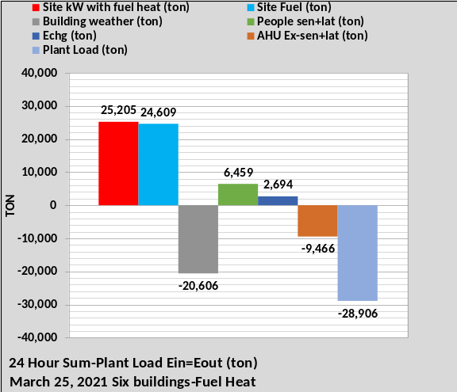
Figure 21: Site Energy Balance-Fuel Heat
Figure 21 is the same as Figure 20 except the facility is assumed to have a separate meter on electrical heat or heat is provided by fuel.
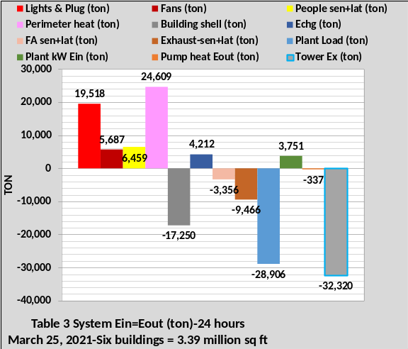
Figure 22: System Energy Balance
Figure 22 illustrates an energy balance with additional data available. Wiring new buildings so that energy balance numbers are available seems like a logical thing to do. Installing meters in an existing building to accomplish understanding about the energy use characteristics of the facility will be driven by the economics.

Four Article Summary
Due to Journal space limitations, the task of this series of four articles was to provide a summary of the (SEE) Model concept with more detail with schematics given by Nelson⁴.
This series of four articles presents a system energy equilibrium (SEE) model that has the potential of modeling the real time performance of a building and plant on any given day. A (SEE) model of an “as designed” facility would be a commissioning tool or for evaluating the real time performance of a facility against what the performance should be if constructed and controlled to an ASHRAE Standard design.
Article 1 was to set the stage by defining the building to be modeled, characteristics of the model, estimates of annual (EUI) values, and examples of energy balance charts.
Article 2 presented details of the building (SEE) model.
Article 3 presented details of the plant (SEE) model.
Article 4 addressed how a (SEE) model and energy balance analysis could be used to analyze a Kansas City office complex on the days of March 22, 2021 through March 26, 2021.
A (SEE) model offers two major possibilities.
1. A city could post (SEE) model energy use of varies type facilities on defined days or all days as the weather changes. This would give building owners the ability to judge their building against ASHRAE Standard designs during changing weather conditions.
2. The (SEE) model can assist in commissioning and evaluating the performance of a building and plant on any day. A (SEE) model of the as designed building and plant would be compared to the actual performance of the facility. If the real facility was not performing as expected the (SEE) model, via energy balance analysis, would be used to define why and how the real system was not performing. Article 4 demonstrated the concept.
This completes the four-article series on the anatomy of a real time building and plant energy model. I hope you have enjoyed the journey and maybe have increased your knowledge of how a building and plant consume energy. That’s what models are for; show us how systems work.

References
- Introduction to Thermodynamics and Heat Transfer. 1956 Prentice-Hall, Inc. by David A. Mooney.
- Thermal Environmental Engineering third edition. 1998 Prentice-Hall Inc. by Thomas H. Kuehn, chapter 3.
- ASHRAE Journal May 2016. “Modeled Performance Isn’t Actual Performance”
- Nelson, Kirby. “System Energy Equilibrium (SEE) Building Energy Model Development & Verification”. http://kirbynelsonpe.com/
- Liu, B. May 2011. “Achieving the 30% Goal: (copy and paste) https://www.energycodes.gov/sites/default/files/documents/BECP_Energy_Cost_Savings_STD2010_May2011_v00.pdf
- Real weather data www.wunderground.com/
- Nelson, K. “7 Upgrades to, Reduce Building Electrical Demand” ASHRAE Journal, December, 2006,
- Nelson, K. “Simulation Modeling of a Central Chiller Plant” CH-12-002. ASHRAE 2012 Chicago Winter Transactions.
- Nelson, K. “Simulation Modeling of Central Chilled Water System” CH-12-003. ASHRAE 2012 Chicago Winter Transactions.
- Kavanaugh, S. “Fan Demand and Energy” ASHRAE Journal, 2000.
- Faris, Gus “Fan-Powered VAV Terminal Units” ASHRAE Journal November 2017
- Kettler, John “Return Fans or Relief Fans” ASHRAE Journal April 2004.
- Taylor, S. 2011. “Optimizing design & control of chiller plants.” ASHRAE Journal (12).
- Nelson, Kirby “The System Energy Equilibrium Model for Chiller Plants, Part 1” Engineered Systems, July 2020.
- Marley Tower SPX Cooling Technologies UPDATE Version 5.4.2
- Steven Taylor. ASHRAE Journal June 2007. “VAV System Static Pressure Setpoint Reset”
- Carrier System Design Manual
- Miles Ryan. ASHRAE Journal February 2021. “Understanding Cascade Control and Its Applications For HVAC”
- Schwedler, Mick. July 1998 “Take It to The Limit…Or Just Halfway?” ASHRAE Journal.
- 2020 ASHRAE HANDBOOK, HVAC Systems and Equipment, page 43.10 Figure 11 Temperature Relations in a Typical Centrifugal Liquid Chiller.

