Benchmark ASHRAE Journal Article of June 2021 “Innovation, Resiliency Create Cornerstone of Office Tower Design”
The June 2021 ASHRAE Journal article, “Innovation, Resiliency Create Cornerstone of Office Tower Design”, documents an office tower designed and constructed to ASHRAE Standard 90.1-2010 Appendix G that achieved an EUI of 53.1 kbtu/ft²-yr in 2019, an exemplary design and construction achievement. The metered electric and natural gas usage for 2019 was given by Figure 2 of the article, therefore providing an opportunity to compare the 2019 results to a system energy equilibrium (SEE) model of the building. The SEE model is constructed to model one day therefore the authors of the ASHRAE article have been requested to provide day energy use data to facilitate a more accurate SEE model and analysis of the design.
The (SEE) Model
The objective of the (SEE) model is to provide the ability to visit a building or plant on any day, with the (SEE) model on a lap top computer, and evaluate the building and plant performance, against expected performance, on that day’s conditions of weather and operation.
This (SEE) model has been developed over a period of several years and the authors modeling experience goes back to 1968. The following lists an estimated 501 equations and calculations, per hour, performed by this (SEE) model.
- Building Model 28
- Solar Model 94
- Tower Model 62
- Pumping Model 53
- Chiller Model 73
- Coil Model 23
- Fans-Supply Air Model 44
- Infiltration Model 21
- Fresh Air Model 27
- Perimeter Heat Model 43
- Performance Calculations 33
Total 501
Essentially nothing is constant in the model, no look up tables or constants, every value is a function of other values in the model. At design weather conditions the 501 equations would be at steady state for design dry bulb, wet bulb, and solar conditions. A change in any one of these three conditions of weather causes the set of equations to reach a new energy equilibrium or load to the plant. Input to the plant consists of adjusting the number of chiller/towers on and the power to the chiller motor to achieve the desired chilled water supply temperature, in this case 44F supply water. The accuracy of the (SEE) model is a function of how well the performance of the system components is understood and how well that understanding can be described by equations.
The following summarizes the basic characteristics of the (SEE) Model.
- The model is of the total building and plant as illustrated by Figure 1.
- The model is the simultaneous solution of basic HVAC equations.
- The model is of any 24-hour day.
- The building is modeled as five zones, four walls and the building interior.
- The building is modeled with all loads of Figure 2 in the interior of the building plus the roof load. The perimeter load is defined by the weather conditions of Figure 2 plus infiltration if it exists.
- The (SEE) Model requires that the energy into the building and plant equals the energy out^{1,2} just as occurs with a real building and plant.
- The (SEE) Model provides the ability to benchmark a building’s energy performance, on any day, against any ASHRAE Standard design, in this case ASHRAE Standard 90.1-2010. This concept offers the opportunity for a city to provide benchmark data each day so that building owners can on any day benchmark their buildings energy use against an ASHRAE Standard design, in this case a 90.1-2010 design.

SEE Model of Madison Wisconsin Office Tower as Defined by ASHRAE Journal Article of June 2021.
Design Weather Conditions

Figure 1 defines the office building as determined from the ASHRAE article and Figure 2 defines the lights, plug and people load and the design day weather. These numbers will likely need to be changed a little based on input from the authors of the ASHRAE Journal article.
Building 9 Story
Building=158,000 Ft-Sq
Building height=117 Ft
Roof = 17,556 Ft-Sq
All walls 37.5% glass
Roof U=.048 Wall U=.090
Glass U=.30 Glass SHGC=.40
Footprint
South=132 Ft North=132 Ft
Each wall=15,444 Ft-Sq
East=133 Ft West=133 Ft
Each Wall=15,561 Ft-Sq

Figure 1: Building

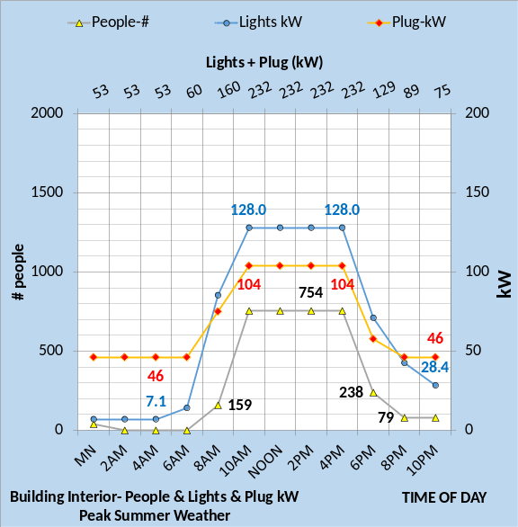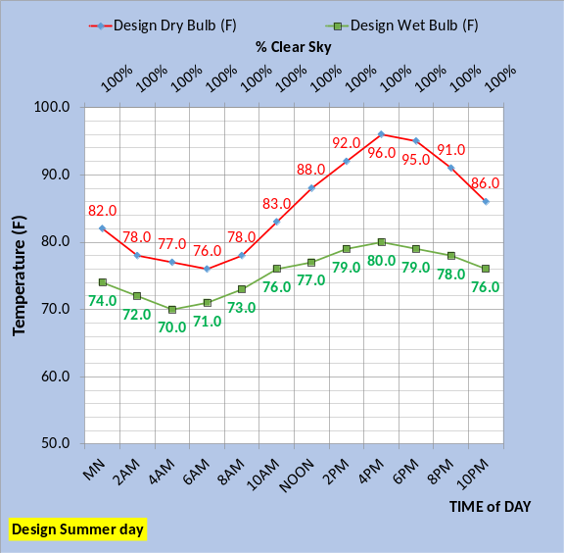
Figure 2: Interior building loads & Design Weather Assumed for Madison Wis. Office Tower of ASHRAE Journal June 2021

The top chart of Figure 2 defines the assumed values of lights and plug loads based on ASHRAE Standard 90.1-2010; values that need to be verified or changed by the authors of the ASHRAE Journal article. The bottom chart is the assumed design day weather.

(EUI) Estimate of SEE Model Design

The SEE model can be used to estimate annual EUI by inputting average weather data for each season. Inputting to the SEE model the basic ASHRAE Standard 90.1-2010 values and the values of Figures 1 & 2 gave as estimated EUI of 48.88 kbtu/ft²-year as given by Figure 3. This value is less than the 53.1 kbtu/ft²-year value given by the ASHRAE Journal article.

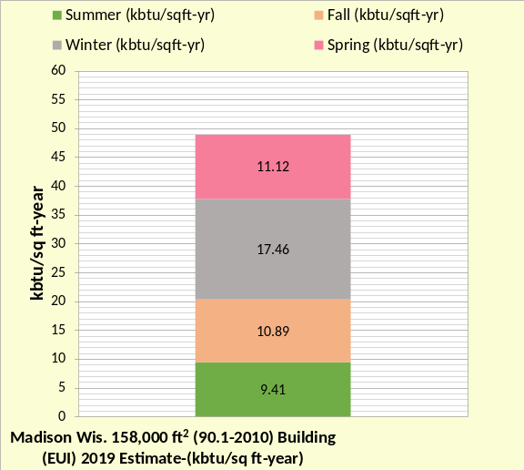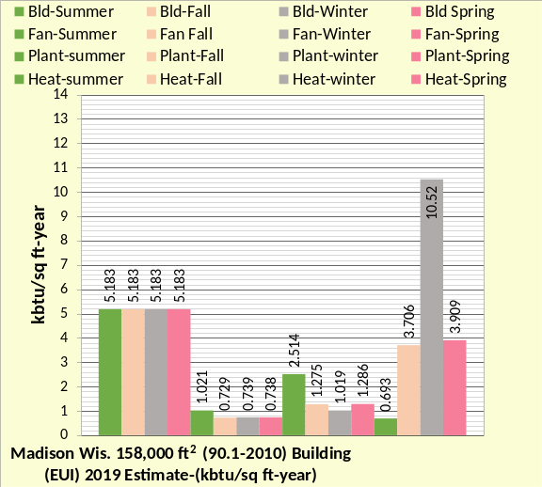
Figure 3: SEE Model of (90.1-2010) Building

The bottom chart of Figure 3 gives the 4 season values. The heat values are low, and the reason is given in the article, the ventilation was on after hours.
Increased Ventilation
The ASHRAE article states, “Metered natural gas (Figure 2b) is higher than prediction because ventilation is operated continuously during the cold nights-“. The (SEE) model of the 90.1-2010 design found that this increased ventilation influenced the EUI value and a necessary input to the SEE model to reasonable match the ASHRAE Journal articles EUI value.

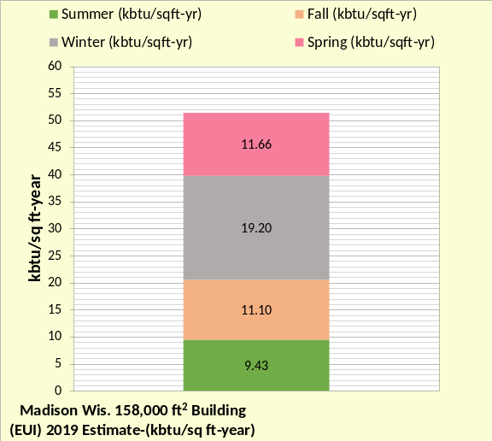 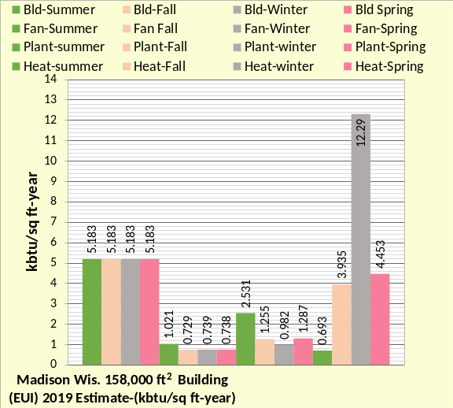 Figure 4: SEE Model EUI Data of Increased ventilation design of ASHRAE Journal article

Increased ventilation, at average 2019 Madison Wisconsin weather data as defined by Dane County Reginal Airport Station of Madison Wisconsin gave an EUI estimate of 51.26 kbtu/ft²-yr as shown by the top chart of Figure 4, a value close to the 53.1 kbtu/ft²-yr given by the ASHRAE article. The bottom chart of Figure 4 breaks the SEE model EUI data into four components for the four seasons illustrating close agreement to the figure 2 data of the article. For example, the bottom chart of Figure 4 shows a SEE model winter heat value of 12.29 kbtu/ft²-yr. For December, January, and February, the article gives natural gas usage of about, 1,920 MMBtu/158,000 ft²=12.15 kbtu/ft²-yr, approximately the same as the SEE model value. Figure 4 demonstrates the (SEE) model is in the ballpark of modelling the real system, however, several details of the design not given by the article had to be assumed. A more accurate SEE model of the system can be developed if the authors of the article could provide additional design details and day energy use data for one or more days including the date or weather conditions for that day. A letter to the Journal requests this additional data.

SEE Model Analysis at Design Day Weather
Given that the SEE model EUI values are close to the values given by the ASHRAE Journal article we will proceed with benchmarking the office tower on specific days. Two conditions of the system will be presented; a 90.1-2010 design as given by Figure 3 and a design with increased ventilation as described in the ASHRAE Journal article and SEE model of Figure 4. First, we will consider the difference in performance at design day conditions as defined by Figure 2 bottom chart.

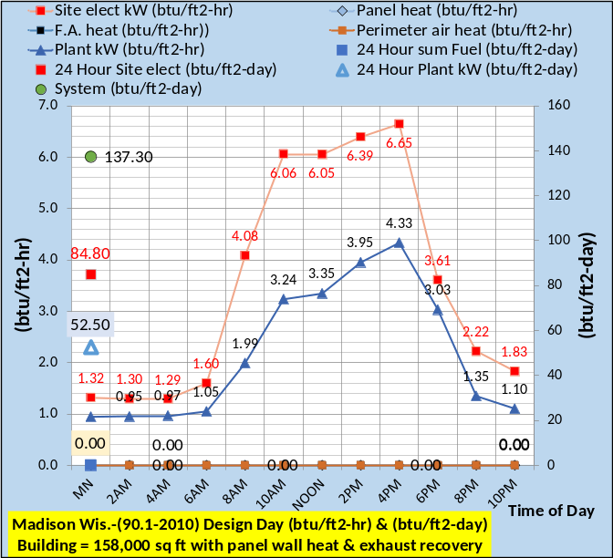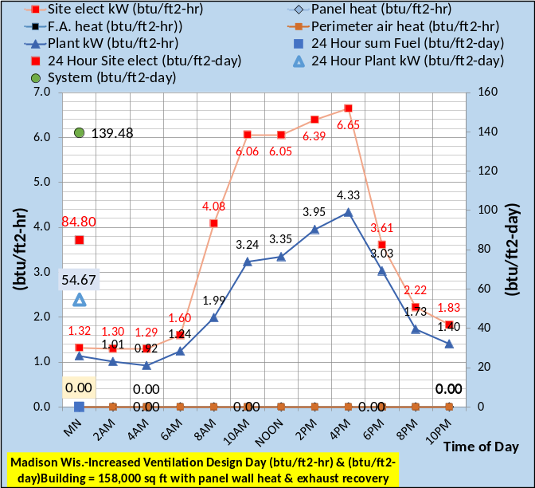
Figure 5: Design Day weather & Energy Consumption Top chart 90.1-2010 Design
Bottom chart increased ventilation
Figure 5 defines the design day 24-hour energy consumption of the office tower for these assumed design day conditions. The top chart is the 90.1-2010 design without the increased ventilation and the bottom chart for increased ventilation. Figure 5 shows a small increased energy use with the increased ventilation occurring at the plant. Heat is zero for all hours.

Energy Balance Analysis

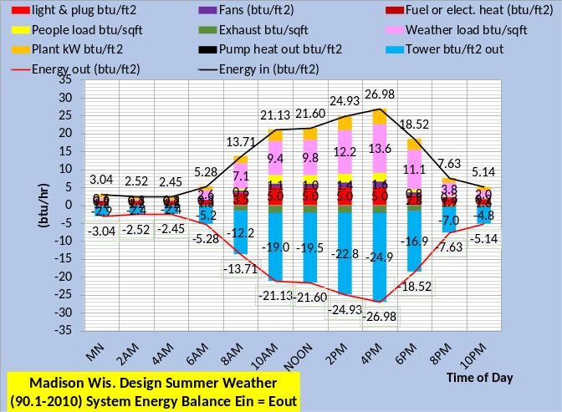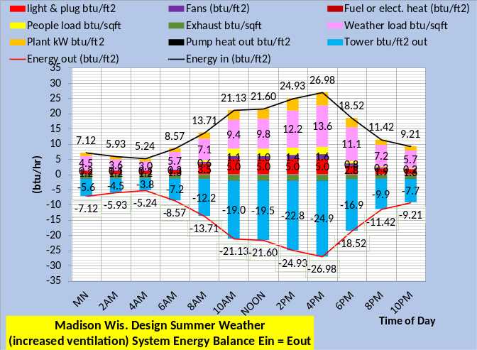
Figure 6: Energy out at the Tower Energy Balance-Ein = Eout at Design Conditions
An energy balance is a fundamental requirement of the (SEE) Model and a fundamental check on the accuracy of an energy model. A model that does no energy balance does not meet the thermodynamic requirement that energy in equals energy out.
The top chart of Figure 6 is the 24-hour energy balance for the system without increased ventilation and the bottom chart is with increased ventilation. Figure 6 gives energy out at the tower or in this case the geo-exchange. Figure 6 illustrates that the increased energy into and out of the system occurs at night, therefore let’s look at an energy balance at 10PM. The top chart of Figure 6 shows the tower energy out is 4.8 btu/ft², the same as the top chart of Figure 7. The bottom chart of Figure 6 shows tower energy out is 7.7 btu/ft², the same as the bottom chart of Figure 7.
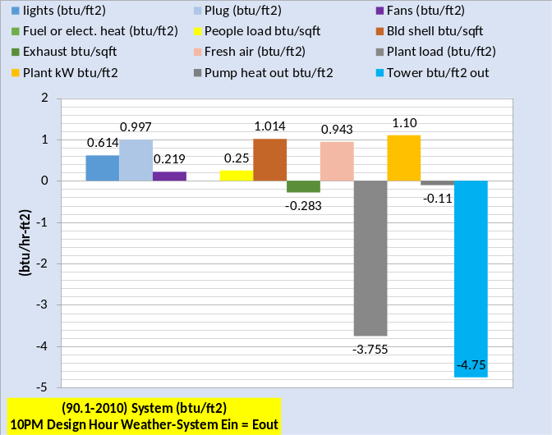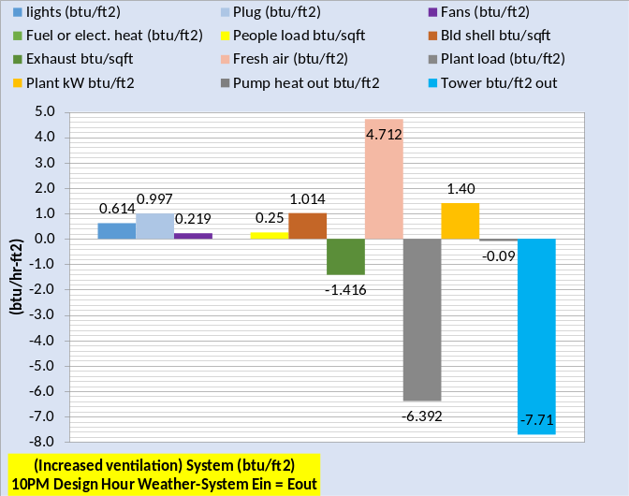
Figure 7: Energy Balance at 10PM

Figure 7 gives an energy balance at 10PM conditions for the controlled ventilation top chart and the increased ventilation bottom chart. Clearly the increased ventilation made a significant difference.
Figure 7 is structured such that the values to the left of the plant load make up the plant load. Add the plant kW energy into the system minus the pump heat to atmosphere and we have the energy out at the tower or geo-exchange. If btu meters were installed for the plant load and/or tower, then the task of arriving at an energy balance would be to balance all other values against these measured values.
To demonstrate the SEE model detail and performance we will look at the real weather performance of the two systems as defined by Figures 3 & 4.

Spring May 27, 2021, Performance of the ASHRAE Journal Office Tower as Defined by Figures 3 & 4

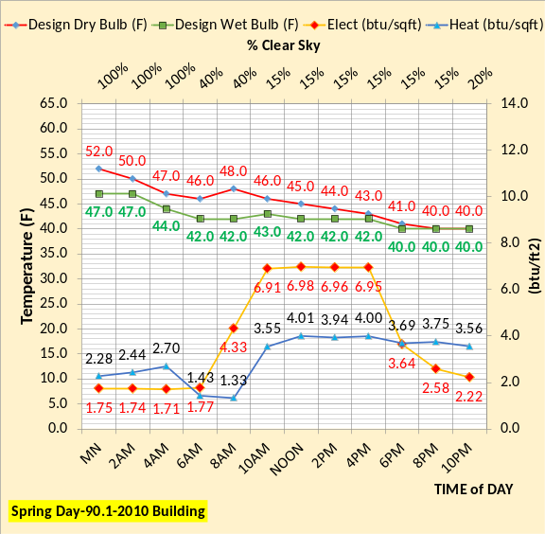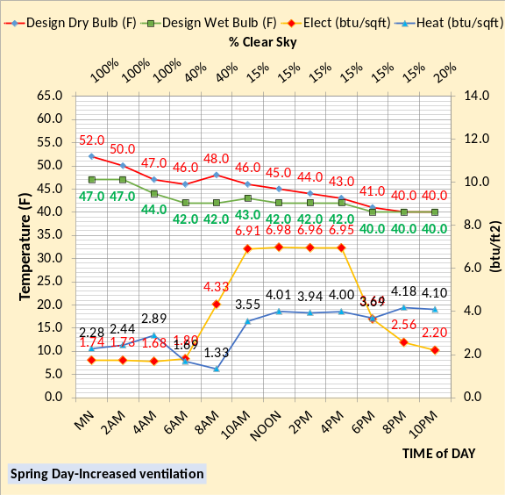
Figure 8: Weather conditions & Energy Use 5/27/21

Figure 8 defines the real weather, Madison Wisconsin, of 5/27/21 and the SEE Model energy use results of the design with and without the increased ventilation into the building. These two values of electrical and gas usage would normally be available from utility companies and therefore represent a method to check the real systems performance against the “as designed” SEE model performance for this day’s weather conditions. If the authors of the ASHRAE Journal article had the day energy use values for this day, and there was a significant difference, then the SEE model analysis could pinpoint the reasons for the differences.
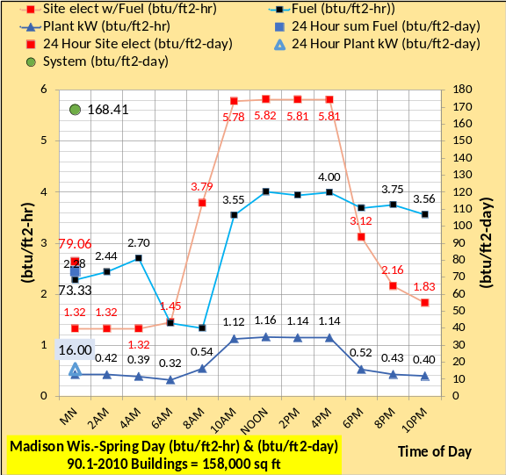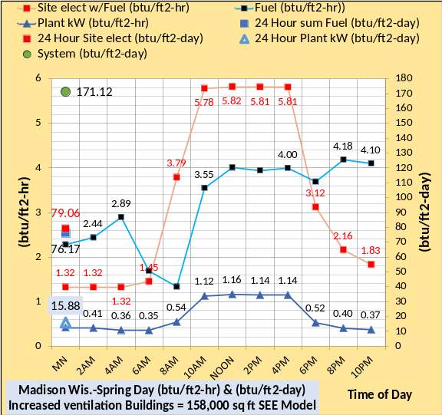
Figure 9: 24 Hour Energy Consumption
Figure 9 breaks the energy consumption into the site, that includes the lights, plug, and fan kW usage, the plant kW usage, and the total heat that includes the wall heat panels, fresh air preheat and the perimeter air supply heat. The top chart gives the system without increased ventilation and the bottom chart with. Both charts give the 24-hour totals so that the real building 24-hour energy consumption could be check against the SEE model at these weather conditions. If a difference exists, then energy balance analysis could identify problems.

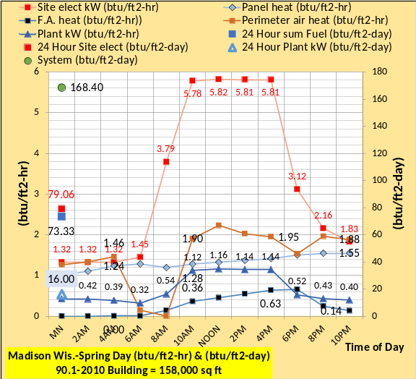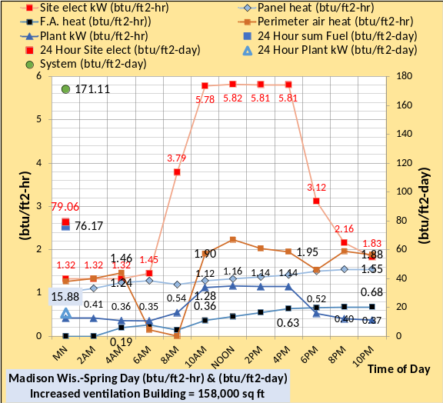
Figure 10: 24-hour energy consumption showing
panel, fresh air, and perimeter air heat

Figure 10 is a very busy chart but demonstrates the SEE model ability to break the energy use into several components suggesting the need for energy meters on the real system. Obviously, the more energy meters the better the system could be evaluated and controlled to minimize energy consumption.
Figure 10 illustrates that the energy consumption during occupied hours is obviously the same for both systems. Increased ventilation during afterhours operation increased kW demand. Let’s look in detail at 10PM.

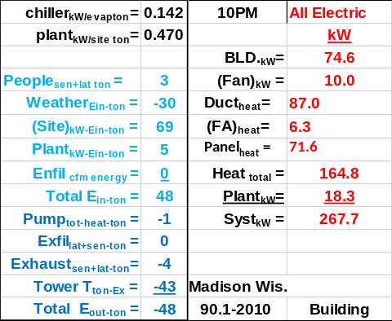
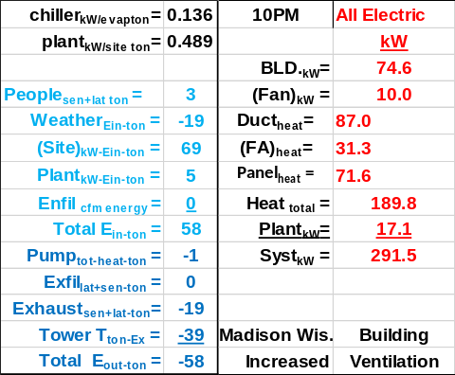
Figure 11: 10PM Energy balance & kW Demand

Figure 10 illustrates a difference in energy consumption at 10PM and Figure 11 gives the details. The building kW includes the lights and plug loads and is the same for both systems. The fans, duct heat, and wall panel heat are also the same. The difference occurs with fresh air heat and plant kW. The fresh air is modelled as preheated to 50F and the exhaust air recovery system also makes a difference. The following analysis will provide an understanding. The net result is a kW demand of 267.7 kW for the fresh air control design, top chart, and 291.5 kW for the increased fresh air design, bottom chart, a 9% increase.

Energy Balance Analysis

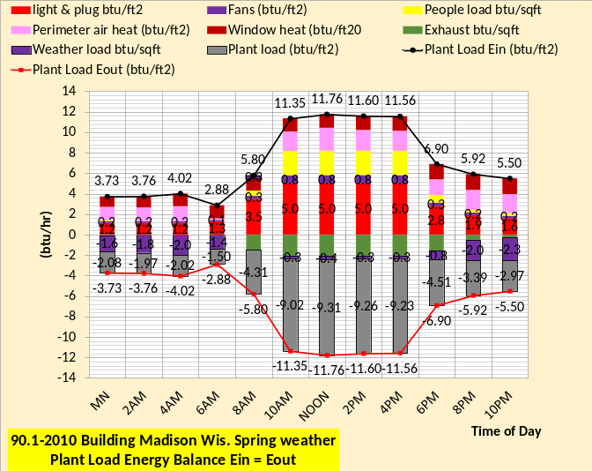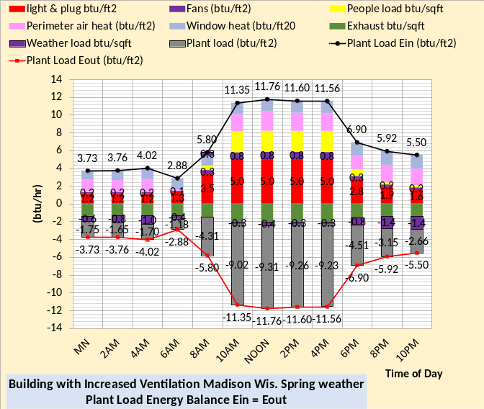
Figure 12: 24 Hour Energy Balance-Plant Load

Figure 12 shows that at 10PM the plant load is 2.97 btu/ft² top chart and 2.66 btu/ft² for the bottom chart with increased ventilation. My first take on this was the SEE model was wrong, how could the plant load decrease with increased ventilation. Figure 11 shows that the increased ventilation system has greater kW demand so I assumed the plant load would be greater. Let’s look at energy out at the tower.
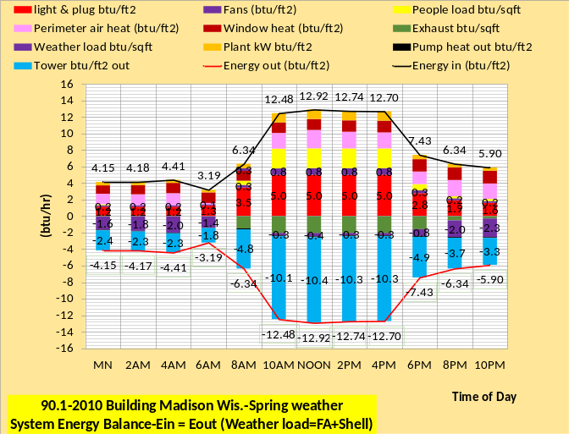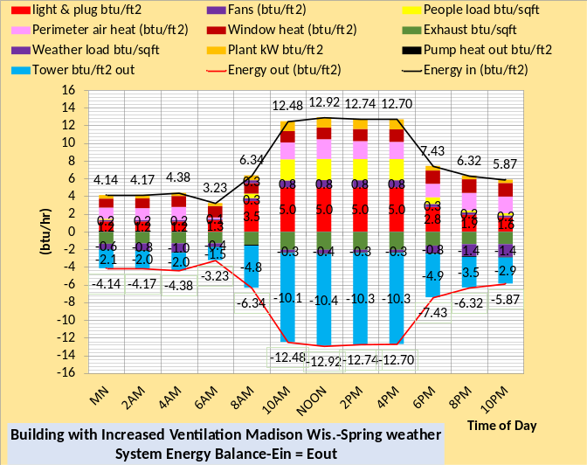
Figure 13: 24 Hour Energy out at the Tower

Figure 13 illustrates the same characteristics as Figure 12, the 10PM load at the tower is 3.3 btu/ft² for the controlled fresh air system and 2.9 btu/ft² for the increased fresh air of the bottom chart.
Let’s look at a detail energy balance at 10PM, but first let’s look at 4PM.

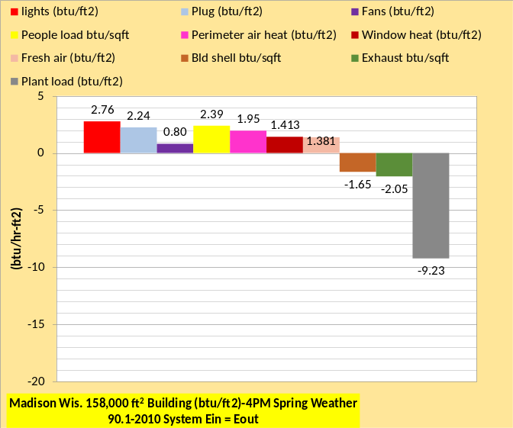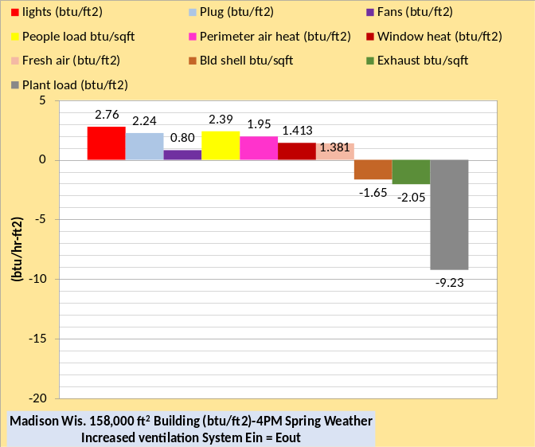
Figure 14: 4PM Plant Load Energy Balance
Ein = Eout Top chart without increased ventilation, Bottom chart with increased ventilation
Figure 14 shows, as also shown by Figure 12, that the energy balance is the same for both system at 4PM and other occupied hours.
Figure 15 demonstrates agreement with Figure 12 where the plant load is less for the increased ventilation system. Both charts of Figure 15 balance, therefore there is an explanation why the plant load decreased with increased ventilation.

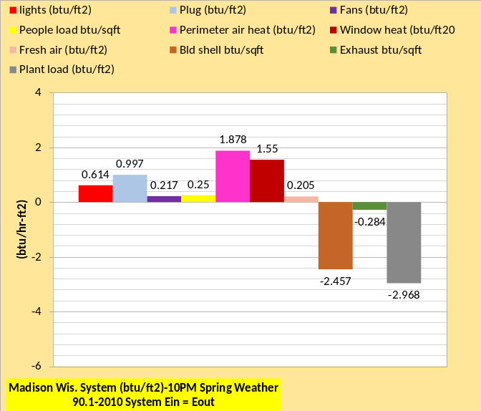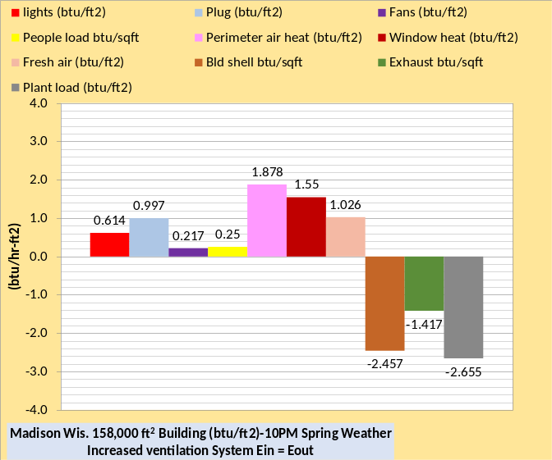
Figure 15: 10PM Plant Load Energy Balance
Ein = Eout Top chart without increased ventilation, Bottom chart with increased ventilation
I have found this condition of “how can this be right?” several times as I developed and studied the performance of building systems with the SEE model. Initially I tried to gain understanding by charting system characteristics and jumping from one chart to the other trying to put together a rational explanation. System schematics brought understanding as demonstrated below.
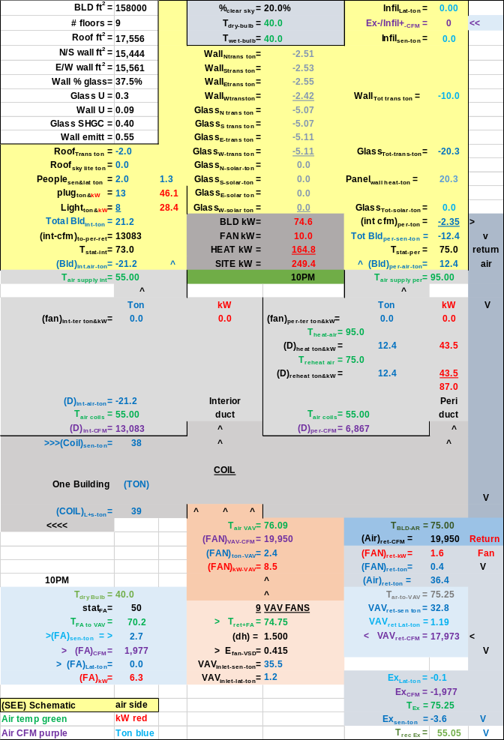
Schematic 1: Controlled Fresh Air-10PM May 27, 2021, Spring Weather

Nomenclature and schematic layout are given below. The schematics have a lot of data, we will focus on some specific values to understand the decrease in load to the plant, with increased ventilation, and therefore to the tower and/or geo-system. Note that the CFM of supply air to the perimeter, 6,867, and interior, 13,083, is the same for both Schematics. The return air is 19,950 CFM for both systems but the CFM of return air to the VAV fan inlet is less for the Schematic 2 system because 9,877 CFM is exhausted, and 1,977 CFM exhausted for the Schematic 1 system. Both
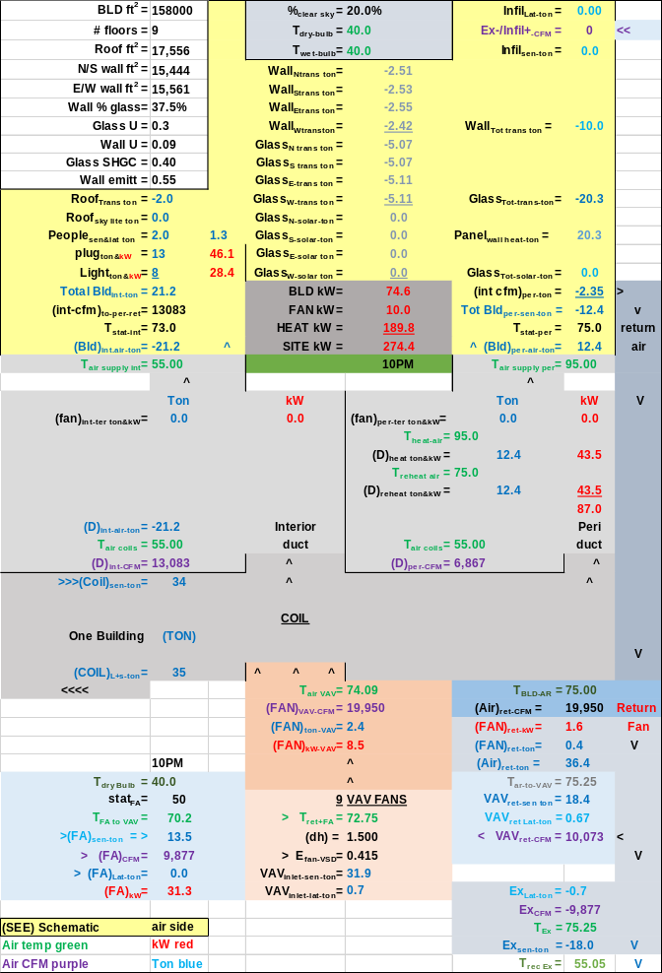
Schematic 2: Increased Fresh Air-10PM May 27, 2021, Spring Weather
systems have 19,950 CFM of air to the inlet of the VAV fans, but the Schematic 2 system has 9,877 CFM of 70.2F air mixed with 10,073 CFM of 75.25F air resulting in 72.75F air to the VAV fans inlet.
The Schematic 1 system has only 1,977 CFM of 70.2F outside air mixing with 17,973 CFM of 75.25F air resulting in a warmer air of 74.75F air to the VAV fans inlet. The net result is that the load to the plant is less with the Schematic 2 system, 35-ton verses 39-ton for the Schematic 1.
Exhaust air recovery influences the system and the obvious question is would the system kW increase or decrease without the exhaust air recovery. Let’s look.

Exhaust Air Recovery Off

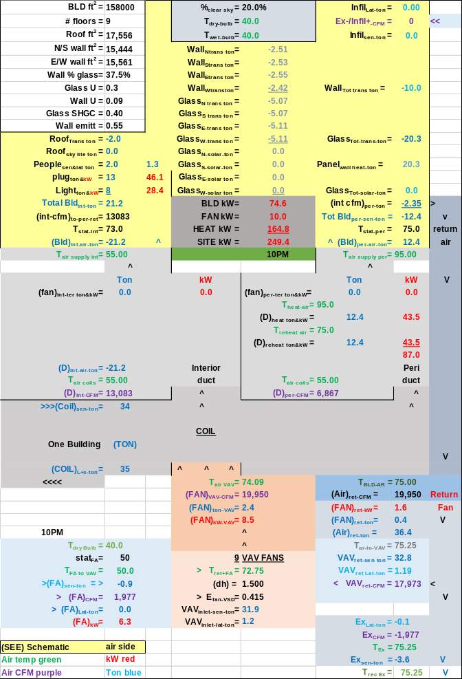
Schematic 3: Controlled Fresh Air
Exhaust Recovery Off

Turning the exhaust air recovery off changed the temperature of outside air to the inlet of the VAV fans. The SEE model fresh air preheat stat is set at 50F, a value to be verified by the ASHRAE Journal authors, therefore 50F air is mixed with return air as shown by both Schematics 3 & 4.
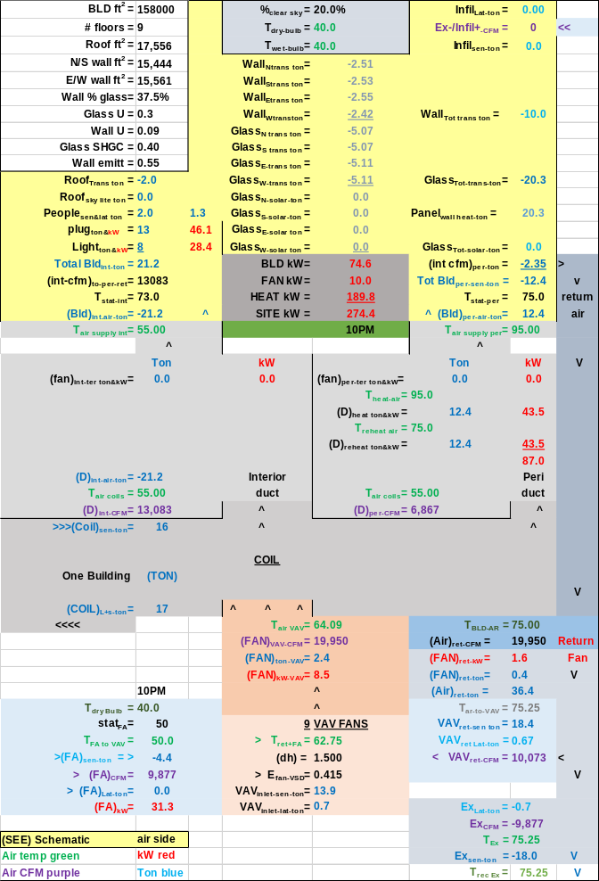
Schematic 4: Increased Ventilation
Exhaust Recovery OFF

The Schematic 3 system has only 1,977 CFM of 50.0F outside air mixing with 17,973 CFM of 75.25F air resulting in air of 72.75F air to the VAV fans inlet. The Schematic 4 system has increased 50F fresh air, preheat is set at 50F, resulting in 62.75F mixed air the VAV inlet resulting in less plant load, 17-ton verses 35 ton for the Schematic 3 system. The bottom line is cold outside air decreases the plant load and the more CFM of cold outside air the lower the plant load.
Figures 16 & 17 summarize the energy balance and system kW demands.
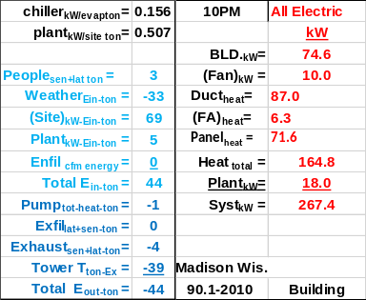
Figure 16: Controlled Fresh Air
10PM Energy Balance & kW Demand
Top Chart with Exhaust Air Recovery-Sch-1
Bottom Chart No Exhaust Air Recovery-Sch-3

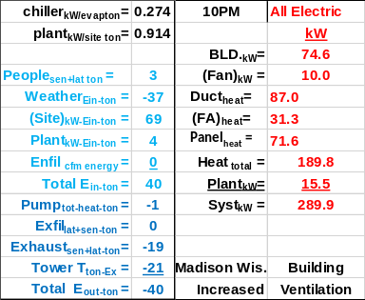
Figure 17: Increased ventilation
10PM Energy Balance & kW Demand
Top Chart with Exhaust Air Recovery-Sch-2
Bottom Chart No Exhaust Air Recovery-Sch-4

Figure 16 illustrates the exhaust air recovery system makes little difference in the kW demand of the system if fresh air is controlled at this 10PM hour of afterhours operation. The difference is the kW demand of the plant. Comparing Schematic 1 & 3 illustrates the plant load is decreased from 39 ton of Schematic 1 with exhaust air recovery to 35-ton, Schematic 3, without exhaust air recovery. No exhaust air recovery allowed colder air to the inlet of the VAV fans and therefore less plant load.
Figure 17 demonstrates the same, more cold fresh air decreased the plant load from 35 ton of Schematic 2 to 17 ton of Schematic 4.
For this system as defined by the schematics the exhaust air energy recovery should be turned off during cold weather operation.
Next, we will consider operation at summer weather conditions.

Summer August 11, 2021, Performance of the Office Tower as Defined by Figures 3 & 4

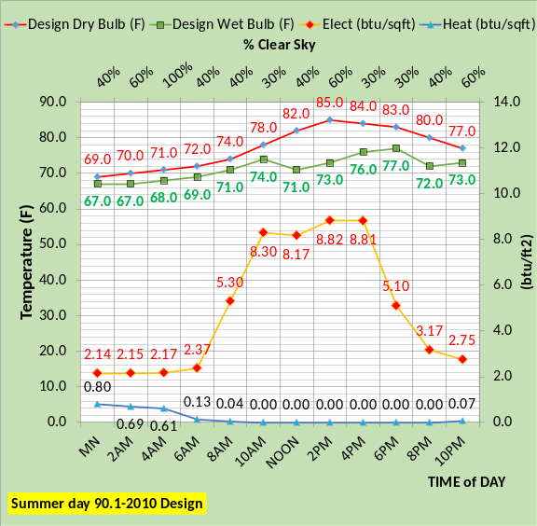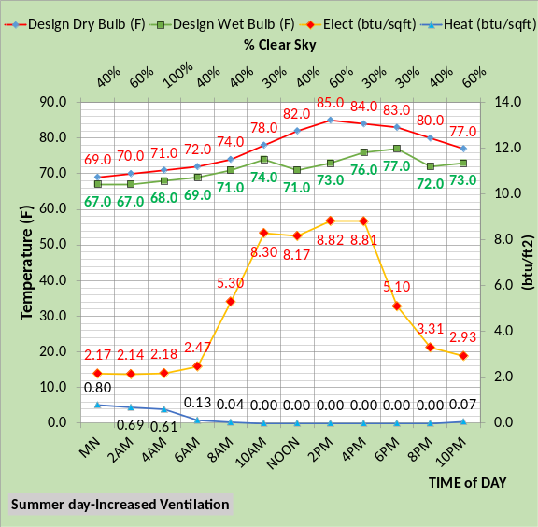
Figure 18: Weather conditions & Energy Use 8/11/21

Figure 18 defines the real weather, Madison Wisconsin, and the SEE Model energy use results of the design with and without the increased ventilation into the building. These two values of electrical and gas usage would normally be available from utility companies and therefore represent a method to check the real system performance against the “as designed” SEE model performance for this day’s weather conditions. If the authors of the ASHRAE Journal article had the day energy use values for this day, and there was a significant difference, then the SEE model analysis could pinpoint the reasons for the differences.

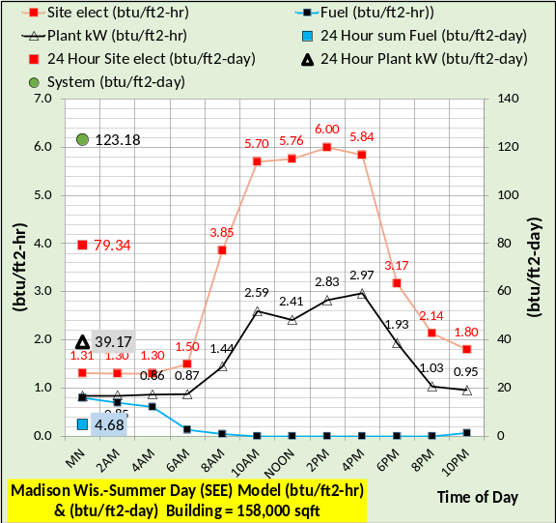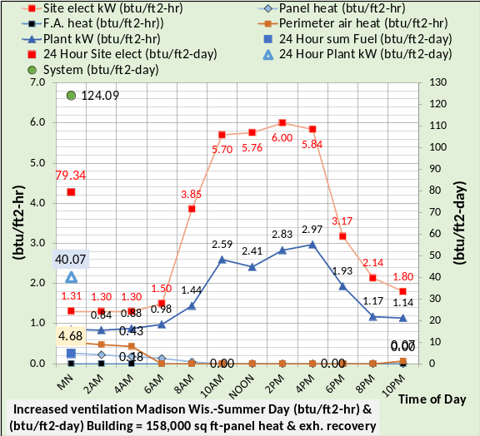
Figure 19: 24-hour energy consumption showing
panel, fresh air, and perimeter air heat

Figure 19 illustrates little difference in the energy consumption for the two conditions of CFM fresh air. The only difference is the plant kW that increases with increased fresh air.
Figure 19 illustrates that the energy consumption during occupied hours is the same for both systems. The ventilation is increased during afterhours operation. At 10PM the plant btu/ft²-hr is .95 for controlled fresh air and 1.14 for increased fresh air. Let’s look in detail at 10PM.

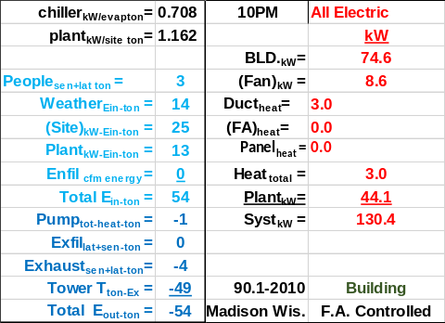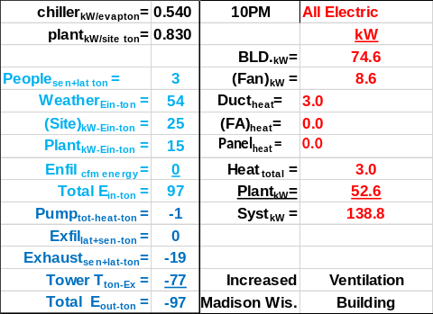
Figure 20: 10PM Energy balance & kW Demand

Figure 20 illustrates that all kW values are the same except the plant kW, which is greater for increased ventilation, resulting in a 24-hour kW increase of about 8.4 kW. The exhaust air energy recovery, for the system as defined here, only effects the plant load and therefore the plant kW demand.
If the authors of the ASHRAE Journal article have energy use data for this day then a comparison to the SEE model design and performance, as given by Figures 18, 19, & 20, could provide insight into the building system and to the capabilities of the SEE model to model a day performance. Selecting a future date to collect data could also be considered.
Next, we look at the 24-hour plant load energy balance.
Energy balance Analysis

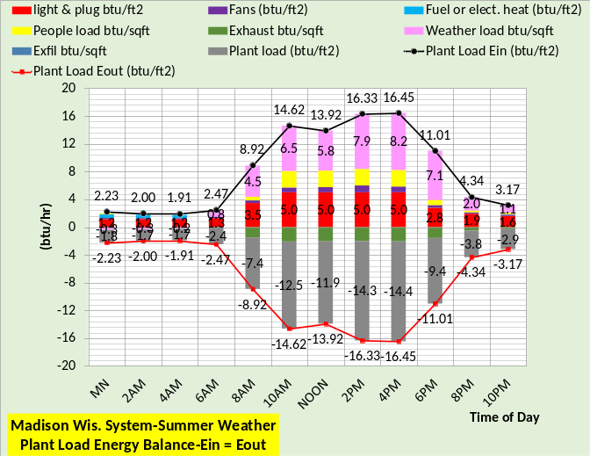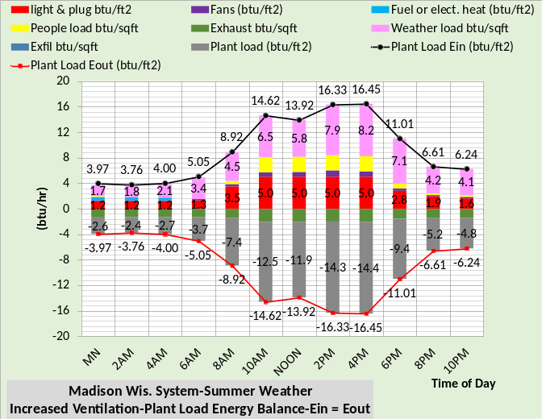
Figure 21; 24 Hour Energy balance

Figure 21 shows that at 10PM the plant load is 2.9 btu/ft² top chart and 4.8 btu/ft² for the bottom chart with increased ventilation. For these summer weather conditions the increased fresh air CFM, during afterhours operation, increased the load on the plant, opposite the result during cold weather operation as discussed above.
Now let’s look at and energy balance at 4PM and 10PM.

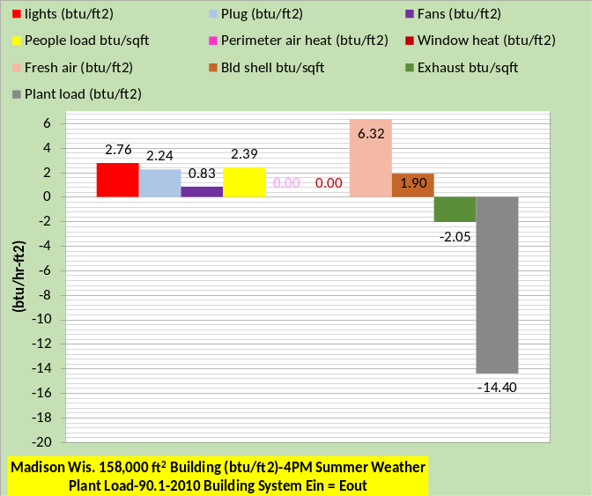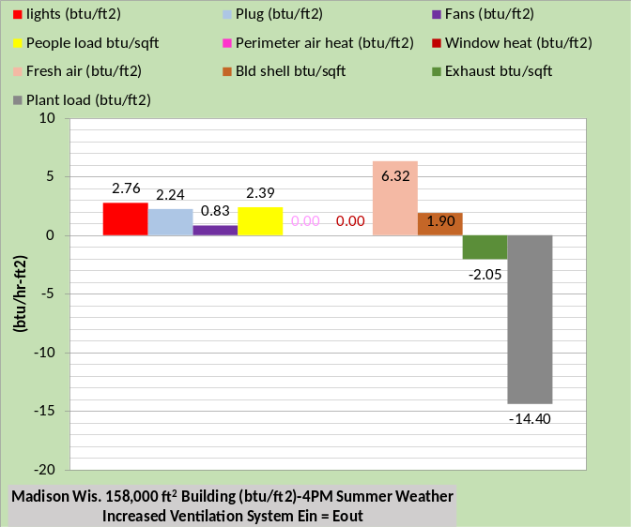
Figure 22: 4PM Plant Load Energy Balance
Ein = Eout Top chart without increased ventilation, Bottom chart with increased ventilation
Figure 22 shows, as also shown by Figure 21, that the energy balance is the same for both system at 4PM and other occupied hours.

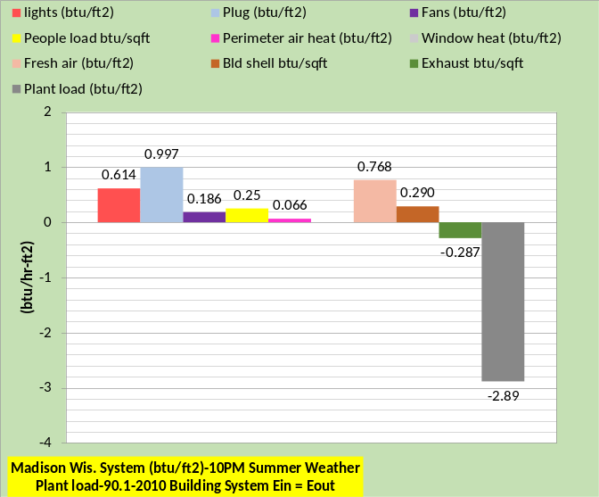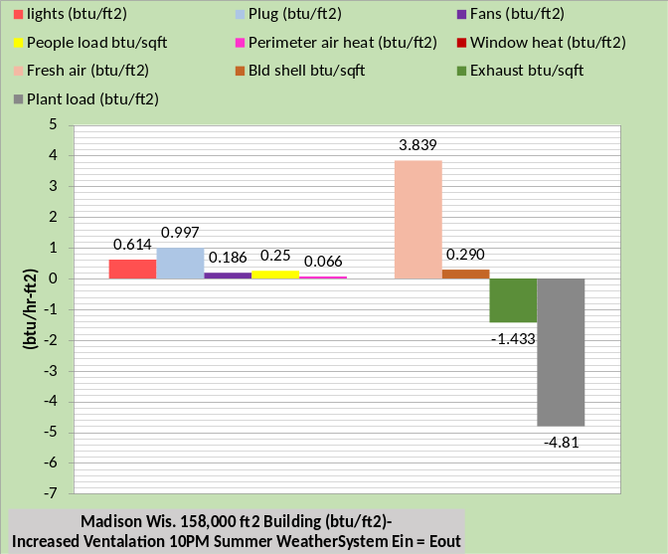
Figure 23: 10PM Plant Load Energy Balance
Ein = Eout Top chart without increased ventilation, Bottom chart with increased ventilation

Figures 22 & 23 plant load values agree with the values of Figure 21, as it must. Figure 23 shows the plant load increased due to the fresh air increase. Also note that the exhaust energy out increased. Let’s look at the effect the exhaust air energy recovery has on the system performance.

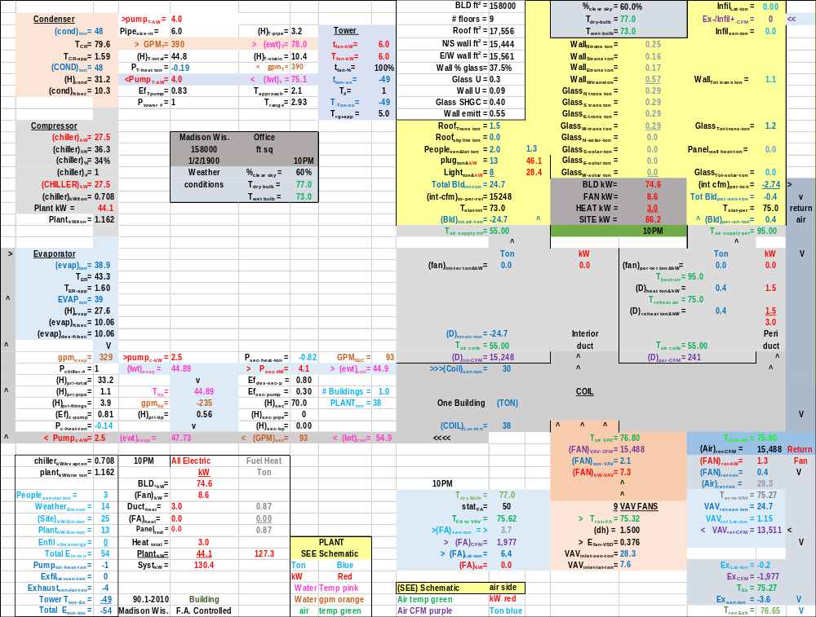
Schematic 5: Total System at 10PM-Controlled Fresh Air-Exhaust Energy Recovery On

The total system schematics give a great deal of data we will not delve into at this point but focus on some specific values.

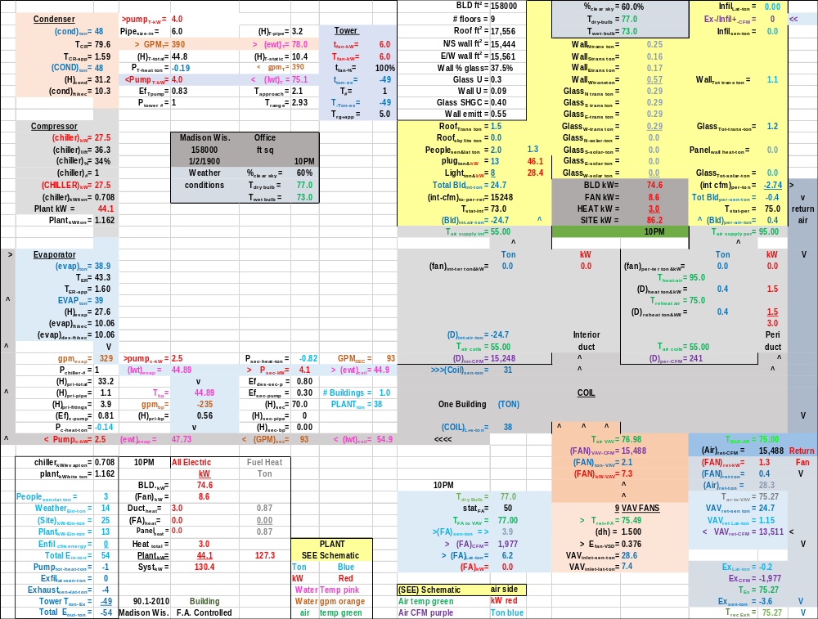
Schematic 6: Total System at 10PM- Controlled Fresh Air-Exhaust Energy Recovery Off

Comparing Schematics 5 & 6 illustrates little changes with the exhaust energy recovery turned off. The reason is that very little exhaust occurs at the 10PM hour if the fresh air is controlled after hours. Next, we look at increase fresh air.

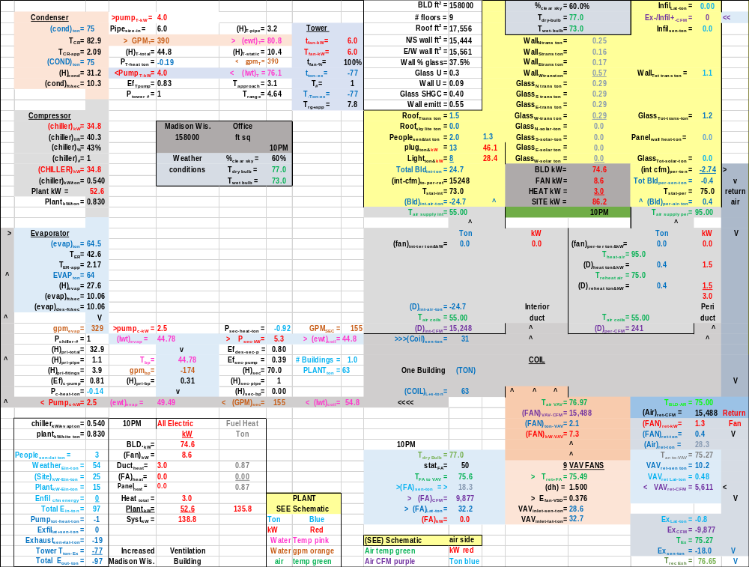
Schematic 7: Total System at 10PM-Increased Ventilation-Exhaust Energy Recovery On

At this point the SEE model exhaust air recovery model only deals with sensible load, therefore the outside air latent load is delivered to the inlet of the VAV fans.

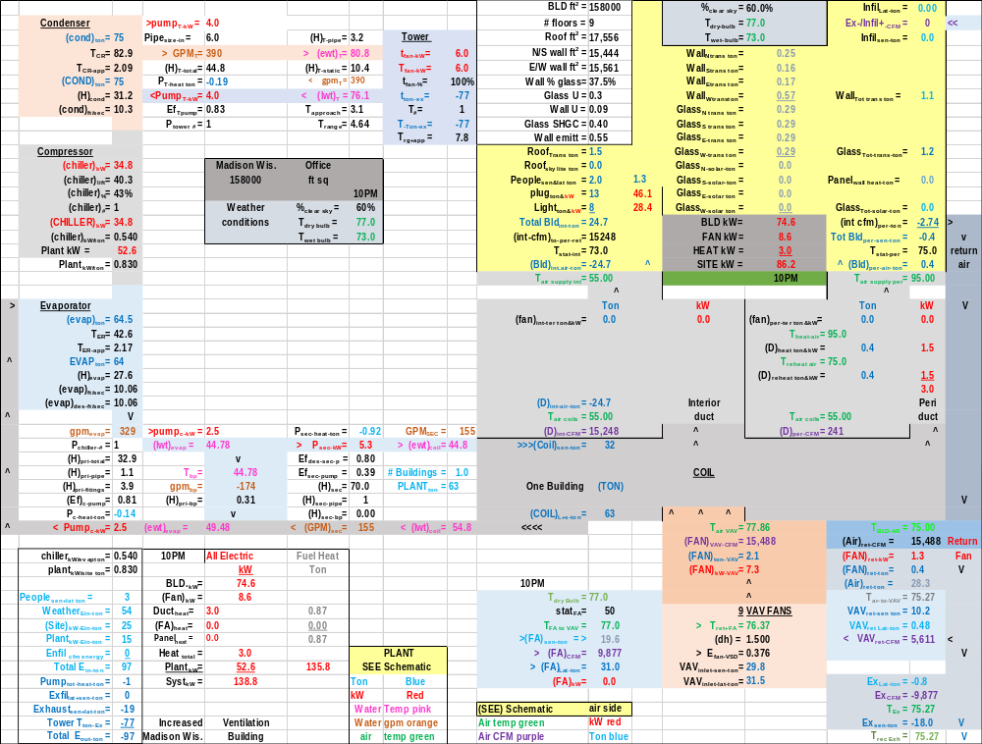
Schematic 8: Total System at 10PM-Increased Ventilation-Exhaust Energy Recovery Off

Comparing Schematics 7 & 8 we see that the latent load to the VAV fan inlet is a little greater, 32.2 ton for the Schematic 7 system and 31.0 ton for the Schematic 8 system. However, the sensible load is a little less for the Schematic 7 resulting in a 63-ton plant load for both systems. The total kW demand is 138.8 kW for both Schematics 7 & 8. The exhaust
air recovery makes essentially no difference at these conditions given by the schematics.

Summary/Conclusions
I believe the SEE model can duplicate the performance of the ASHRAE Journal system and look forward to input by the authors of the article.
Best Regards to all,
Kirby Nelson P.E.

References
- Introduction to Thermodynamics and Heat Transfer. 1956 Prentice-Hall, Inc. by David A. Mooney.
- Thermal Environmental Engineering third edition. 1998 Prentice-Hall Inc. by Thomas H. Kuehn, chapter 3.
- ASHRAE Journal May 2016. “Modeled Performance Isn’t Actual Performance”
- Nelson, Kirby. “System Energy Equilibrium (SEE) Building Energy Model Development & Verification”. http://kirbynelsonpe.com/
- Liu, B. May 2011. “Achieving the 30% Goal: (copy and paste) https://www.energycodes.gov/sites/default/files/documents/BECP_Energy_Cost_Savings_STD2010_May2011_v00.pdf
- Real weather data www.wunderground.com/
- Nelson, K. “7 Upgrades to, Reduce Building Electrical Demand” ASHRAE Journal, December, 2006,
- Nelson, K. “Simulation Modeling of a Central Chiller Plant” CH-12-002. ASHRAE 2012 Chicago Winter Transactions.
- Nelson, K. “Simulation Modeling of Central Chilled Water System” CH-12-003. ASHRAE 2012 Chicago Winter Transactions.
- Kavanaugh, S. “Fan Demand and Energy” ASHRAE Journal, 2000.
- Faris, Gus “Fan-Powered VAV Terminal Units” ASHRAE Journal November 2017
- Kettler, John “Return Fans or Relief Fans” ASHRAE Journal April 2004.
- Taylor, S. 2011. “Optimizing design & control of chiller plants.” ASHRAE Journal (12).
- Nelson, Kirby “The System Energy Equilibrium Model for Chiller Plants, Part 1” Engineered Systems, July 2020.
- Marley Tower SPX Cooling Technologies UPDATE Version
- Steven Taylor. ASHRAE Journal June 2007. “VAV System Static Pressure Setpoint Reset”

NOMENCLATURE Each of the more than 200 variables are defined.
Building structure.
BLD ft² = air-conditioned space
# Floors = number of building floors
Roof ft² = roof square feet
N/S wall ft² =north/south wall square feet
E/W wall ft² =east/west wall square feet
Wall % glass = percent of each wall that is glass
Glass U = glass heat transfer coefficient
Wall U = wall heat transfer coefficient
Glass SHGC = glass solar heat gain coefficient
Wall emit = wall solar index
Building interior space;
Roof_{trans-ton} =transmission through roof (ton)
Roof_{sky-lite-ton} =sky lite load (ton)
People_{ton sen&lat} = sensible & latent cooling load due to people (ton)
Plug_{ton&kW} = cooling load & kW due to plug loads
Light_{ton&kW} = cooling load & kW due to lights
Total Bld_{int-ton} = total building interior load (ton)
(int-cfm) _{to-per-return} = CFM of interior supply air that returns to perimeter of building
T_{stat-int} = interior stat set temperature (F)
Bld_{int-air-ton} = supply air ton to offset interior load
BLD kW = total building kW demand
FAN kW = total fan kW
HEAT kW = total kW due to heat
SITE kW = total site kW=Bld+ Fan+Heat
Building perimeter space;
%_{clear sky} = percent clear sky
T_{dry bulb} = outside dry bulb temperature (F)
T_{wet bulb} = outside wet bulb temperature (F)
Ex/Infil_{lat-ton} = latent air infiltration or exfiltration (ton)
Ex/Infil_{CFM} = air infiltration or exfiltration CFM
Exfil_{sen-ton} =sensible air exfiltration or infiltration (ton)
Wall_{n trans ton} = north wall transmission (ton)
Wall_{s trans ton} = south wall transmission (ton)
Wall_{E trans ton} = east wall transmission (ton)
Wall_{w trans ton} = west wall transmission (ton)
Wall_{tot-trans-ton} = total wall transmission (ton)
Glass_{N-trans-ton} = north wall glass transmission (ton)
Glass_{S-trans-ton} = south wall glass transmission (ton)
Glass_{E-trans-ton} = east wall glass transmission (ton)
Glass_{W trans-ton} = west wall glass transmission (ton)
Glass_{tot-trans-ton} = total transmission thru glass (ton)
Glass_{N-solar-ton} = north glass solar load (ton)
Glass_{S-solar-ton} = south glass solar load (ton)
Glass_{E-solar-ton} = east glass solar load (ton)
Glass_{W-solar-ton} = west glass solar load (ton)
Glass_{tot-solar-ton} = total glass solar load (ton)
(int cfm)_{per-ton} = effect of interior CFM to wall (ton)
Total Bld_{per-sen-ton} total perimeter sensible load (ton)
T_{stat-per} = perimeter stat set temperature (F)
Bld_{per-air-ton} = supply air ton to offset perimeter load
Air handler duct system-Interior duct
T_{air supply int} = temp air supply to building interior (F)
(fan)_{int ter ton&kW} = interior ton & kW due to terminal fans
(D)_{int-air-ton} = cooling (ton) to building interior duct
T_{air coils} = supply air temperature off coils to duct (F)
(D)_{int-CFM} = supply air CFM to building interior duct
Perimeter duct
T_{air supply per} =temp (F) air supply to building perimeter
(fan)_{per ter ton&kW} = perimeter ton & kW of terminal fans
T_{heat-air} = temp supply air before terminal fan heat (F)
(D)_{heat-ton&kW} = heat to perimeter supply air ton & kW
T_{reheat air} = temp perimeter supply air after reheat (F)
(D)_{reheat ton&kW} = reheat of perimeter supply air ton & kW
(D)_{per-air-ton} = cooling (ton) to perimeter duct
T_{air coils} = supply air temperature off coils to duct (F)
(D)_{per-CFM} = supply air CFM to perimeter duct
Coil
(Coil)_{sen-ton} = sensible load on all coils (ton)
(Coil)_{cap-ton} = LMTD * UA = capacity (ton) one coil
LMTD = Coil log mean temperature difference (F)
(Coil)_{L+s-ton} = latent + sensible load on all coils (ton) transferred to Plant
UA = coil heat transfer coefficient * coil area. UA varies as a function water velocity (coil)_{gpm} thru the coil, as the (coil)_{gpm} decreases the coil capacity decreases.
(one Coil)_{ton} = load (ton) on one coil
VAV Fan system
Fresh air
stat_{FA} = fresh air freeze stat set temperature (F)
T_{FA to VAV} = temperature of fresh air to VAV fan
(FA)_{sen-ton} = fresh air sensible load (ton)
(FA)_{CFM} = CFM fresh air to VAV fan inlet
(FA)_{Lat-ton} = fresh air latent load (ton)
(FA)_{kW} = heat kW to stat_{FA} set temperature
Air return
T_{BLD-AR} = return air temp (F) before return fans
(Air)_{ret-CFM} = CFM air return from building
(FAN)_{ret-kW} = return fans total kW
(FAN)_{ret-ton} = cooling load (ton) due to (FAN)_{ret-kW}
(Air)_{ret-ton} = return air (ton) before return fans
T_{AR to VAV} = T_{BLD-AR} + delta T due to return fans kW
VAV_{ret-sen ton} = return sensible (ton) to VAV fans inlet
VAV_{ret-lat ton} = return latent (ton) to VAV fans inlet
VAV_{ret-CFM} = return CFM to VAV fans inlet
Exhaust air
Ex_{Lat-ton} = latent load (ton) exhausted
Ex_{CFM} = CFM of exhaust air
T_{Ex} = temperature of exhaust air
Ex_{sen-ton} = sensible load (ton) exhausted
VAV Fans
T_{ret+FA} = return and fresh air mix temperature (F)
(dh) = VAV air static pressure (in)
E_{fan-VSD} = VAV fans efficiency
VAV_{inlet-sen-ton} = sensible load (ton) inlet to VAV fans
VAV_{inlet-lat-ton} = latent load (ton) inlet to VAV fans
T_{air-VAV} = temp air to coils after VAV fan heat
(FAN)_{VAV-CFM} = CFM air thru coils
(FAN)_{ton-VAV} = load (ton) due to VAV fan kW
(FAN)_{kW-VAV} = total VAV fan kW demand
AIR SIDE SYSTEM PLUS BUILDING
FAN kW = total air handlers kW
SITE kW = total site or air side kW
Plant_{ton} = (COIL)_{L+s ton} load (ton) to plant
CENTRAL PLANT
# Buildings = number of buildings served by plant
Plant ton = total load (ton) to plant
Primary/secondary pumping nomenclature
gpm_{evap} = total gpm flow thru one evaporators
(H)_{pri-total} = total primary pump head (ft) = (H)_{pri-pipe} + (H)_{pri-fittings} + (H)_{pri-bp} + (H)_{evap}
(H)_{pri-pipe} = primary pump head due to piping (ft)
(H)_{pri-fittings} = primary head due to pump & fitting (ft)
(Ef)_{c-pump} = efficiency of chiller pump
P_{c-heat-ton} = chiller pump heat to atmosphere (ton)
P_{c-kW} = one chiller pump kW demand (kW)
P_{chiller-#} = number chiller pumps operating
(lwt)_{evap} = temperature water leaving evaporator (F)
T_{bp} = temperature of water in bypass (F)
gpm_{bp} = gpm water flow in bypass
(H)_{pri-bp} = head if chiller pump flow in bypass (ft)
(ewt)_{evap} = temp water entering evaporator (F)
P_{sec-heat-ton} = secondary pump heat to atmosphere (ton)
P_{sec-kW} = kW demand of secondary pumps
Ef_{des-sec-p} = design efficiency of secondary pumping
Ef_{sec-pump} = efficiency of secondary pumping
(H)_{sec} = secondary pump head (ft) = (H)_{sec-pipe} + (H)_{sec-bp} + (H)_{coil} + (H)_{valve}
(H)_{sec-pipe} = secondary pump head due to pipe (ft)
(H)_{sec-bp} = head in bypass if gpm_{sec} > gpm_{evap}
GPM_{sec} = water gpm flow in secondary loop
(ewt)_{coil} = water temperature entering coil (F)
Pipe_{size-in} = secondary pipe size (inches)
(lwt)_{coil} = temperature of water leaving coil (F)
Evaporator
(evap)_{ton} = load (ton) on one evaporator
T_{ER} = evaporator refrigerant temp (F)
T_{ER-app} = evaporator refrigerant approach (F)
EVAP_{ton} = total evaporator loads (ton)
(H)_{evap} = pump head thru evaporator (ft)
(evap)_{ft/sec} = velocity water flow thru evaporator
(evap)_{des-ft/sec} = evaporator design flow velocity
Compressor:
(chiller)_{kW} = each chiller kW demand
(chiller)_{lift} = (T_{CR} – T_{ER}) = chiller lift (F)
(chiller)% = percent chiller motor is loaded
(chiller)# = number chillers operating
(CHILLER)_{kW} = total plant chiller kW
(chiller)_{kW/ton} = chiller kW per evaporator ton
Plant kW = total kW demand of plant
(Plant)_{kW/site ton} = Plant kW per site ton
Condenser nomenclature:
(cond)_{ton} = load (ton) on one condenser
T_{CR} = temperature of condenser refrigerant (F)
T_{CR-app} = refrigerant approach temperature (F)
(COND)_{ton} = total load (ton) on all condensers
(H)_{cond} = tower pump head thru condenser (ft)
(cond)_{ft/sec} = tower water flow thru condenser
Tower piping nomenclature
Pipe_{size-in} = tower pipe size (inches)
gpm_{T} = each tower water flow (gpm)
GPM_{T} = total tower water flow (gpm)
(H)_{T-total} = total tower pump head (ft)
P_{T-heat} = pump heat to atmosphere (ton)
P_{T-kW} = each tower pump kW demand
Ef_{T-pump} = tower pump efficiency
P_{tower #} = number of tower pumps
(H)_{T-pipe} = total tower pump head (ft)
(ewt)_{T} = tower entering water temperature (F)
(H)_{T-static} = tower height static head (ft)
T_{range} = tower range (F)= (ewt)_{T} – (lwt)_{T}
(lwt)_{T} = tower leaving water temperature (F)
T_{approach} = (lwt)_{T} – (T_{wet-bulb})
Tower nomenclature
t_{fan-kW} = kW demand of one tower fan
T_{fan-kW} = tower fan kW of fans on
t_{fan-%} = percent tower fan speed
t_{ton-ex} = ton exhaust by one tower
T# = number of towers on
T_{ton-ex} = ton exhaust by all towers on
T_{rg+app} = tower range + approach (F)
One hour performance indices
BLD_{kW} = kW demand of building lights & plug loads
Fan_{kW} = air side fans kW, VAV, return terminals
Duct_{heat} = perimeter heat to air supply
FA_{heat} = heat added to fresh air
Heat_{total} = total heat added to air
Plant_{kW} = total plant kW
Syst_{kW} = total system kW
CCWS_{kW} = air side system + plant kW
Chiller_{kW/evap ton} = chiller kW/evaporator ton performance
Plant_{kW/site ton} = plant kW per site or air side ton
CCWS_{kW/site ton} = CCWS kW per load to plant
Weather_{Ein-ton} = weather energy into the system
Site_{kW-Ein-ton} = load (ton) due to site kW
Plant_{kW-Ein-ton} = load (ton) due to plant kW
Total_{Ein-ton} = total energy in to system (ton
Pump_{tot-heat-ton} = total pump heat out (ton)
AHU Ex_{lat ton} = air exhausted latent ton
AHU Ex_{sen ton} = air exhausted sensible ton
Tower T_{ton Ex} = energy exhausted by tower (ton)
Total E_{out ton} = total energy out of system (ton)
24 hour performance indices
BLD_{24hr-kW} = building 24 hour kW usage
Fan_{24hr-kW} = fan system 24 hour kW usage
Duct_{24hr-heat kW or therm} = duct heat
FA_{24hr heat kW or therm} = fresh air heat
Heat_{24hr total kW or therm} = total heat into system
Plant_{24hr kW} = plant 24 hour kW usage
Syst_{24hr kW & therm} = total system 24 hour energy usage
People_{sen+lat ton} =total load (ton) due to people
Enfil_{24hr cfm energy} = change in internal energy
Weather_{24hr-Ein-ton} = 24 hour weather energy into system
SITE_{24hr-kW-Ein-ton} = 24 hour energy into site
Plant_{24hr-kW-Ein-ton} = 24 hour kW energy into plant
Total_{24hr-Ein-ton} = total 24 hour energy into system
Pump_{24hr Heat out-ton} = pump heat to atmosphere (ton)
AHU Ex_{24hr Lat ton} = exhausted latent load from building
AHU Ex_{24hr-sen-ton} = exhausted sensible load from bld.


Schematic Defined

