Anatomy of a Real Time Building Energy model
Part 1-Background, Description of Building to be Modeled, Model Characteristics, & Model Estimates of Annual (EUI).

When the “Oil Embargo” of 1973 occurred, I was a member of a small group of computer simulation engineers at Texas Instruments Inc. (T.I.) designing and evaluating military systems via computer simulations. The modeled systems included the Shrike missile, laser guided bombs, anti-tank missiles, and reaction control systems. The oil embargo occurred the fourth quarter of 1973 and in 1974 (T.I.) gave me the task of modeling the energy consumption of (T.I.) buildings and processes for the purpose of defining what could be done to reduce energy consumption. I used building energy computer programs available at the time that were based on simulating the yearly energy use of a building based on utility bills. I became convinced that a 24-hour real-time model was needed³. On retiring I decided to see if I could develop a model based on basic thermodynamic equations^{1,2} and perhaps develop a real time model^{7,8,9}. That effort has resulted in the System Energy Equilibrium (SEE) Model summarized by this series of articles.
Best regards to all.
Kirby Nelson P.E.
Life member ASHRAE
Executive Summary
The objective of this series of articles is to present a building energy model and procedure for judging the energy performance of a building and plant on any day of the year. The System Energy Equilibrium (SEE) Model incorporates the basic equations, data, and analysis procedures used by engineers to design a building and plant. These equations are solved simultaneously by computer. The (SEE) Model requires, just as a real system operates, that the energy into the system equals the energy out of the system.
The procedure for evaluating the energy use of a building system is to first establish a (SEE) Model of the “as designed” building and plant (system). If on a given day the actual energy consumption of the system is greater than the as designed model then an energy balance analysis may be warranted. A comparison of actual to modeled performance may show that the as designed model needs to be updated. For example, if the lights (watts/ft²) is different than modeled and cannot be changed, then the real value, “as constructed” can and should be input to the model. The (SEE) Model is a tool to determine why a real system is operating different than as constructed efficient performance. The following articles demonstrate the (SEE) model characteristics and procedure for evaluating a real system on a given day, in this case a Kansas City six building office campus designed to ASHRAE Standard 90.1-2010⁵.
(SEE) Model Goal
The goal of this (SEE) Model is to duplicate each hour of the 24-hour performance of a real system, within about 3%, on any day of weather and operational conditions. To accomplish this the (SEE) Model must obey the laws of thermodynamics and model the nonlinear characteristics of the real system components and all details of the system that contribute to the performance of the real system.
The task is to first establish a (SEE) Model of the “as designed” building and plant (system). If on a given day the actual energy consumption of the real system is greater than the as designed model then an onsite energy balance analysis may be warranted. A comparison of actual to modeled performance may also show that the as designed model needs to be updated. As stated above, if the lights (watts/ft²) is different than modeled and cannot be changed, then the real value, “as constructed” can and should be input to the model.
The task of each article of this series is as follows.
Article 1 is to set the stage by defining the building to be modeled, characteristics of the model, and estimates of annual (EUI) values.
Article 2 presents (SEE) model details of the perimeter and internal loads, the VAV fan system and the air supply system.
Article 3 presents details of the plant model including the chiller refrigerant temperatures, tower performance, and plant performance.
Article 4 installs fan powered terminals and return fans into the air handler system.
Article 5 presents the concept of day and hour (EUI) values for spring weather conditions.
Article 6 presents the concept of energy balance analysis at real weather summer conditions.
The Building and Weather Conditions of this Study.

Building 13 Story
Each Building=565,000 Ft-Sq
Building height=169 Ft
13 story building
Roof = 43,462 Ft-Sq
All walls 37.5% glass
Roof U=.048 Wall U=.090
Glass U=.55 Glass SHGC=.40
Footprint
South=240 Ft North=240 Ft
Each wall=40,560 Ft-Sq
East=181.09 Ft West=181.09 Ft
Each Wall=30,604 Ft-Sq

Figure 1: Building Description-Kansas City Missouri Large Office Building Designed to Std. 90.1-2010⁵

Figure 1 presents the modeled building of this study, a 565,000 square foot large office building based on the data provided by Liu⁵. The office campus is assumed to consist of six buildings as defined by Figure 1. The plant load for one building is 864.6-ton, Figure 4, therefore the design load on the plant is (6 * 864.6 = 5,187.6 ton). The plant is modeled as six chiller/towers each with a design capacity of 1,000 ton; therefore, the design plant capacity is 6,000 ton. Article 2 will give more detail about the building (SEE) Model and article 3 will detail the chiller plant.
Figure 2 gives the assumed design day weather conditions with a peak dry bulb of 101F and wet bulb of 78F occurring at 4PM. Figure 2 also gives assumed winter weather that will also be (SEE) modeled to illustrate the (SEE) Model capability to go from summer design conditions to winter conditions. The secondary horizontal axis of Figure 2 gives the percent clear sky as 100% for both summer and winter conditions. Real weather⁶ conditions of articles 5 & 6 input percent clear sky based on cloud conditions.

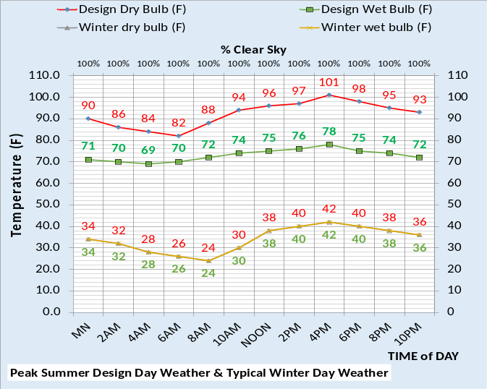
Figure 2: Design Day & Winter Day Weather
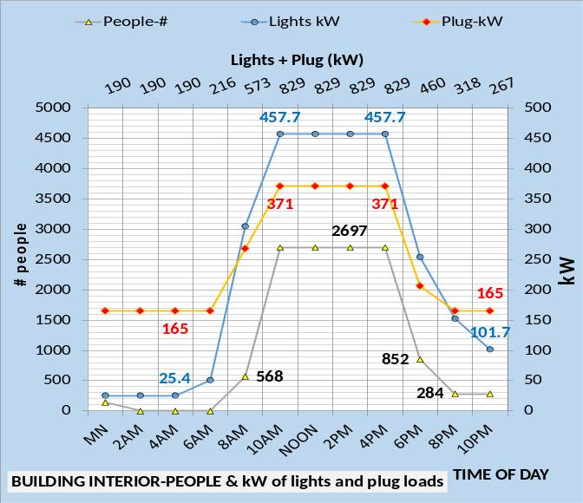
Figure 3: Light kW, Plug kW, & number people

Figure 3 gives the light and plug kW demand per time of day and also the number of people in the building as interpreted from Liu⁵. The lights and plug loads track well to the number of people in the building; a good shut down system is assumed by Liu⁵.
Figures 1, 2, & 3 give the basic data required to define the (SEE) Model building.
Model Characteristics
The following summarizes the basic characteristics of this (SEE) Model.
- The (SEE) Model is the simultaneous solution of basic HVAC equations.
- The (SEE) Model is of any 24-hour day.
- The building is modeled as five zones, four perimeter wall zones and the interior of the building.
- The building is modeled with all loads of Figure 3 in the interior of the building plus the roof load. The perimeter load is defined by the weather conditions of Figure 2 plus infiltration or exfiltration.
- The author expects some load values, efficiencies, and analyses will be questioned. That’s good; the objective is to present an approach to real time building energy modeling and not present the (SEE) Model given here as the final model. Modifications to the model based better data is a part of this (SEE) Model concept.
- The (SEE) Model requires that the energy into the building and plant equals the energy out^{1,2} just as occurs with a real building and plant. System energy balance is an integral part of the (SEE) Model concept given by Article 6.
- The (SEE) Model provides the ability to benchmark a building’s energy performance, on any day, against any ASHRAE Standard design, in this case ASHRAE Standard 90.1-2010 as interpreted from Liu⁵. Nelson⁴ will provide benchmark data for varies cities at real weather conditions⁶.

Table 1 gives building design and control characteristics of the system to be established here as the benchmark best designed and controlled Standard 90.1-2010 building⁵ and plant¹³. Table 1 is consistent with Figures 1, 2, & 3.

Building Location and Design⁵
- Location=Kansas City Mo.
- Ambient temperatures=Figure 5
- Percent clear sky=100%.
- Building design per Liu⁵
- Percent wall glass 37%
- Peak lights kW .81 watts/ft²
- Peak plugs kW .66 watts/ft²
- Return air to building perimeter.
- Duct design static 5.5 in water
- Fan powered terminals not installed
- Return air fans not installed
Building Control
- Lights on/off control- 6% on after hours.
- Plugs on/off control-44% on after hours
- Building pressure control=yes
- Supply air = 55F
- Supply water 44F-44.5F
- Stats controlled = Yes
- Perimeter heat air temp=105F.
- VAV fan duct pressure control=yes
- Fresh air CFM control=yes
- Fresh air heat stat set point=42F
Plant Design & Control
- Chiller/Tower selection¹³.
Table 1: Ideal Design & Control

Energy Balance
System energy balance analyses is a fundamental requirement and therefore tool of a (SEE) Model. Figure 4 top chart gives the energy balance of the building design defining the plant load as 864.6 ton for one of the six buildings served by the central chilled water plant. This design energy balance of Figure 4 would have been determined during the design of the building and plant. The basic equations and manufactures data required to determine the design energy balance are the basic equations of this (SEE) Model. Figure 4 also gives the (SEE) Model energy balance of the building at the 4PM winter temperatures of 42F dry bulb and wet bulb. The building shell load and fresh air load are negative values and 27.6 ton of perimeter heat is required to maintain space comfort.
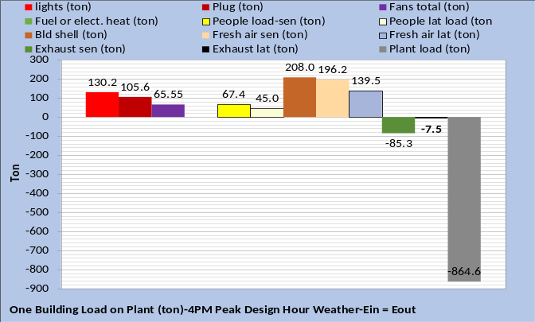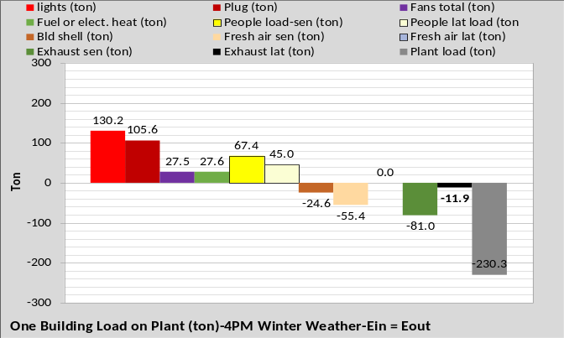
Figure 4: One Building-Top chart energy balance at design 4PM of Figure 2-Bottom chart energy balance at winter 4PM of Figure 2

Comparing the charts of Figures 4 illustrates that the lights and plug loads are the same for design day and the winter day. Total building kW slightly decreased at winter weather conditions. Summing the lights, plugs, and fans of the top chart gives 301.35 ton. The bottom chart includes perimeter heat and sums to 290.9 ton. Perimeter heat is required for winter operation and the fans kW decreased due to less load. One building gives a plant load, at 101F outside temperature, of 864.6 ton as given by Figure 4, reducing to 230.3 ton at winter conditions of 42F outside temperature.
As stated above the top chart would have been determined during the design of the building and plant and the bottom chart could also have be determined by desk top calculations, however the (SEE) Model accomplished the task by simply inputting the winter weather values and adjusting the plant number of chiller/towers on to provide 44F supply water.
The fundamental objective of the (SEE) Model is to model the performance of a system at any given hour or day. However, estimates of annual (EUI) values can be determined. Following are (SEE) Model estimates of annual (EUI) values that put into perspective the effect of changes in design and control of a building and plant as given by Tables 1-4.
(EUI) Estimates (kbtu/ft²-yr)

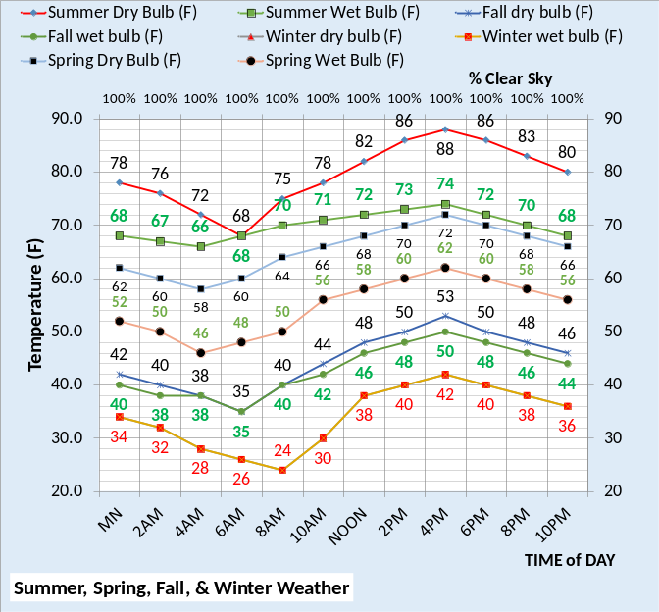
Figure 5: Assumed weather for (kbtu/ft²) estimates

Figure 5 gives the assumed weather conditions for the following (SEE) Model estimates of annual (EUI values. For Table 1 conditions Figure 6 gives the (SEE) Model (EUI) estimated of about 38.2 (kbtu/ft²-yr), a value that is close to the DOE value of about 43 (kbtu/ft²-yr) for new constructed large office buildings. However, Kansas City reports values in the order of 73 (kbtu/ft²-yr) for existing office buildings.
Table 1 gives 22 design and control decisions that were made for the building as defined by the figures and discussion thus far. Changing any one of the 22 items would change the building energy consumption and therefore the (EUI) value, perhaps explaining the Kansas City real building values being greater than the DOE values and this (SEE) Model estimate of the Table 1 system.

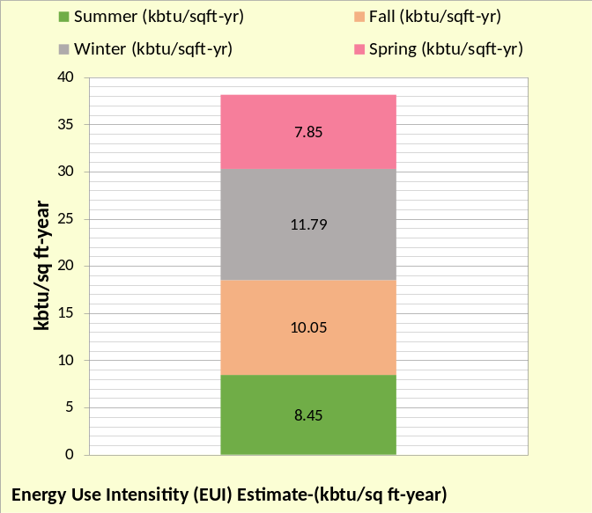
Figure 6: (EUI) estimate-Table 1 system

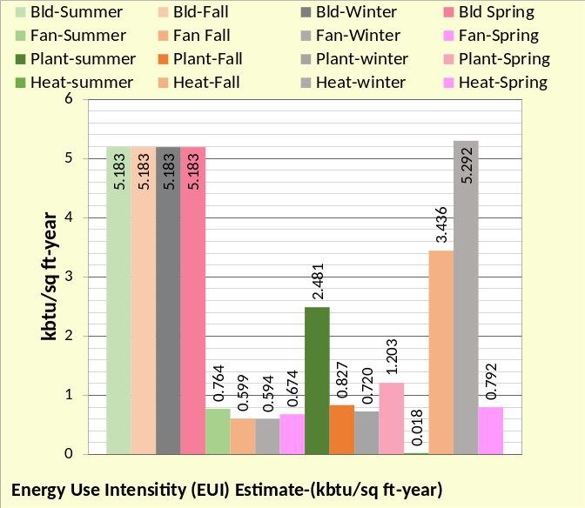
Figure 7: System Components-Table 1 System
Figure 7 breaks the (SEE) Model (EUI) estimate into four values for each of the four seasons. The largest value is the building load due to lights and plug loads and is the same for all seasons. The fan value is relatively constant and the plant load is high at summer conditions and significantly less for the other three seasons. The heat load is high during the winter and fall seasons. Figure 7 illustrates that the building lights and plug loads are predominate with the summer plant and fall and winter heat being significant values. Note that the winter heat value is the largest value.
Add Powered Terminals and Return Fans
Table 1A illustrates the system with fan powered terminals¹¹ and return fans¹² installed into the (SEE) model air handler system.

Building Location and Design⁵
- Location=Kansas City Mo.
- Ambient temperatures=Figure 5
- Percent clear sky=100%.
- Building design per Liu⁵ changed.
- Percent wall glass 37%
- Peak lights kW .81 watts/ft²
- Peak plugs kW .66 watts/ft²
- Return air to perimeter.
- Duct design 5.5 in water
- Fan powered terminals installed
- Return air fans installed
Building Control
- Lights on/off control- 6% on after hours.
- Plugs on/off control-44% on after hours
- Building pressure control=yes
- Supply air = 55F
- Supply water = 44F to 44.5F
- Stats control = Yes
- Perimeter heat air temp=105F.
- VAV fan control=yes
- Fresh air CFM control=yes
- Fresh air heat stat set point=42F
Plant Design & Control
- Chiller/Tower selection¹³.
Table 1A: Ideal Design & Control

At design conditions the fan powered terminals slightly increase the supply air temperature to the perimeter and interior of the building and the return fans slightly increase the air return temperature to the VAV fans. Article 4 will provide details.

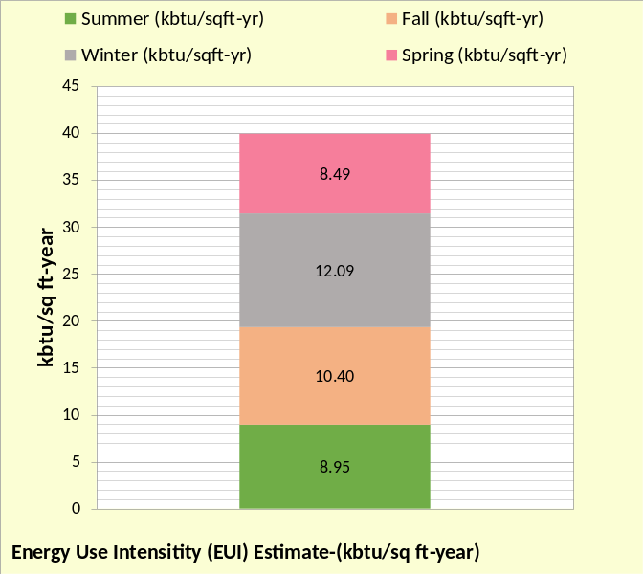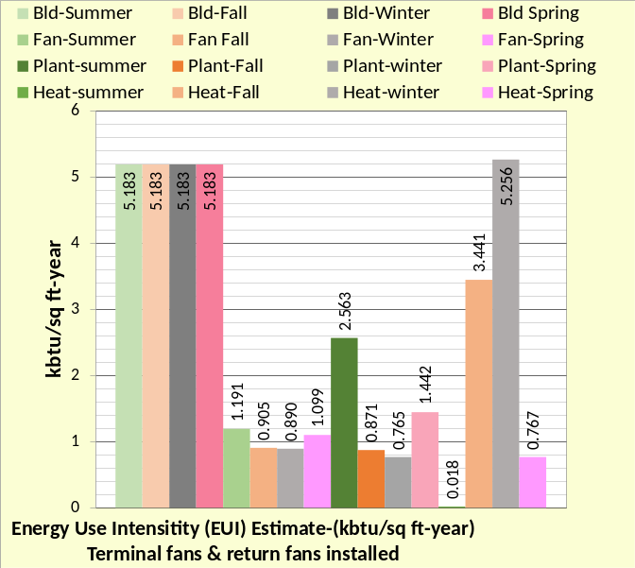
Figure 8: (SEE)Model Estimate (EUI) (kbtu/ft²-yr) with fan powered terminals & return fans added to design-Table 1A

Figure 8 illustrates the increases in (kbtu/ft²-yr) for the four seasons. Comparing to Figure 6, the terminal and return fans increased the (EUI) value from about 38 (kbtu/ft²-yr) to 40 (kbtu/ft²-yr), an increase of about 5%.
Figure 8 bottom chart can be compared to Figure 7. The building value, consisting of the lights and plug loads does not change per season nor does it change with the addition of terminal and return fans. The fan values increased about 50% by adding powered terminals and air return fans.
The plant (kbtu/ft²-yr) also increased due to the terminal and return fans because of the additional plant load provided by the additional kW demand. The plant value increased from about 2% up to 6% depending on the season. The terminals and return fans add heat to the air, therefore a tendency for the perimeter heat to slightly decreased as given by the winter heat values of Figures 8 & 7. Article 4 will give greater detail.

Building Design Changes
Building Location and Design⁵
- Location=Kansas City Mo.
- Ambient temperatures-Figure 5
- Percent clear sky 100%.
- Building design per Liu⁵ changed.
- Percent wall glass from 37% to 50%
- Peak lights kW .81 to 1.01 watts/ft²
- Peak plugs kW .66 to .822 watts/ft²
- Return air to perimeter-no change.
- Duct design 5.5 to 7.0 in water
- Fan powered terminals installed
- Return air fans installed
Building Control
- Lights on/off control 6% on after hours.
- Plugs on/off control 44% on after hours.
- Building pressure control, no infiltration.
- Supply air = 55F
- Supply water = 44F to 44.5F
- Stats control-yes.
- Perimeter heat air temp-105F.
- VAV fan static control-yes.
- Fresh air CFM control-yes.
- Fresh air heat stat set 42F.
Plant Design & Control
- Chiller/Tower selection¹³.
Table 2: Design issues

Table 2 illustrates the design changes made to Table 1A conditions, increasing the estimated annual (EUI) from 40 (btu/ft²-yr) of Figure 8 to 52 (btu/ft²-yr) of Figure 9 top chart. Increasing the percent wall glass increases solar load and transmission during the summer season and increases heating required in the winter due to transmission, offset by solar reducing heating required. Comparing Figure 8 top chart to Figure 9 the summer (kbtu/ft²-yr) value increased from 8.95 to 11.50 a 28% increase. The increase in lights and plug kW plus the increase in static pressure of the VAV duct system contributed to the increased (EUI) value.
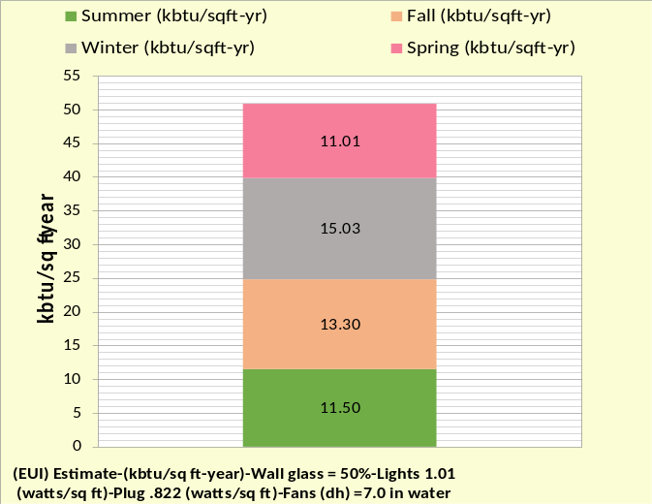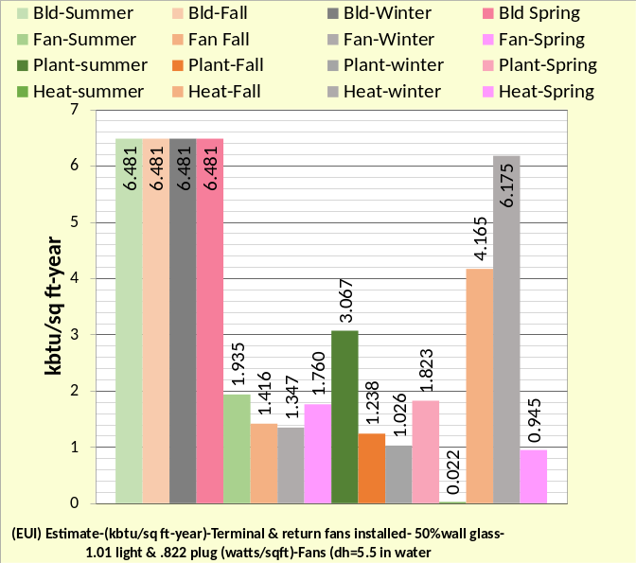
Figure 9: (EUI) values-Table 2 Performance

The building increased from 5.183 to 6.481 due to the increased peak lights kW and plug kW. The plant (kbtu/ft²-yr) increased from 2.563 to 3.067 during summer conditions. The biggest percent increase is fan power due to the increase in duct static pressure from 5.5 to 7.0 inches water.

Building Control Issues

Building Location and Design⁵
- Location=Kansas City Mo.
- Ambient temperatures-Figure 5
- Percent clear sky 100%.
- Building design per Liu⁵ changed.
- Percent wall glass 37%
- Peak lights kW .81 watts/ft²
- Peak plugs kW .66 watts/ft²
- Return air to perimeter.
- Duct design 5.5 in water
- Fan powered terminals installed
- Return air fans installed
Building Control
- Lights on/off control from 6% on after hours to 67% on.
- Plugs on/off control from 44% on
after hours to 67% on.
- Building pressure control, infiltration .2 cfm/sq ft wall max-varies as AH cfm.
- Supply air = 55F
- Supply water = 44F to 44.5F
- Stats control-no.
- Perimeter heat air from 110F to 90F.
- VAV fan static control-no.
- Fresh air CFM control-no.
- Fresh air heat stat from 42F to 60F.
Plant Design & Control
- Chiller/Tower selection¹³.
Table 3: Control Issues

Table 3 are control changes made to Table 1A. Table 2 changes are not in Table 3. Lights and plug loads are modeled as turning down to 67% at night verses 6% for the Liu⁵ design of Table 1 and Table 1A. Infiltration is modeled with a maximum .2cfm per wall square foot occurring at peak VAV air flow (CFM); infiltration is modeled as proportional to VAV air flow. Supply air is not changed from 55F. Supply air can be controlled to minimize energy but will not be addressed here; a later study may be provided. Stat control is the task of keeping the perimeter stat less than the interior stats during the winter and greater during the summer if return air returns at the perimeter of the building as modeled here. Lowering the heating air temperature from 110F to 90F increases heating energy. Relaxed VAV static pressure reset¹⁶ results in increased fan energy use. The Liu⁵ design provides CFM of fresh air consistent with people in the building. Table 3 models turn down to 72% after hours and sets the fresh air heating stat from 42F to 60F. Each of these control changes can be evaluated by the (SEE) Model⁴.
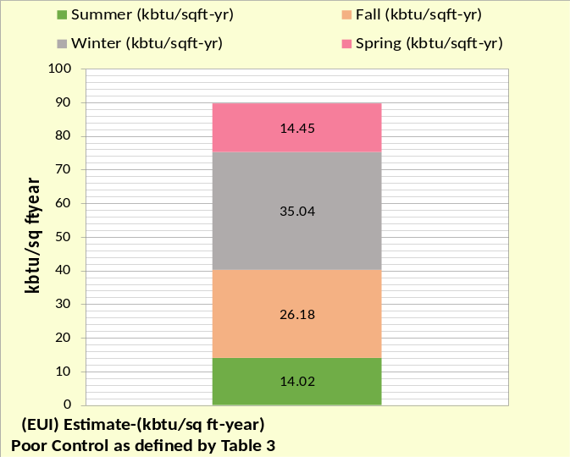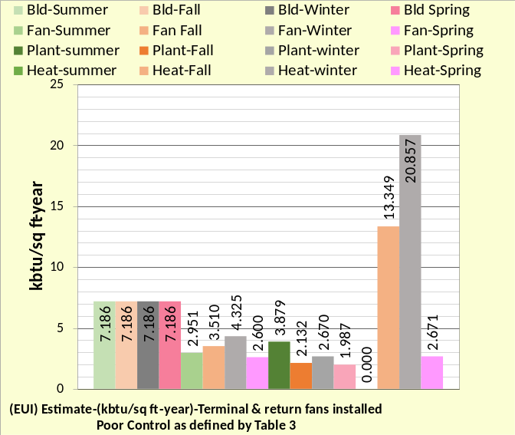
Figure 10: (EUI) values-Table 3 performance
Figure 10 gives the (SEE) Model result of the control changes made per Table 3. The estimated (EUI) increased to 90 (btu/ft²-yr), a 50-point increase from Figure 8 conditions and almost 40 points more than the Table 2 & Figure 9 conditions. Clearly how a system is controlled can have a major effect on its performance. Figure 10 illustrates that all components of the system increased with heating in the winter the largest increase compared to Figures 8 & 9.

Building Design & Control Issues

Building Location and Design⁵
- Location=Kansas City Mo.
- Ambient temperatures-Figure 5
- Percent clear sky 100%.
- Building design per Liu⁵ changed.
- Percent wall glass from 37% to 50%
- Peak lights kW .81 to 1.01 watts/ft²
- Peak plugs kW .66 to .822 watts/ft²
- Return air to perimeter-no change.
- Duct design 5.5 to 7.0 in water
- Fan powered terminals installed
- Return air fans installed
Building Control
- Lights on/off control from 6% on after hours to 67% on.
- Plugs on/off control from 44% on
after hours to 67% on.
- Building pressure control-infiltration .2 cfm/sq ft wall max-varies as AH cfm.
- Supply air = 55F
- Supply water = 44F to 44.5F
- No stats control.
- Heating air temp from 110F to 90F.
- No VAV fan static pressure control.
- No Fresh air CFM control.
- Fresh air heat stat from 42F to 60F.
Plant Design & Control
- Chiller/Tower selection¹³.
Table 4: Design & Control Issues

Table 4 combines the issues of Table 2 & 3 and Figure 11 gives the results. The (SEE) Model estimate of EUI (kbtu/ft²-yr) is about 10 points greater than the individual increases of Figures 9 & 10 at 110 (kbtu/ft²-yr).
Any office building or campus designed to or near ASHRAE Standard 90.1-2010 should have an annual (EUI) of about 40 to 50 (kbtu/ft²-yr). Values greater than this could be because the building is operating at control conditions that can be changed and therefore bring the building into efficient operation. Perhaps the greatest value of a (SEE) Model is the ability to define what the building should be using on any given 24-hour day.

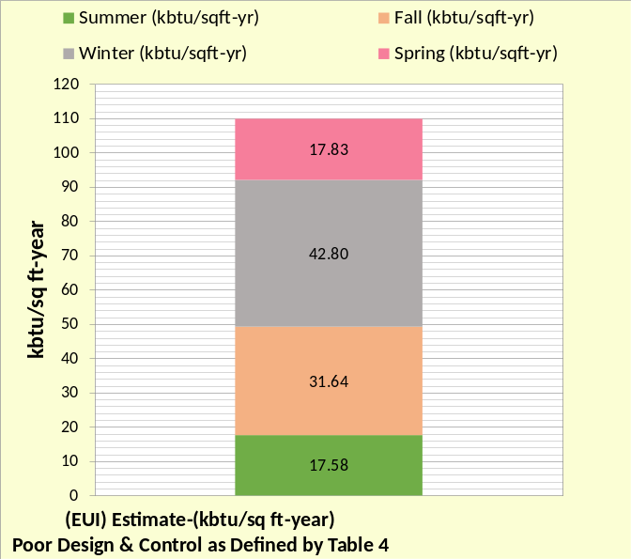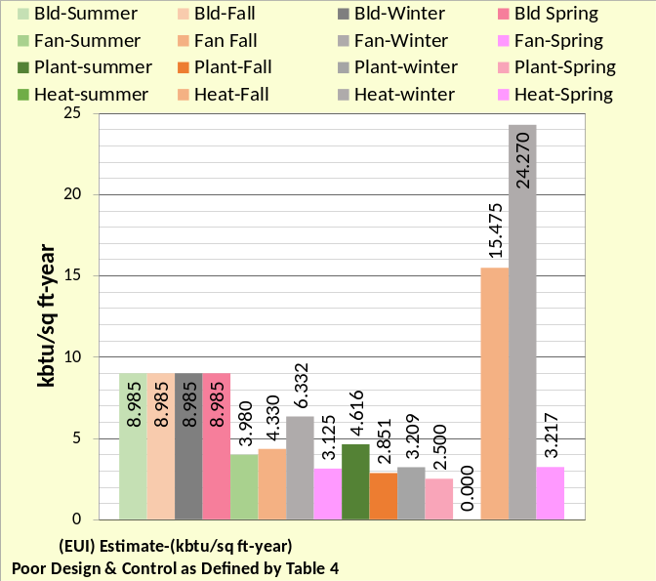
Figure 11: Table 4 performance
What is wrong with controls or perhaps air duct construction may be obvious or can be determined with acceptable effort. A (SEE) Model of the system sets the goal of what the system should be using and also assists in performing an energy balance analysis that can identify problems of control or design. Consider for example that a system is being analyzed on a given two or three days and the weather significantly changes during the time. The weather is input to the (SEE) Model setting a new goal for the system for each day.
References
- Introduction to Thermodynamics and Heat Transfer. 1956 Prentice-Hall, Inc. by David A. Mooney.
- Thermal Environmental Engineering third edition. 1998 Prentice-Hall Inc. by Thomas H. Kuehn, chapter 3.
- ASHRAE Journal May 2016. “Modeled Performance Isn’t Actual Performance”
- Nelson, Kirby. “System Energy Equilibrium (SEE) Building Energy Model Development & Verification”. http://kirbynelsonpe.com/
- Liu, B. May 2011. “Achieving the 30% Goal: (copy and paste) https://www.energycodes.gov/sites/default/files/documents/BECP_Energy_Cost_Savings_STD2010_May2011_v00.pdf
- Real weather data www.wunderground.com/
- Nelson, K. “7 Upgrades to, Reduce Building Electrical Demand” ASHRAE Journal, December, 2006,
- Nelson, K. “Simulation Modeling of a Central Chiller Plant” CH-12-002. ASHRAE 2012 Chicago Winter Transactions.
- Nelson, K. “Simulation Modeling of Central Chilled Water System” CH-12-003. ASHRAE 2012 Chicago Winter Transactions.
- Kavanaugh, S. “Fan Demand and Energy” ASHRAE Journal, 2000.
- Faris, Gus “Fan-Powered VAV Terminal Units” ASHRAE Journal November 2017
- Kettler, John “Return Fans or Relief Fans” ASHRAE Journal April 2004.
- Taylor, S. 2011. “Optimizing design & control of chiller plants.” ASHRAE Journal (12).
- Nelson, Kirby “The System Energy Equilibrium Model for Chiller Plants, Part 1” Engineered Systems, July 2020.
- Marley Tower SPX Cooling Technologies UPDATE Version
- ASHRAE Journal June 2007. “VAV System Static Pressure Setpoint Reset” by Steven T. Taylor

Anatomy of a Real Time Building Energy model
Part 2-(SEE) Building Model
Article 2 has two purposes; one is to give values and understanding of the Table 1 system operation at design day and winter day weather, and to also demonstrate the level of detail that must exist in a (SEE) model if it is to model the real time performance of a system.
Perimeter & Interior Loads
Figure 12 top chart gives the building perimeter loads due to design day weather conditions of Figure 2, with the exception, as stated above in model characteristics, the roof load is modeled as an interior load. The bottom chart gives the perimeter loads due to winter conditions. The only change made in the (SEE) Model going from the top chart to the bottom chart was inputting the winter weather conditions of Figure 2. The (SEE) Model equations made all changes of Figure 12 bottom chart consistent with the requirement that energy into the building equals energy out of the building.
Figure 12 top chart, secondary horizontal axis, gives the perimeter sensible load. At 4PM the 165-ton load is made up of 82.6 ton solar, 63.6-ton glass transmission, and 19-ton wall transmission for a total of 165-ton sensible load as shown on the chart. Add to this the roof load of 43.1 ton of Figure 13 top chart gives the 208-ton shell load of Figure 4 top chart where shell load is a measure of a buildings structural design as related to energy.
Figure 12 bottom chart is consistent with the winter energy balance of Figure 4 bottom chart. All return air is modeled as returning to the perimeter of the building, therefore during winter operation a one-degree F difference in stat set points can transfer heat energy from the interior of the building to the perimeter if the perimeter stat is set one degree less than the interior stat. At 4PM stat control results in a 15.6-ton energy transfer from the interior of the building to the perimeter of the building as shown by Figure 12 bottom chart.
The bottom chart of Figure 4 shows the shell load is minus 24.6 ton at 4PM winter conditions. Figure 12 bottom chart, secondary horizontal axis, gives a perimeter sensible load of minus 17.14 ton at 4PM made up of 64.2 ton solar, minus 19-ton wall
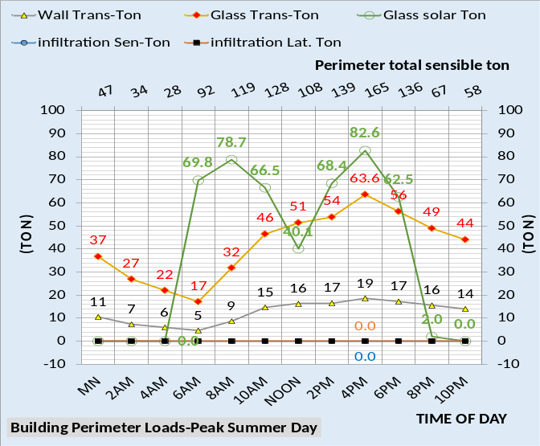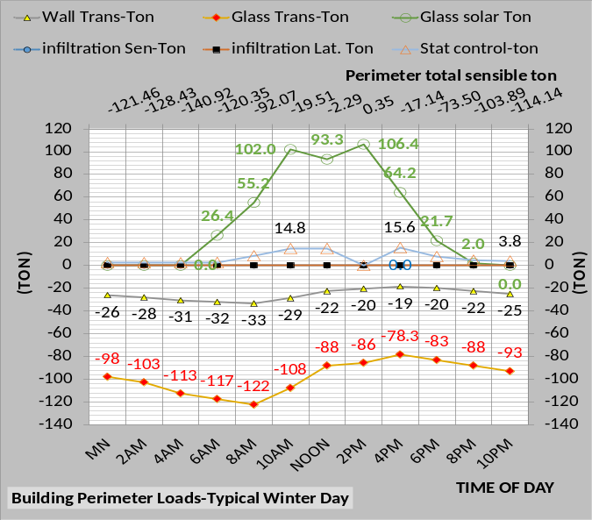
Figure 12: Building Perimeter Loads

transmission and minus 78.3-ton glass transmission for a total of minus 33.1-ton building wall load; offset by the 15.6-ton stat control energy transfer for a total perimeter load of minus 17 ton as shown by Figure 12 bottom chart secondary horizontal axis.
The shell load of Figure 4 bottom chart is made up of the minus 33.1-ton wall load plus the roof load of 8.1 ton of Figure 13 bottom chart for a shell load of (-33.1 + 8.1 = -25 ton) as shown by the winter energy balance of Figure 4 bottom chart.
Figure 13 gives the interior loads that do not change with winter conditions except for the roof load. The roof load is negative for most of the winter hours as shown by the bottom chart and becomes positive 8.1 ton due to roof solar load.

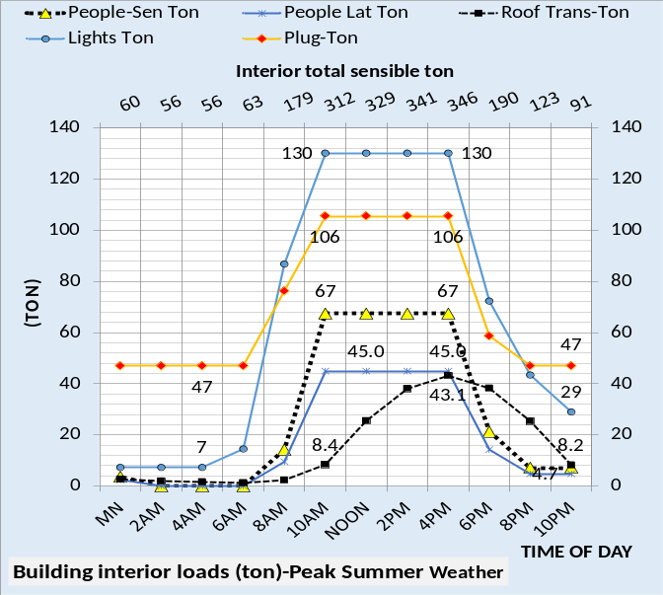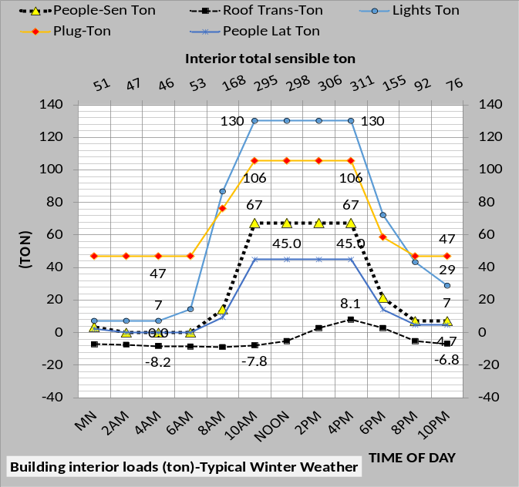
Figure 13: Building Interior Loads

VAV Fan Performance at Design Conditions
Figure 14 gives the VAV fan performance at design day and winter day conditions of Figure 2. Time of day is not shown but is the same as given by all above figures. Both charts of Figure 14 illustrate that the interior CFM of air supply is significantly greater than the perimeter. Winter perimeter CFM is very low at mid-day conditions illustrating a reason, other than energy transfer, that interior air is modeled as returning to the perimeter of the building to assist in fresh air ventilation.
At 4PM design day the interior sensible load is;
Air (ton) = CFM * 1.08 * (75F – 55F)/12,000
Where 75F is the interior stat set point and 55F is the temperature of the supply air to the interior.
Air (ton) = 192,399 CFM * 1.08 * (20F)/12,000
= 346 ton as shown by Figure 13 top chart.
At 4PM design day the perimeter sensible load is;
Air (ton) = 91,607 * 1.08 * (20)/12,000
= 165 ton as shown by Figure 12 top chart.

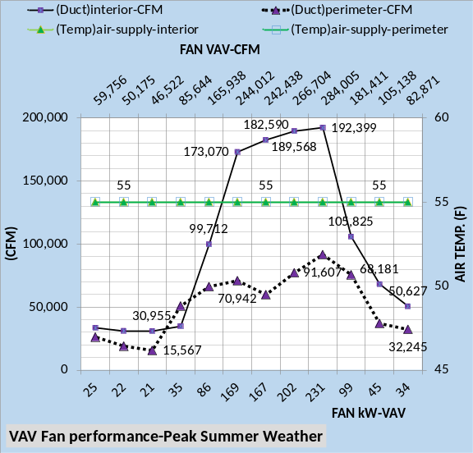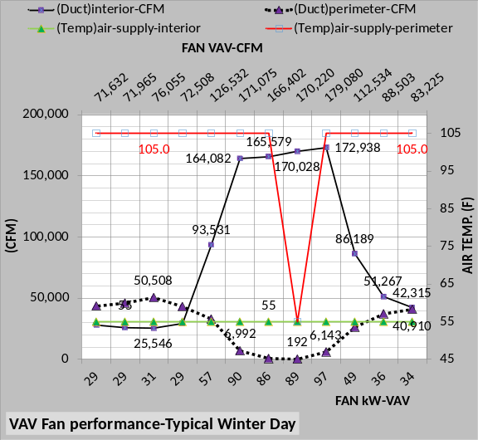
Figure 14: VAV Fan Performance
VAV Fan Performance at Winter Conditions
At winter conditions the supply air temperature to the perimeter at 4PM is 105F as shown by the bottom chart of Figure 14 and the perimeter stat is set at 74F as discussed above, therefore perimeter sensible load at winter conditions is;
Air (ton) = 6,143 CFM * 1.08 * (74 – 105)/12,000
= - 17 ton as shown by Figure 12 bottom chart.
Interior Air (ton) = 172,938*1.08*(75-55)/12,000
= 311 ton as shown by Figure 13 bottom chart.
The bottom chart of Figure 14 shows that 105F heating air is required on the building perimeter except for 2PM when perimeter heat is not required and 55F air is supplied to the perimeter. Figure 15 gives more detail.

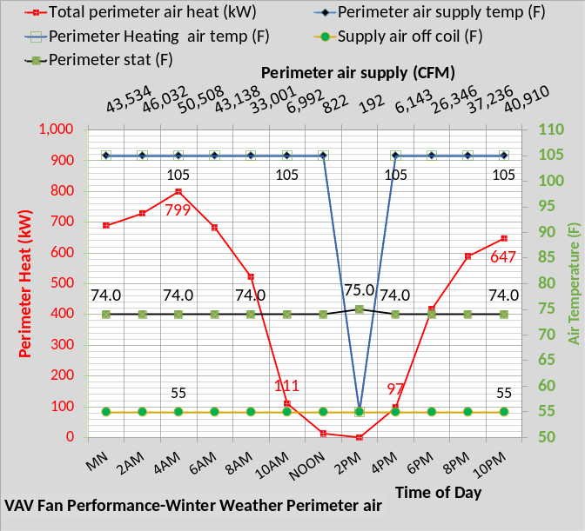
Figure 15: VAV Performance-Perimeter

Figure 12 bottom chart shows the perimeter sensible load at 10PM is minus 114.14 ton. To meet this load the air supply temperature to the perimeter is 105F. The 55F supply air off the coil must be heated to 105F. From Figure 15 at 10PM;
Air heat ton = 40,910 CFM * 1.08 * (105F - 55F) = 184.1-ton heat.
184.1-ton heat * 3.517 kW/ton = 647 kW required to heat the 55F coil supply air to 105F to meet the heating requirement of the perimeter, as shown by Figure 15 at 10PM.
VAV Fan CFM & Air Temperatures
Figure 16 illustrates the air CFM and temperatures for design day. At 4PM the building return air to the inlet of the VAV fans is 236,619 CFM as shown by the bottom chart and 75F return air as shown by top chart. Mixed with 47,386 CFM of fresh air at 101F resulting in an air mixed temperature of 79.34F and 284,005 CFM of air to the inlet of the VAV fans as shown by Figure 16. The VAV fans require 231 kW, Figure 18, to move the 284,005 CFM of air and in the process heats the air from 79.34F to 81.90F as shown by Figure 16 bottom chart.
The heating of the air as it passes through the VAV fans is an example of a required characteristic of the (SEE) Model.
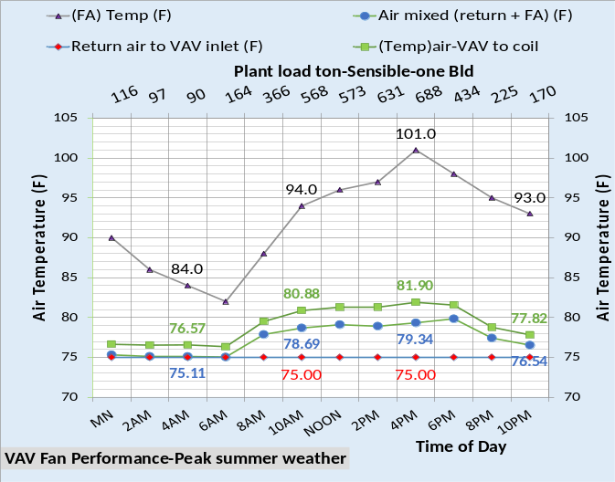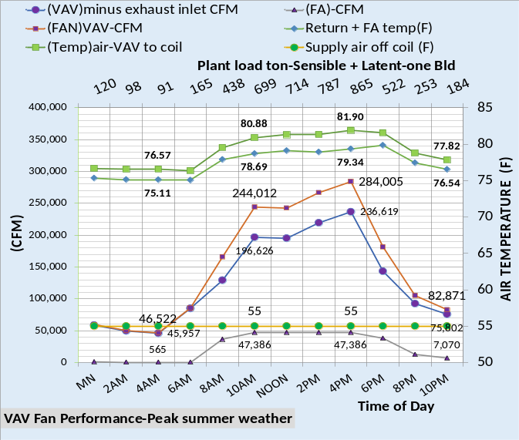
Figure 16: VAV Fan Performance-Design Day
As the air is heated it adds load and in turn the VAV fans must increase CFM to meet the increased load which increases VAV kW and so on until steady state is achieved. The set of (SEE) Model equations are analogues to a set of feedback control equations that seek a new steady state for a change in conditions.
The Table 1 building is modeled as zero air infiltration into the building; therefore, the exhaust CFM, not shown by Figure 16, is equal to the fresh air CFM into the building. Infiltration and/or exfiltration significantly changes the air system which will be addressed at a later article or at Nelson⁴.
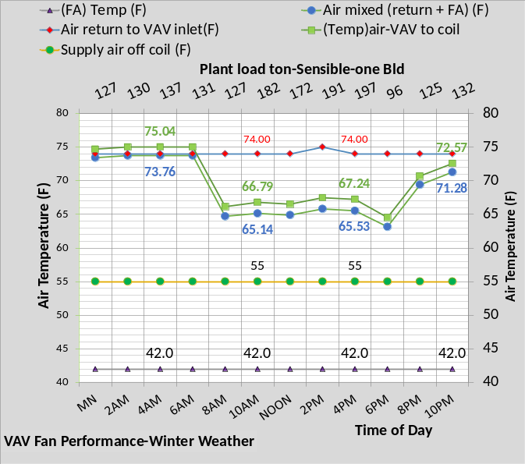
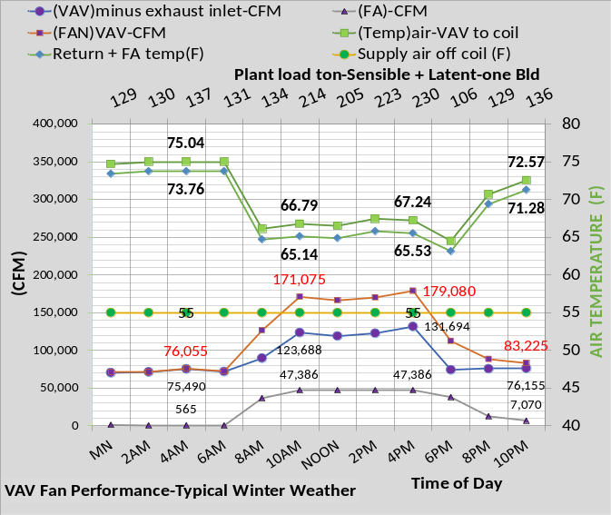
Figure 17: VAV Fan Performance-Winter Day

The secondary horizontal axis of Figure 16 gives the load the VAV fans transferred to the coils and the coils present to the plant. At 4PM the sensible load is 688 ton and the sensible plus latent plant load is 865 ton. Figure 19 below gives the latent loads transferred by the VAV fans to the plant.
Figure 17 gives the same data as Figure 16 but for winter weather conditions. Figure 17 illustrates the air CFM and temperatures for winter weather of Figure 2. At 4PM the building return air to the inlet of the VAV fans is 131,694 CFM at 74F; mixed with 47,386 CFM of fresh air at 42.0F resulting in an air mixed temperature of 65.53F and 179,080 CFM of air to the inlet of the VAV fans. The VAV fans require 97 kW, Figure 18 bottom chart, to move the 179,080 CFM and heats the air to 67.24F as shown by Figure 17. As stated above the building is modeled as zero air infiltration into the building; therefore, the exhaust CFM is equal to the fresh air CFM into the building as shown by Figure 17. The secondary horizontal axis of Figure 17 gives the load the VAV fans transfer to the coils and the coils present to the plant. At 4PM the sensible load is 197 ton and the sensible plus latent is 230 ton. Note the outside temperature of Figure 2 is 42F or less. The fresh air temperature to the VAV fan inlet is controlled to 42F with heat added. Figure 20 below defines the kW required. Figure 19 below gives the latent loads transferred by the VAV fans to the plant.

VAV FANS Performance
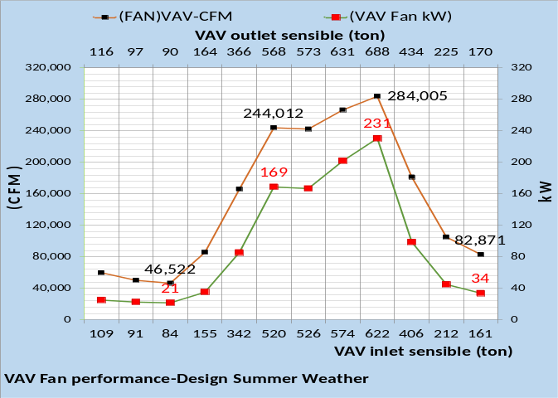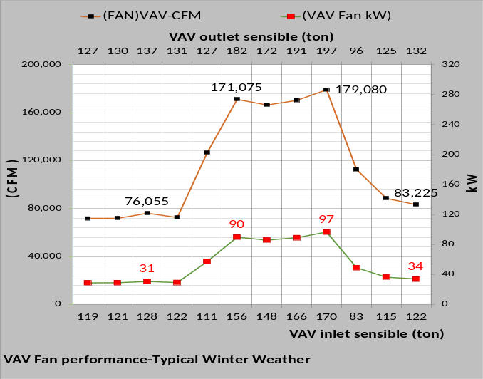
Figure 18: VAV Fan Performance

Figure 18 gives the VAV fan kW, (CFM), and inlet sensible load (ton) and sensible load exiting the VAV fans where load is added by the VAV fan kW.
The VAV fan model is based on Kavanaugh¹⁰ and is the most complex set of model equations, as illustrated by above Figures, except for the chiller/tower model to be addressed by article 3.

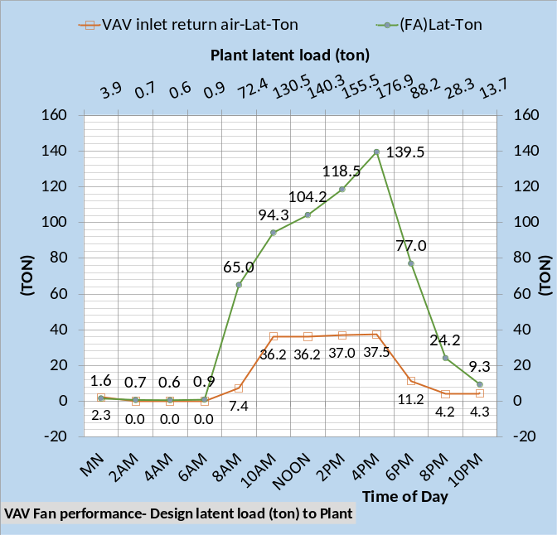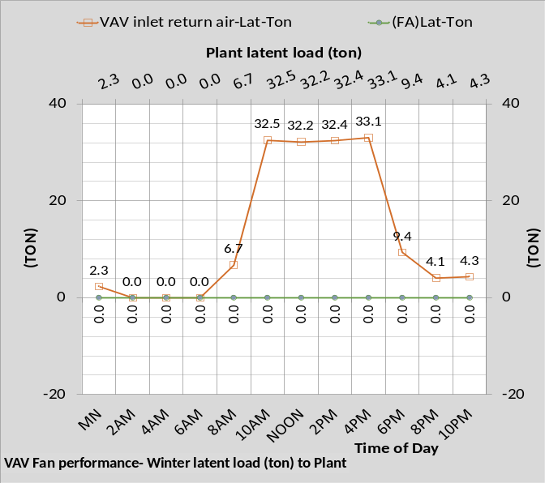
Figure 19: VAV Fan transfer of latent load to Plant

Figure 19 gives the latent load transferred by the VAV fans to the plant. Latent load is a result of people in the building and fresh air input to the inlet of the VAV fans. Air infiltration will add latent load but is modeled as zero for the Table 1 system. Table 1A and Table 2 system also model air infiltration as zero but Tables 3 & 4 system have infiltration.

Building and Air handler kW Demand

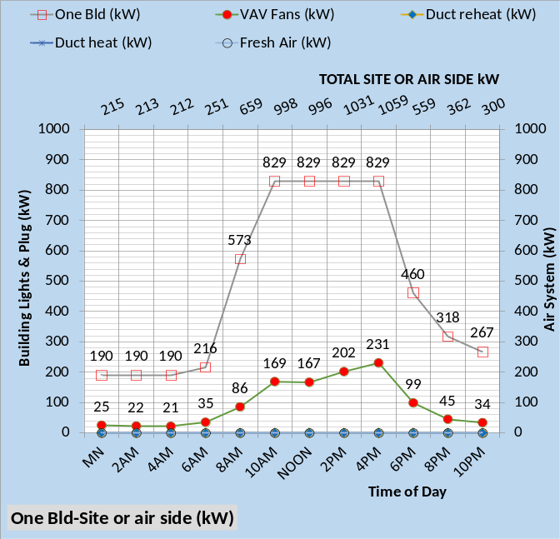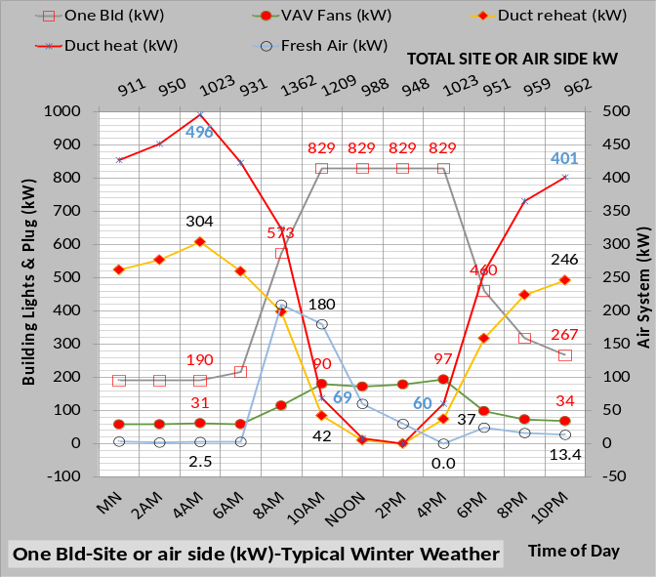
Figure 20: One Building & Fan System (kW)

Figure 20 gives the kW demand total for a building and air handler system or site, not including the plant kW. Comparing the total site kW on the secondary horizontal axis’s illustrates that kW demand during winter operation is significantly greater for all hours except noon, 2PM, & 4pm. Figure 15 above gives the total perimeter air heat kW required and Figure 20 bottom chart breaks it down into duct reheat kW to bring the 55F coil supply air up to 75F, and duct heat kW required to bring the air from 75F to 105F to meet the perimeter heat load requirement. For example, at 10PM the bottom chart of Figure 20 shows 401 kW for duct heat and 246 kW for duct reheat for a total of 647 kW as shown by Figure 15 at 10PM. Fresh air kW to maintain 42F fresh air into the building is shown by Figure 20 bottom chart as 13.4 kW at 10PM and VAV fan kW at 34 kW for a total site kW of 962 as shown by the secondary horizontal axis of bottom chart Figure 20.

System kW Performance-Six Buildings
Design Day & Winter Day Performance

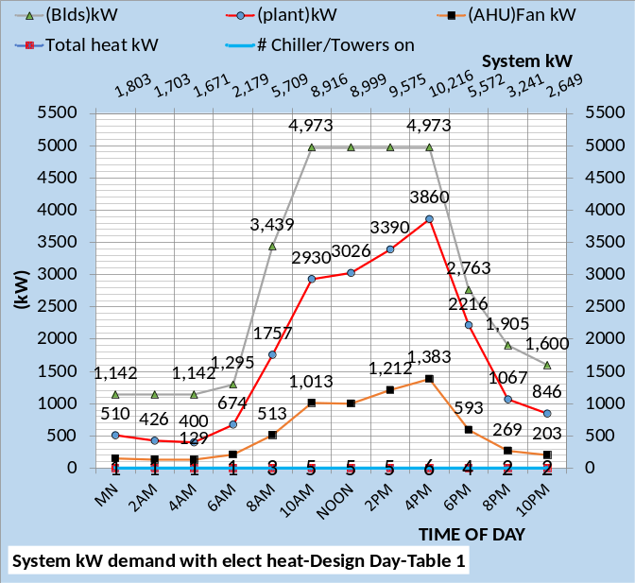
Figure 21: System Performance-Design Day

To this point article 2 has addressed one building with characteristics as defined by Table 1. Introducing the plant requires defining the performance of the six-building campus. All six buildings are modeled with the same characteristics as defined above for one building. Each building could be defined with different characteristics, however that requires more computing power than the author presently has available.
Figure 21 gives the design day performance and Figures 22 & 23 give winter day performance with weather defined by Figure 2. Figure 22 is the electric heat system and Figure 23 is the system with fuel heat.

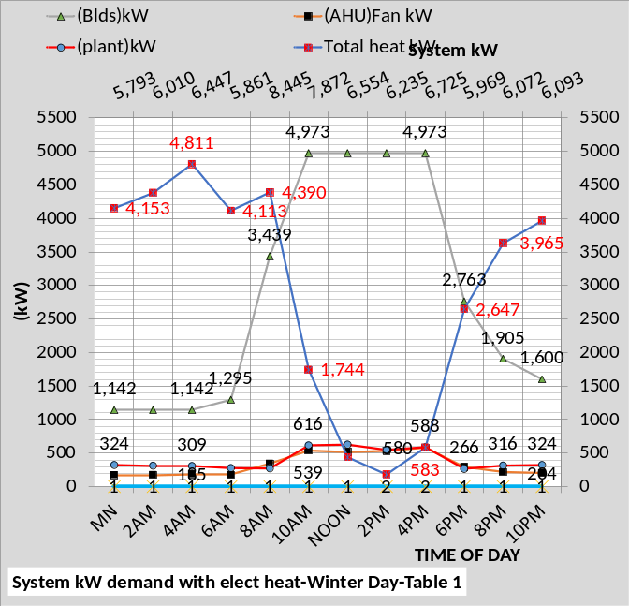
Figure 22: System Performance-Winter Day
Electric Heat

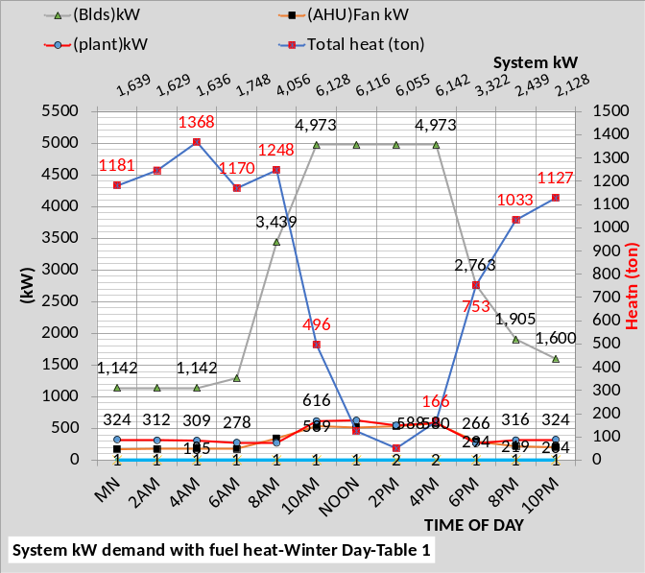
Figure 23: System Performance-Winter Day
Fuel Heat

Comparing the system kW values of Figures 21 & 22 given by the secondary horizontal axis illustrates that winter operation requires significantly more kW during unoccupied hours and close to the design values during occupied hours. The number of chiller/towers on varies from one to six for design day weather and only one to two for winter operation.
Comparing Figures 21 & 23 illustrates that the kW demand during unoccupied hours is close to the same for design day and winter operation of the fuel heat system.

Article Two Summary
Article two had two purpose; one to give values and understanding of the Table 1 system operation at design day and winter day weather, and also demonstrate the detail that must exist in a (SEE) Model if it is to model the real time performance of a system. The author has found that system schematics, too large for this publication, often provide understanding of the system that is difficult with multiply charts. Additional discussion with schematics will be provided at Nelson⁴.
The next article 3 will address plant performance.

Anatomy of a Real Time Building Energy model
Part 3-(SEE) Plant Model
The following will describe the (SEE)¹⁴ Model performance of the plant operating against the load of six buildings.
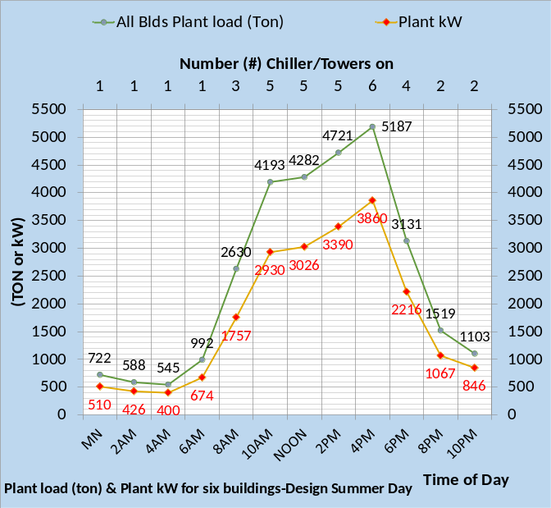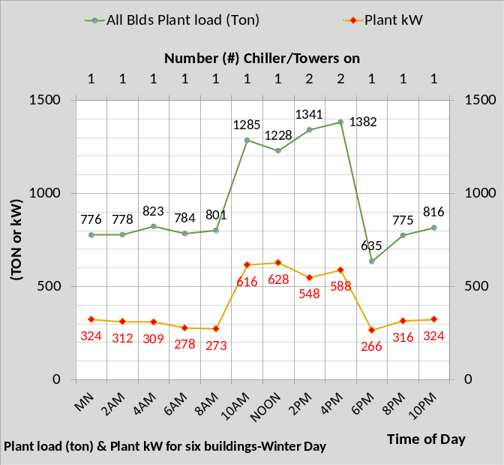
Figure 24: Plant load (ton) & kW demand

Figure 24 gives the plant load (ton) and plant kW demand for design day and winter weather conditions defined by Figure 2. The horizontal axis shows the number of chiller/towers on illustrating the plant operates with only one chiller/tower most of the time during the winter with two chiller/towers required at 2PM & 4PM. During design day operation only one chiller/tower is required during off hours peaking to six chiller/towers at 4PM design hour conditions.

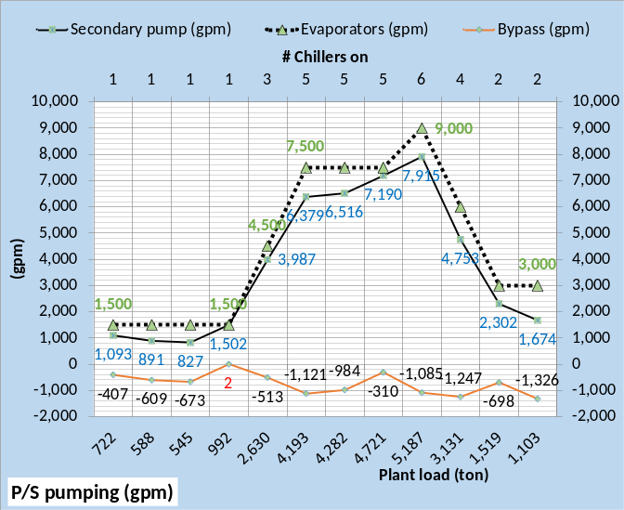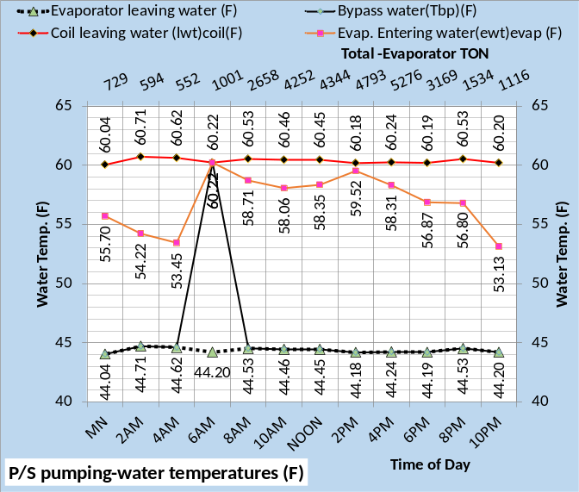
Figure 25: Primary/Secondary pumping-design day

Figure 25 shows the plant load to be picked up by the primary/secondary pumping and delivered to the chiller evaporators. The P/S pumping adds heat to the water therefore the evaporator load as shown by the secondary horizontal axis of Figures 25 & 26 is a little greater than the plant load shown by the primary horizontal axis. The (SEE) plant model assumes that pumping energy is transferred to the water as a function of the pumping efficiency. For example, if the pump is 80% efficient then 80% of the energy to the pump heats the water and 20% goes to the atmosphere.
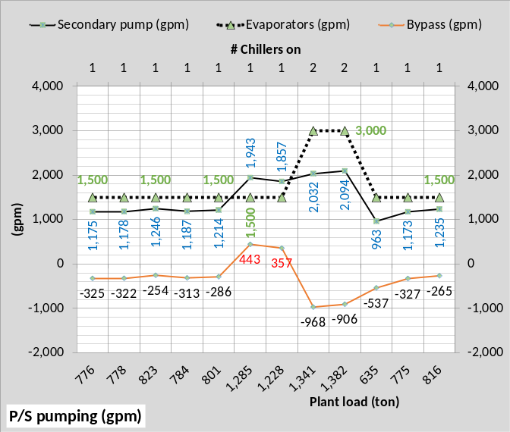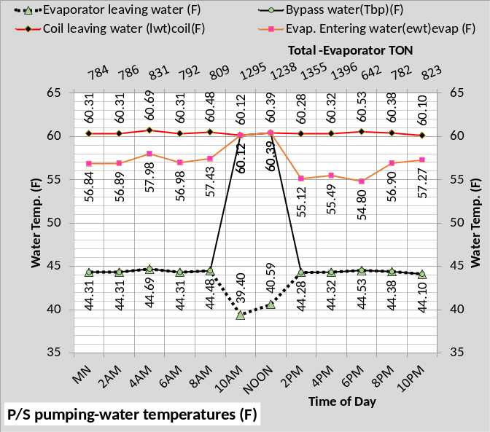
Figure 26: Primary/Secondary pumping-winter

Figure 25, for design day conditions, shows the flow (gpm) is in the wrong direction at 6AM as also shown by the bottom chart. The top chart shows only 2 (gpm) wrong way flow in the bypass therefore essentially no effect on the temperature of water to the coils. Figure 26 shows the same condition for 10AM and noon for winter operation. The top chart shows 443 (gpm) & 357 (gpm) bypass flow requiring the temperature supply off the evaporator to be dropped to 39.4F and 40.59F, shown by the bottom chart, to supply 44F supply water to the coils. A second chiller/tower could be turned on to eliminate the wrong flow in the bypass but that might increase the plant kW. However, that is not necessarily true and is an issue for plant control. Controlling the plant to minimize plant kW is an issue the (SEE) plant model can address and will address in later articles or at Nelson⁴.
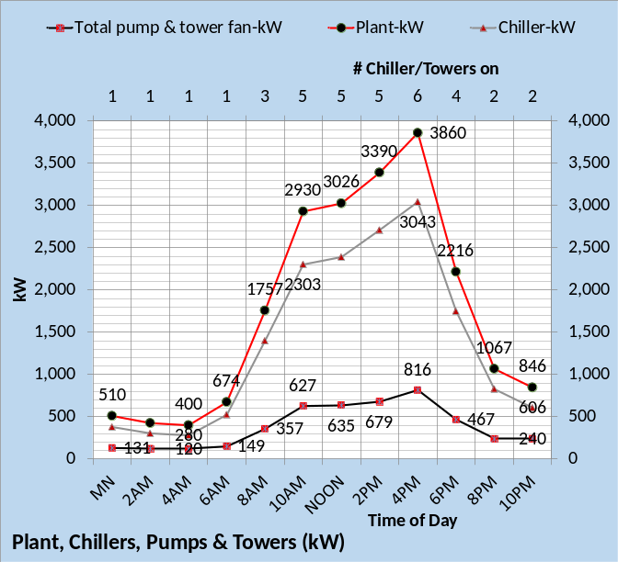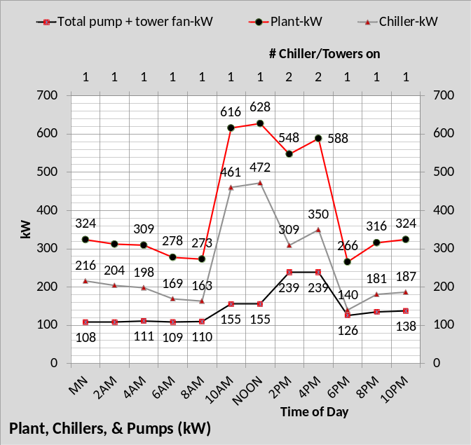
Figure 27: Plant kW-Design day top chart,
Winter day bottom chart
Chiller kW plus pumps and tower fan kW equals plant kW as shown by Figure 27. Plant kW is significantly less during winter operation especially during occupied hours. Afterhours operation with one chiller/tower required brings the plant kW values design day and winter day closer together.
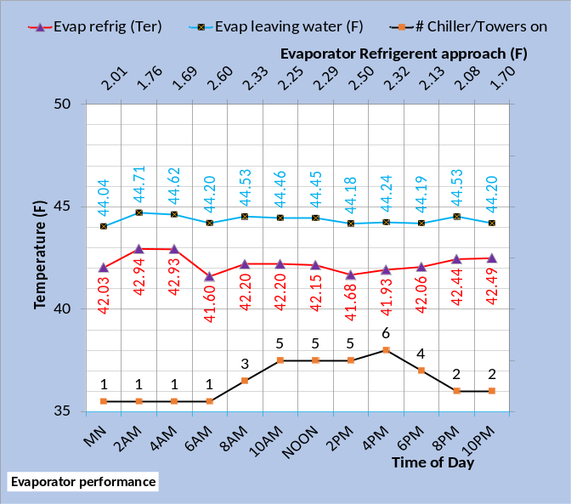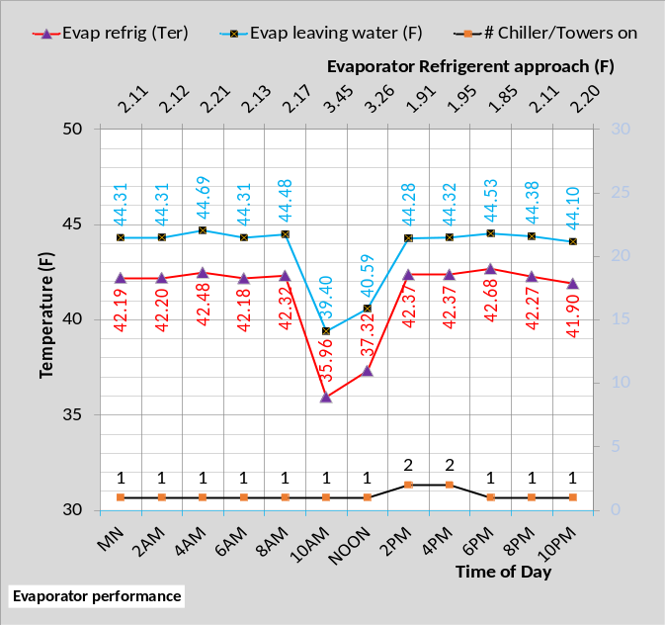
Figure 28: Evaporator performance-top chart design day-bottom chart winter day.
Plant models that duplicate plant performance must model refrigerant temperatures because chiller lift drives chiller kW. The charts of Figure 28 illustrate the importance of evaporator refrigerant approach that is a design characteristic of an evaporator, in general the lower the value the greater the cost of the evaporator and therefore the cost of the chiller. Note how the refrigerant and chilled water supply temperatures must drop when the bypass flow is in the wrong direction, Figures 25 & 26, because colder water must be produced to provide 44F supply water to the coils.
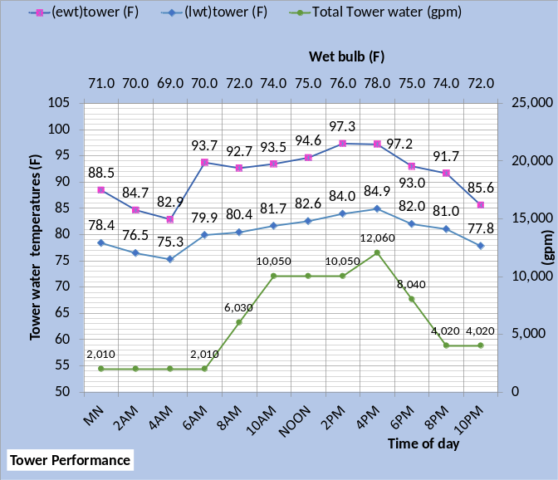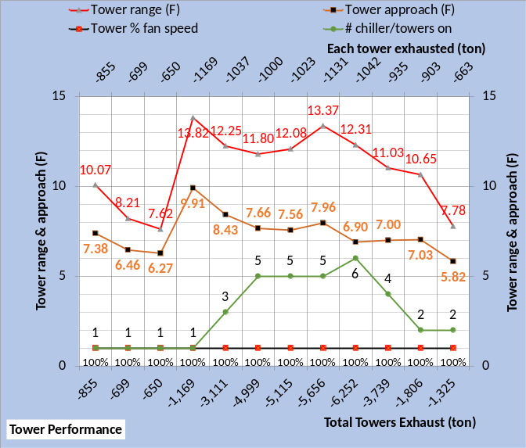
Figure 29: Tower Performance¹⁵-Design Day

Tower performance for design day operation is given by Figure 29. The figure illustrates the wide range of operation as the wet bulb and load on the tower changes. The tower leaving water temperature varies from 84.9F at design hour 4PM down to 75.3F at 4AM. At 4PM peak summer design conditions six chiller/towers are on and the range plus approach is (12.31 + 6.9 = 19.21F) consistent with the design procedures of Taylor¹³. Five chiller/towers are on at 2PM and the range plus approach increased to (13.37 + 7.96 = 21.33F). at 4AM the range plus approach drop to about 14F.
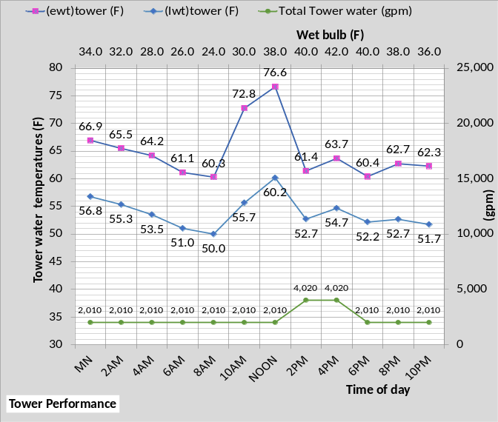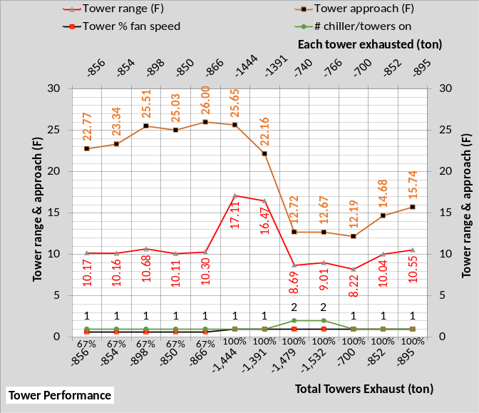
Figure 30: Tower Performance¹⁵-Winter day

Tower performance for winter operation is given by Figure 30. A comparison of Figures 29 & 30 illustrates the wide difference in operation for summer design verses winter operation. The tower leaving water temperature is much colder, as low as 50F. Tower range and approach is also very different from summer operation. Note how tower approach drops at 2PM when two chiller/towers are turned on.
The (SEE) Model must accurately model tower performance, as demonstrated by Nelson¹⁴, if the goal of duplicating plant performance is to be achieved.

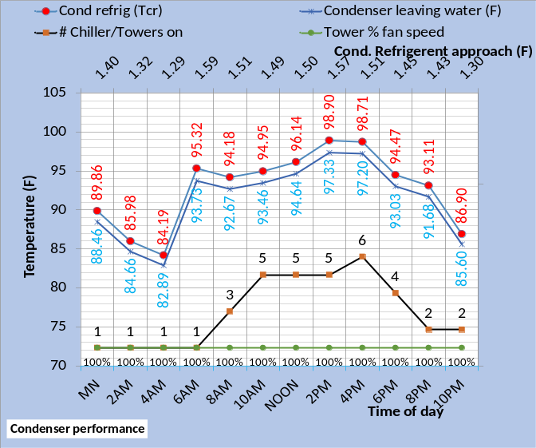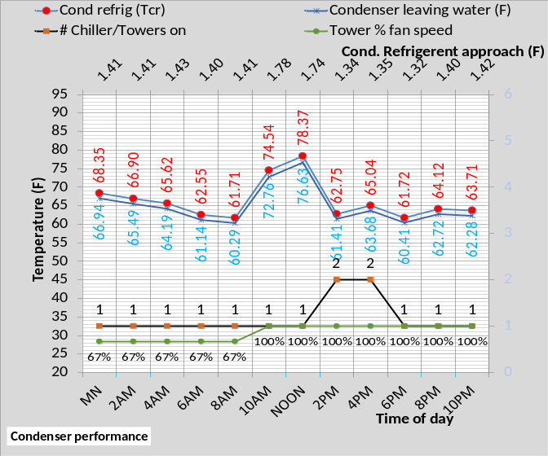
Figure 31: Design/Winter condenser performance

The tower in large part determines the performance of the condenser except condenser refrigerant approach temperature which is a design selected characteristic. Figure 31 illustrates the condenser conditions for both design and winter conditions.
Figure 32 essentially summarizes the plant performance at design day conditions. The top chart gives chiller lift and the bottom chart gives chiller and plant kW/ton values.
Figure 33 summarizes the plant performance at winter conditions illustrating a significant improvement in both chiller and plant kW per ton values.

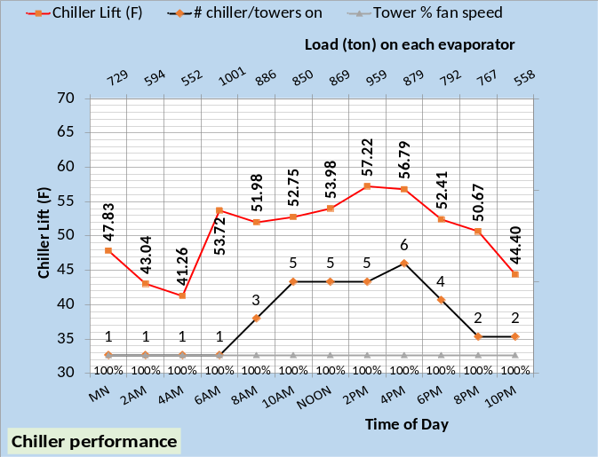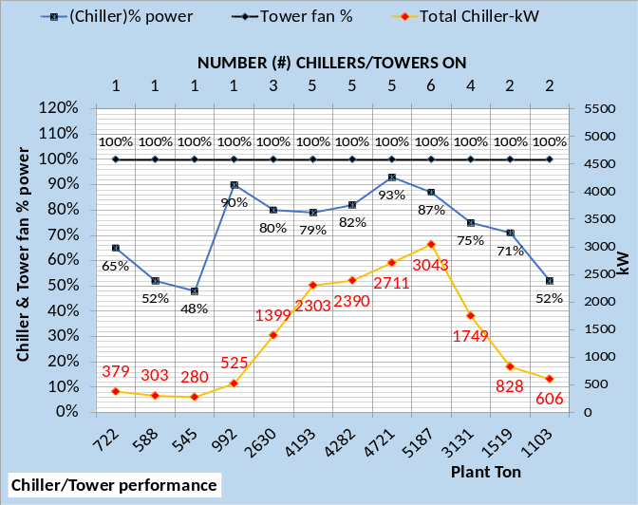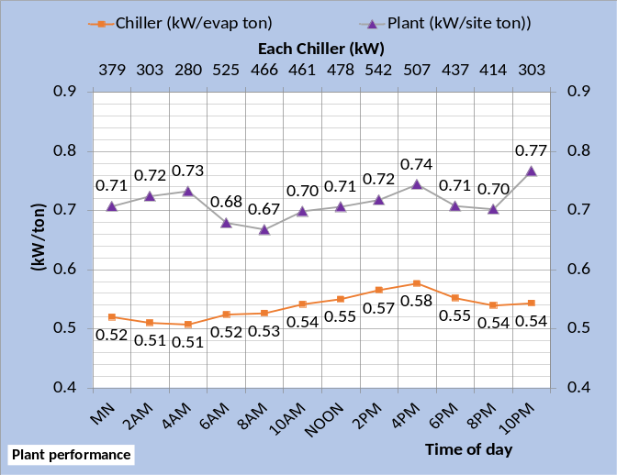
Figure 32: Plant Performance-Design conditions

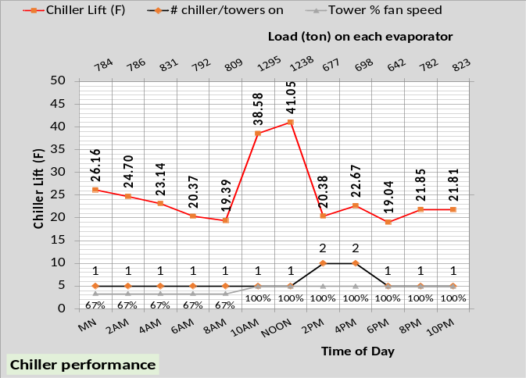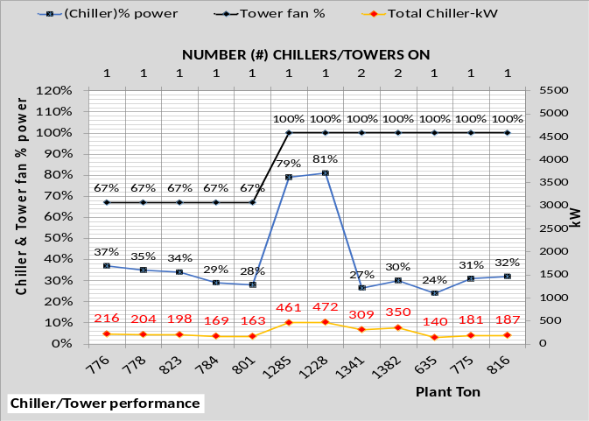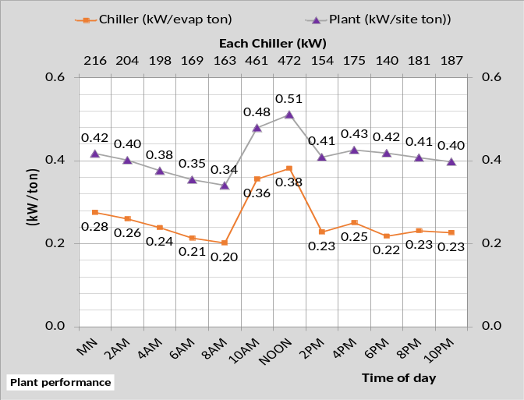
Figure 33: Plant Performance-Winter conditions

Summary
The purpose of this article 3 is to give an understanding of the complexity and detail necessary in a (SEE) Model that is to duplicate real plant performance. Verification of the plant (SEE) Model can be reviewed at references 4 & 14.
Anatomy of a Real Time Building Energy model
Part 4-Install fan powered terminals and return fans
To further demonstrate the (SEE) Model detail and capabilities the following scenario will be assumed. The building and HVAC system was designed to Table 1 conditions and as given by the above figures and discussion. During construction an engineering change installed fan powered terminals¹¹ and return fans¹². Therefore, the as designed (SEE) Model must be upgraded to include fan powered terminals and return fans. At design conditions the fan powered terminals slightly increase the supply air temperature to the perimeter and interior of the building and the return fans slightly increase the air return temperature to the VAV fans.
Figure 34 illustrates the effect of adding fan powered terminals and return fans to the air handler system. Comparing the top and bottom charts shows the air handler CFM increased because the load increased due to the electrical demand of the terminals and return fans. At 4PM design hour the air temperature to the coils increased from 81.90F to 82.27F, a small increase but note the plant load increased from 865 ton to 907 ton therefore adding 42-ton load to the plant because of adding the powered terminals and return fans.
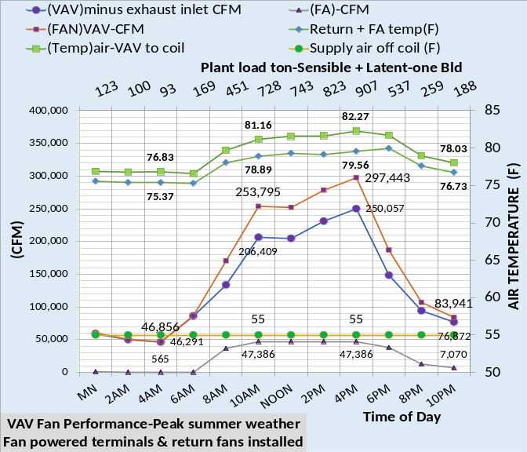
Figure 34: Design Weather-Bottom Chart-Terminal & Return Fans Installed-Top chart from Figure 16

Article 1 states that the terminal and return fans increased the (EUI) value of the Table 1 system from about 38 (kbtu/ft²-yr) to 40 (kbtu/ft²-yr) for the Table 1A system, an increase of about 5%.

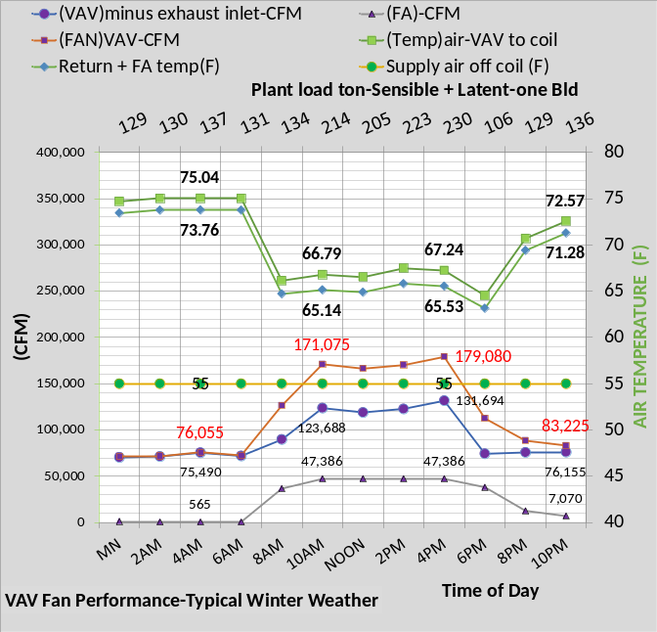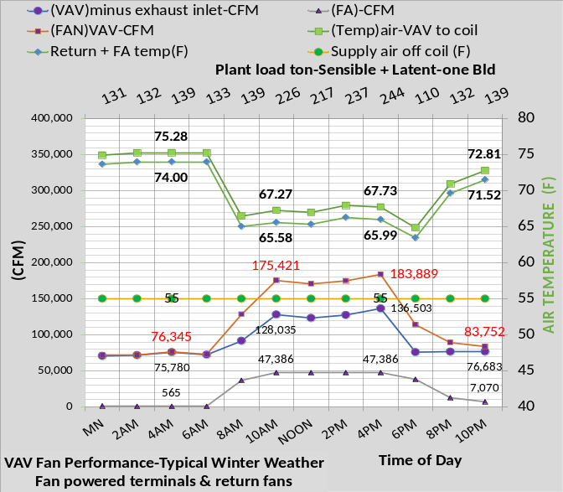
Figure 35: Winter Weather-Bottom Chart Terminal & Return fans Installed-Top chart Figure 17

Figure 35 illustrates the effect the powered terminals and return air fans have on the system during winter operation. Comparing the top chart to the bottom chart, at 4PM the air temperature to the coils increased (67.73F – 67.24F = .49F). The secondary horizontal axis illustrates the increase in sensible plant load at 4PM from 230-ton top chart, to 244-ton, bottom chart, due to the powered terminals and return fans. The reason the effect at winter operation is less than at design conditions is that the VAV fan CFM is less and the terminals¹¹ and return fans¹² CFM and therefore kW demand is proportional to total VAV CFM.
The return fans¹² are modeled as .185 times the VAV fan kW and the terminals¹¹ are modeled as .33 watts/CFM at design. The 26 VAV air handlers in each building have a design value of 13,200 CFM, therefore the powered terminals design value is 4.36 kW and the VAV fans design are 13.64 kW. The fan system operates at less than design, for example at peak summer conditions each VAV air hander is operating at 11,440 CFM with a demand of 9.806 kW and the powered terminals associated with the air handler draw 3.27 kW.
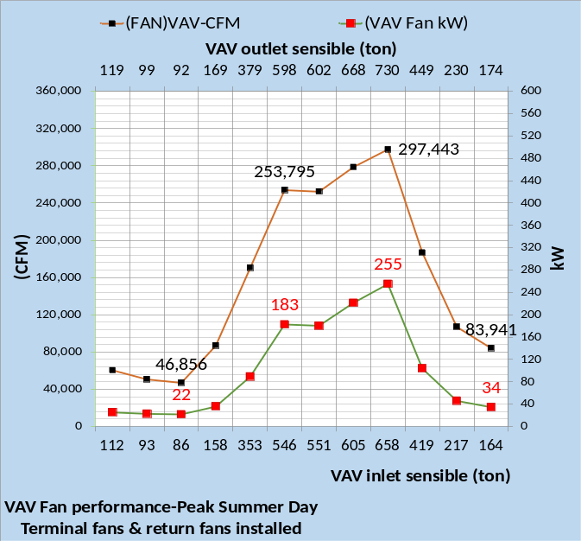
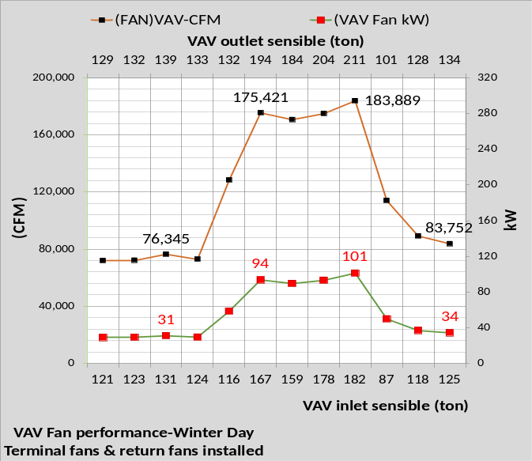
Figure 36: VAV fan kW-One Building

Figure 36 top chart gives the design day VAV fans CFM and kW demand and the bottom chart gives the winter values. Operation during the winter requires significantly less CFM and therefore less VAV fan kW demand. The horizontal axis illustrates an important characteristic of a real system. As the air passes thru the VAV fan system the air is heated. The top chart primary horizontal axis at 4PM shows 658 ton entering the VAV fan system and the secondary horizontal axis shows 730 ton exiting due to VAV fan motor heat added to the air. As the load increases due to the VAV fan heat the VAV fan CFM increases therefore increasing the load until a steady state condition develops. The (SEE) Model equations iterate to a steady state condition just as a real system. This feature of the (SEE) Model is a necessary calculation, analogous to a feedback control system.

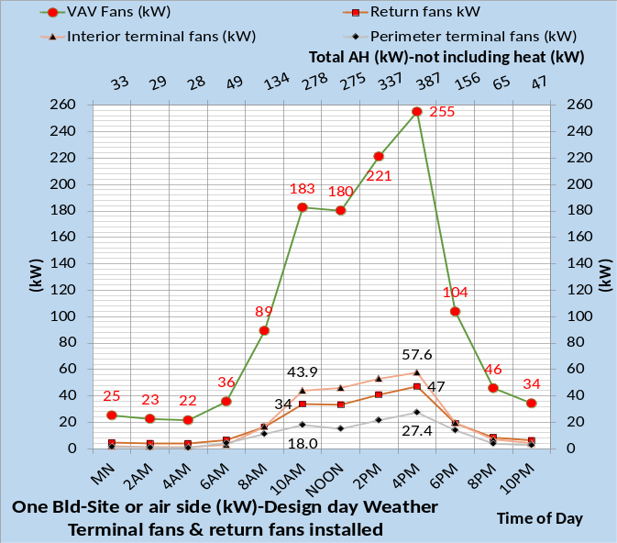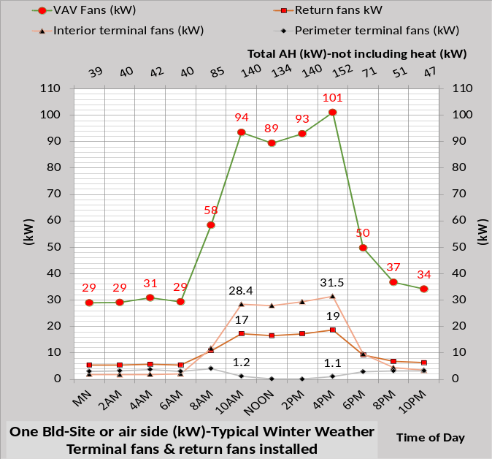
Figure 37: Total air handler fan kW

Figure 37 gives fans kW demand for design and winter conditions. The powered terminals have different kW demand values for interior verses perimeter due to the difference in VAV CFM required. At 4PM, as a group the terminals and returns fans are about half the kW demand of the VAV fans, a significant increase to the air handler fans kW demand but not significant to the total kW demand of the site.

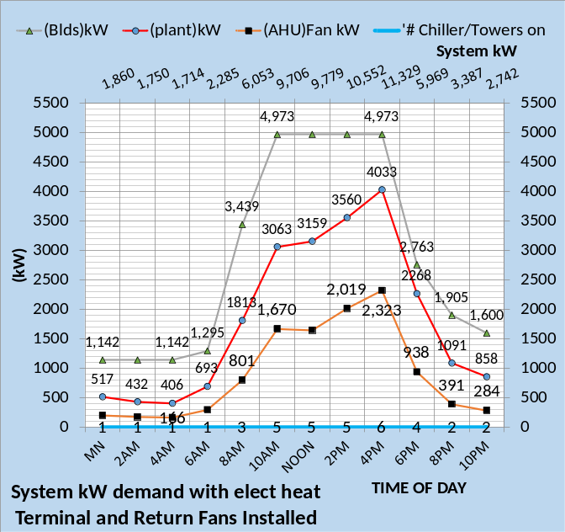
Figure 38: System Performance-Six Buildings-Design Day

Figure 38 gives the kW demand of the six office buildings served by the plant. The total at 4PM is 11,329 kW. The building lights and plug kW is the largest at 4,973 kW with plant kW of 4,033 being the second largest and fans at 2,323 kW or about 20% of the total. An increase of about 131 kW due to return and terminal fans at 4PM as shown by Figure 37 only represents about a 1% increase in system kW. However, this 131 kW also increased the VAV fan kW and the load on the plant with resulting increase in plant kW.
Figure 39 gives the kW demand during winter day operation for the system as defined by Table 1A. The top chart is for an electric heat system and the bottom chart a fuel heat system. For the perimeter electric heat system, top chart, the system kW demand is relatively constant because of the perimeter heat required during unoccupied hours.
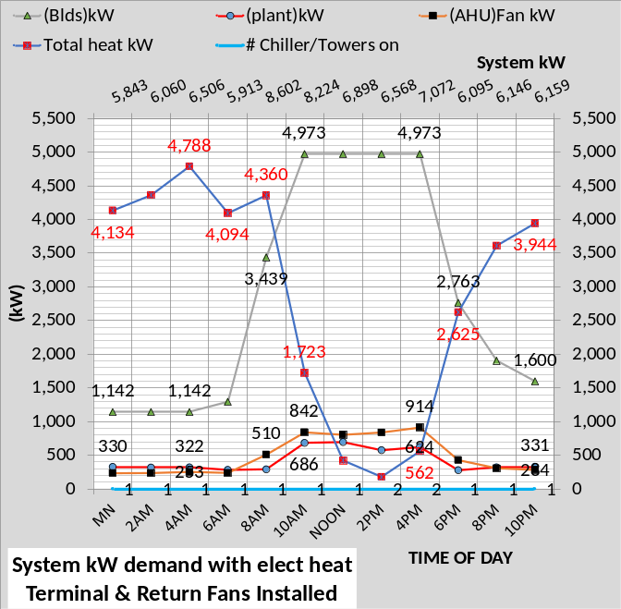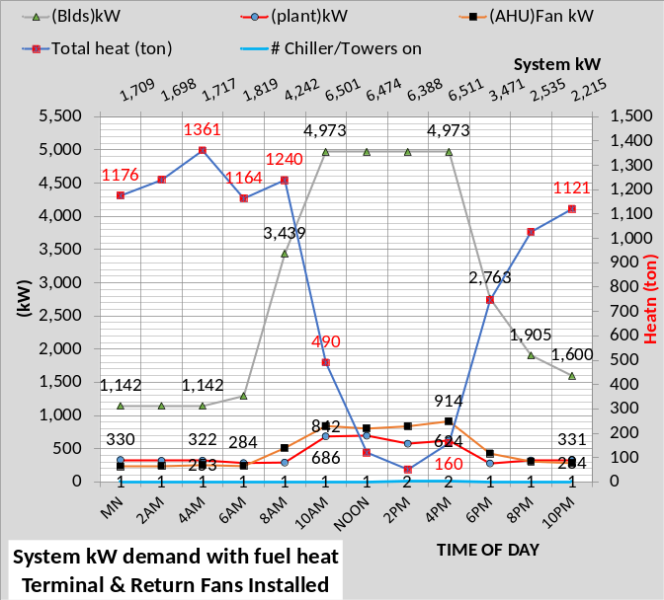
Figure 39: System Performance-Six Buildings-Winter Day
The bottom chart of Figure 39 with fuel heat shows a system kW similar to the design day system kW of Figure 38.
Summary
This article 4 has shown the difference in supply air and system kW performance due to the installation of fan powered terminals and return fan. The next article will present day and hour (EUI) values for April 13, 2020 KC weather.

Anatomy of a Real Time Building Energy model
Part 5-Day & Hour (EUI) Values for
Spring Real Weather Conditions

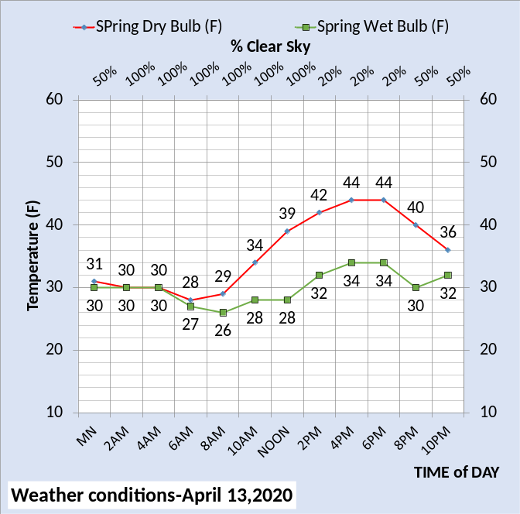
Figure 40: Spring Real Weather Data⁶

Figure 40 is actual weather conditions on April 13, 2020 in Kansas City Missouri. These real weather conditions will be used to demonstrate the concept of hour and day (EUI) values that can judge the performance of buildings on a day similar to April 13. The idea is that a date would be announced as a day building owner should record energy use data to be compared to an ASHRAE 90.1 design, in this case a 90.1-2010⁵ building system. The author will demonstrate this concept at Nelson⁴.
The following charts will benchmark the performance of the systems as defined by Tables 1 thru 4.
This cold day of April 13 requires heat at the perimeter space of the building. Heat can be provided by electricity or by fuel; conditions that significantly affect the electric consumption of the system. Therefore, two charts are given to define the energy use of the system.
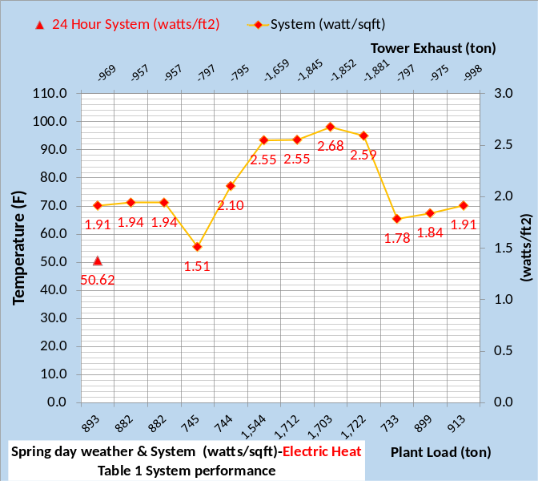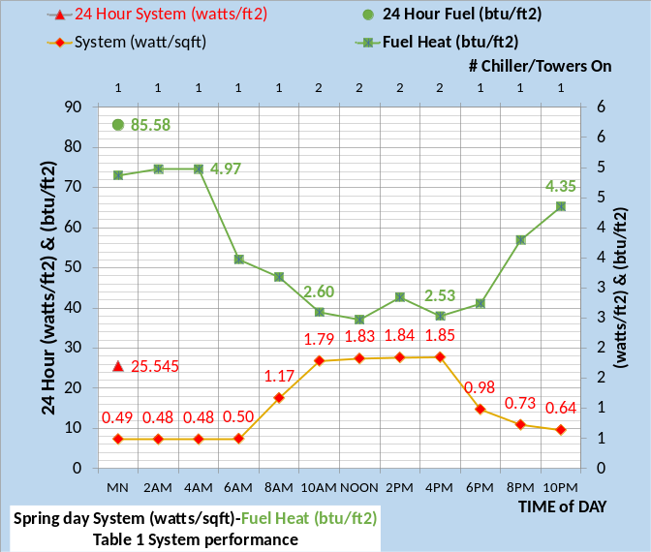
Figure 41: Spring Day-Table 1 System Performance

Figure 41 top chart gives the (watts/ft²) energy consumption for the electric heat system and the bottom chart gives (watts/ft²) and fuel (btu/ft²) for the system with fuel heat. Figure 41 also gives the 24-hour consumption values for each condition.
Figure 41 also gives the Table 1 system plant load (ton), tower exhaust (ton), and the number of chiller/towers on during the 24-hour period.
A building and plant designed and operating to Standard 90.1-2010 would, on this April 13 day, perform close to the values given by Figures 41. Next will consider operation according to Table 1A where fan powered terminals and return fans are installed into the air handling system.
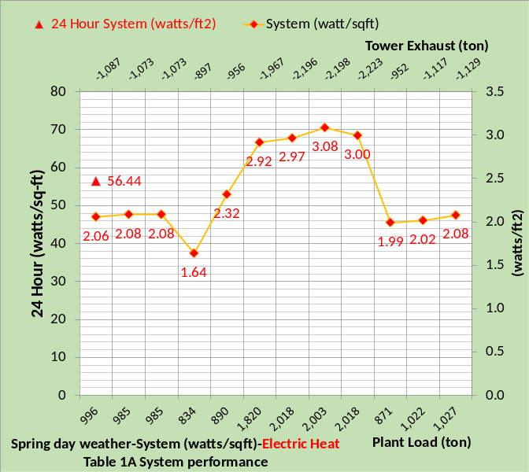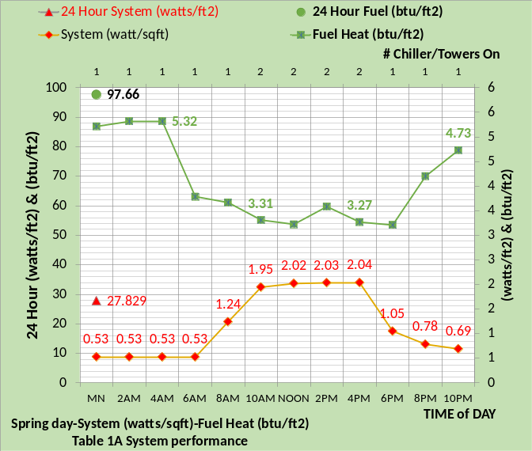
Figure 42: Spring Day-Table 1A System Performance
Installing the fan powered terminals and return fans obviously increased the 24-hour (watts/sq ft) as detailed by article 4. For example, the all-electric system during spring weather increased from 50.62 (watts/sq ft), top chart of Figure 41, to 56.44 (watts/sq ft), top chart of Figure 42. The bottom chart of Figure 42 compared to Figure 41 illustrates that the electric consumption and fuel consumption increased with installation of the terminals and return fans. The fuel consumption increased from 85.58 (btu/sq ft) to 97.66 (btu/sq ft) a 14% increase. The fuel consumption increased because the load increased due to the additional electricity into the system and therefore the fan system CFM increased which in turn increased the supply air reheat required. Fully understanding this increase in fuel consumption is assisted by system schematics, an analysis that will be addressed by Nelson⁴.

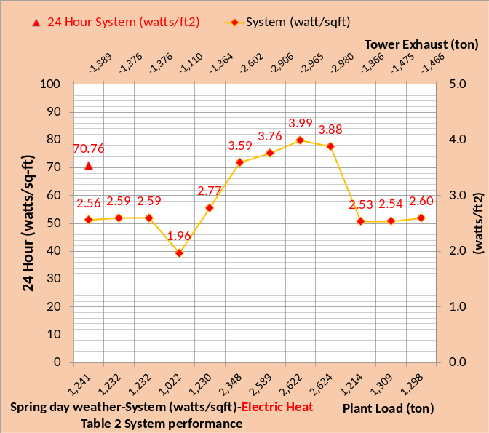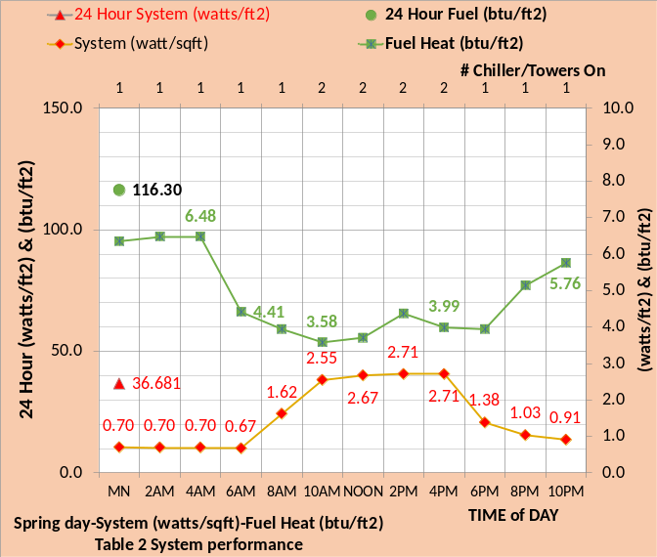
Figure 43: Spring Day-Table 2 System Performance

Figure 43 gives the performance of the Table 2 system. The spring day all electric system increased from 56.44 (watts/ft²) of Figure 42 for the 24 hours to 70.76 (watts/ft²), a 25% increase. The fuel heat, bottom chart, increased from 97.66 (btu/ft²) to 116.30 (btu/ft²), a 20% increase. The plant load at 4PM increased from 2,018 ton to 2,624 ton a 30% increase but the number of chiller/towers on was the same as shown by the secondary horizontal axis of the bottom charts of Figure 42 & 43. The chiller/tower operation at these two conditions can be studied as illustrated by article 3.

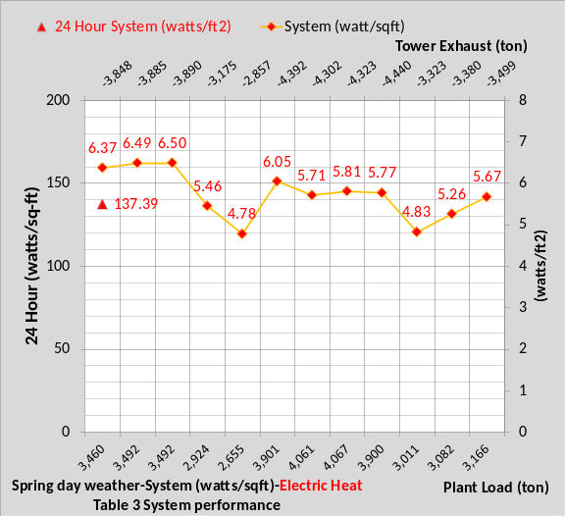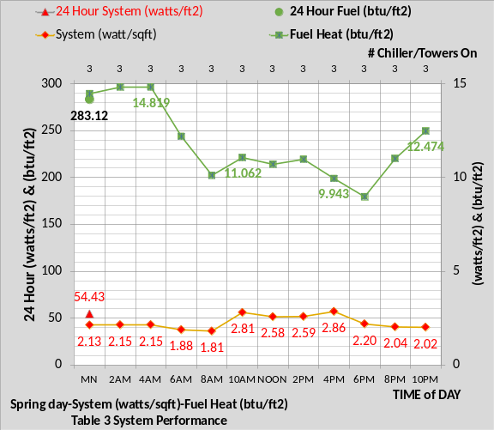
Figure 44: Spring Day-Table 3 System Performance

Figure 44 shows that the control issues of Table 3 increased the energy consumption for the spring day to about 2.4 times compared to Figure 42 and almost 2 times compared to Figure 43. The perimeter fuel required for heat almost tripled compared to Figure 42 bottom chart and increased about 2.4 times compared to Figure 43. Clearly the control issues of Table 3 result in big increases in energy consumption for the spring weather as defined by Figure 40. This big increase due to control issues was also demonstrated by Figure 10 of article 1 with an estimated annual (EUI) value of 90, a 40-point increase over Table 2 system performance as given by Figure 9.
The bottom chart of Figure 44 shows three chiller/towers were on all 24 hours. At design conditions the chillers were selected at 1,000-ton capacity. Note that the plant load is slightly greater than 4,000 ton for several hours and three chiller/towers meet the load. The reason is the wet bulb is in the range of 32F for these hours and the capacity of the chiller is increased due to the performance of the cooling tower. The details of this chiller/tower performance characteristic will be addressed at Nelson⁴.

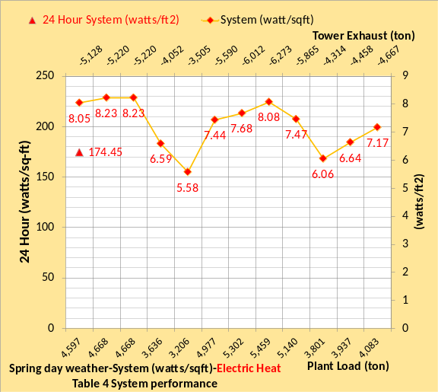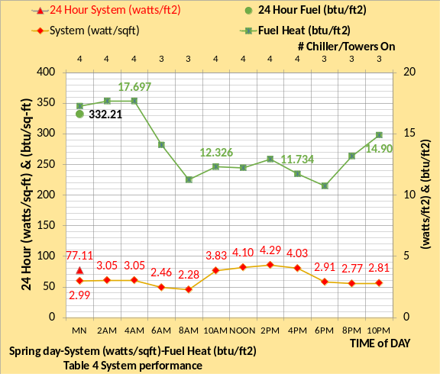
Figure 45: Spring Day-Table 4 System Performance
Table 4 combines Table 2 & 3 resulting in a significant increase in the day energy consumption for spring weather of Figure 40. Compared to Table 1 performance given by Figures 41, the system with electric perimeter heat, top charts, increased 3.5 times during 24-hour operation. The fuel heat for perimeter heating increased 3.9 times. The (SEE) Model can detail the effect of each item of Table 4 and do so with system schematics which assists in understanding the dynamics of the design and/or control change⁴.
Summary
As stated in article 1; one use of the concepts presented here is that a City could announce a date when all office buildings, and similar buildings, should record energy data to be compared to an ASHRAE Standard design. The difference in the real buildings day (EUI) value verses a (SEE) Model of an ASHRAE Standard design would provide the goal for each building. Performing this task during all four seasons would give additional understanding of a buildings energy use characteristics as compared to an ASHRAE Standard designed building.

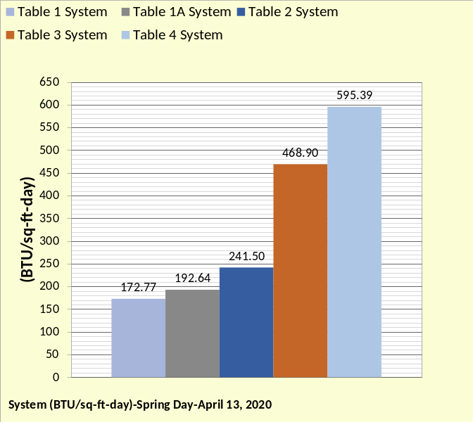
Figure 46: Day (EUI) for April 13, 2020
Figure 46 gives the (SEE) Model day (EUI) values for the conditions as defined by Tables 1 thru 4. The spring day values are significantly greater than the summer values to be given by the next article 6.
The perimeter heat required during the spring day conditions is a rather complex issue requiring close attention to controls to minimize energy consumption. Detail analysis with schematics will be provided at Nelson⁴.

Anatomy of a Real Time Building Energy model
Part 6-Day & Hour (EUI) Values for
Summer Real Weather Conditions & Energy Balance Analysis
The Table 1 system may not be the system as constructed and therefore not the (SEE) Model system to compare the real system to. If the real building was constructed with light levels, or other characteristics, greater than the Table 1 values and these levels cannot be corrected then those values should be installed into the (SEE) Model thereby establishing the performance goal for the real system. This article will address this point and also address energy balance analysis.

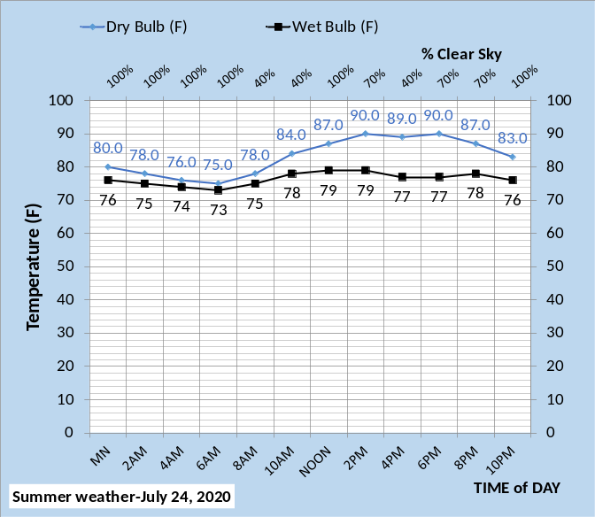
Figure 47: Summer Real Weather Data⁶

Figure 47 is actual weather conditions of July 24, 2020 in Kansas City Missouri. These 24-hour real weather conditions will be used to demonstrate the concept of day & hour (EUI) values and energy balance analysis.
The first task in evaluating the performance of a system is to determine if the system is operating as designed. Probably the most available data for any building or campus is the total kW demand, or as expressed here the (watts/sq ft). The following Figures 48 through Figure 52 give the (watts/sq ft) for the conditions as defined by Tables 1 through Table 4.
A building and plant designed and operating to ASHRAE Standard 90.1-2010 would, on this July 24, 2020 day, perform close to the values given by Figure 48.
For these summer conditions given by Figure 47 perimeter heat is not required and therefore shown as zero for all hours. If perimeter heat is required the (SEE) model gives two charts, one for electric heat and one for fuel heat as demonstrated by Article 5.
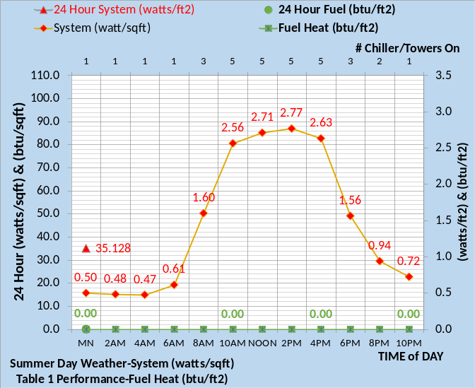
Figure 48: Summer Day-Table 1 System Performance
Installing the fan powered terminals and return fans increased the 24-hour (watts/sq ft) from 35.128 of Figure 48 to 37.082 of Figure 49.
The secondary horizontal axis of Figures 48-52 gives the number of chiller/towers on for this plant defined as six chiller/towers of 1,000-ton capacity at design conditions. The (watts/sq ft) values for a summer day similar to July 24, 2020 can be used to judge any office building or campus against the conditions defined by Tables 1-4.

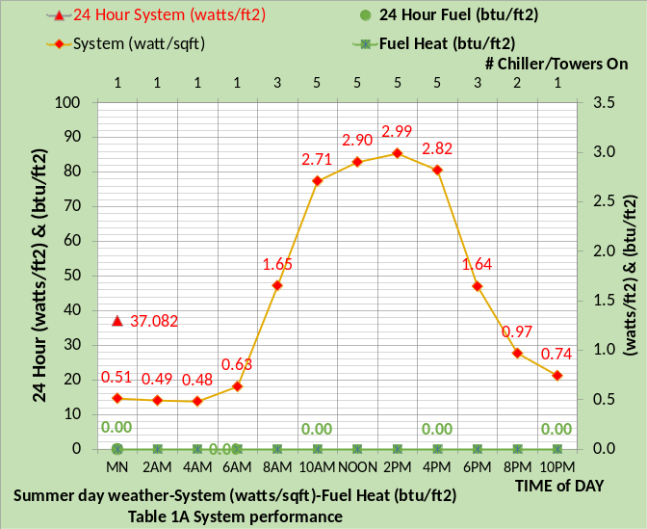
Figure 49: Summer Day-Table 1A System Performance
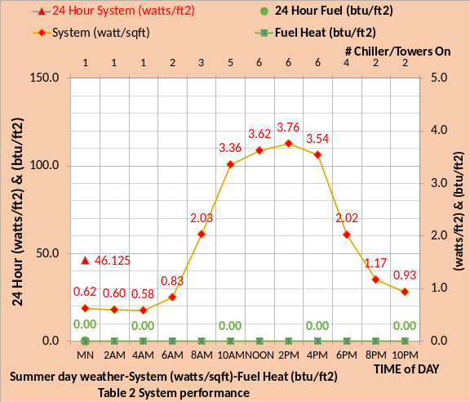
Figure 50: Summer Day-Table 2 System Performance
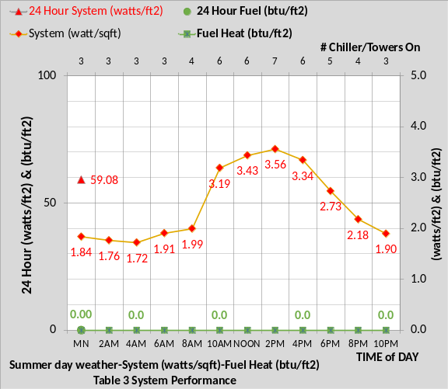
Figure 51: Summer Day-Table 3 System Performance
Figures 48-52 give the (watts/sq ft) values for the conditions as defined by Tables 1-4. The 24-hour sum of (watts/sq ft) increased from 35.128 of Figure 48 to more than double at 72.8 (watts/sq ft) of Figure 52.
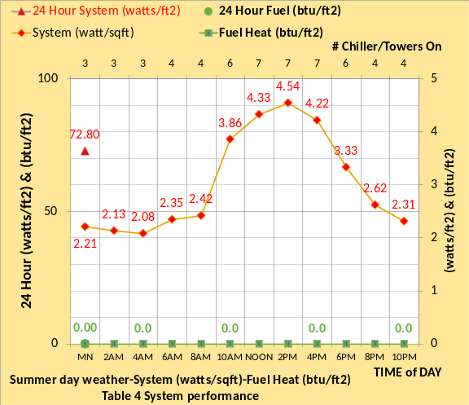
Figure 52: Summer Day-Table 4 System Performance
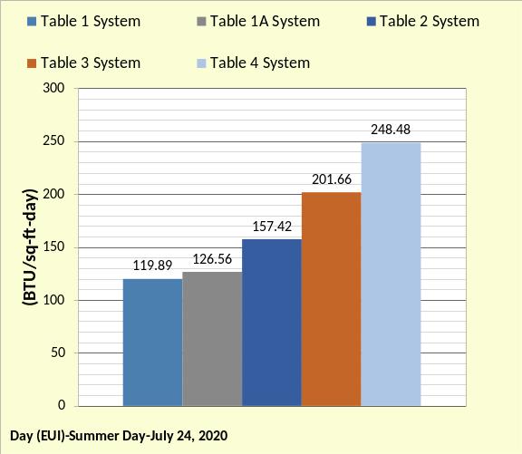
Figure 53: Day (EUI) July 24, 2020

Figure 53 summarizes the (SEE) Model day (EUI) values for the conditions as defined by Tables 1 thru 4 in (btu/ft²-day). These (EUI) values for summer weather are about half the cold weather (EUI) values of Figure 46.
As previously stated, a city could announce a date when all office buildings, and similar buildings, should record energy data to be compared to an ASHRAE Standard design. This day (EUI) value gives the ability to judge all building of a city against all other buildings and against an ASHRAE Standard design building. Taking the data at all four seasons would give additional understanding of a buildings energy use characteristics as compared to an ASHRAE Standard designed building.
If a real building is judged to be using more energy, on a given day, than the design should be using then one approach to defining the design and/or control problems to be corrected is with an energy balance analysis.
Energy Balance Analysis
The first task for a building owner is to determine, based on the conditions given by Tables 1 thru 4 and benchmarked by Figures 48-52, approximately what the real buildings (watts/sq ft) should be. If the real building is using more energy that it should be then action should be taken to correct problems of design and/or control. If a (SEE) model is available then the first task is to develop a (SEE) model of the building system as constructed to compare with actual (watts/sq ft) performance.
Any office building or office campus designed to or near ASHRAE Standard 90.1-2010 should have an annual (EUI) of about 40 to 50 (kbtu/ft²-yr) as discussed in Article 1. Values greater could be because the building is operating at control conditions that can be corrected. Perhaps the greatest value of a (SEE) Model is the ability to define what the building should be using on any given day. A (SEE) Model of the system not only sets the goal of what the system should be using it also assists in performing an energy balance that can identify problems of control and/or design. Consider for example that a system is being analyzed on a given two or three days and the weather significantly changes during the time. A (SEE) Model sets a new goal for the system each day as weather changes and as changes are made to the system and changes also made to the as constructed (SEE) Model of the system. Figure 47, above, gives the weather conditions at Kansas City on July 24, 2020⁶ including the percent clear sky given on the secondary horizontal axis.
Five performance data are required for day and hour benchmarking and for performing an energy balance analysis. Figures 48 thru 52 above gave (watts/sq ft) data which is equivalent to system kW demand required data listed below. An energy balance analysis is typically performed with (btu/ft²) data.
The data required for an energy balance is;
- Plant load (ton)
- Tower exhaust (ton)
- Plant kW demand
- Site kW demand.
- System kW
Plant load and tower exhaust (ton) would be BTU metered data. The system kW value would probably be utility metered data but the plant and site kW values might require meter installations.
Building Location and Design⁵
- Location=Kansas City Mo.
- Ambient temperatures=Figure 47
- Percent clear sky=Figure 47.
- Building design per Liu⁵ changed.
- Percent wall glass 37% to 50%
- Peak lights kW .81 watts/ft²
- Peak plugs kW .66 watts/ft²
- Return air to perimeter.
- Duct design 5.5 in water
- Fan powered terminals installed
- Return air fans installed
Building Control
- Lights on/off control- 6% on after hours.
- Plugs on/off control-44% on after hours
- Building pressure control=yes
- Supply air = 55F
- Supply water = 44F to 44.5F
- Stats control = Yes
- Perimeter heat air temp=105F.
- VAV fan control=yes
- Fresh air CFM control=yes
- Fresh air heat stat set point=42F
Plant Design & Control
- Chiller/Tower selection¹³.
Table 1A: Revised Design & Ideal Control

Table 1A revised with 50% wall glass is defined as the as constructed system and therefore the (SEE) Model that is taken to the site for analysis of the real building. Figure 54 top chart gives the required data for the Table 1A system and the bottom chart with wall glass increased from 37% to 50%.

Building Location and Design⁵
- Location=Kansas City Mo.
- Ambient temperatures-Figure 47
- Percent clear sky = Figure 47.
- Building design per Liu⁵ changed.
- Percent wall glass from 37% to 50%
- Peak lights kW .81 to 1.01 watts/ft²
- Peak plugs kW .66 to .822 watts/ft²
- Return air to perimeter-no change.
- Duct design 5.5 to 7.0 in water
- Fan powered terminals installed
- Return air fans installed
Building Control
- Lights on/off control from 6% on after hours to 67% on.
- Plugs on/off control from 44% on
after hours to 67% on.
- Building pressure control-infiltration .2 cfm/sq ft wall max-varies as AH cfm.
- Supply air = 55F
- Supply water = 44F to 44.5F
- No stats control.
- Heating air temp from 110F to 90F.
- No VAV fan static pressure control.
- No Fresh air CFM control.
- Fresh air heat stat from 42F to 60F.
Plant Design & Control
- Chiller/Tower selection¹³.
Table 4: Design & Control Issues

Table 4 from Article 1 is given here to illustrate the many design and control issues of the assumed real system. The scenario, for this energy balance analysis, is that the real system is the Table 4 system and Figure 55 gives the measured data of the real system.

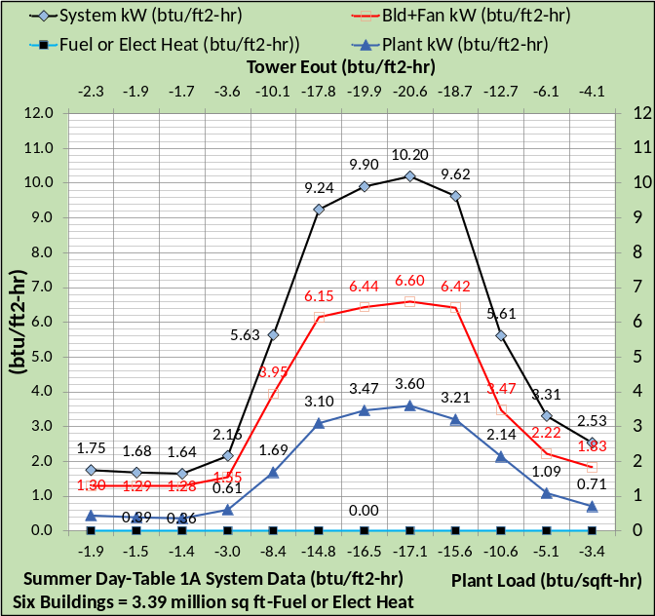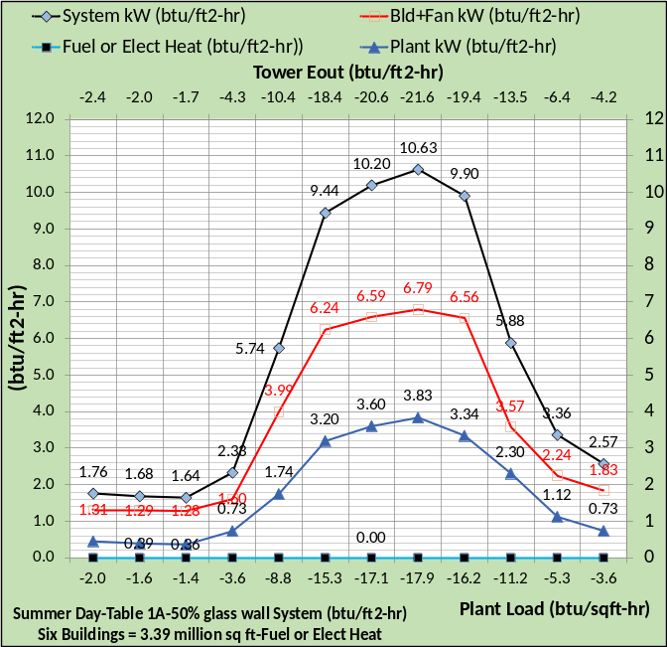
Figure 54: Summer Day-Top chart Table 1A System with 37% wall glass -Bottom chart Table 1A with 50% glass wall installed-July24, 2020 weather

Figure 54 gives the required data for an energy balance analysis. The top chart is the Table 1A system as discussed in Article 1 and the bottom chart is the result of adding 50% glass. The bottom chart is the assumed as constructed system. The bottom chart data is also the benchmark data for the real system, values greater than the bottom chart mean that problems in design and/or control exist in the real system. If the real system was operating close to the values of Figure 54 bottom chart on this day then the conclusion would be that the system was operating as designed.
Figure 54 illustrates the minimum data required to perform an energy balance analysis. The three kW values converted to (btu/ft²) are plant kW, site kW, and system kW. BTU meters would measure plant load and energy out at the towers.
Figure 55 gives the assumed measured data for the assumed real system operating to the design and control conditions of Table 4.

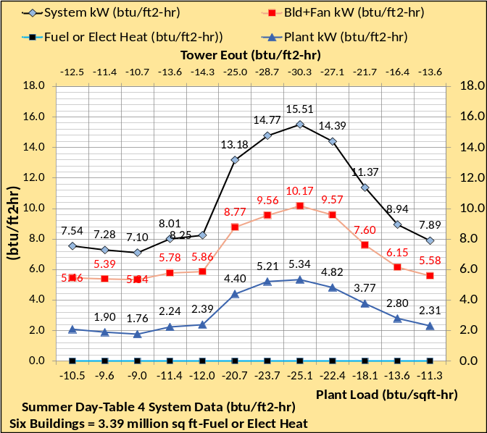
Figure 55: Summer Day-Table 4 Assumed Real System Performance Data-July 24, 2020

Fuel is zero for the summer day operation of Figure 55. Comparing Figures 54, bottom chart, to Figure 55, the assumed real system, illustrates the real system is operating far outside of anticipated performance. An understanding of the real system performance is needed and an energy balance analysis can provide that.
The first step in an energy balance analysis is to verify the BTU meters are reading correctly by performing an energy balance of the plant.
Plant Energy Balance
The plant energy balance has two primary purpose; calibrate the energy meters and establish the plant load (ton) values for an energy balance of the site, in this case a six-building office campus. The plant energy balance could be performed for any hour if the data is collected as shown by Figures 55. A plant energy balance must be achieved to proceed to a system energy balance. A plant balance within 3% would be desired and anything over 6% should probably call for calibration of the meters. The pump heat out value is a relatively small value calculated by the (SEE) Model, a value that can be estimated if a (SEE) model is not available. Pumping kW heat out is the inefficiency of the pumps.

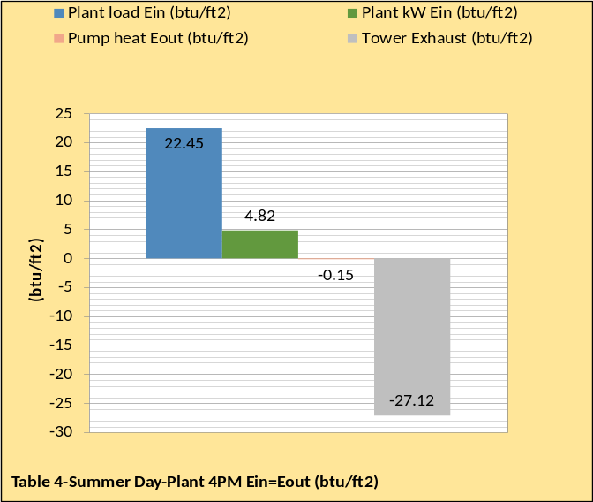
Figure 56: Summer Day-4PM Plant Energy Balance-July 24, 2020-Assumed real system
Figure 56 gives the plant energy balance at 4PM from data of Figures 55. The plant energy balance data should probably be verified for more than one hour to give confidence in the meters and the 24-hour sums.
System energy Balance
Getting an energy balance of the real system involves inputting measured data, Figure 55, and inputting calculating and estimating values to achieve the metered plant load and tower exhaust.
Figure 57 gives the energy balances of the Table 1A and Table 1A revised systems to be compared to the assumed real system of the bottom chart. Figure 57 is structured such that the values to the left of the plant load sum to the plant load value. The plant load plus the values to the right is the plant energy balance data of Figure 56.
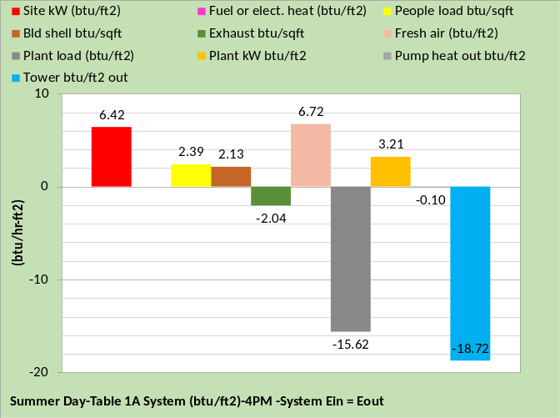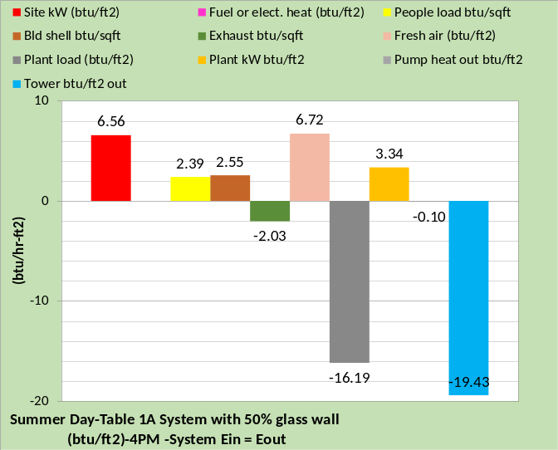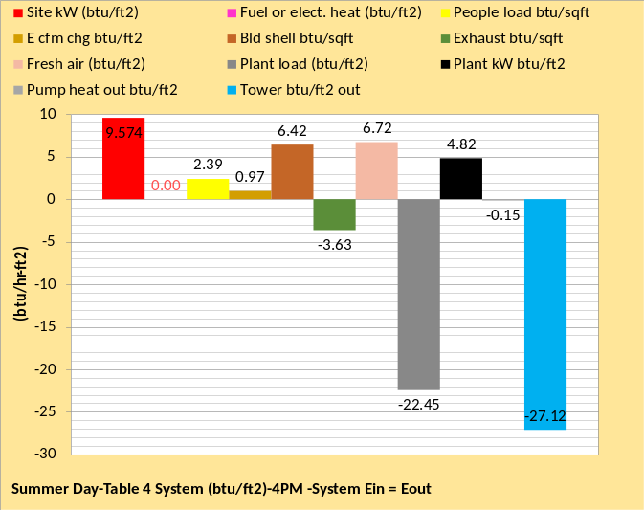
Figure 57: Top chart Table 1A System-Middle Chart Table 1A with 50% glass wall-Bottom chart assumed Real System Energy Balance

The middle chart of Figure 57 is the energy balance of the as constructed system with 50% wall glass installed into the Table 1A (SEE) Model. This as constructed (SEE) Model would be defined by the original design and the known changes made to the design. Other changes to the as constructed (SEE) Model may develop as an energy balance of the real system is conducted and conditions of design and/or control are identified that cannot be corrected.
The bottom chart of Figure 57 is the assumed real system energy balance. For this example, we have the advantage knowing the real systems operation as defined by Table 4. The real system energy balance is constructed with a (SEE) Model by first installing measured values from Figure 55 into the real system (SEE) Model. If the (SEE) Model of the as constructed energy balance is less than the real system energy balance, as is the case from Figure 57, the procedure is to input the measured values that cannot be corrected into the as constructed (SEE) Model. Also input calculated and/or estimated values until a real system energy balance is achieved. Note that the people load and fresh air load are the same for both charts of Figure 57. The figure shows that the site kW or lights, plug, and fan kW as expected by the middle chart are less than the bottom chart of the real system. The question to be determined; can the real values of the bottom chart be reduced or must the as constructed (SEE) model, middle chart, be upgraded with these greater values. We will assume that the larger values of lights and plug loads of the real system were investigated and found to be as constructed values that cannot be reduced. We will also assume that the air duct system has been tested and found to have a static pressure greater than design, 7.0 inches water verses 5.5 design. Our as constructed (SEE) Model of the system is equivalent to Table 2 and shown by Figure 58 top chart with the assumed real system the bottom chart.

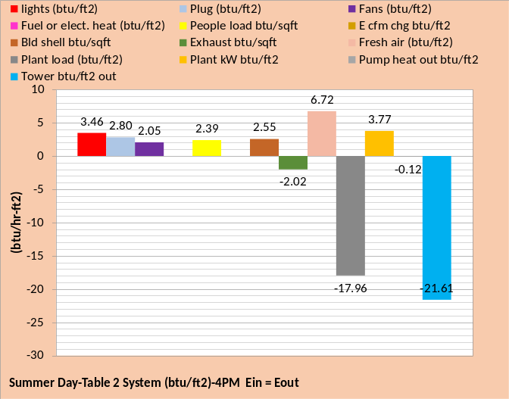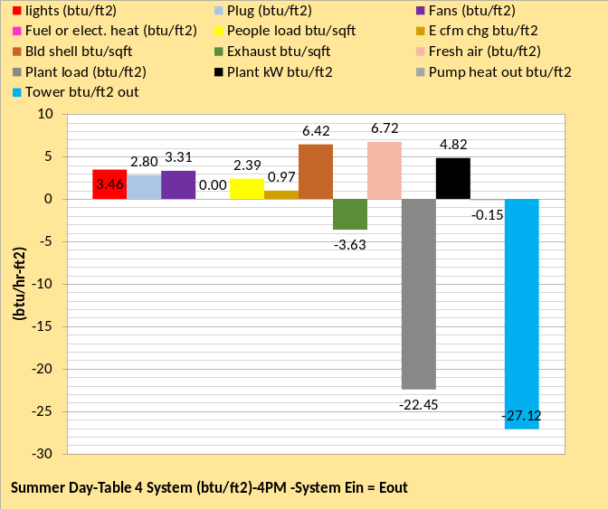
Figure 58: Revised (SEE) Model of As Constructed System and Assumed Real System -4PM Energy Balance
Figure 58 represents our as constructed system and the assumed real system at 4PM energy balance. The lights, plug loads, people, and fresh air values are the same for the two energy balances. Also, the plant load, tower exhaust, and plant kW values are metered values as defined by Figure 55. The assumed real system has three values, that are significantly greater than the as constructed system, fan energy in, building shell, and a term defined here as (E cfm change). This term is a measure of the change in internal energy due to air infiltration into the building, a value determined by the (SEE) Model and necessary for an energy balance of the system. Note that Table 4 defines infiltration as a control problem.
It is impossible to give a repeatable procedure on how to arrive at the real system energy balance. If a (SEE) Model is available the procedure is to input measured, calculated, and estimated data to achieve known metered data. The plant load and tower exhaust values are known so these values must be satisfied with any and all inputs to the real system (SEE) Model. For this study we have the advantage of knowing that the real system is operating according to Table 4.

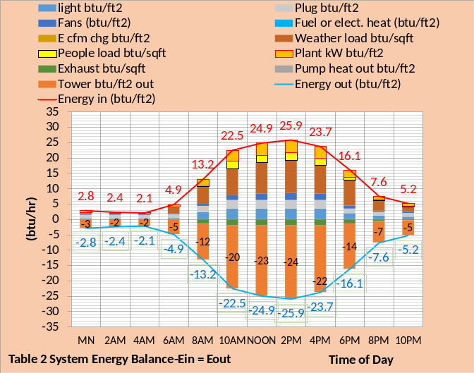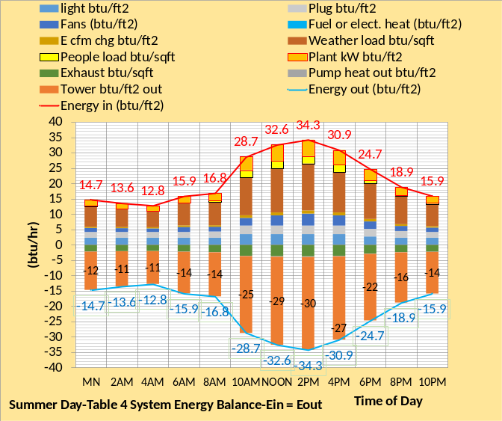
Figure 59: System Energy balance-24 Hours

Figure 59 gives the hourly energy balance for the two system, top chart assumed as constructed system and bottom chart the assumed real system. The energy out of the system is the measured tower energy out plus the relatively small measured or calculated exhaust energy out, plus the very small pump heat out value. The point is that the energy out of the real system is basically known with the measured tower energy out value of Figure 55. The energy into the system consists of seven variables as shown by Figure 59.
Adequate metering of a building is very important to understanding the energy use characteristics of a building and therefore the ability to correct deficiencies in the design and control of the system as illustrated by Table 4. This energy balance approach to analyzing a building’s energy use suggests the need for development and installation of energy meters.
The data of Figure 55 gives the ability to define an energy balance for any hour of this July 24, 2020 day. The following charts of the as constructed system and real system will be given for 10PM, 4AM, and 10AM.

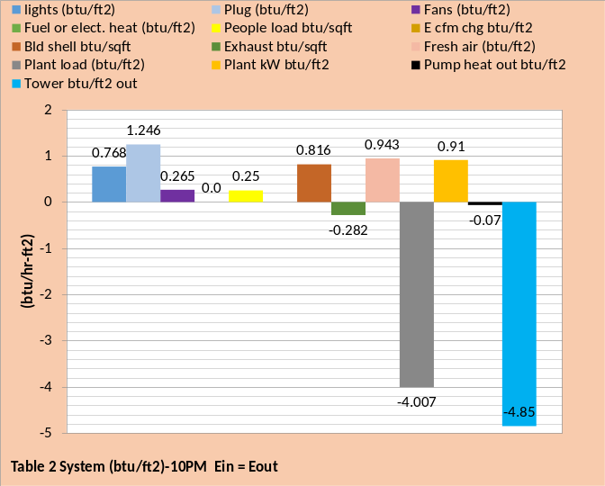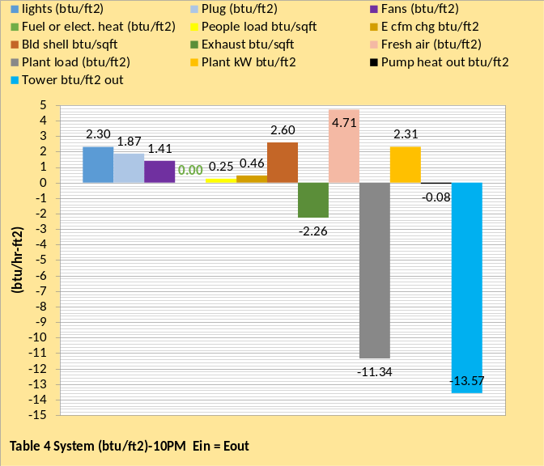
Figure 60: System Energy Balance 10PM-Top chart as Constructed (SEE) model Energy Balance-Bottom Chart Real System Energy Balance

Figures 60, 61, and 62 give energy balance results for different hours of the day. Comparing the top charts to the bottom charts illustrates some of the control deficiency of the real system. For example, Figure 60 & 61 illustrates that the lights and plug loads are not reduced as called for by the ASHRAE Standard 90.1-2010 design. The procedure would be to correct deficiencies in the building and define the new real system energy balance or input the deficiency into the as constructed (SEE) model if the deficiency cannot be corrected. This procedure could take more than one day so the as constructed (SEE) model and real system energy balance would change each day.

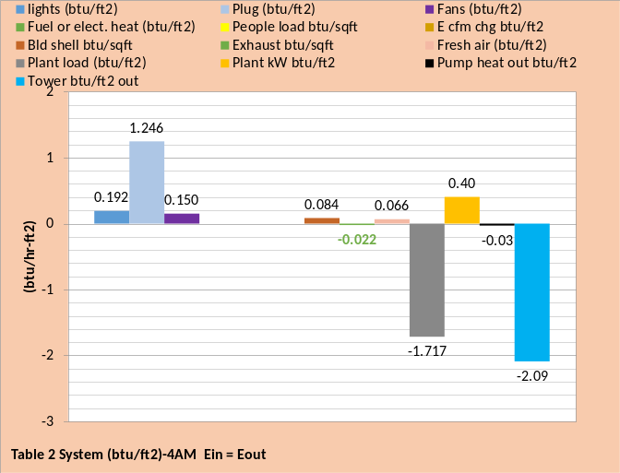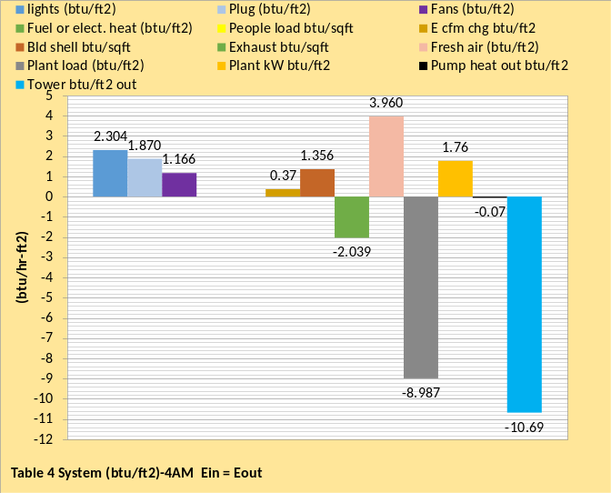
Figure 61: System Energy Balance 4AM-Top chart as Constructed (SEE) Model Energy Balance
-Bottom Chart Real System Energy Balance

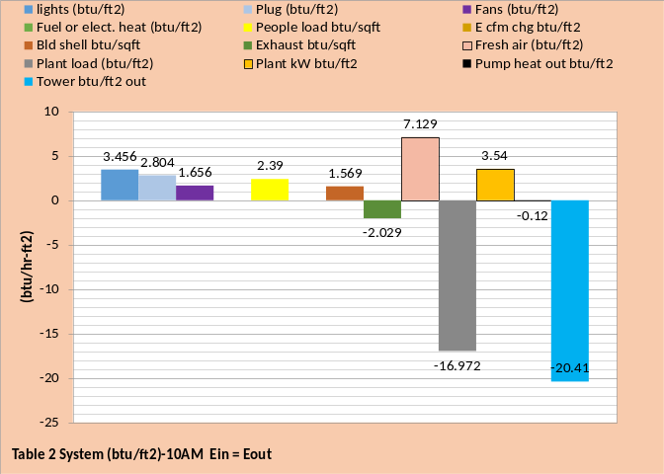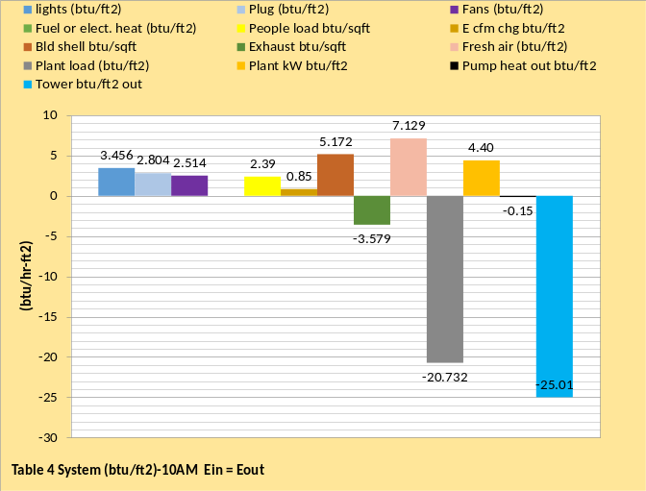
Figure 62: System Energy Balance 10AM-Top chart as Constructed (SEE) Model Energy Balance
-Bottom Chart Real System Energy Balance

Ideally this procedure would proceed until the as constructed (SEE) model energy balance matched the real system energy balance within about 5%.
Table 4 gives eight control issues that contribute to the excessive energy consumption of the real system. As these are corrected the real system would energy balance differently always moving closer to the energy balance of the as constructed system.

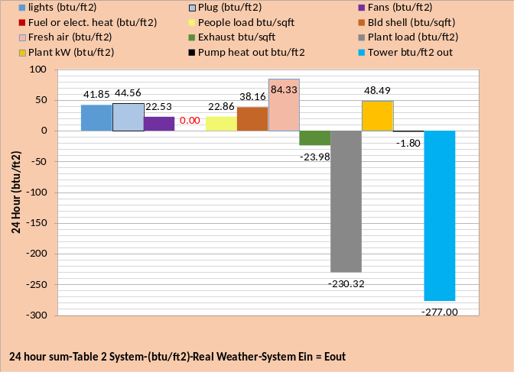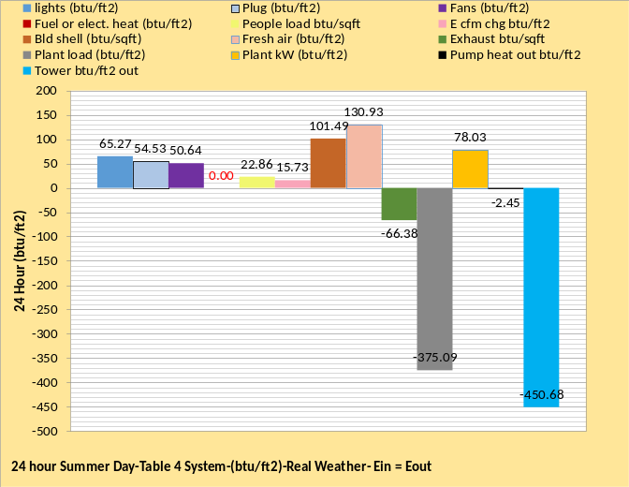
Figure 63: System Energy Balance 24 Hour-Top chart as Constructed (SEE) Model Energy Balance
-Bottom Chart Real System Energy Balance
Figure 63 illustrates that the real system 24-hour performance is a long way from the performance of the as constructed system. The (SEE) Model is not necessary to define some of the problems with the real system but provides a tool to define some problems and most important the (SEE) Model establishes the performance goal as weather and details of the design, that cannot be changed, are identified. The procedure outlined here for an energy balance would be the same for a day when building perimeter heat is required, however the results would be significantly different as suggested by Article 5.

Summary/Conclusions
The task of this series of articles was to achieve the following.
Article 1 was to set the stage by defining the building to be modeled, characteristics of the model, and estimates of annual (EUI) values.
Article 2 presented (SEE) model details of the perimeter and internal loads, the VAV fan system and the air supply system.
Article 3 presented details of the plant model including the chiller refrigerant temperatures, tower performance, and plant performance.
Article 4 installed fan powered terminals and return fans into the air handler system.
Article 5 presented the concept of day and hour (EUI) values for spring weather conditions.
Article 6 presented the concept of energy balance analysis at real weather summer conditions.
This Article 6 completes this series of articles but does not complete the task of developing real time building energy models.
These six articles suggest several research projects needed to better define and better understand a buildings energy consuming characteristic. The author suggests three or more office buildings, like the one of this study, be selected in different weather zones for detail study and (SEE) Model analysis. Buildings with high energy consumption and buildings with both electric heat and fuel heat would be constructive. Energy meters would need to be installed consistent with performing an energy balance analysis as presented by Article 6.

References
- Introduction to Thermodynamics and Heat Transfer. 1956 Prentice-Hall, Inc. by David A. Mooney.
- Thermal Environmental Engineering third edition. 1998 Prentice-Hall Inc. by Thomas H. Kuehn, chapter 3.
- ASHRAE Journal May 2016. “Modeled Performance Isn’t Actual Performance”
- Nelson, Kirby. “System Energy Equilibrium (SEE) Building Energy Model Development & Verification”. http://kirbynelsonpe.com/
- Liu, B. May 2011. “Achieving the 30% Goal: (copy and paste) https://www.energycodes.gov/sites/default/files/documents/BECP_Energy_Cost_Savings_STD2010_May2011_v00.pdf
- Real weather data www.wunderground.com/
- Nelson, K. “7 Upgrades to, Reduce Building Electrical Demand” ASHRAE Journal, December, 2006,
- Nelson, K. “Simulation Modeling of a Central Chiller Plant” CH-12-002. ASHRAE 2012 Chicago Winter Transactions.
- Nelson, K. “Simulation Modeling of Central Chilled Water System” CH-12-003. ASHRAE 2012 Chicago Winter Transactions.
- Kavanaugh, S. “Fan Demand and Energy” ASHRAE Journal, 2000.
- Faris, Gus “Fan-Powered VAV Terminal Units” ASHRAE Journal November 2017
- Kettler, John “Return Fans or Relief Fans” ASHRAE Journal April 2004.
- Taylor, S. 2011. “Optimizing design & control of chiller plants.” ASHRAE Journal (12).
- Nelson, Kirby “The System Energy Equilibrium Model for Chiller Plants, Part 1” Engineered Systems, July 2020.
- Marley Tower SPX Cooling Technologies UPDATE Version
- ASHRAE Journal June 2007. “VAV System Static Pressure Setpoint Reset” by Steven T. Taylor

