Dubai Benchmark at Design Weather Conditions.
Analysis with (SEE) Energy Model
Last year’s analysis, several pages below, is for a ASHRAE Standard 90.1-2010 six-building campus with a six chiller/tower plant.
This year’s analysis will give the performance of a ASHRAE Standard 90.1-2010 large office building with a plant consisting of 3 chiller/towers, as defined by Table 2. Table 3 defines a Table 2 building with bad air control.
Also, the performance of a more efficient building with min reheat air handlers & efficient plant design is presented as defined by Table 4.
A system energy equilibrium (SEE) model is a tool for commissioning and evaluating the performance of a building and plant on any day. The purpose of this paper is to provide performance data on specify days so that building owners can judge the energy performance of their buildings against an ASHRAE Standard design, in this case a 90.1-2010⁵ building and plant design.
Reader should review Anatomy of a Real Time Building Energy Model on this site.

Building 13 Story
Building=565,000 Ft-Sq
Building height=169 Ft
13 story building
Roof = 43,462 Ft-Sq
All walls 37.5% glass
Roof U=.048 Wall U=.090
Glass U=.55 Glass SHGC=.40
Footprint
South=240 Ft North=240 Ft
Each wall=40,560 Ft-Sq
East=181.09 Ft West=181.09 Ft
Each Wall=30,604 Ft-Sq

Figure 1: Building Description-Large Office Building Designed to Std. 90.1-2010⁵

Figure 1 presents the modeled building of this study, a 565,000 square foot large office building based on the data provided by Liu⁵. The following analysis is for one building.

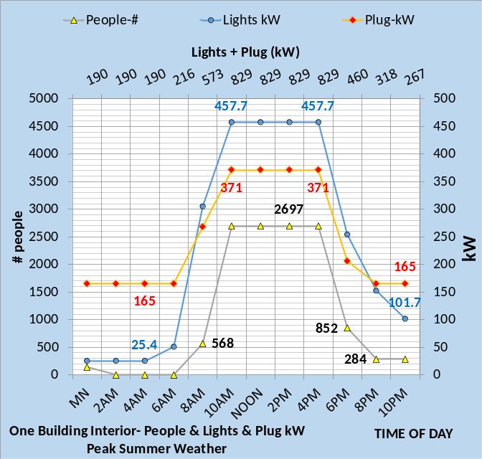
Figure 2: Top Chart-Design Day Weather-Bottom Chart⁵-Light kW, Plug kW, & # people
Figure 2 gives the lights and plug kW demand per time of day and the number of people in the building as interpreted from Liu⁵. Figures 1, 2 & Table 2 give sufficient data to (SEE) model the ASHRAE Standard 90.1-2010⁵ building and plant.
Building Design
- Building 565,000 ft².
- No external solar shading.
- Design weather-Figure 3
- Building design from Liu⁵.
- Percent wall glass 37%
- Peak lights kW .81 watts/ft²
- Peak plugs kW .66 watts/ft²
- Return air to perimeter.
- One VAV AHU/floor 24,000 CFM
- Duct design 5.5 in. water
- Fan powered terminals installed.
- Return air fans installed.
Building Control
- Lights on/off control 6% on after hours.
- Plugs on/off control 44% on after hours.
- Building pressure control, no infiltration.
- Supply air = 55F
- Supply water = 44F to 44.5F
- Stats control-no.
- Perimeter heat air temp-90F.
- VAV fan static control down to 1.5 in.
- Fresh air CFM control-yes.
- Fresh air heat stat set 42F.
Plant Design & Control
- Chiller/Tower selection¹³.
Table 2: STD. 90.1-2010 Building

Chiller Design Load (Ton) | 404.0
Chiller kW | 302.0
Chiller kW/ton | .75
Evap water flow rate (gpm) | 970.0
Evap entering water temp (F) | 54.0
Evap leaving water temp (F) | 44.0
Evap refrigerant temp (F) | 38.8
Evap refrigerant approach (F) | 5.2
Evap pressure drop (ft. water) | 27.6
Evap water velocity (ft. /sec.) | 10.6
Cond heat rejection (ton) | 490
Cond water flow rate (gpm) | 845
Cond entering water temp (F) | 96
Cond leaving water temp (F) | 110.0
Cond refrigerant temp (F) | 114.9
Cond refrigerant approach (F) | 4.9
Cond pressure drop (ft. water) | 31.2
Cond water velocity (ft. /sec) | 10.28
Tower for (SEE) model | Tower¹⁵
Design Wet bulb | 88.0F
Design Load | 490 ton
Tower water flow | 845 gpm
Approach temperature | 8.0 F
Calculated range | 14.00F
Range + approach | 22.00F
One cells with 15HP fan | 12 kW
Selected Tower¹⁵ | NC8402PAN1
Cold water | 96F
Return water to tower | 110F
Capacity | 106.3%
Static lift | 10.6 ft.
Table 2 Chiller/Tower

Table 2 gives the design parameters of the ASHRAE Standard 90.1-2010 building and plant as determined from Liu⁵.

Building Design with bad air control
- Building 565,000 ft².
- No external solar shading.
- Building design from Liu⁵.
- Percent wall glass 37%
- Peak lights kW .81 watts/ft²
- Peak plugs kW .66 watts/ft²
- Return air to perimeter.
- One VAV AHU/floor 24,000 CFM
- Duct design 7.0 in. water
- Fan powered terminals constant on.
- Return air fans installed.
Building Control
- Lights on/off control 6% on after hours.
- Plugs on/off control 44% on after hours.
- Building air infiltration, .1cfm/wall ft2.
- Supply air = 55F
- Supply water = 44F to 44.5F
- Stats control-no.
- Perimeter heat air temp-90F.
- VAV fan static control-down to 5.0 in.
- Fresh air CFM control-yes.
- Fresh air heat stat set 75F.
Plant Design & Control
- Chiller/Tower selection¹³.
Table 3: Table 2 with Bad Control

Table 3 is the Table 2 ASHRAE Standard 90.1-2010 design with bad air side control. These rather minor bad control of the air side will have a significant impact on the energy consumption of the building and plant. The point: control is a key to minimizing the energy consumption of a building and plant.

SEE MODEL DESIGN
Table 4 defines the design of the efficient design building with min reheat air handlers & efficient plant design.
Building Design
- Building 565,000 ft².
- No external solar shading.
- Design weather-Figure 3
- Building design from SEE Model.
- Percent wall glass 37%
- Peak lights kW .81 watts/ft²
- Peak plugs kW .66 watts/ft²
- Return air to perimeter.
- Min reheat AHU’s installed
- Duct design 5.5 in. water
- Fan powered terminals removed.
- Return air fans removed.
Building Control
- Lights on/off control 6% on after hours.
- Plugs on/off control 44% on after hours.
- Building pressure control, no infiltration.
- Supply air = 55F
- Supply water = 44F to 44.5F
- Stats control-yes.
- Perimeter heat air temp-100F.
- VAV fan static control-yes down to1.5 in.
- Fresh air CFM control-yes.
- Fresh air heat stat set 42F.
Plant Design & Control
- Chiller/Tower selection⁴.
Table 4: SEE Model Building

Comparing Table 2 and Table 4 illustrates five differences. The fan power terminals and return fans are removed in Table 4. The stats are controlled, the perimeter heat air is 100F verses 90F for Table 2 System and min reheat AHUs are installed.

Chiller Design Load (Ton) | 375.0
Chiller kW | 244.0
Chiller kW/ton | .71
Evap water flow rate (gpm) | 643.0
Evap entering water temp (F) | 58.0
Evap leaving water temp (F) | 44.0
Evap refrigerant temp (F) | 40.8
Evap refrigerant approach (F) | 3.2
Evap pressure drop (ft. water) | 16.4
Evap water velocity (ft. /sec.) | 6.92
Cond heat rejection (ton) | 448
Cond water flow rate (gpm) | 1081
Cond entering water temp (F) | 93.
Cond leaving water temp (F) | 103.
Cond refrigerant temp (F) | 106.6
Cond refrigerant approach (F) | 3.6
Cond pressure drop (ft. water) | 21.7
Cond water velocity (ft. /sec) | 8.25
Tower for (SEE) model | Tower¹⁵
Design Wet bulb | 88.0F
Design Load | 448 ton
Tower water flow | 1081 gpm
Approach temperature | 5.0 F
Calculated range | 10.00F
Range + approach | 15.00F
One cells with 15HP fan | 16 kW
Selected Tower¹⁵ | NC8403QLN1
Cold water | 93F
Return water to tower | 103F
Capacity | 101%
Static lift | 12.2 ft.
Table 4 SEE Model Chiller/Tower

The Table 4 chiller/Tower design is changed from Table 2 as illustrated by the Table 4 above. This chiller selection is not the most efficient in terms of chiller kW/ton but is the most efficient in terms of plant kW/ton. The point: chiller kW/ton is not the issue, plant kW/ton is.

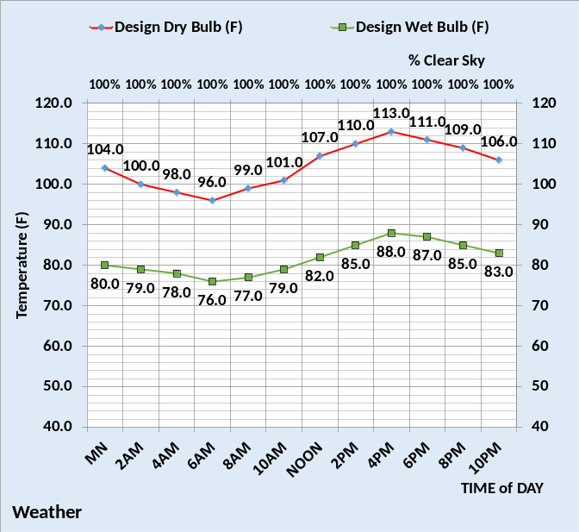
Figure 3: Design Weather

Figure 3 gives the assumed design weather. Each of the designs, Table 2, 3, & 4 will be evaluated with the SEE Model.

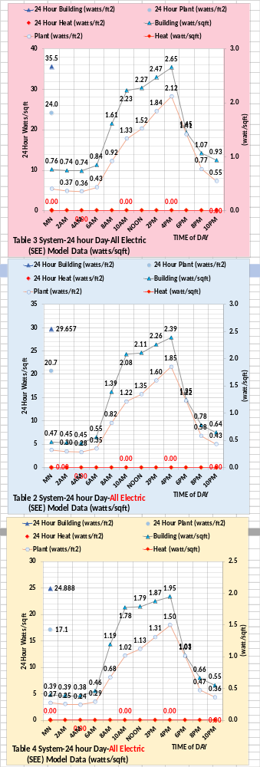
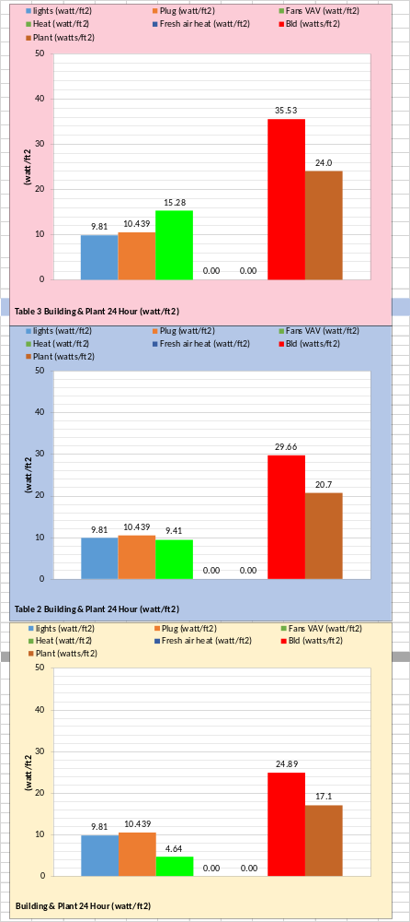
The charts at left give the hourly watts/ft² for the three designs plus the sum for the day, illustrating the significant increase with the Table 3 design and significant decrease with the Table 4 design. The above chart gives day sums for components of the system.

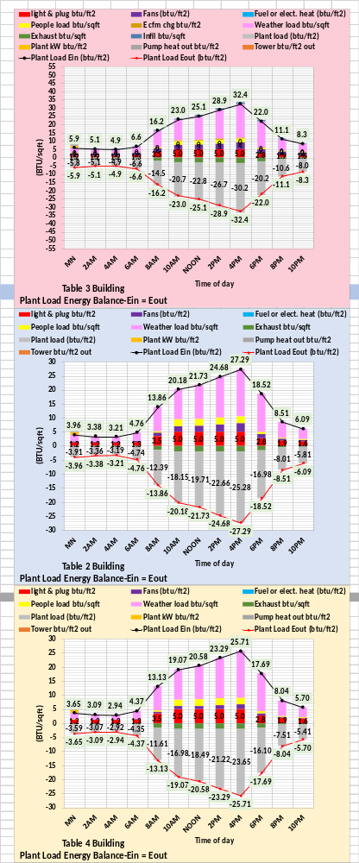

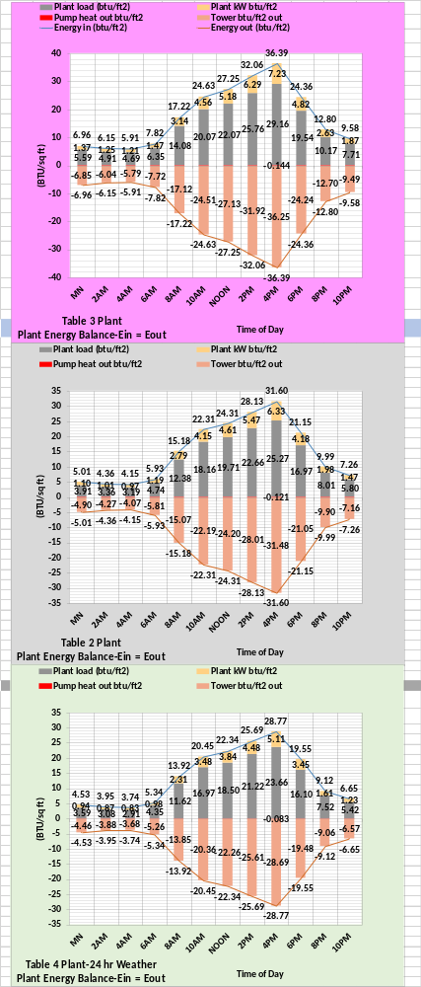
The chart at left gives the building 24-hour energy balance and the above chart gives the plant 24-hour energy balance.

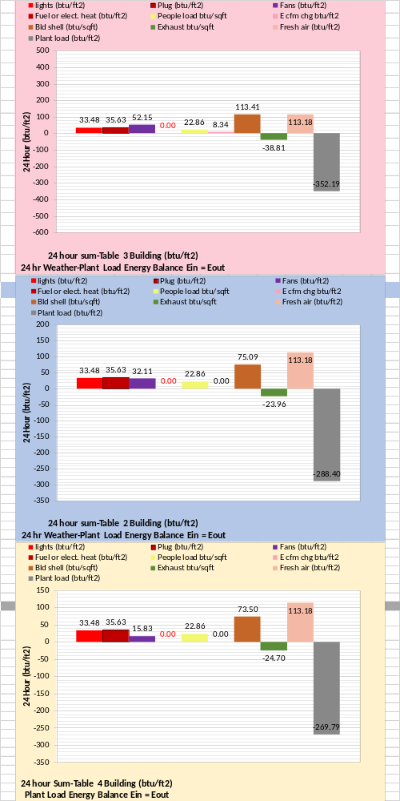
The above chart gives the 24-hour building energy balance with plant load energy out from the building.

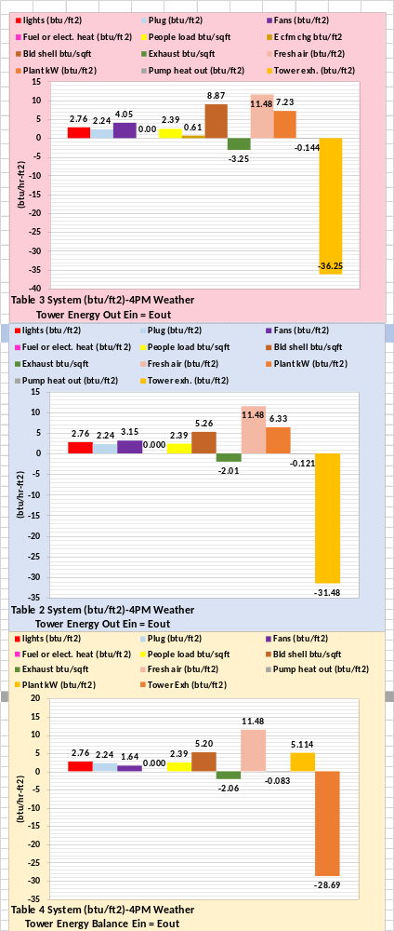
The above chart is the 24-hour energy balance of the total system giving the energy out at the tower.
The SEE Model can give an energy balance for any hour.
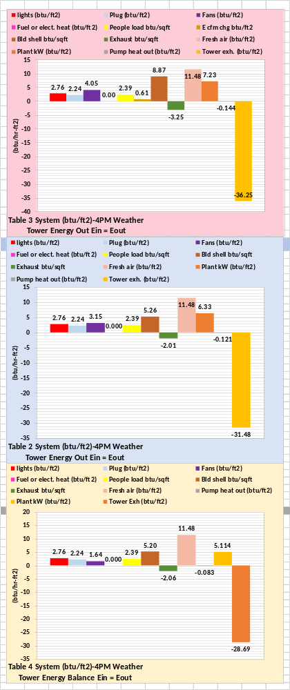
The above chart gives the energy balance (EB) at 4PM in terms of btu/ft².

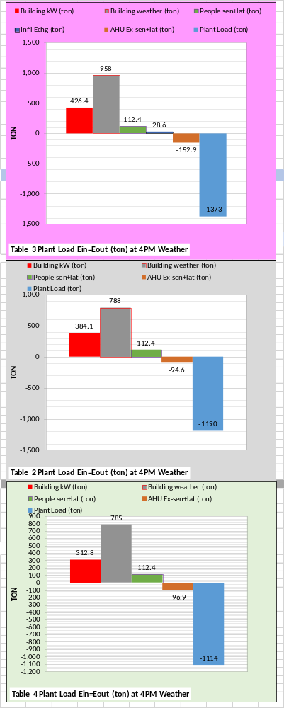
The above chart gives the building EB with fewer components and in (ton). If building kW and plant load were measured values, this EB would be easy to work with and balance the building weather term.

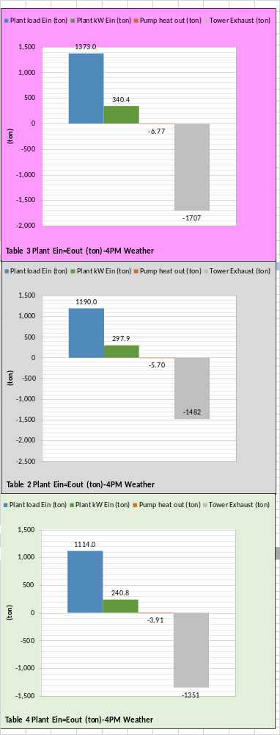
The above plant EB would be easy to verify if the plant load and/or tower energy out was metered.
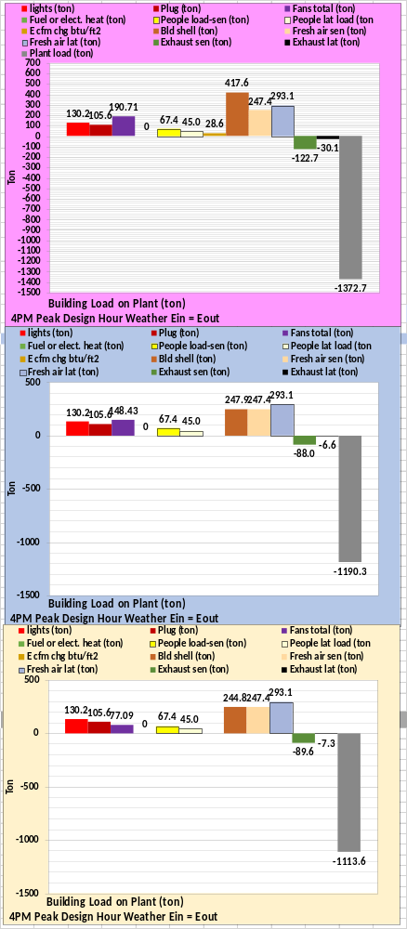
The above chart gives 4PM building or plant load EB with more detail, illustrating the complexity and value of the SEE Model energy balance.
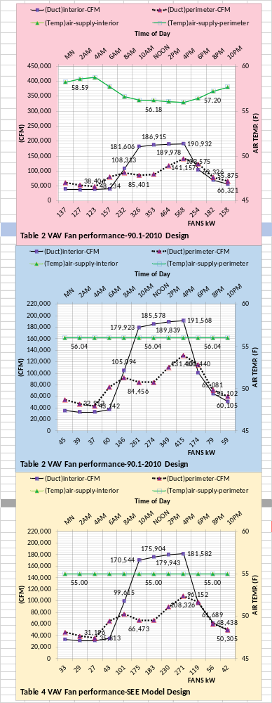
The above chart illustrates the detail the SEE Model can provide. The chart suggests that adequate ventilation occurs during occupied hours.
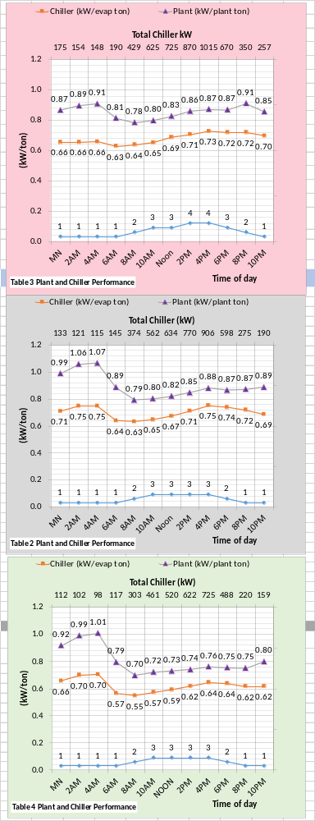
The above chart gives plant performance illustrating the advantage of the Table 4 design.
The above analysis is at design weather conditions. We will now look at real weather performance.
Dubai Benchmark at Real Weather Conditions of March 21, 2022.
Analysis with (SEE) Energy Model
Last year’s analysis, several pages below, is for a ASHRAE Standard 90.1-2010 six-building campus with a six chiller/tower plant.
This year’s analysis will give the performance of a ASHRAE Standard 90.1-2010 large office building with a plant consisting of three chiller/towers, as defined by Table 2 above.
Also, the performance of a more efficient building with min reheat air handlers & efficient plant design is presented defined by Table 4 above.
This real weather analysis will also include the performance of the Table 2 system with bad air control, Table 3 illustrates the bad control of the Table 2 design.
These bad control features of Table 3 result in significant increase in energy consumption as demonstrated by the following.

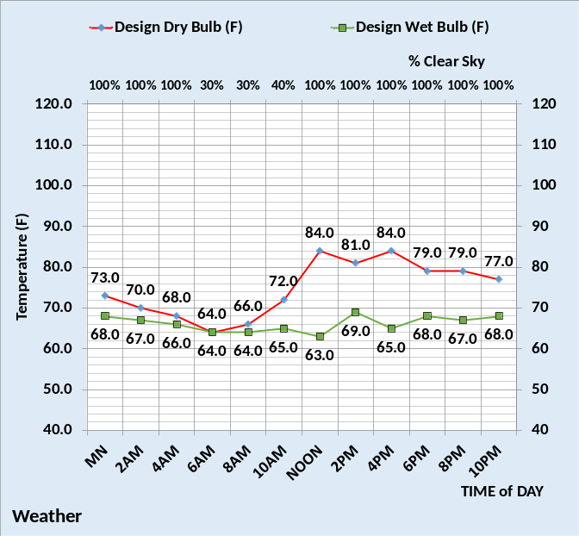
Weather
The above figure gives the weather data for this day.

The figure at right illustrates that the Table 3 system with bad air control, top chart, consumes significantly more energy than the Table 2 system, middle chart, a properly controlled ASHRAE Standard 90.1-2010 large office building. The bottom chart, Table 4 system, consumes significantly less than the Table 2 system. Note that the building watts/ft2 includes lights, plug, and air handler use and does not include heat and the plant energy use.
These charts could be used to judge the energy performance of an office building on a day with similar weather.

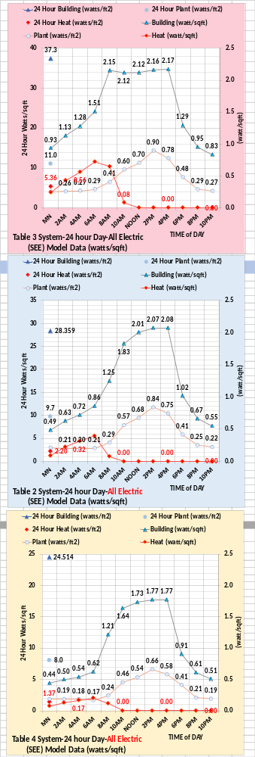
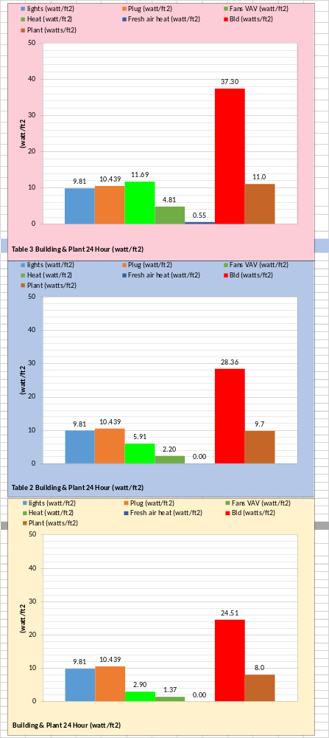

The total energy use of each system is building watts/ft2 + heat watts/ft2 + plant watts/ft2.
The figure at left gives the total energy consumption for this day for components of the system. Clearly what seems like rather insignificant bad control can have a big effect.
If only one meter exists on a building, then the real building watts/ft2 could be used to judge an existing building with weather like this day.
The Table 4 design is clearly the best performer.
The reader can judge the performance of a real building on a similar day by comparing performance to these figures. If the 24-hour energy consumption of a large office falls close to the center figure at left, then the building is operating close to 90.1-2010 performance as defined by Table 2. Values that approach the top chart, Table 3, are out of control. The bottom chart illustrates what is possible by designing an office building to Table 4.
The SEE Model provides an enormous amount of data that can be reviewed at Nelson⁴. The Energy Balance analysis is a feature of the SEE Model that provides an ability to evaluate the performance of a real building on any day.
Next, we look at Energy Balance charts for the weather day defined above.

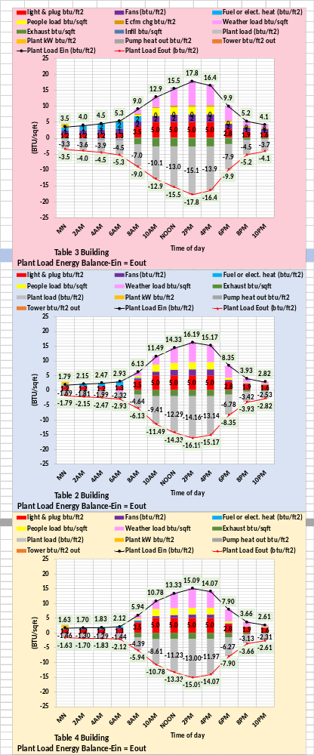
Energy Balance analysis is a major feature of the SEE Model. The above figure gives the 24-hour plant load energy balance.
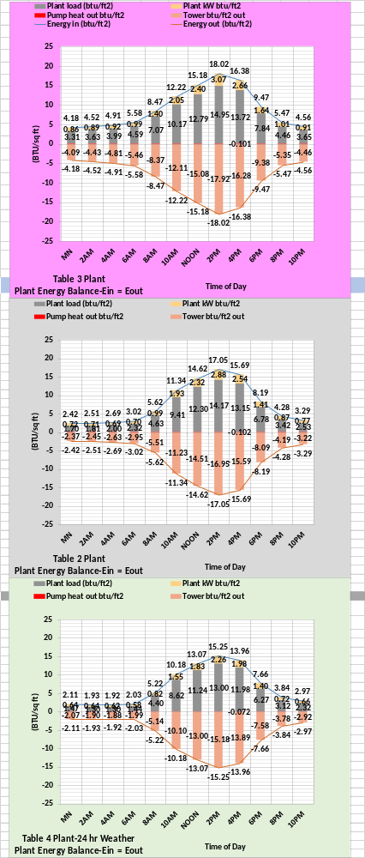
The above figure gives the 24-hour plant energy balance.

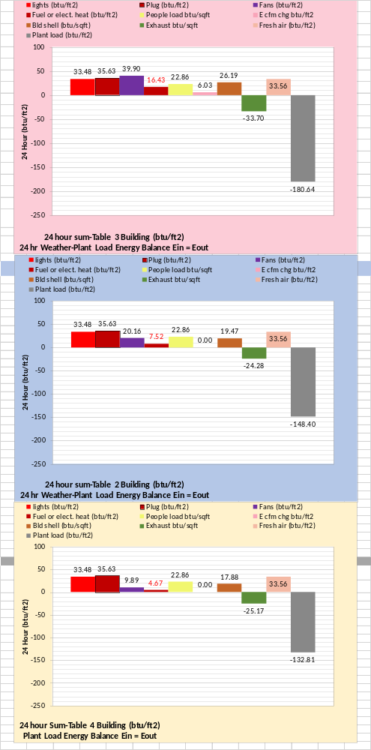
The above figure gives the 24-hour sum plant load energy balance.

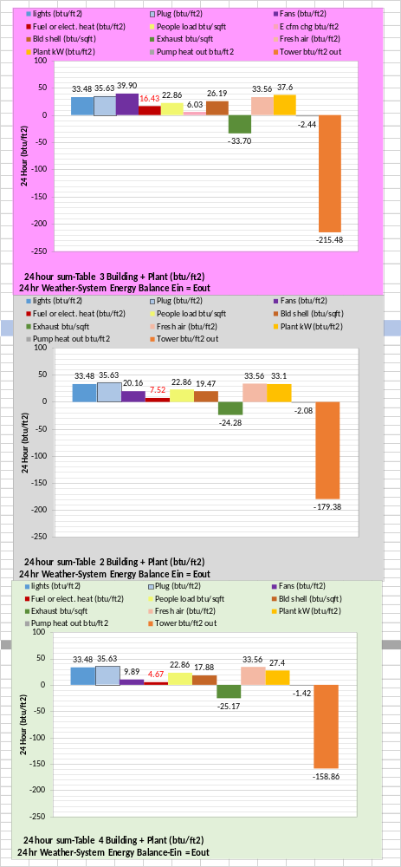
The above figure gives the total 24-hour system energy balance, energy out at the tower.

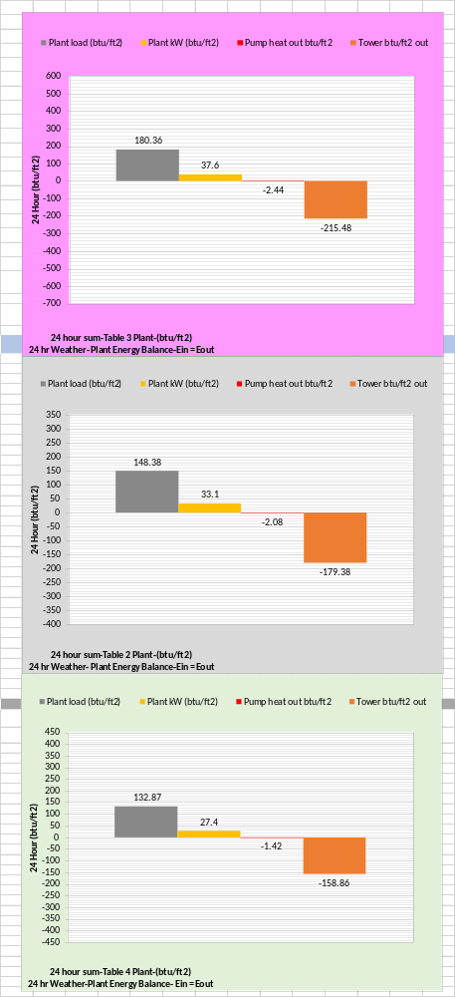
The above figure gives the 24-hour sum for the plant energy balance.
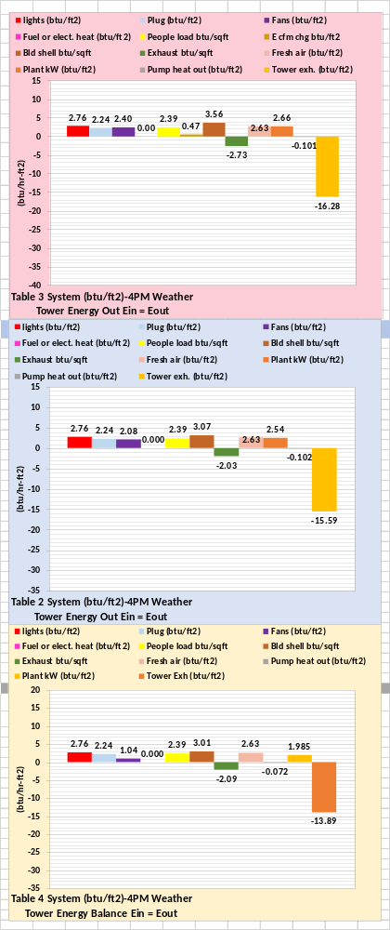
The above figure gives the energy balance at 4PM. An energy balance can be given, by the SEE Model, for any hour.
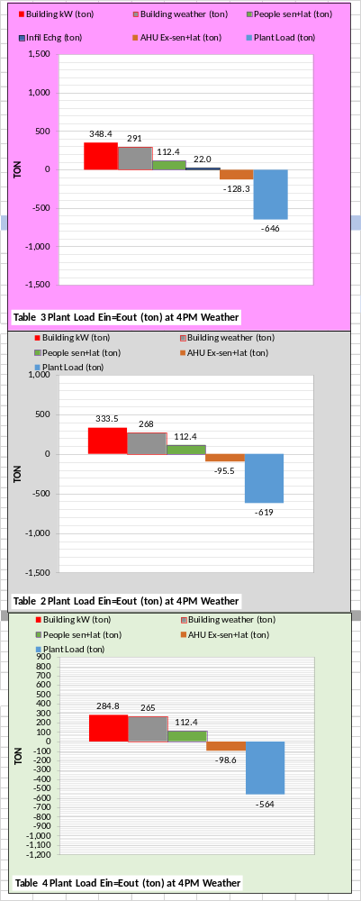
The above figure is a simpler energy
balance in (ton) load. Building kW and plant load could be metered values, therefore providing a method to check and correct the other values.

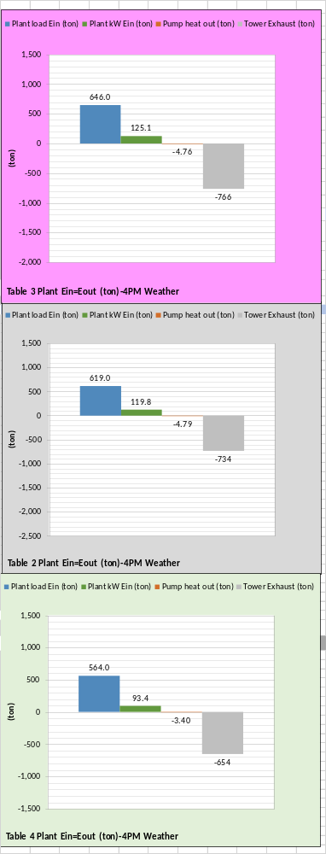
The above figure is the plant energy balance in (ton) load. The only value that cannot be directly metered is the pump heat out and it could be closely estimated by knowing pump kW.

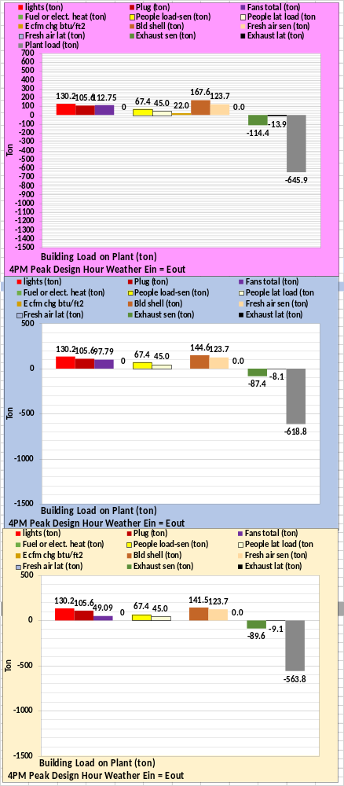
The above figure gives a greater detail plant energy balance in (ton) load.

The above figures have demonstrated the energy balance features of the SEE Model. The SEE Model can give charts of any variable of the building and plant and can also give schematics for any hour. The schematics, as given above are very valuable in understanding how the varies components of a building or plant act under given conditions and illustrates Ein = Eout as occurs in a real building and plant.
The following two sets of charts deal with ventilation and plant performance.

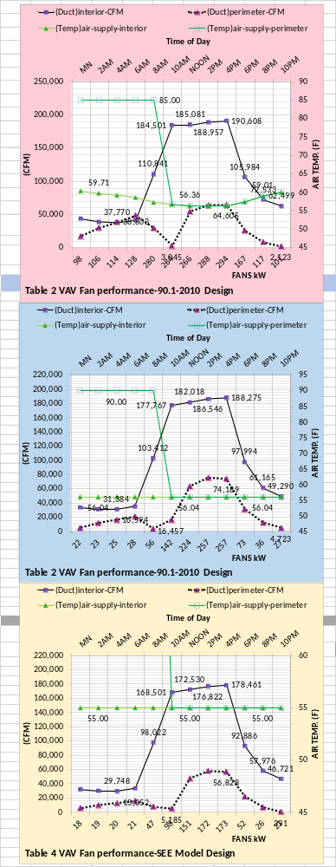
The above chart illustrates that Table 4 design demands significantly less fan kW. The Table 4 perimeter CFM can be increased by controlling the temperature of the heating air, if needed.
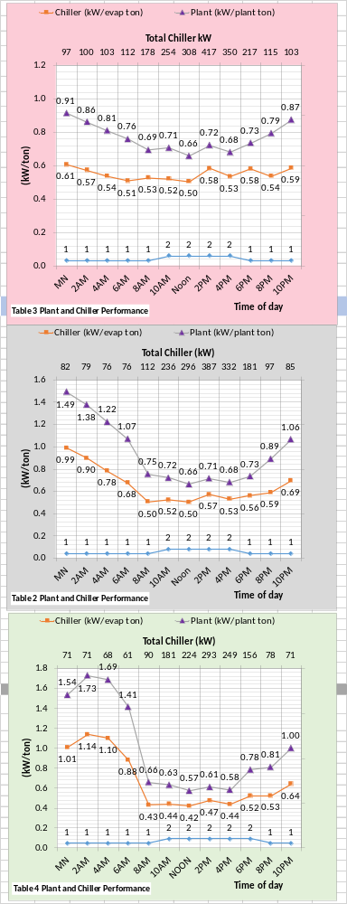
The above charts show the Table 4 design demands less chiller kW. Note the number of chiller/towers on to meet the load of each design.

SUMMARY Performance of Table 3, Table 2, & Table 4 for March 21, 2022.
These charts and Tables 2, 3, & 4 above give information and data that the reader can use to judge office buildings in Dubai on similar weather days.
These two charts are copied from above.
The above chart gives the weather for this day and the chart at right gives the kW performance of each design. On a day with weather close to above a ASHRAE Standard design would perform like the middle chart at right. An office building that approaches the values of the top chart is out of control. The bottom chart gives what is possible with efficient design. Tables 2, 3, and 4 above define each design.
A comparison of the charts at right with the charts for design weather above illustrates significant change.

Dubai Benchmark at Real Weather Conditions of March 25, 2022.
Analysis with (SEE) Energy Model
Last year’s analysis, several pages below, is for a ASHRAE Standard 90.1-2010 six-building campus with a six chiller/tower plant.
This year’s analysis will give the performance of a ASHRAE Standard 90.1-2010 large office building with a plant consisting of three chiller/towers, as defined by Table 2 above.
Also, the performance of a more efficient building with min reheat air handlers & efficient plant design is presented defined by Table 4 above.
This real weather analysis will also include the performance of the Table 2 system with bad air control, Table 3 illustrates the bad control of the Table 2 design.
These bad control features of Table 3 result in significant increase in energy consumption as demonstrated by the following.

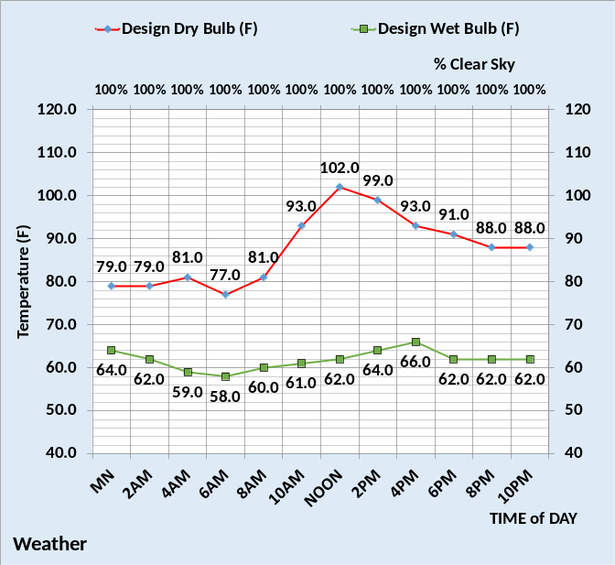
Weather
The above figure gives the weather data for this day.

The figure at right illustrates that the Table 3 system with bad air control, top chart, consumes significantly more energy than the Table 2 system, middle chart, a properly controlled ASHRAE Standard 90.1-2010 large office building. The bottom chart, Table 4 system, consumes significantly less than the Table 2 system. Note that the building watts/ft2 includes lights, plug, and air handler use and does not include heat and the plant energy use.
These charts could be used to judge the energy performance of an office building on a day with similar weather.

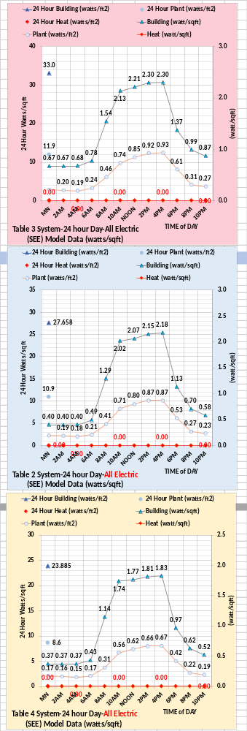
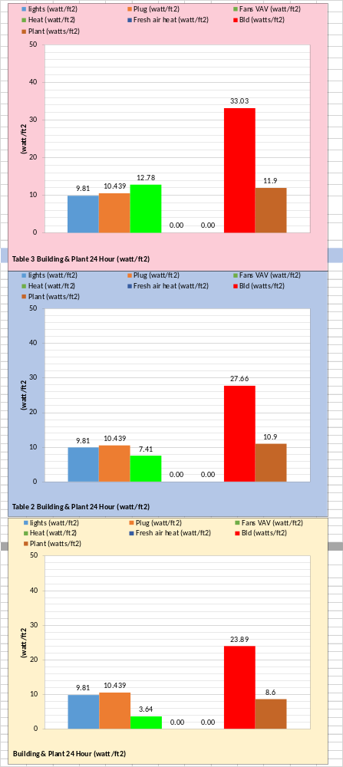

The total energy use of each system is building watts/ft2 + heat watts/ft2 + plant watts/ft2.
The figure at left gives the total energy consumption for this day for components of the system. Clearly what seems like rather insignificant bad control can have a big effect.
If only one meter exists on a building, then the real building watts/ft2 could be used to judge an existing building with weather like this day.
The Table 4 design is clearly the best performer.
The reader can judge the performance of a real building on a similar day by comparing performance to these figures. If the 24-hour energy consumption of a large office falls close to the center figure at left, then the building is operating close to 90.1-2010 performance as defined by Table 2. Values that approach the top chart, Table 3, are out of control. The bottom chart illustrates what is possible by designing an office building to Table 4.
The SEE Model provides an enormous amount of data that can be reviewed at Nelson⁴. The Energy Balance analysis is a feature of the SEE Model that provides an ability to evaluate the performance of a real building on any day.
Next, we look at Energy Balance charts for the weather day defined above.

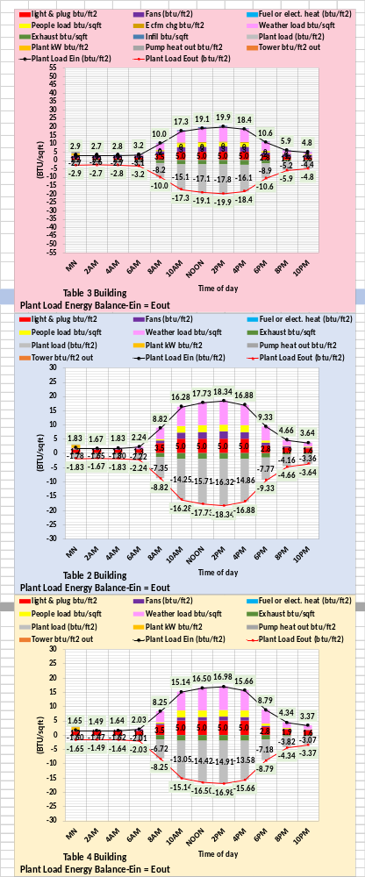
Energy Balance analysis is a major feature of the SEE Model. The above figure gives the 24-hour plant load energy balance.
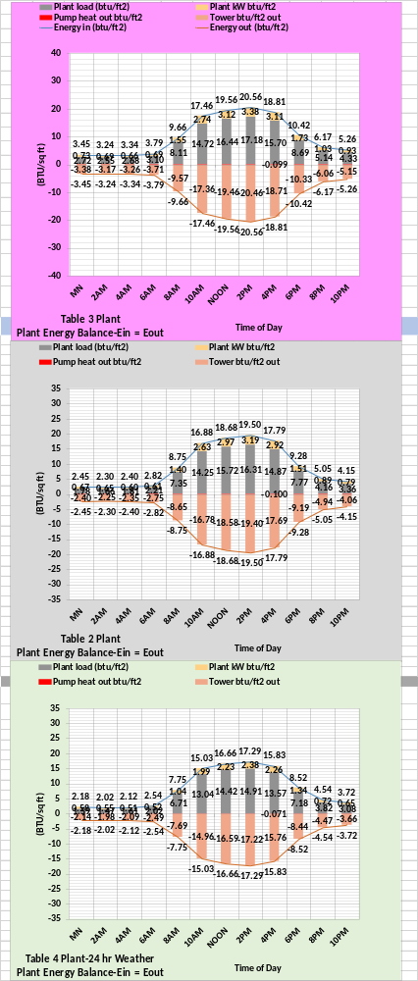
The above figure gives the 24-hour plant energy balance.

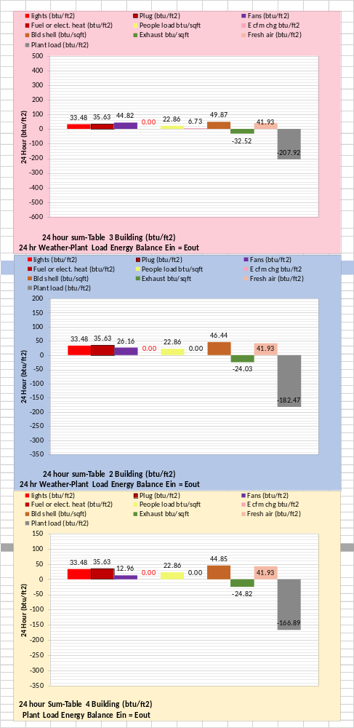
The above figure gives the 24-hour sum plant load energy balance.

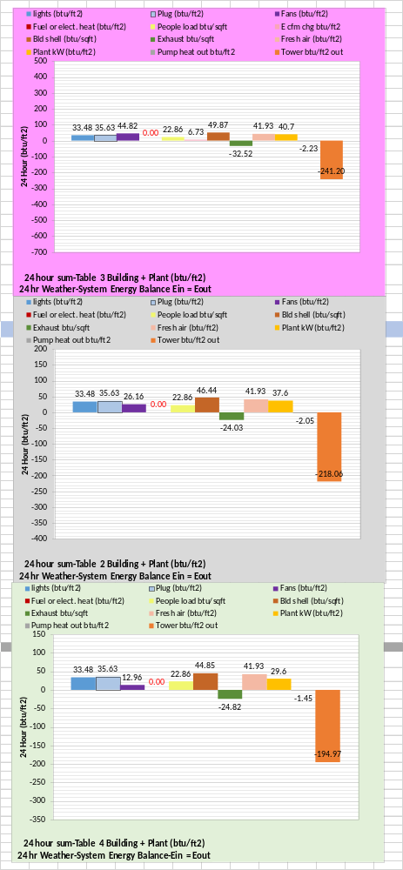
The above figure gives the total 24-hour system energy balance, energy out at the tower.

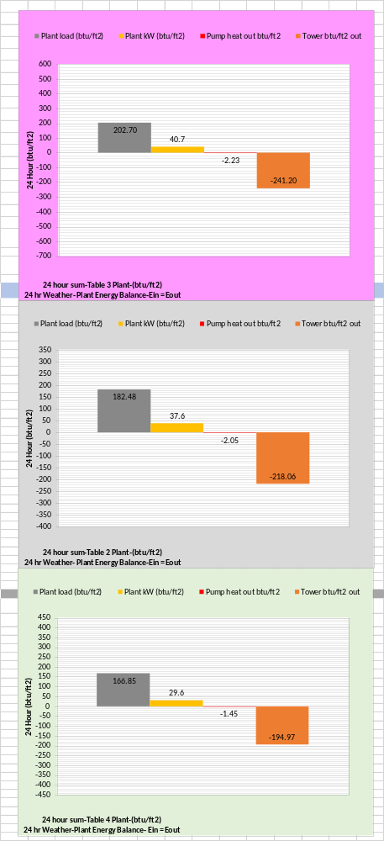
The above figure gives the 24-hour sum for the plant energy balance.
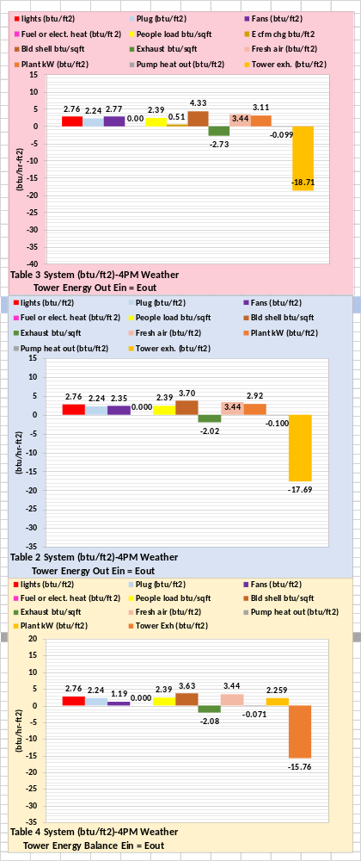
The above figure gives the energy balance at 4PM. An energy balance can be given, by the SEE Model, for any hour.
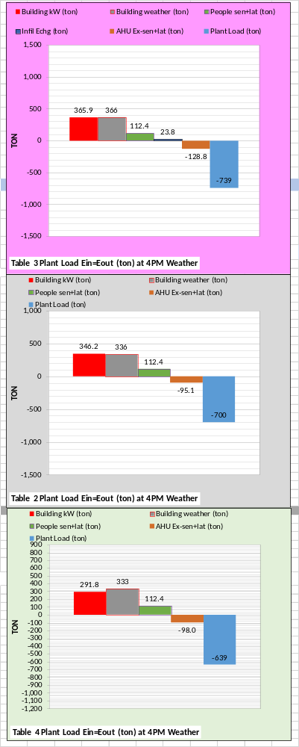
The above figure is a simpler energy
balance in (ton) load. Building kW and plant load could be metered values, therefore providing a method to check and correct the other values.

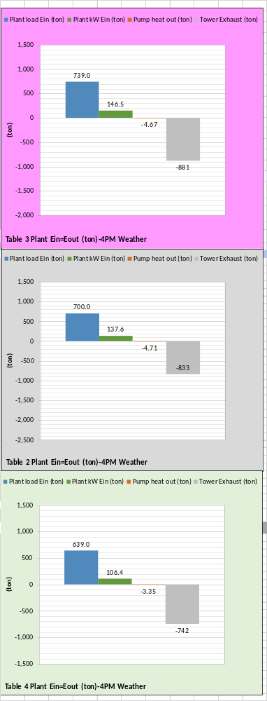
The above figure is the plant energy balance in (ton) load. The only value that cannot be directly metered is the pump heat out and it could be closely estimated by knowing pump kW.

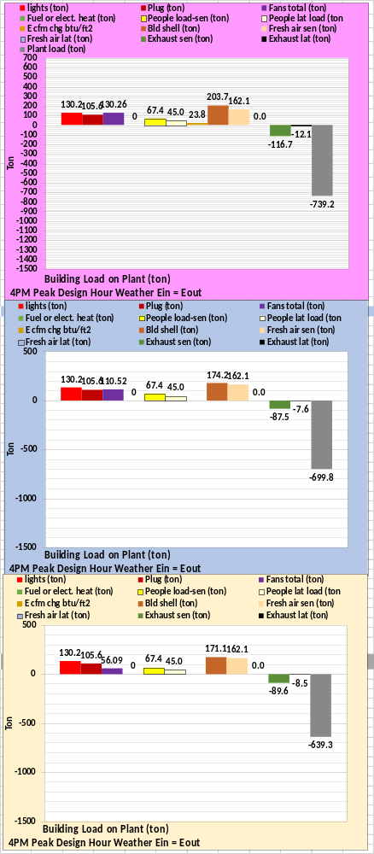
The above figure gives a greater detail plant energy balance in (ton) load.

The above figures have demonstrated the energy balance features of the SEE Model. The SEE Model can give charts of any variable of the building and plant and can also give schematics for any hour. The schematics, as given above are very valuable in understanding how the varies components of a building or plant act under given conditions and illustrates Ein = Eout as occurs in a real building and plant.
The following two sets of charts deal with ventilation and plant performance.

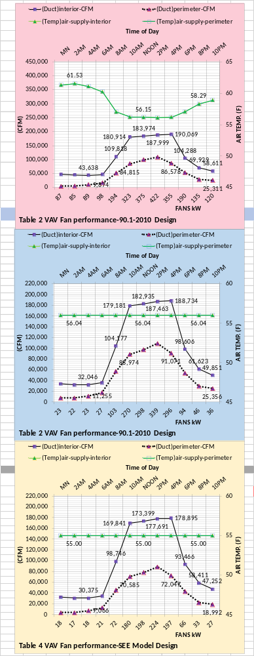
The above chart illustrates that Table 4 design demands significantly less fan kW. The Table 4 perimeter CFM can be increased by controlling the temperature of the heating air, if needed.
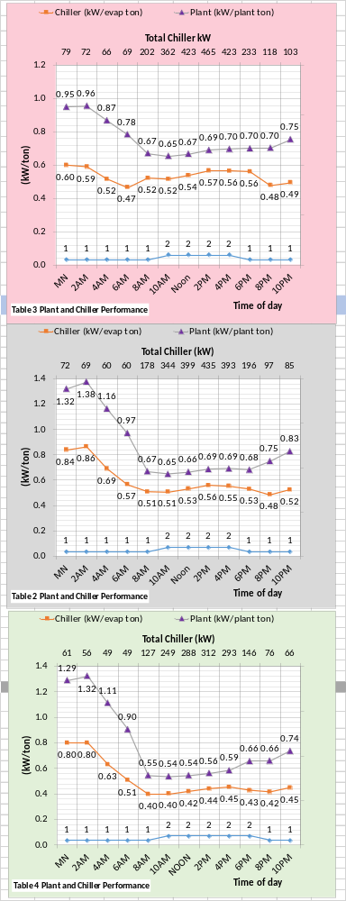
The above charts show the Table 4 design demands less chiller kW. Note the number of chiller/towers on to meet the load of each design.

SUMMARY Performance of Table 3, Table 2, & Table 4 for March 25, 2022.
These charts and Tables 2, 3, & 4 above give information and data that the reader can use to judge office buildings in Dubai on similar weather days.
These two charts are copied from above.
The above chart gives the weather for this day and the chart at right gives the kW performance of each design. On a day with weather close to above a ASHRAE Standard design would perform like the middle chart at right. An office building that approaches the values of the top chart is out of control. The bottom chart gives what is possible with efficient design. Tables 2, 3, and 4 above define each design.
A comparison of the charts at right with above charts for different weather illustrates significant change.

Dubia United Arab Emirates (SEE) Model Building Energy Benchmark at Real Weather Conditions.
Introduction/Building Description
A system energy equilibrium (SEE) model is a tool for commissioning and evaluating the performance of a building and plant on any day. The (SEE) model also provides the capability to judge the performance of systems on any day. The purpose of this paper is to provide performance data on specify days so that building owners can judge the energy performance of their buildings against an ASHRAE Standard design, in this case a 90.1-2010⁵ building and plant design.
Reader should review Anatomy of a Real Time Building Energy Model on this site.

Building 13 Story
Each Building=565,000 Ft-Sq
Building height=169 Ft
13 story building
Roof = 43,462 Ft-Sq
All walls 37.5% glass
Roof U=.048 Wall U=.090
Glass U=.55 Glass SHGC=.40
Footprint
South=240 Ft North=240 Ft
Each wall=40,560 Ft-Sq
East=181.09 Ft West=181.09 Ft
Each Wall=30,604 Ft-Sq

Figure 1: Building Description Large Office Building Designed to Std. 90.1-2010⁵

Figure 1 presents the modeled building of this study, a 565,000 square foot large office building based on the data provided by Liu⁵. The office campus is assumed to consist of six Figure 1 buildings.
Figure 2 top chart gives the assumed design day weather conditions. The secondary horizontal axis of gives the design day percent clear sky.
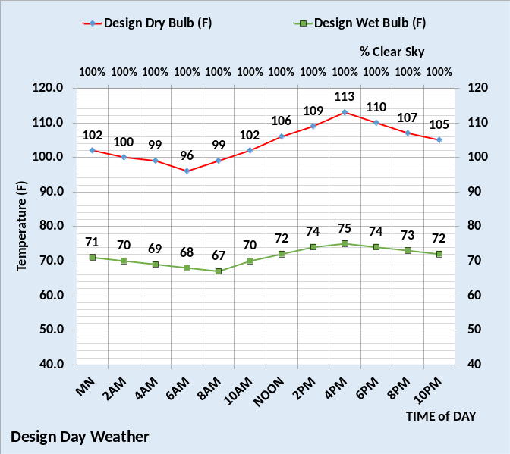
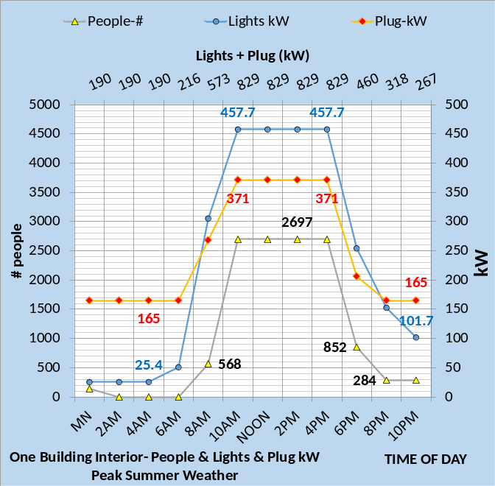
Figure 2: Top Chart-Design Day Weather-Bottom Chart⁵-Light kW, Plug kW, & # people

Figure 2 bottom chart gives the lights and plug kW demand per time of day and the number of people in the building as interpreted from Liu⁵. Figures 1 & 2 plus Table 2 give sufficient data to (SEE) model the ASHRAE Standard 90.1-2010⁵ building and plant.

Building Location and Design
- Location=Dubai
- Building 565,000 ft².
- No external solar shading.
- Design weather-Figure 2
- Building design from Liu⁵.
- Percent wall glass 37%
- Peak lights kW .81 watts/ft²
- Peak plugs kW .66 watts/ft²
- Return air to perimeter-no change.
- One VAV AHU/floor 26,400 CFM
- Duct design 7.0 in. water
- Fan powered terminals installed.
- Return air fans installed.
Building Control
- Lights on/off control 6% on after hours.
- Plugs on/off control 44% on after hours.
- Building pressure control, no infiltration.
- Supply air = 55F
- Supply water = 44F to 44.5F
- Stats control-yes.
- Perimeter heat air temp-105F.
- VAV fan static control-yes.
- Fresh air CFM control-yes.
- Fresh air heat stat set 42F.
Plant Design & Control
- Chiller/Tower selection¹³.
Table 2: System

Table 2 gives the building and plant design defined here as an efficient design and the as constructed system.

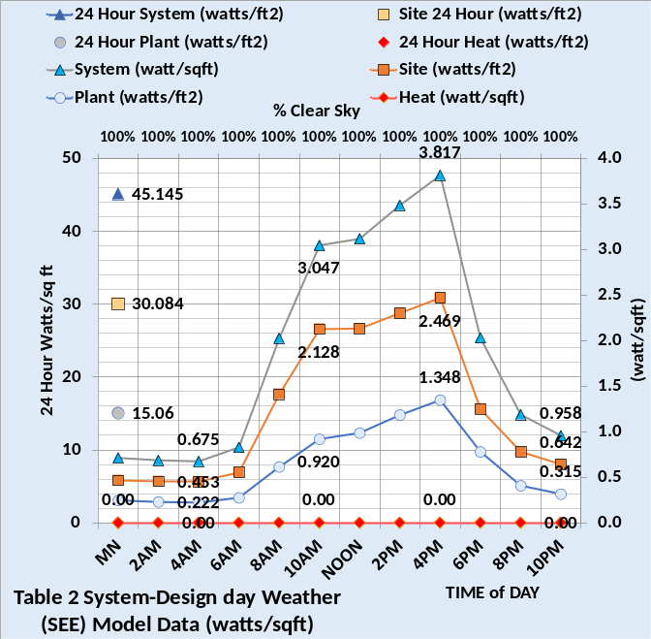
Figure 3: Table 2 System Watts/ft² Design Day Weather

Figure 3 gives the watts/ft² performance of the Figures 1, 2 and Table 2 building and plant, defined here as the ASHRAE Standard 90.1-2010⁵ design, also defined here as the “Table 2 system”.
The total 24-hour consumption operating at the design weather conditions of Figure 2 is 45.145 watts/ft². The building, not including heat, is 30.084 watts/ft² and the plant is 15.06 watts/ft². These values can be used to judge office buildings design and performance when operating close to design weather of this city.
Specific days of weather will be addressed below showing performance of the Table 2 system and the Table 3 system defined below as the Table 2 system with poor control.

Energy Balance of Table 2 System

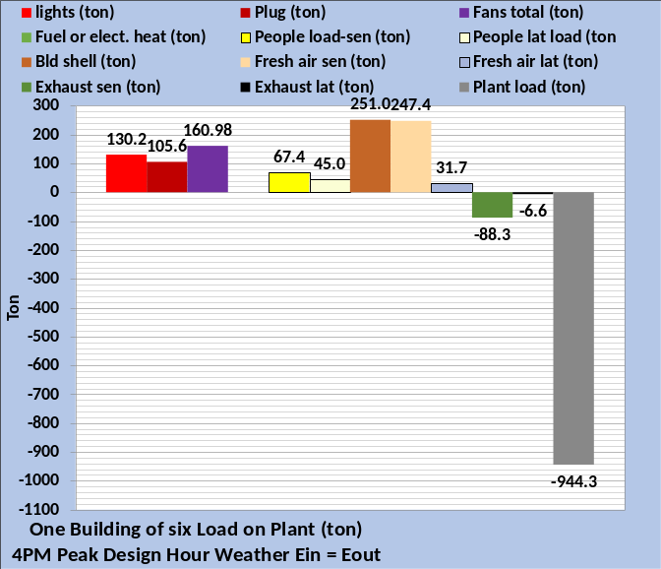
Figure 4: Table 2 System Energy Balance at Design conditions at 4PM of Figure 2

Figure 4 would have been determined during the design of this building and plant. Figure 5 gives the 24-hour energy balance data in (btu/ft²) so that data for any building can be judged against this (SEE) model Standard 90.1-2010 building⁵ as defined by Table 2.
Figure 5 gives the 24-hour energy balance of the plant load, top chart, and the energy out at the tower, bottom chart.

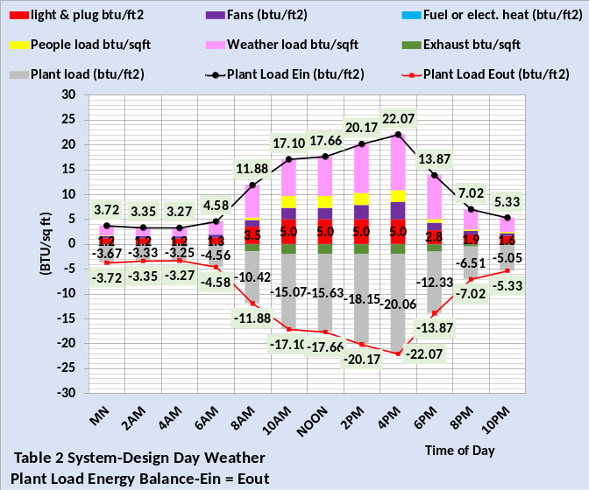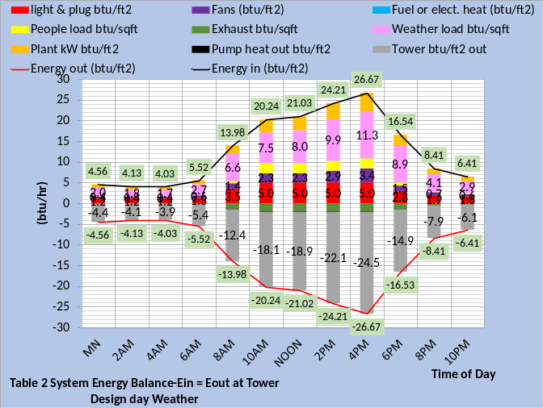
Figure 5: Table 2 System 24 Hour Energy Balance Top chart plant energy balance, Bottom chart system energy balance.

Chiller/Tower Design Data
Tables 1 gives (SEE) model input design data for the chiller and tower and Table 1A defines the chiller/tower design lift. The chiller/tower has 1,000-ton capacity at design conditions of 75F wet bulb. The chiller evaporator is selected with a 5.2F refrigerant approach and the condenser is 4.9F refrigerant approach.
The tower is selected¹⁵ at 1,200-ton load and 75F wet bulb with an approach to wet bulb of 10F and flow of 1,920 gpm with a calculated range of 15.0F. The tower is a one cell unit with a 60hp fan. Six chiller/towers are required to meet the design load Condenser design leaving water temperature is 100.00F and tower leaving water is 85F.
Chiller Design Load (Ton) | 962.2
Chiller kW | 612.2
Chiller kW/ton | .636
Evap water flow rate (gpm) | 1500.0
Evap entering water temp (F) | 60.0
Evap leaving water temp (F) | 44.0
Evap refrigerant temp (F) | 38.8
Evap refrigerant approach (F) | 5.2
Evap pressure drop (ft. water) | 27.6
Evap water velocity (ft. /sec.) | 10.06
Cond heat rejection (ton) | 1200
Cond water flow rate (gpm) | 1928
Cond entering water temp (F) | 85
Cond leaving water temp (F) | 100.00
Cond refrigerant temp (F) | 104.9
Cond refrigerant approach (F) | 4.9
Cond pressure drop (ft. water) | 31.2
Cond water velocity (ft. /sec) | 10.28
Tower for (SEE) model | Tower¹⁵
Design Wet bulb | 75.0F
Design Load | 1200 ton
Tower water flow | 1928 gpm
Approach temperature | 10.0 F
Calculated range | 15.0F
Range + approach | 25F
One cells with 60HP fan | 48 kW
Selected Tower¹⁵ | NC8407VAN1
Cold water | 85F
Return water to tower | 100.0F
Capacity | 103.6%
Static lift | 12 ft.
Table 1: Chiller/Tower Design Data
Chiller/Tower Lift
Chiller lift²⁰ equals condenser refrigerant temperature minus evaporator refrigerant temperature as defined by Table 1A for this chiller/tower selection. Table 1A illustrates the design values that define the refrigerant temperatures and therefore chiller lift. All values are taken from Tables 1. The condenser refrigerant temperature is the sum of wet bulb + tower approach = entering condenser water + tower range = leaving condenser water + condenser refrigerant approach = 101.73F refrigerant temperature. The evaporator refrigerant temperature is determined by the design values of Table 1. Evaporator entering water minus evaporator delta T equals leaving chiller water temperature minus evaporator refrigerant approach temperature equals evaporator refrigerant temperature. The evaporator refrigerant temperature can also be determined by simply subtracting the evaporator refrigerant approach temperature from the evaporator supply water temperature, (44F – 2.6F = 41.4F). Therefore, chiller lift = 101.73F – 41.4F = 60.33F. Chilled water supply temperature has a significant effect on chiller lift and therefore chiller kW demand.
Design Chiller Lift (F)
Condenser refrigerant | 104.9F
Condenser refrigerant approach | 4.9F
Leaving condenser water | 100.00F
Tower range | 15.00F
Entering condenser water | 85F
Tower approach | 10.0F
Wet bulb temperature | 75.0F
Chiller lift = 104.9F – 38.8F = 66.1F
Evaporator entering water | 60F
Evaporator delta temperature | 16F
Leaving chilled water temperature | 44F
Evaporator refrigerant approach | 5.2F
Evaporator refrigerant temperature | 38.8F
Table 1A: Chiller/Tower Lift-Design Conditions

Table 1 & 1A are chiller/tower design selection values for a Dubai plant. Operating at the design conditions of this city is illustrated by the following plant schematic. Detail plant design/selection is a (SEE) plant model capability that will be presented at, “System Energy Equilibrium (SEE) Building Energy Model Development & Verification”. http://kirbynelsonpe.com/

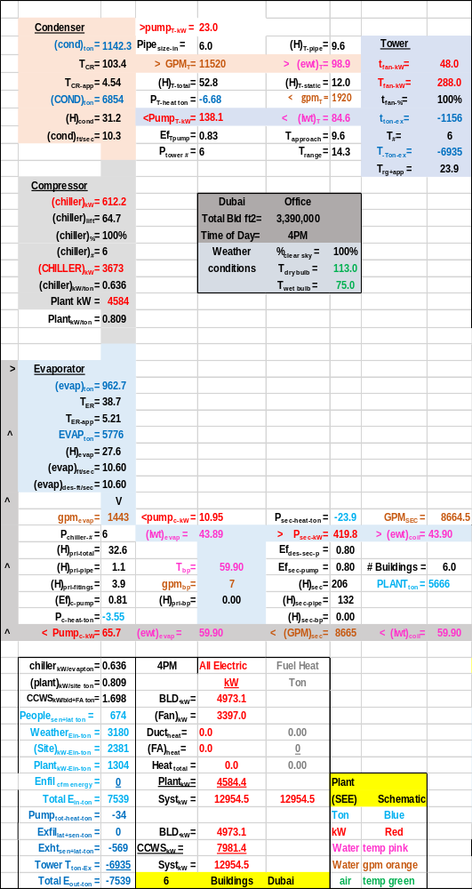
Table 2 Plant Schematic-Design Load

The Table 2 Plant Schematic illustrates the lift at design weather is 64.1F verses 66.1 of Table 1A. Nomenclature is given below so the reader can study the plant schematic.
The plant design will be addressed later illustrating a significantly more efficient chiller/tower.

(EUI) Estimates (kbtu/ft²-yr) for the
Table 2 System
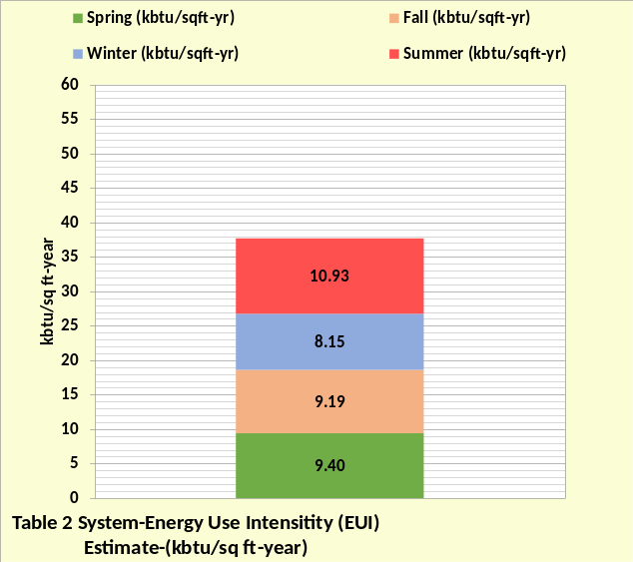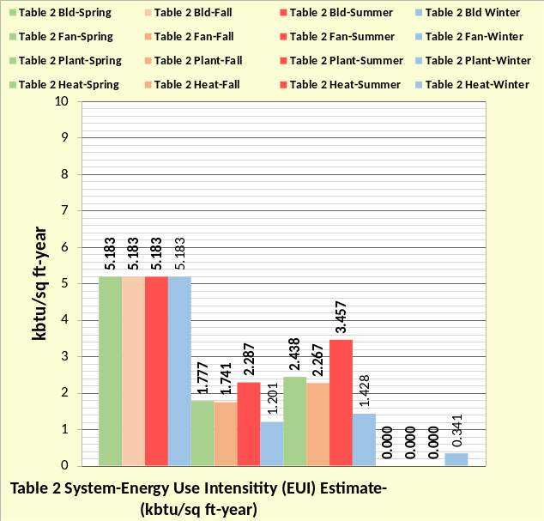
Figure 6: Table 2 System (EUI) estimate & System Components (EUI) per season
Figure 6 is an estimate of annual (EUI) for the Table 2 system and Figure 7 is for the Table 3 system. The bottom charts of Figures 6 & 7 give the (EUI) values of the system components at the four seasons. The Table 3 system is the Table 2 system with poor control. Poor control of the Table 2 system increased the (EUI) value of the Table 2 system about 42%.
Table 3 System-Poor Control
Each of the building controls listed by Table 2 are changed with Table 3 except the 55F supply air temperature and the plant control. The (SEE) model can evaluate each of these poor control issues, and others, as standalone or as additive effect on the performance of the system.
System aging can also have a significant effect on the performance of a system but will not be addressed here, perhaps later.
Building Location and Design
- Location= Dubai
- Building 565,000 ft².
- No external solar shading.
- Average ambient temperatures
- Percent clear sky s defined below.
- Building design per Liu⁵.
- Percent wall glass 37%
- Peak lights kW .81 watts/ft²
- Peak plugs kW .66 watts/ft²
- Return air to perimeter-no change.
- One VAV AHU/floor 26,400 CFM
- Duct design 5.5 to 7.0 in. water
- Fan powered terminals installed
- Return air fans installed
Building Control
- Lights on/off control from 6% on after hours to 67% on.
- Plugs on/off control 44% on after hours to 67% on.
- Building pressure control; infiltration of .2 cfm/ft² walls max-varies as AHU cfm.
- Supply air = 55F
- Supply water = 44F to 44.5F
- Stats control-NO.
- Perimeter heat air temp-90F.
- VAV fan static control-NO.
- Fresh air CFM control-NO.
- Fresh air heat stat set from 42F to 60F.
Plant Design & Control
- Chiller/Tower selection¹³.
Table 3: System-Poor Control

The (EUI) estimates of Figures 6 & 7 are at average weather for the four seasons with 80% clear sky for summer, 60% clear sky for spring and fall, and 20% clear sky for winter weather.
Figures 6 & 7 provide estimated annual (EUI) values so the annual performance of a real building and plant can be judged. Below will provide performance on specific days for Energy Balance Analysis. See Anatomy of a Real Time Building Energy Model for analysis procedures.
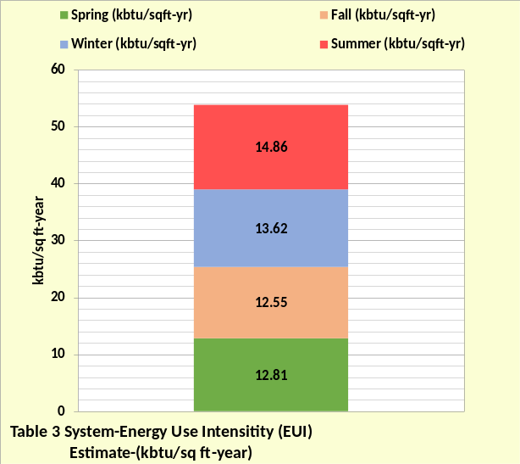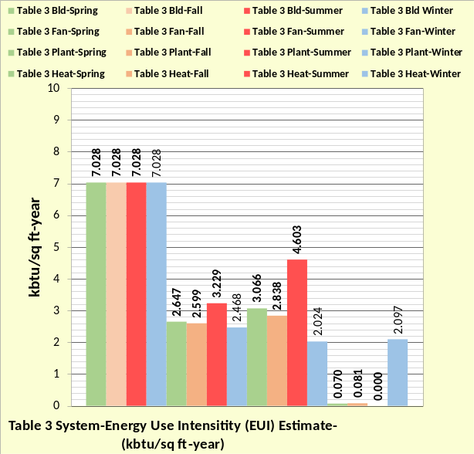
Figure 7: Table 3 System (EUI) estimate & System Components (EUI) per season

An office building or campus for this city should have an annual (EUI) close to Figure 6. If the annual (EUI) is greater than Figure 6 then a (SEE) model analysis of the building might be in order. This site⁴ will provide an approach to energy balance analysis with (SEE) model.
This completes the introduction that give the performance of the Table 2 & 3 systems at design day conditions. The remaining sections of this paper will give performance of the Table 2 & 3 systems at real weather. Nomenclature is given at the end.
Suggest reader visit; Anatomy of a Real Time Building Energy Model on this site that gives (SEE) model analysis procedures.
Stay tuned for more real weather days to be Benchmarked.
Best Regards to All
Kirby Nelson P.E.
Life Member ASHRAE

References
- Introduction to Thermodynamics and Heat Transfer. 1956 Prentice-Hall, Inc. by David A. Mooney.
- Thermal Environmental Engineering third edition. 1998 Prentice-Hall Inc. by Thomas H. Kuehn, chapter 3.
- ASHRAE Journal May 2016. “Modeled Performance Isn’t Actual Performance”
- Nelson, Kirby. “System Energy Equilibrium (SEE) Building Energy Model Development & Verification”. http://kirbynelsonpe.com/
- Liu, B. May 2011. “Achieving the 30% Goal: (copy and paste) https://www.energycodes.gov/sites/default/files/documents/BECP_Energy_Cost_Savings_STD2010_May2011_v00.pdf
- Real weather data www.wunderground.com/
- Nelson, K. “7 Upgrades to, Reduce Building Electrical Demand” ASHRAE Journal, December, 2006,
- Nelson, K. “Simulation Modeling of a Central Chiller Plant” CH-12-002. ASHRAE 2012 Chicago Winter Transactions.
- Nelson, K. “Simulation Modeling of Central Chilled Water System” CH-12-003. ASHRAE 2012 Chicago Winter Transactions.
- Kavanaugh, S. “Fan Demand and Energy” ASHRAE Journal, 2000.
- Faris, Gus “Fan-Powered VAV Terminal Units” ASHRAE Journal November 2017
- Kettler, John “Return Fans or Relief Fans” ASHRAE Journal April 2004.
- Taylor, S. 2011. “Optimizing design & control of chiller plants.” ASHRAE Journal (12).
- Nelson, Kirby “The System Energy Equilibrium Model for Chiller Plants, Part 1” Engineered Systems, July 2020.
- Marley Tower SPX Cooling Technologies UPDATE Version 5.4.2
- Steven Taylor. ASHRAE Journal June 2007. “VAV System Static Pressure Setpoint Reset.”
- Carrier System Design Manual
- Miles Ryan. ASHRAE Journal February 2021. “Understanding Cascade Control and Its Applications For HVAC”
- Schwedler, Mick. July 1998 “Take It to The Limit…Or Just Halfway?” ASHRAE Journal.
- 2020 ASHRAE HANDBOOK, HVAC Systems and Equipment, page 43.10 Figure 11 Temperature Relations in a Typical Centrifugal Liquid Chiller.

Real Weather Performance of Table 2 & Table 3 Systems The following will give (SEE) model results at real weather conditions so that building owners can judge their buildings against ASHRAE Standard 90.1-2010 design for large office buildings. Values close to Table 2 values suggests a building that is operating close to ideal performance. Values close to Table 3 values suggests a building that is out of energy control.
November 26, 2021
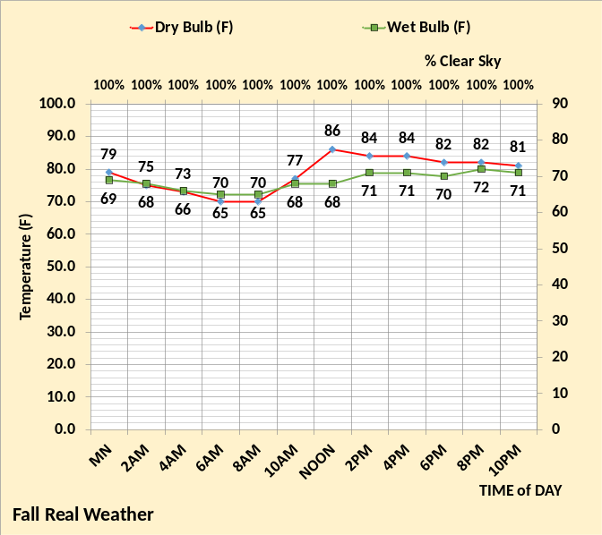Figure A: Real Weather
Figure A illustrates the real weather⁶ for this day.
Figure B top chart gives a 24-hour total btu/ft² for the Table 2 system that is much less than the Table 3 system, bottom chart.
If the real system falls close to the Table 2 system 24-hour values, then the real system is probably operating efficiently on this date. However, the system should be checked at other weather conditions and different seasons.
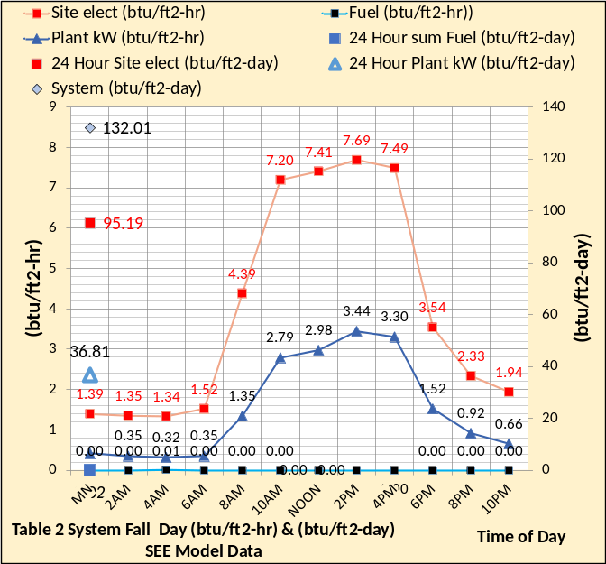 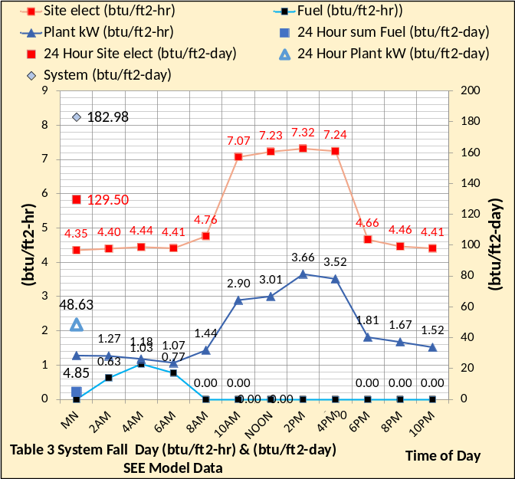Figure B: 24 Hour Performance-Table 2&3 Systems
A system that has values on this day that are close to the Table 3 system, bottom chart of Figure B, is operating far outside of efficient performance. Suggest the reader visit; Anatomy of a Real Time Building Energy Model on this site that gives (SEE) model analysis procedures. A more efficient chiller/tower will be modeled at a later date.
Stay tuned in for more real weather days.

NOMENCLATURE Each of the more than 200 variables are defined.
Building structure.
BLD ft² = air-conditioned space
# Floors = number of building floors
Roof ft² = roof square feet
N/S wall ft² =north/south wall square feet
E/W wall ft² =east/west wall square feet
Wall % glass = percent of each wall that is glass
Glass U = glass heat transfer coefficient
Wall U = wall heat transfer coefficient
Glass SHGC = glass solar heat gain coefficient
Wall emit = wall solar index
Building interior space;
Roof_{trans-ton} =transmission through roof (ton)
Roof_{sky-lite-ton} =sky lite load (ton)
People_{ton sen&lat} = sensible & latent cooling load due to people (ton)
Plug_{ton&kW} = cooling load & kW due to plug loads
Light_{ton&kW} = cooling load & kW due to lights
Total Bld_{int-ton} = total building interior load (ton)
(int-cfm) _{to-per-return} = CFM of interior supply air that returns to perimeter of building
T_{stat-int} = interior stat set temperature (F)
Bld_{int-air-ton} = supply air ton to offset interior load
BLD kW = total building kW demand
FAN kW = total fan kW
HEAT kW = total kW due to heat
SITE kW = total site kW=Bld+ Fan+Heat
Building perimeter space;
%_{clear sky} = percent clear sky
T_{dry bulb} = outside dry bulb temperature (F)
T_{wet bulb} = outside wet bulb temperature (F)
Ex/Infil_{lat-ton} = latent air infiltration or exfiltration (ton)
Ex/Infil_{CFM} = air infiltration or exfiltration CFM
Exfil_{sen-ton} =sensible air exfiltration or infiltration (ton)
Wall_{n trans ton} = north wall transmission (ton)
Wall_{s trans ton} = south wall transmission (ton)
Wall_{E trans ton} = east wall transmission (ton)
Wall_{w trans ton} = west wall transmission (ton)
Wall_{tot-trans-ton} = total wall transmission (ton)
Glass_{N-trans-ton} = north wall glass transmission (ton)
Glass_{S-trans-ton} = south wall glass transmission (ton)
Glass_{E-trans-ton} = east wall glass transmission (ton)
Glass_{W trans-ton} = west wall glass transmission (ton)
Glass_{tot-trans-ton} = total transmission thru glass (ton)
Glass_{N-solar-ton} = north glass solar load (ton)
Glass_{S-solar-ton} = south glass solar load (ton)
Glass_{E-solar-ton} = east glass solar load (ton)
Glass_{W-solar-ton} = west glass solar load (ton)
Glass_{tot-solar-ton} = total glass solar load (ton)
(int cfm)_{per-ton} = effect of interior CFM to wall (ton)
Total Bld_{per-sen-ton} total perimeter sensible load (ton)
T_{stat-per} = perimeter stat set temperature (F)
Bld_{per-air-ton} = supply air ton to offset perimeter load
Air handler duct system-Interior duct
T_{air supply int} = temp air supply to building interior (F)
(fan)_{int ter ton&kW} = interior ton & kW due to terminal fans
(D)_{int-air-ton} = cooling (ton) to building interior duct
T_{air coils} = supply air temperature off coils to duct (F)
(D)_{int-CFM} = supply air CFM to building interior duct
Perimeter duct
T_{air supply per} =temp (F) air supply to building perimeter
(fan)_{per ter ton&kW} = perimeter ton & kW of terminal fans
T_{heat-air} = temp supply air before terminal fan heat (F)
(D)_{heat-ton&kW} = heat to perimeter supply air ton & kW
T_{reheat air} = temp perimeter supply air after reheat (F)
(D)_{reheat ton&kW} = reheat of perimeter supply air ton & kW
(D)_{per-air-ton} = cooling (ton) to perimeter duct
T_{air coils} = supply air temperature off coils to duct (F)
(D)_{per-CFM} = supply air CFM to perimeter duct
Coil
(Coil)_{sen-ton} = sensible load on all coils (ton)
(Coil)_{cap-ton} = LMTD * UA = capacity (ton) one coil
LMTD = Coil log mean temperature difference (F)
(Coil)_{L+s-ton} = latent + sensible load on all coils (ton) transferred to Plant
UA = coil heat transfer coefficient * coil area. UA varies as a function water velocity (coil)_{gpm} thru the coil, as the (coil)_{gpm} decreases the coil capacity decreases.
(one Coil)_{ton} = load (ton) on one coil
VAV Fan system
Fresh air
stat_{FA} = fresh air freeze stat set temperature (F)
T_{FA to VAV} = temperature of fresh air to VAV fan
(FA)_{sen-ton} = fresh air sensible load (ton)
(FA)_{CFM} = CFM fresh air to VAV fan inlet
(FA)_{Lat-ton} = fresh air latent load (ton)
(FA)_{kW} = heat kW to stat_{FA} set temperature
Air return
T_{BLD-AR} = return air temp (F) before return fans
(Air)_{ret-CFM} = CFM air return from building
(FAN)_{ret-kW} = return fans total kW
(FAN)_{ret-ton} = cooling load (ton) due to (FAN)_{ret-kW}
(Air)_{ret-ton} = return air (ton) before return fans
T_{AR to VAV} = T_{BLD-AR} + delta T due to return fans kW
VAV_{ret-sen ton} = return sensible (ton) to VAV fans inlet
VAV_{ret-lat ton} = return latent (ton) to VAV fans inlet
VAV_{ret-CFM} = return CFM to VAV fans inlet
Exhaust air
Ex_{Lat-ton} = latent load (ton) exhausted
Ex_{CFM} = CFM of exhaust air
T_{Ex} = temperature of exhaust air
Ex_{sen-ton} = sensible load (ton) exhausted
VAV Fans
T_{ret+FA} = return and fresh air mix temperature (F)
(dh) = VAV air static pressure (in)
E_{fan-VSD} = VAV fans efficiency
VAV_{inlet-sen-ton} = sensible load (ton) inlet to VAV fans
VAV_{inlet-lat-ton} = latent load (ton) inlet to VAV fans
T_{air-VAV} = temp air to coils after VAV fan heat
(FAN)_{VAV-CFM} = CFM air thru coils
(FAN)_{ton-VAV} = load (ton) due to VAV fan kW
(FAN)_{kW-VAV} = total VAV fan kW demand
AIR SIDE SYSTEM PLUS BUILDING
FAN kW = total air handlers kW
SITE kW = total site or air side kW
Plant_{ton} = (COIL)_{L+s ton} load (ton) to plant
CENTRAL PLANT
# Buildings = number of buildings served by plant
Plant ton = total load (ton) to plant
Primary/secondary pumping nomenclature
gpm_{evap} = total gpm flow thru one evaporators
(H)_{pri-total} = total primary pump head (ft) = (H)_{pri-pipe} + (H)_{pri-fittings} + (H)_{pri-bp} + (H)_{evap}
(H)_{pri-pipe} = primary pump head due to piping (ft)
(H)_{pri-fittings} = primary head due to pump & fitting (ft)
(Ef)_{c-pump} = efficiency of chiller pump
P_{c-heat-ton} = chiller pump heat to atmosphere (ton)
P_{c-kW} = one chiller pump kW demand (kW)
P_{chiller-#} = number chiller pumps operating
(lwt)_{evap} = temperature water leaving evaporator (F)
T_{bp} = temperature of water in bypass (F)
gpm_{bp} = gpm water flow in bypass
(H)_{pri-bp} = head if chiller pump flow in bypass (ft)
(ewt)_{evap} = temp water entering evaporator (F)
P_{sec-heat-ton} = secondary pump heat to atmosphere (ton)
P_{sec-kW} = kW demand of secondary pumps
Ef_{des-sec-p} = design efficiency of secondary pumping
Ef_{sec-pump} = efficiency of secondary pumping
(H)_{sec} = secondary pump head (ft) = (H)_{sec-pipe} + (H)_{sec-bp} + (H)_{coil} + (H)_{valve}
(H)_{sec-pipe} = secondary pump head due to pipe (ft)
(H)_{sec-bp} = head in bypass if gpm_{sec} > gpm_{evap}
GPM_{sec} = water gpm flow in secondary loop
(ewt)_{coil} = water temperature entering coil (F)
Pipe_{size-in} = secondary pipe size (inches)
(lwt)_{coil} = temperature of water leaving coil (F)
Evaporator
(evap)_{ton} = load (ton) on one evaporator
T_{ER} = evaporator refrigerant temp (F)
T_{ER-app} = evaporator refrigerant approach (F)
EVAP_{ton} = total evaporator loads (ton)
(H)_{evap} = pump head thru evaporator (ft)
(evap)_{ft/sec} = velocity water flow thru evaporator
(evap)_{des-ft/sec} = evaporator design flow velocity
Compressor:
(chiller)_{kW} = each chiller kW demand
(chiller)_{lift} = (T_{CR} – T_{ER}) = chiller lift (F)
(chiller)% = percent chiller motor is loaded
(chiller)# = number chillers operating
(CHILLER)_{kW} = total plant chiller kW
(chiller)_{kW/ton} = chiller kW per evaporator ton
Plant kW = total kW demand of plant
(Plant)_{kW/site ton} = Plant kW per site ton
Condenser nomenclature:
(cond)_{ton} = load (ton) on one condenser
T_{CR} = temperature of condenser refrigerant (F)
T_{CR-app} = refrigerant approach temperature (F)
(COND)_{ton} = total load (ton) on all condensers
(H)_{cond} = tower pump head thru condenser (ft)
(cond)_{ft/sec} = tower water flow thru condenser
Tower piping nomenclature
Pipe_{size-in} = tower pipe size (inches)
gpm_{T} = each tower water flow (gpm)
GPM_{T} = total tower water flow (gpm)
(H)_{T-total} = total tower pump head (ft)
P_{T-heat} = pump heat to atmosphere (ton)
P_{T-kW} = each tower pump kW demand
Ef_{T-pump} = tower pump efficiency
P_{tower #} = number of tower pumps
(H)_{T-pipe} = total tower pump head (ft)
(ewt)_{T} = tower entering water temperature (F)
(H)_{T-static} = tower height static head (ft)
T_{range} = tower range (F)= (ewt)_{T} – (lwt)_{T}
(lwt)_{T} = tower leaving water temperature (F)
T_{approach} = (lwt)_{T} – (T_{wet-bulb})
Tower nomenclature
t_{fan-kW} = kW demand of one tower fan
T_{fan-kW} = tower fan kW of fans on
t_{fan-%} = percent tower fan speed
t_{ton-ex} = ton exhaust by one tower
T# = number of towers on
T_{ton-ex} = ton exhaust by all towers on
T_{rg+app} = tower range + approach (F)
One hour performance indices
BLD_{kW} = kW demand of building lights & plug loads
Fan_{kW} = air side fans kW, VAV, return terminals
Duct_{heat} = perimeter heat to air supply
FA_{heat} = heat added to fresh air
Heat_{total} = total heat added to air
Plant_{kW} = total plant kW
Syst_{kW} = total system kW
CCWS_{kW} = air side system + plant kW
Chiller_{kW/evap ton} = chiller kW/evaporator ton performance
Plant_{kW/site ton} = plant kW per site or air side ton
CCWS_{kW/site ton} = CCWS kW per load to plant
Weather_{Ein-ton} = weather energy into the system
Site_{kW-Ein-ton} = load (ton) due to site kW
Plant_{kW-Ein-ton} = load (ton) due to plant kW
Total_{Ein-ton} = total energy in to system (ton
Pump_{tot-heat-ton} = total pump heat out (ton)
AHU Ex_{lat ton} = air exhausted latent ton
AHU Ex_{sen ton} = air exhausted sensible ton
Tower T_{ton Ex} = energy exhausted by tower (ton)
Total E_{out ton} = total energy out of system (ton)
24 hour performance indices
BLD_{24hr-kW} = building 24 hour kW usage
Fan_{24hr-kW} = fan system 24 hour kW usage
Duct_{24hr-heat kW or therm} = duct heat
FA_{24hr heat kW or therm} = fresh air heat
Heat_{24hr total kW or therm} = total heat into system
Plant_{24hr kW} = plant 24 hour kW usage
Syst_{24hr kW & therm} = total system 24 hour energy usage
People_{sen+lat ton} =total load (ton) due to people
Enfil_{24hr cfm energy} = change in internal energy
Weather_{24hr-Ein-ton} = 24 hour weather energy into system
SITE_{24hr-kW-Ein-ton} = 24 hour energy into site
Plant_{24hr-kW-Ein-ton} = 24 hour kW energy into plant
Total_{24hr-Ein-ton} = total 24 hour energy into system
Pump_{24hr Heat out-ton} = pump heat to atmosphere (ton)
AHU Ex_{24hr Lat ton} = exhausted latent load from building
AHU Ex_{24hr-sen-ton} = exhausted sensible load from bld.

