Seattle Benchmark Data for May 17, 2022
This analysis is performed with a System Energy Equilibrium (SEE) Model.
Go to the April 2022 ASHRAE Journal Newsletter to see a review of the SEE Model.

A few pages below are design data for the two systems. This section will present real weather performance of the two systems, ASHRAE Standard 90.1-2010 design and a design with more efficient air handler system and chiller plant.

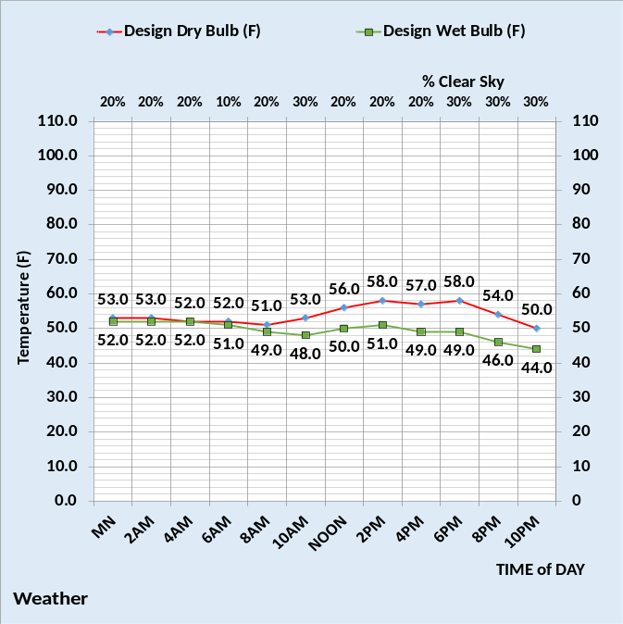
Weather on this day

The above chart gives the weather data that is input to the SEE Model to define the energy consumption, benchmark data, of the two designs on this 24-hour day.

Why do this?
The purpose of day benchmarking is the give engineers a tool to show building owners opportunities to reduce energy consumption, and therefore cost, in their building. The result will be less kW demand on the energy grid of a community and the generation of business to accomplish the reductions.

Who will set this up?
Those most likely to set this up in each city would be the Utility Company, a University, Business Organization, Non-Profit Organization or a combination of two or more.

What will it cost?
The cost will be the salary of one engineer located at the city plus a fee for transfer and training of the SEE Model to that engineer. Email Kirby Nelson at kirbynelsonpe@aol.com for details.

City Control
The City could in many ways control the energy conservation program in their city by setting goals for different type buildings and promoting the installation of energy saving concepts.

How often should day energy benchmarking occur?
The city would advise the date benchmark data would be provided on the net so that building owners could monitor their buildings energy consumption on that date. Benchmark data could be provided each day.

The following is energy data for the two system on this weather day.
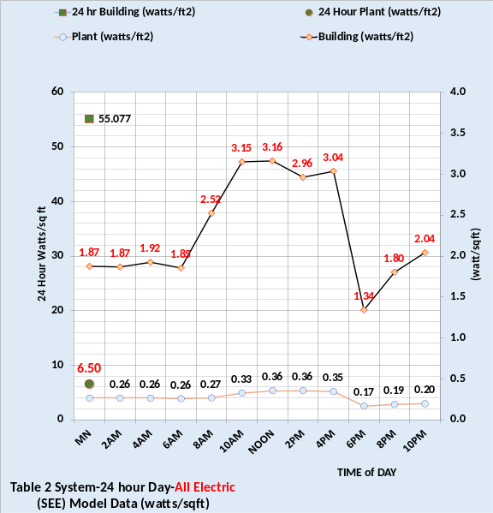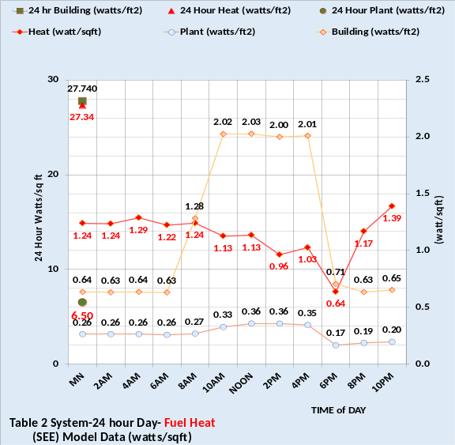
Table 2-90.1-2010 System watts/ft² on this day

The above charts give SEE Modeled typical metered data for buildings and plants. The top chart is for an all-electric system and the bottom chart is with fuel heat given in watts/ft² so relative values can be seen. The 24-hour energy use of the 90.1-2010 design is significantly greater than the efficient design, at right, with heat energy about equal to the building energy use. The building energy use consists of the light, plugs, and fans.
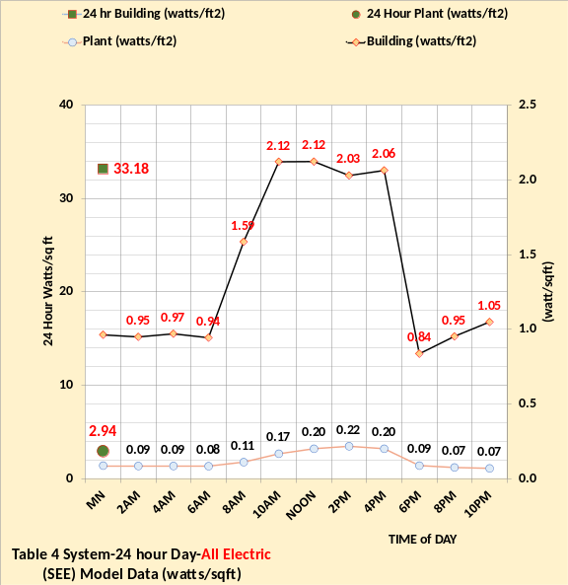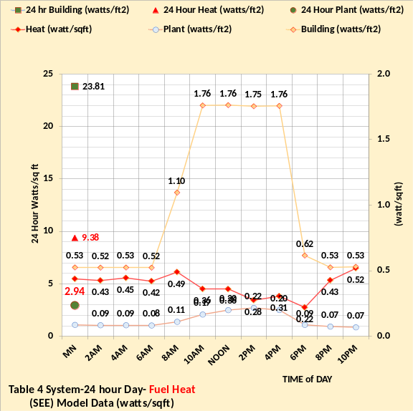
Table 4-Efficient Design-watts/ft² on this day

An office building on this weather day, or similar weather, should if designed to 90.1-2010 consume energy about as shown by the charts at left. The above charts illustrate what is possible with investment in better controls and chiller plant.

Next, we will look at the energy balance of the two designs on this day.

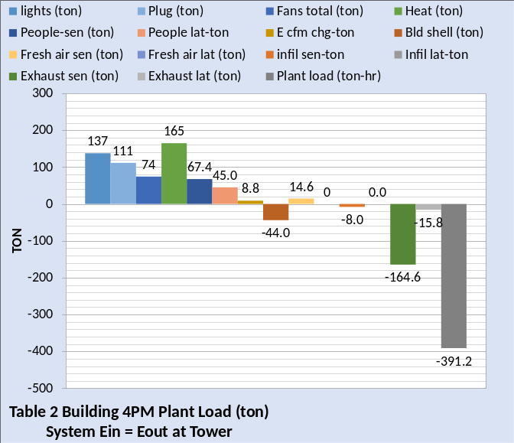
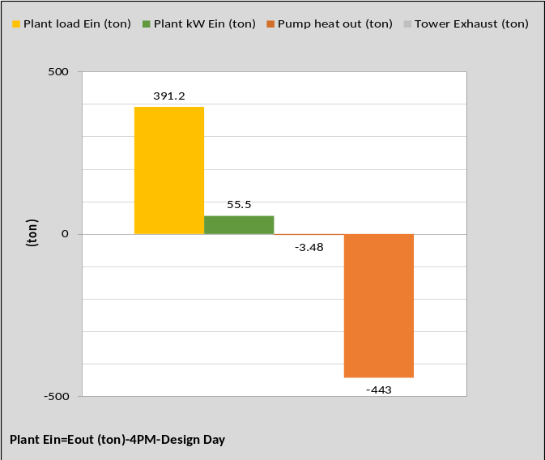
Table 2 Building & Plant Energy Balance

Energy balance analysis is a powerful tool to understand why and how a building and plant is consuming energy. BTU meters play a very important part in the analysis. If the plant load is measured, then the 14 values that make up the plant load can be challenged. If the SEE Model does not give the plant load as measured then the analysis must adjust, measure, etc., to arrive at a SEE Model plant load that equals the measured plant load. This process can be very revealing as to how the building is responding to the weather conditions.

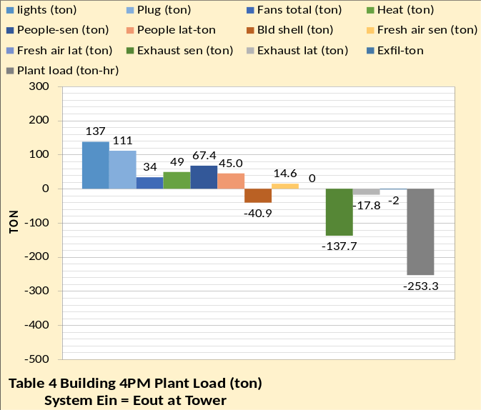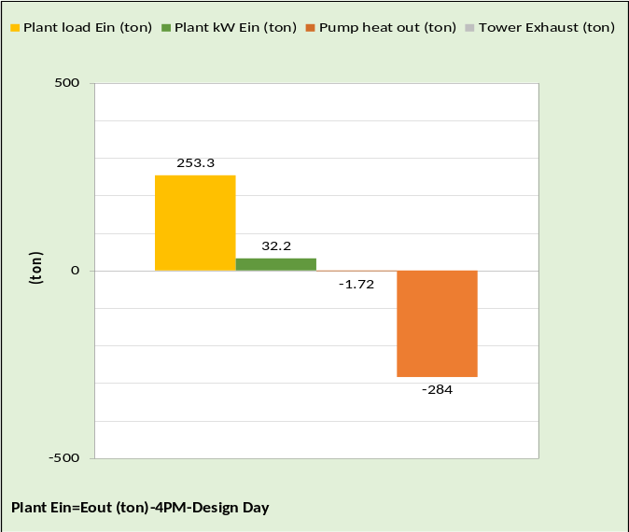
Table 4 Building & Plant-Energy Balance

Typically, the chiller kW is measured and perhaps the plant kW. If a BTU meter provides the tower exhaust energy, then the energy balance of the plant is easy to define, however plant load BTU metered plus plant kW demand is sufficient.

Comparing these energy balance values to the design values below can be very revealing as to how to improve the systems energy consumption.

Seattle Energy Benchmark Data-Design Day Conditions
The following gives design day performance of the two systems.
A procedure to accomplish two major objectives is presented by utilizing a System Energy Equilibrium (SEE) Model.
- Use the SEE Model to define significant reductions in energy consumption of buildings.
- Generation of business to accomplish the energy use reductions.
How to accomplish these objectives starts with showing building owners, on any given day, that their building is using more energy, if in fact it is, than a ASHRAE Standard designed building, or a building and plant upgraded with new air handler system and plant. Go to the April 2022 ASHRAE Journal newsletter for a description of the (SEE) Model.
To illustrate the concept a SEE Model of a large office building will be modeled at real weather conditions. The building is designed with one air handler for each of the 13 floors. The air handler provides cooling for the interior of the building and heating and cooling for the perimeter of the building. The schematics below illustrate the two designs presented here. The Table 2 design is based on ASHRAE Standard 90.1-2010, and the Table 4 design presents a more efficient air control system and a more efficient chiller/tower plant. Twenty-four-hour energy use will be given for a large office building.

Design Performance
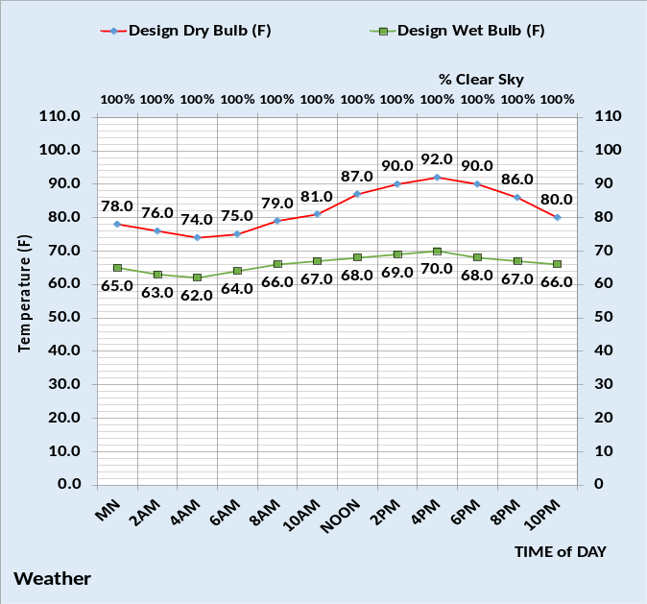
The above figure illustrates the assumed design weather conditions for both designs.

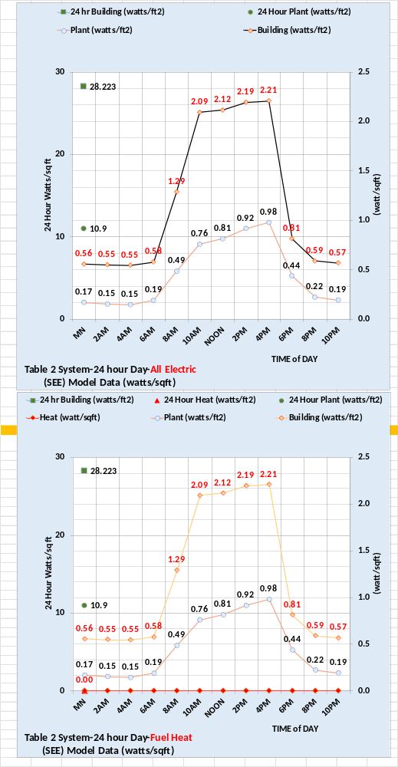Table 2-90.1-2010 System watts/ft² on design day
The above charts give typical metered data for buildings and plants. The bottom chart is with fuel heat given in watts/ft² so relative values can be seen, however at design day conditions HVAC building heat is typically not required. The 24-hour energy use of the 90.1-2010 design is significantly greater than the efficient design. The building energy use consists of the light, plugs, and fans.

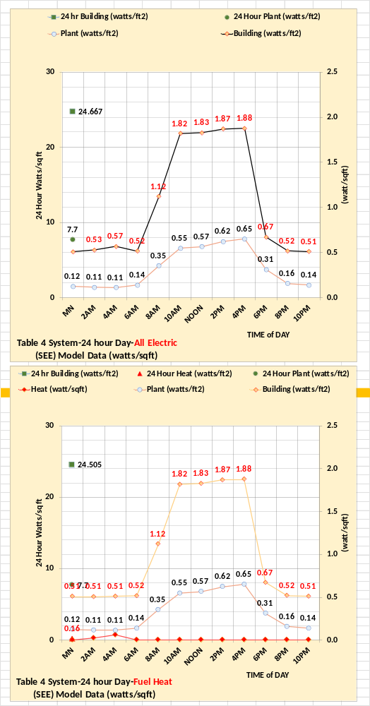Table 4-Efficient Design-watts/ft² on design day
An office building on this design weather day, or similar weather, should if designed to 90.1-2010 consume energy about as shown by the charts at left. The above charts illustrate what is possible with investment in better controls and chiller plant.

Next, we will look at the energy balance of the two designs at design day.

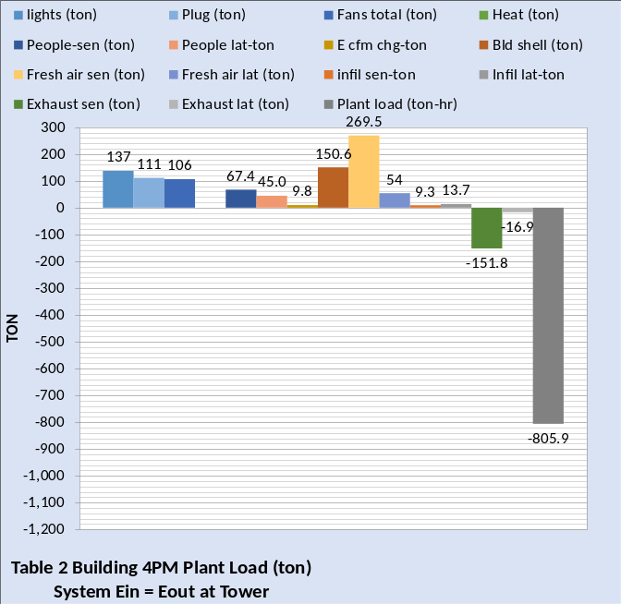 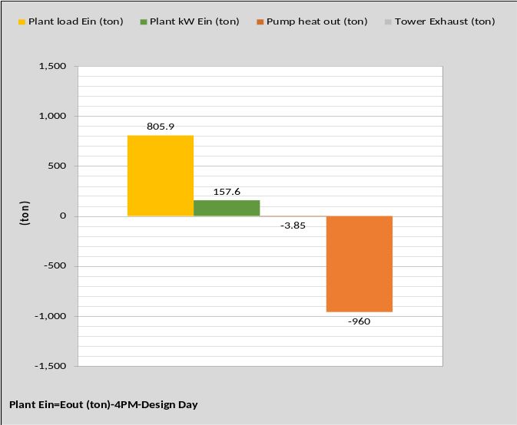Figure-Table 2 System
The above Figure is the energy balance of the Table 2 (90.1-2010) design and the Figure at right is of the Table 4 design that consists of a more efficient air handler system and chiller/tower plant. The Table 4 design also includes exhaust air energy recovery as shown. However, the building structure and the light and plug levels are the same for both designs. The light level is input at .81 watts/ft2 and the plugs at .74 watts/ft2.
The above energy balance figures are equivalent to the calculations the design engineers would perform during the design of the building and plant. The following schematics define the two designs.
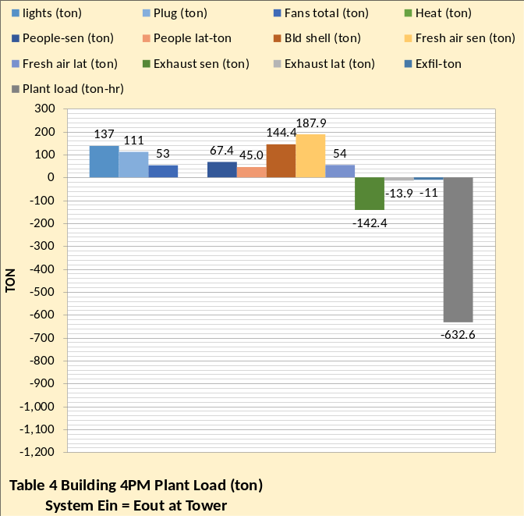 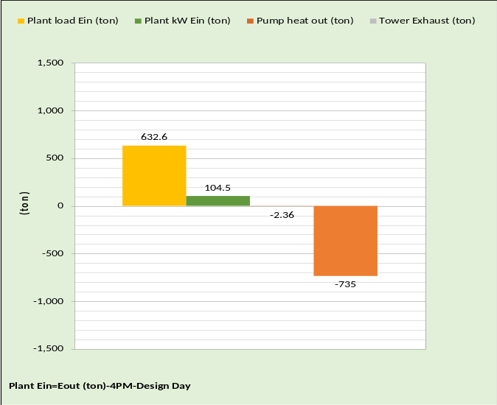Figure-Table 4 System
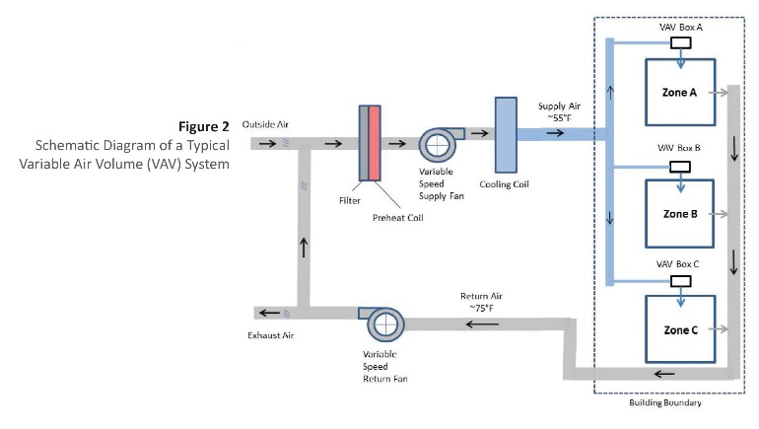
Exhaust air recovery
Comparing the energy balance of the two designs illustrates the reduced energy consumption of the Table 4 design.

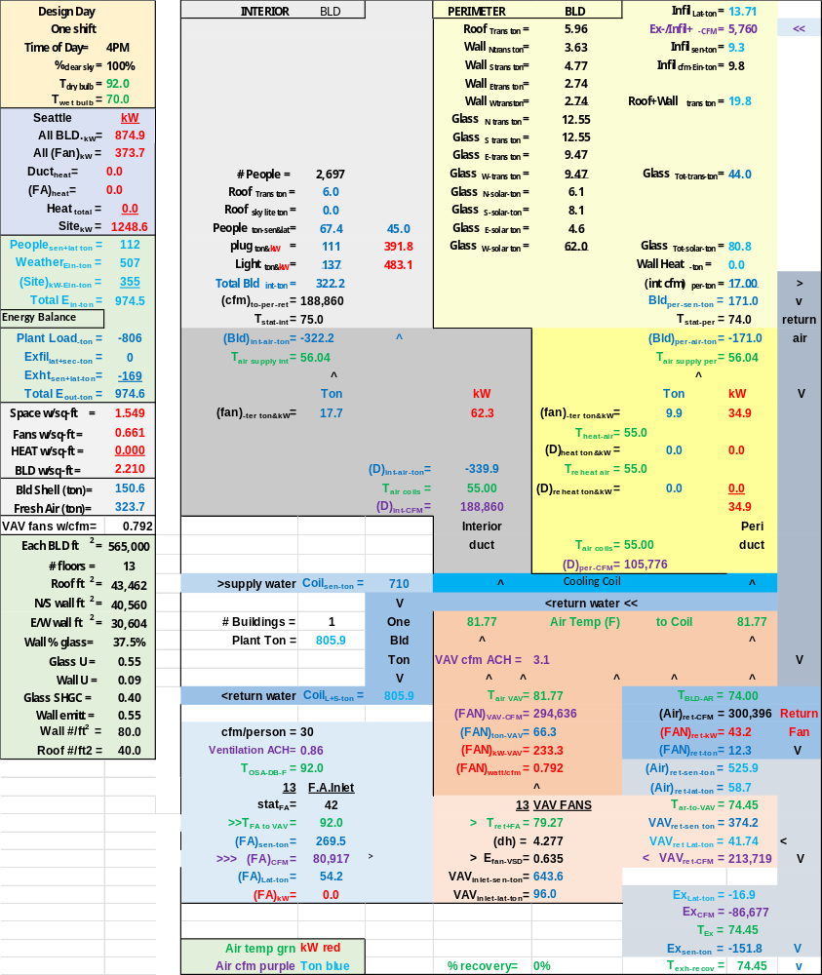
Schematic-Table 2 Building at Design Conditions

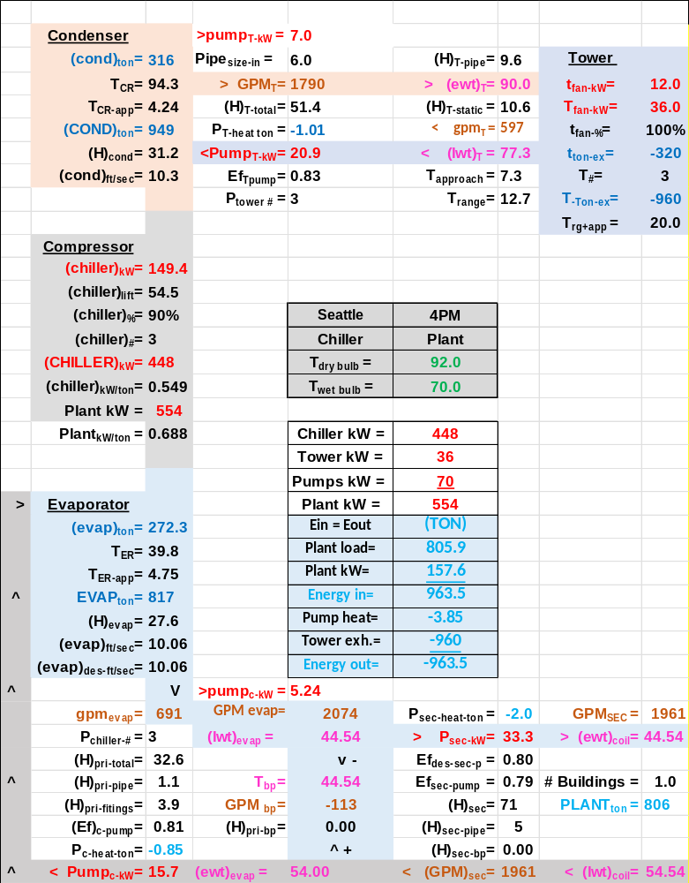
Schematic-Table 2 Plant Design
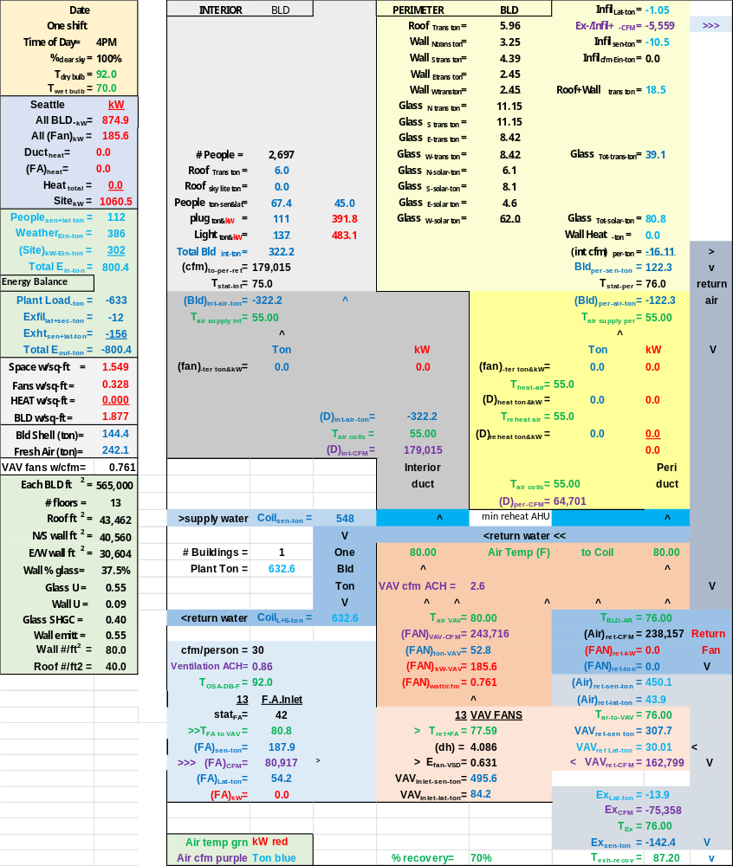
Schematic-Table 4 Building at Design Conditions

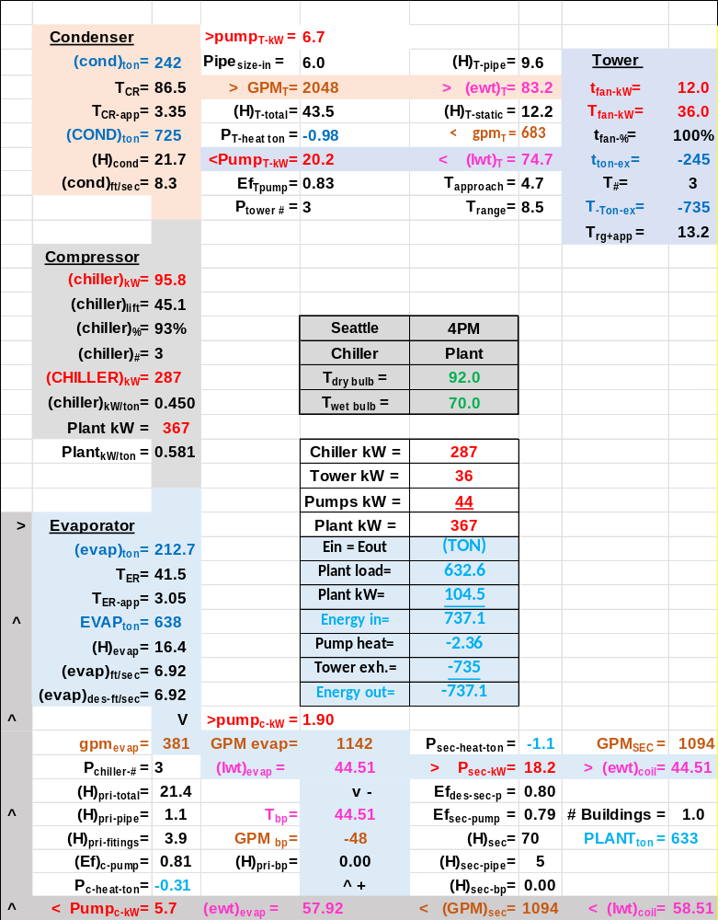
Schematic-Table 4 Plant Design

The above schematics illustrate the level of detail within the SEE Model, detail that is necessary to accurately define the performance of the two systems. The reader is encouraged to review other documents on this site and study the schematics with the understanding that basic HVAC equations define the schematic.
NOMENCLATURE
Building structure.
BLD ft² = air-conditioned space
# Floors = number of building floors
Roof ft² = roof square feet
N/S wall ft² =north/south wall square feet
E/W wall ft² =east/west wall square feet
Wall % glass = percent of each wall that is glass
Glass U = glass heat transfer coefficient
Wall U = wall heat transfer coefficient
Glass SHGC = glass solar heat gain coefficient
Wall emit = wall solar index
Wall weight = #/ft2
Roof weight = #/ft2
Building interior space.
Roof_{trans-ton} =roof load to interior (ton)
Roof_{sky-lite-ton} =sky lite load (ton)
# people = number people in building
People_{ton sen&lat} = sensible & latent cooling load (ton)
Plug_{ton&kW} = cooling load & kW due to plug loads
Light_{ton&kW} = cooling load & kW due to lights
Total Bld_{int-ton} = total building interior load (ton)
(cfm) _{to-per-return} = CFM of interior supply air that returns to perimeter of building
T_{stat-int} = interior stat set temperature (F)
Bld_{int-air-ton} = supply air ton to offset interior load
BLD kW = total building kW demand
FAN kW = total fan kW
Duct Heat kW = kW heating supply air
FA Heat = Fresh air heat
Heat Total = Total building heat
SITE kW = total site kW=Bld+ Fan+Heat
Building perimeter space.
%_{clear sky} = percent clear sky
T_{dry bulb} = outside dry bulb temperature (F)
T_{wet bulb} = outside wet bulb temperature (F)
Ex/Infil_{lat-ton} = latent air infiltration or exfiltration (ton)
Ex/Infil_{CFM} = air infiltration or exfiltration CFM
Exfil_{sen-ton} =sensible air exfiltration or infiltration (ton)
Roof_{trans-ton} = Roof load to perimeter (ton)
Wall_{n trans ton} = north wall transmission (ton)
Wall_{s trans ton} = south wall transmission (ton)
Wall_{E trans ton} = east wall transmission (ton)
Wall_{w trans ton} = west wall transmission (ton)
Roof+Wall_{tot-trans-ton} = total wall/roof transmission (ton)
Glass_{N-trans-ton} = north wall glass transmission (ton)
Glass_{S-trans-ton} = south wall glass transmission (ton)
Glass_{E-trans-ton} = east wall glass transmission (ton)
Glass_{W trans-ton} = west wall glass transmission (ton)
Glass_{tot-trans-ton} = total transmission thru glass (ton)
Glass_{N-solar-ton} = north glass solar load (ton)
Glass_{S-solar-ton} = south glass solar load (ton)
Glass_{E-solar-ton} = east glass solar load (ton)
Glass_{W-solar-ton} = west glass solar load (ton)
Glass_{tot-solar-ton} = total glass solar load (ton)
Wall heat = Heat provided by window panel (ton)
(int cfm)_{per-ton} = effect of interior CFM to wall (ton)
Total Bld_{per-sen-ton} total perimeter sensible load (ton)
T_{stat-per} = perimeter stat set temperature (F)
Bld_{per-air-ton} = supply air ton to offset perimeter load
Air handler duct system-Interior duct
T_{air supply int} = temp air supply to building interior (F)
(fan)_{int ter ton&kW} = interior ton & kW due to terminal fans
(D)_{int-air-ton} = cooling (ton) to building interior duct
T_{air coils} = supply air temperature off coils to duct (F)
(D)_{int-CFM} = supply air CFM to building interior duct
Perimeter duct
T_{air supply per} =temp (F) air supply to building perimeter
(fan)_{per ter ton&kW} = perimeter ton & kW of terminal fans
T_{heat-air} = temp supply air before terminal fan heat (F)
(D)_{heat-ton&kW} = heat to perimeter supply air ton & kW
T_{reheat air} = temp perimeter supply air after reheat (F)
(D)_{reheat ton&kW} = reheat of perimeter supply air ton & kW
(D)_{per-air-ton} = cooling (ton) to perimeter duct
T_{air coils} = supply air temperature off coils to duct (F)
(D)_{per-CFM} = supply air CFM to perimeter duct
Coil
(Coil)_{sen-ton} = sensible load on all coils (ton)
(Coil)_{L+s-ton} = latent + sensible load on all coils (ton)
# Buildings = Number of building loads to plant (ton)
Plant load = Sensible + Latent load to plant
VAV Fan system
Fresh air
CFM\Person = Fresh air cfm/# people in building
Ventilation ACH = Fresh air changes per hour (cfm/ft³)
T_{OSA-DB-F} = OSA DB temp before exhaust air recovery (F)
stat_{FA} = fresh air freeze stat set temperature (F)
T_{FA to VAV} = temperature of fresh air to VAV fan
(FA)_{sen-ton} = fresh air sensible load (ton)
(FA)_{CFM} = CFM fresh air to VAV fan inlet
(FA)_{Lat-ton} = fresh air latent load (ton)
(FA)_{kW} = heat kW to stat_{FA} set temperature
Air return
T_{BLD-AR} = return air temp (F) before return fans
(Air)_{ret-CFM} = CFM air return from building
(FAN)_{ret-kW} = return fans total kW
(FAN)_{ret-ton} = cooling load (ton) due to (FAN)_{ret-kW}
(Air)_{ret-sen-ton} = return air sen (ton) after return fans
(Air)_{ret-lat-ton} = return air lat. (ton) after return fans
T_{AR to VAV} = T_{BLD-AR} + delta T due to return fans kW
VAV_{ret-sen ton} = return sensible (ton) to VAV fans inlet
VAV_{ret-lat ton} = return latent (ton) to VAV fans inlet
VAV_{ret-CFM} = return CFM to VAV fans inlet
Exhaust air
Ex_{Lat-ton} = latent load (ton) exhausted
Ex_{CFM} = CFM of exhaust air
T_{Ex} = temperature of exhaust air
Ex_{sen-ton} = sensible load (ton) exhausted
T_{exh-rec} = Air temp after exhaust recovery (F)
% Recovery = % exhaust air energy to fresh air
VAV Fans
T_{ret+FA} = return and fresh air mix temperature (F)
(dh) = VAV air static pressure (in)
E_{fan-VSD} = VAV fans efficiency
VAV_{inlet-sen-ton} = sensible load (ton) inlet to VAV fans
VAV_{inlet-lat-ton} = latent load (ton) inlet to VAV fans
T_{air-VAV} = temp air to coils after VAV fan heat
(FAN)_{VAV-CFM} = CFM air to coils
(FAN)_{ton-VAV} = load (ton) due to VAV fan kW
(FAN)_{kW-VAV} = total VAV fan kW demand
(FAN)_{watts/cfm} = VAV fans watts/cfm
VAV cfm ACH = VAV cfm air changes per hour
AIR SIDE SYSTEM PLUS BUILDING
Space w/ft² =People space w/ft²
Fans w/ft² = total air handlers w/ft²
HEAT w/ft² = total building heat w/ft²
Building w/ft² = total building w/ft²
Bld Shell (ton) = total building shell load due to weather
Fresh air (ton) = Sensible + Latent to building (ton)
VAV fans w/cfm = VAV fan power (watts/cfm)
CENTRAL PLANT
# Buildings = number of buildings served by plant
Plant ton = total load (ton) to plant
Primary/secondary pumping nomenclature
gpm_{evap} = total gpm flow thru one evaporator
(H)_{pri-total} = total primary pump head (ft) = (H)_{pri-pipe} + (H)_{pri-fittings} + (H)_{pri-bp} + (H)_{evap}
(H)_{pri-pipe} = primary pump head due to piping (ft)
(H)_{pri-fittings} = primary head due to pump & fitting (ft)
(Ef)_{c-pump} = efficiency of chiller pump
P_{c-heat-ton} = chiller pump heat to atmosphere (ton)
pump_{c-kW} = one chiller pump kW demand (kW)
P_{chiller-#} = number chiller pumps operating
Pump_{c-kW} = total chiller pump kW
(lwt)_{evap} = temperature water leaving evaporator (F)
T_{bp} = temperature of water in bypass (F)
gpm_{bp} = gpm water flow in bypass
(H)_{pri-bp} = head if chiller pump flow in bypass (ft)
(ewt)_{evap} = temp water entering evaporator (F)
P_{sec-heat-ton} = secondary pump heat to atmosphere (ton)
P_{sec-kW} = kW demand of secondary pumps
Ef_{des-sec-p} = design efficiency of secondary pumping
Ef_{sec-pump} = efficiency of secondary pumping
(H)_{sec} = secondary pump head (ft) = (H)_{sec-pipe} + (H)_{sec-bp} + (H)_{coil} + (H)_{valve}
(H)_{sec-pipe} = secondary pump head due to pipe (ft)
(H)_{sec-bp} = head in bypass if gpm_{sec} > gpm_{evap}
GPM_{sec} = water gpm flow in secondary loop
(ewt)_{coil} = water temperature entering coil (F)
(lwt)_{coil} = temperature of water leaving coil (F)
Evaporator
(evap)_{ton} = load (ton) on one evaporator
T_{ER} = evaporator refrigerant temp (F)
T_{ER-app} = evaporator refrigerant approach (F)
EVAP_{ton} = total evaporator loads (ton)
(H)_{evap} = pump head thru evaporator (ft)
(evap)_{ft/sec} = velocity water flow thru evaporator
(evap)_{des-ft/sec} = evaporator design flow velocity
Compressor:
(chiller)_{kW} = each chiller kW demand
(chiller)_{lift} = (T_{CR} – T_{ER}) = chiller lift (F)
(chiller)% = percent chiller motor is loaded
(chiller)# = number chillers operating
(CHILLER)_{kW} = total chillers kW
(chiller)_{kW/ton} = chiller kW per evaporator ton
Plant kW = total kW demand of plant
(Plant)_{kW/site ton} = Plant kW per site ton
Condenser:
(cond)_{ton} = load (ton) on one condenser
T_{CR} = temperature of condenser refrigerant (F)
T_{CR-app} = refrigerant approach temperature (F)
(COND)_{ton} = total load (ton) on all condensers
(H)_{cond} = tower pump head thru condenser (ft)
(cond)_{ft/sec} = tower water flow thru condenser
Tower piping nomenclature
Pipe_{size-in} = tower pipe size (inches)
gpm_{T} = each tower water flow (gpm)
GPM_{T} = total tower water flow (gpm)
(H)_{T-total} = total tower pump head (ft)
P_{T-heat} = pump heat to atmosphere (ton)
pump_{T-kW} = each tower pump kW demand
Ef_{T-pump} = tower pump efficiency
P_{tower #} = number of tower pumps
Pump_{T-kW} = total tower pump kW
(H)_{T-pipe} = total tower pump head (ft)
(ewt)_{T} = tower entering water temperature (F)
(H)_{T-static} = tower height static head (ft)
T_{range} = tower range (F)= (ewt)_{T} – (lwt)_{T}
(lwt)_{T} = tower leaving water temperature (F)
T_{approach} = (lwt)_{T} – (T_{wet-bulb})
Tower nomenclature
t_{fan-kW} = kW demand of one tower fan
T_{fan-kW} = tower fan kW of fans on
t_{fan-%} = percent tower fan speed
t_{ton-ex} = ton exhaust by one tower
T# = number of towers on
T_{ton-ex} = ton exhaust by all towers on
T_{rg+app} = tower range + approach (F)

