ASHRAE Journal Review of June 2022 Article. “Water-Cooled to Water-Cooled Chiller Replacement Saves Big” Hong Kong Queensway Government Offices.
Contents
- Introduction.
- Modeled building and chiller plants defined.
- Performance (watts/ft²) of building and plant. Figs 3-7
- Energy Balance Analysis. Figs 8-11
- Building Perimeter Model.
Figs 12-21
- Air Handler Model. Fig 22-56
- Chiller Plant Model. Figs 57-75
- Real Weather performance.
For February 21, 2022. Fig 76-80
For June 17, 2022. Fig 81-85.

1-Introduction
The ASHRAE Journal article of June 2022, “Water-Cooled to Water-Cooled Chiller Replacement Saves Big” describes a chiller plant replacement project. The last sentence of the article states, “The ongoing control strategies for better energy efficiency can be further enhanced by real-time monitoring, commissioning and optimization”.
The purpose of this paper is to show that real-time monitoring coupled with a real time System Energy Equilibrium (SEE) Model would add additional enhancement.
The authors of the ASHRAE Journal article demonstrate a wealth of knowledge and experience. Their review and critique of the SEE Model would be of value to the ASHRAE community.
Kirby Nelson P.E.
Life Member ASHRAE

A brief discussion of the SEE Model can be reviewed at the ASHRAE Journal Newsletter of April 12, 2022. The SEE Building Model is driven by a change in weather that results in a new load to the chiller plant. The building model and plant model are two separate models.

How Buildings, Chiller Plants Work: Discovering the SEE Model

How Buildings, Chiller Plants Work: Discovering the SEE Model
By Kirby Nelson, P.E., Life Member ASHRAE
Since retiring in 2001, Kirby Nelson, P.E., Life Member ASHRAE, has been creating his own modeling tool. He developed the System Energy Equilibrium (SEE) Model to better understand how buildings and chiller plants work. The tool can be used to design and understand how a building or plant responds to changes in weather, equipment or control, Nelson said.
The SEE Model can also be used for commissioning and for benchmarking the energy consumption of buildings on any given day, providing a method to compare the energy consumption of real buildings to standard designs as weather changes from day to day. The SEE Model is presently configured to model a building and plant designed to ANSI/ASHRAE/IES Standard 90.1-2010, Energy Standard for Buildings Except Low-Rise Residential Buildings. Other standards can be modeled, and any design or control parameter can be changed within the model.
“The SEE Model is a concept, not a finished product,” said Nelson. “It is an approach to modeling buildings and chiller plants based on the same equations used to design a building and plant…If the concept is accepted, I believe it will become a college course, and utility companies or others, will provide benchmark data for cities, and a few engineers will become proficient in running and developing SEE Models.”
Nelson discussed the SEE Model and its attributes with ASHRAE Journal.
What is the SEE Model?
The System Energy Equilibrium (SEE) Model is a set of building equations and chiller plant equations solved simultaneously by Microsoft Excel. The SEE Model obeys the first law of thermodynamics: energy in = energy out + change in internal energy (E_{in} = E_{out} + ΔE). Therefore, the SEE Model gives an energy balance for any hour of the day.
The equations are, for the most part, basic HVAC equations, such as those found in 2021 ASHRAE Handbook–Fundamentals’ Chapter 2, “Thermodynamics and Refrigeration Cycles,” and Principles of Heating Ventilation and Air Conditioning.
Users can change and add equations, but they need to be HVAC engineers, competent in Excel and trained on the SEE Model.
What does the SEE Model do?
The SEE Model defines the hourly energy consumption characteristics of a building on any given 24-hour day as well as the hourly energy consumption characteristics of a chiller plant on any given 24-hour day.
I am not aware of other models and software that can perform these actions. To my knowledge, no other model solves for each hour of a 24-hour day. This gives engineers the opportunity to post on the internet how much energy a building that is compliant with versions of ASHRAE Standard 90.1-2007 or newer compliant building should have used the day before, which also allows them to approach building owners with data and estimates of possible reductions in energy use and cost.
How does it work?
Microsoft Excel is a program that iterates to a steady-state condition after a change in conditions. The SEE Building Model is driven by a change in weather that results in a new load to the chiller plant, and the SEE Chiller Plant Model is driven by a change in load on the plant. The building model and plant model are two separate models.
The SEE Model requires energy in = energy out; therefore, an energy balance of the building and plant results, providing an analysis tool to compare a real building and plant performance on a given hour or day.
Using the Excel SEE Model, users can chart variables and gain an understanding of how the building and plant work and interact. The SEE Model is for 24 hours, so it is much smaller than the annual, 8,760-hour, analysis programs.
The SEE Model can provide charts of any variable of a building or plant. The program models chillers’ condenser and evaporator refrigerant temperatures, a building’s air and water flows and other characteristics, including outside air infiltration. The SEE Model can also provide a schematic of the building and plant for any hour, and the energy balance feature provides a method to understand and troubleshoot a building and plant on any day utilizing real energy use data on a given day.
Why should engineers know about the SEE Model?
The SEE Model gives engineers another tool for designing and analyzing the energy consumption of buildings and chiller plants. Excel is available to all; therefore, engineers can develop their own SEE Models.
The SEE Model is different because it is set up to model the energy performance of a building and chiller plant on any given 24-hour day. It does not model 365 days. Also, the energy balance feature sets it apart from other models.
How can engineers review the SEE Model?
Go to http://kirbynelsonpe.com to review the SEE Model approach to designing, benchmarking and energy balance analysis of buildings and chiller plants.
The SEE Model cannot be accessed over the internet. It must be transferred to others by download or flash drive, and users must be trained to operate the SEE Model.
Contact Kirby at kirbynelsonpe@aol.com with questions and comment.

2-Modeled building and chiller plants defined.
The 90.1-2010 design of a 56-story office building has a peak load of 1782 ton, significantly less than the 2,560-ton suggested by the June 2022 article. Many changes could be made to bring the plant load up to about this 2,560-ton value. Three changes were made in the building structure. The percent glass wall was increased from 37% to 67% based on the picture of the building in the Journal. The glass U value was increased from .55 to U=.90 btu/hr-ft², and the wall #/ft² was decreased from 80 to 30, resulting in a peak plant load of 2,480-ton, close to the 2,560-ton suggested by the article. Figure 1 illustrates the 90.1-2010 building design and Figure 2 illustrates the assumed existing building.
The decision to increase the % glass in each wall was made based on the picture in the article. The other two changes were arbitrary. The authors of the article could provide values of the existing building so a more accurate SEE Model can be developed.
The SEE Model must always be input with the detail characteristics of the building being modeled, including the building, lights & plug kW, air handler system, chiller plant and other as may apply.

Figure 1: 90.1-2010 Building
90.1-2010 Design
Building 56 Story
Building=665,255 Ft-Sq
Building height=728 Ft
Roof = 11,880 Ft-Sq
All walls 37.0% glass
Roof U=.048 Wall U=.090
Glass U=.55 Glass SHGC=.40
Wall 80#/ft2 Roof 40#/ft2
Footprint
South=80 Ft North=80 Ft
Each wall=58,240 Ft-Sq
East=148.49 Ft West=148.49 Ft
Each Wall=108,104 Ft-Sq
Design plant load
Sensible load = 1185 ton
Total load = 1782 ton

Figure 2; Assumed Existing building
Existing Building
Building 56 Story
Building=665,255 Ft-Sq
Building height=728 Ft
Roof = 11,880 Ft-Sq
All walls 67.0% glass
Roof U=.048 Wall U=.090
Glass U=.90 Glass SHGC=.40
Wall 30#/ft2 Roof 40#/ft2
Footprint
South=80 Ft North=80 Ft
Each wall=58,240 Ft-Sq
East=148.49 Ft West=148.49 Ft
Each Wall=108,104 Ft-Sq
Design plant load
Sensible load = 1840 ton
Total load = 2480 ton

Table A gives details of the assumed building input to the SEE Model and resulting 2,193.9 kW demand at design conditions. The building is basically assumed to be designed to ASHRAE Standard 90.1-2010 with the modifications to the building structure as defined above; 67% glass wall verses 37% and decreased wall #/ft². Figures 1 & 2 illustrate the load to the plant is increased from 1782 ton to 2480 ton. The increased building shell load in turn increased the required air handler system CFM which in turn increased the kW demand of the air handling system which increased the load to the plant. Rather minor changes can result in significant changes in building performance.
Detail performance characteristics of the existing building will be covered below but first let’s briefly review the chiller plant designs.
Table A gives the assumed characteristics of the Hong Kong office building and some of the resulting performance of the building. The authors of the ASHRAE Journal article may wish to provide more accurate data which will be input to the SEE Model and this paper updated.

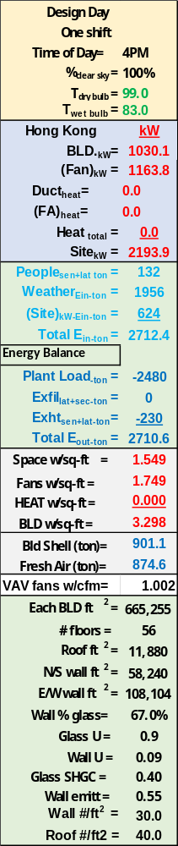
Table A: Assumed Building
Chiller Plants.
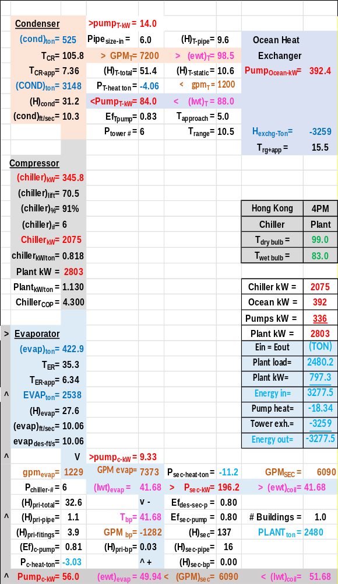
Schematic 1: Old chiller plant

As stated by the article the existing chillers had aged to an average 4.4 COP. The chiller SEE Model had to be degraded to 93% ability to convert electrical energy to refrigerant compression plus the evaporator refrigerant approach was increased from 5.2F to 9.36F and the condenser approach from 4.9F to 9.8F.

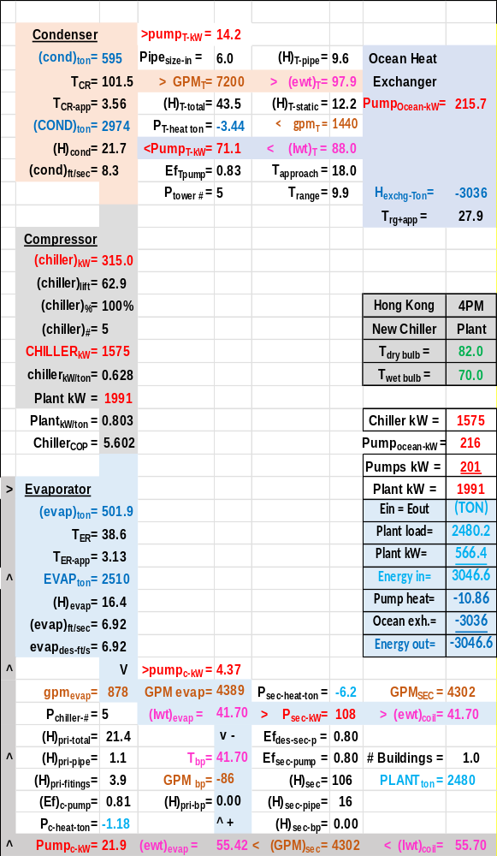
Schematic 2: New chiller plant

These three degradations in the chillers resulted in at design chiller COP=4.30 and therefore chiller .818 kW/ton as shown in schematic 1. The design day load of 2,480 ton is defined above by Figure 2. The plant is modeled as six chillers of 512-ton capacity. Nomenclature at the end of this paper will help understand the plant schematics.
3-Performance (watts/ft²) of buildings and plants

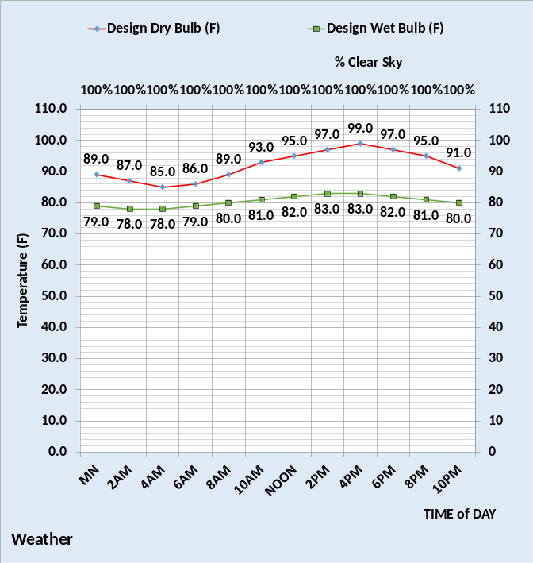
Figure 3: Design Day weather

Figure 3 gives the assumed design day weather conditions.
The following watts/ft² data is typically given by the utility meters on the site and meters on the plant.

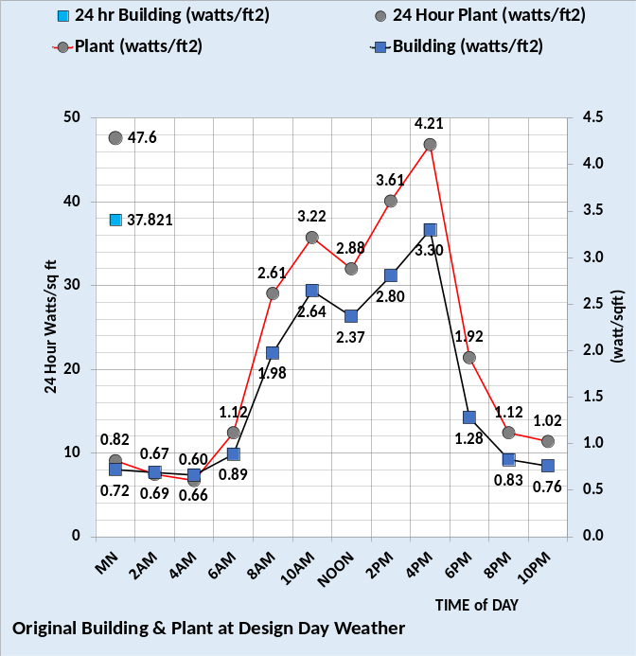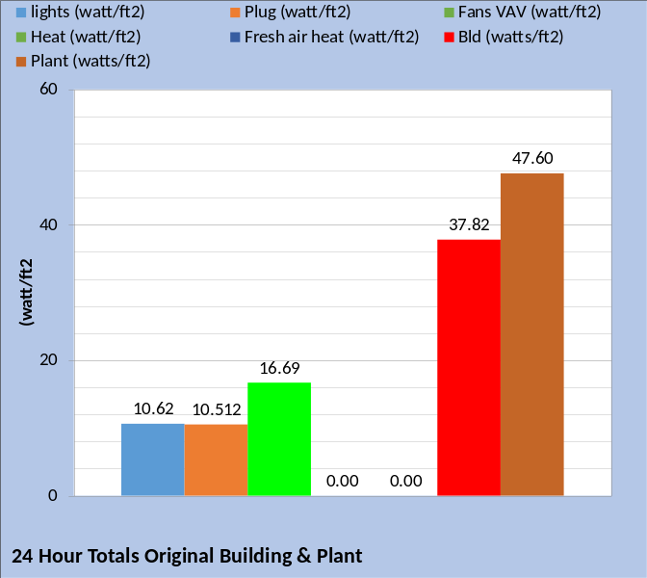
Figure 4: Existing building and old plant performance at design day.

Figure 4 gives the watts/ft² performance of the existing building and the original plant. Plant energy consumption is greater than the building energy consumption.

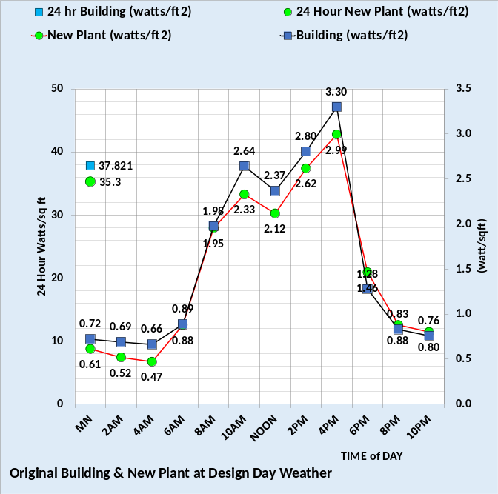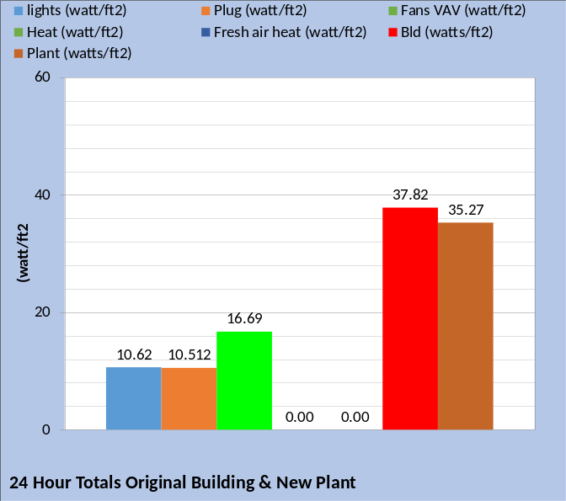
Figure 5: Existing building-new plant

Figure 5 gives the existing building and the new plant energy consumption. The plant energy consumption is now less than the building.
Figure 6 gives the assumed existing building watts/ft² performance and the performance of an upgraded building. The upgraded building installs three changes into the existing building model.

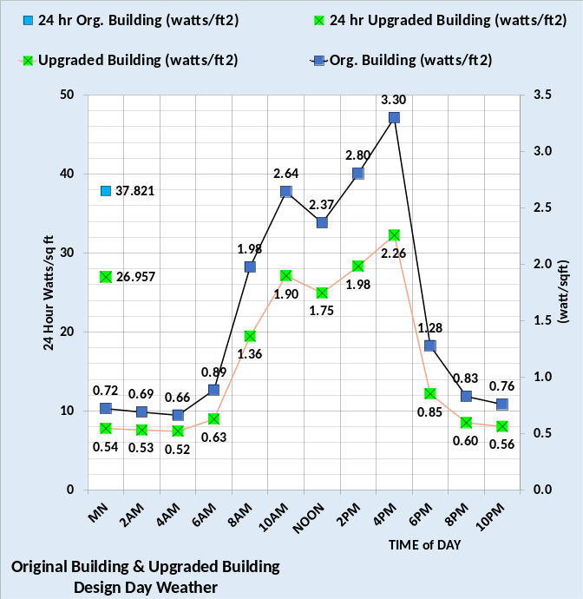
Figure 6: Existing building vs. Upgraded building watts/ft²

The lights are decreased from .86 watts/ft² to .67 watts/ft². The building is pressurized with exfiltration occurring verses infiltration of the assumed existing building. The air handler system is upgraded to eliminate powered terminal fans and the return fan is eliminated because exfiltration is designed as occurring at the building perimeter wall of each floor. Figure 6 illustrates a significant reduction in watts/ft² for the upgraded building at design day conditions of Figure 3.
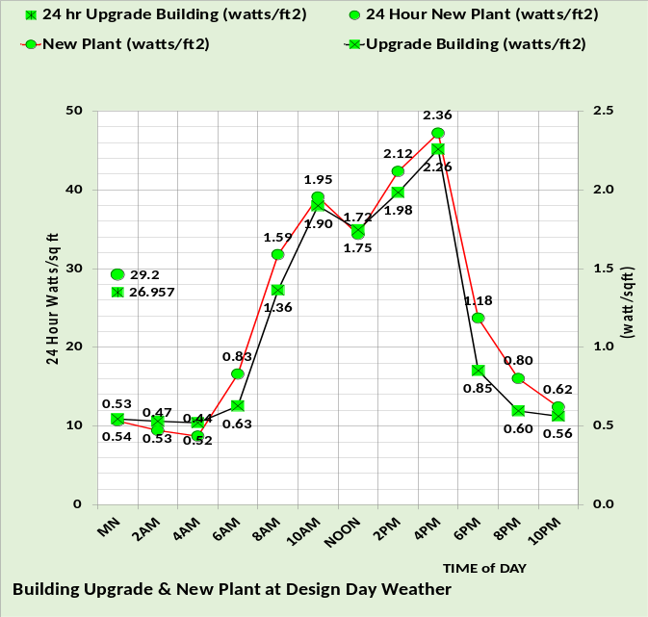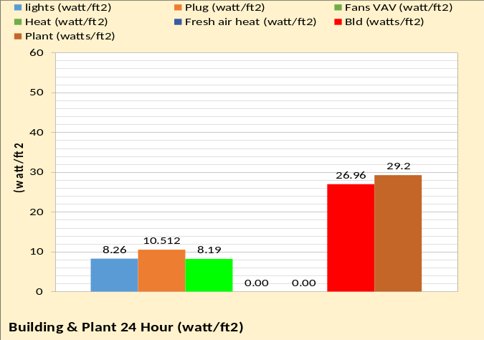
Figure 7: New Plant & Upgraded building

The combination of upgraded building and new chiller plant results in a significant reduction in energy consumption as demonstrated by Figure 7 verses Figure 5. One additional upgrade to consider is the replacement of the windows. If the assumed area and performance of the windows is approximately correct, then significant reduction in energy consumption can be achieved with a new window system that might include the exfiltration feature.
4-Energy Balance Analysis
The SEE Model is set up to model any hour or 24-hour period on any day of weather and operational conditions. The SEE model is built on Microsoft Excel. Excel is oft time dismissed as a spread sheet, an attitude that misses the power of Excel to solve sets of equations simultaneously. The SEE Model is based on basic HVAC equations that engineers use to design building systems and Excel provides the means to solve the equations leading to the possibility of developing real time simulations of a building or plant. Excel also offers the ability to chart any variable over a given 24-hour period, a characteristic that provides important visibility and understanding not given by annual models. The SEE Model can also be structured to provide schematics of the system, as illustrated above, that provides understanding not given by charts. Perhaps the most important feature of the SEE Model on Excel is the ability to provide energy balance charts where energy into the system equals energy out of the system. A btu meter that measures the load to the plant, plus a SEE Model, provides the ability to analyze a building and plant via energy balance analysis. The following will demonstrate.

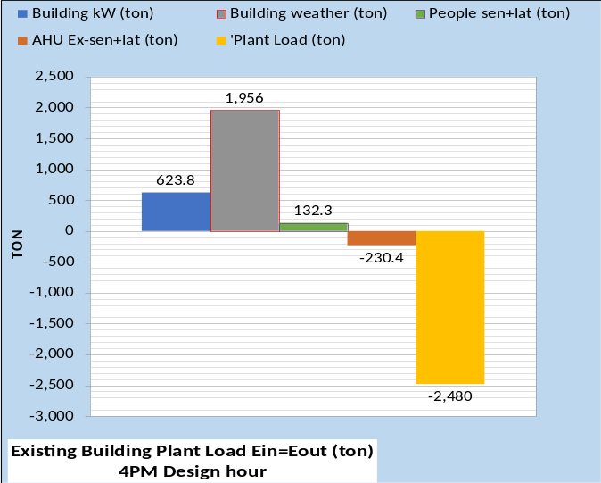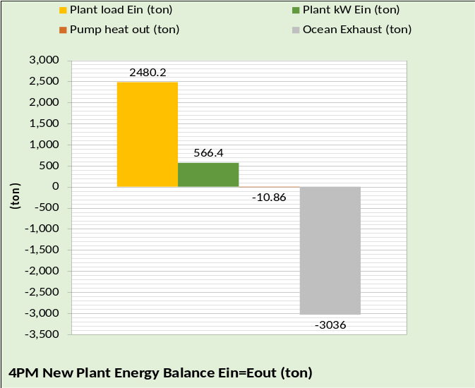
Figure 8: Energy balance at 4PM

The energy balance is in units of (ton=12,000 btu/ft²). Figure 8 is the SEE Model energy balance of the assumed building and new plant at 4PM. Top chart is the building, and the bottom chart is the new plant. If a btu meter on the load to the plant is different than the 2,480-ton given by the SEE Model, then one or more of the other values must change in the model to give the btu meter value. Building kW is the total kW of the building so this is likely a measured value. If the measured building kW is different than the SEE Model then the measured value should be input to the model leaving building weather, people, and air exhaust as variables to be changed in the SEE Model to give the metered value of plant load. If the building weather load must be significantly changed to get a SEE Model plant load that equals the metered value, then problems with the building thermal performance needs to be investigated, illustrating a value of the SEE Model.
The bottom chart, new plant energy balance, provides another check on the SEE Model result. First the plant load, determined as discussed above, would be input to the plant model. Very likely the plant kW, converted to ton, is a measured value and therefore also a check on the model. Metered btu data at the towers, in this case ocean exhaust, would be a valuable addition to the system analysis capability for obvious reasons. Figure 8 illustrates a first step in the energy balance analysis and adjustment of the SEE Model to duplicate a real system. The basic idea is, if you adjust the plant load to equal the metered plant load then the other cumulative values of the SEE Model are necessarily correct. Next, we look at more detail analysis.
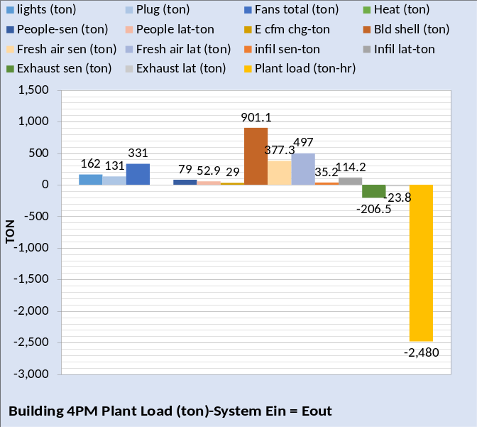
Figure 9: Building 4PM Energy Balance
Figure 9 is a more detail, 14 variables, building energy balance at 4PM. If adjustments, as discussed above, for Figure 8 were required then they should be made to the varies terms of Figure 9 based on analysis, calculations, and perhaps tests to define just what detail of the building load to the plant needs to be adjusted. This process of energy balance analysis could identify major opportunities for improving the energy performance of the building or could identify significant better performance than expected.
The bottom line is the performance of the building is better understood via energy balance analysis that requires energy into the building equals energy out of the building and metered values greatly assist in establishing the energy use characteristics of the building.
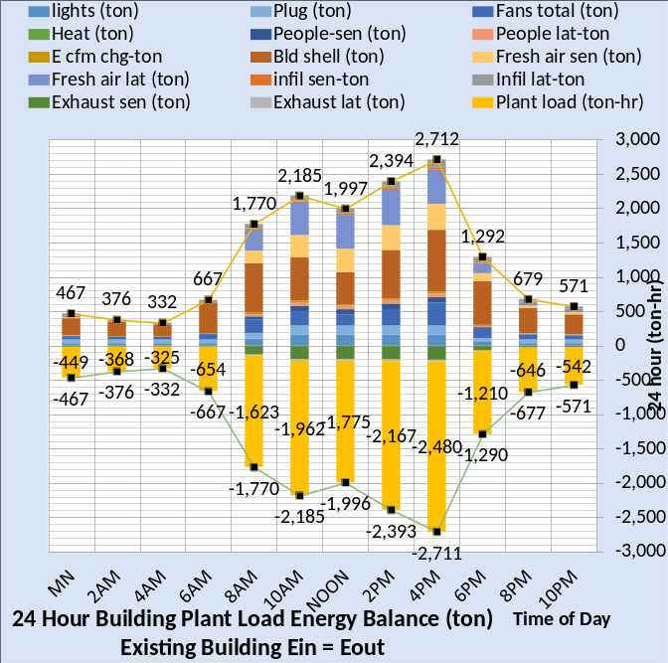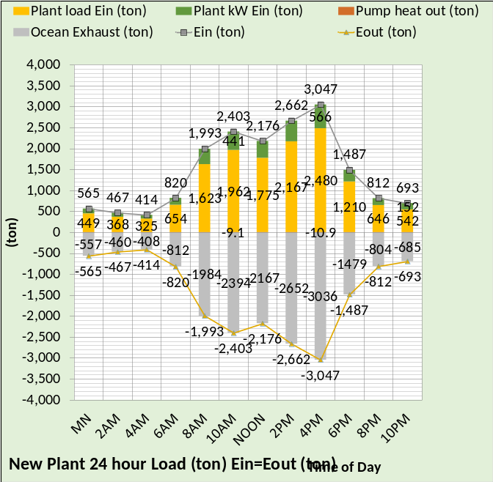
Figure 10: 24 Hour Energy Balance

Figure 10 illustrates the SEE Model capability to provide energy balance data for all 24 hours of the day. The discussion above regarding 4PM could be performed for any hour, therefore providing significantly more understanding about the energy use characteristics of the building.
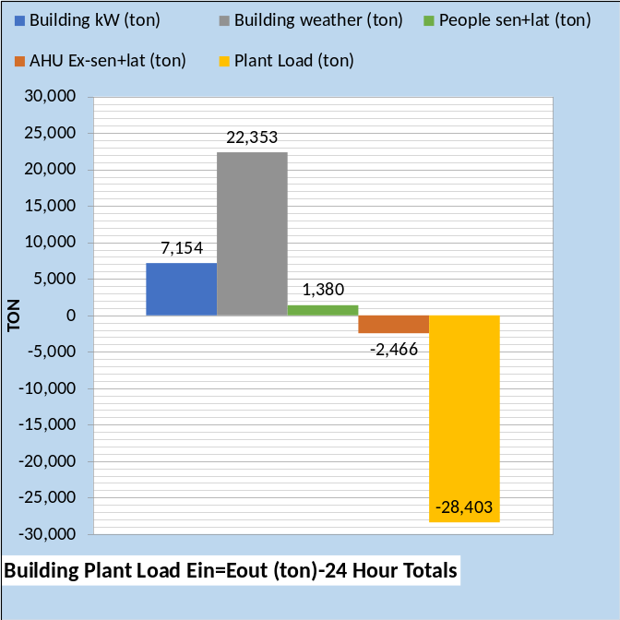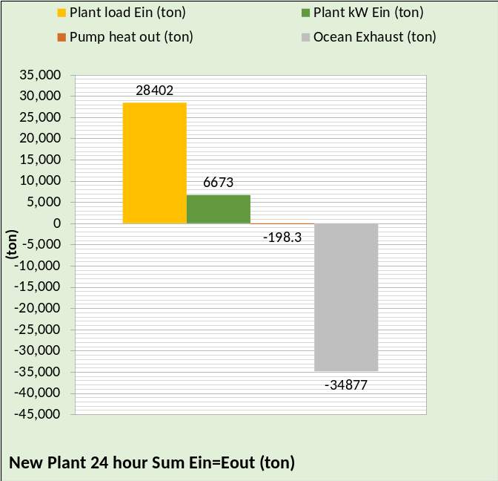
Figure 11: 24 Hour Totals

Figure 11 gives 24-hour totals. If metered data is taken over a 24-hour period, then the SEE Model can provide data which adds another dimension to the analysis of the building and plant.
The energy consumption of a building and plant is a very complex problem that requires, I believe, a very detail hour by hour analysis tool to achieve understanding of the system and therefore make intelligent decisions of control, operation, and modifications to the building and/or plant. The SEE Model offers that capability.
Next, we will consider details of the building model. The accuracy of the SEE Model in terms of identifying building use characteristics is a function of the number and accuracy of the SEE Model equations. This analysis does not warrant that all or in fact any of these equations are 100% correct nor that this is all the detail necessary in the SEE Model. All equations are subject to change based on better data or characteristics of a given building. The bottom line is that the SEE Model, as presently configured, is judged as good but acknowledges that it can and will be improved with time and attention to the concepts of the SEE Model.

5-Building Perimeter
SEE Model
The following provides detail information about the assumed building, demonstrating the detail of the SEE Model.
First, we will address the perimeter of the building.

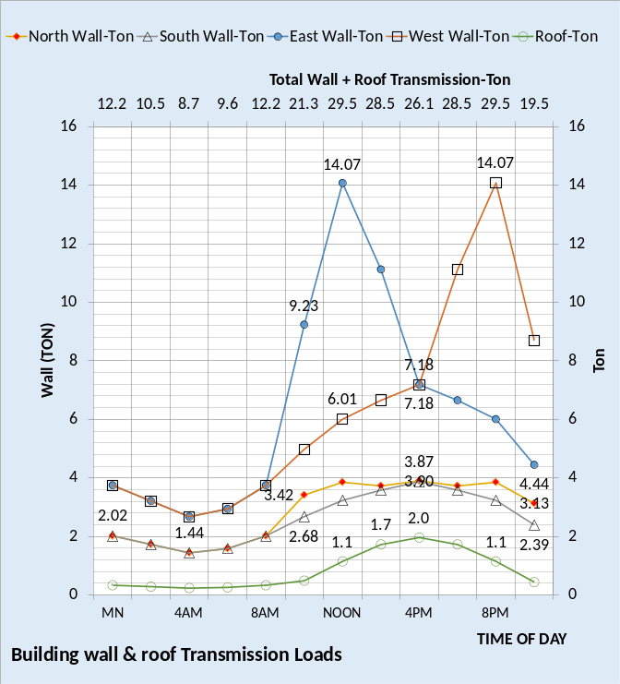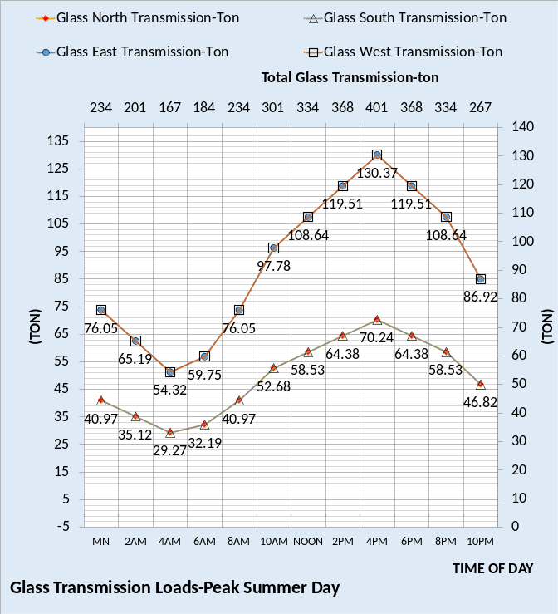
Figure 12: Building transmission loads
The top chart gives the building shell transmission values, and the bottom chart gives the glass transmission. The secondary horizontal axis gives the totals for each chart. Glass transmission drives the total.
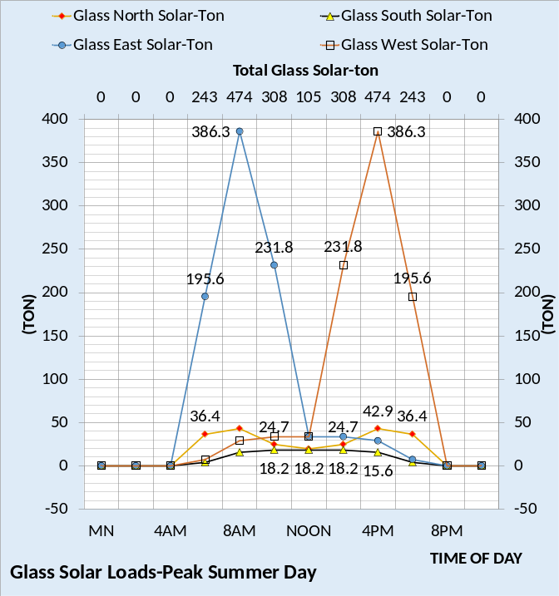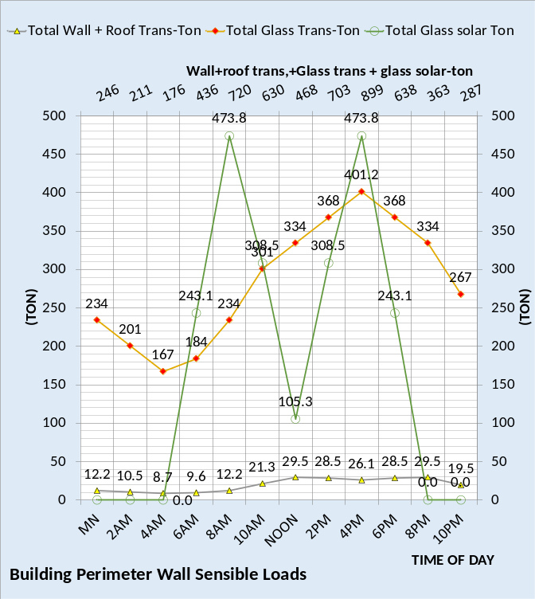
Figure 13: Top chart glass solar-Bottom chart total shell transmission.
The bottom chart shows that the peak perimeter load due to weather is 899 ton at 4PM, however this does not include load due to infiltration. The next charts demonstrate 14 loads make up the total.
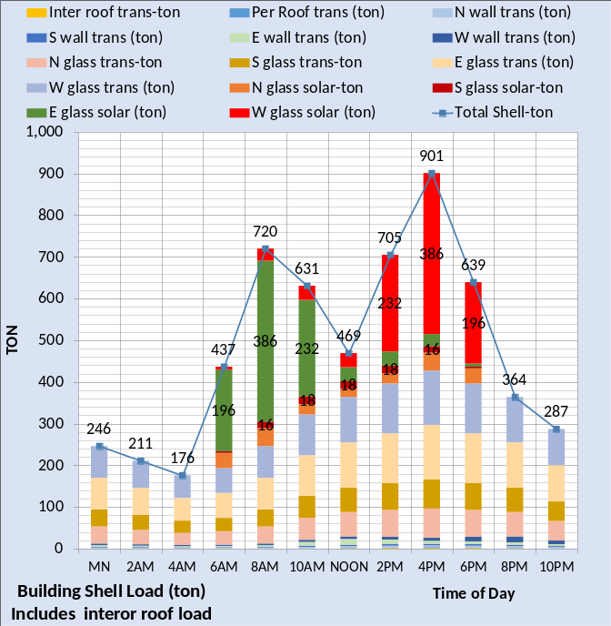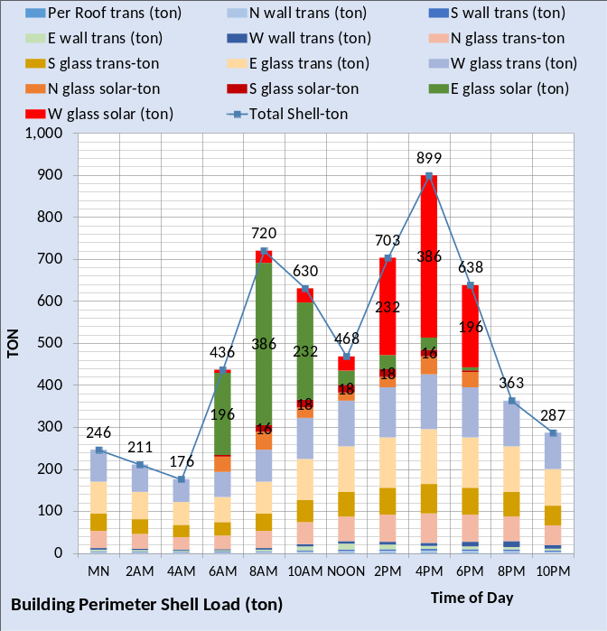
Figure 14: Building shell loads
The top chart includes roof load on the interior of the building, a small load for this building. This value would be significant if the building had a skylight. Building with about 4 floor sometimes have skylights that drive the cooling load. The bottom chart is the building perimeter loads.
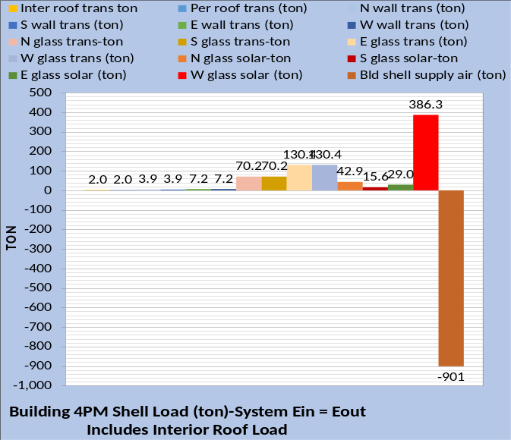
Figure 15: 4PM shell loads-Energy Balance

Figure 15 illustrates the glass solar drives the load. During the morning the east solar would be predominate. Each hour has a very different energy balance chart. The weather load to the building is significantly reduced during cloudy days. As seasons change the solar load changes dramatically. The SEE Model solar input is based on the season and the location of the building in the world. Other variables include orientation of the building, shading systems, and shading from adjacent buildings. The SEE Model attempts to input all variables that make up the solar load to the building.
Blue charts are the existing building & gold charts are the upgraded building.
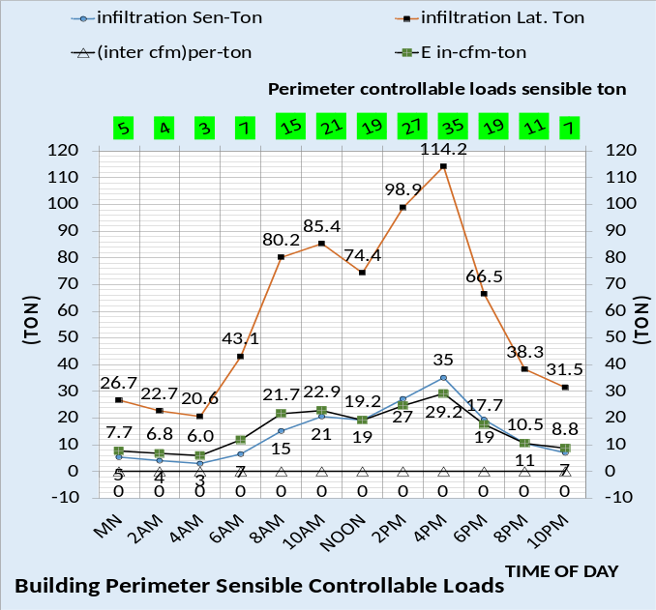
Figure 16: Existing building perimeter controllable loads
Figure 16 gives the loads to the perimeter that are not in the upgraded building design. Infiltration sensible and latent load is modeled in the existing building because infiltration is defined as a load in the 90.1-2010 office building. Infiltration not only results in a load to the space of the building but also is a change in internal energy of the building as a function of infiltration CFM. Energy into the building will not match energy out of the building without this term, (Ein = Eout + chg energy).
The term (inter cfm) per-ton models the transfer of energy from the interior of the building to the perimeter due to the stat set points. This term is zero because the present model assumes the stats are set at the same value. This can be a major value during both summer and winter if the stats are set differently, depending on the path of return air.
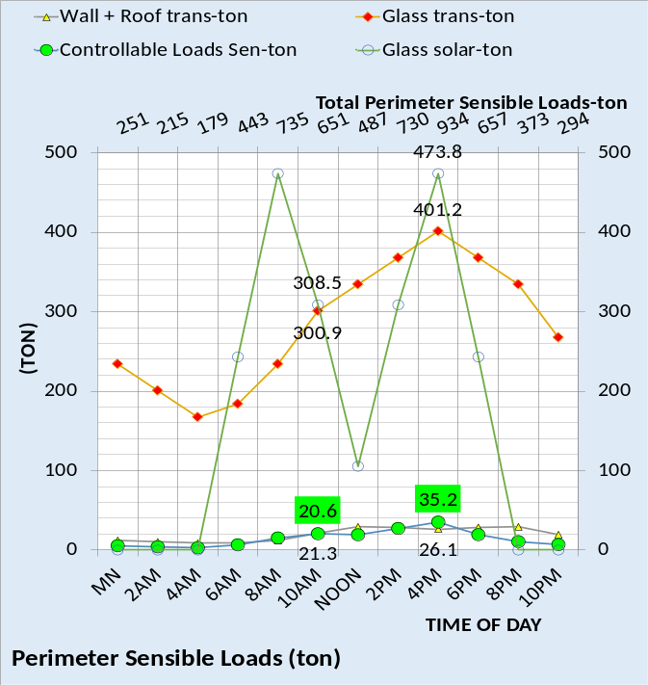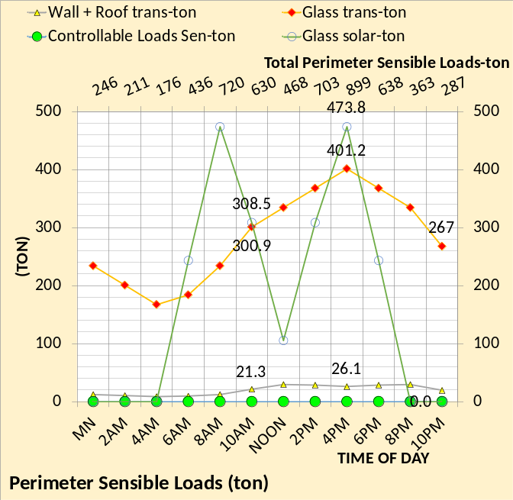
Figure 17: Perimeter Sensible loads- Top chart existing building-Bottom chart upgraded building
Figure 17 top chart gives the existing building perimeter loads with infiltration and the bottom chart gives the upgraded building.
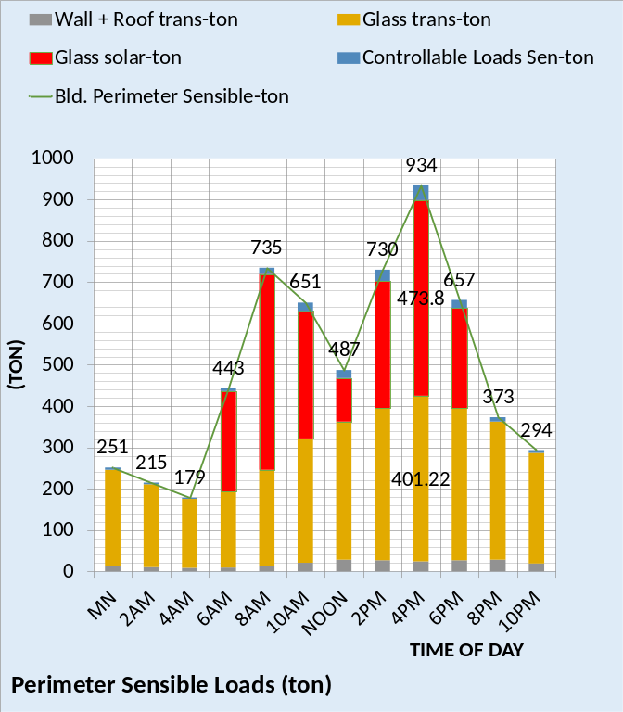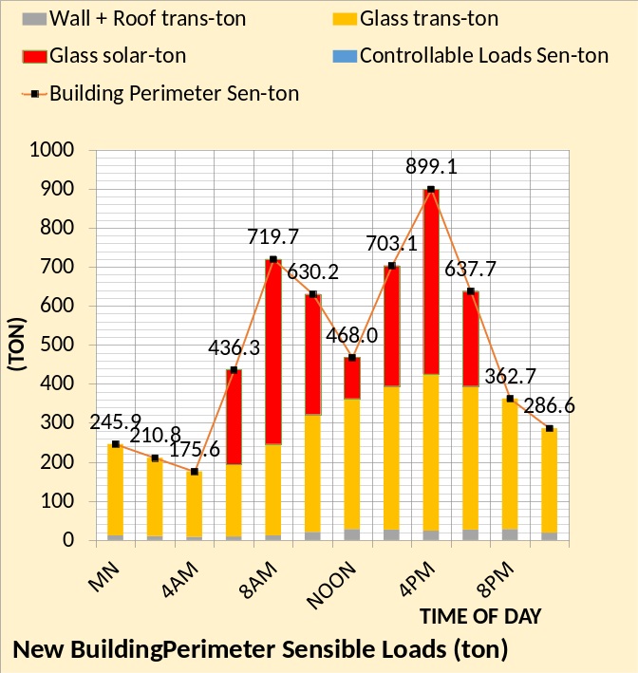
Figure 18: Perimeter sensible loads Top chart existing building-Bottom chart upgraded building
Figure 18 sums the building shell loads for the existing building and upgraded building a rather modest drop in load for the upgraded building.
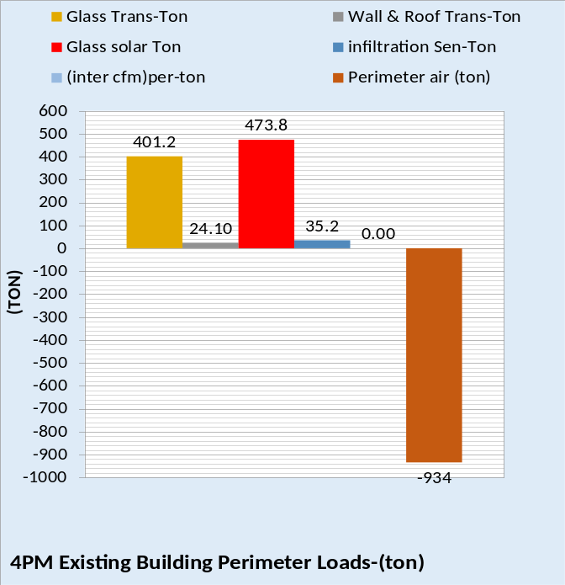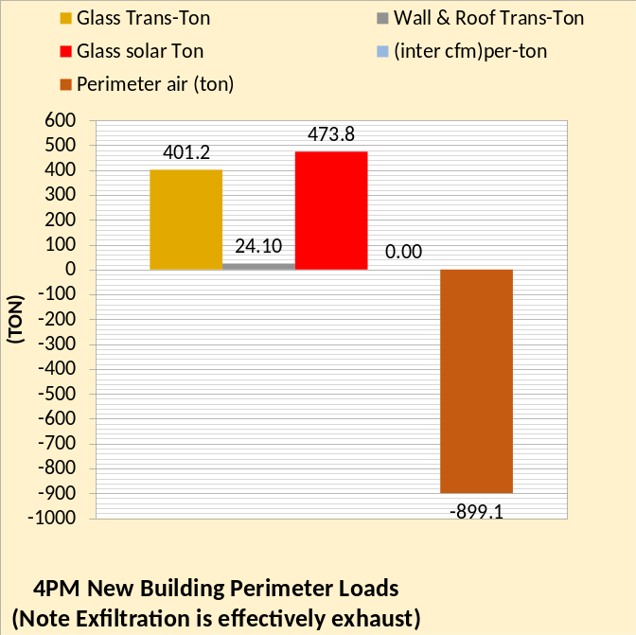
Figure 19: 4PM building loads

Figure 19 is the energy balance for 4PM illustrated the only difference is the outside air infiltration of the existing building.
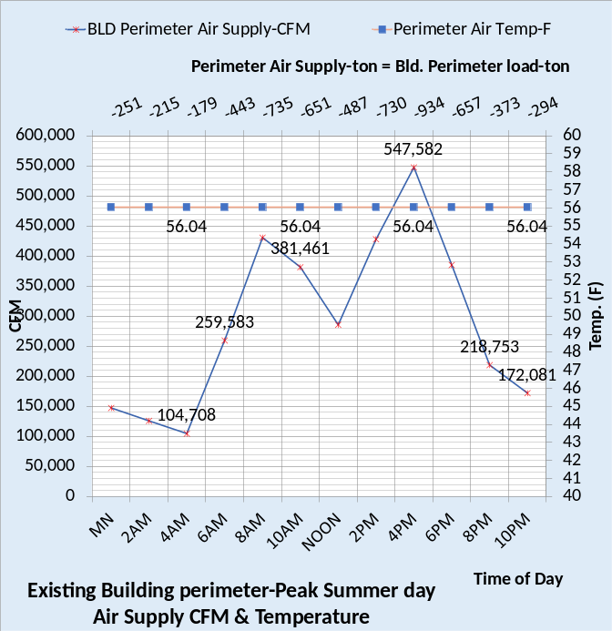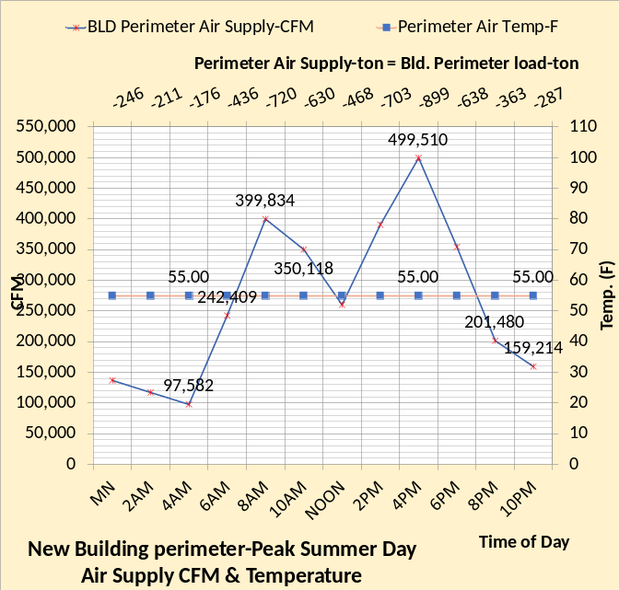
Figure 20: AHU CFM & air temp.

Figure 20 gives the perimeter air supply CFM and temperature for the two buildings. The supply temperature of the existing building is 56.04F because the air is heated by the powered terminals. Figure 21 gives the supply air ton to offset the perimeter load ton.

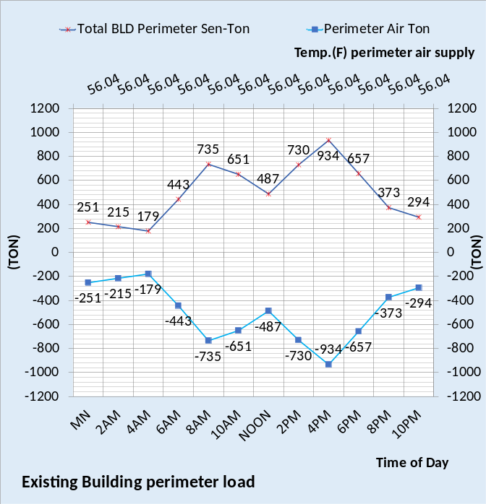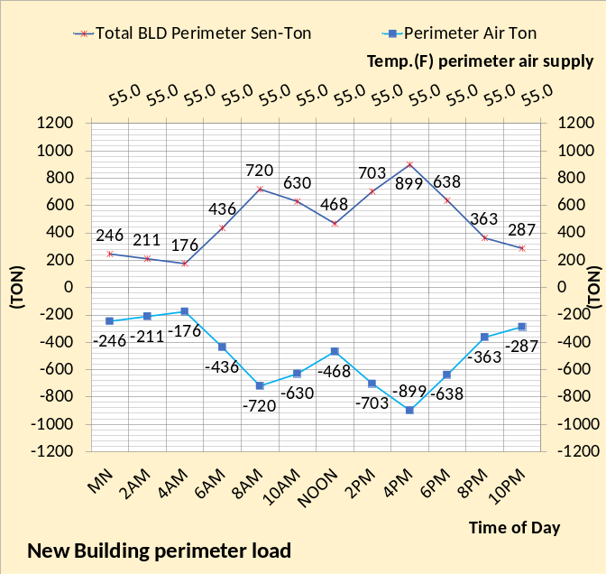
Figure 21: Air supply to offset load

Building Interior Model

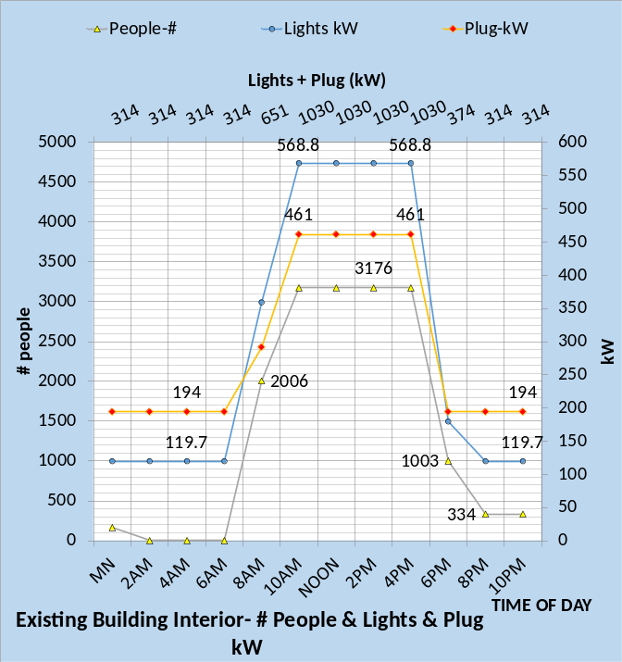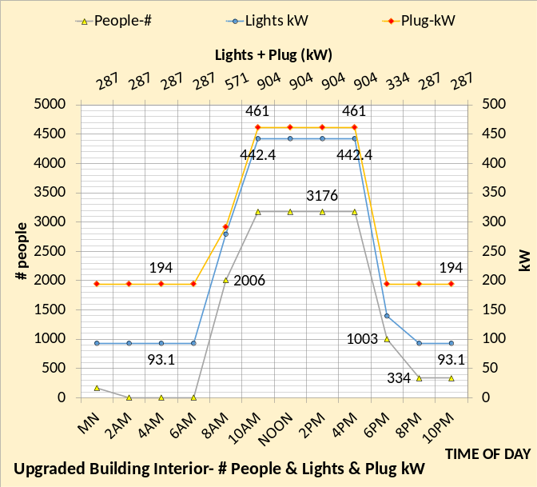
Figure 22: Building internal people #, lights & plug kW

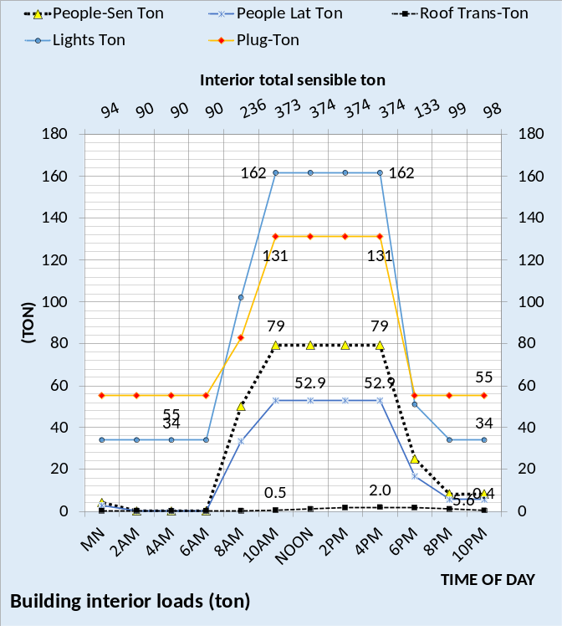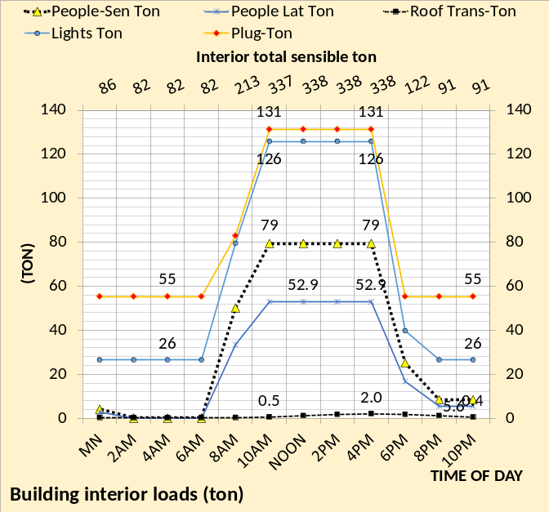
Figure 23: Building interior loads-ton

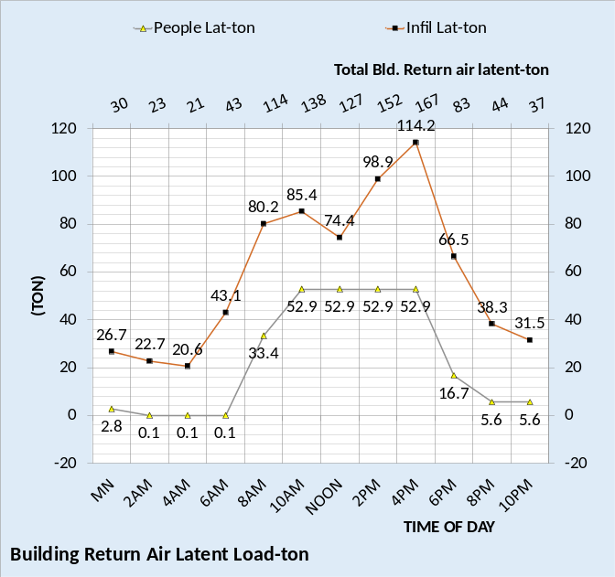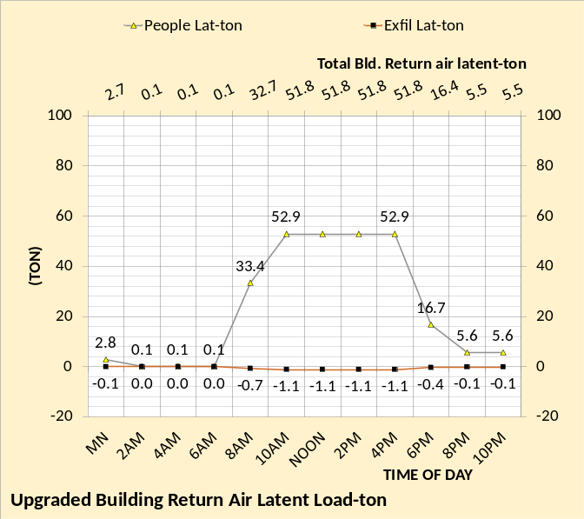
Figure 24: Interior latent loads-ton

Figures 22-25 establish the building interior load. The SEE Model of the air handler system to meet this load is more complex as illustrated by the following figures.
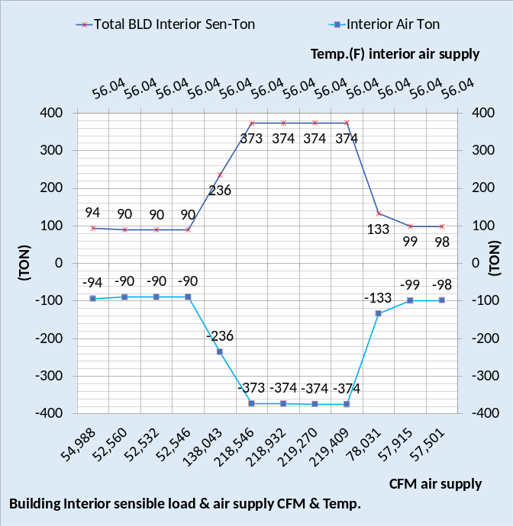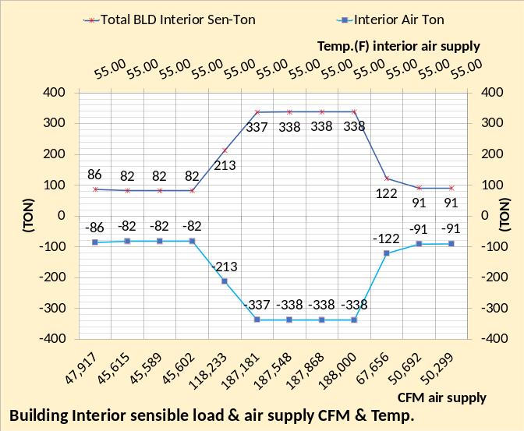
Figure 25: Building Interior loads & air supply to meet loads
As stated, above.
The SEE Model must always be input with the detail characteristics of the building being modeled, including the building, lights & plug kW, air handler system, chiller plant and other as may apply.
The following will demonstrate the detail of the assumed air handler system for this Hong Kong building.
6-Air Handler System

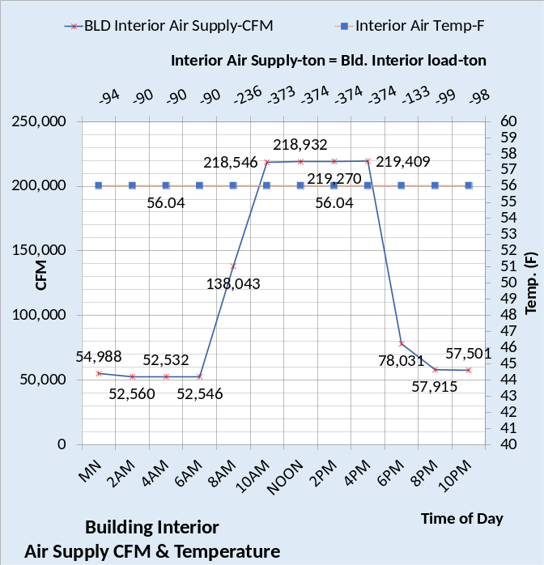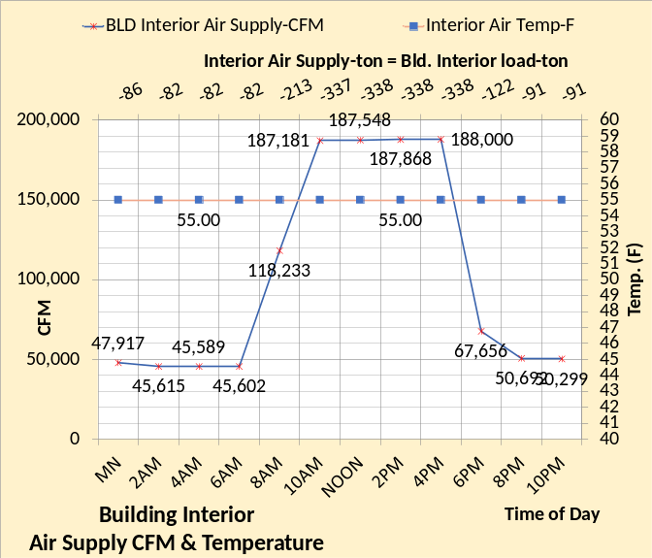
Figure 26: Air supply CFM & temp.

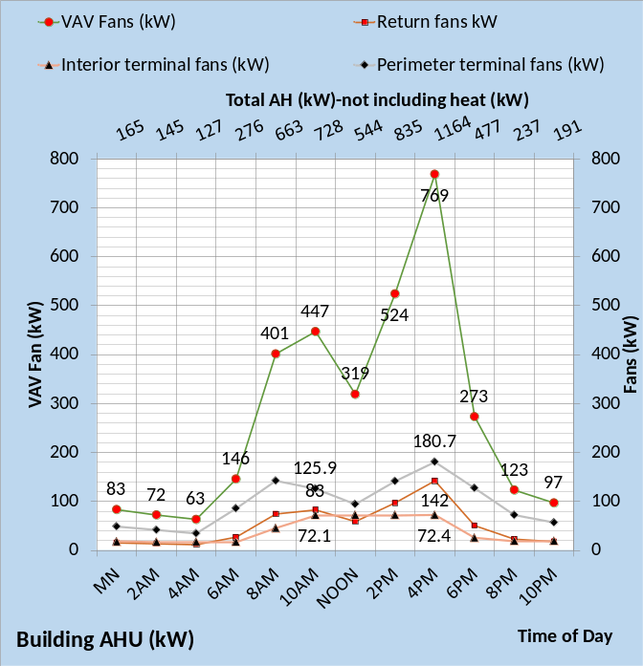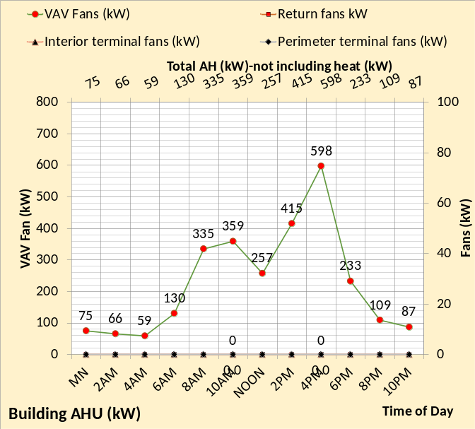
Figure 27: 24-hour kW demand of air handler system

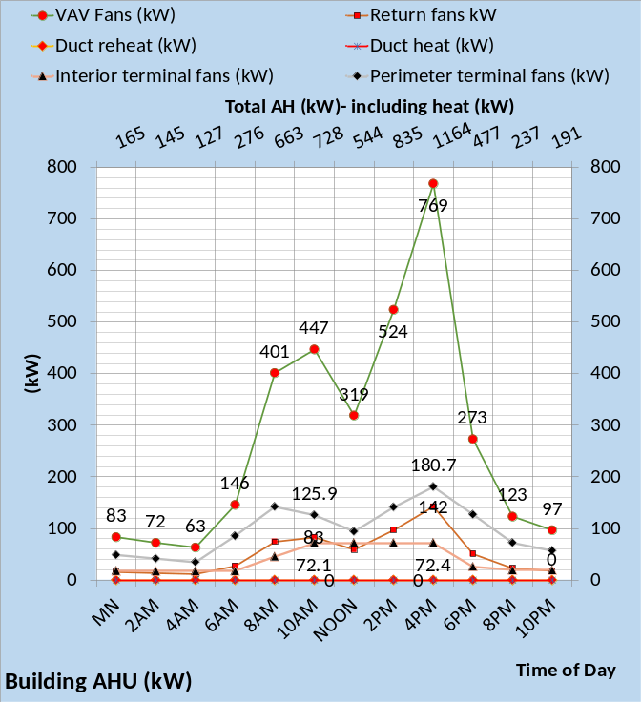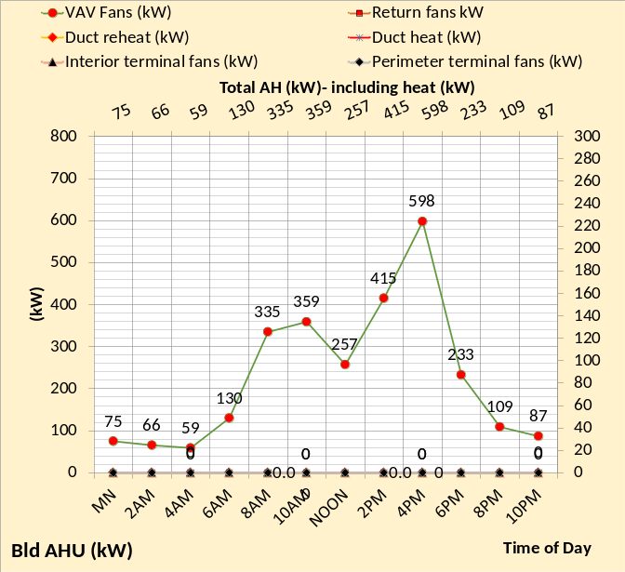
Figure 28: Air handler kW plus space heat kW

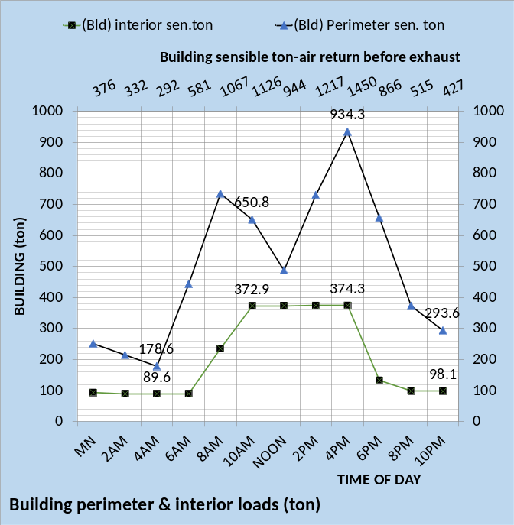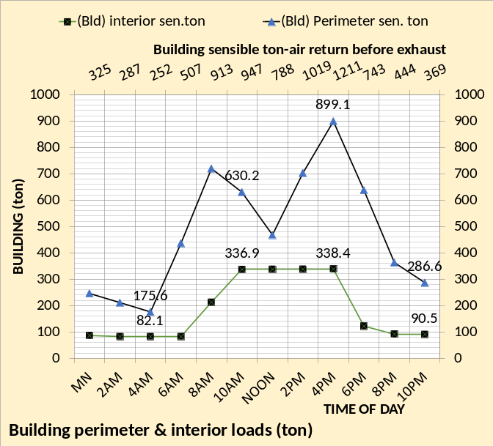
Figure 29: Building interior and perimeter load

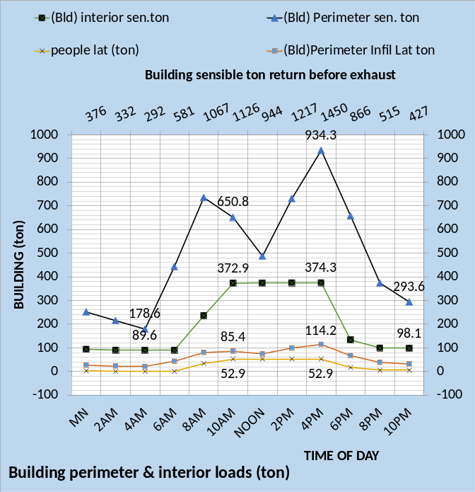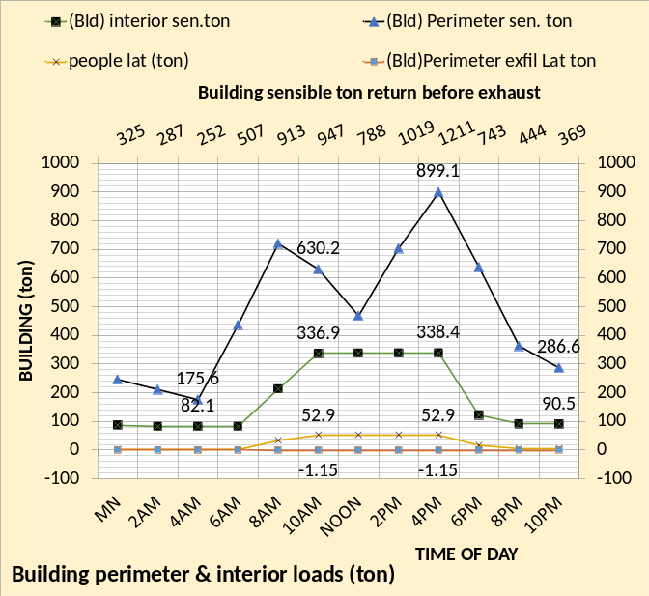
Figure 30: Building sensible 7 latent loads

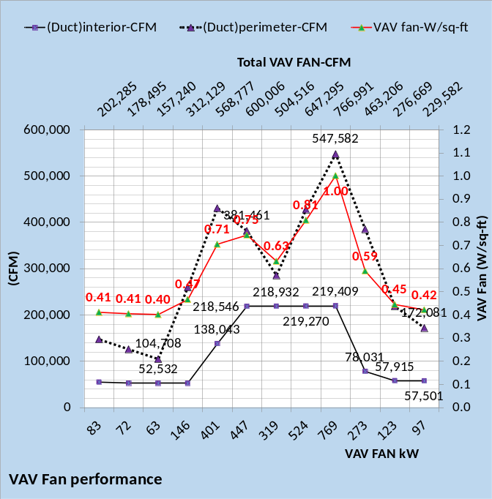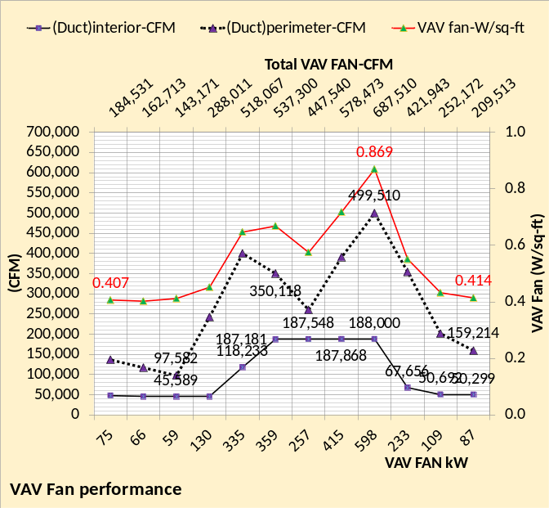
Figure 31: VAV Fan Performance

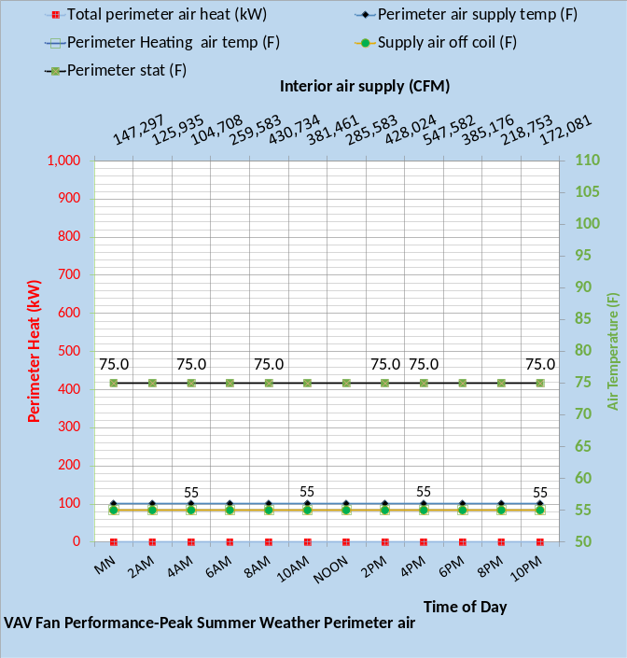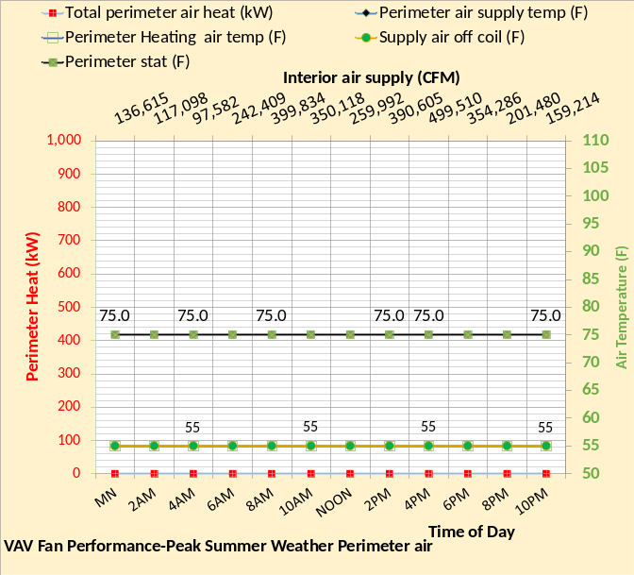
Figure 32: VAV Fan Performance

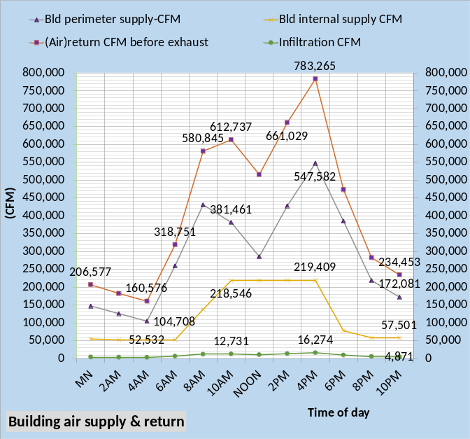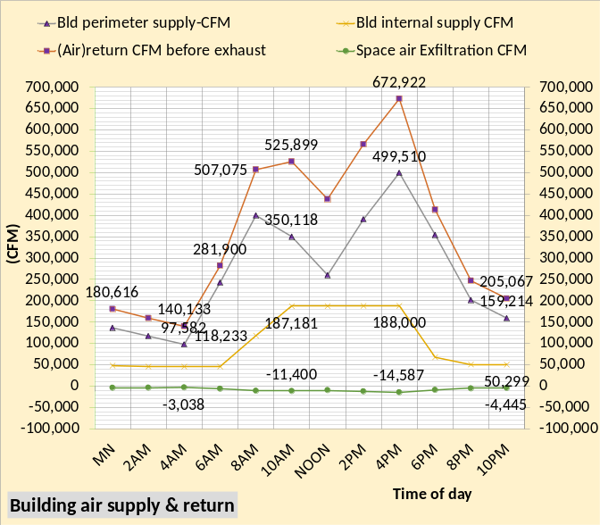
Figure 33: Buildings air supply & return

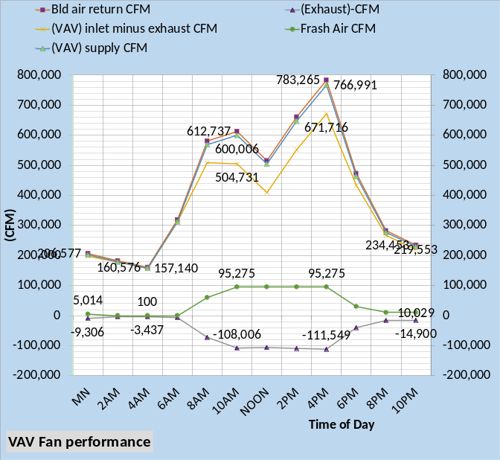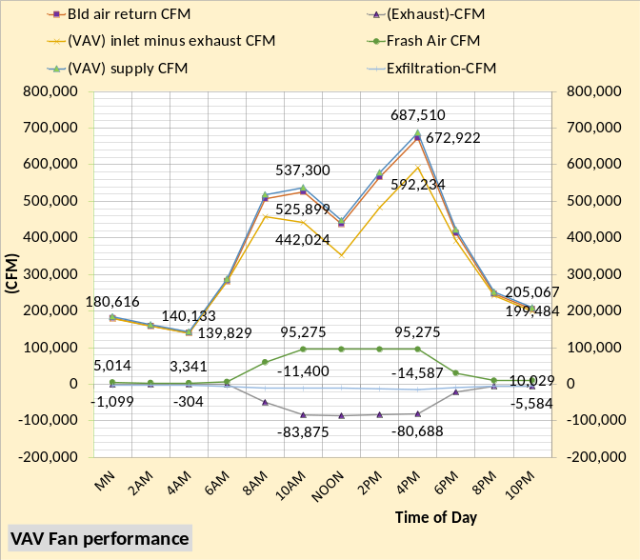
Figure 34: VAV Fan Performance

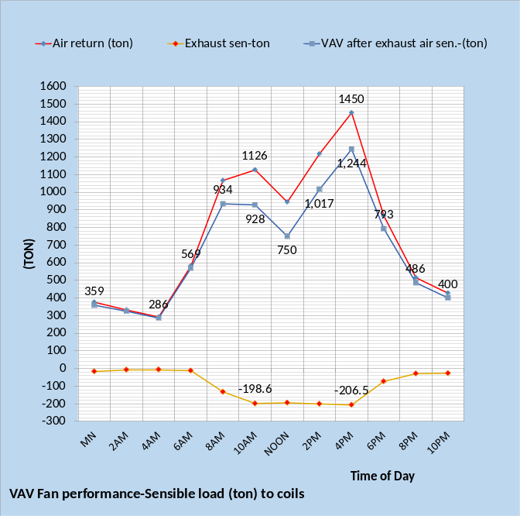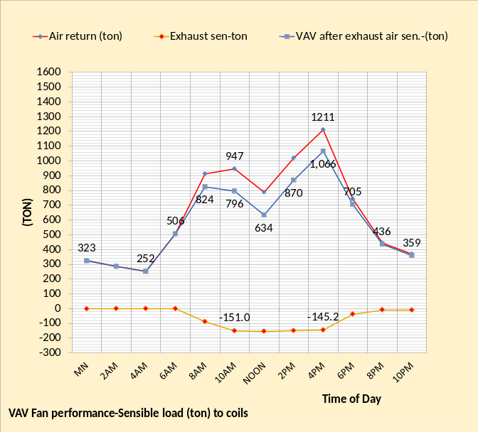
Figure 35: VAV Fan Performance

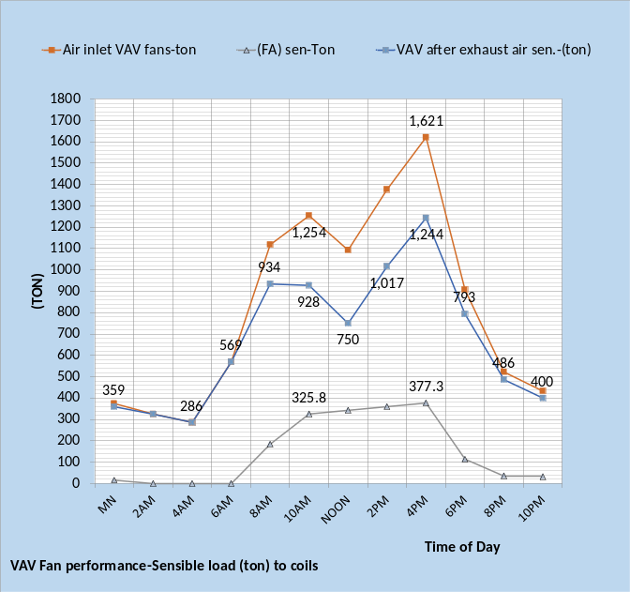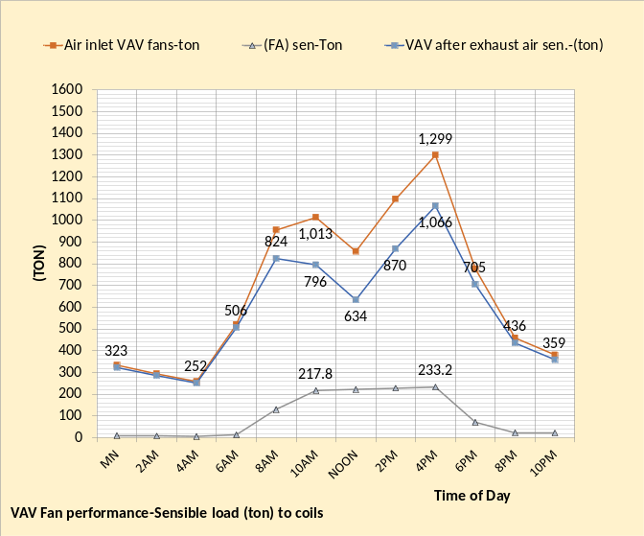
Figure 36: Sensible load to coils

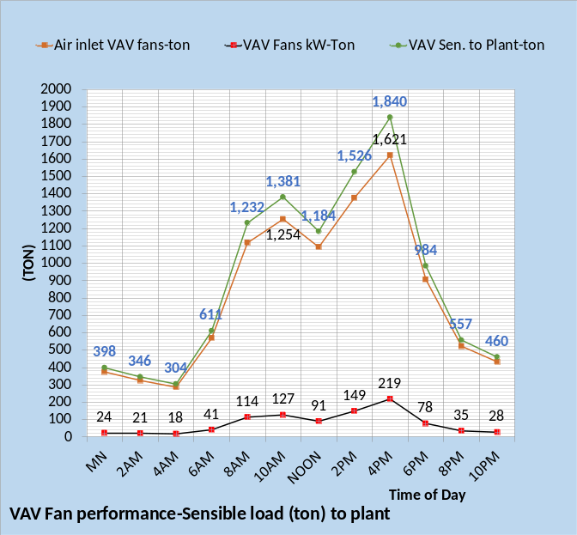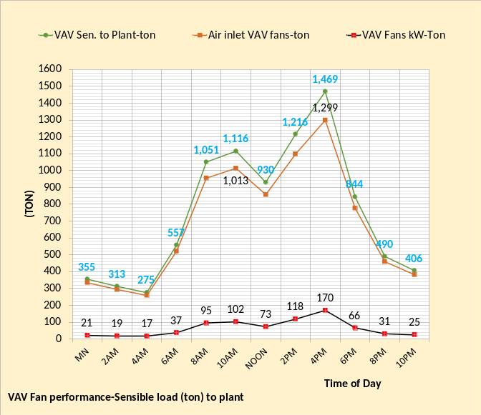
Figure 37: Sensible load to plant

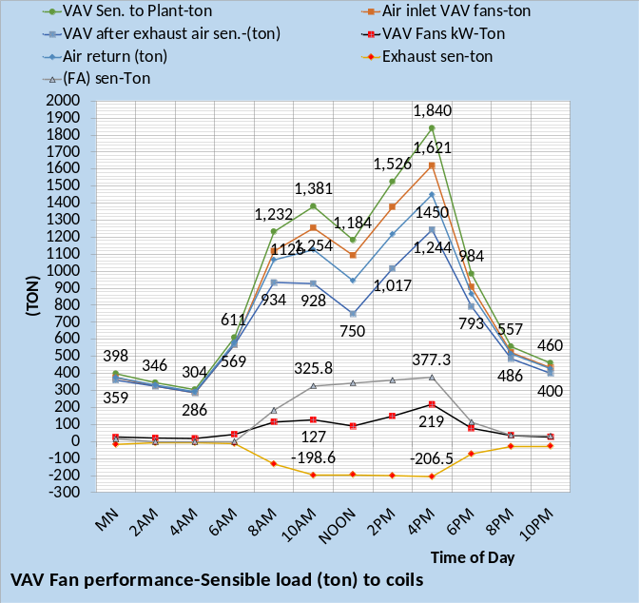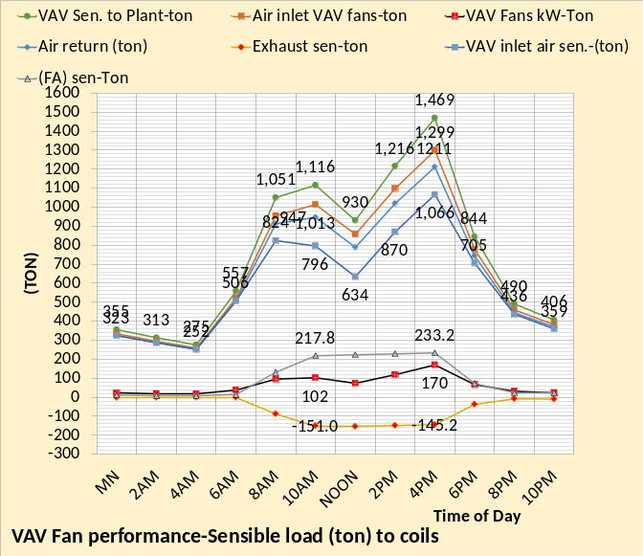
Figure 38: VAV Fan Performance

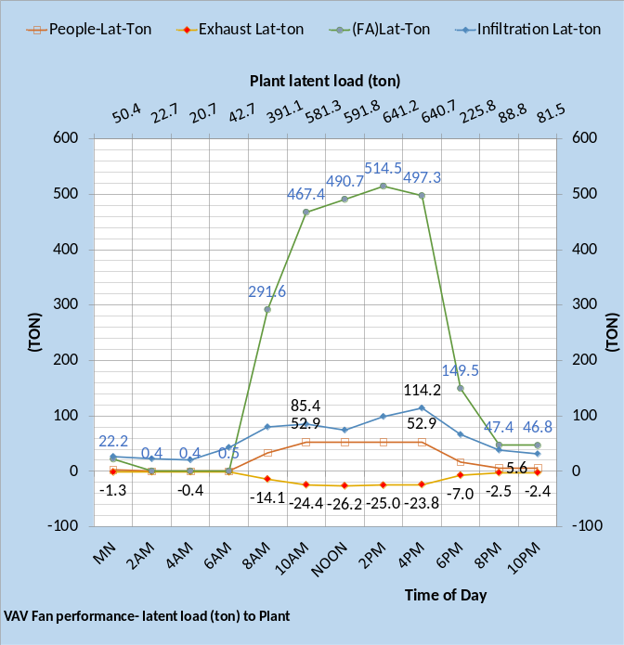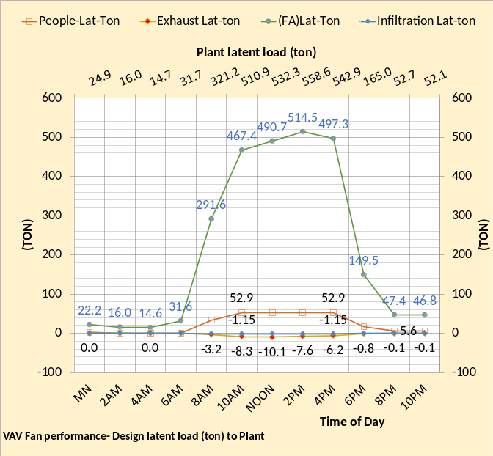
Figure 39: Latent load to plant

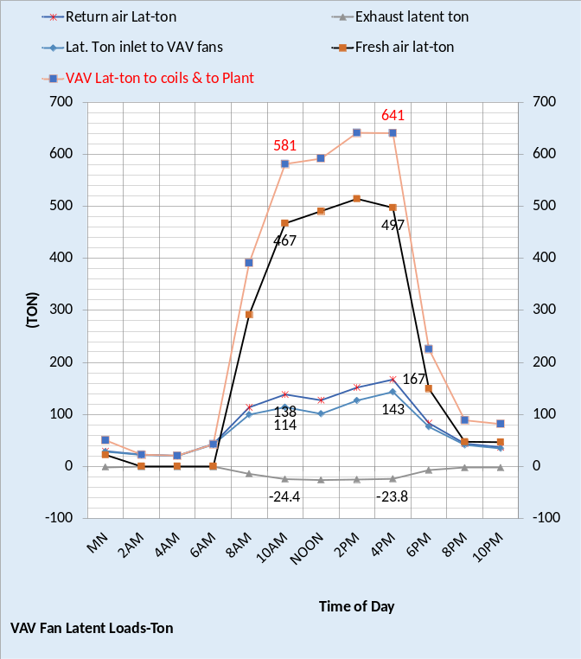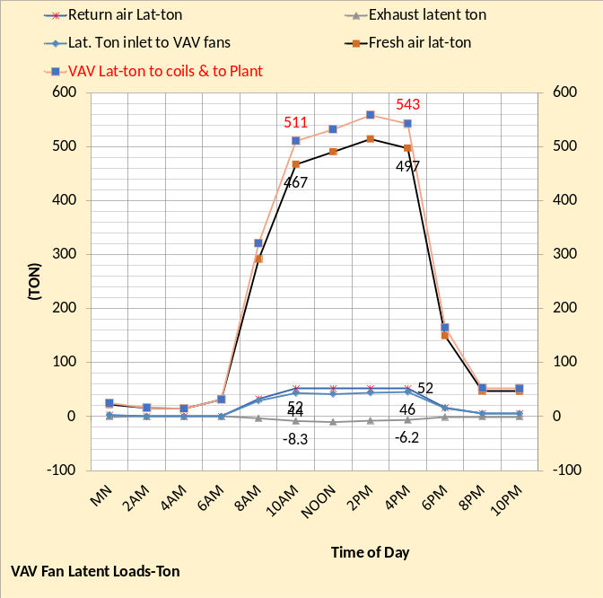
Figure 40: Latent Loads

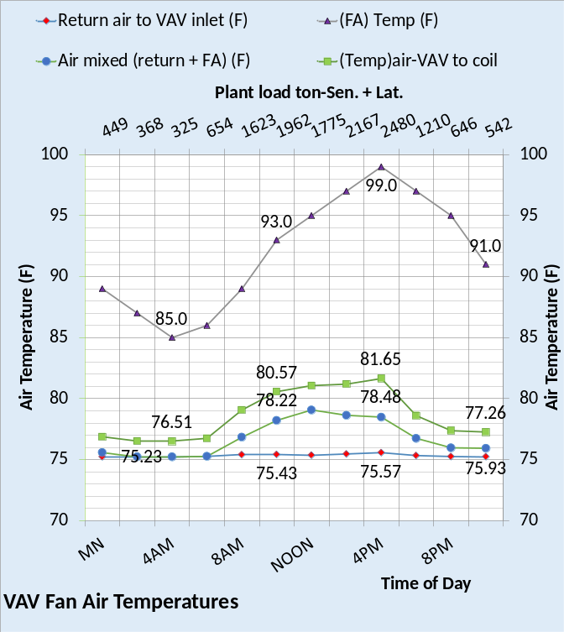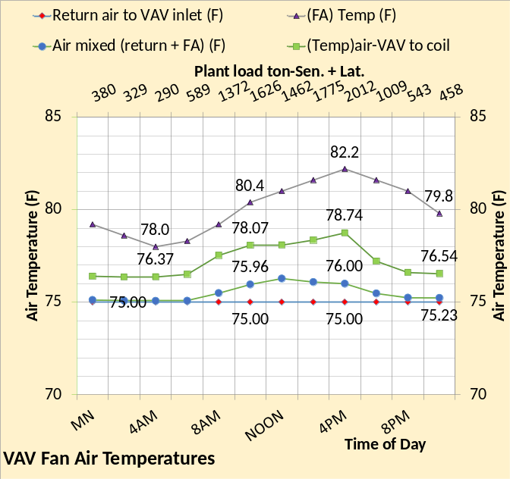
Figure 41: Air temperatures & plant sensible + latent load

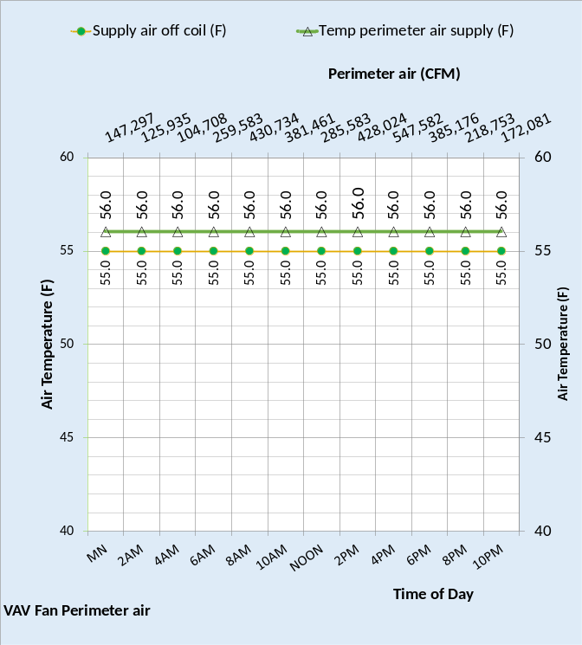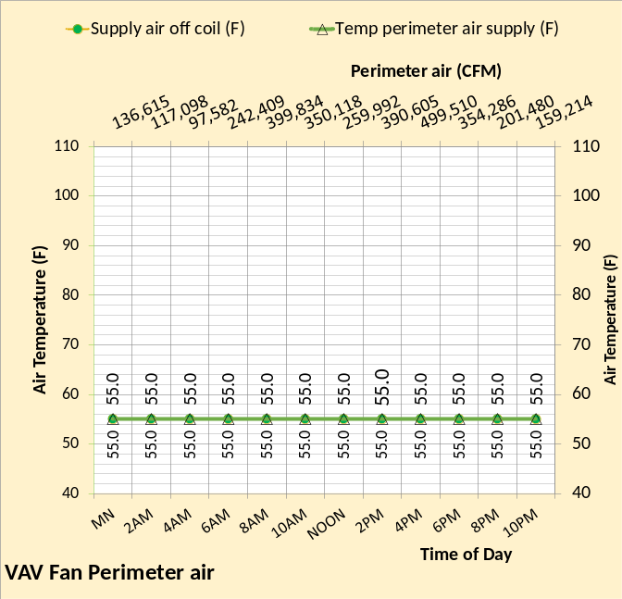
Figure 42: Perimeter air CFM & temp.

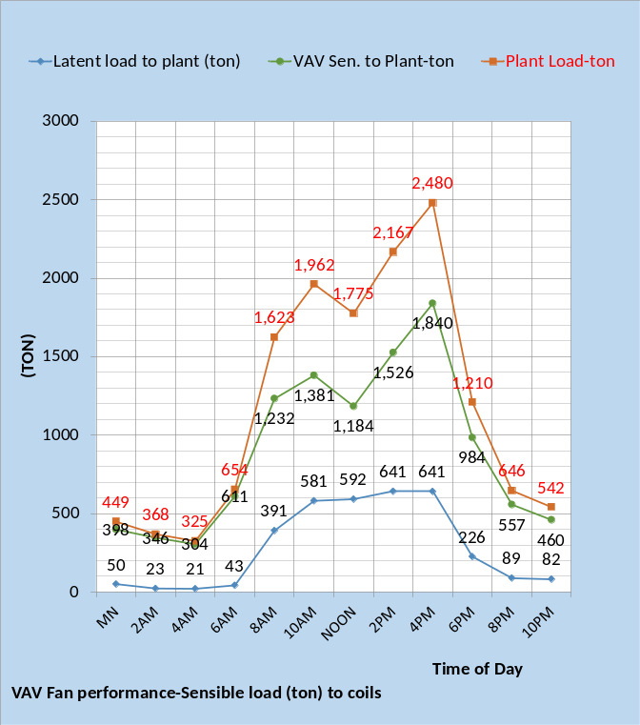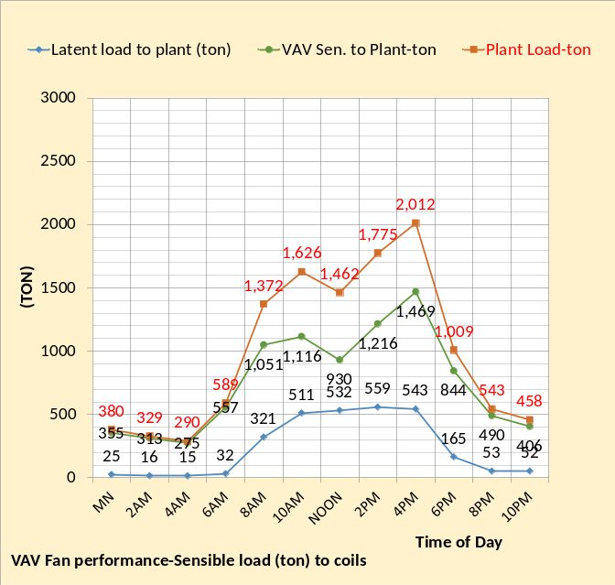
Figure 43: Sensible & latent load to plant

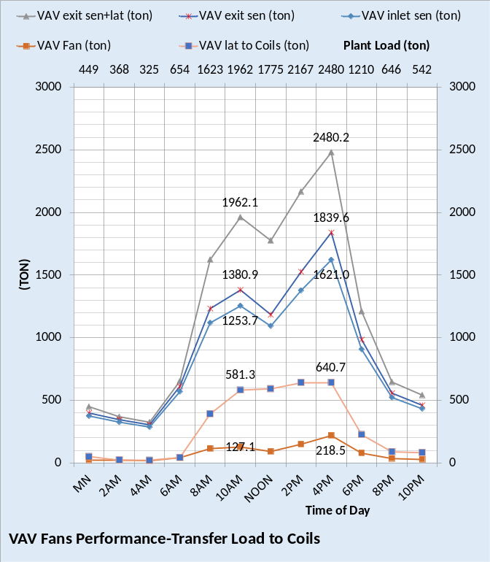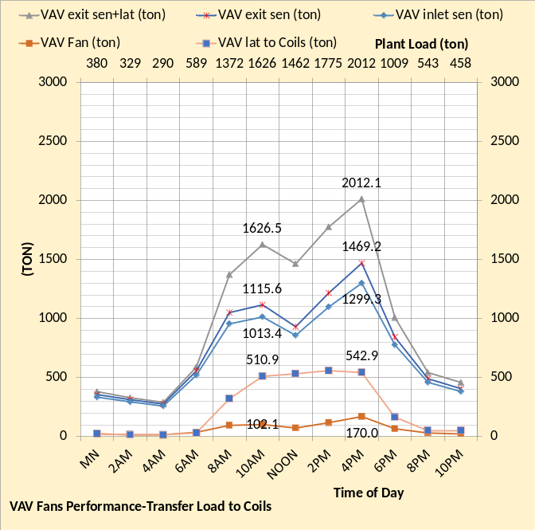
Figure 44: VAV Fan Performance

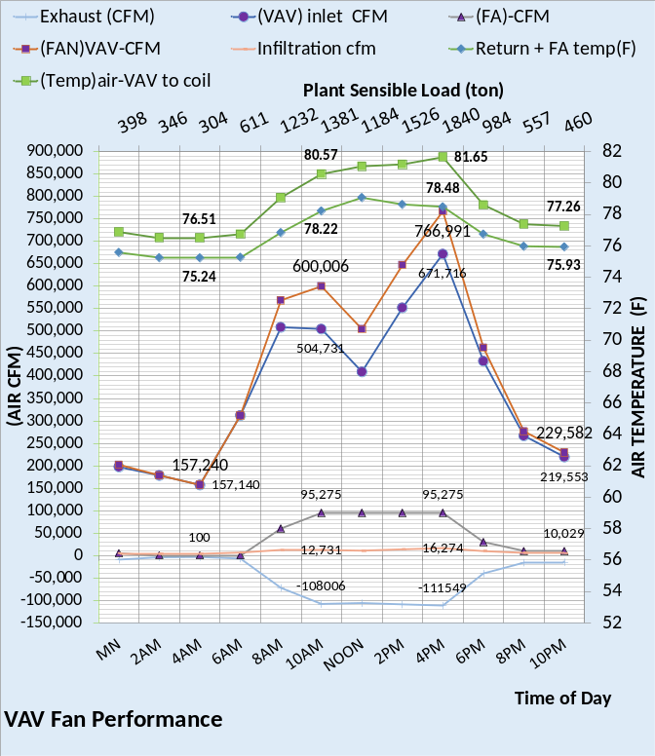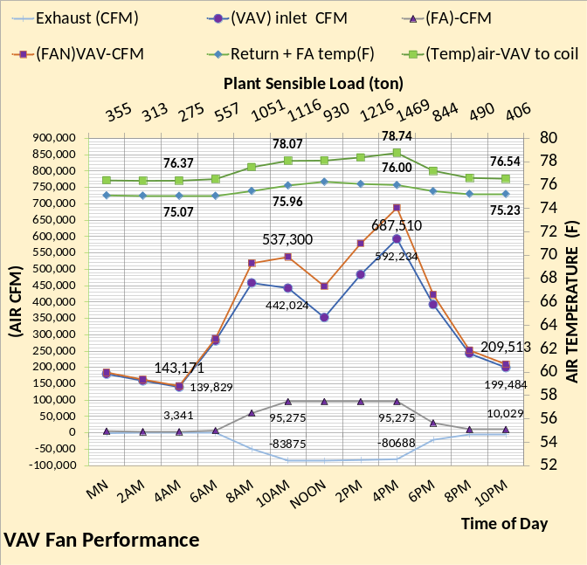
Figure 45: VAV Fan Performance

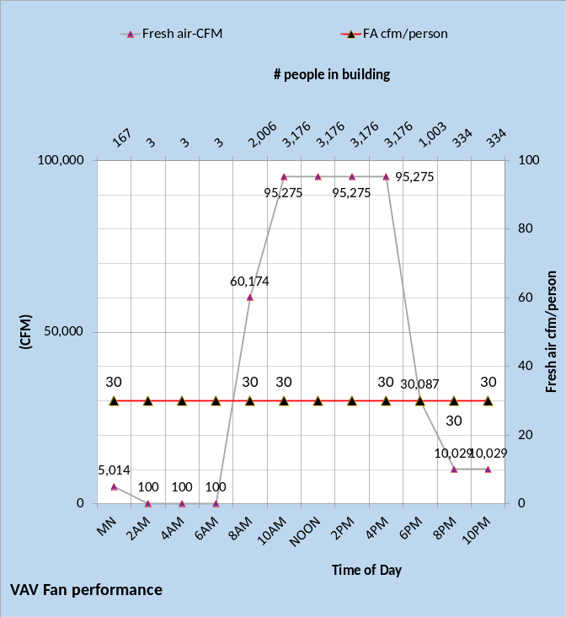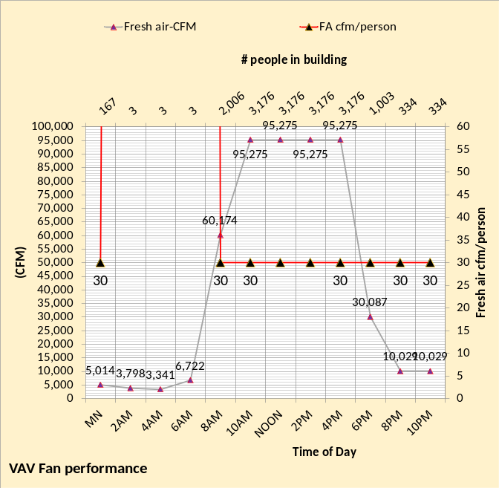
Figure 46: Fresh air performance

The upgraded building has exfiltration not infiltration. Therefore, the fresh air into the building is determined by building pressure requirement, resulting in a very high cfm/person during the time when only three people are assumed in the building.
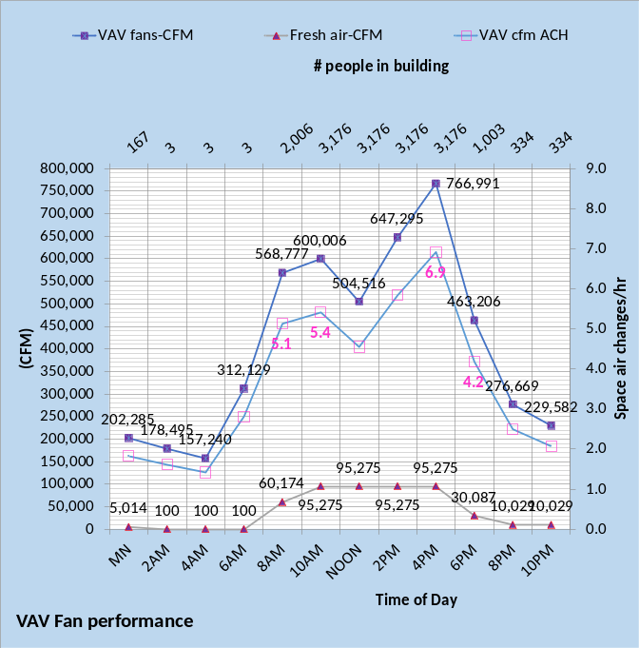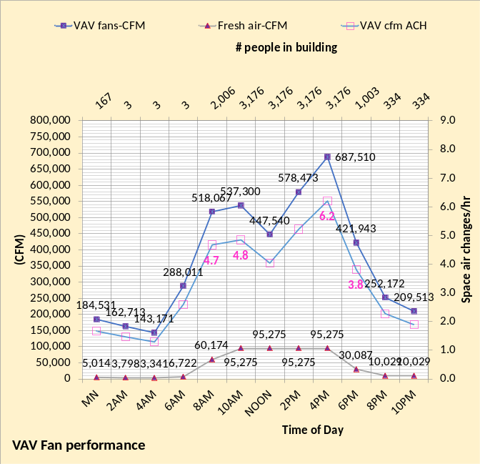
Figure 47: Air changes per hour (ACH)

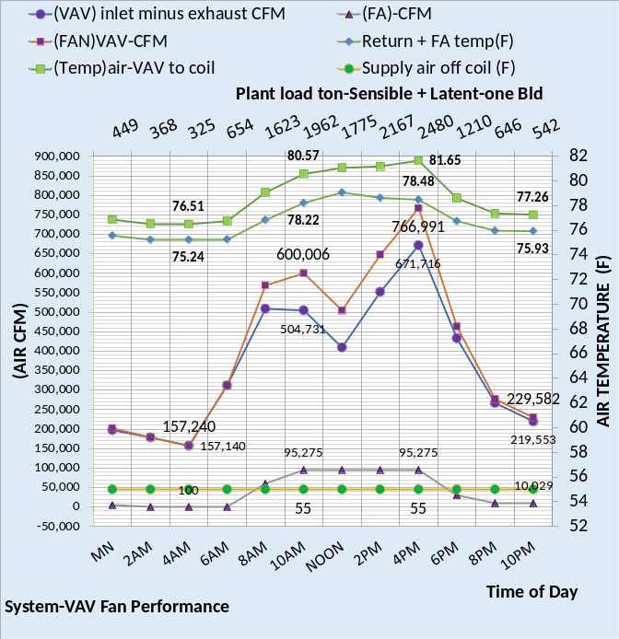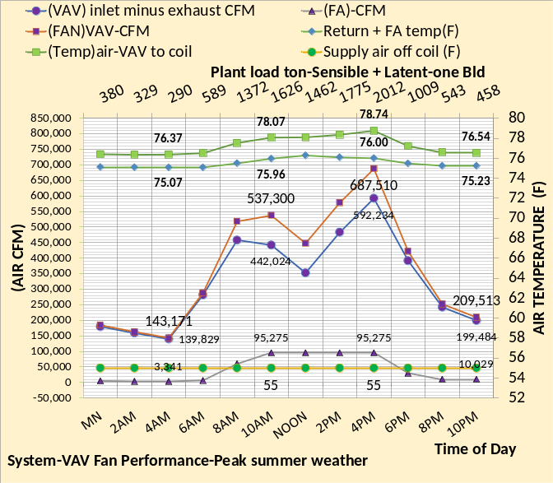
Figure 48: Fans performance

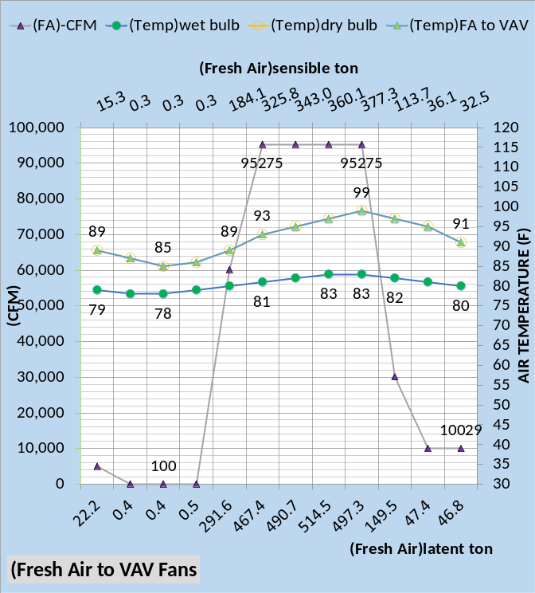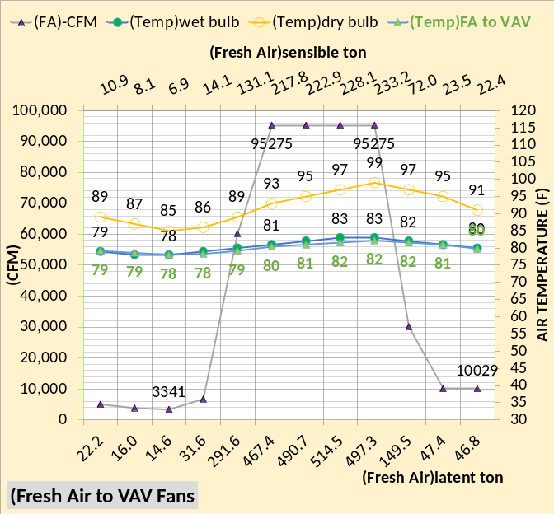
Figure 49: Fresh Air

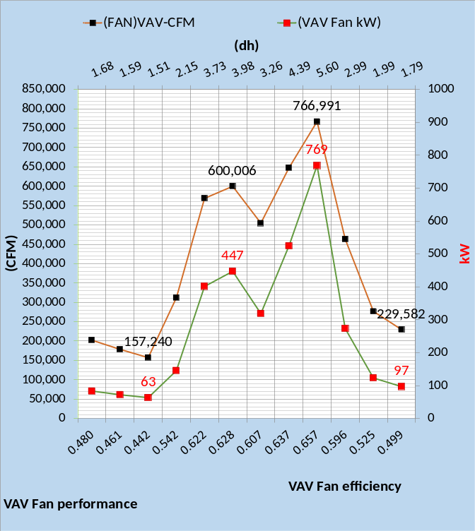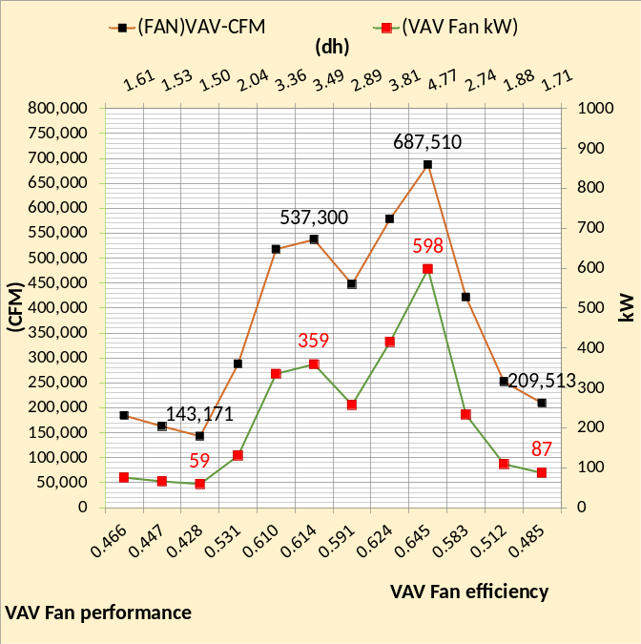
Figure 50: VAV CFM & kW demand

This figure illustrates the complexity of simulating the performance of the VAV fan system. Static pressure & fan efficiency must be modeled as a function of several variables that in turn determine the VAV fan kW.

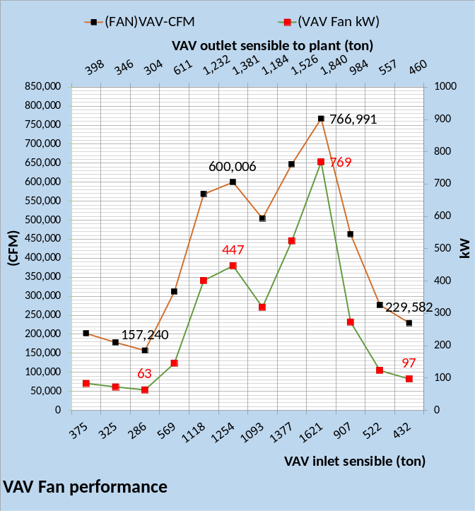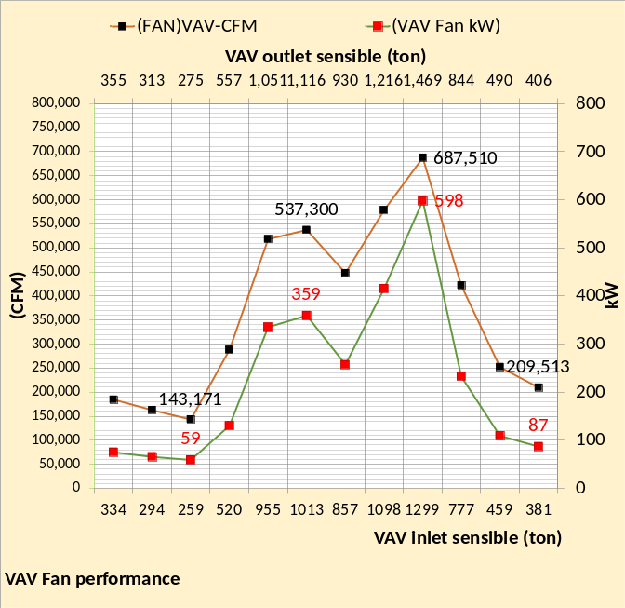
Figure 51: Fan performance

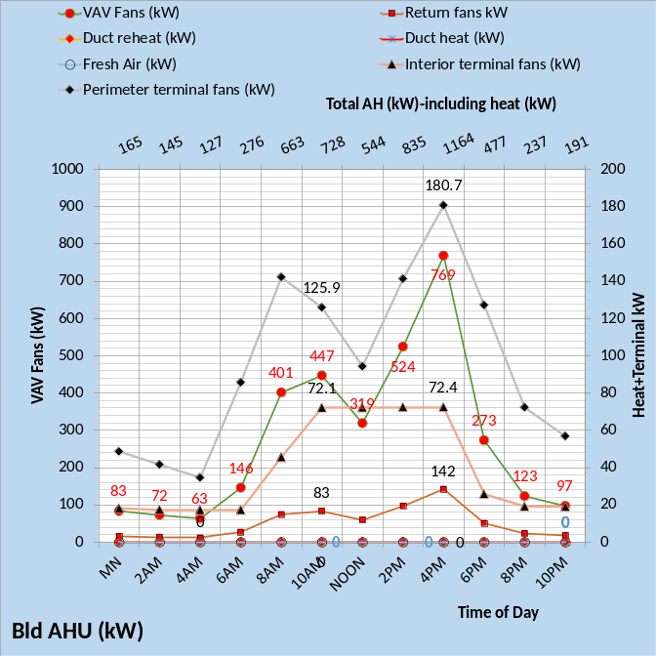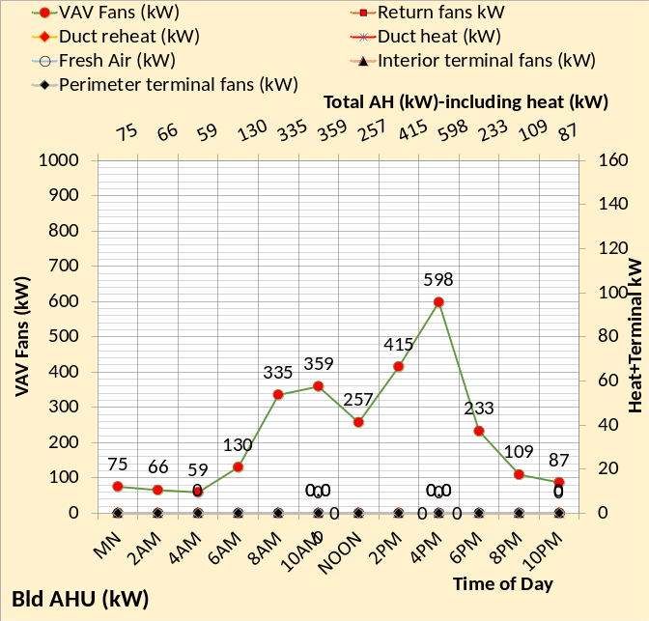
Figure 52: Fan system kW demand including required space heat.

This figure is more complex when heat is required at the perimeter of the building.

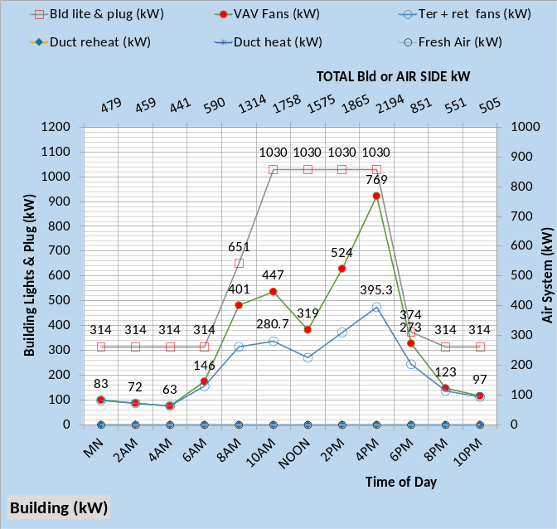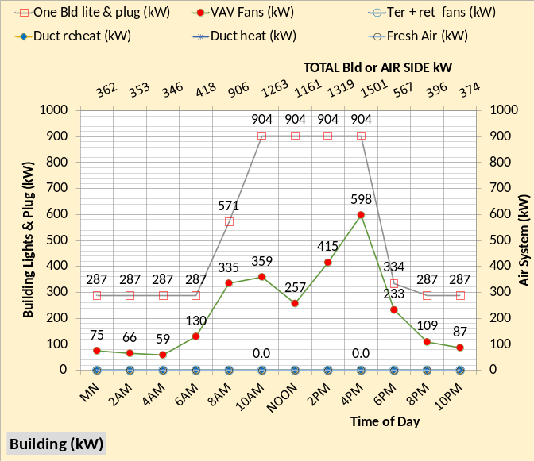
Figure 53: Building kW

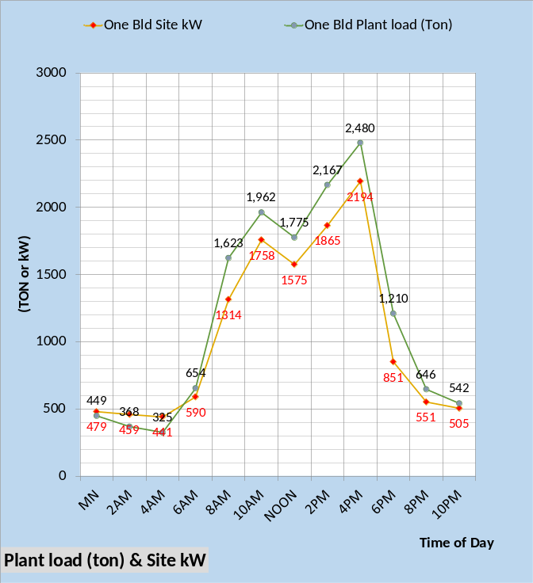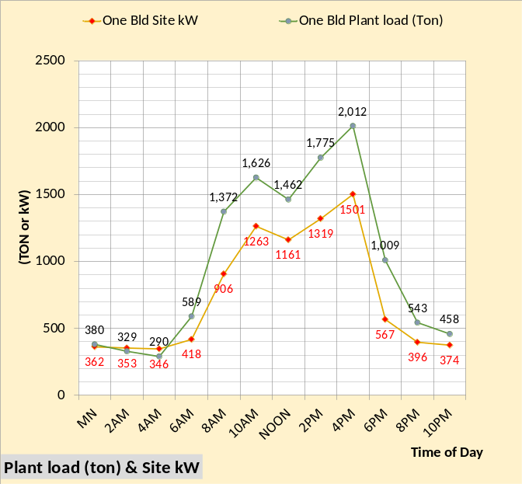
Figure 54: Plant load & site/building kW

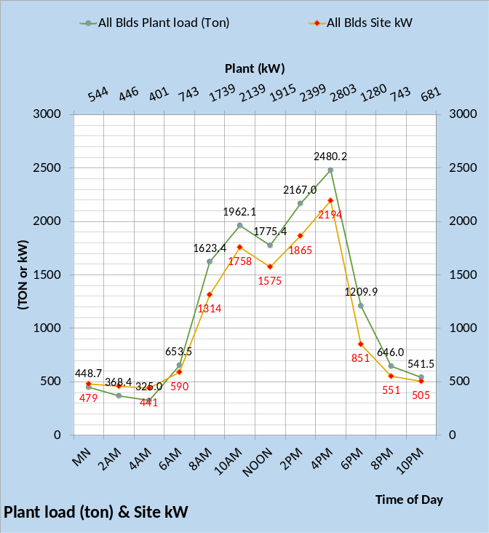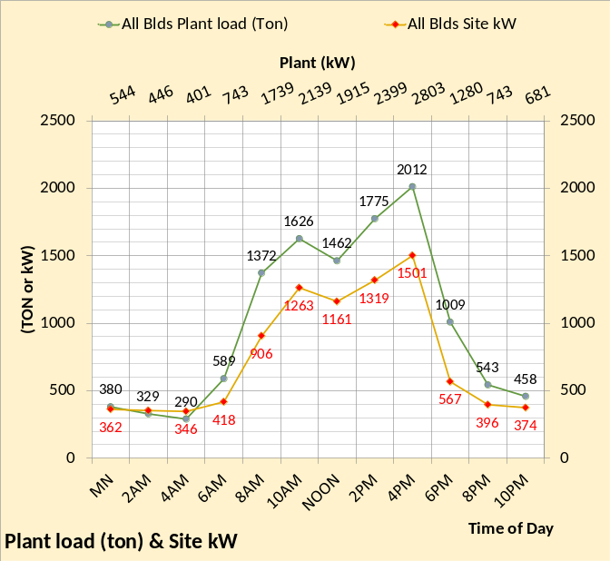
Figure 55: Building 24-hour values

The above charts have demonstrated the detail of the SEE Model as configured to match the building described in the ASHRAE Journal. The equations that define these charts are all changeable based on the characteristics of the building being modeled.
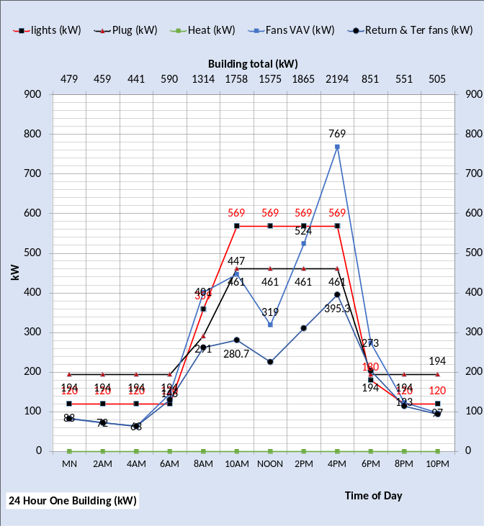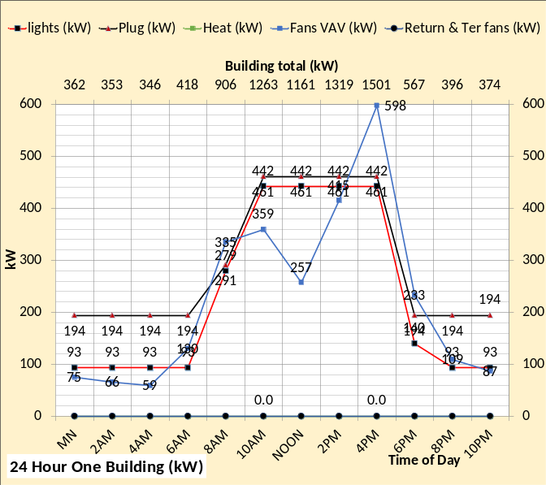
Figure 56: Building 24-hour kW

One objective of the SEE Model is to duplicate the performance, on any day, of a building, in this case a 56-story office building. if the authors of the Journal article provide details the SEE Model will be changed to better data. Next, we address the chiller plants.

7-Chiller Plant Model Details.
The following charts will illustrate the chiller plants, the existing plant and the new plant as described in the ASHRAE Journal of June 2022.
The chiller is a very complex unit, requiring a good model of the evaporator and condenser refrigerant temperatures to define chiller lift and therefore chiller kW demand.
The chiller plant heat is transferred to the ocean thru a heat exchanger. The ocean temperature is assumed as 84F during the summer and a 4F approach heat exchanger for 88F water to the condenser.
Some charts may not show tower as the heat exhaust device, the word should be ocean, not tower.

The old chiller plant charts are dark color, and the new chiller plant charts are green.

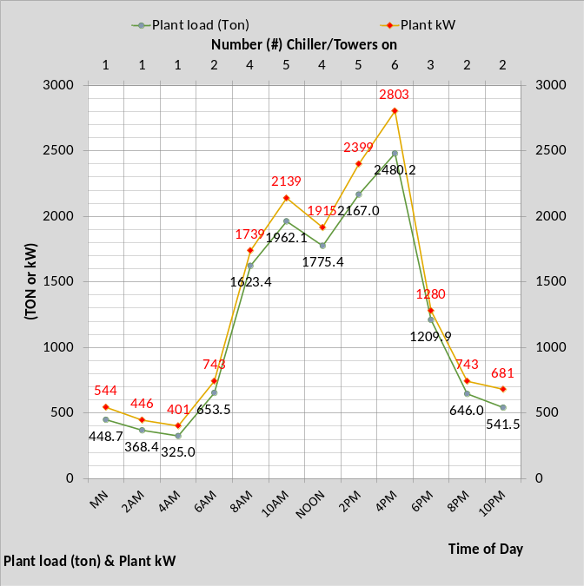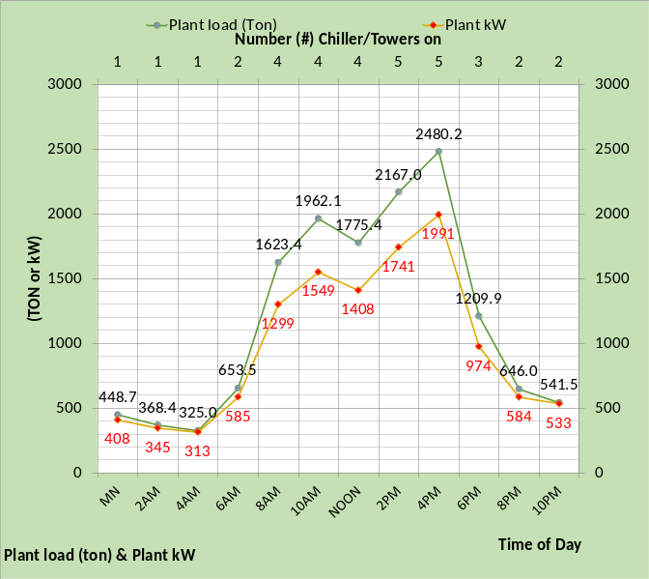
Figure 57: Plant load & kW

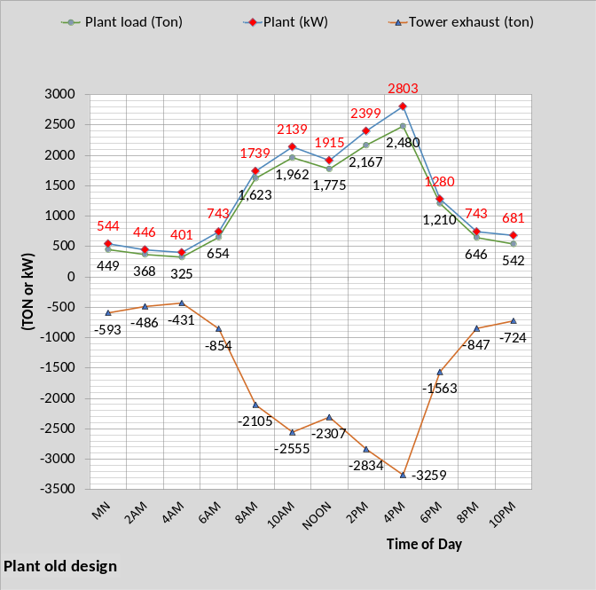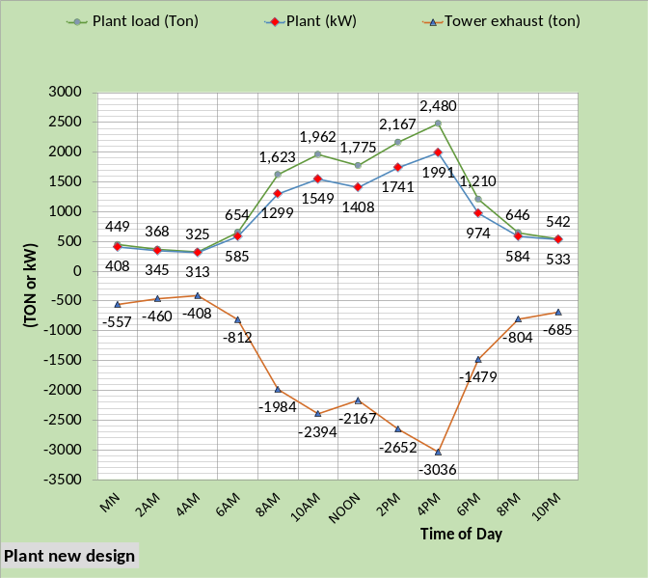
Figure 58: Plant performance

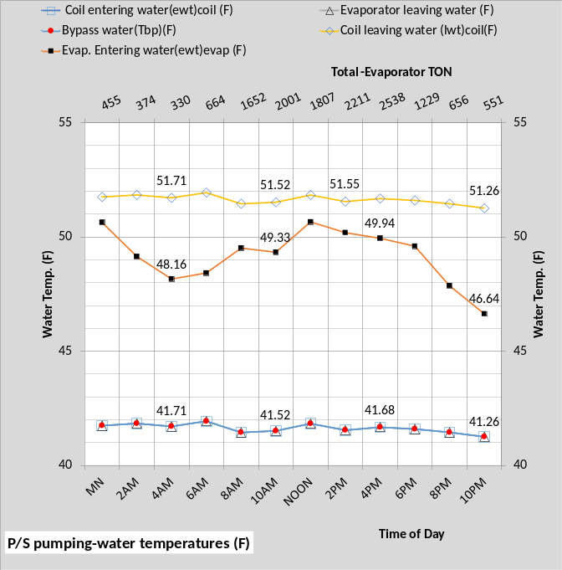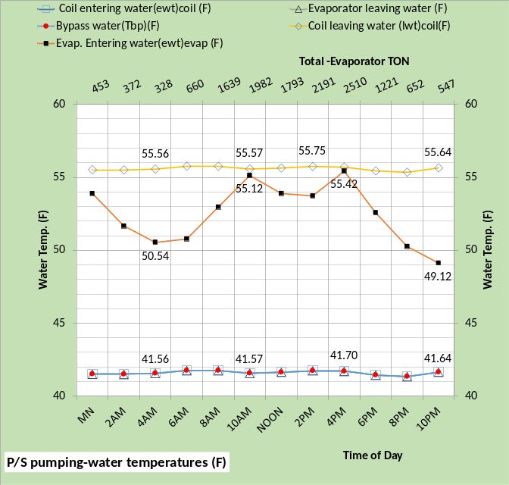
Figure 59: Primary/Secondary Pumping

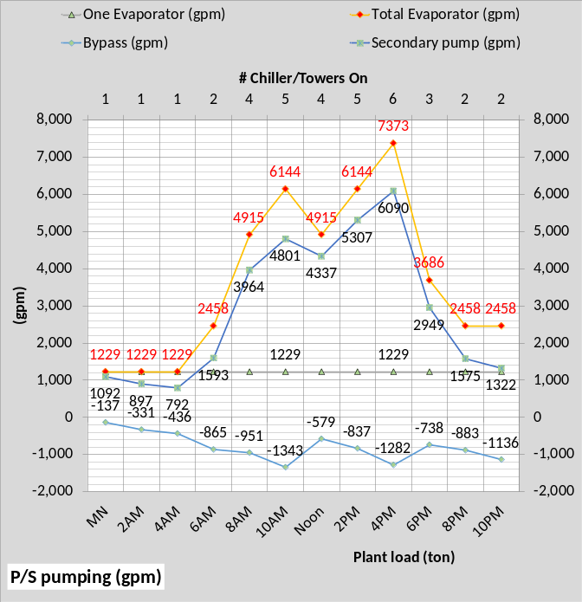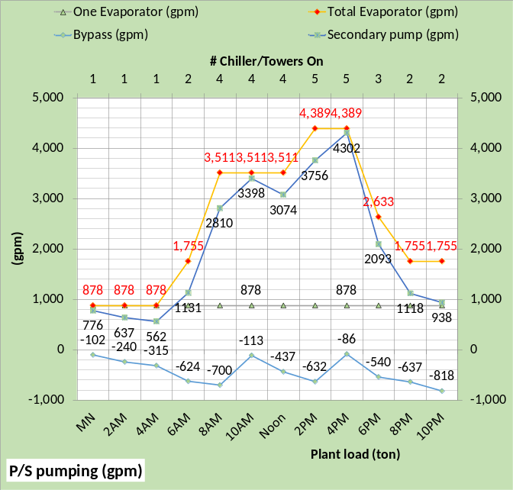
Figure 60: P/S pumping (gpm)

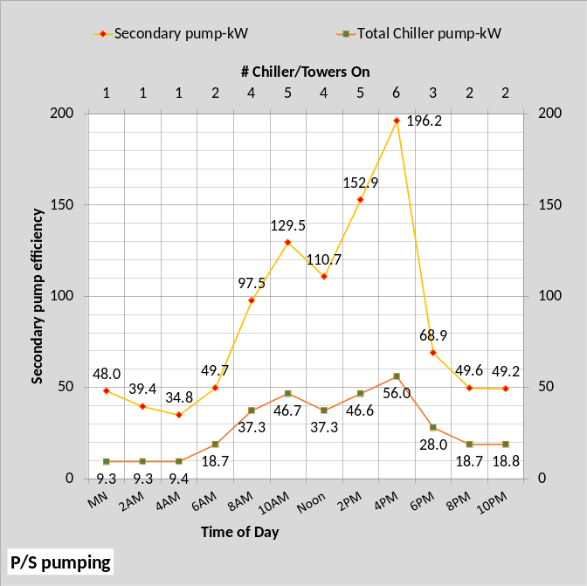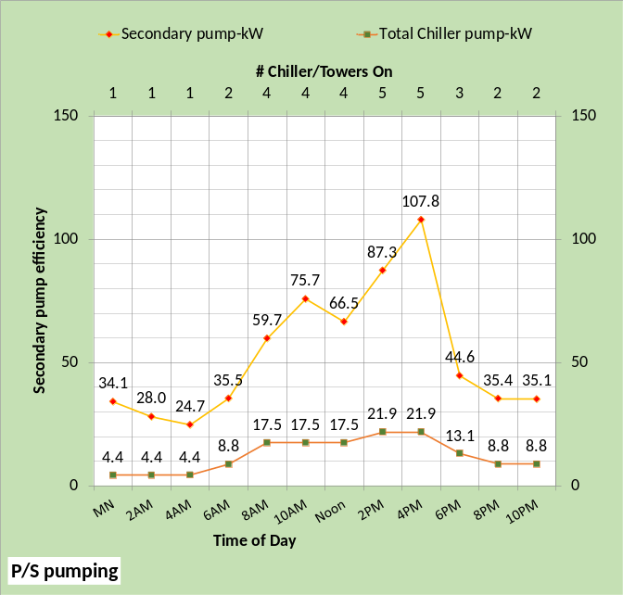
Figure 61: Pumping kW
note as stated above some charts will give tower data when the model is of plant heat exhaust to ocean.

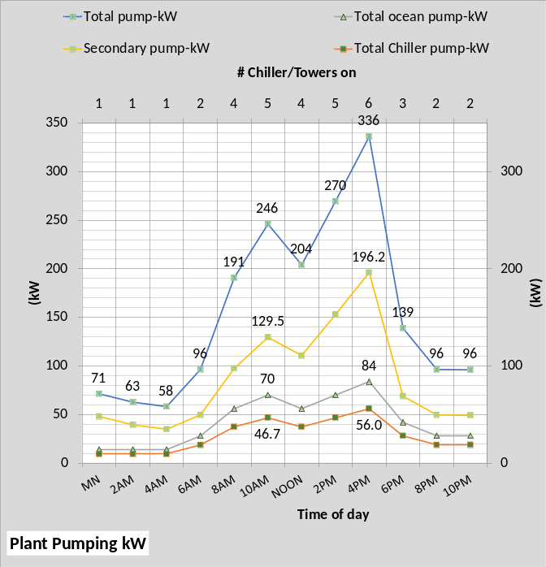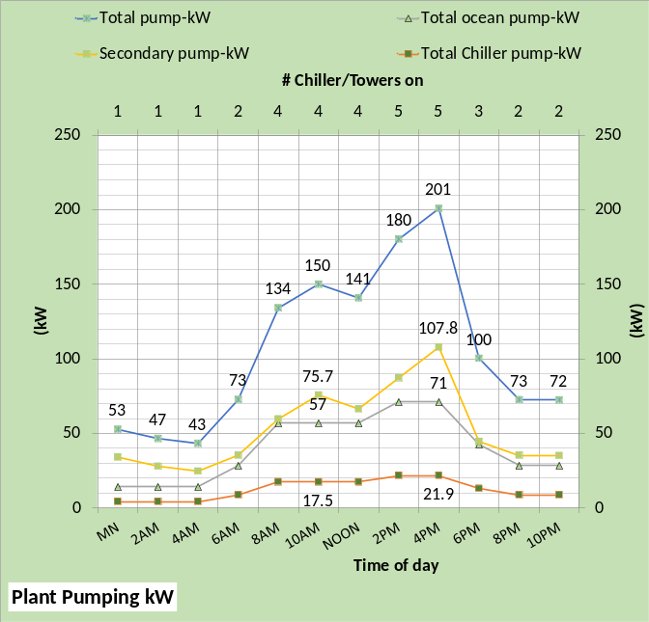
Figure 62: Pump kW

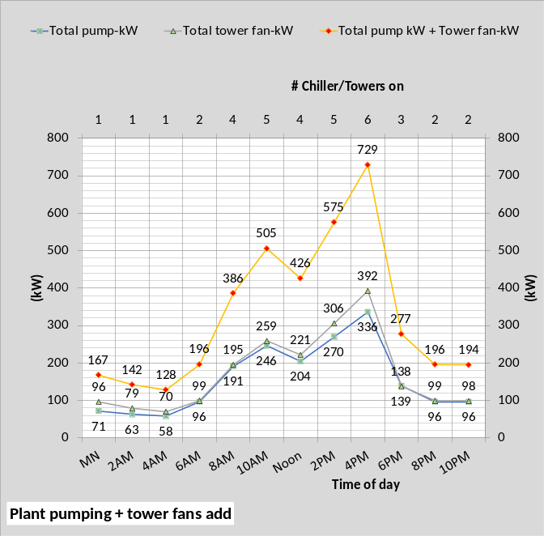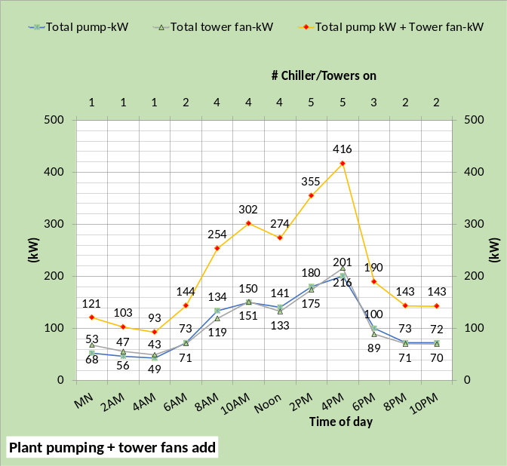
Figure 63: Pump kW

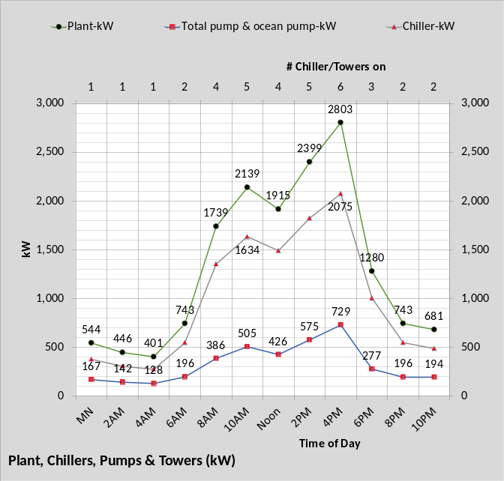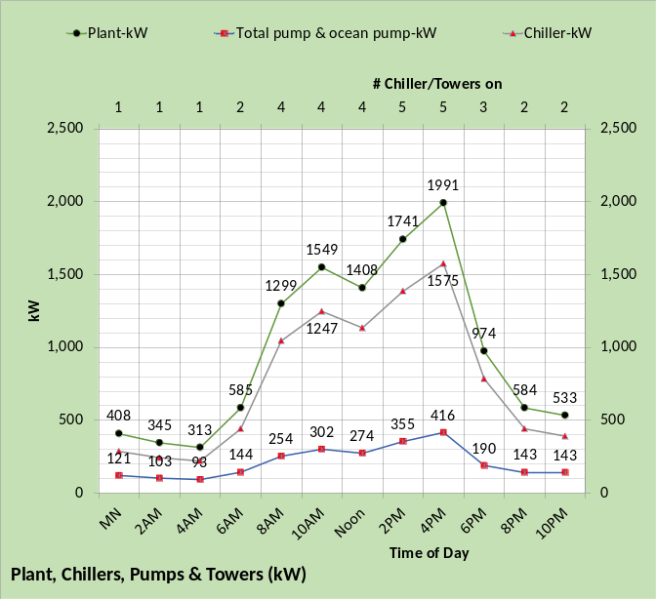
Figure 64: Plant kW

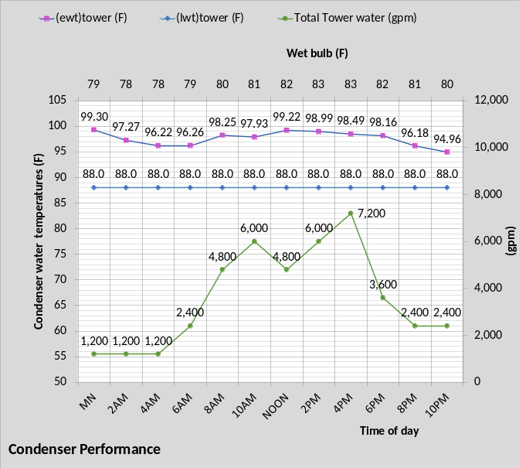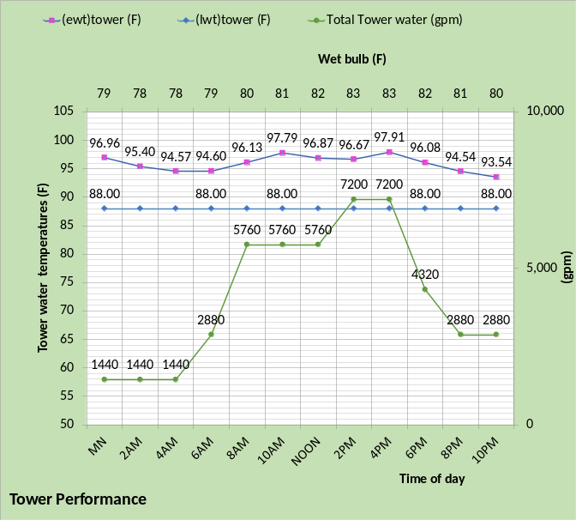
Figure 65: Condenser water gpm

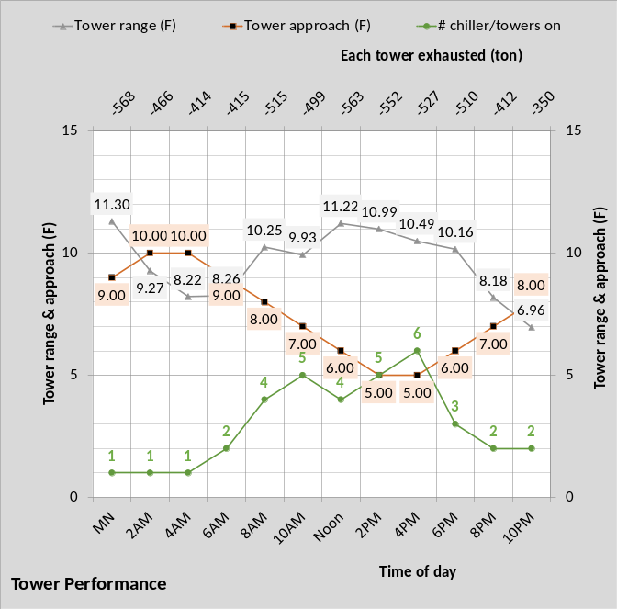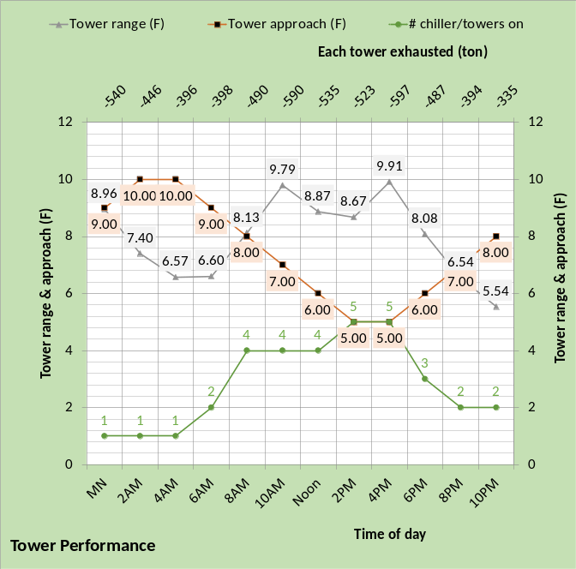
Figure 66: Ocean heat exchanger performance

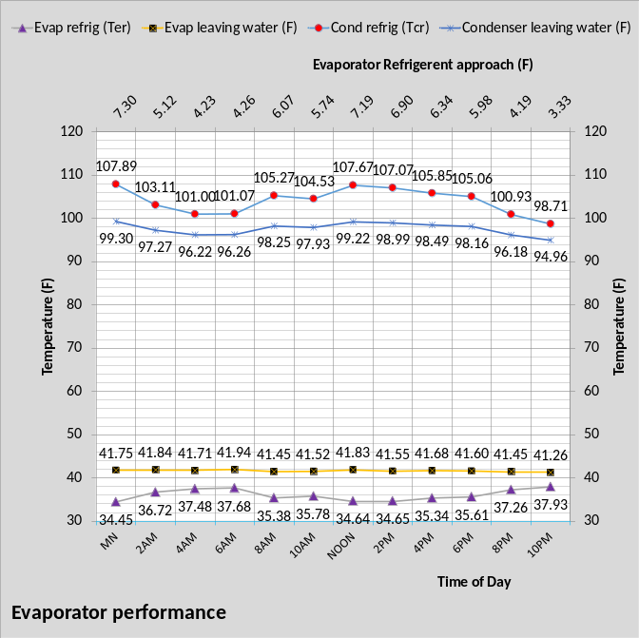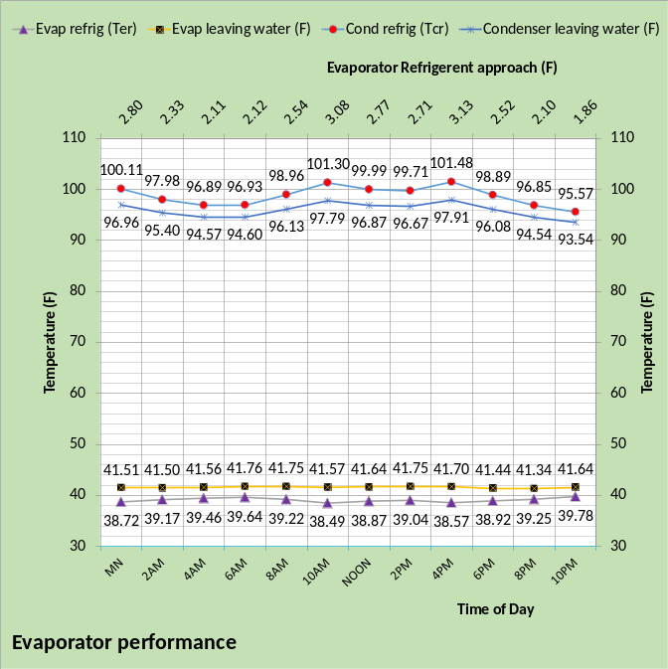
Figure 67: Evaporator Refrigerant Model performance

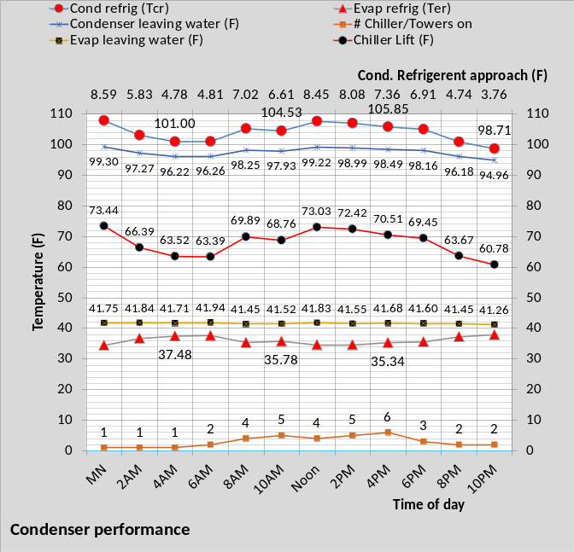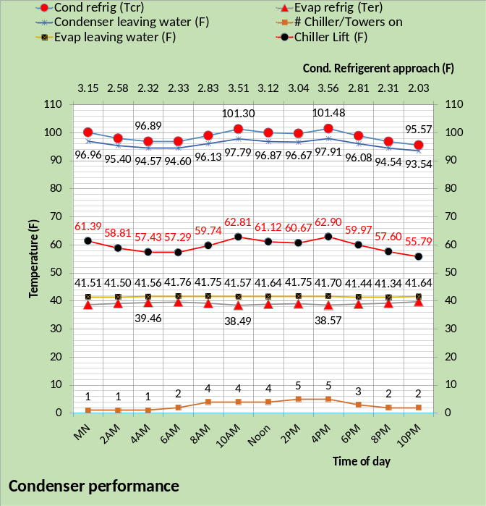
Figure 68: Condenser Refrigerant Model performance

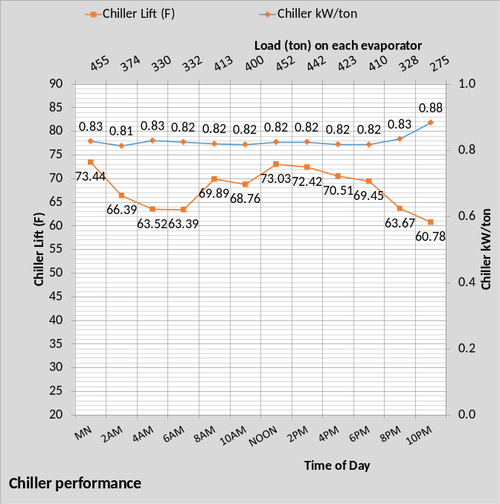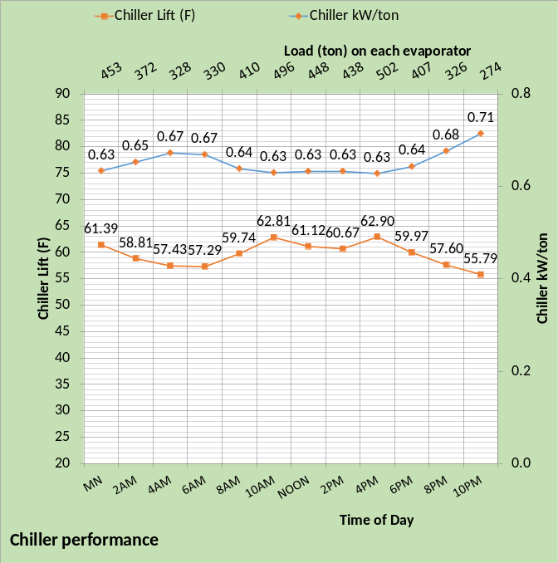
Figure 69: Chiller performance

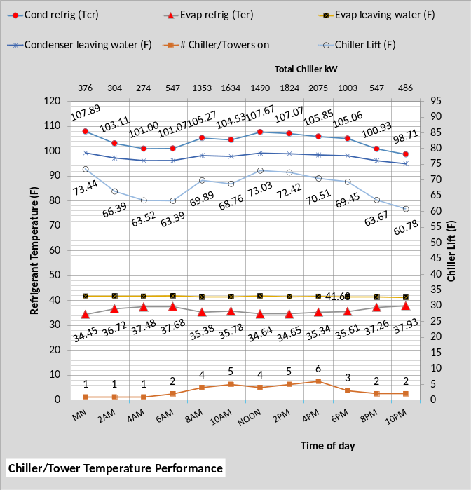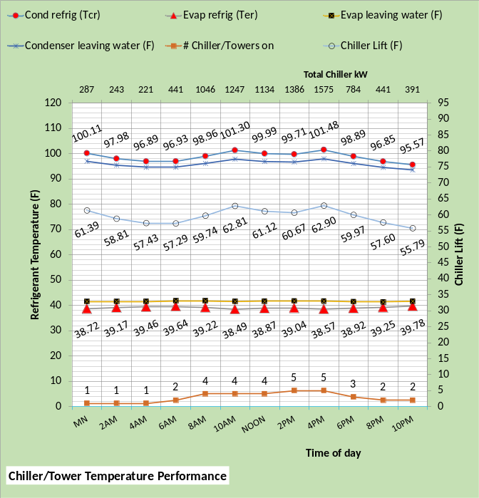
Figure 70: Refrigerant Model

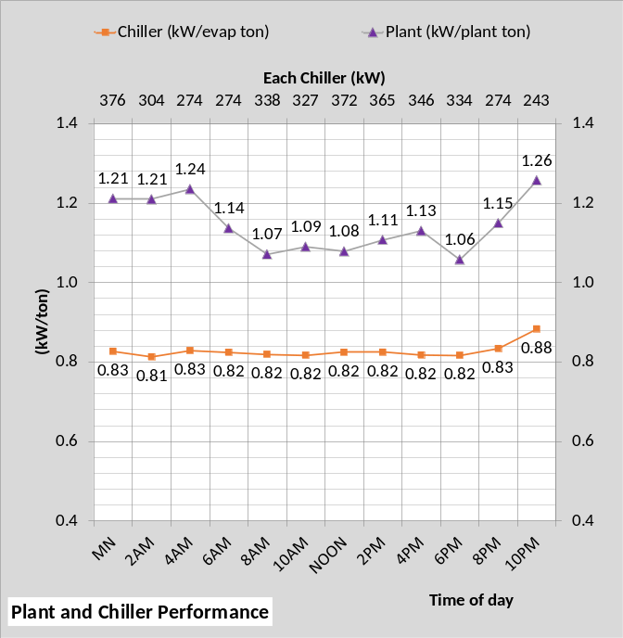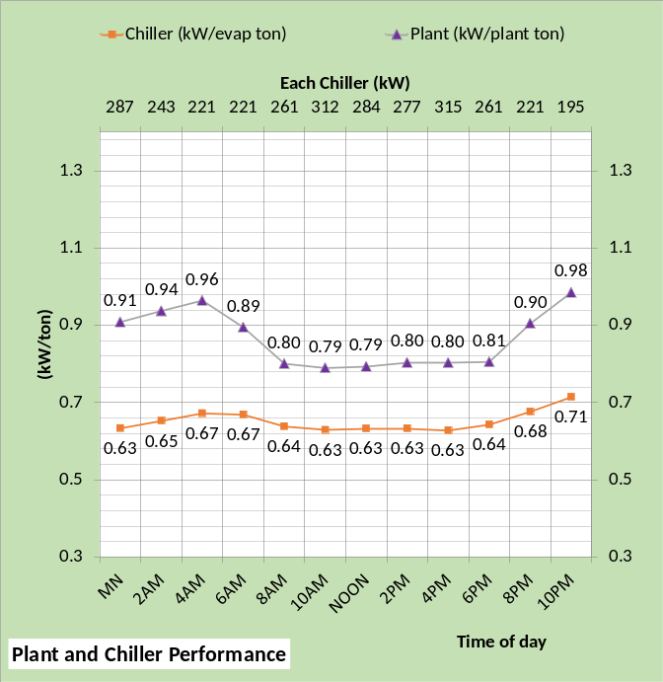
Figure 71: Chiller & Plant kW/ton

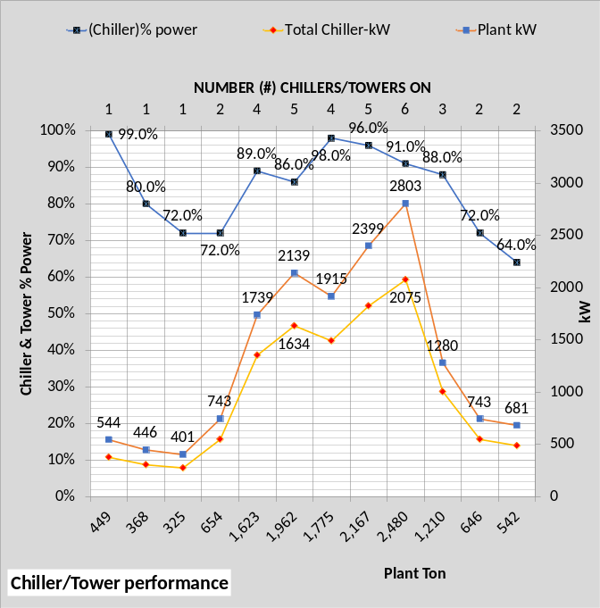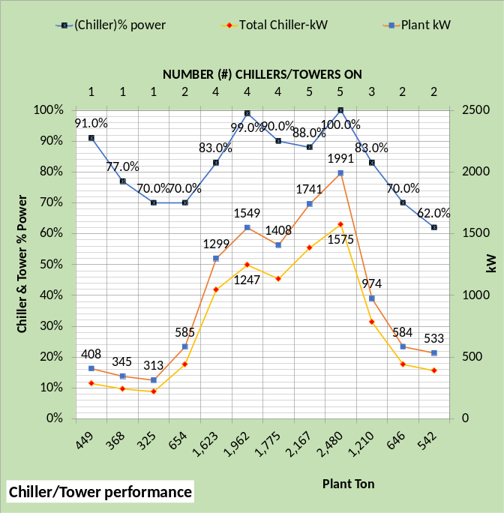
Figure 72: Chiller & Plant performance

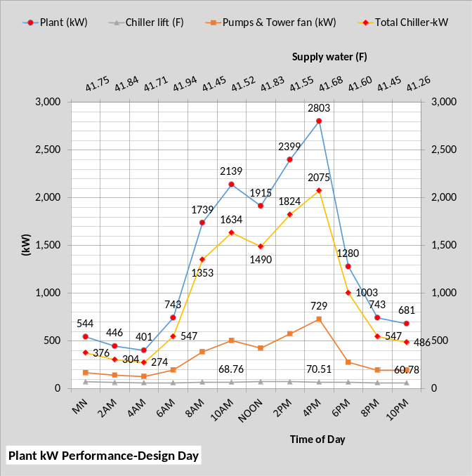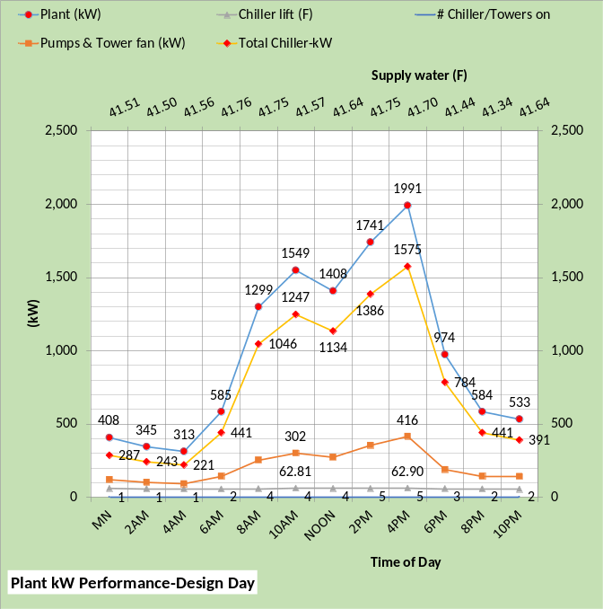
Figure 73: Plant performance

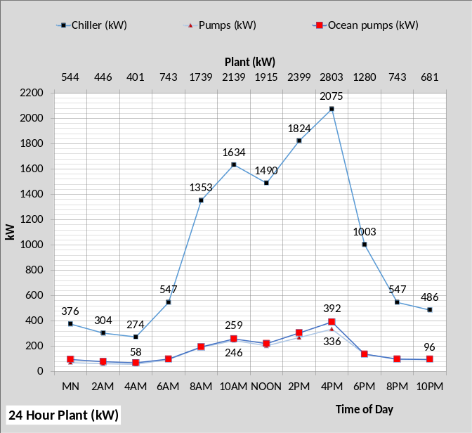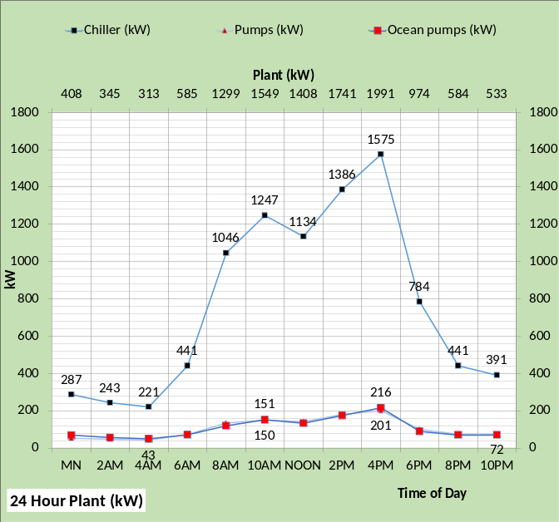
Figure 74: Plant performance

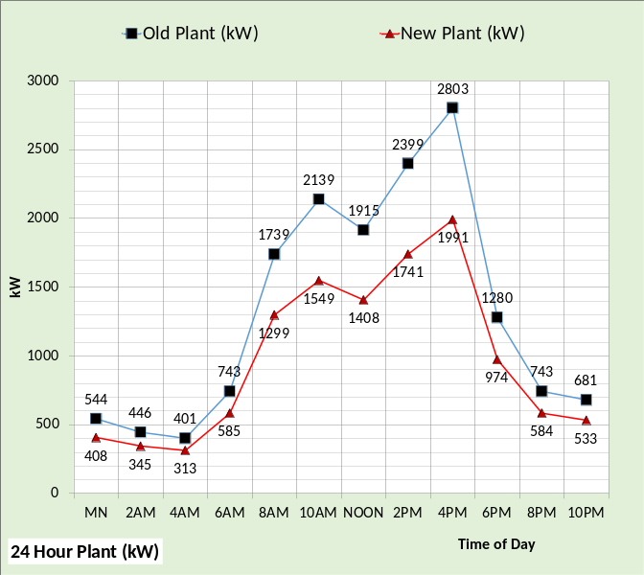
Figure 75: Old plant vs. New plant

The above charts demonstrate the detail equations that make up the SEE Model of the assumed plants based on descriptions in the ASHRAE Journal article of June 2022. The models will be updated if the authors of the ASHRAE Journal article provide details.

8-Real Weather Analysis for February 21, 2022.

Figure 3: Design Day weather
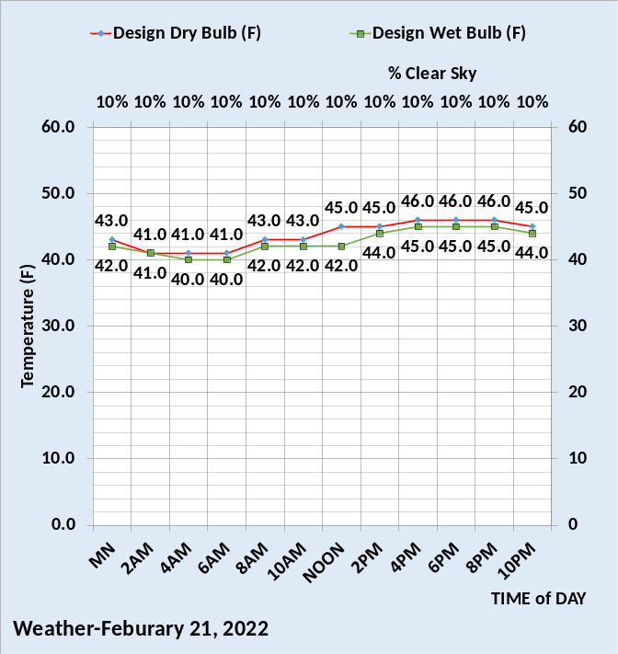
Figure 76: February 21, 2022, weather

February 21, 2022 was a cold day in Hong Kong resulting in very different energy performance of the building, the perimeter of the building must be heated.
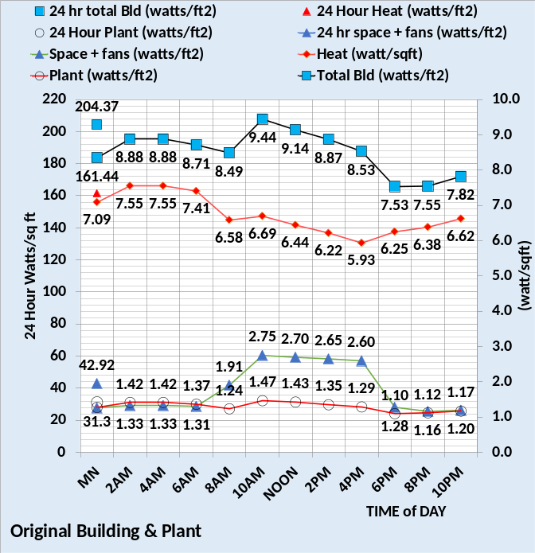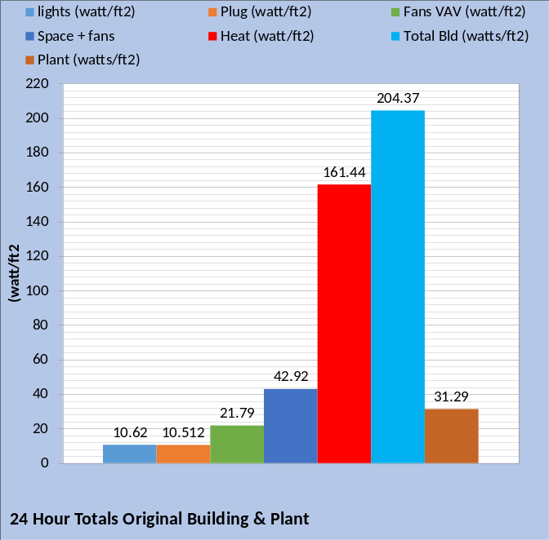
Figure 77: Original building & plant
Space + fans plus heat = total building watts/ft².

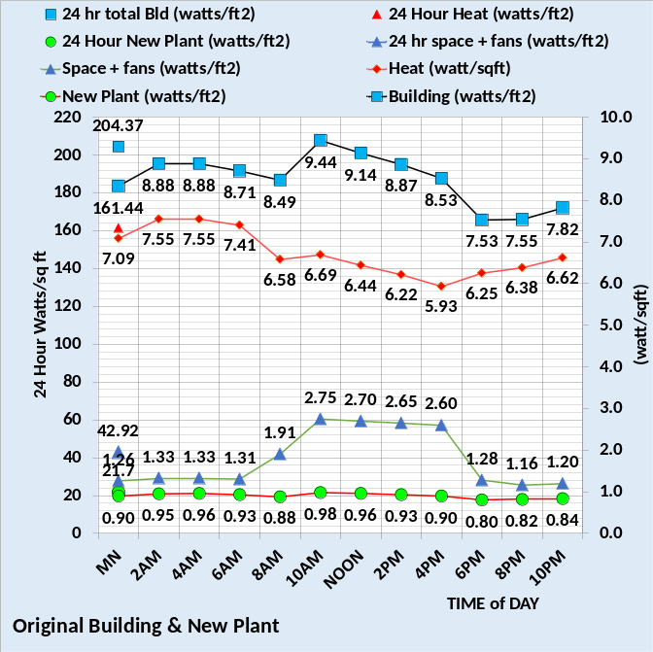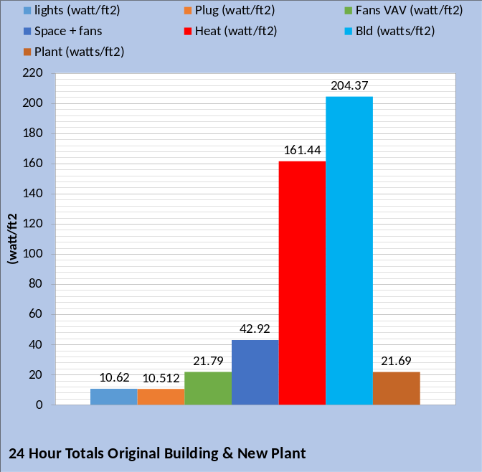
Figure 78: Original building & new plant.
The plant 24-hour value decreased from 31.29 watt/ft² to 21.69 watt/ft² with the new plant.

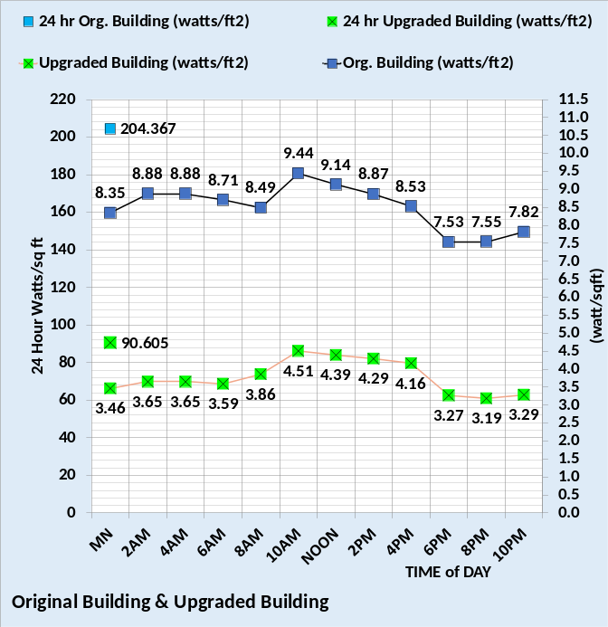
Figure 79: Original building vs. upgraded building performance

The upgraded building as defined above by figures 17 thru 56 has a significantly improvement in energy performance.
The upgraded building, in the authors opinion, can be accomplish with available equipment and controls.

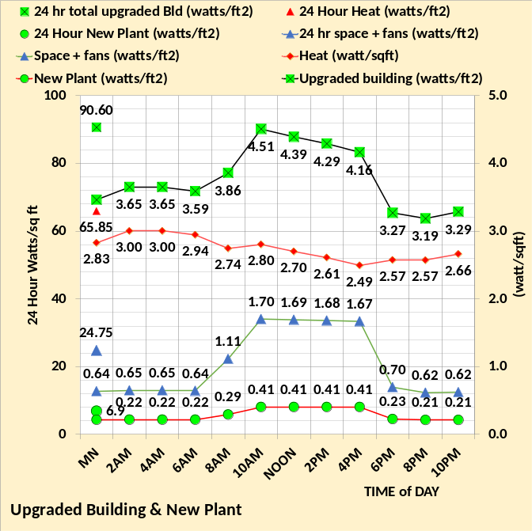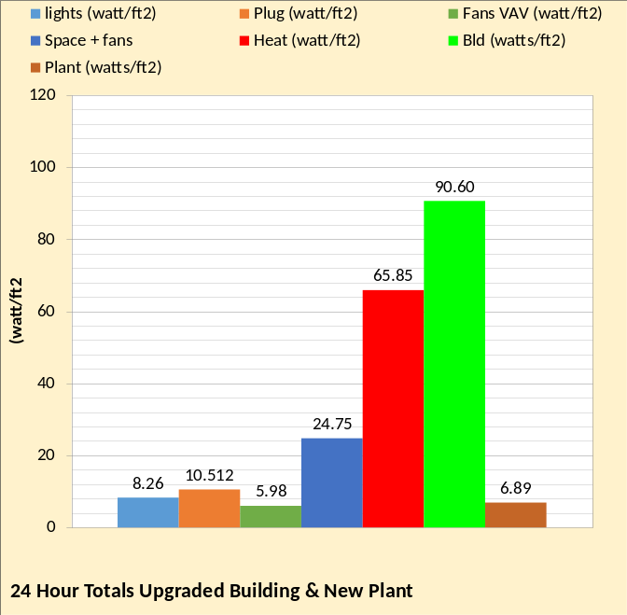
Figure 80: Upgraded building & new plant.

The original building with new plant has, on this February 21 day, a total building plus pant value of about 226 watts/ft². The upgraded building and new plant value for this cold day is about 98 watts/ft² or less than half the existing building and new plant.

The upgraded building energy consumption could be further reduced by replacing the wall glass with a more efficient glass.
Analysis with energy balance charts for this cold day would provide a good understanding of the energy use characteristics and opportunities for reduction. A more detail analysis for this day will be addressed later.

8-Real Weather Analysis for June 17, 2022

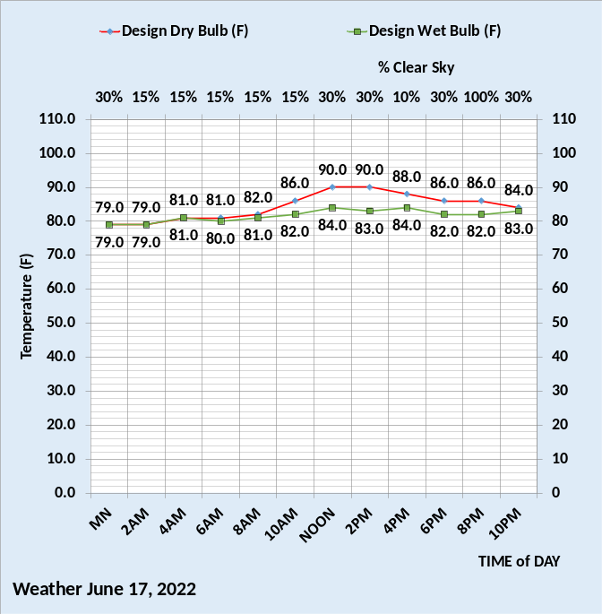
Figure 81: June 17, 2022 weather

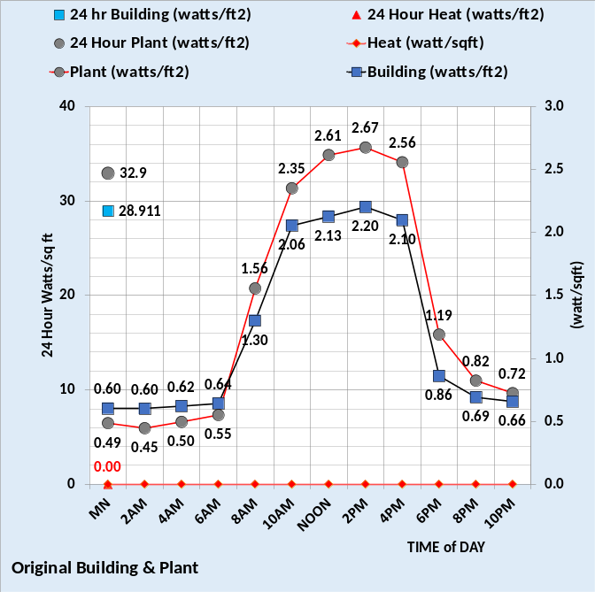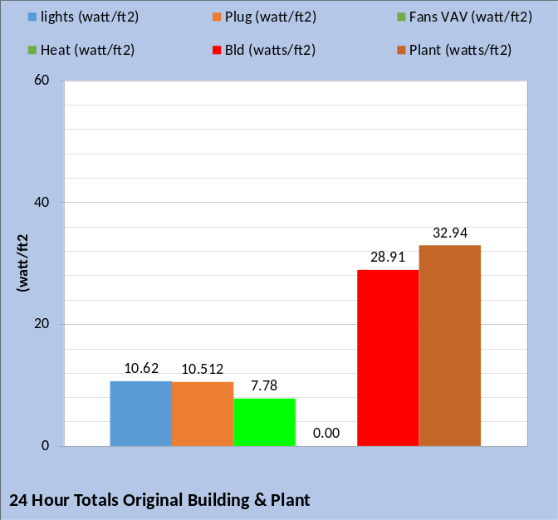
Figure 82: Original building & plant
Space + fans plus heat = total building watts/ft².

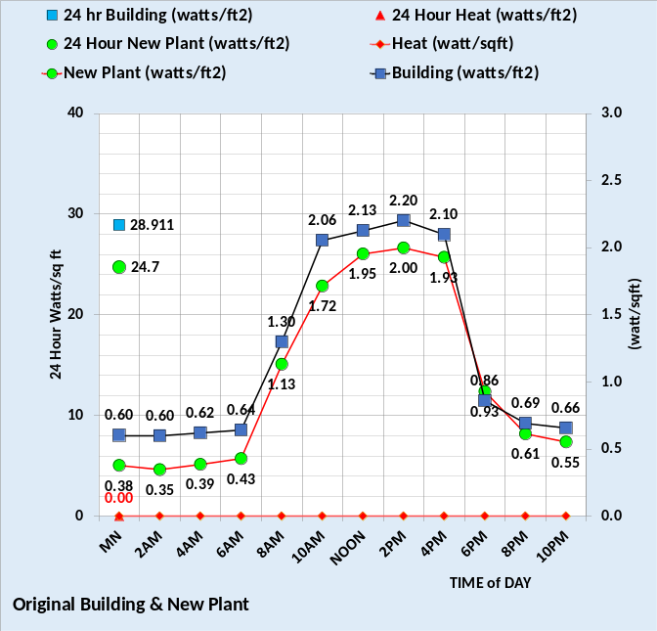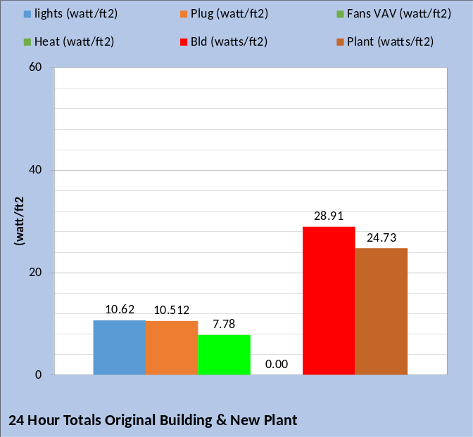
Figure 83: Original building & new plant.
With the new plant the 24-hour plant energy consumption decreased from 32.94 watts/ft² to 24.73 watts/ft².

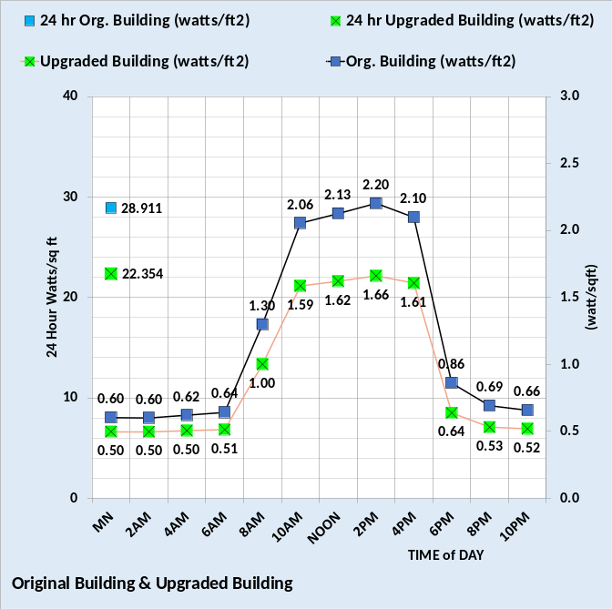
Figure 84: Original building vs. upgraded building performance for weather defined by Figure 81

The upgraded building as defined above by figures 17 thru 56 has a significantly improvement in energy performance.
The upgrade building, in the authors opinion, can be accomplish with available equipment and controls.

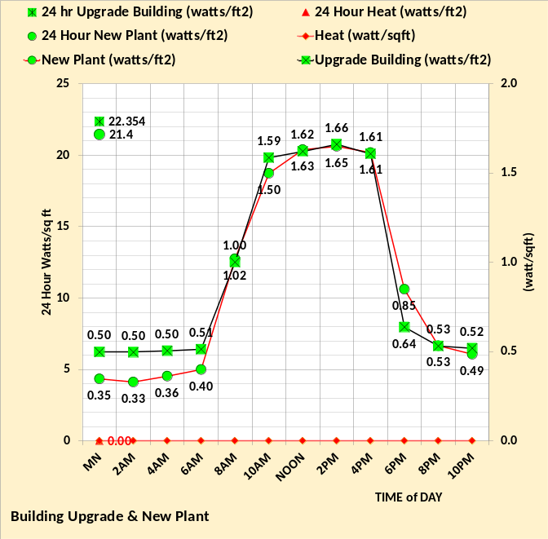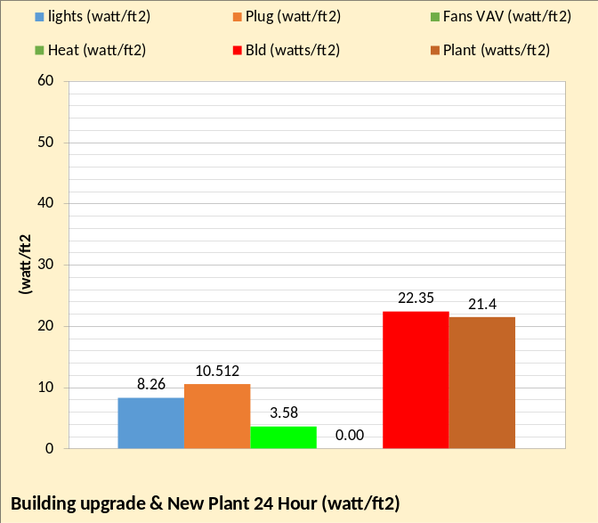
Figure 85: Upgraded building & new plant
The original building with new plant has, on this June 17, 2022 day, a total building plus pant value of about 54 watts/ft². The upgraded building and new plant value for this cloudy summer day is about 44 watts/ft².

The upgraded building energy consumption could be further reduced by replacing the wall glass with a more efficient glass.
Analysis with energy balance charts for this cloudy summer day would provide a good understanding of the energy use characteristics and opportunities for reduction. A more detail analysis for this day will be addressed later.
The analysis of the 56 story Hong Kong office building had to make several assumptions regarding the design of the building. the authors of the ASHRAE Journal article of June 2022 are requested to provide better data so that the SEE Model can be updated.
I would like to coordinate with the authors of the article to define days when the energy use data of the office is recorded, and I can do a SEE Model energy balance analysis. I think that would be beneficial to all. An ASHRAE R&D program might also be possible if the article authors would pursue that.
Stay tuned for more benchmark days.
Kirby Nelson P.E.
Life Member ASHRAE

NOMENCLATURE
Building structure.
BLD ft² = air-conditioned space
# Floors = number of building floors
Roof ft² = roof square feet
N/S wall ft² =north/south wall square feet
E/W wall ft² =east/west wall square feet
Wall % glass = percent of each wall that is glass
Glass U = glass heat transfer coefficient
Wall U = wall heat transfer coefficient
Glass SHGC = glass solar heat gain coefficient
Wall emit = wall solar index
Wall weight = #/ft2
Roof weight = #/ft2
Building interior space.
Roof_{trans-ton} =roof load to interior (ton)
Roof_{sky-lite-ton} =sky lite load (ton)
# people = number people in building
People_{ton sen&lat} = sensible & latent cooling load (ton)
Plug_{ton&kW} = cooling load & kW due to plug loads
Light_{ton&kW} = cooling load & kW due to lights
Total Bld_{int-ton} = total building interior load (ton)
(cfm) _{to-per-return} = CFM of interior supply air that returns to perimeter of building
T_{stat-int} = interior stat set temperature (F)
Bld_{int-air-ton} = supply air ton to offset interior load
BLD kW = total building kW demand
FAN kW = total fan kW
Duct Heat kW = kW heating supply air
FA Heat = Fresh air heat
Heat Total = Total building heat
SITE kW = total site kW=Bld+ Fan+Heat
Building perimeter space.
%_{clear sky} = percent clear sky
T_{dry bulb} = outside dry bulb temperature (F)
T_{wet bulb} = outside wet bulb temperature (F)
Ex/Infil_{lat-ton} = latent air infiltration or exfiltration (ton)
Ex/Infil_{CFM} = air infiltration or exfiltration CFM
Exfil_{sen-ton} =sensible air exfiltration or infiltration (ton)
Roof_{trans-ton} = Roof load to perimeter (ton)
Wall_{n trans ton} = north wall transmission (ton)
Wall_{s trans ton} = south wall transmission (ton)
Wall_{E trans ton} = east wall transmission (ton)
Wall_{w trans ton} = west wall transmission (ton)
Roof+Wall_{tot-trans-ton} = total wall/roof transmission (ton)
Glass_{N-trans-ton} = north wall glass transmission (ton)
Glass_{S-trans-ton} = south wall glass transmission (ton)
Glass_{E-trans-ton} = east wall glass transmission (ton)
Glass_{W trans-ton} = west wall glass transmission (ton)
Glass_{tot-trans-ton} = total transmission thru glass (ton)
Glass_{N-solar-ton} = north glass solar load (ton)
Glass_{S-solar-ton} = south glass solar load (ton)
Glass_{E-solar-ton} = east glass solar load (ton)
Glass_{W-solar-ton} = west glass solar load (ton)
Glass_{tot-solar-ton} = total glass solar load (ton)
Wall heat = Heat provided by window panel (ton)
(int cfm)_{per-ton} = effect of interior CFM to wall (ton)
Total Bld_{per-sen-ton} total perimeter sensible load (ton)
T_{stat-per} = perimeter stat set temperature (F)
Bld_{per-air-ton} = supply air ton to offset perimeter load
Air handler duct system-Interior duct
T_{air supply int} = temp air supply to building interior (F)
(fan)_{int ter ton&kW} = interior ton & kW due to terminal fans
(D)_{int-air-ton} = cooling (ton) to building interior duct
T_{air coils} = supply air temperature off coils to duct (F)
(D)_{int-CFM} = supply air CFM to building interior duct
Perimeter duct
T_{air supply per} =temp (F) air supply to building perimeter
(fan)_{per ter ton&kW} = perimeter ton & kW of terminal fans
T_{heat-air} = temp supply air before terminal fan heat (F)
(D)_{heat-ton&kW} = heat to perimeter supply air ton & kW
T_{reheat air} = temp perimeter supply air after reheat (F)
(D)_{reheat ton&kW} = reheat of perimeter supply air ton & kW
(D)_{per-air-ton} = cooling (ton) to perimeter duct
T_{air coils} = supply air temperature off coils to duct (F)
(D)_{per-CFM} = supply air CFM to perimeter duct
Coil
(Coil)_{sen-ton} = sensible load on all coils (ton)
(Coil)_{L+s-ton} = latent + sensible load on all coils (ton)
# Buildings = Number of building loads to plant (ton)
Plant load = Sensible + Latent load to plant
VAV Fan system
Fresh air
CFM\Person = Fresh air cfm/# people in building
Ventilation ACH = Fresh air changes per hour (cfm/ft³)
T_{OSA-DB-F} = OSA DB temp before exhaust air recovery (F)
stat_{FA} = fresh air freeze stat set temperature (F)
T_{FA to VAV} = temperature of fresh air to VAV fan
(FA)_{sen-ton} = fresh air sensible load (ton)
(FA)_{CFM} = CFM fresh air to VAV fan inlet
(FA)_{Lat-ton} = fresh air latent load (ton)
(FA)_{kW} = heat kW to stat_{FA} set temperature
Air return
T_{BLD-AR} = return air temp (F) before return fans
(Air)_{ret-CFM} = CFM air return from building
(FAN)_{ret-kW} = return fans total kW
(FAN)_{ret-ton} = cooling load (ton) due to (FAN)_{ret-kW}
(Air)_{ret-sen-ton} = return air sen (ton) after return fans
(Air)_{ret-lat-ton} = return air lat. (ton) after return fans
T_{AR to VAV} = T_{BLD-AR} + delta T due to return fans kW
VAV_{ret-sen ton} = return sensible (ton) to VAV fans inlet
VAV_{ret-lat ton} = return latent (ton) to VAV fans inlet
VAV_{ret-CFM} = return CFM to VAV fans inlet
Exhaust air
Ex_{Lat-ton} = latent load (ton) exhausted
Ex_{CFM} = CFM of exhaust air
T_{Ex} = temperature of exhaust air
Ex_{sen-ton} = sensible load (ton) exhausted
T_{exh-rec} = Air temp after exhaust recovery (F)
% Recovery = % exhaust air energy to fresh air
VAV Fans
T_{ret+FA} = return and fresh air mix temperature (F)
(dh) = VAV air static pressure (in)
E_{fan-VSD} = VAV fans efficiency
VAV_{inlet-sen-ton} = sensible load (ton) inlet to VAV fans
VAV_{inlet-lat-ton} = latent load (ton) inlet to VAV fans
T_{air-VAV} = temp air to coils after VAV fan heat
(FAN)_{VAV-CFM} = CFM air to coils
(FAN)_{ton-VAV} = load (ton) due to VAV fan kW
(FAN)_{kW-VAV} = total VAV fan kW demand
(FAN)_{watts/cfm} = VAV fans watts/cfm
VAV cfm ACH = VAV cfm air changes per hour
AIR SIDE SYSTEM PLUS BUILDING
Space w/ft² =People space w/ft²
Fans w/ft² = total air handlers w/ft²
HEAT w/ft² = total building heat w/ft²
Building w/ft² = total building w/ft²
Bld Shell (ton) = total building shell load due to weather
Fresh air (ton) = Sensible + Latent to building (ton)
VAV fans w/cfm = VAV fan power (watts/cfm)
CENTRAL PLANT
# Buildings = number of buildings served by plant
Plant ton = total load (ton) to plant
Primary/secondary pumping nomenclature
gpm_{evap} = total gpm flow thru one evaporator
(H)_{pri-total} = total primary pump head (ft) = (H)_{pri-pipe} + (H)_{pri-fittings} + (H)_{pri-bp} + (H)_{evap}
(H)_{pri-pipe} = primary pump head due to piping (ft)
(H)_{pri-fittings} = primary head due to pump & fitting (ft)
(Ef)_{c-pump} = efficiency of chiller pump
P_{c-heat-ton} = chiller pump heat to atmosphere (ton)
pump_{c-kW} = one chiller pump kW demand (kW)
P_{chiller-#} = number chiller pumps operating
Pump_{c-kW} = total chiller pump kW
(lwt)_{evap} = temperature water leaving evaporator (F)
T_{bp} = temperature of water in bypass (F)
gpm_{bp} = gpm water flow in bypass
(H)_{pri-bp} = head if chiller pump flow in bypass (ft)
(ewt)_{evap} = temp water entering evaporator (F)
P_{sec-heat-ton} = secondary pump heat to atmosphere (ton)
P_{sec-kW} = kW demand of secondary pumps
Ef_{des-sec-p} = design efficiency of secondary pumping
Ef_{sec-pump} = efficiency of secondary pumping
(H)_{sec} = secondary pump head (ft) = (H)_{sec-pipe} + (H)_{sec-bp} + (H)_{coil} + (H)_{valve}
(H)_{sec-pipe} = secondary pump head due to pipe (ft)
(H)_{sec-bp} = head in bypass if gpm_{sec} > gpm_{evap}
GPM_{sec} = water gpm flow in secondary loop
(ewt)_{coil} = water temperature entering coil (F)
(lwt)_{coil} = temperature of water leaving coil (F)
Evaporator
(evap)_{ton} = load (ton) on one evaporator
T_{ER} = evaporator refrigerant temp (F)
T_{ER-app} = evaporator refrigerant approach (F)
EVAP_{ton} = total evaporator loads (ton)
(H)_{evap} = pump head thru evaporator (ft)
(evap)_{ft/sec} = velocity water flow thru evaporator
(evap)_{des-ft/sec} = evaporator design flow velocity
Compressor:
(chiller)_{kW} = each chiller kW demand
(chiller)_{lift} = (T_{CR} – T_{ER}) = chiller lift (F)
(chiller)% = percent chiller motor is loaded
(chiller)# = number chillers operating
(CHILLER)_{kW} = total chillers kW
(chiller)_{kW/ton} = chiller kW per evaporator ton
Plant kW = total kW demand of plant
(Plant)_{kW/site ton} = Plant kW per site ton
Condenser:
(cond)_{ton} = load (ton) on one condenser
T_{CR} = temperature of condenser refrigerant (F)
T_{CR-app} = refrigerant approach temperature (F)
(COND)_{ton} = total load (ton) on all condensers
(H)_{cond} = tower pump head thru condenser (ft)
(cond)_{ft/sec} = tower water flow thru condenser
Tower piping nomenclature
Pipe_{size-in} = tower pipe size (inches)
gpm_{T} = each tower water flow (gpm)
GPM_{T} = total tower water flow (gpm)
(H)_{T-total} = total tower pump head (ft)
P_{T-heat} = pump heat to atmosphere (ton)
pump_{T-kW} = each tower pump kW demand
Ef_{T-pump} = tower pump efficiency
P_{tower #} = number of tower pumps
Pump_{T-kW} = total tower pump kW
(H)_{T-pipe} = total tower pump head (ft)
(ewt)_{T} = tower entering water temperature (F)
(H)_{T-static} = tower height static head (ft)
T_{range} = tower range (F)= (ewt)_{T} – (lwt)_{T}
(lwt)_{T} = tower leaving water temperature (F)
T_{approach} = (lwt)_{T} – (T_{wet-bulb})
Tower nomenclature
t_{fan-kW} = kW demand of one tower fan
T_{fan-kW} = tower fan kW of fans on
t_{fan-%} = percent tower fan speed
t_{ton-ex} = ton exhaust by one tower
T# = number of towers on
T_{ton-ex} = ton exhaust by all towers on
T_{rg+app} = tower range + approach (F)

