Miami 56 Story Office Tower
Design Day Performance

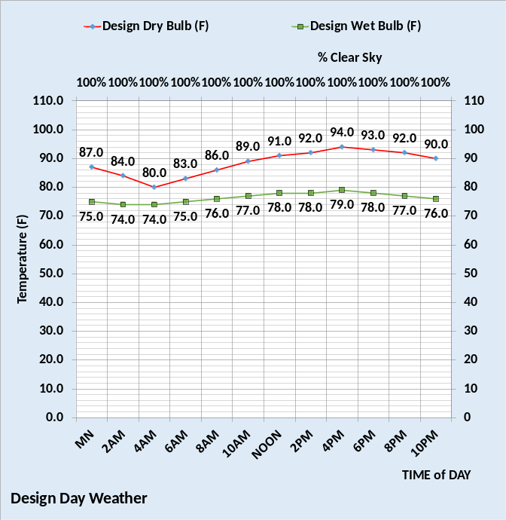Figure 1: Design Day Weather

The above Figure 1 gives the assumed design day weather and Figure 2 gives the watts/ft² performance of the two building designs, an aged building, and an upgraded building. At design the upgraded building uses a little less than half the energy consumed by the aged building at these design conditions.
The data of Figure 2 is typically available by kW meters provided by the local utility.
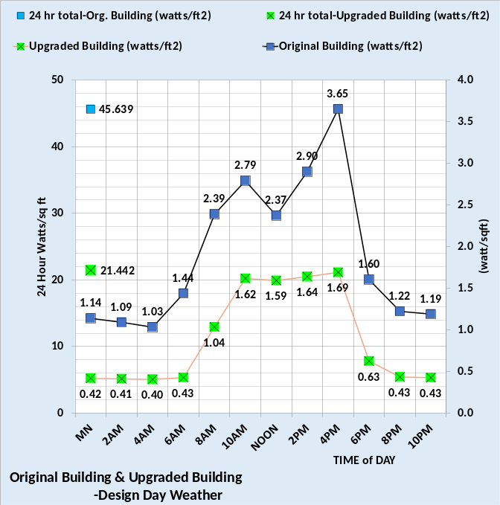Figure 2: Performance of two building designs, aged & upgraded.
At design conditions the aged building consumes 45.64 watts/ft² in the 24-hour day and the upgraded building consumed 21.44 watts/ft². The peak watts/ft² of the aged building is 3.65 and the upgraded building is 1.69 watts/ft².
Tables A & B give the details of the two designs. The Table A building design is intended to be representative of buildings constructed before year 2000. The Table B building is an upgrade of the Table A building & all upgrades are with equipment & controls available today at reasonable cost.

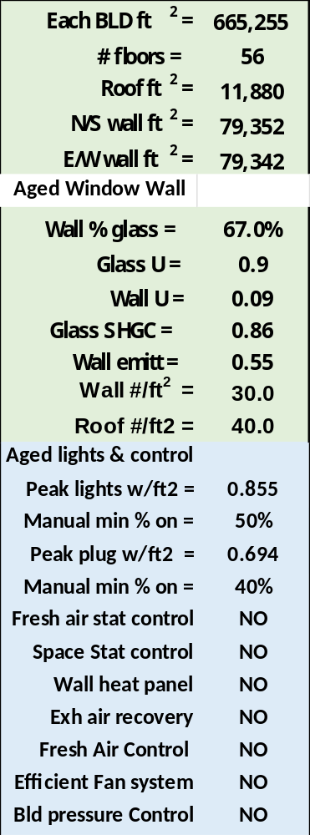
Table A: Aged Building Design
The Table A building is upgraded with nine projects as shown by Table B. The new window wall project reduces the wall % glass, installs more efficient glass and incorporates controllable dampers to accomplish positive pressure on each floor.
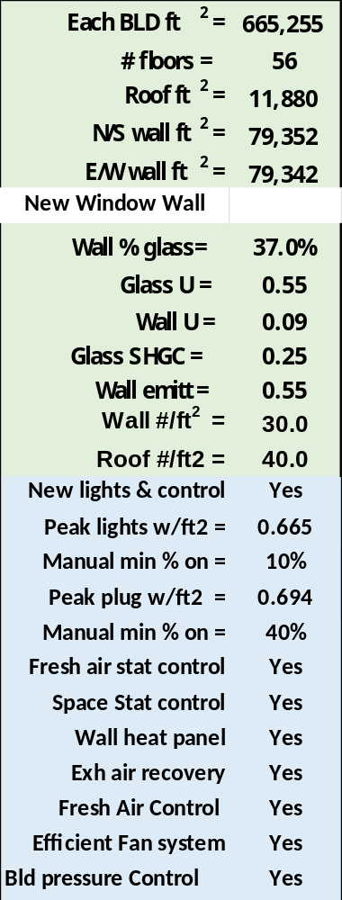
Table B: Upgraded Building Design
Each of the nine projects of Table B are generally defined by HVAC literature.
Table C & D give the performance of the two buildings at peak 4PM design conditions.

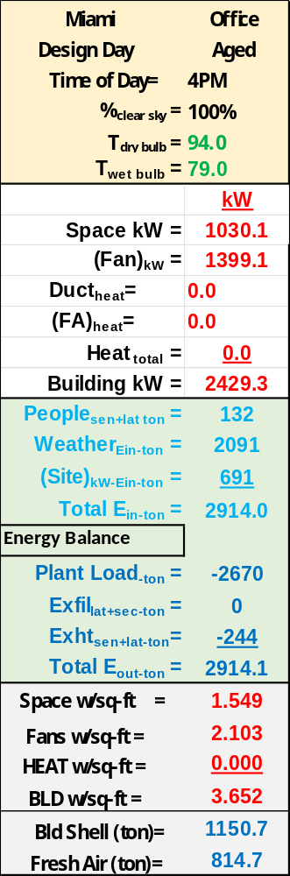
Table C: Aged Building Performance
Clearly the nine projects significantly reduce the energy of the upgraded building as shown by Table D.
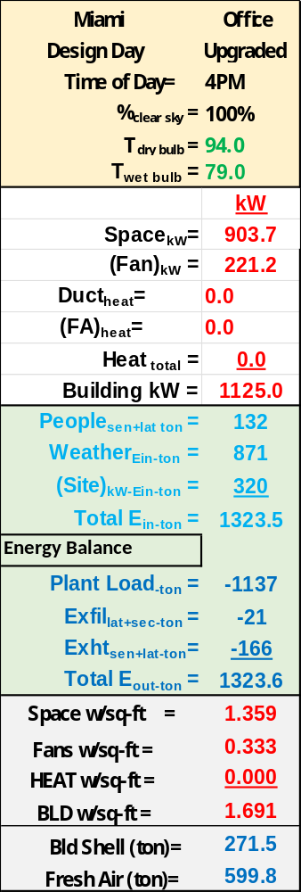
Table D: Upgraded Building Performance
Note the plant load of each building, 2,914 ton for the aged building and 1,137 ton for the aged building upgraded.
Plant Performance
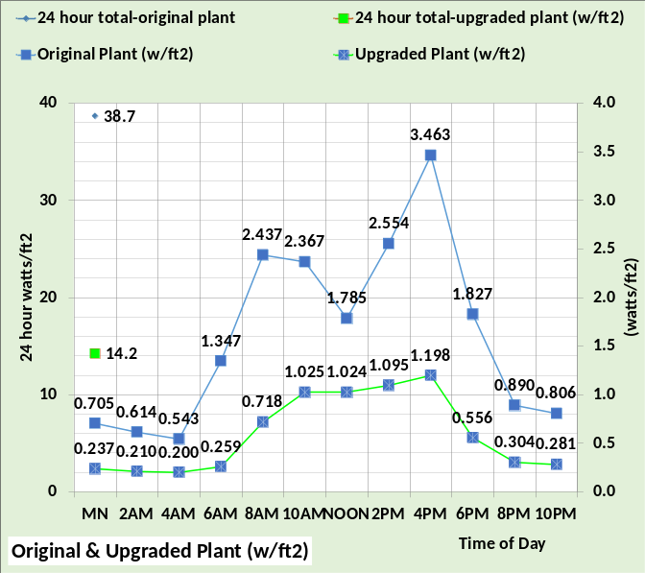Figure 3: Plant performance
Figure 3 gives the plant performance of the two designs illustrating significant reduction with the new plant operating against the loads of the upgraded building. The original plant consisted of three 911-ton chillers and the new plant consists of three 383-ton chillers. The new plant would be project 10 installed after the 9 building projects defined by Tables A & B.
Tables E & F define plant performance at design conditions. The new plant chiller/tower is designed to reduce chiller lift and therefore chiller kW for a given load. The original chiller/tower design is based on an ASHRAE Journal article of July 2011.

Conclusions
The first step is defining projects to reduce energy consumption of an existing building is to first.
- Develop an Energy Balance Model (EBM), also known as a System Energy Equilibrium (SEE) Model, of the existing building showing reasonable agreement on any day of weather. The model must agree with both summer and winter operation within about 6%. After each project the model must be adjusted to agree with real metered values.
The (EBM) or (SEE) Model is built on Microsoft Excel and is therefore available to all. Excel is often dismissed as a spread sheet when in fact Excel is a very powerful modeling tool. Go to posts on this site to review more Information regarding the (SEE) Model.
References:
-Taylor, 2011. “Optimizing Design & Control of Chilled Water Plants” ASHRAE Journal July 2011.
-Cheuk, 2022. “Water to Water-Cooled Chiller Replacement Saves Big” ASHRAE Journal June 2022.
-Scheiber, 2021. “Innovation, Resiliency Create Cornerstone of Office Tower Design” ASHRAE Journal 2021.
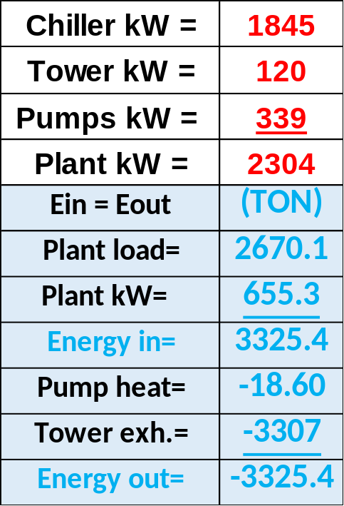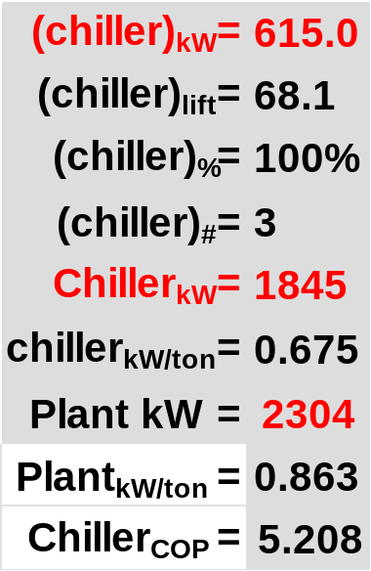
Table E: Original Plant Performance

Note the chiller lift is less with the new plant and therefore the kW/ton values are less. The chiller/tower model is built on Microsoft Excel. Papers on this site give details of the chiller/tower SEE Model.

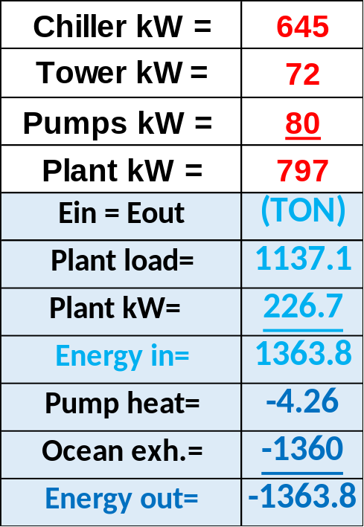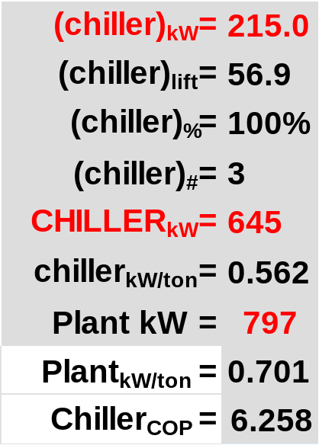
Table F: New Plant performance

Next, we will look at performance at real weather days. Stay tuned for future weather days.
Godspeed to all.
Kirby Nelson P.E.

January 23, 2022, Performance
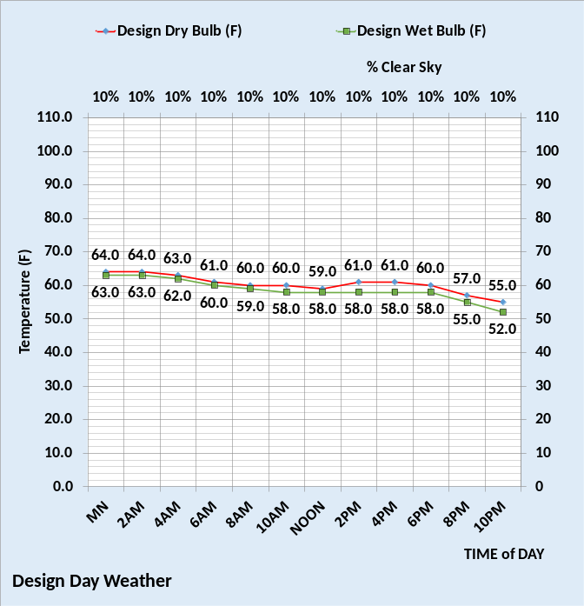
Figure 4: Weather
Figure 4 gives the weather for this day and Figure 5 gives the performance of the two building if both had electric heat. Figure 5 illustrates major opportunities to reduce energy consumption of the original building by installing the nine projects defined above by Table B. A building operating close to the weather conditions of Figure 4 and consuming energy close to the energy consumption of this original building has major problems that should be corrected.
Figure 6 gives the response of the two plants to their respective buildings.
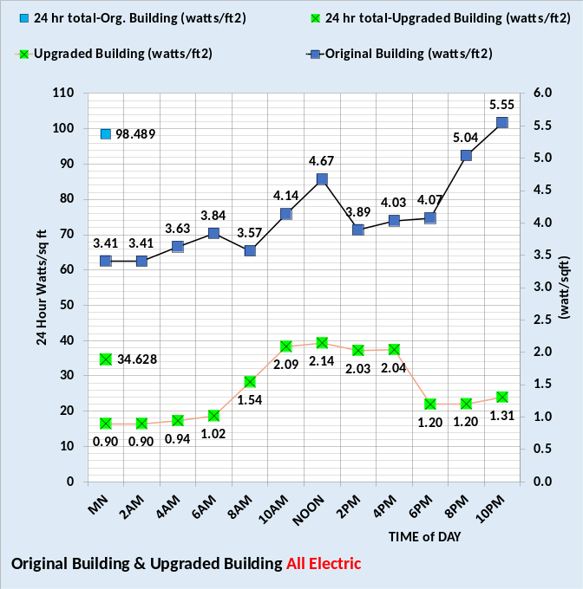
Figure 5: All Electric Buildings
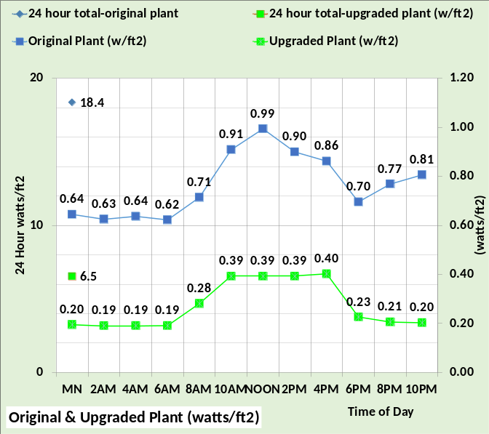
Figure 6: Plant performance

All values here are watts/ft² and can be converted to any building by multiplying by your buildings square feet and dividing by 1000 to get kW demand.
The next figures give performance if heat is separately metered.
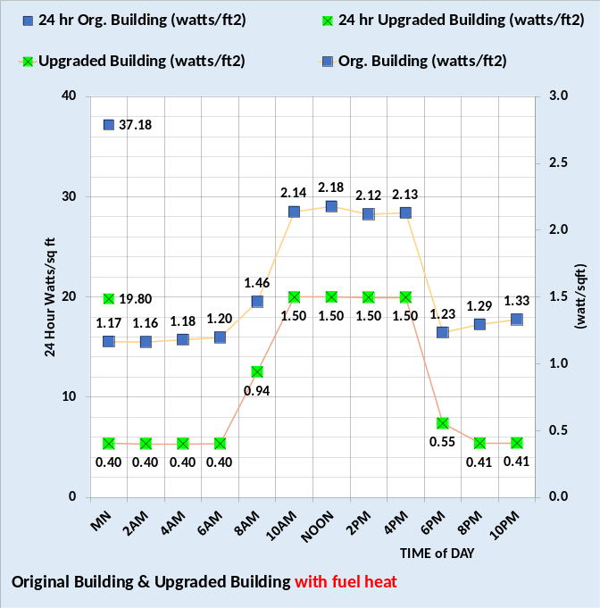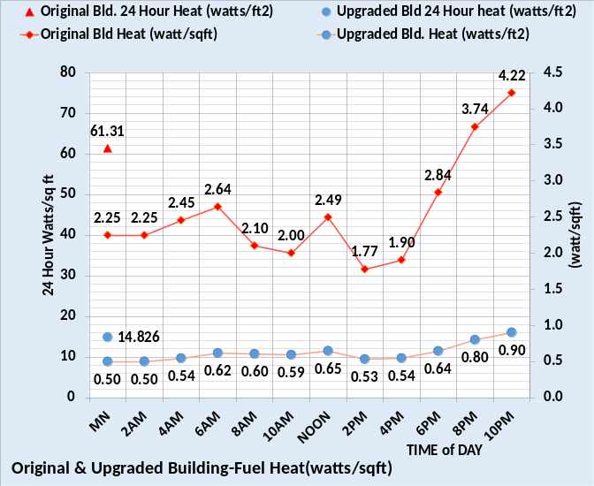
Figure 7: Buildings watts/ft² with separate heat meters.

Figure 7 gives the performance of the two buildings with fuel heat at the weather of Figure 4. The top chart gives the building electric consumption minus heat and the bottom chart gives the fuel consumption in watts/ft². The bottom chart values are heat into the space and therefore are correct for electric heat but if the heat is provided by a boiler the metered values at the boiler would be about 15% more.
Note that the top chart of Figure 7 is similar to Figure 2 above at design conditions where heat was not required. The point is required heat is the big energy user at these weather conditions. Several of the projects defined by Table B deal with reducing heat energy. Also note that the plant performance given by Figure 6 is also good for the loads as defined by figure 7.
Next, we will look at performance on August 3, 2022.

August 3, 2022, Performance

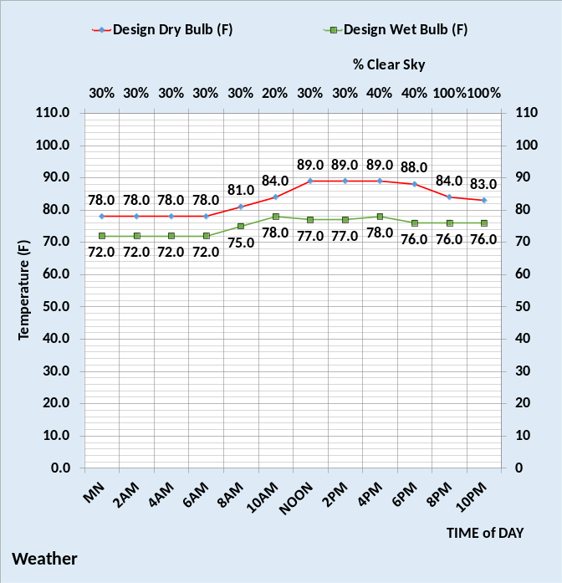
Figure 8: Weather

Figure 8 gives the weather on this date and Figure 9 gives the performance of the two buildings and their associated plants.
Figure 9, top chart, is similar to the design conditions, Figure 2, but a little less energy consumption due to the slight decrease in temperatures but more important the reduced solar load due to clouds. Plant performance, bottom chart of Figure 9, is significantly reduced as compared to design conditions, Figure 3, due to the reduced plant load and the reduced wet bulb temperatures.
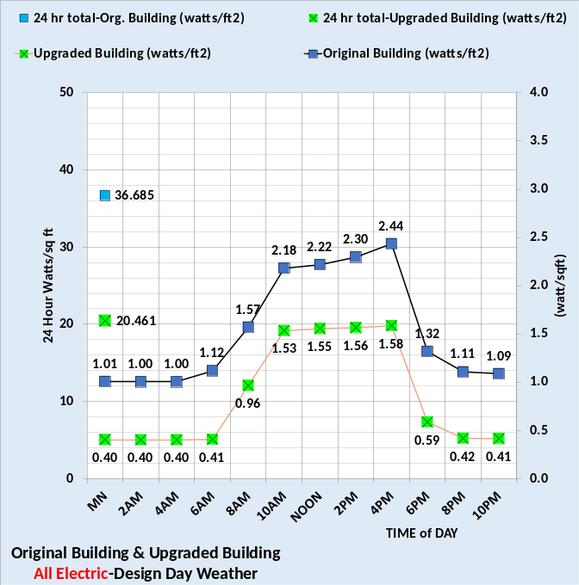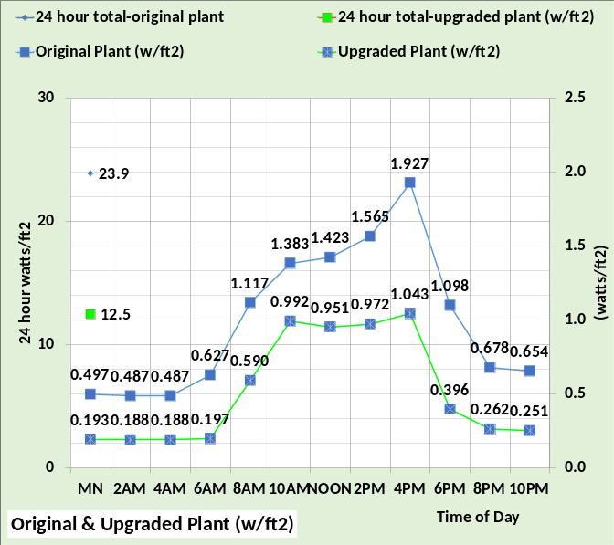
Figure 9: Buildings & Plants Performance

Space heat is not required at these weather conditions.
An office tower in this city on a day with weather similar to Figure 8 can be upgraded to consume energy similar to the upgraded building.

Stay tuned for more weather days.

