Energy Consuming Characteristics
of a Chicago 26-Story Office Tower
Contents.
Page 1. Introduction
Page 7. Executive Summary
Page 32. Chapter 1: 24-Hour Model of 26-Story Chicago Office Tower
Page 123. Chapter 2: 24-Hour Model of Chiller Plant
Page 178. Chapter 3: Install Eleven Energy Saving Projects
Introduction

Chicago
After 50 years of energy conservation America’s buildings waste 30% or more of the energy they consume^{3,4}. This manual defines why and how a Chicago 26-story office tower and chiller plant consume energy and how standard equipment, and controls can bring the building & chiller plant to peak energy efficiency.
The suggested plan to bring buildings to peak energy efficiency utilizes a 24-hour System Energy Equilibrium (SEE) Model^{1,10}, demonstrated here, to achieve the stated objective. The SEE Model is a set of HVAC equations solved simultaneously by Microsoft Excel intended to duplicate the energy consumption of a building over 24 hours on any day of weather.
A suggested OST plan to bring all buildings to peak efficiency is as follows.
OBJECTIVE: Bring all existing buildings to peak energy efficiency utilizing today’s standard equipment and controls, then the installation of “green” projects can be installed at minimum cost.
STRATEGY: Utilize the SEE Model, a 24-hour building & chiller plant energy math model, to define the energy consuming characteristics of a building and chiller plant on any day and then define energy reductions due to the installation of energy saving projects.
TACTICS:
- Develop manuals for various cities, demonstrated here for a 26-story office tower in Chicago, providing building owners, operators, engineers, and technicians, an understanding of why & how buildings consume energy.
- Using the SEE Model cities would, on a given day, define & publish on the internet the energy per ft² data for varies type buildings operating at peak energy efficiency utilizing standard equipment and controls. Building owners would compare their building’s energy consumption on that day and could be spurred to take action to reduce their building’s energy consumption, bringing business to the city and relief to the utility’s supplier.
- SEE Model analysis of buildings could be offered to building owners.
- The SEE Model can be a tool for ASHRAE research to define how buildings use energy.
Author’s Math Modeling Experience.
When the “Oil Embargo” of 1973 occurred, I was a member of a small group of computer simulation engineers at Texas Instruments Inc. (T.I.) designing and evaluating military systems via hybrid (analog/digital) computer simulations. The modeled systems included the Shrike missile, laser guided systems, anti-tank missiles, and a helicopter mounted cannon to shoot electronic surveillance devices into the jungle. The oil embargo occurred in the fourth quarter of 1973 and early 1974 (T.I.) gave me the task of modeling the energy consumption of (T.I.) buildings and processes for the purpose of defining what could be done to reduce energy consumption. I used ECUBE & DOE building energy computer programs available at the time to simulate the annual energy use of a building and plant and the hybrid computer to simulate processes and attempted to simulate a building and plant energy consumption on any given day. In 1982 I left T.I. and lost the enormous power of the hybrid computer. That experience convinced me that a real-time model of one 24-hour day was needed so that a new building or plants could be commissioned on any day, and the performance of old buildings and plants could be evaluated on any day.
On retirement I decided to see if I could develop a 24-hour building & chiller plant model. This effort has resulted in the 24-Hour System Energy Equilibrium (SEE) Model demonstrated by this document. Microsoft Excel is utilized as the computing platform. Excel has the capability to solve a large set of simultaneous equations and iterate to a new steady state condition after a change in any one design, weather, or operational variable. Each equation is a function of these variables and a function of most other equations. For example, a change in outside dry bulb temperature causes most if not all equations to change to a new steady state condition. The task is to write a set of equations that in fact define the performance of a real building or plant. The Executive Summary illustrates the effect of changing one variable.
The Day Energy Conservation Engineers Were Born
A few days after the oil embargo of 1973 my employer Texas Instruments Inc. (T.I.) received a letter from the President of the United States stating that T.I. should make plans to operate its businesses with significantly less energy. Thus, the energy conservation engineer was born in T.I. and all over America. A corporate energy manager was appointed by T.I. and an assistant was assigned the task of bringing together energy use data of all 48 Texas Instrument sites across the T.I. world from Texas to Massachusetts to Japan. The energy use data raised the obvious question, why and how are T.I. facilities using energy and what can be done to reduce energy consumption? I was approached with the question, can building energy consumption be modeled? To my surprise I found that DOE had a building energy analysis program available, thus began the T.I. energy conservation program based on modeling annual building energy use for the purpose of defining energy conservation projects and estimating payback periods.
The Projectionists Got It Wrong
The oil embargo occurred in the 4th quarter of 1973 and America was forced to consider how to operate its businesses and homes with less energy. Those who project the future by looking at past data concluded that less energy would result in a decline in America’s standard of living. The left chart of Figure 1 shows the total America energy consumption in quads illustrating the energy consumption was about 34 quads in 1950 and 75 quads in 1973. The right chart gives the ratio of energy consumption to America’s GDP dollars. The ratio is approximately constant at about 14 kbtu/GDP demonstrating as energy consumption more than doubled over the 24-year period so did GDP, thus leading projectionists of 1974 to conclude that America was facing a future of less increase in standard of living, GDP, as energy availability dropped. However, the projectionists did not perceive the ingenuity the America engineer, and manufacturer were about to bring to the problem.
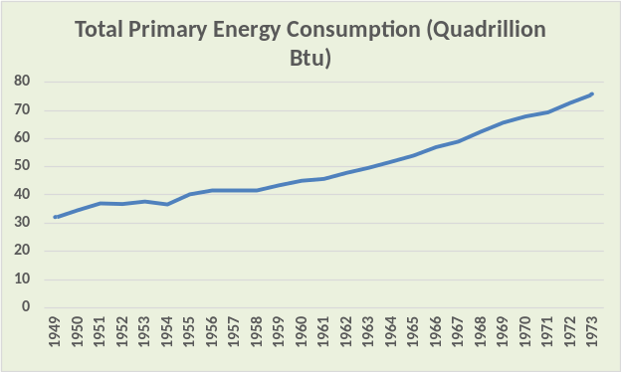 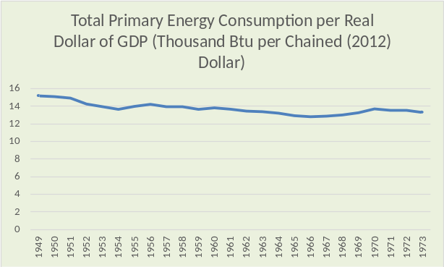Figure 1: Energy use history²

One Corporation’s Energy Conservation Program
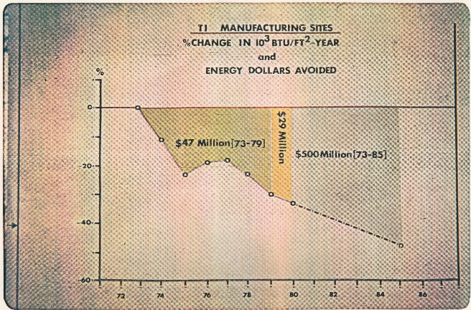
Figure 2: T.I. Energy Conservation Results
Figure 2 is from a 1980 presentation the author made at an energy conference in Washington DC. The T.I. program had achieved a decrease in energy consumption of about 36% by 1980 and did in fact achieve a 50% reduction in kbtu/ft²-yr by 1986 with a resulting energy cost avoidance of over $500 million with an investment of about $60 million. The program relied on the DOE computer program to identify energy saving projects and assist in defining payback. The T.I. program included modifying and replacing HVAC controls and equipment, chiller plant upgrades, & installing TI programable controllers to control clean room fans, on/off control of building lights, and HVAC control. The TI program was one of many as American’s engineers and manufactures, assisted by ASHRAE and DOE, responded to this energy crises/opportunity and achieved remarkable results as shown by Figure 3.
America’s Engineers & Manufactures Respond to The Energy Challenge
Since 1973 America has achieved remarkable success in reducing energy consumption as illustrated by Figure 3. By year 2000 U.S. energy consumption reached a plateau of about 100 quads as GDP dollars continued to increase; America’s standard of living did not decrease as some projected in 1974/75.
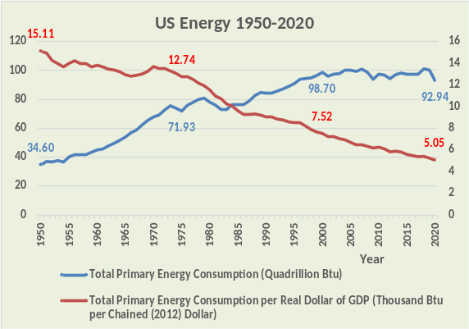
Figure 3: America’s Energy Success
The ratio of energy consumption to GDP, kbtu/$GDP, decreased from a value of 15.11 in 1950 to 7.52 in 2000 to 5.05 in 2020, an extraordinary achievement and a testament to America’s ingenuity and the free enterprise system.
I believe most of this achievement illustrated by Figure 3 can be attributed to more efficient conventional equipment and controls like those used in 1973 when the oil embargo occurred. Today we also have environmental reasons to eliminate energy waste. Lawrence 2023² makes a compelling statement regarding the need to make existing buildings energy efficient, “an estimated 60% or more of buildings that will exist in 2050 and beyond have already been built”. The above picture of Chicago pictorially illustrates the magnitude of the challenge for our cities.
After 50 Years of Energy Conservation Why are buildings not at peak energy efficiency?
Commercial buildings use a significant percentage of America’s energy and apparently, based on Chicago³ data, considerable opportunity exists to reduce energy consumption. DOE⁴ states the following. “On average, 30% of the energy used in commercial buildings is wasted”. Two obvious questions, why after 50 years of energy conservation are buildings continuing to waste significant energy, and how to eliminate this energy waste? Clearly, we need a course correction to bring all buildings to peak energy efficiency utilizing standard equipment and controls. The author’s answer to bringing all buildings to peak efficiency is based on first knowing why and how buildings consume and waste energy. The author knows of no publication or energy model that can give this information and believes 24-hour models can. Zheng’s⁵ study does not address infiltration or return air energy transfer, both can result in significant energy waste as will be shown by Chapter 1. Dirkes⁶ states “modeled performance isn’t actual performance”, demonstrating the need for models that can duplicate the actual energy performance of buildings. Reference 1 is the most recent ASHRAE publication regarding this 24-hour model, previous publications are references 10, 11, 12, & 13. Reference 14 is a web site containing several papers utilizing this 24-hour SEE Model.
The 24-hour System Energy Equilibrium (SEE) Model demonstrated here is a set of simultaneous equations solved by Microsoft Excel. The equations are mostly accepted HVAC equations, therefore, increasing the probability that the model can duplicate the actual energy performance of a building within reasonable accuracy. However, as will be shown, outside air infiltration and return air energy transfer can have a major effect on a building’s energy consumption and both these terms are difficult if not impossible to measure and accurately model in a 26-story office tower, because these two energy paths are unstable and therefore must be eliminated before a stable energy model can be accomplished. A given building may also have other unstable energy waste paths that are not at this time generally recognized or modeled here.

ASHRAE’s Empirical Building Energy Models
ASHRAE has developed energy models for buildings that utilize empirical equations that have little or no basis in the laws of thermodynamics¹. Nelson 2014²⁶ writes, “The hypothesis of energy conservation (first law) was established by J.P. Joule in the 1840s. For the past 170 years, the first law has provided easy to understand relations that define the performance of thermodynamic systems. Is it not time for all to admit we have been on the wrong modeling path for more than 40 years?”
EnergyPlus utilizes empirical equations to define building energy consumption including outside air infiltration as presented by Lisa C. Ng, 2014²³. This approach cannot duplicate the energy consumption of buildings as discussed by a letter in July 2014 ASHRAE Journal²⁴ by Pete Menconi, P.E., stating that the typical variance between simulation and actual building energy consumption is +/- 50%. Peter Rumsey²⁵, P.E., responds to Menconi: “In my experience I have found the same thing.” Nelson 2014²⁶ states “Empirical equations with several coefficients that have no relation to the laws of thermodynamics can never accurately model a real system. A real system operates according to the laws of thermodynamics and, therefore, so must our models of thermodynamic systems.” Menconi²⁴ responds to Nelson²⁶, “My original objection to the methodology…. was and is that it’s impossible to model the differences in uses of buildings, even “twin” buildings.” This statement by Menconi²⁴ clearly establishes the inadequacy of the ASHRAE accepted building energy models. This inadequacy of ASHRAE models is further established by Zheng’s 2018⁵ study that does not address infiltration or return air energy transfer, both can result in significant energy waste as addressed by Nelson¹. Dirkes 2016⁶ states “modeled performance isn’t actual performance”, again demonstrating the need for models that can duplicate the actual energy performance of buildings. One solution to this inadequacy of ASHRAE building energy models is to model with the laws of thermodynamics, i.e., with the (SEE) Model as illustrated by the two charts below from Chapter 1.
Nelson¹ 2025 states that infiltration generates three loads, a sensible wall load, a latent load, and cfm energy into the building load.
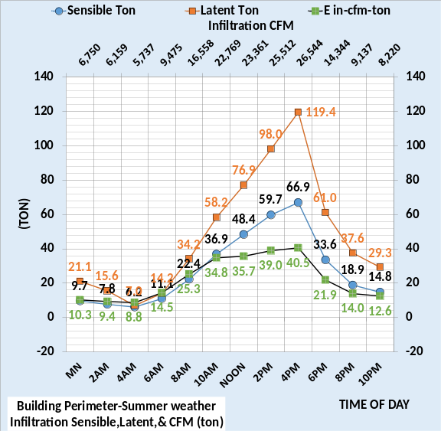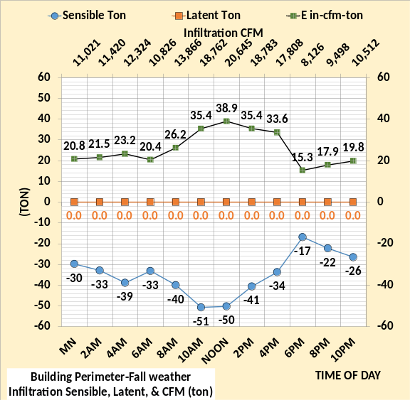
These two charts give the three infiltration loads for summer and fall weather conditions as defined by Chapter 1. Comparing these two charts with the empirical equations of Ng 2014²³ illustrates the simplicity of first law models verses empirical models.
Executive Summary

Detroit GSA McNamara Building is not modeled here.
System Energy Equilibrium (SEE) Model
The (SEE) Model is of the total building, the building is modeled as a box with four walls and a roof. Controls and equipment are modeled as typical or average for each floor. Therefore, for the (SEE) Model to duplicate the energy consumption of a building the building must be simple in structure as illustrated by the picture above. Understanding why and how a simple structure building consumes energy gives understanding of all buildings even though an accurate (SEE) Model of a complex building might not be possible.
The total energy into the building is known via utility meters and plant load energy out can be measured. These two metered values, energy in and energy out must be duplicated, within reasonable accuracy, by the model. People are an energy in value and weather conditions can be either or both an energy in and an energy out value. The (SEE) model has five zones, four wall perimeter zones and the building interior zone. The four walls can require cooling and/or heat during a 24-hour day as the solar on each wall varies during the day.
Sauer⁷ page 2.29 describes the first law of thermodynamics as an energy balance equation, where Energy in - Energy out = increase in energy in the system. The 24-hour energy balance model demonstrated here is based on this thermodynamic concept that energy into the building and chiller plant is equal to the energy out of the building and plant. Basic thermodynamic equations are utilized to model the building and plant, maximizing the possibility that the model can duplicate the actual energy consumption of a building and plant on any 24-hour day of weather.
Energy meters for building analysis
Typically, the energy into the building is defined by the gas and electric utility meters. If, for example, parking lot lights or other kW demand does not contribute to the plant load then these kW loads must be subtracted to arrive at the kW demand that is seen by the plant load. If the building heat is provided by gas or fuel boilers and heat is sent to other than the building, then this heat must be subtracted to arrive at heat in the building that contributes to the plant load. Next a 26-story Chicago office tower will be defined, and the 24-Hour SEE Model demonstrated.
Building & Plant to be (SEE) Modeled
Chicago 26 Story Office Building
Building=498,600 Ft-Sq. Building height=338 Ft
Roof = 19,177 Ft-Sq. Roof U=.063-Solar emittance=.45
All walls 30% glass. Glass U=.55-SHGC=.40
Building Footprint
South=160 Ft North=160 Ft. Each wall=54,080 Ft-Sq
East=119.86 Ft West=119.86 Ft. Each Wall=40,513 Ft-Sq
Walls U=.124-solar emittance=.55
Each of 26 floors has a 12,000 CFM VAV AHU plus
return air fans and fans powered terminals.
AHU provides 55F supply air to both building interior & perimeter.
Perimeter heat, 90F air, is provided by fan powered terminals.
Outside air infiltration assumed as .12cfm/wall ft² max at 12,000 AHU cfm dropping as AHU cfm decreases.
30% of interior return air enters the perimeter zone.
Lights .90 watts/ft² manually controlled to 30% on afterhours
Plugs .73 watts/ft², 30% on afterhours
Fresh air dampers fixed at 30% open & 50F preheat temperature.
Duct static 7.0 inches at 12,000 CFM & no reset
Interior stat 73F & perimeter stats 72F cooling & 76F heating
Chiller Plant consists of four 500-ton chiller/towers.

Figure 4: Assumed 26-story Office Building in Chicago
Figure 4 illustrates the office tower design and control features input to the Model.
Unstable Energy Consumption
Two conditions of Figure 4 are difficult to identify in real buildings, outside air infiltration^{8,9} and return air energy transfer, defined here as unstable energy. These two energy waste paths are impractical to measure or define in a multi-story building and can vary from hour to hour if not by minute. Two similar buildings can have very different energy consuming characteristics^{24,25} because of these two energy wastes. These two energy waste paths must be minimized or eliminated to accomplish a stable 24-hour model of the building’s energy-consuming characteristics. Infiltration is uncontrolled air coming into the building because the building pressure is less than outside pressure and the building is leaky. The difference in pressure is a function of many parameters including, barometric pressure, wind speed and direction, return fan control, and basic structure of the building walls. Return air energy transfer occurs if the building interior thermostats are set differently than the perimeter thermostats and, for example, a percentage of the interior air is drawn to the perimeter zone for return to the VAV fan. The perimeter zone would see this as a load and heat or cool the interior air as required to meet the perimeter thermostat setting. Both issues will be addressed in detail below under wall loads and in detail in Chapter 1.
Summer Weather Performance
The building as defined by Figure 4 and the summer design weather⁸ of Figure 5 is input to the model with the resulting 24-hour watts/ft² given by the right chart of Figure 5. The watts/ft² values permit comparison to other buildings & chiller plants on similar weather days. The following chapters will show that Chicago office buildings using this level of energy on a similar summer day are operating very inefficiently.
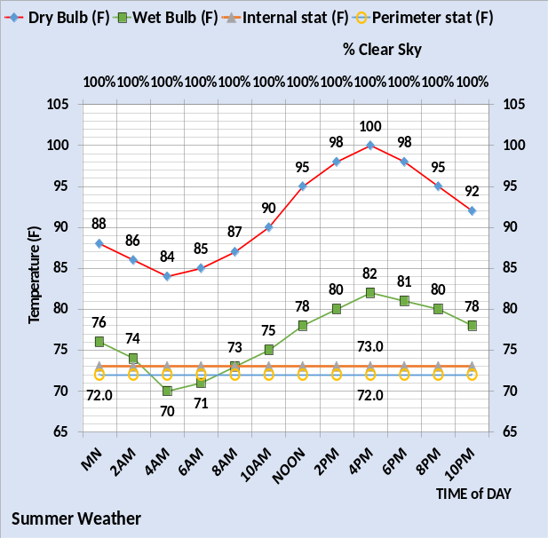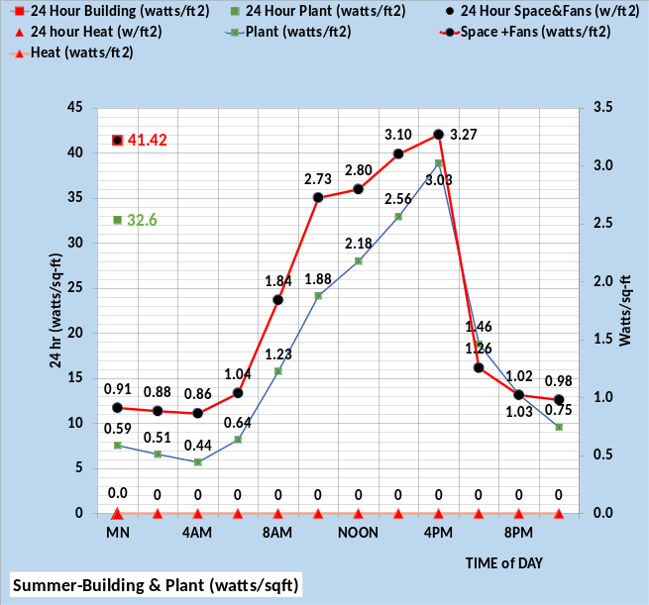
Figure 5: Summer Energy consumption of Figure 4 building & chiller plant
The chiller plant¹⁶ uses about 79% as much energy as the building for these 24-hour summer weather conditions. Over the 24-hour period the plant consumed 32.6 watts/ft² and the building consumed 41.42 watts/ft². Figure 6 gives the summer wall loads.
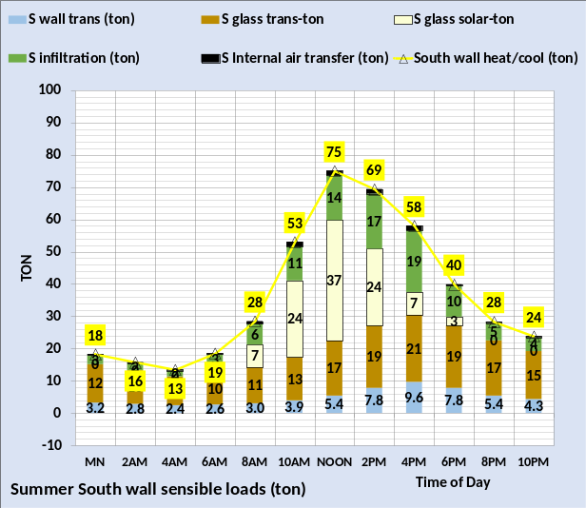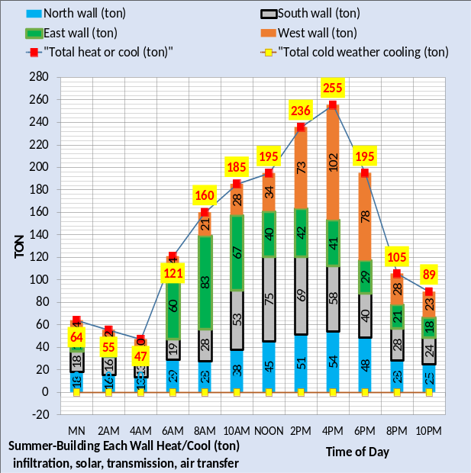
Figure 6: Summer weather wall loads
Figure 6 illustrates the wall loads with the left chart giving the south wall and the right chart giving all four walls. Note the south wall values are also in the right chart. Each of the four walls of the building has five loads as shown by the south wall for a total of 20 wall-loads for each hour. Solar and glass transmission loads are the largest with infiltration and wall transmission being significant loads. The internal air transfer load is small but can be much larger as discussed in Chapter 1. The five loads on each wall gives a total of 20 wall loads the Model solves for each hour. Again, these two loads are unstable and therefore must be eliminated to achieve a stable building energy model, explaining statements by Menconi^{24,27} and Rumsey²⁵ and conclusions by Nelson²⁶.

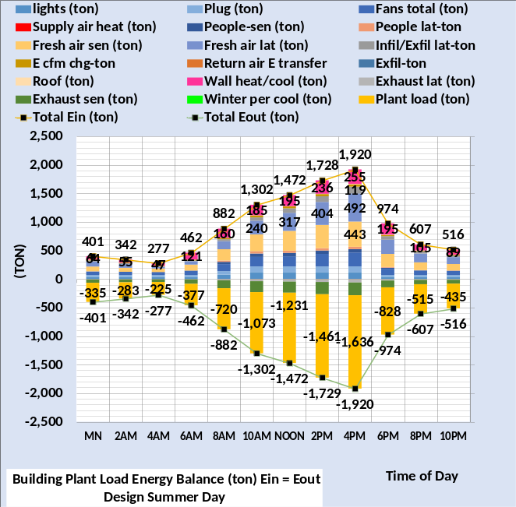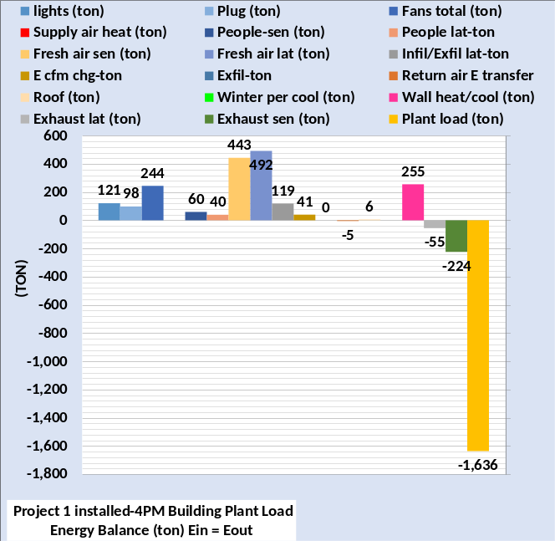
Figure 7: Building loads that define plant load.
Figure 7 defines fifteen loads on the building. The left chart gives the loads plus total energy in and out for the 24-hours. The right chart gives the loads at summer design 4PM conditions. One of the fifteen loads is the sum of the wall loads of Figure 6, the 255-ton wall load at 4PM. The 20 wall loads of Figure 6 resulted in one of the loads of Figure 7, therefore for each hour 34 loads define the plant load of Figure 7. The Model calculates every two hours, or 408 loads determined for the 24-hour day.
Each of these hourly 34 loads is a function of one or more of the other 33 loads, plus design constants and other variables to be identified by Chapter 1. The 24-Hour Model is a group of 34 major equations solved simultaneously by Microsoft Excel. The primary input to the model is weather and solar configuration as the seasons change. A one-degree change in outside dry bulb temperature will result in a change in all four wall loads and a change in fresh air load, infiltration load, and exhaust (ton), resulting in a new steady state plant load just as occurs in a real building. That of course is the challenge, write a set of equations that duplicates the performance of the real building in all conditions of weather.
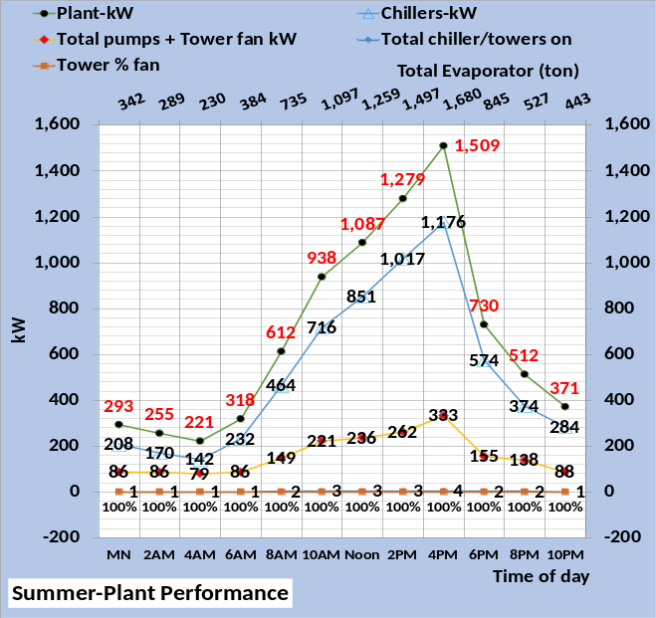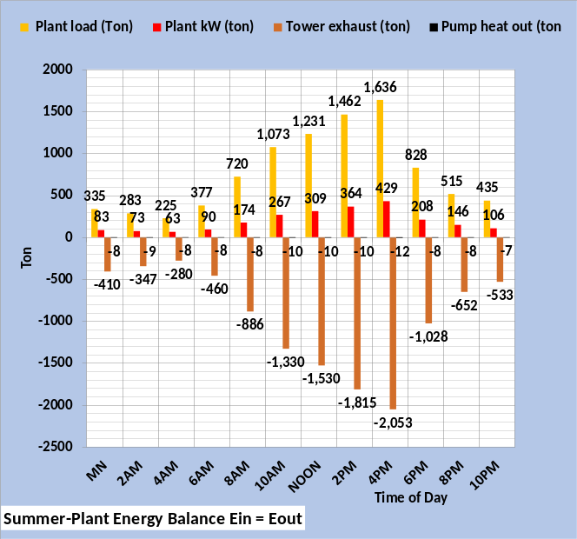
Figure 8: Plant performance.
Figure 8 gives the chiller plant response to the plant loads of Figure 7. Note the plant loads on the right chart are the same as the plant loads of Figure 7. The tower exhaust (ton) plus the pump heat to the atmosphere is the energy out of the plant and the energy in is the plant load and plant kW (ton). For example, at 4PM the energy in is 1,636 ton + 429 ton = 2,065 ton. The energy out is 2,053 ton + 12 ton = 2,065-ton, energy in = energy out for the chiller plant.
The secondary horizontal axis of Figure 8 gives the evaporator load which is a little greater than the plant load because primary/secondary pumping energy is added to the plant load. For example, the 4PM plant load is 1,636 ton and the evaporator load is 1,680 ton or 44 ton more due to the P/S pumping energy into the return water. The kW demand of the plant is shown by the left chart. For example, at 4PM the chiller kW is 1,176 and the pumps and tower fans are 333 kW for a total plant kW of 1,509 as shown. Also note that 4 chiller/towers are on at 4PM and the tower fans are 100% speed. The fall weather performance gives a very different result as shown next.

Fall Weather Performance

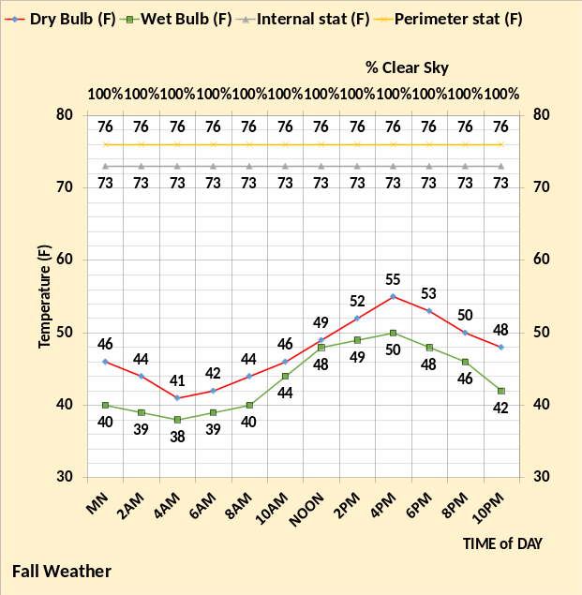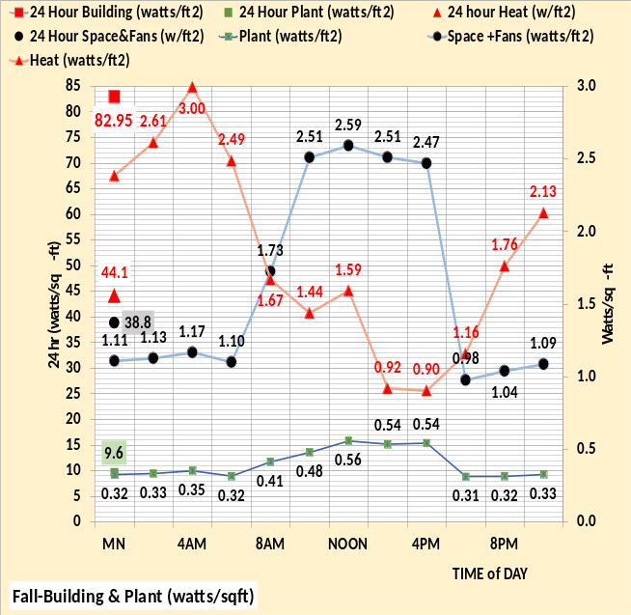
Figure 9: Fall weather energy consumption of Figure 4 building & chiller plant
The only changes made to the model are the weather and thermostat settings of Figure 9 verses Figure 5, plus the solar configuration is changed from summer season to fall season. The building as defined by Figure 4 now needs significant heat to maintain the space comfort temperatures. The building watts/ft² has increased from 41.42 watts/ft² of Figure 5 to 82.95 watts/ft² of Figure 9. The 44.1 watts/ft² of heat plus the 38.8 watts/ft² building space and fans equals the total 82.9 watts/ft². The plant energy reduced from 32.6 watts/ft² to 9.6 watts/ft², 29% of the Figure 5 value.

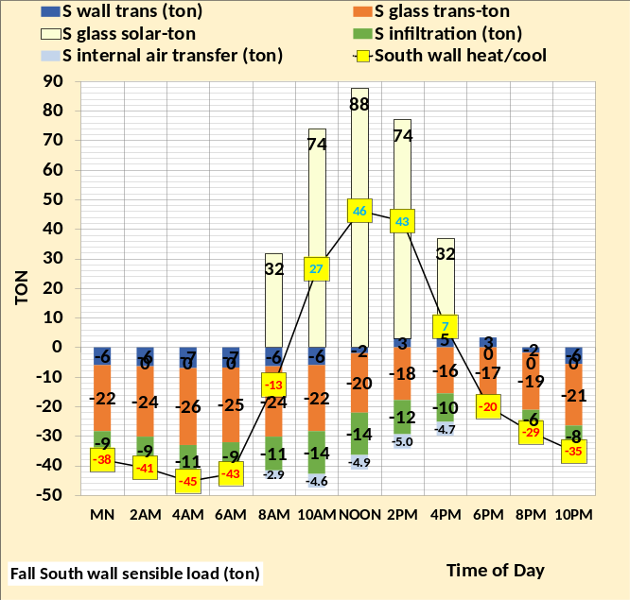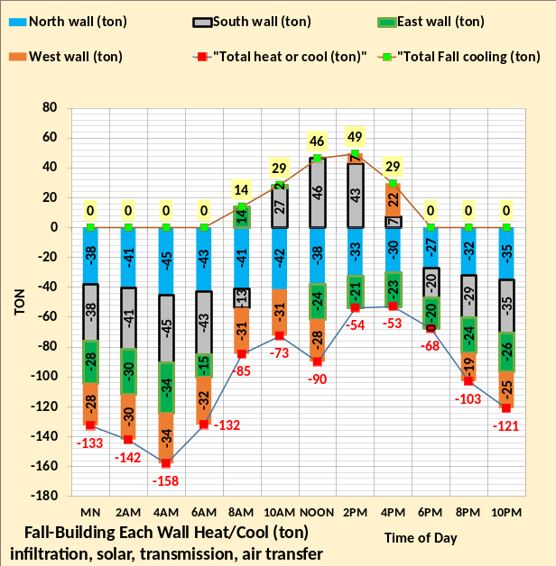
Figure 10: Fall weather wall loads
Figure 10 illustrates the wall loads with the left chart giving the south wall and the right chart giving all four walls. Note the south wall values are also in the right chart going from requiring heat during the morning to requiring cooling at 10AM through 4PM then heat required the rest of the day. The south wall cooling required peaked at 46 ton at noon and the heat required was a max of -45 ton at 4AM. Note the west wall requires 22-ton cooling at 4PM and the south wall requires 7 ton for a total 29-ton cooling. The details of the wall model will be addressed in Chapter 1.

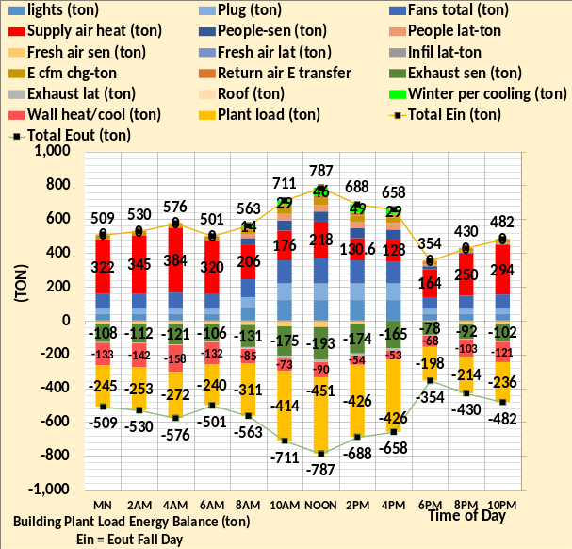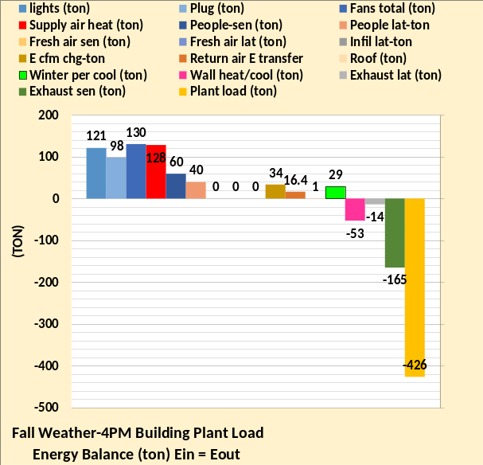
Figure 11: Fall weather- Building loads that define plant load

Figure 11 has two more loads than Figure 7 summer weather, at 4PM right chart supply air heat 128 ton and winter perimeter cooling 29 ton. Figure 11 left chart defines sixteen loads on the building that results in the plant load with two of those loads being from the twenty wall loads of Figure 10, for a total of 36 loads that define the plant load. The minus 53-ton heating wall load at 4PM is shown as one of the loads at 4PM of Figure 11. Also, the winter perimeter cooling load of 29-ton is shown on Figure 10 and Figure 11. At 4PM the north wall required 30-ton heating, the east wall 23-ton heating for total heat load at 4PM of 53-ton, right chart. At 4PM the west wall requires 22-ton cooling, and the south wall 7-ton cooling for a total cooling load of 29-ton as shown by Figure 10 & Figure 11. The solar load of course is the reason both wall heating and cooling are required. The supply air heat of 128 ton at 4PM is due to reheating the 55F perimeter supply air to 90F to meet the perimeter heating load.
Most of these 36 loads are a function of one or more of the other 35 loads, plus design constants and other variables not identified by the 36 loads shown here. The 24-Hour Model is a group of equations solved simultaneously by Microsoft Excel. The only input to the model going from summer conditions to fall weather conditions is solar configuration and the different outside temperatures.

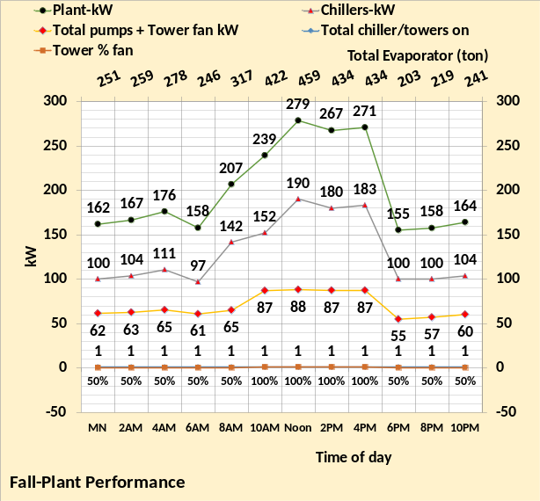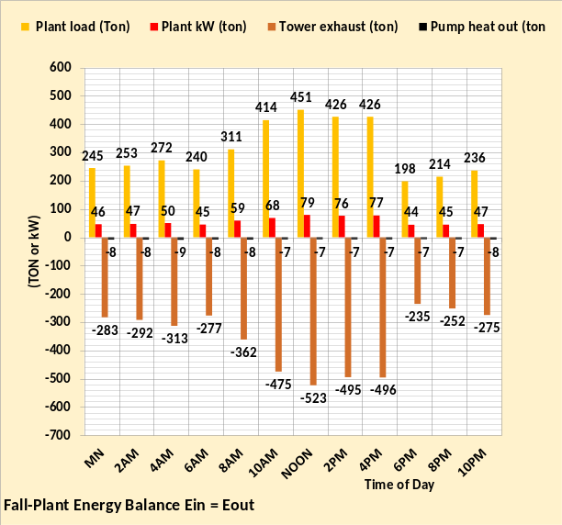
Figure 12: Fall weather plant performance
Figure 12 illustrates the need for only one chiller/tower for these weather conditions. Also note that the tower is operated at 50% fan speed for morning and late evening hours. Note the plant loads on the right chart are the same as the plant loads of Figure 11. The secondary horizontal axis of Figure 12 gives the evaporator load which is a little greater than the plant load because P/S pumping energy is added to the plant load.

Winter weather performance

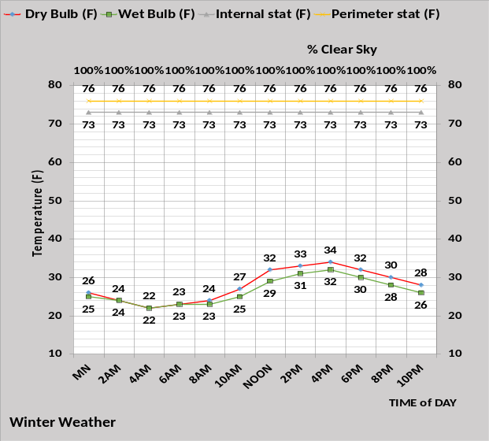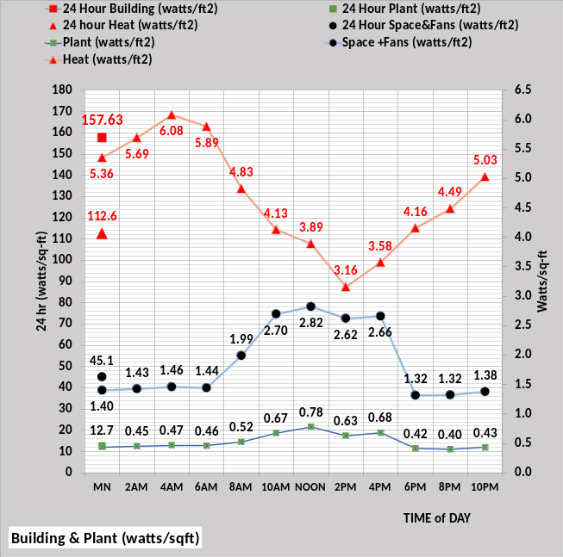
Figure 13: Winter weather energy consumption of Figure 4 building & chiller plant
Heat required for these winter weather conditions more than doubled the fall weather values, 44.1 watts/ft² of Figure 9 to 112.6 watts/ft² of Figure 13. The total building watts/ft² is the heat plus the space and fans equals 157.63 watts/ft². The plant is 12.7 watts/ft².

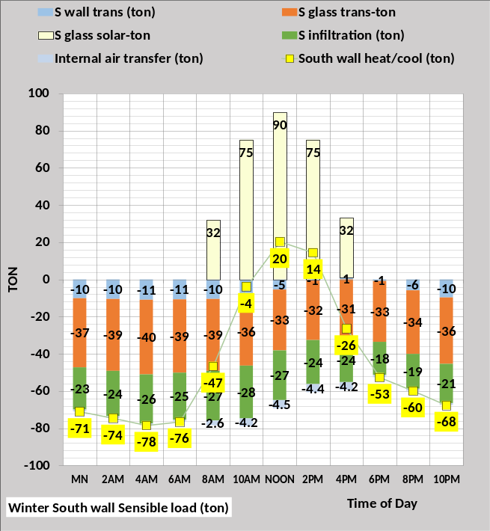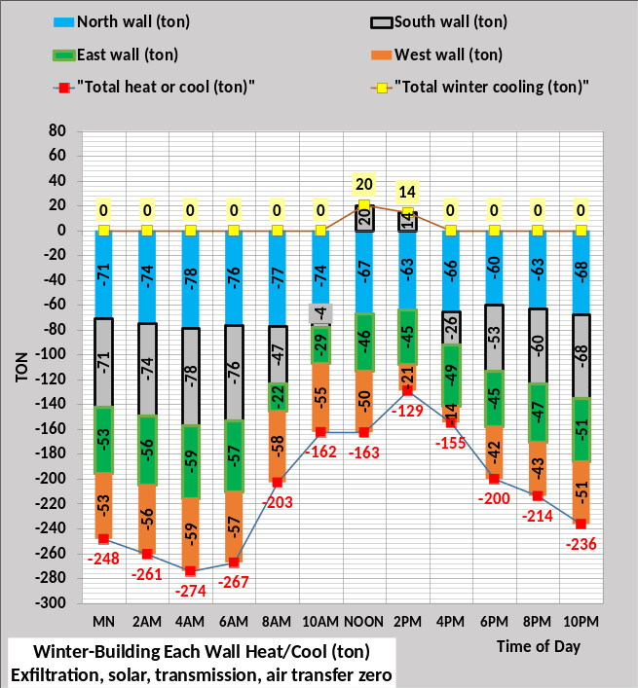
Figure 14: Winter weather wall-loads
Only the south wall required cooling for these winter conditions and small values of 20 & 14 tons. Wall heating was significantly greater than for fall weather.

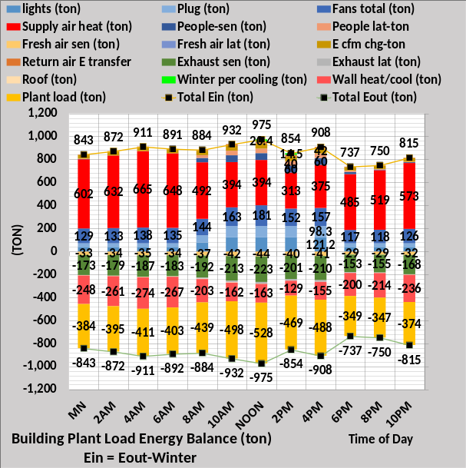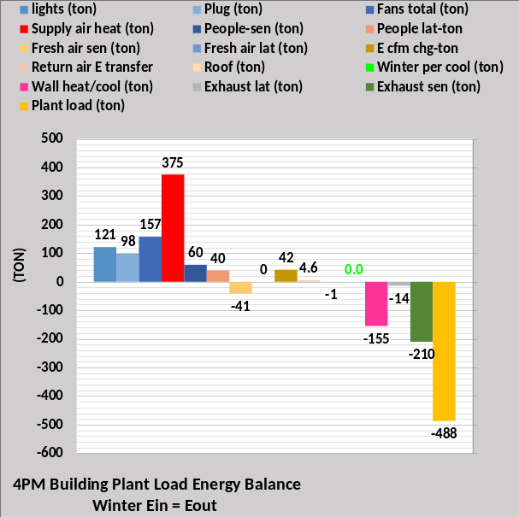
Figure 15: Winter weather- Building loads that define plant load
Figure 15 defines sixteen loads on the building that results in the plant load with two of those loads being the wall loads of Figure 14. The minus 155-ton heating wall load at 4PM is shown as one of the loads at 4PM of Figure 14. Also, the winter perimeter cooling load is 0.0-ton at 4PM but 14 ton an hour earlier at 2PM as shown by Figure 14. The 4PM right chart supply air heat is 375-ton verses 128-ton for fall weather.

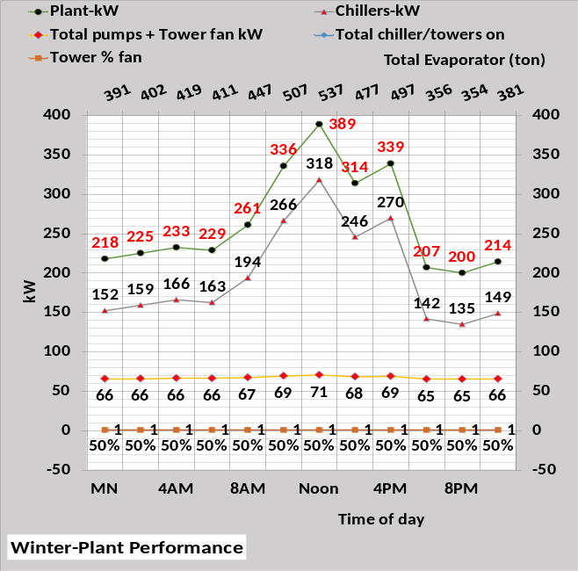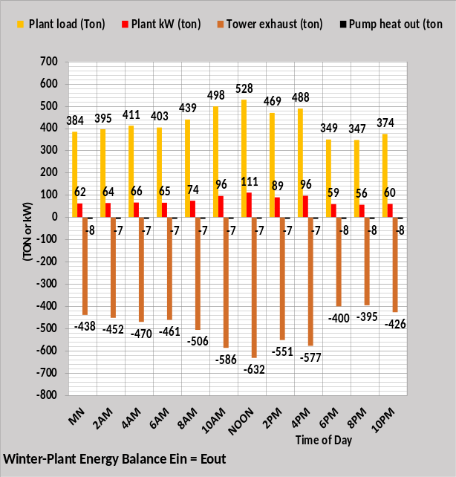
Figure 16: Winter weather plant performance
Figure 16 illustrates the need for only one chiller/tower and the tower operates at 50% fan speed for all hours. Note the plant loads on the right chart are the same as the plant loads of Figure 15. The secondary horizontal axis of Figure 16 gives the evaporator load which is a little greater than the plant load because P/S pumping energy is added to the plant load.

Spring Weather Performance
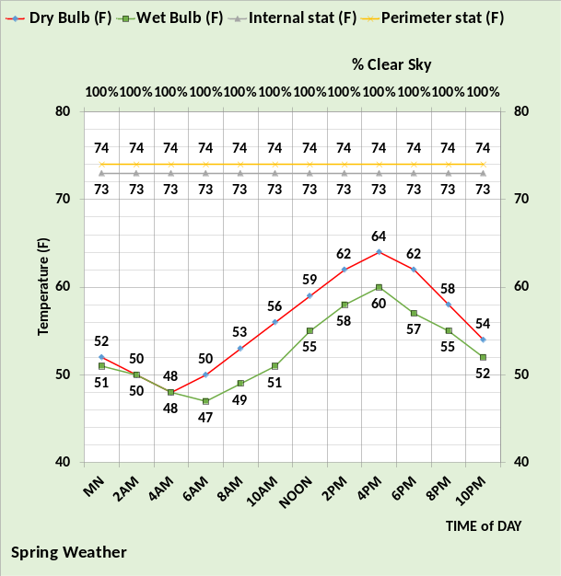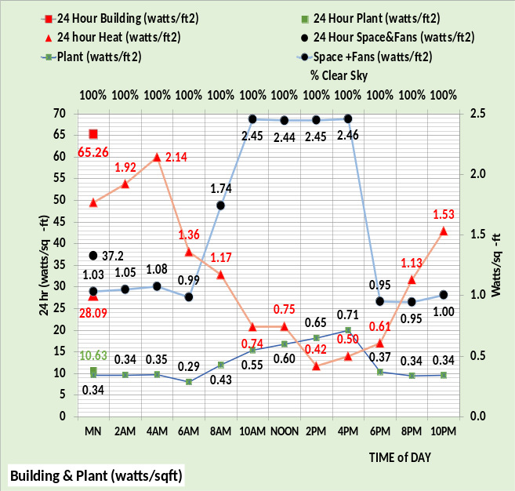
Figure 17: Spring weather energy consumption of Figure 4 building & chiller plant
Spring weather performance is like fall weather performance but less energy consumed due to the milder weather conditions.
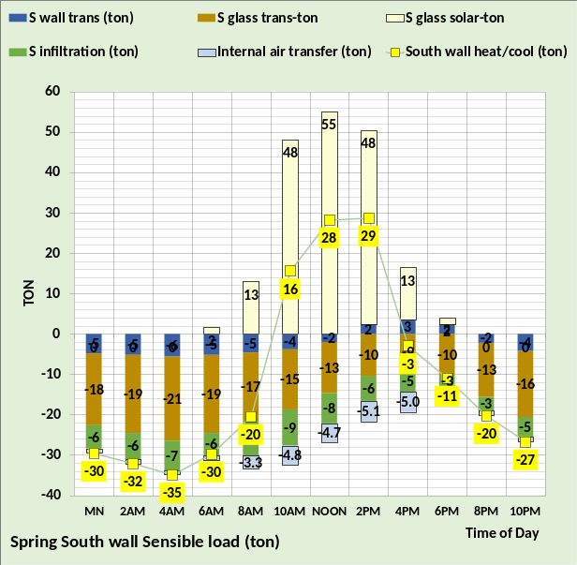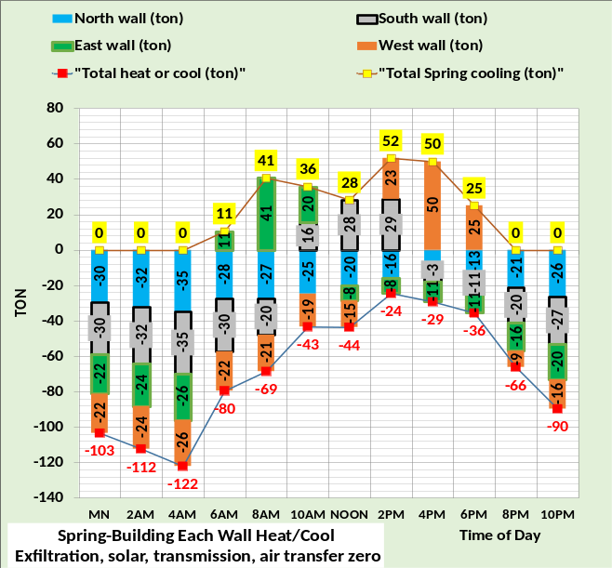
Figure 18: Spring weather wall loads
The spring wall loads are like the fall weather loads but with more cold weather cooling is required because of the milder spring weather.

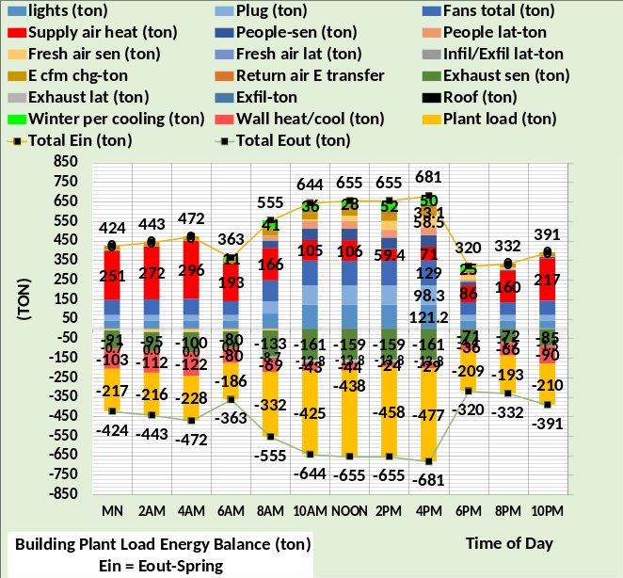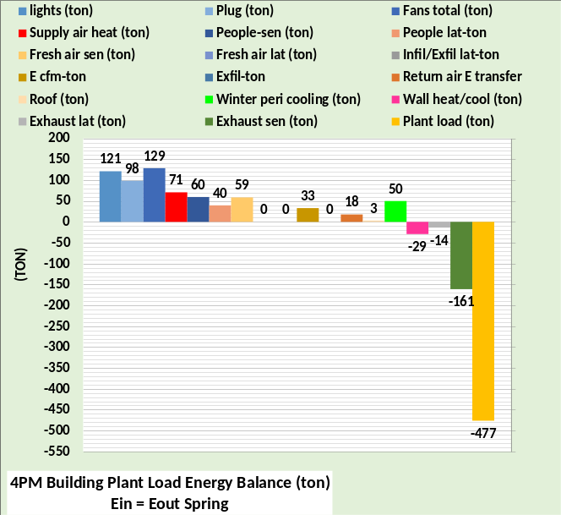
Figure 19: Spring Weather-Building loads that define plant load
The milder spring weather results in a little more plant load as illustrated by comparing the figures.

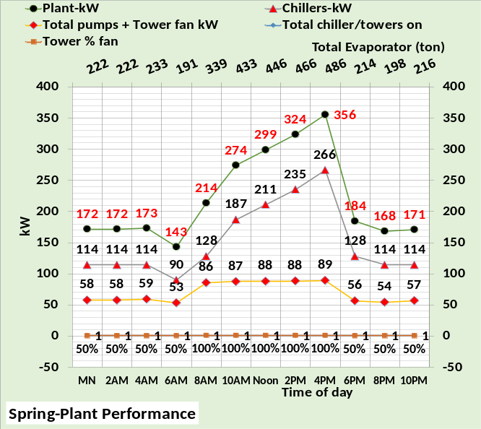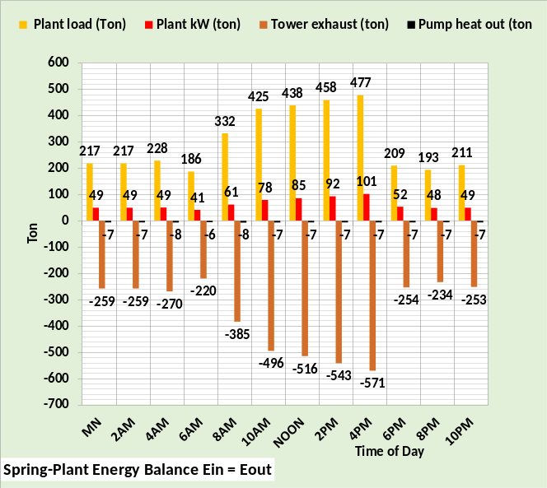
Figure 20; Spring weather plant performance
Plant performance is very similar to the fall weather performance.
Next the energy saving projects are defined.
Energy Saving Projects Defined
The energy-saving projects are as follows.
Project 1 eliminates unstable energy, defined here as outside air infiltration and return air energy transfer. These two energy waste functions are nearly impossible to measure or observe and can change by the hour if not by the minute, therefore must be neutralized so that an accurate model and engineering analysis of the building’s energy consuming characteristics can be achieved. Building positive pressure controls are installed to eliminate infiltration, modeled here by assuming the return exhaust damper is controlled to achieve positive pressure on each floor. The fresh air damper is set at 40% open and therefore fresh air CFM is a function of VAV fans CFM.
All building thermostats are set at the same temperature to eliminate return air energy transfer. All stats at the same temperature setting may be temporary but necessary for a “clean” energy analysis of the building. The change in building energy after the stats are set equal can give an indication of how much return air energy transfer is occurring in the building. Controlling the stats could help stabilize the pressure control system given that return air energy transfer changes the return air load and therefore the load on the VAV fans and the load on the VAV fans defines the VAV kW that in turn contributes to the VAV fan load. Positive building pressure means that those pathways that allowed outside air to get into the building are now paths for conditioned air to exit the building, analogues to air exhaust. Therefore, it seems likely that interior air return to the perimeter will increase with building positive pressure, possibly increasing return air energy transfer unless the stats are at the same setting. Return air energy transfer may be difficult if not impossible to eliminate short of controlling all thermostats on each floor to the same temperature. One possible solution may be to locate perimeter return air duct several feet toward the interior of the building with perimeter stats located a few feet from the outside wall possibly eliminating interior return air from entering the perimeter stat zone of control. This Project 1 will model peak exfiltration as .05 cfm/wall ft² and eliminates return air energy transfer by setting all stats at the same temperature. Each of the following projects are installed to the previous project.
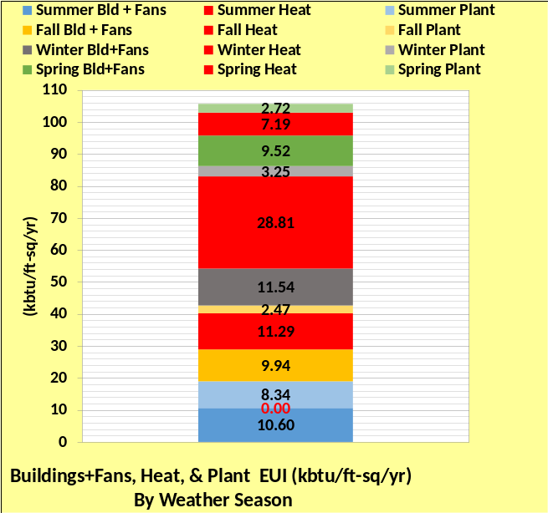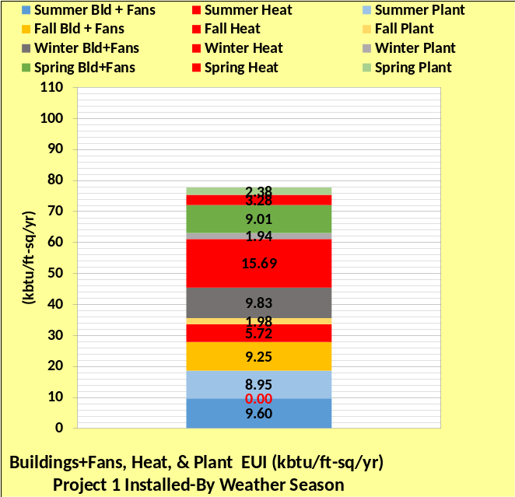
Figure 21: Left chart EUI original building, right chart project 1 installed.
Project 1 installs building positive pressure control and sets the thermostats at the same temperature to eliminate return air energy transfer. Figure 21 illustrates the reduction in estimated EUI with the installation of project 1, 106 EUI verses 78 EUI with Project 1 installed. Figure 21 illustrates the big savings are the reduction in heat energy. No heat is required for summer weather. Fall heat reduced from 11.29 to 5.72 EUI, winter heat reduced from 28.81 to 15.69 EUI, and spring reduced from 7.19 to 3.28 EUI, about a 50% reduction for the year due to less perimeter heat required because two wall loads have been eliminated, infiltration and return air energy transfer.
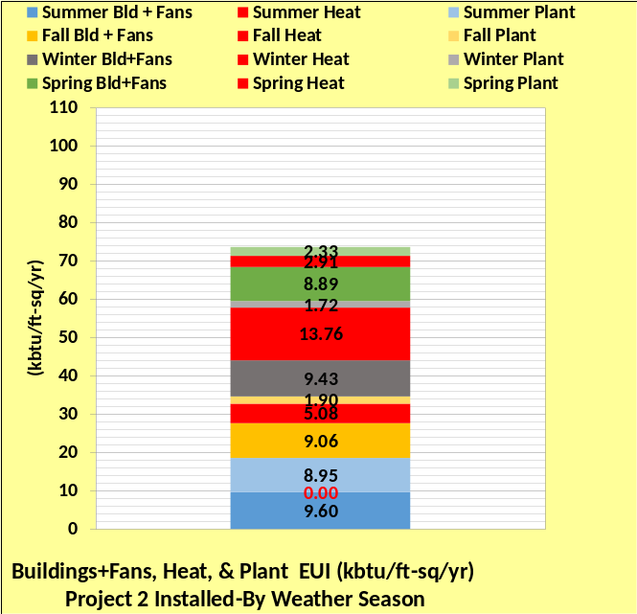
Figure 22: Install project 2 dropping EUI from 78 to 74.
Project 2 is to simply reset the perimeter air heating temperature from 90F to 95F. This reduces the CFM of heating air to the perimeter and therefore decreases the air reheat, resulting in reduced building kW demand and plant load for the fall, winter, and spring seasons. Increasing the perimeter air temperature to 100F or higher will further decrease air reheat, however may be unacceptable for some buildings. We will proceed with 95F perimeter heating air.
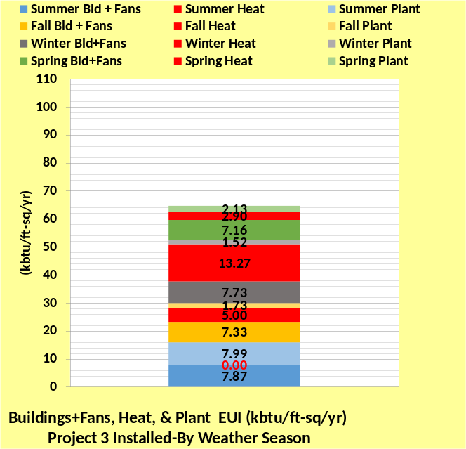
Figure 23: Install project 3, EUI drops from 74 to 64.
Project 3 upgrades the lighting from a peak of .9 watts/ft² to .64 watts/ft². As part of this project, people sensors are installed that result in only 5% of lights being on after hours.
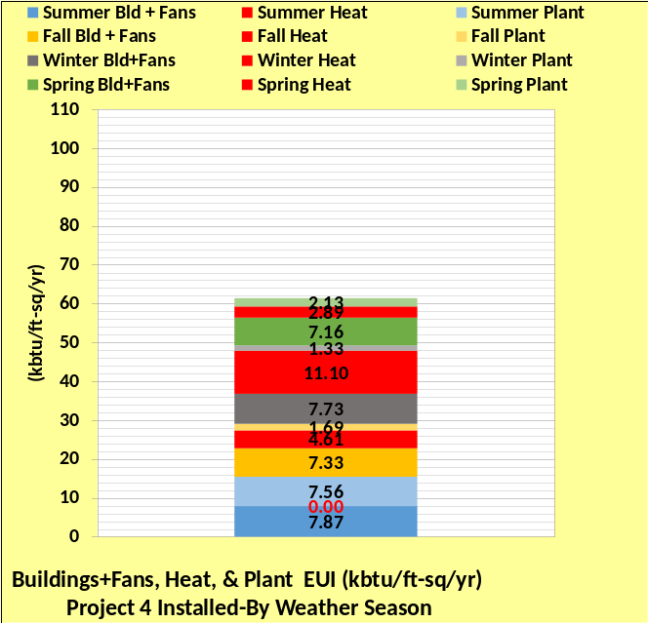
Figure 24: Install project 4 dropping EUI from 64 to 62.
Project 4 installs CO2 people sensing fresh air control that accomplishes 35 CFM of fresh air per occupant. This project also changes the fresh air preheat temperature from 50F to 40F.
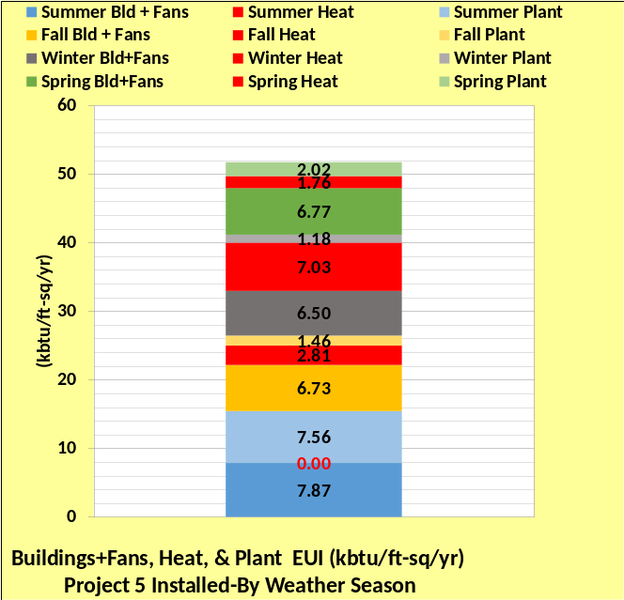
Figure 25: Install project 5 dropping EUI from 62 to 52.
Project 5 installs wall heat panels, modeled to heat 90% of the glass wall transmission.

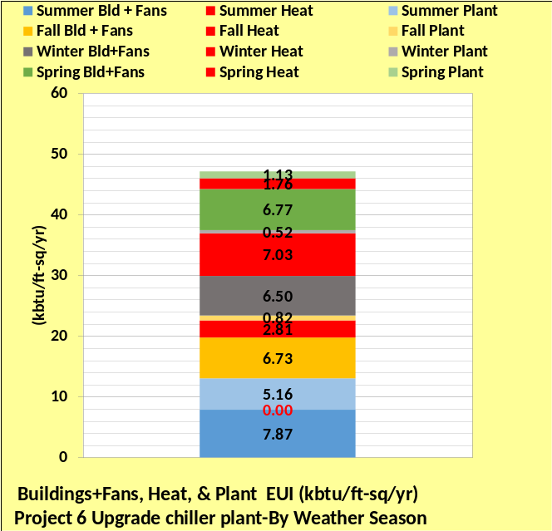
Figure 26: Install project 6 dropping EUI from 52 to 47.
Project 6 installs a more efficient chiller plant. Each chiller design (ton) is reduced from 500 ton to 250 ton with more efficient chillers. The new chiller plant could have been installed first or any project, the only reason for completing the building projects first is to minimize the cost of the new plant because the plant load will be less. However, if this building was in Florida or a similar weather zone where the chiller plant kW is more significant the economics might suggest an earlier upgrade of the chiller plant

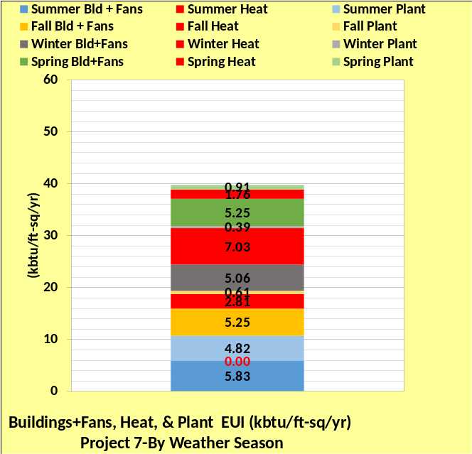
Figure 27: Install project 7 dropping EUI from 47 to 40.
Project 7 consists of modifying the air duct supply, so the design static pressure is reduced from 7.0 inches water to 5.5 inches water. As part of this project, duct pressure reset control is installed to accomplish a minimum 1.5-inch reset duct pressure. This project also removes the interior fan powered terminals with VAV damper control boxes installed. The perimeter fan powered terminals stay because needed for heating the building perimeter.

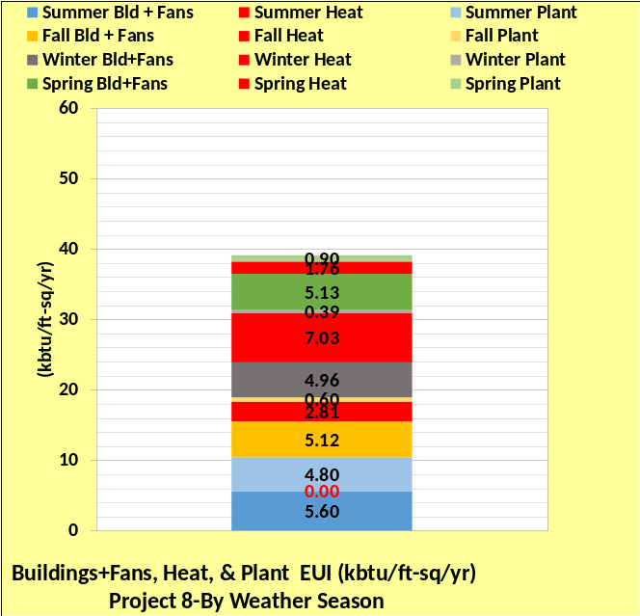
Figure 28: Install project 8 dropping EUI from 40 to 39.
Project 8 modifies the return air duct to eliminate return air energy transfer; therefore, the stats can be returned to occupant control. This project also eliminates the return air fans.

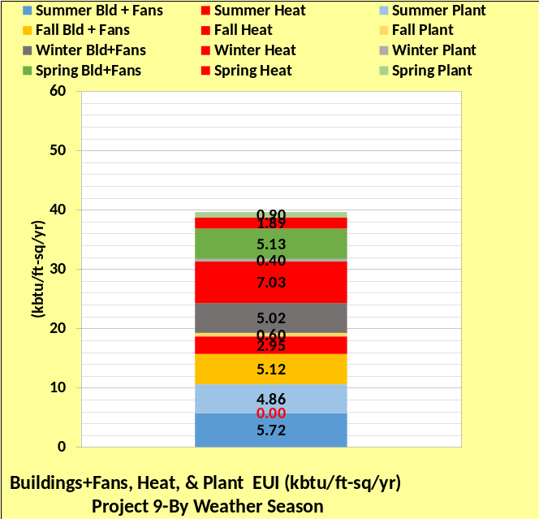
Figure 29: Install project 9 slightly increasing EUI to 39.5 from 39.
Project 9 returns the thermostats to control of occupants, modeled as summer interior stat 73F & perimeter stats 72F cooling & 74F heating.

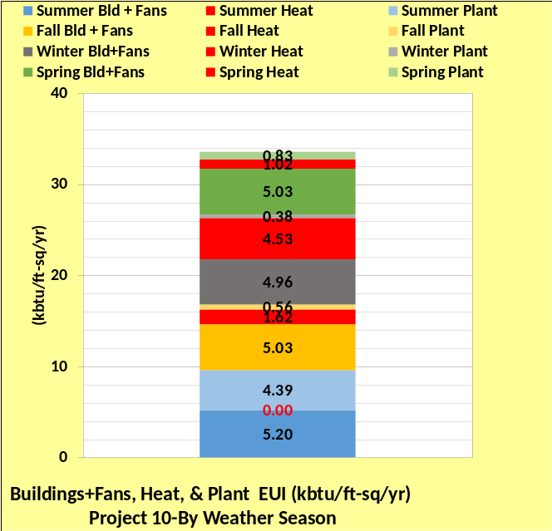
Figure 30: Install project 10 dropping EUI from 39.5 to 33.5.
Project 10 replaces the windows with more efficient windows.
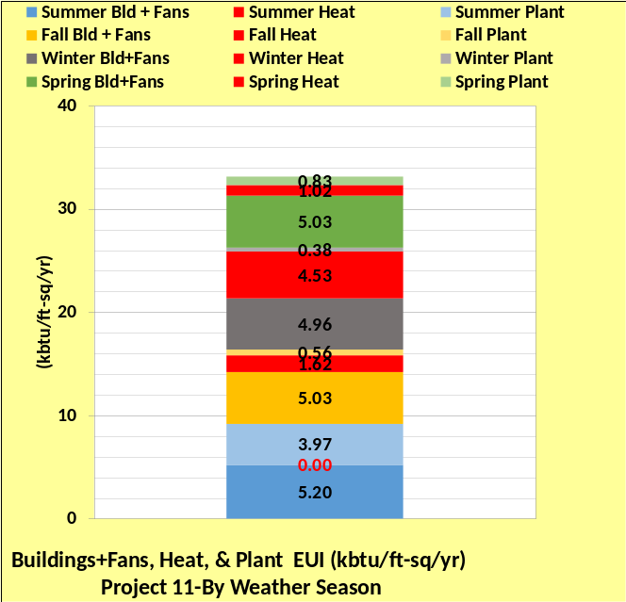
Figure 31: Install project 11 dropping EUI from 33.5 to 33.
Project 11 installs exhaust air energy recovery. Note the summer plant EUI dropped from 4.39 to 3.97.
EUI Estimates with eleven projects
Figure 32: Estimate EUI of Figure 4 building and after eleven energy projects are installed
Figure 32 illustrates the drop in the estimated EUI due to the installation of the eleven energy projects. EUI has decreased from a value of about 106 to a value of about 33, a 69% reduction. Figure 32 illustrates that the heating required by the original building is fall 11.29 EUI, winter 28.81 EUI, and spring 7.19 EUI for a total of 47.29 EUI. After the energy projects are installed, the values are reduced to fall 1.62, winter 4.53, and spring 1.02 for a total 7.17 EUI that is about one sixth the 47.29 heating EUI of the original building. The annual EUI plant total is 16.78 for the original plant and is 5.74 EUI with the building energy projects installed and a new chiller plant installed, a value of about one third the original plant. The building EUI that includes lighting, plug, and air handler EUI totals 41.6 for the original building and 20.22 EUI after energy projects installed, about half the original building values. Heating reductions were the greatest followed by the plant and then the building.
Building & Chiller Plant Schematics
Early in the development of the (SEE) Model the author experienced the frustration of attempting to review several charts to try and understand how the building or plant was working and if the answers were logical and consistent with the laws of thermodynamics and ASHRAE data. The answer to this dilemma was the development of schematics of the building & plant that put relevant model answers in context with other model answers. Schematics 1 & 2 are of the building and plant at 4PM design summer conditions with infiltration and return energy transfer, plant load is 1,634.4 ton. The lower left corner of the building schematic gives colors that help navigate the schematic. The (SEE) Model is a set of equations solved simultaneously by Excel. There is no look up tables as part of the model, only equations. The set of equations is in equilibrium and any change in the weather or operational values like light levels will cause the model to reach a new equilibrium state. The fact that Excel iterates to a new steady state after the change of any operational or design condition is a key to the 24-Hour Model performance. To demonstrate the performance of the model only one variable will be changed, the dry bulb temperature will be changed from 100F of Schematic 1&2 to 82F of Schematic 3&4. The plant load changed from 1,636.4 ton to 1,284.6 ton. The perimeter load changed from 255.4 ton to 147.9 ton and the perimeter supply air CFM changed from 177,822 to 102,954 CFM. The building interior CFM slightly reduced from 186,977 to 186,073 CFM. The fans kW reduced from 859.6 kW to 528.2 kW. All changes occurred within the model, within about 1 second, due to the one changed input of 82F dry bulb from 100F dry bulb. The point is the model is a set of equations where most if not all components of the system are affected by the performance of other components just as occurs in a real system, and the system always reaches steady state where energy into the building or plant equals the energy out of the building or plant.
Schematics 5 & 6 give the building and plant performance just 6 hours after 4PM at 10PM when the sun is down, outside temperatures have dropped to 92F dry bulb & 78F wet bulb, people are essentially gone and lights and plug loads are decreased. The building model responds to these weather & operational changes by giving a plant load of 434.5 ton about one fourth the design load of 1,636.4 ton that occurred 6 hours earlier.
The schematics may appear confusing to the reader at first but with time will become an important tool in understanding how a building and chiller plant work. The nomenclature for the building is at the end of Chapter 1 and the plant nomenclature at the end of Chapter 2.
Simply stated, 24-hour building and chiller plant energy models are an attempt to bring together all relevant knowledge and understanding of ASHRAE Handbooks and literature that deals with the energy consuming characteristics of buildings and chiller plants. The nomenclature for the building defines about 130 terms and the plant defines about 70 terms, illustrating the size of the two models.
The reader is encouraged to study the schematics for understanding of how values change in the system with minor changes in conditions.
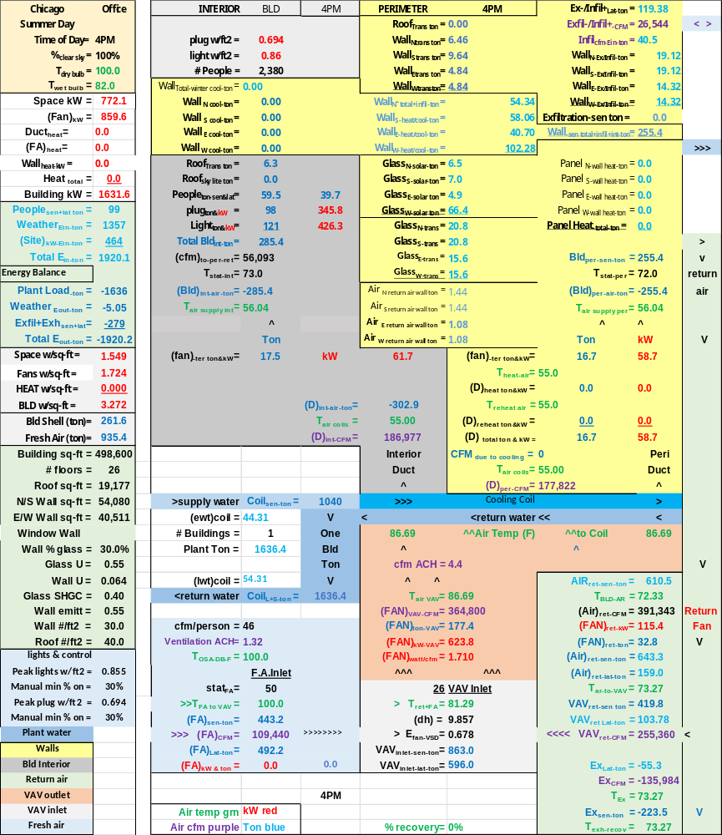Schematic 1: Building at Design load Conditions

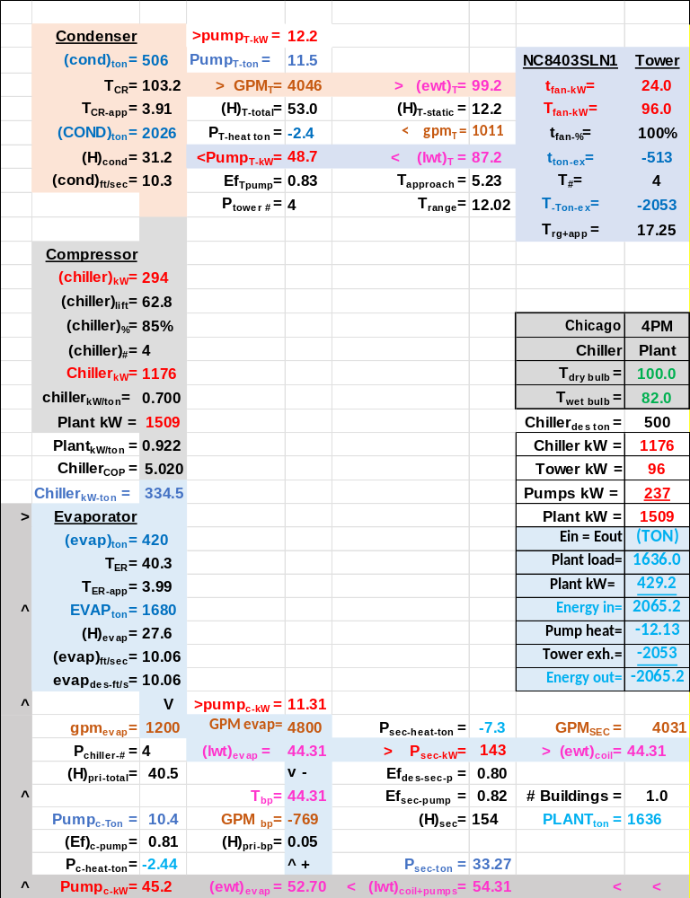
Schematic 2: Plant at Design Load Conditions
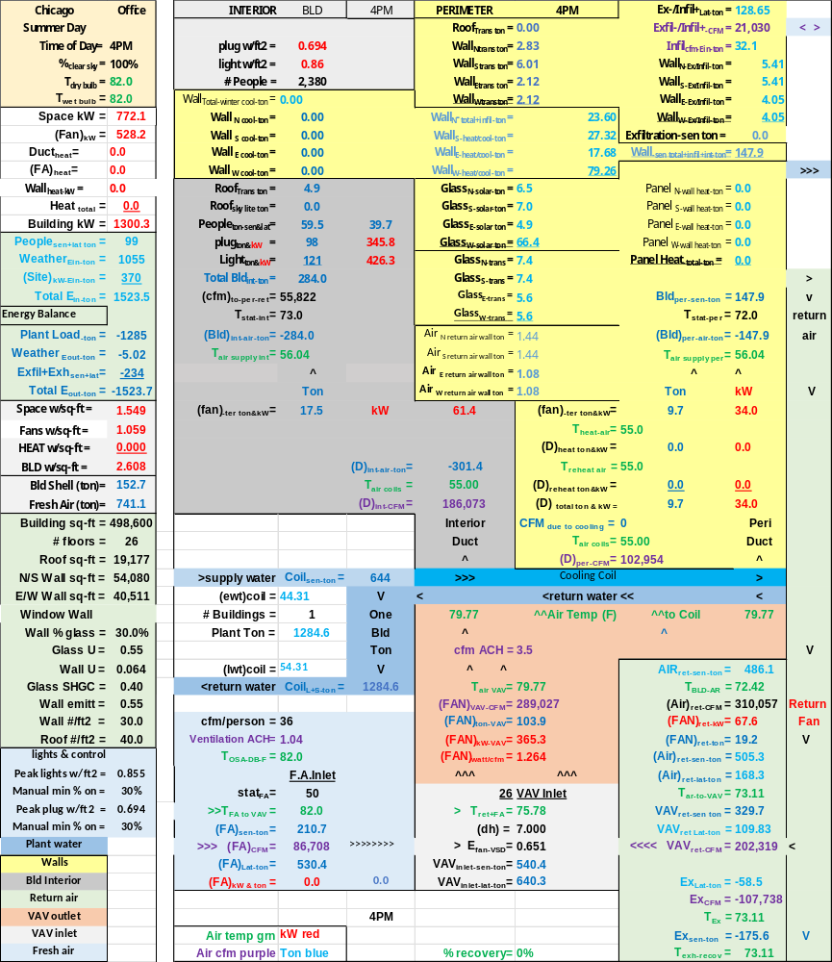
Schematic 3: Change Dry Bulb of Schematic 1 from 100F to 82F
Note the fresh air sensible decreased from 443.2 ton of Schematic 1 to 210.7 ton of Schematic 3, but the latent increased to 530.4 ton from 492.2 ton.
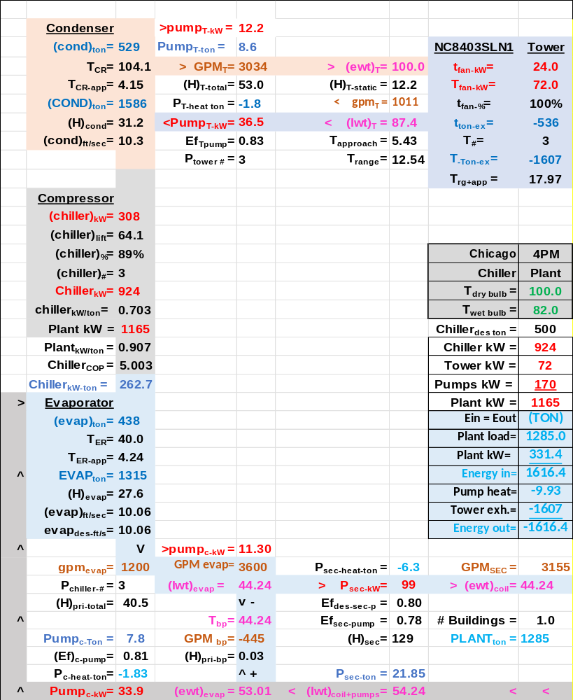
Schematic 4: Plant at 82F dry bulb and 82F wet bulb

Schematic 5: Building at 10PM Conditions

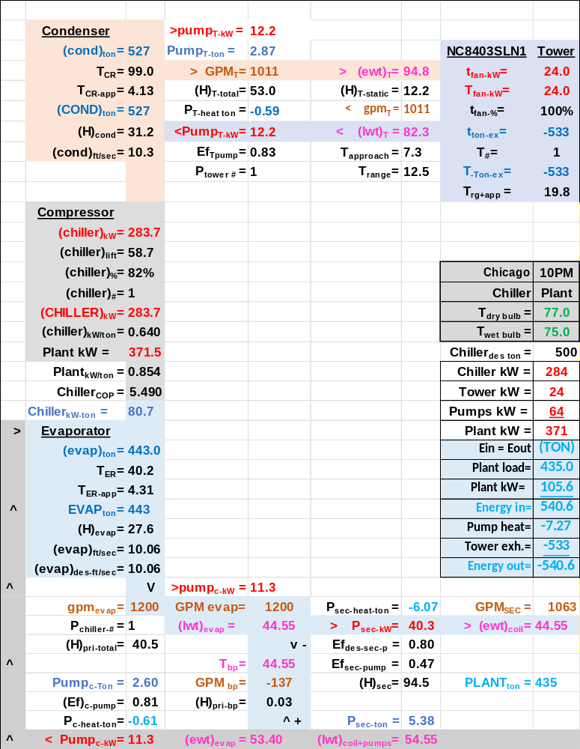Schematic 6: Plant at 10PM Conditions
Chapter 1
24-Hour Model of 26-Story Chicago Office Tower
The purpose of Chapter 1 is to give the reader an understanding of the equations and system characteristics input into the model to establish how and why a building defined by Figure 4 of the Executive Summary consumes energy. Basic HVAC equations are, for the most part, used in the model and the model always requires that energy into the building equals energy out of the building.
CONTENTS
Page 32. Purpose & Contents
Page 34. Building Required to balance load
Page 37. Wall transmission loads
Page 39. Glass transmission loads
Page 40. Walls & glass transmission loads
Page 41. Outside air infiltration
Page 44. Infiltrations wall loads
Page 45. Return air energy transfer to perimeter load
Page 46. Wall Loads due to Transmission, Infiltration & Return Air Transfer
Page 47. Glass Solar loads
Page 49. Cooling and/or heating on each wall
Page 50. Summer weather perimeter loads
Page 51. Fall weather perimeter loads
Page 52. Fall weather perimeter air heat
Page 53. Winter weather perimeter loads & air heat
Page 54. Spring weather perimeter loads & air heat
Page 55. Interior cooling loads
Page 56. Perimeter cold weather cooling loads
Page 57. Interior air supply for summer & fall
Page 58. Interior air supply for winter & spring
Page 59. Building Interior + Perimeter Loads & VAV fans CFM
Page 60. Interior & perimeter air supply & return
Page 61. Interior air return to perimeter
Page 62. Building perimeter air return
Page 63. Building interior air return CFM
Page 64. Mixed air return temperature
Page 65. Return air (ton) before return air fans
Page 66. Return fans effect on return air temperature
Page 67. Return air (ton) after return air fans
Page 68. Nine energies into the return air
Page 70. Return air properties before exhaust damper
Page 71. Building air CFM balance
Page 72. Return air exhaust and VAV inlet
Page 73. VAV fans inlet (ton)
Page 74. Latent load (ton) to VAV fan inlet.
Page 75. VAV supply CFM due to interior & perimeter loads
Page 76. VAV supply CFM due to fresh air CFM
Page 77. VAV supply CFM
Page 78. ACH & Fresh Air CFM per person
Page 80. Fresh air loads
Page 82. VAV fans inlet (ton)
Page 83. VAV Fan kW
Page 84. Temperature rise through VAV fans due to VAV fan kW
Page 85. Plant Sensible Load
Page 86. Temperature rise through coil
Page 87. Air CFM and temperatures at coil
Plant 88. Latent Loads to Plant
Page 89. Plant Load, Sensible + Latent
Page 90. Summer Weather Loads & kW Demand Summary
Page 91. Summer required to balance load
Page 92. Building schematic summer 4PM & 10PM
Page 94. Summer wall loads & energy balance
Page 95. Summer building kW demand
Page 96. Summer kW demand & watts/ft²
Page 97. Fall Weather Loads & kW Demand Summary
Page 98. Fall required to balance load
Page 99. Building schematic fall 4PM & 10PM
Page 101. Fall wall loads & energy balance
Page 102. Fall building kW demand
Page 103. Fall kW demand & watts/ft²
Page 104. Winter Weather Loads & kW Demand Summary
Page 105. Winter required to balance load
Page 106. Building schematics winter 4PM & 10PM
Page 108. Winter wall loads & energy balance
Page 109. Winter building kW demand
Page 110. Winter kW demand & watts/ft²
Page 111. Spring Weather Loads & kW Demand Summary
Page 112. Spring required to balance load
Page 113. Building schematics spring 4PM & 10PM
Page 115. Spring wall loads & energy balance
Page 116. Spring building kW demand
Page 116. Spring kW demand & watts/ft²
Page 117. Chapter 1 comments
Page 118. References for Introduction, Executive Summary & Chapter 1
Page 119. Building Nomenclature

Building Required to balance load
Basic thermodynamic equations are utilized to model the building and plant maximize the possibility that the model can duplicate the actual energy consumption of a building and plant on any 24-hour day of weather. The perimeter of the building is modeled separate from the interior of the building but one VAV air handler on each floor supplies air to both the interior and perimeter of the building, therefore the return air from the interior and perimeter of the building is mixed when returned to the VAV fan inlets. The interior of the building always requires cooling. The perimeter of the building will require heating during cold weather and cooling during warm weather. During cold weather one or more walls may require heating with one or more of the other walls requiring cooling due to solar. This condition is covered in detail below under wall loads.
Building Required to Balance Load
Two-meter readings are convenient if not necessary data required for a (SEE) Model analysis of an existing building.
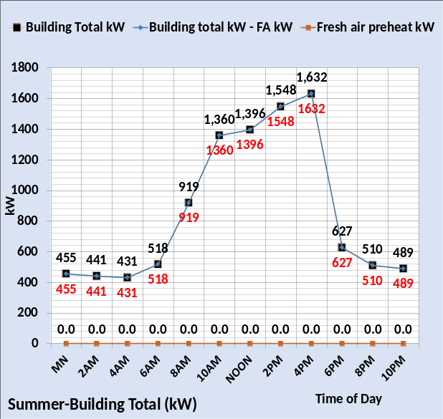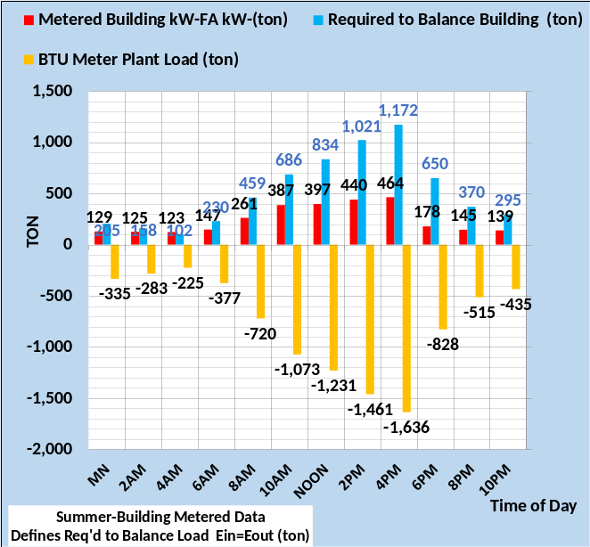
Figure 1: Summer energy balance.
Figure 1, 2, 3, & 4, define the meter readings required to balance loads for the four seasons and temperatures defined by the weather charts of Executive Summary. The required balance load defines the task for the (SEE) Model, defines the loads that sum to the required to balance load. As previously discussed, the model kW value is modified to subtract any kW loads that do not contribute to plant load, for example parking lot lights. Also, the Model is constructed such that the kW to preheat fresh air is not directly input to the building but rather the temperatures of fresh air because of fresh air preheat. The fresh air heat is input to the model not as a kW value but the effect on the fresh air temperatures. Therefore, the fresh air heat must be subtracted from the balance model kW, but the fresh air kW is summed as part of the building total kW demand.
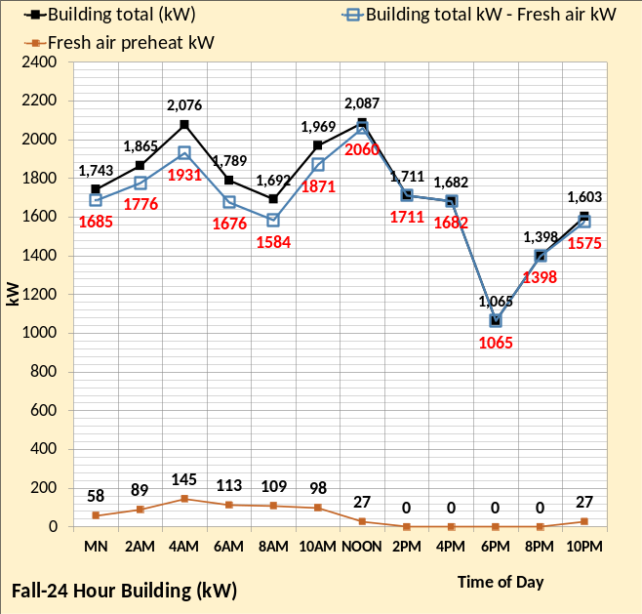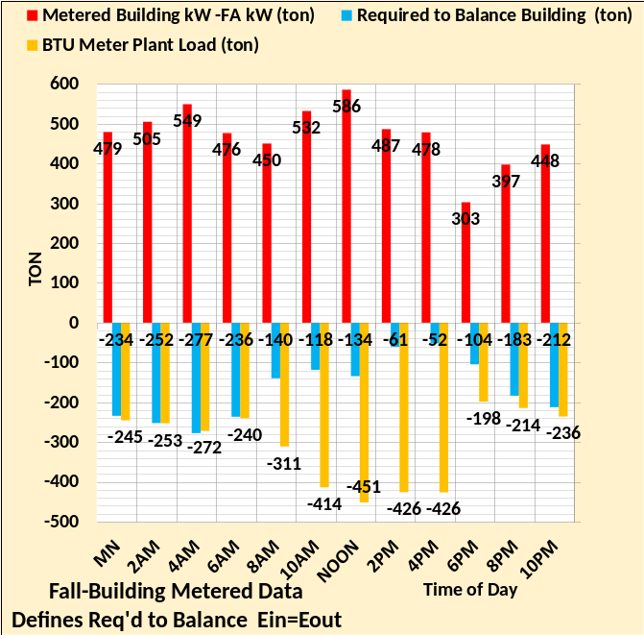
Figure 2: Fall weather Energy Balance
Figure 2 left chart shows fresh air heat occurs during the morning up to noon and then again at 10PM. The building total kW minus fresh air kW is the value used to balance the Model building energy, because that is the kW load seen by the plant load.
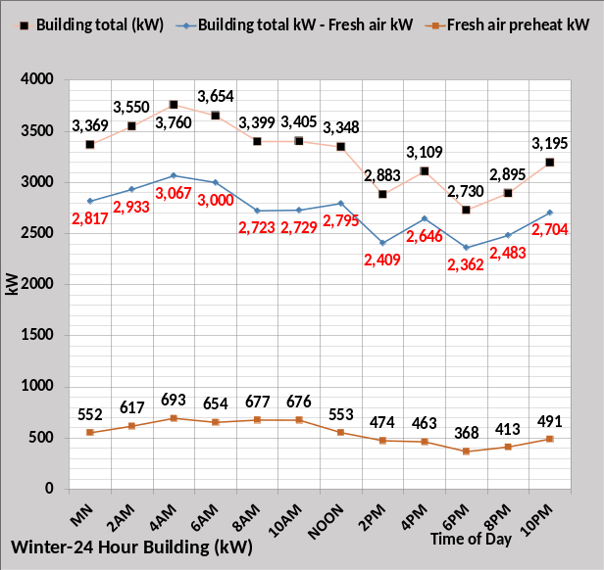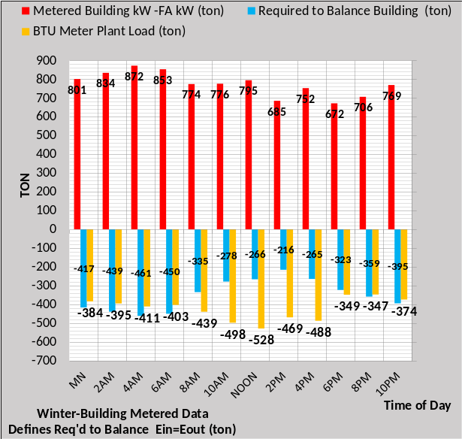
Figure 3: Winter weather Energy Balance
Figure 3 illustrates, as expected, the winter weather fresh air heat significantly reduces the Model kW value that results in building energy balance. The energy input to the building is determined by the temperature of the fresh air entering the building, discussed in more detail below.
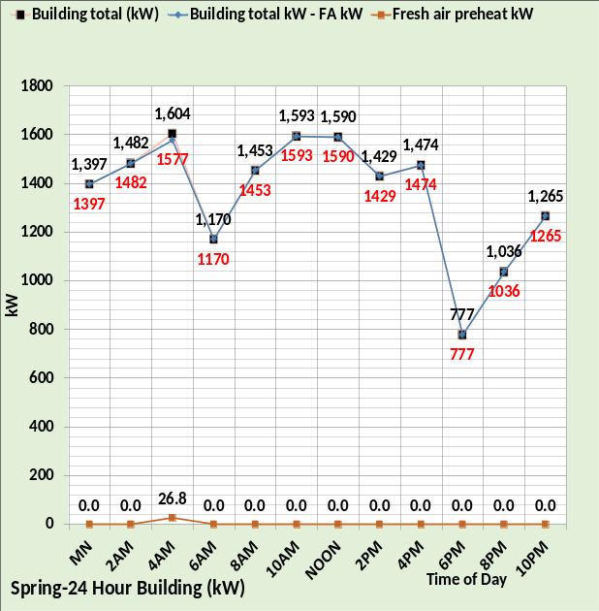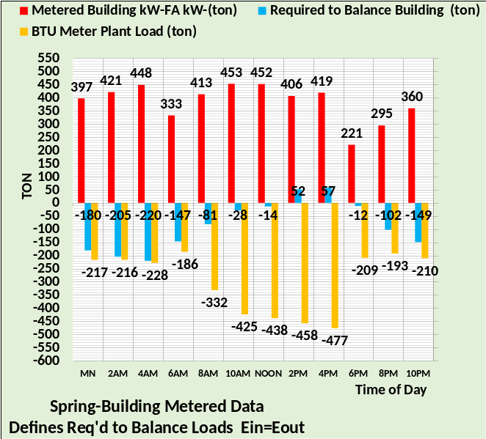
Figure 4: Spring weather energy balance
Figure 4 illustrates that fresh air heating only occurs at 4AM.
The weather data below is copied from the Executive Summary for convenient referral.

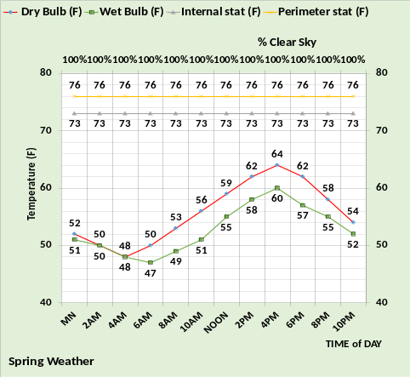
Figure 4a: Four season weather from Executive Summary

Wall transmission loads
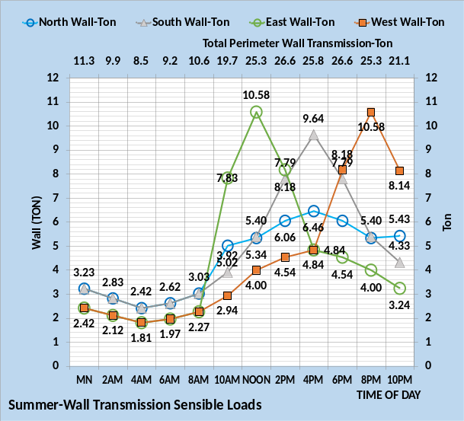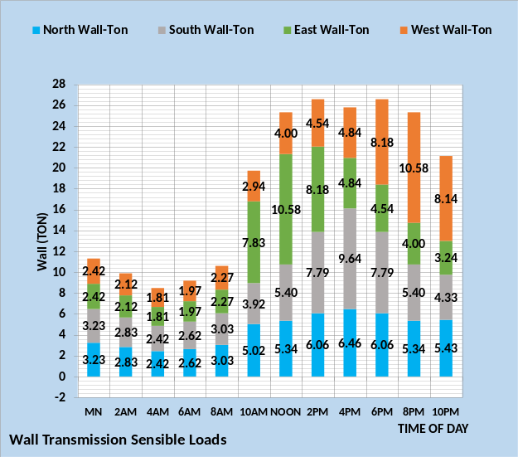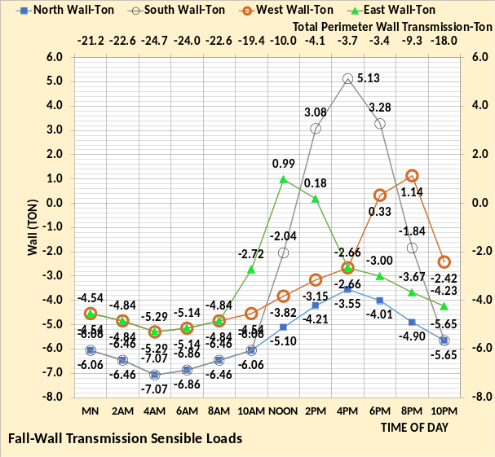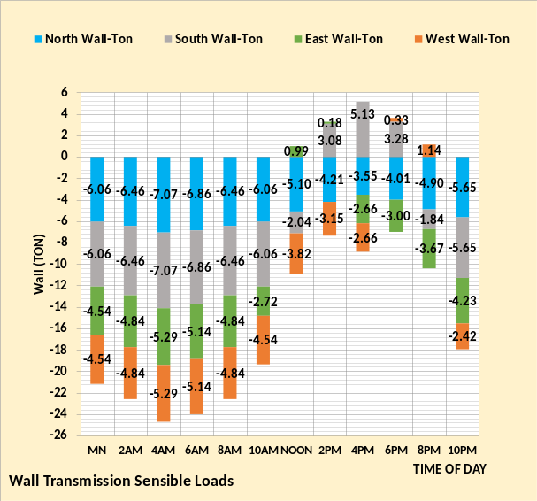
Figure 5: Wall transmission loads for summer & fall

The wall load, not including glass in the wall, is a function of temperatures and solar load on the wall. For clarity the Model data is presented in two forms by Figure 5. The left chart gives the wall transmission load for each wall and the right chart shows the sum of wall transmission load for each hour. Figure 5 illustrates the wall loads result in always cooling load for the summer and heating and cooling load for the fall weather conditions due to solar on the wall. The wall transmission load is delayed coming into the airconditioned space by about four hours due to the mass of the wall. Peak cooling, 5.13 ton, due to solar occurs on the Fall south wall at 4PM and then heat of 5.65 ton required six hours later at 10PM. Note the east wall cooling transmission peaks at about noon and the west wall peaks at about 8PM. The north/south wall transmission load would be the same value if not for the solar on the walls, the same being true for the east/west walls. Note the south wall goes positive, cooling load, during the afternoon due to solar while the north wall requires heat for all hours.

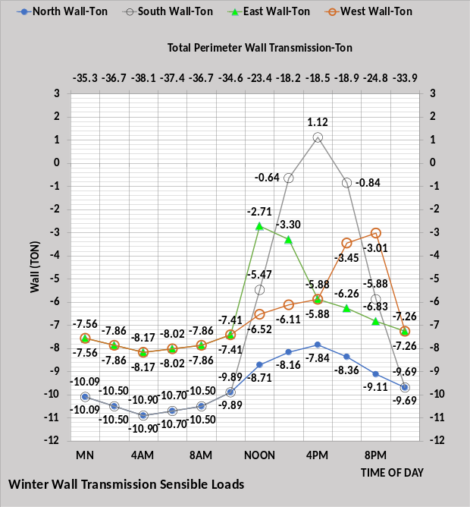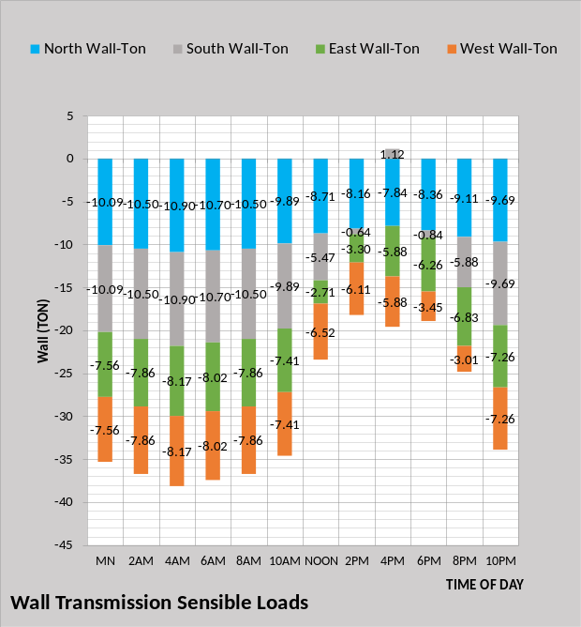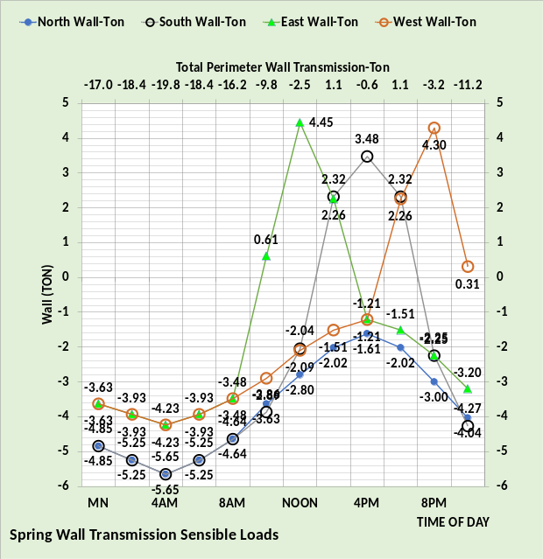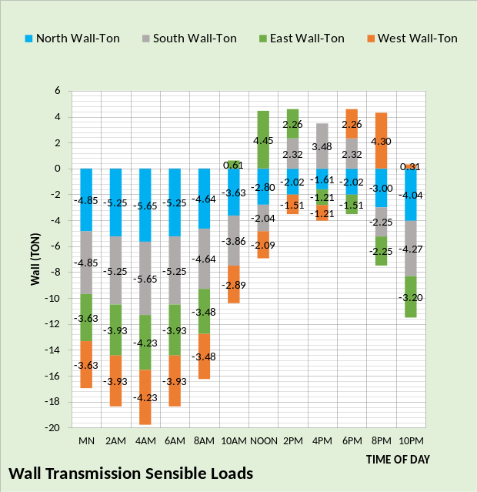
Figure 6: Wall transmission loads for winter & spring
Figure 6 illustrates the winter south wall always required heating except at 4PM. During the spring weather conditions the only wall not requiring cooling at some hours of the day was the north wall. The effect of solar load on the walls is small compared to the effect on the glass wall as shown below by Figure 16.

Glass Transmission Loads
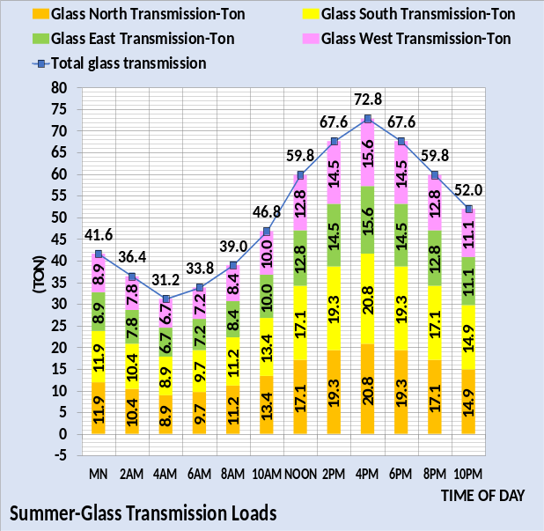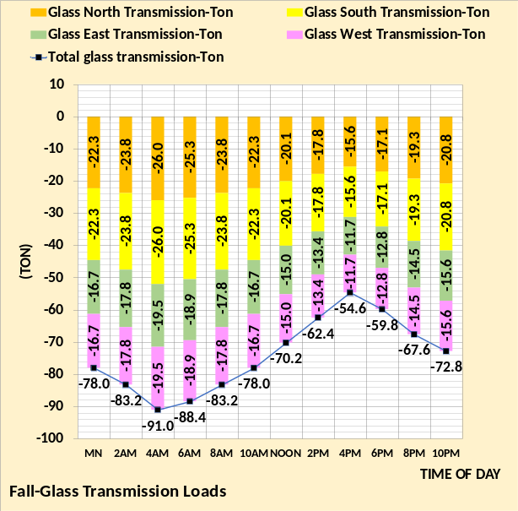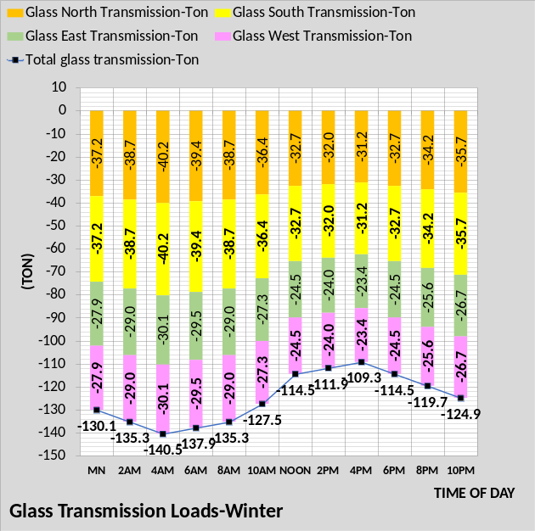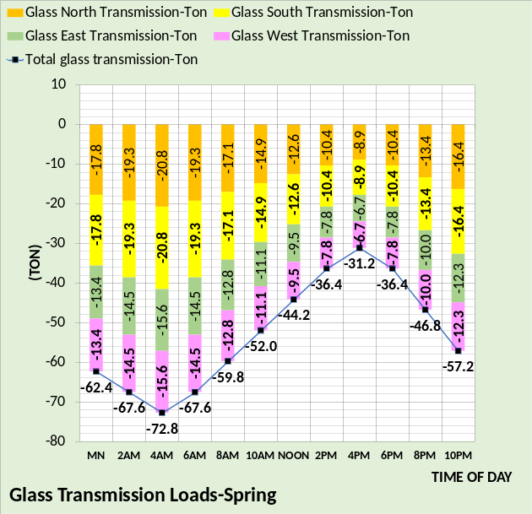
Figure 7: Glass transmission loads
Figure 7 gives the glass wall transmission load for each of the four walls, for each of the four seasons. The summer load peaks at 72.8 ton at 4PM and the winter peak heating load is 140.5 ton at 4AM. Comparing these glass transmission loads with the wall transmission loads of Figure 6 illustrates the glass loads are about three times greater. Figure 4 of Executive Summary shows the glass is 30% of the wall.
Next the wall and glass transmission loads are summed.

Wall & Glass Transmission Loads
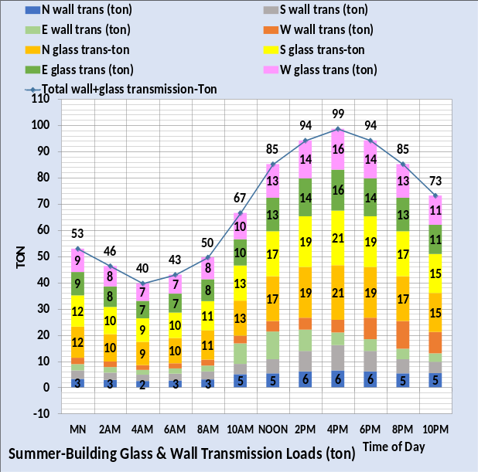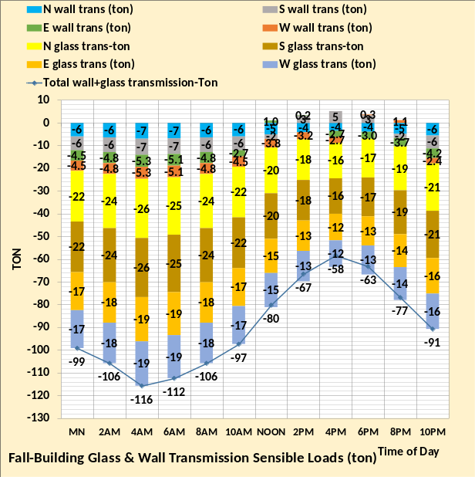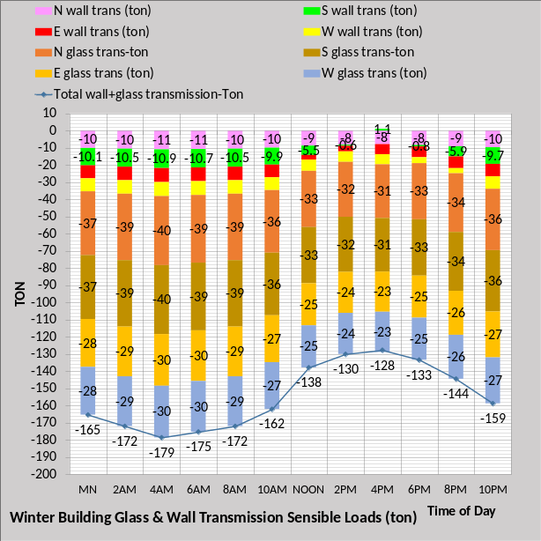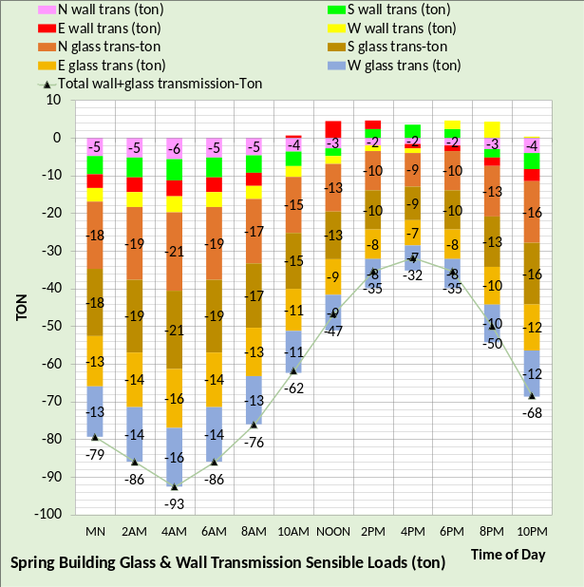
Figure 8: Glass plus wall transmission loads

Figure 8 illustrates that the summer peak wall cooling load of 99 ton occurs at 4PM design hour and the peak winter heating of -179 ton occurs at 4AM. The peak heating load for fall and spring weather days also occurs at 4AM with values of -116 ton and -93 ton.
Three additional wall loads must be considered, infiltration, return air energy transfer, and glass solar. These three additional loads significantly change the results of Figure 8. Solar load results in both heating and cooling required on one or more walls during the 24-hour day of fall, winter, and spring seasons.

Outside air Infiltration
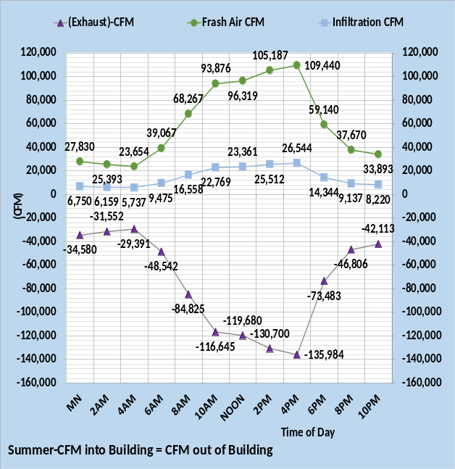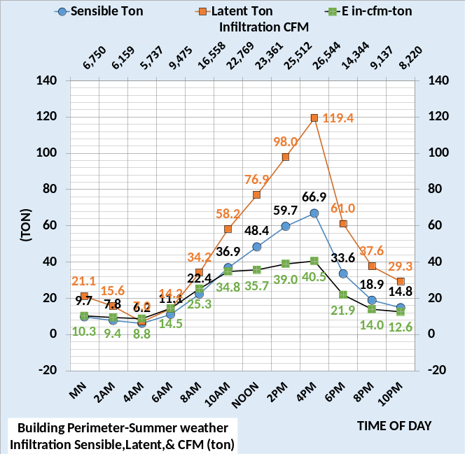
Figure 9: Summer outside air infiltration loads.
Infiltration^{8,9,19,20,21} is a function of several variables and will vary for each building as a function of many variables including initial construction and weathering of the structure. The left chart shows the cfm of air into and out of the modeled building. Fresh air cfm plus infiltration cfm equals exhaust cfm. Infiltration is input to the model as a max of .12 cfm per wall ft² at peak VAV AHU cfm, dropping proportional to the AHU cfm. Infiltration generates three loads on the building, sensible and latent loads plus an energy in term due to the cfm of infiltration (E in-cfm-ton). The infiltration sensible & latent loads are a wall load just as transmission is a wall load. The (E in-cfm-ton) load and latent load are transferred via return air to the inlet of the VAV fans. As modeled here, infiltration is a significate load but can be even greater as discussed in ASHRAE⁸ Handbook and ASHRAE literature⁹. It is of interest to note that Zheng⁵ did not address infiltration in the 19 ECMs of (CH-18-C005) of 2018, nor was return air energy transfer addressed. Apparently, the energy model used by Zheng does not have a building air side model.
The right chart of Figure 9 illustrates for this summer weather, Figure 4a, the latent load is significantly greater than the sensible load. The (E in-cfm-ton) load is a “change in internal energy” term, necessary for the Model to balance.

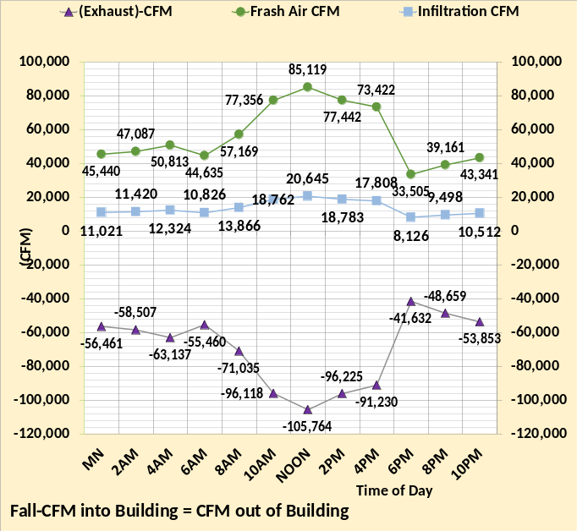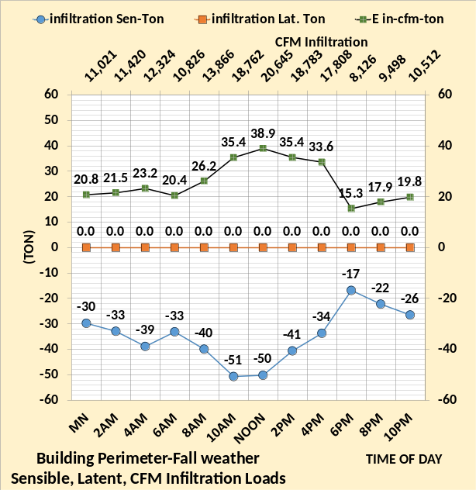
Figure 10: Fall weather outside air infiltration loads.
The left chart illustrates CFM balance. Fall weather conditions result in a zero latent load and the sensible load is a heating load. The (E-in-cfm-ton) load is a cooling load and about the same magnitude as the summer load. The infiltration sensible load is a wall load just as transmission is a wall load. The (E in-cfm-ton) load is transferred via return air to the inlet of the VAV fans.

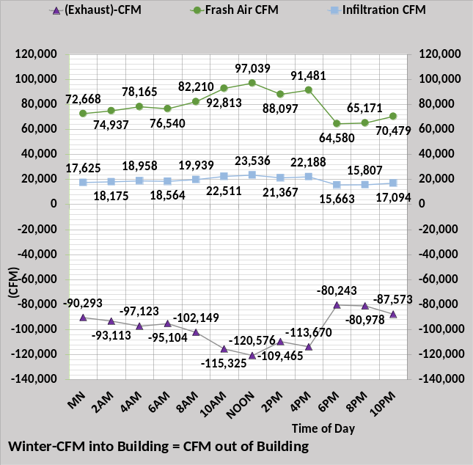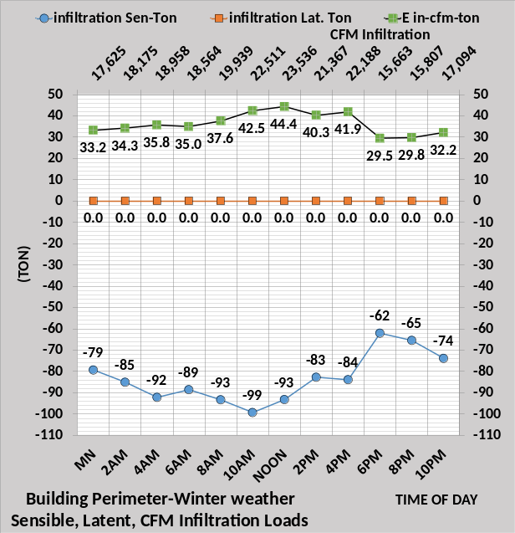
Figure 11: Winter weather outside air infiltration loads.
The left chart illustrates CFM balance. Winter weather infiltration results in a sensible heating load about twice the Fall weather conditions. The latent load is zero and the (E-in-cfm-ton) load is a little more than the summer and fall CFM loads.
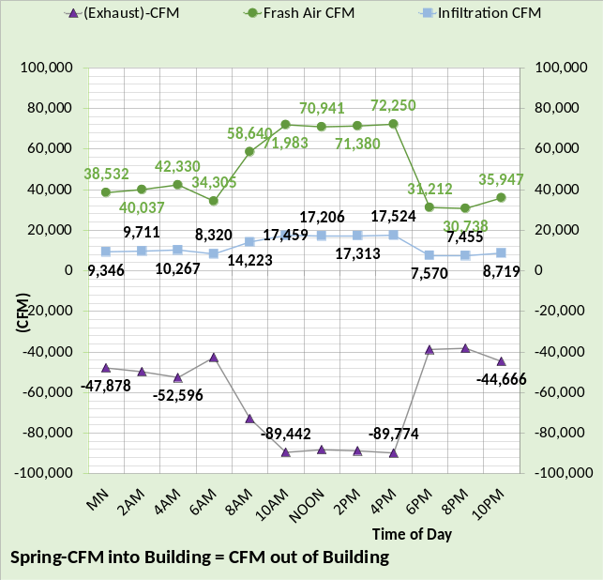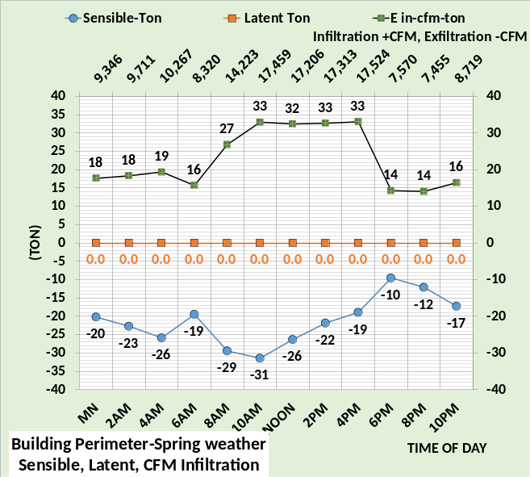
Figure 12: Spring weather outside air infiltration loads.
The left chart illustrates CFM balance. Spring weather infiltration loads are similar to the fall weather infiltration loads but a little less due to the moderate ambient temperatures.

Infiltration wall Load
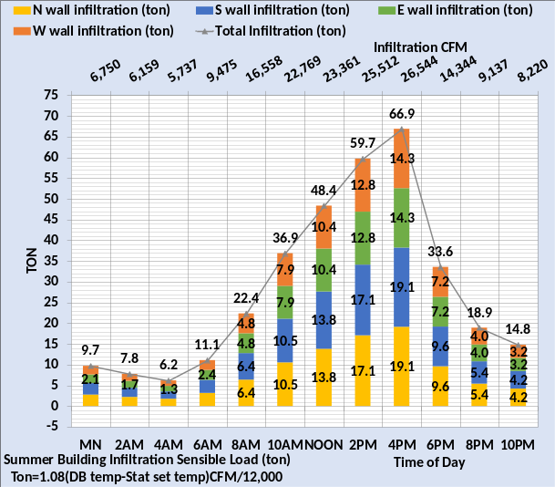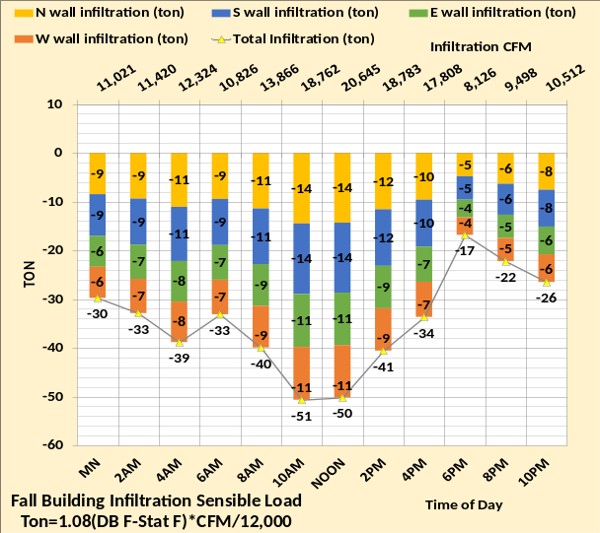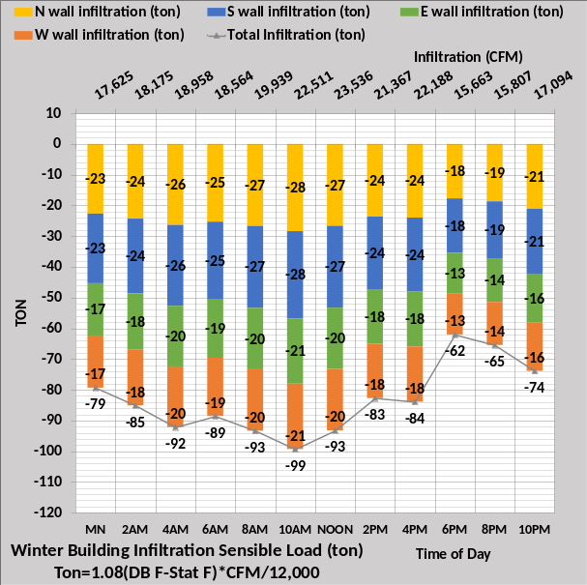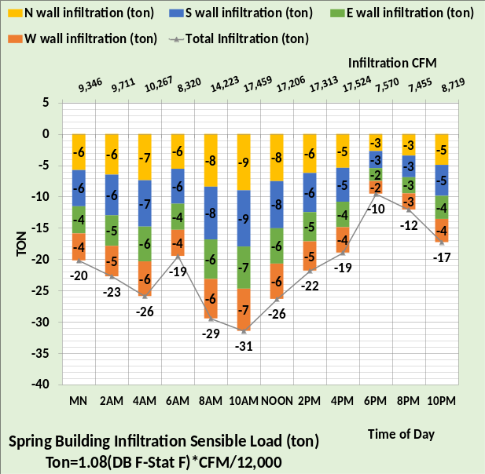
Figure 13: Infiltration sensible loads per wall.

Figure 13 summarizes the infiltration sensible wall loads for the four weather conditions. The infiltration sensible loads are allocated to each wall as a function of wall square feet. A real building will have different infiltration rates due to several variables with wind direction probably being the most determining condition. These wall loads will be summed with the other wall loads below.
As stated above these infiltration loads are assumed with not much understanding except that outside air infiltration does occur in many if not all buildings that do not have a building pressure control system installed.
Infiltration will be an impossible challenge to duplicate in a real building, defined here as unstable energy because it can change by the hour if not by the minute and there is no way to reasonably model the loads due to infiltration. Infiltration must be eliminated before a model of a building’s energy consuming characteristics can be achieved with repeatable results. Return air energy transfer also fits the criteria as unstable energy, discussed next.
Return air energy transfer to perimeter load

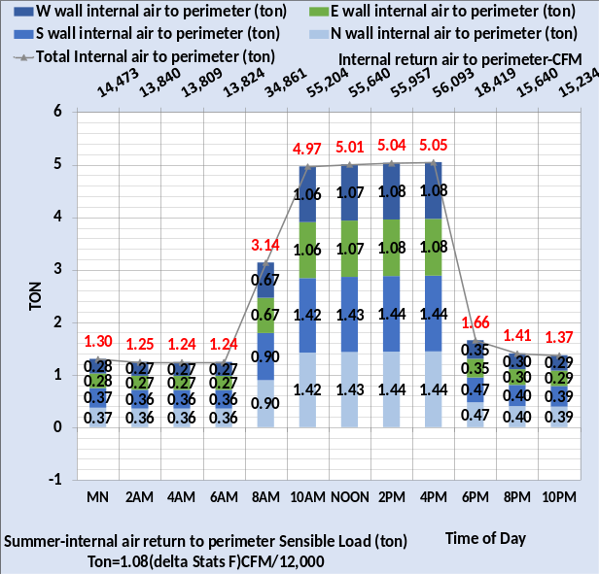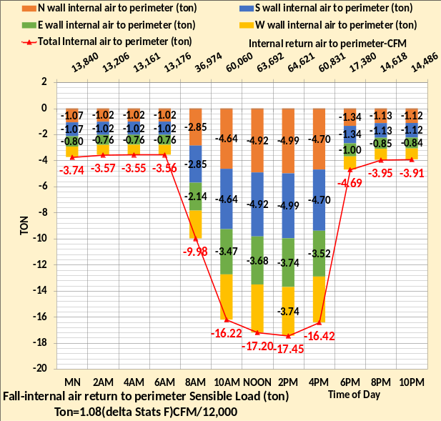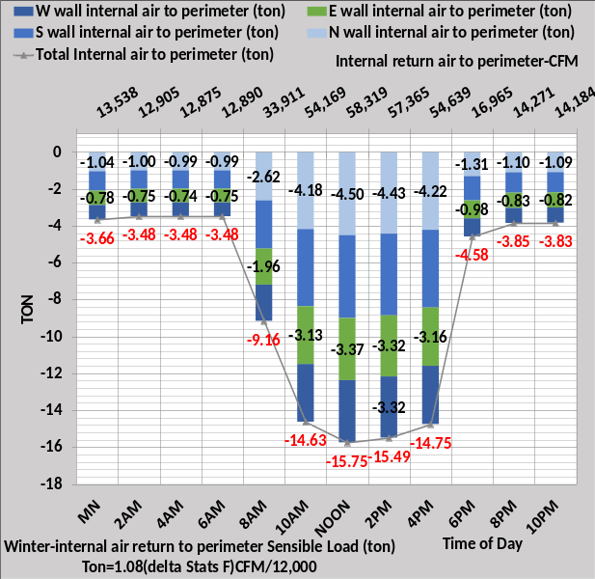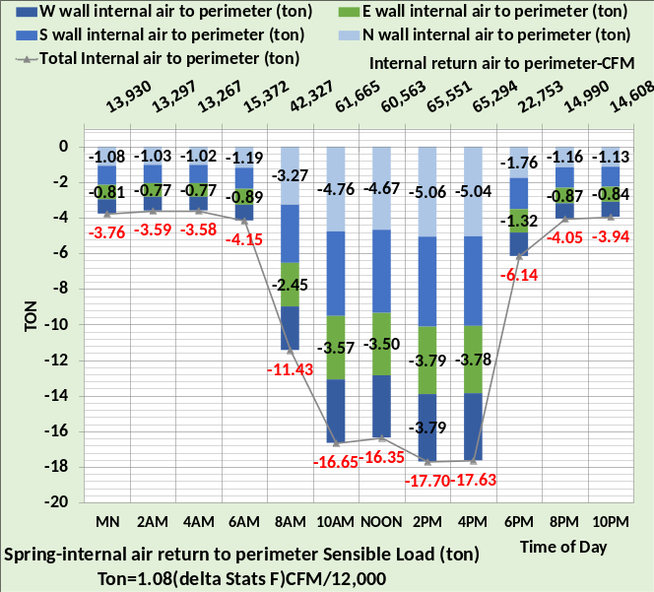
Figure 14: 30% of internal air returns to perimeter before returning to VAV AHU
Because the internal and perimeter stats are set at different values there is an energy transfer if interior return air enters the perimeter zone. The model assumes 30% of interior air comes into the perimeter zone before returning to the VAV AHU. As with infiltration, this is a perimeter wall load allocated to each wall proportional to square feet of the walls.
Figure 14 shows this term adds cooling load during the summer and a heating load for the other three seasons.
Summer 10AM (ton) = 1.08*(73F interior stat-72F perimeter stat) * 55,204cfm/12,000
= 4.97 ton as shown on Figure 14 top left chart
Winter 10AM (ton) = 1.08*(73F interior stat -76F perimeter stat) * 54,169 cfm/12,000
= -14.63 ton as shown on Figure 14 bottom left chart.
To eliminate this “ghost energy” condition simply set all stats to the same temperature.
Wall Loads due to Transmission, Infiltration & Return Air Transfer
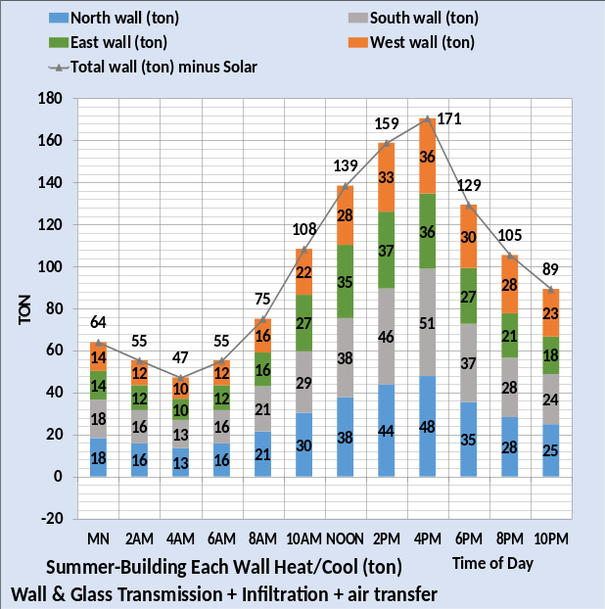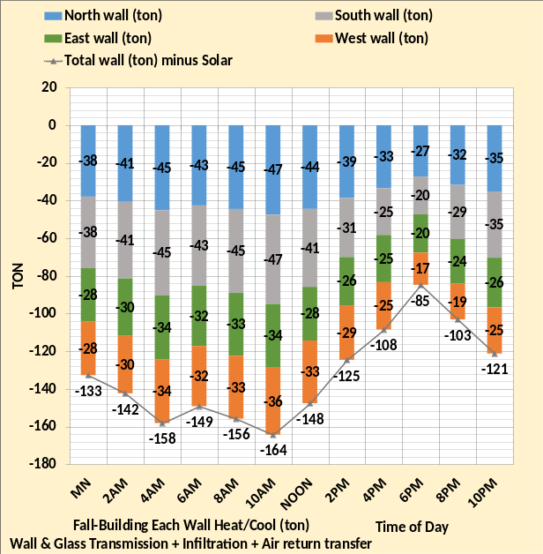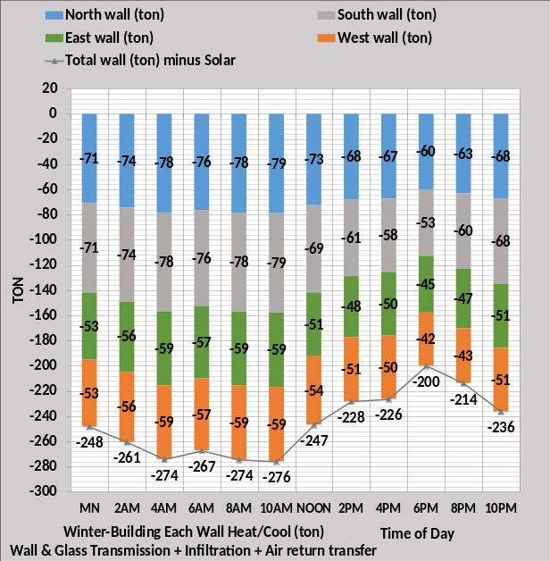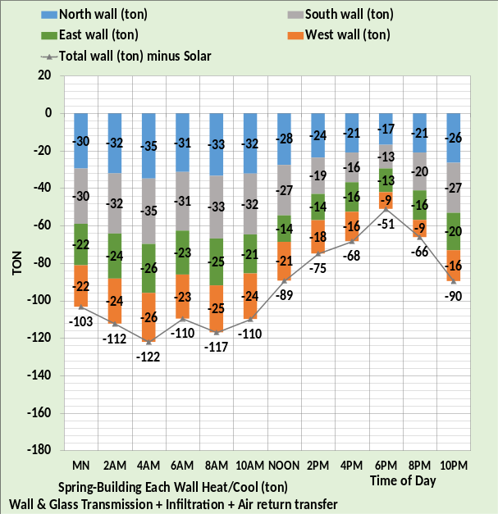
Figure 15: Transmission, Infiltration & Return Air Energy Transfer Total loads
Figure 15 illustrates the summed wall loads before glass solar load is considered. The glass solar load is different for each wall and varies during the day, therefore requires each of the four walls to be calculated separately resulting in the possibility of both wall heating and cooling occurring during a 24-hour day. The loads of Figure 15 result in a summer peak cooling load of 171 ton. The 4PM summer glass solar load of 85-ton, Figure 17, results in 255 ton of Figure 18. Figure 15 at 10AM gives a winter peak heating load of -276 ton, and Figure 17 gives a glass solar load of 114 ton for 10AM resulting in a reduction in the 10AM heating load to -162 ton. Next glass solar load will be given for each hour and season.

Glass Solar loads
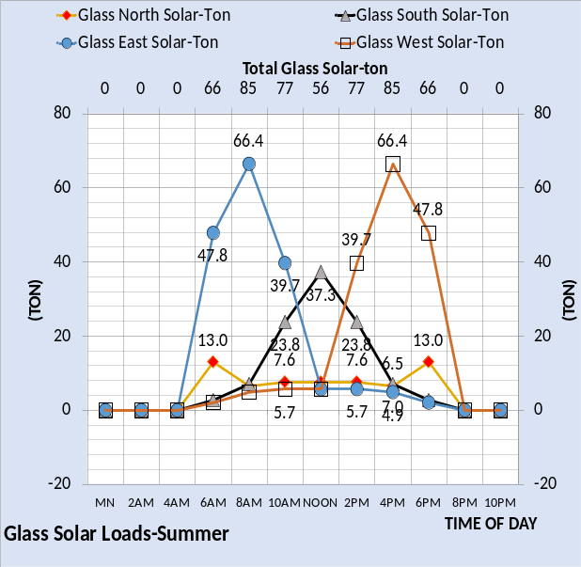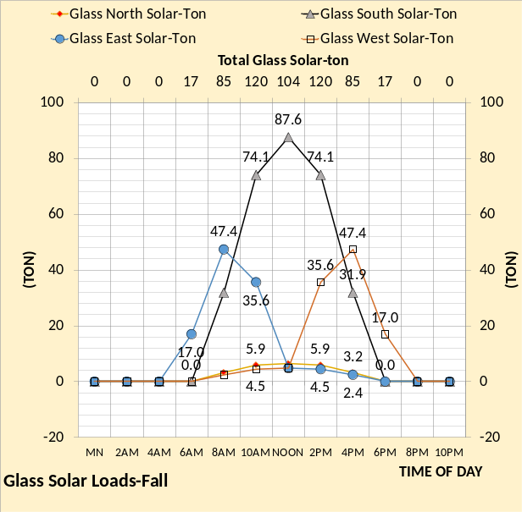
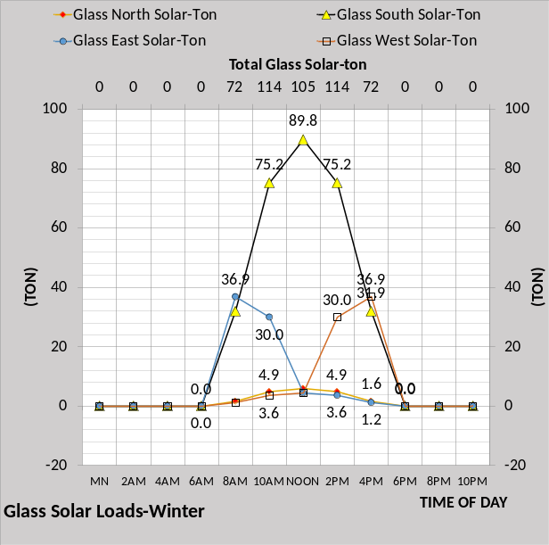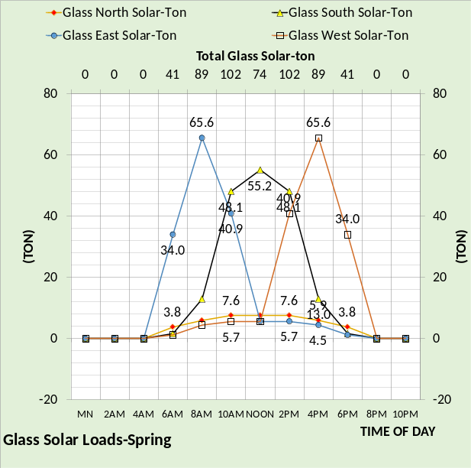
Figure 16: Solar loads on each wall
The summer solar load is for July 23, the fall solar for October 23, the winter solar for January 21, and spring solar is for April 20. The secondary horizontal axis of each chart gives the total glass wall solar ton for each hour; however, the total is for information only and cannot be used in the model because each wall must be addressed separately. Figure 16 illustrates the complexity of the solar load on this building. The building has 30% wall glass, defined by Executive Summary Figure 4, and is orientated as given by Figure 4. A change to any one of these design features will have a significant effect on the solar load on the building. Again, the total solar value cannot be used in the model because each wall is a separate calculation demonstrated by Figure 16. Figures 16 & 17 are of the same data with Figure 17 more clearly showing the solar load on each wall.

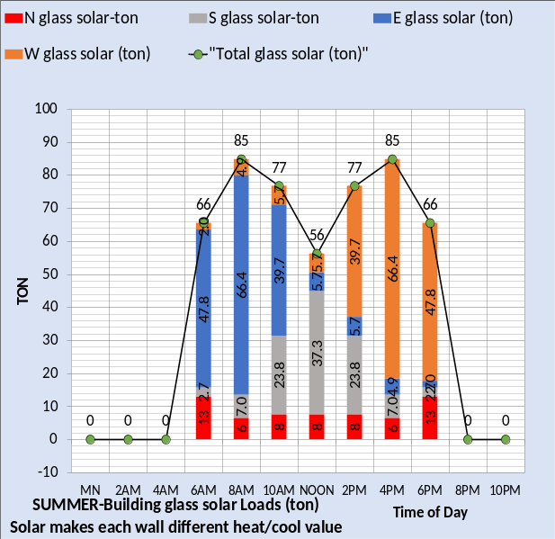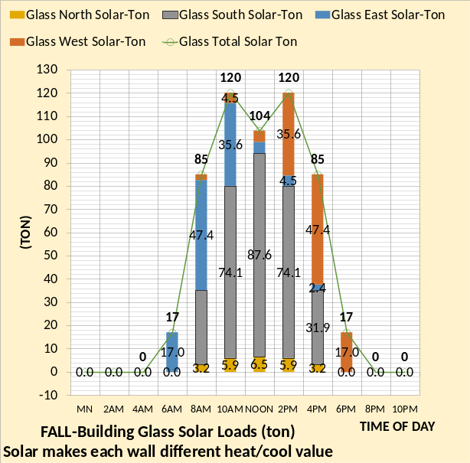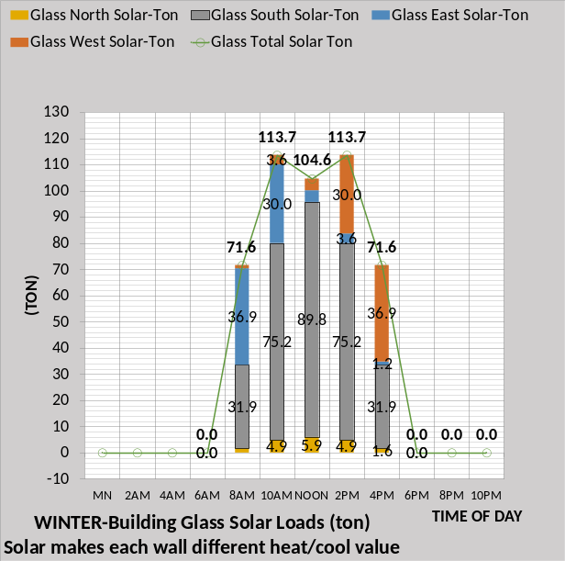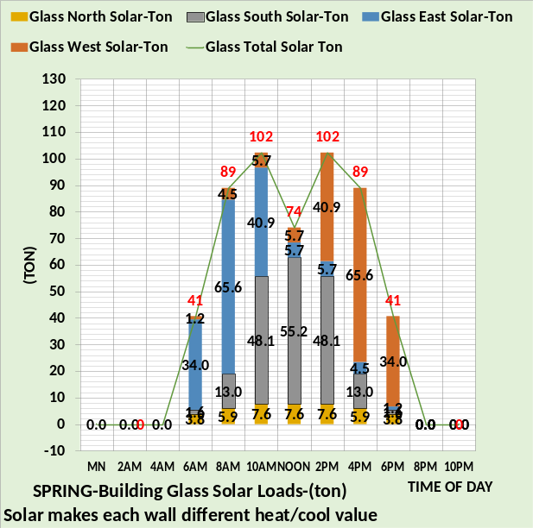
Figure 17: Solar load on each wall of building.
Figure 17 shows the fall weather conditions have the greatest solar load on this building and the summer has the least. The east and west solar loads dominate in the summer, and the south dominate during the fall and winter seasons for this building as configured and oriented. The spring solar loads are about the same for east, west, and south. The next charts, Figure 18, combine Figure 15 wall loads with Figure 17 solar loads resulting in both wall heating and cooling during fall, winter, and spring seasons.

Cooling and/or heating on each wall
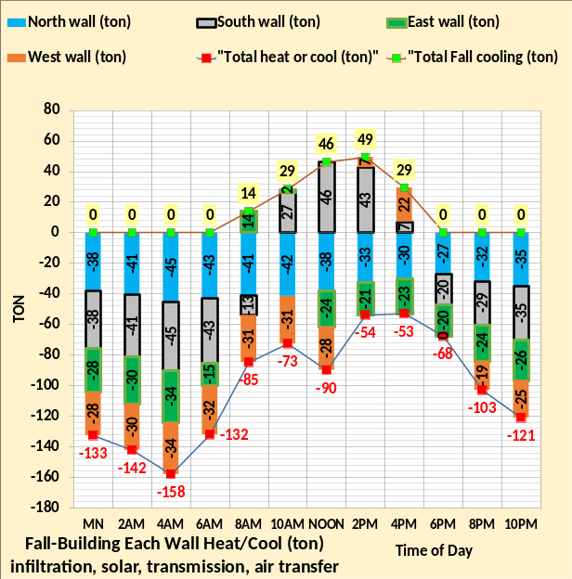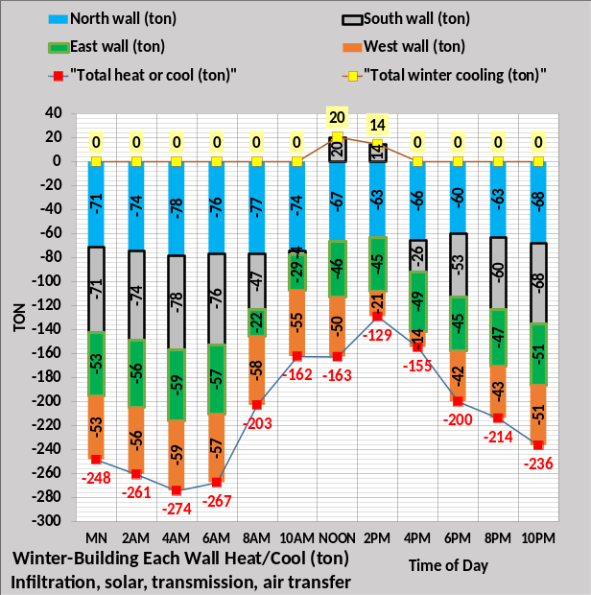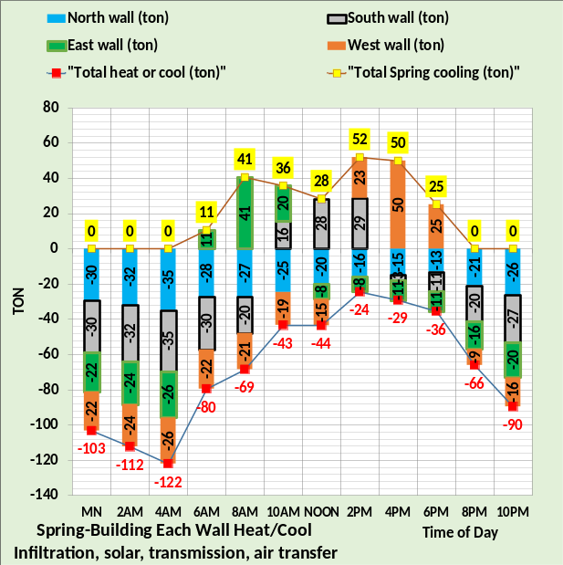
Figure 18: Net cooling and heating on each wall
Figure 18 gives the net load for each season on each wall for each hour. At noon the summer cooling loads are north 15 ton, south 75 ton, east 40 ton, & west 34 ton. The total summer wall load is 195-ton cooling load at noon increasing to 255 ton at 4PM. For fall weather at noon the south wall requires 46-ton cooling, and the other 3 walls require total heating of 90 tons. Note that at 8AM the east wall requires 14-ton cooling and at 4PM both the south and west wall require cooling. For winter at noon the south wall requires 20-ton cooling, and the other 3 walls require heating of a total of 163 ton. Spring weather results in cooling required, at some hour, on all walls except the north wall. Note that 50-ton cooling is required on the spring west wall at 4PM reducing to 25 ton at 6PM.
One VAV air handler is on each of the 26 floors providing 55F supply air that is heated to 90F for the perimeter when heat is required.
Summer weather perimeter loads
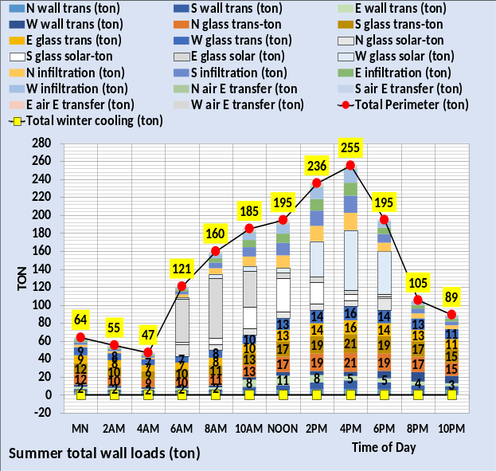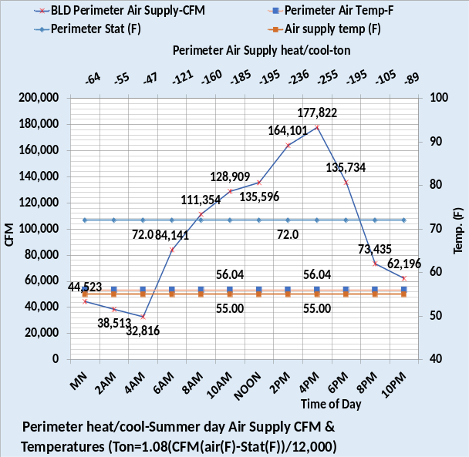
Figure 19: Summer perimeter loads
The left chart of Figure 19 shows the 5 loads on each wall for a total of 20 loads on the four walls. The 5 wall loads are, wall transmission, glass transmission, infiltration, return air energy transfer, and solar load. Figure 19 chart on the left is the same data as the summer chart of Figure 18 but with all 20 loads shown.
The right chart of Figure 19 shows air temperatures and perimeter cfm to meet the perimeter load defined by Figures 18 & 19 left charts. The supply air temperature off the coil is 55F and the perimeter fan powered terminals add heat to the 55F air resulting in 56.04F air to the perimeter to meet the perimeter load.
For example, at noon the perimeter load is.
Air Ton = 1.08*(135,596 cfm) * (72F – 56.04F)/12,000 = 195 ton as shown on the left chart.
Next the fall weather conditions.

Fall weather perimeter loads
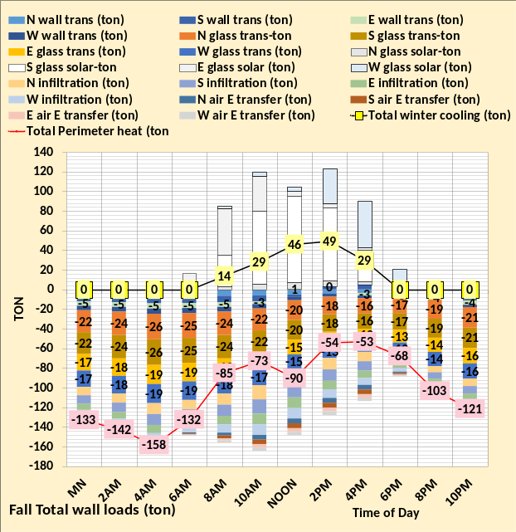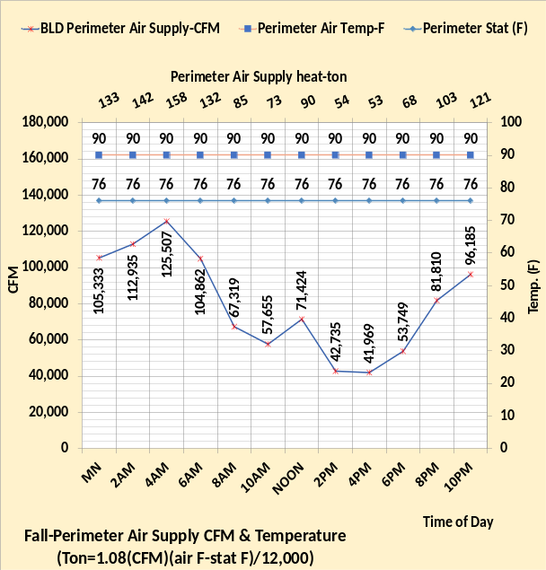
Figure 20: Fall weather Perimeter loads.
The fall weather conditions result in both heating and cooling required by the building perimeter as given by Figure 18 & Figure 20. The interior of the building always requires cooling; therefore, the perimeter cold weather cooling is added to the interior cooling load to give a total cooling load. The right chart of Figure 20 shows the air temperatures and air cfm required to meet the perimeter heating load shown by the left chart and the secondary horizontal axis of the right chart.
The temperature of the heating air is set at 90F as given by Figure 4 of Executive Summary, therefore the 55F supply air from the coil must be heated to 90F to meet the perimeter heat loads defined by Figure 20.

At noon; Air Ton = 1.08*(71,424 cfm) * (90F – 76F)/12,000 = 90-ton heat load as shown on chart.

The perimeter heat load defines the perimeter air CFM and therefore defines the CFM of 55F air that must be heated to 90F by the perimeter fan powered terminals. The perimeter air is heated to 88.96F by air reheat and the perimeter fan powered terminals add heat to arrive at 90F air delivered to the perimeter to meet the heating load.

Fall Weather Perimeter air heat
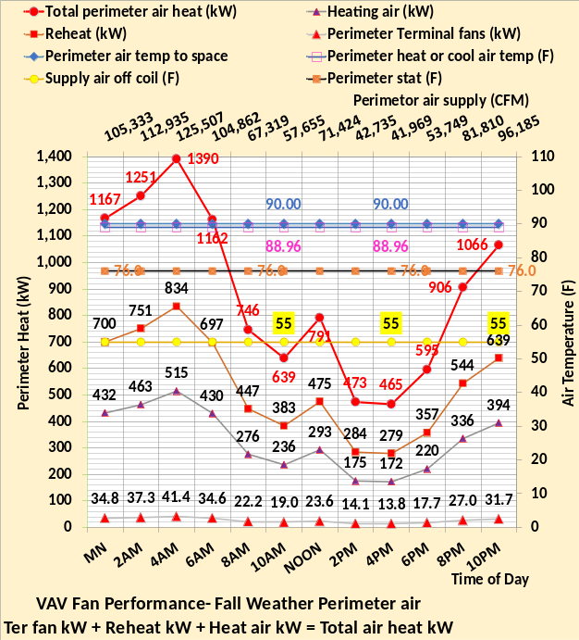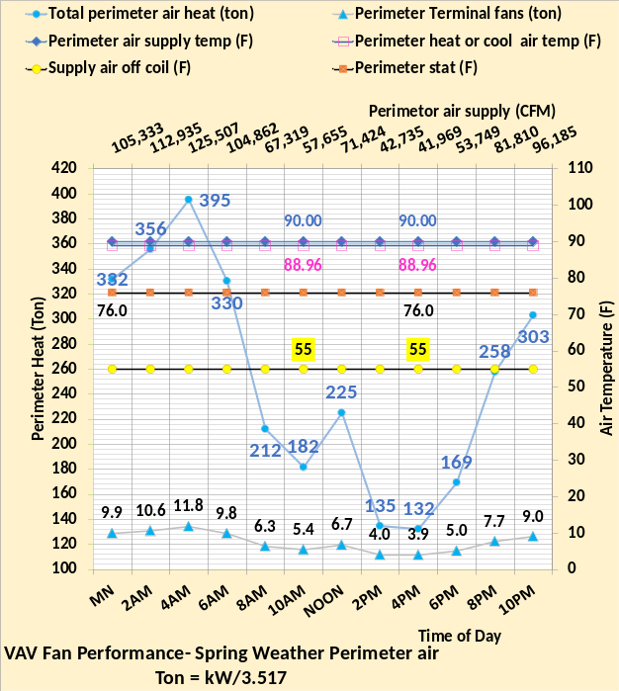
Figure 21: Fall weather perimeter air heat

To get 90F heating air for the perimeter the 55F supply air off the coil must be heated. The CFM of 90F air to meet the load is defined by Figure 20.
At 4AM Heating air (ton) = 1.08 * (125,507) * (90F – 55F)/12,000 = 395 ton as given by Figure 21 right chart.
395 ton * 3.517 kW/ton = 1,390 kW as given by Figure 21 left chart.
The 4AM kW heat is provided by 834 kW air reheating from 55F to 76F, and 515 air heat kW from 76F to 88.96F air and the fan powered terminals add 41.4 kW to heat the air from 88.96F to 90F, for a total of 1,390 kW as shown on Figure 21 left chart.

At noon the total kW heat is shown by Figure 21 left chart as 791 kW, the sum of three terms.
Noon heat kW = reheat 475 kW + heating air 293 kW + perimeter terminal fans 23.6 kW = 791.6 kW

The right chart of Figure 21 shows the load (ton) the perimeter air heat adds to the building plant load.
At noon perimeter terminal fans = 23.6 kW/3.517 kW/ton = 6.7 ton
At noon perimeter air heat & reheat = (475 kW + 293 kW)/3.517 kW/ton = 218.4 ton
Therefore, total perimeter air heat = 6.7 ton + 218.4 ton = 225 ton as shown on the right chart.

Winter weather perimeter loads
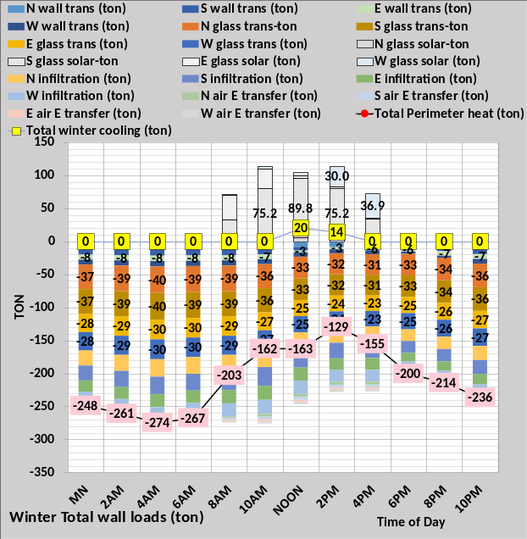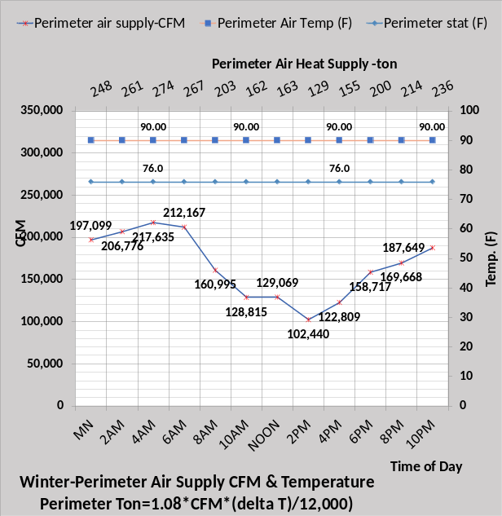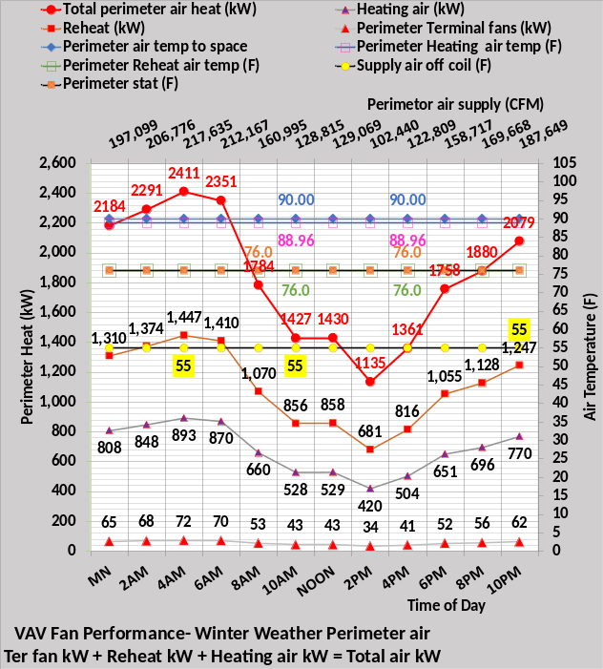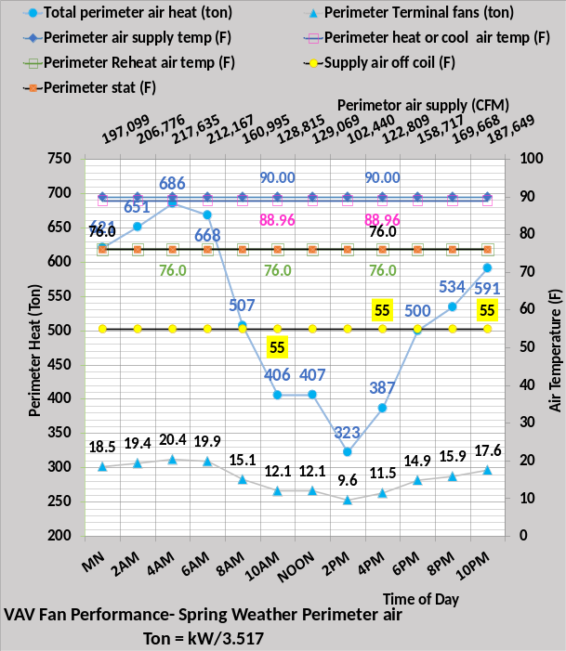
Figure 22: Winter weather perimeter loads & air heat
Figure 22 illustrates the increased heat required during the winter weather. Compared to the fall weather of Figure 21 the 4AM kW heat increased from 1,390 kW to 2,411 kW, a 73% increase.

Spring weather perimeter loads

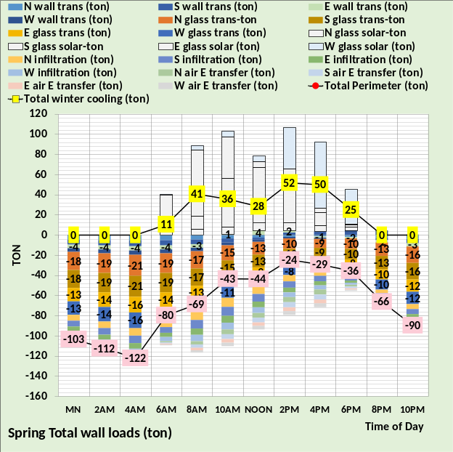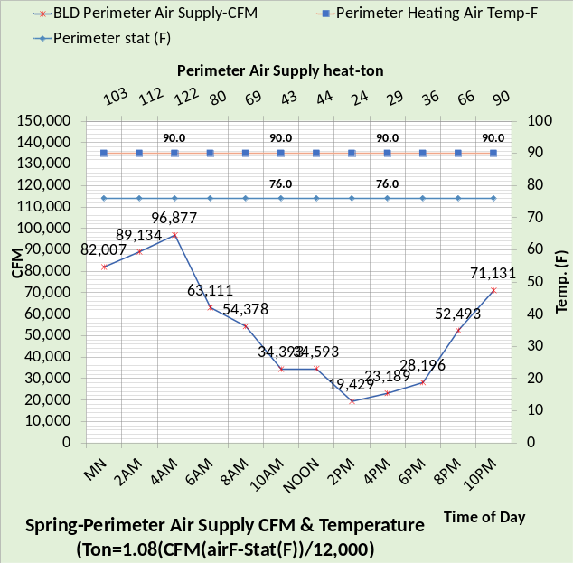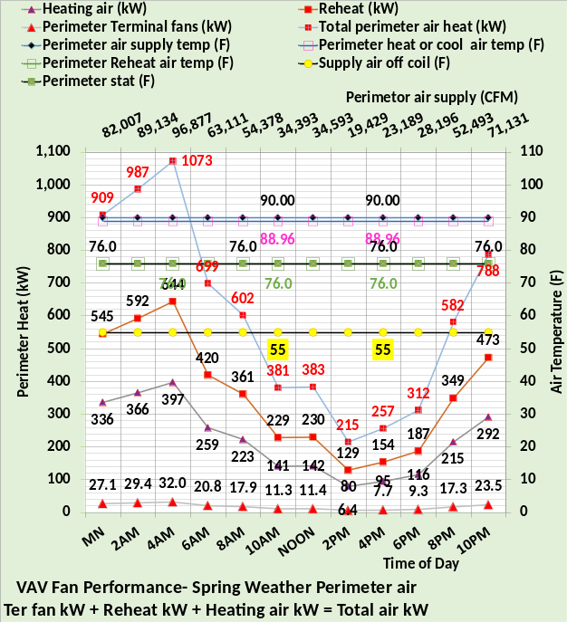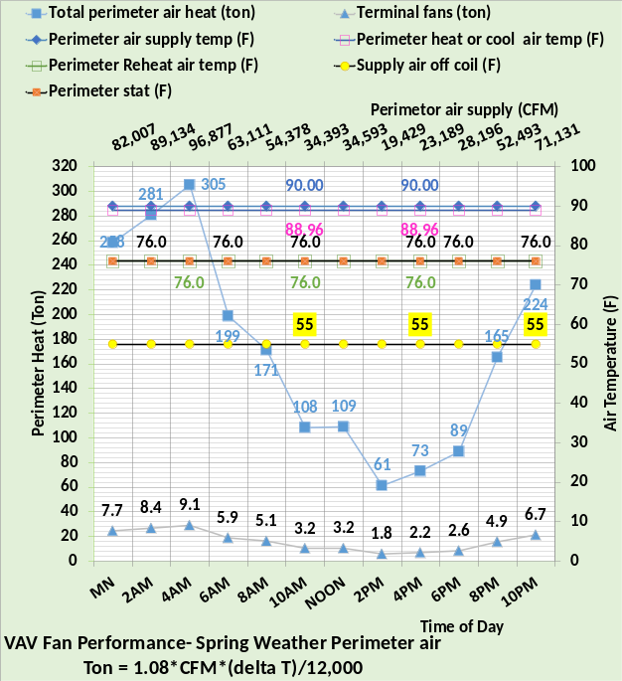
Figure 23: Spring weather perimeter heat.
Compared to fall weather the warmer spring weather results in less perimeter heat required.
Next, we look at the building interior loads.

Interior cooling loads
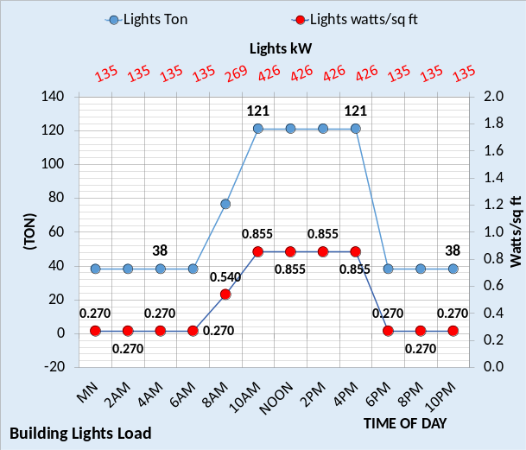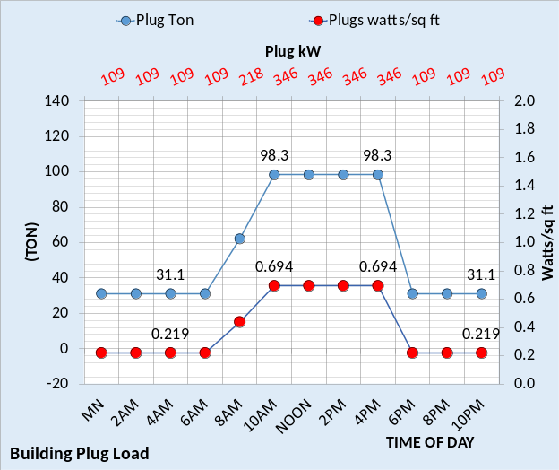
Figure 24: Lights and plug loads
The lights¹⁷ and plug¹⁸ loads are modeled the same for all four seasons as given by Figure 24. These values should be closely estimated for a real building because the values have a significant effect on the day EUI of the building. Any parking lot lights or other lights or plug loads that do not contribute to the plant load should be removed from the model kW values of Figure 24 as addressed above.

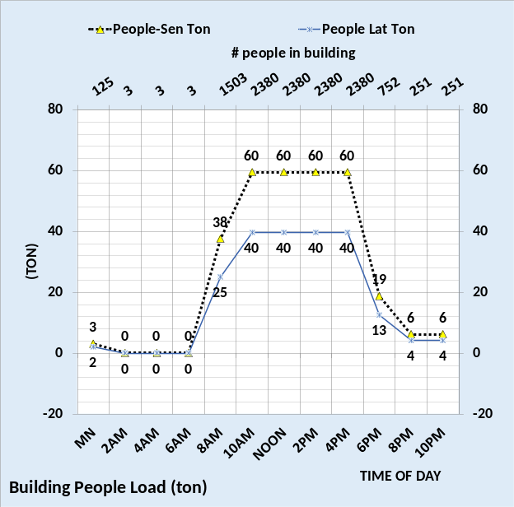
Figure 25: People load
The people load is also modeled the same for all four seasons. The people’s latent load and all other latent loads will be addressed below. The Figure 25 values should be carefully estimated for real buildings.

Perimeter cold weather cooling loads
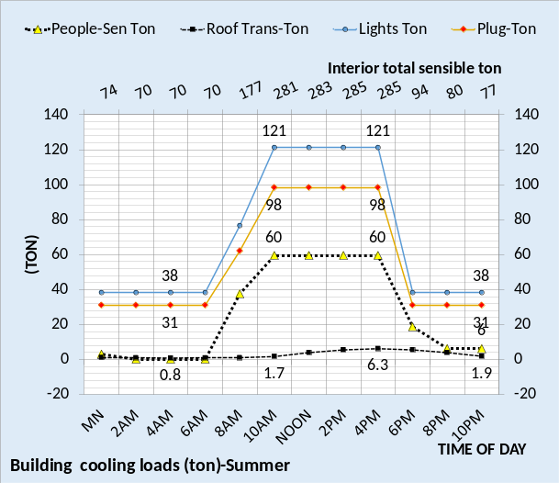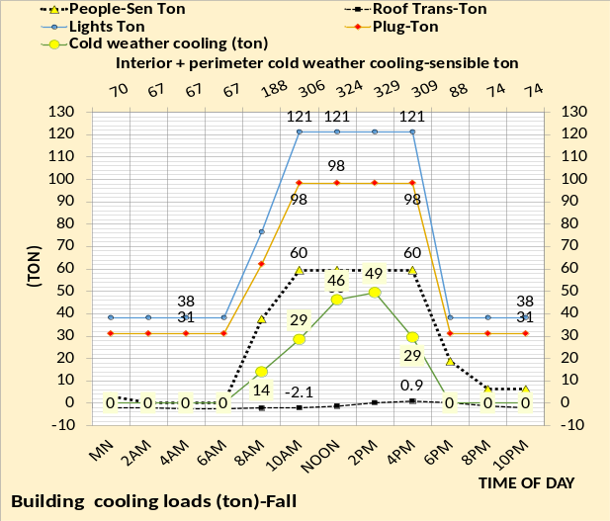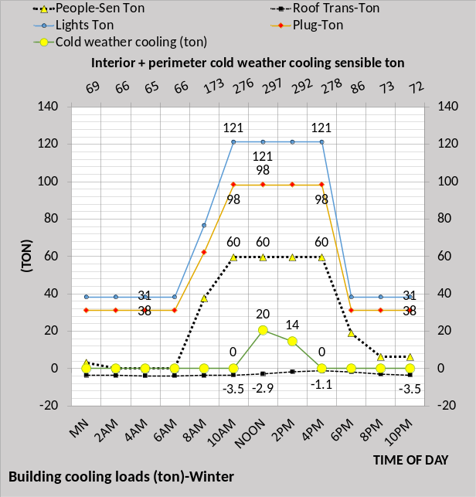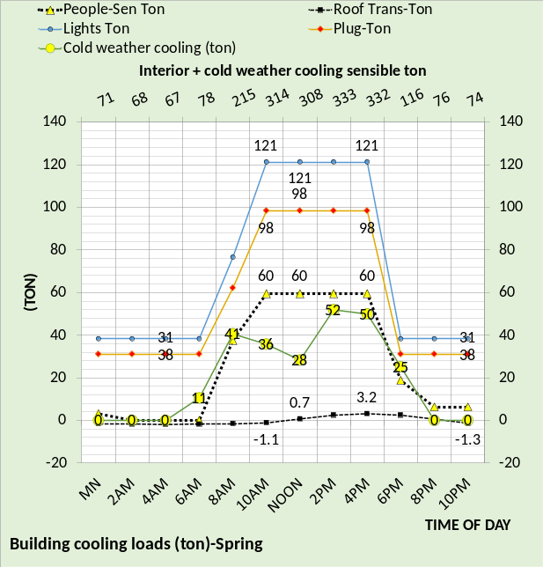
Figure 26: Interior plus perimeter Cooling Loads
As previously stated, the perimeter cold weather cooling load due to solar, see Figure 18, is added to the interior cooling load. The secondary horizontal axis of Figure 26 gives the total cooling load for each season for the weather as defined above in the Executive Summary. For example, spring weather at 10AM, cold weather sensible cooling is 36-ton, people 60-ton, plugs 98-ton, lights 121-ton, for a total of 315 ton. The minus roof 1.1-ton gives 314-ton total cooling load on the secondary horizontal axis.
Next, we will define the supply air cfm and temperature to meet this interior plus perimeter winter cooling load.

Interior air supply for summer & fall
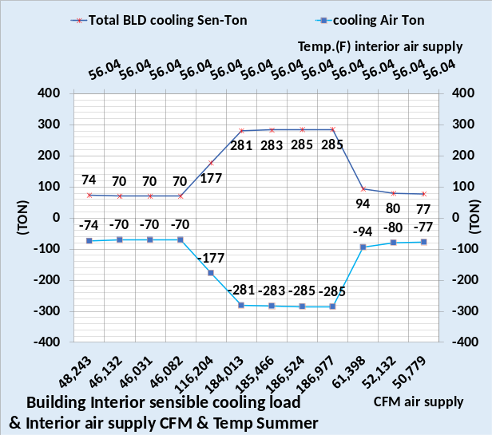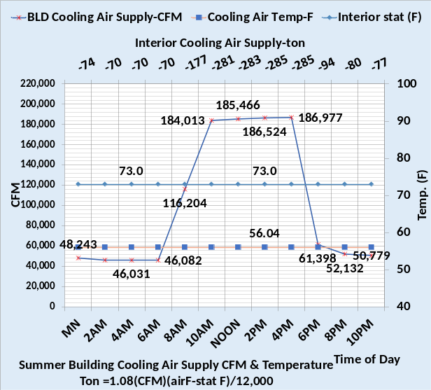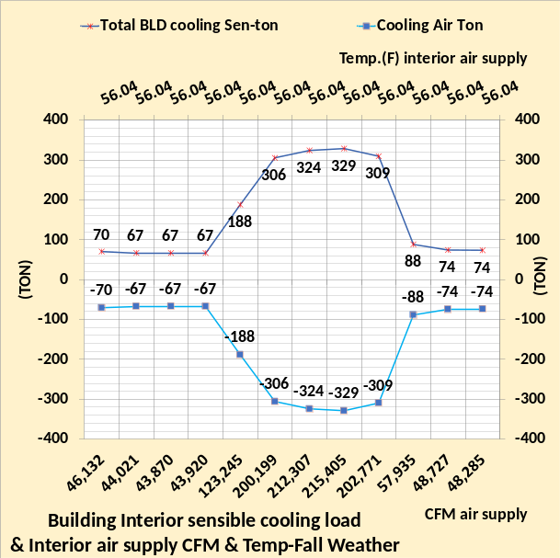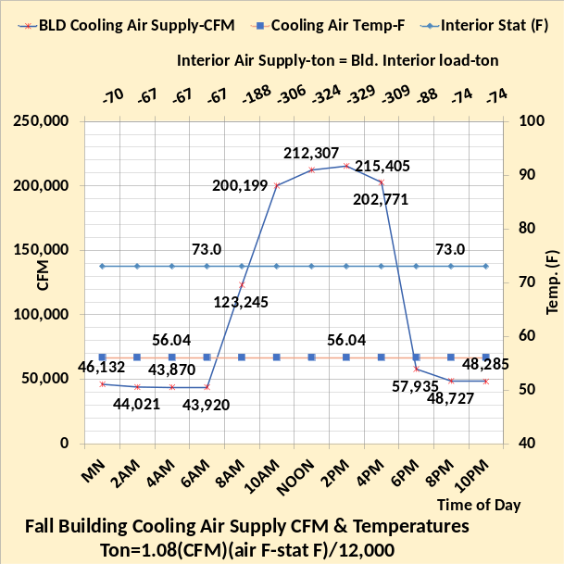
Figure 27: Interior cooling air for summer and fall weather
The interior cooling loads for summer are a little less than the fall weather values because the fall weather interior cooling includes the perimeter cooling that can occur during solar hours as given by Figure 26. Note that when the sun is down the interior cooling load is only affected by the relatively small roof load. The air temperature to the interior is 55F off the coil and heated to 56.04F by the fan powered terminals. Figure 27 defines the interior supply air cfm and temperature to meet the load, to be added to the perimeter cfm to define the VAV fan cfm. Figure 28 will show the winter and spring building internal loads.

Interior air supply for winter & spring

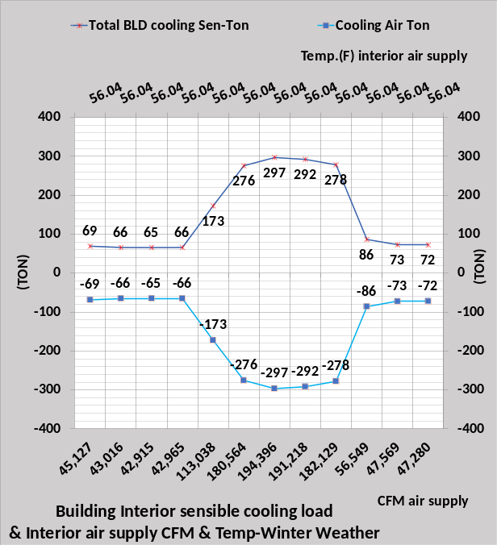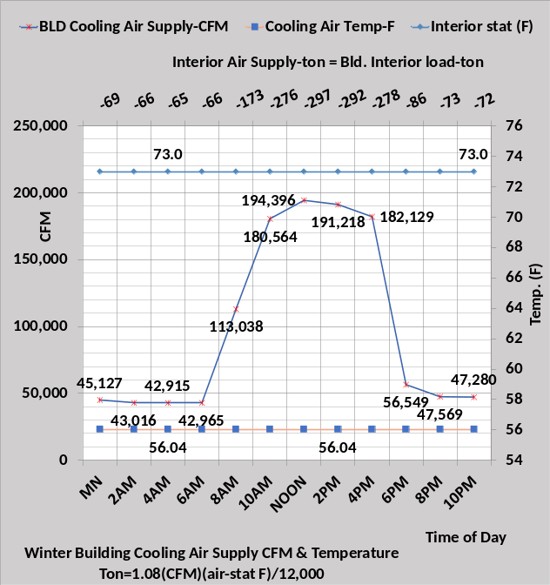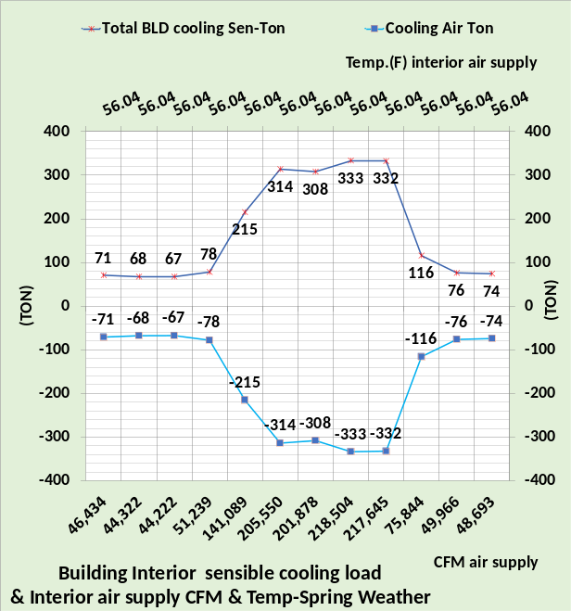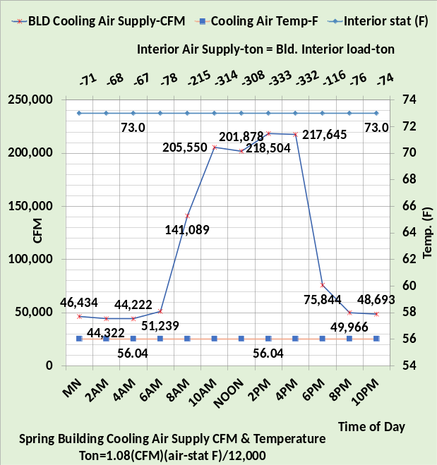
Figure 28: Interior cooling air for winter and spring weather
Figure 26 defined the building interior load for the four seasons and Figures 27 & 28 define the interior air supply temperature and cfm. Consider the spring interior load (ton) at noon.

Ton = 1.08 * 201,878 cfm * (56.04F – 73F)/12,000 = 308 ton as shown on the secondary axis.

Next, we will add the interior and perimeter loads see by the VAV fans.

Building Interior + Perimeter Loads
The above determined the interior and perimeter loads and the following will define the return air to the VAV fans inlet.
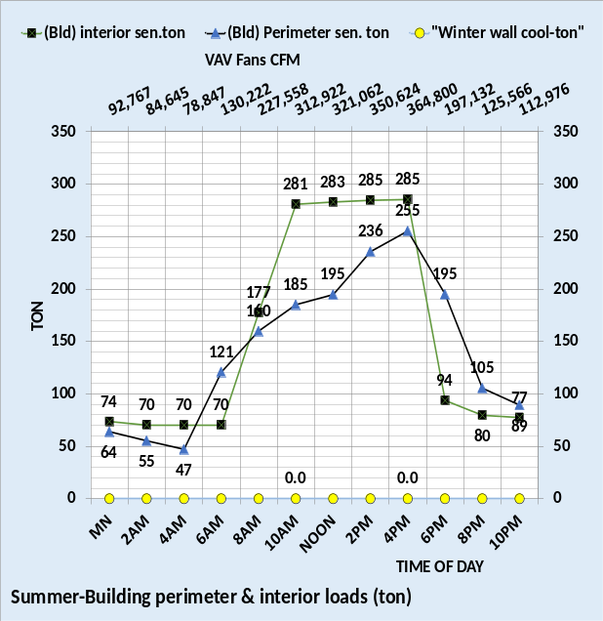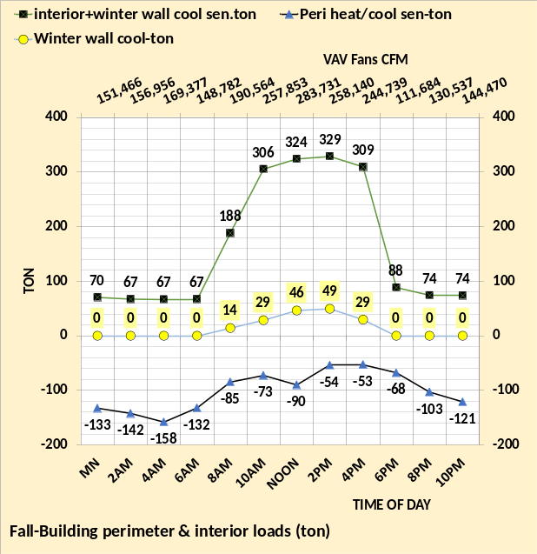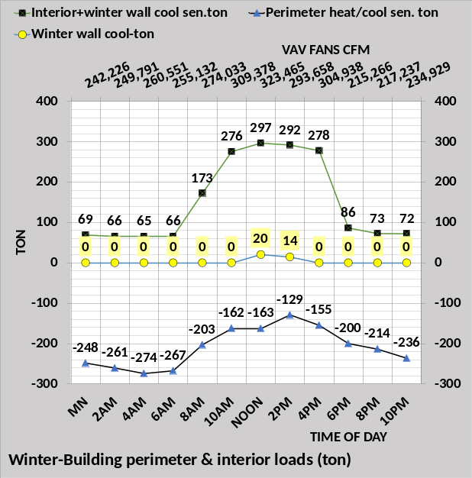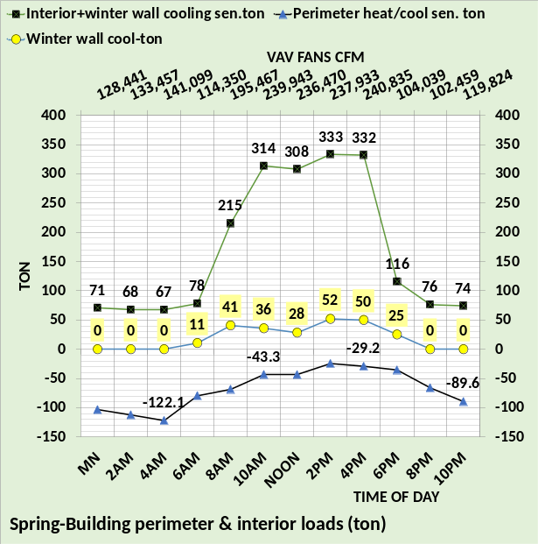
Figure 29: Interior & perimeter loads & VAV fans CFM
Figure 29 gives the building interior and perimeter loads and the VAV fans CFM to meet the loads. The cold weather wall cooling load is shown for fall, winter & spring seasons but as previsouly stated this load is in the interior cooling load. The VAV fans provide 55F supply air to both the interior and perimeter of the building. Perimeter heat load requires heating the 55F perimeter supply air to 90F, as discussed above.

Interior & perimeter air supply & return
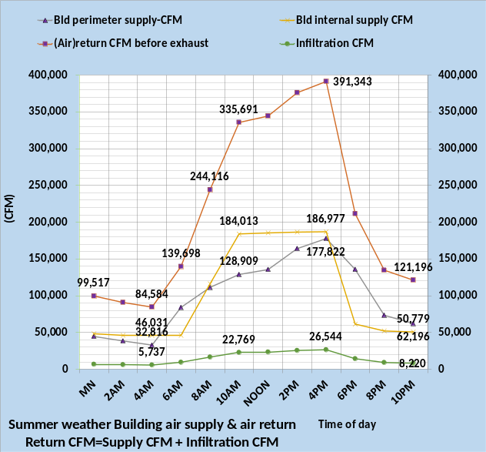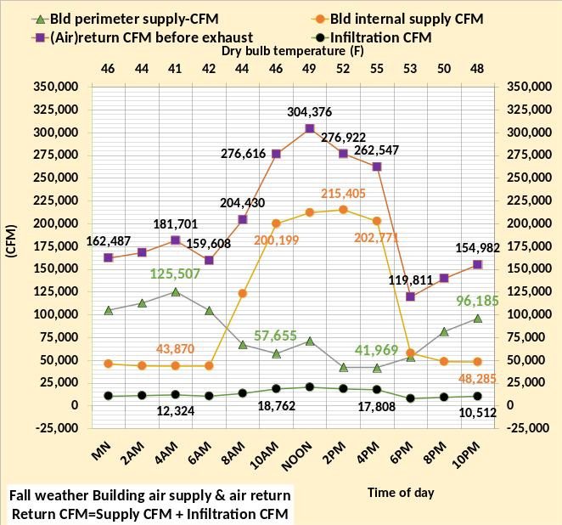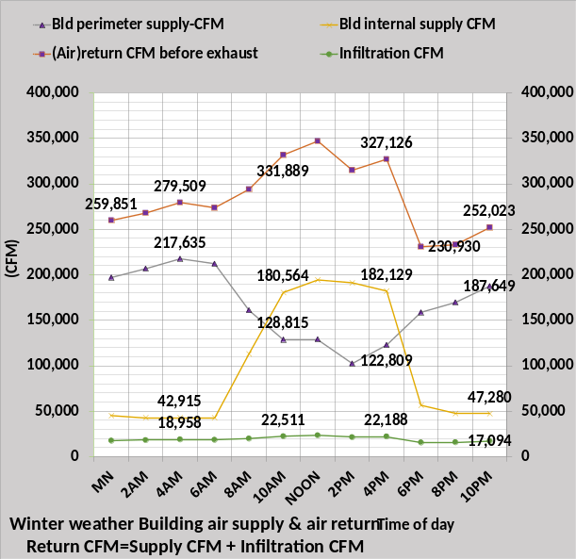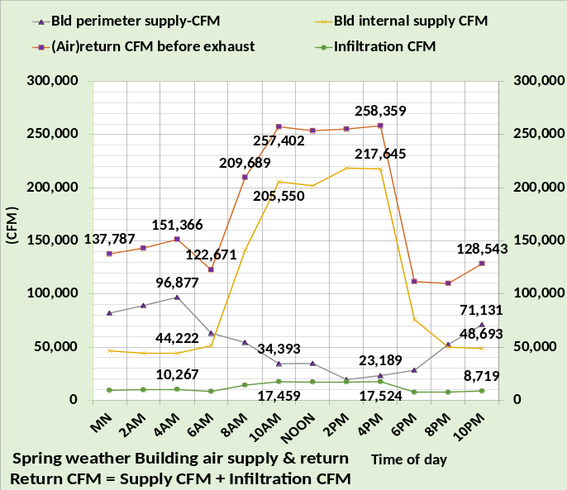
Figure 30: Interior & perimeter CFM supply & return
The interior supply CFM plus perimeter CFM equals the total VAV fan CFM as also given by the secondary axis of Figure 29. Add the outside air infiltration CFM and you have the air return CFM. If return air energy transfer does not occur, then the interior supply CFM returns at the interior thermostat setting and the perimeter air returns at the perimeter thermostat setting. If return air energy transfer does occur, as given by Figures 14 & 15, then return air energy can be significantly changed as shown below.

Interior air return to perimeter
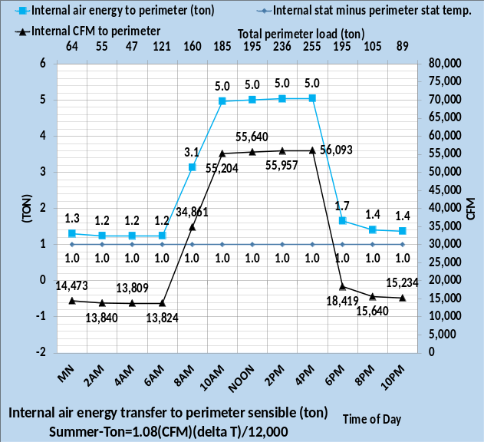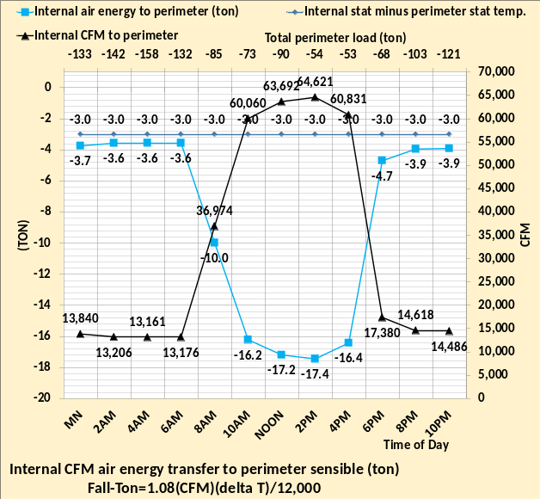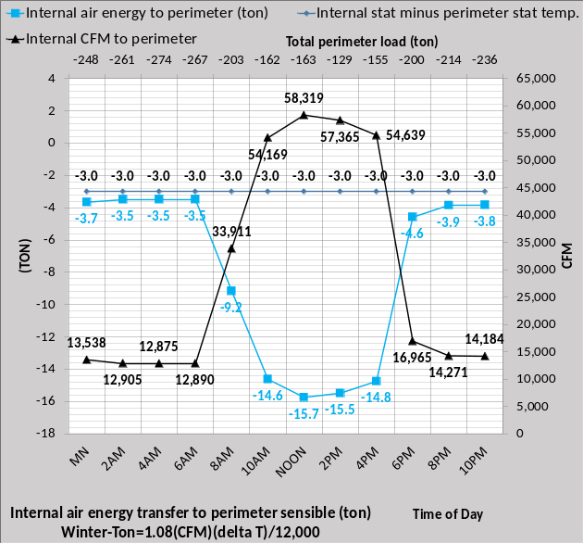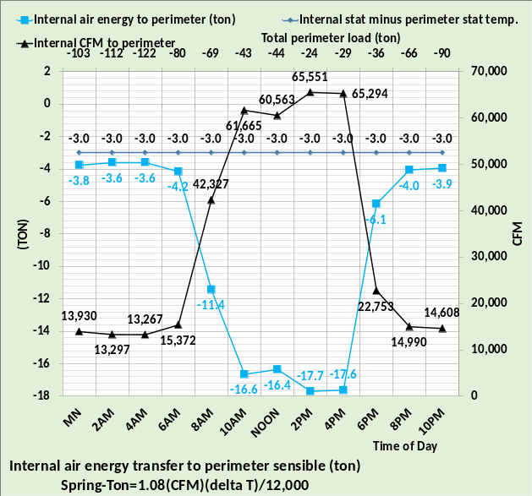
Figure 31: Interior air return to perimeter
The assumed condition is that 30% of the interior supply air returns to perimeter and is therefore heated or cooled to the perimeter thermostat setting. For summer conditions the difference in the stat settings is one degree resulting in a maximum cooling load of 5.0 ton as given by the upper left chart. The other three seasons result in a heating load maximum of about 17 ton for a three-degree difference in stat settings. This energy term can be large as a function of thermostat settings and the percentage of return air that enters the perimeter, for this case 30%. Also, the conditions could be that perimeter air returns to the interior of the building with very different results. This condition could be a major energy waste condition for some buildings, perhaps hiding in plain sight, defined here as ghost energy because it cannot be well defined and may change as a function of infiltration that can change from minute to minute. The return air energy transfer condition modeled here results in very different return air energy as discussed next.
Building perimeter air return
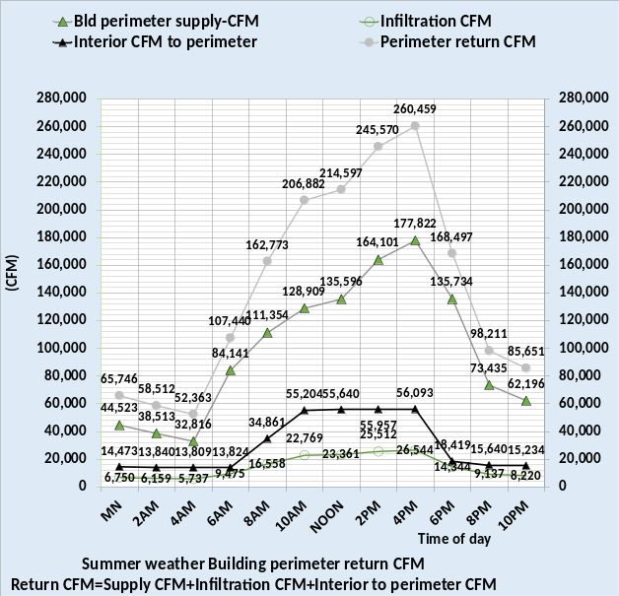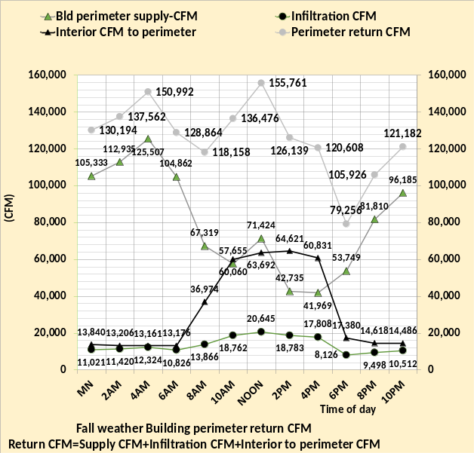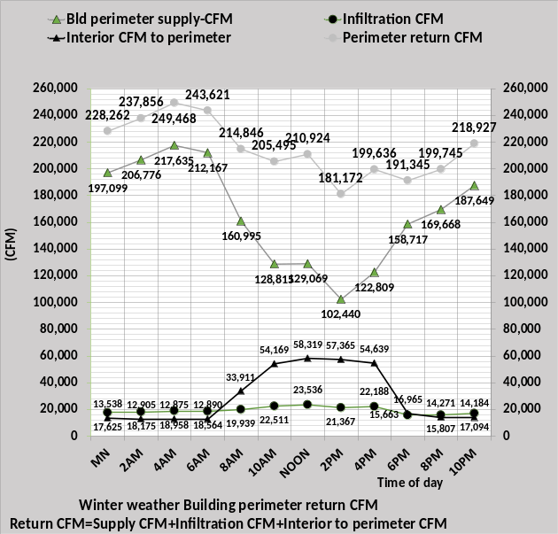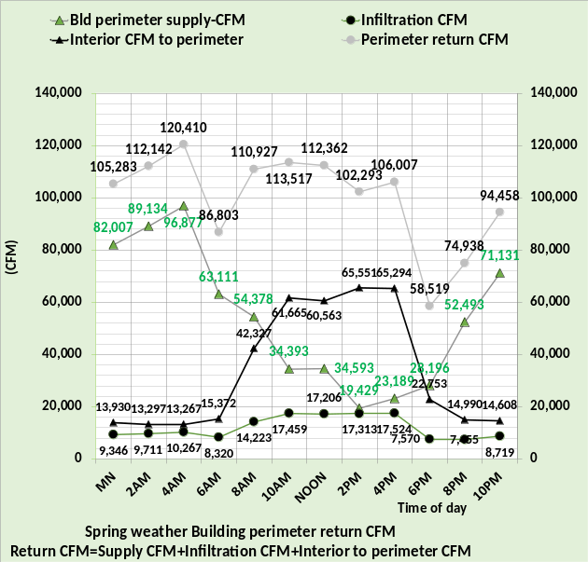
Figure 32: Perimeter air return CFM
The perimeter air return CFM is the sum of perimeter supply and infiltration plus the 30% of interior air that enters the perimeter. This increased CFM of perimeter return air is at the perimeter thermostat setting. The interior return air CFM, at the interior thermostat setting, is reduced by the same amount as the perimeter is increased. Figure 32 shows the perimeter CFM return air is significantly increased by infiltration and 30% interior return air going into the perimeter before entering the return air path. For example, at noon spring weather the perimeter supply CFM is 34,593 CFM but the infiltration adds 17,206 CFM and 30% interior air adds 60,563 CFM for a total perimeter return air of 112,362 CFM at the perimeter thermostat setting of 76F. The perimeter return CFM is more than 3 times the perimeter supply CFM. Next the interior return CFM.

Building Interior Air return CFM
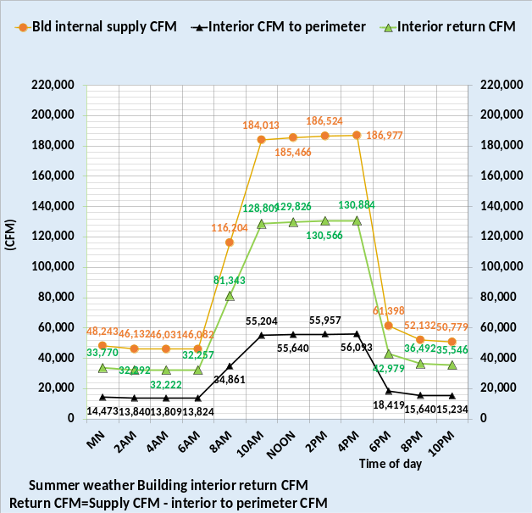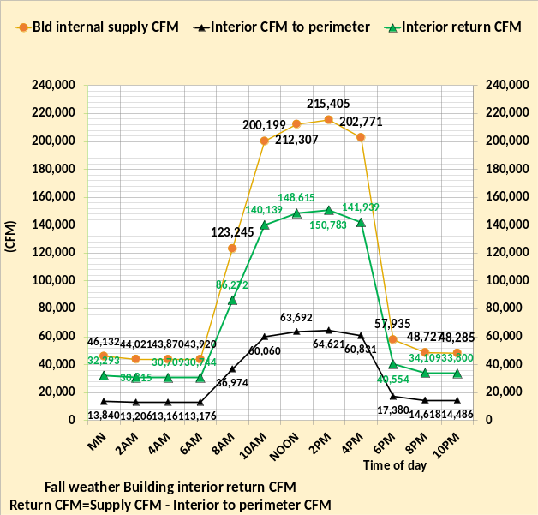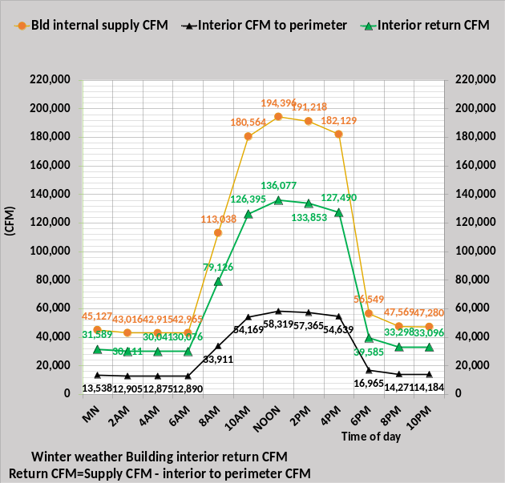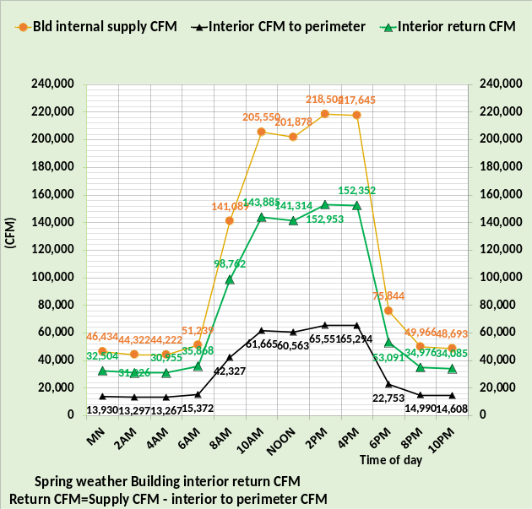
Figure 33: Interior air return CFM
The interior return air to the perimeter significantly changes the energy of the interior return air to the VAV fan inlet. The interior air return CFM at the interior stat setting is reduced by the CFM of interior air to the perimeter. For example, at noon spring weather the interior supply CFM is 201,878 CFM and the 60,564 CFM to perimeter reduces the interior return CFM to 141,314 CFM at 73F thermostat setting. Next the return air mix temperatures will be determined.

Mixed air return temperature
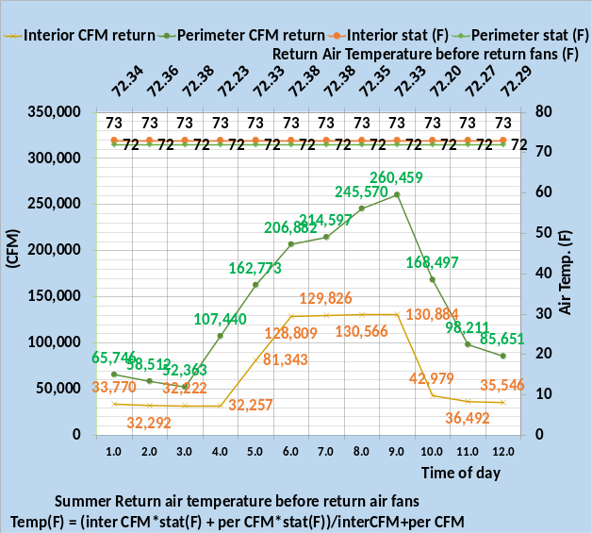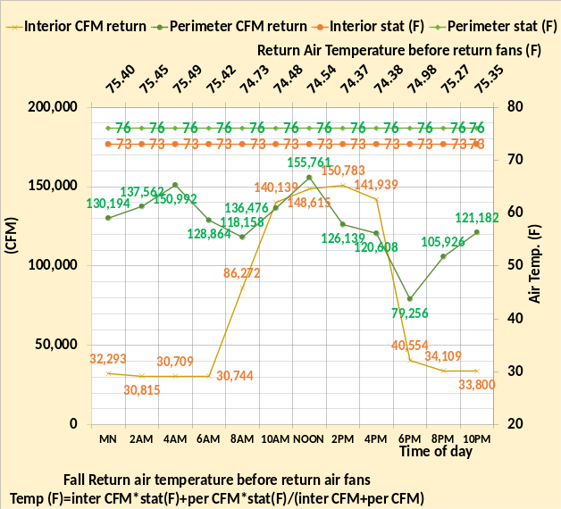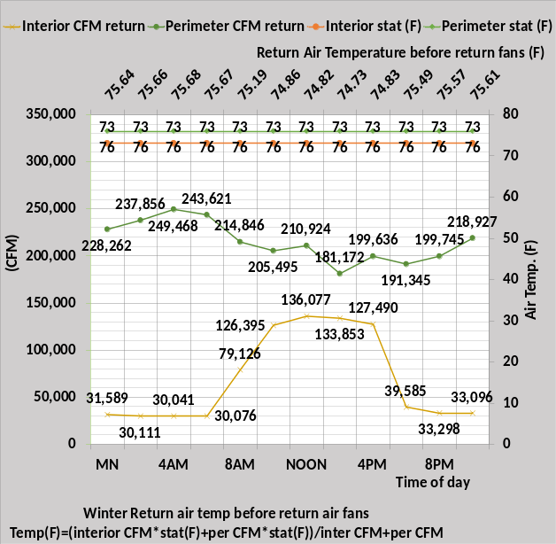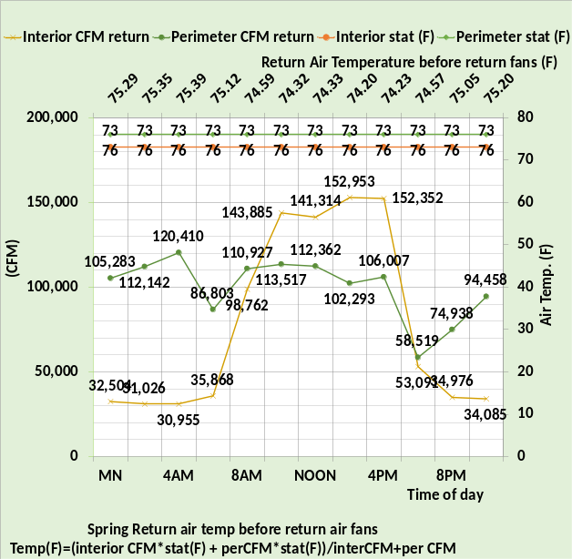
Figure 34: Return air mixed temperature
Figure 34 defines the return air temperature before the return air fans. The secondary horizontal axis gives the mixed air return temperature before the return air fans.
At noon winter conditions,
Temp return air = (136,077cfm*73F+210,924cfm*76F)/(136,077cfm+210,924) = 74.82F.
Shown on the secondary horizontal axis.
The return air fans add heat and therefore raise the temperature of the return air as it travels through the fans. Next let’s look at the (ton) of the return air before the return air fans.

Return air (ton) before return air fans
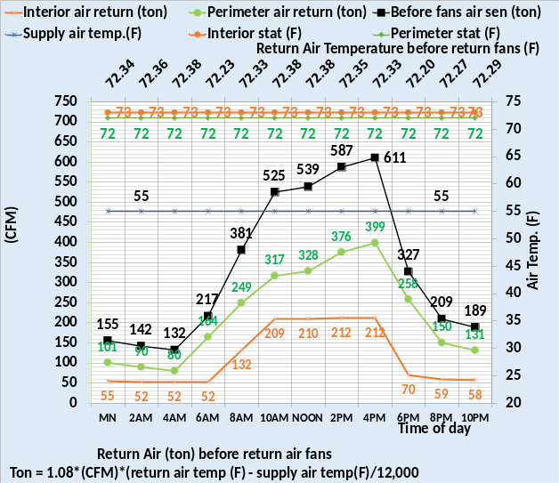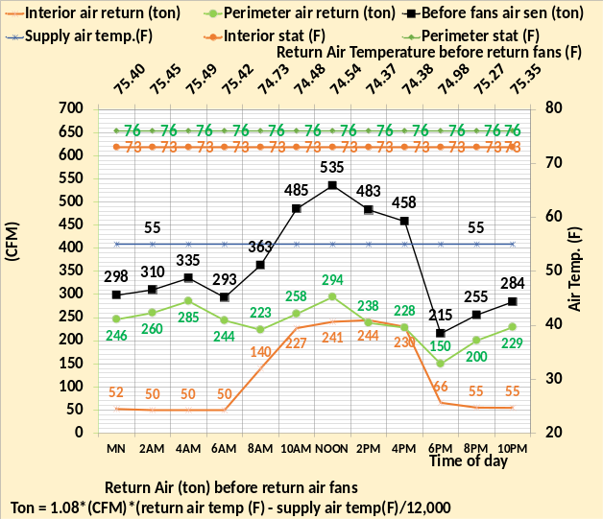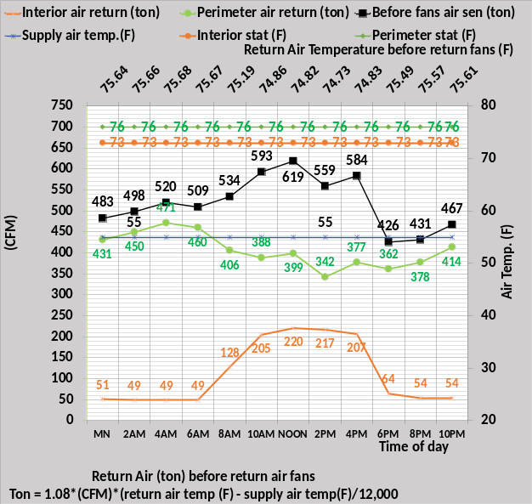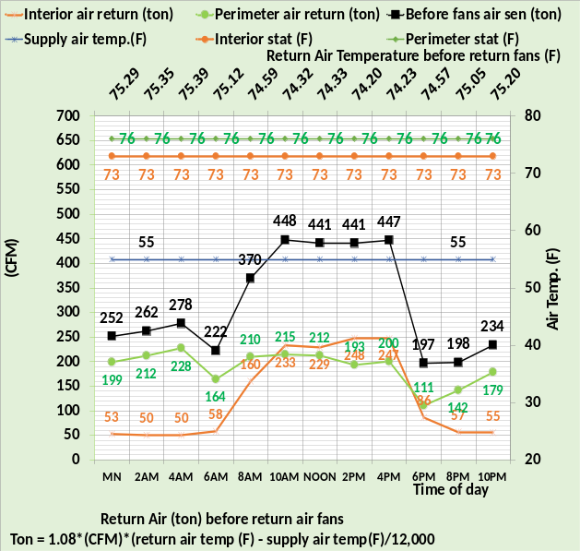
Figure 35: Return air (ton) before the return air fans.
The peak energy of the return air before return fans is for summer 611 ton at 4PM, fall is 535 ton at noon, winter is 619 ton at noon, and spring is 448 ton at 10AM.
At noon winter air temp (ton) = (1.08*(136,077cfm+210,924) *(74.82F-55F))/12,000 = 619 ton (Now we will look at the return air temperature increased by the return fans.

Return fans effect on return air temperature
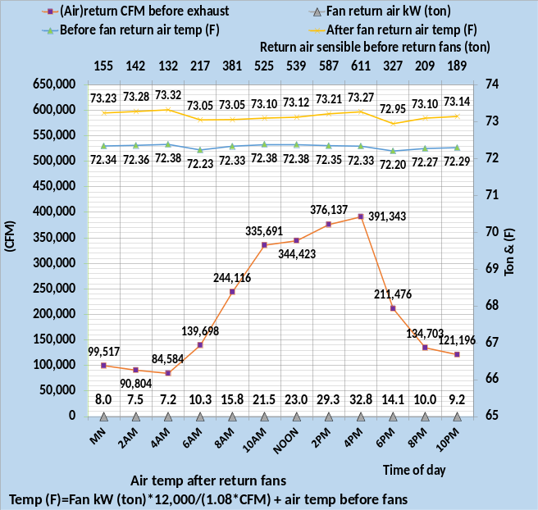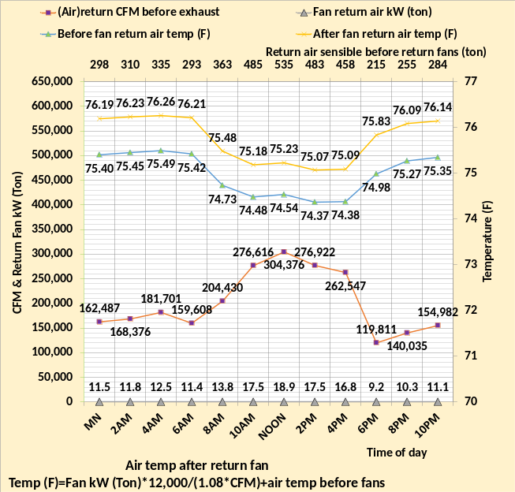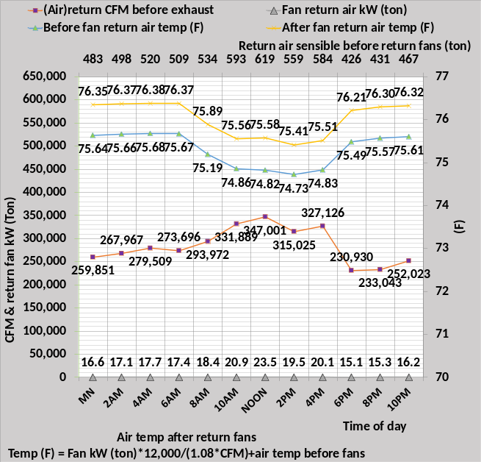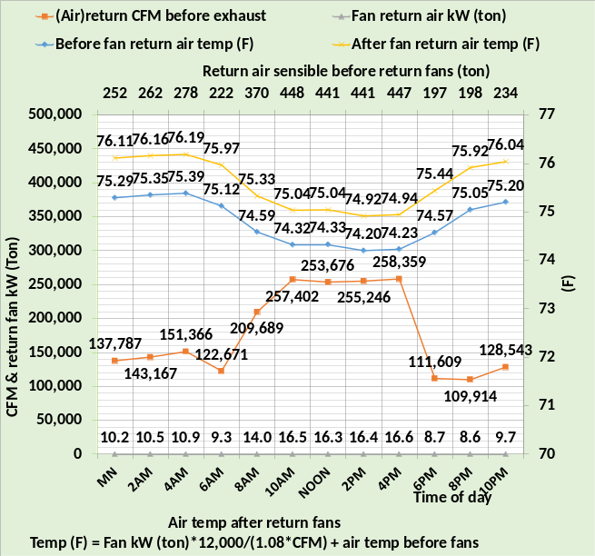
Figure 36: Air temperature after return fans
The return air fans increase the return air temperature by a little less than one degree (F). The secondary horizontal axis gives the return air sensible (ton) before the return fans. Next the return air (ton) after the return air fans will be determined. For example, at noon in winter.
Air temp after fans = (23.5 ton*12,000)/(1.08*347,001cfm) + 74.82F = .752F + 74.82F = 75.57F.
Note, as previously stated, the desk top calculations don’t always exactly agree with the model number because the model number is to several decimal places.

Return air (ton) after return air fans
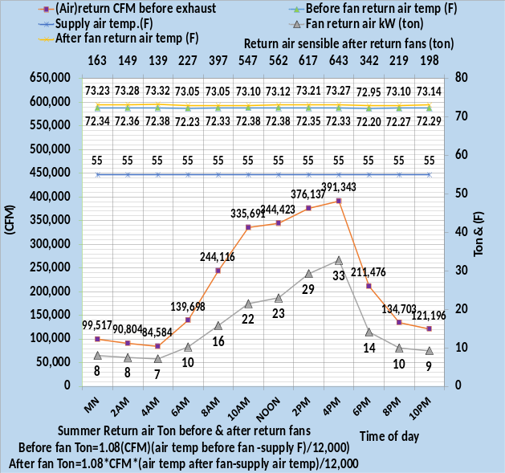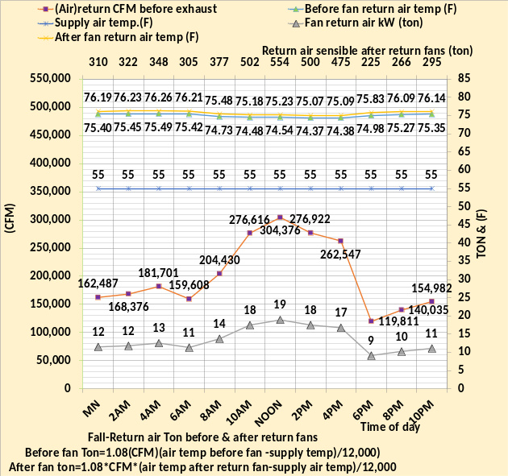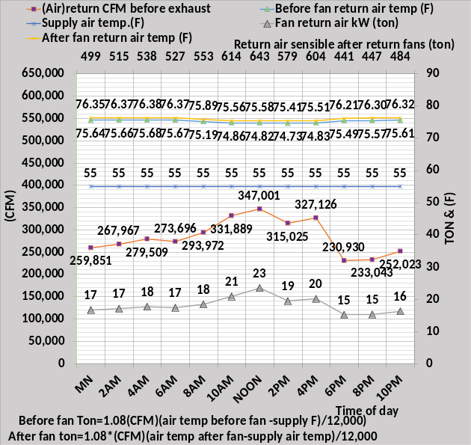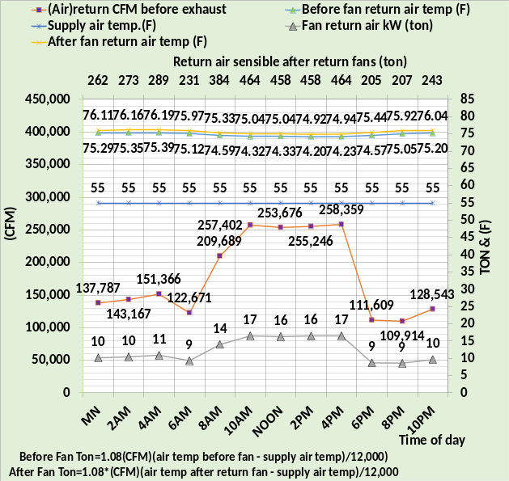
Figure 37: Return air (ton) after return air fans.
The secondary horizontal axis of Figure 37 gives the return air (ton) after the return air fans and Figure 36 gives the value before the return air fans. The return air fans add 10 to 20 (ton) to the return air. Before the return fan air (ton) at winter noon.
= 1.08* 347,001cfm*(74.82F-55F)/12,000 = 619 ton, see Figure 36.
After return fan air (ton)=1.08*347,001cfm(75.58F-55F)/12,000 = 643 ton, see Figure 37.
Next will illustrate another approach to determining the return air (ton) after the return air fans. This first approach determined the CFM and temperatures of the air starting from 55F supply air to air after the return fans. Figures 38 & 39 will demonstrate the approach of defining all energy input to the 55F supply air including the return air energy transfer term.

Nine energies into the return air
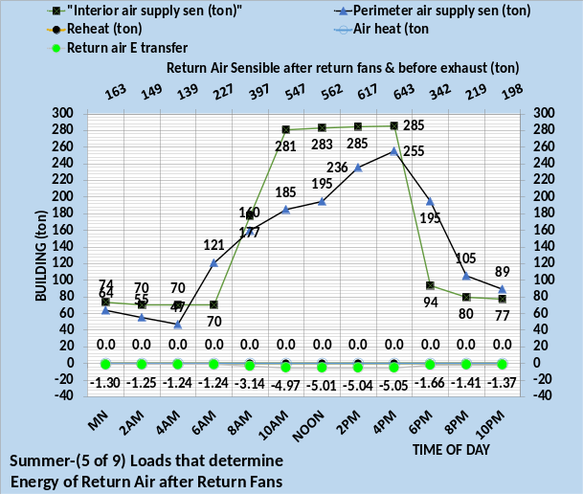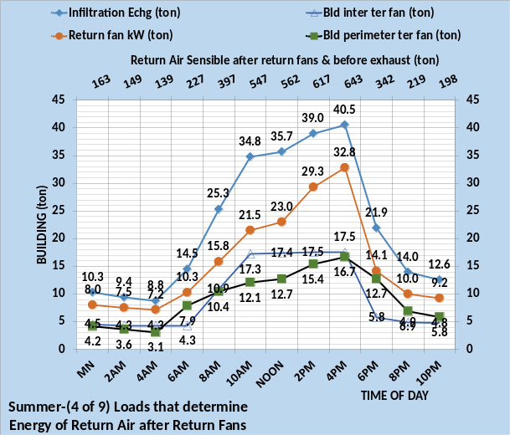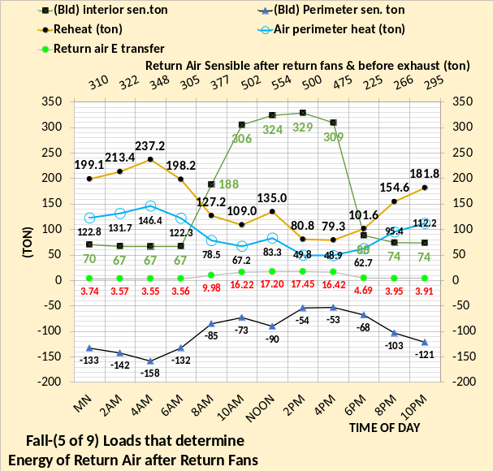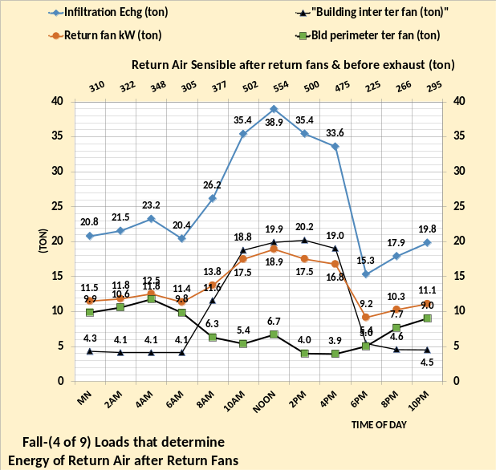
Figure 38: Nine return air energies that equal Figure 37 return air (ton) after fans.
The energy into the return air is equal to the nine terms of Figure 38 & 39, summer and fall weather. All terms in Figures 38 & 39 have been determined above. Adding these 9 terms for any hour will equal the value on the secondary horizontal axis of Figure 37, illustrating two paths to determine the return air load (ton). The return air (ton) in large part determines the load (ton) to the inlet of the VAV fans and therefore the plant load. Let’s look at fall weather at noon starting with the chart on the left. The 55F supply air has an energy input of 324 ton by the interior load and minus 90 ton by the perimeter load. The perimeter air reheat is 135 ton and the heat required to get to 90F air is 83.3 ton. The return air energy transfer term is 17.2 ton. The right chart has 38.9-ton infiltration, terminal fans of 19.9 and 6.7 ton and return fan 18.9 ton. These nine values add to 554 ton as given on the secondary horizontal axis of Figure 38 fall weather at noon, and on Figure 37 fall weather at noon, demonstrating the two approaches to determining the return air energy.
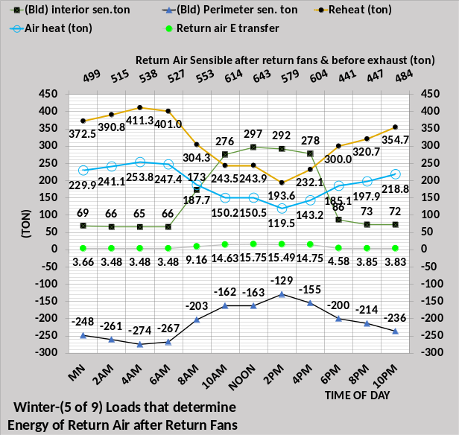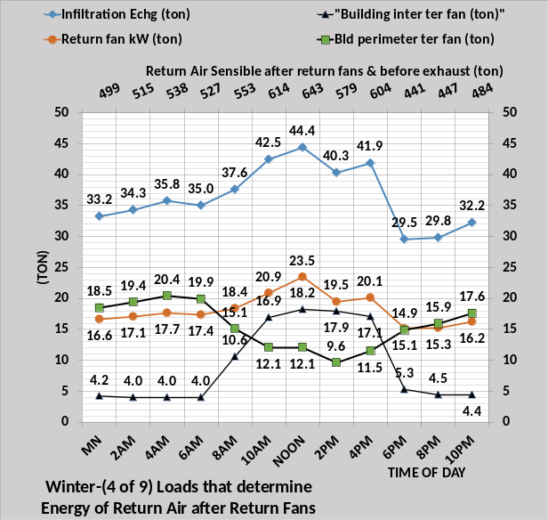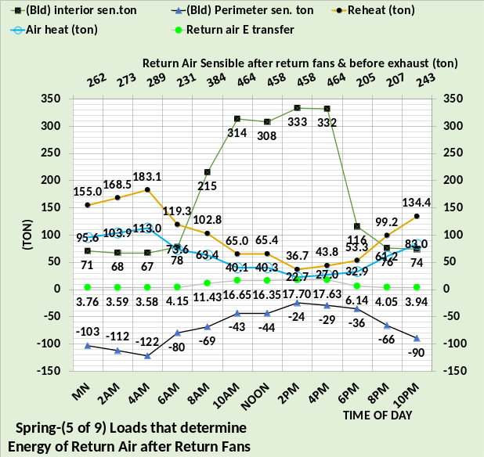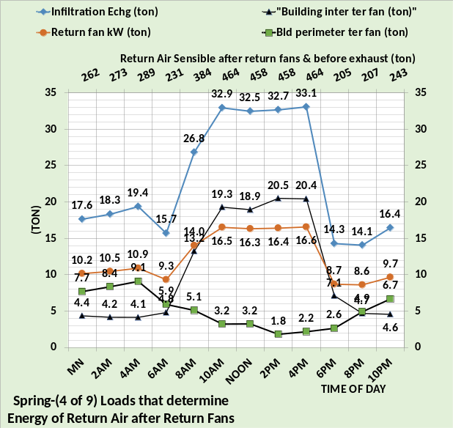
Figure 39: Nine return air energies that equal Figure 37 return air (ton) after fans.

Figure 39 gives the nine terms for winter and spring weather that also agree with Figure 37.

The above defines the return air that is approaching the exhaust damper and the inlet to the VAV fans. The next Figure 40 defines the return air prior to the exhaust damper.

Return air properties before exhaust damper
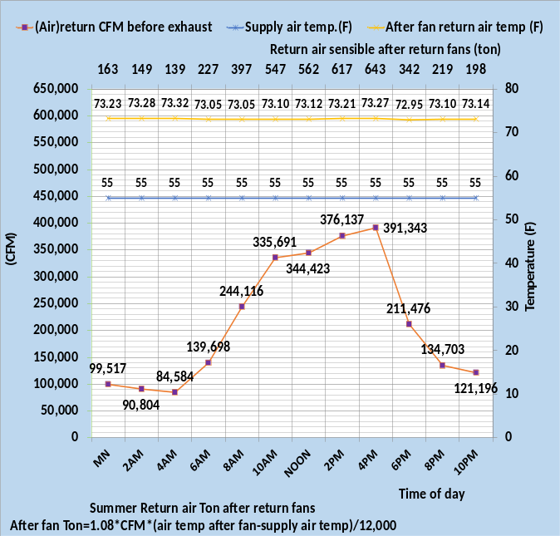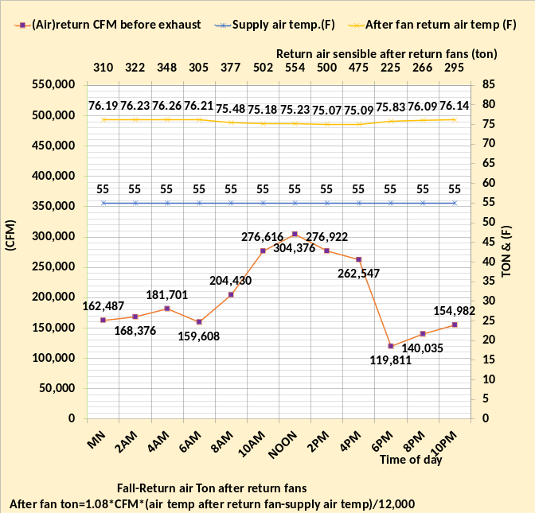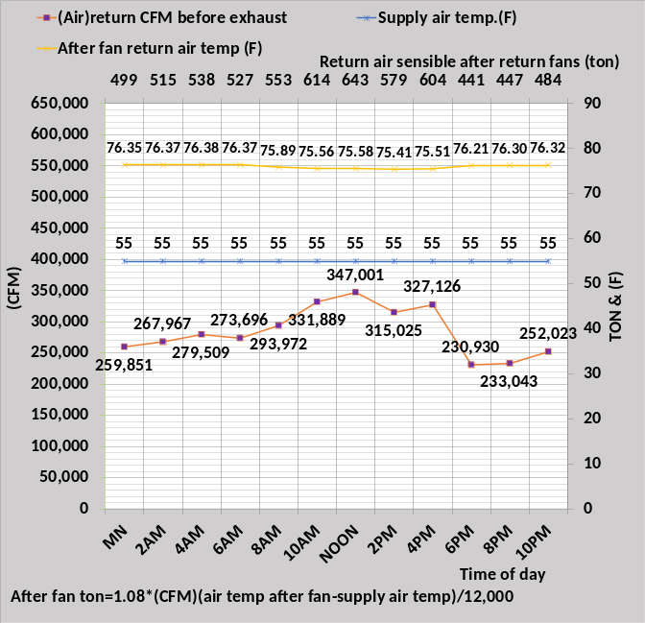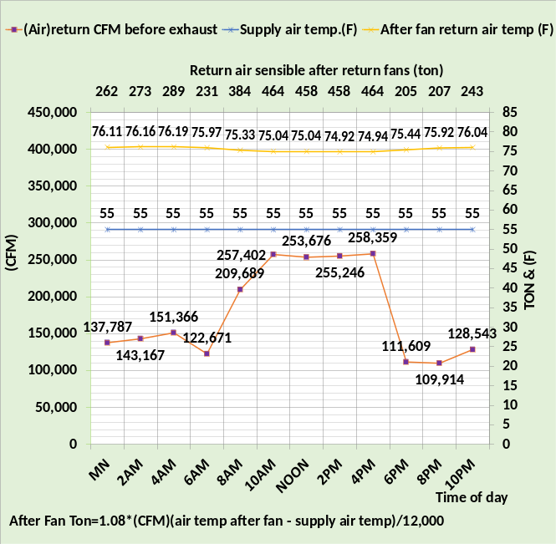
Figure 40: Return air properties before exhaust damper
Figure 40 gives the properties of the return air prior to the exhaust damper and prior to air inlet to the VAV fans. The temperature of the return air is the same as the exhaust air temperature and the VAV inlet air temperature.
The next Figure 41 establishes that CFM into the building equals CFM out of the building, then the properties of the exhaust will be defined.

Building air CFM balance
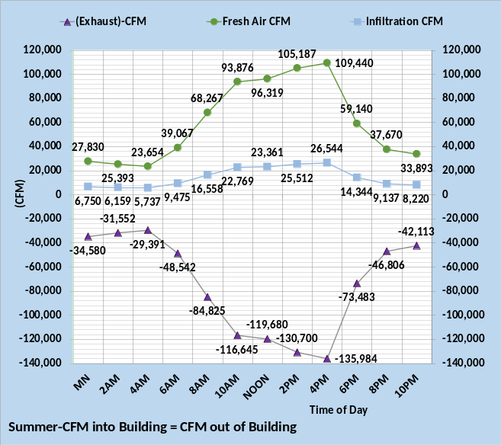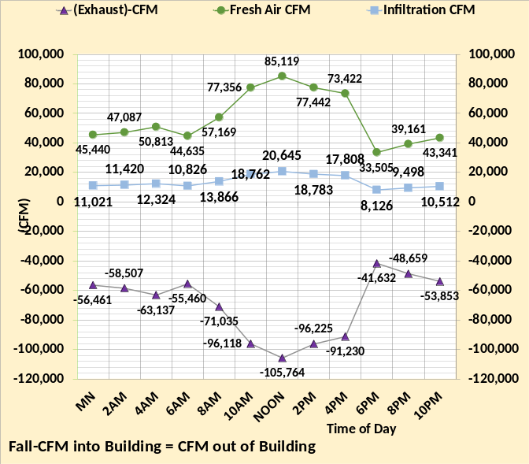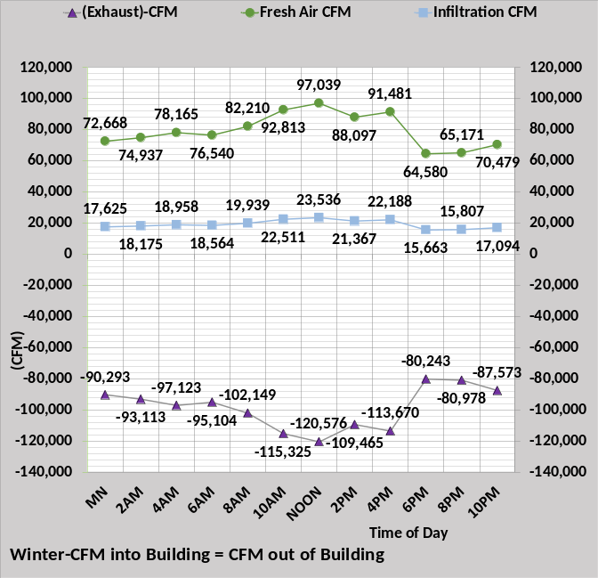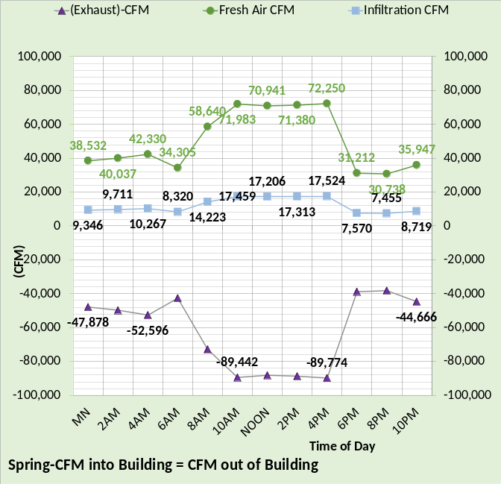
Figure 41: CFM into the building equal CFM out of the building
Figure 41 illustrates a fundamental requirement that might be a good method to estimate infiltration, “ghost energy”. If the fresh air and exhaust CFM can be closely estimated or measured, then the infiltration CFM could be determined. The exhaust value would of course include both exhaust and any other exhaust in the building not associated with the air handler exhaust. Be prepared for the infiltration answer to be that exfiltration is occurring. Also, infiltration can vary from minute to minute.
The exhaust value defines the CFM inlet to the VAV fans as shown by the next Figure 42.

Return air exhaust and VAV inlet
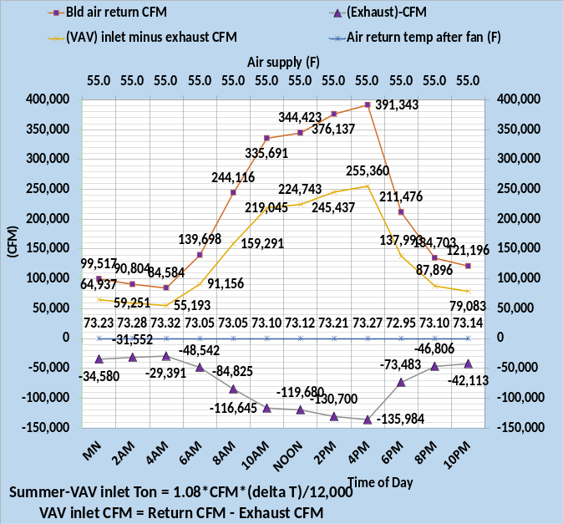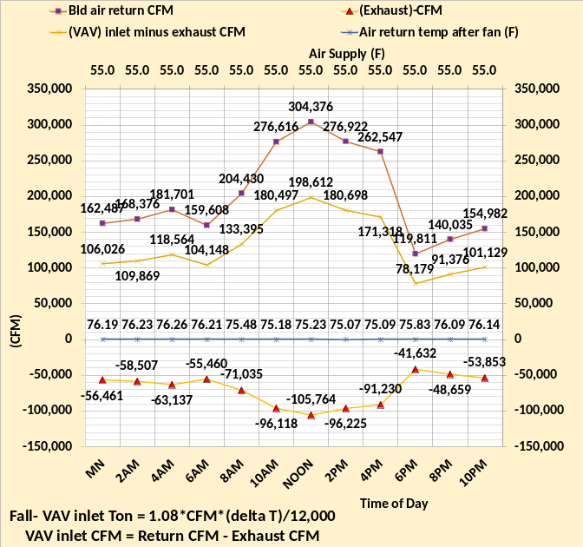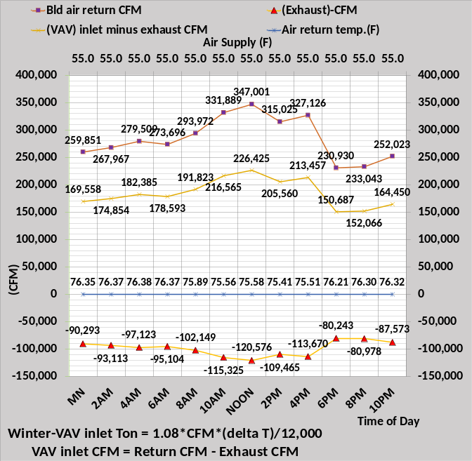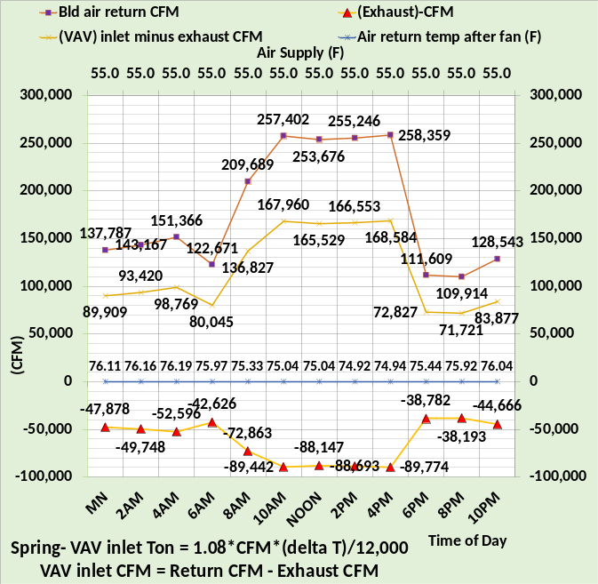
Figure 42: Exhaust CFM and VAV inlet CFM and load (ton)
Figure 42 provides the data necessary to determine the load (ton) to the VAV inlet. For example, at noon spring weather the return air temperature after the return fans is 75.04F and the VAV inlet CFM after exhaust is 165,529 CFM.
VAV inlet (ton) = 1.08*(75.04F – 55F) *165,529 CFM/12,000 = 299 ton
Shown on the next Figure 43.

VAV fans inlet (ton)

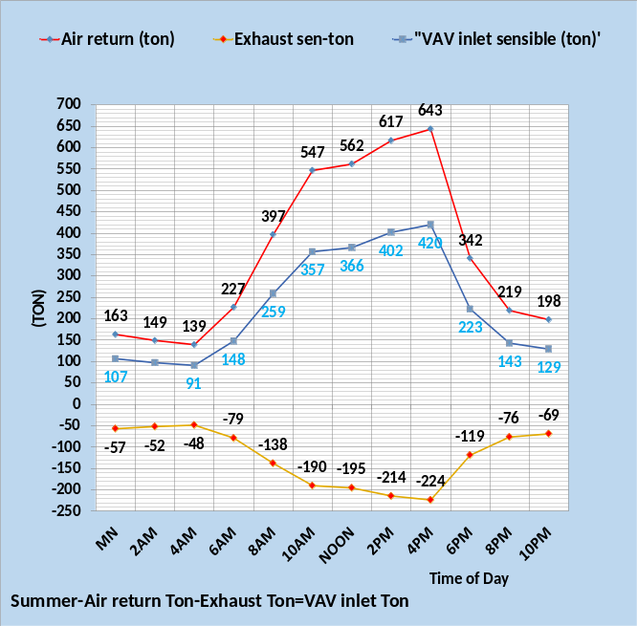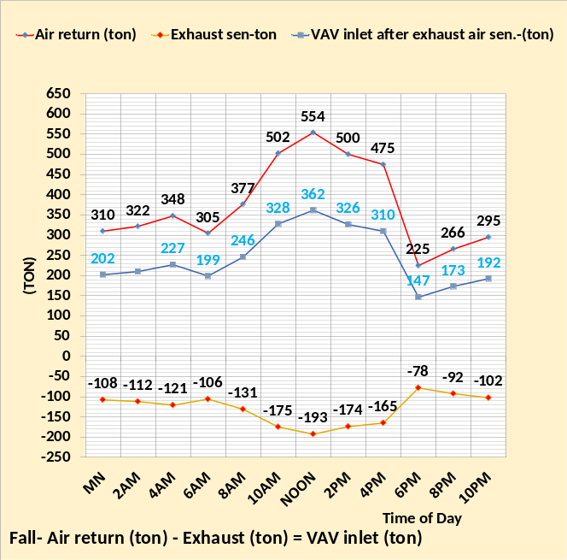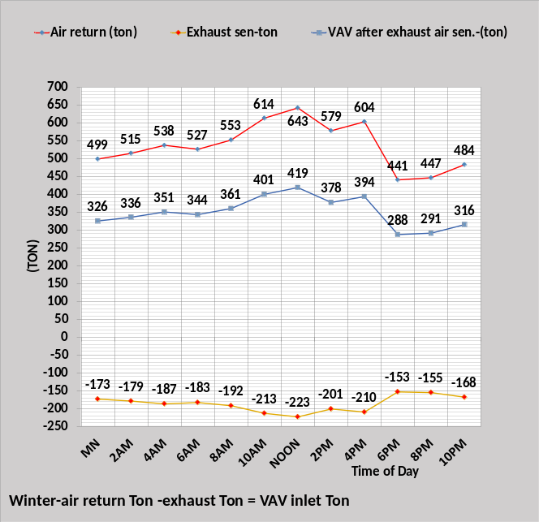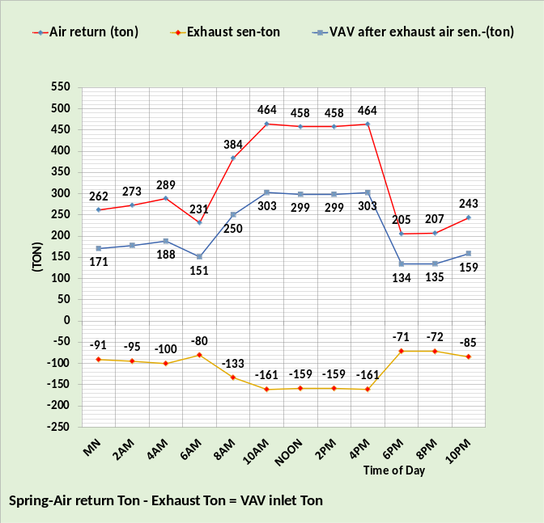
Figure 43: VAV fan air in sensible (ton)
Figure 43 gives the return air (ton), the exhaust air (ton) and the resulting VAV return inlet air (ton). The VAV air return (ton) is mixed with the fresh air to determine the VAV inlet (ton).
Next let’s look at the VAV return latent (ton).

Latent load (ton) to VAV fan inlet.

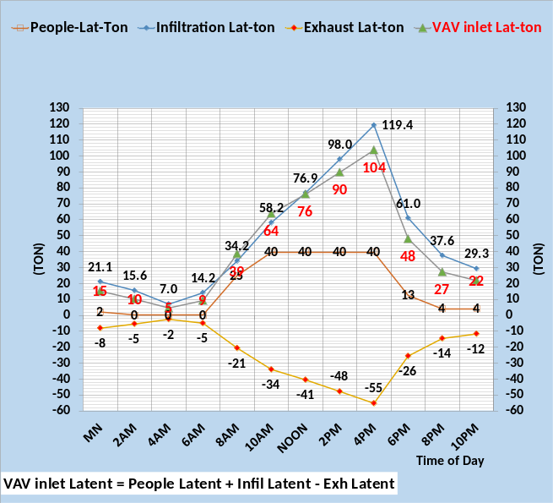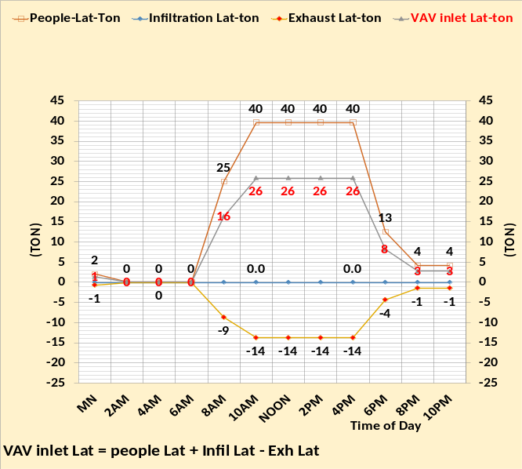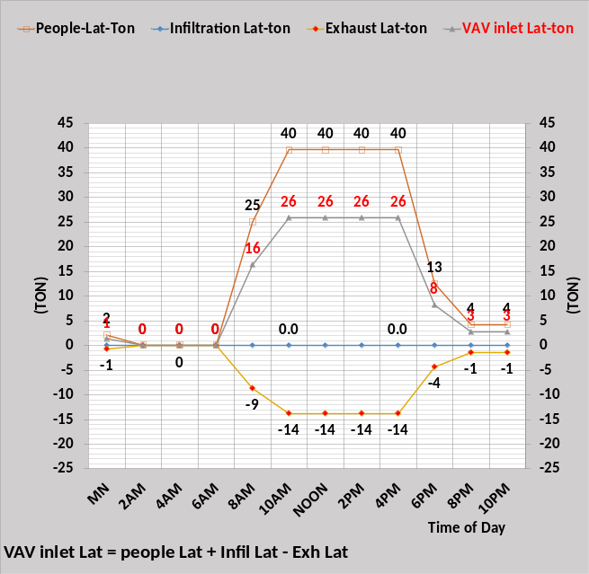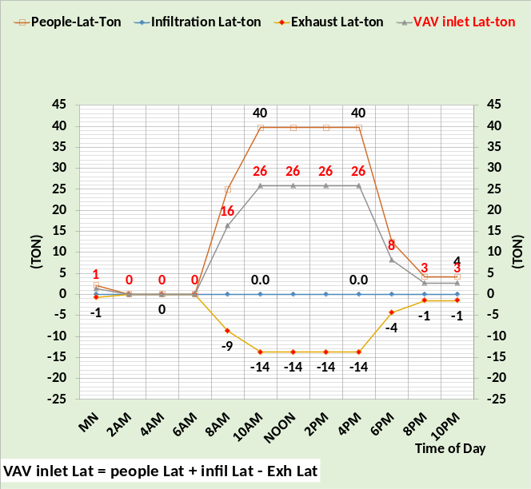
Figure 44: VAV fan in latent (ton)
Figure 44 shows the people and infiltration latent load into the building and the amount of latent load that is exhausted at the exhaust damper. The resulting peak latent load to the VAV fan inlet is 104 ton for the summer weather conditions and 26 ton for the fall and winter and spring weather conditions. Fresh air can also input latent load to the building as addressed below.

VAV Supply CFM due to interior & perimeter loads

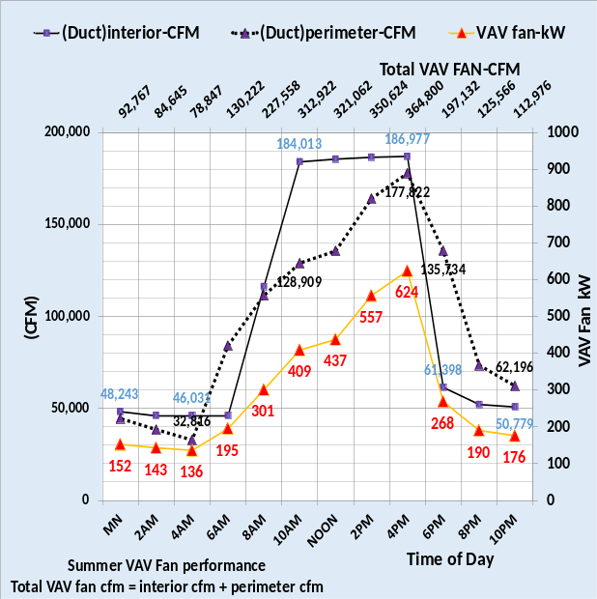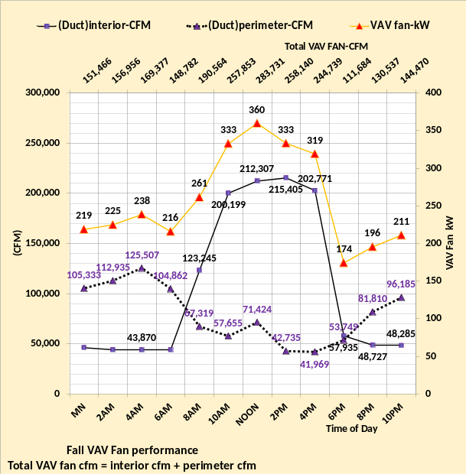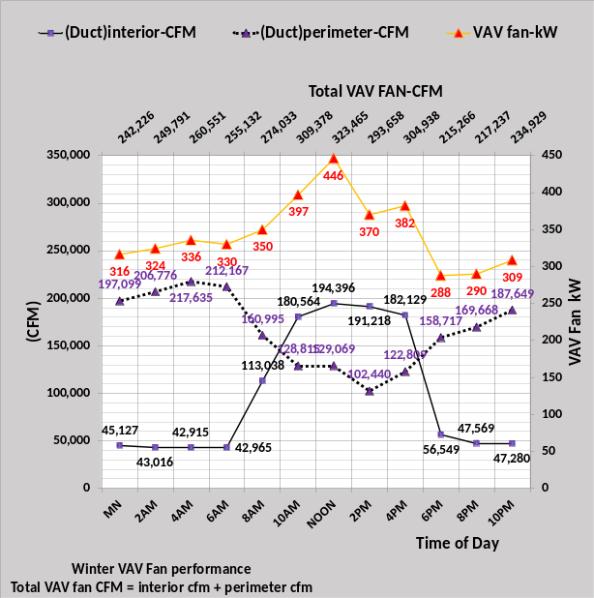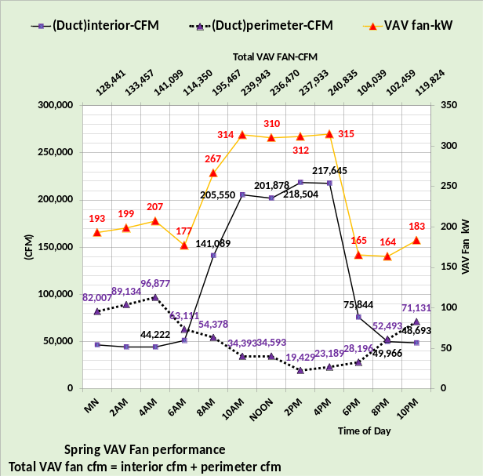
Figure 45: VAV fan CFM defined by interior & perimeter CFM to meet loads, plus VAV fan kW.

Figure 45 shows the total VAV fans CFM is the sum of the perimeter duct CFM and interior duct CFM, values that were figured out above based on the perimeter wall loads & interior light and plug loads, see Figure 29. Figures 46 & 47 arrive at the same value as VAV fan CFM by adding the VAV inlet CFM and fresh air CFM, a result that checks the analysis of each approach to the same VAV supply CFM.

VAV Supply CFM due to fresh air CFM
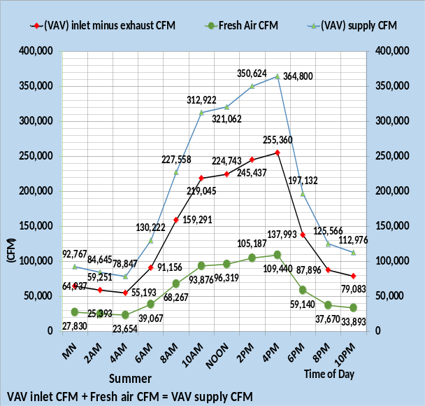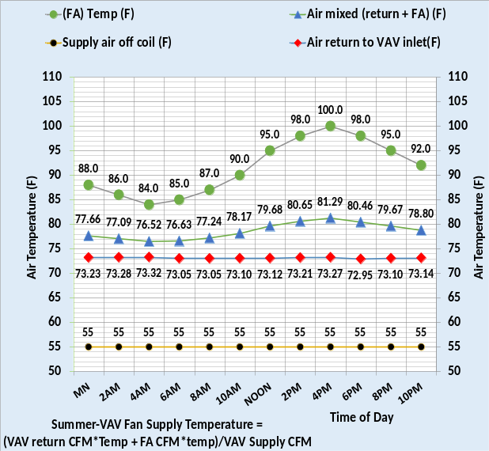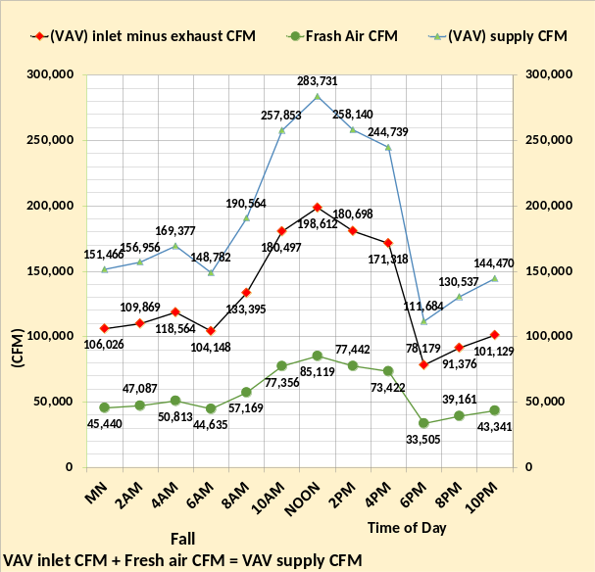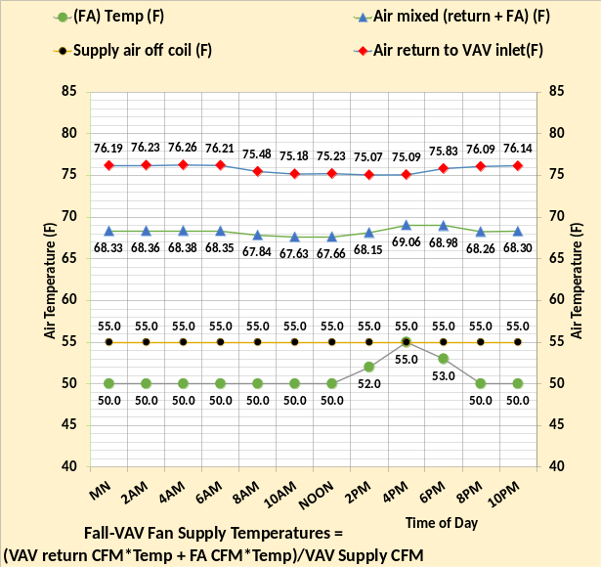
Figure 46: VAV air supply CFM & temperature to VAV fan inlet
Figure 46 gives the CFM and air temperatures associated with the air into the inlet of the VAV fans. The VAV return CFM plus fresh air CFM equals the VAV supply/inlet CFM as shown by the left charts. The temperature of the fresh air delivered to the building is 50F due to fresh air preheating if the outside air temperature is less than 50F. Fresh air preheat consumes kW energy but the energy into the building is determined by the fresh air CFM and air temperature after preheating. However, the fresh air preheat kW is in the total kW demand of the building. The mixed air temperature to the inlet of the VAV fans is for example at 10AM fall weather.
Air temp to VAV inlet = (77,356cfm*50F + 180,497cfm*75.18)/(257,853) = 67.63F as shown on Figure 46 fall weather right chart.
The next Figure 47 is for winter and spring weather.

VAV Supply CFM
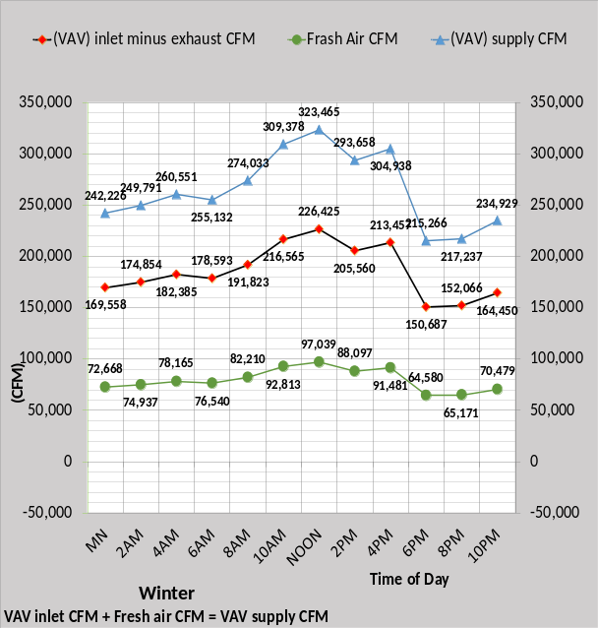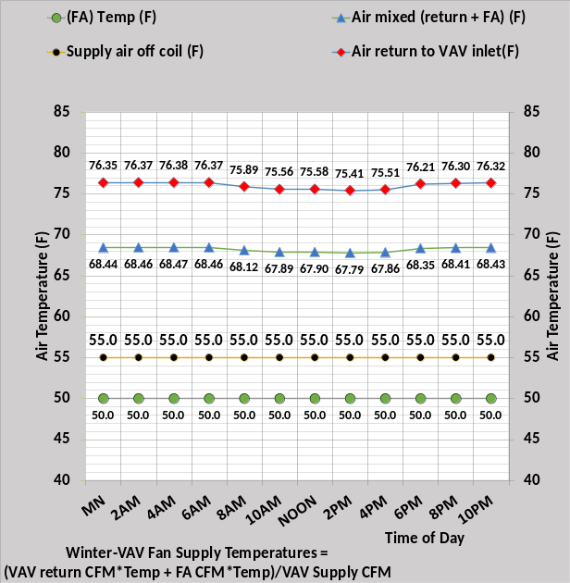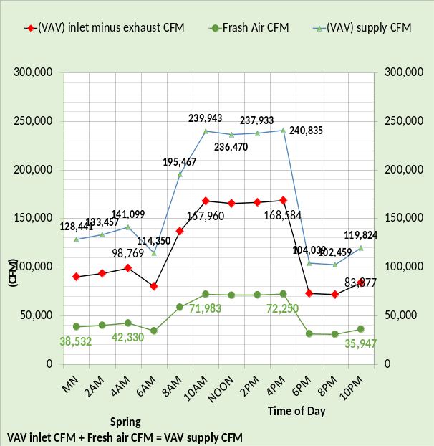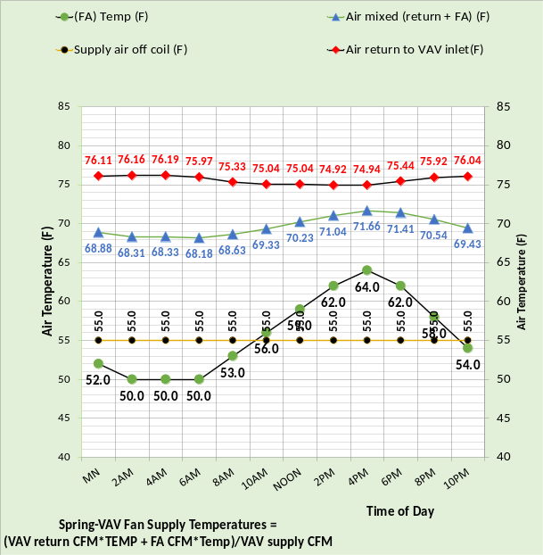
Figure 47: VAV air supply CFM & temperature to VAV fan inlet
The spring weather conditions require fresh air preheating during early morning hours but not for the remaining hours of the day, shown by the right chart. The mixed air temperature of the fresh air and VAV inlet air is shown by the right charts of Figures 46 & 47. As the mixed air moves through the VAV fan the air temperature is increased as a function of the kW required by the VAV fan to move the air to the coils for cooling to the supply air temperature set at 55F. The CFM and temperature of the fresh air in large part defines the building plant load.
Next the air changes per hour and fresh air CFM per person will be given.

ACH & Fresh Air CFM per person

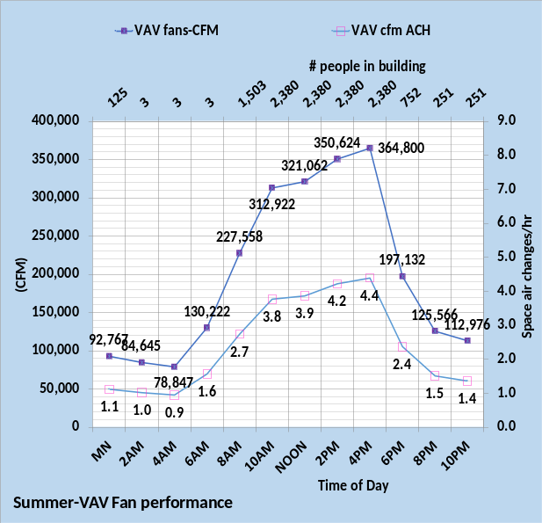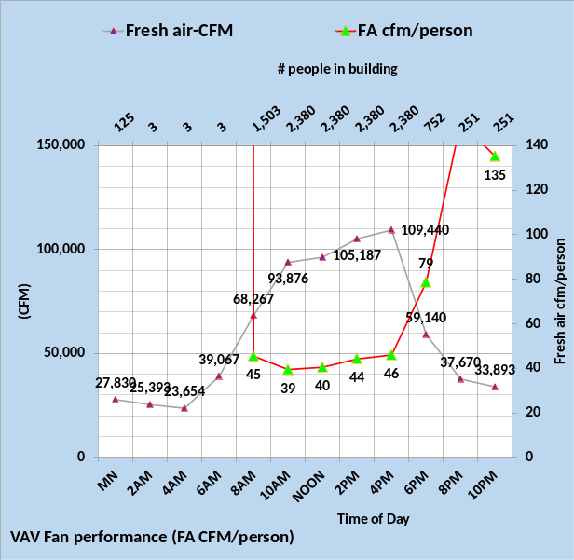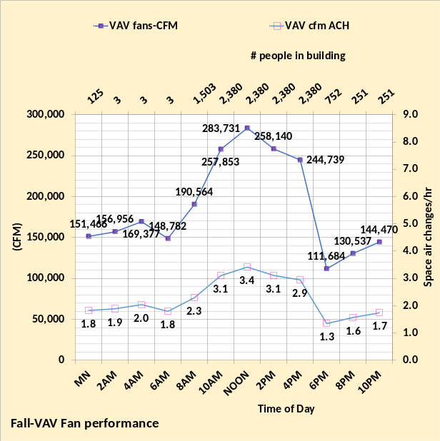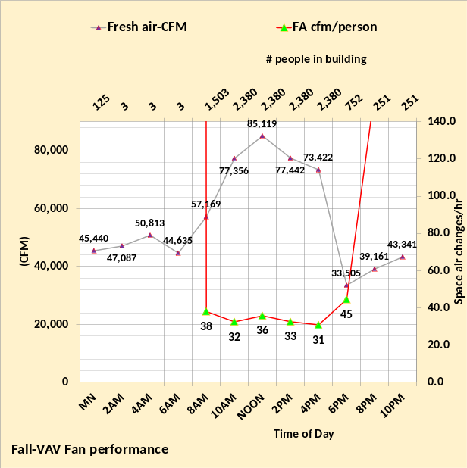
Figure 47a: Air changes per hour (ACH) & fresh air cfm per person in building.

The left charts give air changes per hour and the right chart gives fresh air per person in the building for summer & fall weather performance.

ACH & Fresh Air CFM per person

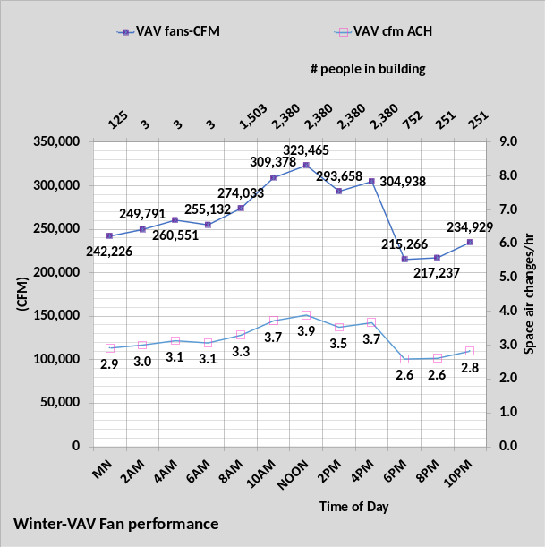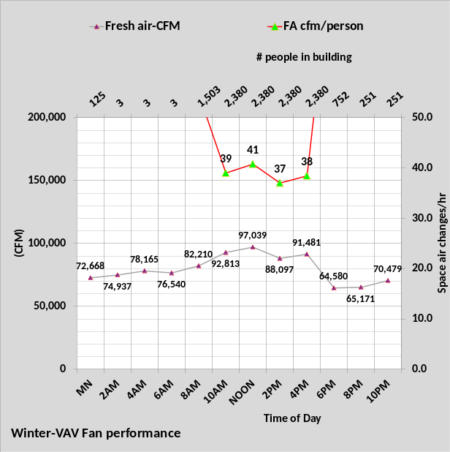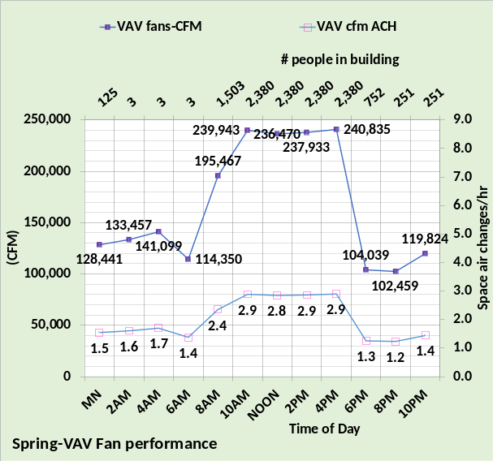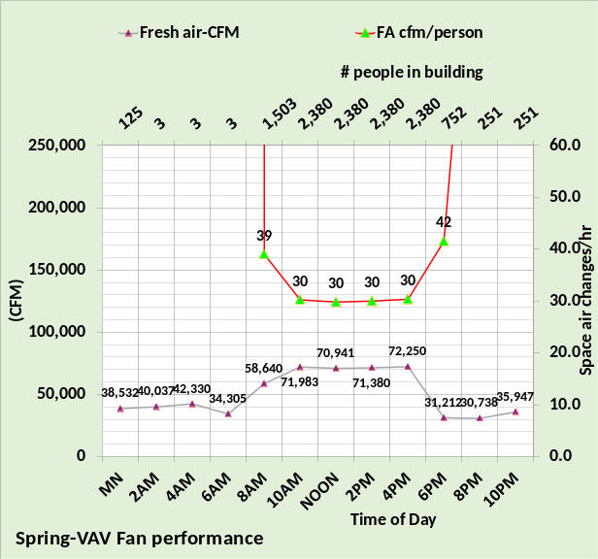
Figure 47b: Air changes per hour (ACH) & fresh air cfm per person in building.

The left charts give air changes per hour, and the right chart gives fresh air per person in the building for winter & spring weather performance.

Fresh air loads
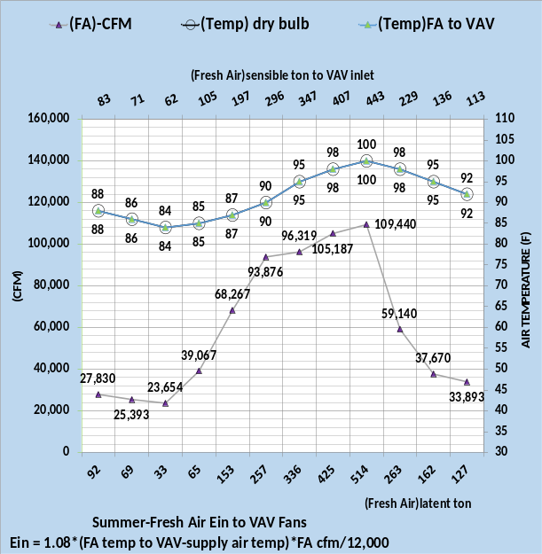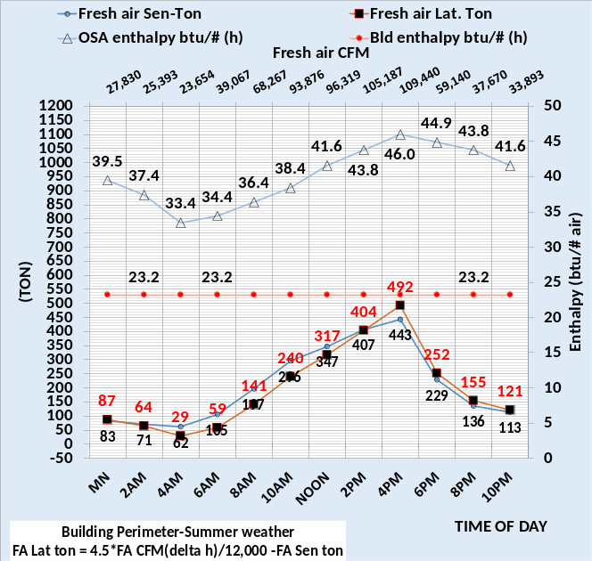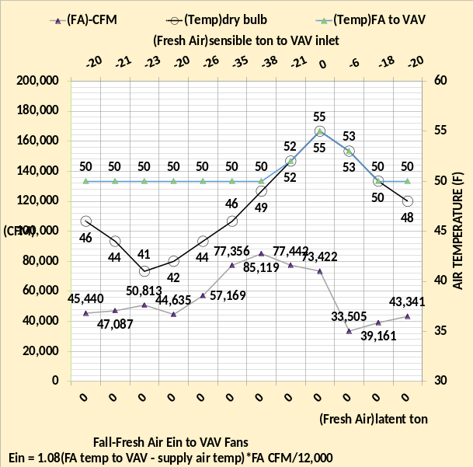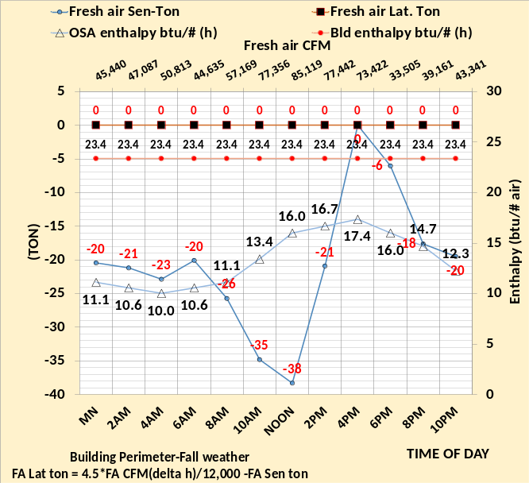
Figure 48: Fresh Air sensible and latent load, summer & fall
Fresh air latent load is a significant value for summer weather but equal to or close to zero for the other three seasons. The left charts show fresh air latent on the primary horizontal axis and the sensible load on the secondary horizontal axis. The right charts give the enthalpy values that determine the latent loads.

Fresh air loads
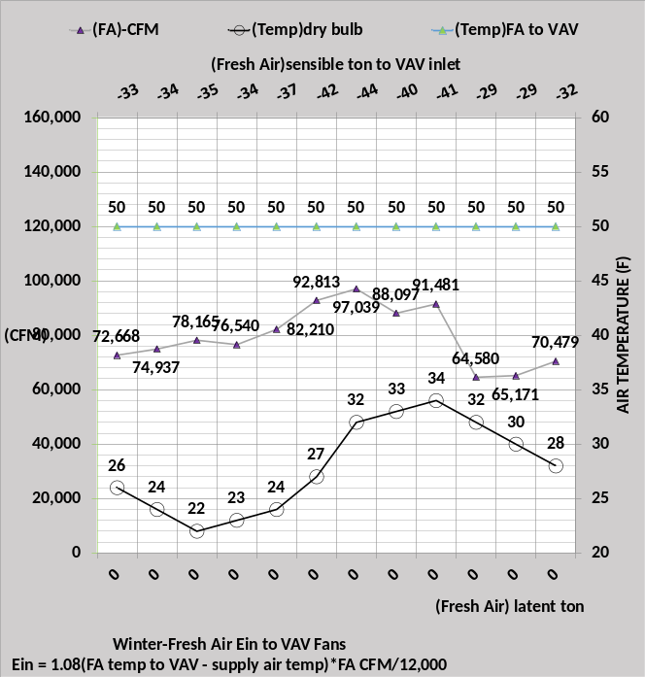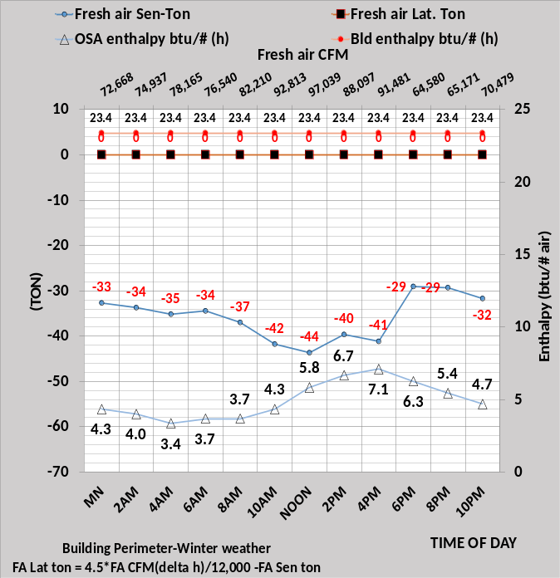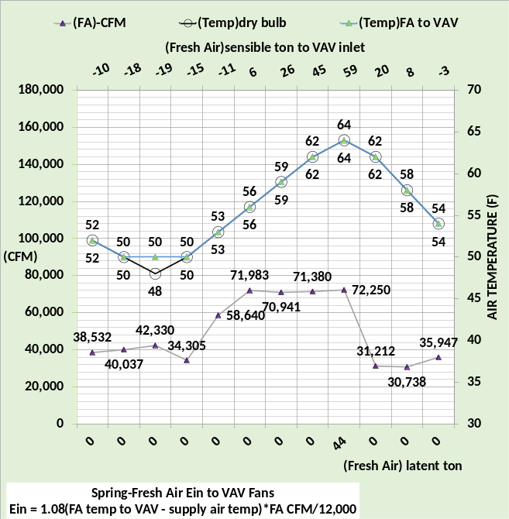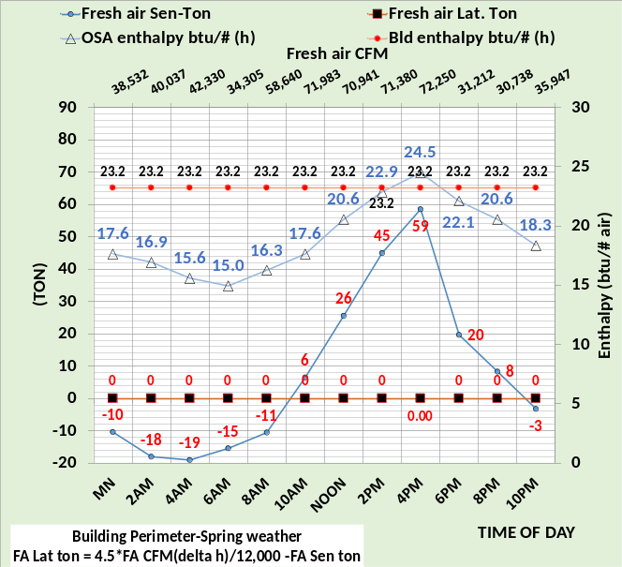
Figure 49: Fresh Air sensible and latent load, winter & spring
The fresh air sensible ton is a function of the preheating set temperature and therefore determines the amount of cooling provided by the fresh air and can be a significant value in the sum of kW demand for the building. Fresh air is important for the health of a building and will be considered further as a What if Project.

VAV fans inlet (ton)
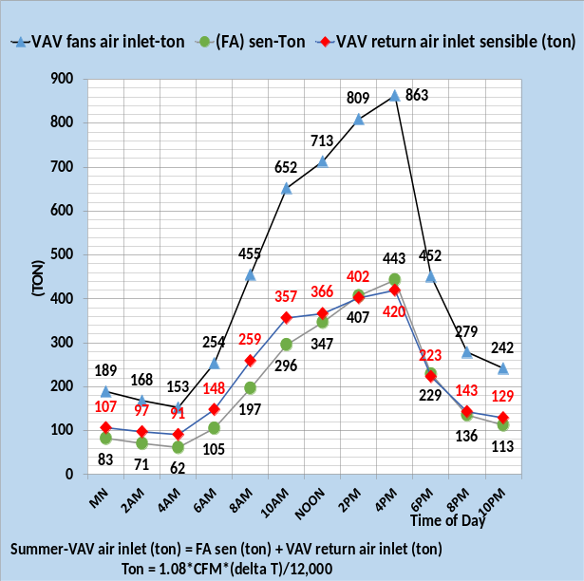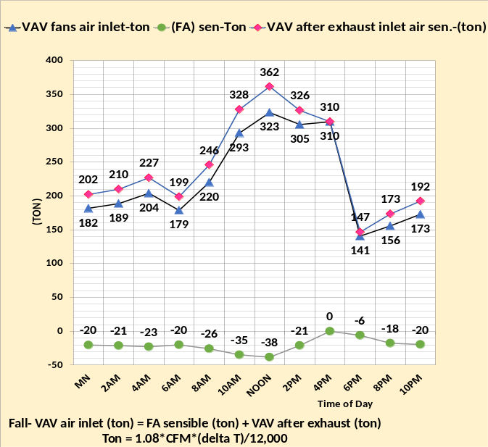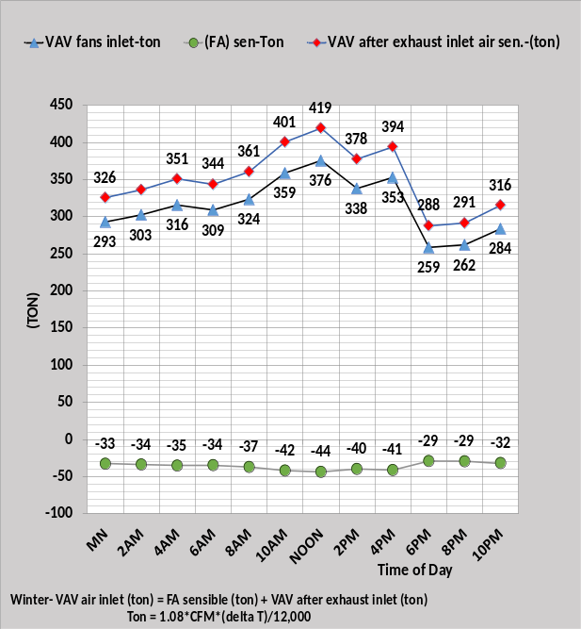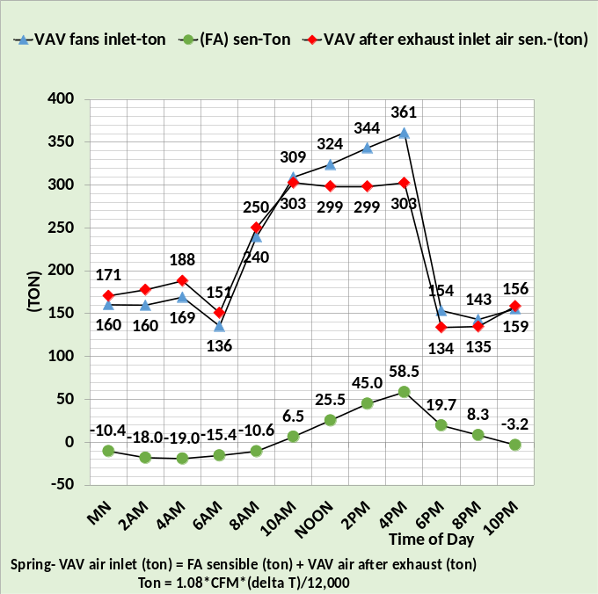
Figure 50: VAV air inlet (ton) to VAV fans
Figure 50 shows the fresh air (ton) plus the VAV after exhaust (ton) equals the (ton) inlet to the VAV fans. The VAV fans add heat and therefore load (ton) to the air that enters the coil for transfer of the building load to the plant.

VAV Fan kW
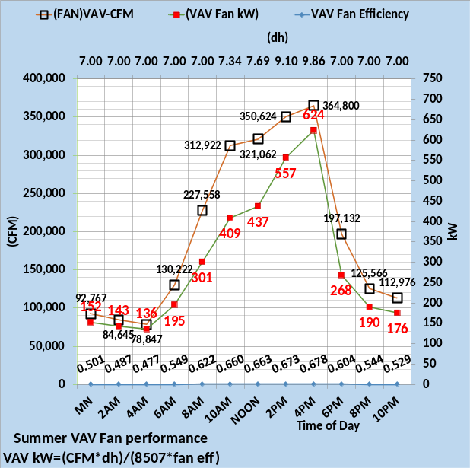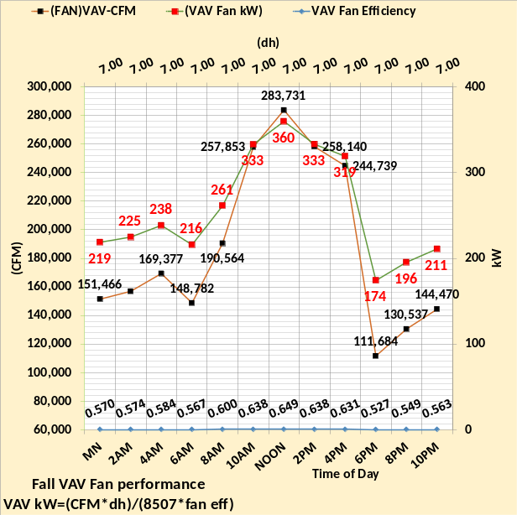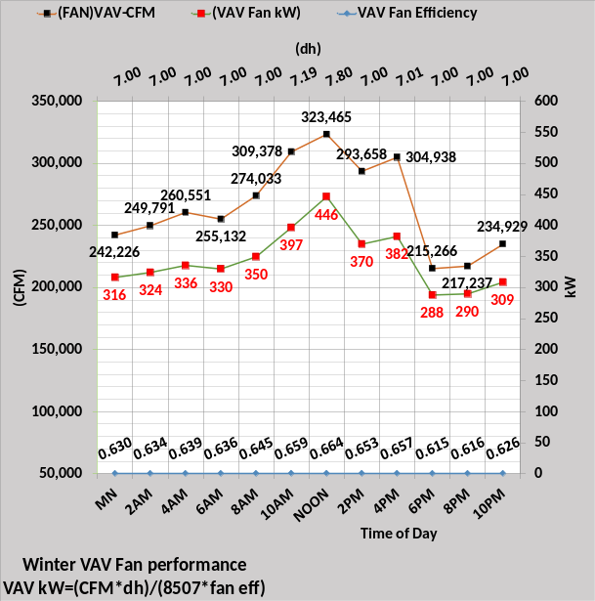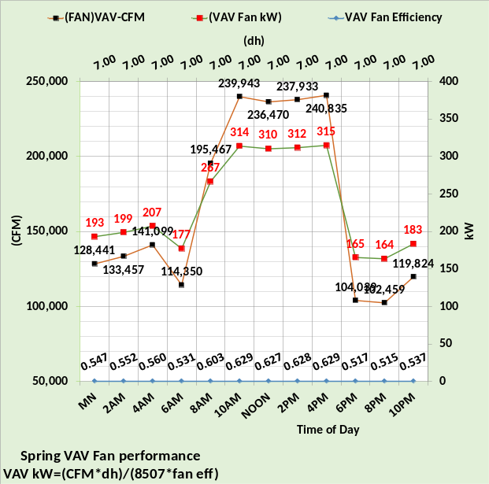
Figure 51: VAV Fans kW
Figures 46 & 47 defined the VAV fan inlet temperature and CFM. The VAV fan CFM is the CFM required to meet the interior and perimeter loads at the set 55F supply air off the coil and the 90F perimeter heating air when heating is required. The kW required by the VAV fan to supply the required CFM is given by the equation; VAV kW = (CFM*dh)/ (8507*fan efficiency).
The VAV fan kW is the greatest for summer conditions at 624 kW. The other three seasons require less VAV CFM and therefore less kW. The peak fall value is 360 kW at noon, the winter value is 446 kW at noon, and the spring peak value is 315 kW at 4PM.
VAV fan efficiency is a nonlinear term that needs to be defined by each manufacturer. Air static pressure (dh) is a function of the VAV supply air duct system and can only be determined after construction of the air supply system.

Temperature rise through VAV fans due to VAV fan kW
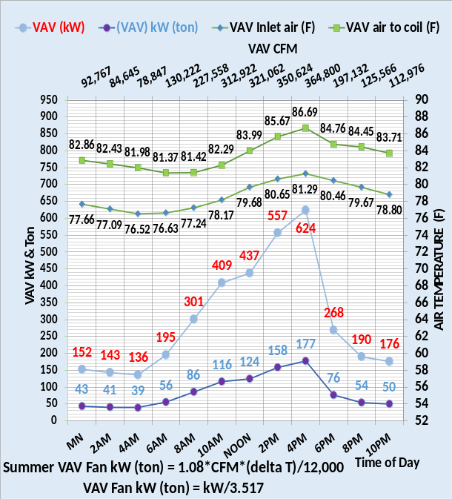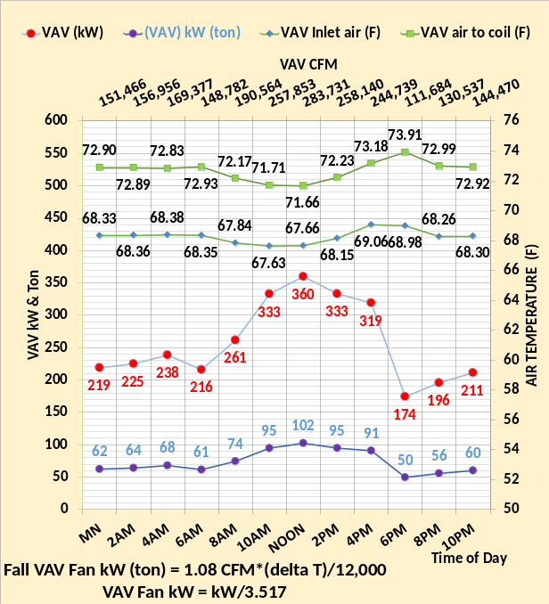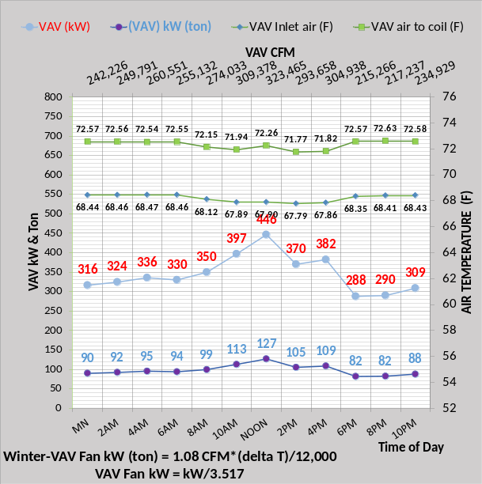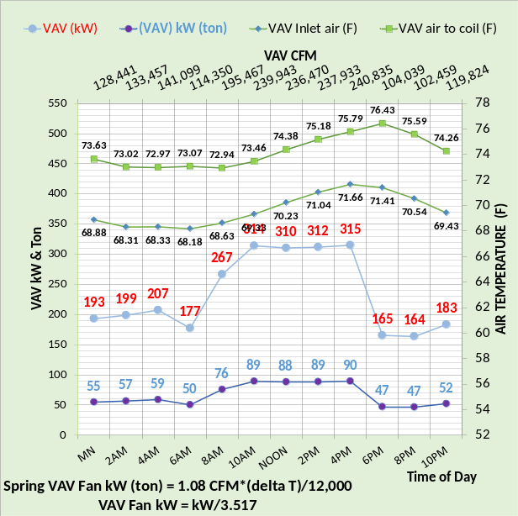
Figure 52: VAV Fans kW heat to supply air.
As the air supply moves through the VAV fans it is heated by the fans raising the air temperature to the coils as shown by Figure 52. Typically for this system, the air temperature has increased about 4F due to the VAV fan kW. For example, consider spring weather at 4PM.
VAV air to coils (F) = (90 ton*12,000)/(1.08*240,835cfm) + 71.66F = 4.15F + 71.66F = 75.81F
Slightly different than the model value of 75.79F on Figure 52 due to rounding of numbers, for example the 90-ton value. The model determines values too many decibels.
Note two hours later at spring 6PM the VAV air is raised to 76.43F from 71.41F by a 47-ton energy into the VAV supply air.
This air temperature raises as the air moves through the VAV fans demonstrates why Excel is uniquely qualified to solve this set of equations, arriving at a steady state condition for this potentially unstable condition where heat added to the air requires more VAV kW that adds more heat to the air. The set of equations has and must have feedback damping provided by other components of the system.
Plant Sensible Load
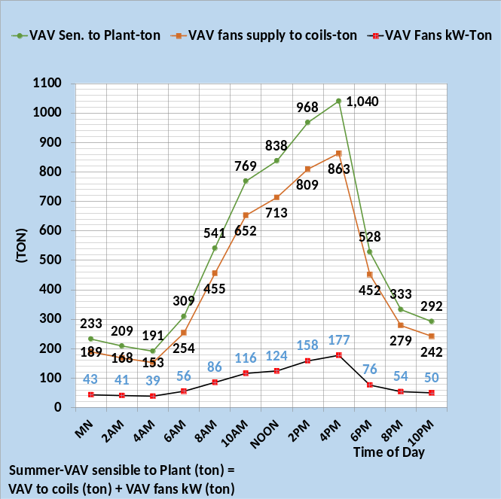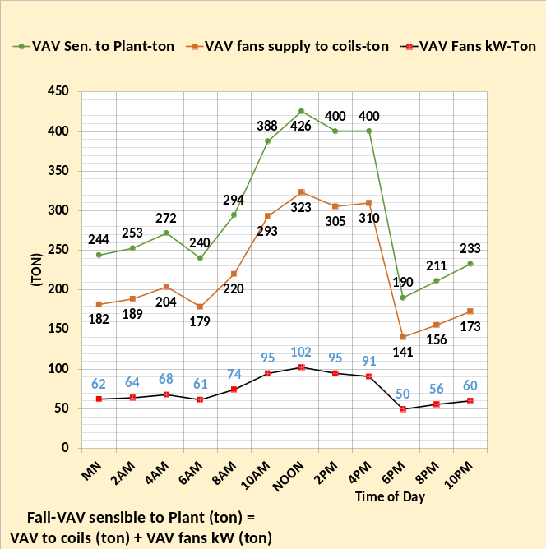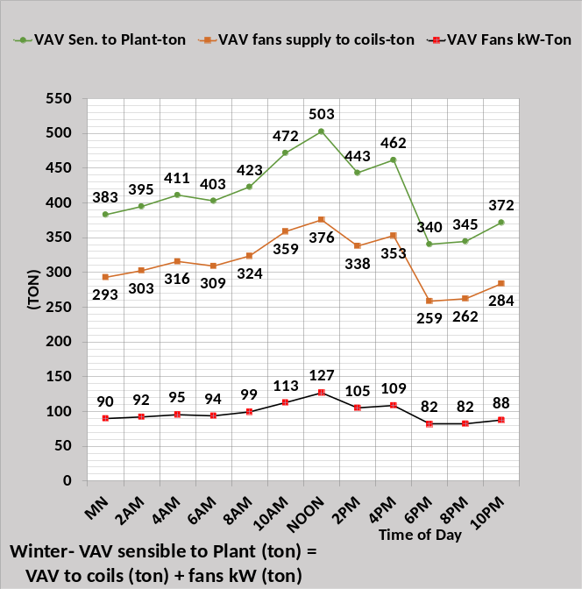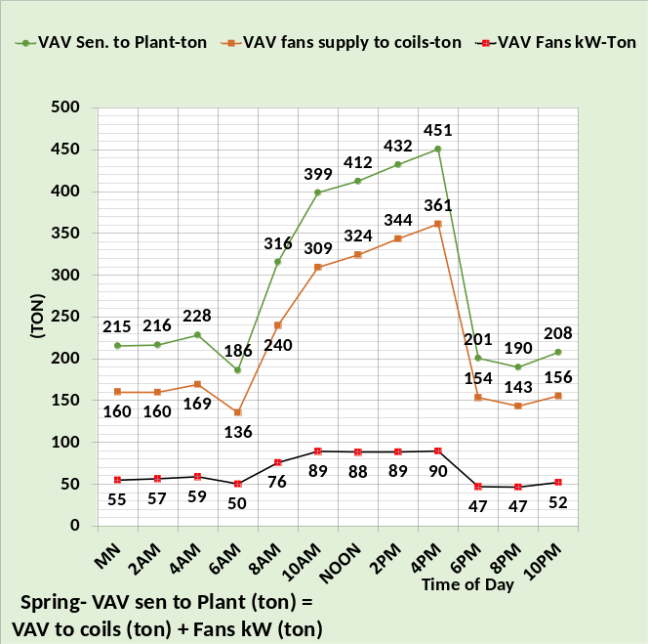
Figure 53: Plant Sensible Load

The sensible load to the coils and therefore to the plant is the load (ton) into the VAV fans plus the (ton) the VAV motor kW adds to the load. The next Figure 54 gives the same value for plant sensible load with the equation,
Ton = 1.08*(VAV fan CFM)*(air temp to coils – 55F supply air)/12,000

Temperature rise through coil
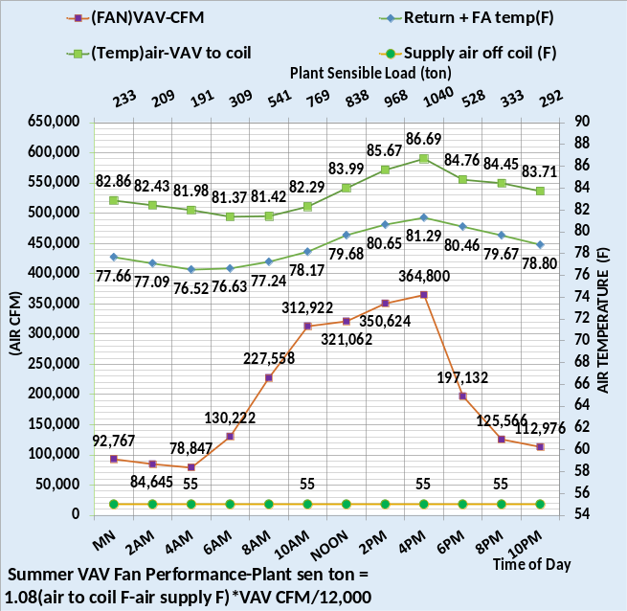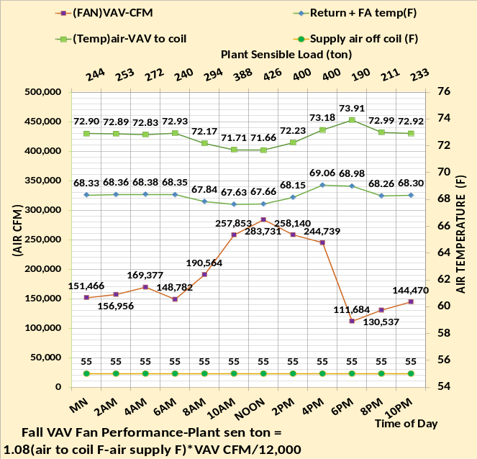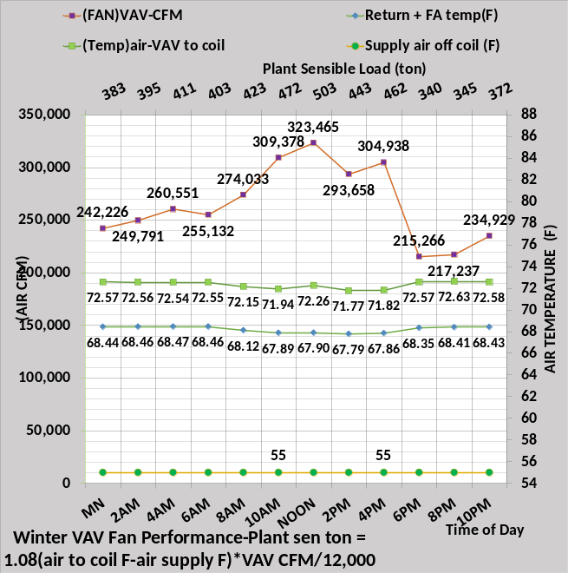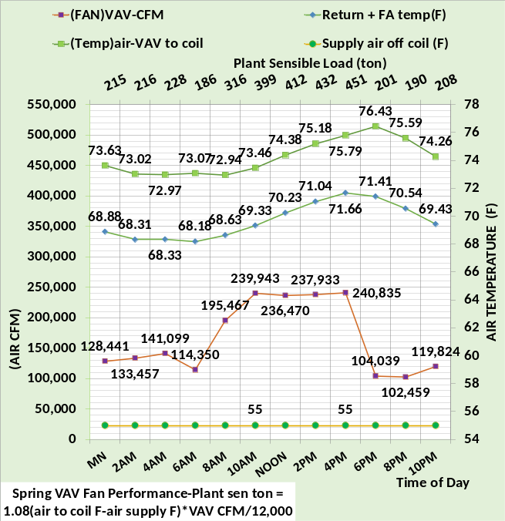
Figure 54: Plant sensible load
For example, spring weather at 4PM,
Plant sensible Ton = 1.08*(240,835) * (75.79F -55F)/12,000 = 451 ton as shown on secondary horizontal axis and Figure 53. The next Figure 55 gives additional variables regarding the plant sensible load.

Air CFM and temperatures at coil
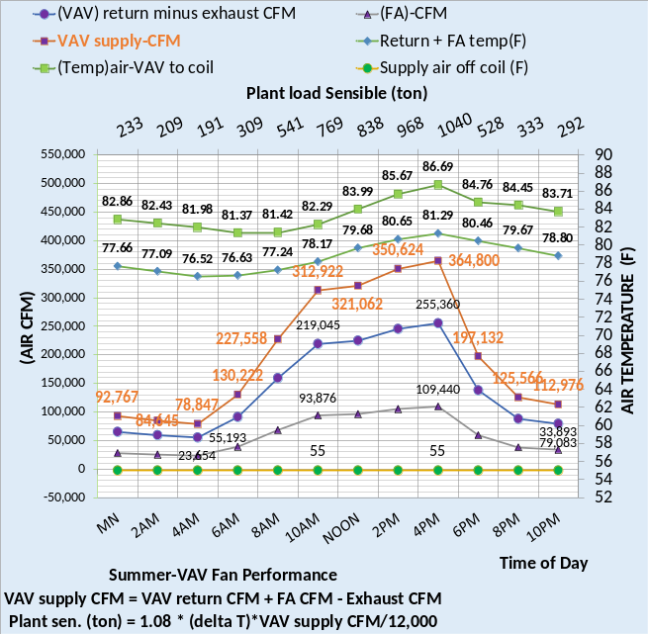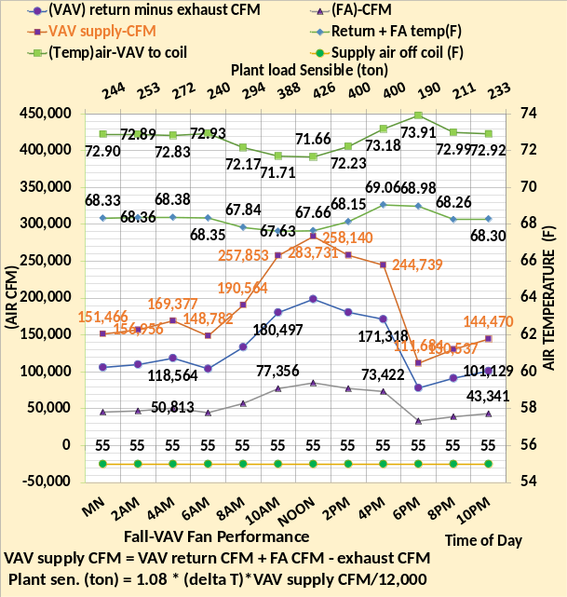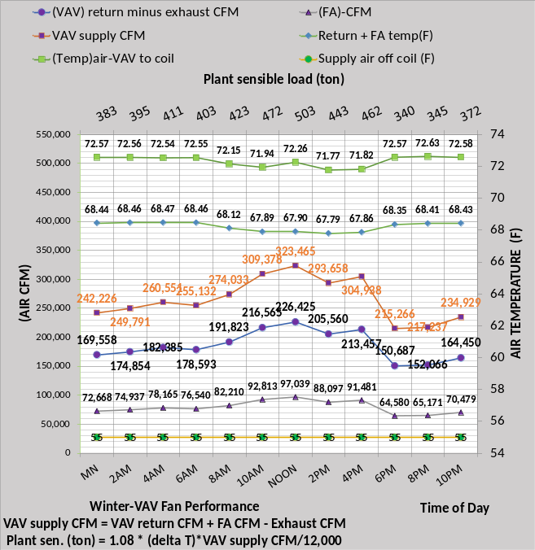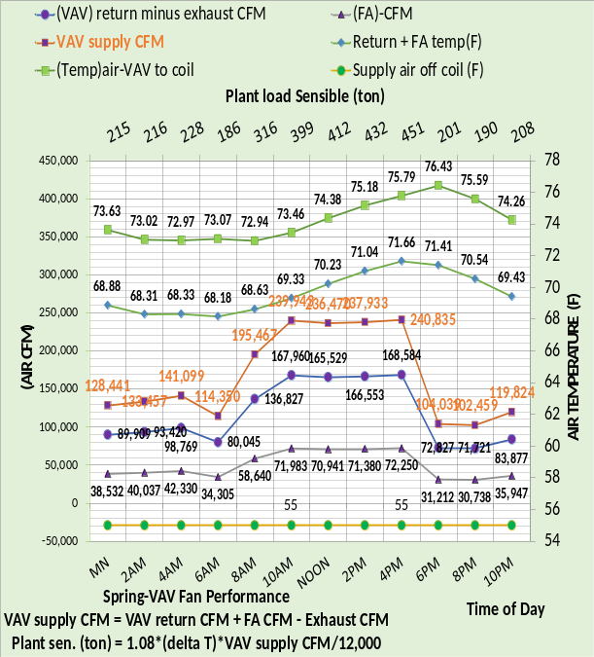
Figure 55: Plant sensible load
Figure 55 gives a more complete picture of the air flow and temperatures that result in the plant sensible load.

Latent Loads to Plant
Figure 44 gave the latent loads to the inlet of the VAV fans. The fresh air latent load is added to this load to give the latent load to the plant.

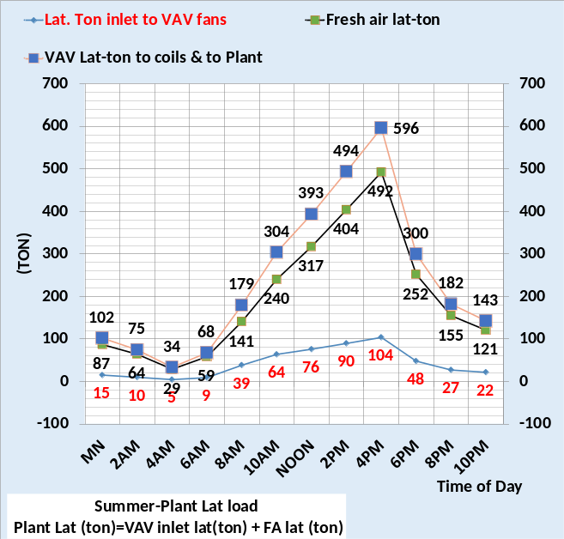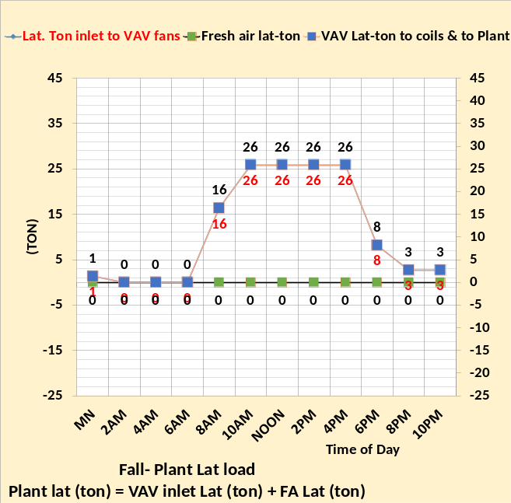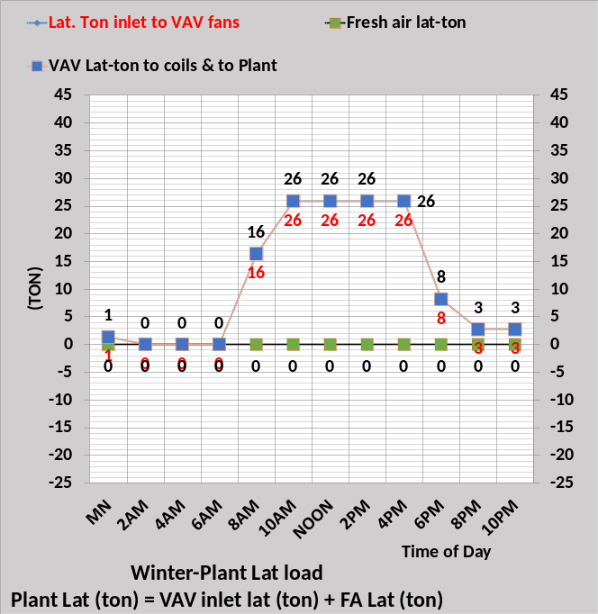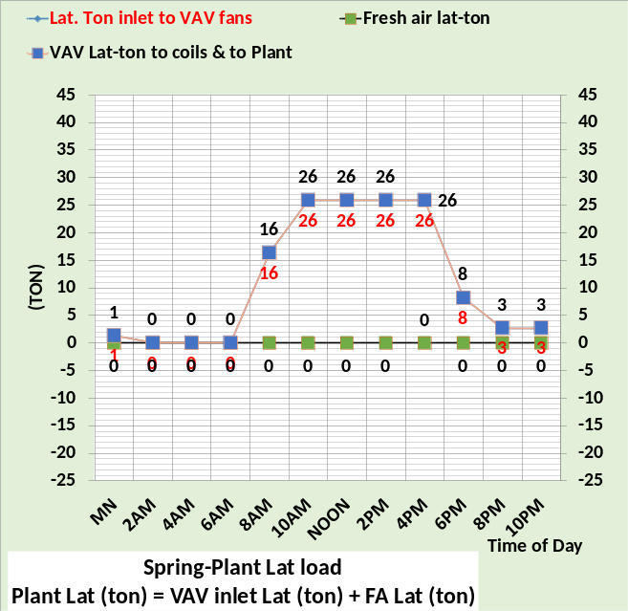
Figure 56: Latent loads to plant
Figure 56 illustrates that summer weather, due mostly to infiltration and fresh air, has a large latent load of 596 ton at 4PM. The other three seasons have latent loads only due to people.

Plant Load, Sensible + Latent
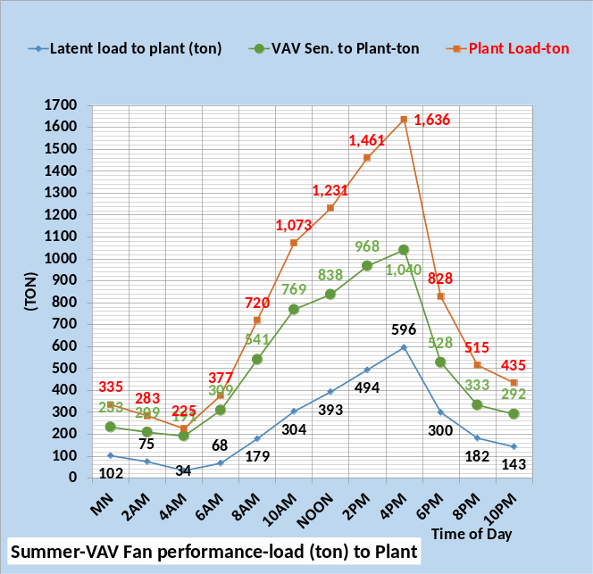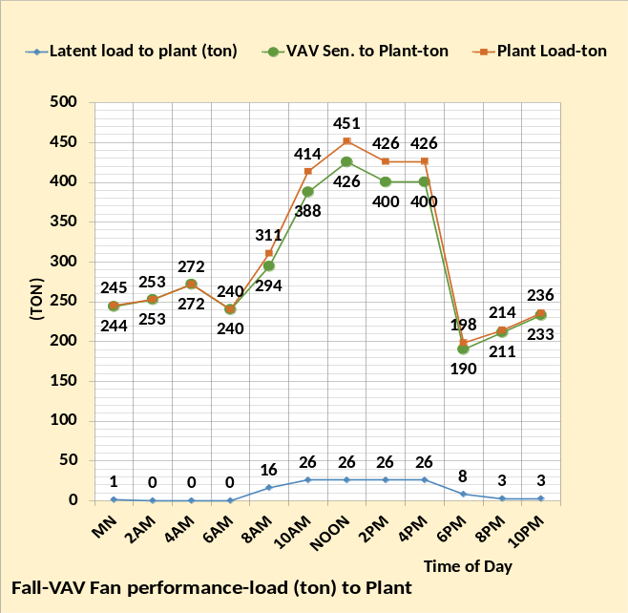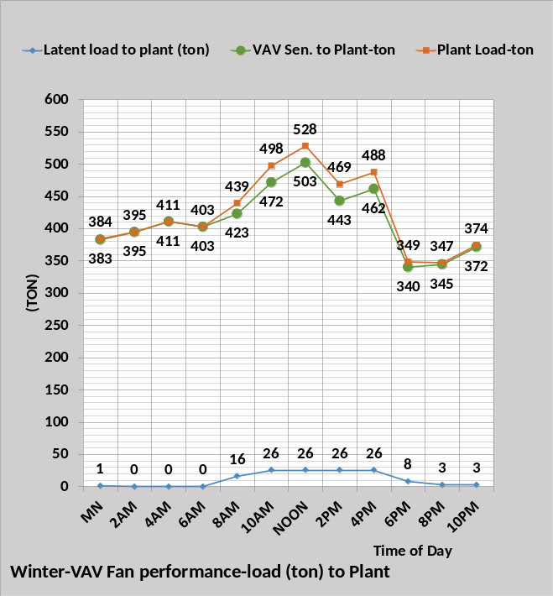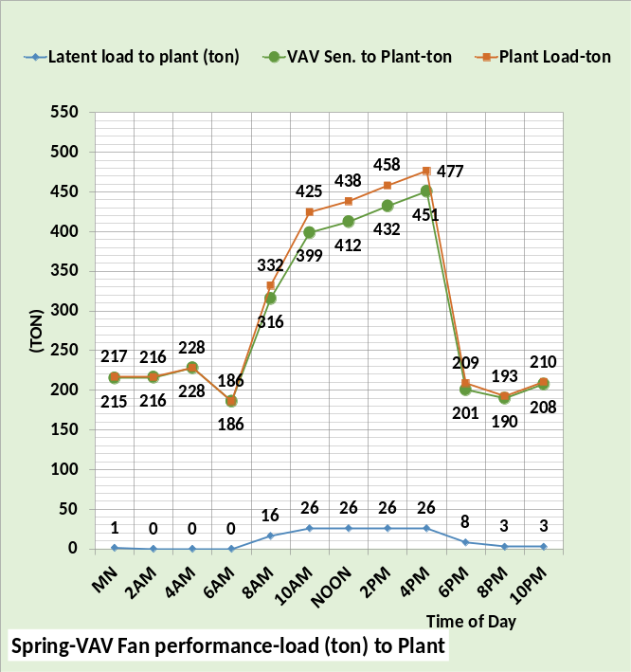
Figure 57: Building load to the plant.
Figures 1, 2, 3, & 4 discussed the metered utility energy into the building and metered plant load that define the required to balance load. The required balance load consists of all the detail loads that have been defined above arriving at plant load the same as Figures 1, 2, 3, & 4.
Next the loads (ton) and kW demand will be summarized for each weather season with building schematics.

Summer Weather Loads & kW Demand Summary
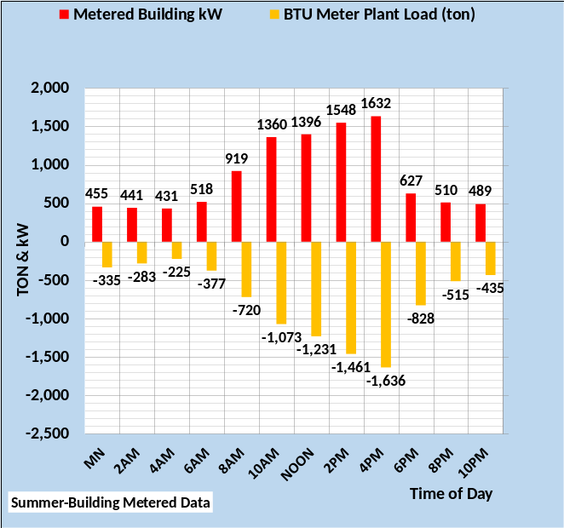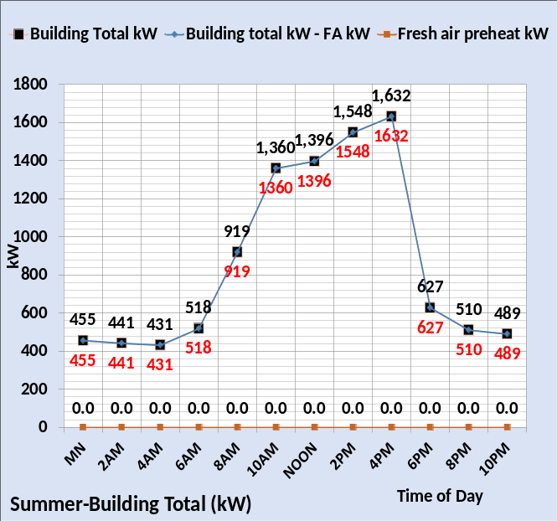
Figure 58: Summer-Metered plant load & adjusted kW demand

Above Figure 1 discussed two-meter readings needed to analyze a building’s energy consuming characteristics, plant load and kW demand that contributes to plant load. The metered plant load reflects the loads due to utility energy into the building and therefore any energy within the utility metered value that does not result in plant load must be estimated and subtracted. For example, parking lot lights or other may be in the kW or other metered value and must be subtracted for model analysis. The left chart of Figure 58 represents the kW demand to the building including fresh air preheat if it occurs but minus any energy to parking lot lights or other. As discussed above with Figure 1, fresh air heat energy is input to the building as the effect on the fresh air temperatures, therefore the right chart of Figure 58 gives the building kW demand minus fresh air kW. Fresh air heat does not occur for this summer weather conditions; therefore, the charts of Figure 58 are the same.
The purpose of this modification of the metered energy into the building is to define an energy value that is seen by the metered plant load and therefore we have two values of the building energy balance which define a third term, required to balance (ton) that represents all other loads on the building due to people, weather, and air energy exhausted. Figure 59 illustrates.

Summer required to balance load
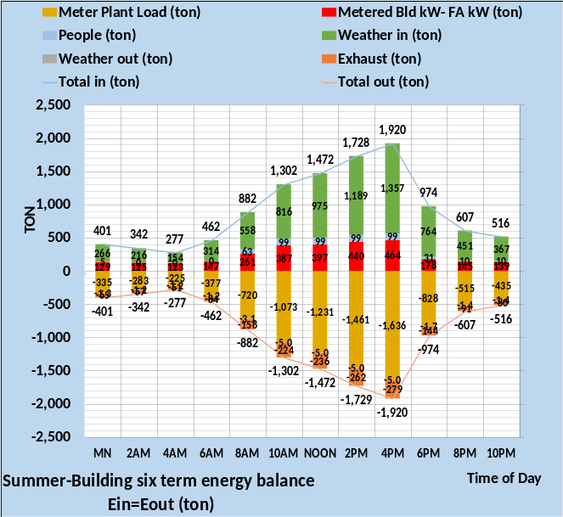
Figure 59: Required to balance (ton)
The left chart of Figure 59 converts the metered building kW minus fresh air heat kW to (ton) therefore defining the “Required to Balance building (ton), satisfying the thermodynamic requirement that energy into the building equals energy out of the building. The left chart establishes the challenge for the (SEE) Model, defining the loads that sum to the required to balance value. The right chart is an energy balance chart that can be estimated. Two values, plant load (ton) and kW, adjusted as discussed, are metered values, and the people load is a rather small load easy to estimate. The weather in (ton) is determined by standard ASHRAE procedures and the weather out is – 5 ton for this summer design weather conditions. The exhaust (ton) could be estimated or perhaps measured. The required to balance (ton) defined by the left chart would be the sum of people load, weather in & out, plus exhaust (ton). For example, at 10AM the required balance is defined by the left chart as 686 ton.
Therefore, 10AM required to balance = 99 ton + 816 ton – 224-ton -5 ton = 686 ton.
The -5-ton weather energy out is caused by the 30% of 73F internal air is returned to the perimeter and cooled to 72F before returning to the VAV fans.
The next two schematics 1 & 2 are for 4PM summer design hour, and 10PM when the sun is down, outside temperatures have decreased, almost all people are gone, and lights and plug loads have been diminished. Figures 58 & 59 values and the summer figures that follow the schematics all have values that are in the schematics. The reader is encouraged to study schematics with the figures to gain an understanding of how informative the schematics can be in understanding what is occurring in the building at a given steady state condition and how those conditions change for a different hour. Some values of all figures of Chapter 1 can be identified in the 4PM and 10PM schematics.

Schematic 1: Summer 4PM Design Hour

Schematic 2: Summer 10PM

Summer Wall Loads & Energy Balance
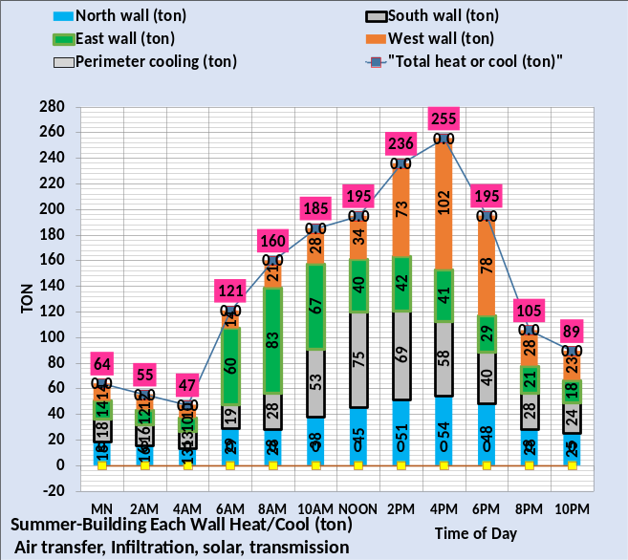
Figure 60: Building loads that define plant load
Figure 60 left chart gives the result of 5 loads on each wall for a total of 20 wall loads, detailed above by Figures 5 through 18. The right chart includes the total from the left chart and defines 14 loads for a total of 34 loads that results in the plant load. Note the plant load of Figure 60 right chart is the same as the plant load of Figure 59 left chart.
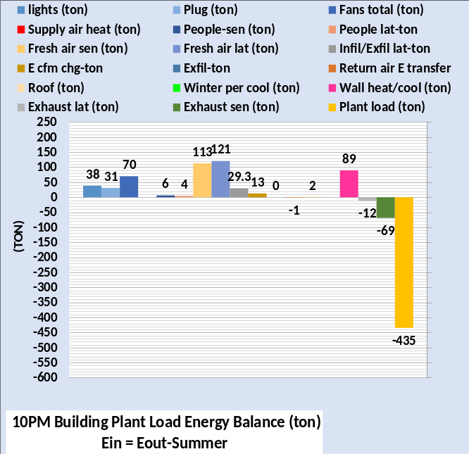
Figure 61: Energy Balance at 4PM & 10PM

Figure 61 is from Figure 60 right chart at 4PM & 10PM giving greater detail of the 14 loads that determine the plant load. These loads can be found in Schematics 1 & 2. This type of chart can be shown for any hour of Figure 60, as can schematics.
Next, we consider building kW demand.

Summer building kW Demand
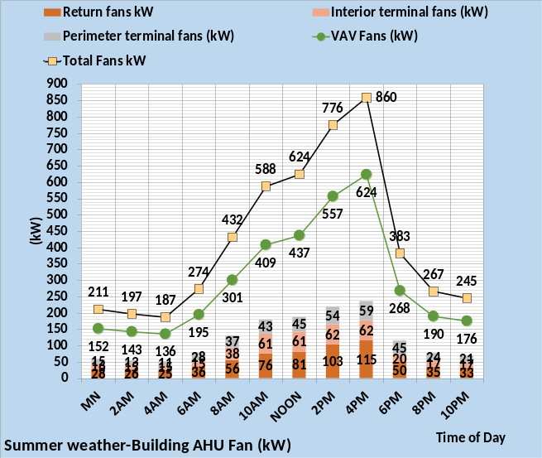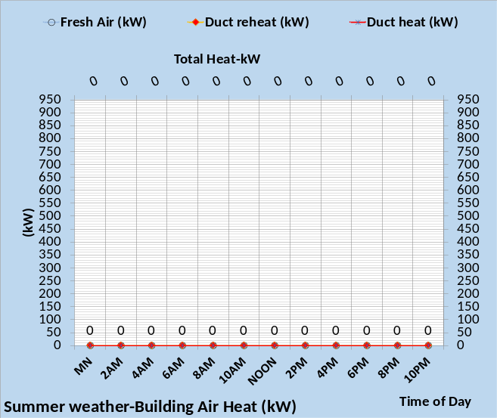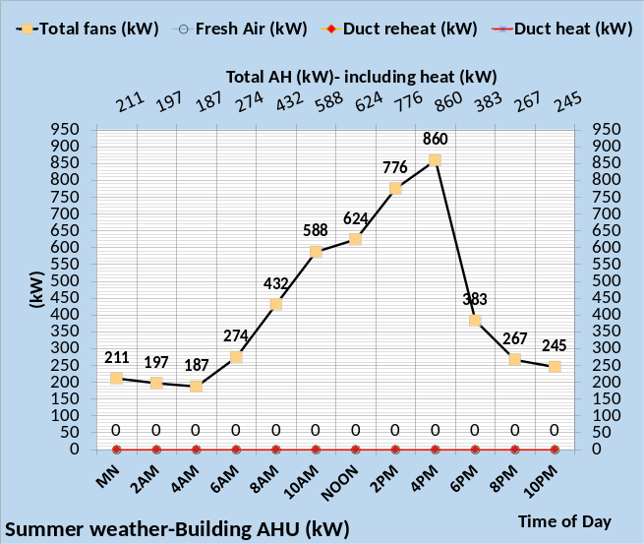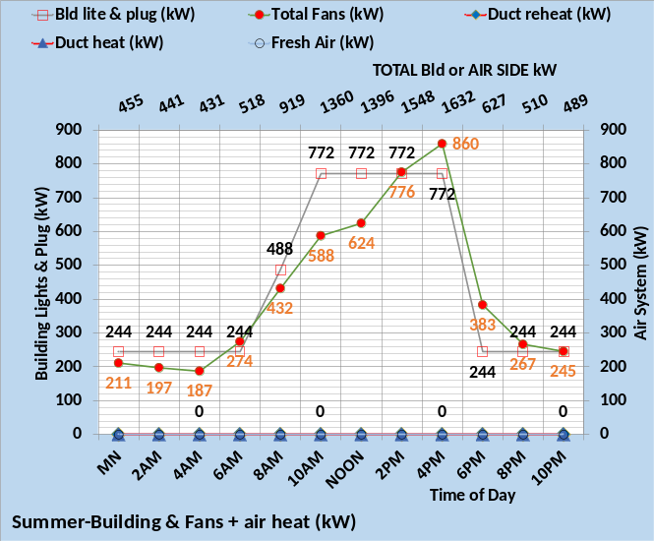
Figure 62: Summer Weather-Building kW demand

Figure 62 upper left chart gives the fan motors kW demand illustrating that the VAV fans kW is about 3 times the sum of the other fans, return and fan powered terminals. The right and bottom left charts illustrate no heat is required for these summer design weather conditions. The bottom right chart shows the fans kW plus the building lights and plug kW gives the building total kW shown on the secondary horizontal axis. The fall, winter, and spring weather charts below have very different results.

Summer kW Demand & Watts/ft²
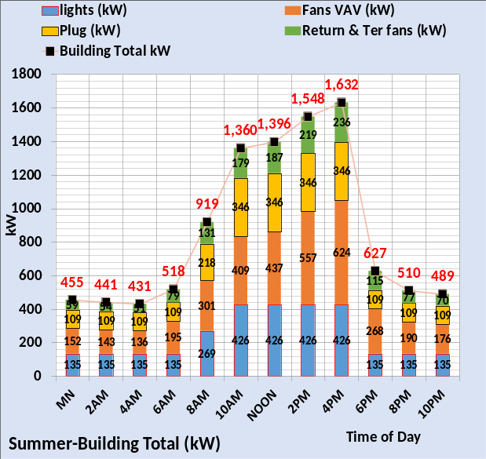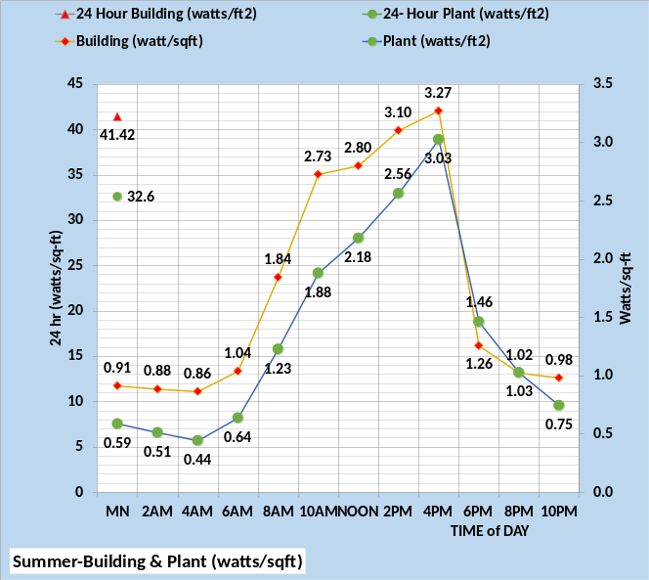
Figure 63: Summer weather building kW demand & watts/ft²

Figure 63 gives the kW demand values in a little different format. Note the total kW demand of Figure 63 left chart is the same as the total kW demand of Figure 62 lower right chart secondary horizontal axis. The right chart of Figure 63 gives the kW demand in watts/ft² and the total 24-hour watts/ft² for the building and the chiller plant. The chiller plant will be addressed in Chapter 2. The fall, winter, and spring kW values are significantly greater than the summer values as shown below.

Fall Weather Loads & kW Demand Summary

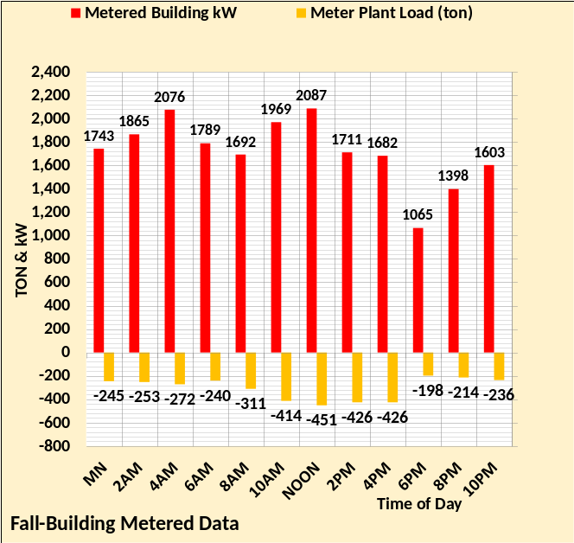
Figure 64: Fall-Metered plant load & adjusted kW demand

Above Figure 2 discussed two-meter readings needed to analyze a building’s energy consuming characteristics, plant load and kW demand and other utility energy into the building that contributes to plant load. This building is assumed to be all electric. The metered plant load reflects the loads due to utility energy into the building and therefore any energy within the utility metered value that does not result in plant load must be estimated and subtracted. For example, parking lot lights or other may be in the kW or other metered value and must be subtracted for model analysis. The left chart of Figure 64 represents the kW demand for the building including fresh air preheat if it occurs but minus any energy to parking lot lights or other. As discussed above with Figure 2, fresh air heat energy is input to the building as the effect on the fresh air temperatures, therefore the right chart of Figure 64 gives the building kW demand minus fresh air kW. Fresh air heat does occur for this fall’s weather conditions as illustrated by the right chart.
Modifying the metered energy into the building to an energy value that is seen by the metered plant load gives us two values of the building energy balance which defines a third value, required to balance (ton) that represents all other loads on the building due to people, weather, and air energy exhaust. Figure 65 illustrates the concept of the required to balance load.

Fall required to balance load

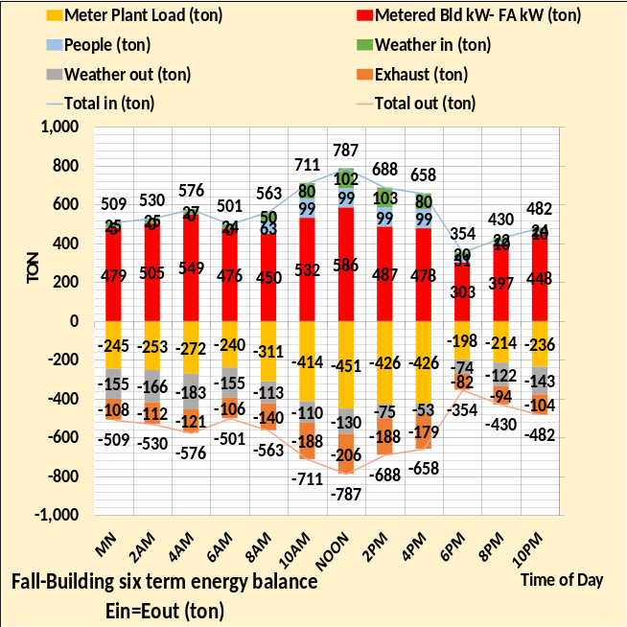
Figure 65: Required to balance (ton)
The left chart of Figure 65 converts the metered building kW minus fresh air heat kW to (ton) therefore defining the “Required to Balance building (ton)”, satisfying the thermodynamic requirement that energy into the building equals energy out of the building. The left chart establishes the challenge for the (SEE) Model, define the loads that sum to the required to balance value. The right chart is an energy balance chart that can be estimated. Two values, plant load (ton) and kW are metered values of Figure 64 & 65. The people load is a rather small load easy to estimate. The weather in & weather load out loads can be determined by standard procedures. The exhaust (ton) could be estimated or perhaps measured. The required to balance (ton) defined by the left chart would be the sum of people load, weather load in & out, plus exhaust (ton). For example, at 10AM required to balance is defined by the left chart as -118 ton.
Therefore, 10AM required to balance = 99 ton + 80 ton – 110 ton – 188 ton = -119 ton
Schematics 3 & 4 are for 4PM and 10PM when the sun is down, outside temperatures have decreased, almost all people are gone, and lights and plug loads have been diminished. Figures 64 & 65 values and the fall figures that follow the schematics all have values that are in the schematics. The reader is encouraged to study these schematics with the figures to gain an understanding of how informative the schematics can be in understanding what is occurring in the building at a given steady state condition and how those conditions change for a different hour. Some values of all fall figures of Chapter 1 can be identified in Schematics 3 & 4.
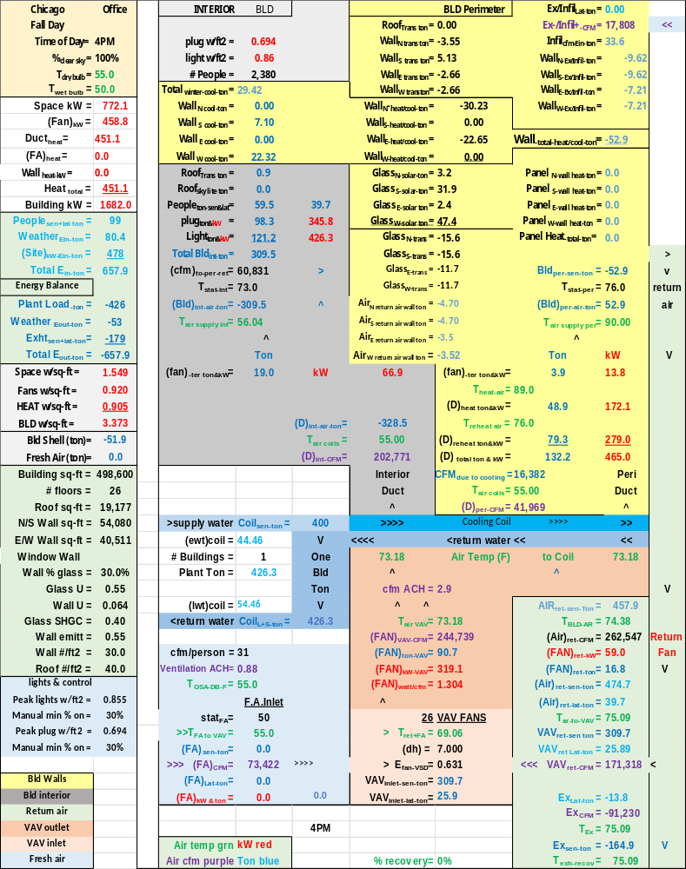
Schematic 3: Fall weather 4PM

Schematic 4: Fall weather 10PM

Fall Wall Loads & Energy Balance
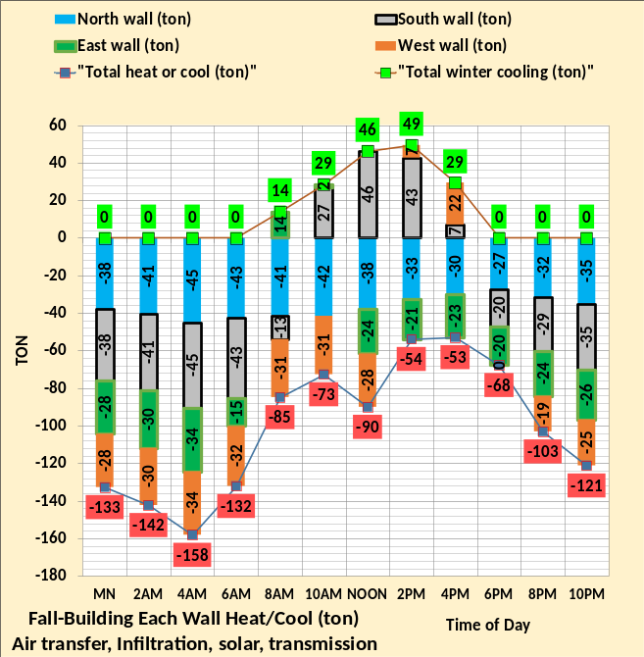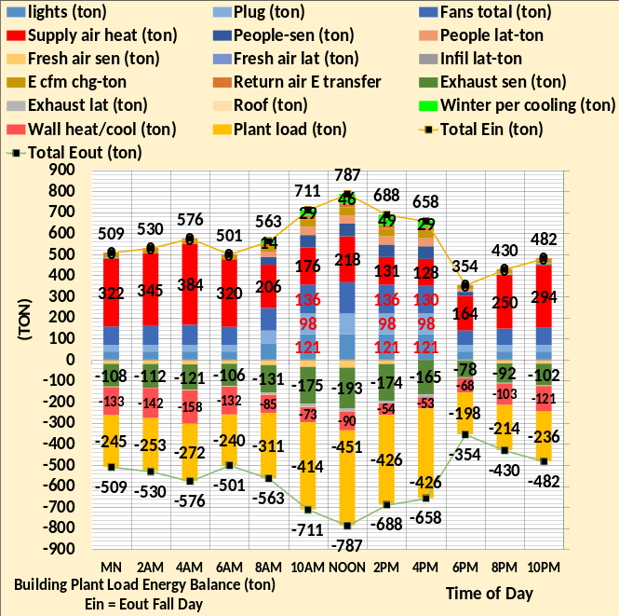
Figure 66: Building loads that define plant load
Figure 66 left chart is the wall loads, showing both wall heating and cooling occur during the 24-hour fall day. The south wall requires peak 46-ton cooling at noon and 7-ton cooling at 4PM plus 22-ton cooling on the west wall for a total 29-ton cooling at 4PM. These wall loads are in the right chart and shown more clearly by Figure 67, 29-ton cooling and -53-ton heating load.
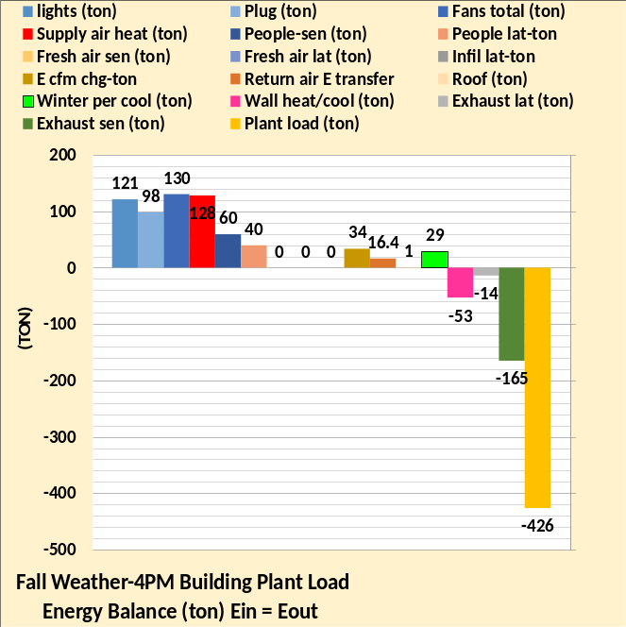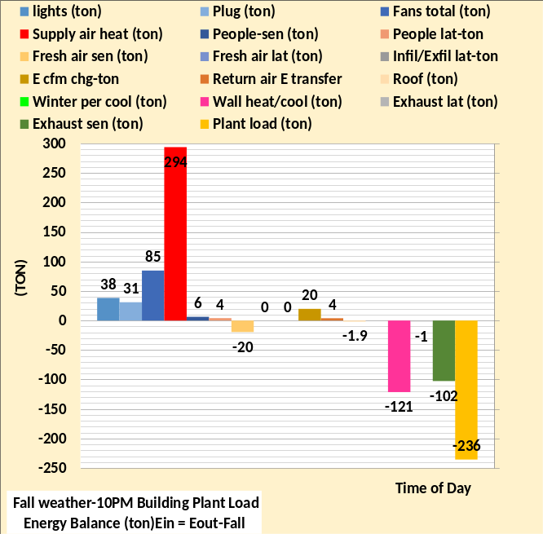
Figure 67: Building loads at 4PM
Schematic 3 gives the fall dry bulb as 55F and wet bulb 50F, therefore infiltration & fresh air latent load is zero as shown by Figure 67. The fresh air sensible load is also zero because the fresh air sensible load is a function of the supply air temperature which is also 55F.
Fall building kW Demand

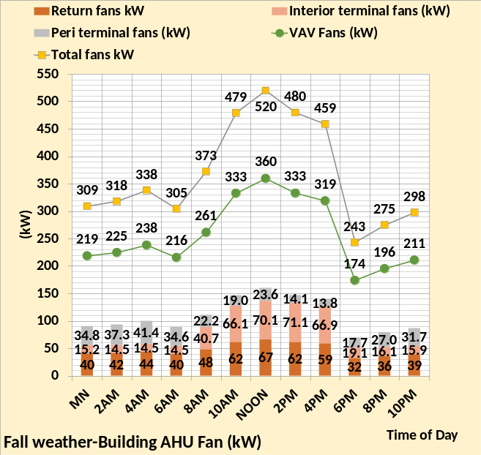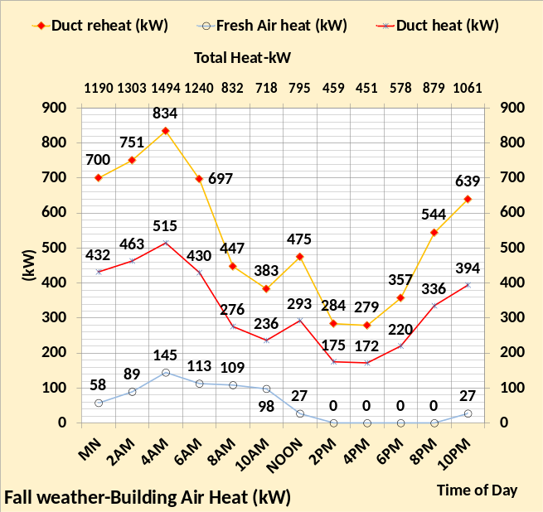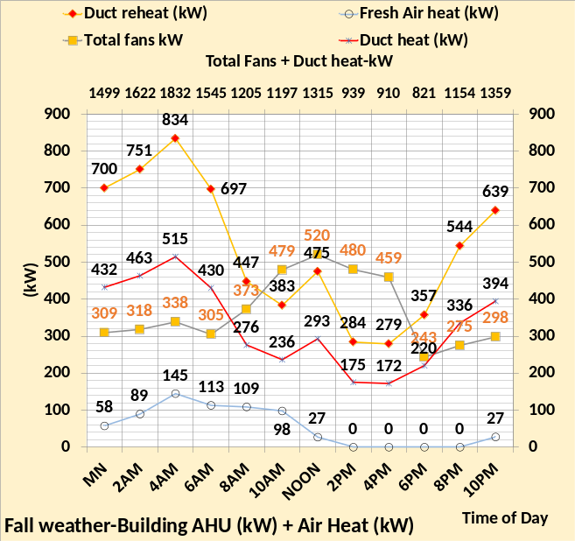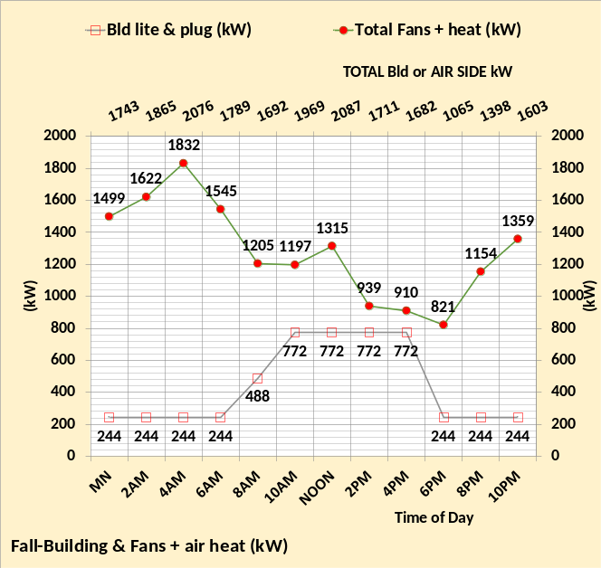
Figure 68: Fall weather building kW demand values
The upper left chart gives the fan motors kW demand values illustrating the dominance of the VAV fans. Above Figure 62 illustrates that the total fans kW for summer weather peaks at 860 kW versus 520 kW for fall weather. However, the upper right chart and lower left chart of Figure 68 shows heat requirements for fall weather drives the total building kW demand to a value greater than summer conditions. The peak kW demand shown by the lower right chart of Figure 68 is 2,087 kW versus 1,632 kW of Figure 62. Note the kW demand due to lights and plugs is the same for Figures 62 & 68.

Fall kW Demand & Watts/ft²

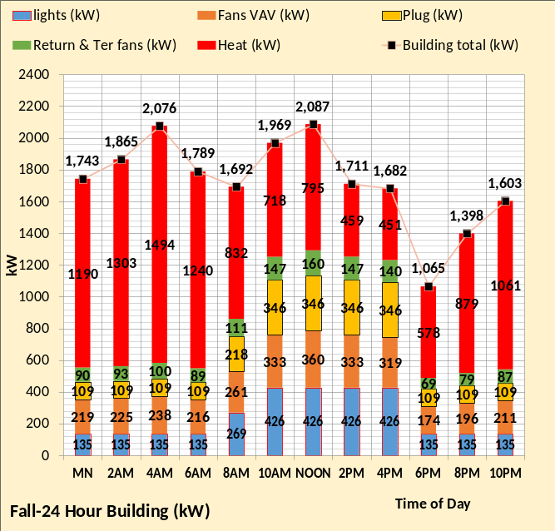
Figure 69: Fall weather building kW demand & watts/ft²

Figure 69 gives the kW demand values in a little different format, the same total building kW values as the secondary horizontal axis of Figure 68, lower right chart. The right chart of Figure 69 gives the kW demand in watts/ft² and the total 24-hour watts/ft² for the building and the chiller plant. The chiller plant will be addressed in Chapter 3. The 24-hour building 82.95 watts/ft² is greater than the summer building 41.42 watts/ft² of Figure 63, however the summer plant is 43.2 watts/ft² versus 9.6 watts/ft² for the fall weather plant of Figure 69. The summer total 24-hour building & plant is 84.62 watts/ft² and the fall weather 24-hour total is 92.55 watts/ft², about 9% greater.
Figures 63 & 69 can be used to judge the energy consumption of the Chicago office buildings on similar weather days. Day watts/ft² values close to these values suggest a building is wasting significant energy.

Winter Weather Loads & kW Demand Summary
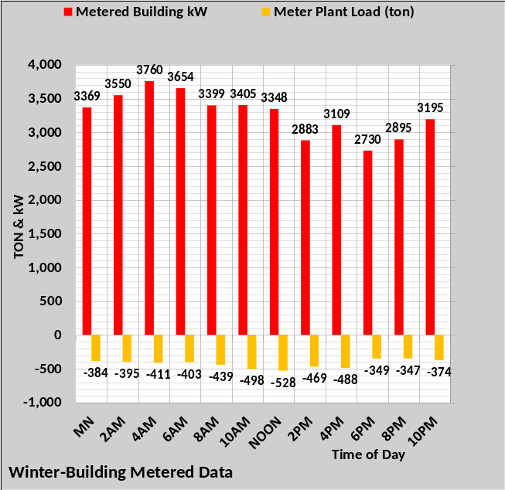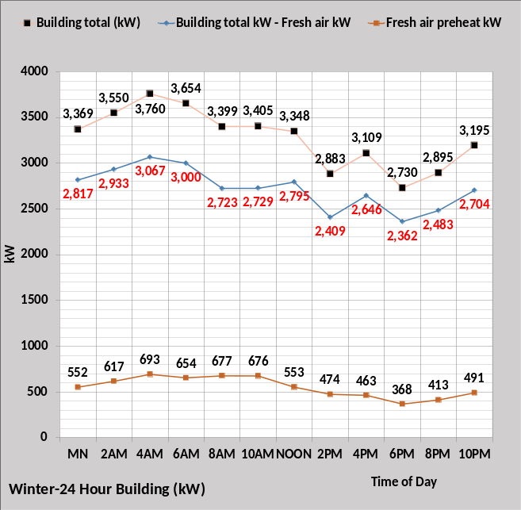
Figure 70: Winter-Metered plant load & adjusted kW demand
Above Figure 3 discussed two-meter readings needed to analyze a building’s energy consuming characteristics, plant load and kW demand and any other utility energy into the building that contributes to plant load. This modeled building is assumed to be all electric. The metered plant load reflects the utility energy loads into the building and therefore any energy within the utility metered value that does not result in plant load must be estimated and subtracted. For example, parking lot lights or other things may be in the metered kW and must be subtracted for model analysis. The left chart of Figure 70 represents the kW demand for the building including fresh air preheat if it occurs but minus any energy to parking lot lights or other. As discussed above with Figure 3, fresh air heat energy is input to the building as the effect on the fresh air temperatures, therefore the right chart of Figure 70 gives the building kW demand minus fresh air kW. Fresh air heat occurs for this winter’s weather conditions as illustrated by the right chart. The kW input to the model is the (Building total kW – Fresh air kW).
Modifying the metered energy into the building to an energy value that is seen by the metered plant load gives two values of the building energy balance which defines a third value, required to balance (ton), that represents all other loads on the building due to people, weather, and exhaust air energy. Figure 71 illustrates the concept of the required balance load.

Winter required to balance load

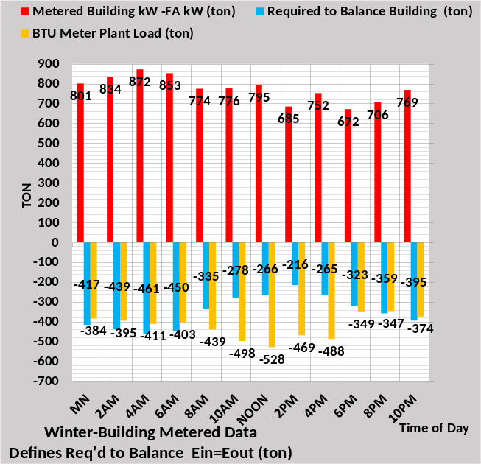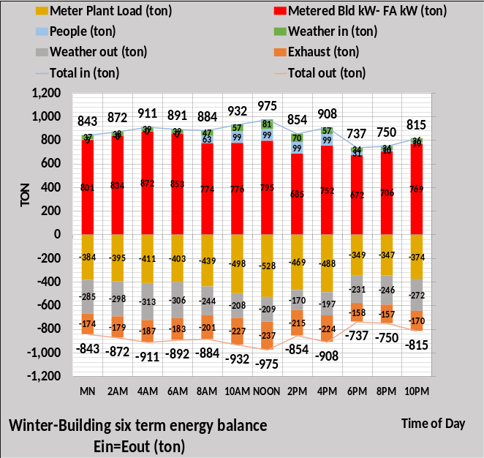
Figure 71: Required to balance (ton)
The left chart of Figure 71 converts the metered building kW minus fresh air heat kW to (ton) therefore defining the “Required to Balance building (ton)”, satisfying the thermodynamic requirement that energy into the building equals energy out of the building. The left chart establishes the challenge for the (SEE) Model, defining the loads that sum to the required to balance value. The right chart is an energy balance chart that can be estimated. Two values, plant load (ton) and kW are metered values of Figure 71left chart. The people load is a rather small load easy to estimate. The weather in & weather out loads can be determined by standard procedures. The exhaust (ton) could be estimated or perhaps measured. The required balance (ton) defined by the left chart would be the sum of people load, weather load in & out, plus exhaust (ton). For example, at 10AM required to balance is defined by the left chart as -278 ton.
Therefore, 10AM required to balance = 99 ton + 57 ton – 208 ton – 227 ton = -279 ton.
Schematics 5 & 6 are for 4PM and 10PM when the sun is down, outside temperatures have decreased, almost all people are gone, and lights and plug loads have been diminished. Figures 71 & 72 values and the winter figures that follow the schematics all have some values that are in the schematics. The reader is encouraged to study these schematics with the figures to gain an understanding of how informative the schematics can be in understanding what is occurring in the building at a given steady state condition and how those conditions change for a different hour. Some values of many winter figures of Chapter 1 can be identified in Schematics 5 & 6.
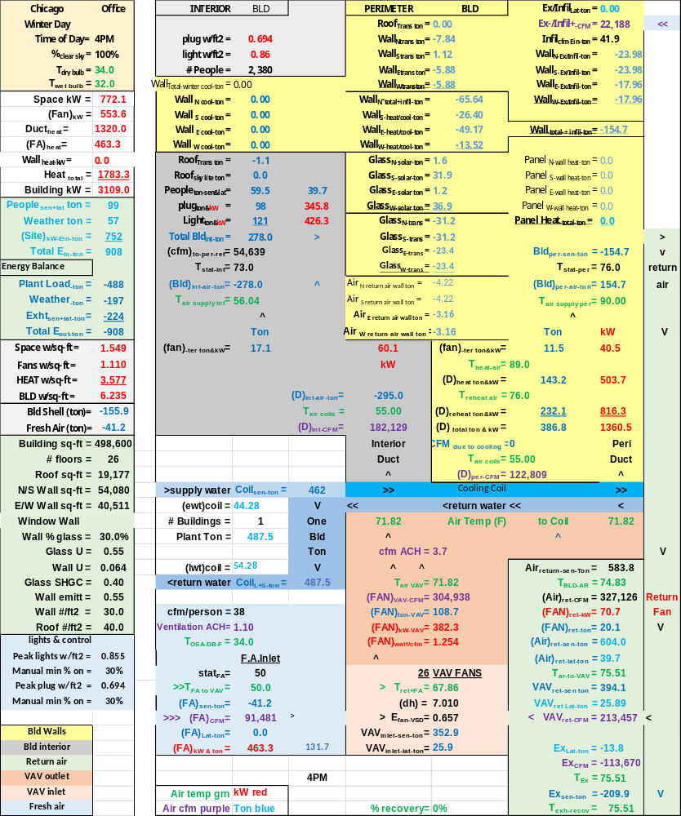
Schematic 5: Winter 4PM


Schematic 6: Winter 10PM

Winter Wall Loads & Energy Balance
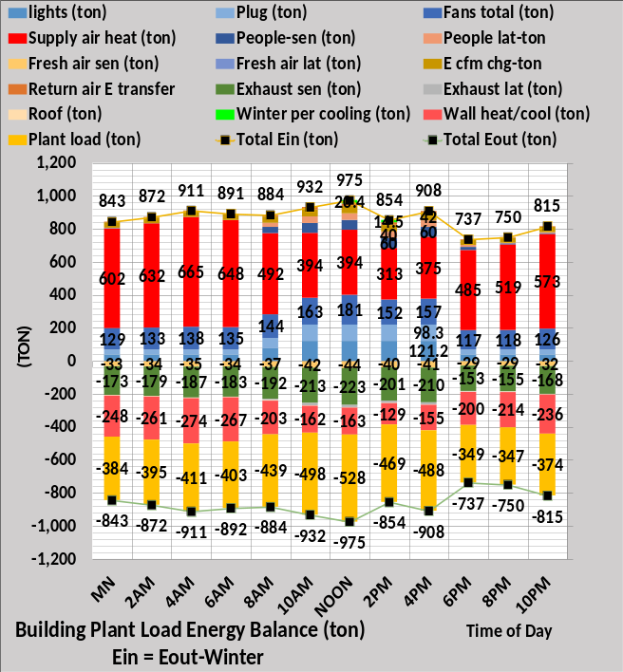
Figure 72: Building loads that define plant load
Figure 72 left chart is the wall loads, showing both wall heating and cooling occur during the 24-hour fall day. The south wall is the only wall requiring cooling, 20-ton cooling at noon and 14-ton cooling at 2PM. The peak heating of -274 ton occurs at 4AM. The wall loads of left chart are in the right chart and shown more clearly by Figure 73 at 4PM.
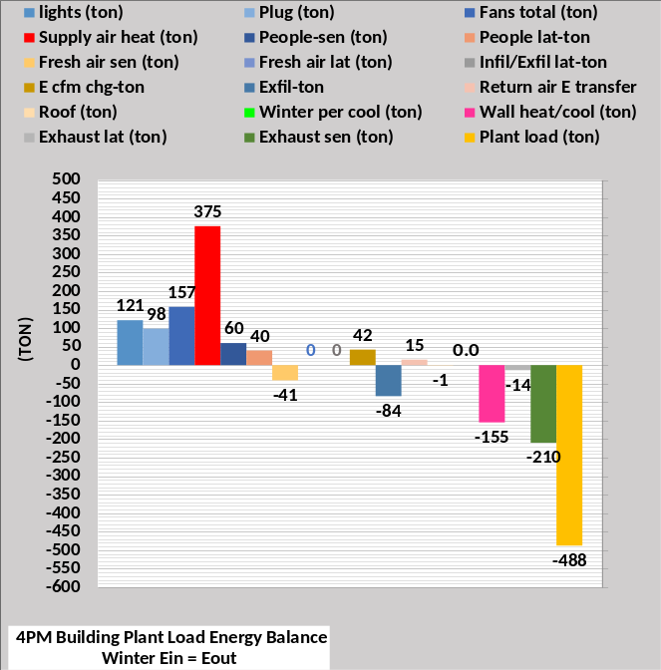
Figure 73: Building loads at 4PM
Figure 73 gives a more detailed view of Figure 72 right chart at 4PM & 10PM. Any hour can be shown like Figure 73. Next, building kW demand.
Winter building kW Demand
Figure 74: Winter weather building kW demand values
The upper left chart gives the fan motors kW demand values illustrating the VAV fans are the big fan motor kW demand. The upper right chart gives the perimeter air supply heat with a peak of 3,032 kW occurring at 4AM. The fall weather peaks at 1,494 kW given by Figure 68. The peak kW demand shown by the lower right chart of Figure 74 is 3,760 kW versus 2,076 kW of Figure 68. The lower left chart of Figure 74 shows the total of fans motors kW and air heat kW on the secondary horizontal axis.

Winter kW Demand & Watts/ft²
Figure 75: Winter weather building kW demand & watts/ft²

Figure 75 gives the kW demand values in a different format, the same total building kW values as the secondary horizontal axis of Figure 74, lower right chart. The right chart of Figure 75 gives the kW demand in watts/ft² and the total 24-hour watts/ft² for the building and the chiller plant. The chiller plant will be addressed in Chapter 3. The 24-hour building 157.63 watts/ft² is greater than the fall building 82.95 watts/ft² of Figure 70. The plant 12.7 watts/ft² is also more than the fall value of 9.6 watts/ft².
Figure 75 can be used to judge the energy consumption of the Chicago office buildings on similar winter weather days. Day watts/ft² values close to these values suggest a building is wasting significant energy.

Spring Weather Loads & kW Demand Summary

Figure 76: Spring-Metered plant load & adjusted kW demand
Above Figure 4 discussed two-meter readings needed to analyze a building’s energy consuming characteristics, plant load and kW, this building is assumed to be all electric. The metered plant load reflects the utility energy loads into the building and therefore any energy within the utility metered value that does not result in plant load must be estimated and subtracted. For example, parking lot lights or other things may be in the metered kW and must be subtracted for model analysis. The left chart of Figure 76 represents the kW demand for the building including fresh air preheat if it occurs but minus any energy to parking lot lights or other. As discussed above with Figure 4, fresh air heat energy is input to the building as the effect on the fresh air temperatures, therefore the right chart of Figure 76 gives the building kW demand minus fresh air kW. Fresh air heat occurs for this spring’s weather conditions only at 4AM as illustrated by the right chart. The kW input to the model is the (Building total kW that contributes to plant load minus fresh air kW).
Modifying the kW metered energy into the building to an energy value that is seen by the metered plant load gives two values of the building energy balance which defines a third value, required to balance (ton), that represents all other loads on the building due to people, weather, and air energy exhausted. Figure 77 illustrates the concept of the required balance load.

Spring required to balance load

Figure 77: Required to balance (ton)
The left chart of Figure 77 converts the adjusted metered building kW minus fresh air heat kW to (ton) therefore defining the “Required to Balance building (ton)”, satisfying the thermodynamic requirement that energy into the building equals energy out of the building. The left chart establishes the challenge for the (SEE) Model, defining the loads that sum to the required to balance value. The right chart is an energy balance chart that can be estimated. Two values, plant load (ton) and kW are metered values of Figure 76. The people load is a rather small load easy to estimate. The weather in & weather out loads can be determined by standard procedures. The exhaust (ton) could be estimated or perhaps measured. The required balance (ton) defined by the left chart would be the sum of people load, weather load in & out, plus exhaust (ton). For example, at 10AM required to balance is defined by the left chart as -28 ton.
Therefore, 10AM required to balance = 99 ton + 92 ton – 44 ton – 175 ton = -28 ton.
The next Figure 78 illustrates that this -28-ton required to balance load at 10AM is defined by 35 loads on the building, 20 wall loads and 15 other loads, defined by the many figures above. This level of detail is necessary if the energy performance of a real building is to be duplicated.
Schematics 7 & 8 are for 4PM and 10PM when the sun is down, outside temperatures have decreased, almost all people are gone, and lights and plug loads have been diminished. Figures 76 & 77 values and the spring figures that follow the schematics all have some values that are in the schematics. The reader is encouraged to study these schematics with the figures to gain an understanding of how informative the schematics can be in understanding what is occurring in the building at a given steady state condition and how those conditions change for a different hour. Some values of many winter figures of Chapter 1 can be identified in Schematics 7 & 8.

Schematic 7: Spring 4PM

Schematic 8: Spring 10PM

Spring Wall Loads & Energy Balance
Figure 78: Building loads that define plant load
Figure 78 left chart is the wall loads, showing both wall heating and cooling occur during the 24-hour fall day. The east wall requires cooling during the morning hours, the south wall during midday and the west wall as the solar day ends. The peak wall cooling of 52 ton occurs at 2PM. The peak heating of -122 ton occurs at 4AM. The wall loads of the left chart are in the right chart and shown more clearly by Figure 79 at 4PM & 10PM. The Figure 79 type chart can be shown for any hour of Figure 78 right chart.
Figure 79: Building loads at 4PM & 10PM. Ein = Eout
Figure 79 gives a more detailed view of Figure 78 right chart at 4PM & 10PM. Note at 4PM the 50-ton wall cooling load on the west wall is shown and the -29-ton heating load on the other three walls. Figure 79 illustrates energy into the building equals energy out of the building.
Spring building kW Demand
Figure 80: Spring weather building kW demand values
The upper left chart gives the fan motor kW demand values illustrating the VAV fans at midday are about twice the sum of the other air fans. The upper right chart gives the perimeter air supply heat with a peak of 1,068 kW occurring at 4AM. The lower left chart shows the sum of air heat and fans kW, with a peak of 1,360 kW occurring at 4AM. The peak kW demand shown by the lower right chart of Figure 80 is 1,604 kW, the sum of the air heat, fans kW and lights plus plug loads kW.

Spring kW Demand & Watts/ft²
Figure 81: Spring weather building kW demand & watts/ft²

Figure 81 gives the kW demand values in a different format, the same total building kW values as the secondary horizontal axis of Figure 80, lower right chart. The right chart of Figure 81 gives the kW demand in watts/ft² and the total 24-hour watts/ft² for the building and the chiller plant. The chiller plant will be addressed in Chapter 3. The 24-hour building total is 65.26 watts/ft² and the plant is 10.71 watts/ft².
Figure 81 can be used to judge the energy consumption of office buildings in Chicago on similar spring weather days. Day watts/ft² values close to these values suggest a building is wasting significant energy.
Chapter 1 COMMENTS
Chapter 1 consists of more than 80 pages and 80 figures and about 350 charts to present and discuss the energy consuming characteristics of a Chicago 26-story office tower. The concept of defining the energy required to balance by metering the plant load and adjusting the metered kW energy into the building to that energy that is seen by the plant load, is perhaps a new approach for some to analyze the energy consuming characteristics of a building. However, the rather simple approach of defining the required energy to balance value takes significant detail to define the loads that make up the required to balance value, about 35 building loads as presented by Chapter 1.
Two building loads have been defined as unstable energy, difficult if not impossible to determine in a real building, infiltration load and load due to return air energy transfer. These two loads could explain why similar buildings can have very different energy consumption^{24,25,26,27}.
The approximately 80 figures of Chapter 1 illustrate that the change in any design or energy use characteristic of a building will change most if not all figures, clearly the energy use of a building is a complex issue necessitating continued study and willingness to challenge all existing understanding and beliefs, including those presented here.
Kirby P. Nelson P.E.
Life Member ASHRAE
References for Introduction, Executive Summary & Chapter 1
- Nelson, Kirby, P.E., ASHRAE Journal March 2025. “Can 24-Hour Energy Models Improve Results of Benchmark Programs?”
- Lawrence, Thomas 2023. “Past, Present and (Possible) Future”. ASHRAE Journal February 2023.
- Chicago 2020 Benchmarking Report.
https://www.chicago.gov/content/dam/city/progs/env/EnergyBenchmark/2020_Chicago_Energy_Benchmarking_Report.pdf
- About the Commercial Buildings Integration Program | Department of Energy
- Zheng O’Neill, “Nationwide Savings Analysis of A Variety of Energy Conservation Measures”. (CH-18-C005), 2018 ASHRAE Winter Conference
- Dirkes II, James V. 2016. “Modeled Performance Isn’t Actual Performance” ASHRAE Journal May 2016.
- Principles of Heating Ventilating and Air Conditioning. ASHRAE Inc. Sauer, Howell, Coad. 1st Law Thermodynamics page 2.29-2ed Law page 2.31-
- ASHRAE Handbook 2021 Fundamentals. Page 2.2, 1st law of thermodynamics. Chapter 16, infiltration. Chapter 14, Climatic Design Information.
- Wagdy, Anis 2014. “Measuring Airtightness of Mid and High-Rise Non-Residential Buildings”. ASHRAE Research Project Report 1478-RP.
- ASHRAE Journal Newsletter April 12, 2022. “How Buildings, Chiller Plants Work: Discovering the SEE Model”. How Buildings, Chiller Plants Work: Discovering the SEE Model | ashrae.org
- Nelson, K. 2006. “7 Upgrades to Reduce Building Electrical Demand” ASHRAE Journal, December 2006.
- Nelson, K. “Simulation Modeling of a Central Chiller Plant” CH-12-002. ASHRAE 2012 Chicago Winter Transactions.
- Nelson, K. “Simulation Modeling of Central Chilled Water System” CH-12-003. ASHRAE 2012 Chicago Winter Transactions.
- Nelson, Kirby. “System Energy Equilibrium (SEE) Building Energy Model Development & Verification”. http://kirbynelsonpe.com/
- Weather Chicago https://www.wunderground.com/weather/us/chicago
- Taylor, Steven. July 2011 ASHRAE Journal. “Optimizing Principles Design & Control of Chilled Water Plants”.
- Myer, Michael 2023. “Lighting Change in ASHRAE/IES Standard 90.1-2022”. ASHRAE Journal September 2023.
- Sarfraz, Omer 2018. “Plug Loads Design Factors”. ASHRAE Journal January 2018.
- Anis, Wagdy 2001. “The Impact of Airtightness on System Design”. ASHRAE Journal December 2001.
- Fahnline, Richard 2016. “Impact of Stack Effect on Building Static Pressure Measurement”. ASHRAE Journal October 2016.
- Trane engineering newsletter “Commercial Building Pressurization” Vol. 31, No 2
- McNulty, Meghan K. June 2025 ASHRAE Journal. “Mapping Space Types Across ASHRAE Standards 62.1, 170, & 241”.
- Ng, Lisa C., Ph.D., 2014. “Improving Infiltration In Energy Modeling” ASHRAE Journal of July 2014.
- Menconi, Pete, P.E., 2014. Letters ASHRAE Journal of July 2014.
- Rumsey, Peter, P.E., 2014. Author response to Menconi letter. ASHRAE Journal of July 2014.
- Nelson, Kirby, P.E., 2014. Letters ASHRAE Journal of September 2014.
- Menconi, Pete, P.E., 2014. Author response to Nelson letter. ASHRAE Journal of September 2014.

Building Nomenclature
Building structure.
BLD ft² = air-conditioned space
# Floors = number of building floors
Roof ft² = roof square feet
N/S wall ft² =north/south wall square feet
E/W wall ft² =east/west wall square feet
Wall % glass = percent of each wall that is glass
Glass U = glass heat transfer coefficient
Wall U = wall heat transfer coefficient
Glass SHGC = glass solar heat gain coefficient
Wall emit = wall solar index
Wall weight = #/ft2
Roof weight = #/ft2
Building interior space.
Roof_{trans-ton} =roof load to interior (ton)
Roof_{sky-lite-ton} =sky lite load (ton)
# people = number people in building
People_{ton sen&lat} = sensible & latent cooling load (ton)
Plug_{ton&kW} = cooling load & kW due to plug loads
Light_{ton&kW} = cooling load & kW due to lights
Total Bld_{int-ton} = total building interior load (ton)
(cfm) _{to-per-return} = CFM of interior supply air that returns to perimeter of building
T_{stat-int} = interior stat set temperature (F)
Bld_{int-air-ton} = supply air ton to offset interior load
Building perimeter space.
%_{clear sky} = percent clear sky
T_{dry bulb} = outside dry bulb temperature (F)
T_{wet bulb} = outside wet bulb temperature (F)
Ex/Infil_{lat-ton} = latent air infiltration or exfiltration (ton)
Ex/Infil_{CFM} = air infiltration or exfiltration CFM
Ex/Infil_{sen-ton} =sensible air exfiltration or infiltration (ton)
Wall_{N-Ex/Infil-ton} = North Wall sensible infiltration or exfiltration
Wall_{S-Ex/Infil-ton} = South Wall sensible infiltration or exfiltration
Wall_{E-Ex/Infil-ton} = East Wall sensible infiltration or exfiltration
Wall_{W-Ex/Infil-ton} = West Wall sensible infiltration or exfiltration
Infil/Exfil-ton = Total Wall sensible infiltration or exfiltration
Wall_{n trans ton} = north wall transmission (ton)
Wall_{s trans ton} = south wall transmission (ton)
Wall_{E trans ton} = east wall transmission (ton)
Wall_{w trans ton} = west wall transmission (ton)
Glass_{N-trans-ton} = north wall glass transmission (ton)
Glass_{S-trans-ton} = south wall glass transmission (ton)
Glass_{E-trans-ton} = east wall glass transmission (ton)
Glass_{W trans-ton} = west wall glass transmission (ton)
Glass_{N-solar-ton} = north glass solar load (ton)
Glass_{S-solar-ton} = south glass solar load (ton)
Glass_{E-solar-ton} = east glass solar load (ton)
Glass_{W-solar-ton} = west glass solar load (ton)
Wall _{Total winter cool-ton} = Total wall cooling during cold weather due to wall solar (ton)
Wall _{N cool-ton} = North wall cold weather cooling (ton)
Wall _{S cool-ton} = South wall cold weather cooling (ton)
Wall _{E cool-ton} = East wall cold weather cooling (ton)
Wall _{W cool-ton} = West wall cold weather cooling (ton)
Panel _{N-wall heat-ton} = North wall panel heat (ton)
Panel _{S-wall heat-ton} = South wall panel heat (ton)
Panel _{E-wall heat-ton} = East wall panel heat (ton)
Panel _{W-wall heat-ton} = West wall panel heat (ton)
Panel heat _{Total-ton} = Heat provided by window panel (ton)
(int cfm)_{per-ton} = Total wall effect of interior return CFM to wall (ton)
Total Bld_{per-sen-ton} total perimeter sensible load (ton)
T_{stat-per} = perimeter stat set temperature (F)
Bld_{per-air-ton} = supply air ton to offset perimeter load
Air handler duct system-Interior duct
T_{air supply int} = temp air supply to building interior (F)
(fan)_{int ter ton&kW} = interior ton & kW due to terminal fans
(D)_{int-air-ton} = cooling (ton) to building interior duct
T_{air coils} = supply air temperature off coils to duct (F)
(D)_{int-CFM} = supply air CFM to building interior duct
Perimeter duct
T_{air supply per} =temp (F) air supply to building perimeter
(fan)_{per ter ton&kW} = perimeter ton & kW of terminal fans
T_{heat-air} = temp supply air before terminal fan heat (F)
(D)_{heat-ton&kW} = heat to perimeter supply air ton & kW
T_{reheat air} = temp perimeter supply air after reheat (F)
(D)_{reheat ton&kW} = reheat of perimeter supply air ton & kW
T_{air coils} = supply air temperature off coils to duct (F)
(D)_{per-CFM} = supply air CFM to perimeter duct
Coils
(Coil)_{sen-ton} = sensible load on all coils (ton)
(Coil)_{L+s-ton} = latent + sensible load on all coils (ton)
Plant load = Sensible + Latent load to plant
VAV Fan system
Fresh air
CFM\Person = Fresh air cfm/# people in building
Ventilation ACH = Fresh air changes per hour (cfm/ft³)
T_{OSA-DB-F} = OSA DB temp before exhaust air recovery (F)
stat_{FA} = fresh air freeze stat set temperature (F)
T_{FA to VAV} = temperature of fresh air to VAV fan
(FA)_{sen-ton} = fresh air sensible load (ton)
(FA)_{CFM} = CFM fresh air to VAV fan inlet
(FA)_{Lat-ton} = fresh air latent load (ton)
(FA)_{kW&ton} = heat kW/ton to stat_{FA} set temperature
Air return
Air _{return-sensible-ton} = Return air sensible (ton) before return fans
T_{BLD-AR} = return air temp (F) before return fans
(Air)_{ret-CFM} = CFM air return from building
(FAN)_{ret-kW} = return fans total kW
(FAN)_{ret-ton} = cooling load (ton) due to (FAN)_{ret-kW}
(Air)_{ret-sen-ton} = return air sen (ton) after return fans
(Air)_{ret-lat-ton} = return air lat. (ton) after return fans
T_{AR to VAV} = T_{BLD-AR} + delta T due to return fans kW
VAV_{ret-sen ton} = return sensible (ton) to VAV fans inlet
VAV_{ret-lat ton} = return latent (ton) to VAV fans inlet
VAV_{ret-CFM} = return CFM to VAV fans inlet
Exhaust air
Ex_{Lat-ton} = latent load (ton) exhausted
Ex_{CFM} = CFM of exhaust air
T_{Ex} = temperature of exhaust air
Ex_{sen-ton} = sensible load (ton) exhausted
T_{exh-rec} = Air temp after exhaust recovery (F)
% Recovery = % exhaust air energy to fresh air
VAV Fans
T_{ret+FA} = return and fresh air mix temperature (F)
(dh) = VAV air static pressure (in)
E_{fan-VSD} = VAV fans efficiency
VAV_{inlet-sen-ton} = sensible load (ton) inlet to VAV fans
VAV_{inlet-lat-ton} = latent load (ton) inlet to VAV fans
T_{air-VAV} = temp air to coils after VAV fan heat
(FAN)_{VAV-CFM} = CFM air to coils
(FAN)_{ton-VAV} = load (ton) due to VAV fan kW
(FAN)_{kW-VAV} = total VAV fan kW demand
(FAN)_{watts/cfm} = VAV fans watts/cfm
VAV cfm ACH = VAV cfm air changes per hour
AIR SIDE SYSTEM PLUS BUILDING
Space w/ft² =People space w/ft²
Fans w/ft² = total air handlers w/ft²
HEAT w/ft² = total building heat w/ft²
Building w/ft² = total building w/ft²
Bld Shell (ton) = total building shell load due to weather
Fresh air (ton) = Sensible + Latent to building (ton)
BLD kW = total building kW demand
FAN kW = total fan kW
Duct Heat kW = kW heating perimeter supply air
FA Heat = Fresh air heat before entering building
Heat Total = Total building heat

Chapter 2
24-Hour Model of 26-Story Office Tower’s Chiller Plant
Contents
Page 125. Introduction
Page 126. Chiller/Tower Selection Data. (Table 1)
Page 127. Chiller COP
Page 128. Plant Schematics
Page 130. Plant Energy Balance-four seasons
Page 131. Plant kW Performance-4 seasons
Page 132. P/S pumping Loop-4PM Summer Schematic
Page 133. Primary/Secondary Pumping-Summer
Page 134. Evaporator Performance-Summer Schematic
Page 135. P/S Pumping & Evaporator Performance-Summer
Page 136. Chiller/Tower Performance-Summer 4PM Schematic
Page 137. Chiller Lift-Summer
Page 138. Plant kW-Summer
Page 139. Cooling Tower Performance-Summer
Page 140. Chiller/Tower Performance
Page 141. Fall Weather Plant Schematic
Page 142. P/S Pumping Fall Weather
Page 143. P/S Pumping & Evaporator Performance-Fall
Page 144. Plant kW-Fall
Page 145. Cooling Tower Performance-Fall
Page 146. Chiller Lift-Fall
Page 147. Chiller/Tower Performance-Fall
Page 148. Winter Weather Plant Performance-Noon Schematic
Page 149. P/S Pumping Winter Weather
Page 150. P/S Pumping & Evaporator Performance-Winter
Page 151. Plant kW-Winter
Page 152. Cooling Tower Performance-Winter
Page 153. Chiller Lift-Winter
Page 154. Chiller/Tower Performance-Winter
Page 155. Spring Weather Plant Performance-4PM Schematic
Page 156. P/S Pumping Spring Weather
Page 157. P/S Pumping & Evaporator Performance-Spring
Page 158. Plant kW-Spring
Page 159. Cooling Tower Performance-Spring
Page 160. Chiller Lift-Spring
Page 161. Chiller/Tower Performance-Spring
Page 162. Summary-Chiller Plant Performance-4 Seasons
Page 163. Evaporator Load
Page 164. Tower Performance
Page 165. Chiller Lift
Page 166. Plant kW Performance
Plant 167. Plant Performance Indices
Page 168. Chiller Plant Characteristics & Control
Page 168. Schematic 9-Plant at summer design Conditions, 82F wet bulb.
Page 169. Schematic 10-Increase wet Bulb Temperature to 86F
Page 170. Schematic 11- Increase Chiller kW to provide 44.54F supply water
Page 171. Summary & correcting wrong way flow in bypass pipe
Page 172. Schematic 12-Winter noon Performance
Page 173. Schematic 13-Increase Chiller Pump kW/Flow to Correct Bypass Flow
Page 174. Schematic 14-Turn on Second Chiller/Tower to Correct Bypass Flow
Page 175. References and Nomenclature

INTRODUCTION
(SEE) Plant Model Objectives
The objective of a System Energy Equilibrium (SEE) Plant Model is to duplicate the hourly performance of a real chiller plant at all operational conditions within about 10%. To accomplish this the (SEE) Model must obey the laws of thermodynamics and input the nonlinear characteristics of the real plant components and model all details of the plant that significantly contribute to the performance of the real plant.
A chiller plant model has significantly less components than a building model and ghost energy terms do not exist as far as the author is aware. However, the chiller’s performance is dependent on the tower’s performance and vice versa. Therefore, the model of each is critical to the model performance of the pair. This chiller/tower model has been checked against manufacturers data, however not much data is available for the chiller but considerable data⁵ is available for the tower. The chiller/tower of this initial model, before an energy project redesigns the chiller plant, is a rather inefficient plant but probably typical of older aged plants. Table 1 gives the chiller/tower data.
Why Chiller Plant Model?
The first task of a chiller plant model is the design of the plant. The second task, after the plant is operational and on any day of weather, is to answer the question, “is the plant operating as designed?” A Model of the plant offers the opportunity to visit the plant on any day under any conditions of weather and load and the model will define performance compared to “as designed performance” of the plant as it operates at part load conditions. Third, if the plant is not operating as designed then the Model provides a tool to help evaluate and define why plant performance is substandard. Fourth the Model provides a means of defining control strategies or perhaps becoming part of the control software. Fifth the Model offers the ability to visit the plant in future years and define plant degradation due to aging, bad control practice or other issues. Sixth the Model offers a design tool for defining upgrading or expansion of the plant. And seventh a Model provides the opportunity to evaluate issues raised by plant operators.
In summary a (SEE) plant model provides.
- Plant design tool.
- Answers “Is the plant operating as designed”?
- Help define why plant performance is substandard.
- Define plant control strategies.
- Define causes of plant degradation/ageing.
- Define upgrading or expansion of the plant.
- Model issues raised by plant operators and/or technical issues.
Next the modeled chiller/tower is defined by Table 1.

Chiller/Tower Data
Table 1 gives the data for the modeled chiller & tower.

Chiller Design Load (Ton) | 500.0
Chiller kW | 346.0
Chiller design kW/ton | .692
Chiller design COP | 5.08
Evap water flow rate (gpm) | 1200.0
Evap entering water temp (F) | 54.0
Evap leaving water temp (F) | 44.0
Evap refrigerant temp (F) | 38.8
Evap refrigerant approach (F) | 5.2
Evap pressure drop (ft. water) | 27.2
Evap water velocity (ft. /sec.) | 10.06
Cond heat rejection (ton) | 590
Cond water flow rate (gpm) | 1018.0
Cond entering water temp (F) | 88.0
Cond leaving water temp (F) | 102
Cond refrigerant temp (F) | 106.9
Cond refrigerant approach (F) | 4.9
Cond pressure drop (ft. water) | 31.2
Cond water velocity (ft. /sec) | 10.28
Tower⁵
Design Wet bulb | 82.0F
Design Load | 590 ton
Tower water flow | 1018 gpm
Approach temperature | 6.0 F
Calculated range | 14F
Range + approach⁷ | 20F
one cell with 30HP fan⁷ | 24 kW
Selected Tower⁵ | NC8403SLN1
Cold water | 88F
Return water to tower | 102F
Capacity | 100.2%
Static lift | 12.2 ft.
Table 1: Chiller & Tower | Data
The chiller/tower of Table 1 does not meet the minimum chiller performance data of today; however, it may represent chiller/towers operating in older buildings. An energy saving project listed in the Executive Summary upgrades the chiller plant⁴ after the building is brought to peak or near peak energy efficiency.

Chiller/Tower Indices at design conditions of Table 1.
The maximum COP^{6,8} is defined by the refrigerant temperatures.
Max COP = T2/ (T1-T2)
T2 = Evaporator refrigerant absolute temperature.
T1 = Condenser refrigerant absolute température.
From Table 1 for 100% tower fan speed at design conditions.
Max COP = (38.8+460)/(106.9+460-38.8+460) = 7.32
The actual COP of the chiller/tower is defined by cooling provided/power required. From Table 1.
Actual COP = (500 ton * 12000 btu/ton) / (346kW * 3413 btu/kW) = 5.08
Therefore, the COP ratio at design is 5.08/7.32 = .694
ALSO, kW/ton = 3.52/COP_{actual} = 3.52/5.08= .692 kW/ton
This COP ratio is a necessary input to the (SEE) model & will vary due to type chiller and refrigerant used.
The Plant Model & Real Plant Iterate to Study State Condition
The chiller/tower acts as a unit, the performance of one affects the performance of the other as illustrated by reference 1. For example, if the wet bulb temperature changes the chiller kW must increase or decrease to provide 44F supply water at this new wet bulb condition. As the chiller kW changes the condenser load changes and therefore the tower cold water changes that changes the chiller lift and therefore the required chiller kW to give 44F supply water. In a real plant the system would iterate to steady state conditions so therefore must also the plant model. This requirement on the plant model is a necessary capability that is provided here by a set of equations solved by Microsoft Excel that iterate to steady state conditions after a change in any one condition or design parameter. Below under Plant Characteristics & Control, changing one input value, for example plant load or wet bulb temperature, will cause many if not all plant performance values to change to a new plant steady state condition. The model is a set of equations solved simultaneously where all equations are inputs into other equations and therefore the set of equations reaches a new steady state after a change in any one or more variables. Microsoft Excel is ideally configured to handle this type of model. The accuracy of the model is a function of each equation and its ability to simulate the performance of a real chiller plant. Each equation of the model can be changed as required to duplicate the performance of different plant designs.

Plant Schematics
The plant schematics were developed³ as part of the model to provide a more complete understanding of the plant as conditions change. Schematic 1 gives the major components of the plant and a description of the three energy loops that transfer the building plant load to the atmosphere via the cooling tower. The energy loops are the P/S pumping water loop that picks up the building plant load and transfers the load to the chiller refrigerate loop via the evaporator. The chiller refrigerant loop transfers the building load plus compressor heat to the condenser and the tower water loop transfers the total load to the tower that exhausts the building load plus plant load to the atmosphere.
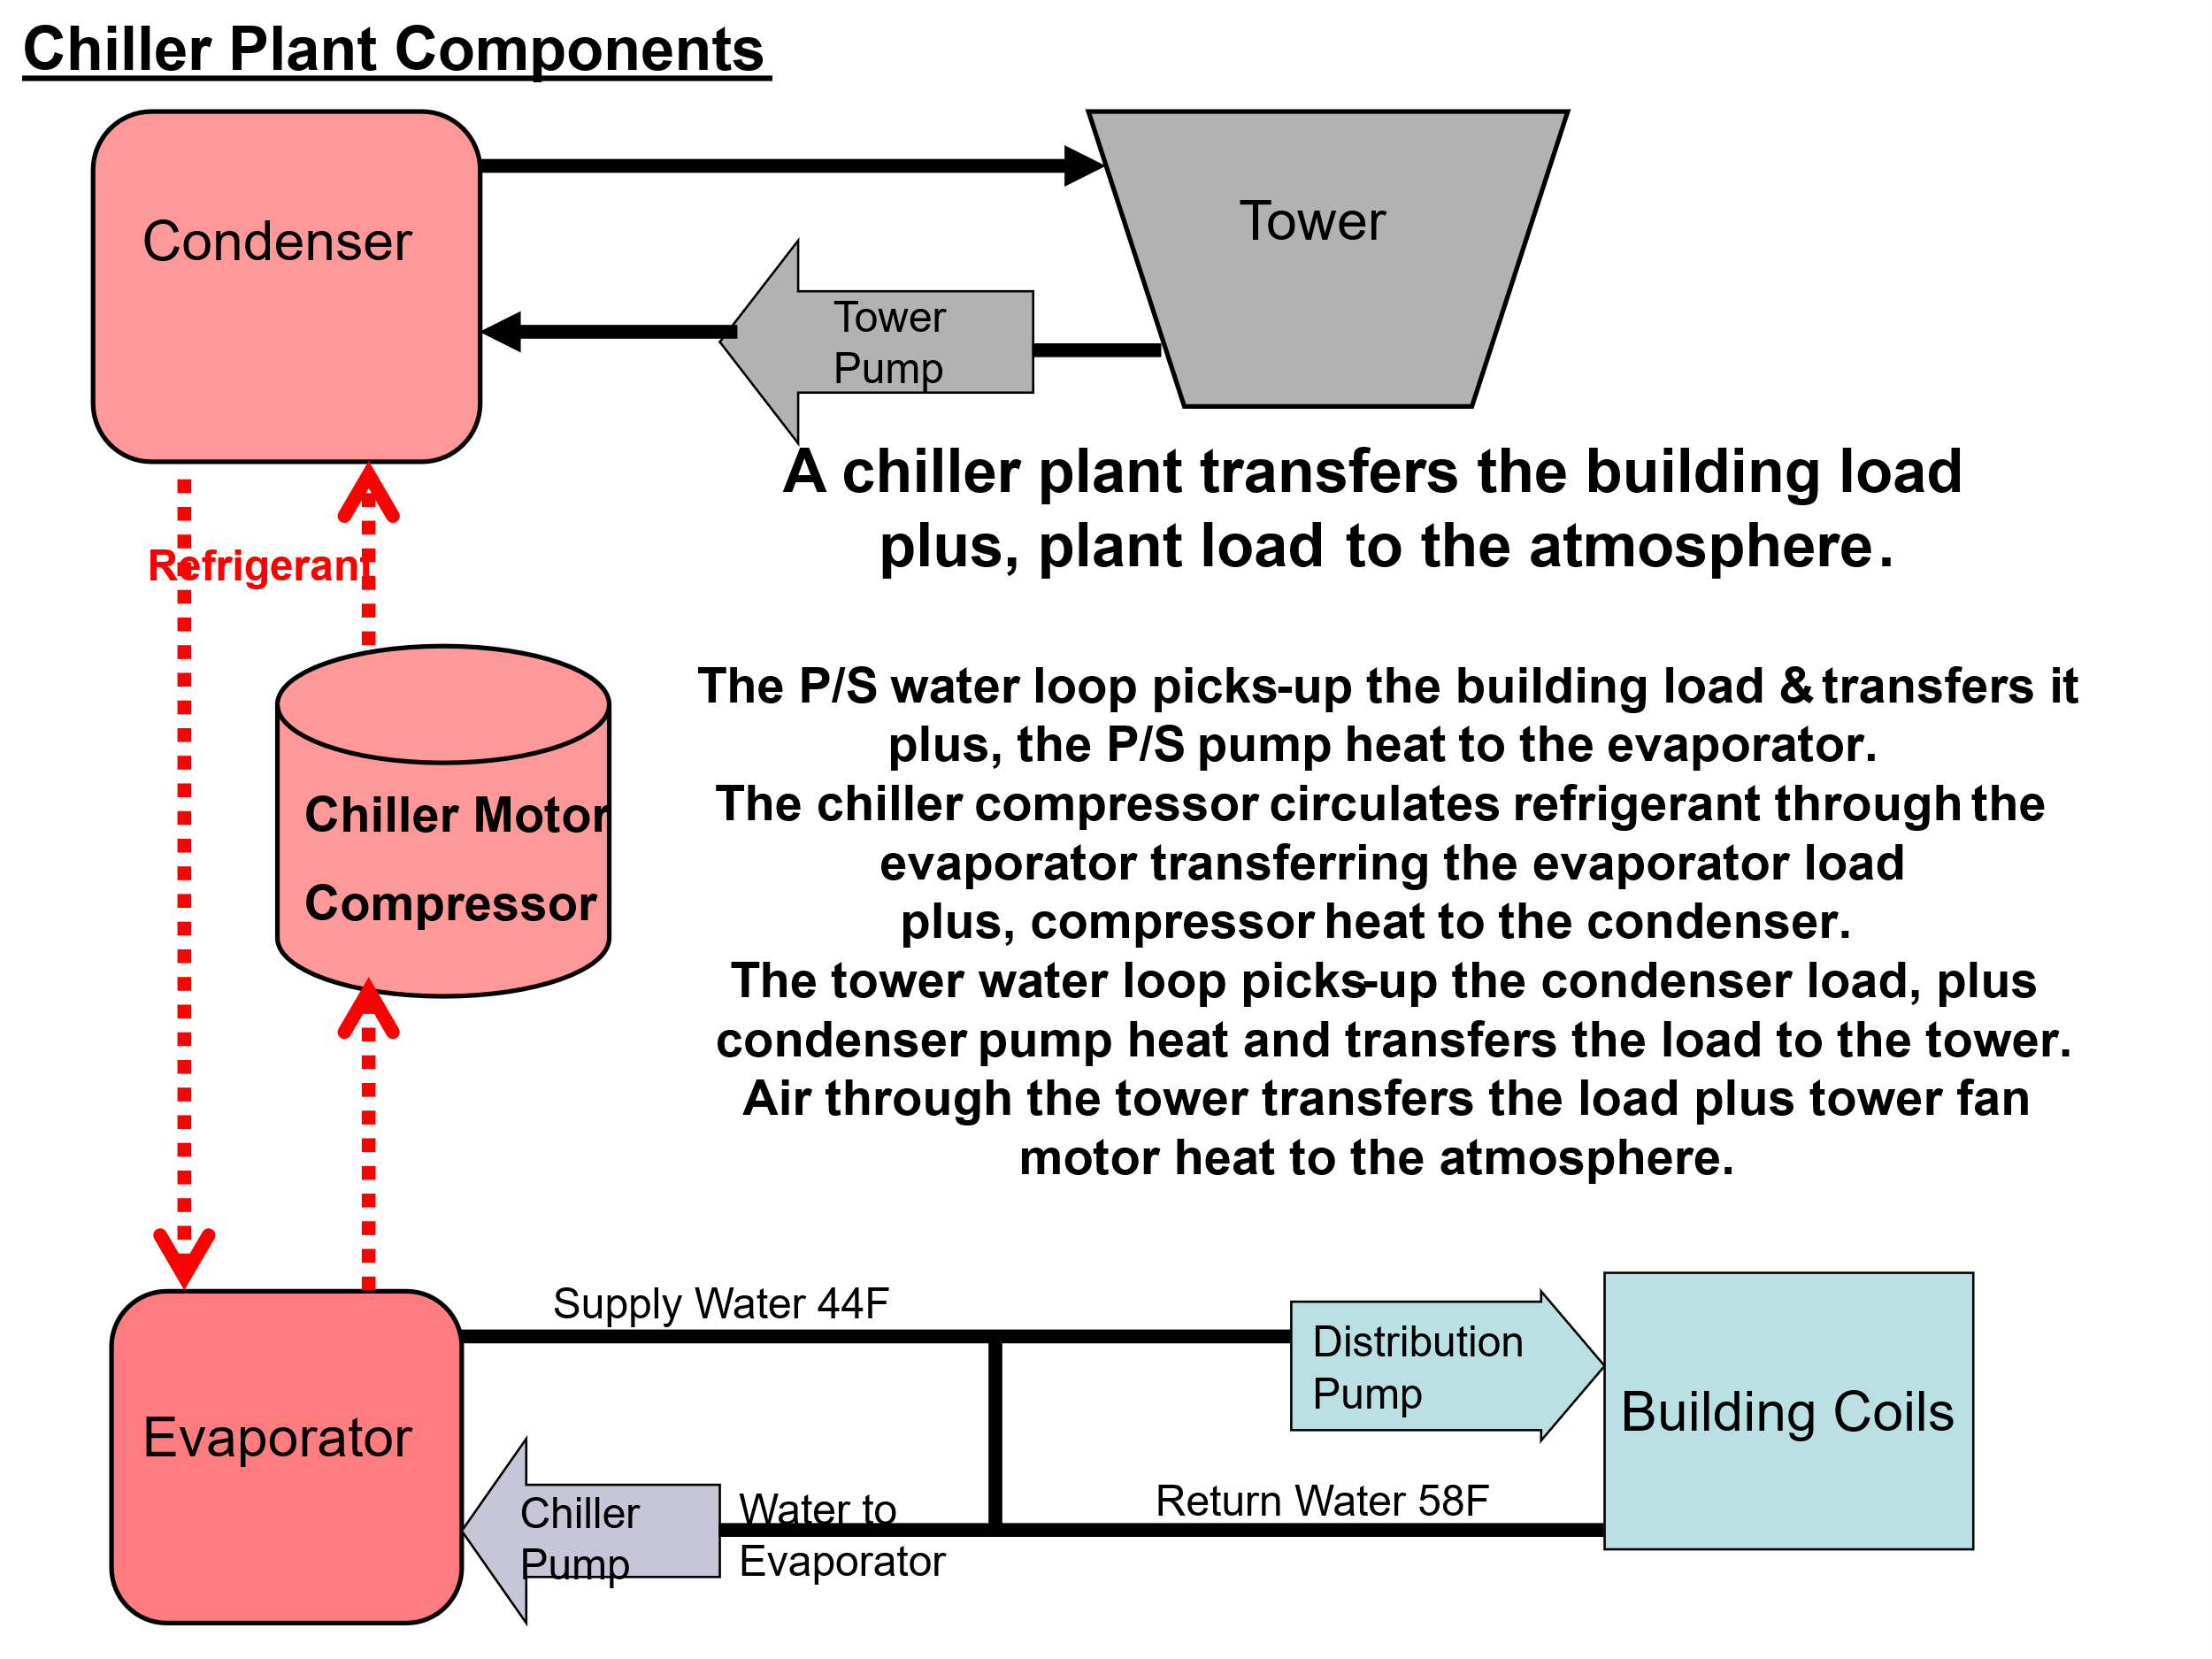
Schematic 1: Chiller Plant Components

Schematic 2 is configured the same as Schematic 1 but with values determined by the plant (SEE) Model. Schematic 2 is the chiller/tower defined by Table 1 operating at peak summer design load of 2,175 ton. The plant load of 2,175 ton is transferred to the evaporator plus P/S pumping load of 72 ton due to distribution pumps 59.13 ton and 13.0 ton due to chiller pumps = 2,247-ton evaporator load. The P/S pump heat to atmosphere is 9.5 ton & 3.05 ton due to the inefficiency of the pumps. The 2,247-ton evaporator load plus chiller motor 447.6-ton load plus 14.4-ton condenser pump load = 2,709-ton condenser load. The tower water loop picks up the 2,709-ton condenser load and transfers, plus tower fan motor of 34-ton, = 2,743-ton to the atmosphere.

Schematic 2: Chiller Plant at summer peak design load.
Schematic 2 is the chiller and tower of Table 1 operating at peak summer load conditions of 2,175-ton load also given by the building schematic of the Executive Summary & Chapter 1.
Plant Energy Balance-four seasons
Figure 1: Plant Energy Balance
Figure 1 illustrates the fundamental concept of this 24-hour plant model, energy in = energy out. The energy in is the metered plant load as defined in Chapter 1, and the plant kW, determined here by Chapter 2, converted to (ton). The energy out is the pump heat not input to the plant water plus the tower exhaust ton. If this were an open chiller not all chiller kW would be transferred to the refrigerant. The summer plant energy in and out is about four times the other seasons because 4 chiller/towers are required to meet the summer building load and only one chiller/tower is required for the other three seasons.
Schematic 2 energy balance at 4PM summer peak weather agrees with Figure 1 top left chart. At 4PM the energy in from the building is 1,636 ton plus the plant kW-ton = 1,509 kW/3.517 = 429 ton for a total 2,065-ton energy in. The plant kW load includes the pumping kW load plus tower fan kW load plus chiller kW load. The energy out is the 2,053-ton exhausted by the tower plus the pump heat to atmosphere of 12 ton for a total energy out of 2,065-ton, same as the energy in. Next the plant kW demands for the three seasons.

Plant kW Performance-four seasons
Figure 2: Plant load & Plant kW
Chapter 1 defined the plant load repeated here in Figure 2. The task for the plant is to provide chilled water, about 44.3F for this design, to be pumped to the building to remove the building load. Figure 2 gives the plant kW demand, number of chillers/towers on, and tower fan speed required to transfer the building load plus plant energy to the atmosphere via the cooling tower. The tower fan speed is 50% for all winter hours and some of the fall & spring hours. The fall weather is the lowest peak plant kW value at 279 kW and the winter peak plant kW of 389 kW is the second highest. The summer peak plant of 1,509 kW is about 4 times the winter value. The plant kW per plant load (ton)is always less than one as illustrated by Figure 2. For summer weather at 4PM, plant kW/ton = 1,509 kW/1,636 ton = .92 kW/ton. The greater separation of the kW & ton values for the other three seasons suggests better performance. At 4PM winter weather plant kW/ton = 339 kW/488 ton = .695 kW/ton, significantly better than the summer .92 kW/ton. As the wet bulb decreases the tower produces colder water and therefore improved chiller performance, however as discussed below as the web bulb decreases the tower cold water approach to wet bulb increases⁷.

P/S Pumping Loop-Summer 4PM

Schematic 3: P/S pumping-4PM summer design weather-from Schematic 2

Schematic 3 illustrates the P/S pumping loop for summer 4PM. Water flow of 4,800 gpm of supply water leaves the evaporator at 44.31F temperature and enters the building coils at the same temperature because the bypass flow is in the right direction. The flow into the bypass pipe is 769 gpm so 4,031 gpm of 44.31F water enters the building coils. The 1,636-ton building load is picked up by the 4,031 gpm of 44.31F secondary water. The water exits the coils at 54.31F, therefore 4,031 gpm of 54.31F water is mixed with the 769 gpm of 44.31F bypass water giving 4,800 gpm of 55.70F water to the evaporator.
To accomplish these P/S water flows the four chiller pumps require 45.2 kW and the secondary pump requires 143 kW. The secondary pump is 82% efficient in these conditions so 82% of the 143-kW energy, 33.3 ton, enters the secondary water and 18% of the 143-kW energy, 7.3 ton, goes to the atmosphere as heat off the secondary pump. The four chiller pumps are 81% efficient so 81% of the 45.2 kW energy, 10.4 ton, enters the water and 19%, 3.05 ton, goes to the atmosphere as heat off the chiller pumps.
The P/S pumping energy that enters the supply/return water raises the evaporator load as shown by Schematic 4 below but first let’s look at the details of the summer P/S pumping water flows, temperatures, and kW demand.

P/S Pumping-Summer weather
Figure 3: Primary/Secondary Pumping-Summer weather
The upper left chart gives the P/S (gpm) flows. Each chiller pump moves 1,200 gpm so as chiller pumps turn on as chiller/towers are turned on to meet the evaporator load, the chiller pump flow increases or decreases in steps of 1,200 gpm. The secondary pump flow is a function of building load (ton), so chiller pump flow not needed by the building load is diverted to the bypass pipe flow.
The upper right chart gives the parameters of the chiller pump kW demand. At noon,
Chiller pump kW = 4,800 gpm*40.5 ft* .746/(3960 * .81) = 45.2 kW as shown on the chart.
81% of this 45.2 kW energy enters the P/S water and 19% is heat off the pumps.
The lower left chart gives the parameters of the primary pump kW. At noon.
Psec-kW=(3,022 gpm*126 ft *.746)/(3960*.767) = 94 kW as shown on the chart.
The lower right chart shows the loads the P/S pumping puts on the evaporator and the total evaporator load on the secondary horizontal axis. The P/S pumping parameters can be changed as required to fit an existing system. Next the evaporator performance.

Evaporator Performance
Schematic 4: P/S pumping & evaporator load-4PM summer weather-from Schematic 2
Schematic 4 adds the evaporator to Schematic 3.
Schematic 4 gives evaporator data at 4PM with the load on each chiller/tower 420 ton verses the design value of 500 ton of Table 1 above. Four chiller/towers are on for a total evaporator load of 1,680 ton. The evaporator’s refrigerant temperature is 40.3F and the refrigerant temperature approach to evaporator water is 3.99F, resulting in 44.31F supply water off the evaporator. Table 1 at design load conditions of 500-ton evaporator load are slightly different values of refrigerant temperature (38.8F) and approach of 5.2F.

P/S Pumping & Evaporator Performance
Figure 4: P/S Pumping & evaporator performance-Summer Weather
The upper left chart illustrates the P/S pumping load plus the building load equals the evaporator load. The upper right chart gives the parameters that define the evaporator load. At 4PM, Evaporator (ton) = 4,031 gpm*(54.31F-44.31F)/24 = 1,689 ton as shown on chart.
The lower left chart gives the parameters to define the evaporator entering water temperature. At 4PM, Evap. (ewt)=(44.31F*769gpm)+(54.31F*4,031gpm)/(4,800gpm)=52.70F shown on the secondary horizontal axis of lower left chart.
The lower right chart is another set of parameters to define the evaporator load. At 4PM,
Evap. (ton) = 4,800 gpm * (52.70F – 44.31F)/24 = 1,680 ton shown on the secondary horizontal axis of lower right chart.
Note: the computer model is solving to several decimal places and desktop calculations sometimes do not exactly match.
Schematic 5: Chiller/Tower Performance (Chiller Lift = 104.7F – 40.1F = 64.6F)
Schematic 5 is from Schematic 2 showing the chiller components and tower at peak 4PM design load. The chiller compressor pumps 40.3F refrigerant from the evaporator to the condenser. Energy input to the refrigerant raises the refrigerant temperature to 103.2F at the condenser. The energy into the refrigerant is the evaporator 1,680-ton load, four chiller compressors of 1,176 kW demand or 334.5-ton, and 11.5-ton tower pump load, equals 2,026-ton condenser load as shown. The condenser refrigerant approach is 3.91F and the condenser head is 31.2 feet water and 10.3 ft/sec water velocity. The four condenser pumps demand 48.7 kW. The tower approach to wet bulb is 5.23F, (82.0F wet bulb + 5.23F approach = 87.23F tower leaving water temperature). The tower range is (99.2F entering tower water – 87.2F leaving tower water = 12.0F range).

Chiller Lift-24-hours summer
Figure 5: Chiller lift
The upper left chart defines the evaporator leaving water temperature, evaporator refrigerant approach temperature, and refrigerant temperature. The upper right chart defines the same for the condenser plus gives the tower fan speed. The lower two charts define water and refrigerant temperatures and the chiller lift. The chiller lift peaks at 2PM.

Plant kW
Figure 6: Plant kW
Figure 6 shows the kW demand of the plant components. The upper left chart gives the tower pump kW, the upper right chart gives the total plant pumping kW, the lower left chart gives the total pump plus tower fan kW, and the lower right chart gives the plant kW.

Cooling Tower Performance
Figure 7: Cooling tower performance⁵
As previously stated, the chiller & tower act as a unit, change in performance of one result in performance change of the other. The three charts of Figure 7 present a picture of the tower performance over the 24-hours of summer. The upper left chart illustrates the loads that define the condenser load. The evaporator load plus the load due to the chiller kW plus the tower pump load equals the condenser load. The upper right chart illustrates an interesting characteristic of a cooling tower, in general as the wet bulb temperature drops the tower approach temperature increases.

Chiller/Tower Performance
Figure 8: Chiller/Tower performance-Summer
Figure 8 gives a picture of the chiller/tower performance over the 24-hours of summer. Note the number of chiller/towers on is one during the morning hours, two on at 8AM, then three, peaking four at 4PM, then dropping back to two on at 10PM. The upper left chart shows at peak 4PM conditions the four chillers are at 85% power to provide 44.31F evaporator supply water shown by the lower left chart with an evaporator load of 1,680 ton. The chiller COP is equal to the evaporator (ton) divided by the chiller demand kW converted to (ton). At 4PM peak load is 1,680 ton and the chiller kW demand is 1,176 kW from Figure 8, resulting in a 334.5 (ton) load as shown by Schematic 5 and Figure 7. Therefore COP = 1,680 (ton)/334.5 (ton) = 5.02 as shown by Figure 8. This COP of this chiller does not meet the present ASHRAE Standards⁴ requirements.
Fall Weather-Plant Performance
Schematic 6: Fall weather 4PM
These 4PM values can be found in the following charts giving the reader the opportunity to become familiar with plant schematics.
Primary/Secondary Pumping-Fall weather
Figure 11: Primary/Secondary Pumping
The upper left chart gives the P/S (gpm) flows. Each chiller pump moves 1,200 gpm. The secondary pump flow is a function of building load (ton), so chiller pump flow not needed by the building load is diverted to the bypass pipe flow.
The upper right chart gives the parameters of the chiller pump kW demand. At noon.
Chiller pump kW = 1,200 gpm*40.5 ft* .746/(3960 * .81) = 11.3 kW as shown on the chart.
81% of this 11.3 kW energy enters the P/S water and 19% is heat off the pumps.
The lower left chart gives the parameters of the primary pump kW. At noon.
Psec-kW=(1,102gpm*95 ft *.746)/(3960*.482) = 41 kW as shown on the chart.
The lower right chart shows the loads the P/S pumping puts on the evaporator and the total evaporator load on the secondary horizontal axis. The P/S pumping parameters can be changed as required to fit an existing plant pump system.
P/S Pumping & Evaporator Performance
Figure 12: P/S Pumping & evaporator performance-Fall Weather
The upper left chart illustrates the P/S pumping load plus the building load equals the evaporator load. The upper right chart gives the perimeters that define the evaporator load. At noon. Evaporator (ton) = 1,102gpm*(54.80F-44.80F)/24 = 459 ton as shown on chart.
The lower left chart gives the parameters to define the evaporator entering water temperature. At noon. Evap. (ewt)=(44.80F*98gpm)+54.80F*1,102gpm)/(1,200gpm)=53.99F shown on the secondary horizontal axis.
The lower right chart is another set of parameters to define the evaporator load. At noon. Evap. (ton) = 1,200 gpm * (53.99F – 44.80F)/24 = 459 ton shown on the secondary horizontal axis. Note: the computer model is solving to several decimal places and desktop calculations sometimes do not exactly match.
Plant kW
Figure 13: Plant kW

Figure 13 gives the kw demand of the plant components. The upper left chart gives the tower pump kW, the upper right chart gives the total plant pumping kW, the lower left chart gives the total pump plus tower fan kW, and the lower right chart gives the plant kW.

Cooling Tower Performance
Figure 14: Cooling Tower Performance
The upper left chart illustrates the loads that define the condenser load. The evaporator load plus the load due to the chiller kW plus the tower pump load equals the condenser load. The upper right chart illustrates an interesting characteristic of a cooling tower, in general as the wet bulb temperature drops the tower approach increases. A tower characteristic further discussed below.

Chiller Lift
Figure 15: Chiller Lift
Chiller lift is the difference between the condenser refrigerant temperature and the evaporator refrigerant temperature. In general, an increased lift requires increased chiller kW to produce the required evaporator leaving water temperature. The upper left chart illustrates that the evaporator refrigerant temperature is less than the evaporator leaving water temperature as a function of the evaporator approach. The upper right chart illustrates that the condenser refrigerant temperature is more than the return water to the tower as a function of the condenser refrigerant approach temperature. The two bottom charts illustrate the chiller lift value over 24 hours.

Chiller/Tower performance
Figure 16: Chiller/Tower Performance
The weather conditions and building load result in the chiller plant’s ability to meet the loads with one chiller/tower. The upper left chart shows the peak demand of 55% for one chiller occurs at noon. The evaporator supply water is 44.80F from the lower left chart and a 459-ton evaporator load as shown by Figure 13. The chiller COP is significantly improved over the summer chiller COP shown in Figure 10.
The chiller COP is equal to the evaporator (ton) divided by the chiller demand kW converted to (ton). At noon peak load is 459 ton and the chiller kW demand is 190 kW from upper right chart, resulting in a 54.1 (ton) load as shown by Figure 13, upper left chart. Therefore COP = 459 (ton)/54.1 (ton) = 8.48 as shown above by Figure 16. This COP for Fall weather meets present standard but the same chiller plant operating at summer weather does not as illustrate by Figure 10, making the point that a Plant Model may be required to evaluate the performance of a chiller plant at weather conditions on the day of analysis.
Winter Weather-Plant Performance
Schematic 7: Winter weather-noon
At noon the bypass flows 89 gpm in the wrong direction, illustrating an interesting characteristic of P/S pumping that will be addressed below under plant characteristics & control.
Pumping-Winter weather
Figure 17: Primary/Secondary Pumping
The upper left chart gives the P/S (gpm) flows. The chiller pump moves 1,200 gpm. The secondary pump flow is a function of building load (ton), so chiller pump flow not needed by the building load is diverted to the bypass pipe flow. At 10AM & noon the required building load gpm was greater than the chiller pump flow resulting in wrong-way flow in the bypass pipe, a condition that requires more chiller kW demand to provide 44F water to the building coils. The upper right chart gives the parameters of the chiller pump kW demand. At noon.
Chiller pump kW = 1,200 gpm*40.5 ft* .746/(3960 * .81) = 11.3 kW as shown on the chart.
81% of this 11.3 kW energy enters the P/S water and 19% is heat off the pumps.
The lower left chart gives the parameters of the primary pump kW. At noon.
Psec-kW=(1,289gpm*97 ft *.746)/(3960*.536) = 44 kW as shown on the chart. The lower right chart shows the loads the P/S pumping puts on the evaporator and the total evaporator load
on the secondary horizontal axis.
P/S Pumping & Evaporator Performance
Figure 18: P/S Pumping & evaporator performance-Fall Weather
The upper left chart illustrates the P/S pumping load plus the building load equals the evaporator load. The upper right chart gives the perimeters that define the evaporator load. At noon. Evaporator (ton) = 1,289gpm*(54.33F-44.33F)/24 = 537 ton as shown on chart.
The lower left chart gives the parameters to define the evaporator entering water temperature. At noon. Evap. (ewt)=(54.33F*-89gpm)+(54.33F*1,289gpm)/(1,200gpm)=54.33F shown on the secondary horizontal axis.
The lower right chart is another set of parameters to define the evaporator load. At noon. Evap. (ton) = 1,200 gpm * (54.33F – 43.58F)/24 = 537 ton shown on the secondary horizontal axis. The wrong bypass flow of 89 gpm requires less than 44F evaporator leaving water and therefore increased chiller kW.
Plant kW
Figure 19: Plant kW

Figure 19 gives the kw demand of the plant components. The upper left chart gives the tower pump kW, the upper right chart gives the total plant pumping kW, the lower left chart gives the total pump plus tower fan kW, and the lower right chart gives the plant kW.

Cooling Tower Performance
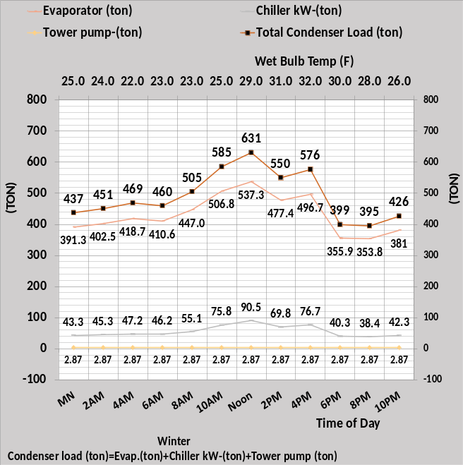
Figure 20: Cooling Tower Performance
The upper left chart illustrates the loads that define the condenser load. The evaporator load plus the load due to the chiller kW plus the tower pump load equals the condenser load. The upper right chart illustrates the complexity of the tower approach. In general, as the wet bulb temperature drops the tower approach increases, however the load on the tower is a contributing component.

Chiller Lift
Figure 21: Chiller Lift
Chiller lift is the difference between the condenser refrigerant temperature and the evaporator refrigerant temperature. In general, an increased lift requires increased chiller kW to produce the required evaporator leaving water temperature. The upper left chart illustrates that the evaporator refrigerant temperature is less than the evaporator leaving water temperature as a function of the evaporator approach. The upper right chart illustrates that the condenser refrigerant temperature is more than the return water to the tower as a function of the condenser refrigerant approach temperature. The two bottom charts illustrate the chiller lift value over 24 hours.

Chiller/Tower Performance

Figure 22: Chiller/Tower performance
The upper left chart shows the peak percent chiller power is 92% at noon. The evaporator load is 537-ton, but the design capacity of the chiller is 500 (ton) per Table 1, illustrating the increased capacity of the chiller/tower at less than design wet bulb. The evaporator supply water is 43.58F, less than 44F, because of the wrong-way flow in the bypass pipe. Below under Plant Design & Control will address the effect of wrong-way bypass flow.

Spring Weather-Plant Performance
Schematic 8: Plant Spring weather-4PM
P/S Pumping-Spring weather
Figure 23: P/S pumping
The upper left chart gives the P/S (gpm) flows. The chiller pump moves 1,200 gpm. The secondary pump flow is a function of building load (ton), so chiller pump flow not needed by the building load is diverted to the bypass pipe flow. The upper right chart gives the parameters of the chiller pump kW demand. At 4PM.
Chiller pump kW = 1,200 gpm*40.5 ft* .746/(3960 * .81) = 11.3 kW as shown on the chart.
81% of this 11.3 kW energy enters the P/S water and 19% is heat off the pumps.
The lower left chart gives the parameters of the primary pump kW. At 4PM.
Psec-kW=(1,165gpm*95 ft *.746)/(3960*.502) = 42 kW as shown on the chart. The lower right chart shows the loads the P/S pumping puts on the evaporator and the total evaporator load
is on the secondary horizontal axis. Schematic 8 shows a plant load of 477 ton increasing to 486 ton on the evaporator due to the P/S pumping load.
P/S Pumping & evaporator performance
Figure 24: P/S Pumping & evaporator performance-Fall Weather
The upper left chart illustrates the P/S pumping load plus the building load equals the evaporator load. The upper right chart gives the perimeters that define the evaporator load. At 4PM. Evaporator (ton) = 1,165gpm*(54.47F-44.47F)/24 = 486 ton as shown on chart.
The lower left chart gives the parameters to define the evaporator entering water temperature. At 4PM. Evap. (ewt)=(44.47F*35gpm)+(54.47F*1,165gpm)/(1,200gpm)=54.18F shown on the secondary horizontal axis.

Plant kW

Figure 25: Plant kW

Figure 25 gives the kw demand of the plant components. The upper left chart gives the tower pump kW, the upper right chart gives the total plant pumping kW, the lower left chart gives the total pump plus tower fan kW, and the lower right chart gives the plant kW.

Cooling Tower Performance
Figure 26: Cooling Tower Performance
The upper left chart illustrates the loads that define the condenser load. The evaporator load plus the load due to the chiller kW plus the tower pump load equals the condenser load. The upper right chart illustrates an interesting characteristic of a cooling tower, in general as the wet bulb temperature drops the tower approach increases. A condition to be further addressed below.

Chiller Lift
Figure 27: Chiller Lift
Chiller lift is the difference between the condenser refrigerant temperature and the evaporator refrigerant temperature. In general, an increased lift requires increased chiller kW to produce the required evaporator leaving water temperature. The upper left chart illustrates that the evaporator refrigerant temperature is less than the evaporator leaving water temperature as a function of the evaporator approach. The upper right chart illustrates that the condenser refrigerant temperature is more than the return water to the tower as a function of the condenser refrigerant approach temperature. The two bottom charts illustrate the chiller lift value over 24 hours.

Chiller/Tower Performance
Figure 28: Chiller/Tower performance
The upper left chart shows the peak percent chiller power is 77% at 4PM. The evaporator load is 486-ton, Figure 25, the design capacity of the chiller is 500 (ton) per Table 1, illustrating the increased capacity of the chiller/tower at less than design wet bulb.
Next a summary of Chapter 2.

Summary-Chiller Plant Performance
P/S Pumping Performance
Figure 29: Primary/Secondary Pumping System
Primary/secondary pumping for the four seasons is given, illustrating the significant difference P/S pumping can have on the performance of the chiller plant. However, the operation of the chiller plant, ie number of chiller/towers on can significantly change the effect of P/S pumping and the operation of the plant.

Evaporator Load
Figure 30: Evaporator Load
It is of interest to note that the evaporator load is in the same ballpark during the early morning hours for all four seasons. The summer evaporator load increases to about four times the early morning value but the other three seasons all require only one chiller/tower to meet the 24-hour load. The winter noon conditions show the chiller must provide 43.58F water to get 44.33F water to the building, see Schematic 7.

Tower Performance

Figure 31: Tower Performance⁵
The 4PM summer condenser load (ton) = 4,046 gpm*(99.25F – 87.23F)/24 = 2,026 ton
See Schematic 2 for condenser gpm.
The 4PM fall condenser load (ton) = 1,011 gpm*(74.99 – 63.38)/24 = 489 ton
See Schematic 6 for condenser gpm.
The noon winter condenser load (ton) = 1,011gpm*(89.87F – 74.90F)/24 = 631 ton
See Schematic 7 for condenser gpm.
The 4PM spring condenser load (ton) = 1,011gpm*(85.51F – 72.13F)/24 = 564 ton
See Schematic 8 for condenser gpm.

Chiller Lift
Figure 32: Chiller Lift¹

Plant kW Performance

Figure 31: Plant kW Performance
Plant kW demand performance is about the same except for summer operation for obvious reasons of greater evaporator load. Figures 31 & 32 should be studied together to gain an understanding of how the plant reacts to changing weather and plant operation.

Plant Performance Indices

Figure 32: Plant Performance Indices
In general, the chiller and plant performance indices improve with decreasing weather temperatures.

Chiller Plant Characteristics & Control
Schematic 9: Copy of Schematic 2-Chiller Plant at peak summer design conditions.
At plant design conditions 4 chiller/towers at 85% chiller power are required to produce 44.31F supply water to the building. The cooling tower approach to wet bulb temperature is 5.23F. The only change to Schematic 10 is the wet bulb is increased to 86F, a 4F increase, and the tower approach decreased to 4.16F as suggested by Schwedler 2014⁷. The supply water increased to 46.91F illustrating the interaction of the chiller/tower, not addressed by Schwedler 2014⁷. The chiller kW must be increased to drop the supply water temperature.
Schematic 10: Increased wet bulb from 82F of Schematic 9 to 86F.
The only change made to Schematic 10 is the increase of the wet bulb to 86F, the plant load of 1,636 ton and chiller and plant kW does not change. However, the cooling tower loop does change. The tower (ewt) increased to 102.2F from 99.2F and the condenser refrigerant increased to 106.1F from 103.2F primarily because the tower (lwt) increased from 87.2F to 90.2F due to the 4F increase in wet bulb temperature. The chiller kW must be increased to achieve 44.43F chiller water supply as shown by Schematic 11.
Schematic 11: Increase chiller power from 294kW to 308kW to achieve 44.43F supply water
Both water loops and the refrigerant loop change values due to the increase in chiller kW. The four chiller/towers are at 89% power from 85% of Schematic 10. The condenser load increases to 510 ton from 506 ton due to the chiller increased kW. The condenser refrigerant temperature increased to 106.3F from 106.1F and the chiller lift increased to 65.8F from 63.2F primarily because the evaporator refrigerant temperature dropped to 40.4F from 42.9F to achieve 44.43F supply water verses 46.91F of Schematic 10. Schwedler 2014⁷ analysis does not include the chiller and is therefore incomplete, the chiller/tower act as a unit.
Summary
Schwedler 2014⁷ states, “A project team decides that in lieu of full-year analysis they will use a spreadsheet to estimate conditions.” This statement is confusing because the article does not give any full-year analysis data and only gives tower performance data with no discussion or data on how the tower effects the chiller performance. Also, apparently Schwedler is unaware of the power of Microsoft Excel to solve a set of simultaneous equations as utilized by the (SEE) Model. One final point regarding the Schwedler article, the cooling tower is selected with a range of 14F when a selected tower with 10F range would reduce the condenser refrigerant temperature by about 4F and therefore the chiller lift resulting in less chiller kW. The 14F range tower requires a bigger chiller verses a 10F range tower and smaller chiller. Schwedler⁸ and Taylor¹⁰ make arguments for the bigger chiller smaller tower.
Next, we look at the wrong-way bypass flow.

Correcting the wrong way flow in bypass pipe.
The following three Schematics 12, 13, & 14, will address the noon winter wrong way bypass flow of Schematic 7 above. Schematic 12 is a copy of Schematic 7 illustrating one chiller/tower is on and the tower fan is 50%, the result is a plant kW of 389.
An ideal that may occur to the reader is to increase the chiller pump flow² to change the bypass flow direction. Schematic 15 slightly increases the chiller pump kW from 11.29 kW to 13.68 kW and therefore increased flow from 1200 gpm to 1300 gpm resulting in correct flow in the bypass, but the plant kW only decreased slightly from 389 kW to 384 kW.
Schematic 16 turns on a second chiller/tower and the plant kW dropped to 267, a significant reduction suggesting a plant model can be of value in efficient control of a chiller plant. Turning on the second chiller/tower increased the chiller pump kW from 11.3 to 22.8, the tower pump kW from 12.2 to 24.3, and the tower fan kW from 3.4 to 6.9. However, the chiller kW dropped from 318.3 kW to 84.8 kW for each chiller or a total of 170 kW, a significant reduction. The net result is the plant kW dropped from 389 to 267 kW, illustrating how a plant model could be of value to plant operators to make decisions on how best to operate a plant. Plant models could be a part of the automated control of the plant.
Clearly turning on the second chiller/tower is the correct energy saving control.

Schematic 12: Winter noon performance. Copy of Schematic 7.
Bypass flows 89 gpm in the wrong direction requiring 43.58F evaporator chilled water supply and therefore an increase in chiller kW. Chiller kW = 318.3 & plant kW = 389. Two solutions are considered, increase chiller pump flow and turn on second chiller.

Schematic 13: Increase chiller pump kW to get 1300 gpm flow to get correct bypass flow. Bypass flow is 9gpm in the correct direction. Chiller pump kW has increased to 13.7 kW verses 11.3 kW of Schematic 12, and chiller kW decreased from 318.3 kW to 311.4 kW. Plant kW slightly decreases to 384 kW from 389 kW of Schematic 12; a 5 kW decrease with this chiller pump control. The chiller design capacity is 500 ton and the load on the chiller is 538 ton, illustrating the increase in capacity with wet bulb 29F which is less than 82F design. Schematic 14 turns on two chiller/towers with a bigger decrease in plant kW.
Schematic 14: Second chiller/tower reduces plant kW to 267 vs. 384 kW of Schematic 13.
Turning on the second chiller/tower significantly decreases plant kW to 267 verses 384 kW of Schematic 13. Each chiller is at 25% capacity with 84.8 kW demand and therefore 170 kW for the two chillers. The pumps and tower fan kW double but the net plant kW is less, illustrating the value of a (SEE) Plant Model for efficient control of a plant.
The next Chapter 3 will deal with energy saving projects the first being the elimination of unstable energy, infiltration and return air .

References for Chapter 2
- 2020 ASHRAE HANDBOOK, HVAC Systems and Equipment, chiller lift, page 43.10 Figure 11 Temperature Relations in a Typical Centrifugal Liquid Chiller.
- Mark Baker, Dan Roe, Mick Schwedler. ASHRAE Journal June 2006. “Prescription for Chiller Plants”. (paper at http://kirbynelsonpe.com)
- Nelson, K. “Simulation Modeling of Central Chilled Water Systems” CH-12-003. ASHRAE 2012 Chicago Winter Transactions.
- Thomas, Varkie. Varkie Thomas | Energy-Models.com
- Marley Tower selection program. COOLSPEC. 2024 SPX Cooling, Tech, version 8.2.1
- Thermal Environmental Engineering 3ed edition. 1998 Prentice-Hall Inc. by Thomas H. Kuehn, Chapter 3, Mechanical Vapor-Compression Refrigeration Cycles.
- Schwedler, Mick, 2014. ASHRAE Journal January 2014 “Effect of Heat Rejection Load and Wet Bulb on Cooling Tower Performance”.
- Introduction to Thermodynamics and heat Transfer. David A. Mooney. Prentice Hall, 1956.
- Schwedler, Mick 1998. “Take It to The Limit…Or Just Halfway?” ASHRAE Journal July 1998.
- Taylor, Steven 2012. “Optimizing Design & Control Of Chilled Water Plants” ASHRAE Journal July 2011.
Nomenclature-CHILLER PLANT
# Buildings = number of buildings served by plant
Plant ton = total load (ton) to plant
Secondary/distribution pump
(ewt)_{coil} = water temperature entering coil (F)
(lwt)_{coil + pumps} = temperature of water leaving coil/building (F)
GPM_{sec} = water gpm flow in secondary loop to building
P_{sec-heat-ton} = secondary pump heat to atmosphere (ton)
P_{sec-kW} = kW demand of secondary pumps
P_{sec-ton} = load to evaporator (ton)
Ef_{des-sec-p} = design efficiency of secondary pumping
Ef_{sec-pump} = efficiency of secondary pumping
(H)_{sec} = secondary pump head (ft)
Chiller pump
gpm_{evap} = gpm flow through one evaporator
GPM_{evap} = Total gpm flow through all evaporator on
(H)_{pri-total} = total primary pump head (ft)
(Ef)_{c-pump} = efficiency of chiller pump
Pump_{c-heat-ton} = chiller pump heat to atmosphere (ton)
pump_{c-kW} = one chiller pump kW demand (kW)
Pump_{chiller-#} = number chiller pumps operating
Pump_{c-kW} = total chiller pump kW
Pump_{c-ton} = Total load to evaporator
T_{bp} = temperature of water in bypass (F)
GPM_{bp} = gpm water flow in bypass
(H)_{pri-bp} = head if chiller pump flows in bypass (ft)
(ewt)_{evap} = temp water entering evaporator (F)
(ewt)_{evap} = Water temperature to evaporator after bypass water
Evaporator
(lwt)_{evap} = temperature water leaving evaporator (F)
(evap)_{ton} = load (ton) on one evaporator
T_{ER} = evaporator refrigerant temp (F)
T_{ER-app} = evaporator refrigerant approach (F)
EVAP_{ton} = total evaporator loads (ton)
(H)_{evap} = pump head through evaporator (ft)
(evap)_{ft/sec} = velocity water flow through evaporator
(evap)_{des-ft/sec} = evaporator design flow velocity
Compressor:
(chiller)_{kW} = each chiller kW demand
(chiller)_{lift} = (T_{CR} – T_{ER}) = chiller lift (F)
(chiller)% = percent chiller motor is loaded
(chiller)# = number chillers operating
(CHILLER)_{kW} = total chillers kW
(chiller)_{kW/ton} = chiller kW per evaporator ton
Plant kW = total kW demand of plant
(Plant)_{kW/ton} = Plant kW per site ton
Chiller COP = Chiller coefficient of performance
Chiller _{kW-ton} = Chiller kW load (ton)
Condenser:
(cond)_{ton} = load (ton) on one condenser
T_{CR} = temperature of condenser refrigerant (F)
T_{CR-app} = refrigerant approach temperature (F)
(COND)_{ton} = total load (ton) on all condensers
(H)_{cond} = tower pump head through condenser (ft)
(cond)_{ft/sec} = tower water flow through condenser
Tower piping nomenclature
gpm_{T} = each tower water flow (gpm)
GPM_{T} = total tower water flow (gpm)
(H)_{T-total} = total tower pump head (ft)
P_{T-heat} = pump heat to atmosphere (ton)
pump_{T-kW} = each tower pump kW demand
Ef_{T-pump} = tower pump efficiency
P_{tower #} = number of tower pumps on
Pump_{T-kW} = total tower pump kW
Pump_{T-ton} = Pump load on tower (ton)
Tower
(ewt)_{T} = tower entering water temperature (F)
(H)_{T-static} = tower height static head (ft)
T_{range} = tower range (F)= (ewt)_{T} – (lwt)_{T}
(lwt)_{T} = tower leaving water temperature (F)
T_{approach} = (lwt)_{T} – (T_{wet-bulb})
t_{fan-kW} = kW demand of one tower fan
T_{fan-kW} = tower fan kW of fans on
t_{fan-%} = percent tower fan speed
t_{ton-ex} = ton exhaust by one tower
T# = number of towers on
T_{ton-ex} = ton exhaust by all towers on
T_{rg+app} = tower range + approach (F)

Chapter 3
Install Energy Saving Projects
Outside air infiltration and return air energy transfer are two energy waste paths that are impractical to measure or define in a multi-story building and can vary from hour to hour if not by minute, defined here as ghost energy. Two similar buildings can have very different energy consuming characteristics because of the construction of the building walls and construction of the air side system supply and return duct. As modeled here, the energy consumption of these two energy wastes is significant but it could be much greater or much less as a function of detail construction, ambient conditions, and fans operation. The infiltration and return air energy values selected for the model are arbitrary and could be much more or less for any given building. These two energy waste functions must be eliminated to accomplish a stable 24-hour model of the building’s energy-consuming characteristics. Project 1 should be installed first in a building so that the energy consuming characteristics of the building can be modeled and addressed as part of a program to bring the building to peak energy efficiency.
Energy Saving Projects Defined
The energy-saving projects are as follows, expanded from page 18 Summary.
- Project 1 eliminates ghost energy, defined here as outside air infiltration and return air energy transfer. These two energy waste functions are nearly impossible to measure or observe and can change by the hour if not by the minute, therefore must be neutralized so that an accurate model and engineering analysis of the building’s energy consuming characteristics can be achieved. Building positive pressure controls are installed to eliminate infiltration, modeled here by assuming the return exhaust damper is controlled to achieve positive pressure on each floor. The fresh air damper is set at 40% open and therefore fresh air CFM is a function of VAV fans CFM.
All building thermostats are set at the same temperature to eliminate return air energy transfer. All stats at the same temperature setting may be temporary but necessary for a “clean” energy analysis of the building. The change in building energy after the stats are set equal can give an indication of how much return air energy transfer is occurring in the building. Controlling the stats could help stabilize the pressure control system given that return air energy transfer changes the return air load and therefore the load on the VAV fans and the load on the VAV fans defines the VAV kW that in turn contributes to the VAV fan load. Positive building pressure means that those pathways that allowed outside air to get into the building are now paths for conditioned air to exit the building, analogues to air exhaust. Therefore, it seems likely that interior air return to the perimeter will increase with building positive pressure, possibly increasing return air energy transfer unless the stats are at the same setting. Return air energy transfer may be difficult if not impossible to eliminate short of controlling all thermostats on each floor to the same temperature. One possible solution may be to locate perimeter return air duct several feet toward the interior of the building with perimeter stats located a few feet from the outside wall possibly eliminating interior return air from entering the perimeter stat zone of control. This Project 1 will model peak exfiltration as .05 cfm/wall ft² and eliminates return air energy transfer by setting all stats at the same temperature. Each of the following projects are installed to the previous project.
- Project 2 is to simply reset the perimeter air heating temperature from 90F to 95F. This reduces the CFM of heating air to the perimeter and therefore decreases the air reheat, resulting in reduced building kW demand and plant load for the fall, winter, and spring seasons. Increasing the perimeter air temperature to 100F or higher will further decrease air reheat, however may be unacceptable for some buildings. We will proceed with 95F perimeter heating air.
- Project 3 upgrades lighting from a peak of .9 watts/ft² to .64 watts/ft². As part of this project, people sensors are installed that result in only 5% of lights being on after hours.
- Project 4 installs CO2 people sensing fresh air control that accomplishes 35 CFM of fresh air per occupant. This project also changes the fresh air preheat temperature from 50F to 40F.
- Project 5 installs wall heat panels, modeled to heat 90% of the glass wall transmission.
- Project 6 installs a more efficient chiller plant. Each chiller design (ton) is reduced from 500 ton to about 250 ton with more efficient chillers. The new chiller plant could have been installed first or any project, the only reason for completing the building projects first is to minimize the cost of the new plant because the plant load will be less. However, if this building was in Florida or a similar weather zone where the chiller plant kW is more significant the economics might suggest an earlier upgrade of the chiller plant
- Project 7 consists of modifying the air duct supply, so the design static pressure is reduced from 7.0 inches water to 5.5 inches water. As part of this project, duct pressure reset control is installed to accomplish a minimum 1.5-inch reset duct pressure. This project also removes the interior fan powered terminals with VAV damper control boxes installed. The perimeter fan powered terminals stay because needed for heating the building perimeter.
- Project 8 modifies the return air duct to eliminate return air energy transfer and eliminates the return air fans.
- Project 9 The thermostat control is returned to the occupants, modeled as summer interior stat 73F & perimeter stats 72F cooling & 74F heating.
- Project 10 replaces the windows with more efficient windows.
- Project 11 installs exhaust air energy recovery.
Energy Saving Projects Installed
The energy-saving projects are as follows.
Project 1 eliminates ghost energy, defined here as outside air infiltration and return air energy transfer. These two energy waste functions are nearly impossible to measure or observe and can change by the hour if not by the minute, therefore must be neutralized so that an accurate model and engineering analysis of the building’s energy consuming characteristics can be achieved. Building positive pressure controls are installed to eliminate infiltration, modeled here by assuming the return exhaust damper is controlled to achieve positive pressure on each floor. The fresh air damper is set at 40% open and therefore fresh air CFM is a function of VAV fans CFM.
All building thermostats are set at the same temperature to eliminate return air energy transfer. All stats at the same temperature setting may be temporary but necessary for a “clean” energy analysis of the building. The change in building energy after the stats are set equal can give an indication of how much return air energy transfer is occurring in the building. Controlling the stats could help stabilize the pressure control system given that return air energy transfer changes the return air load and therefore the load on the VAV fans and the load on the VAV fans defines the VAV kW that in turn contributes to the VAV fan load. Positive building pressure means that those pathways that allowed outside air to get into the building are now paths for conditioned air to exit the building, analogues to air exhaust. Therefore, it seems likely that interior air return to the perimeter will increase with building positive pressure, possibly increasing return air energy transfer unless the stats are at the same setting. Return air energy transfer may be difficult if not impossible to eliminate short of controlling all thermostats on each floor to the same temperature. One possible solution may be to locate perimeter return air duct several feet toward the interior of the building with perimeter stats located a few feet from the outside wall possibly eliminating interior return air from entering the perimeter stat zone of control. This Project 1 will model peak exfiltration as .05 cfm/wall ft² and eliminates return air energy transfer by setting all stats at the same temperature. Each of the following projects are installed to the previous project.
(Model changes. Exfiltration change HT from .12 to .05 & change HP from +GD/GC to -GD/GC. The perimeter stat set is KH and interior stat is GB.

Project 1 Installed

Figure 1: Left chart EUI original building, right chart project 1 installed.
Project 1 installs building positive pressure control and sets the thermostats at the same temperature to eliminate return air energy transfer. Figure 1 illustrates the reduction in estimated EUI with the installation of project 1, 108 EUI verses 78 EUI with Project 1 installed. Figure 1 illustrates the big savings are the reduction in heat energy. No heat is required for summer weather. Fall heat reduced from 11.29 to 5.72 EUI, winter heat reduced from 28.81 to 15.69 EUI, and spring reduced from 7.19 to 3.28 EUI, about a 50% reduction for the year due to less perimeter heat required because two wall loads have been eliminated, infiltration and return air energy transfer.

Project 2 Installed

Figure 2: Install project 2 dropping EUI from 78 to 74.
Project 2 is to simply reset the perimeter air heating temperature from 90F to 95F. This reduces the CFM of heating air to the perimeter and therefore decreases the air reheat, resulting in reduced building kW demand and plant load for the fall, winter, and spring seasons. Increasing the perimeter air temperature to 100F or higher will further decrease air reheat, however may be unacceptable for some buildings. We will proceed with 95F perimeter heating air.
(Model change KN=95F)

Project 3 Installed
Figure 3: Install project 3, EUI drops from 74 to 64.
Project 3 upgrades the lighting from a peak of .9 watts/ft² to .64 watts/ft². As part of this project, people sensors are installed that result in only 5% of lights being on after hours.
(Model changes EU=.64 EV=5%)

Project 4 Installed
Figure 4: Install project 4 dropping EUI from 64 to 62.
Project 4 installs CO2 people sensing fresh air control that accomplishes 35 CFM of fresh air per occupant. This project also changes the fresh air preheat temperature from 50F to 40F.
(Model changes IY=40F JG=35 JH=0)
Project 5 Installed
Figure 5: Install project 5 dropping EUI from 62 to 52.
Project 5 installs wall heat panels, modeled to heat 90% of the glass wall transmission.
(Model changes DR=90%)
Project 6 Installed
Figure 6: Install project 6 dropping EUI from 52 to 47.
Project 6 installs a more efficient chiller plant. Each chiller design (ton) is reduced from 500 ton to 250 ton with more efficient chillers. The new chiller plant could have been installed first or any project, the only reason for completing the building projects first is to minimize the cost of the new plant because the plant load will be less. However, if this building was in Florida or a similar weather zone where the chiller plant kW is more significant the economics might suggest an earlier upgrade of the chiller plant.
Project 7 Installed
Figure 7: Install project 7 dropping EUI from 47 to 40.
Project 7 consists of modifying the air duct supply, so the design static pressure is reduced from 7.0 inches water to 5.5 inches water. As part of this project, duct pressure reset control is installed to accomplish a minimum 1.5-inch reset duct pressure. This project also removes the interior fan powered terminals with VAV damper control boxes installed. The perimeter fan powered terminals stay because needed for heating the building perimeter.
(Model changes GK=5.5 from 7.0, GJ=1.5, MG=0 to remove interior terminals)
Project 8 Installed
Figure 8: Install project 8, dropping EUI from 40 to 39.
Project 8 modifies the return air duct to eliminate return air energy transfer; therefore, the stats can be returned to occupant control. This project also eliminates the return air fans.
(Model changes JV=0% from 30%, GT =0*GR)
Project 9 Installed
Figure 9: Installing project 9 slightly increasing EUI to 39.5 from 39.
Project 9 returns the thermostats to control of occupants, modeled as summer interior stat 73F & perimeter stats 72F cooling & 74F heating.
(Model changes GB=73F, KH=72F cooling & 74F heating)

Project 10 Installed

Figure 10: Install project 10 dropping EUI from 39.5 to 33.5.
Project 10 replaces the windows with more efficient windows.
(Model changes V=.25, W=.25)
Project 11 Installed

Figure 11: Install project 11 dropping EUI from 33.5 to 33.
Project 11 installs exhaust air energy recovery. Note the summer plant EUI dropped from 4.39 to 3.97.
(Model changes II=70% summer only)

EUI Estimates with eleven projects
Figure 12: Estimate EUI of original building and after eleven energy projects are installed
Figure 12 illustrates the drop in the estimated EUI due to the installation of the eleven energy projects. EUI has decreased from a value of about 108 to a value of about 33, a 69% reduction. Figure 12 illustrates that the heating required by the original building is fall 11.29 EUI, winter 28.81 EUI, and spring 7.19 EUI for a total of 47.29 EUI. After the energy projects are installed, the values are reduced to fall 1.62, winter 4.53, and spring 1.02 for a total 7.17 EUI that is about one sixth the 47.29 heating EUI of the original building. The annual EUI plant total is 17.12 for the original plant and is 5.44 EUI with the building energy projects installed and a new chiller plant installed, a value of about one third the original plant. The building EUI that includes lighting, plug, and air handler EUI totals 41.6 for the original building and 20.22 EUI after energy projects installed, about half the original building values. Heating reductions were the greatest followed by the plant and then the building.

Each of the energy-saving projects generates all the charts and schematics of Chapters 1 & 2, therefore each project will be explained in full detail.

